Exploring the Effects of Integrated Nitrogen Nutrition on Boro Rice Growth and Yield: A Sustainable Approach

Abstract
This study evaluates the impact of integrated nitrogen nutrition on the growth, yield, and nitrogen use efficiency of boro rice (Oryza sativa). Four rice cultivars (BRRI dhan29, BRRI dhan59, BRRI dhan28, and Binadhan-10) were tested under six nitrogen treatments, including prilled urea (PU), urea super granules (USG), and combinations of PU with organic amendments (poultry manure, cowdung, and vermicompost). The experiment was conducted in a randomized complete block design (RCBD) with three replications. Significant variations in growth and yield parameters were observed among cultivars and nitrogen treatments. Binadhan-10 (V₄) exhibited superior growth, with the highest plant height (90.62 cm), total tillers per hill (10.46), and grain yield (4.999 t ha⁻¹). Among nitrogen sources, the combination of 105 kg N ha⁻¹ from PU + 3 t ha⁻¹ poultry manure (N₄) resulted in the highest grain yield (5.85 t ha⁻¹), straw yield (6.21 t ha⁻¹), and biological yield (12.07 t ha⁻¹). The interaction between Binadhan-10 and N₄ produced the highest combined grain (6.03 t ha⁻¹) and straw yield (6.33 t ha⁻¹), as well as the highest biological yield (12.36 t ha⁻¹). Integrated nutrient management significantly improved nitrogen use efficiency compared to conventional prilled urea alone, with reductions in nitrogen loss and enhanced yield attributes. This research highlights the potential of integrated nutrient management, combining organic and inorganic fertilizers, to optimize rice yield, improve nitrogen efficiency, and ensure sustainable agricultural practices.
Keywords: Integrated nitrogen nutrition, boro rice, yield attributes, response

1. Introduction

Agriculture constitutes the foundation of Bangladesh’s economy, accounting for over 11.02% of the Gross Domestic Product (GDP) and employing over 37% of the labor force (BBS, 2024). Agriculture in the country is predominantly characterized by rice (Oryza sativa), which covers roughly 74.85% of the total cultivated area and constitutes almost 80% of the irrigated land (BBS, 2024). The tropical and humid climate of Bangladesh, combined with its advantageous terrain, renders it optimal for rice farming. Rice is a fundamental crop essential for worldwide food security, with more than fifty percent of the world's population relying on it for nourishment (Chauhan & Johnson, 2011).

Efficient plant nutrition is essential for crop output, and the effectiveness of nutrient management has emerged as a significant issue due to escalating soil nutrient pressures. In Bangladesh, the degradation of soil fertility poses a substantial impediment to attaining elevated crop yields. Nitrogen (N) is a crucial component for rice cultivation; yet, its management is intricate due to elevated demand and soil instability (Islam et al., 2016). The efficiency of fertilizer utilization is inadequate, with nitrogen usage efficiency (NUE) in rice agriculture varying between 30% and 45% for irrigated flooded rice (Vlek & Craswell, 1981). The prevalent use of prilled urea using broadcasting techniques significantly contributes to inefficiencies, resulting in substantial nitrogen losses through volatilization, denitrification, and leaching (Rahman & Barmon, 2015). To reduce these losses and enhance nitrogen use efficiency (NUE), techniques such as the application of Urea Super Granules (USG) have been suggested, as they provide a better regulated release of nitrogen (Sarker et al., 2020).

In Bangladesh, farmers frequently utilize nitrogen fertilizers like prilled urea in substantial amounts, often leading to inefficiencies caused by leaching, volatilization, and denitrification (Sarker et al., 2020). To resolve this issue, integrated nitrogen nutrition, which amalgamates organic and inorganic fertilizers, is emerging as a more sustainable strategy. Integrated nutrient management (INM) approaches enhance soil health and nitrogen use efficiency, decreasing reliance on chemical fertilizers while fostering increased yields and improved environmental results (Chakraborty et al., 2016). The integration of organic fertilizers, including poultry manure and cow dung, with synthetic fertilizers is increasingly recognized for its potential to augment soil nutrient levels and promote crop yield (Bhowal et al., 2020).

Alongside the optimization of nitrogen utilization, integrated nutrient management (INM) is crucial for sustainable agriculture. The integration of organic and inorganic fertilizers can improve soil health and fertility by remedying deficits in micronutrients and organic matter (Khatun, 2015). The ongoing dependence on synthetic fertilizers, devoid of organic additives, has resulted in a decrease in soil organic matter in Bangladesh, frequently falling below 1.5% (Rahman & Barmon, 2015). Consequently, the incorporation of organic inputs like poultry manure, cow dung, and vermicompost, alongside chemical fertilizers, can enhance soil quality and crop yield.

This study seeks to explore optimal rice cultivation practices by: (i) evaluating the impact of various rice varieties on crop performance and nitrogen use efficiency, (ii) assessing the influence of different nitrogen sources on rice performance and NUE, and (iii) analyzing the interactive effects of rice varieties and nitrogen sources on these parameters. This project will enhance sustainable agriculture practices by discovering effective nitrogen management measures and boro rice cultivars to improve yields in Bangladesh.

2. Materials and Methods

2.1 Experimental Design
A field experiment was conducted to evaluate the effects of rice cultivars and nitrogen sources on crop performance and nitrogen use efficiency. The experiment followed a Randomized Complete Block Design (RCBD) with three replications. The treatments consisted of four rice cultivars (Factor A) and six nitrogen sources (Factor B). The rice cultivars tested were BRRI dhan29 (V₁), BRRI dhan59 (V₂), BRRI dhan28 (V₃), and Binadhan-10 (V₄), while the six nitrogen sources were as follows: Control (N₁), 140 kg N ha⁻¹ from Prilled Urea (PU) (N₂), 83 kg N ha⁻¹ from Urea Super Granule (USG) (N₃), 105 kg N ha⁻¹ from PU + 3 t ha⁻¹ Poultry Manure (PM) (N₄), 112 kg N ha⁻¹ from PU + 5 t ha⁻¹ Cowdung (N₅), and 77 kg N ha⁻¹ from PU + 4 t ha⁻¹ Vermicompost (N₆). The experiment was conducted at the Agronomy Field Laboratory, Bangladesh Agricultural University, Mymensingh, Bangladesh, and included a total of 72 unit plots (4.0 m × 2.5 m each).

2.2 Field Preparation and Fertilizer Application
The experimental plots were established on 10 January 2017, after the selection of a high-quality field at the Agronomy Field Laboratory. The required nitrogen, phosphorus, potassium, and sulfur for each treatment were calculated on a per-hectare basis. Fertilizers applied included Triple Super Phosphate (TSP), Muriate of Potash (MoP), Gypsum, Zinc Sulphate (ZnSO₄), and organic amendments (cowdung, poultry manure, and vermicompost) as per treatment requirements. Fertilizers were applied during final land preparation on 13 January 2017.
Nitrogen was applied in the form of urea at three equal splits: 15, 30, and 45 days after transplanting (DAT). Urea Super Granules (USG) was manually placed at a depth of 6–8 cm at the center of four hills of two adjacent rows on 23 January 2017.

2.3 Transplanting and Crop Management
Seedlings of BRRI dhan29 and BRRI dhan28 were obtained from the Agronomy Field Laboratory, Bangladesh Agricultural University; BRRI dhan59 from the Bangladesh Rice Research Institute, Gazipur; and Binadhan-10 from the Bangladesh Institute of Nuclear Agriculture, Mymensingh. Seedlings, aged 39 days, were transplanted on 17 January 2017, maintaining a spacing of 25 cm × 15 cm between hills and rows. Careful management of the crops was ensured throughout the growing season, including essential intercultural operations such as gap filling, weeding, irrigation, and plant protection measures.

2.4 Harvesting and Yield Measurement
Maturity was determined when 90% of the grains turned golden yellow. The rice cultivars were harvested on different dates: BRRI dhan59, BRRI dhan28, and Binadhan-10 were harvested on 4 May 2017, and BRRI dhan29 was harvested on 15 May 2017. For each plot, five hills were randomly selected and tagged for recording growth parameters. A 1 m² area was harvested from each plot to measure both grain and straw yields.
The harvested crops were brought to a clean threshing floor, where the grains were cleaned and sun-dried to a moisture content of 14%. The straw was also sun-dried. The dry weights of the grains and straw were recorded, and the yields were converted to t ha⁻¹.

2.5 Statistical Analysis
Data collected from various parameters were analyzed using Analysis of Variance (ANOVA), and mean differences were compared using Duncan’s Multiple Range Test (DMRT) (Gomez & Gomez, 1984). Statistical analysis was performed using the open source computer software package R.
3. Results and Discussion
This study aimed to assess the effects of rice cultivars and integrated nitrogen management on the growth and yield of boro rice. Significant variations were observed in various growth and yield-related parameters, influenced by the rice cultivars, nitrogen sources, and their interactions.

3.1 Growth Characteristics
3.1.1 Plant Height
The plant height at 25, 50, and 75 days after transplanting (DAT) was significantly influenced by both the rice variety and nitrogen source at the 1% probability level. Among the varieties tested, Binadhan-10 exhibited the tallest plant height, with values of 34.67 cm, 55.04 cm, and 71.31 cm at 25, 50, and 75 DAT, respectively (Figure 1). This variety outperformed the other varieties, consistent with findings by Chakraborty (2016), who reported substantial variations in plant height across different varieties.
In comparison with other studies, the performance of Binadhan-10 in terms of plant height is notable. For instance, Das et al. (2015) observed that the BRRI dhan47 variety reached a plant height of 93.19 cm, which was the tallest among the varieties tested in their study, surpassing the shorter Koshihikari variety, which had a height of 78.30 cm. While Binadhan-10 showed impressive growth in this study, it appears to be of a more intermediate height when compared to varieties such as BRRI dhan47 (Das et al., 2015). However, the superior growth of Binadhan-10 is still significant when compared to many other varieties under similar conditions.
Similarly, the nitrogen source significantly influenced plant height, with the application of 140 kg N ha⁻¹ from prilled urea (PU) resulting in the tallest plants at 33.61 cm, 50.58 cm, and 70.75 cm at 25, 50, and 75 DAT, respectively (Figure 2). This confirms the importance of nitrogen in promoting vegetative growth. These results align with the findings of Prayoga et al. (2018), who noted that nitrogen application significantly affected plant height, with varieties like Inpari 34 showing taller growth under optimal nitrogen management.
The interaction between rice variety and nitrogen source did not significantly affect plant height at 25 and 75 DAT. However, at 50 DAT, the interaction between certain varieties and nitrogen sources was significant (Figure 7), indicating that nitrogen management can have varying effects depending on the variety during critical growth stages. This observation is supported by the study of Prayoga et al. (2018), which also showed varying plant growth in different rice varieties when combined with different nitrogen management strategies.

3.1.2 Total Tillers Hill⁻¹
The number of total tillers per hill at 25, 50, and 75 days after transplanting (DAT) was significantly influ,enced by variety at the 1% significance level. Binadhan-10 exhibited the highest number of tillers, with 4.73, 11.46, and 17.74 at 25, 50, and 75 DAT, respectively (Figure 3). This result is in line with previous studies by Wang et al. (2017), who found significant varietal differences in tillering, which directly influence plant growth and yield.
In comparison with other studies, the performance of Binadhan-10 is remarkable. For example, Jayhoon et al. (2024) observed that some varieties had the highest number of tillers per hill at 75 DAT. Similarly, in a study by Liu et al. (2019), nitrogen application after low-temperature exposure significantly enhanced tillering in rice, which aligns with our results that highlight the role of nitrogen management in tiller production.
The nitrogen source also had a significant effect on tillering. The combination of 105 kg N ha⁻¹ from prilled urea (PU) and 3 t/ha poultry manure (PM) produced the highest number of total tillers, with 4.86, 12.31, and 17.95 at 25, 50, and 75 DAT, respectively (Figure 4). This suggests that integrated nitrogen management, utilizing both organic and inorganic nitrogen sources, effectively enhances tiller production. This is consistent with findings from Geetha and Balasubramanian (2016), who observed significant improvements in tillering with optimized nitrogen management practices, particularly when using integrated sources like poultry manure.
Despite the significant effect of variety and nitrogen source on total tillers, no significant interaction between variety and nitrogen source was observed. However, the combination of Binadhan-10 and 105 kg N ha⁻¹ from poultry manure (V₄×N₄) resulted in the highest number of tillers at all growth stages (Figure 8), further emphasizing the benefits of organic-inorganic nitrogen combinations for optimal tiller production.

3.1.3 Total Dry Weight

The total dry weight of rice at 25, 50, and 75 days after transplanting (DAT) was significantly influenced by the variety at the 1% level (Figure 5). Among the varieties evaluated, Binadhan-10 exhibited superior biomass accumulation, with dry weights of 1.17g at 25 DAT, 4.02g at 50 DAT, and 24.09g at 75 DAT. These results underscore Binadhan-10's ability to accumulate biomass efficiently, which is crucial for promoting robust growth and enhancing yield potential. Previous research has indicated that varietal differences in dry matter production and nitrogen use efficiency (NUE) are key factors affecting crop productivity, with efficient nitrogen utilization contributing to enhanced growth and higher biomass production (Namai et al., 2009).

The nitrogen source also significantly influenced total dry weight across all growth stages (Figure 6). The combination of 105 kg N ha⁻¹ from PU + 3 t ha⁻¹ poultry manure (N₄) resulted in the highest total dry weight, with 1.26g at 25 DAT, 4.22g at 50 DAT, and 26.96g at 75 DAT. These findings highlight the importance of combining organic amendments, such as poultry manure, with chemical fertilizers to improve biomass production and nitrogen use efficiency. Integrated nitrogen nutrition, which combines organic and inorganic sources of nitrogen, has been shown to improve dry matter accumulation, crop yield, and NUE in rice. This strategy not only enhances biomass production but also supports sustainable agricultural practices by minimizing nitrogen losses (Puteh & Mondal, 2014).

Although the interaction between variety and nitrogen source did not show a significant effect on total dry weight, the combination of Binadhan-10 and poultry manure (V₄×N₄) consistently resulted in the highest total dry weight across all growth stages (Figure 9). This suggests that while both variety and nitrogen source independently influence biomass production, their combined effect, particularly when Binadhan-10 is paired with organic amendments, results in the optimal biomass accumulation. These findings are consistent with previous research indicating that combining high nitrogen efficiency varieties with well-managed nitrogen sources can enhance dry matter production and yield (Li et al., 2013).

3.2 Yield and Yield-Contributing Traits
3.2.1 Plant Height at Maturity
The plant height at maturity varied significantly among the rice varieties at the 1% significance level (Table 1). Binadhan-10 produced the tallest plants, reaching 90.62 cm, while BRRI dhan59 produced the shortest plants, measuring 77.48 cm. This variation underscores the significant genetic differences in growth traits among rice varieties. These results align with previous studies, which show that varietal differences in plant height are influenced by genetic factors that affect plant vigor and overall biomass accumulation (Jahan et al., 2022).

No significant differences were observed in plant height at maturity due to nitrogen source alone. However, the treatment with 77 kg N ha⁻¹ from PU + 4 t ha⁻¹ vermicompost (N₆) resulted in the tallest plants, followed by the control treatment (N₁), which suggests that organic nitrogen sources might have a marginally positive effect on plant height. Previous studies have reported similar findings, where the application of organic fertilizers such as vermicompost positively influenced plant height in rice, though to a lesser extent than chemical fertilizers (Shanker et al., 2024).

The interaction between variety and nitrogen source significantly affected plant height at maturity (Table 3). Binadhan-10, when paired with 105 kg N ha⁻¹ from poultry manure (V₄×N₄), produced the tallest plants at maturity, reaching 92.57 cm, while BRRI dhan59 with control (V₂×N₁) produced the shortest plants, measuring 77.22 cm. This interaction highlights the importance of appropriate nitrogen management in combination with variety selection to maximize growth. The positive interaction between Binadhan-10 and poultry manure was also observed in other studies, where high-efficiency nitrogen sources, combined with suitable varieties, resulted in increased growth and productivity (Faruk et al., 2021).

3.2.2 Grain Yield
The grain yield was significantly influenced by the variety at the 1% level of probability (Table 1). Binadhan-10 produced the highest grain yield of 4.99 t/ha, while BRRI dhan59 produced the lowest yield at 4.53 t ha⁻¹. These findings are consistent with previous studies, where Binadhan-10 was identified as a high-yielding variety under optimal conditions. For instance, a study by Chowdhury et al. (2016) also reported that varieties like Binadhan-13 demonstrated significant yield advantages compared to other varieties, confirming the high potential of these varieties when grown under proper agronomic practices.

The nitrogen source significantly affected the grain yield. The highest grain yield (5.85 t ha⁻¹) was obtained from the treatment with 105 kg N ha⁻¹ from PU + 3 t/ha poultry manure (N₄), while the lowest yield (3.29 t ha⁻¹) was observed in the control treatment (N₁) (Table 2). This suggests that integrated nitrogen management, combining both chemical fertilizers and organic amendments, can significantly increase grain yield. These results are consistent with findings by Puteh and Mondal (2014), who observed that nitrogen application from integrated sources greatly improved rice yield, especially when organic fertilizers were combined with synthetic nitrogen.

The interaction between variety and nitrogen source significantly affected grain yield at the 5% level (Table 3). The highest grain yield (6.03 t ha⁻¹) was recorded with the combination of Binadhan-10 and poultry manure (V₄×N₄), while the lowest yield (2.99 t ha⁻¹) was recorded with BRRI dhan59 and the control (V₂×N₁). This demonstrates the importance of selecting the appropriate variety in combination with the optimal nitrogen source for maximizing grain yield. Similar interactions between variety and nitrogen source have been observed in previous studies, which emphasize that variety selection, in combination with proper nitrogen management, plays a critical role in optimizing rice yield (Norman et al., 2015).

3.2.3 Straw Yield
The straw yield in rice was significantly influenced by variety at the 1% significance level (Table 1). Binadhan-10 produced the highest straw yield of 5.50 t ha⁻¹, while BRRI dhan59 produced the lowest straw yield at 5.05 t ha⁻¹. This suggests that Binadhan-10 has a higher potential for both grain and straw production, contributing to its overall superior productivity. These results align with studies indicating that high-yielding varieties like Binadhan-10 exhibit higher biomass accumulation, both in grain and straw, under optimal nitrogen conditions (Ma et al., 2023).

The nitrogen source significantly influenced the straw yield. The highest straw yield (6.21 t ha⁻¹) was achieved with 105 kg N ha⁻¹ from PU + 3 t ha⁻¹ poultry manure (N₄), while the lowest yield (3.81 t ha⁻¹) was observed in the control treatment (N₁) (Table 2). These results emphasize that integrated nitrogen management, combining both organic and chemical nitrogen sources, increases not only grain yield but also biomass production, which is crucial for straw utilization in various agricultural practices. This is consistent with findings by Yi et al. (2023), who showed that poultry manure, when integrated with chemical fertilizers, improves both straw and grain yields in rice production (Yi et al., 2023).

The interaction between variety and nitrogen source significantly affected straw yield at the 5% level (Table 3). The highest straw yield (6.33 t ha⁻¹) was recorded with the combination of Binadhan-10 and poultry manure (V₄×N₄), while the lowest straw yield (3.52 t ha⁻¹) was recorded with BRRI dhan59 and the control (V₂×N₁). This highlights the importance of selecting the right variety in combination with the appropriate nitrogen source to optimize both straw and grain production. These results align with findings from Zhang et al. (2022), who reported that nitrogen management significantly affects both grain yield and straw biomass, especially when organic nitrogen sources like poultry manure are used in combination with high-efficiency rice varieties (Zhang et al., 2022).

3.2.4 Biological Yield
The biological yield of boro rice was significantly influenced by varietal differences at the 1% significance level (Table 1). Binadhan-10 exhibited the highest biological yield (10.50 t ha⁻¹), surpassing BRRI dhan59, which recorded the lowest yield (9.58 t ha⁻¹). This result underscores the superior biomass accumulation potential of Binadhan-10, likely attributable to its enhanced physiological and morphological traits that support both vegetative and reproductive growth. Similar varietal variations in yield performance have been observed in previous studies, with BRRI dhan29 and BRRI dhan28 also showing significant differences in total biomass and grain yield (Akter et al., 2018).
Nitrogen management significantly impacted biological yield (p < 0.01). The maximum biological yield (12.07 t ha⁻¹) was achieved with the application of 105 kg N ha⁻¹ from prilled urea (PU) combined with 3 t ha⁻¹ poultry manure (N₄), whereas the control treatment (N₁) resulted in the lowest yield (7.10 t ha⁻¹) (Table 2). This highlights the importance of integrated nutrient management (INM), where organic sources enhance nutrient availability and microbial activity, thereby improving biomass accumulation. Supporting evidence from Akter et al. (2018) demonstrated that integrating poultry manure with urea (75:25 ratio) substantially improved grain yield and is presumed to enhance biological yield as well. Similar findings were also reported in experiments where poultry manure combined with inorganic fertilizers improved rice biomass and soil health (Salam et al., 2020).

A significant interaction between variety and nitrogen source was observed (p < 0.01). The highest biological yield (12.36 t ha⁻¹) was recorded when Binadhan-10 was grown under N₄ treatment (V₁×N₄), while the lowest yield (6.51 t ha⁻¹) was observed in BRRI dhan59 with no nitrogen input (V₂×N₁) (Table 3). This synergistic effect confirms that the selection of appropriate variety along with optimized nitrogen management is vital for maximizing total biomass. Integrated approaches have consistently demonstrated improved outcomes across varietal lines, as shown in studies where BRRI dhan29 combined with poultry manure and partial urea replacement significantly outperformed other combinations in terms of grain and straw yields (Salam et al., 2020), (Akter et al., 2018).

3.2.5 Harvest Index
Although statistical analysis revealed no significant varietal effect on the harvest index (HI) at the 1% significance level, numerical variation was noted. Binadhan-10 recorded a slightly higher HI (47.51%) compared to BRRI dhan59 (47.13%), indicating a marginally greater proportion of biomass allocated to grain production. Similar findings have been reported by Razib et al. (2023), who observed non-significant but numerically different harvest indices among BRRI dhan28, BRRI dhan29, and Surjomoni varieties under different nitrogen regimes. This pattern suggests inherent varietal traits influence assimilate partitioning.
Nitrogen source had a statistically significant effect on harvest index (p < 0.01). The highest HI (48.50%) was achieved with 105 kg N ha⁻¹ from prilled urea plus 3 t ha⁻¹ poultry manure (N ha⁻¹), while the control (N₁) recorded the lowest HI (46.30%). This reflects the role of integrated nitrogen management in enhancing nitrogen use efficiency and grain partitioning. Supporting studies demonstrate that combining organic and inorganic nitrogen sources optimizes physiological efficiency and improves grain yield and HI (Chakraborty et al., 2016). These findings also align with Bithy (2023), who reported improved harvest indices under integrated nutrient systems in BRRI dhan29.

The interaction between variety and nitrogen source was not statistically significant, yet practical implications were evident. The combination of Binadhan-10 with the N₄ treatment (V₁×N₄) produced the highest HI (48.81%), while BRRI dhan59 under the control condition (V₂×N₁) yielded the lowest (45.96%). This suggests that specific genotype-management combinations can enhance physiological efficiency even if the interaction term is not statistically significant. Comparable interactive trends were noted by Akter et al. (2018) and Razib et al. (2023), where nitrogen application methods differentially influenced HI across varieties.

Figure 1: Effect of variety on plant height at different DAT
V₁ = BRRI dhan29, V₂ = BRRI dhan59, V₃ = BRRI dhan28, V₄ = Binadhan-10

Figure 2: Effect of nitrogen source on plant height at different DAT
N₁ = Control, N₂ = 140 kg N ha⁻¹ from prilled urea (PU), N₃ = 83 kg N ha⁻¹ from urea super granule (USG), N₄ = 105 kg N ha⁻¹ from PU + 3 t ha⁻¹ PM, N₅ = 112 kg N ha⁻¹ from PU + 5 t ha⁻¹ cowdung, N₆ = 77 kg N ha⁻¹ from PU + 4 t ha⁻¹ vermicompost

Figure 3: Effect of variety on total tillers hill⁻¹ at different DAT
V₁ = BRRI dhan29, V₂ = BRRI dhan59, V₃ = BRRI dhan28, V₄ = Binadhan-10

Figure 4: Effect of nitrogen source on total tillers hill⁻¹ at different DAT
N₁ = Control, N₂ = 140 kg N ha⁻¹ from prilled urea (PU), N₃ = 83 kg N ha⁻¹ from urea super granule, N₄ = 105 kg N ha⁻¹ from PU + 3 t ha⁻¹ PM, N₅ = 112 kg N ha⁻¹ from PU + 5 t ha⁻¹ cowdung, N₆ = 77 kg N ha⁻¹ from PU + 4 t ha⁻¹ vermicompost

Figure 5: Effect of variety on total dry weight at different DAT
V₁ = BRRI dhan29, V₂ = BRRI dhan59, V₃ = BRRI dhan28, V₄ = Binadhan-10

Figure 6: Effect of nitrogen sources on total dry weight at different DAT
N₁ = Control, N₂ = 140 kg N ha⁻¹ from PU, N₃ = 83 kg N ha⁻¹ from USG, N₄ = 105 kg N ha⁻¹ from PU + 3 t ha⁻¹ PM, N₅ = 112 kg N ha⁻¹ from PU + 5 t ha⁻¹ cowdung, N₆ = 77 kg N ha⁻¹ from PU + 4 t ha⁻¹ vermicompost

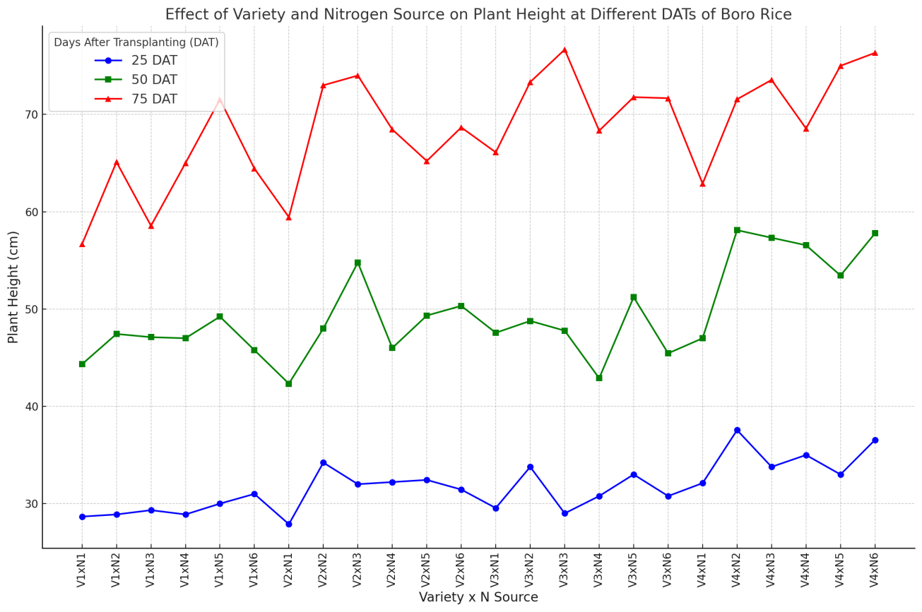
Figure 7: Effects of interaction of variety and nitrogen source on plant height at different DAT of boro rice

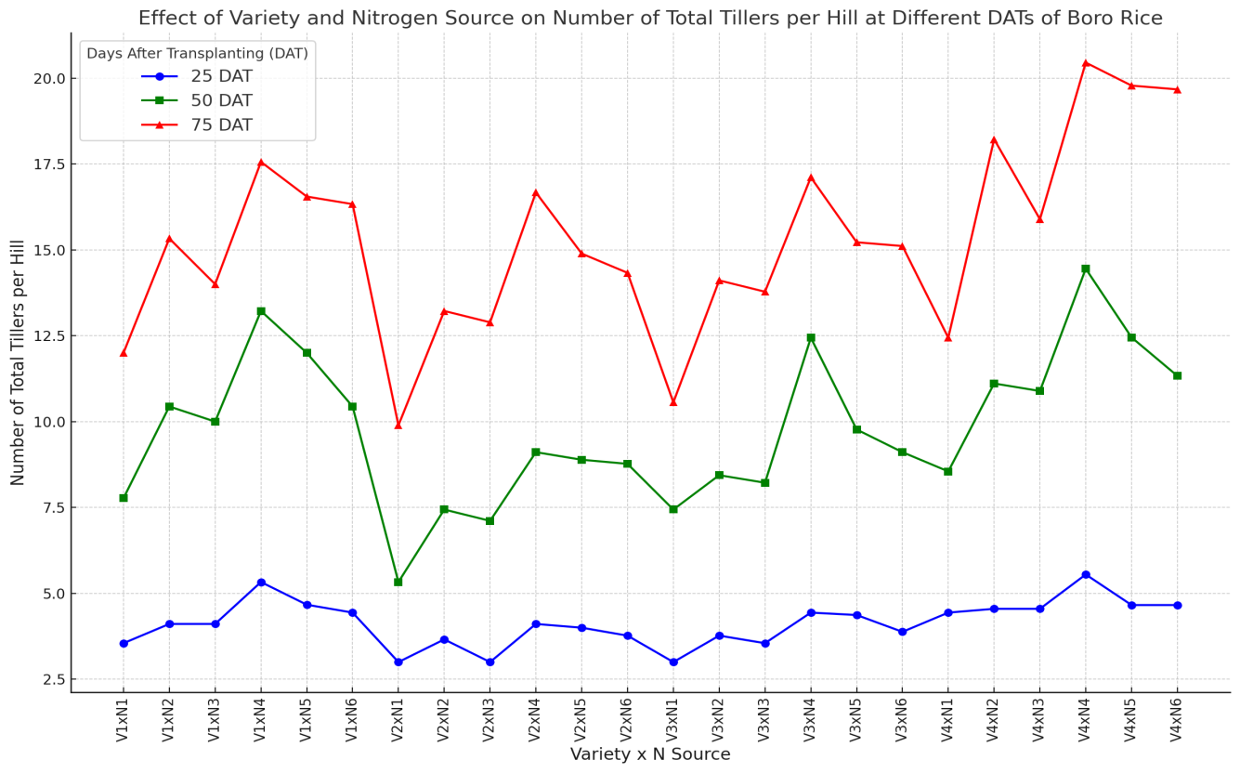
Figure 8: Effects of interaction of variety and nitrogen source on number of total tillers hill-1 at different DAT of boro rice
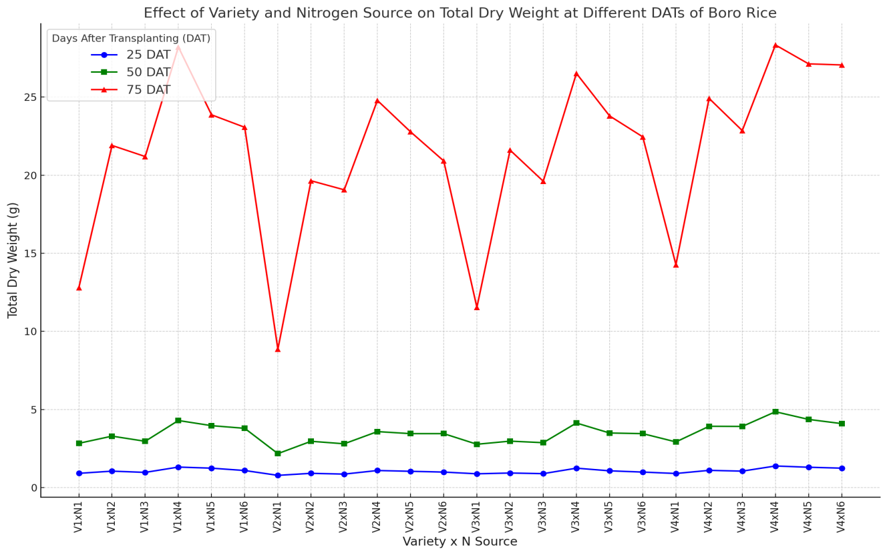

Figure 9: Effects of interaction of variety and nitrogen source on total dry weight at different DAT of boro rice

Table 1. Effect of cultivars on yield and yield contributing characters of boro rice
Rice cultivars | Plant height at maturity (cm) | Grain yield  (t ha⁻¹) | Straw yield  (t ha⁻¹) | Biological yield  (t ha⁻¹) | Harvest index (%)
V₁ | 89.34 a | 4.839 b | 5.309 b | 10.15 b | 47.56
V₂ | 77.48 c | 4.530 d | 5.054 d | 9.584 d | 47.13
V₃ | 86.51 b | 4.702 c | 5.187 c | 9.889 c | 47.40
V₄ | 90.62 a | 4.999 a | 5.503 a | 10.50 a | 47.51
Sx | 0.941 | 0.032 | 0.038 | 0.061 | 0.259
Level of significance | ** | ** | ** | ** | NS
CV (%) | 4.64 | 2.80 | 3.14 | 2.60 | 2.33
In a column, figures with same letter (s) or without letter do not differ significantly whereas figures with dissimilar letter differ significantly (as per DMRT).
** =Significant at 1% level of probability, * =Significant at 5% level of probability, NS = Not significant
V₁ = BRRI dhan29, V₂ = BRRI dhan59, V₃ = Binadhan-8, V₄ = Binadhan-10

Table 2. Effect of nitrogen sources on yield and yield contributing characters of boro rice
Nitrogen sources | Plant height at maturity (cm) | Grain yield  (t ha⁻¹) | Straw yield  (t ha⁻¹) | Biological yield  (t ha⁻¹) | Harvest index (%)
N₁ | 84.34 | 3.29f | 3.81 f | 7.10 f | 46.30
N₂ | 85.81 | 4.68d | 5.31d | 10.00 d | 46.80
N₃ | 86.28 | 4.28 e | 4.86 e | 9.14 e | 46.78
N₄ | 86.88 | 5.85a | 6.21a | 12.07 a | 48.50
N₅ | 85.19 | 5.32 b | 5.76b | 11.09 b | 48.02
N₆ | 87.43 | 5.17 c | 5.60c | 10.78 c | 47.99
Sx | 1.15 | 0.039 | 0.047 | 0.075 | 0.317
Level of significance | NS | ** | ** | ** | **
CV (%) | 4.64 | 2.80 | 3.14 | 2.60 | 2.33
In a column, figures with same letter (s) or without letter do not differ significantly whereas figures with dissimilar letter differ significantly (as per DMRT)
** =Significant at 1% level of probability, * =Significant at 5% level of probability, NS = Not significant

Table 3. Interaction effects of cultivars and nitrogen sources on yield and yield contributing characters of boro rice

Interaction (Cultivars x N sources) | Plant height at maturity (cm) | Grain yield  (t ha⁻¹) | Straw yield  (t ha⁻¹) | Biological yield  (t ha⁻¹) | Harvest index (%)
V₁xN₁ | 82.23defgh | 3.30i | 3.78j | 7.09k | 46.62
V₁xN₂ | 91.35ab | 4.89e | 5.48fg | 10.38g | 47.11
V₁xN₃ | 90.25abc | 4.35fg | 4.90h | 9.25hi | 46.99
V₁xN₄ | 90.77ab | 5.87ab | 6.22a | 12.09ab | 48.55
V₁xN₅ | 91.32ab | 5.41c | 5.83cde | 11.25de | 48.08
V₁xN₆ | 90.13abc | 5.19cd | 5.63defg | 10.82efg | 47.98
V₂xN₁ | 74.95h | 2.99j | 3.52j | 6.51l | 45.96
V₂xN₂ | 77.16gh | 4.32fg | 4.94h | 9.26hi | 46.69
V₂xN₃ | 75.64gh | 4.15g | 4.79h | 8.94i | 46.44
V₂xN₄ | 74.89h | 5.67b | 6.10abc | 11.77bc | 48.19
V₂xN₅ | 82.77cdefg | 5.07de | 5.54efg | 10.61g | 47.77
V₂xN₆ | 79.47fgh | 4.96de | 5.43g | 10.39g | 47.71
V₃xN₁ | 87.77abcde | 3.16ij | 3.70j | 6.86kl | 46.01
V₃xN₂ | 86.75bcdef | 4.49f | 5.05h | 9.54h | 47.06
V₃xN₃ | 87.67abcde | 4.23g | 4.84h | 9.07i | 46.63
V₃xN₄ | 86.88bcdef | 5.83ab | 6.20ab | 12.04ab | 48.47
V₃xN₅ | 80.25efgh | 5.38c | 5.75def | 11.14def | 48.40
V₃xN₆ | 89.77abcd | 5.10de | 5.56efg | 10.67fg | 47.82
V₄xN₁ | 92.43ab | 3.70h | 4.24i | 7.95j | 46.60
V₄xN₂ | 87.95abcd | 5.00de | 5.80de | 10.81efg | 46.33
V₄xN₃ | 91.57ab | 4.38fg | 4.93h | 9.32hi | 47.08
V₄xN₄ | 94.97a | 6.03a | 6.33a | 12.36a | 48.81
V₄xN₅ | 86.45bcdef | 5.42c | 5.92bcd | 11.35cd | 47.82
V₄xN₆ | 90.33abc | 5.43c | 5.78def | 11.22de | 48.43
Sx | 2.30 | 0.077 | 0.095 | 0.150 | 0.635
Level of sig. | ** | * | * | ** | NS
CV (%) | 4.64 | 2.80 | 3.14 | 2.60 | 2.33

4. Conclusion
This study's findings highlight the substantial advantages of integrated nitrogen nutrition in improving the development, yield, and nitrogen usage efficiency of boro rice (Oryza sativa). The amalgamation of prilled urea with organic amendments, especially poultry manure, shown enhanced outcomes regarding plant growth, grain yield, and nitrogen usage efficiency. Among the evaluated cultivars, Binadhan-10 demonstrated superior performance in all growth and yield metrics. Integrated nutrient management enhanced rice productivity while simultaneously decreasing nitrogen loss by volatilization, leaching, and denitrification, therefore fostering more efficient and sustainable agricultural methods. The research indicates that the integration of organic and inorganic fertilizers maximizes nitrogen utilization, improves soil quality, and is a feasible approach for sustainable rice cultivation in Bangladesh. Future research should concentrate on enhancing nitrogen management strategies to optimize environmental sustainability while preserving high agricultural output.
REFERENCES
- Akter, M. S., Yeasmin, S., & Hasan, A. K. (2018). Effect of integrated nitrogen application on the yield of two Boro rice varieties: BRRI dhan29 and BRRI dhan74. Archives of Agriculture and Environmental Science, 3(4), 410-415.
- Bangladesh Bureau of Statistics. (2024). Statistical year book of Bangladesh. Bangladesh Bureau of Statistics, Ministry of Planning, Government of People’s Republic of Bangladesh. Dhaka, p. 3.
- Bithy, P. A. (2023). Morpho-physiological and yield attributes of boro rice varieties as influenced by different nitrogen sources. Research in Agriculture Livestock and Fisheries, 10(2), 175-182.
- Bhowal, S. K., Hossain, M. H., Bashir. M. M. (2020). Integrated nutrient management on the yield and profitability of cauliflower. Bangladesh Agron. J. 23(2): 45-49
- Chakraborty, H. (2016). Growth and yield of boro rice as affected by weed management (MS Thesis). Department of Agronomy, Sher-e-Bangla Agricultural University, Dhaka–1207, pp. 1–84.
- Chauhan, B. S., & Johnson, D. E. (2011). Growth response of direct seeded rice to oxadiazon and bispyribac-sodium in aerobic and saturated soils. Weed Science, 59, 119-122. https://doi.org/10.1614/WS-D-11-00018.1
- Chowdhury, S. A., Paul, S. K., & Sarkar, M. A. R. (2016). Yield performance of fine aromatic rice in response to variety and level of nitrogen. Journal of Environmental Science and Natural Resources, 9(1), 41-45.
- Das, B., Haque, M., Mannan, M., & Mazumder, S. (2015). Performance study of Koshihikari rice variety and its economic prospect in comparison with three popular rice varieties of Bangladesh. Asian Journal of Agricultural Extension, Economics and Sociology, 5(2), 147-157. https://doi.org/10.9734/AJAEES/2015/15990
- Faruk, M., Hussain, A., Yusuf, M. A., & Mehedi, M. N. H. (2021). Performance of transplant Aus rice varieties under different nitrogen management practices. Asian Plant Research Journal.
- Gomez, K. A., & Gomez, A. A. (1984). Statistical procedures for agricultural research (2nd ed.). John Wiley & Sons.
- Geetha, P., & Balasubramanian, P. (2016). Effect of varieties and nitrogen application on growth and yield of aerobic rice. ORYZA-An International Journal on Rice, 53, 458-463.
- Islam, S., Khatun, A., Rahman, F., Hossain, A., Naher, U. A., & Saleque, M. A. (2016). Rice response to nitrogen in tidal flooded non-saline soil. Bangladesh Rice Journal, 19(2), 65-70.
- Jahan, A., Islam, A., Sarkar, M. I. U., Iqbal, M., Ahmed, M. N., & Islam, M. R. (2022). Nitrogen response of two high yielding rice varieties as influenced by nitrogen levels and growing seasons. Geology, Ecology, and Landscapes, 6(1), 24-31.
- Jayhoon, A. S., Kumar, P., Yadav, M. K., Kumar, M., & Singh, S. K. (2024). Expression analysis of OsGBSSI and OsGS3 genes, and investigation of morphological and biochemical characteristics across diverse rice (Oryza sativa L.) genotypes. Biology Bulletin Reviews, 14(Suppl 3), S405-S416.
- Li, M., Zhang, H., Yang, X., Ge, M. J., Wei, H., Dai, Q., Huo, Z., & Xu, K. (2013). Characteristics of dry matter accumulation and translocation in rice cultivars with high yield and high nitrogen use efficiency. Acta Agronomica Sinica, 39, 101.
- Liu, Z., Tao, L., Liu, T., Zhang, X., Wang, W., Song, J., Yu, C., & Peng, X. (2019). Nitrogen application after low-temperature exposure alleviates tiller decrease in rice. Environmental and Experimental Botany, 162, 97-106.
- Ma, P., Zhang, K.-Y., Liao, X.-H., Aer, L., Yang, E.-L., Deng, J., Zhou, L., & Zhang, R.-P. (2023). Effects of nitrogen application rate on dry matter weight and yield of direct-seeded rice under straw return. Agronomy, 13(12), 3058.
- Namai, S., Toriyama, K., & Fukuta, Y. (2009). Genetic variations in dry matter production and physiological nitrogen use efficiency in rice (Oryza sativa L.) varieties. Breeding Science, 59, 269-276.
- Norman, R., Roberts, T., Hardke, J., Slaton, N., Moldenhauer, K., Frizzell, D., Duren, M., Castañeda-González, E., & Fulford, A. (2015). Grain yield response of five new rice varieties to nitrogen fertilization. Agronomy Journal, 626, 256-271.
- Puteh, A., & Mondal, M. M. A. (2014). Growth and yield performance of rice as affected by nitrogen rate. Life Sciences Journal, 11(8), 653-655.
- Prayoga, M. K., Rostini, N., Simarmata, T., Setiawati, M., Stoeber, S., & Adinata, K. (2018). Growth of rice (Oryza sativa) varieties: Mendawak, Inpari 34, Ciherang, and Bangir in Ciganjeng Village, Pangandaran District. Jurnal Biodjati, 3(2), 3232. https://doi.org/10.15575/BIODJATI.V3I2.3232
- Khatun, A., (2015). Nitrogen use efficiency of lowland rice as affected by organic and chemical sources. Open Access Library Journal, 2(1), 1-16.
- Razib, M. A. H., Sarker, A. U., Sultana, N., Islam, M. N., & Podder, R. (2022). Performance of three boro rice varieties under different levels of nitrogen application. Research in Agriculture Livestock and Fisheries, 9(3), 267-278.
- Rahman, S., & Barmon, B. K. (2015). Exploring the potential to improve energy saving and energy efficiency using fertilizer deep placement strategy in modern rice production in Bangladesh. Energy Efficiency, 8(6), 1241-1250
- Salam, M. A., Chakraborty, S., & Rahman, A. (2020). Effect of integrated nutrient management on the growth and yield of boro rice (Oryza sativa L.) cultivars. Archives of Agriculture and Environmental Science, 5(4).
- Shanker, U., & Rani, M. (Eds.). (2024). Occurrence, distribution and toxic effects of emerging contaminants. CRC Press, Taylor & Francis Group.
- Sarker, A., Samanta, S., & Saha, G. (2020). Effect of nitrogen management and seedling raising methods on the productivity of Aus rice under tidal ecosystem of Bangladesh. Journal of Applied Biology, 4(1), 68-84.
- Vlek, P. L. G., & Craswell, E. T. (1981). Ammonia volatilization from flooded soils. Fertilizer Research, 2, 227–245.
- Wang, Y., Lu, J., Ren, T., Hussain, S., Guo, C., Wang, S., ... & Li, X. (2017). Effects of nitrogen and tiller type on grain yield and physiological responses in rice. AoB Plants, 9(2), plx012.
- Yi, B., Li, S., & Zhang, H. (2023). Effects of dynamic nitrogen application on rice yield and quality under straw returning conditions. Environmental Research, 243, 117857.
- Zhang, H., Liu, M., & Xu, J. (2022). Effects of dynamic nitrogen application on rice yield and straw biomass. Journal of Plant Nutrition, 45(3), 758-773.

