Original Research Article Re-formulate the abstract
On Simulation of the Sampling Distribution of Mean with Targeted Objectives

Abstract English language reformulation
A controversy exists regarding the use of simulations of the sampling distribution of the mean (SSDM). While some researchers argue that SSDMs can be misleading, others contend that they can facilitate learning. Given these conflicting perspectives, a strategic and effective guideline for implementing SSDMs is essential. This study evaluates an SSDM designed with targeted learning objectives, using the statistical software R. Through the analysis of applied examples, the study finds that a strategically guided SSDM can enhance learning while minimizing potential misunderstandings.
Key Words: Simulation; sampling distribution of mean, simulated sampling distribution of mean, test of hypothesis
1. Introduction

The simulation of the sampling distribution of the mean (SSDM) has been a topic of ongoing debate in statistical education. While some researchers argue that SSDMs can mislead students (Watkins, Bargagliotti, & Franklin, 2014), others contend that they can effectively facilitate learning (Lane, 2015). Given these contradictory conclusions, it is essential for instructors to implement SSDMs with clearly defined objectives and strategic guidelines to enhance learning while minimizing potential misconceptions.
A critical part of this strategy involves making a clear distinction between the exact sampling distribution of the mean (SDM) and its simulated counterpart (SSDM), in order to clarify the scope and limitations of simulation. This paper closely examines the components of the SDM and explicitly differentiates it from the SSDM to prevent conceptual confusion. The SSDM is structured around specific learning objectives, with an emphasis on hypothesis testing to verify the theoretical properties of the SDM through simulation.
This study aims to build confidence and conceptual clarity in the use of SSDMs for teaching by aligning simulations with purposeful instructional goals and applied examples. All simulations are conducted using the open-source statistical software R, which not only facilitates SSDM implementation but also helps students develop practical computational skills.
The remainder of this paper is organized as follows: Section 2 provides a brief literature review; Section 3 presents methods for distinguishing between the SDM and SSDM and evaluates the use of SSDMs; Section 4 describes examples and applications; Section 5 summarizes the simulation results; and Section 6 provides concluding remarks.

2. Literature Review Add modern literary studies

Many previous studies have evaluated and recommended the use of simulations of the sampling distribution of the mean (SSDM) in teaching statistics (e.g., Chance et al., 2007; Hancock & Rummerfeld, 2020; Lane, 2015; Lane & Tang, 2000; Watkins, Bargagliotti, & Franklin, 2014). These studies highlight the growing role of SSDMs in promoting deeper understanding of statistical concepts. It has been suggested that computer-based simulations can be made more effective when instructors ask students to predict the shape, center, and spread of a sampling distribution before running the simulation, and then encourage them to reflect on their observations afterward.
Despite their potential, various studies have identified misconceptions and challenges associated with using SSDMs (e.g., Hodgson & Burke, 2000; Lunsford, Rowell, & Goodson-Espy, 2006; Pfaff & Weinberg, 2009; Watkins, Bargagliotti, & Franklin, 2014). For instance, Pfaff and Weinberg (2009), using a card-based simulation, found no evidence that the activity improved students' understanding. Similarly, Hodgson and Burke (2000) reported that simulation of the SDM led 6 of their 18 students to believe that “one must draw multiple samples in order to make valid statistical inferences.”
While some researchers raise concerns, others argue that simulation-based approaches help students develop a more intuitive grasp of sampling distributions or related abstract ideas (e.g., Beckman, DelMas, & Garfield, 2017; Mills, 2004; Pfaff & Weinberg, 2009; Wood, 2005). Watkins, Bargagliotti, and Franklin (2014) discovered that SSDMs can mislead students when plotting estimated means against sample sizes—potentially reinforcing incorrect interpretations. These misunderstandings are echoed in studies by Mulekar & Siegel (2009) and Lunsford, Rowell, & Goodson-Espy (2006). Nevertheless, Lane (2015) suggested that such issues can be mitigated by increasing the number of samples, which enhances the reliability and clarity of the simulation output.
This paper builds on these findings by evaluating the SSDM’s role in verifying the theoretical properties of the SDM, using hypothesis testing as a central pedagogical tool.

3. Methods
In this section, we would like to introduce SDM and SSDM and make a clear distinction between them.

3.1. Definition of SDM
For a population P with mean $μ_{x}$ and standard deviation $σ_{x}$ the sampling distribution of mean (SDM) is the probability distribution of sample means ($\overline{x}$) over all possible samples of a given size ($n$). Let $μ_{\overline{x}}$ and $σ_{\overline{x}}$ denote the mean and standard deviation of the SDM over all possible samples of size $n$. As a matter of fact, $σ_{\overline{x}}$ describes the accuracy of $\overline{x}$ in estimating $μ_{x}$ and hence the term standard error (SE) is preferable to standard deviation $σ_{\overline{x}}$ for an SDM. The SDM has the following three important properties:
- $μ_{\overline{x}}=μ_{x}$, a relationship between mean of the SDM $(μ_{\overline{x}})$ and the true population mean $\left(μ_{x}\right)$. This relationship is invariant with respect to the sample size $n$ and the distribution of P.
- $σ_{\overline{x}}=σ_{x}/\sqrt{n}$, a relationship between the SE of the SDM $(σ_{\overline{x}})$ and the standard deviation ${(σ}_{x})$ of the population P. This relation is also invariant with respect to the sample size $n$ and the distribution of P.
- The SDM is either (a) normal if the population P is normal, irrespective of the sample size $n$, or (b) approximately normal if the sample size $n$ large, i.e., $n≥30$, given that the population P is not normal. This property is called the Central Limit Theorem (CLT).

3.2 The simulation of SDM (SSDM)
The sampling distribution of the mean (SDM) is defined as the distribution of all possible sample means for a given sample size, drawn from a population. As such, the SDM represents an exact theoretical distribution based on every possible sample. In practice, however, it is rarely feasible to take all possible samples. Instead, we rely on a large number of randomly generated samples—limited by computational capacity and available resources—to approximate the SDM through simulation. This approximation is known as the simulated sampling distribution of the mean (SSDM). The SSDM is inherently dependent on the choices made by the simulator, including the number of samples, sampling methods, and the specific learning or analytical objectives the simulation is intended to serve.

3.3. Evaluation of SSDM with targeted objectives
In general, we do not expect the simulated sampling distribution of the mean (SSDM) to be identical to the theoretical sampling distribution of the mean (SDM), nor should we assume that the parameters of the SSDM are equal to those of the SDM. When conducting an SSDM, it is important to align the simulation with clearly defined learning objectives. For instance, one might investigate how the sample size (n) influences the shape and variability of the SSDM (Mulekar & Siegel, 2009), or how the number of simulation replications (M) impacts conclusions about key properties of the SDM.
In this study, the SSDM is evaluated in the context of three core properties of the SDM, using a hypothesis testing framework and are specified as follows:

- $H_{01}$: ${\tilde{μ}}_{\overline{x}}=μ_{\overline{x}}$ vs $H_{a1}$: ${\tilde{μ}}_{\overline{x}}≠μ_{\overline{x}}$
- $H_{02}$: ${\tilde{σ}}_{\overline{x}}=σ_{\overline{x}}$ vs $H_{a2}$: ${\tilde{σ}}_{\overline{x}}≠σ_{\overline{x}}$
- $H_{03}:$SSDM is N($μ_{\overline{x}}, σ_{\overline{x}}$) vs $H_{a3}:$SSDM is not N($μ_{\overline{x}}, σ_{\overline{x}}$)
where ${\tilde{μ}}_{\overline{x}}$ and ${\tilde{σ}}_{\overline{x}}$ are mean and SE of the SSDM, and $μ_{\overline{x}}$ and $σ_{\overline{x}}$ are mean and SE of SDM.
For the test of (1), $H_{0}$: ${\tilde{μ}}_{\overline{x}}=μ_{\overline{x}}$, we opt to apply a T-test and Z-test.
The T-test is defined by
$$T=\frac{{\overset{̿}{x}}_{n,M}-μ_{\overline{x}}}{\tilde{s}/\sqrt{n}}$$
where
${\overset{̿}{x}}_{n,M}=\frac{1}{M}\sum_{j=1}^{M}{{\overline{x}}_{n,j}}$ and $\tilde{s}=\sqrt{\frac{1}{M-1}\sum_{j=1}^{M}{{\left({\overline{x}}_{n,j}-{\overset{̿}{x}}_{n,M}\right)}^{2}}}$

The values of ${\overset{̿}{x}}_{n,M}$ and $\tilde{s}$ vary by the choice of $M$, the simulation replications used in the SSDM and are estimates of ${\tilde{μ}}_{\overline{x}}$ and ${\tilde{σ}}_{\overline{x}}$. The values of $μ_{\overline{x}}$ and $σ_{\overline{x}}$ are specified by the properties of the SDM. The test statistic T is assumed to follow a $t$ distribution with $(M-1)$ degrees of freedom.
The Z-test is defined by
$$Z=\frac{{\overset{̿}{x}}_{n,M}-μ_{\overline{x}}}{σ_{\overline{x}}}$$
which is assumed to follow a standard normal distribution.

For the test of (2), $H_{0}$: ${\tilde{σ}}_{\overline{x}}=σ_{\overline{x}}$, we conduct a Chi-square test for a specified variance given by
$$χ^{2}=\frac{(M-1){\tilde{s}}_{\overline{x}}^{2}}{σ_{\overline{x}}^{2}}$$
where ${\tilde{s}}_{\overline{x}}^{2}=\frac{\sum_{j=1}^{M}{{({\overline{x}}_{n,j}-{\overset{̿}{x}}_{n,M})}^{2}}}{M-1}$. The test statistic $χ^{2}$ is assumed to follow a chi-square distribution with $\left(M-1\right)$ degrees of freedom.
For the test of (3), $H_{0}$: SSDM is normal, we employ Anderson-Darling tests of normality by using R function ad.test() from nortest package. As a computational tool, the statistical software R (R Core Team, 2024) has been used for all computations and simulations in this article.
4. Examples and applications Simulation explanation separately
In this section, three example scenarios are investigated to evaluate the performance of SSDM in assessing three properties of SDM. Examples and simulation applications are conducted for both finite population and infinite populations.

Example 1
For this example, we consider a finite population P1={167, 150, 125, 120, 150, 150, 40, 136, 120, 150}, consisting of heart rates (measured in beats per minute) of ten asthmatic patients in a state of respiratory arrest, as reported by Pagano and Gauvreau (2000). Note that the population mean is $μ_{x}=130.8$ and the population standard deviation is $σ_{x}=33.65$. As shown in Figures 1.1(a)–1.1(c), the population P1​ is clearly not normally distributed, exhibiting left skewness and a potential outlier. The Anderson-Darling normality test also supports the non-normality of P1 with a p-value of 0.008004.
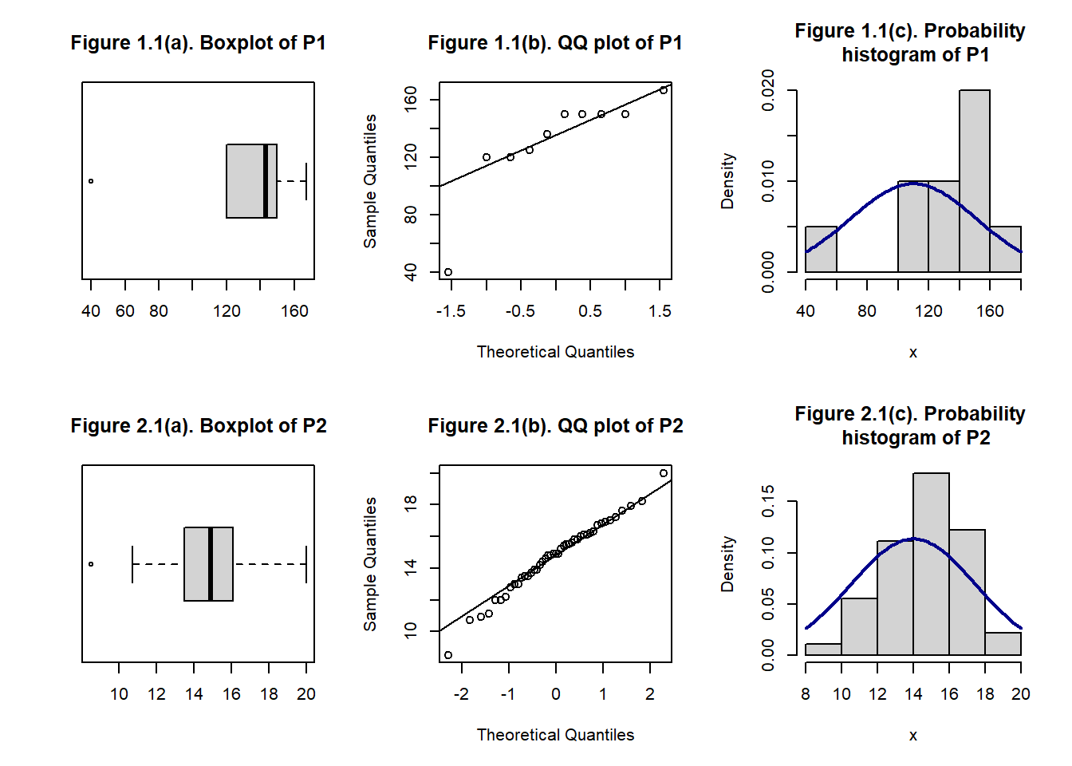
Now, let us consider the sampling distribution of the mean (SDM) for samples of size 10. According to the properties of the SDM outlined in Section 3.1, the mean of the SDM is $μ_{\overline{x}}=μ_{x}=130.8$ and the standard deviation is $σ_{\overline{x}}=\frac{σ_{x}}{\sqrt{n}}=\frac{33.65}{\sqrt{10}}=10.64$. To construct the exact SDM, one would need to consider all ${10}^{10}$ possible samples (with replacement) of size 10 from P1. Clearly, investigating ${10}^{10}$ samples is computationally infeasible.
This is where a simulated sampling distribution of the mean (SSDM) becomes useful. Instead of generating the full SDM, we approximate it by generating a large number of sample means. In this study, M=5000 sample replications, each of size 10 (with replacement), are used to construct the SSDM. This SSDM is then used to evaluate the three hypothesis tests discussed in Section 3.3, defined particularly for this problem scenario as follows:
- $H_{0}$: ${\tilde{μ}}_{\overline{x}}=130.8$
- $H_{0}$: ${\tilde{σ}}_{\overline{x}}=10.64$
- $H_{0}:$SSDM is $N\left(130.8, 10.64\right)$

Example 2

In this example, we assume a finite population, P2, generated from the American Time Use Survey (ATUS) Wellbeing Respondent data. The assumed population consists of the amount of time (in hours) that 45 adult Americans spent engaging in three randomly selected activities. The time data is represented by the following observations, each reported to one decimal place:
P2 = {15.6, 13.0, 13.7, 14.2, 13.9, 16.1, 13.0, 16.1, 16.0, 14.9, 16.9, 17.9, 14.9, 16.2, 13.5,
17.0, 16.3, 13.4, 15.5, 20.0, 10.9, 17.6, 12.2, 13.9, 15.2, 14.8, 16.7, 12.0, 17.2, 11.1, 14.9,
14.8, 8.5, 12.0, 12.8, 14.4, 15.4, 14.6, 18.2, 15.8, 10.7, 16.8, 13.5, 15.5, 15.8}

For population P2, it is straightforward to verify that the population mean is $μ_{x}=14.74$ and the standard deviation is $σ_{x}=2.20$. As shown in Figures 2.1(a)–2.1(c), population P2 is approximately normally distributed. The Anderson-Darling normality test further supports this conclusion, with a p-value of 0.6688.
Now, let us consider the sampling distribution of the mean (SDM) for samples of size n = 25. By the properties outlined in Section 3.1, the mean of the SDM is $μ_{\overline{x}}=14.74$ and the standard error is $σ_{\overline{x}}=\frac{2.2}{\sqrt{25}}=0.44$.

To construct the exact SDM, one would need to consider all possible samples of size 25 (with replacement) from P2, amounting to 45²⁵ combinations. Clearly, enumerating all these samples is computationally infeasible. Therefore, we approximate the SDM by generating the means of M = 5000 sample replications, each of size 25 (with replacement), to construct the simulated sampling distribution of the mean (SSDM).
This SSDM is then used to evaluate the three hypothesis tests discussed in Section 3.3, defined for this problem scenario as follows:

- $H_{0}$: ${\tilde{μ}}_{\overline{x}}=14.74$
- $H_{0}$: ${\tilde{σ}}_{\overline{x}}=0.44$
- $H_{0}:$SSDM is $N\left(14.74, 0.44\right)$

Example 3.
In this example, an infinite normal P3 ~ N(μ = 1.5, σ = 2) is considered, along with the corresponding simulated sampling distributions of the mean (SSDM) for sample sizes $n$ ranging from 10 to 1000, in increments of 10, as defined by the sequence seq(10,1000,10). According to properties (1) and (2) described in Section 3.1, the mean of the sampling distribution of the mean (SDM) from Population P3 is $μ_{\overline{x}}=1.5$, and the standard error of the SDM is $σ_{\overline{x}}=\frac{2}{\sqrt{n}}$​, where $n$ is the sample size.
To approximate this SDM using an SSDM, M=5000 sample replications, each of size 25 (with replacement), have been generated to evaluate the three hypothesis tests discussed in Section 3.3, which are defined for this problem scenario as follows:

- $H_{0}$: ${\tilde{μ}}_{\overline{x}}=1.5$
- $H_{0}$: ${\tilde{σ}}_{\overline{x}}=\frac{2}{√n}$
- $H_{0}:$SSDM is $N\left(μ_{\overline{x}}=1.5, σ_{\overline{x}}=\frac{2}{√n}\right)$
where $n$ take values in the seq(10,500,10).

5. Results and discussion of tests using SSDM

Given the characteristics of Population P1​ from Example 1, we expect the mean and standard error of the SSDM to align with those of the SDM, thereby satisfying tests (a) and (b). However, we do not expect either the SDM or the SSDM to be normally distributed, which corresponds to test (c) as specified in Example 1. To evaluate these expectations, refer to the results from 10 runs of the SSDM used to assess tests (a)–(c) of Example 1, as reported in Table 1.
Table 1. Results of ten separate runs of SSDM for tests (a)-(c) for population P1 of Example 1.
Runs | $${\overset{̿}{x}}_{n,M}$$ | $$\tilde{s}$$ | t.pval | z.pval | $χ^{2}$.pval | ad.pval
1 | 130.72 | 10.75 | 0.600 | 0.596 | 0.308 | 3.70E-24
2 | 130.84 | 10.70 | 0.781 | 0.780 | 0.588 | 3.70E-24
3 | 130.65 | 10.86 | 0.342 | 0.332 | 0.040 | 3.70E-24
4 | 130.53 | 10.76 | 0.074 | 0.071 | 0.266 | 3.70E-24
5 | 130.99 | 10.79 | 0.205 | 0.198 | 0.148 | 3.70E-24
6 | 130.98 | 10.48 | 0.220 | 0.227 | 0.133 | 3.70E-24
7 | 130.91 | 10.68 | 0.469 | 0.467 | 0.735 | 3.70E-24
8 | 130.61 | 10.62 | 0.199 | 0.199 | 0.888 | 3.70E-24
9 | 130.82 | 10.62 | 0.906 | 0.906 | 0.824 | 3.70E-24
10 | 130.69 | 10.82 | 0.457 | 0.449 | 0.086 | 3.70E-24

The results in Table 1 clearly indicate that the mean of the SSDM for each of the ten runs (column 2, Table 1) closely approximates the mean of the SDM (130.8). The standard error of the SSDM (column 3, Table 1) is equal to or very close to the standard error of the SDM (10.64). The p-values from the T and Z tests (columns 6 and 7) provide no evidence to reject the null hypothesis that the mean of the SSDM equals the mean of the SDM at the 5% significance level. The p-value from the χ² test suggests that the standard error of the SSDM aligns with that of the SDM in most cases, except for run 3, where the p-value is 0.040—slightly below the 0.05 threshold. This deviation may be attributed to the randomness inherent in the sampling procedure. The p-values from the Anderson-Darling tests indicate that the SSDM is not normally distributed, consistent with the non-normality of the SDM. Overall, the expectations regarding the SSDM’s conformity to the SDM appear to be well met.
Noting the characteristics of Population P2​ from Example 2, we expect the mean and standard error of the SSDM to align with those of the SDM, and SDM or the SSDM to be normally distributed, which corresponds to tests (a)-(c) as specified in Example 2. To evaluate these expectations, refer to the results from 10 runs of the SSDM reported in Table 2.
Table 2. Results of ten separate runs of SSDM for tests (a)-(c) for population P2 of Example 2.
Runs | $${\overset{̿}{x}}_{n,M}$$ | $$\tilde{s}$$ | t.pval | z.pval | $χ^{2}$.pval | norm.pval
1 | 14.73 | 0.45 | 0.206 | 0.202 | 0.380 | 0.340
2 | 14.74 | 0.45 | 0.783 | 0.779 | 0.058 | 0.507
3 | 14.73 | 0.44 | 0.057 | 0.057 | 0.994 | 0.458
4 | 14.74 | 0.44 | 0.599 | 0.602 | 0.426 | 0.045
5 | 14.75 | 0.44 | 0.555 | 0.556 | 0.889 | 0.282
6 | 14.74 | 0.44 | 0.959 | 0.959 | 0.870 | 0.374
7 | 14.74 | 0.44 | 0.817 | 0.816 | 0.764 | 0.062
8 | 14.74 | 0.45 | 0.544 | 0.541 | 0.347 | 0.173
9 | 14.74 | 0.44 | 0.726 | 0.725 | 0.590 | 0.062
10 | 14.74 | 0.44 | 0.831 | 0.831 | 0.945 | 0.262

The results in Table 2 show that the empirical mean of the SSDM for each of the ten runs (column 2, Table 2) closely approximates the mean of the SDM (14.74). The standard error of the SSDM (column 3, Table 2) is equal to or very close to the standard error of the SDM (0.44). The p-values from the T and Z tests (columns 6 and 7) indicate no reason to reject the null hypothesis that the mean of the SSDM equals the mean of the SDM at the 5% significance level. The p-values from the $χ²$ test suggest that the standard error of the SSDM is consistent with that of the SDM across all ten runs. The p-values from the Anderson-Darling tests suggest that the SSDM is normally distributed with characteristics matching those of the SDM, except for run 4, where the p-value is 0.045—slightly below the 0.05 threshold. Overall, the expectations regarding the SSDM’s conformity to the SDM appear to be met.

Table 3. Results of tests involving the SSDM for varying sample sizes, based on M=5000 sample replications from Population P3​ in Example 3
$$n$$ | $${\overset{̿}{x}}_{n,M}$$ | SE(SSDM) | SE(SDM) | Difference | z.pval | t.pval | $χ^{2}$.pval | norm.pval
10 | 1.497 | 0.628 | 0.633 | 0.005 | 0.697 | 0.695 | 0.456 | 0.347
50 | 1.500 | 0.285 | 0.283 | 0.002 | 0.919 | 0.920 | 0.433 | 0.828
100 | 1.499 | 0.201 | 0.200 | 0.001 | 0.596 | 0.598 | 0.565 | 0.919
150 | 1.497 | 0.164 | 0.163 | 0.001 | 0.167 | 0.169 | 0.678 | 0.821
200 | 1.501 | 0.140 | 0.141 | 0.001 | 0.734 | 0.731 | 0.325 | 0.750
300 | 1.499 | 0.117 | 0.116 | 0.001 | 0.474 | 0.479 | 0.300 | 0.111
400 | 1.500 | 0.102 | 0.100 | 0.002 | 0.984 | 0.985 | 0.051 | 0.429
500 | 1.500 | 0.091 | 0.089 | 0.001 | 0.978 | 0.979 | 0.116 | 0.818
600 | 1.501 | 0.081 | 0.082 | 0.001 | 0.532 | 0.528 | 0.339 | 0.909
700 | 1.500 | 0.075 | 0.076 | 0.001 | 0.827 | 0.825 | 0.336 | 0.060
800 | 1.500 | 0.070 | 0.071 | 0.000 | 0.680 | 0.678 | 0.611 | 0.758
900 | 1.500 | 0.067 | 0.067 | 0.000 | 0.634 | 0.634 | 0.980 | 0.007
1000 | 1.498 | 0.063 | 0.063 | 0.000 | 0.009 | 0.008 | 0.523 | 0.071

From the results in Table 3, it appears that the means are close to 1.5 (column 2), regardless of the sample size $n$. The standard errors of the SSDM (column 3) and the exact SDM (column 4) both decrease as $n$ increases, which aligns with our expectations based on the properties described in Section 3. Additionally, the absolute difference between SE(SSDM) and SE(SDM) also decreases with increasing $n$, indicating improved accuracy of the SSDM for larger sample sizes.

While the test results for Example 3 are reported for selected values of $n$ in Table 3, the complete results for $n$ ranging from 10 to 1000 in increments of 10 (i.e., seq(10,1000,10)) are plotted against the sample size $n$ in Figures 3.1–3.6. These plots consistently support the expectations of the SSDM in reference to the SDM.
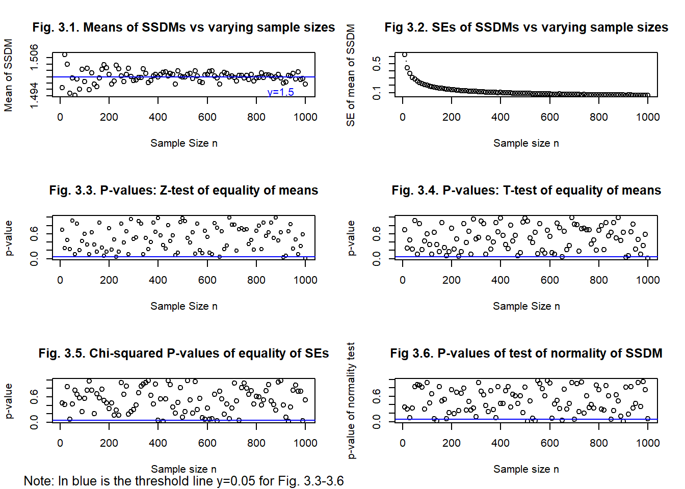

In Figures 3.3–3.6, the blue lines represent the 5% significance level. Figure 3.1 demonstrates that the mean of the SSDM converges toward the mean of the SDM (1.5). Figure 3.2 shows that the standard error of the SSDM decreases as the sample size $n$ increases, closely mirroring the behavior of the SDM. The p-values from the Z and T tests for equality of means between the SSDM and SDM (Figures 3.3 and 3.4) indicate that expectations are satisfactorily met. Similarly, the results of the $χ²$ test for equality of standard errors (Figure 3.5) support this conclusion. The normality of the SSDM, characterized by the parameters of the SDM, is also confirmed (Figure 3.6). Based on the test results presented in Figures 3.3–3.6, the estimated probabilities of successfully achieving the targeted objectives are 0.97 (Z-test), 0.96 (T-test), 0.95 ($χ²$ test), and 0.95 (normality test).

6. Concluding remarks
Guided by targeted learning objectives, this study finds that the Simulated Sampling Distribution of the Mean (SSDM) is a valuable tool for illustrating the properties of the Sampling Distribution of the Mean (SDM), which can otherwise be difficult to grasp in introductory statistics courses. Key distinctions between the SDM and SSDM are clearly established. Specifically, the mean and standard error (SE) of an SDM are fixed parameters, whereas the mean and SE of an SSDM are estimates of those parameters and, therefore, vary across simulation replications (M). Consequently, an SSDM should not be expected to match the SDM exactly, as it is practically impossible to replicate the precise set of samples that define the SDM.
Expectations surrounding the SSDM should be clearly communicated to students—ideally through examples, interactive activities, or simulated outputs accompanied by thoughtful explanations and interpretations—before they engage with the SSDM. Simulations can offer valuable, though approximate, insights into theoretical concepts that might otherwise remain abstract or inaccessible. Instructors should be mindful of potential misconceptions, such as those highlighted in Watkins et al. (2014), and take steps to address them proactively.
Indeed, engaging with SSDMs can be both enjoyable and educational when integrated with clear, guided objectives. When implemented thoughtfully, SSDMs enhance students’ conceptual understanding and help them develop the ability to critically evaluate simulation results without falling prey to common misconceptions.

References
ATUS (2021). The American Time Use Survey (ATUS) Data Dictionary: 2021 Well-being Module Data
https://www.bls.gov/tus/dictionaries/wbmintcodebk21.pdf

Chance, B., Ben-Zvi, D., Garfeld, J., & Medina, E. (2007). The Role of Technology in
Improving Student Learning of Statistics. Technology Innovations in Statistics Education, 1(1). https://doi.org/10.5070/T511000026

Hancock, S.A. & Rummerfeld, W. (2020). Simulation Methods for Teaching Sampling
Distributions: Should Hands-on Activities Precede the Computer? Journal of Statistics Education, 28(1), 9-17. https://www.tandfonline.com/doi/full/10.1080/10691898.2020.1720551

Hodgson, T. & Burke, M. (2000). On Simulation and the Teaching of Statistics. Teaching
Statistics, 22(3), 91-96. https://doi.org/10.1111/1467-9639.00033

Lane, D. M. (2015). Simulations of the Sampling Distribution of the Mean Do Not Necessarily
Mislead and Can Facilitate Learning. Journal of Statistics Education, 23(2). https://doi.org/10.1080/10691898.2015.11889738.

Lane, D. M. & Tang, Z. (2000). Effectiveness of Simulation Training on Transfer of statistical
Concepts. Journal of Educational Computing Research, 22 (4), 383-396.
https://doi.org/10.2190/W9GW-5M9C-UQVT-1E0R

Lunsford, M. L., Rowell, G. H., & Goodson-Espy, T. (2006). Classroom Research:
Assessment of Student Understanding of Sampling Distributions of Means and the Central Limit Theorem in Post-Calculus Probability and Statistics Classes. Journal of Statistics Education [online], 14(3). https://doi.org/10.1080/10691898.2006.11910587

Mills, J. D. (2004). Learning abstract statistics concepts using simulation. Educational
Research Quarterly, 28(4), 18-33. https://eric.ed.gov/?id=EJ718121

Mulekar, M. S. & Siegel, M. H. (2009). How Sample Size Affects a Sampling Distribution.
The Mathematics Teacher, 103(1), 35-42. https://doi.org/10.5951/MT.103.1.0034

Pfaff, T. J. & Weinberg, A. (2009). Do hands-on activities increase student understanding?: A
case study. Journal of Statistics Education 17(3), https://eric.ed.gov/?id=EJ868321

R Core Team (2024). R: A Language and Environment of Statistical Computing. R Foundation for Statistical Computing, Vienna, Austria, https://www.R-project.org/

Watkins, A. E., Bargagliotti, A., & Franklin, C. (2014). Simulation of the Sampling
Distribution of the Mean Can Mislead. Journal of Statistics Education, 22(3). https://doi.org/10.1080/10691898.2014.11889716

Wood, M. (2005). The Role of Simulation Approaches in Statistics. Journal of Statistics
Education, 13(3). https://doi.org/10.1080/10691898.2005.11910562

