Adopting Recycled Water For Irrigation In Nigeria: Review of Potential Environmental Impacts

Abstract
In light of growing water scarcity and the rising demand for sustainable agricultural practices, this study investigates the potential for using recycled water as an irrigation source in Nigeria. This review synthesizes existing literature to evaluate the environmental impacts associated with adopting recycled water for irrigation, considering factors like water quality, soil health, and ecosystem effects. It examines global best practices in agricultural water recycling, analyses the potential environmental and economic benefits, and identifies key risks, such as heavy metal accumulation and public health concerns. The findings highlight that recycled water can offer an alternative nutrient source, reduce dependency on freshwater, and improve crop yields. However, to ensure safe adoption, Nigeria will require robust regulatory frameworks, investment in treatment infrastructure, and tailored public awareness programs. By drawing lessons from countries like Israel and Australia, this study suggests pathways for Nigeria to develop region-specific guidelines that address local soil conditions, crop requirements, and community concerns. These insights provide a foundation for policymakers and agricultural stakeholders to consider recycled water as a viable strategy to enhance water security, support sustainable farming, and promote rural economic resilience.

Keywords: Water recycling, Irrigation, water security, agricultural productivity

1. Introduction
With the long list of global crises faced today, water scarcity remains a critical problem demanding urgent attention. Water scarcity depicts the lack of sufficient freshwater resources to satisfy water demand (Caretta et al., 2022). Human beings, animals, and other living organisms cannot live without water. Additionally, industrial productions, livestock rearing, food production, biodiversity and environmental conservation, are all dependent on water, therefore, water is life (Dhanasekaran, 2019). According to Dhanasekaran (2019), fresh water is the only available source for drinking, industrial use, agricultural development, and all other purposes. In sub-saharan Africa, and most regions of the world, agriculture uses over 70 percent of freshwater, and with the growing global population, agricultural production is estimated to increase 50 percent as water withdrawals increases 15 percent (Khokhar, 2017). There is significant increase in water demand as well as water misuse, and this has increased widespread risks of water stress and scarcity (Baker et al., 2016). In developing countries like Nigeria, water scarcity is a critical issue affecting agricultural productivity and sustainability (FAO, n.d). In Nigeria, agriculture is a major sector of the economy. A study on employment rate in 2020 stated that agriculture accounts for up to 35% of total employment in Nigeria for the year 2020 (Dikeogu-Okoroigwe et al., 2024). According to the FAO, agriculture remains the foundation of the Nigerian economy, providing livelihood for most Nigerians and generating millions of jobs (FAO, 2020).
Nigeria has a growing population projected to experience a constant increase in the following decades (Iyanda, Falade, 2019). According to Doris (2023), Nigeria will experience a population growth of over 377 million people by 2050. As the Nigerian population grows, the need and demand for agricultural development also marginally increases, thereby proving the need for improvement in production to match the country’s increasing population for sustainable development to be achieved (Aina et al., 2019). With the advent of climate change, disruptions in rainfall patterns, and increasing pressure on traditional water sources like groundwater and surface water has resulted in the urgent need for exploration of alternative solutions to ensure water security and sustainable agricultural practices (Rastogi et al., 2024). There are various alternative sources or approaches for alternative water sources for agriculture, however, one promising approach is the use of recycled water for irrigation (Aishwarya et al., 2022). This approach involves treating wastewater to a quality suitable for reuse as a source of irrigation in agriculture (Drechsel et al., 2010).
Globally, recycled water has been successfully used in agriculture, and has provided multiple benefits such as water conservation, nutrient recycling, and effective wastewater management (Poustie et al., 2020). However, the adoption of such practices in Nigeria is still in its early stages, with limited implementation and awareness (Adewumi, 2016). This review aims to evaluate the potential environmental impacts of adopting recycled water for irrigation in Nigeria. By examining global practices, current initiatives within the country, and relevant case studies, this paper seeks to provide a comprehensive understanding of the benefits, risks, and necessary measures for successful implementation in Nigeria. The findings will inform policymakers, agricultural practitioners, and stakeholders about the feasibility and implications of using recycled water for irrigation and contribute to sustainable water management and agricultural resilience in Nigeria.
Although recycled water presents a promising alternative, its adoption for agricultural irrigation is limited by concerns over water quality and potential health risks, especially in a densely populated and agriculturally intensive country like Nigeria. Lessons from countries such as Israel and Australia demonstrate that successful implementation requires stringent regulatory standards, infrastructure investment, and ongoing quality monitoring. By aligning Nigeria’s water recycling efforts with global best practices, there is significant potential to mitigate water scarcity, enhance food security, and promote sustainable land use, particularly in semi-arid regions facing severe drought conditions.
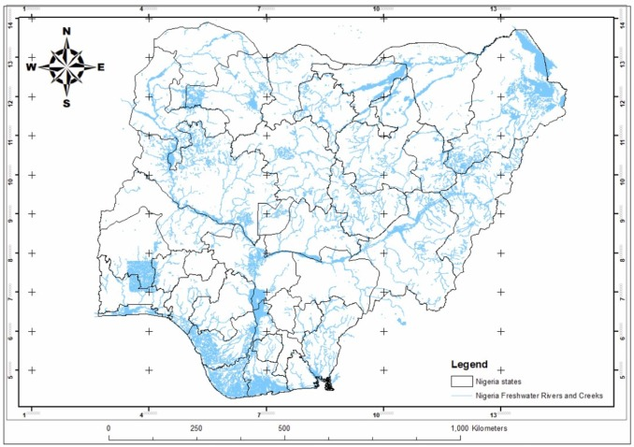
Figure 1: Map of Nigeria showing water distribution across regions (Isukuru et al., 2024)

2. Overview of Water Recycling Practices

Water recycling, also known as water reclamation or reuse, treats wastewater to remove contaminants, making it suitable for various purposes, including agriculture and irrigation (EPA, 2024). The treatment type and degree depend on the intended reuse (I.L. Pepper et al., 2015). Treatment typically involves primary (removal of large solids), secondary (biological treatment for organic matter degradation), and tertiary stages (advanced filtration and disinfection) (Anjaneyulu et al. 2005). Globally, recycled water is used in agriculture, industry, and landscape irrigation (Wang et al., 2017). Countries like Israel, Spain, and Australia have successfully implemented large-scale programs, demonstrating benefits like water conservation, reduced freshwater dependence, and enhanced nutrient management (Jimenez & Asano, 2008; Angelakis et al., 2018). While water recycling initiatives in Nigeria are limited, with efforts mainly focused on urban wastewater treatment, there is growing discussion around its potential for agricultural reuse. Studies have explored using treated wastewater for irrigation in peri-urban areas of Lagos and Kano (Binns et al., 2003). Despite the benefits, large-scale implementation faces infrastructural, financial, and regulatory challenges (Helmecke et al., 2020).

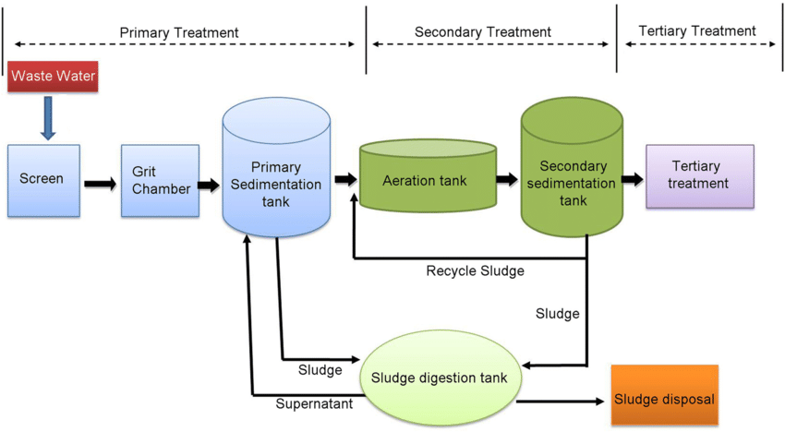

Figure 2: Wastewater treatment process showing primary, secondary, and tertiary treatment stages as used in industries to meet discharge standards (Chauhan, J., & Kumar, S., 2020).

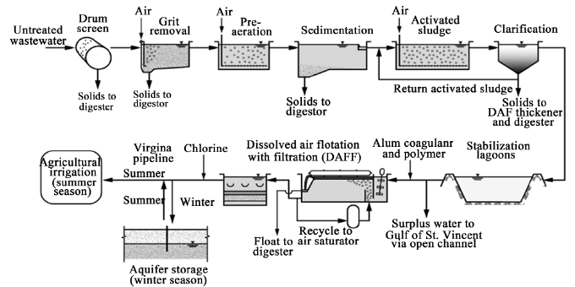

Figure 3: Process flow diagram for the Bolivar sewage treatment facility used in water reuse for unrestricted irrigation.(Ranieri, Leverenz, & Tchobanoglous, 2011)

2.1 Definition and Types of Recycled Water
Recycled water, also known as reclaimed or treated wastewater, is water that has been used and subsequently treated to remove impurities, making it suitable for various purposes, including irrigation. The recycling process involves multiple stages of treatment to ensure that the water meets specific quality standards. These stages typically include primary treatment (removal of large particles), secondary treatment (biological treatment to remove organic matter), and tertiary treatment (advanced filtration and disinfection) (Asano & Levine, 1996).
There are different types of recycled water based on the treatment level and intended use:
- Non-potable Recycled Water: Treated water used for purposes such as irrigation, industrial processes, and toilet flushing.
- Indirect Potable Reuse: Treated wastewater that is added to groundwater or surface water sources and eventually used for drinking after further treatment.
- Direct Potable Reuse: Treated wastewater that is directly incorporated into the potable water supply without blending with other sources.
  - Global Practices and Success Stories of Recycled Water Use in Agriculture
Globally, recycled water has been successfully integrated into agricultural practices, particularly in water-scarce regions. Countries like Israel, Australia, and Spain have pioneered the use of recycled water for irrigation, demonstrating both economic and environmental benefits.
Israel: As highlighted in the introduction, Israel reuses approximately 85% of its treated wastewater for agriculture. This is achieved through advanced treatment technologies and a centralized water management system. The success in Israel is attributed to severe water scarcity, strong government support, and advanced technological infrastructure.
Australia: Australia has also made significant strides in using recycled water for irrigation, particularly in the Murray-Darling Basin. This region has implemented various projects that utilize recycled water for irrigating crops like grapes, citrus, and vegetables. The Australian experience highlights the importance of stringent water quality regulations and community engagement in the successful adoption of recycled water (Radcliffe, 2004).
Spain: Spain has successfully integrated recycled water into its agricultural sector, with over 400 million cubic meters used annually for irrigation, allowing farmers to maintain crop yields even in water-stressed areas.
Transferability to the Nigerian Context: Opportunities and Constraints
While these global examples provide valuable insights, the direct transfer of these practices to Nigeria requires careful consideration of the country's unique socio-economic, environmental, and regulatory landscape.
Socio-economic Factors: Nigeria's agricultural sector is characterized by a large number of smallholder farmers with limited access to capital and technology. This contrasts with the large-scale, technologically advanced agricultural systems in countries like Israel and Australia. Therefore, the adoption of recycled water in Nigeria must be economically viable for smallholder farmers, potentially through government subsidies or cooperative models.
Environmental Factors: Nigeria's diverse climate and soil conditions necessitate region-specific approaches to recycled water use. For example, the arid and semi-arid regions of northern Nigeria may benefit from recycled water for irrigation, but careful attention must be paid to soil salinity and sodicity. In contrast, the humid regions of southern Nigeria may face different challenges related to waterlogging and nutrient management.
Regulatory and Institutional Factors: Nigeria lacks a comprehensive regulatory framework for water recycling, which hinders the widespread adoption of this practice. The establishment of clear water quality standards, monitoring protocols, and enforcement mechanisms is crucial for ensuring the safe and sustainable use of recycled water in agriculture.
Technological Factors: The choice of appropriate wastewater treatment technologies is critical for the successful implementation of recycled water projects in Nigeria. Technologies should be cost-effective, easy to operate and maintain, and capable of removing pathogens and contaminants to levels that meet regulatory standards. Constructed wetlands and other nature-based solutions may be particularly suitable for rural areas with limited access to electricity and technical expertise.
Public Perception: Public acceptance is a key factor in the success of any water recycling project. In Nigeria, there may be cultural or religious concerns about using recycled water for irrigation, particularly for food crops. Therefore, effective public awareness campaigns are needed to educate communities about the benefits and safety of recycled water.
By carefully addressing these constraints and leveraging the opportunities, Nigeria can adapt global best practices to develop sustainable and context-appropriate recycled water programs for agriculture. Region-specific guidelines that address local soil conditions, crop requirements, and community concerns is critical.

2.3 Current Status of Recycled Water Use in Nigeria
The adoption of recycled water for irrigation in Nigeria remains in its nascent stages, facing a complex web of challenges despite its potential to address water scarcity. While pilot projects and research studies have explored the possibilities, widespread and sustained implementation is lacking. These challenges can be categorized into infrastructural, regulatory, socio-economic, and technical barriers:
Infrastructural Deficiencies: A significant impediment is the lack of adequate wastewater treatment infrastructure designed to produce water of suitable quality for agricultural use. Existing treatment plants are often overwhelmed by the demands of growing urban populations and are not specifically designed to remove contaminants of concern for irrigation, such as heavy metals and pathogens. This leads to the use of inadequately treated wastewater, posing risks to soil health and public health.
Regulatory Gaps and Enforcement: Nigeria lacks comprehensive national guidelines and standards specifically for the use of recycled water in agriculture. The absence of clear regulations regarding water quality, monitoring protocols, and enforcement mechanisms creates uncertainty and discourages investment in recycling initiatives. While various environmental regulations exist, their application to recycled water is often ambiguous and inconsistently enforced.
Socio-Economic Factors: Public perception and acceptance of recycled water remain a significant hurdle. Concerns about potential health risks, cultural beliefs, and a general lack of awareness about the benefits of recycled water contribute to resistance among farmers and consumers. Additionally, the cost of implementing and maintaining recycling systems can be prohibitive for many farmers, particularly smallholder farmers who constitute a significant portion of the agricultural sector.
Technical and Research Needs: Further research is needed to assess the long-term impacts of recycled water use on soil health, crop productivity, and the accumulation of contaminants in the food chain under Nigerian conditions. There is also a need for locally adapted treatment technologies that are cost-effective and suitable for the specific characteristics of Nigerian wastewater.
Despite these challenges, there are ongoing policy discussions and initiatives that signal a growing recognition of the potential of recycled water. The Federal Ministry of Water Resources has expressed interest in exploring water reuse as part of its national water resources management strategy. Additionally, some state governments are considering incorporating water recycling into their urban development plans. However, these discussions have yet to translate into concrete policies and large-scale investments.
Moving forward, a coordinated approach involving government agencies, research institutions, the private sector, and local communities is essential to overcome these barriers and unlock the potential of recycled water for sustainable agriculture in Nigeria. This includes developing clear regulatory frameworks, investing in appropriate infrastructure, promoting public awareness, and fostering research and innovation in water recycling technologies.

2.4 Environmental Benefits of Using Recycled Water
The use of recycled water for irrigation in Nigeria presents several environmental benefits, particularly in the context of the nation's specific ecological challenges.
Reduced Pressure on Freshwater Resources: As the FAO (2016) reports, agriculture in Nigeria accounts for a significant portion of water withdrawals, totaling 5,510 million m3 (44 percent), with 4,549 million m3 used for irrigation. By substituting freshwater with recycled water, the strain on rivers, lakes, and groundwater reserves can be significantly reduced, preserving these resources for other critical uses and maintaining ecosystem health (Friedler, 2001). This is particularly important in regions where water scarcity is exacerbated by climate change and population growth.
Addressing Drought and Desertification: In the northern regions of Nigeria, where drought and desertification are major concerns, recycled water can provide a reliable water source for irrigation, enabling agriculture to continue even during dry periods. This helps to combat desertification by maintaining vegetation cover and preventing soil erosion. The integration of drought-resistant crops with recycled water irrigation could further enhance the resilience of agricultural systems in these areas.
Nutrient Recycling and Reduced Fertilizer Use: Recycled water often contains valuable nutrients such as nitrogen and phosphorus. When used for irrigation, these nutrients can act as a natural fertilizer, reducing the need for synthetic fertilizers. This not only lowers the cost for farmers but also minimizes the environmental impacts associated with fertilizer production and runoff, such as eutrophication of water bodies. Studies have shown that the nutrient content in recycled water can improve soil fertility and enhance crop yields, particularly in nutrient-poor soils common in some parts of Nigeria.
Mitigation of Water Pollution: Properly treated recycled water can be a safer alternative to the direct use of untreated or poorly treated wastewater for irrigation, a practice that, as noted in studies conducted in Nsukka (Chigor et al., 2020), can lead to the spread of harmful pathogens and antibiotic-resistant bacteria. By ensuring that recycled water meets stringent quality standards, the risk of waterborne diseases and soil contamination can be significantly reduced. Additionally, the controlled treatment and distribution of recycled water can prevent the uncontrolled discharge of pollutants into natural water bodies.
Promotion of Soil Health: The use of recycled water can improve soil health by increasing organic matter content and enhancing soil structure. As Sani et al. (2022) found in their study in the semi-arid tropical zone of Nigeria, treated wastewater improved soil aggregate stability, leading to better water infiltration and permeability. This can enhance the long-term productivity of agricultural lands and reduce the risk of soil degradation.
Economic Benefits: Beyond the direct environmental benefits, the use of recycled water can also provide significant economic advantages. By reducing the need for freshwater extraction and synthetic fertilizers, farmers can lower their operational costs. Additionally, the increased reliability of water supply can lead to more stable crop yields and higher incomes, contributing to the economic resilience of agricultural communities. The development of water recycling infrastructure can also create jobs and stimulate economic growth in related sectors.
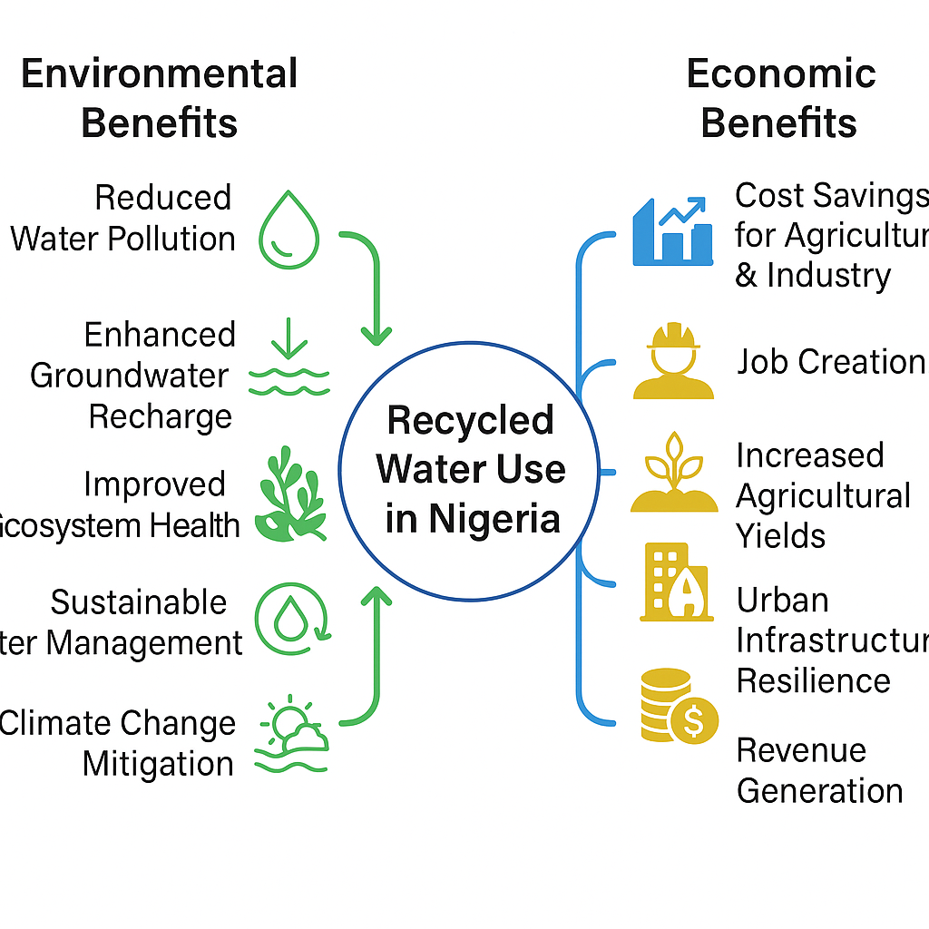
Figure 4: Conceptual Model of the Environmental and Economic Benefits of Recycled Water Use in Nigeria

2.5 Potential Environmental Risks and Challenges
Despite the various benefits of using recycled water for irrigation in agriculture, if the use of recycled water for irrigation is not properly managed, recycled water can adversely affect crop growth, soil productivity, and pose risks to soil health by increasing the salinity and sodicity of the soil, increased heavy metal accumulation, and decreased hydraulic conductivity of soil (Rahman et al., 2022). Recycled water may contain salts, heavy metals, and other contaminants that can accumulate in the soil over time, potentially leading to soil salinity, toxicity, and degradation of soil structure (Sidan et al., 2022). The quality of recycled water is a critical factor in its safe use for irrigation. Contaminants such as pathogens, pharmaceuticals, and industrial chemicals can pose risks to human health and the environment if not adequately removed during treatment (Qingyang et al., 2022). Additionally, the use of recycled water can also impact local ecosystems and biodiversity. Changes in water quality and quantity can affect aquatic habitats, flora, and fauna, potentially disrupting ecological balance (Xu et al., 2014).
One of the critical considerations in using recycled water for irrigation is the potential accumulation of heavy metals, which can impact soil and crop health. While treatment processes remove most contaminants, trace metals like lead, cadmium, and arsenic may remain in low concentrations, especially if industrial effluent is part of the wastewater source. Over time, these metals can build up in the soil, potentially reaching toxic levels that can impair plant health and pose risks to consumers through the food chain. Regular testing and careful management of water sources, including separate treatment standards for industrial wastewater, are essential to minimize these risks. Developing adaptive strategies for monitoring soil and crop health could further mitigate long-term environmental impacts.

3. Conclusion
This review has examined the potential for adopting recycled water for irrigation in Nigeria, considering the environmental benefits, challenges, and necessary measures for successful implementation. The findings indicate that recycled water offers a viable strategy to enhance water security, support sustainable farming, and promote rural economic resilience in Nigeria, particularly in the face of increasing water scarcity and climate change impacts.
Globally, successful examples from countries like Israel, Australia, and Spain demonstrate the feasibility and benefits of integrating recycled water into agricultural practices. However, the direct transfer of these practices to Nigeria requires careful consideration of the country's unique socio-economic, environmental, and regulatory landscape.
The review highlights several potential environmental benefits, including reduced pressure on freshwater resources, mitigation of drought and desertification, nutrient recycling, mitigation of water pollution, and promotion of soil health. Economically, the use of recycled water can lower operational costs for farmers, increase crop yields, and stimulate economic growth in related sectors.
Despite these benefits, significant challenges remain. Infrastructural deficiencies, regulatory gaps, socio-economic factors, and technical needs hinder the widespread adoption of recycled water in Nigeria. To overcome these challenges, the following recommendations are made:
Establish a Comprehensive Regulatory Framework: Develop clear national guidelines and standards for the use of recycled water in agriculture, including water quality standards, monitoring protocols, and enforcement mechanisms.
Invest in Treatment Infrastructure: Prioritize investments in wastewater treatment infrastructure designed to produce water of suitable quality for agricultural use, incorporating advanced treatment technologies and nature-based solutions.
Promote Public Awareness and Engagement: Implement public awareness campaigns to educate communities about the benefits and safety of recycled water, addressing cultural and religious concerns.
Support Research and Development: Encourage research to assess the long-term impacts of recycled water use on soil health, crop productivity, and the accumulation of contaminants in the food chain under Nigerian conditions.
Foster Collaboration and Partnerships: Promote collaboration among government agencies, research institutions, the private sector, and local communities to ensure a coordinated and integrated approach to water recycling.
By addressing these recommendations, Nigeria can unlock the potential of recycled water for irrigation, contributing to sustainable water management, agricultural resilience, and economic development. Future research should focus on developing region-specific guidelines that address local soil conditions, crop requirements, and community concerns, ensuring the safe and sustainable use of recycled water in agriculture across Nigeria.

COMPETING INTERESTS DISCLAIMER:
Authors have declared that they have no known competing financial interests OR non-financial interests OR personal relationships that could have appeared to influence the work reported in this paper.

References
Abegunrin, T. P., Awe, G. O., Idowu, D., & Adejumobi, M. (2016). Impact of wastewater irrigation on soil physico-chemical properties, growth and water use pattern of two indigenous vegetables in southwest Nigeria. Catena, 139, 167-178.
Adewumi, J. (2016). Planning of wastewater reuse programme in Nigeria. Consilience: Journal of Sustainable Development.
Aina, I., Falola, A., Amoussou, J., Oni, M., & Aribisala, T. (2019). The effect of population growth on the agricultural production in Nigeria (1961-2013). Croatian Journal of Food Science and Technology, 11(2), 230-236. https://doi.org/10.17508/CJFST.2019.11.2.12
Akinyemi, J. O., & Souley, S. (2014). Monitoring the Quality of Some Sources of Irrigation Water in Different Parts of Ogun State, Nigeria. IERI Procedia, 9, 123-128.
Akinyemi, J., Kumapayi, O., & Adeokun, O. (2004). Potential use of industrial wastewater in irrigation - case study of Ibadan Metropolis, Nigeria. Journal of Environmental Extension, 4, 37-42.
Angelakis, A. N., & Snyder, S. A. (2015). Wastewater treatment and reuse: Past, present, and future. Water, 7(9), 4887-4895. https://doi.org/10.3390/w7094887
Anjaneyulu, Y., Sreedhara Chary, N., & Samuel Suman Raj, D. (2005). Decolourization of industrial effluents – available methods and emerging technologies – a review. Reviews in Environmental Science and Biotechnology, 4(4), 245-273. https://doi.org/10.1007/s11157-005-1246-z
Baker, B., & Aldridge, C., & Omer, A. (2016). Water: Availability and use. Mississippi State University Extension. 2016. p3011.
Binns, J. A., Maconachie, R., & Tanko, A. (2003). Water, land and health in urban and peri-urban food production: The case of Kano, Nigeria. Land Degradation & Development, 14(5), 431-444. https://doi.org/10.1002/ldr.571
Caretta, M. A., Mukherji, A., Arfanuzzaman, M., Betts, R. A., Gelfan, A., Hirabayashi, Y., Lissner, T. K., Liu, J., Lopez Gunn, E., Morgan, R., Mwanga, S., & Supratid, S. (2022). Chapter 4: Water. In H.-O. Pörtner, D. C. Roberts, M. Tignor, E. S. Poloczanska, K. Mintenbeck, A. Alegría, M. Craig, S. Langsdorf, S. Löschke, V. Möller, A. Okem, & B. Rama (Eds.), Climate Change 2022: Impacts, Adaptation and Vulnerability. Contribution of Working Group II to the Sixth Assessment Report of the Intergovernmental Panel on Climate Change (pp. 551–712). Cambridge University Press. https://doi.org/10.1017/9781009325844.006
Chen, L., Chen, Z., Liu, Y., Lichtfouse, E., Jiang, Y., Hua, J., Osman, A., Farghali, M., Huang, L., Zhang, Y., & Rooney, D., & Yap, P. S. (2024). Benefits and limitations of recycled water systems in the building sector: A review. Environmental Chemistry Letters, 22(1), 75-87. https://doi.org/10.1007/s10311-023-01683-2
Chauhan, J., & Kumar, S. (2020). Wastewater ferti‑irrigation: An eco‑technology for sustainable agriculture. *Sustainable Water Resources Management, 6*(10). https://doi.org/10.1007/s40899-020-00389-5
Dhanasekaran, N. C. (2019). Water scarcity - Challenging the future. International Journal of Agriculture Environment and Biotechnology, 12(2), 221-228. https://doi.org/10.30954/0974-1712.08.2019.2
Dikeogu-Okoroigwe, C., & Okonkwo, O. (2024). Agricultural sector productivity and employment generation in Nigeria. International Journal of Agriculture Environment and Biotechnology, 14(2), 126-141.
Drechsel, P., Scott, A., Sally, R., Redwood, M., & Bachir, A. (2010). Wastewater irrigation and health: Assessing and mitigating risk in low-income countries. International Water Management Institute. Earthscan.
Dunsin, T. S., & Oladoja, N. (2021). Nutrient recovery from wastewater and reuse in agriculture: A review. Environmental Chemistry Letters, 19(2), 675-689. https://doi.org/10.1007/s10311-020-01159-7
FAO. (2016). AQUASTAT country profile – Nigeria. Food and Agriculture Organization of the United Nations (FAO). Rome, Italy.
Food and Agriculture Organization of the United Nations. (2020, November 24). Nigeria at a glance. FAO. http://www.fao.org/nigeria-at-a-glance
Food and Agriculture Organization of the United Nations. (n.d.). Water scarcity: One of the greatest challenges of our time. FAO. https://www.fao.org/newsroom/story/Water-Scarcity-One-of-the-greatest-challenges-of-our-time/en
Friedler, E. (2001). Water reuse: An integral part of water resources management: Israel as a case study. Water Policy, 3(1), 29-39.
Hamilton, A. J., Stagnitti, F., Premier, R., Boland, A. M., & Hale, G. (2007). Quantitative microbial risk assessment models for consumption of raw vegetables irrigated with reclaimed water. Applied and Environmental Microbiology, 73(10), 3285-3290. https://doi.org/10.1128/AEM.00036-07
Helmecke, M., Fries, E., & Schulte, C. (2020). Regulating water reuse for agricultural irrigation: Risks related to organic micro-contaminants. Environmental Sciences Europe, 32(1), 4. https://doi.org/10.1186/s12302-019-0283-0
Isukuru, E. J., Opha, J. O., Isaiah, O. W., Orovwighose, B., & Emmanuel, S. S. (2024). Nigeria's water crisis: Abundant water, polluted reality. *Cleaner Water, 2*, 100026. https://doi.org/10.1016/j.clwat.2024.100026
Iyanda, F. (2019). On mathematical projection of Nigeria population using numerical techniques. Journal of Science and Technology, 5(2), 176-182.
Jiménez, B., & Asano, T. (2008). Water reclamation and reuse around the world.
Kasbohm, J., Grothe, S., Steingrube, W., Lai, L., Hong, N., & Huong, N. (2009). Integrated water resources management (IWRM) - An introduction. Journal of Geology, Series B, 3-14.
Khokhar, T. (2017, March 22). Chart: Globally, 70% of freshwater is used for agriculture. World Development Indicators. The World Bank Group. https://blogs.worldbank.org/opendata/chart-globally-70-freshwater-used-agriculture
Lyu, S., Wu, L., Wen, X., Wang, J., & Chen, W. (2022). Effects of reclaimed wastewater irrigation on soil-crop systems in China: A review. Science of The Total Environment, 813, 152531. https://doi.org/10.1016/j.scitotenv.2021.152531
Mishra, S., Kumar, R., & Kumar, M. (2023). Use of treated sewage or wastewater as an irrigation water for agricultural purposes - Environmental, health, and economic impacts. Total Environment Research Themes, 6, 100051. https://doi.org/10.1016/j.totert.2023.100051
Mojekeh, M., & Eze, P. (2011). The Environmental Impact of Production and Sales of Sachet Water in Nigeria. African Research Review, 5.
Pepper, I. L., Gerba, C. P., & Gentry, T. J. (2015). Environmental microbiology (3rd ed.). Elsevier. https://doi.org/10.1016/B978-0-12-394626-3.00027-2
Poustie, A., Yang, Y., Verburg, P., Pagilla, K., & Hanigan, D. (2020). Reclaimed wastewater as a viable water source for agricultural irrigation: A review of food crop growth inhibition and promotion in the context of environmental change. Science of The Total Environment, 739, 139756. https://doi.org/10.1016/j.scitotenv.2020.139756
Rahman, M., Aghajani Shahrivar, A., Hagare, D., & Maheshwari, B. (2022). Impact of recycled water irrigation on soil salinity and its remediation. Soil Systems, 6(1), 13. https://doi.org/10.3390/soilsystems6010013
Ranieri, E., Leverenz, H., & Tchobanoglous, G. (2011). An examination of the factors involved in agricultural reuse: Technologies, regulatory and social aspects. *Journal of Water Resource and Protection, 3*(5), 115–125. https://doi.org/10.4236/jwarp.2011.35038
Rao, A. P., Patel, J., & Pradhan, A. K. (2022). Application of alternative sources of water in agricultural food production: Current trends and future prospects. Current Opinion in Food Science, 47, 100877. https://doi.org/10.1016/j.cofs.2022.100877
Rastogi, M., Kolur, S. M., Burud, A., Sadineni, T., Sekhar, M., Kumar, R., & Rajput, A. (2024). Advancing water conservation techniques in agriculture for sustainable resource management: A review. Journal of Geography, Environment and Earth Science International, 28(3), 41-53. https://doi.org/10.9734/jgeesi/2024/v28i3755
Sani, A., Adamu, U., Hayatu, B., Adam, I., Aliyu, R., Garba, M., Aliyu, J., Almu, H., & Abdulkadir, N. (2022). Treated wastewater irrigation effects on aggregate stability of Sandy loam soils in Semi-arid Tropical Zone of Nigeria. Global Journal of Agricultural Research. • Chigor, V., Ibangha, I. I., Chigor, C., & Titilawo, Y. (2020). Treated wastewater used in fresh produce irrigation in Nsukka, Southeast Nigeria is a reservoir of enterotoxigenic and multidrug-resistant Escherichia coli. Heliyon, 6.
Shi, Q., Xiong, Y., Kaur, P., Sy, N. D., & Gan, J. (2022). Contaminants of emerging concerns in recycled water: Fate and risks in agroecosystems. Science of The Total Environment, 814, 152527. https://doi.org/10.1016/j.scitotenv.2021.152527
Toze, S. (2006). Reuse of effluent water-benefits and risks. Agricultural Water Management, 80(1-3), 147-159. https://doi.org/10.1016/j.agwat.2005.07.010
Urama, K. (2005). Land-use intensification and environmental degradation: empirical evidence from irrigated and rain-fed farms in south eastern Nigeria. Journal of Environmental Management, 75(3), 199-217.
Wang, Z., Li, J., & Li, Y. (2017). Using reclaimed water for agricultural and landscape irrigation in China: A review. Irrigation and Drainage, 66(2), 259-274. https://doi.org/10.1002/ird.2129
Xu, M., Wang, Z., Duan, X., & Pan, B. (2014). Effects of pollution on aquatic ecology and water quality bio-assessment. Hydrobiologia, 729, 33-45. https://doi.org/10.1007/s10750-013-1504-y

