**Kinetic and Thermodynamic Study of Oxidation of Alcohols using Chromium based reagents and Silver nano catalyst: A spectrophotometric approach**

**Abstract**— The ability to generate valuable products through oxidation makes it one of the most pivotal industrial processes. Although numerous studies have explored the quantitative aspects of alcohol to aldehyde/ ketone transformations, there is a scarcity of research on the kinetic and thermodynamic analysis of alcohol oxidation. This paper reports the kinetics of oxidation of some aliphatic and cyclic alcohols by Pyridinium chlorochromate (PCC) and Pyridinium dichromate (PDC)in acidic medium. These reagents are readily available and stable and effectively oxidize a wide range of alcohols into carbonyl compounds. These versatile compounds are employed as oxidants for alcohols, amino acids and aniline. In the context of this research, the kinetics of aliphatic and cyclic alcohols oxidation was investigated under acidic conditions. The reaction was found to exhibit a first-order dependency with respect to the concentration of oxidants. The progress of the oxidation reaction was tracked using a UV-Vis Spectrophotometer. Consequently, the reactions were monitored by observing the reduction in absorbance of the reaction mixture at time intervals. The absorbance of the reaction mixture was spectrophotometrically measured at 354 nm for PCC and 470 nm for PDC. The effect of temperature using Arrhenius equation and ionic strength which followed Bronsted-Bjerrum equation was studied. Notably, an increase in alcohol concentration was found to enhance the rate of oxidation.

**Keywords:** Chemical kinetics, oxidation of alcohols, Pyridinium chlorochromate (PCC), Pyridinium dichromate (PDC), Spectrophotometer

**Abbreviations and notation:** PCC, PDC, Silver nanoparticle AgNP , Cr chromium

# Introduction

The oxidation of alcohols holds significant industrial importance, as it leads to the production of valuable compounds. In India, the thriving indigenous perfumery sector enjoys a global market presence, highlighting the pivotal role of the study of perfumes, fragrances, and cosmetic formulations. While organic oxidants have traditionally dominated alcohol oxidation reactions, the utilization of inorganic oxidants remains relatively scarce [1, 2]. This paper presents Cr(VI) as an oxidant for the oxidation of various perfumery alcohols, offering promising avenues for enhancing the efficiency and sustainability of these processes within the industry.

In this study, we utilized PCC and pyridinium dichromate (PDC) as oxidants for converting alcohols into carbonyl compounds. It is well-established that the oxidation mechanism is influenced by the specific counter-ion linked to the chromium anion. Our interest lies in exploring the kinetic and mechanistic intricacies of oxidation facilitated by complexed Cr(VI) species, as numerous reports on dichromates have already been documented [3, 4]. Herein, a detailed analysis of the kinetics and mechanisms governing the oxidation of both aliphatic and cyclic alcohols using these reagents under acidic conditions is presented [5-10]. The main aims of the present investigation are to determine kinetic parameters and to evaluate the rate laws, study the correlation analysis of effect of temperature on reactivity, study effect of ionic strength, study effect of silver nanoparticle [11] and providing a suitable mechanism for the oxidation process [12-14]. There are various reviews, focusing on the mechanisms, catalyst design, applications, and future directions for selective oxidation of alcohols using various catalytic strategies [15-21]. The purpose of this study is to highlight the potential of plant-derived silver nanoparticles as highly efficient catalysts for alcohol oxidation, suggesting the development of more effective and sustainable industrial oxidation methods. Table-1 and Table-2 includes the information of selected alcohols and oxidizing agents for the study.

.

# Experimental

Kinetic measurements

All chemicals used were of ‘Anal R’ grade. The oxidant solution in the acid-water medium adheres to Beer-Lambert's law, meaning the absorbance correlates linearly with the oxidant concentration [6]. To investigate the reaction under first-order conditions, an excess of substrate was maintained over the oxidant [Substrate] >> [Oxidant] [4]. The reaction mixture was prepared by combining the appropriate amounts of substrate, H2SO4, and water, then allowed to equilibrate in a thermostatic bath for a sufficient duration. Upon addition of the oxidant solution, the reaction commenced [4]. The absorbance of the reaction mixture was monitored spectrophotometrically at 354 nm for PCC and 470 nm for PDC using a spectrophotometer.

Product Analysis

A large volume containing an excess of alcohol relative to the oxidant was allowed to react with 2, 4-dinitrophenylhydrazine [14]. The formation of a yellow-orange precipitate ensued, which was then filtered, washed, dried, and weighed. The confirmation of the carbonyl compound (whether aldehyde or ketone) was performed by determining its melting point.

# Results and discussion

*Using oxidizing agents*

The reactions exhibit first-order kinetics with respect to PCC, indicating a linear relationship between the logarithm of absorbance and time. Table 3 given below shows the increasing rate constant with increased alcohol concentration. Duplicate runs demonstrated the reproducibility of the rate constants.

The oxidation rate intensified with higher concentrations of alcohols. Comparing the rate constant data for aliphatic and cyclic alcohols revealed that 2-chloroethanol exhibits a higher reaction rate than n-butanol, whereas Cinnamyl alcohol oxidizes slower than Cyclohexanol for both the oxidants (Fig.1 and Fig.2). The faster oxidation of alcohols can be attributed to several factors like length of the Carbon chain, electrophilicity of atoms, steric hinderance, etc [12]. The activation energy of such alcohols is likely to be lower than that of other alcohols, enabling a faster reaction rate [14].

*Effect of ionic strength*

The use of Na2SO4 was aimed to examine the impact of altering ionic strength within the range of µ = 5 to 25 x 10-2 mol dm-3 at 313K on the oxidation rate [11]. The resulting graphs (Fig.3 and Fig.4), depicting log k against √µ, displayed linear trends running parallel to the √µ axis. These outcomes imply that fluctuations in ionic strength do not influence the oxidation rate. The Bronsted- Bjerrum equation was employed to ascertain the impact of ionic strength (µ) on the oxidation rate.

log k = logk0 +1.02 ZA ZB√µ

Furthermore, this assertion finds reinforcement in the underlying reaction mechanism.

*Effect of temperature*

The oxidation process was investigated within the temperature range of 303-318K tabulated in Table 5 and Table 6, and an assessment of the thermodynamic activation parameters was conducted. Across all the alcohols examined, the rate constants (k) exhibited an upward trend with increasing temperature, demonstrating an inverse relationship with the energy of activation (fig.5 and fig.6).

*Effect of silver nanoparticle*

The green synthesis of nanoparticles is an eco-friendly and sustainable alternative to conventional chemical methods, as it eliminates the use of harmful reagents and reduces environmental impact [21-23]. The silver nanoparticles were extracted from leaves of *Ziziphus jujuba* plant [21] and used in the reaction which resulted into increased in rate of reaction for alcohols (fig.7)

To prepare AgNPs from *Ziziphus jujuba* leaves, leaves were collected locally in Mumbai, India,and carefully washed. They were dried in a hot air oven at a temperature of 65-70°C, finely crushed and 5 grams of the resultingmaterial was weighed and brought to boiled with distilled water. The solution was filtered and 2 ml of thisleaf extract was added to 100 ml of0.001M AgNO3 solution with continuous stirring on amagnetic plate. After 15-20 minutes, the formation of brown-colored AgNPs was observed. The UV spectrum showed the presence of Ag NP.

Characterization of the synthesized AgNPs was performed using UV-Vis spectra. The UV-Vis absorption graph shows a peak around 450-480 nm. This peak is characteristic of silver nanoparticles (AgNPs), indicating the presence of AgNPs synthesized using *Ziziphus jujuba* leaves (fig.8)

Fig.9.(a). shows a densely packed aggregation of silver nanoparticles. The particles appear to have a rough, clustered surface, indicative of the typical morphology of AgNPs synthesized through biological methods. The high surface area is beneficial for catalytic applications due to more active sites being available for reactions. The higher magnification reveals more details of the surface structure, showing individual nanoparticles and their interconnections (fig.9b). These characteristics suggest that the AgNPs will have a high surface area and numerous active sites, making them effective catalysts in chemical reactions, such as the oxidation of alcohols.

The spectrum indicates that plant-derived organic compounds, such as polyphenols, proteins, or other metabolites, might have capped the silver nanoparticles, facilitating their stabilization (fig. 10). The peak at **537 cm⁻¹** can be related to metal-oxygen bonding, suggesting interactions between the silver nanoparticles and plant-based molecules or a direct interaction with oxygen from the stabilizing compounds in the plant extract. The involvement of hydroxyl, carbonyl, and aromatic functional groups is common in green synthesis methods involving plant extracts.

The rate of the reaction increased when nano catalyst was used (Table 7). From Fig.11 and Fig. 12, it is observed that the alcohols containing smaller carbon chains have higher rates than the ones which have more carbon atoms.

The concluded reaction mechanism is given below:

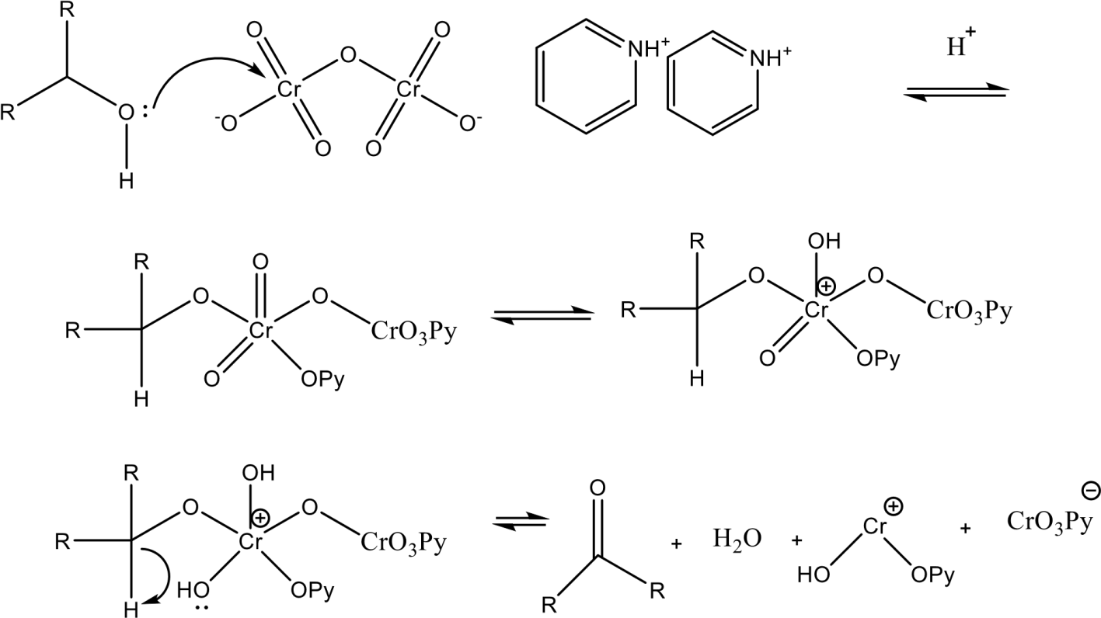

.

.

# Conclusions

Though PCC and PDC themselves are sufficient for the oxidation, the presence of silver can potentially improve the efficiency of oxidation of alcohols. Silver facilitates electron transfer reaction as it activates oxidant species. It stabilizes intermediates by interacting with them on their surface.

Considering the aliphatic alcohols, 2-chloroethanol oxidizes faster than n-butanol due to the electron withdrawing effect of the chlorine atom, which makes the hydroxyl group more susceptible to oxidation. This effect increases the reactivity of 2-chloroethanol towards oxidizing agents, facilitating a quicker oxidation process compared to n-butanol. While in the case of cyclic alcohols, the steric hindrance around the hydroxyl group in cinnamyl alcohol due to the aromatic ring and double bond could slow down its oxidation compared to the less hindered cyclohexanol.

.

# References

1. Patel S, Mishra BK (2007) Chromium (VI) oxidants having quaternary ammonium ions: studies on synthetic applications and oxidation kinetics. Tetrahedron 63:4367–4406. [https://doi.org/10.1016/j.tet.2007.02.073](https://doi.org/10.1016/j.tet.2007.02.073" \t "_new)
2. Corey EJ, Suggs JW (1975) Pyridinium chlorochromate: An efficient reagent for oxidation of primary and secondary alcohols to carbonyl compounds. Tetrahedron Lett 16:2647–2650. [https://doi.org/10.1016/S0040-4039(00)75204-X](https://doi.org/10.1016/S0040-4039(00)75204-X" \t "_new)
3. Mardhanpally AK, et al. (2022) Cornforth's and Corey-Suggs Cr (VI) compounds as efficient reagents for selective oxidation of certain polyols in aqueous KHSO4 medium – A kinetic and mechanistic approach. Chem Data Collect 39:100847. [https://doi.org/10.1016/j.cdc.2022.100847](https://doi.org/10.1016/j.cdc.2022.100847" \t "_new)
4. Jain S, Hiran BL, Bhatt CV (2009) Oxidation of some aliphatic alcohols by pyridinium chlorochromate – Kinetics and mechanism. J Chem 6:237–246. [https://doi.org/10.1155/2009/907071](https://doi.org/10.1155/2009/907071" \t "_new)
5. Harit H, Hiran BL, Joshi SN (2015) Kinetics and mechanism of oxidation of primary alcohols by pyridinium dichromate. Chem Sci 4:49–58.
6. Dai Z, et al. (2018) Kinetic studies of Fenton oxidation reaction by UV-VIS spectroscopy. J Lab Chem Educ 6:141–147. [https://doi.org/10.5923/j.jlce.20180605.01](https://doi.org/10.5923/j.jlce.20180605.01" \t "_new)
7. Jain H, Panday D (2023) Oxidation of secondary alcohols by isoquinolinium dichromate in non-aqueous medium: A kinetics study. Rasayan J Chem 16:237. [https://doi.org/10.31788/RJC.2023.1648433](https://doi.org/10.31788/RJC.2023.1648433" \t "_new)
8. Motwani K, Dangarh BK, Shorgar N (Year Unspecified) Title Unavailable. Int J Sci Res.
9. Golkari M (2023) Oxidation of some organic compounds with selective catalysis – Review. J Chem React Synth 13:66–85.
10. Kabilan S, et al. (2002) Oxidation of benzyl alcohol by pyridinium dichromate in acetonitrile: Using the para/meta ratio of substituent effects for mechanism elucidation. J Chem Soc, Perkin Trans 2 6:1151–1157. [https://doi.org/10.1039/b200742h](https://doi.org/10.1039/b200742h" \t "_new)
11. Tiwari A, Prabhu DV, Parbat HA (2024) Biogenically synthesized silver nanoparticles catalyzed oxidation of aliphatic and cyclic alcohols by KIO4: Kinetic and thermodynamic study. Rasayan J Chem 17:1831–1849. https://doi.org/10.31788/RJC.2024.1738867
12. Gupta H, Havaldar F, Prabhu DV (2023) Kinetic studies of the oxidation of cinnamyl alcohol by potassium salts in acidic medium.
13. Prabhu DV, Dhage SS, Parbat HA, Tiwari A (2024) Kinetic investigations of biodegradation of industrial waste effluents and oxidation of perfumery alcohols. Recent Dev Chem Biochem Res 2:49–74.
14. Prabhu DV, et al. (2023) Oxidation studies of perfumery phenols found in Indian spices. pp. 94–109. [https://doi.org/10.9734/bpi/rpcsr/v6/4154B](https://doi.org/10.9734/bpi/rpcsr/v6/4154B" \t "_new)
15. Hano C, Abbasi BH (2021) Plant-based green synthesis of nanoparticles: Production, characterization, and applications. Biomolecules 12:31. [https://doi.org/10.3390/biom12010031](https://doi.org/10.3390/biom12010031" \t "_new)
16. Patel RR, Singh SK, Singh M (2023) Materials Advances 4:1831–1849. [https://doi.org/10.1039/D2MA00887A](https://doi.org/10.1039/D2MA00887A" \t "_new)
17. Khan MR, et al. (2023) Green synthesis of silver nanoparticles with its bioactivity, toxicity, and environmental applications: A comprehensive literature review. Environ Nanotechnol Monit Manag 100872. [https://doi.org/10.1016/j.enmm.2022.100872](https://doi.org/10.1016/j.enmm.2022.100872" \t "_new)
18. Larrañaga-Tapia M, et al. (2024) Green synthesis trends and potential applications of bimetallic nanoparticles towards the sustainable development goals 2030. Nanoscale Adv 6:51–71. [https://doi.org/10.1039/D3NA00437B](https://doi.org/10.1039/D3NA00437B" \t "_new)
19. Soltys L, et al. (2021) Green synthesis of metal and metal oxide nanoparticles: Principles of green chemistry and raw materials. Magnetochemistry 7:145. [https://doi.org/10.3390/magnetochemistry7110145](https://doi.org/10.3390/magnetochemistry7110145" \t "_new)
20. Dikshit PK, et al. (2021) Green synthesis of metallic nanoparticles: Applications and limitations. Catalysts 11:902. [https://doi.org/10.3390/catal11080902](https://doi.org/10.3390/catal11080902" \t "_new)
21. Gavade NL, Kadam AN, Suwarnkar MB, Ghodake VP, Garadkar KM (2015) Spectrochim Acta A Mol Biomol Spectrosc 136:953–960. [https://doi.org/10.1016/j.saa.2014.09.118](https://doi.org/10.1016/j.saa.2014.09.118" \t "_new)
22. Patel RR, Singh SK, Singh M (2023) Green synthesis of silver nanoparticles: Methods, biological applications, delivery, and toxicity. Mater Adv 4:1831–1849. [https://doi.org/10.1039/D2MA00747A](https://doi.org/10.1039/D2MA00747A" \t "_new)
23. Guimarães ML, et al. (2020) Green synthesis of silver nanoparticles using Ziziphus joazeiro leaf extract for production of antibacterial agents. Appl Nanosci 10:1073–1081. [https://doi.org/10.1007/s13204-020-01395-y](https://doi.org/10.1007/s13204-020-01395-y" \t "_new)

TABLES

Table 1-General information about used alcohols

Name of alcohol

Molecular formula

Molar mass (g/mol)

Structural formula

n

-

butanol

C

4

H

10

O

74.12

2

-

chloroethanol

C

2

H

5

OCl

80.52

Cyclohexanol

C

6

H

12

O

100.61

Cinnamyl alcohol

C

9

H

10

O

134.17

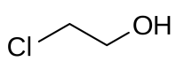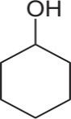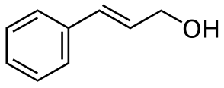

Table 2- General information about Oxidizing agents

|  |  |  |  |
| --- | --- | --- | --- |
| Name | Molecular formula | Molar mass(g/mol) | Structural formula |
| Pyridinium  chlorochromate  Pyridinium dichromate | C5H5NHClCrO3  C10H12N2Cr2O7 | 215.55  376.24 |  |

Table 3: Rate constant of oxidation of alcohol using PCC and PDC reagent

|  |  |  |  |  |  |  |  |  |  |
| --- | --- | --- | --- | --- | --- | --- | --- | --- | --- |
| **[alcohol] mol dm-3** | **[oxidant] mol dm-3** |  |  |  | **k x 103 s-1** | |  |  |  |
|  |  | **PPCC** |  |  |  | **PDC** |  |
| **n-butanol** | **2-chloro ethanol** | **cyclohexanol** | **Cinnamyl alcohol** | **n-butanol** | **2-chloro ethanol** | **cyclohexanol** | **Cinnamyl alcohol** |
| **SET I** |  |  |  |  |  |  |  |  |  |
| 1.00 | 2.50 | 5.56 | 8.50 | 1.61 | 0.31 | 2.90 | 4.91 | 0.75 | 0.52 |
| 1.00 | 5.00 | 4.57 | 7.01 | 0.69 | 0.28 | 2.89 | 4.62 | 0.69 | 0.50 |
| 1.00 | 10.0 | 4.32 | 6.89 | 0.46 | 0.19 | 1.83 | 2.30 | 0.64 | 0.50 |
| 1.00 | 15.0 | 3.11 | 6.32 | 0.46 | 0.11 | 0.90 | 0.46 | 0.51 | 0.16 |
| 1.00 | 20.0 | 3.06 | 5.41 | 0.23 | 0.02 | 0.21 | 0.20 | 0.46 | 0.09 |
| 1.00 | 25.0 | 3.04 | 4.22 | 0.10 | 0.02 | 0.13 | 0.16 | 0.38 | 0.06 |
| **SET II** |  |  |  |  |  |  |  |  |  |
| 0.25 | 5.00 | 4.01 | 5.29 | 1.09 | 0.04 | 0.23 | 2.76 | 0.27 | 0.06 |
| 0.50 | 5.00 | 4.38 | 6.63 | 1.19 | 0.23 | 0.46 | 3.22 | 0.41 | 0.15 |
| 0.63 | 5.00 | 4.46 | 7.91 | 1.28 | 0.29 | 0.69 | 3.45 | 0.53 | 0.20 |
| 0.75 | 5.00 | 5.57 | 8.52 | 1.62 | 0.38 | 0.92 | 3.68 | 0.60 | 0.26 |
| 0.88 | 5.00 | 5.82 | 9.60 | 1.76 | 0.41 | 1.38 | 4.37 | 0.68 | 0.28 |
| 1.00 | 5.00 | 6.17 | 9.82 | 1.98 | 0.52 | 1.94 | 5.12 | 1.01 | 0.33 |

Table 4- Effect of ionic strength using Na2SO4

|  |  |  |  |  |  |  |  |  |
| --- | --- | --- | --- | --- | --- | --- | --- | --- |
| µ×102 moldm-3 |  | **PCC** | |  |  | **PDC** | |  |
| **n-butanol** | **2-chloro ethanol** | **cyclohexanol** | **Cinnamyl alcohol** | **n-butanol** | **2-chloro ethanol** | **cyclohexanol** | **Cinnamyl alcohol** |
| 05 | 1.88 | 1.69 | 0.86 | 1.59 | 5.04 | 1.39 | 2.64 | 1.87 |
| 10 | 1.88 | 1.65 | 0.92 | 1.59 | 4.20 | 1.00 | 2.94 | 1.93 |
| 15 | 1.88 | 1.65 | 0.92 | 1.49 | 5.03 | 1.20 | 3.45 | 1.88 |
| 20 | 1.68 | 1.71 | 0.92 | 1.49 | 4.21 | 1.46 | 3.29 | 1.64 |
| 25 | 1.84 | 1.65 | 1.84 | 1.49 | 4.22 | 1.37 | 3.59 | 1.69 |

Table 5- Effect of temperature of PCC and PDC (303K to 318K)

|  |  |  |  |  |  |  |  |  |
| --- | --- | --- | --- | --- | --- | --- | --- | --- |
| Temperature (K) |  |  |  | **k x 102 s-1** | |  |  |  |
|  |  | **PCC** |  |  |  | **PDC** |  |
| **n-butanol** | **2-chloro ethanol** | **cyclohexanol** | **Cinnamyl alcohol** | **n-butanol** | **2-chloro ethanol** | **cyclohexanol** | **Cinnamyl alcohol** |
| 303 | 2.101 | 4.021 | 0.819 | 0.026 | 0.928 | 1.810 | 0.296 | 0.0890 |
| 308 | 2.138 | 4.376 | 0.904 | 0.032 | 1.382 | 2.336 | 0.345 | 0.0921 |
| 313 | 2.142 | 4.603 | 0.972 | 0.038 | 1.614 | 3.614 | 0.368 | 0.0964 |
| 318 | 2.163 | 4.835 | 1.030 | 0.041 | 1.846 | 3.895 | 0.391 | 0.0982 |

Table 6- Temperature parameters of PCC and PDC

|  |  |  |  |  |  |  |  |  |
| --- | --- | --- | --- | --- | --- | --- | --- | --- |
| **Parameters** |  |  | **PCC** | |  | | **PDC** |  |
| **n-butanol** | **2-chloro ethanol** | **cyclohexanol** | **Cinnamyl alcohol** | **n-butanol** | **2-chloro ethanol** | **cyclohexanol** | **Cinnamyl alcohol** |
| **∆E**  (kJmol-1) | 21.1 | 9.65 | 62.88 | 71.76 | 23.25 | 16.96 | 34.19 | 53.56 |
| **∆G**  (kJmol-1) | -80.03 | -93.96 | -88.19 | -83.18 | -86.07 | -90.12 | -83.31 | -86.79 |
| **∆H**  (kJmol-1) | 18.58 | 7.13 | 60.36 | 69.24 | 20.73 | 14.44 | 31.67 | 51.04 |
| **∆S**  (kJmol-1 K-1) | -0.202 | -0.286 | -0.091 | -0.046 | -0.215 | -0.249 | -0.170 | -0.118 |

Table 7: Rate constant data for the alcohol oxidation by PCC and PDC in 0.2 M H2SO4 and AgNP from *Ziziphus* leaves at temperature 303K

|  |  |  |  |  |  |  |  |  |  |
| --- | --- | --- | --- | --- | --- | --- | --- | --- | --- |
| **[alcohol] mol dm-3** | **[oxidant] mol dm-3** |  |  | | **k x 103 s-1** | |  |  |  |
|  | **PCC** | |  |  |  | **PDC** |  |
| **n-butanol** | **2-chloro ethanol** | **cyclohexanol** | **Cinnamyl alcohol** | **n-butanol** | **2-chloro ethanol** | **cyclohexanol** | **Cinnamyl alcohol** |
| **SET I** |  |  |  |  |  |  |  |  |  |
| 0.25 | 5.0 | 0.06 | 5.29 | 1.61 | 0.04 | 0.87 | 2.76 | 0.70 | 0.06 |
| 0.50 | 5.0 | 1.38 | 6.63 | 1.84 | 0.23 | 2.02 | 3.22 | 0.96 | 0.15 |
| 0.63 | 5.0 | 1.84 | 7.91 | 2.07 | 0.29 | 2.31 | 3.45 | 1.12 | 0.20 |
| 0.75 | 5.0 | 2.07 | 8.52 | 2.53 | 0.38 | 2.44 | 3.68 | 2.32 | 0.26 |
| 0.88 | 5.0 | 2.33 | 9.60 | 2.79 | 0.41 | 2.50 | 4.37 | 2.94 | 0.28 |
| 1.00 | 5.0 | 4.66 | 9.82 | 3.31 | 0.52 | 0.87 | 5.12 | 3.80 | 0.33 |

# Figure Captions

**Fig. 1** Rate constant data for oxidation of alcohols using PCC Oxidizing agent

**Fig.2** Rate constant data for oxidation of alcohols using PDC Oxidizing agent

**Fig.3**. Effect of ionic strength on the oxidation rates of alcohols by PCC in 0.2M H2SO4 [alc.]= 0.2 mol dm-3, [PCC] = 2.5 x 10-2 mol dm-3, Temperature = 313K

**Fig.4**. Effect of ionic strength on the oxidation rates of alcohols by PDC in 0.2M H2SO4.[alc]=0.2 mol dm-3, [PDC] = 2.5 x 10-2 mol dm-3, Temperature = 313K

**Fig.5** Temperature graph of PCC

**Fig.6** Temperature graph of PDC

**Fig.7**. Synthesis of AgNP

**Fig.8** UV graph of AgNP Using *Ziziphus jujuba* leaves

**Fig 9.(a),(b)**: SEM images of AgNP prepared from *Ziziphusjujuba* leaves

**Fig.10** FTIR Spectra of AgNP derived from *Ziziphus jujuba* leaves

**Fig. 11** Rate constant data for alcohol oxidation using PCC and AgNP from *Ziziphus* leaves

**Fig. 12** Rate constant data for alcohol oxidation using PDC and AgNPs from *Ziziphus* leaves

FIGURES

0

2

4

6

8

10

0.2

0.4

0.6

0.8

1

1.2

**Rate constant (k x 10**

**3**

**s**

**-**

**1**

**)**

**[**

**Alcohol] mol dm**

**-**

**3**

2-

chloroethanol

n-butanol

cyclohexanol

cinnamyl alcohol

Fig. 1 Rate constant data for oxidation of alcohols using PCC Oxidizing agent

0

1

2

3

4

5

6

0.2

0.4

0.6

0.8

1

1.2

**Rate constant (k x 10**

**3**

**s**

**-**

**1**

**)**

**[**

**Alcohol] mol dm**

**-**

**3**

2-

chloroethanol

n-butanol

cyclohexanol

cinnamyl alcohol

Fig.2 Rate constant data for oxidation of alcohols using PDC Oxidizing agent

0.6

1

1.4

1.8

2.2

5

15

25

35

**logk**

**√µ**

2-

chloroethanol

n-butanol

cyclohexanol

cinnamyl alcohol

Fig.3. Effect of ionic strength on the oxidation rates of alcohols by PCC in 0.2M H2SO4 [alc.]= 0.2 mol dm-3, [PCC] = 2.5 x 10-2 mol dm-3, Temperature = 313K

1

1.5

2

2.5

3

3.5

4

4.5

5

10

15

20

25

30

**logk**

**√µ**

n-butanol

2-

chloroethanol

cyclohexanol

cinnamyl alcohol

Fig.4. Effect of ionic strength on the oxidation rates of alcohols by PDC in 0.2M H2SO4.[alc]=0.2 mol dm-3, [PDC] = 2.5 x 10-2 mol dm-3, Temperature = 313K

-4

-3.2

-2.4

-1.6

-0.8

0

0.00314

0.00319

0.00324

0.00329

0.00334

**log k**

**1**

**/T**

n-butanol

2-

chloroethanol

cinnamyl alcohol

cyclohexanol

Fig.5 Temperature graph of PCC

-3.2

-2.4

-1.6

0.00314

0.00319

0.00324

0.00329

0.00334

**log k**

**1**

**/T**

2-

chloroethanol

cyclohexanol

cinnamyl alcohol

n-butanol

Fig.6 Temperature graph of PDC

Fig.7. Synthesis of AgNP

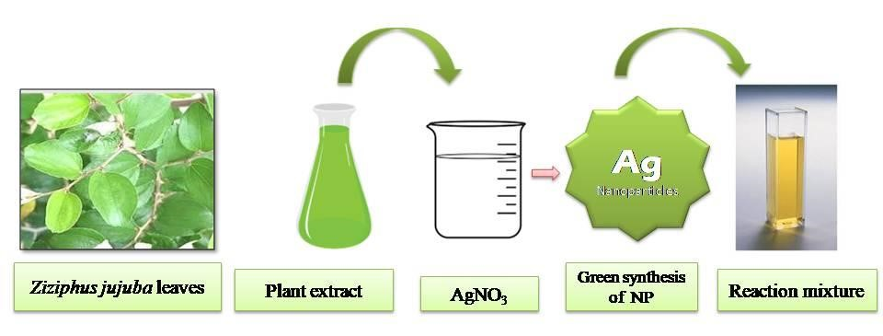

0

0.5

1

1.5

2

2.5

3

3.5

4

4.5

200

300

400

500

600

700

800

**Abs.**

**Wavelength (nm)**

Fig.8 UV graph of AgNP Using Ziziphus jujuba leaves

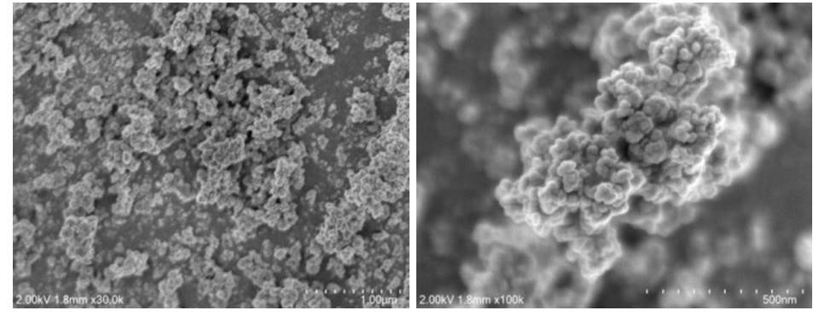

(

a

)

(

b

)

Fig 9.(a),(b): SEM images of AgNP prepared from Ziziphusjujuba leaves

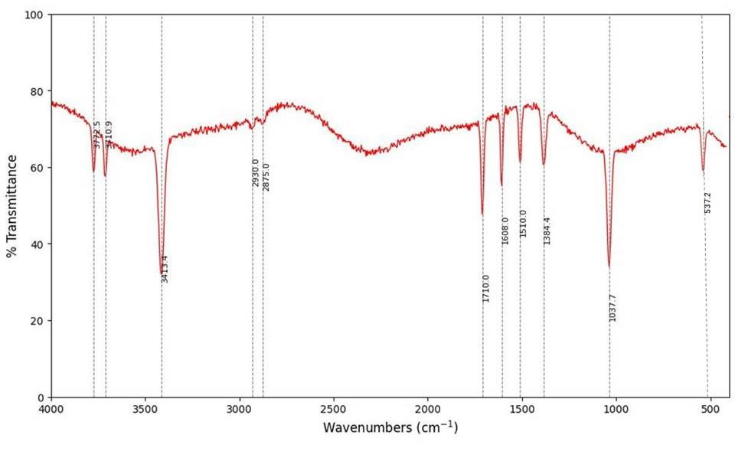

Fig.10 FTIR Spectra of AgNP derived from Ziziphus jujuba leaves

0

2

4

6

8

10

12

0.2

0.4

0.6

0.8

1

1.2

**Rate constant (k x 10**

**3**

**s**

**-**

**1**

**)**

**[**

**Alcohol] mol dm**

**-**

**3**

chloroethanol

2-

n-butanol

cyclohexanol

cinnamyl alcohol

Fig. 11 Rate constant data for alcohol oxidation using PCC and AgNP from Ziziphus leaves

Fig. 12 Rate constant data for alcohol oxidation using PDC and AgNPs from Ziziphus leaves