Assessment of heavy metal contamination in millet seed cultivated in Senegal: Implication for Human health

ABSTRACT
A sample of hulled millet and an unhulled millet sample were collected from a rural area and their metal contents (Na, K, Mg, Ca, Cr, Fe, Ni, Cu, Zn, Cd, and Pb) were analyzed. The samples were wetly digested, and the metals were analyzed by atomic absorption spectroscopy. The Na concentration was measured between 44.7 and 64.5 mg/kg in the hulled millet (I) and unhulled millet (II) samples. Potassium was detected at concentrations between 2690.7 and 4519.5 mg/kg in I and II, respectively. The Mg concentration was measured between 905.0 and 1476.7 mg/kg in samples I and II. Calcium was found at low values ​​of 13.8 and 14.2 mg/kg in both I and II, respectively. Chromium, nickel and lead are completely absent in both millet samples. Iron concentrations in I and II are 10.6 and 16.9 mg/kg in I and II, respectively. Copper and zinc are between 0.9 mg/Kg (I) and 1.1 mg/Kg (II) for Cu and 14.2 mg/Kg (I) and 16.1 mg/Kg (II) for Zn. Cadmium is between 0.100 mg/kg and 0.200 mg/kg in samples I and II. According to this study, hulled millet has lower levels of all elements than unhulled millet, suggesting that the hull also contains metal. Since the Na/K ratio is less than 1, which is the recommended value, these millet samples could prevent high blood pressure. The Ca/Mg ratio, which deviates in both samples from the recommended value of between 1 and 2, is a handicap for consumption based mainly on millet grown in this rural area.

Keywords: Millet, digestion, heavy metal, atomic absorption spectroscopy, WHO, FAO.

Introduction
Millet is a nutritious cereal grown in Senegal and widely consumed by the entire population. This cereal constitutes the staple food in many rural areas. It is used in the preparation of porridge, bread, pancakes, or couscous accompanied by meat, fresh fish, or dried fish ^{1–6}. Small industrial units ensure the transformation into flour and finished products. It is also consumed in urban areas, especially during major religious festivals. Although it is an important source of food in Senegal, its production has stagnated in recent years. Indeed, in traditional production areas, peanut cultivation is becoming increasingly widespread due to the financial resources attached to its production. The best land is reserved for cash crops to the detriment of millet food crops. It should be noted that millet cultivation is carried out only during the rainy season in the Sahel region ^{7,8}. In addition, extreme weather phenomena (late arrival of rains, shorter duration of the rainy season, decrease in rainfall which limits access to water, wind carrying all kinds of dust) have a negative effect on yields which continue to decrease. Between 2016 and 2018 there was a slight increase in millet production, but between 2020 and 2021 the millet harvest experienced a drastic drop of 9.17% reaching 1,039,860 tones according to ANSD statistics ⁹. The use of fertilizers and manure remains marginal for this production, the sown areas of which are regularly decreasing. It has been reported that the use of manure helps improve soil quality by reducing heavy metal levels that can affect crops by inhibiting the photosynthesis process essential for plant growth ¹⁰. Indeed, heavy metals can replace the magnesium atom present in chlorophyll and prevent this molecule from playing its fundamental role in plant growth. Harvests can be contaminated by heavy metals such as lead, cadmium, zinc ^{11–13}. This work aims to study the quality of raw millet and hulled millet with regard to heavy metal contamination and the presence of micronutrients useful for nutrition.

Materials and methods

Instrumentation

All experiments were carried out using a Thermo Fischer Atomic Absorption 3000. The samples were run in triplicates and the values reported are mean of triplicates.

Reagents and standards

All solutions were prepared with distilled-deionized water (18MΩcm, Milli-Q, Millipore, Bedford, MA, USA). Sulfuric acid (H₂SO₄ , 98%), perchloric acid (HClO₄ , 70%) and nitric acid (HNO_{3 ,}65%), from Sigma-Aldrich France, were used in the procedure of digestion of the samples. The analytical solutions were prepared from standard solution dilutions 1000 μgmL⁻¹ of Na, K , Mg, Ca, Cr, Fe, Ni, Cu, Zn, Cd and Pb (Aldrich, France). All materials used were decontaminated in nitric acid solution 10% v/v by 24 h. Decorticated milled seeds (I) and non-decorticated millet seed (II) samples were purchased from the market of Dakar situated in the center of the town.

Extraction of heavy metals from millet seed

Five grams of unhulled and hulled millet were weighed and collected in a Kjeldahl flask. Wet digestion was carried out with an acid mixture (3:2:1 nitric acid, perchloric acid and sulfuric acid) for 4 hours to obtain a clear solution. The samples were cooled to room temperature and the volume was made up to 100 mL with ultra-pure water. They are stored in the refrigerator in food grade polyethylene bottles previously washed with a 6N nitric acid solution.

Table 1 : Analytical conditions and calibration curves for Na, K, Mg, Ca, Cr, Fe, Ni, Cu, Zn, Cd and Pb analysis by Atomic Absorption Spectroscopy.
Mineral | Wavelength (nm) | Range of detection | Correlation coefficient (R²) | Calibration curve equation
Sodium | 598 | 0.02-0.8 | 0.9960 | y = 123.66x +14.486
Potassium | 766.5 | 0.03-1.6 | 0.9969 | y = 0.1621x +0.0096
Magnesium | 285.2 | 0.003-0.6 | 0.9955 | y = 0.5648x +0.0109
Calcium | 422.7 | 0.005-4 | 0.9918 | y = 0.0052x +0.0018
Chromium | 357.9 | 0.03-10 | 0.9966 | y = 0.0133x +0.0029
Iron | 248.3 | 0.05-0.8 | 0.9979 | y = 0.031x +0.0042
Nickel | 232 | 0.09-8 | 0.9906 | y = 0.0451x +0.0173
Copper | 324.8 | 0.01-4 | 0.9975 | y = 0.1418x +0.0078
Zinc | 213.9 | 0.005-1.6 | 0.9958 | y = 0.2175x +0.0040
Cadmium | 228.8 | 0.004-1.8 | 0.9971 | y = 0.1947x +0.0006
Lead | 217 | 0.1-12 | 0.9992 | y = 0.0253x +0.0005

Table 2. Metal level in triplicate (mg/Kg) and Provisional Tolerable Weekly Intake (PTWI) values for metals.
Element (mg/Kg) | Hullet millet | Unhullet millet | PTWI for a 70-kg Individual (mg/week) | LOD (mg/l)
Na | 45.1 ± 0.012 | 64.500± 0.002 | 14000 ¹³ | 0.030
K | 3500.9 ± 0.0001 | 4519.5 ± 0.015 | 24500 ¹⁴ | 0.2
Mg | 1250.4 ± 0.0101 | 1476.7 ± 0.102 | 2940 ¹⁵ | 0.0008
Ca | 11.80 ± 0.002 | 14.2 ± 0.0052 | 8400 ¹⁵ | 0.0007
Cr | 0.000 | 0.000 | 1.631^{16,17} | 0.005
Fe | 14.9 ± 0.006 | 16.9 ± 0.002 | 392 ^{16,17} | 0.001
Ni | 0.000 | 0.000 | 2.450 ^{16,17} | 0.0012
Cu | 0.9 ± 0.002 | 1.1 ± 0.000 | 245 ^{16,17} | 0.001
Zn | 14.2 ± 0.004 | 16.1 ± 0.005 | 490 ^{16,17} | 0.001
Cd | 0.01 ± 0.001 | 0.02 ± 0.000 | 0.490 ^{16,17} | 0.0004
Pb | 0.000 | 0.000 | 1.750 ^{16,17} | 0.005

Results and Discussion

Levels of mineral in millet seeds
Both samples contain important minerals at varying levels (Table 2). Hulled millet contains less sodium than unhulled millet with contents of 45.1 mg/Kg and 64.5 mg/Kg (Table 2). This content of hulled millet is in the range [39.60 mg/Kg-44.8 mg/Kg] reported for two millet varieties grown in northern Cameroon ¹⁸. The plant based food are generally low in Na element as reported by Olaofe et al. ¹⁹. The potassium concentration is the highest with values of 3500.9 mg/Kg and 4519.5 mg/Kg, respectively, for hulled and unhulled millet. Potassium is the most abundant mineral. This fact is corroborated by the results of other researchers who indicated that potassium is the most abundant mineral in agricultural products ²⁰. These potassium contents are comparable to the values obtained (2766.8 mg/Kg – 3287 mg/Kg) for varieties cultivated in the north of Cameroon ¹⁸. Sodium and potassium are important minerals for proper metabolism. They are necessary for maintaining the osmotic balance of body fluids, body pH, proper functioning of the muscular and nervous systems, glucose absorption, and normal protein retention during growth ²¹. The sodium/potassium ratio is an important factor in the prevention of high blood pressure. A Na/K ratio of less than 1 is recommended. In both our samples, the Na/K ratios were well below the recommended value (0.013 for I and 0.014 for II). This suggests that hulled or unhulled millet may have the potential to prevent high blood pressure.
The calcium concentrations of the two samples are very close: 11.8 mg/Kg for hulled millet and 14.2 mg/Kg for unhulled millet. This mineral is the least present. The levels found for both samples are lower than those reported (100.22 mg/Kg – 112.23 mg/Kg) for several varieties grown in China ²². The magnesium concentration is 1250.4 mg/Kg for hulled and 1476.7 mg for unhulled millet . These values are comparable to the value of 1129.71 mg/Kg reported for a variety of millet grown in China ²³. The calcium and magnesium contents indicate that millet can contribute to ensuring the necessary daily intake of these two micronutrients. Calcium and magnesium are micronutrients essential for the development and maintenance of normal bones and teeth. Both contribute to normal muscle function and energy metabolism while playing an important role in cellular metabolism. A Ca/Mg ratio between 2 and 1 is recommended for a good balance. The Ca/Mg ratio are lower than the recommended value of 1 (0.0094 for I and 0.0096 for II). This suggests that a diet exclusively based on our two samples is not recommended or should be supplemented.
Human exposure to chromium can occur in several ways: through food or drink consumption, through breathing or through skin contact. Absorption of less than 200 μg per day is essential for certain metabolisms such as lipids or carbohydrates. Absorption of large quantities can lead to more or less serious disturbances such as dermatitis, kidney damage, attacks on the respiratory, nervous or blood systems ²⁴. In this study, the chromium levels in millet samples were found to be zero for both hulled and unhulled millet and below the permissible level set by WHO (2011) which is 1 mg/kg ²⁵. The absence of Cr in these hulled and unhulled millet crops makes both forms of millet suitable for human and animal consumption.
Iron is an essential nutrient for the growth and development of living organisms. It is present in several molecules of the biological system and its deficiency induces a malfunction of these molecules ²⁶. The excessive presence of iron is associated with the development of certain types of diseases such as cancers, diabetes, heart or liver diseases ²⁷. The two samples of hulled and unhulled millet have iron concentrations of 14.9 mg/Kg and 16.9 mg/Kg, respectively, indicating that 11.85% of the iron is concentrated on the protective film of millet seeds. These values are lower than the limit value of 392 mg/Kg, defined by WHO /FAO ²⁸, the iron concentration is not of concern from the point of view of toxicity of hulled and unhulled millet used for consumption.
Nickel toxicity is assessed based on the state of the element, the solubility of the chemical matrix and the form of exposure ²⁹. Damage may be noted irreversible in internal tissues causing certain types of cancers or on the skin ³⁰. The most noted effect is allergic contact dermatitis ³¹. In this study, the complete absence of Ni in both hulled and unhulled millet was noted. Although the WHO has not established any standards for this metal, some authors have estimated the daily dietary intake of nickel between 70 μg and 400 μg ³².
Exposure to copper, which is an essential element for many biological processes, can lead to health risks when levels are very high. Irreversible complications can be observed during copper poisoning ³³. Biological development requires the presence of many enzymes containing the element copper ³⁴. Both hulled and unhulled millet samples have similar copper concentrations of 0.9 mg/Kg and 1.1 mg/Kg, respectively. Most of the copper is concentrated inside the seed and not on the seed pellicle. These values are lower than the limit value of 20 mg/Kg, defined by WHO /FAO ³⁵, the copper concentration is not of concern from the point of view of toxicity of hulled and unhulled millet used for consumption.
Although essential for human metabolism, zinc is dangerous at high levels. Zinc is essential for many physiological functions. Several metalloenzymes contain zinc which is essential for their functioning such as in enzymatic catalysis ³⁶. Ingestion of massive doses of zinc over a short period induces acute toxicity depending on the mode of contact. Exposure to low doses over longer periods is also harmful to health ³⁷.
In this study, the zinc levels of both hulled and unhulled millet samples had similar concentrations of 14.2 mg/kg and 16.1 mg/kg, respectively. Most of the zinc is concentrated inside the seed and not on the protective film of millet seeds. These levels are well below the limit of 50 mg/kg recommended by the WHO. The zinc concentration of these samples does not pose any particular risk for the consumption of this cereal.
Cadmium metal, which is not essential for metabolism, is slowly eliminated if ingested and is highly toxic. Its presence in crops is a major concern. Cadmium poisoning can cause serious damage to the lungs, kidneys, and skeleton ³⁸. In this study, the cadmium concentrations in hulled and unhulled millet were 0.01 mg/Kg and 0.02 mg/Kg, respectively. The cadmium concentration in unhulled millet was 2 times higher than that in hulled millet. We believe that half of the cadmium is present on the surface of the seed and that hulling removes 50 % of the initial content. However, these values are lower than the value set by the WHO which is 0.490 mg/Kg ³⁹. There is no risk for human or animal consumption of the millet crops studied in this work.
Lead is a toxic element and is known to cause severe anemia, kidney damage, nervous system and liver damage. It can also negatively affect the reproductive system by causing decreased and impaired sperm in men and miscarriages in women ⁴⁰. The results show that the lead levels in hulled and unhulled millet are 0.000 mg/kg. This value is lower than the limit value of 1 mg/kg recommended by the WHO ³⁹.

Intake of heavy metal

Weekly intakes of metals through consumption of I and II were calculated assuming a daily consumption of 75 g of milled (Table 3). Tolerable Maximum Weekly Intake (TMWI) (70 Kg body weight) is calculated using the method described in the literature ⁴¹. The results are presented in Table 3. The maximum intake reached 5565 μg per week of iron for consumers of I and 8875.5 μg per week for users of II. The maximum intake of copper and zinc are, respectively, 472.5 and 7455 μg per week for I and 577.5 and 8452.5 μg per week for II. The weekly doses of cadmium are not significant : 5.25 and 10.5 μg per week for I and II, respectively. Comparing the provisional tolerable weekly intakes (Table 3) of FAO/WHO and other organizations ^{42,43} and the doses found in the study, it can be concluded that the consumption of decorticated and non-decorticated millet will not affect human health.

Table 3. Possible maximum intake of heavy metal through the consumption of decorticated millet (I) and non-decorticated millet (II).
Sample | I | II
Fe (μg/week)ª | 7822.5 | 8875.5
% of PTWI | 1.99 | 2.26
Cu (μg/week)ª | 472.5 | 577.5
% of PTWI | 0.19 | 0.24
Zn (μg/week)ª | 7455 | 8452.5
% of PTWI | 1.52 | 1.75
Cd (μg/week)ª | 5.25 | 10.5
% of PTWI | 1.07 | 2.14
ªCalculated using the level in each sample (Table 2) and assuming an average daily consumption of 75 g of milled for a personal weight of 70 Kg.

Conclusion
In conclusion, the periodic assessment of metal concentrations in millet crops in Senegal and the creation of quality control criteria for cereals, due to contamination with undesirable minerals, are important in terms of food safety for these consumer products. In addition, it is necessary to conduct a comprehensive risk assessment of toxic elements in future studies to assess risks to consumer health. In the study, it was identified that heavy metals are present in relatively low quantities and do not pose health problems, both for hulled and unhulled millet, for consumers. Therefore, it seems necessary to extend the study to all areas where this cereal is grown. Indeed, areas close to major traffic routes, which are often more contaminated with heavy metals, can produce crops at high risk of accumulation of heavy elements that are dangerous to the health of millet consumers. Despite the levels found in this study, monitoring must be carried out on all harvests of the different cereals grown and consumed in Senegal.

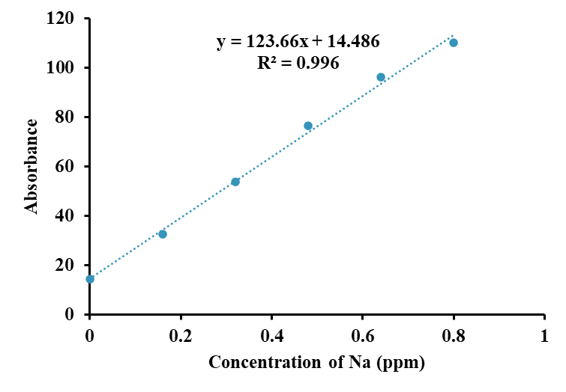 | 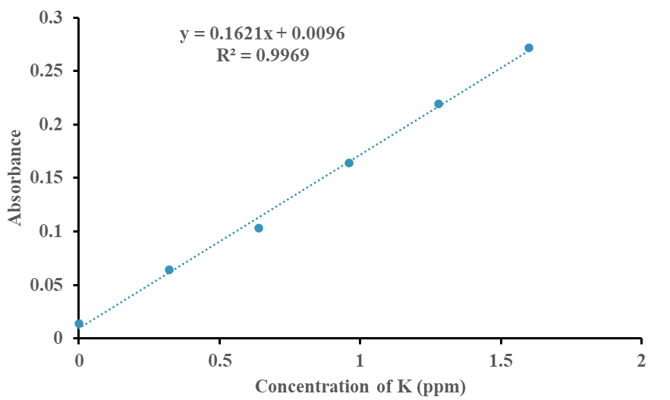
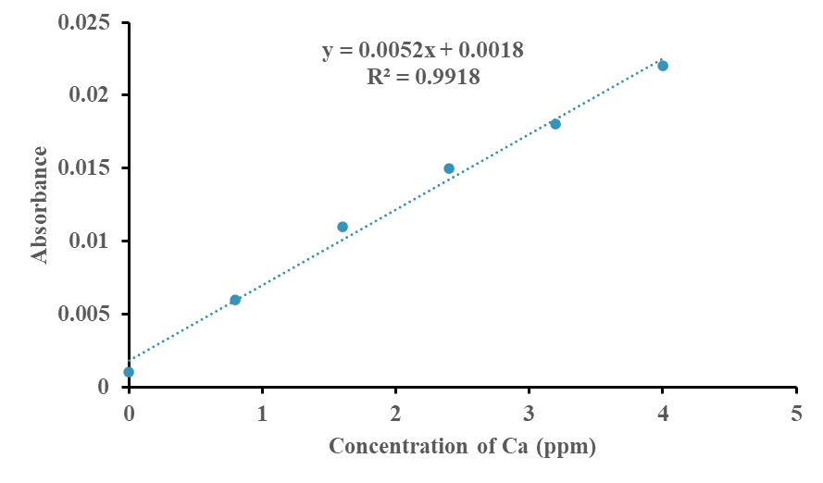 | 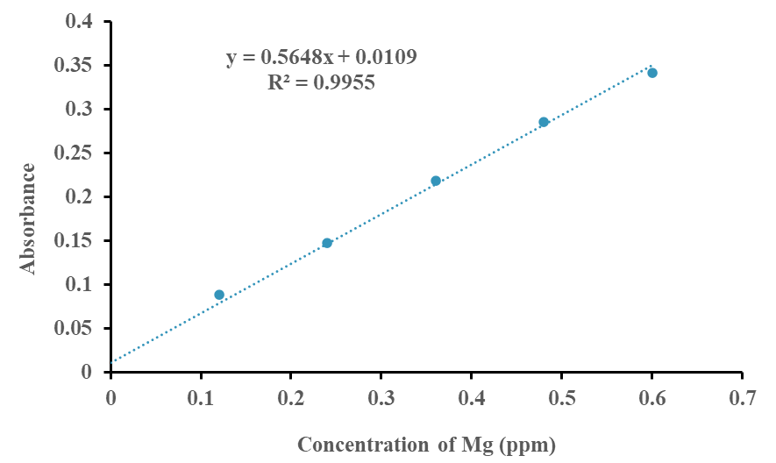
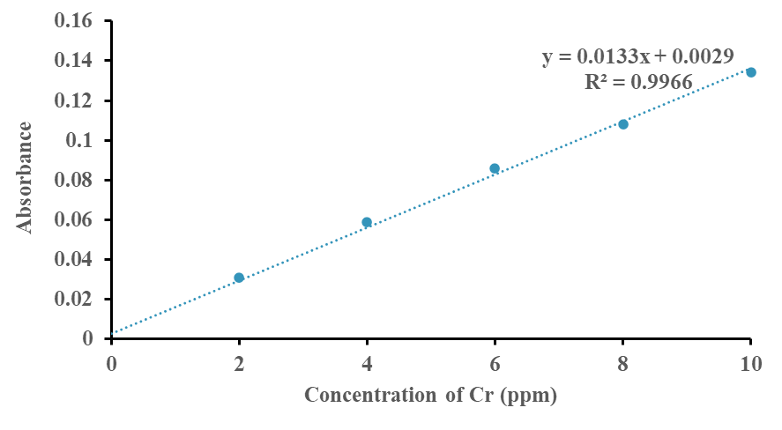 | 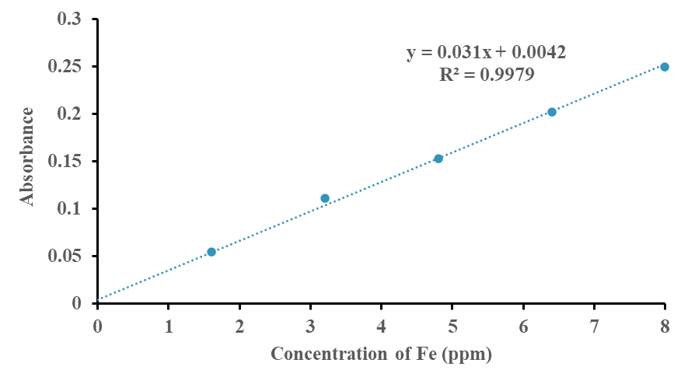
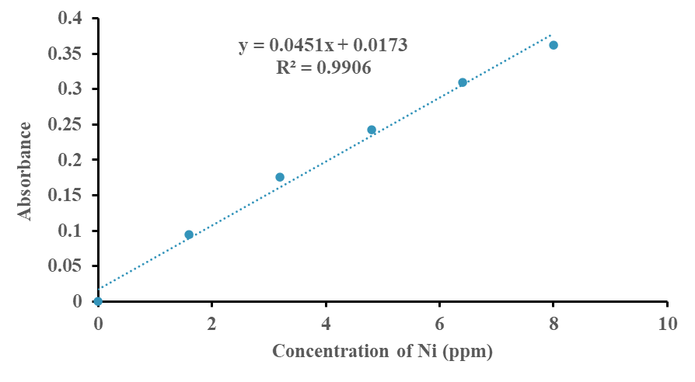 | 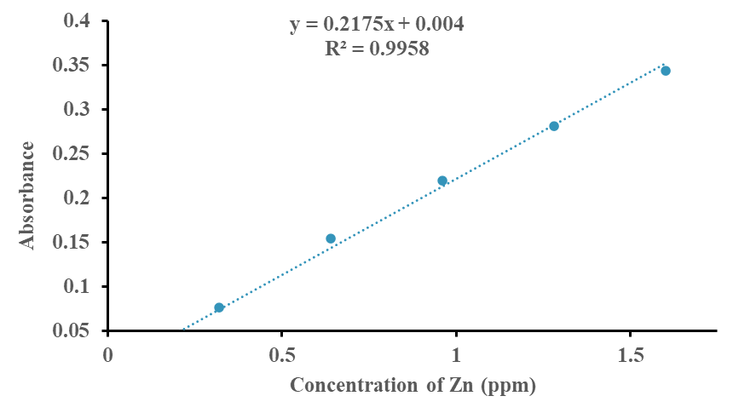
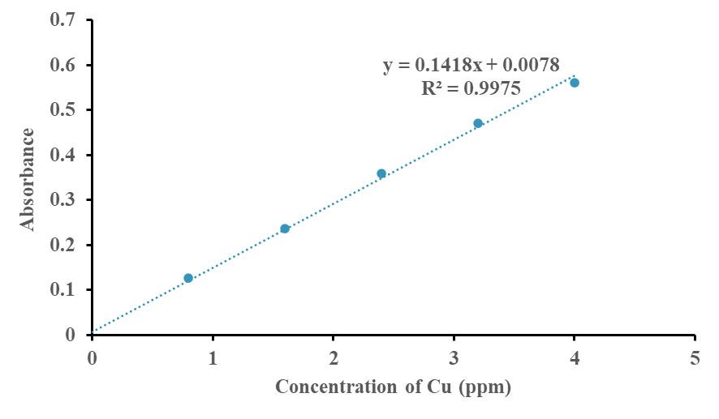 | 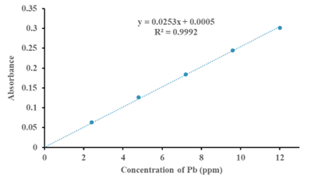
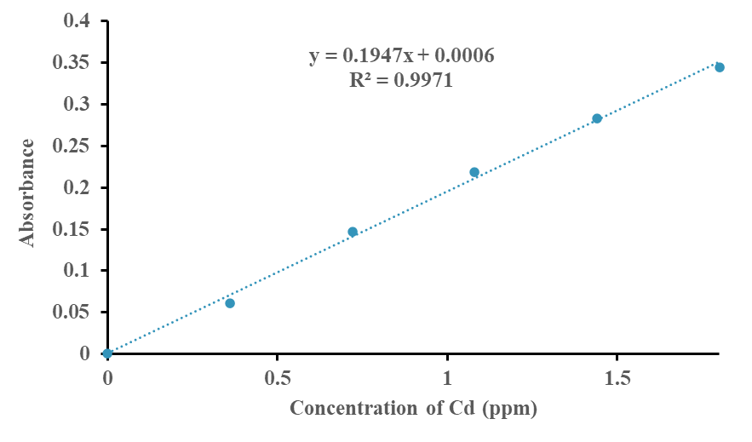
Figure 1: Calibration curves for determination of Na, K, Ca, Mg, Cr, Fe, Ni, Cu, Zn Pb and Cd.

References

1. Yadav DN, Chhikara N, Anand T, Sharma M, Singh AK. Rheological quality of pearl millet porridge as affected by grits size. Journal of Food Science and Technology 2014;51(9):2169–2175.
https://doi.org/10.1007/s13197-013-1252-z
2. Wang Y, Compaoré-Sérémé D, Sawadogo-Lingani H, Coda R, Katina K, Maina NH. Influence of dextran synthesized in situ on the rheological, technological and nutritional properties of whole grain pearl millet bread. Food Chemistry 2019;285:221–230.
https://doi.org/10.1016/j.foodchem.2019.01.126
3. Hayes AMR, Swackhamer C, Mennah-Govela YA, Martinez MM, Diatta A, Bornhorst GM, Hamaker BR. Pearl millet (Pennisetum glaucum) couscous breaks down faster than wheat couscous in the Human Gastric Simulator, though has slower starch hydrolysis. Food Funct 2020;11(1):111–122.
https://doi.org/10.1039/C9FO01461F
4. Moussa M, Ponrajan A, Campanella OH, Okos MR, Martinez MM, Hamaker BR. Novel pearl millet couscous process for West African markets using a low-cost single-screw extruder. International Journal of Food Science and Technology 2022;57(7):4594–4601.
https://doi.org/10.1111/ijfs.15797
5. Tanwar R, Panghal A, Kumari A, Chhikara N. Nutritional, Phytochemical and Functional Potential of Pearl Millet: A Review. Chemistry & Biodiversity 2025; e202402437.
https://doi.org/10.1002/cbdv.202402437
6. Onyeoziri IO, Torres-Aguilar P, Hamaker BR, Taylor JRN, de Kock HL. Descriptive sensory analysis of instant porridge from stored wholegrain and decorticated pearl millet flour cooked, stabilized and improved by using a low-cost extruder. Journal of Food Science 2021;86(9):3824–3838.
https://doi.org/10.1111/1750-3841.15862
7. Ntare BR. Intercropping Morphologically Different Cowpeas With Pearl Millet in a Short Season Environment in the Sahel. Experimental Agriculture 1990;26(1):41–47.
https://doi.org/10.1017/S0014479700015386
8. Marteau R, Sultan B, Moron V, Alhassane A, Baron C, Traoré SB. The onset of the rainy season and farmers’ sowing strategy for pearl millet cultivation in Southwest Niger. Agricultural and Forest Meteorology 2011;151(10):1356–1369.
https://doi.org/10.1016/j.agrformet.2011.05.018
9. ANSD 2020. Rapport Sur Les Résultats Définitifs de l’Enquête Agricole Annuelle (EAA) Dakar 105 p. ANSD. (2022). « Bulletin Mensuel Des Statistiques Economiques et Financières de Juillet 2022 ». Résultats Définitifs de La Campagne Agricole 2021/2022. ISSN 0850–1467. Http://Www.Ansd.Sn, Chrome-Extension://Efaidnbmnnnibpcajpcglclefindmkaj/Https://Www.Ansd.Sn/Sites/Default/Files/2022-11/BULLETIN_JUILLET_2022_0.Pdf. (accessed April 25, 2025)
10. Yassen AA, Nadia BM, Zaghloul SM. Role of some organic residues as tools for reducing heavy metals hazards in plant. World Journal of Agricultural Sciences 2007;3(2):204–209.
11. Gzik A, Kuehling M, Schneider I, Tschochner B. Heavy metal contamination of soils in a mining area in South Africa and its impact on some biotic systems. J Soils & Sediments 2003;3(1):29–34.
https://doi.org/10.1007/BF02989466
12. Shen W, Feng Z, Song H, Jin D, Fu Y, Cheng F. Effects of solid waste-based soil conditioner and arbuscular mycorrhizal fungi on crop productivity and heavy metal distribution in foxtail millet (Setaria italica). Journal of Environmental Management 2022;313:114974.
https://doi.org/10.1016/j.jenvman.2022.114974
13. WHO. Guideline: Potassium Intake for Adults and Children. Geneva: World Health Organization (WHO); 2012.
14. WHO. Guideline: Sodium Intake for Adults and Children.Geneva: World Health Organization (WHO); 2012.

15. Institute of Medicine (US) Standing Committee on the Scientific Evaluation of Dietary Reference Intakes. Dietary Reference Intakes for Calcium, Phosphorus, Magnesium, Vitamin D, and Fluoride. Washington (DC): National Academies Press (US); 1997. PMID: 23115811.
16. Larsen K-V, Cobbina SJ, Ofori SA, Addo D. Quantification and health risk assessment of heavy metals in milled maize and millet in the Tolon District, Northern Ghana. Food Science & Nutrition 2020;8(8):4205–4213.
https://doi.org/10.1002/fsn3.1714
17. Geneva: FAO and W. FAO/WHO. 2004. Safety evaluation of certain food additives and contaminants / prepared by the sixty-first meeting of the Joint FAO/WHO Expert Committee on Food Additives (JEFCA). Geneva: FAO and WHO. https://apps.who.int/ iris/handle/10665/43038. FAO/WHO 2004 (accessed April 25, 2025).
18. Mawouma S, Condurache NN, Turturică M, Constantin OE, Croitoru C, Rapeanu G. Chemical Composition and Antioxidant Profile of Sorghum (Sorghumbicolor (L.) Moench) and Pearl Millet (Pennisetumglaucum (L.) R.Br.) Grains Cultivated in the Far-North Region of Cameroon. Foods 2022;11(14):2026.
https://doi.org/10.3390/foods11142026
19. Olaofe O, Sanni CO. Mineral contents of agricultural products. Food Chemistry 1988;30(1):73–77.
https://doi.org/10.1016/0308-8146(88)90026-X.
20. Audu SS, Aremu MO. Effect of Processing on Chemical Composition of Red Kidney Bean (Phaseolus vulgaris L.) Flour. Pakistan Journal of Nutrition 2012;10(11):1069–1075.
https://doi.org/10.3923/pjn.2011.1069.1075.
21. Academies P. National Research Council (US) Subcommittee on the Tenth Edition of the Recommended Dietary Allowances. Recommended Dietary Allowances: 10th Edition. Washington (DC): National Academies Press (US); 1989. PMID: 25144070.
22. Liang K, Liang S, Lu L, Zhu D, Cheng L. Geographical origin traceability of foxtail millet based on the combination of multi-element and chemical composition analysis. International Journal of Food Properties 2018;21(1):1769–1777.
https://doi.org/10.1080/10942912.2018.1506479.
23. Zhang H, Rui Y-K. Determining mineral elements in four kinds of grains from Beijing market by ICP-MS simultaneously. Journal of Saudi Chemical Society 2012;16(1):31–33
https://doi.org/10.1016/j.jscs.2010.10.014.
24. Ziarati, P. Comparing Heavy Metal Contents of Panax Ginseng Samples from Selected Markets in Tehran and Beijing. Journal of Environmental and Analytical Toxicology 2013;3(5):1–4.
https://doi.org/10.4172/2161-0525.1000183.
25. World H. World Health Organization (WHO). Permissible Limits of Heavy Metals in Soil and Plants. Geneva, Switzerland: WHO; 2011.
26. Hussien Siraj T. Review on Role of Micronutrients, Current Status, and Knowledge Gaps in Ethiopian Agriculture for Ensuring Food Security. International Journal of Novel Research and Development 2023; 8(9):b735-b744.
27. Fraga CG, Oteiza PI. Iron toxicity and antioxidant nutrients. Toxicology 2002;180(1):23–32.
https://doi.org/10.1016/S0300-483X(02)00379-7.
28. Codex Alimentarius Commission. Food additives and contaminants. Joint FAO. WHO Food Standards Program. 2001;1:1–289.
29. Genchi G, Carocci A, Lauria G, Sinicropi MS, Catalano A. Nickel: Human Health and Environmental Toxicology. Int J Environ Res Public Health 2020;17(3):679.
https://doi.org/10.3390/ijerph17030679.
30. Scientific Opinion on the Risks to Public Health Related to the Presence of Nickel in Food and Drinking Water, 2015 - EFSA Panel on Contaminants in the Food Chain (CONTAM). EFSA Journal - Wiley Online Library.
https://doi.org/10.2903/j.efsa.2015.4002
31. Mania M, Szynal T, Wojciechowska-Mazurek M, Rebeniak M. Nikiel w środkach spożywczych. Przemysł Spożywczy 2016;70(08).
https://doi.org/10.15199/65.2016.8.6
32. Nielsen F. Nickel. Advances in Nutrition 2021;12(1):281–282.
https://doi.org/10.1093/advances/nmaa154.
33. Sailer J, Nagel J, Akdogan B, Jauch AT , Engler J, Knolle PA, Zischka H. Deadly excess copper. Redox Biol 2024;75:103256.
https://doi.org/10.1016/j.redox.2024.103256
34. Chen L, Min J, Wang F. Copper homeostasis and cuproptosis in health and disease. Signal Transduct Target Ther 2022;7(1):378.
https://doi.org/10.1038/s41392-022-01229-y.
35. Li S-M, Fang Y, Wu H-MN and YX. Heavy Metals in Chinese Therapeutic Foods and Herbs. Journal of the Chemical Society of Pakistan 2012;34(5):1091.
36. Price S, Que EL. Probing metalloenzyme dynamics in living systems: Contemporary advances in fluorescence imaging tools and applications. Current Opinion in Chemical Biology 2024;81:102475.
https://doi.org/10.1016/j.cbpa.2024.102475.
37. Nriagu J. Zinc Toxicity in Humans. In: Encyclopedia of Environmental Health. (Nriagu JO. ed) Elsevier: Burlington; 2011; pp. 801–807.
https://doi.org/10.1016/B978-0-444-52272-6.00675-9.
38. Barthwal J, Nair S, Kakkar P. Heavy Metal Accumulation in Medicinal Plants Collected from Environmentally Different Sites. Biomedical and Environmental Sciences 2008;21(4):319–324.
https://doi.org/10.1016/S0895-3988(08)60049-5.
39. Food and Agriculture Organization /World Health Organization . Joint FAO/WHO Expert Committee on Food Additives. Evaluation of Certain Additives and Contaminants, 2006, 67th Joint FAO/WHO Expert Committee on Food Additives; WHO Technical Report Series; FAO/WHO: Rome, Italy, 2006.
40. ATSDR (2007) Toxicological Profile for Lead. Agency for Toxic Substances and Disease Registry: US Department of Health and Human Services, Public Health Service, Atlanta, GA, United States.
41. De Smet PAGM, Kelle K, Hansel R, Hänsel R, Chandler RF. Adverse Effects of Herbal Drugs. In: Adverse Effects of Herbal Drugs Springer-verlag; 1992.
42. Filippini T, Cilloni S, Malavolti M, Tesauro M, Bottecchi I, Ferrari A, Vescovi L, Vinceti M. Dietary intake of cadmium, chromium, copper, manganese, selenium and zinc in a Northern Italy community. Journal of Trace Elements in Medicine and Biology 2018;50:508–517.
https://doi.org/10.1016/j.jtemb.2018.03.001
43. Barberá R, Farré R, Mesado D. Oral intake of cadmium, cobalt, copper, iron, lead, nickel, manganese and zinc in the University student’s diet. Food / Nahrung 1993;37(3):241–245.
https://doi.org/10.1002/food.19930370308.

