Original Research Article

RADIATION DOSE AND IMAGE QUALITY OF ROUTINE CT EXAMINATIONS IN SOME SELECTED HOSPITALS IN SOKOTO STATE

Abstract
In computed tomography (CT) scans, it is increasingly important to optimize radiation dose while maintaining image quality. This is necessary as the use of CT scans continues to rise. It is possible to improve image quality and avoid unnecessary radiation exposure by tailoring the radiation dose in accordance with the patient-specific parameters such as body mass index (BMI). The purpose of this study is to investigate the relationship between radiation dose, signal-to-noise ratio (SNR), and image quality in routine CT scan. emphasis is placed on the influence of anatomical regions and patient BMI on the metrics of image quality. A retrospective analysis was carried out on 136 patients (66 males and 70 females) who underwent routine CT examinations of the brain, thorax, and abdomen using a 16-slice CT scanner manufactured by GE Healthcare, USA. The Patients were categorized according to BMI as underweight (UW), normal weight (NW), overweight (OW), and obese classifications (OB). The image quality was assessed by measuring the signal intensity, noise (i.e. standard deviation S.D), and computing the signal-to-noise ratio (SNR) across the CT brain, CT thorax and CT abdomen. Statistical analysis, such as student’s t-tests, were conducted to evaluate differences in image quality metrics between both genders and BMI groups, with a significant p- value of < 0.05. The study recorded no significant differences in signal intensity, noise levels, and SNR between patients from both genders across the three anatomical regions (p > 0.05), suggesting that the imaging protocols ensured uniform image quality irrespective of gender. Nonetheless, as BMI increased, signal intensity and noise levels exhibited a significant increase (p < 0.05). Significantly, the SNR increased with increased BMI, indicating that larger patients had adequate radiation doses to improve image quality. Notwithstanding the increase in noise associated with increased BMI, the protocol effectively optimized the SNR to guarantee diagnostic image quality. Radiation dose tailoring according to anatomical region and BMI is important for image quality enhancement in CT scans, while reducing radiation exposure. The uniformity of image quality metrics across genders illustrates the efficacy of standardized protocols. Advanced CT technologies, including Automatic Exposure Control (AEC) and iterative reconstruction methods, are essential for radiation dose adjustment, thereby improving image quality and ensuring patient safety. These findings support the adoption of patient-specific dose optimization procedures in clinical practice to enhance diagnostic results.
Keywords: Noise Index, SNR, image quality, routine CT, radiation dose.

Introduction
Computed Tomography (CT) is an essential instrument in contemporary diagnostic imaging, providing a well detailed cross-sectional images for precise diagnoses of various medical conditions. As the utilization of CT scans becomes increasingly popular, it is important to optimize radiation dose while maintaining the image quality [1], [2]. An important element of this optimization process is the adjustment of radiation dose according to the designated region of interest (ROI). The imaging protocol differs with difference in the anatomical region, and a uniform radiation dose may either diminish image quality or subject patients to indiscriminate radiation exposure [3], [4]. Clinicians can tailor the dose according to the ROI to balance minimizing radiation exposure with ensuring good image quality for a better diagnosis [5]
When analyzing a particular ROI, an essential metric for evaluating image quality in CT imaging is the Signal-to-Noise Ratio (SNR). The SNR denotes the correlation between the intended signal and extraneous noise in the image, where a higher SNR signifies a more quality and clearer image [6] For an optimal signal-to-noise ratio to be achieved, an increase in radiation exposure is necessary, because higher photon counts reduce the image noise [7], [8]. The difficulty is especially evident in areas with low-contrast structures, such as the liver or brain, which needs a much more high SNR to distinguish fine details [9] Conversely, areas such as the bones, which inherently display strong contrast, may necessitate a lower dose to attain adequate SNR. It is this variability that highlights the necessity of modifying radiation dose based on the need of the ROI. Advancements in technology, especially the deployment of Automatic Exposure Control (AEC) devices, have been very helpful in tackling this challenge [10], [11]. AEC modulates the radiation dose in real-time according to the designated ROI, guaranteeing that regions that requires an increased SNR receive sufficient radiation while minimizing exposure in regions that requires lesser radiation [12]. In CT thorax or CT abdomen, where attenuation is significantly high, AEC augments the dose to improve image quality. Contrarily, in regions such as the extremities, where attenuation is diminished, AEC decreases the dose, hence minimizing indiscriminate radiation exposure. This localized dose modification enhances patient safety and the diagnostic quality of the image.
Aside the AEC, iterative reconstruction algorithms have notably enhanced the ability to retain image quality at a reduced radiation dose. These methods reduces the noise in the images that is reconstructed, facilitating clearer and sharper images at lower doses without tempering the signal-to-noise ratio, especially in regions that are sensitive to noise such as the brain or thorax [13]. Integrating AEC with iterative reconstruction methods enables clinicians to optimize radiation dose, maintaining imaging quality while reducing patient exposure [14], [15].
This study examines the correlation among radiation dose, SNR, and image quality in routine CT scans, emphasizing the impact of the ROI and latest technological innovations in CT imaging.

Materials and Methods
Patients
This retrospective study was approved by the Research Ethic Committee of Sokoto State Advanced Medical Diagnostic center (SSAMDC), assigned the ethical number SSREC/ID-0091-22, and consent was not required. The data was obtained from the Picture Archiving and Communication System (PACS) of 16 multi-slice CT scanner (CT Revolution, GE Healthcare, USA). The scanner can reconstruct 16 slices, in which each measure either 0.63 mm or 1.25 mm in rotation. This enhanced version of GE's Light is considered one of the state-of-the-art in Modern CT technology. The Digital Imaging and Communications in Medicine (DICOM) system of the hospital was accessed and data for CT brain, CT thorax and CT abdomen was extracted from the console of Picture Archiving and Communication System (PACS). Pregnant patients and pediatric were excluded from this study. This study comprised data from 136 patients, consisting of 70 females and 66 males.

CT Parameters
Routine CT scans were conducted in accordance with the protocol of SSAMDC.
All the important data, which includes the tube current (mA) tube potential (kV), Scan range, rotation time, CTDIvol, DLP, pitch factor, weight, gender, age, and height, were recorded from the console in specified survey booklets.

BMI Classification
Before the CT scan was conducted, weight and height were measured for each patient, and their BMI was calculated. The patient cohorts were classified according to BMI metrics: underweight (UW) as a BMI below 18.5 kg/m², normal weight (NW) as a BMI ranging from 18.5 to less than 25 kg/m², overweight (OW) as a BMI from 25 to less than 30 kg/m², and obese (OB) as a BMI of 30 kg/m² or higher.

Image Quality Evaluation
The noise levels of the CT Brain, CT thorax, and CT abdomen images were obtained by measuring the standard deviation (SD). The measurement was conducted by positioning the circular ROI size of 299mm² to 304mm² along the frontal lobe, choroid plexus, and occipital lobe, which constitute the three ROIs in the case of a CT brain (figure 1). For the CT thorax, circular ROI of similar size of 299mm² to 304 mm² were also positioned on the right atrium, right ventricle, and aorta (figure 2). Three circular ROIs of same size were again positioned on the kidney, liver, and right colon for the CT abdomen (figure3).
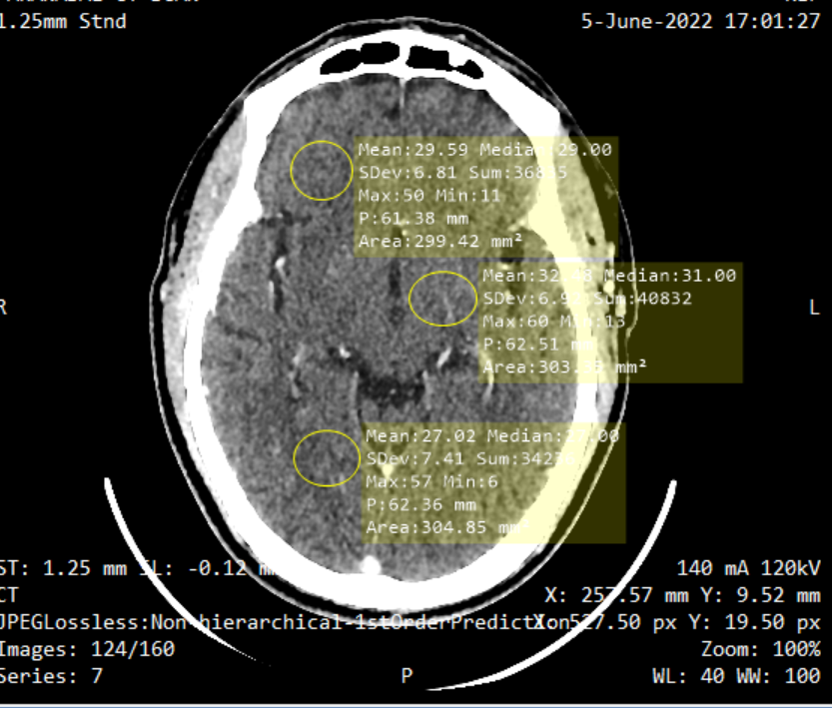
Figure 1: positioning the ROI on image of CT brain for the calculation of noise magnitude.

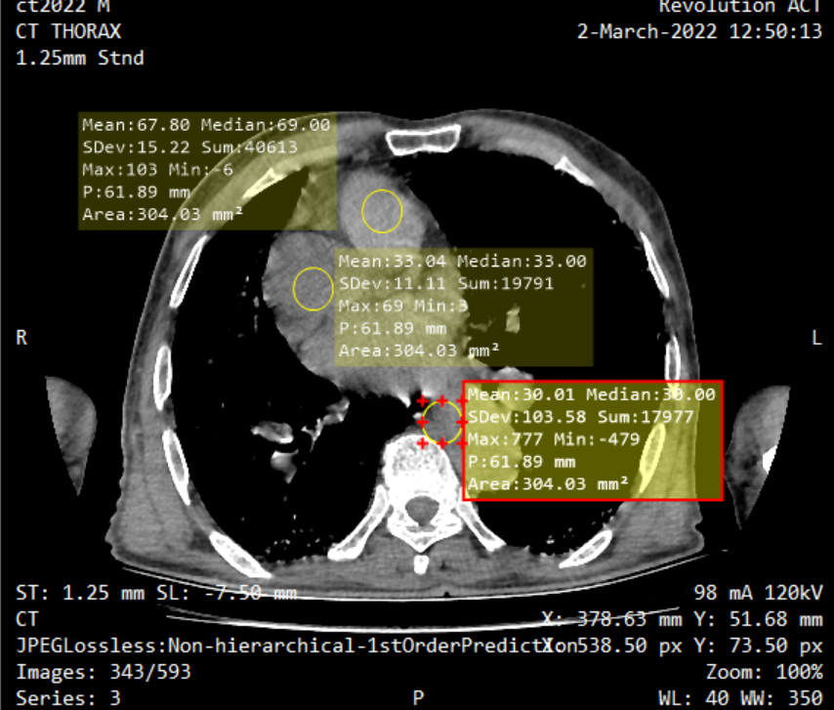
Figure 2: positioning the ROI on image of CT thorax for the calculation of noise magnitude.

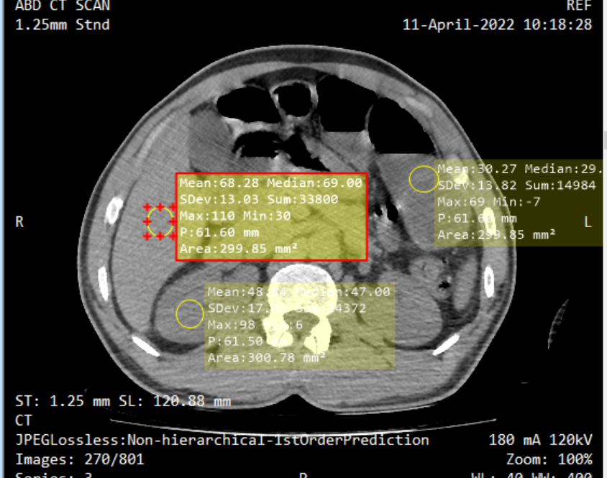
Figure 3: positioning the ROI on image of CT abdomen for the calculation of noise magnitude.

The SNR was calculated. Noise can originate from various causes, including thermal fluctuations and photon, and may also depend on the signal. In CT, noise is typically expressed as a standard deviation, δ, and is represented by the following equation:

$Noise \left(δ\right)=\sqrt{\frac{∑{\left(χ_{i}-χ_{mean}\right)}^{2}}{n-1}}$

where $χ_{i}$ represents a CT number in the Hounsfield unit (HU), $χ_{mean}$ denotes the average CT number within the ROI, and $n$ denotes the total HU inside the ROI.

Statistical analysis
The data for signal intensity, noise index and SNR across the three anatomical regions (i.e. Brain, Thorax, and Abdomen) for male (M) and female (F) patients was extracted and compiled into a Microsoft Excel spreadsheet for analysis. Bar charts were created to visually compare the data between genders across these anatomical regions. This visualization facilitated a direct comparison of signal values, noise index and SNR, providing any potential discrepancies based on gender. Furthermore, statistical analyses, including a student’s t-test, were conducted to ascertain whether the variations in signal intensity, noise index and SNR among different BMI were statistically significant. A p value of less than 0.05 were recorded in all cases signifying a significant difference. This method offered an extensive comprehension of the dataset, allowing for precise interpretations and enabling us to derive significant results consistent with our research objectives.

Results
Table 1 presents a summary of patient demography, acquisition parameters, and image quality metrics for CT scan conducted for the three regions (i.e. brain, thorax and abdomen). The data is shown as mean ± standard deviation (SD) for various parameters.

Region |  | mean ± SD
 |  | Brain | Thorax | Abdomen
Patient characteristics | n | 30 | 30 | 76
 | Age (y/o) | 33.34 ± 14.0 | 32.5 ± 12.3 | 38.4 ±12.8
 | Weight (kg) | 27.91±6.63 | 68.4±16.4 | 66.2±14.3
 | Height (m) | 1.63±0.12 | 1.605 ± 0.1 | 1.66 ± 0.2
 | BMI (kg/m²) | 22.60 ± 4.9 | 26.1 ± 7.5 | 28.3 ± 7.2
Acquisition parameter and dose | kV | 120 .00± 0 | 120 ± 0 | 120± 0
 | mAs | 105.62± 18.64 | 121.5 ± 47.9 | 120.31 ± 45.8
 | Scan range (cm) | 16.49 ± 4.31 | 35.93 ± 9.30 | 76.8 ± 13.3
 | CTDI_{vol} (mGy) | 27.7±6.44 | 9.84 ± 2.63 | 7.65± 3.31
 | DLP (mGy.cm) | 556.2 ± 136.21 | 364.1 ± 107.06 | 371.3 ± 167.4
Image quality | Signal | 28.45±2.01 | 48.02±5.10 | 46.33±6.53
 | Noise | 6.36±2.05 | 13.95±2.89 | 15.28±4.61
 | SNR | 4.84±1.06 | 3.68±0.55 | 3.41±0.81

Table 1: demography, acquisition parameter and image quality metrics of patients

Demography
The average age is similar across the three regions but has a relatively higher values for the abdomen (38.4 ± 12.8 years). Significant weight differences are observed. The brain region has a much lower mean weight of 27.91 ± 6.63 compared to that of thorax and abdomen which are 68.4 ± 16.4 and 66.2 ± 14.3 respectively. The heights are almost consistent across the three regions, with slight variations. The BMI values increase from the thorax to the abdomen suggesting a variation in the body types for these regions.

Dose and Acquisition Parameters
The voltage (kV) remains constant at 120 across all regions, showing a standardized imaging protocol. mAs values differ, with the brain region having the lowest (105.62 ± 18.64), the thorax has a slightly higher mAs (121.5 ± 47.9), but almost like that of the abdomen (120.31 ± 45.8). This shows the differences in exposure settings tailored to the density and thickness of the regions. There is a considerably differences in the scan range. The Abdomen has the longest scan range (76.8 ± 13.3 cm), while the brain has the shortest (16.49 ± 4.31 cm), reflecting the anatomical requirements for each region. The computed tomography dose index CTDI_{vol}, is highest for the brain (27.7 ± 6.44 mGy) and lowest in the case of the abdomen (7.65 ± 3.31 mGy). This indicates a higher dose requirement for CT brain, potentially due to the need for finer detail. The Dose-Length Product (DLP), is highest for the Brain (556.2 ± 136.21) despite its shorter scan range, showing a higher dose concentration for each centimeter scanned.

Image quality
Signal values are relatively consistent across the thorax (48.02 ± 5.10) and the abdomen (46.33 ± 6.53) but are significantly lower for the brain (28.45 ± 2.01), this could be due to the lower mAs settings. Noise is found to be lowest for the brain (6.36 ± 2.05) and highest for the abdomen (15.28 ± 4.61), this shows the variability in the clarity of the images based on the body region. Brain has the highest SNR (4.84 ± 1.06) and the abdomen has the lowest (3.41 ± 0.81), showing a better image clarity and detail in brain scans compared to the abdomen.

Table 2 presents a comparison of image quality metrics (Signal, Noise, and SNR) of CT scans of the three regions between male and female patients. The values are presented as mean ± SD, and p - values are provided to assess statistical significance in the differences between both genders

Table 2: Comparison of image quality metrics (Signal, Noise, and SNR) of CT scans of the three regions between male and female patients
Mean ±SD
SIGNAL |  |  |  | NOISE |  |  | SNR
Region | Male | Female | P value | Male | Female | P value | Male | Female | P value
Brain | 28.96±2.14 | 28.86±1.75 | 0.14 | 6.70±2.53 | 5.98±1.31 | 0.35 | 4.75±1.05 | 4.95±1.10 | 0.61
Thorax | 47.18±3.81 | 48.85±6.15 | 0.38 | 13.34±1.78 | 14.48±3.50 | 0.27 | 3.77±0.54 | 3.58±0.57 | 0.37
Abdomen | 47.28±5.01 | 45.22±7.89 | 0.17 | 14.73±2.75 | 15.93±6.10 | 0.26 | 3.34±0.81 | 3.24±0.88 | 0.13

The signal values for each region indicate a minimal difference between both genders. For the brain region, the value for male is 28.96 ± 2.14 while that of female is 28.86 ± 1.75. The p - value for this region is 0.14 indicating no statistically significant difference between genders for this region. The thorax region has 47.18 ± 3.81as the value for male and 48.85 ± 6.15 for female. The P-value for this region is 0.38 again showing no significant gender-based variation. The abdomen recorded 47.28 ± 5.01as the value for male and 45.22 ± 7.89 for female. The P-value for this region is 0.17 confirming that the difference is not statistically significant. The signal values are relatively consistent between genders across all regions, implying that the imaging protocol gives similar signal intensities for both males and females.
The noise levels also show slight differences between both genders with the brain having 6.70 ± 2.53 as the value for male and 5.98 ± 1.31for female. The p-value is 0.35 indicating an insignificant gender difference in noise levels. The thorax has13.34 ± 1.78 as the value for male and 14.48 ± 3.50 for female. This region has a p-value of 0.27 indicating no significant difference statistically. For the abdominal region, 14.73 ± 2.75 is the value for male and 15.93 ± 6.89 for female. This region has a p-value of 0.26 confirming that noise levels do not vary significantly between genders. Noise levels are consistent between females and males across regions, signifying that the image quality, in terms of noise, is comparable for patients of both genders. SNR values for brain shows 4.75 ± 1.05 for male and 4.95 ± 1.10 for female with a p-value of 0.61, indicating no significant difference between genders. The thorax has 3.77 ± 0.54 as the value of SNR for male and 3.58 ± 0.57 for female. Its p-value is 0.37 showing no significant difference in SNR. The SNR for abdomen is 3.34 ± 0.81for male and 3.24 ± 0.88 for female with a p-value of 0.13 suggesting no significant gender-based variation in SNR. The values for SNR remain consistent between male and female, signifying that the overall image quality is similar for patients of both genders.
Conclusively, Table 2 shows that there are no statistically significant differences in signal, noise, or SNR between patients of both genders across the three regions. This findings is in line with the study reported by [16] which suggests that the Image protocol is applicable and equally effective for both genders, maintaining consistent image quality parameters irrespective of the gender involved.

Table 3 presents statistics of signal, noise, and SNR in the abdomen area across various BMI categories: Underweight (UW), Normal Weight (NW), Overweight (OW), and Obesity (OB). The comparisons of these parameters were conducted using a t-test to assess significant differences between the BMI categories. As BMI increases, there is a noticeable increase in signal values across the categories. The p-value of less than 0.05
TABLE 3: statistics of signal, noise, and SNR in the abdomen area across various BMI categories
ABDOMEN |  |  |  |  |  | t -Test
BMI | Underweight  (n=12) | Normal weight  (n=13) | Overweight  (n=18) | Obesity  (n=33) | P value | NW VS UW | NW VS OW | NW VS OB
signal | 29.22±3.17 | 38.37±3.03 | 45.88±1.45 | 55.94±5.45 | p<0.05 | p<0.05 | p<0.05 | p<0.05
noise | 10.25±0.56 | 11.66±0.47 | 13.47±0.67 | 19.53±7.82 | p>0.05 | p<0.05 | p<0.05 | p<0.05
SNR | 1.57±0.26 | 2.26±0.21 | 3.14±0.26 | 4.65±0.69 | p>0.05 | p<0.05 | p<0.05 | p<0.05
Similarly, higher BMI also increase the noise value. However, the p-value is p > 0.05, which indicates that the difference in noise levels is not significant between the BMI categories. As BMI increases, the SNR increases with higher values in the Obesity category compared to the lower BMI groups. The SNR results show p value of > 0.05, signifying that no statistical significance across the BMI categories, though the trend shows that a higher BMI corresponds to better SNR. For the t- test comparison, all the parameters show significant differences with p value of < 0.05 for signal, noise, and SNR when compared the normal weight category to other categories of BMI. These findings align with the study that investigates the relationship between BMI and image quality parameters in CT scan. It shows that higher BMI often correlates with increased noise levels, as reported in the study by [17] where it was reported that as patient BMI increases, the amount of noise in CT images tends to rise due to increased tissue attenuation and scatter. These situations require dose adjustments to maintain image quality.
Furthermore, SNR improve with higher BMI, despite higher noise levels, this is in line with the study by [7] which suggests optimized imaging protocols for patients with higher BMI. Similar study by [18] reported that SNR increase can be achieved with adjustment in dose to account for larger body mass. Though, the lack of significant differences in statistics of SNR across all the BMI categories shows that the CT protocols were already optimized to provide good image quality despite variations in body habitus, as reported in the study by[13].

Figure 4 shows a bar chart for the signal in Hounsfield Unit (HU) numbers for CT examinations across the three regions for male (M) and female (F) patients. For male patients, the bar chart for brain is higher than that for females, though both values are within a range below 40 HU. The bar chart representing HU number for females is slightly higher than that for males in the thorax region, with both values reaching around 50 HU.

Figure 4: bar chart for the CT across the three regions for patients of both genders

This implies that there is similar tissue density in the thorax region for both genders, but with a marginal increase in females. The bar chart representing both males and females are very close in the abdomen region, showing minimal difference. Both genders show values between 40 and 50 HU, which suggests similar density characteristics in the region. Slight variations in HU numbers between males and females across the three regions can be noticed from the bar chart, but in general, the thorax and abdomen show identical densities for the two genders. On the other hand, the brain region, indicates a slightly higher HU number for males compared to females.

The bar chart in figure 5 compare the S.D. across the three body regions (brain, thorax, and abdomen) separately for males and females. The SD for males is slightly higher than that for females in the brain region, signifying the noise variability for the male patients is slightly greater in this region compared to the female patients, though both are relatively low. In the thorax region, the S.D for both genders are close, but the female gender shows a slightly higher value

Figure 5: Comparison of the S.D. across the three body regions for patients of both gender
This indicates that for the thorax region, the noise for females exhibits more variability than for males, though the difference is relatively small. For the abdomen region, the noise for both males and females are quite high, with females showing a marginally higher S.D. This indicates that the abdomen region shows the greatest variability among the three regions for both genders, with females showing a slightly higher S.D.

Figure 6 presents a bar chart comparing the SNR of CT scan across the three body regions for males and females’ patients. For the brain region, SNR for both males and females are quite high, with females showing a slightly higher SNR. This implies that the image quality in relation to noise is better in the female patients for this region, Though the difference is small.

Figure 6: bar chart comparing the SNR of CT scan across the three body regions for patients of both genders
Both males and females’ patients have a relatively lower SNR in the thorax region compared to the brain region, with the male patients having a slightly higher value than the female. This suggests that the image quality relative to noise is slightly better in male patients compared to females in the region. The abdomen region has SNR similar for both males and females, but slightly lower than in the brain and thorax regions, indicating that the image quality in this region is similar across sexes but is lower in comparison to the brain.

Conclusion
This study highlights the relationship between radiation dose and image quality in routine CT scans. The results underscore the necessity of tailoring radiation dose according to anatomical regions and individual patient characteristics, such as BMI, to enhance image quality while reducing patient exposure. The correlation between increased signal and noise with increasing BMI aligns with prior research conducted by[19] which reported that higher BMI results in greater image noise due to enhanced tissue attenuation and scattering. This underscores the necessity for dose modifications to preserve diagnostic image quality in patients with higher BMI.
Furthermore, the trend of enhanced SNR as BMI increases, despite higher noise levels, aligns with research conducted by [7], which supports the need for optimized protocol methods to address differences in patient body habitus. The findings also correspond with that of [20], where it was reported that dose increment for patients with higher BMI results in enhanced SNR, thereby improving image clarity. The absence of statistically significant changes in SNR among BMI categories shows that the protocol employed need to be effectively optimized to ensure clearer image across all patient groups, as also reported in the study by [13]
The uniformity in the metrics of image quality across genders reinforces the necessity of a standardized protocol, as demonstrated by [16], to guarantee equitable diagnostic results for male and female patients. This research substantiates the effectiveness of new CT technologies, including iterative reconstruction and Automatic Exposure Control (AEC) methods, in improving image quality and also the safety of the patient, as reported by [11].
The findings of this study offer significant insights into the practical implementation of dose optimization techniques for routine CT scan of patients across various BMI, to achieve better image quality, thereby adding to the continuous efforts to improve patient care in the field of medical imaging.
References

[1] N. A. Muhammad, M. K. A. Karim, H. H. Harun, M. A. A. Rahman, R. N. R. M. Azlan, and N. F. Sumardi, ‘The impact of tube current and iterative reconstruction algorithm on dose and image quality of infant CT head examination’, Radiat. Phys. Chem., vol. 200, no. May, p. 110272, 2022, doi: 10.1016/j.radphyschem.2022.110272.
[2] J. E. Park et al., ‘Image quality and radiation dose of brain computed tomography in children: effects of decreasing tube voltage from 120 kVp to 80 kVp’, Pediatr. Radiol., vol. 47, no. 6, pp. 710–717, 2017, doi: 10.1007/s00247-017-3799-8.
[3] R. N. Chityala, K. R. Hoffmann, D. R. Bednarek, and S. Rudin, ‘Region of interest (ROI) computed tomography’, in Medical Imaging 2004: Physics of Medical Imaging, 2004, p. 534. doi: 10.1117/12.534568.
[4] P. D. Maldjian and A. R. Goldman, ‘Reducing radiation dose in body CT: A primer on dose metrics and key CT technical parameters’, Am. J. Roentgenol., vol. 200, no. 4, pp. 741–747, 2013, doi: 10.2214/AJR.12.9768.
[5] A. Ferrero, N. Takahashi, T. J. Vrtiska, A. E. Krambeck, J. C. Lieske, and C. H. McCollough, ‘Understanding, justifying, and optimizing radiation exposure for CT imaging in nephrourology’, Nat. Rev. Urol., vol. 16, no. 4, pp. 231–244, 2019, doi: 10.1038/s41585-019-0148-8.
[6] M. K. A. Karim, S. Hashim, D. A. Bradley, K. A. Bakar, M. R. Haron, and Z. Kayun, ‘Radiation doses from computed tomography practice in Johor Bahru, Malaysia’, Radiat. Phys. Chem., vol. 121, pp. 69–74, 2016, doi: 10.1016/j.radphyschem.2015.12.020.
[7] H. Elnour, H. Ahmed Hassan, A. Mustafa, H. Osman, S. Alamri, and A. Yasen, ‘Assessment of Image Quality Parameters for Computed Tomography in Sudan’, Open J. Radiol., vol. 07, no. 01, pp. 75–84, 2017, doi: 10.4236/ojrad.2017.71009.
[8] J. Gariani, S. P. Martin, D. Botsikas, C. D. Becker, and X. Montet, ‘Evaluating the effect of increased pitch, iterative reconstruction and dual source CT on dose reduction and image quality’, Br. J. Radiol., vol. 91, no. 1088, 2018, doi: 10.1259/bjr.20170443.
[9] E. Halim et al., ‘Task-based assessment for radiation dose optimization in CT abdominal examinations: A phantom study’, Radiat. Phys. Chem., no. February, p. 111966, 2024, doi: 10.1016/j.radphyschem.2024.111966.
[10] W. A. Kalender et al., ‘Technical approaches to the optimisation of CT’, Phys. Medica, vol. 24, no. 2, pp. 71–79, 2008, doi: 10.1016/j.ejmp.2008.01.012.
[11] H. Kawashima, K. Ichikawa, S. Hanaoka, and K. Matsubara, ‘Optimizing image quality using automatic exposure control based on the signal-difference-to-noise ratio: a phantom study.’, Australas. Phys. Eng. Sci. Med., vol. 42, no. 3, pp. 803–810, Sep. 2019, doi: 10.1007/s13246-019-00784-z.
[12] M. Mahesh, ‘The Essential Physics of Medical Imaging, Third Edition.’, Med. Phys., vol. 40, no. 7, Jul. 2013, doi: 10.1118/1.4811156.
[13] R. Livingstone, J. Pradip, P. Dinakran, and B. Srikanth, ‘Radiation doses during chest examinations using dose modulation techniques in multislice CT scanner’, Indian J. Radiol. Imaging, vol. 20, no. 2, pp. 154–157, 2010, doi: 10.4103/0971-3026.63036.
[14] J. Greffier, F. Pereira, F. Macri, J. P. Beregi, and A. Larbi, ‘CT dose reduction using Automatic Exposure Control and iterative reconstruction: A chest paediatric phantoms study’, Phys. Medica, vol. 32, no. 4, pp. 582–589, 2016, doi: 10.1016/j.ejmp.2016.03.007.
[15] W. Stiller, ‘Basics of iterative reconstruction methods in computed tomography : A vendor-independent overview’, Eur. J. Radiol., vol. 109, no. October, pp. 147–154, 2018, doi: 10.1016/j.ejrad.2018.10.025.
[16] I. Sebelego, S. Acho, B. van der Merwe, and W. I. D. D. Rae, ‘Size based dependence of patient dose metrics, and image quality metrics for clinical indicator-based imaging protocols in abdominal CT procedures’, Radiography, vol. 29, no. 6, pp. 961–974, 2023, doi: 10.1016/j.radi.2023.07.011.
[17] H. I. Almohammed, W. Elshami, Z. Y. Hamd, and M. Abuzaid, ‘Optimizing CT Abdomen–Pelvis Scan Radiation Dose: Examining the Role of Body Metrics (Waist Circumference, Hip Circumference, Abdominal Fat, and Body Mass Index) in Dose Efficiency’, Tomography, vol. 10, no. 5, pp. 643–653, 2024, doi: 10.3390/tomography10050049.
[18] S. Gharbi, S. Labidi, M. Mars, M. Chelli, S. Meftah, and M. F. Ladeb, ‘Assessment of organ dose and image quality in head and chest CT examinations: A phantom study’, J. Radiol. Prot., vol. 38, no. 2, pp. 807–818, 2018, doi: 10.1088/1361-6498/aac336.
[19] A. B. Hade and S. I. Essa, ‘Evaluation of the Influence of Body Mass Index and Signal-To-Noise Ratio on the Pet/Ct Image Quality in Iraqi Patients With Liver Cancer’, East Eur. J. Phys., vol. 2023, no. 1, pp. 241–245, 2023, doi: 10.26565/2312-4334-2023-1-32.
[20] Y. Bouchareb, N. Tag, H. Sulaiman, K. Al-Riyami, Z. Jawa, and H. Al-Dhuhli, ‘Optimization of BMI-Based Images for Overweight and Obese Patients - Implications on Image Quality, Quantification, and Radiation Dose in Whole Body (18)F-FDG PET/CT Imaging.’, Nucl. Med. Mol. Imaging (2010)., vol. 57, no. 4, pp. 180–193, Aug. 2023, doi: 10.1007/s13139-023-00795-5.

