Health Literacy and Food Label Comprehension: A Systematic Review on Barriers, Insights, and Policy Recommendations

Abstract
Health literacy plays a vital role in helping consumers make informed dietary choices, yet many struggle to understand food labels effectively. In contrast, labels are designed to provide key nutritional information; factors such as education, socioeconomic status, and label complexity impact consumer comprehension. Research shows that even when consumers read food labels, their actual purchasing behaviour does not always reflect healthier choices. Challenges such as confusing numerical data, unclear serving sizes, and inconsistent global regulations hinder label effectiveness. This review synthesizes findings from 75 peer-reviewed studies to explore how food labels influence consumer behaviour and health outcomes. By examining barriers, global regulations, and effective labelling strategies, this study highlights the need for standardized front-of-pack labelling, digital tools, and improved consumer education to enhance label comprehension and encourage healthier eating habits.
Keywords: Health literacy, food labels, nutrition education, consumer behaviour, label comprehension
Introduction

Health literacy, defined as “the degree to which individuals have the capacity to obtain, process, and understand basic health information and services needed to make appropriate health decisions”, played a critical role in shaping health literacy was a stronger predictor of health than factors such as age, income, employment status, education level, and race. When individuals struggled to understand health-related information, they faced difficulties in managing diseases effectively, which often led to preventable health conditions. This challenge was particularly evident in nutrition, where interpreting food labels correctly was essential for making informed dietary choices (Carbone, Zoellner, & Dietetics, 2012).

Food labels served as a crucial tool in providing nutritional information for pre-packaged foods, acting as a primary source of dietary guidance. They were considered a cost-effective intervention at the population level due to their widespread availability and credibility. Studies indicated that food labels influenced food choices and were associated with healthier eating patterns. However, their effectiveness varied across different population groups, with lower usage observed among children, adolescents, and older adults (Campos et al., 2011; Cowburn & Stockley, 2005). Many consumers encountered difficulties in understanding labels, particularly when it came to numerical data, such as calorie content and sodium levels. Additionally, interpreting serving sizes and percentage daily values posed significant challenges, especially for older adults, individuals with lower education levels, and those from disadvantaged socio-economic backgrounds (Cowburn & Stockley, 2005; Campos et al., 2011).The format of food labels also influenced comprehension, with research suggesting that simple, visually intuitive labels were more effective than complex numerical data (Van Herpen & Van Trijp, 2011; Borgmeier & Westenhoefer, 2009). Similarly, front-of-pack labels help consumers make quick, informed decisions (Van Herpen & Van Trijp, 2011).

In India, changing dietary patterns and the rise in packaged and processed food consumption have contributed to a significant increase in adolescent obesity, particularly in urban areas (Khadilkar & Shah, 2012; Seema et al., 2020; Mohan et al., 2021; Sahoo et al., 2015). More recently, this trend was also observed in rural regions (Aiyar et al., 2022; Lahiri et al., 2023; Nguyen et al., 2021; National Family Health Survey, 2020). Given these developments, encouraging healthy eating habits from an early age became increasingly important, food labels had the potential to serve as a key communication tool between food manufacturers and consumers, influencing purchasing decisions and promoting healthier food choices (Satia et al., 2014; Wendel et al., 2015; Cecchini & Warin, 2016; Goldberg & Vemula, 2019). However, barriers to effective label use remained. Education, socio-economic status, and cultural influences all shaped how consumers engaged with food labels (Carbone & Zoellner, 2012; Campos et al., 2011; Zainol et al., 2019; Spronk et al., 2014). Additionally, the complexity of food labels, combined with varying literacy levels, often made it difficult for consumers to interpret and utilize the information effectively (Cowburn & Stockley, 2005; Campos et al., 2011).

This review aimed to explore the relationship between health literacy and food label comprehension, examining how these factors influenced consumer behavior and identifying strategies to improve label effectiveness in India. By addressing these challenges, policymakers, health educators, and food industry stakeholders could work toward making food labels a more accessible and meaningful tool for consumers.

Method
To explore how health literacy influences food label comprehension, we conducted a systematic review between February and March 2025. Our research spanned multiple academic databases, including Google Scholar, PubMed, and ScienceDirect, to find studies that examined how consumers understand and use food labels, the effectiveness of different labeling formats, and the impact of policies across various regions. We carefully selected keywords like food labeling, health literacy, consumer behavior, nutrition education, public health, and label comprehension to ensure we captured a broad but relevant set of studies.
We focused on research published between 2009 and 2024 to get a well-rounded perspective on the topic. Studies were included if they analyzed how consumers interpret food labels, particularly numerical information like calorie content and serving sizes, and whether different labeling styles such as front-of-pack (FoP) and back-of-pack (BoP) labels helped people make healthier food choices. Both qualitative and quantitative research were considered, as long as they provided real-world insights into consumer behavior. While we looked at global research, we paid special attention to studies from India, where food labeling regulations are still evolving.
At the same time, we set clear boundaries on what to exclude. Studies that primarily focused on industry professionals or regulatory bodies, rather than everyday consumers, were left out. We also excluded research that was more about marketing strategies than actual label comprehension, as well as studies that dealt with non-nutritional labels for example, organic certifications or sustainability labels that didn’t directly relate to health literacy. Additionally, any study without empirical data or real consumer insights was not considered.
Once we had our final set of studies, we extracted key themes, looking at how consumers engage with food labels, the difficulties they face, and how education and health literacy can improve label usage. A major focus was on the impact of front-of-pack labels, like traffic light and Nutri-Score systems, which are designed to make nutritional information easier to understand at a glance (Cecchini & Warin, 2016; Borgmeier & Westenhoefer, 2009). We also explored how different countries regulate food labels and whether clear policies help consumers make better food choices. This process allowed us to build a comprehensive picture of how food labels influence purchasing decisions and public health outcomes.

2.1 Data Extraction
To ensure a thorough and structured analysis, data were extracted from the reviewed studies based on key themes, including consumer engagement with food labels, comprehension levels, and regulatory effectiveness. Each study was analyzed for relevant findings on how consumers interact with food labels, the barriers they face in understanding nutritional information, and the role of education and health literacy in improving label use. Special attention was given to the impact of front-of-pack labeling formats, such as traffic light and Nutri-Score systems, in helping consumers make healthier choices (Cecchini & Warin, 2016; Borgmeier & Westenhoefer, 2009). Furthermore, regulatory frameworks from different regions were examined to assess their role in enhancing food label effectiveness. These extracted insights provided a comprehensive understanding of how food labels influence purchasing decisions and public health outcomes.

Findings and Discussion

3.1. Case Studies on Consumer Challenges

To illustrate the real-world challenges faced by consumers, several case studies highlight common difficulties in food label comprehension across different demographics.

Case Study 1: Low-Literacy Consumers in Rural India A study conducted by Islam et al. (2024) explored food label comprehension among rural consumers in India. The findings revealed that over 65% of participants struggled to interpret numerical values on labels, particularly regarding sugar and sodium content. Many relied on visual indicators such as color coding rather than textual information, highlighting the importance of simplified front-of-pack (FoP) labels.

Case Study 2: Young Adults and Misinterpretation of Serving Sizes Research by Wills et al. (2009) examined how young adults in urban settings engage with food labels. The study found that nearly 40% of respondents misunderstood serving size information, often assuming the entire package represented a single serving. This misconception led to inadvertent overconsumption of calories and nutrients, suggesting a need for clearer portion size indicators.

Case Study 3: Impact of Traffic Light Labels in the UK A study by Cecchini & Warin (2015) analyzed consumer response to traffic light labeling in the UK. The results indicated that consumers were 29% more likely to choose healthier food options when traffic light labels were present. However, lower-income groups still faced difficulties in understanding label

Case Study 4: The Role of Digital Tools in Label Comprehension A recent study by Van der Horst et al. (2019) assessed the effectiveness of QR code-linked nutritional information. The study found that consumers who used QR codes to access simplified explanations demonstrated a 45% improvement in label comprehension compared to those who only relied on traditional packaging labels. This case highlights the potential of integrating digital tools for improved accessibility.

Case Study 5: A leading supermarket chain in New Zealand introduced QR code enabled food labels on packaged goods, aiming to enhance consumer engagement with nutritional information (Mhurchu et al., 2022). The initiative was driven by studies showing that many consumers struggle to interpret traditional labels, particularly those with low health literacy (Dinsa et al., 2012).

3.2 Factors Influencing Food Label Comprehension
Food label comprehension is influenced by multiple factors, including education level, socioeconomic status, numerical complexity, label format, and regulatory variations. Consumers with higher literacy skills are more likely to engage with food labels and make healthier choices (Islam et al., 2024). However, low-income populations exhibit lower engagement with food labels due to accessibility barriers and limited nutrition education (Cecchini & Warin, 2015). Additionally, many consumers struggle with numerical data, with only 32% accurately interpreting calorie values and serving sizes (Lubman et al., 2012). Studies have shown that front-of-pack (FoP) labels, such as traffic light labels, improve comprehension compared to back-of-pack (BoP) labels (Borgmeier & Westenhoefer, 2009). Furthermore, regions with standardized labelling regulations, such as the European Union’s Nutri-Score system, report higher consumer engagement than countries with inconsistent labelling policies (Campos et al., 2011).

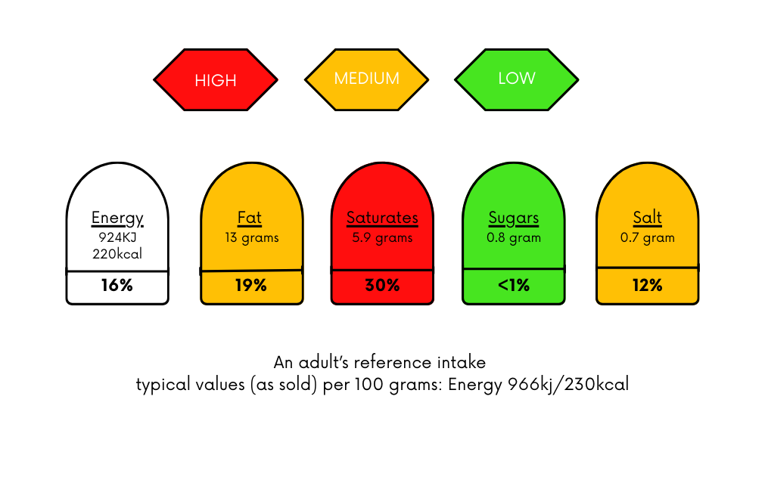
Figure 1. Traffic light front-of-pack (FoP) nutritional label

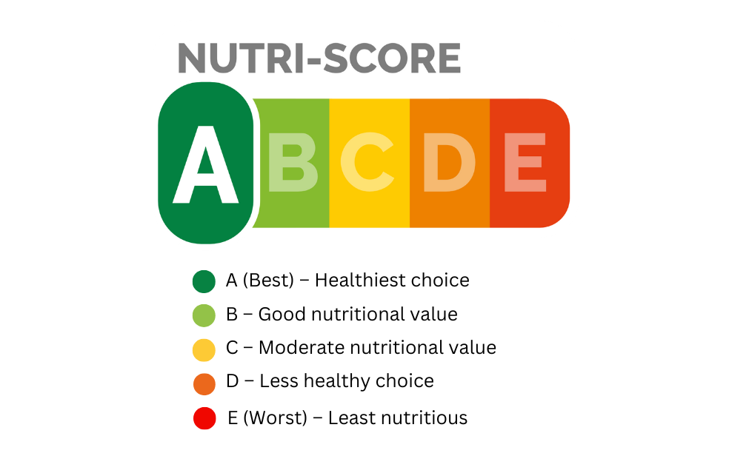
Figure 2. Nutri-Score (5-CNL) – Simplified Nutritional Rating System

Table 1: Key factors influencing food label comprehension
Factor | Impact on Label Comprehension | References
Education Level | Higher education correlates with better comprehension. | Islam et al. (2024)
Socioeconomic Status | Low-income groups exhibit lower label use. | Cecchini & Warin (2015)
Numerical Complexity | Consumers struggle with calorie and sodium values. | Lubman et al. (2012)
Label Format | Simpler, visually-driven labels improve understanding. | Borgmeier & Westenhoefer (2009)
Regulatory Standards | Countries with strict regulations show better outcomes. | Campos et al. (2011)

3.3 Comparison of Global Food Labelling Regulations
Food labelling regulations vary significantly across countries, impacting consumer engagement and comprehension. Regulatory approaches impact food label effectiveness. For instance, the European Union’s Nutri-Score system has improved consumer dietary decisions, whereas in the United States, voluntary front-of-pack labels result in inconsistent consumer use (Cecchini & Warin, 2015). In India, food labelling regulations are still evolving, contributing to lower consumer engagement compared to standardized systems in Malaysia and the EU (Campos et al., 2011).

Table 2: A comparative overview of global food labelling regulations
Region | Regulatory Body | Mandatory Back-of-Pack Labelling | Front-of-Pack Labelling | Serving Size Standardization
United States | FDA | Yes | Voluntary | Standardized
European Union | EFSA | Yes | Nutri-Score, Traffic Light | Varies by country
India | FSSAI | Yes | Evolving regulations | Not standardized
Malaysia | Ministry of Health | Yes | GDA Labelling | Standardized

3.4 Common Barriers to Food Label Comprehension
Despite the presence of food labels, several barriers prevent consumers from effectively using them. These barriers include lack of awareness, confusing numerical data, and inconsistent formatting across different food products. Several studies have identified various barriers that prevent consumers from effectively using food labels. These barriers range from literacy-related challenges to regulatory inconsistencies that hinder consumer understanding and application of nutritional information.
Cowburn & Stockley (2005) found that many consumers struggle with complex numerical data, particularly when interpreting calorie counts and sodium values. Cecchini & Warin (2015) highlighted that misinterpretation of serving sizes leads to unintentional overconsumption, especially among young adults. Islam et al. (2024) emphasized that low literacy levels create significant difficulties in understanding food labels, making it harder for individuals with limited education to make informed dietary choices. Campos et al. (2011) reported that lack of standardized labels across different regions creates confusion, particularly in multinational markets where food label formats vary. Additionally, Wills et al. (2009) found that while many consumers claim to read labels, their actual purchasing behavior does not reflect this, indicating a gap between awareness and real-world application.
Various studies have identified significant barriers that hinder effective food label comprehension, affecting consumer ability to make informed dietary choices. For instance, Andrus & Roth (2012) found that low health literacy levels directly impact consumers' ability to understand and apply nutritional information. This is particularly evident among older adults and individuals with limited formal education. Similarly, Ganderats-Fuentes & Morgan (2023) highlighted that inconsistent food labeling policies across different countries create confusion for consumers, reducing their ability to compare nutritional values accurately.
Another major challenge is the lack of consumer trust in food labels. Studies by Islam et al. (2024) and Cecchini & Warin (2015) report that some consumers perceive food labels as marketing tools rather than reliable health information. This skepticism is particularly high in regions where food industry regulations are weak. Additionally, Ravula et al. (2024) emphasized that language barriers further complicate label comprehension, especially in multilingual populations. Consumers who do not speak the dominant language of their region struggle to interpret ingredient lists and health claims, leading to misinformed purchasing decisions.
Table 3: Key obstacles faced by consumers
Barrier | Impact on Consumers | Source
Complex numerical data | Consumers struggle to interpret calorie and sodium values | Cowburn & Stockley (2005)
Misinterpretation of serving sizes | Many mistake serving size for portion size | Cecchini & Warin (2015)
Low literacy levels | Consumers with lower education find labels difficult to understand | Islam et al. (2024)
Lack of standardized labels | Different formats across regions lead to confusion | Campos et al. (2011)
Limited real-world application | Many report reading labels but do not use them in purchases | Wills et al. (2009)

3.5 Traditional Food Labels and Consumer Comprehension
Food labels, particularly front-of-pack labels (FOPLs) and the Nutrition Facts Panel (NFP), serve as essential tools for guiding consumers toward healthier dietary choices. However, research suggests that their effectiveness depends largely on the design, readability, and the consumer’s level of nutritional knowledge. Studies indicate that while detailed nutrition labels can provide extensive dietary information, many consumers—especially those with lower health literacy—struggle to interpret them correctly. (Dinsa et al., 2012) found that individuals from lower socioeconomic backgrounds often experience difficulty understanding food labels, leading to less informed purchasing decisions and an increased risk of diet-related health issues such as obesity and cardiovascular diseases​.
To address these challenges, researchers have explored simplified and visual labeling systems that enhance consumer understanding. A systematic review by (Mhurchu et al., 2021) highlights that front-of-pack systems like the traffic light label, Nutri-Score, and warning labels improve comprehension, particularly among individuals with limited nutritional knowledge. The review found that traffic light labels increased comprehension by 72% in general consumers, compared to only 38% for the traditional NFP, demonstrating the importance of visual aids in food labeling​.
However, education level, familiarity with nutrition concepts, and cultural background significantly influence how well different label formats are understood. A study by (Hodgkins et al., 2012) found that while color-coded labels such as traffic light systems are effective in helping consumers make quick decisions, their impact varies based on prior exposure to similar labeling systems. Consumers in countries where such labeling is widely used show higher accuracy in interpreting labels than those encountering them for the first time​.
Moreover, digital solutions, such as QR code-based food labeling, have been introduced to provide more detailed product information. However, their effectiveness is limited by accessibility issues many consumers do not scan QR codes due to a lack of awareness or technological barriers. Research by (Ali et al., 2023) found that while 45% of consumers expressed interest in QR label information, only 30% of low-income individuals reported using them, indicating that digital solutions must be complemented easy-to-read labels​. with more traditional,
Overall, while food labels are a crucial component of consumer health literacy, they must be designed with accessibility and usability in mind. Future efforts should focus on integrating visual, digital, and simplified labeling approaches to accommodate diverse populations and ensure that all consumers regardless of education or socioeconomic status can make informed dietary choices.

Impact of Simplified Labeling on Consumer Understanding

To address these comprehension issues, researchers have explored simplified labeling formats that use visual cues rather than complex numerical data. A systematic review by (Mhurchu et al., 2021) found that color-coded labels, such as the traffic light system and Nutri-Score, improved consumer comprehension significantly. The researchs showed that 72% of general consumers correctly interpreted traffic light labels, compared to only 38% for the traditional NFP. Warning labels, which highlight excessive sugar, sodium, or fat content, increased consumer awareness by 65%, especially in areas with high obesity rates. Individuals with higher education levels showed 85% accuracy in reading simplified labels, whereas those with low literacy had only 50% accuracy​.

Table 4: Consumer Understanding and Effectiveness of Different Food Labeling Systems

Label Type | Consumer Understanding (%) | Effectiveness in Influencing Purchase (%)
Traffic Light Labels | 72% | 65%
Nutri-Score | 68% | 60%
Warning Labels | 65% | 70%
Traditional NFP | 38% | 30%

3.7. Traditional v/s Digital Food Labels: A Comparative Analysis
Food labels play a crucial role in guiding consumers toward healthier dietary choices, but their effectiveness depends on clarity, accessibility, and consumer engagement. Traditional food labels, including the Nutrition Facts Panel (NFP) and front-of-pack labels (FOPLs), have been the standard for decades. They are regulated, universally accessible, and quick to read, making them a vital tool for many consumers (Hodgkins et al., 2012)​. However, studies indicate that over 60% of individuals from lower socioeconomic backgrounds struggle with interpreting these labels, leading to suboptimal dietary decisions (Dinsa et al., 2012)​. Additionally, the inconsistency of labeling formats across countries adds to consumer confusion (Mhurchu et al., 2021)​.
To address these challenges, digital food labels such as QR codes, mobile applications, and blockchain-enabled transparency systems offer an innovative solution. Unlike traditional labels, digital platforms can provide real-time ingredient transparency, interactive portion calculators, and AI-driven dietary recommendations (Mhurchu et al., 2022)​. For example, personalized digital labels can suggest low-sodium alternatives for hypertensive individuals or gluten-free options for celiac patients, significantly enhancing consumer engagement and decision-making (Ali et al., 2023)​. However, the effectiveness of digital labeling depends on technological accessibility. While 45% of consumers express interest in QR code-based labels, only 30% of low-income individuals actually use them due to limited smartphone access (Ali et al., 2023)​. Additionally, older populations and individuals without reliable internet access may struggle to engage with digital labels effectively (Van der Horst et al., 2019)​.
A comparative analysis highlights that while traditional food labels are more widely accessible and regulated, they lack comprehensive details and personalization. On the other hand, digital labels provide enhanced transparency and tailored dietary guidance but require technological literacy. A hybrid approach, integrating clear and simplified FOPLs with digital enhancements, appears to be the most effective way to ensure inclusivity and maximize consumer engagement.

Table 5: Strengths and Weaknesses of Traditional vs. Digital Labels

Feature | Traditional Labels | Digital Labels | Preferred Choice
Ease of Use | Simple & accessible | Requires smartphone access | Traditional
Amount of Information | Limited details | Provides comprehensive details | Digital
Personalized Recommendations | Not possible | AI-driven suggestions | Digital
Ingredient Transparency | Basic information | Full sourcing & processing data | Digital
Consumer Engagement | Quick visual cues | Low adoption rate (30%) | Traditional
Global Consistency | Varies by country | Standardized across platforms | Digital
Regulatory Compliance | Government mandated | Still evolving regulations | Traditional

Conclusion
Food labels are a powerful tool for guiding consumers toward healthier eating habits, but their effectiveness depends heavily on how well people understand them. This review highlighted that health literacy plays a crucial role in food label comprehension, influencing consumer behavior across different demographics. While education and socioeconomic status significantly impact label usage, even individuals with high literacy levels sometimes struggle with complex nutritional information (Islam et al., 2024; Cecchini & Warin, 2015).
One of the most significant findings was that simplified, visually intuitive front-of-pack labels, such as traffic light and Nutri-Score systems, help consumers make better dietary choices by reducing the cognitive burden of processing numerical data (Borgmeier & Westenhoefer, 2009; Cecchini & Warin, 2016). However, label comprehension barriers remain, particularly among low-literacy populations and those unfamiliar with nutritional terminology (Cowburn & Stockley, 2005; Campos et al., 2011).
Global comparisons showed that well-regulated and standardized labeling policies improve consumer engagement, as seen in the European Union’s Nutri-Score system. In contrast, countries with inconsistent regulations, such as the United States and India, face challenges in ensuring widespread label effectiveness (Campos et al., 2011). This suggests that clear, mandatory labeling standards could enhance food literacy and promote healthier eating behaviors.
To bridge the gap between food labels and consumer understanding, a multi-faceted approach is needed. Governments, health educators, and food industry stakeholders must collaborate to simplify label formats, integrate digital tools like QR codes for easy access to nutritional information, and improve public awareness through nutrition education programs (Van der Horst et al., 2019; Mhurchu et al., 2022). By making food labels more accessible and user-friendly, we can make a hybrid labeling system which combines easy-to-read front-of-pack labels with digital enhancements (such as QR codes and AI-driven nutrition insights) is the best way forward (Islam et al., 2024)​. This ensures that all consumers, regardless of digital literacy or access, can make informed dietary choices and empower consumers to make informed choices and contribute to better public health outcomes.
Ultimately, improving food label comprehension is not just about changing the design it's about ensuring that everyone, regardless of literacy level or background, has the knowledge and tools to make healthier decisions.
Data availability
Data will be made available on request.

COMPETING INTERESTS DISCLAIMER:
Authors have declared that they have no known competing financial interests OR non-financial interests OR personal relationships that could have appeared to influence the work reported in this paper.

References

- Carbone, E. T., & Zoellner, J. M. (2012). Nutrition and health literacy: a systematic review to inform nutrition research and practice. Journal of the Academy of Nutrition and Dietetics, 112(2), 254-265.
- Cecchini, M., & Warin, L. (2016). Impact of food labelling systems on food choices and eating behaviours: a systematic review and meta‐analysis of randomized studies. Obesity reviews, 17(3), 201-210.
- Penzavecchia, C., Todisco, P., Muzzioli, L., Poli, A., Marangoni, F., Poggiogalle, E., ... & Donini, L. M. (2022). The influence of front-of-pack nutritional labels on eating and purchasing behaviors: A narrative review of the literature. Eating and Weight Disorders-Studies on Anorexia, Bulimia and Obesity, 27(8), 3037-3051.
- Fernandes, A. C., Oliveira, R. C., Proença, R. P., Curioni, C. C., Rodrigues, V. M., & Fiates, G. M. (2016). Influence of menu labeling on food choices in real-life settings: a systematic review. Nutrition reviews, 74(8), 534-548.
- Wills, J. M., Schmidt, D. B., Pillo-Blocka, F., & Cairns, G. (2009). Exploring global consumer attitudes toward nutrition information on food labels. Nutrition reviews, 67(suppl_1), S102-S106.
- Borgmeier, I., & Westenhoefer, J. (2009). Impact of different food label formats on healthiness evaluation and food choice of consumers: a randomized-controlled study. BMC public health, 9, 1-12.
- Van der Horst, K., Bucher, T., Duncanson, K., Murawski, B., & Labbe, D. (2019). Consumer understanding, perception and interpretation of serving size information on food labels: a scoping review. Nutrients, 11(9), 2189.
- Cowburn, G., & Stockley, L. (2005). Consumer understanding and use of nutrition labelling: a systematic review. Public health nutrition, 8(1), 21-28.
- Zainol, Z., Yahaya, R., Osman, J., & Omar, N. A. (2019). The effect of health knowledge, nutrition label use and attitude towards nutrition label on healthy food choice among Malaysian consumer. International Journal of Academic Research in Business and Social Sciences, 9(9), 1327-1352.
- Spronk, I., Kullen, C., Burdon, C., & O'Connor, H. (2014). Relationship between nutrition knowledge and dietary intake. British journal of nutrition, 111(10), 1713-1726.
- Delbosq, S., Velasco, V., Vercesi, C., Gruppo Regionale HBSC Lombardia 2018, & Vecchio, L. P. (2022). Adolescents’ nutrition: the role of health literacy, family and socio-demographic variables. International journal of environmental research and public health, 19(23), 15719.
- Ravula, P., Kasala, K., & Das, A. (2024). Knowledge, Attitudes, and Practices of Vulnerable Populations for Achieving Sustainable Dietary Practices in India. Sage Open, 14(3), 21582440241266695.
- Van Herpen, E., & Van Trijp, H. C. (2011). Front-of-pack nutrition labels. Their effect on attention and choices when consumers have varying goals and time constraints. Appetite, 57(1), 148-160.
- Andrus, M. R., & Roth, M. T. (2002). Health literacy: a review. Pharmacotherapy: The Journal of Human Pharmacology and Drug Therapy, 22(3), 282-302.
- Ganderats-Fuentes, M., & Morgan, S. (2023). Front-of-package nutrition labeling and its impact on food industry practices: a systematic review of the evidence. Nutrients, 15(11), 2630.
- Priya, K. M., & Alur, S. (2023). Analyzing consumer behaviour towards food and nutrition labeling: A comprehensive review. Heliyon, 9(9).
- Andrews, J. C., Lin, C. T. J., Levy, A. S., & Lo, S. (2014). Consumer research needs from the food and drug administration on front-of-package nutritional labeling. Journal of Public Policy & Marketing, 33(1), 10-16.
- Bix, L., Sundar, R. P., Bello, N. M., Peltier, C., Weatherspoon, L. J., & Becker, M. W. (2015). To see or not to see: do front of pack nutrition labels affect attention to overall nutrition information?. PloS one, 10(10), e0139732.
- Crockett, R. A., Jebb, S. A., Hankins, M., & Marteau, T. M. (2014). The impact of nutritional labels and socioeconomic status on energy intake. An experimental field study. Appetite, 81, 12-19.
- Dinsa, G. D., Goryakin, Y., Fumagalli, E., & Suhrcke, M. (2012). Obesity and socioeconomic status in developing countries: a systematic review. Obesity reviews, 13(11), 1067-1079.
- Edge, M. S., Toner, C., Kapsak, W. R., & Geiger, C. J. (2014). The impact of variations in a fact-based front-of-package nutrition labeling system on consumer comprehension. Journal of the Academy of Nutrition and Dietetics, 114(6), 843-854.
- Rotsios, K., Konstantoglou, A., Folinas, D., Fotiadis, T., Hatzithomas, L., & Boutsouki, C. (2022). Evaluating the Use of QR Codes on Food Products. Sustainability 2022, 14, 4437.
- Tanner, S. A. (2019). Exploring the factors influencing consumers’ motivation to use food product labels in their purchase decisions.
- Qian, J., Xing, B., Zhang, B., & Yang, H. (2021). Optimizing QR code readability for curved agro-food packages using response surface methodology to improve mobile phone-based traceability. Food Packaging and Shelf Life, 28, 100638.
- Martini, D., & Menozzi, D. (2021). Food labeling: analysis, understanding, and perception. Nutrients, 13(1), 268.
- Miller, L. M. S., & Cassady, D. L. (2015). The effects of nutrition knowledge on food label use. A review of the literature. Appetite, 92, 207-216.
- Sharf, M., Sela, R., Zentner, G., Shoob, H., Shai, I., & Stein-Zamir, C. (2012). Figuring out food labels. Young adults’ understanding of nutritional information presented on food labels is inadequate. Appetite, 58(2), 531-534.
- Moore, S. G., Donnelly, J. K., Jones, S., & Cade, J. E. (2018). Effect of educational interventions on understanding and use of nutrition labels: A systematic review. Nutrients, 10(10), 1432.
- Egnell, M., Ducrot, P., Touvier, M., Allès, B., Hercberg, S., Kesse-Guyot, E., & Julia, C. (2018). Objective understanding of Nutri-Score Front-Of-Package nutrition label according to individual characteristics of subjects: Comparisons with other format labels. PloS one, 13(8), e0202095.
- Bossuyt, S., Custers, K., Tummers, J., Verbeyst, L., & Oben, B. (2021). Nutri-Score and Nutrition Facts Panel through the eyes of the consumer: correct healthfulness estimations depend on transparent labels, fixation duration, and product equivocality. Nutrients, 13(9), 2915.
- Egnell, M., Boutron, I., Péneau, S., Ducrot, P., Touvier, M., Galan, P., ... & Julia, C. (2022). Impact of the Nutri-Score front-of-pack nutrition label on purchasing intentions of individuals with chronic diseases: results of a randomised trial. BMJ open, 12(8), e058139.
- He, J., Mazzù, M. F., & Baccelloni, A. (2023). A 20-country comparative assessment of the effectiveness of nutri-score vs. Nutrinform Battery front-of-pack nutritional labels on consumer subjective understanding and liking. Nutrients, 15(13), 2852.
- Kim, E. J., Ellison, B., Prescott, M. P., & Nayga Jr, R. M. (2021). Consumer comprehension of the nutrition facts label: A comparison of the original and updated labels. American Journal of Health Promotion, 35(5), 648-657.
- Acton, R. B., Rynard, V. L., Adams, J., Bhawra, J., Cameron, A. J., Contreras-Manzano, A., ... & Hammond, D. (2023). Awareness, use and understanding of nutrition labels among adults from five countries: Findings from the 2018–2020 International Food Policy Study. Appetite, 180, 106311.
- Choi, Y., Kim, H. J., Park, J., Lee, S. W., Rahmati, M., Koyanagi, A., ... & Yon, D. K. (2024). National prevalence and trends in food labeling awareness, comprehension, usage, and COVID-19 pandemic-related factors in South Korea, 2014–2022. Scientific Reports, 14(1), 2617.
- Sousa, L. M. L. D., Stangarlin-Fiori, L., Costa, E. H. S., Furtado, F., & Medeiros, C. O. (2020). Use of nutritional food labels and consumers’ confidence in label information. Revista de Nutrição, 33, e190199.
- Wilde, P., Pomeranz, J. L., Lizewski, L. J., & Zhang, F. F. (2020). Consumer confusion about wholegrain content and healthfulness in product labels: a discrete choice experiment and comprehension assessment. Public health nutrition, 23(18), 3324-3331.
- Moreira, M. J., García-Díez, J., de Almeida, J. M., & Saraiva, C. (2021). Consumer knowledge about food labeling and fraud. Foods, 10(5), 1095.
- Sonnenberg, L., Gelsomin, E., Levy, D. E., Riis, J., Barraclough, S., & Thorndike, A. N. (2013). A traffic light food labeling intervention increases consumer awareness of health and healthy choices at the point-of-purchase. Preventive medicine, 57(4), 253-257.
- Jain, S., Gomathi, R., & Kar, S. S. (2018). Consumer awareness and status of food labeling in selected supermarkets of Puducherry: An exploratory study. International Journal of Advanced Medical and Health Research, 5(1), 36-40.
- Lewis, J. E., Arheart, K. L., LeBlanc, W. G., Fleming, L. E., Lee, D. J., Davila, E. P., ... & Clark Jr, J. D. (2009). Food label use and awareness of nutritional information and recommendations among persons with chronic disease. The American journal of clinical nutrition, 90(5), 1351-1357.
- Wojcicki, J. M., & Heyman, M. B. (2012). Adolescent nutritional awareness and use of food labels: Results from the national nutrition health and examination survey. BMC pediatrics, 12, 1-8.
- Latiff, Z. A. A., & Ayob, M. A. (2015). Consumption awareness of Indian community towards food label in Klang, Selangor. International Academic Research Journal of Business and Technology, 1(2), 45-50.
- Kumar, N., & Kapoor, S. (2017). Do labels influence purchase decisions of food products? Study of young consumers of an emerging market. British Food Journal, 119(2), 218-229.
- Rao, A. (2021). A Comparative Study to Check Awareness of Food Labeling between Nutrition and Non-Nutrition Undergraduate Students. Indian Journal of Public Health Research & Development, 12(4).

