**Exploring the impact of cultural shock and integration process on internally displaced persons: A study on riverbank erosion induced displacements in Bangladesh**

**Abstract**

This study firstly takes into account the initial ‘Cultural shock’ encountered by Internally Displaced Persons (IDP)’swithin a new placement. In the next step, it tries to measure their social integration level with host community in four different sectors. Therefore, utilizing the well-known ‘Social integration model’ of Fedorenko, the study explored the degree of adaption levels among migrated persons in context of socio economic, cultural, political and psychological index. However, the researchers have taken the case of Tepakhola and Ambikapur areas that is Padma riverbank erosion affected IDP’s of FaridpurUpazila, Bangladesh. The study has followed ‘Mixed method’ research approach to analyze current trend of integration procedure of displaced people from riverbank erosion. Using the survey questionnaire and semi-structured interviews, challenges and vulnerabilities faced by households of IDPs have been explored. The findings suggest that it took them years to become accustomed to new cultural setting and people of migrated areas by overcoming emotional attachment of native homestead. According to statistical data, IDP’s find difficulty in obtaining access to political decision-making, less support from neighbors in time of hardship within the migrated community. Nevertheless,those migrated gradually and have experience of migration only once are economically stable than those suddenly migrated with worst living condition. The study also reveals that because of inadequate aid facility operated by government and nongovernmental agencies, they are more expose to vulnerability and uncertainty. 65% participants expressed ‘low’ faith in integration and found to be in doubt when questioned on settling permanently in new areas.

***Keywords:*** Social inclusion, vulnerabilities, landless, flood and economic crisis.

We have seen that the number of characters in the summary is 256. We suggest that the author reduce this to 250 and add the word study site to the key words.

**1. Introduction**

South Asia’s rapid and worsening climate vulnerability has caught the attention of researchers around the world because it is identified as a driving factor of internal as well as inter-state mass displacement within the region. Most of its cross-border population movement is suffered by India, Pakistan, and Bangladesh. Around 40 million people in this region are at risk of displacement by 2050, estimated by the World Bank (Sharma, 2023). The number will be 63 million by 2050, according to the study of a news agency, Reuters (Rowling, 2020). It is a timely need that climate-driven internally and inter-state displaced people get proper legal protection under the country’s constitutions, unlike in previous years when they were ignored in drafting the 1951 UN Convention on Refugees (McAdam, 2020).

In Bangladesh, river erosion is considered one of multiple risks faced by it being a part of the active delta of the world, the Bay of Bengal. Its 17 areas in 12 districts are currently at high risk of river erosion, marked by Bangladesh Centre for Environmental and Geographic Information Services (CEGIS) with a 50% probability of complete wiping off from the map by three mighty rivers- Padma, Meghna and Jamuna of Bangladesh (Anam, 2021). Climate change, rapid urbanization, sand extraction, floods, etc. are some serious causes behind the increased trend in erosion recently. Being the number one driver of migration, climate change will cause displacement of 13.3 million by 2050 in Bangladesh, as predicted by the World Bank (Bangladesh struggles). The Ministry of Water Resources of the People’s Republic of Bangladesh explored information that the riverbank erosion would erode around 28 km² of land in the current year that incorporated dwelling houses and cultivating paddy fields and islands, and the area is more than the destroyed land in the last year (Anam, 2021).Being a remarkable flood prone country in the world, it too has 257 (two hundred and fifty-seven) rivers, out of which 59 are transboundary rivers (Miah, 2001). Every year thousands of people are forced to leave their homes because of riverbank erosion and have to settle in another new locality, which involves socio-cultural shock when adjusting in a new setting. Many, as their last option, choose to migrate to big cities for livelihood purposes after losing everything in river erosion, further constraining the city’s-capacity to live (Sun, 2022). Along with it brings unemployment, livelihood struggle, psychological suffering, loss of property, poverty etc. misery for those affected communities every year. Many a time, after witnessing disastrous natural calamities, people choose to migrate for lack of decent income to survive. Thus, the study by Saha (2016) showed migration as a key adaptive strategy in the face of livelihood stress emanated after cyclone Aila in Khulna district (Saha, 2016).

Till now, an abundance of research work has been done on various aspects of river erosion-affected populations such as economic hardship, food insecurity, healthcare facilities etc. However, in this paper a new dimension of looking at the suffering faced by displacement-affected people has been employed, which is adaptation to ‘cultural shock’ when they decide to move on from their native area. Their experiences of facing cultural shock, adapting strategies, and social inclusion process are some vital points that need to be explored; as yet, we have insufficient knowledge about this area of study. Cultural shock in relation to riverbank erosion displacement and the crucial local adaptation process they have to go through individually have earned little importance in the research realm of Bangladesh.

In order to generate some advancement in that direction, we have decided on some specific questions that our study is going to explore. Due to major river erosion by mighty Padma, a large number of IDPs are living in Tepakhola and Ambikapur areas of FaridpurSadorUpazila. To reveal the challenges of cultural shock of these IDPs is one of the key focus areas of this research, when they had to migrate. Another key focus of this research is to examine the major influential factors when they try to integrate in a new community. Assessing the social inclusion process of IDPs, which means host community’s acceptance of IDPs to their community is another objective as these two communities are equally important for an integration process. Revealing the dearth of enough climate-sensitive policies in Bangladesh is another key significance of conducting this study.

**2. Literature reviews**

Generally armed conflict, insurgencies, violence are regarded as the most significant causes of internal displacement around the globe which seeks humanitarian assistance. However, the report of millions of internally displaced persons in Nigeria, plagued with Boko Haram insurgencies, banditry, ethno-religious conflict, political violence can be mentioned. Issues such as food insecurity, health and accommodation, livelihoods, education, vulnerabilities of specific groups, lack of policy environment etc are alarming in addressing IDP situations (Fayehun and Akanle, 2022). Relation between IDPs and rates of mental disorders suffered by them has been found in many researches too. Depression, post-traumatic stress disorder, anxiety, somatic disorder, substance abuse are common among them although cannot be generalized for every case (Porter and Haslam, 2005). However, research illustrates, the willingness of returning to respective home increases 14 times more if assurance of financial aid for reintegration, employment opportunity, agricultural subsidize etc. which are ranked as highest priority by IDPs guaranteed by government in context of peace restoration for internally displaced religious minorities from Pakistan (Khan and Sepulveda, 2022).There is the rise of concern surrounding a new phenomenon called, ‘Environmental refugee’ who seek sanctuary elsewhere because of environmental hazards. Problems like severe calamities, profound poverty, and population pressure play major roles in displacement (Myers, 2001). Natural disaster like floods all over the world plays big role in displacement, loss of property, destruction of crop, lands, loss of lives. Study on internally displaced peoples of Nigeria’s Muye town near Gurara River which is a flood prone area reveals that high occurrence of flood every year force people relocate elsewhere (Dauda and Kolo, 2022). Survey research result in Pakistan also found psychological, social and economic distress among rural communities who faced displacement due to riverbank erosion as people had insufficient income, no agricultural lands, and food security (Ahmed and Afzal, 2021). Even USA is no different from the problem of river erosion. Chicago, one of the biggest cities of USA lost over 66,000 hectares of land (Sun, 2019).

In the case of Bangladesh, it is vulnerable to climate change, sea level rise, riverbank erosion, seasonal natural hazards etc. throughout the year. Recently, salinity hazards causing health insecurities and livelihood instability among various southwestern districts of Bangladesh. Lack of insufficient alternatives is influencing households getting inclined to migration trend in the unions of Gabura, Munshiganj, Atulia, Padmapukur (Rakib et al. 2019). On the other hand, due to river erosion, a huge number of people cast off their house, property, family in the river bank areas. Riverbank erosion is a most common natural phenomenon in the low-lying delta plain countries like Bangladesh where large number of rivers and tributaries such as the Padma, Jamuna and Meghna have extremely vulnerable character of erosion and destabilize the civilization (Md Rayhan et al. 2021). During the time of rainy season, the river of Bangladesh reveals their devastating approaches how a huge number of people face river erosion in every year.

Because of not abandoning the country, they are considered as ‘internally displaced person ‘(IDPs). As they tack their house from one area to another, they usually face different types of problems including insecurity, unemployment. Drawing on a comparison between 1200 displaced and non-displaced households in a survey study of RabiulHaque et al., its data supported that people with multiple time displaced face greater loss in access to land ownership, impoverishment, healthcare, electricity (Rabiul et al. 2020). World Food Programme, (2000) reportsthat, Internal Displaced Persons (IDPs) face special difficulties related to violence and abuse, especially in areas of continuing conflict. According to a Norwegian Refugee Council (2017) report that, “Displaced people face a number of hardships, including lack of access to water, healthcare, shelter, education and a basic income (Odunmorayo, 2015).

Among most flood prone districts are Satkhira, Jessore, Chuadanga, Kustia, which suffer from seasonal tidal surge, water-logging leading to impair farming opportunity (WFP, 2000). According to the Disaster Management Bureau (DMB), riverbank erosion, which is caused by the continuous shifting of channels, within the major three rivers Jamuna, Padma and Meghna alone displaces an estimated 500,000 (Five lakh) people annually. In one estimate, during the last five years, about 135,632 (One lakh thirty five thousands six hundreds thirty two)families became homeless due to riverbank erosion on twelve rivers (Poncelet et al., 2010). Whenever people are being displaced they are facing with worsening socio-economic problem, landless, unemployment. Islam conducted a study at five (5) villages of Mymensingh district at riverbank of the Brahmaputra and the finding explored severe on agriculture, livelihood, and natural resources that higher rate of population displacement has noted where 73% of the riverbank erosion victims took temporary migration and 27% were forced for permanent displacement (Md. Islam et al., 2017). Almost 8700(Eight thousands seven hundreds) ha of land and 200,000 (Two lakh) people are out casted from their house in 20 districts out of 64 in Bangladesh which are most prone to riverbank erosion during rainy monsoon season (Alam, 2017). Rahim et al. (2024) emphasized in their paper that river erosion significantly affects economic, social, psychological and ethical risks in the local community and provided a guideline for reducing its adverse impact from the local government and non-governmental organizations end. However, long-term socio-economic vulnerabilities was highlighted in the study of Ali and Khan by surveying 70 riverbank erosion affected households in Lalmonirhat district (Ali and Khan, 2023).

Thus we have chosen this particular concerning area of research as riverbank erosion is one of the major natural problems in Bangladesh where thousands of people loss their regular income, lands, property every year. Also the main research gap for our study is, there has been scarcely any work rendered on the cultural shock issue of IDPs where the social integration process is revealed. Most of the previous research papers focus on the socio-economic conditions of the IDPs because of floods, river erosions or any other reasons of migration. In this study, our prime focus is on exploring the sufferings of cultural shock and social integration process of IDPs who are forced to migrate due to river erosion in case of Bangladesh. As far as the literature review is concerned, it would be more appropriate for the author to specify the page on which the authors' idea was explored. This also applies to the review used in the introduction

**2.1 Objectives of the study:**

The objectives of the study are respectively --

1. Revealing the challenges of cultural shock faced by these IDPs is one of the key objectives of this research when they had to migrate. OK!
2. Examining the major influential factors playing part, -when they try to integrate with a new community. OK!
3. Assessing the social inclusion process of IDPs, the host community’s acceptance of IDPs to their community, as these two communities are equally important for an integration process. OK!

# 3. Theoretical framework

In line with UN Office for the Coordination of Humanitarian Affairs (OCHA), Internally Displaced Persons (IDPs) are regarded as “Persons or groups of persons who have been forced or obliged to flee or to leave their homes or places of habitual residence, in particular as a result of or in order to avoid the effects of armed conflict situations of generalized violence, violations of human rights or natural or human-made disasters, and who have not crossed an internationally recognized state border”(OCHA, 1998). Report from Internal Displacement Monitoring Centre (IDMC) confirms that the highest number of new displacements in a decade occurred in 2020 alone numbering 40.5 million, where Bangladesh was one of those countries with at least one million IDPs along with China, Philippines, India, USA, Syria etc. (Ghráinne, 2022). Conflict and disaster are the two most common drivers behind this huge sum of displacement. Many times, people misinterpret IDPs and refugees as same, however there lies quite factual distinction between these two. The most fundamental distinction is the crossing of international border that makes a person termed as ‘refugee’ and provide them with international protection under refugee law whereas an IDP remains within the border of the origin state without protection from international law.

Now understanding of Cultural shock means an emotional state, precipitated by the anxiety that results from entering in a different cultural setting, devoid of familiar signs and symbols of social affinity (Oberg, 1960). As proposed by Kalervo Oberg (1960), it consists of four stages including- Honeymoon stage, Frustration stage, Adjustment stage and Acceptance stage. Generally, ‘Honeymoon’ stage starts when individuals feel fascinated by new people, culture, food, discoveries moving into a new setting for first few weeks. In next stage of ‘Frustration’, not understanding and differences of language, culture, values, foods etc. with host community creates feeling of frustration, crisis within the person. At third stage of ‘Adjustment’, people tend to adjust with the situation by understanding new settings, language, people, food etc. Finally in the last and ‘Acceptance’ stage, acceptance takes place, openness occurs towards foods, habits, customs etc. gradually overcoming initial shock by stop judging and draw together resources which are needed to feel at ease. Cultural and societal differences, individual differences, expectation and reality, tolerance of ambiguity are crucial factors that influence the entire process of cultural shock.

On the other hand, social integration model of internally displaced persons is standing on four pertinent spheres of human life without which a social life cannot be lead efficiently. These are integral parts of understanding social process of integration for any given society and in case of internally displaced persons, the human needs are placed at the heart of the model. Total four intersected areas of social integration as developed by Fedorenko are (Fedorenko, 2018).

***Socio-cultural***

The main concern of this area is to preserve IDP’s cultural, linguistic identity, communication with host community people, participation in social life without discrimination. Few affecting indicators can be-- presence of any regional cultural difference, levels of communication, and participation in community gatherings.

***Socio-economic*** concerns involve housing and livelihood condition, availability of employment, and having any property and savings etc.

***Socio-political*** involves freedom of expression, participating in election such as excess to participation in community decision, getting relief/aid from state agencies etc.

***Socio-psychological*** proper integration with new people, feelings of belongingness in new community, and motivation for permanent settlement in future etc.

•

Socio

-

psychological

components

•

Socio

-

political

components

•

Socio

-

economic

components

•

Socio

-

cultural

components

Stage 1:

Honeymoon

stage

Stage 2:

Frustration

stage

Stage 4:

Acceptance

stage

Stage 3:

Adjustment

stage

***Figure 1-: Author’s self-constructed framework based on Oberg’s ‘Cultural shock’ theory and Fedorenko’s Social integration’ theory***(Oberg, 1960 & Fedorenko, 2018)

However, based on the ‘Cultural shock’ concept of Oberg and ‘Social integration model’ of Fedorenko, we have tried to explore level of cultural shock and measure the integration procedures, faced by river erosion affected IDP’s in two villages of Faridpur union precisely. This model is specifically useful in exploring the current position and process of integration of internally displaced persons in a new community. These components of the model affect the degree of social integration of IDP and their social well-being. Our study has been constructed in accordance to these two theories in analyzing Faridpur Sadar’s river erosion affected IDPs. As it reflects on various aspects of social life closely, it is relevant to apply in our study addressing the research objectives.

# 4. Methodology

**4.1 Research design**

We have carried out the study in mixed method research approach where both quantitative and qualitative data collecting techniques are used for determining factors influencing certain behavior or phenomenon. The reason behind choosing ‘Mixed method’ of research approach particularly in this study is the need of gathering primary data from field in accordance with theoretical framework where prospective data collection and analysis eventually builds up an understanding of existing state of cultural shock suffered by IDPs and their current social inclusion momentum. To have a dynamic perspective on our research topic, specifically river erosion affected people; two areas of FaridpurUpazila, Bangladeshwere our main target population who are adversely affected from years by the mighty river, Padma.

**4.2 Study area and its Population**

The main study area of our paper was 'Ishan Gopalpur',-which is a union of Faridpur Sador Upazila, is located in the North-East side of Faridpur city, Bangladesh. There are total 27,234 (Twenty-seven thousands two hundreds thirty four)people who are currently living in this union[1].More specifically, Tepakhola and Ambikapur are the two areas of this union where data are collected from targeted people who had been migrated there after they were affected by river erosion.2 Basically, they came here from VajonDanga and NotunDokan area which is in the East side of Faridpur Sadar Upazila near the Padma River. Here, the author has made no mention the document reference, i.e. the name of the structure, the date of publication and the pagination, which highlights the total number of internally displaced persons.

**4.3 Sampling techniques, sample size**

The two areas we have selected as our target population have large number of populations of around 27,234 (Twenty-seven thousands two hundreds thirty four)people under study, so it was quite hard to include whole population in our study. As it was impossible to figure out our unit of analysis group from huge population, so for selecting our study respondents, we have thus used ‘Snowball sampling’ where respondents guided us to population most relevant to our target group. That means, we had identified few respondents who were migrated to these areas after losing their home in river erosion and shifted here as ‘Internally Displaced Person’. The total number of sample size was 120 (One hundred and twenty), further divided into two groups- male and female with 60 persons in each unit. The author no mention the number of people investigated and the mathematical formula use. Similarly, he has nt provide a cartographic illustration highlighting the study area. What is the population sampling ratio of 27,234?

**4.4 Data analysis process**

We have analyzed both primary and secondary data for the study. It includes on-field primary data, secondary data sources like journal and newspaper articles. Basically, we used the survey method with close-ended questionnaire set and interviews with semi-structured questionnaire set designed for our sample group were the main data collecting techniques employed here. We had a list of questions that we used as an interview guide for this semi-structured interview method, but the informants had a lot of freedom in how they responded. Following the ethical guidelines, we conducted interviews with semi-structured questionnaire set between October 2023 to January 2024. Before starting the interview, we explained the purpose of the research, the reason for asking them to participate, confidentiality and the right to withdraw. The verbal and written consent was taken for the interviews as per the respondent’s choice. Obtained data was then analyzed using simple content analysis method where similar responses were categorized into one. How was this data processed? What tools and software were used? Please specify.

**4.5 Limitation**

Because of resource and time constraints, the study is based in only one union of Faridpur Sador Upazila, Bangladesh. This paves the way for further study in this area of social integration process of IDPs with a large representative sample size in other parts of Bangladesh that are currently dealing with large-scale riverbank erosion related displacement. The study consists of various important sections such as firstly the literature review section, followed by the theoretical framework for guiding the whole study, then next section is about research procedure and our specific study area, followed by data analysis and interpretation part and lastly concluding with discussion section.

# 5. Result and data analysis

The data obtained from on-field are analyzed through quantitative and qualitative research approach. For better understanding, we have divided the entire analysis part into two sections; quantitative and qualitative.

**Quantitative analysis section**

At first, personal details of respondents are arranged according to ‘Socio-demographic’ category and then their responses are evaluated according to our research objectives. We had chosen total 120 (One hundred and twenty)respondents from both who are ‘Internally Displaced’ according to our research target population from Padma river bank erosion affected area of Faridpur who migrated to Tepakhola and Ambikapur after losing their habitat into incursive Padma’s riverbed. For maintaining equal representation, we have proportionately taken 30:30= Male: Female = 60 respondents each from both Tepakhola and Ambikapur areas.

**5.1 Socio-demographic characteristics**

The socio-demographic characteristics of total 120 respondents participated in our study are given in tables below.

5.1.1 table 1-Gender of respondents

|  |  |  |
| --- | --- | --- |
| **Sex** | **Frequency** | **Percentage** |
| **Male** | 60 | 50% |
| **Female** | 60 | 50% |
| **Total** 120 100 | | |

Source? Analyse!

5.1.2. Fig 2-Age of respondents

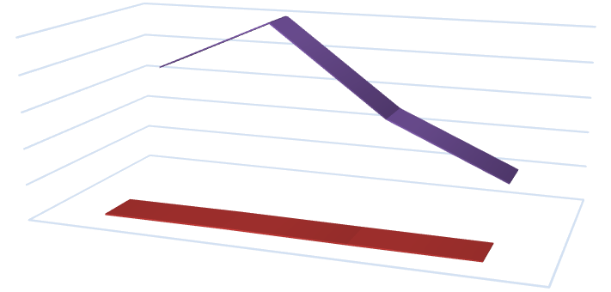

Percentage

Frequency

0.00

%

1000.00

%

2000.00

%

3000.00

%

4000.00

%

5000.00

%

21

to

30

years

40

to

31

years

50

to

41

years

60

to

51

years

%

29.17

%

41.67

20.83

%

%

8.33

35

50

25

10

**Age of respondents**



Percentage



Frequency

Source? Analyze! Interpret

5.1.3. fig 3-Educational qualification of respondents

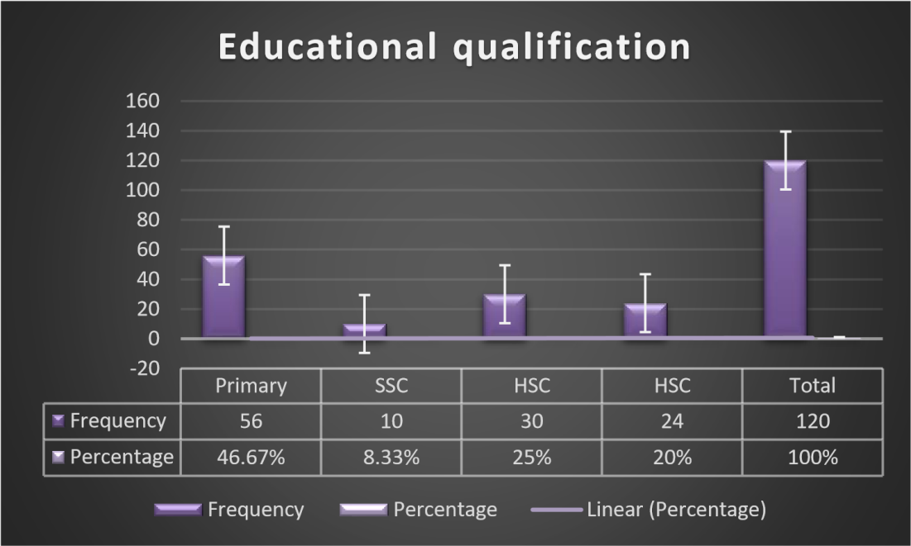

Source? Analyze! Interpret!

5.1.4. table 2-Employment status of respondents

|  |  |  |
| --- | --- | --- |
| **Employment status** | **Frequency** | **Percentage** |
| **Male (60)** | Employed - 43 Unemployed -17 | Employed - 71.67% Unemployed - 28.33% |
| **Female (60)** | Employed - 30 Unemployed - 30 | Employed - 50% Unemployed - 50% |
| **Total** | 120 | 100 |

Source? Analyze!

5.1.5. fig 4-Number of respondent’s children



None

2

1

to

2

to

3

0

20

40

60

Frequency

Percentage

Frequency

Percentage



None

35

29.17

%



1

2

to

40

33.33

%



2

3

to

45

37.50

%

**Number of respondent’s children**

Source?

Tables and figures under 5.1 section show that the study included equal numbers of male and female respondents, 60 male and 60 female. This selection process was considered important to us because it can give proper insight of integration process experienced by both genders, not overpowering another. We had the highest number of respondents in ‘31 to 40 years’ age group that is 41.67%, followed by 29.17% respondents from ‘21 to 30years’ group, 20.83% from ‘41 to 50 years’ group and the lowest number 8.33% from ‘51 to 60 years’ age group. The Most common level of educational qualification possessed by respondents is primary education about 46.67%, followed by HSC then graduation level. Around 72% of the male respondents were employed while female participants had same proportional rate of being employed and unemployed that is 50:50. Around 37.50% respondents had 3to 4 children which was highest, followed by 33.33% ofrespondentspossessed only 1 or 2 children and 29.17% had no children.

**5.2 Experience of cultural shock suffered by IDPs**

In order to measure the level of ‘Cultural shock’ suffered by our study respondents, we have collected their feedback on a questionnaire set arranged according to the stages of cultural shock theory which were measured in an integrity scale of Low, Medium and High.

In response to the question of finding any differences such as language, food, culture etc. with current and previous community setting after displacement, most respondents answered that they found lower level of difference, whereas few found the difference level in medium and high apparently.

5.2.1-table 3- Responses collected on experience of ‘Cultural shock’

|  |  |  |  |  |
| --- | --- | --- | --- | --- |
| **Concerns related to ‘Cultural shock’ stages** | | **[Respondent’s feedback in Likert scale]**  **High Medium Low Nil** | | |
| **1. experiencing difference of language, food habit, culture of new community with the previous one** | | 0 55 35 30 | | |
| **2. level of surprise with new people, language, food, culture** | | 65 35 15 5 | | |
| **3.finding any difficulties communicating with new people** | | 10 60 35 15 | | |
| **4. any difficulties accepting their food habit, culture, festival, customs** | | 0 35 | 70 15 | |
| **5.If yes, feels frustrated with these existing differences** | | 5 30 | 50 35 | |
| **6. completely got accustomed with new people & surroundings now** | | 50 20 | 50 0 | |
| **7.How long it took to get adjusted with new settings and people** | | (Months)  25 (21%) | (Years)  95 (79%) | |

Source?

According to the Table 3, out of total 120 (One hundred and twenty) targeted IDPs chosen for our study, the highest number of 55 (Fifty five) persons found difference in language, food habit, culture etc. with their previous areas of residence compared to the newly settled one after migration. The surprising element in the exiting difference were accepted by around 65 respondents rated as high, followed by 35 people rated as medium scale. Later on, the question of difficulties in communicating with new people of migrated area, the most common response was ‘Medium’ by 60 people and 35 people found it less difficult consequently. It has been observed that people had low level of inconvenience in the process of adopting to the new environment, settings, culture, language etc. as highest 70 people corresponded with ‘Low scale’ and 35 responded to ‘Medium scale’. Around 50 respondents answered that they do not feel frustrated in relation to existing differences in new areas and 30 people remained neutral here. However, on the question of getting accustomed with new people and surrounding in all respect, surprisingly the responses were equally divided into 50 people responding ‘High’, on the other hand, 50 people responding ‘Low’. And about 79% of respondents felt, it took them years to get completely adjust at their new accommodation.

**5.3 Identifying major influential factors in the social integration process of IDPs with host community**

According to the theoretical framework of the study, we have collected response following Fedorenko’s four components of social integration process among Padma riverbank erosion affected IDP’s of Tepakhola and Ambikapur areas. By using ‘Likert-scale’ of measuring respondent feedback on close-ended survey questionnaire related to our study objectives, we have got a comprehensive view on their level of social integration in four major areas of their current setting. It has been showed the summarized respondent’s feedback represented in the following tables.

5.3.1 fig 5-Level of ‘Socio-cultural’ integration

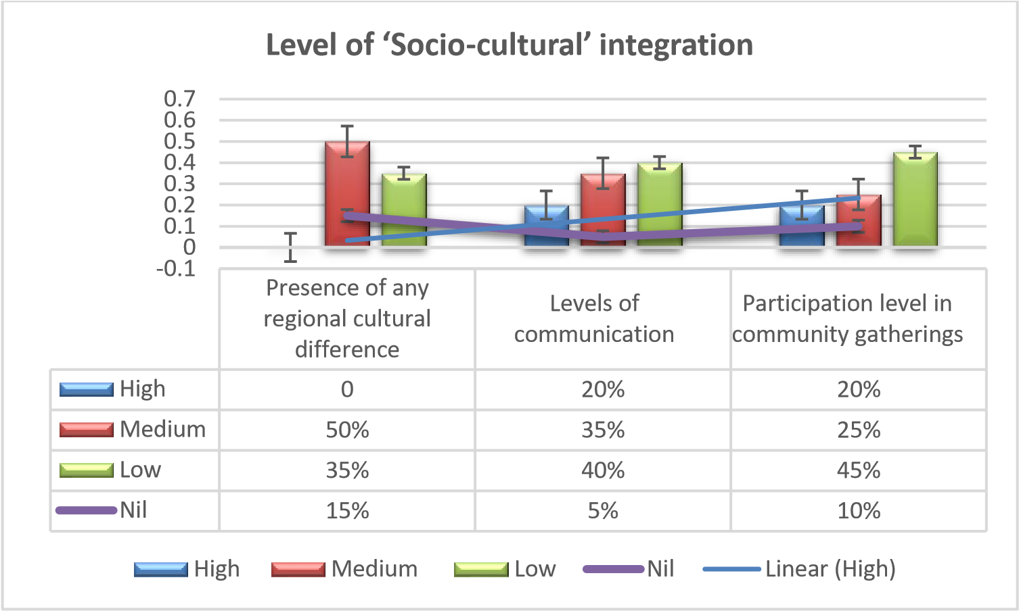

Source?

Following Fedorenko’s ‘Social integration’ model, we have taken into account about three factors playing pertinent roles in deciding IDP’s ‘Socio-cultural’ integration process in a new setting, for instance it is IDPs from Tepakhola and Ambikapur areas in our study. After conducting close-ended questionnaire survey on the targeted IDPs, the result discovered that a highest number of people found some regional cultural differences when they came for living in a new area. 50% people marked the difference level in ‘Medium scale’, only 35% people found it as ‘Low’ and 15% people chose to remain undecided. The communication level also revealed quite low with their new neighbors which is around 20% people rated as ‘High’ and 35% people as ‘Medium’ in contrast 40% people found it ‘Low’. For the next factor on question of excess to community gatherings alongside host community, the highest response was ‘Low’ from 45% respondents, 20% and 25% rated it ‘High’ and ‘Medium’ respectively and 10% remained neutral.

5.3.2fig 6- Level of ‘Socio-economic’ integration

Source?

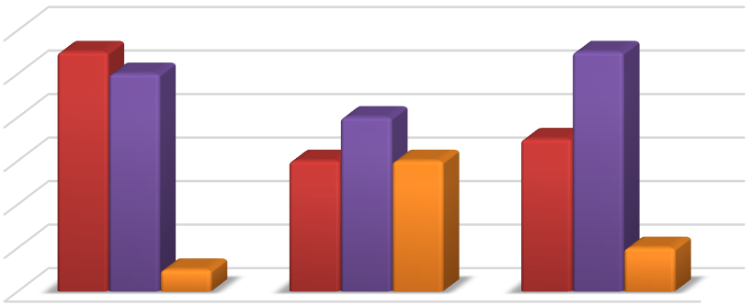

%

0

%

10

20

%

30

%

%

40

50

%

60

%

Housing & Livelihood

condition

Employability

Property & savings

%

45

30

%

35

%

50

%

40

%

55

%

5

%

30

%

10

%

**Respondent’s feedback in integrity scale**



Better



Worst



Unchanged

Now moving to the next component of ‘Social integration model’, we recorded responses on three factors related to IDP’s current economic conditions after facing migration due to riverbank erosion. On the question of their housing and living conditions, the highest 50% participants said it to be worse off than previous accommodation, whereas 45% rated their condition better. The next question was about their source of income where the highest 40% participants claimed to be unemployed after migration, 30% being employed and 30% remained neutral. Moreover, the highest 55% participants have left with no proper savings and property on their names and 35% persons said to possess better savings than previous condition.

5.3.3 fig 7-Level of ‘Socio-political’ integration



**%**

**8.33**

**25**

**%**

**%**

**4**

**00**

**25.**

**%**

**37**

**.50**

**%**

**0**

**%**

**%**

**2.50**

**1**

**3**

**3.33**

**%**

**4**

**1.60**

**%**

**%**

**2.50**

**1**

%

-20.00

-10.00

%

%

0.00

10.00

%

20.00

%

30.00

%

40.00

%

50.00

%

60.00

%

EXTREMELY SATISFIED

SOMEWHAT SATISFIED

NEITHER SATISFIED/DISSATISFIED

SOMEWHAT DISSATISFIED

EXTREMELY DISSATISFIED

**Socio**

**-**

**political integration factors**

Getting relief/aid from state agencies

Source?

Questions concerning the participation level in community decision-making, as part of ‘Social-political’ integration process, the most common response recorded in this module was extremely or somewhat dissatisfied involving around 62.50% of respondents, followed by 33.33% people rating it as ‘somewhat or extremely satisfied’. On the next question about receiving any kind of aid/relief from the government, the highest response was ‘extremely or somewhat dissatisfied’ composing 54.10% participants, followed by a large section of 33.33% participants chose to remain silent in this question and only 12.50% people found their participation as highly satisfactory.

5.3.4 fig 8-Level of ‘Socio-psychological’ integration

|  |  |  |
| --- | --- | --- |
| **Socio-psychological integration factors** |  | **[Respondent’s feedback in integrity scale]**  **High Medium Low Nil** |
| 1. **integration with community** | **new** | 20 20 55 25 |

**b.feelings of belongingness** 15 40 50 15

|  |  |  |  |  |  |
| --- | --- | --- | --- | --- | --- |
| **c.** | **motivation for permanent**  **settlement** | 25 | 30 | 15 | 50 |

Source?

The last component of the model was integration at ‘Socio-psychological’ level with new host community. Upon asking about their relation or interaction with surrounding people, highest 55 participants felt lower level of connectivity with neighbors, followed by 25 participants rating it ‘Nil’, another 20 called it ‘Medium’ and only 20 found it ‘High’. Feeling of belongingness was lowest among the highest number of participants that is 50; ‘Medium’ by 40 and only 15 said it ‘High’ at their current residential areas. Most of the participants were uncertain about their future which is why around 50 gave no answer to their permanent settlement at the current area. On the other hand, 25 respondents were quite confident about their motivation to become permanent hereafter.

**Qualitative analysis section**

According the Minister of Water Resources department, about 30 to 40% of homeless people in Bangladesh are mainly river erosion affected people whose number is around 50,000 (Fifty thousands) households per year (Sun, 2019). These people become the victim of aggressive Padma’s heavy erosion; they are forced to dismantle their own houses as their fortune sink. During monsoon, especially in September, October months river erosion takes severe form and within three months span around 5,081 families got uprooted from their origin, confirmed by local government in 2019 (Sun, 2019).In voice of one of the participants on choosing new destination for settlement, *“I could not understand what was going to happen and suddenly within 23 days, my whole home was gobbled up by the mighty Padma. We lost everything before our eyes. With no clue of where to go, my relative here (at current migrated place) suggested me to come here, offering me some land.”*(S. Ahmed, personal interview, 20 December, 2023)Although few get lucky to have their relatives who give them temporary shelter, most of displaced people are unfortunately left to live under open sky overnight having no support at all. Since 1973, Bangladesh’s major rivers such asthe Jamuna, Ganges and Padma continuously destroyed around 1590 square km of floodplains leaving 1.6 million homeless (Sun, 2019).

Among the participants, some told us, *“After coming to new place, people did not receive us warmly, had been less friendly, did not talk to us often. Only those few relatives we had had communications with us. We were never invited in any of marriage ceremony, cultural programmes or functions hold at our community.”*(R. Talukdar, personal interview, 1 January, 2024)

Due to river erosion, the floating population of refugees and homeless people increases by 250,000(Two lakh fifty thousands) per year. River erosion occurs in 51 districts out of the 64 districts of Bangladesh which is a testament of how crucial to address the suffering of these displaced populations. Forced displacement as a result of sudden river erosion is the dreadful impact innocent people face due to loss of homes, lands, property and livelihoods. 4.7 million people were displaced from 2008-2014 due to natural disasters in Bangladesh, estimated by Internal Displacement Monitoring Centre(Sun, 2019). One of the respondents said, *“This horrific Padma has engulfed my patrimonial inherited 60 bigha farming lands and made me destitute overnight, I have nothing left to pass on to my children”.* (K. Sheikh, personal interview, 10 January, 2024)Not only people lose their homesteads, agricultural lands, but also the entire community lose valuable infrastructures like dams, roads, schools, bazaars, orphanages too (Chowdhury, 2022).

Because of low income, many parents who have more than 3 children are unable to continue their education after displacement. Moreover, they fall into the web of rural poverty because of forced displacement and its related negative impacts.*“Neither government nor any NGO did anything for us. Currently we are living on others’ mercy, on others land by borrowing money. Some grant from government or NGO could have been a big support for us”*(F. Khatun, personal interview, 10 January, 2024) expressed by a migrated women participant. Many IDPs interviewed expressed, *“People hves a negative perception towards river erosion affected people and calling us ‘Nodi bhangar manush or Beribadher lok’ are not good people. Therefore, we do not get any respect anywhere.”*(H, Mia, personal interview, 23 December, 2023)

Although river erosion problem is beyond human control, initiatives to lessen their misery are ofcourse relies on the government.

# 6. Discussion

This study mainly shaded light on the very much neglected issue of ‘Social integration’ of internally displaced persons who migrated to Tepakhola and Ambikapur areas, situated at FaridpurSadarUpazilla, due to losing their habitat in Padma’s riverbed in the past. Particularly it tried to explore initial ‘Cultural shock’ syndrome suffered by IDPs who comes to a new place all of a sudden due to failure of adapting to new ambience. In addition, the study uncovered some major setbacks in the ‘Social integration’ procedures that take place between host community and those IDP’s in that new settlement aftermath of migration. Analyzing all of those primary and secondary data collected for our study, we can make a generic statement that ‘Social integration’ is a long and continuous process which take into account of both IDPs and host community’s everyday interaction on cultural, economic, political and psychological levels. Prior communication and relatives are seen as major influence in choosing new address for IDPs.

The vulnerabilities suffered by river erosion affected people have been examined in relation to four integral aspects of social life, which are- cultural, economic, political and psychological. Overall, in terms of adapting to the current regional cultural differences; for example, in language, food habit, cultural norms and rituals, precisely 50% of study participants, migrated IDPs felt the differences ‘Medium’ and 35% found it quite ‘Low’. But more than half respondents reported no serious complication while interacting with the host community in their day-to-day life, only 40% claimed to have less communication with neighborhood peoples. Remarkably, despite maintaining better degree of communication with fellow neighbors at Tepakhola and Ambikapur areas, 45% of our study respondents accepted to have little participation in community gatherings like social festivities, occasions etc. against merely 20% and 25% who said to have high and medium involvement respectively, showed in Figure 9.

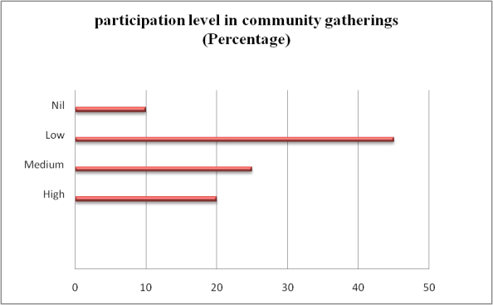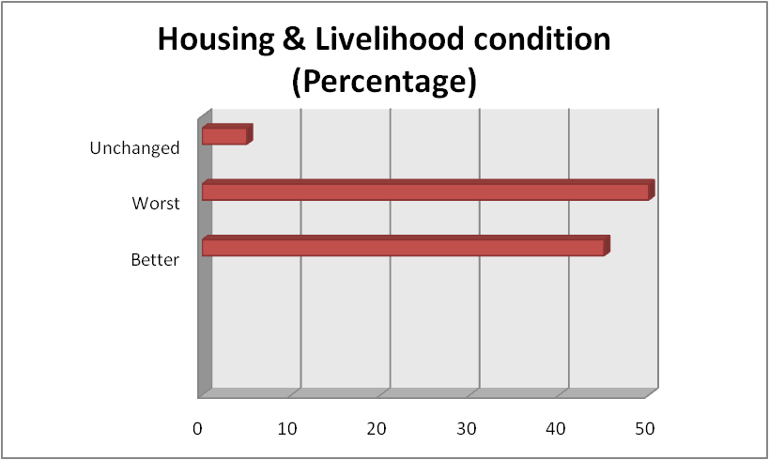

**Figure 9 Participation level in community gatherings**

**Figure 10- Housing & livelihood condition**

Current state of livelihood condition is worst for 50% of the respondents, so are their housing condition. The primary reason behind it was the displacement due to riverbank erosion they had to face and lost their home, agricultural lands, property etc. everything destroying their future. Mostly people are living in rental houses after coming here because of landless condition and the percentage is the highest around 50 (Figure 10) who are bound to stay at rental houses finding no other way around which is quite difficult to sustain as their earning has decreased compared to the past because of employment scarcity. Several displaced respondents voiced also that because of currently living in rental houses, they cannot rear domestic animals as well as cultivate various types of vegetables, another common source of earning at the frontier or backside of their houses which previously could be done easily as they were owner of those lands before becoming victim of river erosion.

On the other hand, only 33.33% of the IDPs possessed their own building after migrating here at Tepakhola and Ambikapur. The primary reason behind it is, the long duration of staying here after facing displacement, for example, many of them living for 10 to 15 years after migration at Tepakhola and Ambikapur areas and they have settled down here very comfortably and their income per month is quite high compared to those larger section of poor IDPs, which is around 70% whose earning is between 10,000 (Ten thousands) to 15,000 (Fifteen thousands)BDT per month. However, it is observed from the survey data that respondents who have got better employability options right now because of migration are enjoying better lifestyle in terms of housing, income generation and it comprised 45% of total participation. About 16% IDPs belongs to affluent class where one/two family members reside in abroad or does private jobs, have stability in income source of 25,000 (Twenty-five thousands) to over 50,000 (Fifty thousands) BDT per month. In the current socio-economic condition of Bangladesh, 70% of displaced persons interviewed have lower income and poor living status that’s a large portion works as farmers, day labourers, and drivers or remain unemployed (Figure 11). The most vulnerable section comprises almost 8.5% who have less than 10,000 BDT (Ten thousands) to survive with their family and forced to live in mud house, tin shade houses etc. It is sad that those living in poverty line cannot even afford to send their children to schools because of economic crisis. Consequently, we need to mention about the discovered relation between economic solvency and degree of social integration in current settings is found to be higher among those IDPs who are influential in economic status, resides in own lands. However, for others with low economic status, their integration level is quite low and has less participation in community level decision-making too. This finding coincides with Alam (2017) study, which also revealed a strong relation between low livelihood status and poverty cycle suffered by hazard prone households (Alam, 2017).



**8**

**%**



**70**

**%**



**6**

**%**



**%**

**16**

Average household income per month

Less than 10,000 BDT

10

,000

–

15

,000 BDT

15

,000

–

25

,000 BDT

25

,000

–

,000 BDT

50

Figure 11: Average monthly income per household

Source?

However, one important aspect we observed that the role of government agencies or non-governmental organizations in lessening the IDP’s suffering by providing aid assistance and relief is found to be rare, as dissatisfaction level is 50% among the respondents, out of which 15% expressed extremely dissatisfied and about 40% avoided from answering the question that was quite unexpected response from them. The support of immediate shelter, food, water, place for living etc. are the basic needs of those internally displaced people voiced by the study respondents what they expected to have from the government and other humanitarian organizations but did not get any when they lost everything in Padma’s dreadful swallowing. Although river erosion problem is beyond human control, initiatives to lessen their misery is of course relies on the government. Thus, our study finding further underscores the importance of government and non-governmental guideline to address the suffer and needs of IDPs echoing Rahim et al. (2024)’s call for proper framework.

Also, our findings indicate the frequency of displacement experienced by river erosion affected IDPs has a significant role to play on their psychological decision making for permanent settlement at their new destination. According to the survey reports, 66.66% IDPs has been displaced once because of riverbank erosion whereas 33.33% were displaced twice or more in their lifetime which has made them comparatively more vulnerable in all aspects of life than those has suffered only once.

Out of 120 (One hundred and twenty) respondents selected for this study, 50% were at indecision regarding their motivation behind settlement in their current places as they are not well integrated into society yet. This is why half percentage of our study population said to have low level of faith in terms of ‘social integration’ at their current settings. This reinforces the previous study findings of Penning et al. (2013) which says social ties, attachments are strong for settling in new migrant locations (Penning et al., 2013).

Unlike those facing displacement all of a sudden suffer miserably comparatively than those who have gradually shifted to a new place with proper resources beforehand. Black et al. (2011) supports the view that migration is seen as a way to improvise income source and build resilience for many to outdo natural hazard shocks (Black et al., 2011). Although it does not fully support our study findings, it is partially true for those IDP’s who choose migration as safety option even before losing homelands and started settling into new place progressively and found better employability too.

Regarding perception about ‘Motivation for permanent settlement’, our survey data explores that higher education level and employability play great influencing factors among participants, when asked about their ultimate faith level in permanent settling down at current places. Around 66 participants showed high level of ‘Faith’ for settling down permanently out of which male participants are highest in numbers in contrast to female. 58.34% employed male participants responded positive whereas comparatively ‘Low Faith’ level was identified among female participants. And factors like low-income source, social exclusion, lower educations levels were identified as primary reasons behind their ‘Low Faith’ which were identified during interviews. Thus, it gave us a new insight of the picture differing from previous research results. Author pagination

**7. Conclusion**

In this article, the researchers evaluated the challenges of cultural shock of river erosion affected IDP;, when they had to migrate. Another key focus of this research was to examine the major influential factors when they try to integrate in a new community. By incorporating the ‘Cultural shock’ concept of Oberg and the ‘Social integration model’ of Fedorenko, the researchers came to the conclusion that migrated people at Tepakhola and Ambikapur of the 'Ishan Gopalpur Union face major challenges on various levels of socioeconomic, cultural, political, and psychological contexts. A high percentage of IDPs feel insecure in terms of their present employability, housing condition, and savings, along with remaining disconnected from local community engagement after settling down in a new area. Drawing from on-field empirical data, it has been observed that the lack of a comprehensive policy framework at the governmental level inaddressingthe internal migration issue in Bangladesh is driving climate change-affected people to live in mercy of nature, without protection and propelling them into an uncertain future. As 70% of climate induced-displaced people have experienced displacement more than once, Bangladesh needs to develop policies holistically dedicated to protecting migratory people at local levels as well as fix a budget to fit the crisis of loss and damage. It is important to note that across each of the areas studiedfor this study paper under Faridpur Sador Upazila, there was no huge difference in result counted in four sectors of social integration because of geographical location or environmental exposure. The findings of this study can facilitate our national policy makers while drafting framework and programmes addressing riverbank erosion-affected people’s sufferings in future. A more holistic and inclusive framework is prerequisite if the vulnerability level of those IDPs needs to be minimized by ensuring standard livelihood and social protection across Bangladesh. The conclusion does not contain an opening

**8. References**

Ahmed, Dilshad and Afzal, Muhammad. (2021) Flood hazards, human displacement and food inxsecurity in rural riverine areas of Punjab, Pakistan: policy implications. Environmental Science and Pollution research, 28, 1012510139. https://doi.org/10.1007/s11356-020-11430-7

Alam, G. M. M. (2017) Livelihood cycle and vulnerability of rural households to climate change and hazards in Bangladesh. *Environmental Management, 56, 777-791*. https://doi.org/10.1007/s00267-017-0826-3

Ali, Md. H. and Khan, U. F. (2023) ‘Socio-Economic Impacts of Teesta Riverbank Erosion: Evidence from Lalmonirhat District, Bangladesh.’ *International Journal of Advanced Multidisciplinary Research and Studies. 3 (4): 471-476*

Anam, Mahfuz. (2021) ‘River Erosion May Eat Up 28sq km area: Forecasts a Govt Research Organisation’. *The Daily Star.* https://www.thedailystar.net/backpage/news/river-erosion-may-eat-28sq-km-area-2109245

Black, Richard; Stephen Bennnett; Sandy Thomas & John Beddington (2011) Migration as adaptation. *Nature* 478: 447-449.

Chowdhury, M. H. (2022, September 17). River erosion makes thousands homeless and gobbles up farmlands. *bdnews24.com*. https://bdnews24.com/bangladesh/3ks01d61uk

Dauda, H. J. &Kolo, D. M. (2022). Effects of Flooding on Internally Displaced Persons (IDPs) in a Flood Prone Area: A Case Study of Muye Town in Lapai Local Government Area, Niger State, Nigeria. *KIU Journal of Social Sciences, 8(2w),* 157-168.

Fayehun, O. &Akanle, O. (2022). Humanitarian Crises and Internally Displaced Persons (IDPs) in Nigeria, A Situation Analysis. The University of Warwick.

Fedorenko, O. (2018) The theoretical model of social integration of internally displaced persons in the community. *Bulletin of Taras Shevchenko National University of Kyiv Social Work.* https://doi.org/10.17721/2616-7786.2018/31/4

Ghráinne, N.,Bríd. (2022) Internally Displaced Persons and International Refugee Law. Oxford University Press, UK.

Khan, M. S., & Sepulveda, L. (2022). Conflict, displacement and economic revival: The case of the internally displaced minority entrepreneurs in Pakistan. *Strategic Change, 31(4),* 461-477.

# McAdam, Jane. (2020) Current Developments - Protecting People Displaced by the Impacts Of Climate Change: The UN Human Rights Committee and the Principle of Non-Refoulement. American Journal of International Law, 114(4), p. 708-725

Md. Islam Azharul et al., ‘Impacts of Riverbank Erosion Hazards in the Brahmaputra Floodplain Areas of

Mymensingh in Bangladesh’ (2017) 28(2), *Progressive Agriculture*, 73–83 https://www.banglajol.info/index.php/PA/article/view/33467

Md Rayhan Ali et al. ‘River Bank Erosion, Induced Population Migration and Adaptation Strategies in the SirajganjSadarUpazila, Bangladesh’ (2021) 2(2) *European Journal of Environment and Earth Sciences* 131.

Miah, M. A. (2001) Effect on water resources from upstream water diversion in the Ganges basin. J Environ Qual, 30 (2): 356-368.

Myers, Norman. (2001) Environmental refugees: a growing phenomenon of the 21st century. The Royal Society.

Oberg, K. (1960). Cultural Shock: Adjustment to New Cultural Environments. *Practical Anthropology 7: 177-182*

OCHA Guiding Principles on Internal Displacement. (1998) IDMC. https://www.internal-displacement.org/internaldisplacement

Odunmorayo, Emmanuel. (2015) The Number of Internally Displaced Persons (IDPS) in Nigeria is growing, quickly. *Ventures Africa*. https://www.venturesafrica.cxom/the-number-of-internally-displaced-persons-idps-in-nigeria-isgrowing-quickly/

Penning-Rowsell, Edmund C; Parvin Sultana; Paul M. Thompson (2013) The ‘last resort’? Population movement in response to climate-related hazards in Bangladesh. *Environmetal Science & Policy* 27(1): S44-S59.

Poncelet Alice et al, A Country Made for Disasters: Environmental Vulnerability and Forced Migration in Bangladesh, in Environment, Forced Migration and Social Vulnerability by Tamer Afifi and Jill Jager (editors), Springer: 2010, New York, P. 213.

Porter, M. & Haslam, N. (2005). Predisplacement and postdisplacement factors associated with mental health of refugees and internally displaced persons: A meta-analysis. *Journal of the American Medical Association, 294(5),* 602-612.

RabiulHaque et al. (2020) Climate-related displacement, impoverishment and healthcare accessibility in mainland Bangladesh. Asian Population Studies. Volume 16, 2020. https://doi.org/10.1080/17441730.2020.1764187

Rahim, Md. A. et al., (2024) ‘Assessment of Socio-Economic Impacts of River Bank Erosion: Enhancing Resilience in the Coastal Belt of Bangladesh’ *The Journal of Environment & Development.* https://doi.org/10.1177/10704965241246710

Rakib, M. A. et al. (2019) Severe salinity contamination in drinking water and associated human health hazards increase migration risk in southwestern coastal part of Bangladesh. *Journal of Environmental Management*. https://doi.org/10.1016/j.jenvman.2019.03.101

# Rowling, Megan. (2020) Climate change could create 63 million migrants in South Asia by 2050. *Reuters.* December 18, 2020. https://www.reuters.com/article/us-climate-change-migration-southasia-tr-idUSKBN28S1WV

Saha K. S. (2016) Cyclone Aila, livelihood stress and Migration: Empirical evidence from costal Bangladesh. *Disasters.* https://doi.org/10.1111/disa.12214

# Sharma, Bhumika. (2023) Climate Displacement in South Asia and India’s Imperative to Act. *South Asian Voices.* June 13, 2023 https://southasianvoices.org/climate-displacement-in-south-asia-and-indias-imperative-to-act/

Steel, Z.;Chey, T.; Silove, D.; Marnane, C.; Bryan, R. & Van Ommeren, M. (2009). Association of torture and other potentially traumatic events with mental health outcomes among populations exposed to mass conflict and displacement: A systematic review and meta-analysis. *Journal of the American Medical Association, 302(5),* 537-549.

Sun, D. (2024, September 9). *River erosion: A silent disaster in Bangladesh*. Daily-sun. https://www.daily-sun.com/printversion/details/421798

# Sun, Yazhou. (2022) Climate Migration Pushes Bangladesh’s Megacity to the Brink. *Bloomberg*. June 29, 2022. https://www.bloomberg.com/news/features/2022-06-28/bangladesh-flooding-fuels-climate-migration-to-dhaka

WFP Emergency Report No. 45 of 2000. 10 Nov 2000. *Relief Web*. https://reliefweb.int/report/bangladesh/wfpemergency-report-n0-45-2000

1. Bangladesh Population and Housing Census 2011 Zila Report – Faridpur" Cultural survey report of Faridpur SadarUpazila 2007.