Original Research Article

A Study on the Development of 21st Century Skills among Girls at Kanya Shiksha Parisar in Madhya Pradesh

Abstract
In today’s fast-changing global environment, education must equip learners not only with academic knowledge but also with essential 21st-century skills such as critical thinking, communication, leadership, collaboration, and creativity. This study explores how effectively Kanya Shiksha Parisars (KSPs) in Madhya Pradesh are fostering these skills among girl students through a holistic and inclusive educational approach. Employing a mixed-methods design, the research draws on responses from 1,259 students, 130 teachers, and 26 head teachers across 26 KSP campuses, selected through stratified random sampling.
Quantitative data from student surveys and qualitative insights from teacher feedback reveal a high level of student engagement in skill-building activities. Over 85% of respondents affirm that KSPs positively contribute to their development in areas such as teamwork, time management, leadership, and problem-solving. However, gaps remain in access to leadership opportunities, digital literacy, and creative skill enhancement. Teachers show strong intent but face challenges such as curriculum overload and limited resources, hindering the integration of innovative pedagogies. The study concludes that KSPs are significantly advancing the development of 21st-century skills among girls but would benefit from further systemic support, targeted teacher training, and enhanced digital infrastructure.
Keywords: 21st-century skills, Kanya Shiksha Parisar, girls' education, Madhya Pradesh, critical thinking, leadership, holistic development, digital literacy, student empowerment.

- Introduction
In the 21st century, the nature of education has undergone a paradigm shift. As global challenges become more complex and the demand for innovation grows, the need for equipping students—especially girls—with essential 21st-century skills has become more pressing than ever. These skills, including critical thinking, creativity, collaboration, communication, leadership, adaptability, and digital literacy, are vital for learners to succeed in an increasingly interconnected, competitive, and dynamic world. Beyond traditional academic competencies, these skills prepare students to become proactive, resilient, and innovative problem-solvers.
India, despite substantial progress in educational access, continues to face gender disparities in terms of learning outcomes, opportunities, and leadership development. Recognizing the need for focused, gender-sensitive education, the Government of Madhya Pradesh introduced Kanya Shiksha Parisars (KSPs)—residential schools designed to offer quality education to girls, particularly those from disadvantaged and marginalized communities. These institutions aim to foster not only academic learning but also holistic personal development, encouraging girls to emerge as confident and capable individuals ready to thrive in the 21st century.
KSPs emphasize a blend of classroom learning, extracurricular activities, leadership training, and wellness practices to foster a wide range of competencies. Students engage in project-based learning, peer collaboration, and leadership roles while also participating in creative and performing arts, debates, field visits, and sports—all of which contribute to the development of well-rounded personalities. However, the actual impact of these strategies on students’ acquisition of 21st-century skills remains an under-researched area.
Educational researchers emphasize the need to embed these competencies within daily teaching and institutional culture. Trilling and Fadel (2009) outlined that modern education must prioritize “learning and innovation skills,” including problem-solving and communication, alongside digital competencies. Ravitz et al. (2012) argued that project-based learning environments significantly enhance skills such as collaboration and critical thinking. In India, Mishra and Koehler (2006) advanced the TPACK framework, which supports integrating technology, pedagogy, and content knowledge to build digital and creative capabilities in students.
The National Education Policy (NEP), 2020 provides a strong policy framework that supports this vision, advocating for holistic, multidisciplinary, and skill-oriented education. It promotes inquiry-driven, discovery-based, and learner-centered teaching approaches. Yet, there is a clear research gap in assessing how ground-level institutions like KSPs are translating these principles into practice, particularly concerning girls’ skill development in low-resource or rural settings.
This study aims to evaluate the role of Kanya Shiksha Parisars in fostering 21st-century skills among girls in Madhya Pradesh. Through a combination of quantitative student responses and qualitative teacher feedback, the research highlights institutional strengths, pedagogical gaps, and opportunities for systemic improvement. In doing so, it contributes to the discourse on gender equity in education, and the broader national goal of empowering girls through meaningful, future-ready learning experiences.
- Review of Related Literature
In the rapidly evolving landscape of the 21st century, education systems around the world are being redefined to equip learners with more than just academic knowledge. Key competencies such as critical thinking, collaboration, creativity, communication, and adaptability are now regarded as essential for navigating the demands of modern life and work (Trilling & Fadel, 2009). These 21st-century skills enable students to solve complex problems, lead effectively, and engage meaningfully in society. The Partnership for 21st Century Learning (P21) highlights these core domains—learning and innovation skills, life and career skills, and information, media, and technology skills—as the cornerstone of a future-ready education (Bell, 2010).
The education of girls, particularly in developing countries like India, is central to achieving broader developmental goals. Research by UNESCO (2016) emphasizes that investing in girls’ education results in numerous societal benefits including improved health, reduced poverty, and increased civic participation. However, many girls continue to face structural and cultural barriers that limit their access to skill-based education. In this context, programs like the Kanya Shiksha Parisar (KSP) serve a transformative role by offering residential schooling that prioritizes both academic achievement and life skill development. Studies such as those by King and Winthrop (2015) suggest that gender-responsive schooling not only improves learning outcomes but also contributes to empowerment and leadership among adolescent girls.
India’s National Education Policy (NEP) 2020 has reoriented the national vision of education by calling for competency-based, experiential learning that integrates critical thinking, creativity, and communication skills into the curriculum. The policy advocates for a shift from rote learning to student-centered pedagogies such as project-based learning, collaborative activities, and vocational exposure (Government of India, 2020). Despite this vision, on-the-ground implementation in government-run schools remains inconsistent due to resource constraints and teacher preparedness. Residential models like KSPs, designed to provide holistic education in a safe environment, present a promising opportunity to align practice with policy.
Teachers play a pivotal role in this transformation. The Technological Pedagogical Content Knowledge (TPACK) framework introduced by Mishra and Koehler (2006) underlines the importance of integrating technology, content, and pedagogy to foster 21st-century skills. Yet many Indian teachers, particularly in rural and government schools, continue to rely on traditional lecture-based methods that leave limited room for innovation and student participation (Banerjee et al., 2017). For effective skill development, there is a pressing need to empower educators through ongoing professional development and reduce the pressure of overburdened curricula.
The residential model of schooling has also been studied for its positive impact on girls’ development. Research by Nayar (2011) and Kabeer (2005) demonstrates that when girls are placed in nurturing environments away from limiting social norms, they exhibit greater self-confidence, participation in leadership roles, and academic ambition. Access to co-curricular activities, field visits, and life skill training in such settings significantly boosts their capacity to thrive in a complex world.
Despite a growing body of global and national research on 21st-century skills, there is limited empirical work focusing specifically on residential girls’ schools in India. This study aims to fill that gap by investigating how Kanya Shiksha Parisars in Madhya Pradesh are fostering these essential skills through academic rigor, extracurricular involvement, and teacher-led initiatives.
- Objectives of the Study
The research was guided by three primary objectives:
- To evaluate the role of Kanya Shiksha Parisars in fostering 21st-century skills—such as critical thinking, teamwork, leadership, problem-solving, and creativity—through academic and extracurricular activities.
- To assess the efforts of teachers in promoting these skills among girl students through student-centered pedagogies and skill-oriented interventions.
- To identify the strengths, weaknesses, opportunities, and challenges (SWOC) in promoting 21st-century skills among girls at Kanya Shiksha Parisars (KSPs) in Madhya Pradesh, and to provide insights for strategic educational planning and policy interventions.
- Methodology
This study adopts a mixed-methods research design to comprehensively assess the development of 21st-century skills among girl students in Kanya Shiksha Parisars (KSPs) across Madhya Pradesh. The mixed-method approach enables the integration of both quantitative and qualitative data, offering a nuanced understanding of student experiences, teacher practices, and institutional efforts.
4.1 Sampling Technique
A stratified random sampling method was employed to ensure adequate representation from various regions and socio-economic backgrounds. The sample comprised 26 Kanya Shiksha Parisars across different districts of Madhya Pradesh, selected to capture geographic, cultural, and economic diversity. A total of 1,259 students, 130 teachers, and 26 head teachers participated in the study.
4.2 Data Collection Tools
To assess the development of 21st-century skills, a structured questionnaire was designed for students, featuring 13 key statements aligned with various skill domains. These included academic performance, creativity, teamwork, leadership, problem-solving, time management, and stress management. Responses were collected using a three-point Likert scale—Agree, Disagree, and Can’t Say—to gauge students' self-perceptions and experiences.
Additionally, a semi-structured questionnaire was administered to teachers and head teachers to gather insights into classroom practices, co-curricular initiatives, and perceived barriers in fostering 21st-century skills. Classroom observations and informal interactions also supported the qualitative findings.
- Results and Discussions
In today's rapidly evolving world, 21st-century skills—such as critical thinking, leadership, teamwork, problem-solving, and creativity-are essential for students to adapt, innovate, and succeed in their future endeavors. The Kanya Shiksha parisar (KSP) strives to cultivate these skills through a well-rounded educational experience that includes academic challenges, extracurricular activities, leadership opportunities, and personal development initiatives.
A survey conducted among 1,259 students at KSP aimed to assess their engagement in skill-building experiences. The overall findings, as detailed in Table 1, reveal a highly positive perception of the parisar’s role in fostering student growth, with 85.95% of responses being affirmative, while 10.51% disagreed and 3.54% were uncertain. These insights highlight both the successes and areas for enhancement in equipping students with the skills necessary for the 21st century.
Table-1: Number and Percentage of Student Responses regarding 21st Century Skill
 |  | N = 1259
S. No. |  | Statement |  | No. and Percentage of Responses
S. No. |  | Statement |  | Agree |  | Disagree |  | Can’t say
S. No. |  | Statement |  | N | % | N | % | N | %
1 | Academic and Extracurricular Engagement | I successfully complete subject-related, challenging projects and assignments. |  | 1211 | 96.19 | 24 | 1.91 | 24 | 1.91
2 | Academic and Extracurricular Engagement | I get opportunities to participate in music, arts, and drama at the KanyaShiksha Campus. |  | 1205 | 95.71 | 43 | 3.42 | 11 | 0.87
3 | Teamwork, Leadership, and Social Skills | Studying at the KanyaShiksha Campus has helped me develop teamwork and leadership skills. |  | 1124 | 89.28 | 91 | 7.23 | 44 | 3.49
4 | Teamwork, Leadership, and Social Skills | During school activities, I develop a sense of unity with my classmates. |  | 1227 | 97.46 | 17 | 1.35 | 15 | 1.19
5 | Teamwork, Leadership, and Social Skills | While working in groups, I cultivate empathy. |  | 1185 | 94.12 | 42 | 3.34 | 32 | 2.54
6 | Teamwork, Leadership, and Social Skills | I enjoy working in groups. |  | 1156 | 91.82 | 47 | 3.73 | 56 | 4.45
7 | Teamwork, Leadership, and Social Skills | By participating in activities as a leader, I have improved my communication skills and ability to connect with others. |  | 915 | 72.68 | 272 | 21.60 | 72 | 5.72
8 | Teamwork, Leadership, and Social Skills | I have had opportunities to lead as a class monitor, house captain, group leader, or student administrator. |  | 742 | 58.94 | 455 | 36.14 | 62 | 4.92
7 | Decision-Making, Conflict Resolution, and Competitions | I can easily resolve issues and disputes among my peers. |  | 1137 | 90.31 | 38 | 3.02 | 84 | 6.67
8 | Decision-Making, Conflict Resolution, and Competitions | I participate in competitions like debates and speeches. |  | 788 | 62.59 | 429 | 34.07 | 42 | 3.34
9 | Decision-Making, Conflict Resolution, and Competitions | I get opportunities to solve problems and make decisions through projects and other activities. |  | 1113 | 88.40 | 87 | 6.91 | 59 | 4.69
10 | Decision-Making, Conflict Resolution, and Competitions
11 | Decision-Making, Conflict Resolution, and Competitions
12 | Time Management and Stress Management | I complete all tasks or activities on time. |  | 1150 | 91.34 | 61 | 4.85 | 48 | 3.81
13 | Time Management and Stress Management | Stress management techniques, such as yoga and meditation, are taught at the KanyaShiksha Campus. |  | 1114 | 88.48 | 114 | 9.05 | 31 | 2.46
 |  | Overall |  | 1082.08 | 85.95 | 132.31 | 10.51 | 44.62 | 3.54

The results highlight the extent to which 21st-century skills are being fostered through academic, extracurricular, and leadership opportunities. The findings are grouped thematically for clarity.

  - Academic and Extracurricular Engagement
Students expressed strong confidence in their ability to complete subject-related, challenging projects and assignments, with 96.19% agreeing. Additionally, 95.71% stated that they get opportunities to participate in music, arts, and drama, highlighting the campus’s emphasis on holistic education. The high agreement rates in these areas suggest that students find the parisar academically stimulating and artistically enriching. These results reflect a strong academic foundation paired with opportunities for artistic expression—both vital for fostering problem-solving and creativity. The integration of these domains demonstrates KSP’s commitment to holistic education that goes beyond rote learning.
  - Teamwork, Leadership, and Social Skills
A significant 97.46% of students reported developing a sense of unity with classmates during school activities, and 94.12% stated that group work helps cultivate empathy. Furthermore, 91.82% enjoy working in groups, indicating that collaborative learning is both engaging and beneficial. The development of teamwork and leadership skills was acknowledged by 89.28% of students, reinforcing the effectiveness of the campus’s initiatives in building interpersonal skills.
However, while 72.68% of students felt that leadership activities improved their communication skills, only 58.94% had actually taken up leadership roles such as class monitor, house captain, or group leader. Meanwhile, 36.14% disagreed, indicating that leadership opportunities may not be equally accessible to all students. Encouraging broader participation in leadership roles could help bridge this gap. To address this, leadership roles must be more equitably distributed across the student population.

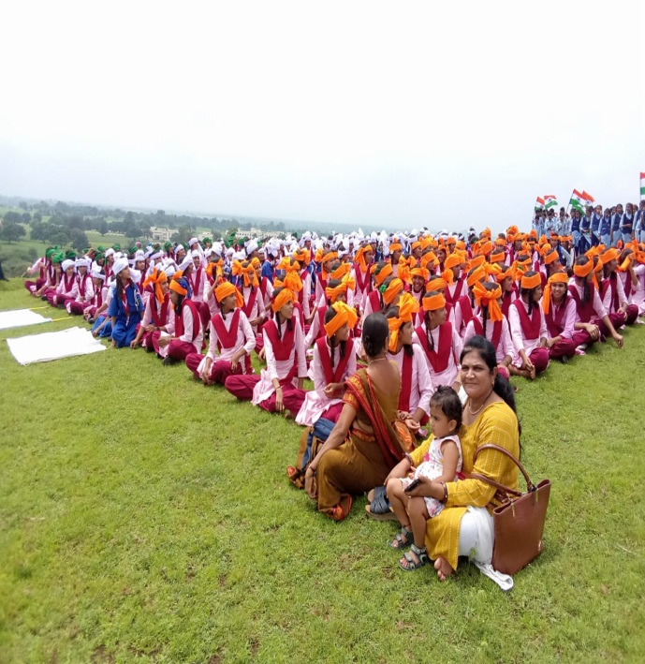 | 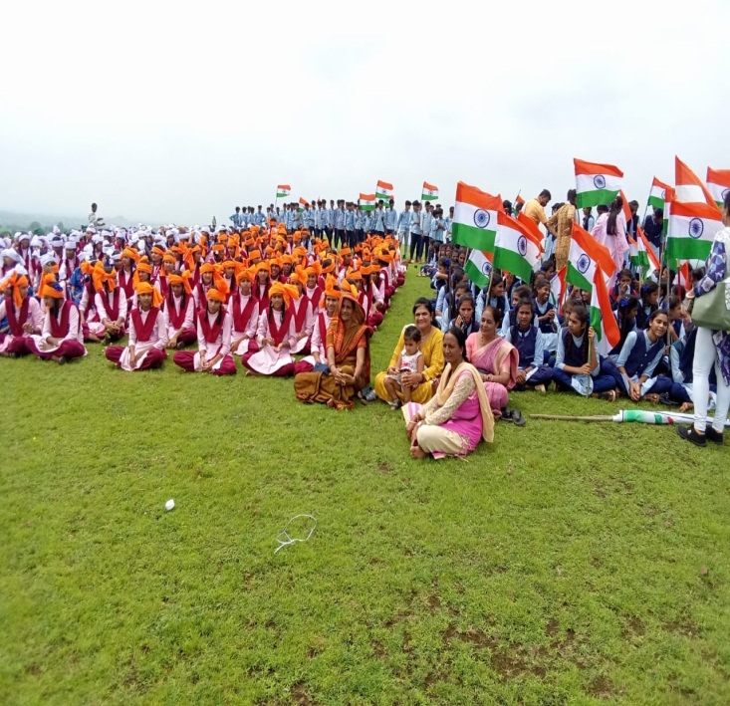
(Source-Primary Data) Picture-1- KSP Badwani

  - Decision-Making, Conflict Resolution, and Competitions
Most students (90.31%) felt confident in their ability to resolve issues and disputes among peers, reflecting a strong sense of responsibility and problem-solving skills. Similarly, 88.40% stated that they have opportunities to make decisions and solve problems through projects and activities. Participation in debates and speeches was reported by 62.59% of students, but 34.07% disagreed, suggesting that competitive platforms could be further encouraged to boost confidence and critical thinking skills. This suggests that while communication and critical thinking are being nurtured, structured platforms for showcasing these skills may be underutilized. Enhancing debate, extempore, and public speaking events could strengthen these areas further.
  - Time Management and Stress Management
A high 91.34% of students claimed they complete tasks on time, which reflects a strong work ethic and discipline among students. Additionally, 88.48% confirmed that they are taught stress management techniques like yoga and meditation, emphasizing the school focus on mental well-being. However, 9.05% disagreed, indicating that some students may not be fully benefiting from these techniques or that implementation could be improved. Continuous reinforcement and wider reach of such interventions are recommended.
Thus the survey results indicate that the Kanya Shiksha Parisar is highly effective in fostering academic excellence, teamwork, empathy, leadership, and problem-solving skills. However, areas such as leadership accessibility, participation in competitions, and stress management programs could be further strengthened.
The Kanya Shiksha Parisar has created a nurturing environment where students excel academically, socially, and personally. While overall responses are overwhelmingly positive, expanding leadership opportunities, increasing participation in competitions, and reinforcing stress management practices could further strengthen student development. By addressing these areas, the parisar can continue to provide a well-rounded and enriching learning experience shown in figure 1.

Figure – 1: Percentage of different aspect of 21st Century Skill

5.5 Promotion of 21st Century Skills
The promotion of 21st-century skills among girl students at Kanya Shiksha Parisars (KSPs) is actively supported by educators who serve as facilitators of holistic development. Data collected from teachers indicates that a range of activities—including debates, extempore speaking, cultural programs (such as dance, music, mimicry, role play, storytelling), sports, and other co-curricular engagements—are regularly organized to nurture communication, creativity, and self-expression. Additionally, field visits to local places are conducted to offer experiential learning opportunities beyond the classroom. Teachers across the KSPs demonstrated a high level of awareness regarding the significance of 21st-century competencies, particularly in areas such as critical thinking, effective communication, creativity, and digital literacy. To foster these skills, many teachers reported incorporating student-centered pedagogical approaches, including project-based learning, collaborative tasks, and problem-solving activities conducted through laboratory work or group participation. However, despite these efforts, the findings also reveal that traditional lecture-based methods continue to dominate classroom instruction. Teachers often face challenges in integrating skill-based learning within their subject areas, largely due to curriculum overload and pressure to meet academic benchmarks. This constraint limits the effective implementation of innovative teaching strategies aimed at developing 21st-century skills, highlighting a need for curriculum restructuring and teacher support in adopting modern, skill-oriented pedagogy. These results indicate that traditional lecture-based teaching methods are still dominant among teachers resulting gap in the adoption of innovative teaching strategies. The teachers are found unable to integrate these skills into their subject areas due to overloaded curriculum which puts pressure to meet academic outcomes leaving little space for skill-based teaching.
5.6 21st Century Skills: A SWOC Analysis
The implementation and development of 21st-century skills among girl students at Kanya Shiksha Parisars reveal a complex interplay of institutional strengths, systemic weaknesses, external opportunities, and internal challenges. A comprehensive SWOC analysis provides valuable insights into the current landscape.
Strengths observed in the KSP system include a consistent focus on core 21st-century competencies such as problem-solving and critical thinking, which are integrated into academic and project-based tasks. Group activities are widely promoted, fostering teamwork, collaboration, and interpersonal communication. Students are also introduced to foundational digital literacy, enhancing their readiness for technology-enhanced learning environments. Furthermore, active classroom discussions and structured opportunities for student council leadership roles support the development of communication and leadership skills.
Despite these strengths, several weaknesses hinder the full realization of 21st-century competencies. Access to advanced technological tools and platforms remains limited, particularly in rural and under-resourced KSPs. The curriculum often lacks a strong emphasis on emerging digital skills, such as coding and data literacy. Specialized training modules dedicated to the systematic development of creativity, innovation, and global awareness are notably absent. These gaps restrict students’ exposure to a broader, future-ready skill set.
Nonetheless, there are significant opportunities to enhance skill development. Government initiatives aimed at promoting digital inclusion and literacy can be strategically aligned with school-level programs. Partnerships with technology companies and non-governmental organizations (NGOs) can offer external training and mentorship in digital and creative domains. Online learning platforms provide scalable solutions for skill enhancement, while teacher training programs focused on innovative and futuristic pedagogies can build educator capacity. Additionally, facilitating student exchange and experiential learning programs can help expand global perspectives among learners.
However, these opportunities are tempered by several challenges. The rapidly evolving nature of technology requires constant upskilling, which is often difficult in environments with limited infrastructure. The digital divide continues to impact students from different socio-economic backgrounds, leading to disparities in access and engagement. Many teachers lack advanced training in integrating emerging technologies into their teaching practice. Moreover, resource constraints—such as insufficient access to computers, internet connectivity, or instructional software—impede the adoption of ICT-enabled teaching methods. A cultural resistance to shifting away from traditional pedagogical practices also presents a significant barrier.
In conclusion while KSPs exhibit considerable strengths in promoting 21st-century learning and are well-positioned to leverage emerging opportunities, focused efforts are required to overcome infrastructural, pedagogical, and systemic limitations. A strategic and inclusive approach is essential for creating an educational environment that is truly responsive to the needs of the 21st century.
- Conclusion
The present study provides a comprehensive analysis of the development of 21st-century skills among girl students enrolled in Kanya Shiksha Parisars (KSPs) across Madhya Pradesh. In an era where education must transcend academic learning to prepare students for complex real-world challenges, the integration of critical thinking, leadership, teamwork, creativity, and problem-solving into the school environment is not just desirable—it is essential.
The findings from student and teacher responses indicate that KSPs are making meaningful strides in promoting holistic development through academic rigor and co-curricular activities. A high percentage of students reported positive experiences related to teamwork, leadership development, conflict resolution, and exposure to arts and creativity. These outcomes reflect the effectiveness of the KSP model in fostering a supportive and enriching environment for skill-building.
However, the study also highlights key areas for improvement. Limited leadership opportunities, uneven participation in competitive forums, and inconsistent access to stress management practices and advanced digital tools indicate gaps in program implementation. Teachers, though aware and enthusiastic, face constraints such as curriculum overload and inadequate training in innovative methodologies. Additionally, infrastructural limitations and a lack of integration of global and digital competencies further inhibit the realization of a fully skill-enriched curriculum.
The SWOC analysis reinforces these observations by outlining the structural strengths of KSPs while simultaneously drawing attention to systemic weaknesses and external challenges. Opportunities exist in the form of government schemes, technological partnerships, and online platforms, which, if strategically harnessed, can transform these institutions into dynamic centers of 21st-century learning.
To ensure long-term impact, it is imperative that policy interventions focus on strengthening teacher capacity, integrating skill development within core curricula, and investing in digital infrastructure. With sustained efforts, Kanya Shiksha Parisars have the potential to serve as exemplary models for empowering girls with the skills, confidence, and resilience required to thrive in the 21st century.
References
- Bhattacharya, I. & Sharma, K. (2007). India in the knowledge economy – an electronic paradigm. International Journal of Educational Management, 21(6), 543–568.
- Chatterjee, G. (2021). Developing Critical Thinking Skills in Indian Schools: A Way Forward. International Journal of Education and Development, 11(3), 25–32.
- MHRD (Ministry of Human Resource Development). (2018). Digital Literacy Mission: Status Report. Government of India.
- Mishra, P., & Mehta, R. (2017). What We Teachers Need to Know About 21st Century Learning. Journal of Education and Practice, 8(24), 91–98.
- NCERT. (2022). Learning Outcomes at the Elementary Stage. National Council of Educational Research and Training, New Delhi.
Retrieved from: https://ncert.nic.in/pdf/publication/otherpublications/LO_Learning_Outcomes.pdf
- National Education Policy (NEP) 2020. Ministry of Education, Government of India.
Retrieved from: https://www.education.gov.in/sites/upload_files/mhrd/files/NEP_Final_English_0.pdf
- Partnership for 21st Century Learning (P21). (2019). Framework for 21st Century Learning.
Retrieved from: http://static.battelleforkids.org/documents/p21/P21_Framework_Brief.pdf
- Trilling, B., & Fadel, C. (2009). 21st Century Skills: Learning for Life in Our Times. Jossey-Bass.
- UNESCO. (2015). Rethinking Education: Towards a Global Common Good? Paris: United Nations Educational, Scientific and Cultural Organization.
Retrieved from: https://unesdoc.unesco.org/ark:/48223/pf0000232555
- World Economic Forum. (2020). Schools of the Future: Defining New Models of Education for the Fourth Industrial Revolution.
Retrieved from: https://www.weforum.org/reports/schools-of-the-future-defining-new-models-of-education-for-the-fourth-industrial-revolution/

