Microwave-Assisted Aqueous Extraction of Orange Peel Oil

ABSTRACT
Aims:
This study aimed to develop a green, sustainable, and efficient method for extracting high-quality orange peel oil using Microwave-Assisted Aqueous Extraction (MWAE) by targeting the disruption of orange peel cell walls.
Study Design:
An experimental design combining one-factor-at-a-time (OFAT) optimization and Response Surface Methodology (RSM) using a Central Composite Design-Face Centered (CCD-FCC) approach was followed.
Place and Duration of Study:
Department of Chemical Engineering, Institute of Chemical Technology, Mumbai, India, from 2012 to 2017.
Methodology:
Orange peels were subjected to microwave (MW) pretreatment under varying conditions of power (240–600 W), time (0–5 minutes), and particle size (0.01–5 mm). Aqueous extraction was subsequently performed at optimized temperatures (60–100°C) and agitation speeds (500–1500 rpm). The extracted oil was characterized for antioxidant activity, physical properties, and chemical composition. Process engineering aspects such as diffusion coefficients, activation energy, eddy drop size, extraction kinetics, and energy efficiency were analyzed. Scanning Electron Microscopy (SEM) was used to study peel morphology pre- and post-treatment.
Results:
Optimized conditions (400 W MW pretreatment for 4 minutes, peel particle size of 0.16 mm, aqueous extraction at 70°C and 500 rpm) yielded 0.84% w/w orange peel oil in significantly reduced time and energy compared to conventional methods. SEM images confirmed cell wall rupture after MWAE. The extracted oil exhibited good antioxidant activity, typical bright orange color (CIELAB values: L*=60.1, a*=+33.0, b*=+64.2), and a composition rich in terpenes and flavonoids. The MWAE method required 5.78 times less energy compared to traditional steam distillation and resulted in lower CO₂ emissions.
Conclusion:
MWAE is a promising, sustainable, and efficient alternative to conventional orange peel oil extraction methods, offering reduced extraction time, moderate energy requirements, solvent-free operation, and preservation of oil quality.
Keywords: Essential oil, aqueous extraction, Response surface Methodology, Mass transfer coefficient , Extraction Kinetics.

Pic 1. Graphical Abstract
Aqueous Extraction
MW –pre-treatment
Orange peel
Aqueous Extraction
Oil layer
Flavedo (polymer matrix): cellulose, pectin
Water holding glands
Bursting of water holding glands
Ruptured oil glands

Aqueous phase

Effect of (MW pre-treatment) parameters: lbedo and Flavedo, Orange peel average particle size: (0.01, 0.16, 0.2, 5 mm), Power: (240, 400, 540, 600 W), Time: (0, 1, 2, 3, 4, 5 min)
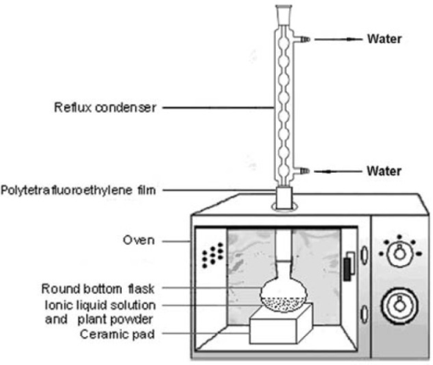
70 ̊̊C
Aqueous Extraction parameters:
Temperature: (60, 70, 80, 90, 100 ̊̊̊̊ºC)
Time: (0.2, 0.25, 0.5, 0.75, 1h)
Agitation speed: (500, 1000, 1500 rpm)

Temperature control bath
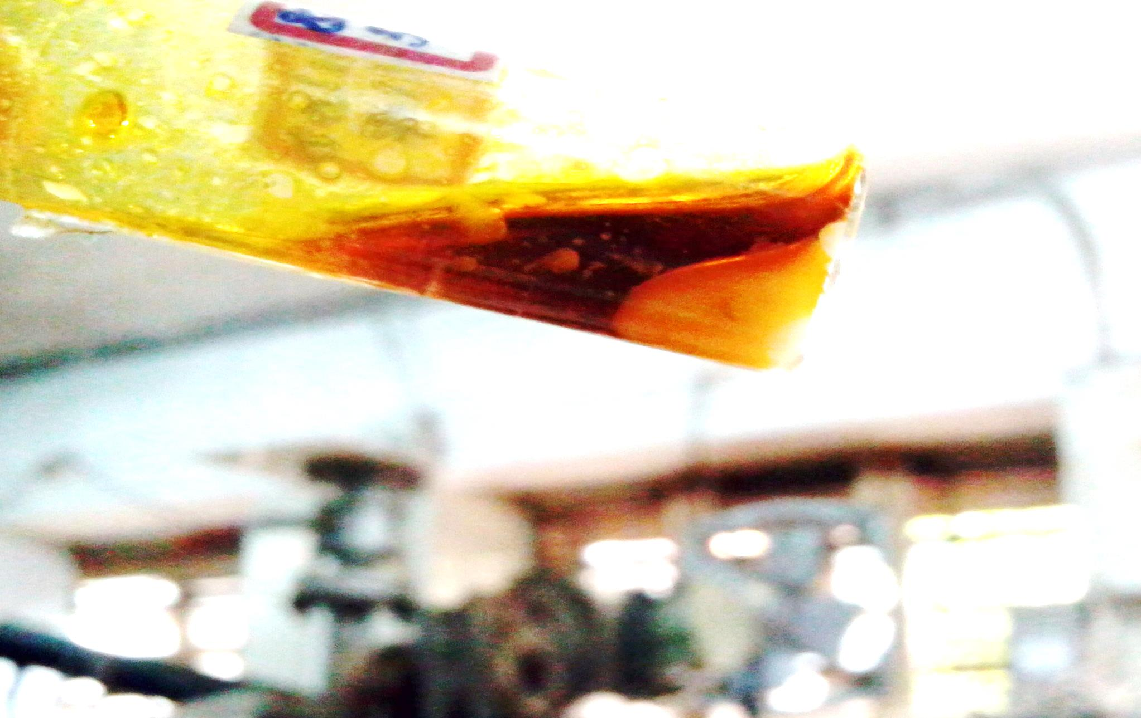

Oil gland

- INTRODUCTION:
Oranges are the most grown fruit globally in tropical and subtropical climates [1]. Its production is 9.23 tonnes, with India producing 2 % (29 lakh tons yearly). Orange pulp serves users and juice producers, whereas peels yield oil, powder, and essence. Orange essential oils contain terpenes for their scent and flavor, with applications in pharmaceuticals, food, cosmetics, and antimicrobial properties [3]. Methods for orange essential oil extraction include organic solvents [4], thermal/hydro distillation [5], steam distillation, mechanical expulsion [8], supercritical carbon dioxide (scCO2) [9], and enzyme solution [15], [16]. Mechanical pressing and scCO2 produce quality oil, but have limitations [9], [16], [18]. Organic solvents affect quality [4], [9],[10], [15],[18], [19]. M.W. irradiation releases various components [15], [22],[24], [25]. M.A.E. combines hydrodistillation [31] or Clevenger apparatus [33], producing oil in 15-35 min [15],[19], [22], [24],[34], [25]. In this study, aqueous extraction was developed considering peel size, albedo, temperature, and M.W. parameters. S.E.M. images showed cellular disruption after Microwave assisted aqueous extraction (MWAE), indicating a solvent-free process.
2 EXPERIMENTAL SECTION
2.1 Materials and Methods:
Fresh orange peels were obtained from fruit juice processors. N-Hexane, acetonitrile, and methanol (A.R. grade) were obtained from S.D. Fine Chemicals, Mumbai. The limonene standard was obtained from Himedia (Mumbai, India). The mixer produced sizes of 0.01 mm, 1.6 mm, 2, and 5 mm using blades. A Samsung M.W. oven at 2450 MHz with a power of 240-900 W was used for M.W. pretreatment with a condenser. Extraction was performed using a 250 cm3 glass reactor with a stirrer. For the M.W. pre-treatment, the RBF contained 100 g of orange peels. The parameters studied were microwave power (240-600 W), pretreatment time (0-5 min), peel size (0.01-5 mm), and albedo effects. Extraction occurred at 1:1 peel:water ratio, varying temperature (60-100 °C), and agitation (500-1500 rpm).
The % Yield of orange peel oil was calculated using:
$\% Yield=\frac{(Weight of oil extracted in gram)}{(Weight of the orange peels taken for experiment 100 g)}*100$ (I)
Oil yield was measured in grams per gram of oil obtained from 100 ‘g’ of orange peel. The percentage of oil was calculated using equation (I).
2.4 Analytical Methods
2.4 1 Moisture Content
The moisture content of the peels, both pre-and post-oil extraction, was determined using the standard AOAC method [2].
2.4.2 Oraganoleptic Characterisation of oil
Visual assessment of the extracted orange peel oil color was performed by comparing it with the standard orange peel oil and limonene. Orange peel oil color was measured using the CIELAB color space method [38].
$C*= \sqrt{{a*}^{2}+{b*}^{2}}$……………..(II)
$h= \tan^{-1}{(\frac{b*}{a*}})$……………..(III)
$WI=\sqrt{(100-{L*}^{2 })+{a*}^{2}+{b*}^{2}}$……(IV)
The fragrance of the oil was determined by sensory analysis, and the density of the oil was determined using an Anton Parrs densitometer (Model no. DMA 4500), and the solubility of the oil was measured in water. The oil-specific gravity was determined as follows:
$specific gravity of Oil =\frac{weight of particular volumen of oil extract}{Weight of equal volume of water}*100$……….(V)
2.4.3 DPPH Assay (Antioxidantactivity): To understand the antioxidant properties of the oil, it was subjected to the DDPH assay using the following protocol. The standards required for the DPPH assay are as follows:
Preparing a standard DPPH solution: The standard DPPH solution was prepared by dissolving 24 mg DPPH in approximately 100 cm³ methanol, working solution of stock for 0.98±0.02 at 517 nm, 3 cm³ aliquot to 100 μl sample (10–500 µg). cm³), the mixture was shaken and kept in the dark for 15 min, after which the absorbance of the mixture was measured at 517 nm wavelength.
Further, the oil sample was analysed for its radical scavenging activity using following equation
$Scavenging effect \left( \%\right)= \frac{(Absorbance of control-Absorbance of Sample)}{Absorbance of control}*100$…….(VI)
2.4.4 Chemical composition of oil:
GC-FID-MS and HPLC-PDA-MS. GC-MS analysis was performed using a Thermo Scientific BP-1 column at 240°C with a 12°C/min heating ramp to 210°C. HPLC-MS was conducted using a Thermo Finnigan LCQ Advantage Max with a C-18 column and a 50:50 acetonitrile:methanol mobile phase at 0.3 cm³/min flow rate.

3 Results and Discussion
3.1 Characterization of oil:
Oil characterization was performed using GC-FID-MS and HPLC-PDA-MS. GC-MS analysis used Thermo Scientific equipment with BP-1 column at 240 °C injector/detector temperatures, 12°C.min-1 ramp to 210°C, and 55 °C cooling. HPLC-MS was performed using Thermoelectron Finnigan L.C.Q. with a C-18 column and 50:50 acetonitrile-methanol phase at 0.3 cm3.min-1 flow. Orange peel particles less than 2 mm in diameter were measured using a Beckman Coulter counter, and above 2 mm, a scale was used. The surface morphology was studied using scanning electron microscopy (SEM; Jeol SM 5800 LV). The samples were dried, silver-coated in Polar-On SC 7640, and examined at 5.0 kV, 15 mm distance.
3.2 Response Surface Methodology (RSM):
RSM using a Central Composite Design was performed using a design expert quadratic model to study the significance of the MWAE process. This study excluded variables such as peel particle size, albedo and flavedo effects, and agitation parameters. Factors, including microwave power, pretreatment time, and extraction temperature, were optimized using a quadratic model for their parabolic relation.
3.3 Effect of particle size of orange peels on MWAE of orange oil
Microwave pretreatment of 100 g of albedo-free orange peels (0.16 mm) for 3 min at 240 W with hot aqueous extraction for 12 h at 80 ± 2 °C yielded 0.293 g oil with C.I.E. values of 60.1, 33.0, 64.2, 72.18, and 41.21. Oil yield from 2 mm and 5 mm peel particles was 0.08 ± 0.04 g and 0.02 g respectively (Fig 1). Orange with 83.5 % moisture has dielectric constant 67.40 ± 0.17, affecting microwave heating [49]. For 0.16 mm particles, a better surface area allowed improved microwave penetration, with mass transfer increasing to 6.9 x 10-14 m2.s-1 (Fig 1). For the 2 mm and 5 mm particles, the mass transfer coefficients were approximately 10-15 m2.s-1, reducing the oil yield. Qadariyah et al. [32] found that M.W. treatment was optimal for medium-sized particles.

Fig 1: Effect of orange peel particle size on orange oil yield at 3 min, 240 W M.W. pre-treatment and aqueous extraction at 80 ⁰C, 500 rpm for 12 h
3.3 Effect of microwave pre-treatment power:
The microwave (M.W.) pre-treatment for 3 min at 240 W power of 100 g of albedo free orange peels at an optimised average peel particle size of 0.16 mm followed by aqueous extraction for 4 h at 80 ± 2 °C and 500 rpm, produced 0.2± 0.03 g of orange peel oil as the separate phase at the top of the suspension at 2 h of extraction time with an energy need of 10 kJ (Table A1). With an increase in the M.W. power up to 400 W and maintaining the M.W. pre-treatment time as 3 min improved the oil yield to 0.62 ± 0.04 g (Fig 2(a)) and with energy need of 10.5 kJ (Table A1). The variation in repeated runs was approximately 0.01-0.04 % with a statistical p-value of 0.00016 < 0.05, the study of the effect of microwave time was significant. Although the energy requirement increased with an increase in the M.W. power to 400 W, the emphasis was on improving the oil yield.

Fig 2(a): Effect of microwave pre-treatment power on orange oil yield 0.16 mm average peel particle-size, albedo-free orange peels for 3 min followed by aqueous extraction until 3 h 80 ± 2 °C.

Fig 2(b): Diffusion coefficient at different microwave pre-treatment power on orange oil yield 0.16 mm average peel particle-size, albedo free orange peels for 3 min followed by aqueous extraction until 3 h at 80 ± 2 °C.
3.4 Effect of M.W. pre-treatment time on MWAE of orange peel oil
When exposed to a M.W. power of 400 W for up to 4 min, the oil yield increased to 0.84 g (Fig 2(c)), with a total energy need of 10.8 kJ and mass transfer coefficients of 5 x 10-12 m2s-1. Repeated runs showed 0.01-0.05 % variation with p-value of 0.007 < 0.05, indicating significant microwave time data. M.W. pretreatment with intermittent 30 s ON/OFF mode was preferred, as continuous exposure beyond 30 s caused volatile materials to escape and resulted in peel charring.

Fig 2(c) Effect of Microwave pre-treatment time on orange oil yield at microwave pre-treatment power of 400 W, 100 g of albedo-free orange peels, 0.16 mm particle-size followed by aqueous extraction until 2 h at 80 ± 2 °C, 500 rpm

The M.W. pretreatment time is a crucial parameter because it is associated with mass transfer and thermal energy accumulation. The M.W. pre-treatment time had a significant effect on the yield at all levels of M.W. power, peel particle size, agitation speed, aqueous extraction temperature, and aqueous extraction time. The mass transfer coefficient of the M.W. pre-treated peels at 4 min increased from 6.1 x 10⁻¹⁴ m²s⁻¹ required in the case of 1 min M.W. pre-treatment to 5 x 10⁻¹² m²s⁻¹ (Fig 2(d))

Fig 2 (d): Diffusion coefficient at different for the effect of Microwave pre-treatment time on orange oil yield at microwave pre-treatment power of 400 W, 100 g of albedo free orange peels, 0.16 mm particle-size followed by aqueous extraction until 2 h at 80 ± 2 °C, 500 rpm.

After 5 min of M.W. pretreatment, the peels charred (Fig 2(e)) and the oil obtained after aqueous extraction was brown, as noted through the C.I.E. L*a*b* color spacing scale of 56.7, 4.7, and 12.2, indicating oil degradation. Thus, the optimal M.W. pretreatment power and time were 400 W and 4 min, respectively.
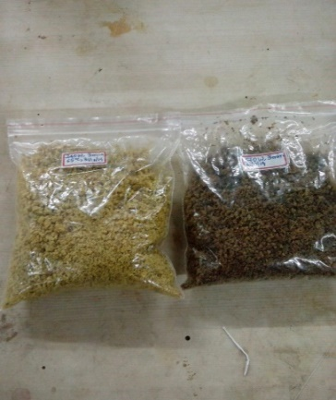
400 W, 4 min
400 W, 5 min
Fig 2(e): The difference in the color of the peels treated with M.W. (1.) at 400 W, 4 min and (2.) 400 W, 5min

This corroborates earlier reports, where Ferhat et al. [4] anticipated that with an increase in the microwave pre-treatment time, the product yield would increase up to a certain level. They predicted that heating of the peels by M.W. expanded the water and increased the internal pressure, thereby causing the cell to break in a shorter time. Housova and Hoke [5], Ferhat et al. [4], and Tiwari et al. [6] determined that M.W. treatment for a longer time beyond the optimum excessively heats the plant material and subsequently affects the organoleptic properties of the oil.

3.5 Effect of the presence of albedo in case of MWAE of orange oil
Orange peels with and without albedo, pre-treated with M.W. at 400 W for 4 min and aqueous extraction at 80 ̊C yielded 0.78 ±0.03 g and 0.84 ± 0.01 g oil respectively. The literature shows that enzyme-extracted oil is lower for peels with albedo due to substrate-specific enzymes [16], while M.W.'s are not substrate-specific [56]. The polymer adsorbs the extracted oil molecules [57] and reduces the oil yield during MWAE. lower yield with albedo results from to 8-10 % weight in peel (Allaf et al., 2013,Ververis et al., 2007). M.W. targets the oil glands in the flavedo [59], causing localized heating [60] and cellular rupture. The M.W. treatment of peels with albedo yields slightly less oil than that with flavedo, providing a cost advantage by eliminating albedo separation.
3.6 Effect of aqueous heating temperature
The M.W. pre-treated peels, when subjected to aqueous extraction at temperatures from 50 to 100 °C, showed an increase in the oil yield with an increase in temperature up to 80 °C. At 90 and 100 °C, the recovery of oil decreased. The oil yields at 70 ̊C and 80 ̊C were similar 0.8 % w/w and 0.84 % w/w (Fig 3 (a)). The variation observed in repeated runs was 0.01- 0.05 %, with a statistical p-value of 1.5 x 10⁻⁵. The energy needs were similar (10.86 kJ) in the case of 70 ⁰C compared to the 80 ⁰C (10.9 kJ) aqueous heating temperature. Hence 70 ⁰C was selected as the aqueous extraction temperature to be at lower side of temperature.

Fig 3 (a): Effect of aqueous extraction temperature on orange oil extraction yield at Microwave pre-treatment time of 4 min at 400 W, 500 rpm, 0.16 mm average particle-sized 100 g of orange peels followed by aqueous extraction until 12 h.
At 90 ⁰C and 100 ⁰C, the separated oil layer at the surface of the extraction mass re-emulsified as the extracted oil turned into globules or bubbles owing to the entrapment of air in the oil (Fig 3 (b)). This is because at 90 ⁰C -100 ⁰C, the water phase starts boiling, creating continuous bubbles at the surface. The collapse of bubbles upon expansion produces a fine mist of oil droplets. The continuous agitation of the slurry led to the re-dispersion and re-absorption of oil in the slurry and in the aqueous phase of the solid peel particles, forming an emulsion. It was difficult to recover oil from the resulting mass, even by ultracentrifuging the mass at 20,000 rpm for 1 h, resulting in a complete loss of oil.
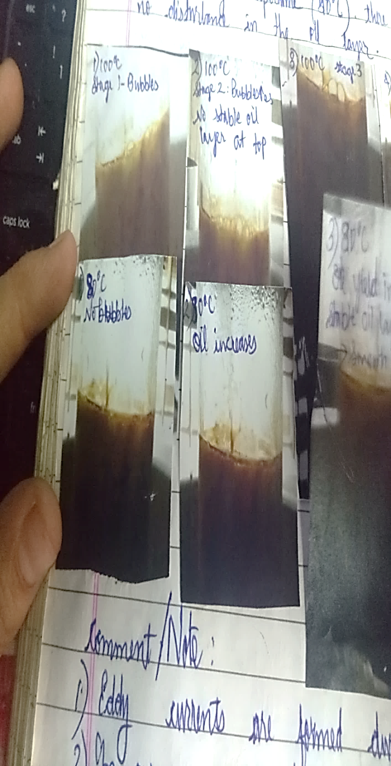
Oil layer seen as disturbed bubbles layer due to boiling
Fig 3 (b): Bubbles at the surface of aqueous extraction mass when aqueous heating was made at 100⁰C temperature
Therefore, optimizing the aqueous extraction temperature is important to obtain a better yield and an efficient process. Hence, data related to the heating temperature of the aqueous solution were significant. The mass transfer coefficient in the case of aqueous heating increased from 50 ⁰C (6.8 x 10⁻¹³ m².s⁻¹) to 70 ⁰C (5.2 x 10⁻¹² m².s⁻¹) (Fig 3c). From the energy requirement of the process, the optimal yield, and mass transfer perspective, 70 °C was selected as the optimum temperature for orange oil extraction.

Fig 3 (c): Diffusion coefficient related to the effect of aqueous extraction temperature on orange oil extraction yield at microwave pre-treatment time of 4 min at 400 W, 500 rpm, 0.16 mm average particle-sized 100 g of orange peels followed by aqueous extraction until 12 h.
Fakayode and Abobi [1] found that increasing the extraction temperature and time beyond the optimum reduced the oil yield in the steam distillation of orange oil. At low temperatures, steam moves slowly through the peels, with insufficient pressure for extraction. At the optimal temperature and time, internal pressure disrupts the cells, enabling extraction. However, excessive temperatures cause peel hardening or thermal degradation, which decreases the yield [1]. Research has shown that temperature affects molecular movement and solubility (Fakayode and Abobi, 2018; Houšová and Hoke, 2002; Kliemann et al., 2009). At low temperatures, product solubility in the extracting solvents is low, whereas increased temperature improves solubility and yield. However, higher temperatures compromise the product quality [39].

3.8 Effect of agitation speed
The aqueous extraction of orange peel oil at 70 °C from orange peel pre-treated with M.W. for 4 min at 400 W showed reduced extraction time at different agitation speeds. At 1500 rpm, oil appeared at 5, 30, and 15 min at 500 and 1000 rpm. However, prolonged agitation at 1500 rpm caused turbulence and re-dispersed oil. At 1500 rpm, eddy droplet sizes by Kolmogorov's and Davies methods were 51.24 µm and 67.12 µm, while at 500 rpm, sizes were 290 µm and 251 µm (Doran, 1995; Davies, 1985,-Davies, 1987). An eddy size below the optimum peel particle size (0.16 mm) caused turbulent currents and oil loss. Reducing agitation to 500 rpm for 6 min after oil surfacing enabled complete recovery because a larger eddy size prevented emulsion formation.

Fig 4(a): Effect of agitation speed in aqueous extraction (constant Microwave pre-treatment time of 4 min, 400 W, 0.16 mm particle-sized, 100 g of albedo-free orange peels followed by aqueous extraction up to 12 h at 70 ± 2 °C).

Fig 4(b): Diffusion coefficient for the effect of agitation speed in aqueous extraction (constant Microwave pre-treatment time of 4 min, 400 W, 0.16 mm particle-sized, 100 g of albedo free orange peels followed by aqueous extraction up to 12 h at 70 ± 2 °C).
3.9 Response surface methodology using central composite design for MWAE
3.9.1 Selection of a suitable model for Orange peel essential oil Extraction process
For model selection, key factors include selecting the highest-order polynomials with significant terms while maximizing the adjusted and predicted R2 [1]. The central composite design extends the factorial design in response surface modeling to obtain the maximum responses. The orange peel oil extraction rate was second order. The C.C.D. estimates the squared terms in the second-order and linear terms in first-order reactions. In face-centered composite design, star points are at ±1 from the center point, with α=1, where α = 2(k − p)/4, k= variables, and p= center point [64]. The C.C.D. requires fewer experiments than the Plackett-Burman design. Although the Box-Behnken design is rotatable, it has poor prediction regions. In this study, the R.S.M. face-centered C.C.D. [65] was used. The quadratic model showed the maximum predicted and adjusted R² values, best describing the response-input relationships, and was selected to optimize the parameters and understand variable interactions.
Table 1: Model Summary Statistics
Source | Std. Dev. | R² | Adjusted R² | Predicted R² | PRESS
Quadratic | 0.173 | 0.926 | 0.859 | 0.659 | 1.37 | Suggested
2F1 | 0.556 | 0.0021 | -0.458 | -3.99 | 20.1 | Aliased
Cubic | 0.210 | 0.934 | 0.791 | -80.1 | 326 | Aliased
Linear | 0501 | 0.00211 | -0.185 | -0.565 | 6.29 | Aliased

3.9.2 RSM regression study
The R.S.M. study gave the following regression equation, which showed a functional relationship between the oil yield and the assessment variables for the MW-AE.
$Oil=+2.72411+2.88182e^{-003}*P_{1}+0.28593*t_{1}-0.087173*T_{1}-3.53977e^{-006}*P_{1}^{2}-0.035085*t_{1}^{2}+6.21591e^{-004}*T_{1}^{2}+9.85908e^{-019}*P_{1}*t_{1}+2.1098e^{-019}P_{1}*T_{1}+1.49649e^{-017}*t_{1}*T_{1}$…….. (XXX)
(where P₁ the M.W. pretreatment power, t₁ the M.W. pretreatment time, and T₁: Aqueous extraction temperature).
The plot (Fig 5 a) showed the predicted values overlapping with the observed values. Optimal parameters from the quadratic model using central composite design (C.C.D.) included M.W. power (P1) of 400 W, pre-treatment time (t1) of 4 min, and aqueous temperature (T1) of 70 °C (Table A.3.1). Fig 5 (b) shows that the oil yield improved with increasing aqueous extraction temperature and M.W. pretreatment power. However, beyond the optimal conditions (70-80 0C, 4 min, 400 W), the orange essential oil yield decreased. ANOVA and F-test showed significant interactions between the regression coefficients and variables. The Model F-value was 13.81 indicates significance, with 0.02 % noise probability. "Prob> F" values below 0.0500 indicate significant terms. The model showed std. dev. of 0.17, mean of 0.40, CV % of 43.59, with predicted R-squared (0.9255) agreeing with the Adjusted R-Squared (0.8585), demonstrating a good fit (Table A.3.2, A.3.3).
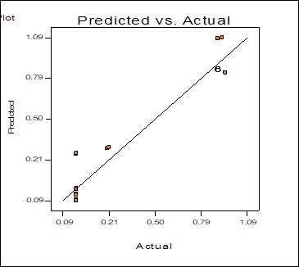
R2= 0.8585 (Adjusted), R2= 0.9255 (Predicted)
(a)
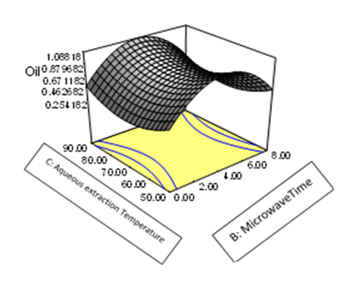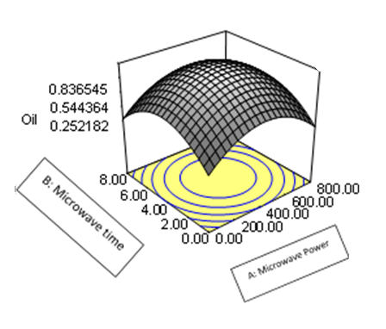
(b) and (c)).
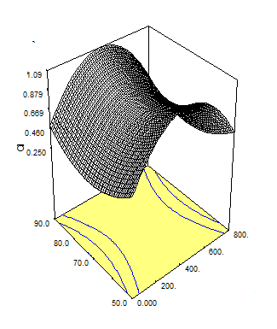
C: Aqueous Extraction Temperature
Oil (g)
A: Microwave Power
(d)
Fig 5 (a) Plot showing predicted values overlapped with the observed values (b)- (c) (d) Response surface methodology plots for optimisation of MWAE
3.10 Surface morphology of orange peel
The S.E.M. image reveals the rough and irregular structure of the orange peel after MWAE (Fig 6(b)) against a smooth structure with no treatment, as shown in Fig 6(a). The microwave heats the internal water. Owing to the pressure created by the expansion of water molecules, the glandular walls rupture more rapidly and distort the cellular structure. Thus, with microwave-assisted aqueous extraction, the membrane integrity is lost, aiding quicker oil extraction.

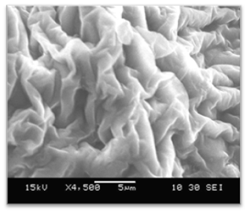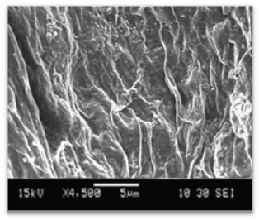
- (b)
Fig 6: (a) S.E.M. image of orange peels before any treatment, (b) Scanning electron microscopy of MWAE orange peel
3.11 Characterisation of extracted oil
CIELAB color analysis showed L*= 60.1, a*= +33.0, b*= +64.2, H= 43 0, C*= 72.18, and h*= 62.790, indicating a bright orange color. GC-MS analysis revealed five volatile compounds in Citrus sinensis peel oil: α-pinene, d-limonene, limonene oxide, linalool, and citronellal (Fig A.2, Table A.4). HPLC-MS showed non-volatile compounds, including Tangeritin, Sinensetin, Nobiletin, Tocotrienol, and Tocopherol acetate (Fig A.3, Table A.5). The oil composition was aligned with that in previous studies [9,67,69,70]. Limonene oxide is formed by radical formation during M.W. irradiation [71,72]. The oil showed antioxidant activity in the DPPH assay (Fig A.4.1, Fig A.4.2, Table A.6) due to limonene, tocotrienol, and tocopherol acetate [73-74]. The oil had specific gravity 0.87 ± 0.03, density 0.86 ± 0.02 kg.m-3, was water-insoluble, matching standard properties [1].
3.15 Key features of the developed MWAE process of orange peel oil compared with the state of art literature:
In the MWAE of orange peels for oil, microwave pre-treatment weakened the cellular structures while developing eco-friendly aqueous extraction. This solvent-free methodology makes peel residue and effluent suitable for pharmaceutical and food applications. This process excludes the high temperatures required for distillation or steam diffusion [19], [22], [24], [34],[25]. Oil separates the above reaction mass during agitation and is extracted using a pipette without centrifugation [76]. This process requires simple equipment, unlike distillation or supercritical extraction [5]–[7][9]. It has reduced energy requirements compared with classical methods, with improved mass transfer and eliminated albedo removal. The R.S.M. study showed the interaction between the dependent variables. Limitations include limonene oxide formation, particle size restrictions owing to MW charring, requirement of two reactors, need for skilled monitoring, and difficult MW scaling.
4 CONCLUSION
This paper reports the successful extraction of orange peel oil using MWAE. The process development parameters, including the M.W. pre-treatment conditions and aqueous extraction conditions, were optimized using the one-factor-at-a-time method and R.S.M. Face Centred C.C.D. model. The process engineering aspects, including the diffusion coefficient, eddy diffusion size, and rate of reaction (second-order), were determined— energy evaluation and comparison of the energy needs of the currently developed process. Thus, the process is a suitable, sustainable, lean, economical, and eco-friendly alternative to the available orange peel extraction processes because of the many advantages of the developed approach.

ABBREVIATIONS
C.C.D. Central Composite Design
De Diffusion coefficient
HPLC MS High-performance liquid chromatography-mass spectroscopy
HPLC
P.D.A. High-performance liquid chromatography –photodiode array
M.W. Microwave
MWAE microwave-assisted aqueous extraction R.S.M. Response Surface Methodology

ETHICAL COMPLIANCE: All procedures performed in this study involving human participants were in accordance with the ethical standards of the institutional and/or national research committee and with the 1964 Helsinki Declaration and its later amendments or comparable ethical standards.
CONFLICT OF INTEREST DECLARATION: The authors declare that they have no affiliations with or involvement in any organization or entity with any financial interest in the subject matter or materials discussed in this manuscript.
SUPPLEMENTORY INFORMATION:
Has been provided in a separate attachment.

COMPETING INTERESTS DISCLAIMER:
Authors have declared that they have no known competing financial interests OR non-financial interests OR personal relationships that could have appeared to influence the work reported in this paper.

REFERENCES:
[1] O.A. Fakayode, K.E. Abobi, Optimization of oil and pectin extraction from orange (Citrus sinensis) peels: a response surface approach, J. Anal. Sci. Technol. 9 (2018) 1–20. https://doi.org/10.1186/s40543-018-0151-3.
[2] G.L. Sagar Alok, Pareek Sunil, Sharma Sunil, Yahia Elhadi, Fruit and Vegetable Waste: Bioactive Compounds, Their Extraction, and Possible Utilization Narashans, Compr. Rev. Food Sci. Food Saf. 17 (2018). https://doi.org/10.1111/1541-4337.12330.
[3] T.A. Yerou Ould K, Ibri K. Bouhadi D, Hariri A., Meddah B., The use of orange (Citrus sinensis) peel as antimicrobial and anti-oxidant agents, J. Fundam. Appl. Sci. 9 (2017) 1351–1357.
[4] V. Njoku, B. Evbuomwan, Utilzation of Essential oil and Pectin extracted from Nigerian Organe peels, Greener J. Chem. Sci. Technol. 1 (2014) 1–5.
[5] TsegayeFekadu, T. Seifu, A. Abera, Extraction of Essential Oil from Orange Peel using Different Methods and Effect of Solvents, Time, Temperature to Maximize Yield, Int. J. Sci. Comput. 9 (2019) 24300–24308.
[6] A.L.R. Mercy Nisha Pauline J., Nithyalakshmi B., Extraction of Orange oil by Improved Steam Distillation and its Characterization Studies, Int. Jouranl Eng. Technol. Manag. Appl. Sci. 3 (2015) 1–8.
[7] N.A. Mansour Golmohammadi, Alimohammad Borghei, Alimohammad Borghei, Ali Zenouzi, Optimization of Essential oil extraction from orange peels using steam explosion, Heliyon. 4 (2018) 1–8. https://doi.org/10.1016/j.heliyon.2018.e00893.
[8] A. Ebrahimi, A.A. Qotbi, A. Seidavi, V. Laudadio, V. Tufarelli, Effect of different levels of dried sweet orange (Citrus sinensis) peel on broiler chikens growth performance, Arch. Therzumchit. 56 (2013) 11–17.
[9] H. Nautiyal, K. Tiwari, Supercritical Carbon Dioxide Extraction of Indian orange peel oil and hydro distillation comparison on their compositions, Sci. Technol. 2 (2012) 27–31. https://doi.org/10.5923/j.scit.20120203.01.
[10] K. Bica, P. Gaertner, R. Rogers, Ionic Liquids and Fragrances- direct isolation of orange essential oil, Green Chem. 13 (2011). https://doi.org/10.1039/c1gc15237h.
[11] D.V. Dandekar, V.G. Gaikar, Microwave assisted extraction of curcuminoids from Curcuma longa, Sep. Sci. Technol. 37 (2003) 2669–2690. https://doi.org/10.1081/SS-120004458.
[12] F.C. Mohamed A. Ferhat, Brahim Y. Meklati, Jacqueline Smagja, An improved microwave Clevenger apparatus for distillation of essential oils from orange peel, J. Chromatogr. A. 1112 (2006) 121–126. https://doi.org/doi:10.1016/j.chroma.2005.12.030.
[13] M.A.F. Malek Aboudaou, · Mohamed Hazzit, · Agustín Ariño· Djamel Djenane, Solvent free‑microwave green extraction of essential oil from orange peel (Citrus sinensis L.): efects on shelf life of favored liquid whole eggs during storage under commercial retail conditions, J. Food Meas. Charact. 13 (2019) 3162–3172. https://doi.org/https://doi.org/10.1007/s11694-019-00239-9.
[14] K.A.M. Gavahian Mohsen, Chu Yan-Hwa, Recent advances in orange oil extraction: an opportunity for valorisation of orange peel waste a review, Int. J. Food Sci. Technol. 54 (2019) 925–932.
[15] P. Putnik, D. Kovacevic, A. Jambrak, F. Barba, G. Cravotto, A. Binello, J. Lorenzo, A. Shpigelman, Innovative green and novel strategies for the extraction of bioactive added value compounds, Molecules. 22 (2017) 1–24.
[16] H. Sowbhagya, V. Chitra, Enzyme-assisted extraction of flavourings and colourants from plant materials, Crit. Rev. Food Sci. Nutr. 50 (2010) 146–151. https://doi.org/10.1080/10408390802248775.
[17] J.H.C. and A.J.H. Thomas M. Attard, Baillie Watterson, Vitaliy L. Budarin, Microwave assisted extraction as an important technology for valorising orange waste, New J. Chem. 38 (2014) 2147–2708.
[18] T. Allaf, V. Tomao, C. Besombes, F. Chemat, Thermal and mechanical intensification of essential oil extraction from orange peel via instant autovaporization, Chem. Eng. Process. Process Intensif. 72 (2013) 24–30. https://doi.org/10.1016/j.cep.2013.06.005.
[19] A. Farhat, A. Fabiano-Tixier, M. Maataooui, J. Maingonnat, M. Romdhane, F. Chemat, Microwave steam diffusion for extraction of essential oil from orange peel: Kinetic data, extract’s global yield and mechanism, Food Chem. 125 (2011) 255–261. https://doi.org/10.1016/j.foodchem.2010.07.110.
[20] H. Abbasi, A. Seidavi, W. Liu, L. Asadpour, Investigation on the effect of different levels of dried sweet orange (Citrus sinensis) pulp on performance, carcass characteristics and physiological and biochemical parameters in broiler chicken, Saudi J. Biol. Sci. 30 (2014) 1–8.
[21] Z. Pourhossein, A.A.A. Qotbi, A. Seidavi, V. Laudadio, G. Centoducati, V. Tufarelli, Effect of different levels of dietary sweet orange (Citrus sinensis) peel extract on humoral immune system responses in broiler chickens, Anim. Sci. J. 86 (2015) 105–110. https://doi.org/10.1111/asj.12250.
[22] H.S. Kusuma, A.F.P. Putra, M. Mahfud, Comparison of two isolation methods for essential oils from orange peel (Citrus auranticum L) as a growth promoter from Fish: Microwave steam distillation and conventional steam distillation, J. Aquac. Res. Dev. 7 (2016) 409. https://doi.org/10.4172/2155-9546.1000409.
[23] M.M. Kusuma H., Kinetic studies on extraction of essential oil from sandalwood (Santalum album) by microwave air hydrodistillation method, Alexandria Eng. J. 57 (2018) 1163–1172.
[24] M. Boukroufa, C. Boutekedjiret, L. Petigny, N. Rakotomanomana, F. Chemat, Bio refinery of orange peels waste: A new concept based on intergrated green and solvent free extraction process using ultrasound and microwave techniques to obtain essential oil, polyphenols and pectin, Ultrason. Sonochem. 24 (2015) 72–79. https://doi.org/10.1016/j.ultsonch.2014.11.015.
[25] I.K. Shakir, S.J. Salih, Extraction of essential oils from citrus by products using Microwave steam distillation, J. Chem. Pet. Eng. 16 (2015) 11–22.
[26] M.M. Kusuma H.S., Comparison of kinetic models of oil extraction from sandalwood by microwave-assisted hydrodistillation, Int. Food Res. J. 24 (2017) 1697–1702.
[27] M.M. Kusuma, H. S., Chemical Composition of Essential Oil of Indonesia Sandalwood Extracted by Microwave- Assisted Hydrodistillation, AIP Conf. Proc. 1755 (2016). https://doi.org/10.1063/1.4958484.
[28] M.M. Kusuma H., Microwave assisted Hydrodistillation for extraction of essential oil from Patchouli (Pogostemon cablin) leaves, Period. Polytech. Chem. Eng. 61 (2015) 82–92.
[29] M.M. Kusuma H., Altway A., Solvent free Microwave extraction of essential oil from dried pachouli (Pogostemon cablin Benth) leaves, J. Ind. Eng. Chem. 3650 (2017) 1–19. https://doi.org/https://doi.org/10.1016/j.jiec.2017.09.04.
[30] A.F. Sauid S., Extraction methods of essential oil from Kaffir lime (Citrus hystrix): A review, Malaysian J. Chem. Eng. Technol. 1 (2018) 56–64.
[31] J.H.C. Bustamante Julen, Stempvoort Sytze van, Maria Garcia- Gallarreta, Microwave assisted hydro-distillation of essential oils from wet citrus peel waste, J. Clean. Prod. 137 (2016). https://doi.org/• 10.1016/j.jclepro.2016.07.108.
[32] L. Qadariyah, P.D. Amelia, C. Admiralia, D.S. Bhuana, M. Mahfud, Extraction of orange peel’s essential oil by solvent-free microwave extraction, in: AIP Conf. Proc., AIP Publishing LLC., 2017. https://doi.org/10.1063/1.4982325.
[33] A.J. and M.C.G. Antonio Martínez-Abad, Marina Ramos, Mahmoud Hamzaoui, Stephane Kohnen, Optimisation of Sequential Microwave-Assisted Extraction of Essential Oil and Pigment from Lemon Peels Waste, Foods. 9 (2020) 1493. https://doi.org/https://doi.org/10.3390/foods9101493.
[34] N. Sahraoui, M.A. Vian, M. El Maataoui, C. Boutekedjiret, F. Chemat, Valorization of citrus by-products using Microwave Steam Distillation (MSD), Innov. Food Sci. Emerg. Technol. 12 (2011) 163–170.
[35] D. Pingret, A.S. Fabiano-Tixier, F. Chemat, An Improved Ultrasound Clevenger for Extraction of Essential Oils, Food Anal. Methods. 7 (2014) 9–12. https://doi.org/10.1007/s12161-013-9581-0.
[36] S. Bourgou, F.Z. Rahali, I. Ourghemmi, M. Saïdani Tounsi, Changes of Peel Essential Oil Composition of Four Tunisian Citrus during Fruit Maturation, Sci. World J. (2012) 1–10. https://doi.org/10.1100/2012/528593.
[37] N. Thiex, L. Novotny, A. Crawford, Determination of ash in animal feed: AOAC official method 942.05 revisited, J. AOAC Int. 95 (2012) 1392–1397. https://doi.org/10.5740/jaoacint.12-129.
[38] J. Pathare Pankaj B., Opara Umezuruike L., Al-Said Fahad AL, Measurement and Analysis in Fresh and Processed Foods A Review, Food Bioprocess Technol. (2012). https://doi.org/10.1007/s11947-012-0867-9.
[39] K.B. Ansari, V.G. Gaikar, Green hydrotropic extraction technology for delignification of sugarcane bagasse by using alkybenzene sulfonates as hydrotropes, Chem. Eng. Sci. 115 (2014) 157–166.
[40] R. Wongkittipong, L. Prat, S. Damronglerd, C. Gourdon, Solid–liquid extraction of andrographolide from plants—experimental study, kinetic reaction and model, Sep. Purif. Technol. 40 (2004) 147–154. https://doi.org/10.1016/j.seppur.2004.02.002.
[41] M.M. Kusuma, H. S., The extraction of essential oils from patchouli leaves (Pogostemon cablin Benth) using a microwave air hydrodistillation method as a new green technique, R. Soc. Chem. 7 (2016) 1336.
[42] P.M. Doran, Bioprocess engineering principles, Academic Press, London, 1995.
[43] J.T. Davies, A physical interpretation of drop sizes in homogenizers and agitated tanks, including the dispersion of viscous oils, Chem. Eng. Sci. 42 (1987) 1671–1676. https://doi.org/10.1016/0009-2509(87)80172-0.
[44] S. Lagergren, About the theory of so-called adsorption of soluble substances, K. Sven. Vetenskapsakademiens Handl. 24 (1998) 1–39. https://www.scirp.org/(S(351jmbntvnsjt1aadkposzje))/reference/ReferencesPapers.aspx?ReferenceID=1464105.
[45] H. and P. Ho, Y.-S., Adamou, H.-O.H., Fauduet, C., Kinetics and model building of leaching of water-soluble compounds of Tilia sapwood, Sep. Purif. Technol. 45 (2002). https://doi.org/https://doi.org/10.1016/j.seppur.2005.03.007.
[46] Y.C. Tingchun Li, Honghong Fan, Zhengpeng Li, Jun Wie, Yi Lin, The accumulation of pigment in fiber related to proanthocyanidins synthesis for brown cotton, Acta Physiol Plant. 34 (2012) 813–818. https://doi.org/10.1007/s11738-011-0858-x.
[47] C.F. Chau, Y.L. Huang, Comparison of the Chemical Composition and Physicochemical Properties of Different Fibers Prepared from the Peel of Citrus sinensis L. Cv. Liucheng, J. Agric. Food Chem. 51 (2003) 2615–2618. https://doi.org/10.1021/jf025919b.
[48] J.A. Robertson, M.A. Eastwood, An examination of factors which may affect the water holding capacity of dietary fibre, Br. J. Nutr. 45 (1981) 83–88.
[49] A.A. Barba, M. D’Amore, Relevance of dielectric properties in microwave assisted processes, in: Microw. Mater. Charact., IntechOpen, 2012: pp. 91–118. https://doi.org/10.5772/51098.
[50] S.W. Hao-Jiang, Zhigang Liu, Microwave Processing: Effects and impacts on food components, Crit. Rev. Food Sci. Nutr. (2017) 2476–2489. https://doi.org/10.1080/10408396.2017.1319322.
[51] H.G.M.K. Urmila R. Ramasamy, Water holding capacity of soluble and insoluble polysaccharides in pressed potato fibre, Ind. Crops Prod. 64 (2015) 242–250.
[52] J.I.Ř.I.N.A. Houšová, K. Hoke, Microwave heating–the influence of oven and load parameters on the power absorbed in the heated load., Czech J. Food Sci. 20 (2002) 117–124.
[53] M.A. Ferhat, B.Y. Meklati, F. Chemat, Comparison of different isolation methods of essential oil from Citrus fruits: cold pressing, hydrodistillation and microwave ‘dry’ distillation, Flavour Fragnance J. 22 (2007) 494–504. https://doi.org/doi.org/10.1002/ffj.1829.
[54] A. Kammoun Bejar, N. Kechaou, N. Boudhrioua Mihoubi, Effect of microwave treatment on physical and functional properties of orange (Citrus sinensis) peel and leaves., J. Food Process. Technol. 2 (2012).
[55] A.K. Tiwari, S.N. Saha, V.P. Yadav, U.K. Upadhyay, D. Katiyar, T. Mishra, Extraction and Characterization of Pectin from Orange Peels, Int. J. Biotechnol. Biochem. 13 (2017) 39–47.
[56] E. Destandau, T. Michel, C. Elfakir, Microwave‐assisted Extraction, in: M.A. Rostagno, J.M. Prado (Eds.), Green Chem. Ser., Cambridge: Royal Society of Chemistry, 2013: pp. 113–156.
[57] N. Saranya, P. Devi, R. Nithiyanantham, S., Jeyalaxmi, Cells Disruption by Ultrasonication, Bionanoscience. 4 (2014) 335–337.
[58] C. Ververis, K. Georghiou, D.G. Danielidis, D., Hatzinikolaou, P. Santas, R. Santas, V. Corleti, Cellulose, hemicelluloses, lignin and ash content of some organic material and their suitability for use as paper pulp supplements, Bioresour. Technol. 98 (2007) 296–301.
[59] A.R.S. Al-Hilphy, Development of steam essential oils extractor, OSR J. Agric. Vet. Sci. 8 (2015) 2319–2372.
[60] C. Gabriel, S. Gabriel, E.H. Grant, B.S. Halstead, D.M.P. Mingos, Dielectric parameters relevant to microwave dielectric heating, Chem. Soc. Rev. 27 (1998) 213–224.
[61] E. Kliemann, K.N. De Simas, E.S. Amante, E. R., Prudêncio, R.F. Teófilo, M.M. Ferreira, R.D. Amboni, Optimization of pectin acid extraction from passion fruit peel using response surface methodology, Int. J. Food Sci. Technol. 44 (2009) 476–483.
[62] Y. Zhou, F. Gao, Z. Y., J. Lu, Study on the extraction kinetics of phenolic compounds from petroleum refinery waste lye, J. Saudi Chem. Soc. 18 (2014) 589–592. https://doi.org/10.1016/j.jscs.2011.11.011.
[63] J.T. Davies, Drop sizes of emulsions related to turbulent energy dissipation rates. Chemical Engineering Science, Chem. Eng. Sci. 40 (1985) 839–842. https://doi.org/10.1016/0009-2509(85)85036-3.
[64] C. M., Optimization Methods: From theory to design scientific and technological aspects in mechanics, 1 st, Springer, 2013. https://www.springer.com/gp/book/9783642311864.
[65] J.M.D. a S.L.C. Ferreira a,∗, R.E. Bruns b, H.S. Ferreira a, G.D. Matos a, A. G.C. Brandao˜ a, E.G.P. da Silva a, L.A. Portugal a, P.S. dos Reis c, W.N.L. dos S. A.S. Souza a, Box-Behnken design: An alternative for the optimization of analytical methods, Anal. Chim. Acta. 597 (2007) 179–186. https://doi.org/doi:10.1016/j.aca.2007.07.011.
[66] H.H. Zahra Alhani, Hamid Reza Monsef-Esfahani, Yaghoob Amanzade, M.A. Faramarzi, Analysis of Citrus aurantium L. Hydrolate and its comparison with the commercial samples, Iran. J. Pharm. Res. 3 (2004).
[67] S.R.K. Cholke P.B., Bhor A.K, Shete A.M., Extraction and GC-MS Anlysis of orange (Citrus sinensis), Res. J. Life Sci. Bioinformatics, Pharm. Chem. Sci. (2017). https://doi.org/DOI - 10.26479/2017.0205.04.
[68] W.J. Yen, B.H. Chen, Isolation of xanthophylls from Taiwanese orange peels and their effects on the oxidation stability of soybean oil, Food Chem. 53 (1995) 417–425. https://doi.org/10.1016/0308-8146(95)99837-P.
[69] G.M. Kamal, F. Anwar, A.I. Hussain, N. Sarri, M.Y. Ashraf, Yield and chemical composition of Citrus essential oils as affected by drying pretreatment of peels, Int. Food Res. J. 18 (2011) 1275.
[70] B.H. Chen, Y.Y. Chen, Stability of chlorophylls and carotenoids in sweet potato leaves during microwave cooking, J. Agric. Food Chem. 41 (1993) 1315–1320. https://doi.org/10.1021/jf00032a029.
[71] R.C. F. Parrino, A. Fidalgo, L. Palmisano, L.M. Ilharco, M. Pagliaro, Polymers of limonene oxide and carbon dioxide: polycarbonates of the solar economy, ACS Omega. 3. (2018) 4884–4890. https://doi.org/10.1021/acsomega.8b00644.
[72] F.Z. X. Quan, Y. Zhang, S. Chen, Y. Zhao, Generation of hydroxyl radical in aqueous solution by microwave energy using activated carbon as catalyst and its potential in removal of persistent organic substances, J. Mol. Catal. Chem. 263 (2007) 216–222.
[73] J. Hudzicki, Kirby-Bauer disk diffusion susceptibility test protocol, 2009.
[74] T.R.P. and B.S.M.R. P.K. Shanthi, B. Dhanalakshmi, Characterization and antioxidant activity of Orange Peel Eextracts, Int. J. Sci. Environ. Technol. 8 (2019) 636–640.
[75] A. Franco-Vega, N. Ramírez-Corona, E. Palou, A. López-Malo, Estimation of mass transfer coefficients of the extraction process of essential oil from orange peel using microwave assisted extraction, J. Food Eng. 170 (2016) 136–143. https://doi.org/10.1016/j.jfoodeng.2015.09.025.
[76] L. Coll, D. Saura, M.P. Ruiz, J.M. Ros, J.A. Canovas, J. Laencina, Viscometric control in the enzymatic extraction of citrus peel oils, Food Control. 6 (1995) 143–146. https://doi.org/10.1016/0956-7135(95)00010-O.

