A Critical Review on Evaluating Integrated Pest Management in Agricultural Systems: Progress and Prospects

Abstract
Integrated Pest Management (IPM) is a cornerstone of sustainable agriculture. IPM is an ecological approach to managing pest populations. It emphasizes the use of multiple tactics to suppress pests while minimizing negative impacts on the environment and human health. In contrast to traditional practices that focus solely on eradication through pesticides, IPM prioritizes preventative measures, monitoring pest populations, and utilizing biological controls when necessary.
This review examines the effectiveness of IPM in addressing contemporary agricultural challenges, and analyses its strengths, including its ecological benefits and potential for yield protection. However, it also critically evaluates the limitations of IPM, particularly its dependence on robust monitoring and knowledge-intensive practices.
Keywords: Integrated pest management, pest control, sustainable agriculture, biological control, environmental protection, human health.
1. Introduction
Insects gravely disturb crops growth, causing large losses in agricultural production. In addition to microbes that cause diseases, insects belonging to different orders e.g. (Coleoptera, Lepidoptera, Orthoptera, and Diptera) can also impede agricultural productivity (Babu et al., 2019). Based on an assessment by a group of researchers, pests, illnesses, and viruses have caused roughly one-third of the overall output loss, whereas arthropods were responsible for around 18–20% of the damage (Sharma et al., 2017). Although the spread of insects and, eventually, microbes that are both persistently and non-persistently transmitted, can be inhibited by insecticides, the overuse of these pesticides can damage naturally occurring biocontrol agents, eutrophicate water, cause birth defects, nerve damage, and cancer, among other health disorders . A clear relationship between the usage of pesticides and the annual variation in pest prevalence and pressure among nations is suggested by the data, which takes into account the policies, costs, and pesticide-related variations among nations, along with farmers' concerns regarding yield loss and climate variations (Jorgensen et al., 2014).
Crops are unable to spontaneously develop resistance qualities against the pests they could encounter in the fields since they are typically cultivated from seeds purchased for each cultivation cycle. Therefore, we think that in order to design more effective and long-lasting agricultural pest management solutions, an explicitly evolutionary viewpoint is required. One may draw a connection from medicine, wherein the overuse of medications has exacerbated the issue of antibiotic resistance in microorganisms. The key takeaway from this is that while antibiotics might eradicate infections, their improper use can encourage the selection of resistance genotypes in the targeted (or other) pathogenic species. The importance of using evolutionary theory in medical research is becoming more widely recognized (Randolph et al., 2010).
When the IPM concept was introduced, it sparked a lot of research into other activities that might support IPM programs. Currently, a Web of Science search for "Integrated Pest Management" yields about 50,000 results, indicating that IPM and related concerns have captivated a horde of scholars. Still, despite the declared passion for IPM, most farming systems still heavily rely on chemical pesticides. In fact, IPM is far from being effectively studied or used, most likely because no integrative IPM science has yet surfaced (Hokkanen, 2015).
2. History of IPM and its development
The IPM philosophy is not a recent one. Since the development of the cotton pest management program in the 1920s, the idea has existed. Insect control was "supervised" by certified Entomologists under this plan, and insecticide applications were made in accordance with findings from routinely observed pest and natural enemy populations. This was considered a substitute for pesticide programs that were dependent on the calendar. A solid understanding of ecology and an examination of anticipated changes in pest and natural enemy populations provide the foundation of supervised control. The optimal combination of chemical and biological treatments is sought and determined for a particular insect pest in supervised control, also known as integrated control. The application of chemical pesticides is done in a way that minimizes the interference with biological control. Only when consistent monitoring shows that a pest population has grown to an economically significant level, chemical controls are implemented. Therefore, such therapy is necessary to keep the population from suffering economic harm to the point where losses would outweigh the expense of artificial control methods (Ehi et al., 2014). Following the development of contemporary fungicides in the eighteenth century, and herbicides and insecticides in the nineteenth, research on chemical weapons, specifically gas-based weapons, during the two world wars produced new organic compounds with insecticidal qualities that were subsequently applied to agriculture (Jean et al., 2021).
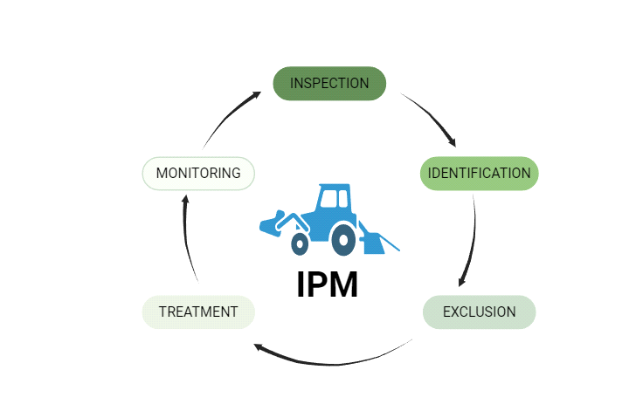

Figure 1: IPM and its processing
Applying IPM may require us to re-evaluate our existing plant breeding initiatives and change our focus from yield maximization to a variety of objectives (Weiner, 2017). The critical need to increase genetic variety in plant tolerance and resistance has already been discussed, but crops needed for IPM may also need to flourish under conditions that are different from those seen in traditional agricultural areas. For instance, crops grown under IPM may be interplanted with companion plants that attract beneficial insects (Quinn et al., 2017) or enhance soil quality (Xiao et al., 2019). These plants must be able to coexist and yield enough yields without outcompeting one another. As a result, some have claimed that we must specifically breed our crops for IPM (Lamichhane et al., 2018), for instance, by choosing cultivars that are suitable for intercropping or the used plant protection techniques. In general, evolutionary understanding of host-parasite interactions is necessary for breeding for resistance (Brown, 2015). Understanding and taking advantage of the intricate intra- and interspecific interactions that exist between plants in agro-ecosystems is another requirement for IPM breeding. For instance, plants are able to identify their neighbors and adjust their growth and reproductive patterns or launch defense mechanisms in response to their presence, identification, or health (Kong et al., 2018, Ninkovic et al., 2019). The genetic similarity of the constituent plants may determine the directions and intensities of such reactions (Ehlers and Bilde, 2019). Furthermore, current breeding practices and the low plant-genetic variety in traditional agricultural fields may have led to the emergence of selection pressures that are different from those that are frequently found in nature.
3.Components of IPM
IPM techniques are based mostly on monitoring, cultural practices, biological control, chemical control, and physical control.
Monitoring
The practice of IPM mostly depends on pest surveillance and forecasting. The phrase "surveillance" describes the process of closely monitoring something, including a crop or pest, in order to record changes, gather pertinent information, and forecast the pest population's future. It is composed of basic components like determining the prevalence of the pest species (Dhruti et al., 2024).
Cultural practices
IPM's cultural practices are crucial because they reduce insect prevalence and improve crop health, which supports sustainable agriculture. These methods cover a wide range of techniques that hinder insect growth while fostering favourable circumstances for crops (Dikshya et al., 2022). Although cultural practices are becoming more popular, there are still obstacles in the way of their adoption because traditional farming practices need to be significantly altered.
Biological control
In IPM, biological control of pests is an essential tactic for sustainable agriculture. Encouraging the use of natural predators like ladybirds to control pest populations, such as aphids, without the use of hazardous chemicals. The effectiveness of pest management has increased due to developments in the mass manufacturing and administration of biological control agents (BCAs), such as microbial antagonists and parasitoids. IPM reduces the need for chemicals while improving pest control (Dhruti et al., 2024, Tiwari, 2024).
Chemical control
Chemical control is still essential, especially when paired with other tactics to improve sustainability and efficacy. As evidenced by studies on the fall armyworm, where a 100% mortality rate was achieved with combined treatments, research indicates that combining chemical insecticides such as chlorantraniliprole with biological agents (Heterorhabditis bacteriophora and Beauveria bassiana) significantly increases pest mortality rates (Mahwish et at., 2024).
Physical control
By upsetting the life cycles and habits of pests, physical controls like barriers and traps aid in the prevention of pest infestations. Sticky traps, for example, are useful for catching flying insects, while mesh screens are useful for preventing them from entering structures. Physical barriers and hand eradication are among the earliest techniques of controlling pests . They don't leave any toxic leftovers and don't need permission from the government, making them environmentally beneficial (Dilip et al., 2024, Upama, 2022).
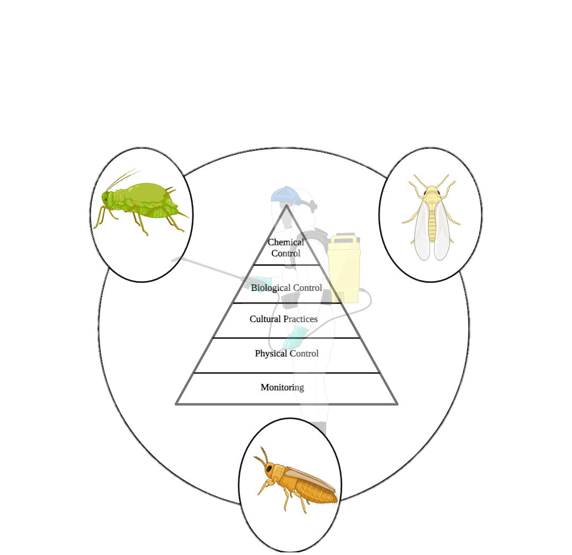
Figure 2: Major components of IPM
4.Role of IPM in Organic Farming
Integrated pest management, is essential to organic farming because it encourages environmentally friendly methods that reduce the need for artificial pesticides while improving ecological balance. IPM combines a number of tactics, including chemical, mechanical, cultural, and biological approaches, to efficiently control pest populations (Sikha, 2023).

4.1 Components of IPM in Organic farming
Diverse Control strategies
In organic farming, integrated pest management, uses a variety of control techniques that combine mechanical control which uses barriers, traps, and hand removal to physically keep pests away from crops, chemical control where pheromones and biopesticides are used sparingly and strategically to reduce their negative effects on the ecosystem, biological control which suppresses pest populations using microbial agents and natural predators, enhancing ecosystem health and biodiversity, and cultural approaches which uses habitat modification, crop rotation, and intercropping to break the life cycles of pests and lessen infestations, to manage insect populations in a sustainable manner. This comprehensive strategy improves agricultural output and ecological balance while lowering dependency on artificial pesticides (Abdallah, 2023).
Economic Benefits
In organic farming, IPM promotes sustainable practices that save expenses and increase productivity, which has major financial advantages. This comprehensive strategy combines a number of pest management techniques, improving agricultural yields and lowering the need for chemical pesticides, which can be expensive. Namely, cost savings which create more resilient farming systems by promoting soil health and biodiversity, which will lessen the need for future expensive interventions also reduces the need for costly chemical pesticides, which lowers farmers' input expenses (Somit, 2024) and increased crop yield where crop yields can be greatly increased by using efficient pest management techniques, which will directly affect farmers' profits. IPM can assist farmers in meeting market needs as consumer preferences shift toward sustainably produced food, which could result in higher prices for organic items (Sanjoy et al., 2024).
4.2 Organic approved pesticides and IPM strategies
In organic farming in particular, organic-approved pesticides and IPM techniques are critical to sustainable agriculture. In addition to improving crop health, this strategy encourages environmental sustainability (Sikha, 2023).
Organic approved pesticides
Biopesticides made from natural sources, such as plantsv and microbes, are used in organic farming since they are less damaging to the environment. Examples of products that target certain pests without harming beneficial organisms are diatomaceous earth, neem oil, and insecticidal soaps. Consumer confidence in organic products is preserved by regulations governing the use of organic pesticides to guarantee that they adhere to safety requirements (Rizal et al., 2022).
IPM strategies
IPM successfully manages pest populations by combining biological, cultural, and mechanical, strategies. Crop rotation, intercropping, and the use of resistant cultivars are examples of cultural practices that can stop insect outbreaks. For prompt actions, monitoring methods such as visual inspections and sticky traps are essential (David, 2021). There are still issues, such as the requirement for in-depth entomology expertise and the restrictions on the strategies that can be used under organic certification criteria, even though organic approved pesticides and IPM techniques are advantageous (David, 2021).
5.Differences between IPM in conventional and organic farming
The main areas of distinction between conventional and organic farming's use of IPM are how they handle insect management, resource usage, and environmental effect. Although the proper management of pests is the goal of both systems, there are substantial differences between their methods and underlying ideologies (Kristina et al., 2020).
5.1 Pest control strategies
IPM in conventional farming
In addition to biological and cultural methods, conventional IPM frequently combines targeted chemical treatments, which enables efficient pest control while lowering the overall usage of pesticides. Up to 90% less insecticide has been used to combat pests like the codling moth thanks to methods like mating disruption using synthetic pheromones. According to studies, IPM can result in significant cost reductions, for example, over a ten-year period, apple orchard growers in Nova Scotia reported a 25% decrease in pest management expenses (Nikita et al., 2024).
IPM in organic farming
Natural parasitoids and predators play a major role in organic IPM, which supports ecological balance and biodiversity. Crop rotation and intercropping are two techniques that are highlighted as ways to improve soil health and interfere with pest life cycles. Despite its advantages, organic farmers find it difficult to implement IPM because of a lack of resources and expertise, which calls for constant training and assistance (Prodipto et al., 2023).
5.2 Resource use and efficiency
Resource use efficiency in conventional farming
The use of synthetic fertilizers and pesticides in conventional farming usually results in higher yields, which can boost short-term profitability. Dependence on chemical fertilizers can lead to weaknesses that could compromise sustainability over the long run, such as price swings and environmental deterioration (Cahyaningtyas et al., 2024).
Resource use efficiency in organic farming
When compared to traditional approaches, organic practices, such as integrated organic input management, can increase nutrient utilization efficiency by as much as 40.9%. Techniques like vegetative barriers and low tillage are frequently used in organic systems, which significantly reduce runoff and soil erosion and increase water usage efficiency. Because organic farming relies more on natural inputs, it typically has higher energy efficiency per unit area, but yields per unit product may be lower (Laurence et al, 2015).
5.3 Influence on the environment
Effects on conventional farming
IPM reduces the use of synthetic pesticides by promoting the use of biological and cultural controls. It improves profitability while preserving environmental integrity by reducing the cost of pest management. IPM techniques can support beneficial insect populations, which support ecosystem health and pest management (Prodipto et al., 2023).
Effects on organic farming
Compared to traditional methods, organic farming, which frequently integrates IPM, improves soil quality and decreases nutrient loss. According to studies, organic farms support over three times as many species as conventional farms, indicating a much greater level of species variety. By doing away with synthetic pesticides, organic methods lower the hazards of chemical residues in food and the environment (Hsiao et al., 2020).
6.Economic and Environmental impacts of Integrated Pest Management
IPM has a substantial positive economic impact, increasing profitability and supporting sustainable agriculture practices. In Brazil, IPM increased net income by 11.21% while reducing insecticide applications by almost 94%, bringing expenditures down from $112.19 - 11.83 each crop cycle (Mauricio et al., 2023). With a benefit-cost ratio of 13:1, the implementation of IPM in avocado growing in East Africa might result in an average yearly economic gain of $66 million in Kenya (Charity et al., 2022). In line with current agricultural sustainability goals, IPM maximizes farmers' yields, doubles revenue, ensures food security, and promotes sustainable agriculture practices (Sanjoy et al., 2024). The economic effects of IPM approaches vary in developing nations, and assessments emphasize the use of agronomic and biological practices, especially with regard to insects, to improve social, ecological, and economic well-being (George et al., 2019).
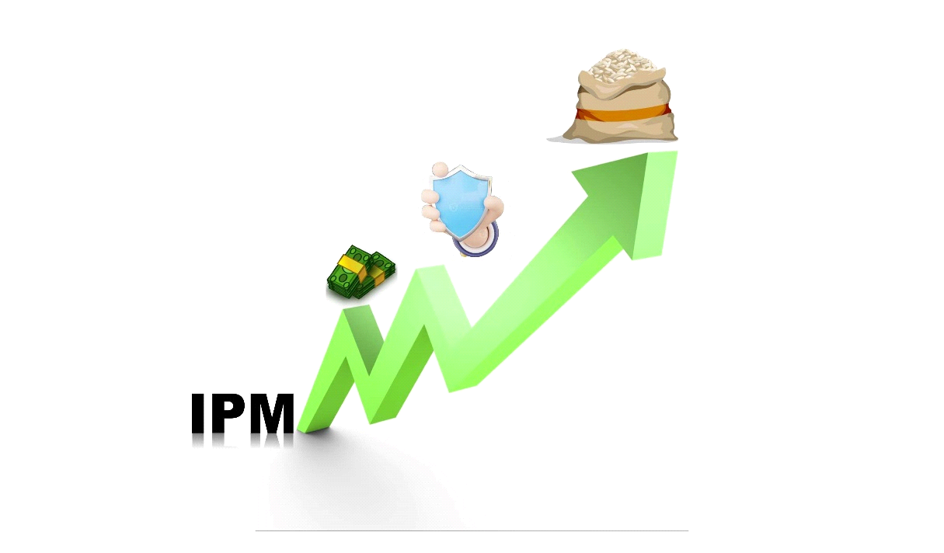

Figure 3: Economic impact of IPM
IPM has a substantial positive influence on the environment by fostering ecological balance and lowering the need for dangerous pesticides. IPM techniques promote biological control by protecting non-pest species and natural predators, which strengthens agro-ecosystems and increases crop yields (Ivan et al., 2024). This comprehensive strategy balances economic feasibility with environmental safety by promoting sustainable agricultural methods and reducing the usage of pesticides (Sanjoy et al., 2024, Somit, 2024). The conservation of beneficial organisms which are essential for controlling pests can be facilitated by IPM measures (Ivan et al., 2024). IPM reduces the need for synthetic pesticides by combining biological, cultural, and mechanical approaches, which helps to mitigate contamination of soil and water (Somit, 2024). IPM reduces negative effects on the environment by providing environmentally friendly pest control techniques, encouraging sustainable farming practices, addressing the effects of global trade, and improving the general health and safety of the environment.
Even if there are many advantages to IPM, there are still issues like farmer involvement and knowledge gaps, which means that in order to fully utilize IPM in sustainable agriculture, support and education are still needed.
7.Resources and tools of Integrated Pest Management
Using a range of instruments and resources, IPM reduces the usage of pesticides while improving the sustainability of agriculture. IPM's core components include resource repositories, modern techniques, and decision-making tools (Prodipto et al., 2023).
7.1 Resource repositories
Interactive toolbox
A plethora of information, including economic thresholds and pest management techniques, is available in online repositories such as the IPM Resource Toolbox, catering to a variety of user requirements such as information about economic thresholds and pest control. It is available in several languages and is designed to support on-going updates (Mark et al., 2022).
7.2 Modern techniques
Biological control
Mostly biological control focused on reliance on chemical pesticides is decreased by using microbiological agents and beneficial insects. Cultural practices, including crop rotation and intercropping, are two strategies that improve ecosystem health and pest resistance. Technological advances including real-time pest monitoring are made possible by precision agriculture and remote sensing, which increases the precision of interventions (Abdallah, 2023).
7.3 Decision making tools
Decision Support Systems (DSSs)
By using risk algorithms and intervention thresholds to optimize interventions, these technologies support farmers in making well-informed decisions about pest control. Farmers and stakeholders can benefit from these data-driven insights. These systems improve the efficacy and efficiency of pest management techniques, which eventually supports sustainable farming methods (Vittorio et al., 2023).
Web based platforms
Wider adoption of IPM approaches is encouraged by initiatives such as the IPM Resource Toolbox, which offers varied users validated and easily available decision tools (Mark et al., 2022).

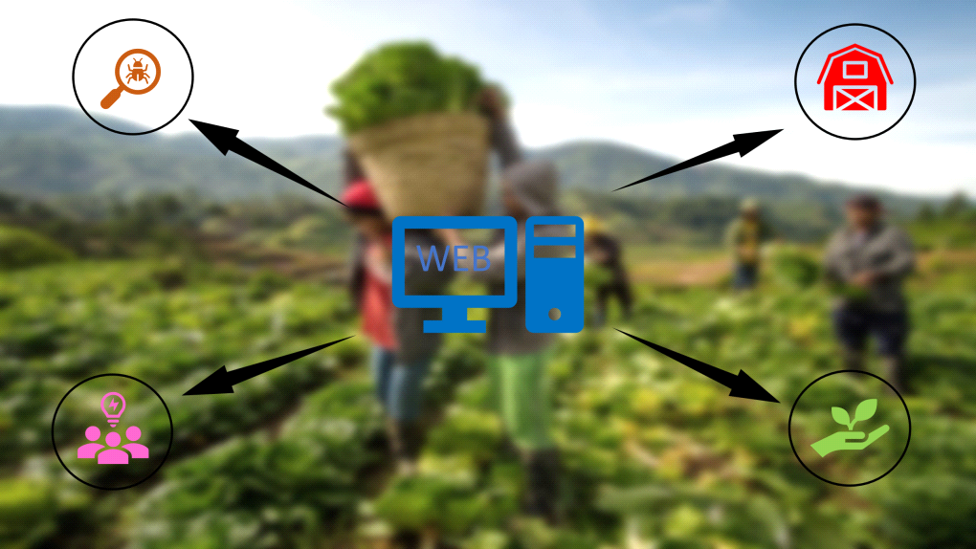

Figure 4: Decision management through information network
IPM provides a comprehensive method to manage pests, but in order to reach its full potential, several issues still need to be resolved, such as reduced farmers’ participation and comprehension of ecological concepts.
8.Challenges of Integrated Pest Management
Numerous obstacles prevent IPM from being used effectively in agriculture. The adoption of IPM practices is complicated by a number of socioeconomic, educational, and environmental factors, which lead to these obstacles (Jeffrey et al., 2019).
8.1 Lack of Farmer engagement and knowledge
Many farmers demonstrate moderate to poor knowledge of IPM principles, particularly with regard to pest identification and pesticide modes of action. This limits their capacity to execute these methods successfully (Sanjoy et al., 2024). A significant portion of farmers, more than 60% in Nepal, have not received any official training in IPM. This lack of understanding is a result of insufficient training and outreach initiatives. Farmers are discouraged from using IPM practices by low market pricing for organic crops and a lack of technical support (Shaurav et al., 2022).
8.2 Economic constraints
Farmers' adoption of IPM is severely impeded by financial restrictions. These limitations are frequently caused by excessive input costs, a lack of expertise, and insufficient access to high-quality resources. The cost of making the switch to IPM can be substantial, particularly for smallholder farmers who do not have access to the required tools or resources. As a result of immediate financial strain, farmers frequently turn to utilizing very toxic pesticides, which undermines the long-term advantages of IPM (Mohammad et al., 2024).
8.3 Environmental and Climate challenges
Pest issues are made worse by climate change, which makes it harder for IPM techniques to keep up with changing pest dynamics. In order to mitigate the effects on the environment, IPM integrates biological management, cultural practices, and limited chemical use, emphasizing ecological balance. In order to ensure long-term agricultural sustainability, regular monitoring and well-informed decision-making are crucial for adjusting IPM practices to changing climatic circumstances. The depletion of natural resources makes the use of successful IPM measures even more difficult (Tiwari, 2024).
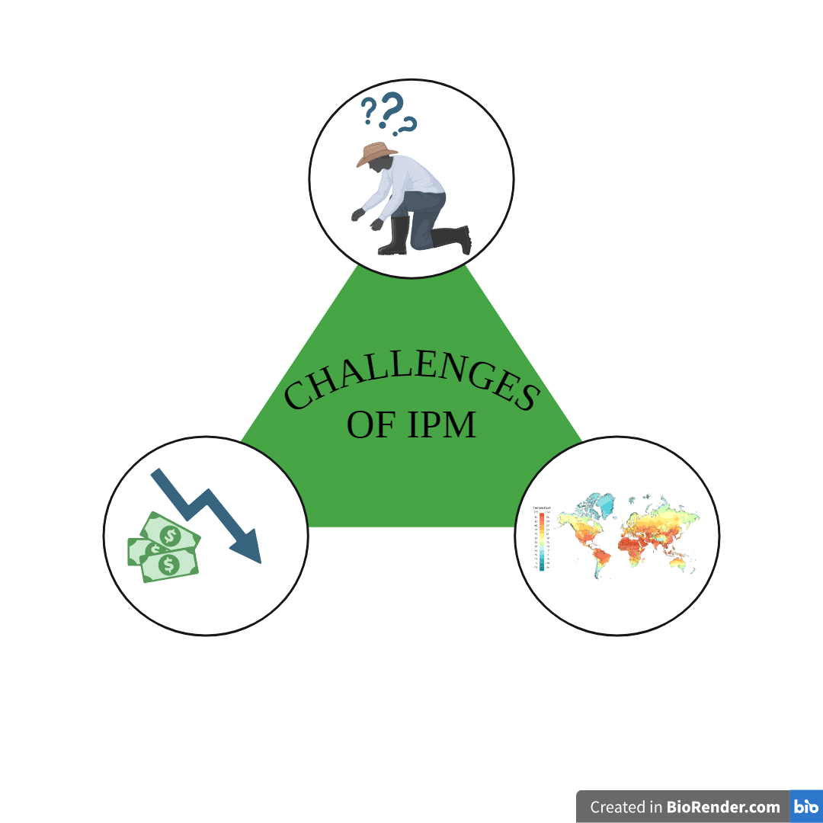
Figure 5: Major challenges in IPM

9. Future Directions of IPM
Future developments in IPM are progressively concentrated on environmentally conscious methods that incorporate cutting-edge technology and ecological concepts. The goal of this evolution is to minimize the impact on environmental while improving insect management (Jean et al., 2021).
Technological Advancements
Remote sensing, AI, drones, precision agriculture, and other technologies can be integrated to improve the efficacy and efficiency of integrated pest management. These tools can support data-driven decision-making, focused interventions, and precise pest monitoring (Rupali et al., 2022). A key component in IPM is now the use of beneficial species, including as microbiological agents and predatory insects. By using this technique, less synthetic pesticides are needed (Abdallah, 2023). The creation of genetically modified crops that express insecticidal proteins, like Bt. cotton, is an example of how biotechnology might improve pest resistance (Tara et al., 2018). Real-time monitoring of pest populations is made possible by technologies like drones and automated traps, which also help to contain infestations by allowing for focused actions (Fernando et al., 2022).
Climate Adaptive Strategies
It will be essential to create IPM plans that can withstand climate change. This entails being aware of how shifting weather patterns impact the biology and ecology of pests and modifying management strategies accordingly (Tiwari, 2024). It is essential to breed crops resistant to pest pressures in light of changing climates. Geographic Information Systems can assist in identifying pest risk areas, enabling focused treatments (Chandana et al., 2024). Optimizing pest control timing can be achieved by adjusting planting and harvesting dates based on predictive climate models. Additionally, adjusting control strategies, like the timerite method, to account for climatic differences can enhance the effectiveness of pest management (James Maino et al., 2024).
Community and Ecosystem Approaches
Expanding the scope of the ecosystem approach and promoting community involvement can improve the efficacy of IPM. This entails taking the agricultural environment as a whole into account and encouraging cooperation between farmers, academics, and legislators (Hosam and Maha, 2023). The productivity of agriculture and the state of the environment are greatly increased by community-based programs that educate farmers about sustainable techniques. More farmers and ecosystems benefit from improved pest control techniques and knowledge sharing that occurs when local people are involved in pest management (Muhammad et al., 2024). Using targeted chemical interventions, cultural practices, and biological control, IPM places a strong emphasis on understanding pest life cycles and their interactions with the environment. According to studies, IPM can increase biological control and preserve natural predators, increasing crop yields and lowering the need for chemical pesticides (Tiwari, 2024, Ivan et al., 2024).
Integrated Approach with Other Sustainable techniques
More comprehensive and sustainable agricultural systems can result from combining IPM with other sustainable agricultural techniques like organic farming, agroecology, and conservation agriculture. IPM's future rests in its ability to overcome its present obstacles via backing from policymakers, innovation in technology, education, and adaptable tactics. IPM will keep developing as time goes on, incorporating fresh scientific knowledge and technological advancements. In order to keep IPM at the vanguard of sustainable agriculture and contribute to future generations' access to food, environmental health, and economic viability, it will be imperative that we embrace these changes and challenges (Tiwari, 2024, Kenneth et al., 2016).
10.Conclusion
IPM has become a viable and efficient mean of controlling pests, providing a well-rounded solution that reduces the adverse effects of conventional techniques. The IPM approach integrates biological, cultural, physical, and chemical control measures to effectively address the underlying causes of pest infestations, all the while protecting human health and the environment. Even while IPM has many benefits, its effective application necessitates constant observation, assessment, and modification to fit particular farming circumstances. It is recommended that future research concentrate on creating novel IPM tactics, tackling new pest threats, and encouraging farmers and policymakers to adopt these approaches more widely. To sum up, IPM is a viable approach to sustainable agriculture and pest control. We can preserve human health, preserve our ecosystems, and guarantee a more robust food supply for future generations by adopting this integrated strategy.
References:

- Babu, A. M., Indhu, G., & Geetha, B. (2019). Diversity and Relative abundance of insects in cucurbits. Environment and Ecology 37 (3), 682-686.
- Sharma, S., Rubaljot, K., & Ramesh, A. (2017). Breeding insect resistant crops for Sustainable agriculture. Baru Sahib, Himachal Pradesh, India Ludhiana, Punjab, India. ISBN 978-981. DOI:10.1007/978-981-10-6056-4
- Jorgensen, L. N., Mogens, S. H., Jens, G. H., Poul, L., Bill, C., Rosemary, B. et al. (2014). IPM Strategies and their dilemmas including an introduction to www.eurowheat.org. Journal of Integrative Agriculture. 13(2),265–281. DOI: https://doi.org/10.1016/S2095-3119(13)60646-2
- Randolph, M. N., Carl, T. B., Peter, T. E., Jeffrey, S. F., Peter, G., Diddahally, R. G. et al. (2010). Evolution in health and medicine Sackler colloquium: Making evolutionary biology a basic science for medicine. Proceedings of the National Academy of Sciences of the United States of America, 26(107). 1800-7. Doi: https://doi.org/10.1073/pnas.0906224106
- Hokkanen, H., M. T. (2015). Integrated pest management at the crossroads: Science, politics, or business. Arthropod-Plant Interactions, 543–545. https://doi.org/10.1007/s11829-015-9403-y
- Ehi, E., Nwinyi, & Ajani, O. O. (2013). Integrated Pest Management. Weed and Pest Control (105-115). InTech Publisher, Croatia. DOI: 10.5772/54476
- Jean, P. D., Jean, N. A., Rica, J. F., Francoise, L., Kris, A. G. W., & Alain, R. (2021). Integrated pest management: good intentions, hard realities. Agronomy for Sustainable Development, Doi: 10.1007/s13593-021-00689-w
- Weiner, J. (2017). Applying plant ecological knowledge to increase agricultural sustainability. Journal of Ecology, 105(4). 865-870. DOI: https://doi.org/10.1111/1365-2745.12792.
- Quinn, N. F., Brainard, D. C., & Szendrei, Z. (2017). Floral strips attract beneficial insects but do not enhance yield in cucumber fields. Journal of Economic Entomology, 110(2):517-524. DOI: https://doi.org/10.1093/jee/tow306
- Xiao, X. M., Cheng, Z. H., Lv, J., Xie, J. M., Ma, N., & Yu, J. H. (2019). A green garlic (Allium sativum L.) based intercropping system reduces the strain of continuous monocropping in cucumber (Cucumis sativus L.) by adjusting the micro-ecological environment of soil. Peer Journal, 7. https://doi.org/10.7717/peerj.7267
- Lamichhane, J. R., Arseniuk, E., Boonekamp, P., Czembor, J., Decroocq, V., & Enjalbert, J. (2018). Advocating a need for suitable breeding approaches to boost integrated pest management: A European perspective. Pest Management Science, 74(6), 1219-1227. https://doi.org/10.1002/ps.4818
- Brown, J. K. (2015). Durable resistance of crops to disease: A Darwinian perspective. Annual Review of Phytopathology, 53(1), 513-539. Doi: https://doi.org/10.1146/annurev-phyto-102313-045914
- Kong, C. H., Zhang, S. Z., Li, Y. H., Xia, Z. C., Yang, X. F., Meiners, S. J. (2018). Plant neighbor detection and allelochemical response are driven by root-secreted signaling chemicals. Nature Communications, 9. https://doi.org/10.1038/s4146 7-018-06429 -1
- Ninkovic, V., Rensing, M., Dahlin, I., & Markovic, D. (2019). Who is my neighbor? Volatile cues in plant interactions. Plant Signaling & Behavior, 14(9), 1634993. https://doi.org/10.1080/15592 324.2019.1634993
- Ehlers, B. K., & Bilde, T. (2019). Inclusive fitness, asymmetric competition and kin selection in plants. Oikos, 128(6), 765–774. https://doi.org/10.1111/oik.06390
- Sanjoy, S., Atanu, M., Manasij, D., Sampurna, B., Anik, B., Niharika, P., et al. (2024). An Updated Integrated Pest Management System: A Footprint for Modern-Day Sustainable Agricultural Practices. Uttar Pradesh Journal of Zoology, 45. 71-79. 10.56557/UPJOZ/2024/v45i83998.
- Dhruti, S. S., Aradhana, B., Ashutosh, M., & Rojalindehury. (2024). Futuristic Trends in Agriculture Engineering & Food Sciences e-ISBN: 978-93-5747-688-1 IIP Series. 3(24). Chapter 7 Integrated pests’ management in crop protection: Implementation and benefits.
- Sonia, B., Dikshya, P., & Bhola, G. (2022). A review on cultural practice as an effective pest management approach under integrated pest management. Tropical Agroecosystems, 3, 34-40.
- Tiwari, A. K. (2024). Advances in Biological Control Strategies for Sustainable Pest Management. Uttar Pradesh Journal of Zoology, 45(3).214–232. DOI:https://doi.org/10.56557/upjoz/2024/v45i33894.
- Mahwish, R., Fatima, A., Riffat, B., & Sania, Iftikhar. (2024). Integrated Pest Management Precision: Harnessing the Joint Influence of Entomopathogenic Fungi, Nematodes, and Chlorantraniliprole for Targeted Control of Fall Armyworm (Spodoptera Frugiperda). Journal of Health and Rehabilitation Research,. 4(1). https://doi.org/10.61919/jhrr.v4i1.631
- Wangithi, C., Muriithi, B. W., Diiro, G., Dubois, T., Mohamed, S., Lattorff, H. M. G. et al. (2022). Synergies of integrated pest and pollinator management in avocado farming in East Africa: An ex-ante economic analysis. Plos one, 17(7). Doi: https://doi.org/10.1371/journal.pone.0303547
- Ivan, G., Amanda, R., Skidmore, M. A., Milne, P., O. A., Ian, K., Rick, E., et al. (2024). Integrated pest management enhances biological control in a US midwestern agroecosystem by conserving predators and non-pest prey. Agriculture, Ecosystems & Environment, 368. 109009. 10.1016/j.agee.2024.109009.
- Somit, R. M. (2024). Optimizing Sustainable Agricultural Practices: A Case Study of Integrated Pest Management Strategies in Farming. International Journal of Scientific Research in Engineering and Management, ISSN: 2582-3930.
- Mark, R., Margherita, F., Paolo, D., Isidora, S., Marta, M., Nicolas, M. J. et al. (2022). Development of an online pan-European Integrated Pest Management Resource Toolbox. Open Research Europe, 2(72). Doi: https://doi.org/10.12688/openreseurope.14679.2
- Vittorio, R., Tito, C., Irene, S., & Giorgia, F. (2023). Sharing decision-making tools for pest management may foster implementation of Integrated Pest Management. Food Security, 15, 1459-1474. Doi: http://dx.doi.org/10.1007/s12571-023-01402-3
- Upama, A. (2022). Insect pest management, mechanical and physical techniques. Reviews in Food and Agriculture, 3(1). 48-53.
- Rupali, N., Fraz, A., Renu, S., Nisha, B., & Kewal, K. (2022). Ethnobotanical Studies on Some Angiosperms of Tehsil Hiranagar of District Kathua (Jammu and Kashmir), India. Acta Botanical Plantae. http://dx.doi.org/10.5281/zenodo.7134745
- Hosam, A., A. A., Maha, A., K. A. (2023). The Impact of Environmental Awareness on Personal Carbon Footprint Values of Biology Department Students, Faculty of Science, El-Mergib University, Al-Khums, Libya. Acta Biology Forum, 18-22. http://dx.doi.org/10.5281/zenodo.8330130
- Kenneth, G. S., & Alberto, T. B. (2016). Designing Standardized and Optimized Surveys to Assess Invertebrate Biodiversity in Tropical Irrigated Rice Using Structured Inventory and Species Richness Models. Environmental Entomology, 45(2):446-64. https://doi.org/10.1093/ee/nvw003
- Tara, Y., Veer, S., Acharya, V. S., & Ramawtar, Y. (2018). Molecular approaches and their role in integrated pest management. Journal of Pharmacognosy and Phytochemistry. 7(6). 145-150.
- Fernando, H., l. F., Juliano, B. P., Tavvs, M. A., Robert, L. K., & Pedro, T. Y. (2022). How does the digital transformation of agriculture affect the implementation of integrated pest management. Frontiers in Sustainable Food System, 6(2022). https://doi.org/10.3389/fsufs.2022.972213
- Chandana, C. R., Sushila, N., Sreenivas, A. G., Chandana, T. P., Vishal, F., & Hallikeri. (2024). Climate-smart pest management strategies: Under changing climate scenarios. Journal of Advances in Biology and Biotechnology, 27(6). 364-377. https://doi.org/10.9734/jabb/2024/v27i6896
- James, M., Paul, U., Celia, C. P., Xuan, Cheng., & Ridsdill, S., T. J. (2024) Adapting pest management strategies to changing climates for the red legged earth mite, Halotydes destructor. Scientific Reports, 14(1). http://dx.doi.org/10.1038/s41598-024-67602-9
- Muhammad, R. A., Oktoni, E., Mawaddah, P., A. S., Alfis, Y., & Siti, A. (2024). Empowering communities with Integrated Pest Management for sustainable agriculture. Jurnal Pengabdian Kepada Masyarakat:Teknologi'dan Aplikasi. 5(10). 51-59.
- Shaurav, S., Laxman, C. T., Keshav, B., Dipak, k., & Asbin, B. (2022). Perception of farmers on handling pesticide and adoption of IPM in west rukum of Nepal. Socio Economy and Policy Studies, 2(2). 78-84. http://dx.doi.org/10.26480/seps.02.2022.78.84
- Mohammad, R. B., Dipankar, B., Nilav, R. B., Mukil, V., A. Ashick, R. R., & Ashwin, N. M. (2024). Role of integrated pest management in agriculture. International Journal of Zoology and Applied Biosciences, 9(2). 40-46. http://dx.doi.org/10.55126/ijzab.2024.v09.i02.007
- Shikha, S. (2023). Cultivating sustainable solutions: Integrated Pest Management (IPM) for safer and greener agronomy. Corporate Sustainable Management Journal, 1(2), 103-108. Doi: http://dx.doi.org/10.26480/csmj.02.2023.103.108
- Abdallah, A. F. (2023). Modern techniques in integrated pest management to achieve sustainable agricultural development. International Journal of Family Studies, Food Science and Nutrition Health, 4(1), 1-14. Doi: https://dx.doi.org/10.21608/ijfsnh.2024.293410.1010
- Sanjoy, S., Atanu, M., Manasij, D., Sampurna, B., Anik, B., Niharika, P. et al. (2024). An Updated Integrated Pest Management System: A Footprint for Modern-Day Sustainable Agricultural Practices. Uttar Pradesh Journal of Zoology, 45(8), 71-79. Doi: http://dx.doi.org/10.56557/UPJOZ/2024/v45i83998
- Rizal, M., Octivia, T., Tri, L. M., Rohimatun., & Maris, P. (2022). IPM on organic estate crops: opportunities and challenges. IOP Conference Series: Earth and Environmental Science, 974(1), 012059-012059. Doi: https://iopscience.iop.org/article/10.1088/1755-1315/974/1/012059
- David, H. H. (2021). The Future of Organic Insect Pest Management: Be a Better Entomologist or Pay for Someone Who Is. Insects, 12(2), 140. Doi: https://doi.org/10.3390/insects12020140
- Kristina, K. G., Johan, A. S., & Asa, L. (2020) Making sense of Integrated Pest Management (IPM) in the light of evolution. Evolution Applications, 13(8), 1791-1805. Doi: https://doi.org/10.1111/eva.13067
- Nikita, D., Sujatha, G. S., Katta, S. S. T., Sanjay, H., Vidya, M. E., Rupali, J. S. et al. (2024). Integrated Pest Management: Success Stories and Key Takeaways. Uttar Pradesh Journal of Zoology, 45(16), 229-244. Doi: https://doi.org/10.56557/upjoz/2024/v45i164304
- Prodipto, B. A., Sujit, M., Israt, J., Mitu, D., Uttam, B. A., Famin, J. A. et al. (2023) Integrated Pest Management (IPM) in Agriculture and Its Role in Maintaining Ecological Balance and Biodiversity. Advances in Agriculture, 2023(1). Doi: https://doi.org/10.1155/2023/5546373
- Cahyaningtyas, P. S., Desy, S., Dewanti. R. P., & Wikanditha, K. (2024). Comparative Efficiency Analysis of Organic and Conventional Melon Farming. IOP Conference Series: Earth and Environmental Science, 1364(1), 012043-012043. Doi: https://iopscience.iop.org/article/10.1088/1755-1315/1364/1/012043
- Laurence, S., Adrian, G. W., & Bruce, P. (2015). The energy efficiency of organic agriculture: A review. Renewable Agriculture and Food Systems, 30(3), 280-301. Doi: https://doi.org/10.1017/S1742170513000471
- Hsiao, L. L., Yuan, H. C., & Bing Y. W. (2020). The compare organic farm and conventional farm to improve sustainable agriculture, ecosystems, and environment. Organic Agriculture, 10(6), 409-418. Doi: https://link.springer.com/article/10.1007/s13165-020-00278-3
- Jeffrey, A., George, N., & Catherine, L. (2019). Obstacles to Widespread Diffusion of IPM in Developing Countries: Lessons From the Field. Journal of Integrated Pest Management, 10(1), 1-8. Doi: https://doi.org/10.1093/jipm/pmz008

