Original Research Article
Temperature and pH-Driven Lipase Dynamics of Penicillium spp. and Aspergillus niger for Sustainable Treatment of Agro-Industrial Wastewater

.

ABSTRACT

The increasing environmental burden of palm oil mill effluent (POME) has necessitated the search for eco-friendly remediation strategies. This study investigated the potential of Penicillium spp. and Aspergillus niger isolated from palm oil mill press fibre (PPF) for lipase production and their application in the biodegradation of POME. The fungi were screened for lipase activity using Tween 80 agar, Tributyrin agar, and Phenol Red agar. Conventional identification methods were employed. PPF from a local oil mill was processed for solid-state fermentation (SSF). Lipase production involved moistening 3 g of PPF with 10 mL of basal medium, sterilizing at 121 °C and 15 psi for 20 minutes, and inoculating with 2 mL of spore suspension (1.0 × 10⁷ spores/mL). Lipase activity was measured spectrophotometrically using p-nitrophenyl laurate (p-NPL) over 15 days at varying temperatures (25 °C – 45 °C) and pH levels (3.0 – 7.5). Initial lipase yields were 104 U/mL for Penicillium spp. and 398 U/mL for A. niger. Optimization significantly enhanced enzyme production. Penicillium spp. peaked at 35 °C (373 U/mL) and pH 6.5 – 7.0 (771 U/mL), while A. niger peaked at 25 °C (387 U/mL) and pH 7.0 – 7.5 (755 U/mL). Statistically significant differences (P =.05) were observed. Crude lipases showed effective POME degradation, with Penicillium spp. achieving 99.77% at pH 7.0, and A. niger 88.77% at pH 6.5. These findings demonstrate that fungal-derived lipases are promising tools for sustainable bioremediation of lipid-rich effluents, and that PPF is a viable substrate for enzyme production.

Keywords: Lipase, Aspergillus niger, Penicillium spp., Palm oil mill effluent, Biodegradation, Agro-waste, Solid-state fermentation.

1. INTRODUCTION

Lipases (triacylglycerol acylhydrolases, EC 3.1.1.3) and esterases (carboxylic-ester hydrolases, EC 3.1.1.1) are hydrolytic enzymes that catalyze the cleavage of ester bonds. Although they have historically been considered interchangeable, advances in enzymology have uncovered important differences in their substrate specificity and behavior. Esterases generally act on short-chain, water-soluble esters, while lipases target long-chain, water-insoluble triglycerides, which require interaction with hydrophobic, emulsified substrates [1].
Lipases are widely used in various fields, including food processing, pharmaceuticals, biodiesel production, and wastewater treatment [2]. Fungal-derived lipases are particularly valuable because they are secreted extracellularly, have a broad substrate range, and remain resilient under harsh conditions [3]. Compared to bacterial lipases, fungal enzymes can be more easily recovered, perform better in organic solvents, and exhibit broader stability across different pH levels and temperatures, making them ideal for industrial applications such as treating palm oil mill effluent (POME) [2, 4].
Environmental factors, particularly pH and temperature, significantly affect the production and activity of fungal lipases. Optimal activity is usually observed under slightly acidic to neutral conditions (pH 6.0 – 7.5), although fungal lipases can maintain stability over a wide pH range [5, 6]. Most fungal species produce lipases optimally at temperatures between 25 °C and 40 °C, with some thermophilic strains remaining active at temperatures up to 50 °C [2, 7]. Aspergillus species are well-known for their lipase production, although the optimal production parameters can vary by species. For instance, Aspergillus niger produces lipase most efficiently at 40 °C and pH 7.5, while Aspergillus carneus secretes an alkaline lipase with peak activity at pH 8.0 [8].
Fungal lipases are typically produced through submerged fermentation (SmF) or solid-state fermentation (SSF). SmF allows for precise control and scalability, while SSF—using agro-wastes like palm press fiber (PPF)—better mimics natural fungal habitats and results in higher enzyme titres at lower operational costs [9, 10]. SSF is especially beneficial in developing regions due to its minimal water and energy requirements.
The expression and secretion of fungal lipases are regulated by various factors, including pH, temperature, oxygen availability, carbon and nitrogen sources, and fermentation duration. Peak enzyme production usually occurs within 48 to 96 hours of fermentation, though this can vary by species and conditions [2]. Fungal genera such as Aspergillus, Penicillium, Candida, Geotrichum, and Mucor have been extensively studied for their lipolytic capabilities, but enzyme yield is highly strain-dependent. Additionally, some studies have investigated the use of dried fungal biomass as immobilized enzyme systems, enhancing stability and reusability in industrial operations [2, 11].
Fungal lipases exhibit remarkable catalytic versatility, functioning effectively in both aqueous and non-aqueous environments. Beyond hydrolysis, they can catalyze esterification and transesterification reactions, which are critical for synthesizing biodiesel, flavor esters, and surfactants. Their ability to operate in challenging conditions without the need for cofactors further enhances their industrial appeal [2, 12, 13].
Key fungal strains used in commercial lipase production include Candida rugosa, Rhizopus oryzae, Mucor miehei, Aspergillus niger, and Humicola lanuginosa [14]. Other promising lipase producers include Fusarium, Geotrichum, Trichoderma, and newly characterized strains such as Aspergillus terreus, Stemphylium lycopersici, and Thermomyces lanuginosus [15, 16]. Lipases rank as the third most widely used industrial enzyme group, following proteases and amylases, and play crucial roles across multiple sectors. The global lipase market is projected to exceed USD 797.7 million by 2025 due to increasing demand from the food, pharmaceutical, and biofuel industries [11].
Fungal lipases also play a vital role in bioremediation. For example, Pseudomonas lipases have been shown to degrade up to 92.6% of hydrocarbons in oil-contaminated soil [6, 17]. Palm oil mill effluent (POME) is a significant environmental pollutant, characterized by high chemical oxygen demand (COD), fats, and suspended solids. Lipase-producing fungi offer an eco-friendly solution by accelerating lipid degradation and improving effluent quality. Studies have demonstrated that lipase-assisted bioremediation of POME under optimized pH (4.0 – 7.0) and temperature (35 – 45 °C) significantly reduces oil content and converts organic waste into non-toxic compounds [18, 19].
Solid-state fermentation using PPF, a lignocellulosic byproduct of palm oil processing, is a promising approach for sustainable lipase production. PPF is abundant and rich in cellulose, hemicellulose, and lignin, making it an economical substrate for fungal fermentation [9, 20]. Utilizing PPF in SSF not only promotes waste valorization but also supports enzyme production, aligning with the principles of a circular economy.
Despite these advancements, there are still gaps in our understanding of how various environmental and physiological factors influence fungal lipase production, particularly among different species and substrates. Therefore, this study aims to optimize the pH and temperature conditions for enhanced lipase production by Penicillium spp. and Aspergillus niger. Additionally, it will evaluate the resulting enzymatic activity and biodegradation efficiency. The findings of this research will contribute to the development of efficient and scalable biotechnological solutions for enzyme production and environmental remediation.
2. materialS and methods

2.1 Sample Collection
Approximately 200 g of oil-contaminated soil samples were randomly collected from six distinct locations in Bokkos, Plateau State, Nigeria: Mundat, Kamoi, Sha, Toff, Ritcha, and Karfa. The samples were obtained using a sterile soil auger at a depth of 4 inches below the soil surface to ensure the collection of active microbial communities. Each sample was carefully transferred to sterile plastic bags and transported to the Microbiology Laboratories at Plateau State University, Bokkos, and Joseph Sarwuan Tarka University, Makurdi, for further analysis. PPF was obtained from a local palm oil mill in Nasarawa, State.
2.2 Sample Preparation
The PPF was thoroughly washed with distilled water to remove residual oil, dirt, and other impurities. It was chemically treated with 1% (w/v) NaOH at 50 °C for 30 minutes to remove lignin and hemicellulose, followed by repeated washing with distilled water until pH 7.0 was achieved. The cleaned fibre was sun-dried for 48 hours to reduce moisture content followed by further drying in a hot air oven at 60 °C to 70% moisture. The dried PPF was then ground into smaller particles using a mechanical grinder and sieved through a 2 mm mesh to achieve a uniform particle size. The processed PPF was stored in a clean, airtight plastic container until further use.
2.3 Isolation and Identification of Lipase Producing Fungi
The fungal strains were isolated using Potato Dextrose Agar (Lab M), supplemented with Ampicillin and tetracycline at a concentration of 30 mg/L to inhibit bacterial contamination. The medium was sterilized by autoclaving at 121 °C and 15 psi for 15 minutes. Antibiotics were added to the medium immediately before pouring the plates, ensuring the temperature was maintained between 40 °C and 45 °C to preserve their efficacy [21].
Ten grams of soil samples from each site were suspended in a 250 mL Erlenmeyer flask containing 100 mL of distilled water. The mixture was agitated thoroughly to dislodge soil clumps and then allowed to settle. The supernatant was decanted, and a 10⁻fold serial dilution was performed. Precisely, 0.1 mL of dilutions 10⁻² to 10⁻⁴ were inoculated onto Potato Dextrose Agar (PDA) plates and incubated at 25 °C for 5 days. Fungal colonies were sub-cultured on PDA plates to obtain pure isolates which were stored on PDA slants at 4 ºC.
Pure fungal isolates were identified based on their cultural and morphological characteristics [22]. Cultural characteristics took cognize of colony colour, shape, growth pattern, and consistency on PDA. Morphological identification involved microscopic examination of 5-day-old fungal mycelia stained with 2% Lactophenol blue. Key microscopic features, including spore shape, colour, and mycelium (septate or non-septate), were observed for identification [23].

Pure cultures were regularly sub-cultured onto fresh sterile PDA slants every 2 - 3 weeks to maintain viability and kept at 4 ºC.
2.4 Qualitative Screening of Fungi for Lipase Production
The screening was conducted using three different media, namely; Tween-80 agar, Tributyrin agar, and Phenol Red agar to qualitatively assess fungal lipase production.
Tween-80 Agar was prepared with the following composition (g/L): peptone (15 g), NaCl (5 g), CaCl₂ (1 g), agar (15 g), and Tween-80 (10 mL), all dissolved in distilled water. The pH was adjusted to 6.0 using 1M NaOH before autoclaving. Approximately 20 mL of the medium was poured into sterile Petri dishes, inoculated with fungal isolates, and incubated at 27 °C ± 2 °C for 48 hours. Lipase activity was indicated by the formation of a clear zone (mm) around the fungal colonies, as well as the precipitation of calcium monolaurate [24].
Phenol Red Agar was prepared by incorporating 0.01% (w/v) phenol red, 1% (v/v) olive oil, 0.1% (w/v) CaCl₂, and 2% (w/v) agar into distilled water, adjusting the pH to 7.4. The medium was sterilized, poured into Petri dishes, and inoculated with the fungal isolates. The plates were incubated at 27 °C ± 2 °C for 48 hours, and lipase activity was detected by a colour change in the phenol red indicator. The diameter of the clear zone surrounding fungal colonies served as a measure of lipase activity [25, 26].
Tributyrin Agar was prepared by dissolving 4.6 g of Tributyrin Agar (TBA) in 198 mL of distilled water, followed by the addition of 2 mL of tributyrin and 20 µL of Tween-20 (as an emulsifier). The mixture was sterilized, poured into sterile Petri dishes, and inoculated with the fungal isolates. After incubation at 27 °C ± 2 °C, lipase activity was determined based on distinct clear zones around the fungal colonies [27].
2.5 Preparation of Inoculum
The spore suspension was prepared by adding 20 mL of sterile distilled water containing 0.1% Tween 80 to a 7-day-old fungal culture plate. The spores were carefully dislodged using a sterile curved glass rod. The suspension was then adjusted to a concentration of 1.0 × 10⁷ spores/mL using a hemocytometer. A volume of 2 mL of the standardized spore suspension was aseptically inoculated into triplicate flasks containing sterilized PPF.
2.6 Preparation of Moistening Medium and Lipase Production in Solid-State Fermentation
The moistening medium was prepared by dissolving 6% (w/w) glucose, 3% (w/w) olive oil, and 0.5% (w/w) peptone in distilled water and adjusting the pH to 5.0. For SSF, 3 g of pretreated PPF was placed in a 250 mL Erlenmeyer flask and moistened with 10 mL of the basal medium. The setup was autoclaved at 121 °C, 15 psi for 20 minutes, then allowed to cool to room temperature. Each flask was inoculated with 2 mL of a spore suspension (1.0 × 10⁷ spores/mL) and thoroughly mixed. The flasks were incubated at 30 °C ± 1 °C in a shaker incubator (150 rpm) for 5 days.
At the end of the incubation period, lipase extraction was carried out. All experiments were performed in triplicates, and data were presented as the mean values of triplicate determinations [28].
2.7 Studies on Effects of pH and Temperature on Lipase Production
To determine the optimal pH for lipase production, the fermentation medium was prepared and adjusted to different pH levels (3.0, 3.5, 4.0, 4.5, 5.0, 5.5, 6.0, 6.5, 7.0 and 7.5) using 0.1 M NaOH and 0.1 M HCl before sterilization. The effect of temperature on lipase production was conducted under optimal pH at 25 °C, 30 °C, 35 °C, 40 °C, and 45 °C.
2.8 Extraction and Determination of Lipase Activity
The fermented substrate was thoroughly mixed with 70 mL of 0.1M phosphate buffer (pH 7.0) after the fermentation period and it was agitated in an orbital shaker (150 rpm) Model LH-100F for one hour at 30 ºC. The flask contents were filtered using a muslin towel and the supernatant was centrifuged at 10,000 rpm at 4 ºC for 15 minutes. Lipase activity was measured by spectrophotometric method using a p-nitrophenyl laureate (p-NPL) as substrate. The assay protocol comprised of 0.05 mL crude lipase mixed with 2.2 mL phosphate buffer (pH 7.0) and 0.25 mL of p-NPL. Activity was assessed following a 30-minute hydrolysis reaction at 30 °C and pH of 5.0 at the wavelength of 412 nm using a UV spectrophotometer (Model UV752). One unit of lipase activity was defined as the quantity of enzyme that releases one mol of p-nitrophenol per milliliter per minute per gramme of dry substrate used for SSF [29].
2.9 Laboratory-Scale Bioremediation of POME Using Crude Lipase
For the bioremediation study, a modified Zajic and Suplisson medium was employed, consisting of palm oil mill effluent (POME) and various inorganic salts dissolved in 1 litre of distilled water. The mineral salt medium contained the following components: 2.0 g of Na₂HPO₄, 0.17 g of K₂SO₄, 4.0 g of NH₄NO₃, 0.53 g of KH₂PO₄, and 0.10 g of MgSO₄·7H₂O [30].
Ten milliliters (10 mL) of the mineral salt medium was dispensed into each of ten test tubes, and 2 mL of POME was added to each tube. The mixture was then sterilized by autoclaving at 121 °C and 15 psi for 15 minutes. After cooling, 2 mL of crude lipase enzyme was added to each of nine test tubes, while the tenth test tube, which did not contain enzyme, served as the control.
The experimental setup was incubated at 30 °C for 15 minutes. Following the incubation, the absorbance was measured at 412 nm using a UV-Vis spectrophotometer to determine the extent of lipid degradation [31].
2.10 Statistical Analysis
Data was analyzed using statistics package for social science version software (20). The statistical significance of means was measured by using the ANOVA. P=.05 was considered statistically significant [32].
3. results and discussion
3.1 rESULTS
3.1.1 Effect of Temperature Variations on Lipase Production

Figure 1 illustrates the initial lipase production of 104 U/mL and 398 U/mL by Penicillium spp. and Aspergillus niger respectively on PPF before optimization. Figure 2 presents the effect of temperature variation on lipase production by Penicillium spp. and Aspergillus niger at day 3. Lipase production by Penicillium spp. ranged from 123 U/mL - 346 U/mL. The production at 25 ºC (346 U/mL) was immediately followed by a steady decline with increasing temperatures. The production of lipase by A. niger ranged from 173 U/mL - 338 U/mL and followed a similar pattern. Lipase production peaked at 30 ºC (338 U/mL) followed by a gradual decline with increase in temperature. There was a significant difference in the lipase produced at the different temperatures at P =.05.
The effect of varying temperatures on lipase production by Penicillium spp. and Aspergillus niger on day 6 is depicted in Figure 3. The production of lipase by both fungi ranged from 179 U/mL - 336 U/mL with peaks at 25 ºC - 30 ºC and no significant difference between the fungi (P ˃.05). After 30 ºC - 45 ºC lipase production was marked with significant decrease as temperature increased (P = .05). Figure 4 showed a significant difference in the peaks of lipase production for A. niger and Penicillium spp. on day 9. Penicillium spp. at 25 ºC produced 296 U/mL of lipase but with the peak at 30 ºC (357 U/mL) followed by a decline. Contrary, lipase production by A. niger was peaked at 25 ºC (369 U/mL) and followed by a decline as temperature increased.

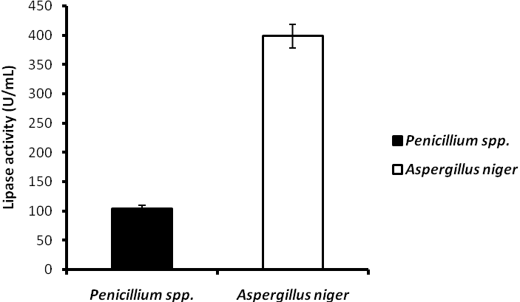
Figure 1. Initial production of lipase by Penicillium and A. niger at 25 ºC pH 4.0 on day 3 before optimization. Bar represent standard error of duplicate determination

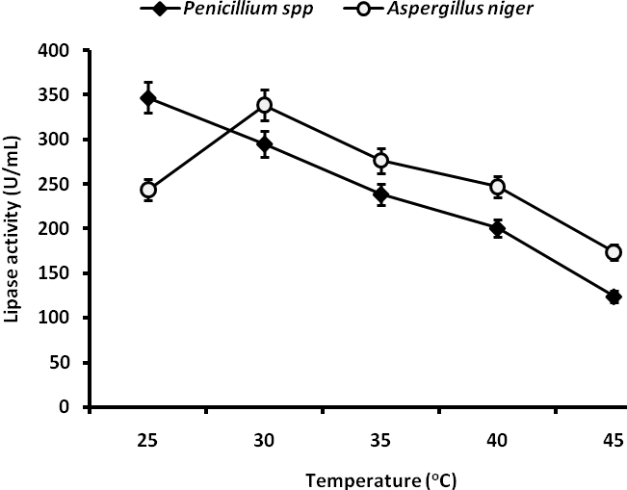
Figure 2. Effect of temperature variation on lipase production by Penicillium spp. and Aspergillus niger on day 3. Bar represent standard error of duplicate determination

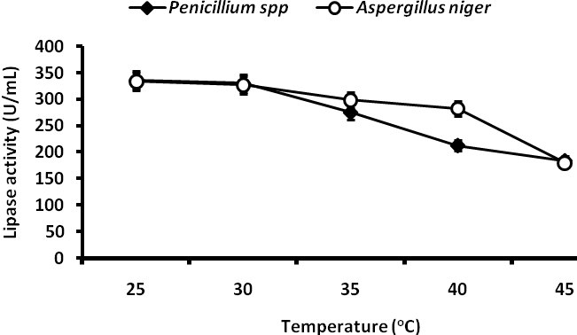
Figure 3. Effect of temperature variation on lipase production by Penicillium spp. and Aspergillus niger on day 6. Bar represent standard error of duplicate determination

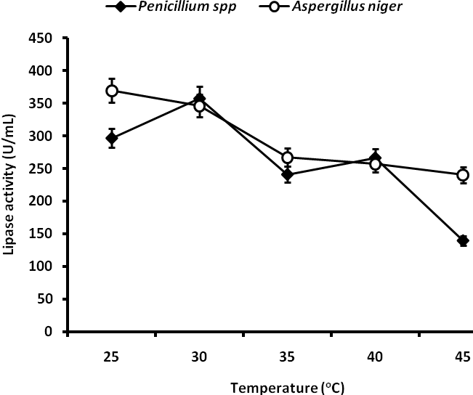
Figure 4. Effect of temperature variation on lipase production by Penicillium spp. and Aspergillus niger on day 9. Bar represent standard error of duplicate determination

Figure 5 depicts the effect of varying temperatures on lipase production by Penicillium spp. and Aspergillus niger on day 12. Lipase production ranged from 387 U/mL - 177 U/mL. The production of lipase by Penicillium spp. at 25 ºC (328 U/mL) and peaked at 35 ºC (373 U/mL) after which production declined with increasing temperatures. A. niger exhibited peak production of 387 U/mL at 25 ºC followed by moderate decrease in production from 30 ºC - 35 ºC and rapid decline at 45 ºC. There was a significant difference in lipase production across the different temperatures at P = .05. Figure 6 showed the effect of varying temperature on lipase production by Penicillium spp. and Aspergillus niger on day 15 with P = .05. Penicillium spp. showed a gradual increase in production at 25 ºC (280 U/mL) to peak production at 35 ºC (330 U/mL) and declined quickly. A. nger exhibited broad lipase production optima at 25 ºC - 30 ºC (368 U/mL) followed by a decline at 35 ºC (272 U/mL) and 40 ºC - 45 ºC (240 U/mL).

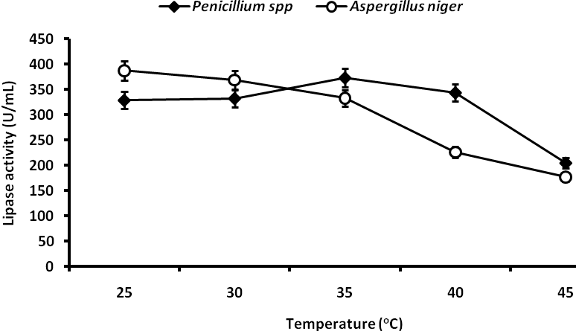
Figure 5. Effect of temperature variation on lipase production by Penicillium spp. and Aspergillus niger on day 12. Bar represent standard error of duplicate determination

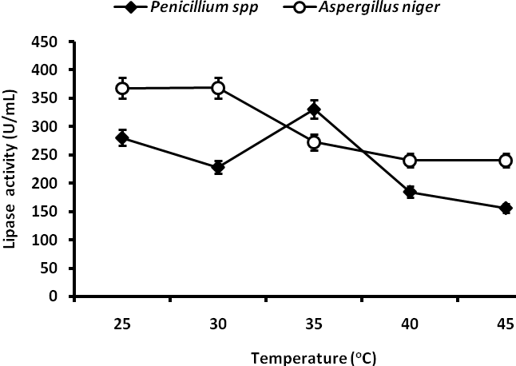
Figure 6. Effect of temperature variation on lipase production by Penicillium spp. and Aspergillus niger on day 15. Bar represent standard error of duplicate determination
3.1.2 Effect of pH Variations on Lipase Production
Figure 7 presents the effect of pH variation on lipase production by Penicillium spp. and Aspergillus niger on day 3. Lipase production by Penicillium spp. ranged from 104 U/mL - 746 U/mL and peaked at pH 7.0. Similarly, A. niger exhibited significant difference in lipase production ranging from 211 U/mL - 763 U/mL and with the peak at pH 7.0 (P = .05). The effect of varying pH on lipase production by Penicillium spp. and A. niger on day 6 is depicted in Figure 8. Penicillium spp. exhibited significant lipase production at lower acidic range with peak at pH 4.5 (742 U/mL) while A. niger performed better at the near neutral of pH 6.5 (718 U/mL). Similarly, on day 9 Penicillium spp. and A. niger exhibited peak productions of lipase at pH 5.0 (713 U/mL) and pH 6.5 (768 U/mL) (Figure 9). The same trend was repeated on day 12 with peak lipase production at pH 5.0 (747 U/mL) and A. niger with at pH 7.0 - 7.5 (748 U/mL - 755 U/mL) Figure 10. Figure 11 illustrates the effect of varying pH on lipase production by Penicillium spp. and A. niger on day 15. Lipase production by Penicillium spp. at pH 6.5 was 771 U/mL and A. niger at pH7.5 produced 623 U/mL. Production was statistically significant at P = .05.
Figure 12 depicts the biodegradation of palm oil mill effluent (POME) by crude lipases from Penicillium sp. and A. niger across different pH levels. The biodegradation efficiency of Penicillium sp. increased from 41% at pH 3.0 to 67% at pH 4.5, followed by a sharp decline to 5.95% at pH 6.0. However, biodegradation rose significantly at higher pH levels, reaching 96.27% at pH 6.5 and peaking at 99.77% at pH 7.0. Similarly, A. niger exhibited substantial bioremediation potential, achieving 84% degradation at pH 3.0. This was followed by a gradual decline, reaching its lowest point at pH 6.0 (3.0%). However, degradation increased sharply at higher pH levels, recording 88.77% at pH 6.5 and 77.4% at pH 7.0.

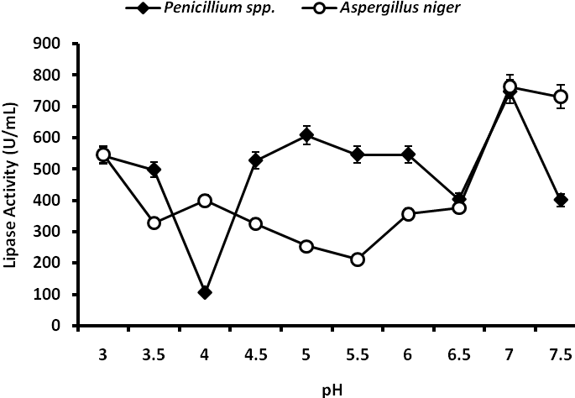
Figure 7. Effect of pH variation on lipase production by Penicillium spp. and Aspergillus niger on day 3. Bar represent standard error of duplicate determination
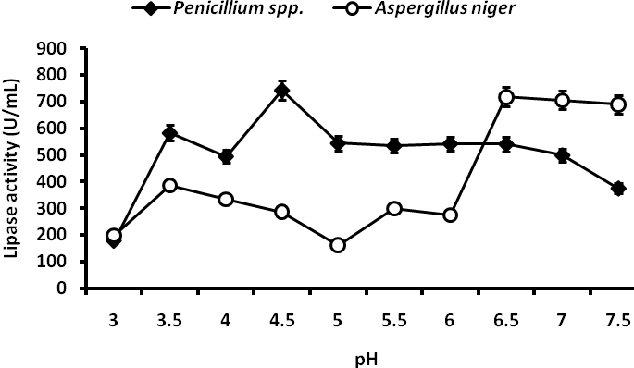
Figure 8. Effect of pH variation on lipase production by Penicillium spp. and Aspergillus niger on day 6. Bar represent standard error of duplicate determination
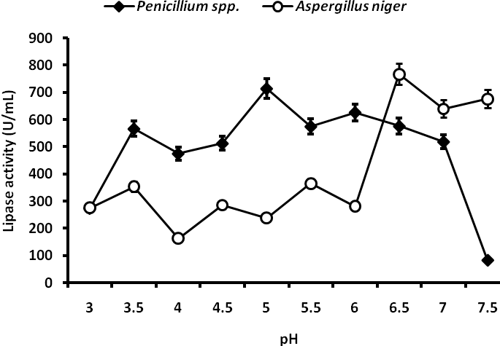
Figure 9. Effect of pH variation on lipase production by Penicillium spp. and Aspergillus niger on day 9. Bar represent standard error of duplicate determination
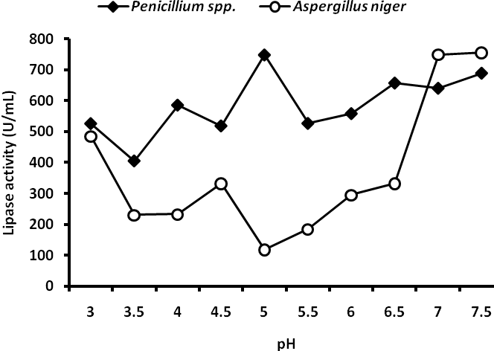
Figure 10. Effect of pH variation on lipase production by Penicillium spp. and Aspergillus niger on day 12. Bar represent standard error of duplicate determination
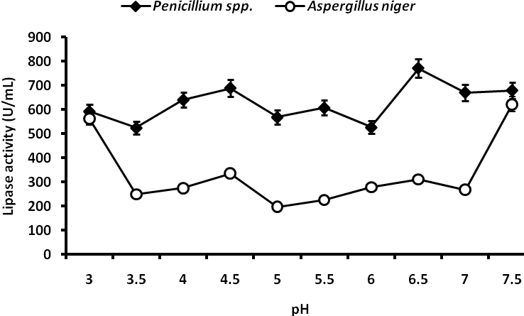
Figure 11. Effect of pH variation on lipase production by Penicillium spp. and Aspergillus niger on day 15. Bar represent standard error of duplicate determination
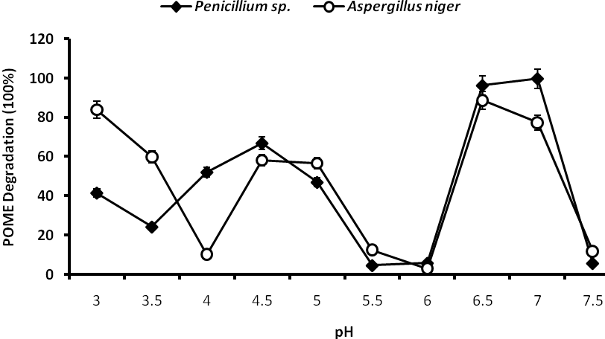
Figure 12. Biodegradation of POME by crude lipases of Penicillium sp. and A. niger. Bar represent standard error of duplicate determination

3.2 DISCUSSION
The current study examined the lipase-producing abilities of Penicillium spp. and Aspergillus niger, which were isolated from PPF. The research focused on optimizing environmental conditions, specifically temperature and pH, to enhance enzyme production and its application in the biodegradation of POME. The findings demonstrate the significant potential of these fungal species as effective biocatalysts in both industrial and environmental biotechnology.
Initial screening revealed that A. niger exhibited higher baseline lipase production (398 U/mL) compared to Penicillium spp. (104 U/mL) on pretreated PPF, stressing its inherent metabolic versatility in utilizing lipid-rich substrates. This differential lipolytic activity aligns with an earlier study which emphasized the high enzyme secretion efficiency of Aspergillus species on agro-industrial residues [33].
3.2.1 Effect of Temperature Variations on Lipase Production
The effect of temperature on lipase production was consistently notable across the 15-day incubation period. At day 3, Penicillium spp. and A. niger displayed peak lipase activities at 25 °C and 30 °C respectively, with both organisms showing a decline in production at higher temperatures. By day 9, however, Penicillium spp. peaked at 30 °C (357 U/mL) while A. niger achieved maximal production at 25 °C (369 U/mL), indicating a shift in optimal temperature as fungal metabolism progressed. This corroborates the findings of many studies that temperature directly affects fungal growth and protein dynamics, which ultimately affect the secretion of secondary metabolites [34, 35]. The observed temperature-dependent enzyme dynamics suggest mesophilic characteristics, corroborating findings of other studies which reported that fungal lipases generally exhibit optimal activity between 25 °C and 35 °C [2]. However, the optimal temperature for producing fungal lipases varies depending on the specific fungal strain, but generally falls within the range of 30 °C to 45 °C [11]. Some studies have reported peak lipase activity at 30 °C, while others have found 40 °C or 45 °C to be optimal for bacterial lipases [11, 36]. According to [36] temperature control is a critical factor for lipase production, as a significant reduction in lipolytic activity resulted from a small variation in the temperature of the system. This is because temperature regulates microorganism development through metabolic activities, influences cell structure, and external enzyme excretion. Cultivating microorganisms at optimal development temperatures leads to increased productivity [37]. Higher temperature accelerates enzymatic reactions in cells, while protein denaturation slows metabolism, affecting cell proliferation and productivity [38].
Interestingly, a distinct pattern emerged on day 12 when Penicillium spp. demonstrated peak production at 35 °C (373 U/mL), while A. niger maintained its optimum at 25 °C (387 U/mL). By day 15, Penicillium spp. sustained a high production rate at 35 °C (330 U/mL), unlike A. niger, which declined after 30°C. This thermotolerance in Penicillium spp. suggests possible adaptation mechanisms or the presence of thermostable isoforms of lipase [39].
3.2.2 Effect of pH Variations on Lipase Production
The pH-dependent production of lipase demonstrated even more dramatic variation. On day 3, both fungi exhibited maximum enzyme production at pH 7.0, suggesting a preference for near-neutral conditions at early growth stages. However, by day 6, Penicillium spp. peaked at pH 4.5, while A. niger peaked at pH 6.5. This divergence in pH optima indicates strain-specific regulatory control of lipase gene expression, possibly influenced by shifts in nutrient availability and fungal developmental stage [40, 41]. Similar patterns were observed on subsequent days, with Penicillium spp. consistently favouring slightly acidic conditions (pH 4.5 – 6.5) aligning with the findings that Penicillium spp. generally favour slightly acidic conditions, with optimum growth often occurring at pH values between 3 and 4.5. [42], while A. niger favoured near-neutral to mildly alkaline pH (pH 6.5 – 7.5), reaffirming earlier findings on the broad pH adaptability of Aspergillus lipases [43, 44].
Peak lipase production was recorded at pH 6.5 – 7.5 for both fungi by day 12 and day 15, suggesting these conditions may support the highest lipase yield under stationary-phase or late log-phase conditions. These findings align with observations that reported enhanced lipase secretion by fungal isolates during nutrient limitation and metabolic stress [45].
3.3.1 Efficacy of Biodegradation of POME using Crude Lipases
Importantly, the application of crude fungal lipases in the biodegradation of POME demonstrated remarkable efficacy. Crude enzymes derived from Penicillium spp. and Aspergillus niger achieved degradation efficiencies of 99.77% and 88.77%, respectively, at optimal pH values of 7.0 and 6.5. Degradation rates at lower pH values (41–84%) declined markedly at pH 6.0 but recovered significantly under mildly alkaline conditions, suggesting that the active conformations of the enzymes are stabilized at near-neutral to slightly alkaline pH levels [45]. This pH-dependent activity profile highlights the structural sensitivity of fungal lipases to ionic environments, which is consistent with their extracellular nature and their adaptation to complex effluent matrices [2]
The observed rapid and extensive degradation reflects a robust hydrolytic response, likely facilitated by the crude enzyme mixtures’ compatibility with high-fat wastewater such as POME. Comparable findings were reported by [8] who documented over 90% degradation of chicken and sheep fats using crude lipases from A. niger strains MH078571.1 and MH079049.1 at pH 8.0 after five days of incubation. The sharp decline in degradation observed at pH 6.0, particularly for A. niger (reducing to as low as 3.0%), may be attributed to enzyme denaturation or impaired substrate binding under suboptimal ionic conditions. This pronounced pH sensitivity underscores the critical importance of maintaining favorable pH conditions for efficient enzymatic treatment of lipid-rich effluents.
The findings align with those of [47] who emphasized pH optimization as a key parameter in the development of enzyme-based wastewater remediation technologies. These results collectively reinforce the potential of crude fungal lipases as cost-effective and scalable biocatalysts for the treatment of industrial effluents such as POME, particularly when environmental parameters are properly controlled.
3.4 Implications and Future Directions
The consistency of lipase production across optimal temperature (25 °C – 35 °C) and pH (6.5 – 7.5) profiles, alongside demonstrated biodegradation efficacy, positions Penicillium spp. and A. niger as promising candidates for industrial lipase production and environmental cleanup of lipid-rich effluents. The observed variability in enzyme production over time also stresses the importance of fine-tuning growth conditions to maximize yields at specific fermentation stages.
Future work should explore the purification, immobilization, and kinetic characterization of the lipases to further elucidate their industrial utility. Additionally, molecular profiling of the isolates could unveil genetic determinants underlying enzyme production and regulation. Pilot-scale studies are warranted to validate these laboratory findings in real-world effluent treatment scenarios.
4. Conclusion

This study has demonstrated the significant potential of Penicillium spp. and Aspergillus niger for lipase production using PPF as a low-cost substrate. The results revealed that both fungi exhibit variable but substantial lipase production under different environmental conditions, with optimal temperatures ranging between 25 °C and 35 °C and pH values between 6.5 and 7.5. Notably, A. niger generally exhibited higher lipase yields during early fermentation stages, while Penicillium spp. showed enhanced production at slightly elevated temperatures and later stages.
Furthermore, the crude lipases produced by both fungi effectively degraded POME, achieving biodegradation efficiencies as high as 99.77% under optimal pH conditions. These findings demonstrate the practical applicability of these fungal isolates in biotechnological processes, particularly in enzyme-based waste treatment and valorization of agro-industrial by-products.
In conclusion, the integration of fungal lipases into sustainable bioremediation strategies offers a promising approach to managing environmental pollution while promoting circular bioeconomy principles. Continued research on enzyme optimization, stability, and large-scale application is essential for industrial deployment.

References

1. Alvarez-Macarie, E., & Baratti, J. (2000). Short chain flavour ester synthesis by a new esterase from Bacillus licheniformis. Journal of Molecular Catalysis B: Enzymatic, 10(4), 377– 383. https://doi.org/10.1016/S1381-1177(99)00109-5.
2. Kumar, A., Verma, V., Dubey, V. K., Srivastava, A., Garg, S. K., Singh, V. P., et al. (2023). Industrial applications of fungal lipases: A review. Frontiers in Microbiology, 14, 1142536. https://doi.org/10.3389/fmicb.2023.1142536
3. Vishnoi, N., Dixit, S., & Mishra, J. (2020). Microbial enzymes: Roles and applications in industries. In N. K. Arora, S. Mehnaz, & R. B. Tewari (Eds.), Microbial enzymes: Roles and applications in industries (Microorganisms for Sustainability, Vol. 11). Springer. https://doi.org/10.1007/978-981-15-1710-5_8.
4. Ahmed, A., Dabi, N. K., Verma, S., Gehlot, P., Purohit, P., Kumar, R., et al. (2023). Evaluation of Thar Desert bacterial lipases for catalytic efficiencies and biodiesel production potentials. Biologia, 78, 1187–1197. https://doi.org/10.1007/s11756- 023- 01340-7.
5. Yao, W., Liu, K., Liu, H., Jiang, Y., Wang, R., Wang, W., et al. (2021). A valuable product of microbial cell factories: Microbial lipase. Frontiers in Microbiology, 12, 743377. https://doi.org/10.3389/fmicb.2021.743377
6. Santos, M. R., Hirata, D. B., & Angelotti, J. A. F. (2022). Lipases: Sources of acquisition, ways of production, and recent applications. Catalysis Research, 2(2), 35. https://doi.org/10.21926/cr.2202013.
7. Rabbani, G., Ahmad, E., Ahmad, A., & Khan, R. H. (2022). Structural features, temperature adaptation and industrial applications of microbial lipases from psychrophilic, mesophilic and thermophilic origins. International Journal of Biological Macromolecules, 225, Article 11.146. https://doi.org/10.1016/j.ijbiomac.2022.11.146
8. Alabdalall, A. H., Al-Anazi, N. A., Aldakheel, L. A., Al-Suhaibani, A. N., & Al-Ajmi, M. F. (2021). Application and characterization of crude fungal lipases used to degrade fat and oil wastes. Scientific Reports, 11, 19670. https://doi.org/10.1038/s41598- 021-98927-4.
9. Mattedi, A., Sabbi, E., Farda, B., Djebaili, R., Mitra, D., Ercole, et al. (2023). Solid- state fermentation: Applications and future perspectives for biostimulant and biopesticides production. Microorganisms, 11(6), 1408. https://doi.org/10.3390/ microorganisms11061408
10. Anita, S. H., Oktaviani, M., & Hermiati, E. (2023). Utilization of pretreated oil palm empty fruit bunches and their hydrolysate for ethanol production by Indonesian ethanologenic yeast. Biodiversitas, 24(10), 5243–5252.
11. Ali, S., Khan, S. A., Hamayun, M., & Lee, I. J. (2023). The recent advances in the utility of microbial lipases: A review. Microorganisms, 11(2), 510. https://doi.org/10.3 390/microorganisms11020510.
12. Bharathi, D., & Rajalakshmi, G. (2019). Microbial lipases: An overview of screening, production and purification. Biocatalysis and Agricultural Biotechnology, 22, 101368. https://doi.org/10.1016/j.bcab.2019.101368.
13. Thapa, S., Li, H., O’Hair, J., Bhatti, S., Chen, F. C., Nasr, K. A., et al. (2019). Biochemical characteristics of microbial enzymes and their significance from industrial perspectives. Molecular Biotechnology, 61(8),579–601. https://doi.org/10.1007/s12033- 019-00187-1
14. Joshi, R., Sharma, R., & Kuila, A. (2019). Lipase production from Fusarium incarnatum KU377454 and its immobilization using Fe₃O₄ NPs for application in waste cooking oil degradation. Bioresource Technology Reports, 5, 134–140. https://doi.org/10.1016/j.biteb.2019.01.005
15. Rocha, K. S., Queiroz, M. S., Gomes, B. S., Dallago, R., de Souza, R. O., Guimarães, D. O., et al. (2020). Lipases of endophytic fungi Stemphylium lycopersici and Sordaria sp.: Application in the synthesis of solketal derived monoacylglycerols. Enzyme and Microbial Technology, 142, 109664. https://doi.org/10.1016/j.enzmictec.2020.109664
16. Helal, S. E., Abdelhady, H. M., Abou-Taleb, K. A., Hassan, M. G., & Amer, M. M. (2021). Lipase from Rhizopus oryzae R1: In-depth characterization, immobilization, and evaluation in biodiesel production. Journal of Genetic Engineering and Biotechnology, 19, 1–13. https://doi.org/10.1186/s43141-020-00094-y
17. Sahoo, R. K., Sahu, A., & Subudhi, E. (2020). Bioremediation of hydrocarbon using bacterial lipase from waste biomass. Iranian Journal of Science and Technology, Transactions A: Science, 44, 1287–1293.
18. Nwuche, C. O., Aoyagi, H., & Ogbonna, J. C. (2014). Treatment of palm oil mill effluent by a microbial consortium developed from compost soils. International Scholarly Research Notices, 2014, 1–8. https://doi.org/10.1155/2014/762070
19. Thegarathah, P., Jewaratnam, J., Simarani, K., & Elgharbawy, A. A. M. (2024). Aspergillus niger as an efficient biological agent for separator sludge remediation: Two-level factorial design for optimal fermentation. Peer J, 12, e17151. https://doi.org/10.7717/peerj.17151
20. Ng, W., Chong, T., Soo, T., Tang, K., Ab Karim, N. A., Phuah, T., et al. (2022). Pickering emulsion stabilized by palm-pressed fiber cellulose nanocrystal extracted by acid hydrolysis-assisted high-pressure homogenization. PLOS ONE, 17(8), e0271512. https://doi.org/10.1371/journal.pone.0271512
21. Oladimeji, K. A. (2022). Antibiotic resistance and molecular identification of bacteria isolated from pharmaceutical effluents in Ilorin Metropolis (Master’s thesis, Kwara State University, Nigeria).
22. Musa, H., Kasim, F. H., Gunny, A. A. N., Gopinath, S. C., & Ahmad, M. A. (2018). Biosecretion of higher halophilic lipase by a novel Bacillus amyloliquefaciens AIKK2 using agro-waste as supporting substrate. Process Biochemistry, 72, 55–62.
23. Domsch, K. H., Gams, W., & Anderson, T.-H. (1980). Compendium of soil fungi (Vol. 1). Academic Press.
24. Abdulmumini, S. A., Yusuf-Salihu, B. O., & AbdulSalam, Z. B. (2022). Isolation, identification and screening of lipase-producing fungi from the soil environment of Ilorin Metropolis. Journal of Advances in Microbiology, 22(9), 25–30. https://doi.org/10.9734/jamb/2022/v22i930485
25. Salwoom, L., Raja Abd Rahman, R. N. Z., Salleh, A. B., Mohd. Shariff, F., Convey, P., Pearce, D., & Mohamad Ali, M. S. (2019). Isolation, characterisation, and lipase production of a cold-adapted bacterial strain Pseudomonas sp. LSK25 isolated from Signy Island, Antarctica. Molecules, 24(4), 715. https://doi.org/10.3390/molecules24 040715
26. Haq, A., Adeel, S., Khan, A., Rana, Q. U. A., Khan, M. A. N., Rafiq, M., et al. (2020). Screening of lipase-producing bacteria and optimization of lipase-mediated biodiesel production from Jatropha curcas seed oil using whole cell approach. BioEnergy Research, 13, 1280–1296.
27. Wadia, T., & Jain, S. K. (2017). Isolation, screening and identification of lipase- producing fungi from oil-contaminated soil of Shani Mandir Ujjain. International Journal of Current Microbiology and Applied Sciences, 6(7), 1872–1878.
28. Lopez-Ramirez, N., Volke-Sepulveda, T., Gaime-Perraud, I., Saucedo-Castañeda, G., & Favela- Torres, E. (2018). Effect of stirring on growth and cellulolytic enzymes production by Trichoderma harzianum in a novel bench-scale solid-state fermentation bioreactor. Bioresource Technology, 265, 291–298.
29. Hu, S. M., Zhou, J. M., Zhou, Q. Q., Li, P., Xie, Y. Y., Zhou, T., et al. (2021). Purification, characterisation, and biological activities of exopolysaccharides from Lactobacillus rhamnosus ZFM231 isolated from milk. LWT, 147, 111561. https://doi.org/10.1016/j.lwt.2021.111561.
30. Yahemba, J. B., Orukotan, A. A., Onyeiwu, S. C., & Ijah, U. J. J. (2022). Potential of chicken droppings in reclaiming diesel-contaminated soil from a farmland situated at Gonin-gora, Chikun Local Government Area (L.G.A), Kaduna State, Nigeria. Journal of Applied Sciences and Environmental Management, 26(8), 1313–1320.
31. Loretta, O. O., Stephen, E., Ezeata, A., & Usman, E. (2016). In vitro biodegradation of palm oil mill effluent (POME) by Bacillus subtilis, Pseudomonas aeruginosa, and Aspergillus niger. Journal of Bioremediation & Biodegradation, 7, 361. https://doi.org/10.4172/2155-6199.1000361.
32. Ebah, E. E., Odo, J. I., Dickson, I. O. E., & Iqbal, M. N. (2024). Biodegradation of combine tributyltn and diphenyltin by bacteria in freshwater sediment. International Journal of Molecular Microbiology, 7(1), 29–38.
33. Rosas-Vega, F. E., Pozzan, R., Martínez-Burgos, W. J., Letti, L. A. J., de Mattos, P. B. G., Ramos-Neyra, L. C., et al. (2025). Enzymes produced by the genus Aspergillus integrated into the biofuels industry using sustainable raw materials. Fermentation, 11(2), 62. https://doi.org/10.3390/fermentat ion11020062
34. Abu B. N., Karsani, S. A., & Alias, S. A. (2020). Fungal survival under temperature stress: A proteomic perspective. PeerJ, 8, e10423. https://doi.org/10.7717/peerj.10423
35. Abu B. N., Lau, B. Y. C., González-Aravena, M., et al. (2024). Geographical diversity of proteomic responses to cold stress in the fungal genus Pseudogymnoascus. Microbial Ecology, 87, Article 11. https://doi.org/10.1007/s0024 8-023-02311-w
36. Akhter, K., Karim, I., Aziz, B., Bibi, A., Khan, J., & Akhtar, T. (2022). Optimization and characterization of alkaliphilic lipase from a novel Bacillus cereus NC7401 strain isolated from diesel fuel-polluted soil. PLOS ONE, 17(8), e0273368. https://doi.org/10.1371/journal.pone.0273368
37. Kazeem, M. O., Mayaki, M. A., & Musa, D. (2024). Response surface optimization of lipase production by Pseudomonas sp. on a low-cost shea-nut cake using solid- state fermentation. Ife Journal of Science, 26(1), 1–12.
38. Ali, A. A., Hameed, K. W., & Nadder, M. I. (2021). Isolation of Pseudomonas aeruginosa and testing of lipase (EC 3.1.1.3) production conditions. Turkish Journal of Computer and Mathematics Education (TURCOMAT), 12, 277–284.
39. Matrood, A., & Rhouma, A. (2021). Penicillium and Aspergillus species characterization: Adaptation to environmental factors and sensitivity to aqueous medicinal plants extracts. Review of Plant Studies, 8(1), 1–11. https://doi.org/10.18488/journal.69.2021.81.1.11.
40. Rosenau, F., & Jaeger, K.-E. (2000). Bacterial lipases from Pseudomonas: Regulation of gene expression and mechanisms of secretion. Biochimie, 82(11), 1023–1032. https://doi.org/10.1016/S0300-9084(00)01182-2.
41. Park, M., Lee, J. S., Jung, W. H., & Lee, Y. W. (2020). pH-dependent expression, stability, and activity of Malassezia restricta MrLip5 lipase. Annals of Dermatology,32(6), 473–480. https://doi.org/10.5021/ad.2020.32.6.473.
42. Frisvad, J. C. (2014). Penicillium/Penicillia in food production. In C. A. Batt & M. L. Tortorello (Eds.), Encyclopedia of food microbiology (2nd ed., pp. 14–18). Academic Press. https://doi.org/10.1016/B978-0-12-384730-0.00249-4.
43. Kareem, S. O., Adebayo, O. S., Balogun, S. A., Adeogun, A. I., & Akinde, S. B. (2017). Purification and characterization of lipase from Aspergillus flavus PW2961 using magnetic nanoparticles. Nigerian Journal of Biotechnology, 32(1), 77–82. https://doi.org/10.4314/njb.v32i1.11.
44. Šimonovičová, A., Vojtková, H., Nosalj, S., Piecková, E., Švehláková, H., Kraková, L., et al. (2021). Aspergillus niger environmental isolates and their specific diversity through metabolite profiling. Frontiers in Microbiology, 12, 658010. https://doi.org/10.3389/fmicb.2021.658010.
45. Okal, E. J., Gui, H., Magige, E. A., Khan, S., Wu, S., Ge, Z., et al. (2023). Insights into the mechanisms involved in the fungal degradation of plastics. Ecotoxicology and Environmental Safety, 262, 115202. https://doi.org/10. 1016/j. ecoenv.2023.115202.
46. Masson, P., & Lushchekina, S. (2022). Conformational stability and denaturation processes of proteins investigated by electrophoresis under extreme conditions. Molecules, 27(20), 6861. https://doi.org/10.3390/molecules27206861.
47. Ahmad, N., Ahmad, H., Sajid, Z., Tahir, M., Salma, H., Tamimi, S., et al. (2024). Role of microbial enzymes in wastewater processing and treatment. In Microbial Treatment of Wastewater (pp. 27–45). Elsevier. https://doi.org/10.1016/B978-0- 443-22072-2.00003-6.

