G0W0+BSE study of optoelectronic and thermoelectric characteristics of bulk and monolayer PdS2 in orthorhombic structure for Solar cell applications

**Abstract**

This study uses highly accurate first principles calculations withing HSE06 functional, G0W0+BSE and Boltzmann transport theory to investigate the optoelectronic and thermoelectric properties of PdS2 in bulk and monolayer phase. PdS2 in orthorhombic structure phase is taken in this paper. PdS2, a Transition metal dichalcogenide (TMDC) compound, has tunable bandgap, rendering it a promising candidate for optoelectronic applications such as solar cells, LEDs, and photodetectors. The lattice parameters obtained with inclusion of van der Waals corrections (vdW-DFC09x) are extremely well matched with experimental results. G0W0 approximation is utilized to accurately estimate the electronic band gap, and the predicted indirect band gap of 0.76 and 1.75 eV in bulk and monolayer shows that PdS2 is semiconductor material and these values are in good agreement with the results obtained experimentally. The optical properties have been studied by incorporate the role of interaction between the excited electron and the hole left in the valence band region so-called G0W0+BSE. Optical spectra data shows that PdS2 possesses substantial optical absorption within visible light wavelengths indicating its potential for solar cell applications. The study also examines the thermoelectric properties of the material under investigation in bulk and monolayer such as the electrical and thermal conductivity, Seebeck coefficient, and figure of merit (ZT). The figure of merit ZT value of the bulk phase was found to be about unity while for the monolayer phase, the figure of merit is greater than unity. This study effectively shows an improvement of the figure of merit values by reducing the dimension from bulk to monolayer.

**Keywords: PdS2, BoltzTraP, G0W0+BSE, Solar cell, Thermoelectric**.

**1.0 Introduction**

Nowadays, Modern society relies heavily on semiconductors since they are widely utilized in power electronics, solid-state lasers, computer processors, light-emitting diodes (LEDs), optical sensors and solar cells [1, 2]. Due to the possibility of using 2D materials in optoelectronic, nano-electronic and thermoelectric devices, there is currently inexhaustible research on them [3]. The two-dimensional transition metal dichalcogenides (TMDCs) with formula MX2, where M stands for transition metals and X for chalcogen. Chalcogens are the elements stay in group 16 of Periodic Table which includes oxygen O, sulphur S, selenium Se, tellurium Te, polonium Po and livermorium Lv. They all have 8 valence electrons where 2 in s-orbital and 4 in p-orbital. Material scientists and engineers usually are not interested to Po due to the radioactivity, and Lv is very unstable where Lv-293 has a half-life of 0.06 s [4, 5]. Based on the structure, TMDC can be divided into two categories, layered and not layered. The layered structure has strong in-plane bonds but only the weak van der Waals (vdW) force binds two layers together. With this layered structure, it is possible to make TMDC ultra-thin film to only few atoms thick or even single layer which so called monolayer. TMDC layered structure come from different space groups which are 12-C2/m (NbTe2), 61-Pbca (PdS2), 164-P3m1 (PdTe2), and 194-P63/mmc (MoS2) [6, 7]. Most of the TMDC exist in either 2H (194-P63/mmc) or 1T (164-P3m1) polytypes [8] and Rasmussen and Thygesen [9] had searching stable TMDC structure intensively using computational method. In contrast, the 2D monolayers are substantial bandgap semiconductors with direct band gaps of 1-2 eV. The multifaceted chemistry of MX2 in conjunction with band-gap phenomenon allows for a multitude of application areas, such as energy storage, solar cell catalysis and field-effect transistors. Numerous TMDCs have been thoroughly studied, both theoretically and experimentally (e.g., MoS2, MoSe2, and WS2) [10]. On the other hand, research on palladium dichalcogenides (PdX2) is scarce. Palladium disulphide (PdS2) is chosen in this work as a promising thermoelectric material as well as for solar cell application because is less toxic, clean and cheaper. Palladium disulphide (PdS2) crystal was first successfully produced by Grønvold and Røst [11] with orthorhombic structure and lattice constants of a = 5.460 Å, b = 5.541 Å, c = 7.531 Å. PdS2 is identified to have a band gap energy of 0.7eV to 0.8eV with a resistivity of $\sim 1Ωm$ and Seebeck coefficient of 240µVK-1 at room temperature [12, 13]. PdS2 was studied using density functional theory (DFT)and genera within local density approximation (LDA) and generalized gradient approximation (GGA) functionals but the result shows zero band gap energy indicating that LDA is not suitable for predicting physical properties of PdS2 [14, 15]. Even that the result of the band gap energy is zero, Hamidani et al [16] were able to show that the valance band near to the Fermi level is dominated by p orbital of S and conduction band near to Fermi level is dominated by d orbital of Pd. The stable structure of monolayer PdS2 was first predicted to be 1T structure[16] which was confirmed by Moujaes & Diery in 2019 [17]. Also, Wang et al.[8] found that PdS2 in monolayer structure with space group of 61-Pbca is more stable structure.. They also showed that PdS2 monolayer has an indirect band gap energy of 1.60eV. Despite the fact that DFT approach gives an accurate description of material properties at ground states but it has some shortcomings. The drawback of DFT is that it doesn't provide accurate information about the material characteristics related to the excited states. In particular, it is widely known that DFT is not appropriate for exact electronic band gap prediction since the quasiparticle (QP) band structure cannot be accurately predicted using DFT Kohn-Sham energy [2, 18]. This limitation could be overcome by using GW approach. Generally, there are two ways to calculate GW: self-consistent and nonself-consistent. However, the full self-consistent GW technique is prohibitively costly. The fundamental band gap can therefore be accurately predicted by combining DFT with many-body perturbation theory (MBPT) under the nonself-consistent GW approximation sometimes called G0W0 method. Also, optical properties of PdS2 have been investigated extensively with standard DFT using independent particle approach of Ehrenreich and Cohen and one-particle Green’s function approach. However, neither of these approaches provides correct evaluation of optical spectra, because the optical spectrum and the shape of the calculated dielectric function show significant differences from those obtained experimentally. Normally, traditional DFT and one-particle Green's function have the drawback of not being able to capture the excitonic impact of electron-hole interaction, which requires two-particle method. It has been established that the influence of electron-hole correction in the optical spectra allows the two-particle approach to accurately describe the optical properties of a variety of systems. An exciton is a neutral particle that is created when a positive hole and an electron combine. Excitons are essential for transferring energy through materials because they are produced by incident light. Excitons have been studied in TMD monolayers in MoS2, MoSe2, MoTe2, WS2, WSe2, WTe2, PtS2, and PtSe2 [19]. In Janus TMD monolayers like MoSSe and WSSe, MoSTe, WSeTe, PtSTe, and PtSeTe, excitons have also been studied [17, 20]. Furthermore, the excitonic effects in Janus TMDs bilayers were studied by Silveira et al. Several TMDs have shown to be viable options for solar cell applications [21]. In the case of thermoelectric properties of PdS2, Boltzmann transport equation (BTE) is used for computing various temperature dependent transport properties which includes electrical conductivity, thermal conductivity, and Seebeck coefficient. The Seebeck coefficient, electrical conductivity, and thermal conductivity were originated from electronic structure of the materials and directly related to the charge carrier concentration [22]. The Seebeck coefficient has a negative correlation with charge carrier concentration while electrical conductivity and thermal conductivity increase with charge carrier concentration [23, 24]. Tan et al. [25] also show that there will be an optimum charge carrier concentration which has to be identified in order to maximize the potential of TE materials or devices. For this reason, Hamid Elsheikh et al. [26] mention that typically, TE materials have a charge carrier concentration between 1019 cm3 to 1021cm3. In this research, Seebeck coefficients and excitonic effects of PdS2 in bulk and monolayer forms are the most important characteristic we are going to look into. The Seebeck effect is the phenomena that by giving a temperature difference to a material, an electrical potential difference will be generated. In this paper, electronic properties are computed within many-body perturbation theory (MBPT) using the G0W0 approximation plus SOC and van der Waals interaction. Structural properties were investigated using bare DFT with various exchange-correlation functionals while in the case of thermoelectric properties Boltzmann transport theory was used.

**METHOD**

**2.0 Computational Details**

The planewave self-consistent field (PWSCF) from Quantum Espresso (QE) package [27, 28] is utilized to obtain geometric optimization, the density of states (DOS) and electronic band structure of the systems in bulk and monolayer forms. The structural relaxations are performed under Perdew-Burke-generalized gradient approximation GGA-PBE, Wu-cohen, generalized gradient approximation GGA-WC [29], PBE-Sol [30] and local density approximation LDA [31] exchange correlation energies with inclusion of spin orbit coupling (SOC) and van der Waals corrections. The first Brillouin zone (BZ) for bulk was sampled with $\left(12×12×12\right)$ K-point grid for Monkhorst pack mesh [32] and $\left(12×12×1\right)$ for monolayer. The full relativistic norm conserving and norm conserving pseudopotential library of Dal carso et,al [33] are used to model the interaction between valence electron and ionic core potential. For both bulk and monolayer PdS2, kinetic energy cutoffs of 60 Ry and 320 Ry were used to expand the electronic wave functions and charge density. For this cutoff value, the DFT/HSE computations have fully converged. To account for the impact of the van der Waals (vdW) interaction, we used a vdW-DF approach for the exchange-correlation functional in addition to the semi-local GGA and LDA. In order to obtain the real quasi-particle (QP) energies corrections to the Khon-Sham energy values for electronic and optical properties calculations, we employed GW calculations within the G0W0 formulation, which is included in the Yambo package [34, 35]. The GW method can theoretically explain features that result from excitations of a single particle [36]. The Brillouin zone of GW was sampled using a K-points set of $\left(6×6×6\right)$ for bulk and $\left(6×6×1\right)$ for monolayer PdS2 in order to obtain the convergence of QP energies. For GW self-energy, the cutoff energy is set to 20Ry. Based on the ground state Kohn-Sham wavefunctions and eigenvalues acquired from the Quantum Espresso code, we employed BSE as implementation in YAMBO code for optical properties calculations. The Tamm-Dancoff approximation's coupling terms were ignored in order to solve the BSE Hamiltonian. We use the scissor operator that we derive from our DFT calculations to simulate the self-energy corrections and also to avoid the expensive GW computations for all K-points as well as for each energy eigenvalue in the transition space, to ensure the absorption spectrum converges, 60 conduction bands and 50 valence bands are used to solve Bethe-Salpeter Equation (BSE) and dielectric function. Optical absorption spectra can be finally obtained by determining the excited states and their energies, since they are proportional to the imaginary part of the frequency-dependent dielectric function. Direct transitions between unoccupied (holes) and occupied (electrons) states give the imaginary part of the dielectric function ε2(ω) which is a frequency dependence. In terms of excitonic states, the imaginary part of dielectric functions is written as follows [37] :

$ε_{2}\left(ω\right)=\frac{16πe^{2}}{ω^{2}}\sum_{S}{{\left|\vec{λ.}\left\langle O | \vec{υ} | S\right\rangle \right|}^{2}δ\left(ω-Ω^{s}\right)}$ (1)

Where $\vec{υ}$ is the velocity operator of single-particle, $\vec{λ}$ is the polarization vector of light, and $\left\langle O | \vec{υ} | S\right\rangle$ is the valence and conduction bands in the optical transition matrix.

BoltzTraP code [38] was then used to calculate the transport parameters (thermal conductivity, electrical conductivity, and Seebeck coefficient) using a denser k mesh (5 folds on each axis). PdS2 in monolayer phase was created by altering the input files of the bulk form; atoms were removed to leave only one layer, and the vacuum thickness was then increased. In order to confirm that the interaction between the two layers is sufficiently small, the convergence test was also performed on the vacuum thickness and 25 $Å$ was found to be enough. BTE began by defining the electric current density statement that follows [39].

$j_{i}={σ_{ijk}E_{j}B_{k}+σ}_{ij}E_{j}+ν_{ij}∇_{j}T+…$ (2)

where $∇_{j}T$ is the temperature gradient, $E_{j}$ is the perturbed electric field, $B_{k}$ is the perturbed magnetic field, and $v_{ij}$, $σ_{ij}$ and $σ_{ijk}$ are the conductivity tensors. To get the conductivity tensors from the DFT calculation results, the following formula must be used to do the Fourier expansion of the band energies.

${\tilde{ε}}_{i}\left(k\right)=\sum_{R}{S_{R}\left(k\right)C_{R}\left(k\right)}$ (3)

where $S_{R}$ is the Star function $C_{R}$ is the Fourier expansion coefficient and $R$ is the lattice vector. Equations below are used to calculate the transport tensors.

$σ_{αβ}\left(T;μ\right)=\frac{1}{Ω}\int{σ_{αβ}\left(ε\right)\left[-\frac{∂f_{μ\left(T;ε\right)}}{∂ε}\right]}dε$ (4) $v_{αβ}\left(T;μ\right)=\frac{1}{eTΩ}\int{σ_{αβ}\left(ε-v\right)\left[-\frac{∂f_{μ\left(T;ε\right)}}{∂ε}\right]}dε$ (5)

$κ_{αβ}\left(T;μ\right)=\frac{1}{e^{2}TΩ}\int{σ_{αβ}{\left(ε-v\right)}^{2}\left[-\frac{∂f_{μ\left(T;ε\right)}}{∂ε}\right]}dε$ (6)

$σ_{αβγ}\left(T;μ\right)=\frac{1}{Ω}\int{σ_{αβγ}\left(ε\right)\left[-\frac{∂f_{μ\left(T;ε\right)}}{∂ε}\right]}dε$ (7)

where $μ$ is the chemical potential, $f_{μ}$ is the Fermi-Dirac distribution function, $Ω$ is the volume of the unit cell, $κ_{αβ}$ is the electronic thermal conductivity, $σ_{αβ}$ is the electrical conductivity. Next, the Seebeck coefficient can be obtained using the subsequent formula.

$S_{ij}=\sum_{i,j}{{\left(σ^{-1}\right)}_{αi}ν_{αj}}$ (8)

TE material or device's efficiency is measured by its figure of merit (ZT), which can be defined by the equation stated below:

$ZT=\frac{S^{2}σT}{κ}$ (9)

where $κ$ is the thermal conductivity, T is the absolute temperature, σ is the electrical conductivity and $S$ is the Seebeck coefficient.

Conversely, in order to confirm the thermodynamics stability of the material under investigation and comprehend the feasibility of fabrication, the cohesive energy $E_{Coh}$ was computed using equation (10).

$E_{Coh}=\frac{E_{Total}-2E\left(S\right)-E(Pd)}{3}$ (10)

where $E_{Total}$ is the total energy of the PdS2 compound and E(Pd) and E(S) are the energies of the Pd and S atoms, respectively

**3.0 RESULTS AND DISCUSSION**

**3.1 Structural Properties of Palladium disulphide**

The first stage in any first-principles calculation is geometrical relaxation, which helps to prevent a specific inaccuracy for precise predictions of other quantities such as seebeck coeficient, optical parameters and electronic band gap. Geometry optimization is a computational procedure that involves adjusting cell parameters and atomic coordinates to decrease the structure's overall energy and produce a stable structure. At room temperature and atmospheric pressure bulk PdS2 show thermodynamically stable orthorhombic primitive unit cell with a space group of (61-Pbca). The schematic diagram and the Brillouin zone (BZ) of the optimized bulk and monolayer of PdS2 in the orthorhombic unit cell are displayed in Figure 1(a) and (b). The computed structural properties are mainly lattice constants. Table 1 displays the optimized lattice constants of PdS in the bulk phase. The calculated lattice constant with PBE exchange correlation shows that the lattice constant $c$ accounts for the majority of the inaccuracy, suggesting that PBE-GGA functional is not able to effectively handle the van der Waals (vdW) force. PBE-GGA tends to over-bind whereas the others tend to underestimate the vdW force. Similar trends regarding vdW force were noted for LDA and PBE-GGA in References [12, 40-43]. Due to their proximity, LDA and GGA neglect the vdW interaction, which is a long-range interaction. WC-GGA and PBEsol-GGA perform better than LDA and PBE-GGA and estimate the lattice constants to the same order precision. On the other hand, the lattice parameters $a, b and c$ that were computed with inclusion of vdW corrections (vdW-DFC09x) matched very well with experimental results. In addition to the impact of the vdW interaction, the ambient environment in our DFT calculation had a pressure of 0 Pa and a temperature of 0 K. Thus, the effects of pressure and temperature have not been taken into account in this research. Including van der Waals corrections is crucial for estimating lattice parameters of layered materials, as our computed lattice parameters concluded. The PdS2 monolayer's cohesive energy was determined to be -0.134 eV⁄atom, which is comparable to the formation energies of other monolayer materials.

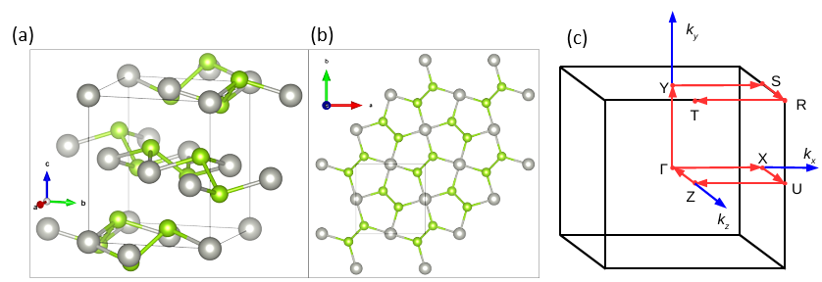Figure 1: (a)Primitive unit cell of bulk PdS2 in orthorhombic structure (b) Plane view of monolayer PdS2 in orthorhombic structure, where Grey sphere represent Pd atom and green sphere represent S atom (c) Brillouin zone(BZ) and k path of PdS2

**Table 1: C**alculated lattice parameters of bulk PdS2 in orthorhombic structure with different functionals

|  |  |  |  |
| --- | --- | --- | --- |
| Method | Lattice Parameters | | |
|  | $$a(Å)$$ | $$b(Å)$$ | $$c(Å)$$ |
| LDA | 5.4428 | 5.5125 | 7.1117 |
| PBESol | 5.4569 | 5.5371 | 7.4481 |
| PBE | 5.4960 | 5.5881 | 8.3053 |
| WC | 5.4777 | 5.5448 | 7.3384 |
| vdW-DFC09x | 5.494 | 5.561 | 7.590 |
| PBE [12] | 5.494 | 5.590 | 8.633 |
| DFT-D [12] | 5.531 | 5.600 | 7.591 |
| SCAN + rVV10 [43] | 5.45 | 5.53 | 7.20 |
| Experiment [44] | 5.460 | 5.541 | 7.531 |

**3.2 Electronic Properties**

Band structure, density of states (DOS), and partial density of states (PDOS) are the electronic parameters under consideration. In this research, the impact of van der Waals interactions and spin-orbit coupling (SOC) were also investigated. Firstly, band structure calculations are done with and without SOC. In particular, SOC effect was considered in the band structure calculations because Pd is heavy element. Figure 2(a) and (b) illustrate the electronic band structure of PdS2 in bulk form within DFT framework based on PBE approximation with and without SOC. The Fermi energy level scale is set at 0 eV of the irreducible Brillouin zone (BZ) by black lines. Also, from the same figures, the valance band maximum (vbm) is found to be located at $Γ$ point while the conduction band minimum (cbm) is located in between Y and S. However, the PBE band gap with and without accounting for the effects of interactions between electron spin and orbital motion which is called spin-orbit coupling (SOC) was found to be 0.24 and 0.25 eV respectively. As reported earlier [8, 45] SOC does not give significant effect on the band structures of PdS2 . But the band gap determined by HSE as shown in Figure 2(c) was found to be 0.50 eV, which is higher than the value obtained with PBE. Due to the approximation used in the exchange-correlation functional, the value is, however, less than the experimental result of 0.7 to 0.8 eV [46], which represents the limitation of the bare DFT approach. However, we have also carried out G0W0 corrections in order to address the discrepancy between the DFT calculation within GGA exchange-correlation potential and experimental data. Upon incorporating GW self-energy corrections (G0W0 approximation), the calculated indirect band gap of 0.51 eV in PBE+SOC+vdW is corrected to 0.75 eV, which is in good accordance with experimental results [46] as can be seen in Figure 2(d) . Table 2 lists the computed electronic band gaps of bulk monolayer PdS2 as well as earlier theoretical and experimental findings. From this point, the indirect band gap nature of PdS2 in bulk form has now been verified, and all of the fundamental band gaps found for the compound correspond nicely with previous findings. Conversely, previous first principles calculations reported that PdS2 is a semi metal material [47, 48]. However, experimental lattice parameters were used for these investigations. On the other hand, PdS2 has been described as a semiconductor using PBE [49]; this is in line with our findings. However, when dispersion corrections (PBE + D3) are applied, PdS2 was found to be a metal, which is in line with the LDA results by Guo et al.[47]. Our results also pointed that optimizing lattice parameters play a vital role in predicting band gap value of semiconductor material. Three dimensions are reduced to two as the structures transition from the bulk phase to the monolayer phase. For PdS2 in monolayer phase, the K route is $\overline{Γ}→\overline{X}→\overline{S}→\overline{Y}→\overline{Γ }→\overline{S}$. As displayed in Figure 3(a) and (b) PdS2 monolayer is a semiconductor material with an indirect band gap of 1.10 and 1.42 eV at the PBE and hybrid (HSE) levels and these values are smaller than experimental value. For accurate band gap prediction, we used many-body perturbation theory (MBPT) within G0W0 approximation to include self-energy corrections in the quasiparticle (QP) energy. A G0W0 approximation yield an energy gap of 1.75 eV.

**Table 2:** The band gap energies Eg (in unit eV) of bulk and monolayer phases of PdS2

|  |  |  |  |
| --- | --- | --- | --- |
| Material | Method | Bandgap value (eV) | Type of band gap |
| Bulk | PBE-GGA+vdW | 0.25 | Indirect |
| PBE-GGA+SOC+vdW | 0.24 | Indirect |
| HSE | 0.50 | Indirect |
| G0W0 | 0.76 | Indirect |
| PBE-GGA [47, 48] | 0.00 | - |
|  | Experimental [46] | 0.7-.0.8 | Indirect |
| Monolayer | PBE-GGA | 1.10 | Indirect |
| HSE | 1.42 | Indirect |
|  | G0W0 | 1.75 | Indirect |
| PBE-GGA [50] | 1.16 | Indirect |
|  | HSE [51] | 1.47 | Indirect |



Figure 2 Band Structure of Bulk PdS2 in orthorhombic structure (a) PBE (b) PBE+SOC (c) HSE (d) G0W0

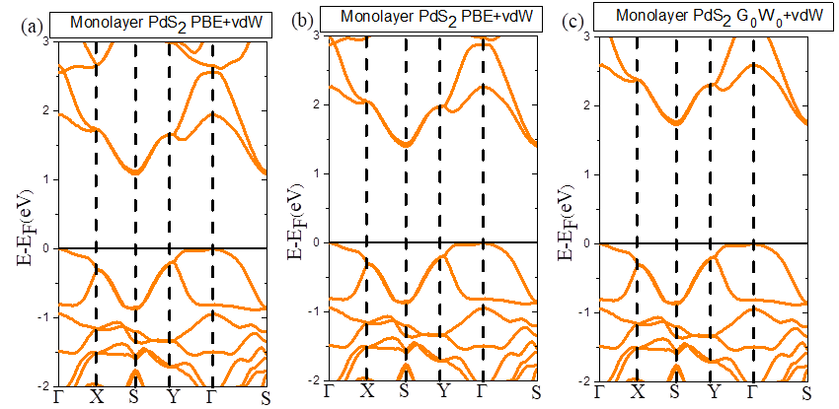

Figure 3: Band structure of monolayer PdS2 in orthorhombic structure (a) PBE (b) HSE (c) G0W0

Total and partial density of states (DOS and PDOS) have been examined in order to better understand the nature of the band gap configuration and the orbital arrangement in the electronic structure of PdS2 [52, 53]. Figure 4 (a) and (b) display the total density of states (DOS) and the partial DOS of PdS2 in the bulk phase for each system element. The partial DOS show how each element contributes to the related energy; this knowledge is crucial for the doping process as well as for modifying band structures at the Fermi level. The conduction band of PdS2 in bulk form is mostly made up of the p-orbital of the Pd atoms and s- and p-orbitals of S atoms, whereas the valence band is made up of the s- and d-orbitals of the Pd atom as seen in Figure 4. In general, material properties close to the Fermi level are responsible by both s-, p- and-orbitals of the Pd atoms and the s-and p-orbitals of S atoms. Additionally, we investigated the total density of states (DOS) and PDOS of PdS2 in monolayer form and the findings are shown in Figure 5 (a) and (b). According to the orbital character, the p-orbital of the Pd atoms, s- and -p orbitals of S atoms form the conduction band minimum (CBM) whereas s-and - d orbitals of Pd atoms as well as s-orbital of S atoms contribute the most to the valence bands maximum (VBM).

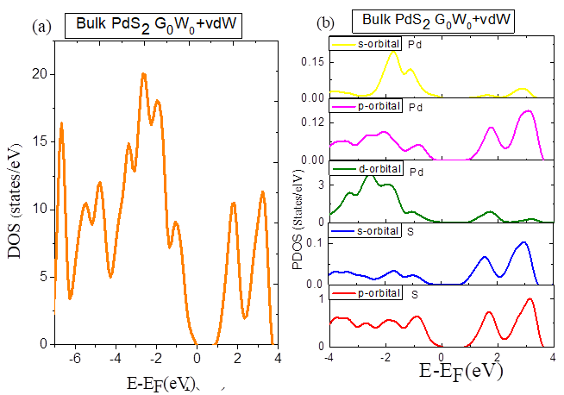

Figure 4: DOS of bulk PdS2 in orthorhombic structure (a) PBE (b) PBE+SOC (c) HSE (d) G0W0

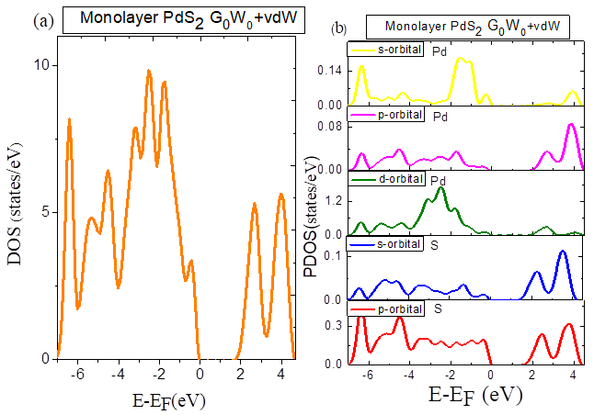

Figure 5: (a) DOS (b) PDOS of monolayer PdS2 in orthorhombic structure using G0W0 method

3.3 Thermoelectric Properties

The transport properties calculated in this paper are thermal conductivity, Seebeck coefficient andelectrical conductivity. Conversely, Seebeck, Peltier, and Thomson effects are among the various physical processes that make up the thermoelectric effect. The TE effect examined in this study is referred to the Seebeck effect as this work solely focuses on it. The Seebeck effect is a process whereby electrical potential difference is generated that due to temperature difference. The range of chemical potentials $μ$ under investigation is 0.18838Ry to 0.55188Ry whereas the range of temperatures T was 15 K to 1500 K. The grid size is 15Ry for T and 0.00050Ry for $μ$. The Fermi level of PdS2 is 0.33831Ry. Table 4 lists the maximum Seebeck coefficient S, electronic thermal conductivity per relaxation time $K/τ$, electrical conductivity per relaxation time $σ/τ$, power factor per relaxation time ${PF}/τ$, and figure of merit *ZT* of the bulk phase PdS2 that were found in this research. It should be noted that the TE characteristics are directionally dependent; to determine the direction dependency, one uses the tensor, with the direction being respected with regard to the crystal axis. Because PdS2 has an orthorhombic crystal structure, it has three distinct crystal axes, which translate into three components in the tensor. As shown in Table 3 PdS2 in bulk form possesses |S| approximately $0.003V/K$ independent of crystal direction, $K/τ$ in order of ${10}^{15} W/{mKs}$, ${PF}/τ$ in order of ${10}^{15} {V^{2}}/{mKΩs}$, $σ/τ$ in order of . PdS2 in bulk form has ZT value close to unity which indicates that is a good TE material. The effects of temperature and chemical potential on the TE parameters are displayed in Figures 6, 7.8, and 9. Our results show that |S| reduce at higher temperature and when the temperature rises, $σ/τ$ decreases because of the carriers' dispersion event. As one of the heat conduction methods, the reason why $K/τ$ increases with temperature is due to rise in carrier-carrier collision. Because of the cancelling effect of *S* and $σ/τ$ , ${PF}/τ$ peaks at high temperatures. From Figure 5 and Figure 6, it is clear that S and $σ/τ$ have negative correlation and as they reduced as temperature increase, the cancelling effect become smaller and hence higher ${PF}/τ$. ZT decrease as the temperature increase due to the negative effect of $K/τ$. Regarding monolayer, the chemical potential μ range for the monolayer under investigation was 0.36190Ry to 0.04410Ry, and the temperature T range, $μ$ and T grid were unchanged from that of the bulk phase with a Fermi level of -0.21234Ry. The maximum of $S_{xx}$ experienced a 32-fold increment as the phase transition from bulk to monolayer and $\left|S\right|$ increased significantly. Apart from the fact that $K/{τ_{zz}}$ and ${{PF}_{zz}}/τ$ decreased in comparison to the bulk form results, there is no general trend for $σ/τ$, $K/τ$ or ${PF}/τ$. The scattering impact on the out-of-plane direction is what causes the drop in $K/{τ_{zz}}$. ZT has risen above unity (with the exception of ${ZT}_{zz}$, which has also increased). The effect of temperature on $σ/τ$ reduces significantly. The relationship between ZT with temperature of monolayer phase have the same trend as presented in bulk phase. High value of ZT can be attributed to the intrinsically ultralow thermal conductivity and mainly due to higher power factor. The thermoelectric application of any material relies on its figure of merit which in turn depends on the amount of power factor [54].

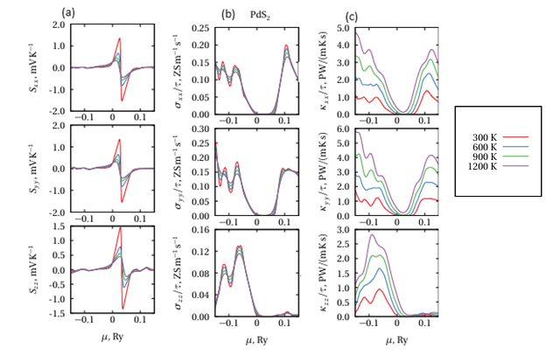

Figure 6: (a) Seebeck coefficient (b) Electrical conductivity per relaxation time (c) Electronic thermal conductivity per relaxation time of bulk PdS2 in orthorhombic structure

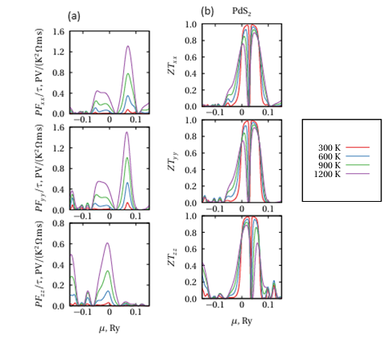

Figure 7: (a) Power factor per relaxation time (b Figure of merit of PdS2 in orthorhombic structure

Table 3: The minimal of Seebeck coefﬁcient S, the maximal of Seebeck coefﬁcient S, electrical conductivity per relaxation time σ/τ, and ﬁgure of merit ZT for monolayer PdS2 in orthorhombic structure

|  |  |  |
| --- | --- | --- |
|  | Minimal | Chemical Potential , Ry |
|  | -0.0028 VK-1  -0.0028VK-1  -0.0028 VK-1 | 0.3849  0.3734  0.3849 |
| Maximal Chemical Potential $μ$, Ry | | |
| $$S_{xx}$$ $$S_{yy}$$ $$S_{zz}$$ | 0.0028VVK-1  0.0028VK-1  0.0028VK-1 | 0.3639  0.3639  0.3639 |
| $${σ_{xx}}/τ$$ $${σ_{yy}}/τ$$ $${σ_{zz}}/τ$$ | 3.0330 $×{10}^{20}$ W/mKs $$3.8044×{10}^{20} Sm^{-1}s^{-1}$$ $$1.9131×{10}^{20} Sm^{-1}s^{-1}$$ | 0.4409  0.1884  0.2799 |
| $${K_{xx}}/τ$$ $${K_{yy}}/τ$$ $${K_{zz}}/τ$$ | $6.2115×{10}^{15}$ $W/mKs$ $$7.5518×{10}^{16} W/mKs$$ $$3.3537×{10}^{16} W/mKs$$ | 0.1884  0.1884  0.2489 |
| $$ZT_{xx}$$ $$ZT_{yy}$$ $$ZT_{zz}$$ | 0.9986  0.9986  0.9986 | 0.3999  0.3999  0.3999 |

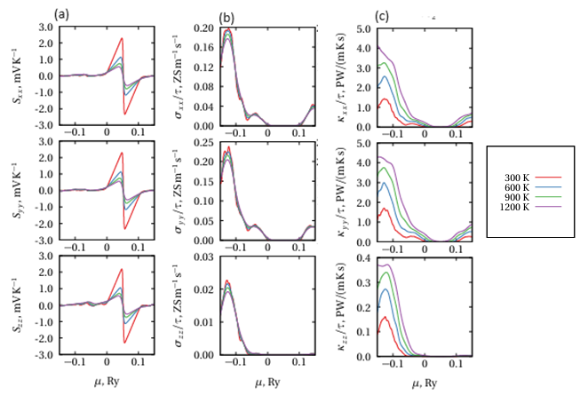

Figure 8: (a) Seebeck coefficient (b) Electrical conductivity per relaxation time (c) Electronic thermal conductivity per relaxation time of monolayer PdS2 in orthorhombic structure



Figure 9: (a) Power factor per relaxation time (b) Figure of merit of monolayer PdS2 in orthorhombic structure

Table 4: The minimal of Seebeck coefﬁcient S, the maximal of Seebeck coefﬁcient S, electrical conductivity per relaxation time σ/τ, and ﬁgure of merit ZT for monolayer PdS2 in orthorhombic structure

|  |  |  |
| --- | --- | --- |
|  | Minimal | Chemical Potential , Ry |
|  | -0.0028 VK-1  -0.0028VK-1  -0.0027 VK-1 | -0.1444  -0.1444  -0.1444 |
| Maximal Chemical Potential $μ$, Ry | | |
| $$S_{xx}$$ $$S_{yy}$$ $$S_{zz}$$ | 0.0029VVK-1  0.0029VK-1  0.0028VK-1 | -0.1674  -0.1674  -0.1674 |
| $${σ_{xx}}/τ$$ $${σ_{yy}}/τ$$ $${σ_{zz}}/τ$$ | 4.1462 $×{10}^{20}$ W/mKs $$5.8798×{10}^{20} Sm^{-1}s^{-1}$$ $$5.5283×{10}^{19} Sm^{-1}s^{-1}$$ | -0.3244  -0.3359  -0.3334 |
| $${K_{xx}}/τ$$ $${K_{yy}}/τ$$ $${K_{zz}}/τ$$ | $5.1649×{10}^{15}$ $W/mKs$ $$5.2514×{10}^{16} W/mKs$$ $$4.6899×{10}^{16} W/mKs$$ | -0.3619  -0.3619  -0.3619 |
| $$ZT_{xx}$$ $$ZT_{yy}$$ $$ZT_{zz}$$ | 1.0023  1.0067  0.9993 | -0.2049  -0.2049  -0.2049 |

**3.4** **Optical Properties**

Investigating material's optical properties is essential for comprehending its possible uses such as solar cell, photodetector and so on [55, 56]. Typically, optical characteristics indicate how a material behaves in the presence of electromagnetic radiation [57]. The thorough literature review reveals that there is little research done on the optical properties associated with the PdS2 in bulk and monolayer structures. Optical spectra calculations of PdS2 in bulk and monolayer structure using precise methods that account for the impact of electron-hole interaction have not been performed based on the literature. In this work. two separate methods are used to compute the optical characteristics of PdS2 material in bulk and monolayer structures with polarization along the x-direction (in-plane. The first method is by including electron-electron (e-e) interaction and neglecting electron-hole (e-h) interaction is neglected (G0W0+RPA). Then, the second method is by incorporate the role of interaction between the excited electron and the hole left in the valence band region (G0W0+BSE). Also, it has been established that this advanced method (G0W0+BSE) for optical properties calculations provide excitation energy, which generate excitons. The optical parameter addressed in this research is imaginary part of frequency-dependent dielectric function $ε_{2}\left(ω\right)$. The material's ability to absorb photon energy is described by its $ε_{2}\left(ω\right)$. It is well known that when light beams hit a material's surface, some of the energy is reflected back and some is transmitted to the surface and the energy transfer to the surface is known as light absorption. Using Quantum Espresso and YAMBO packages [34, 58], these properties have been obtained and analysed in detail. Even though optical properties calculation via BSE is computationally expensive but yield results in agreement with experimental measurements. Previous research has shown that the number of k-points, the number of occupied (Oc.) and unoccupied (Unoc.) bands have a significant impact on optical spectra. Converging test analysis of BSE spectra has been carried out with great attention in order to precisely depict the effect of e-h interaction by solving BSE. According to Figure 10 (a), it is evident that when the K-point refines, the absorption spectra's first peaks shown blueshift. At the 12×12×1, 18×18×1, 20×20×1, 25×25×1, and 30×30×1 K-points, the initial peaks, which correspond to the optical gaps, were determined to be, respectively, 1.49, 1.50, 1.55, 1.56, and 1.56 eV. A convergence test concerning the k-point indicated that 25 x 25 x 1 mesh was found to be adequate for accurate optical spectra of PdS2 in monolayer form. Our convergence test findings demonstrated that the number of K-points in the mesh has an impact on the BSE output. Therefore, choosing the right K-points is crucial to obtaining a correct optical spectrum that agrees with experiment results. As a result, 30×30×1 K-points mesh is used to compute BSE spectra with regard to the number of filled and empty bands. The optical spectra for 15 occupied and 15 unoccupied bands, as well as the 25 occupied and 25 unoccupied bands, were nearly identical in size and shape at low energies, as Figure 9 (b) illustrates. Figures 10 depict imaginary parts of frequency-dependent dielectric functions  of PdS2 in bulk and monolayer as calculated using G0W0+RPA and G0W0+BSE techniques. According to the computed $ε_{2}\left(ω\right),$ the first critical point, also known as the optical gap, occurs at 0.76 and 1.75 eV for PdS2 in bulk and monolayer form within G0W0+RPA method, and these values corresponds to the QP band gaps. At these points, the conduction bands minimum and valence bands maximum separated. In other word, the inter-band transitions between the valence bands maximum and conduction bands minimum are represented by the edge of optical absorption (called first critical point), and this corresponds to the band gap of the material under study. However, we found a considerable improvement in the optical gap results by including electron-hole interaction via G0W0+BSE method. As indicated by an arrow in Figure 11, the bound excitons that are absent from G0W0+RPA method appear below G0W0 gaps when electron-hole interactions were included. The first excitonic peaks due to inter-band transitions by solving BSE appears at about 0.59 and 1.56 eV for bulk and monolayer respectively. We calculated an exciton binding energy of 0.17 and 0.19 eV for bulk and monolayer form of PdS2 by comparing the location of the first critical point by the G0W0 method with the position of the first excitonic peak obtained via G0W0+BSE calculations, which is the optical gap in the case of the BSE approach. The first excitonic peak of 1.56 eV via G0W0+BSE approach reveals that PdS2 in monolayer form can absorb light within visible light range. Equation 11 is used to calculate the binding energy:

$E_{b}=E_{g}-E_{exc}$ (11)

where $E_{g}$ is the QP band gap and $E_{exc}$ is the initial excitation energy. By including electron-hole interaction in the imaginary part of the dielectric function, PdS2 in monolayer form shows strong absorption in the energy range of 1.6 to 6.0 eV. According to our theoretical analysis of PdS2 in monolayer form, a device made of this material can be operated on a wide range of the energy scale.

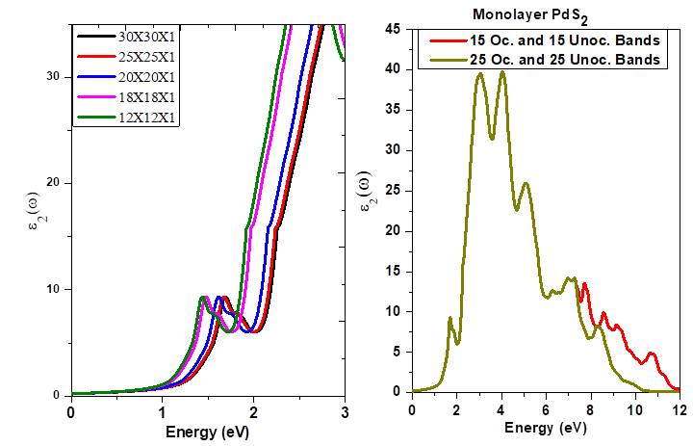

Figure 10: Converging test findings for (a) $ε_{2}\left(ω\right)$ in relation to the irreducible Brillouin zone (BZ)'s K-point count (b) $ε_{2}\left(ω\right)$ in relation to the number of occupied and unoccupied bands

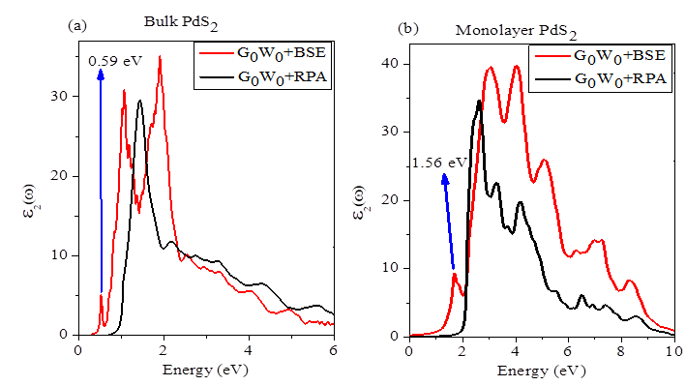

Figure 11: The imaginary part of dielectric function of (a) Bulk PdS2 in orthorhombic structure (b) Monolayer PdS2 in orthorhombic structure using G0W0+RPA and G0W0+BSE methods

**4.0 Conclusion**

The work uses first principles density functional theory to carefully investigate in detail the structural, electronic, optical, and thermoelectric properties of PdS2 in bulk and monolayer phases. The structural parameters determined by adding van der Waals corrections (vdW-DFC09x) are extremely well matched with experimental results. The predicted band gaps of PdS2 in bulk and monolayer were found to be 0.76 and 1.75 eV within G0W0 approximation and these values are in good agreement with the results obtained experimentally. The optical properties have been studied with inclusion of excitonic effects so-called G0W0+BSE. Strong visible light absorption of PdS2 in bulk and monolayer phases indicates that the material under investigation is appropriate for use in solar cell applications. Seebeck coefficient, thermal conductivity, electrical conductivity, power factor, and figure of merit have all been used to explain the thermoelectric properties of the PdS2 in bulk and monolayer phases, leading to the conclusion that the compound may be beneficial for thermoelectric applications.

**COMPETING INTERESTS DISCLAIMER:**

Authors have declared that they have no known competing financial interests OR non-financial interests OR personal relationships that could have appeared to influence the work reported in this paper.

REFRENCES

[1] N. Hossain, M.H. Mobarak, M.A. Mimona, M.A. Islam, A. Hossain, F.T. Zohura, M.A. Chowdhury, Results in Engineering, 19 (2023) 101347.

[2] A. Lawal, A. Shaari, L. Taura, A. Radzwan, M. Idris, M. Madugu, Materials Science in Semiconductor Processing, 124 (2021) 105592.

[3] A. Garg, S. Basu, N.P. Shetti, K.R. Reddy, Journal of Environmental Chemical Engineering, 9 (2021) 106408.

[4] R.G. Egdell, E. Bruton, Philosophical Transactions of the Royal Society A, 378 (2020) 20190302.

[5] C. Prodi, T. Out.

[6] J.A. Wilson, A. Yoffe, Advances in Physics, 18 (1969) 193-335.

[7] G. Kedarnath, V.K. Jain, New Journal of Chemistry, 47 (2023) 20688-20702.

[8] Y. Wang, Y. Li, Z. Chen, Journal of Materials Chemistry C, 3 (2015) 9603-9608.

[9] F.A. Rasmussen, K.S. Thygesen, The Journal of Physical Chemistry C, 119 (2015) 13169-13183.

[10] S. Joseph, J. Mohan, S. Lakshmy, S. Thomas, B. Chakraborty, S. Thomas, N. Kalarikkal, Materials Chemistry and Physics, 297 (2023) 127332.

[11] F. Grønvold, E. Røst, B. Aurivillius, N. Eliasson, B. Thorell, Acta Chemica Scandinavica, 10 (1956) 1620-1634.

[12] W. Lei, W. Wang, X. Ming, S. Zhang, G. Tang, X. Zheng, H. Li, C. Autieri, Physical Review B, 101 (2020) 205149.

[13] L. Zhang, A. Zunger, Nano Letters, 15 (2015) 949-957.

[14] P. Miró, M. Ghorbani‐Asl, T. Heine, Angewandte Chemie, 126 (2014) 3059-3062.

[15] E.A. Moujaes, W. Diery, Physica E: Low-dimensional Systems and Nanostructures, 128 (2021) 114611.

[16] A. Hamidani, B. Bennecer, K. Zanat, Journal of Physics and Chemistry of Solids, 71 (2010) 42-46.

[17] E.A. Moujaes, A.C. Dias, Journal of Physics and Chemistry of Solids, 182 (2023) 111573.

[18] J. Ding, X. Xie, X. Ouyang, J. Chen, F. Ouyang, Z. Liu, J.-T. Wang, J. He, Y. Liu, Nano Research, (2024) 1-9.

[19] B. Chettri, P. Karki, P. Chettri, S.K. Das, B. Sharma, Transition Metal Dichalcogenides Properties, Synthesis, and Application in Nanoelectronics Devices, in: Advanced Nanomaterials and Their Applications, CRC Press, 2023, pp. 57-88.

[20] W.-J. Yin, H.-J. Tan, P.-J. Ding, B. Wen, X.-B. Li, G. Teobaldi, L.-M. Liu, Materials Advances, 2 (2021) 7543-7558.

[21] A. Raj, M. Kumar, D.V. Singh, A. Anshul, FlatChem, (2024) 100629.

[22] Y. Ge, W. Li, J. Ren, Z. Shuai, Physical Review B, 110 (2024) 035201.

[23] S. Wang, F. Fu, X. She, G. Zheng, H. Li, X. Tang, Intermetallics, 19 (2011) 1823-1830.

[24] S. Shittu, G. Li, X. Zhao, X. Ma, Applied Energy, 268 (2020) 115075.

[25] G. Tan, S. Wang, Y. Yan, H. Li, X. Tang, Journal of alloys and compounds, 513 (2012) 328-333.

[26] X. Zheng, C. Liu, Y. Yan, Q. Wang, Renewable and sustainable energy reviews, 32 (2014) 486-503.

[27] P. Giannozzi, O. Andreussi, T. Brumme, O. Bunau, M.B. Nardelli, M. Calandra, R. Car, C. Cavazzoni, D. Ceresoli, M. Cococcioni, Journal of physics: Condensed matter, 29 (2017) 465901.

[28] P. Giannozzi, S. Baroni, N. Bonini, M. Calandra, R. Car, C. Cavazzoni, D. Ceresoli, G.L. Chiarotti, M. Cococcioni, I. Dabo, Journal of physics: Condensed matter, 21 (2009) 395502.

[29] M. Ilkhani, M.R. Abolhassani, M. Aslaninejad, Physical Review B—Condensed Matter and Materials Physics, 80 (2009) 125131.

[30] J.P. Perdew, V.N. Staroverov, J. Tao, G.E. Scuseria, Physical Review A—Atomic, Molecular, and Optical Physics, 78 (2008) 052513.

[31] J. Perdew, A. Zunger, Phys. Rev. B, 23 (1981) 5048-5079.

[32] H.J. Monkhorst, J.D. Pack, Physical review B, 13 (1976) 5188.

[33] A. Dal Corso, Physical Review B, 64 (2001) 235118.

[34] A. Marini, C. Hogan, M. Grüning, D. Varsano, Computer Physics Communications, 180 (2009) 1392-1403.

[35] D. Sangalli, A. Ferretti, H. Miranda, C. Attaccalite, I. Marri, E. Cannuccia, P. Melo, M. Marsili, F. Paleari, A. Marrazzo, Journal of Physics: Condensed Matter, 31 (2019) 325902.

[36] P. Koval, D. Foerster, D. Sánchez-Portal, Physical Review B, 89 (2014) 155417.

[37] E.E. Salpeter, H.A. Bethe, Physical Review, 84 (1951) 1232.

[38] G.K. Madsen, D.J. Singh, Computer Physics Communications, 175 (2006) 67-71.

[39] J. He, Y. Liu, R. Funahashi, Journal of Materials Research, 26 (2011) 1762-1772.

[40] A. Lawal, A. Shaari, R. Ahmed, L. Taura, Current Applied Physics, 18 (2018) 567-575.

[41] A. Lawal, A. Shaari, R. Ahmed, N. Jarkoni, Results in physics, 7 (2017) 2302-2310.

[42] A. Lawal, L. Taura, Y.Z. Abdullahi, A. Shaari, A.B. Suleiman, A. Gidado, I.M. Chiromawa, Physica B: Condensed Matter, 646 (2022) 414307.

[43] L.-Y. Feng, R.A.B. Villaos, Z.-Q. Huang, C.-H. Hsu, F.-C. Chuang, New Journal of Physics, 22 (2020) 053010.

[44] A. Kuc, N. Zibouche, T. Heine, Physical Review B—Condensed Matter and Materials Physics, 83 (2011) 245213.

[45] M. Jakhar, A. Kumar, Journal of Materials Chemistry A, 10 (2022) 6785-6795.

[46] F. Hulliger, Journal of Physics and Chemistry of Solids, 26 (1965) 639-645.

[47] G. Guo, W. Liang, Journal of Physics C: Solid State Physics, 19 (1986) 995.

[48] D. Dai, H.-J. Koo, M.-H. Whangbo, C. Soulard, X. Rocquefelte, S. Jobic, Journal of Solid State Chemistry, 173 (2003) 114-121.

[49] M.J. Piotrowski, R.K. Nomiyama, J.L. Da Silva, Physical Review B—Condensed Matter and Materials Physics, 88 (2013) 075421.

[50] D. Raval, S. Gupta, P. Gajjar, in: Journal of Physics: Conference Series, IOP Publishing, 2023, pp. 012008.

[51] V.K. Gudelli, G.-Y. Guo, New Journal of Physics, 23 (2021) 093028.

[52] A. Radzwan, A. Lawal, A. Shaari, I.M. Chiromawa, S.T. Ahams, R. Ahmed, Computational Condensed Matter, 24 (2020) e00477.

[53] Y.S. Itas, A.B. Suleiman, C.E. Ndikilar, A. Lawal, R. Razali, I.I. Idowu, M.U. Khandaker, P. Ahmad, N. Tamam, A. Sulieman, Crystals, 12 (2022) 870.

[54] S. Ahmad, G. Schreckenbach, Materials Today Communications, 24 (2020) 100976.

[55] Y. Saadu Itas, A.B. Suleiman, C.E. Ndikilar, A. Lawal, R. Razali, I.I. Idowu, M. Uddin Khandaker, A.M. Danmadami, P. Ahmad, T.B. Emran, Journal of Chemistry, 2023 (2023) 4574604.

[56] A. Lawal, A. Shaari, R. Ahmed, L. Taura, L. Madugu, M. Idris, Optik, 177 (2019) 83-92.

[57] M. Idris, A. Shaari, R. Razali, A. Lawal, S. Ahams, Computational Condensed Matter, 23 (2020) e00460.

[58] G. Onida, L. Reining, A. Rubio, Reviews of Modern Physics, 74 (2002) 601.