**Seasonal analysis of aerosol frequency and assessment of the radiative impact of a dust episode in Burkina Faso, West Africa**

.

ABSTRACT

|  |
| --- |
| This work is a contribution to the optical and radiative characterization of aerosols, with the aim of showing the impact of season on the frequency of typical days defined by aerosol optical depth (AOD) and then quantifying the impact of aerosols on incident radiation. The study is based on MODIS sensor observations and in situ measurements, followed by climate model simulations. To this end, a seasonal analysis of AOD indicates a majority frequency of mixed days, with a strong dominance of standard days, which are identified by a maximum frequency centered around one AOD value, depending on climate zone and season. However, dusty days defined by AOD values above 0.8 are due to pulses of mineral particles from emission sources located in the Sahara and the associated atmospheric circulation during harmattan or monsoon periods. Thus, a simulation of the radiative impact of a dust event associated with AOD values observed around 3.09, 1.75 and 1.41 respectively at the Ouagadougou, Dori and Gaoua sites highlights a modification of the solar radiation incident by the aerosol layer. This extinction of solar energy results in an increase in diffuse flux during the dust event, ranging from 41.20 W/m2 to 136.92 W/m2 compared with the days before and after the dust episode, followed by a decrease in direct flux ranging from 78.60 W/m2 to 259.64 W/m2. This highlights the diffusive nature of the aerosol population specific to desert dust. |

*Keywords:* Aerosol optical depth, Radiation, Streamer model, MODIS, HYSPLIT

1. INTRODUCTION

The African continent is one of the world's richest sources of solar energy, with maximum sunshine levels in desert areas such as the Sahel and Sahara in the north, and the Kalahari Desert in the south (Marticorena et al., 2011). A NASA study conducted between 1983 and 2005 in the Sahara places the Agadem region in Niger as the second sunniest on the planet, with an average annual irradiation of 6.92 kWh/m²/d (Dankassoua et al., 2017). Average monthly solar radiation values of around 7 kWh/m² and 8.25 kWh/m² were also obtained at the Dakar site in Senegal and the Nouakchott site in Algeria respectively (Bilal et al., 2007). Similarly, an assessment of solar potential between 2015 and 2016 in Niamey indicates a high availability of sunshine associated with average values between 5.10 kWh/m² and 6.30 kWh/m² (Dankassoua et al., 2017). In addition, a recent study by Niang et al (Niang et al., 2023)confirms the importance of the solar potential available in the Sahel, with an average daily value calculated at around 5.43 kWh/m², with maxima observed in the north at the Niamey site in Niger. It should also be noted that knowledge of the solar energy potential for a given site is a vital parameter for the development of scientific, technological and economic research into solar and thermal systems (Bilal et al., 2007; M. S. Drame, 2012). However, much of this radiation is attenuated by the atmosphere, either through absorption or scattering by aerosols, greenhouse gases, molecules and water vapour. In the Sahel, atmospheric particles are strongly dominated by mineral dusts, characterized by their ability to scatter and absorb solar radiation(Bado et al., 2024; Nébon, Dramé, Sall, et al., 2019). These particles can considerably attenuate solar radiation and then cause the atmospheric layers to cool down (Korgo et al., 2021), especially during dust episodes. This has a direct impact on the efficiency of solar conversion systems, whose operation relies mainly on the available solar potential, in addition to dust deposits on the surface of the modules (M. S. Drame et al., 2021). To this end, Dramé et al (M. Drame et al., 2011)achieved a reduction in direct radiative flux from 200 W/m² to 300 W/m², with an increase in diffuse flux from 50 W/m² to 150 W/m² at the Dakar site in Senegal on a day characterized by a dust cloud. Another study carried out on the same site in 2012 revealed a reduction of around 10% and 28% respectively in global and direct radiation due to the effect of aerosols (M. Drame et al., 2012), with a solar potential calculated at 7 kWh/m²/d in May. A similar study carried out in Burkina Faso on typical days defined according to the atmospheric aerosol load, showed a reduction in normal direct flux of between 75% and 22%, depending on the climatic zone (Nébon, Dramé, Bruno, et al., 2019). Our study complements this work by analyzing the frequency of aerosols as a function of season and climatic zone, and then demonstrating their impact on the radiation balance by focusing on a dust event identified on the basis of typical days. The study is based on in situ measurements, satellite observations, a radiative transfer model and trajectories. In addition, this work is a contribution to the optical and radiative characterization of aerosols whose climatic role is still known with large uncertainties.

2. material and methods

**2.1. The Streamer radiative transfer model**

The streamer model is a radiative transfer code developed by Key and Schweiger (Key, 2002; Key & Schweiger, 1998) that enables the radiative impact of atmospheric aerosols to be assessed quickly and easily. This simulation code is widely described and presented by several authors (M. S. Drame et al., 2012; Goni et al., 2019; Nébon, Dramé, Bruno, et al., 2019) who have demonstrated the model's performance in quantifying the direct effect of aerosols and estimating the solar radiation incident on the earth's surface. However, the terms of the radiation balance are treated separately at different spectral bands defined by visible wavelengths between 0.4  and 0.8  and telluric infrared radiation between 0.8  and 500 . In addition, this code uses six (06) aerosol models predefined as tropospheric, maritime, rural, arctic haze, smoke and urban to simulate solar radiation. These models were created using a Mie code to generate optical parameters specific to the aerosol population in the study area. The absorption of the main gases in the visible spectrum is also included, but may be omitted from the calculations (M. S. Drame et al., 2012).

**2.2. HYSPLIT model**

HYSPLIT is a hybrid model that combines the Eulerian and Lagrangian approach to simulating air mass trajectories in time and space (B. Korgo et al., 2013; Carvalho et al., 2007; Nébon et al., 2018). Indeed, the Eulerian model considers fixed points in space through which air masses circulate, while the Lagrangian model is based on the temporal spatial movements of an air parcel (Stohl, 1998). In addition, the Lagrangian approach takes into account advection and diffusion phenomena, and then allows the calculation of air mass concentrations by considering a system of fixed meshes (Draxler, 1998; Zhang & Chen, 2007). For our study, we use the HYSPLIT model to plot the back trajectories of air masses over different atmospheric layers, taking into account the Saharan boundary layer and the nature of the particles, which are strongly dominated by desert dust.

**2.3. Study data and statistical parameters**

We use measurements from the MODIS sensor airborne by the Aqua and Aura satellites of the A-train observation system, a constellation of satellites grouped together in a single observation system (L’Ecuyer & Jiang, 2010). MODIS has 36 spectral bands in which measurements are taken with a spatial resolution of 1 to 250 km and a temporal resolution of 1 to 2 days. In addition, it uses different aerosol property inversion algorithms (Tanré et al., 1997) and for our study we use inversions of MODIS-Terra Deep-Blue which is more suited to measurements in arid and semi-arid regions. This measurement concerns the aerosol optical depth measured at 550 nm and available on Giovanni's website (<https://giovanni.gsfc.nasa.gov/>). It is an indicator of atmospheric aerosol loading that depends on wavelength , altitude (z) and extinction coefficient  and is defined by the following equation (Bado et al., 2019; Korgo et al., 2021) :

 (1)

In addition, we use in situ measurements from the national meteorological agency. These are global solar radiation measured on a horizontal plane and modeled by equation (2) where TL denotes Link's haze factor and the height of the sun (Bilal et al., 2007; Dankassoua, Madougou, et al., 2017) :

 (2)

For a good fit of the streamer code, we use statistical indicators that define the accuracy of the model in simulating radiation as a function of atmospheric aerosol loading, compared with in situ measurements. These include the root mean square error (RMSE), which illustrates the variation of simulated radiation from measurements, and the mean absolute error (MAE). The smaller the RMSE and MAE values, the more accurate the model. In addition, we calculate the mean bias error (MBE), which gives an indication of the average deviation of the model's radiation from the measurements. A positive MBE value indicates an overestimate, while a negative value indicates an underestimate. These parameters are defined by expressions (3), (4) and (5) where N represents the number of measurement points,  and  are respectively the radiation calculated by the model and observed at the measurement stations (Kerkouche et al., 2013; Nébon, Dramé, Bruno, et al., 2019).

 (3)

 (4)

 (5)

We also calculate correlation coefficients R and determination coefficients R2 by plotting linear regression lines with values between 0 and 1. Values close to 1 indicate perfect agreement between the model used and the ground-based sensors at the sites. Our study concerns three (03) sites chosen according to the different climatic zones of Burkina Faso (Kabore et al., 2017; Nébon, Dramé, Bruno, et al., 2019; Soro et al., 2024), namely Dori (14.035°N ; -0.034°E) in the Sahel in the north, Ouagadougou (12.20°N ; -1.40°E) in the Sudano-Sahelian zone in the center and Gaoua (10.29°N ; -3.25°E) located in the Sudanian zone in the south of the country. These sites each house a meteorological station for in situ measurements of meteorological parameters such as solar radiation available continuously for the whole of 2017.

**2.4. Typical days and methodology**

To better quantify the radiative impact of aerosols, a daily frequency distribution of the AOD at 550 nm measured by the MODIS Terra and Aqua sensor was carried out by Nébon et al (Nébon, Dramé, Bruno, et al., 2019). Based on an analysis of aerosol frequencies, and in agreement with Dramé et al (M. S. Drame et al., 2015), three categories of days were identified according to the AOD, which defines the atmospheric aerosol load. These include clear-sky days marked by aerosol-free atmospheric conditions where the presence of aerosols appears to be negligible, and correspond to AOD values below 0.2. The second category of day concerns mixed days defined by AOD values between 0.2 and 0.8. These days are characterized by an aerosol plume composed of combustion and mineral particles. The third category of days is identified by AOD values above 0.8 and are known as polluted days. They are less frequent and concern dust events marked by a sharp reduction in atmospheric visibility, with AOD values that may exceed 2 or 3. We will therefore carry out a seasonal analysis of the atmospheric aerosol load at three sites representative of Burkina Faso's climatic zones, in order to show the impact of season on the frequency of aerosols that define day categories. On the basis of this classification, we will look at a typical dust event, with the aim of highlighting the radiative impact of mineral particles in a climatic context specific to Burkina Faso.

**3. RESULTS AND ANALYSIS**

**3.1. Study of seasonal aerosol frequencies**

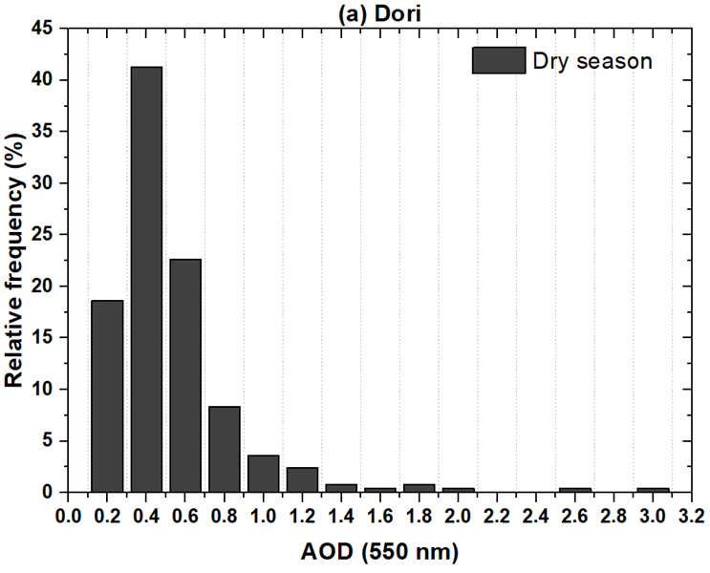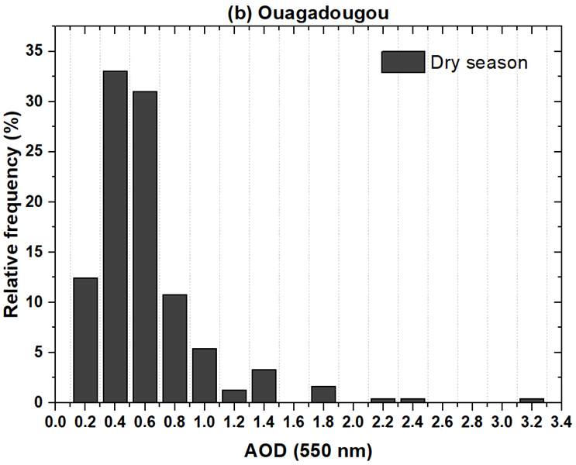

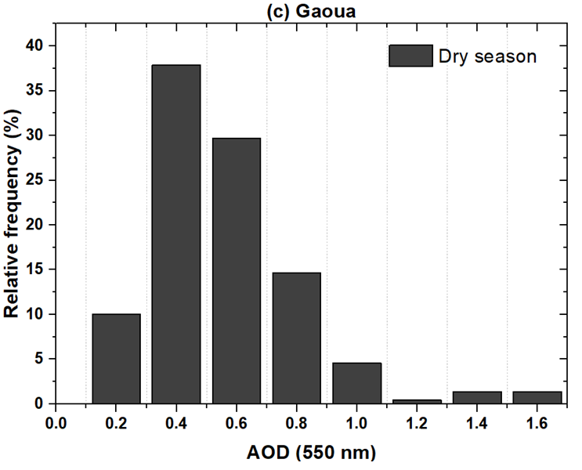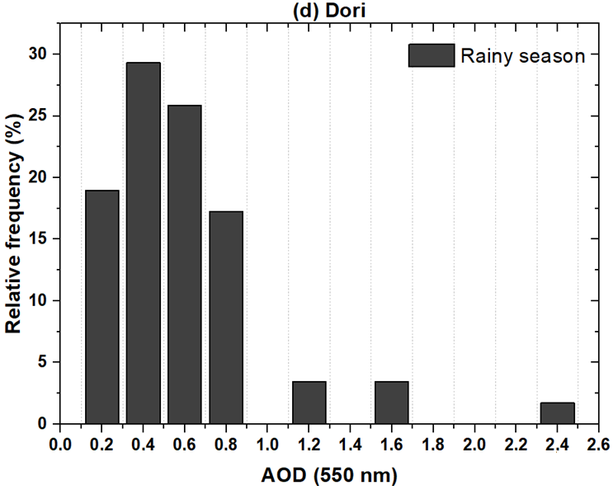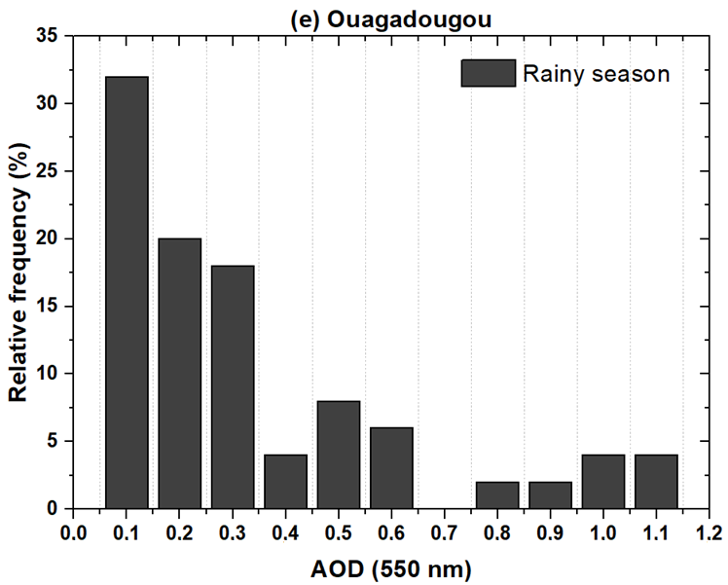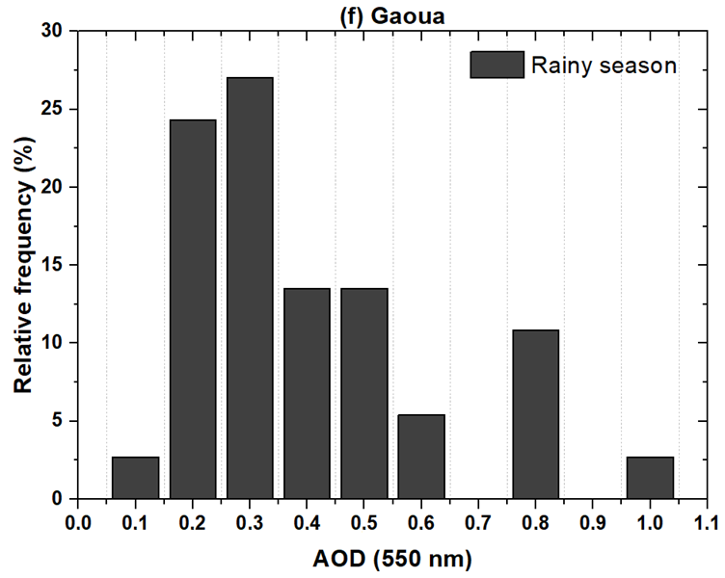

**Figure 1:** Frequency distribution of daily mean AOD at 550 nm by season at the Ouagadougou, Dori and Gaoua sites

**Figure 1** shows the seasonal frequency distribution of aerosol optical depth (AOD), particularly during the dry season defined by the period from October to May, and the wet monsoon season from June to September. This representation shows the impact of seasonal dynamics on the frequency of aerosols that define typical days. Indeed, an analysis of the latter clearly shows a maximum AOD frequency during the harmattan period centered around a value of 0.4 at all sites, whatever the climatic zone. In agreement with Nébon et al (Nébon, Dramé, Bruno, et al., 2019), this maximum frequency corresponds to standard days that characterize atmospheric conditions defined by an average presence of aerosols. In addition, this dry season is marked by two categories of days, with a remarkable presence of mixed days at all sites, depending on the climatic zone. However, during the harmattan period, clear days are practically nonexistent, if not in the minority **(Figure 1a, Figure 1b, Figure 1c)**. All this is corroborated by the northeasterly winds that prevail during this period and are responsible for transporting desert particles from emission sources in the north and for local emissions. However, in the wet season, with the exception of Dori **(Figure 1e)** in the Sahelian zone, where the maximum frequency that defines standard days is observed at an AOD value equal to 0.4, it is centered around 0.2 **(Figure 1d)** and 0.3 **(Figure 1f)** respectively for the Ouagadougou and Gaoua sites. This indicates a high level of aerosol elimination during the monsoon season in the Sudano-Sahelian and Sudanian zones, due to atmospheric leaching and vegetation cover, leading to clear days when the presence of aerosols appears to be negligible. In addition, the frequency of aerosols in the Sahel, particularly at the Dori site, is justified by the proximity of dust emission sources, which are strongly influenced by the harmattan flow that is very active in the Sahara during the West African monsoon season. It should also be noted that this wet period is identified by two categories of days, mainly mixed and dusty, notably in the Sahel at the Dori site and Ouagadougou in the Sudano-Sahelian zone, except for Gaoua in the Sudanian zone, where all three categories of days are observed. The Sudanian zone to the south is strongly influenced by south-westerly winds, which are responsible for cloud convection and the transport of combustion particles into the Gulf of Guinea. The Sudano-Sahelian zone is at the crossroads of northeast and southwest winds, which can lead to aerosol plumes. Furthermore, the frequency of dust events corresponding to days with AOD ≥ 1 in the wet season is probably due to the turbulence of convective systems and the long-range transport of aerosols from the Sahara into the upper atmospheric layers justified by strong harmattan activity. However, dry-season dust is simply linked to the activation of emission sources in the Sahel and Sahara, and to strong harmattan winds from the northeast in the lower layer. In line with the classification, mixed or intermediate days are the most frequent and are due to a mixture of mineral particles and combustion particles, very often due to local emissions justified by the resuspension of dust and road traffic. They also concern the standard days that dominate this category of days and are characterized by average atmospheric pollution.

**3.2. Radiative impact of a dust episode**

**3.2.1. Air mass origin**

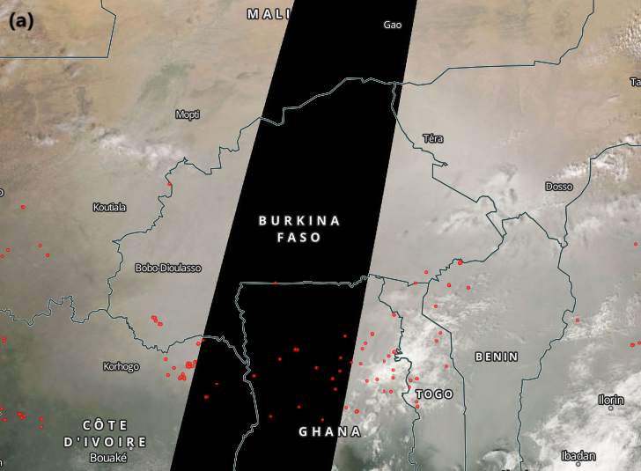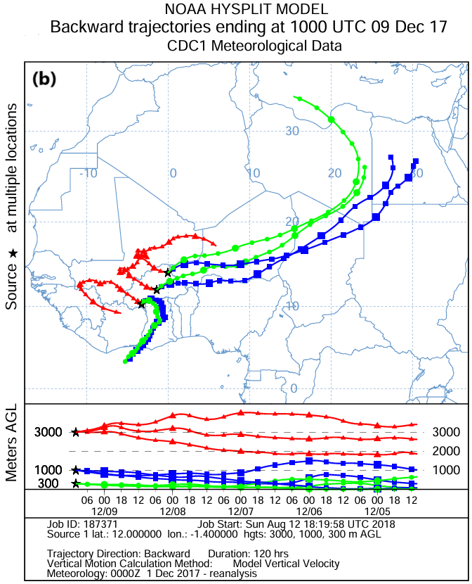

**Figure 2:** Illustration of the dust episode through a visualization of the MODIS sensor and the HYSPLIT model retrotrajectories

The day of December 09, 2017 is identified by very remarkable AOD values, measured by the MODIS sensor at 550 nm on the three sites representative of the climatic zones. Indeed, the optical depth on this day is observed around 3.09 at the Ouagadougou site in the Sudano-Sahelian zone, 1.75 at the Dori site in the Sahel and 1.41 at Gaoua in the Sudanian zone. These values are corroborated by the MODIS sensor image in figure 2a, which shows a thick layer of dust covering the whole country on December 09, thus confirming the special nature of this day as a dust event. This is also in line with the back trajectories calculated by the HYSPLIT model at 300 m, 1000 m and 3000 m **(figure 2b)**. These indicate that air masses at the Dori and Ouagadougou sites originate from the north and northeast, probably due to a strong thermal low at Bodélé in Chad, recognized as the world's largest source of dust emissions (Prospero et al., 2002). However, a plume of aerosols can be observed at Gaoua due to the origin of winds at 300 m and 1000 m altitude, responsible for combustion particles from the Gulf of Guinea, followed by north-westerly winds at 3000 m laden with desert dust. It should also be noted that, due to its position, the Sudanian zone is favorable to bushfire particles linked to the strong activation of combustion sources in this period of winter in the Gulf of Guinea, which are clearly illustrated by the red dots on **figure 2a**.

**3.2.2. Streamer model validation**

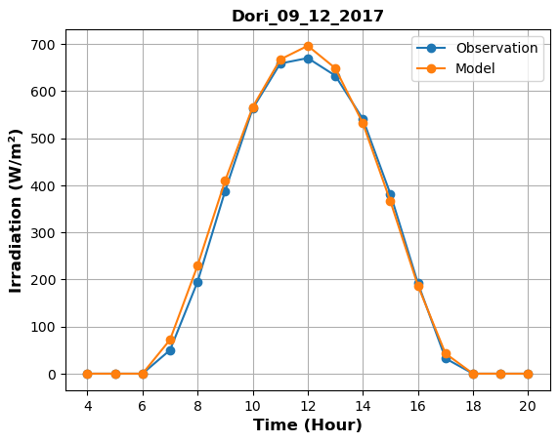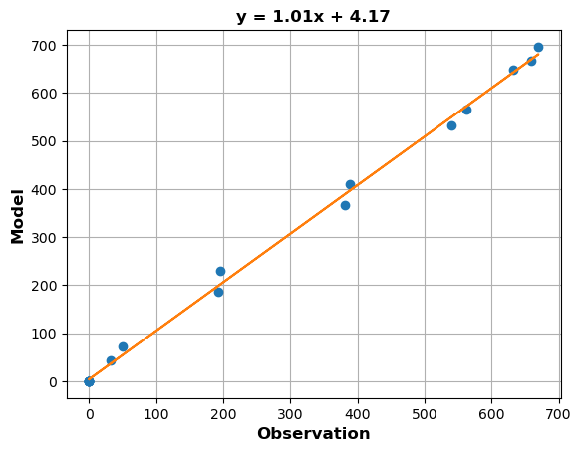

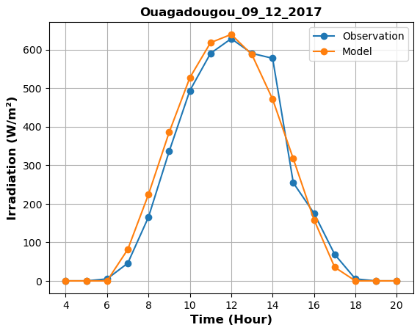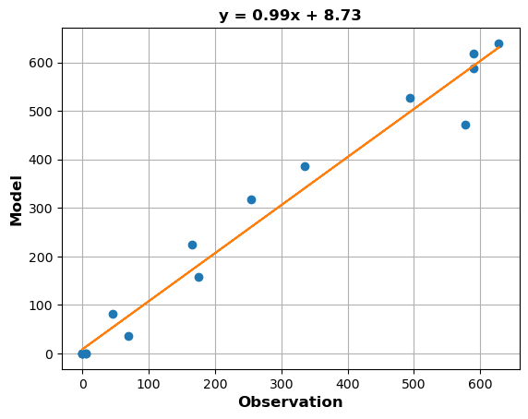

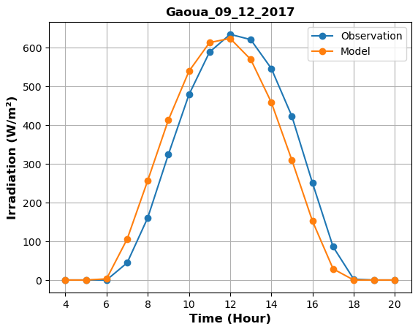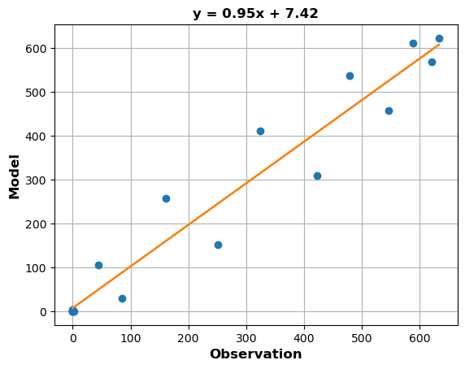

**Figure 3:** Illustration of the correlation between in situ data and tropospheric model simulations

The aim of this validation is to adapt the streamer simulation code to the calculation of solar flux in the case of a standard cloudless atmosphere. This will enable us to better assess the radiative impact of aerosols in a climate context specific to Burkina Faso. For this reason, we have opted for the tropospheric model, given the nature of the particles that predominate in this part of the Sahel. Moreover, this is the atmospheric layer where meteorological phenomena are strongly felt, resulting in aerosol emissions, particularly mineral particles. An analysis of the comparison between the time series of radiation measured during the dust event on December 09 and that simulated **(Figure 3)** shows a very good approach to the simulation model, whatever the climatic zone illustrated by the different sites. This model performance is confirmed by the statistical indicators summarized in **Table 1**, especially the coefficients of determination R2 and correlation R, which respectively give values close to 1. However, measurements at the Dori and Ouagadougou sites are overestimated due to positive MBE values. On the other hand, the negative MBE value in the Sudanian zone at the Gaoua site indicates an underestimation of the radiation observed at this site. Furthermore, the RMSE and MAE values highlight the accuracy of the model, which appears to be more precise at the Dori and Ouagadougou sites than at the Gaoua site, which is identified by large error values (RMSE = 60.03 and MAE = 44.36). To this end, a classification of the model's performance according to climatic zone shows perfect agreement between in situ measurements and model simulations, with greater precision in the Sahel, followed by the Sudano-Sahelian zone. Uncertainties in simulation models are very often linked to the aerosol population defined by the AOD, which is not homogeneous given the highly varied chemical nature of particles in different localities, and the many emission sources.

**Table 1:** Calculation of statistical indicators

|  |  |  |  |  |  |
| --- | --- | --- | --- | --- | --- |
| **Site** | **RMSE** | **MBE** | **MAE** | **R2** | **R** |
| **Dori** | 14.54 | 6.61 | 10.10 | 0.99 | 0.99 |
| **Ouagadougou** | 38.96 | 6.40 | 26.37 | 0.97 | 0.98 |
| **Gaoua** | 60.03 | -5.06 | 44.36 | 0.94 | 0.96 |

**3.2.3. Impact of the dust event on radiation**

**3.2.3.1. In the Sahelian zone at the Dori site**

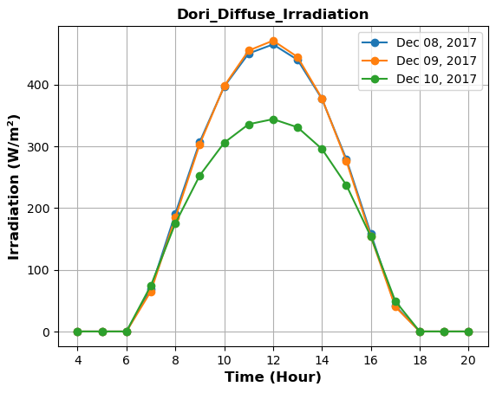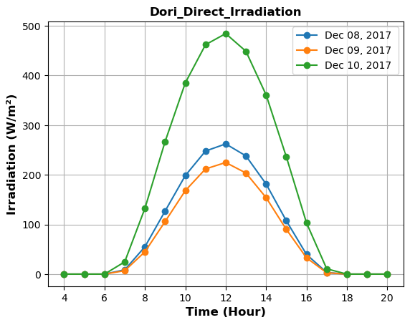

**Figure 4:** Simulation of diffuse and direct radiation before, during and after the dust event at the Dori site

**Figure 4** shows the direct and diffuse radiation simulated by the streamer model before, during and after the event at the Dori site. An analysis of this figure shows an early arrival of the dust layer in the Sahel at the Dori site from December 08, before its propagation on December 09, probably due to its position close to the Sahara. This observation is clearly illustrated by an increase in diffuse radiation of around 121.11 W/m2 and 127.25 W/m2 respectively before and during the event, compared with the day of December 10 which corresponds to the departure of the dust cloud in this area. At the same time, normal direct radiation decreased by 222.18 W/m2 and 259.64 W/m2 respectively before and during the event. These diurnal cycles of diffuse and direct flux are consistent with the daily AOD averages recorded around 1.46, 1.75 and 0.51 respectively before, during and after the Sahel dust event. All this is corroborated by in situ measurements of global radiation at the Dori site, which are reflected in the change illustrated by a decrease on December 08 and 09 compared with December 10 of 143.2 W/m2 and 123.7 W/m2 respectively.

**3.2.3.2. In the Sudano-Sahelian zone at the Ouagadougou site**

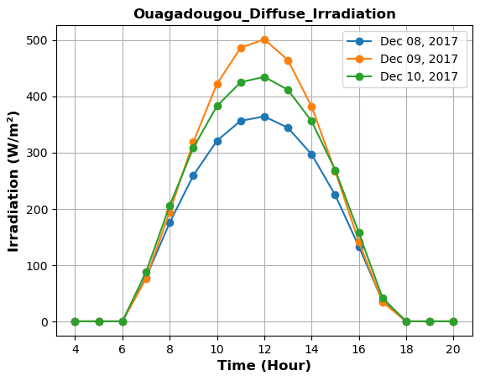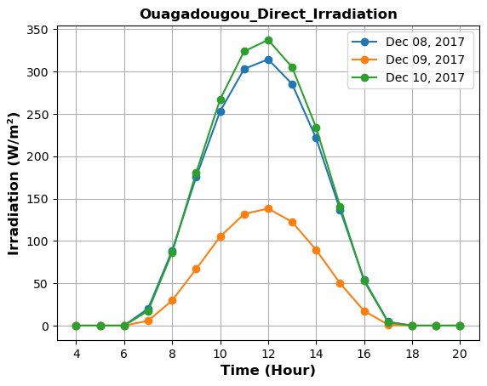

**Figure 5:** Simulation of diffuse and direct radiation before, during and after the dust event at the Ouagadougou site

At the Ouagadougou site, the impact of the dust storm on December 09 is clearly visible in the reduction in overall solar radiation compared with that observed before and after the event, following on-site measurements. To this end, a strong attenuation of solar radiation of the order of 101.70 W/m2 and 132.20 W/m2 respectively compared to the December 08 and December 10 measurements was recorded during the day of the dust event. This could result in a massive influx of dust from the Sahara, forming a thick layer of aerosols that is not transparent to solar radiation, thus justifying the high AOD value of 3.09, which highlights the scale of the dust episode. Furthermore, a simulation of direct and diffuse radiation on December 08, 09 and 10 using the streamer radiative transfer code **(figure 5)**, shows an increase in diffuse flux of the order of 136.92 W/m2 and 66.54 W/m2 on the day of the event, respectively, compared with the day before and after the dust cloud was observed. This increase in diffusivity leads to a sharp change in direct radiation during the event, characterized by a decrease of around 176.23 W/m2 and 199.14 W/m2 compared with the direct flux simulated before and after the event. This evolution of direct and diffuse radiation is supported by the aerosol optical depth values measured by the MODIS airborne sensor before (AOD = 0.82), during (AOD = 3.09) and after (AOD = 1.10) the event.

**3.2.3.3. In the Sudanian zone at the Gaoua site**

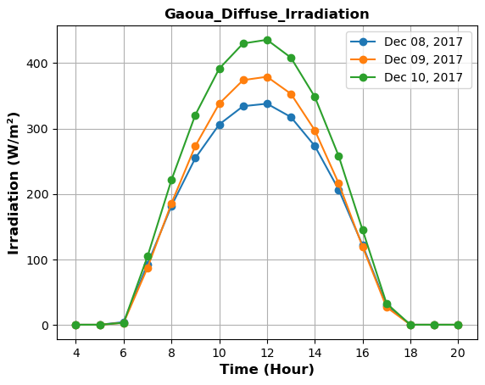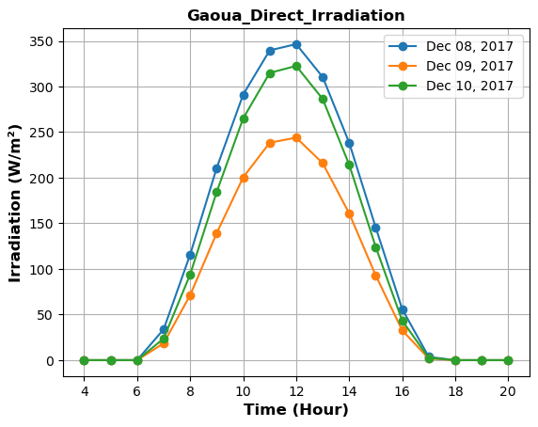

**Figure 6:** Simulation of diffuse and direct radiation before, during and after the dust event at the Gaoua site

Global radiation measurements at the Gaoua site before, during and after the event show a reduction of 72.10 W/m2 and 113.30 W/m2 compared with December 08 and 10, corresponding respectively to the days before and after the dust event. However, the diffuse solar flux calculated during the dust event on December 09 at this site in the south-west **(figure 6)** shows an increase of 41.20 W/m2 compared with December 08 and a decrease of 56.51 W/m2 compared with the diffuse flux on December 10, probably linked to the day's AOD of 1.24. This increase in diffuse flux during the following day is simply due to the flow of mineral particles in a north-south direction, causing a strengthening of the dust layer until December 10 in the Sudanian zone. The diurnal cycle of direct radiation **(Figure 6)** follows a similar pattern to the overall flux measured before, during and after the dust event. On the other hand, the impact of dust can be seen in the attenuation of the direct flux on December 09 by 102.50 W/m2 and 78.60 W/m2 compared with December 08 and 10 respectively. This decrease is in good agreement with the aerosol concentration represented by the AODs observed by the MODIS sensor around 0.70, 1.41 and 1.24 respectively before, during and after the dust storm that hit the whole of Burkina Faso on December 09.

**4. CONCLUSION**

Our study highlighted the impact of seasonal dynamics on the frequency of typical days defined by aerosol optical depth in a climatic context specific to Burkina Faso. This shows the importance of typical days associated with harmattan and monsoon flows in different climatic zones. These days are strongly dominated by mixed days associated with an aerosol plume and dusty days with dust episodes distinguished by very remarkable AOD values. In addition, dust episodes are caused by strong Saharan thermal lows and northeasterly winds. In addition, an analysis of a dust event recorded during the winter allows us to quantify the direct radiative effect of mainly desert aerosols, which is characterized by a modification of the diffuse and direct solar flux. This attenuation of solar radiation highlights the diffusive nature of particles, associated with the diffuse flux linked to the atmospheric aerosol load. This has an impact on the operation of solar conversion systems, hence the need to study the correlation between aerosols and photovoltaic or thermal solar production. The aim is to assess the impact of typical days on the performance of these technologies, which offer an alternative to energy problems in Sahelian countries such as Burkina Faso.

Consent

Not applicable.

Ethical approval

Not applicable.

References

B. Korgo, Roger, J. ., & Bathiebo, J. (2013). Climatology of air mass trajectories and aerosol optical thickness over Ouagadougou. *Global Journal of Pure and Aplied Sciences*, *19*, 169–181. https://doi.org/https://doi.org/10.4314/gjpas.v19i1.22

Bado, N., Bazyomo, S. D., Wende, G., Ouedraogo, P., Korgo, B., Dramé, M. S., Kieno, F. P., & Kam, S. (2024). Contribution of Satellite Observations in the Optical and Microphysical Characterization of Aerosols in Burkina Faso , West Africa. *Atmospheric and Cli- Mate Sciences*, *14*, 154–171. https://doi.org/10.4236/acs.2024.141010

Bado, N., Ouédraogo, A., Guengané, H., Maurice Ky, T. S., Bazyomo, S. D., Korgo, B., Dramé, M. S., Sall, S. M., Kieno, F. P., & Bathiebo, D. J. (2019). Climatological Analysis of Aerosols Optical Properties by Airborne Sensors and in Situ Measurements in West Africa: Case of the Sahelian Zone. *Open Journal of Air Pollution*, *08*(04), 118–135. https://doi.org/10.4236/ojap.2019.84007

Bilal, B. O., Sambou, V., Kébé, C. M. F., Ndongo, M., & Ndiaye, P. A. (2007). Etude et modélisation du potentiel solaire du site de Nouakchott et de Dakar. *Journal Des Sciences*, *7*, 57–66.

Carvalho, J. C., Vilhena, M. T., & Moreira, D. M. (2007). Comparison between Eulerian and Lagrangian semi-analytical models to simulate the pollutant dispersion in the PBL. *Applied Mathematical Modelling*, *31*, 120–129. https://doi.org/10.1016/j.apm.2005.08.009

Dankassoua, M., Madougou, S., & Foulani, A. A. A. (2017). Study of global solar radiation in Niamey during the pre-monsoon and monsoon periods of 2013 (May to October). Renewable Energy Review, 20, 131–146.

Dankassoua, M., Saïdou, M., & Yahaya, S. (2017). Evaluation of Solar Potential at Niamey : Study Data of Insolation from 2015 and 2016. *Smart Grid and Renewable Energy*, *8*, 394–411. https://doi.org/10.4236/sgre.2017.812026

Drame, M., Bilal, B. O., Camara, M., Sambou, V., & Gaye, A. (2012). Impacts of aerosols on available solar energy at Mbour , Senegal. *Journal of Renewable and Sustainable Energy*, *4*, 1–13. https://doi.org/10.1063/1.3682078

Drame, M., Jenkins, G. S., Camara, M., & Robjhon, M. (2011). Observations and simulation of a Saharan air layer event with a midtropospheric dust layer at Dakar , Senegal , 6 – 7 July 2010. *Journal of Geophysical Research*, *116*, 6–7. https://doi.org/10.1029/2011JD016368

Drame, M. S. (2012). Characterization and climatic impacts of aerosols in West Africa. Cheick Anta DIOP University of Dakar.

Drame, M. S., Camara, M., & Gaye, A. T. (2012). Simulation of the impact of aerosols on solar radiation in Mbour, Senegal. La Météorologie, 51–57. https://doi.org/10.4267/2042/48513

Drame, M. S., Ceamanos, X., Roujean, J. L., Boone, A., Lafore, J. P., Carrer, D., & Geoffroy, O. (2015). On the Importance of Aerosol Composition for Estimating Incoming Solar Radiation: Focus on the Western African Stations of Dakar and Niamey during the Dry Season. *Atmosphere*, *6*, 1608–1632. https://doi.org/10.3390/atmos6111608

Drame, M. S., Diop, D., Talla, K., Diallo, M., Ngom, B. D., & Nebon, B. (2021). Structural and physicochemical properties of dust collected on PV panels surfaces and their potential influence on these solar modules efficiency in Dakar, Senegal, West Africa. *Scientific African*, *12*, 1–9. https://doi.org/10.1016/j.sciaf.2021.e00810

Draxler, R. R. (1998). An Overview of the HYSPLIT _ 4 Modelling System for Trajectories , Dispersion , and Deposition. *Australian Meteorological Magazine*, *47*, 295–308.

Goni, S., Adannou, H. A., Diop, D., Kriga, A., Khayal, ahamoud Y., Nebon, B., Cheidikh Beye, A., Aziz Niang, S. A., & Drame, M. S. (2019). Observation and Simulation of Available Solar Energy at N’Djamena, Chad. *Smart Grid and Renewable Energy*, *10*(06), 165–178. https://doi.org/10.4236/sgre.2019.106011

Kabore, B., Kam, S., Ouedraogo, G. W. P., & Bathiébo, D. J. (2017). Study of climate change in Burkina Faso from 1983 to 2012: the case of the cities of Bobo Dioulasso, Ouagadougou and Dori. Arabian Journal of Earth Sciences, 4(2), 50–59.

Kerkouche, K., Cherfa, F., Arab, A. H., Bouchakour, S., Abdeladim, K., & Bergheul, K. (2013). Evaluation of global solar irradiation on an inclined surface according to different models for the Bouzaréah site. Renewable Energy Review, 16, 269–284.

Key, J. R. (2002). *Streamer User ’ s Guide*.

Key, J. R., & Schweiger, A. J. (1998). Tools for atmospheric radiative transfer: STREAMER and FLUXNET. *Computers and Geosciences*, *24*(5), 443–451. https://doi.org/10.1016/S0098-3004(97)00130-1

Korgo, B., Kafando, P., Zouma, B., Bado, N., Zerbo, I., Roger, J.-C., & Bathiebo, J. D. (2021). The Radiative Forcing of Aerosols in a West Africa Sahelian Urban City: Case Study of Ouagadougou. *Atmospheric and Climate Sciences*, *11*(01), 73–85. https://doi.org/10.4236/acs.2021.111005

L’Ecuyer, T. S., & Jiang, J. H. (2010). Touring the atmosphere aboard the A-Train. *Physics Today*, *63*(7), 36–41. https://doi.org/10.1063/1.3463626

Marticorena, B., Haywood, J., Coe, H., Formenti, P., Liousse, C., Mallet, M., & Pelon, J. (2011). Tropospheric aerosols over West Africa : highlights from the AMMA international program. *Atmospheric Science Letters*, *12*, 19–23. https://doi.org/10.1002/asl.322

Nébon, B., Dramé, M. S., Bruno, K., Florent, K. P., Sall, S. M., & Joseph, D. (2018). Optical and microphysical analysis of aerosols in Sahelian Zone : Case of the Ouagadougou City in Burkina Faso. *Elixir International Journal*, *119*, 50975–50982.

Nébon, B., Dramé, M. S., Bruno, K., Hassime, G., Niang, D. N., Sall, S. M., Florent, K. P., & Joseph, B. D. (2019). Study of Aerosol Impact on the Solar Potential Available in Burkina Faso, West Africa. *International Journal of Environment and Climate Change*, *9*(5), 297–310. https://doi.org/10.9734/ijecc/2019/v9i530116

Nébon, B., Dramé, M. S., Sall, S. M., Bruno, K., Niang, D. N., Florent, K. P., & Joseph, B. D. (2019). Intra-Seasonal and Annual Variation of Aerosols and Their Radiative Impact in the Sahelian Zone of Burkina Faso. *Atmospheric and Climate Sciences*, *09*(01), 62–74. https://doi.org/10.4236/acs.2019.91004

Niang, S. A. A., Gueye, A., Sarr, A., Diop, D., Goni, S., & Nebon, B. (2023). Comparative Study of Available Solar Potential for Six Stations of Sahel. *Smart Grid and Renewable Energy*, *14*(08), 153–167. https://doi.org/10.4236/sgre.2023.148009

Prospero, J. M., Ginoux, P., Torres, O., Nicholson, S. E., & Gill, T. E. (2002). Environmental characterization of global sources of atmospheric soil dust identified with the Nimbus 7 Total Ozone Mapping Spectrometer (TOMS) absorbing aerosol product. *Reviews of Geophysics*, *40*(1), 2-1-2–31. https://doi.org/10.1029/2000RG000095

Soro, B., Diallo, A., Dimitri, S., Bazyomo, Y. B., Ouedraogo, A., Salack, S., & Bathiebo, J. D. (2024). Optimal Sizing of Output Energy of PV Power Plants under Extreme Climate Conditions : Case of Sudanian Sahel. *Current Journal OfApplied Science AndTechnology*, *43*(10), 66–83. https://doi.org/https://doi.org/10.9734/cjast/2024/v43i104437

Stohl, A. (1998). Computation , accuracy and applications of trajectories — a review and bibliography. *Atmospheric Environment*, *32*(6), 947–966.

Tanré, D., Kaufman, Y. J., Herman, M., & Mattoo, S. (1997). Remote sensing of aerosol properties over oceans using the MODIS / EOS spectral radiances. *Journal of Geophysical Research*, *102*(3).

Zhang, Z., & Chen, Q. (2007). Comparison of the Eulerian and Lagrangian methods for predicting particle transport in enclosed spaces. *Atmospheric Environment*, *41*(25), 5236–5248.