Original Research Article

Stage at initial presentation, management and factors associated with progression among Primary open-angle glaucoma Patients treated at a tertiary hospital in Tanzania

ABSTRACT
Objective: To assess the stage of Primary Open Angle Glaucoma (POAG) at diagnosis, determine the proportion of patients experiencing disease progression, and identify factors influencing progression.
Methods:
In this retrospective cohort, 201 newly diagnosed POAG patients aged 18 years and older, each with a minimum of five Humphrey 24-2 SITA-standard visual field tests (VFTs) taken at six-month intervals undergoing treatment were enrolled, for a total of 363 eyes. Disease severity was classified based on visual field mean deviation (MD) as mild (MD > -6 dB), moderate (MD -6 to -12 dB), advanced (MD -12 to -20 dB), or severe (MD < -20 dB). The primary outcome was POAG progression defined as an annual VFI deterioration of ≤ -1% per year. Kaplan-Meier survival analysis was used to estimate the probability of progression, while Cox regression analysis identified factors associated with disease progression.
Results: At diagnosis, 228 eyes`(62.8%) had mild to moderate POAG and 135(37.2%) had advanced to severe POAG. At an average of 6 years follow-up, 140 eyes (38.6%) showed progression, with a mean VFI decline of -2.2% per year. 108 of 140 eyes( 77.1%) progressed to advanced and severe stages. Uncontorlled elevated intraocular pressure strongly predicted disease progression (p < 0.001), and eyes with IOP above target values had a 4.3 times higher risk of progression. Other significant risks included severe disease stage, normal-tension glaucoma, and myopia, while frequent follow-ups and trabeculectomy were protective.
Conclusion: A significant proportion of POAG patients progressed to advanced stages. Eyes with IOP above target values had a 4.3 times higher risk of progression and uncontrolled high intraocular pressure (IOP) predicted disease progression.
Keywords: Primary Open-Angle Glaucoma, Visual Field Test, Visual Field Mean Deviation, Visual Field Index, Glaucoma Progression, Progression Risk Factors

INTRODUCTION
Primary Open-Angle Glaucoma (POAG) is the most common subtype of glaucoma, affecting approximately 58.9 million people worldwide, with an estimated 6 million developing bilateral blindness (1). Africa bears a disproportionately high burden, with the highest global prevalence of POAG. Compared to Western Europe, the African population experiences a fourfold higher rate of blindness due to POAG, presents with more severe disease at diagnosis, and has a faster rate of progression (2–6) .
Elevated intraocular pressure (IOP) is the most frequently reported risk factor for glaucoma onset and progression (7–16). However other factors such as older age, thinner central corneal thickness (CCT), severe mean deviation (MD) at diagnosis, diabetes mellitus (DM), hypertension (HTN), myopia, disc hemorrhages, peripapillary atrophy, and a family history of glaucoma have also been linked to disease progression (11,13,17,18).
The primary goal of POAG management is to control IOP to slow or prevent disease progression (19). However, progression rates vary significantly among individuals. Some patients experience rapid visual field deterioration despite aggressive treatment, while others progress slowly even with conservative management (20–22) This variability highlights the need to better understand risk factors influencing disease progression, particularly in regions where limited data exist on disease patterns. Identifying these risk factors can help clinicians monitor disease more effectively, recognize high-risk patients, intervene promptly, and adjust treatment strategies accordingly, ultimately reducing the risk of permanent visual disability and preserving vision-related quality of life.
This study aimed to assess the stage of POAG at initial presentation, determine the proportion of patients who experienced disease progression during follow-up at Kilimanjaro Christian Medical Centre (KCMC), and identify key predictive risk factors associated with progression.

MATERIALS AND METHODS
Study Design and Setting: A retrospective cohort study was conducted at the KCMC Eye Clinic in northern Tanzania from January 2010 to December 2020. KCMC Eye Clinic is a specialized facility and the primary referral site for ophthalmic cases in the region (northern Tanzania).
Study Population: The study included all patients diagnosed with primary open-angle glaucoma (POAG) at the KCMC Eye Clinic during the study period. Inclusion criteria comprised newly diagnosed POAG patients aged 18 years and older with a minimum of five reliable visual field tests (VFTs) performed at least six months apart, ensuring adequate assessment of visual field progression. Patients were excluded if they had conditions affecting VFT results, such as advanced proliferative diabetic retinopathy, retinal vein occlusion, macular degeneration, or end-stage glaucoma at presentation.
Sampling Technique A consecutive sampling method was employed to recruit newly diagnosed POAG patients attending the KCMC Eye Clinic during the study period.
Data Collection Methods and Tools A retrospective review of medical records was conducted for patients meeting the study’s eligibility criteria. A structured data collection sheet, developed based on variables from previous studies (Heijl et al., 2013; Alemu et al., 2010; Mwanza et al., 2022), was utilized. The sheet captured socio-demographic details, clinical profiles, and risk factors for POAG progression.
VFT results were obtained from the Humphrey Visual Field Analyzer (Model: 740i S/N 7401-17434) at the KCMC Eye Clinic. This device has a high diagnostic accuracy, with 100% sensitivity and 94% specificity for glaucoma detection. It employs Software Guided Progression Analysis (GPA) for VFI slope analysis, which has 93% specificity in detecting glaucoma progression.

Data Collection Procedure: A list of glaucoma patients attending KCMC during the study period was obtained from the hospital's electronic system. Medical records of patients aged 18 years and older were reviewed to identify newly diagnosed POAG cases. The initial reliable VFT results, conducted within three months of the first visit, were assessed for glaucomatous damage based on the Hodapp, Parrish, and Anderson criteria. Recorded gonioscopy findings were used to determine the anterior chamber angle status, with Shaffer classification grades 3 and 4 indicating open-angle glaucoma. In cases without gonioscopy findings, the recorded Van Herick grade of anterior chamber status was applied, with grades 3 and 4 considered indicative of an open angle. Eligible patients were then enrolled in the study.
Study Variables The primary outcome variable was POAG progression, categorized dichotomously as either “Yes” (progression) or “No” (no progression). Progression was defined as an annual VFI deterioration of ≤ -1% per year, whereas patients with a VFI decline greater than -1% per year were classified as non-progressors.
Independent variables included socio-demographic factors (age at diagnosis, gender, residence) and clinical characteristics such as POAG subtype (normal-tension vs. high-tension), stage at presentation, mean intraocular pressure (IOP), refractive errors (myopia and hyperopia), number of follow-up visits, number of VFTs, stage at presentation based on mean deviation values, comorbidities (hypertension and diabetes), and treatment modalities (medication, laser, trabeculectomy).

Operational Definitions:
- Significant POAG Progression: A VFI slope ≤ -1% per year.
- Target IOP: Defined cut-off values were 15-17 mmHg for mild glaucoma (MD 0.01 - 6 dB), 12-15 mmHg for moderate glaucoma (MD 6.01 - 12 dB), and 10-12 mmHg for severe glaucoma (MD < -12 dB) (Sihota et al., 2018).

Data Management and Analysis
Data were analyzed using STATA version 17 (StataCorp LLC, College Station, Texas, USA). The dataset was cleaned, and descriptive statistics were performed, summarizing categorical variables with frequencies and percentages, and numeric variables with means and standard deviations (SD).
Survival analysis was performed using the “stset” command to declare the dataset as survival data. Kaplan-Meier survival curves were used to estimate the probability of disease progression and compare progression across disease stages and treatment modalities. The log-rank test assessed differences in progression times, with significance set at P-value < 0.05.
Cox regression analysis was performed to assess factors associated with POAG progression. Univariate analysis was done to obtain crude hazard ratios (CHR), followed by multivariable analysis to obtain adjusted hazard ratios (AHR). Variables with a P-value of < 0.05 were considered statistically significant

Ethical Considerations: Ethical approval was obtained from the Kilimanjaro Christian Medical University College Research and Ethical Review Committee (KCMU-CRERC) Number PG 72/2023. Permission for the study was granted by the head of hospital services and the head of the ophthalmology department at KCMC. Patient confidentiality was ensured by using file numbers instead of names during data collection.

Dissemination of Results Plan: The research findings will be disseminated to the Kilimanjaro Christian Medical University College (KCMUCo) and the Department of Ophthalmology. A copy of the final report will be made available at the KCMUCo and Ophthalmology Department libraries for reference. In addition, the final manuscript will be submitted for publication in a peer-reviewed medical journal to ensure broader dissemination within the scientific and medical community.

RESULTS
Of the 8,942 glaucoma patients attended, 201 primary open-angle glaucoma patients (363 eyes) met the eligibility criteria for enrolment in the study. (Figure 1)
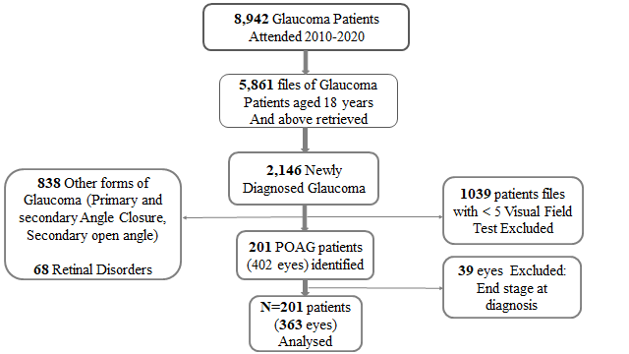
Figure 1: Flowchart of patient selection process

Demographic and clinical characteristics
The median age at diagnosis was 64 years (IQR: 57-71), with a slight male predominance (55.2%). The median follow-up period was 6 years (IQR: 5-8). Systemic comorbidities (hypertension or diabetes mellitus) were present in 37.8% of participants. High-tension POAG accounted for 86.1% of cases, and the most common presenting complaint was poor vision (83.1%) (Table 1).
Refractive errors were observed in 34.2% of eyes, with myopia being the most prevalent (73.4%). During follow-up, treatment included medication alone (38%), laser treatment (36.6%), surgery alone (18.5%), and combined laser and surgery (6.9%).

Table 1 : Participants demographics and clinical characteristics (N=201)
Variable | Frequency (n) |  | Percentage (%)
Age (years, Median IQR*: 64 (57,71))
<60 |  | 33 | 16.4
60-80 |  | 143 | 71.2
>80 |  | 25 | 12.4
Sex
Female |  | 90 | 44.8
Male |  | 111 | 55.2
Comorbidities
None |  | 125 | 62.2
Hypertension |  | 24 | 31.6
Diabetes Mellitus |  | 27 | 35.5
Both |  | 25 | 32.9
POAG type
High tension POAG |  | 173 | 86.1
Normal tension POAG |  | 28 | 13.9
Complaints at presentation
Poor vision |  | 167 | 83.0
Eye check-up |  | 14 | 7.0
Others † |  | 20 | 10.0
* Interquartile range
† Ocular pain, headache, change glass

Disease Stages at Diagnosis

At diagnosis, 43% of eyes had mild disease (average MD -3.0 dB), 19.8% had moderate disease (average MD -8.4 dB), 13.2% had advanced disease (average MD -17.1 dB), and 24% had severe disease (average MD -27.9 dB). The overall mean deviation (MD) at diagnosis was -11.9 (±1.3), indicating moderately advanced glaucoma (Table 2).
Table 2: Distribution of POAG stages at Diagnosis (N=363)
Disease stage | n (%) | Average Mean deviation (Mean ±SD) | MD Reference ranges
Mild | 156 (43) | -3.0 (-1.4) | > -6dB
Moderate | 72 (19.8) | -8.4 (-1.8) | -6 to -12 dB
Advanced | 48 (13.2) | -17.1 (-2.4) | -12 to -20 dB
Severe | 87 (24) | -27.9 (-2.7) | < -20 dB
Total | 363 (100)

Proportion of Eyes with POAG Progression based on Visual field index deterioration
During follow-up, 38.6% (140 eyes) showed progression at an average rate of -2.2% VFI/year. Among these, 30.7% had severe disease at diagnosis, 28.6% had mild disease, 25.7% had moderate disease, and 15% had advanced disease. Progression rates were -2.1% for mild, -3.31% for moderate, -2.9% for advanced, and -1.51% for severe disease stages. Notably, 77.1% of the 140 progressed eyes moved to more severe stages.
During follow-up, 76.3% of eyes achieved normal intraocular pressure (IOP, 9-21 mmHg), but only 18.5% of eyes reached the target IOP for their disease stage. Among eyes that progressed, 90.6% did not attain target IOP.

Table 3: Proportion eyes with POAG progression (N=140)
Disease stage | Eyes progressed  n (%) | Eyes progressed into subsequent stages n (%) | Progression rates (%VFI/year)
Mild | 40 (28.6) | 39 (97.5) | -2.1
Moderate | 36 (25.7) | 30 (83.3) | -3.31
Advanced | 21 (15) | 21 (100) | -2.9
Severe | 43 (30.7) | 18 (41.9) | -1.51

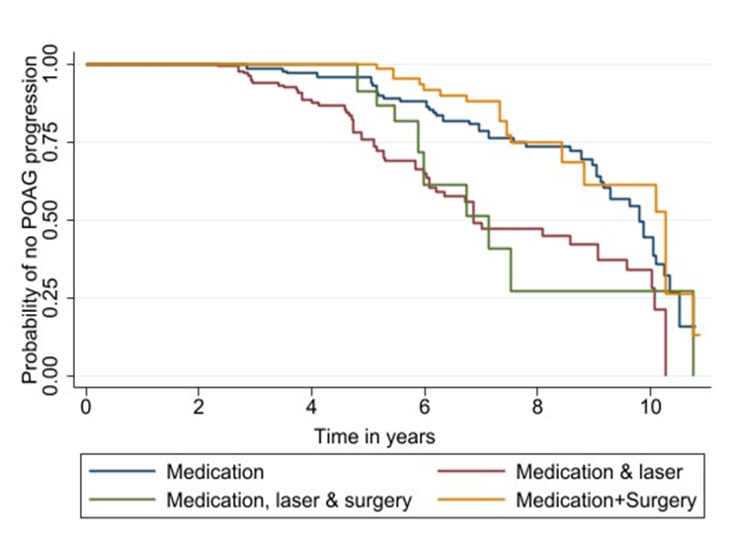
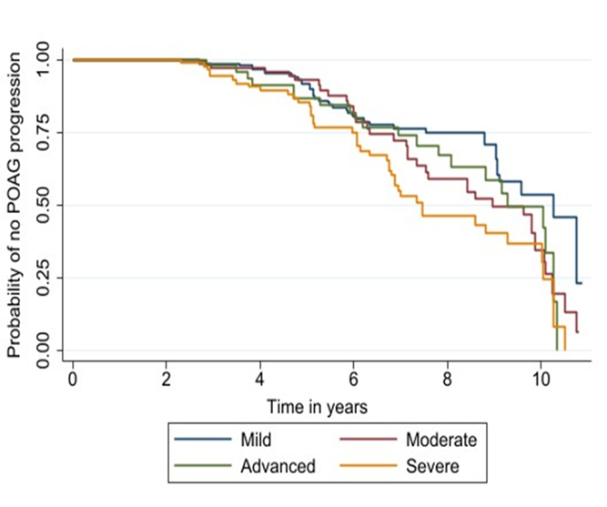
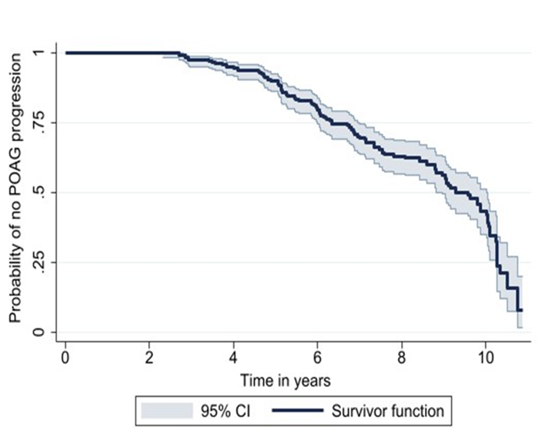
Kaplan-Meier Survival Analysis (Figure 2)
The Kaplan-Meier survival curve (Figure 2a) indicates that 50% of eyes with POAG remained non-progressive for 9 years. Eyes diagnosed with severe disease (Figure 2b) and those treated with medication followed by laser (figure 2c) had the fastest progression, with a 50% non-progression probability at 7 years.
(a)

(c)
(b)
P-value <0.001
P-value =0.042

Figure 2: Kaplan-Meier Survival Curve Showing: (a) Overall Probability of POAG Eyes Remaining Non-Progressive during Follow-Up (b) Probability of Non-Progression across Different Disease Stages at Diagnosis (c) Probability of Non-Progression across Different Treatment Modalities

Factors associated with POAG progression
POAG progression was significantly associated with normal tension glaucoma, disease stage, myopia, and high mean and target IOP, while more follow-up visits reduced progression risk. Trabeculectomy lowered progression by 50% in univariate analysis but was not significant in multivariate analysis.
Table 4: Univariate and Multivariate analysis of factors associated with POAG progression (N=363)
Variable | Yes n (%) | cHR* (95% CI) | p-value | aHR† (95% CI) | p-value
Age (years)
<60 | 13 (22.0) | 1 |  | 1
60-80 | 100 (38.5) | 1.4 (0.7-2.7) | 0.397 | 1.2 (0.6-2.5) | 0.717
>80 | 27 (61.4) | 1.5 (0.7-3.4 | 0.307 | 1.3 (0.5-3.2) | 0.690
Sex
Female | 64 (39.3) | 1 |  | 1
Male | 76 (38.0) | 0.8 (0.6-1.2) | 0.396 | 0.9 (0.6-1.6) | 0.819
Comorbidity
No | 73 (49.3) | 1 |  | 1
Yes | 67 (89.3) | 1.1 (0.7-1.7) | 0.580 | 1.6 (0.9-2.7) | 0.076
Normal tension POAG
No | 104 (33.6) | 1 |  | 1
Yes | 36 (66.7) | 2.0 (1.3-3.3) | 0.003 | 2.6 (1.4-4.8) | 0.002
Disease stage
Mild | 40 (25.6) | 1 |  | 1
Moderate | 36 (50.0) | 1.2 (0.7-2.1) | 0.538 | 1.4 (0.7-2.7) | 0.297
Advanced | 21 (43.8) | 1.3 (0.6-2.5) | 0.524 | 2.6 (1.2-5.8) | 0.017
Severe | 43 (49.4) | 1.9 (1.1-3.2) | 0.020 | 3.0 (1.7-5.5) | <0.001
Refractive error
Absent | 88 (36.8) | 1 |  | 1
Myopia | 34 (37.4) | 2.6 (1.2-4.3) | 0.001 | 2.1 (1.9-4.4) | 0.002
Hyperopia | 18 (54.5) | 0.9 (0.6-1.5) | 0.726 | 1.1 (0.6-1.7) | 0.995
Average IOP
Normal | 13 (19.1) | 1 |  | 1
High | 127 (43.1) | 2.1 (1.3-3.2) | 0.001 | 3.7 (2.1-6.8) | <0.001
Follow-up visits | 140 (38.6) | 0.9 (0.93-0.96) | <0.001 | 0.9 (0.8-0.9) | <0.001
Surgery(TE)
No | 109 (41.3) | 1
Yes | 31 (31.3) | 0.5 (0.3-0.9) | 0.022 | 0.94 (0.5-1.7) | 0.847
*Crude Hazard Ratio † Adjusted Hazard Ratio

DISCUSSION
This study examined Primary Open Angle Glaucoma (POAG) from diagnosis to progression and identified the key factors influencing the disease progression over a median follow-up period of six years. The study findings provided critical insights into the natural history of POAG, its response to treatment modalities, and prognostic factors that may guide clinical management.
The median age of the study population was 64 years (IQR: 57-71), consistent with the age-related nature of POAG as reported in previous studies (23–26). A slightly higher prevalence was observed in males (55.2%), aligning with previous studies (25–30) this could be due to estrogen’s neuroprotective role in reducing glaucoma risk in women (31–36).
A significant majority (86.1%) of patients were diagnosed with high-tension POAG, while only 13.9% had normal-tension POAG (NTG). This distribution may be attributed to high intraocular pressure (IOP) being the most recognized risk factor for glaucoma development and progression(7), (8–16) Similarly, other studies have reported lower NTG prevalence, ranging from 12% to 26%(37), (38–40)The predominant presenting complaint was poor vision (83%), highlighting the asymptomatic nature of early POAG and the need for routine screening to facilitate earlier diagnosis.
At diagnosis, 43% of eyes had mild disease, while 24% presented with severe disease, with an overall mean deviation (MD) of -11.9 dB (± 1.3), indicative of moderately advanced glaucoma. These findings suggest a concerning proportion of patients already experiencing significant visual field loss at first presentation potentially due to delays in diagnosis. The study did not specifically address factors contributing to this delay, but one possible reason is the low rate of regular eye check-ups in the community, with only 7% of participants undergoing routine exams. This aligns with findings from previous studies (41) and (42) . Additional factors, such as economic barriers (43) (44), lack of financial and emotional support (45), and the shortage of ophthalmologists (only 69 in Tanzania, as per the 2019 RAAB Survey), likely contribute to delays in diagnosis and treatment.
During follow-up, 38.6% of eyes showed disease progression, with an average visual field index (VFI) decline of -2.2% per year. This rate was higher than the -1.1% to -1.5% reported in previous studies (20,46,47) suggesting significant worsening over time highlighting the need for vigilant monitoring. The observed progression was comparable to a study in Ghana (44.7%) (48) but lower than Ethiopia’s reported rate of 55.3% (8), where higher mean IOP was noted. Studies from Turkey (10)the US (14), and France (20), reported slightly higher progression rates, possibly due to differences in follow-up duration and progression definitions.
The highest progression was seen in eyes initially diagnosed with severe disease (30.7%), followed by mild (28.6%), moderate (25.7%), and advanced cases (15%). This confirms that disease severity at diagnosis is a critical predictor of future deterioration, with more severe cases exhibiting faster decline. Notably, 77.1% of progressing eyes advanced to more severe stages, highlighting the relentless nature of glaucoma despite therapeutic interventions.
Multivariate logistic regression identified several key factors associated with POAG progression. Normal-tension POAG was significantly associated with higher progression risk (aHR: 2.6, 95% CI: 1.4-4.8, p = 0.002), consistent with literature (49), suggesting that NTG may be influenced by non-IOP-related mechanisms such as vascular insufficiency and oxidative stress. Higher baseline disease severity was also predictive of progression similar to other studies (14,50,51) with advanced and severe disease stages in current study demonstrating significantly increased risk (aHR: 2.6, p = 0.017; aHR: 3.0, p < 0.001, respectively)
Refractive errors, particularly myopia, were strongly associated with disease progression (aHR: 2.1, 95% CI: 1.9-4.4, p = 0.002) similar to report by (52). Myopia has been linked to structural changes in the optic nerve head, predisposing individuals to glaucomatous damage. On the other hand a higher number of follow-up visits was inversely associated with progression (aHR: 0.9, p < 0.001), emphasizing the importance of regular monitoring in mitigating disease deterioration.
Elevated intraocular pressure (IOP) was a strong predictor of disease progression (aHR: 3.7, 95% CI: 2.1–6.8, p < 0.001), consistent with previous studies (7–16) When eyes were classified based on target IOP (mild = 15–17, moderate = 12–15, severe + advanced = 10–12), 81.5% failed to reach the target IOP. This suggests potential gaps in treatment efficacy, adherence, or perhaps the need for re-evaluating treatment protocols and follow-up practices so as to ensure better IOP control in our setting. Furthermore the data shows that 55% of eyes that progressed to subsequent stages did not attain the target IOP, implying a strong correlation between inadequate IOP control and disease progression. Multivariate analysis confirmed that eyes not attaining the target IOP had a 4.3 times higher risk of progression (p < 0.001), compared to a 3.7 times increased risk when higher-range IOP was considered as a risk for progression. These findings emphasize the critical importance of achieving the target IOP in glaucoma management, rather than solely focusing on normal-range IOP.
Trabeculectomy significantly reduced progression risk by 50% in univariate analysis but lost statistical significance in the multivariate model. This suggests that while surgical intervention remains a valuable option for advanced cases, its long-term efficacy in preventing progression may be influenced by other factors such as post-surgical IOP fluctuations and patient adherence to follow-up care.

Conclusion: The study on POAG patients attending the KCMC eye clinic in northern Tanzania found significant variation in disease stages at presentation: 43% had mild disease, 13% moderate, 13.2% advanced, and 24% severe. Over a mean follow-up period of 6 years, 38.6% of eyes showed progression, with an average progression rate of -2.2% per year. Factors such as higher intraocular pressure (IOP), severe disease at presentation, and myopia were significantly associated with progression, while trabeculectomy and increased follow-up visits acted as protective factors.
Strengths of the study include its use of gold standard visual field testing to assess progression, which has a high specificity for detecting POAG-related changes. However, limitations include potential selection bias due to the specialized setting. The retrospective nature of the study also led to missing data and incomplete records, which may have affected some outcomes. To mitigate this issue, we enrolled as many participants as possible.
The study recommends personalized treatment plans focusing on target IOP, early surgical intervention, and structured follow-up visits. It also suggests implementing hospital- and community-based screening for early detection. Further research is encouraged to enhance understanding and treatment for NTG, to address barriers to early diagnosis, assess treatment strategies, and conduct meta-analyses to define universal progression cut-offs values.
REFERENCES
1. Tham YC, Li X, Wong TY, Quigley HA, Aung T, Cheng CY. Global prevalence of glaucoma and projections of glaucoma burden through 2040: A systematic review and meta-analysis. Ophthalmology [Internet]. 2014;121(11):2081–90. Available from: http://dx.doi.org/10.1016/j.ophtha.2014.05.013
2. Fraser S, Bunce C, Wormald R. Retrospective analysis of risk factors for late presentation of chronic glaucoma. Br J Ophthalmol. 1999;83(1):24–8.
3. Mafwiri M, Bowman RJC, Wood M, Kabiru J. Primary open-angle glaucoma presentation at a tertiary unit in Africa: intraocular pressure levels and visual status. Ophthalmic Epidemiol. 2005;12(5):299–302.
4. Drance S, Anderson DR, Schulzer M, Group CN-TGS. Risk factors for progression of visual field abnormalities in normal-tension glaucoma. Am J Ophthalmol. 2001;131(6):699–708.
5. Ntim-Amponsah CT. Visual loss in urban and rural chronic glaucoma patients in Ghana. Trop Doct. 2002;32(2):102–4.
6. Kyari F, Abdull MM, Bastawrous A, Gilbert CE, Faal H. Epidemiology of glaucoma in sub-saharan Africa: prevalence, incidence and risk factors. Middle East Afr J Ophthalmol. 2013;20(2):111.
7. Le. Predictors of Long-term Progression in the Early Manske, M Cristina Heijl, Anders Hyman, Leslie Bengtsson, Boel Dong, LiMing Yang, Zhongmingifest Glaucoma Trial. Ophthalmology [Internet]. 2007;114(11):1965–72. Available from: https://www.sciencedirect.com/science/article/pii/S0161642007002412
8. Alemu AM, Kristoffersen CJ, Kristoffersen MS, Stewart JA, Stewart WC. Long-term benefit of reduced intraocular pressure in primary open-angle glaucoma patients in Ethiopia. Eur J Ophthalmol. 2010;20(2):310–5.
9. Wang YX, Hu LN, Yang H, Jonas JB, Xu L. Frequency and associated factors of structural progression of open-angle glaucoma in the Beijing Eye Study. Br J Ophthalmol. 2012;96(6):811–5.
10. Kocatürk T, Bekmez S, Katrancı M, Çakmak H, Dayanır V. Long term results of visual field progression analysis in open angle glaucoma patients under treatment. Open Ophthalmol J. 2015;9:116.
11. Pantalon AD, Feraru C, Chiseliţă D. Risk factors and long term progression in open angle glaucoma patients. Vol. 60, Romanian journal of ophthalmology. 2016. p. 174–80.
12. Pleet A, Sulewski M, Salowe RJ, Fertig R, Salinas J, Rhodes A, et al. Risk Factors Associated with Progression to Blindness from Primary Open-Angle Glaucoma in an African-American Population. Ophthalmic Epidemiol. 2016;23(4):248–56.
13. Actis AG, Versino E, Brogliatti B, Rolle T. Risk Factors for Primary Open Angle Glaucoma (POAG) Progression: A Study Ruled in Torino. Open Ophthalmol J. 2016;10:129–39.
14. Kim JH, Rabiolo A, Morales E, Yu F, Afifi AA, Nouri-Mahdavi K, et al. Risk Factors for Fast Visual Field Progression in Glaucoma. Am J Ophthalmol [Internet]. 2019;207:268–78. Available from: https://doi.org/10.1016/j.ajo.2019.06.019
15. Yarube I, Saidu A, Hassan S. Intraocular pressure negatively correlates with serum brain-derived neurotrophic factor in patients with primary open-angle glaucoma. Sub-Saharan African J Med [Internet]. 2019 Jan 1;6(1):10–5. Available from: https://www.ssajm.org/article.asp?issn=2384-5147
16. Salowe RJ, Chen Y, Zenebe-Gete S, Lee R, Gudiseva H V., Di Rosa I, et al. Risk factors for structural and functional progression of primary open-angle glaucoma in an African ancestry cohort. BMJ Open Ophthalmol. 2023;8(1):1–9.
17. Anderson DR. Collaborative normal tension glaucoma study. Curr Opin Ophthalmol. 2003 Apr;14(2):86–90.
18. Heijl A, Leske MC, Bengtsson B, Hyman L, Bengtsson B, Hussein M, et al. https://doi.org/10.1016/S0161-6420(01)00873-9. Arch Ophthalmol [Internet]. 2002 Oct 1;120(10):1268–79. Available from: https://doi.org/10.1001/archopht.120.10.1268
19. Zahari M, Mukesh BN, Rait JL, Taylor HR, McCarty CA. Progression of visual field loss in open angle glaucoma in the Melbourne Visual Impairment Project. Clin Experiment Ophthalmol. 2006;34(1):20–6.
20. Aptel F, Aryal-Charles N, Giraud JM, El Chehab H, Delbarre M, Chiquet C, et al. Progression of visual field in patients with primary open-angle glaucoma - ProgF study 1. Acta Ophthalmol. 2015;93(8):e615–20.
21. Saunders LJ, Medeiros FA, Weinreb RN, Zangwill LM. What rates of glaucoma progression are clinically significant? Vol. 11, Expert Review of Ophthalmology. 2016. p. 227–34.
22. Spaeth GL. European glaucoma society terminology and guidelines for glaucoma. Br J Ophthalmol. 2021;105(Suppl 1):1–169.
23. Dielemans I, Vingerling JR, Wolfs RCW, Hofman A, Grobbee DE, de Jong PTVM. The Prevalence of Primary Open-angle Glaucoma in a Population-based Study in The Netherlands: The Rotterdam Study. Ophthalmology [Internet]. 1994;101(11):1851–5. Available from: https://www.sciencedirect.com/science/article/pii/S0161642094310906
24. Tham Y-C, Li X, Wong TY, Quigley HA, Aung T, Cheng C-Y. Global prevalence of glaucoma and projections of glaucoma burden through 2040: a systematic review and meta-analysis. Ophthalmology. 2014;121(11):2081–90.
25. Kim KE, Kim MJ, Park KH, Jeoung JW, Kim SH, Kim CY, et al. Prevalence, Awareness, and Risk Factors of Primary Open-Angle Glaucoma: Korea National Health and Nutrition Examination Survey 2008–2011. Ophthalmology [Internet]. 2016;123(3):532–41. Available from: https://www.sciencedirect.com/science/article/pii/S0161642015013251
26. Zhang N, Wang J, Li Y, Jiang B. Prevalence of primary open angle glaucoma in the last 20 years: a meta-analysis and systematic review. Sci Rep [Internet]. 2021;11(1):1–12. Available from: https://doi.org/10.1038/s41598-021-92971-w
27. Kabiru J, Bowman R, Wood M, Mafwiri M. Audit of trabeculectomy at a tertiary referral hospital in East Africa. J Glaucoma. 2005 Dec;14(6):432–4.
28. Bowman RJC, Hay A, Wood ML, Murdoch IE. Combined cataract and trabeculectomy surgery for advanced glaucoma in East Africa; visual and intra-ocular pressure outcomes. Eye (Lond). 2010 Apr;24(4):573–7.
29. Bhat A, untoo R. Epidemiological Study And Presenting Features Of Primary Open Angle Glaucoma(POAG) At Initial Diagnosis . JMS Ski [Internet]. 2020 Dec 12;23(Suppl 1 SE-PGRPP Abstracts). Available from: https://jmsskims.org/index.php/jms/article/view/710
30. State R, Health P, Management C, Harcourt P, Awoyesuku EA. Profile of Primary Open Angle Glaucoma Patients Attending a Tertiary Health Institution in Niger Delta , Nigeria – A case study of 1000 patients. 2023;22(2):42–9.
31. Hulsman CAA, Westendorp ICD, Ramrattan RS, Wolfs RCW, Witteman JCM, Vingerling JR, et al. Is Open-Angle Glaucoma Associated with Early Menopause? : The Rotterdam Study. Am J Epidemiol [Internet]. 2001 Jul 15;154(2):138–44. Available from: https://doi.org/10.1093/aje/154.2.138
32. Lee AJ, Mitchell P, Rochtchina E, Healey PR. Female reproductive factors and open angle glaucoma: the Blue Mountains Eye Study. Br J Ophthalmol [Internet]. 2003 Nov 1;87(11):1324 LP – 1328. Available from: http://bjo.bmj.com/content/87/11/1324.abstract
33. Sator MO, Joura EA, Frigo P, Kurz C, Metka M, Hommer A, et al. Hormone replacement therapy and intraocular pressure. Maturitas [Internet]. 1997;28(1):55–8. Available from: https://www.sciencedirect.com/science/article/pii/S0378512297000601
34. Sator MO, Akramian J, Joura EA, Nessmann A, Wedrich A, Gruber D, et al. Reduction of intraocular pressure in a glaucoma patient undergoing hormone replacement therapy. Maturitas [Internet]. 1998;29(1):93–5. Available from: https://www.sciencedirect.com/science/article/pii/S0378512297000911
35. Newman-Casey PA, Talwar N, Nan B, Musch DC, Pasquale LR, Stein JD. The potential association between postmenopausal hormone use and primary open-angle glaucoma. JAMA Ophthalmol. 2014;132(3):298–303.
36. Pasquale LR, Loomis SJ, Weinreb RN, Kang JH, Yaspan BL, Bailey JC, et al. Estrogen pathway polymorphisms in relation to primary open angle glaucoma: an analysis accounting for gender from the United States. Mol Vis. 2013;19:1471–81.
37. Majeed F, Tauheed S, Aamir IS, Atif A, Majeed R. Frequency of Normal-Tension Glaucoma in Suspected Cases of Primary Open Angle Glaucoma. Pakistan J Ophthalmol. 2007;23(4):192–7.
38. Buys YM, Gaspo R, Kwok K. Referral source, symptoms, and severity at diagnosis of ocular hypertension or open-angle glaucoma in various practices. Can J Ophthalmol [Internet]. 2012;47(3):217–22. Available from: http://dx.doi.org/10.1016/j.jcjo.2012.03.031
39. Tarkkanen AHA, Kivelä TT. Comparison of primary open-angle glaucoma and exfoliation glaucoma at diagnosis. Eur J Ophthalmol. 2014;25(2):137–9.
40. Chen Y, Hughes G, Chen X, Qian S, Cao W, Wang L, et al. Genetic variants associated with different risks for high tension glaucoma and normal tension glaucoma in a Chinese population. Invest Ophthalmol Vis Sci. 2015;56(4):2595–600.
41. Fraser S, Bunce C, Wormald R. Risk factors for late presentation in chronic glaucoma. Invest Ophthalmol Vis Sci. 1999;40(10):2251–7.
42. Prior M, Francis JJ, Azuara-Blanco A, Anand N, Burr JM. Why do people present late with advanced glaucoma? A qualitative interview study. Br J Ophthalmol [Internet]. 2013 Dec 1;97(12):1574 LP – 1578. Available from: http://bjo.bmj.com/content/97/12/1574.abstract
43. Scott Fraser clinical research fellow 2001. deprivation-and-late-presentation-of-glaucoma_-case-control-study.
44. Liu H, Chen C, Chen Z, Li Q, Li Q, Liu W. Factors associated with delayed first ophthalmological consultation for primary glaucoma: a qualitative interview study. Front Med. 2023;10(July).
45. Saw S-M, Gazzard G, Friedman D, Foster PJ, Devereux JG, Wong ML, et al. Awareness of glaucoma, and health beliefs of patients suffering primary acute angle closure. Br J Ophthalmol [Internet]. 2003 Apr 1;87(4):446 LP – 449. Available from: http://bjo.bmj.com/content/87/4/446.abstract
46. Leung CKS, Liu S, Weinreb RN, Lai G, Ye C, Cheung CYL, et al. Evaluation of Retinal Nerve Fiber Layer Progression in Glaucoma: A Prospective Analysis with Neuroretinal Rim and Visual Field Progression. Ophthalmology [Internet]. 2011;118(8):1551–7. Available from: https://www.sciencedirect.com/science/article/pii/S0161642010013886
47. Bengtsson B, Patella VM, Heijl A. Prediction of Glaucomatous Visual Field Loss by Extrapolation of Linear Trends. Arch Ophthalmol [Internet]. 2009 Dec 14;127(12):1610–5. Available from: https://doi.org/10.1001/archophthalmol.2009.297
48. Mwanza J-C, Tulenko SE, Budenz DL, Herndon LW, Hall A, Hay-Smith G, et al. ncidence of Glaucoma Progression and Rate of Visual Field Deterioration in a Cohort of Urban GhanaiansI. J Glaucoma [Internet]. 2022;31(7). Available from: https://journals.lww.com/glaucomajournal/fulltext/2022/07000/incidence_of_glaucoma_progression_and_rate_of.4.aspx
49. Yokoyama Y, Maruyama K, Konno H, Hashimoto S, Takahashi M, Kayaba H, et al. Characteristics of patients with primary open angle glaucoma and normal tension glaucoma at a university hospital: A cross-sectional retrospective study. BMC Res Notes. 2015;8(1):1–8.
50. Heijl A, Buchholz P, Norrgren G, Bengtsson B. Rates of visual field progression in clinical glaucoma care. Vol. 91, Acta Ophthalmologica. 2013. p. 406–12.
51. Peters D, Bengtsson B, Heijl A. Lifetime risk of blindness in open-angle glaucoma. Am J Ophthalmol [Internet]. 2013;156(4):724–30. Available from: http://dx.doi.org/10.1016/j.ajo.2013.05.027
52. Lee JY, Sung KR, Han S, Na JH. Effect of myopia on the progression of primary openangle glaucoma. Investig Ophthalmol Vis Sci. 2015;56(3):1775–81.

