***Case Report***

***From Breast to Sclera: A Silent and Devastating Invasion***

**Abstract**

**Introduction:** Ocular metastases remain a rare manifestation of systemic malignancies. Scleral involvement is an exceptionally uncommon presentation, often mimicking inflammatory conditions, which may delay diagnosis and management.

**Case Report:** We present the case of a 48-year-old woman with a history of left breast invasive ductal carcinoma diagnosed three years earlier. She underwent conservative treatment, lymph node dissection, chemotherapy, radiotherapy, and was maintained on Tamoxifen. She consulted the emergency department for a painful red left eye evolving over three days. Ophthalmologic examination revealed an 8/10 best-corrected visual acuity, a firm scleral nodule with vascular disorganization, and dilated scleral vessels. Systemic workup showed multiple cutaneous nodules, left pleural effusion, and axillary lymphadenopathy. Histopathological examination confirmed metastatic involvement of the sclera from breast carcinoma. Despite corticosteroid therapy, the lesion progressed. Imaging revealed multiple pulmonary metastases and an intra-auricular thrombus, leading to a comprehensive oncologic management.

**Discussion:** Scleral metastases are extremely rare and often masquerade as nodular scleritis. The presence of a treatment-resistant scleral nodule in a neoplastic context should raise suspicion of secondary malignancy. Biopsy is crucial to confirm the diagnosis and initiate timely oncologic care.

**Conclusion:** Although uncommon, scleral metastasis should always be considered in patients with a history of malignancy presenting with atypical ocular symptoms. Early recognition can improve overall prognosis and quality of life.

**Keywords:** Breast cancer, Scleral metastasis, Ocular oncology, Secondary tumor, Nodular scleritis

Introduction

Breast cancer, a leading cause of morbidity and mortality among women, is characterized by its propensity to metastasize to distant sites (Yousef et al., 2024). Although ocular metastasis is a recognized manifestation, it remains a clinical enigma, often overlooked due to its rarity. Scleral involvement is an exceptionally uncommon presentation, often mimicking inflammatory conditions, which may delay diagnosis and management (Mahmodlou et al., 2018). The management of patients with metastatic cancer is complex and multidisciplinary as it should not only aim at prolonging survival but also at preserving quality of life (Thariat et al., 2022).

## **Case Report**

We report the case of a 48-year-old woman with a history of left breast invasive ductal carcinoma diagnosed three years prior. The initial presentation included a 4 cm breast nodule, which was managed with conservative treatment, lymph node dissection, radiotherapy, and chemotherapy. The patient was maintained on Tamoxifen, and a systemic extension workup performed one month before her consultation was unremarkable.

She presented to the emergency department with a three-day history of a painful red left eye.

### **Ophthalmologic Examination:**

* **Visual acuity:** 8/10 (corrected) in the left eye
* **Findings in the left eye:** A firm scleral nodule (**Figure 1)** with vascular architectural disruption, scleral vessel dilation (**Figure 2),** and a negative fluoresceine test (**Figure 3**). A juxta-nodular Dellen effect was observed (**Figure 4**), but no corneal ulceration or infiltration was noted. The lens was clear, and fundoscopy was normal.
* **Right eye and systemic examination:** No abnormalities detected.

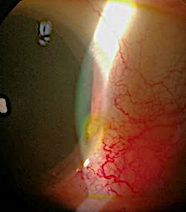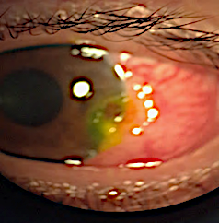

**Figure 1 : Scleral nodule**  **Figure 2 : Scleral vessel dilation**

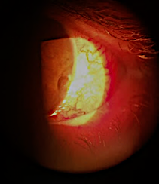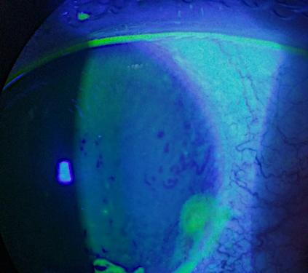

Figure 3 : fluorescéine - : Figure 4 : Effet Dellen

### **Initial Management and Evolution**

An infectious and immunological workup was initiated, and the patient was started on topical and systemic non-steroidal anti-inflammatory drugs (NSAIDs) for 15 days.

At the 7-day follow-up, symptoms remained unchanged. Infectious tests were negative, and immunological investigations were still ongoing. Given the stationary evolution, the patient was hospitalized, and high-dose intravenous corticosteroids (1 g Solumedrol for three days) were initiated, followed by oral steroids.

After 21 days, the nodule's size had doubled from 4 mm to 8 mm **(Figure 5),** with progressive corneal thinning.

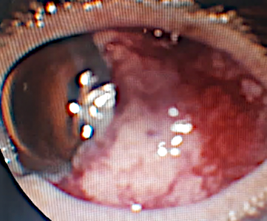

**Figure 5  : scleral nodule 8mm**

### **Systemic Findings and Confirmatory Diagnosis**

* **Multiple dorsal cutaneous nodules** were noted **(Figure 6).**
* **Respiratory symptoms** developed, with exertional dyspnea due to a moderate left pleural effusion and a 1 cm axillary lymph node (**Figure 7).**
* **A conjunctivo-scleral biopsy under local anesthesia** was performed, revealing secondary tumor cells from invasive ductal carcinoma.
* **Orbital MRI** **(Figure 8)** confirmed the lesion's extent.
* **Ocular B-scan ultrasonography and retinography** ruled out choroidal metastasis.
* **Whole-body imaging (CT TAP)** demonstrated multiple pulmonary metastases, a moderate pleural effusion, and an intra-auricular thrombus.

The final diagnosis was **scleral metastasis of breast cancer with multiple systemic metastases.** Oncologic management was initiated.

.

 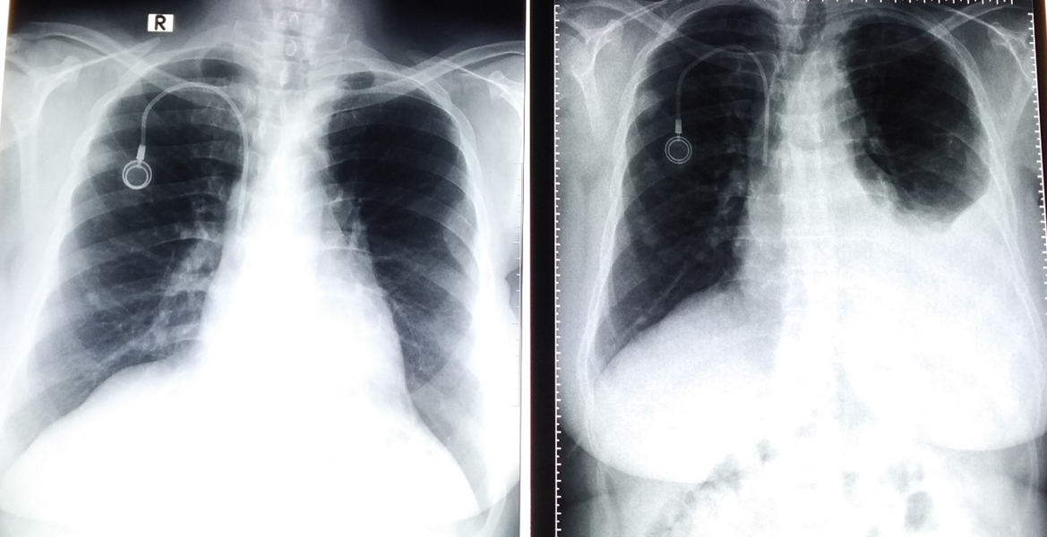

**Figure 6 : Multiple dorsal cutaneous nodules** **. Figure 7 :** left pleural effusion

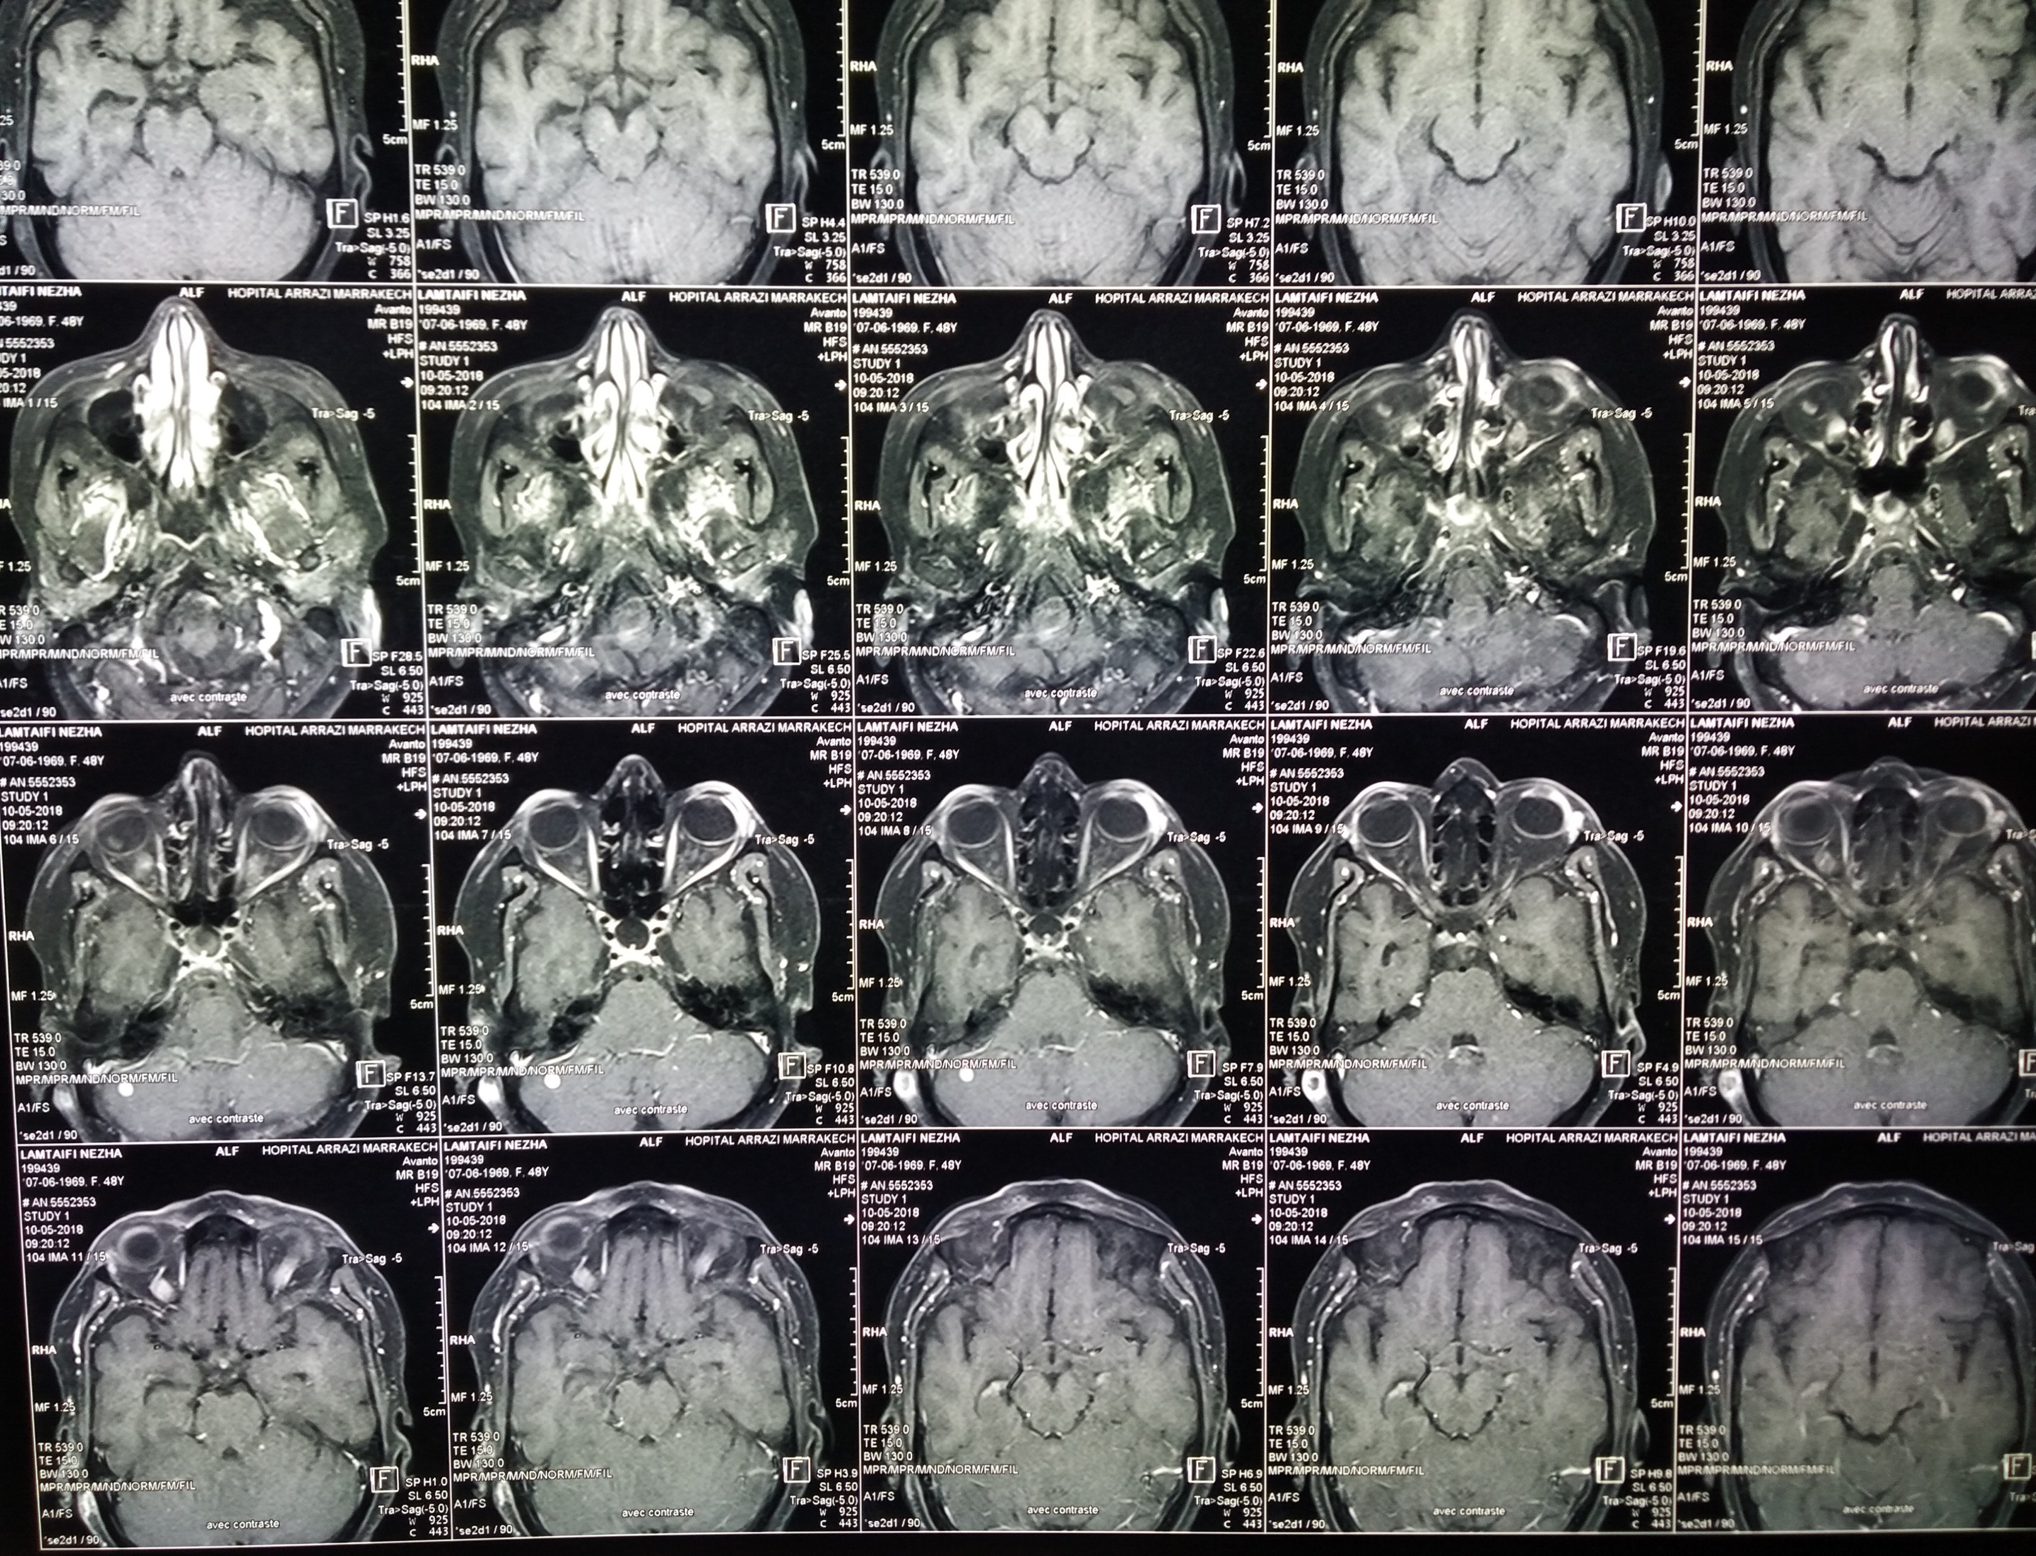

**Figure 8 : IRM oculo-orbito-cérebrale**

**Discussion :**

#### **Epidemiology and Rarity of Scleral Metastasis**

Ocular metastases are uncommon, with the choroid being the most frequently affected site due to its rich vascular supply. The sclera, being avascular and composed mainly of dense collagen, is an unusual site for metastatic spread, making scleral metastases exceptionally rare **(Togashi et al., 2021)**. According to recent studies, orbital and ocular metastases account for approximately **2-10%** of systemic cancer metastases, with breast carcinoma being the most common primary malignancy **(Dupuis et al., 2021)**. However, reported cases of direct scleral involvement remain extremely limited, with only a handful documented in the literature **(Razem & Slimani, 2021)**.

#### **Clinical Presentation and Diagnostic Challenges**

The clinical presentation of scleral metastases is often nonspecific, leading to frequent misdiagnoses. Symptoms can include:

* Persistent ocular redness and irritation
* Pain, often mimicking nodular anterior scleritis
* Visual disturbances, including decreased acuity if adjacent structures are affected
* Increased tear production (epiphora)
* Nodular scleral thickening with associated vascular congestion

Unlike primary inflammatory conditions, metastatic scleral nodules are often resistant to conventional corticosteroid therapy, a key diagnostic clue **(Shah & Lamichhane, 2017)**. In our patient, the lesion initially mimicked an idiopathic scleritis but failed to respond to anti-inflammatory treatment, prompting further investigation.

#### **Pathophysiology and Mechanisms of Scleral Metastasis**

Several mechanisms have been proposed to explain the development of scleral metastases:

1. **Hematogenous spread**: Breast carcinoma cells may disseminate via systemic circulation and lodge in the sclera through posterior ciliary arteries. However, given the sclera’s avascular nature, this remains a less likely pathway.
2. **Direct extension from orbital disease**: Some cases suggest that scleral involvement may arise from orbital metastases infiltrating adjacent structures **(Chudasama et al., 2020)**.
3. **Lymphatic dissemination**: While the eye has limited lymphatic drainage, periocular lymphatics may serve as a conduit for tumor spread **(Grajales-Alvarez et al., 2020)**.
4. **Hematogenous microembolization**: Tumor cells may reach the sclera through microvascular invasion of episcleral and conjunctival vessels **(Kim & Pearce, 2020)**.

The presence of multiple distant metastases, including pulmonary nodules and pleural effusion in our patient, suggests that scleral involvement was likely a result of widespread hematogenous dissemination.

#### **Diagnostic Approach and Role of Biopsy**

A key challenge in scleral metastasis is distinguishing it from inflammatory or infectious etiologies. The following investigations play a crucial role:

* **Slit-lamp biomicroscopy**: Identifies scleral thickening, vascular abnormalities, and associated corneal changes (e.g., Dellen effect).
* **Fundoscopy & Ultrasonography (B-mode)**: Essential to rule out choroidal involvement, as metastases frequently affect the choroid before other ocular structures.
* **Neosynephrine Test**: Helps differentiate inflammatory scleritis (which blanches with phenylephrine) from tumor-associated nodules (which do not).
* **Imaging (MRI, CT TAP)**: Provides insight into systemic disease extent, revealing additional metastatic foci, as seen in our case **(Salinas-Botrán et al., 2019)**.
* **Histopathological Confirmation**: A conjunctivo-scleral biopsy remains the gold standard for diagnosis. Immunohistochemical studies help confirm the primary tumor origin, particularly in cases where systemic history is unclear.

In our case, biopsy revealed secondary tumor cells consistent with invasive ductal carcinoma, reinforcing the need for an aggressive oncologic workup.

#### **Management Strategies and Prognostic Implications**

The treatment of scleral metastases primarily depends on the extent of systemic disease. Current strategies include:

* **Systemic chemotherapy & targeted therapy**: These remain the cornerstone of management, particularly for hormone receptor-positive breast cancer, which responds well to hormonal therapy such as Tamoxifen or aromatase inhibitors **(Blohmer et al., 2020)**.
* **Radiotherapy**: In selected cases, localized radiotherapy may be used for pain relief or tumor shrinkage. Frameless stereotactic radiosurgery has shown promising results in intraocular metastases **(Cárdenas et al., 2020)**.
* **Surgical interventions**: Enucleation is reserved for cases with severe pain, significant proptosis, or impending globe rupture **(Danek et al., 2019)**.
* **Intravitreal anti-VEGF therapy**: Although not standard for scleral metastases, it has been explored in cases with concurrent choroidal involvement to reduce tumor-induced vascular leakage **(Kızıloğlu et al., 2019)**.

Our patient’s rapid disease progression, despite corticosteroid therapy, necessitated urgent oncologic intervention. The presence of multiple systemic metastases significantly worsened her prognosis, emphasizing the need for early detection and intervention.

#### **Prognosis and Survival Considerations**

The prognosis of patients with scleral metastases remains poor, given that it typically signifies advanced systemic disease. The median survival following diagnosis of ocular metastases from breast cancer varies between **6 to 24 months**, depending on the extent of systemic involvement **(Shaikh et al., 2018)**. Early identification of ocular metastases can provide an opportunity for timely oncologic treatment, potentially improving quality of life and survival.

**Conclusion**

### Scleral metastasis remains an exceedingly rare manifestation of systemic malignancy, often misdiagnosed as inflammatory pathology. Given its nonspecific presentation and resistance to corticosteroid therapy, clinicians must maintain a high index of suspicion, particularly in patients with a known oncologic history. Early recognition, coupled with appropriate systemic workup, allows for timely oncologic intervention, potentially improving patient outcomes. Although uncommon, metastatic breast carcinoma to the eye may be underrecognized, and a thorough ocular examination should be an integral part of oncologic surveillance.

**COMPETING INTERESTS DISCLAIMER:**

Authors have declared that they have no known competing financial interests OR non-financial interests OR personal relationships that could have appeared to influence the work reported in this paper.

### **Références :**

* 1.Togashi K, Nishitsuka K, Hayashi S, et al. Metastatic orbital tumor from breast ductal carcinoma with neuroendocrine differentiation initially presenting as ocular symptoms: a case report and literature review. Front Endocrinol. 2021;2021:12. doi: 10.3389/fendo.2021.625663. [[DOI](https://doi.org/10.3389/fendo.2021.625663)] [[PMC free article](https://pmc.ncbi.nlm.nih.gov/articles/PMC7937957/)] [[PubMed](https://pubmed.ncbi.nlm.nih.gov/33692758/)] [[Google Scholar](https://scholar.google.com/scholar_lookup?journal=Front%20Endocrinol&title=Metastatic%20orbital%20tumor%20from%20breast%20ductal%20carcinoma%20with%20neuroendocrine%20differentiation%20initially%20presenting%20as%20ocular%20symptoms:%20a%20case%20report%20and%20literature%20review&author=K%20Togashi&author=K%20Nishitsuka&author=S%20Hayashi&volume=2021&publication_year=2021&pages=12&pmid=33692758&doi=10.3389/fendo.2021.625663&)]
* 2.Dupuis JEK, Marchand M, Javidi S, et al. Enophthalmos as the initial systemic finding of undiagnosed metastatic breast carcinoma. Int Med Case Rep J. 2021;14:25–31. doi: 10.2147/IMCRJ.S282113. [[DOI](https://doi.org/10.2147/IMCRJ.S282113)] [[PMC free article](https://pmc.ncbi.nlm.nih.gov/articles/PMC7850410/)] [[PubMed](https://pubmed.ncbi.nlm.nih.gov/33536796/)] [[Google Scholar](https://scholar.google.com/scholar_lookup?journal=Int%20Med%20Case%20Rep%20J&title=Enophthalmos%20as%20the%20initial%20systemic%20finding%20of%20undiagnosed%20metastatic%20breast%20carcinoma&author=JEK%20Dupuis&author=M%20Marchand&author=S%20Javidi&volume=14&publication_year=2021&pages=25-31&pmid=33536796&doi=10.2147/IMCRJ.S282113&)]
* 3.Razem B, Slimani F. An early orbital metastasis from breast cancer: a case report. Int J Surg Case Rep. 2021;78:300–302. doi: 10.1016/j.ijscr.2020.12.049. [[DOI](https://doi.org/10.1016/j.ijscr.2020.12.049)] [[PMC free article](https://pmc.ncbi.nlm.nih.gov/articles/PMC7777453/)] [[PubMed](https://pubmed.ncbi.nlm.nih.gov/33383286/)] [[Google Scholar](https://scholar.google.com/scholar_lookup?journal=Int%20J%20Surg%20Case%20Rep&title=An%20early%20orbital%20metastasis%20from%20breast%20cancer:%20a%20case%20report&author=B%20Razem&author=F%20Slimani&volume=78&publication_year=2021&pages=300-302&pmid=33383286&doi=10.1016/j.ijscr.2020.12.049&)]
* 4.Cárdenas JRV, Penella ADV, Ibarra EC. Frameless radiosurgery for intraocular metastatic tumor: case report. Rep Pract Oncol Radiother. 2020;25(1):1–5. doi: 10.1016/j.rpor.2019.10.001. [[DOI](https://doi.org/10.1016/j.rpor.2019.10.001)] [[PMC free article](https://pmc.ncbi.nlm.nih.gov/articles/PMC7000959/)] [[PubMed](https://pubmed.ncbi.nlm.nih.gov/32042271/)] [[Google Scholar](https://scholar.google.com/scholar_lookup?journal=Rep%20Pract%20Oncol%20Radiother&title=Frameless%20radiosurgery%20for%20intraocular%20metastatic%20tumor:%20case%20report&author=JRV%20C%C3%A1rdenas&author=ADV%20Penella&author=EC%20Ibarra&volume=25&issue=1&publication_year=2020&pages=1-5&pmid=32042271&doi=10.1016/j.rpor.2019.10.001&)]
* 5.Blohmer M, Zhu L, Atkinson JM, et al. Patient treatment and outcome after breast cancer orbital and periorbital metastases: a comprehensive case series including analysis of lobular versus ductal tumor histology. Breast Cancer Res. 2020;22(1):70. doi: 10.1186/s13058-020-01309-3. [[DOI](https://doi.org/10.1186/s13058-020-01309-3)] [[PMC free article](https://pmc.ncbi.nlm.nih.gov/articles/PMC7318761/)] [[PubMed](https://pubmed.ncbi.nlm.nih.gov/32586354/)] [[Google Scholar](https://scholar.google.com/scholar_lookup?journal=Breast%20Cancer%20Res&title=Patient%20treatment%20and%20outcome%20after%20breast%20cancer%20orbital%20and%20periorbital%20metastases:%20a%20comprehensive%20case%20series%20including%20analysis%20of%20lobular%20versus%20ductal%20tumor%20histology&author=M%20Blohmer&author=L%20Zhu&author=JM%20Atkinson&volume=22&issue=1&publication_year=2020&pages=70&pmid=32586354&doi=10.1186/s13058-020-01309-3&)]
* 6.Chudasama R, Hsu A, Constantinou M. Orbital metastasis in inflammatory breast cancer. Breast J. 2020;26(8):1629–1630. doi: 10.1111/tbj.13839. [[DOI](https://doi.org/10.1111/tbj.13839)] [[PubMed](https://pubmed.ncbi.nlm.nih.gov/32291824/)] [[Google Scholar](https://scholar.google.com/scholar_lookup?journal=Breast%20J&title=Orbital%20metastasis%20in%20inflammatory%20breast%20cancer&author=R%20Chudasama&author=A%20Hsu&author=M%20Constantinou&volume=26&issue=8&publication_year=2020&pages=1629-1630&pmid=32291824&doi=10.1111/tbj.13839&)]
* 7.Grajales-Alvarez R, Gutierrez-Mata A. Orbital metastases from breast cancer: a retrospective analysis of 28 cases. Cancer Treat Res Commun. 2020;24 doi: 10.1016/j.ctarc.2020.100184. [[DOI](https://doi.org/10.1016/j.ctarc.2020.100184)] [[PubMed](https://pubmed.ncbi.nlm.nih.gov/32575027/)] [[Google Scholar](https://scholar.google.com/scholar_lookup?journal=Cancer%20Treat%20Res%20Commun&title=Orbital%20metastases%20from%20breast%20cancer:%20a%20retrospective%20analysis%20of%2028%20cases&author=R%20Grajales-Alvarez&author=A%20Gutierrez-Mata&volume=24&publication_year=2020&pmid=32575027&doi=10.1016/j.ctarc.2020.100184&)]
* 8.Kim CU, Pearce WA. Metastatic breast carcinoma involving the optic disc. Am J Ophthalmol Case Rep. 2020;18 doi: 10.1016/j.ajoc.2020.100698. [[DOI](https://doi.org/10.1016/j.ajoc.2020.100698)] [[PMC free article](https://pmc.ncbi.nlm.nih.gov/articles/PMC7170934/)] [[PubMed](https://pubmed.ncbi.nlm.nih.gov/32322751/)] [[Google Scholar](https://scholar.google.com/scholar_lookup?journal=Am%20J%20Ophthalmol%20Case%20Rep&title=Metastatic%20breast%20carcinoma%20involving%20the%20optic%20disc&author=CU%20Kim&author=WA%20Pearce&volume=18&publication_year=2020&pmid=32322751&doi=10.1016/j.ajoc.2020.100698&)]
* 9.Salinas-Botrán A, Guarín-Corredor MJ. Orbital metastasis in breast cancer. N Engl J Med. 2019;381(12):e26. doi: 10.1056/NEJMicm1814570. [[DOI](https://doi.org/10.1056/NEJMicm1814570)] [[PubMed](https://pubmed.ncbi.nlm.nih.gov/31532964/)] [[Google Scholar](https://scholar.google.com/scholar_lookup?journal=N%20Engl%20J%20Med&title=Orbital%20metastasis%20in%20breast%20cancer&author=A%20Salinas-Botr%C3%A1n&author=MJ%20Guar%C3%ADn-Corredor&volume=381&issue=12&publication_year=2019&pages=e26&pmid=31532964&doi=10.1056/NEJMicm1814570&)]
* 10.Kızıloğlu ÖY, Türköz FP, et al. Breast carcinoma metastasis to the medial rectus muscle: case report. Turk J Ophthalmol. 2019;49(3):168–170. doi: 10.4274/tjo.galenos.2018.39018. [[DOI](https://doi.org/10.4274/tjo.galenos.2018.39018)] [[PMC free article](https://pmc.ncbi.nlm.nih.gov/articles/PMC6624466/)] [[PubMed](https://pubmed.ncbi.nlm.nih.gov/31245980/)] [[Google Scholar](https://scholar.google.com/scholar_lookup?journal=Turk%20J%20Ophthalmol&title=Breast%20carcinoma%20metastasis%20to%20the%20medial%20rectus%20muscle:%20case%20report&author=%C3%96Y%20K%C4%B1z%C4%B1lo%C4%9Flu&author=FP%20T%C3%BCrk%C3%B6z&volume=49&issue=3&publication_year=2019&pages=168-170&pmid=31245980&doi=10.4274/tjo.galenos.2018.39018&)]
* 11.Danek DJ, Blessing NW, Tse DT. Corneal perforation with uveal prolapse: an initial presentation of orbital metastatic breast cancer. Am J Ophthalmol Case Rep. 2019;16 doi: 10.1016/j.ajoc.2019.100551. [[DOI](https://doi.org/10.1016/j.ajoc.2019.100551)] [[PMC free article](https://pmc.ncbi.nlm.nih.gov/articles/PMC6804488/)] [[PubMed](https://pubmed.ncbi.nlm.nih.gov/31650080/)] [[Google Scholar](https://scholar.google.com/scholar_lookup?journal=Am%20J%20Ophthalmol%20Case%20Rep&title=Corneal%20perforation%20with%20uveal%20prolapse:%20an%20initial%20presentation%20of%20orbital%20metastatic%20breast%20cancer&author=DJ%20Danek&author=NW%20Blessing&author=DT%20Tse&volume=16&publication_year=2019&pmid=31650080&doi=10.1016/j.ajoc.2019.100551&)]
* 12.Aghdam KA, Zand A, Sanjari MS. Isolated unilateral infiltrative optic neuropathy in a patient with breast cancer. Turk J Ophthalmol. 2019;49(3):171–174. doi: 10.4274/tjo.galenos.2018.24478. [[DOI](https://doi.org/10.4274/tjo.galenos.2018.24478)] [[PMC free article](https://pmc.ncbi.nlm.nih.gov/articles/PMC6624459/)] [[PubMed](https://pubmed.ncbi.nlm.nih.gov/31245981/)] [[Google Scholar](https://scholar.google.com/scholar_lookup?journal=Turk%20J%20Ophthalmol&title=Isolated%20unilateral%20infiltrative%20optic%20neuropathy%20in%20a%20patient%20with%20breast%20cancer&author=KA%20Aghdam&author=A%20Zand&author=MS%20Sanjari&volume=49&issue=3&publication_year=2019&pages=171-174&pmid=31245981&doi=10.4274/tjo.galenos.2018.24478&)]
* 13.Shaikh R, Tariq K, Sharma S, et al. Metastatic breast cancer presenting as orbital mass: a case report with literature review. J Global Oncol. 2018;2018(4):1–4. doi: 10.1200/JGO.2017.009282.[[DOI](https://doi.org/10.1200/JGO.2017.009282)] [[PMC free article](https://pmc.ncbi.nlm.nih.gov/articles/PMC6180836/)] [[PubMed](https://pubmed.ncbi.nlm.nih.gov/30241170/)] [[Google Scholar](https://scholar.google.com/scholar_lookup?journal=J%20Global%20Oncol&title=Metastatic%20breast%20cancer%20presenting%20as%20orbital%20mass:%20a%20case%20report%20with%20literature%20review&author=R%20Shaikh&author=K%20Tariq&author=S%20Sharma&volume=2018&issue=4&publication_year=2018&pages=1-4&pmid=30241170&doi=10.1200/JGO.2017.009282&)]
* 14.Nifosí G, Zuccarello M. Unilateral localized extraocular muscle metastasis by lobular breast carcinoma. BMJ Case Rep. 2018;2018 doi: 10.1136/bcr-2018-224726. bcr-2018-224726. [[DOI](https://doi.org/10.1136/bcr-2018-224726)] [[PMC free article](https://pmc.ncbi.nlm.nih.gov/articles/PMC6194382/)] [[PubMed](https://pubmed.ncbi.nlm.nih.gov/30317191/)] [[Google Scholar](https://scholar.google.com/scholar_lookup?journal=BMJ%20Case%20Rep&title=Unilateral%20localized%20extraocular%20muscle%20metastasis%20by%20lobular%20breast%20carcinoma&author=G%20Nifos%C3%AD&author=M%20Zuccarello&volume=2018&publication_year=2018&pmid=30317191&doi=10.1136/bcr-2018-224726&)]
* 15.Shah RK, Lamichhane S. Ocular metastasis from breast carcinoma simulating anterior scleritis: a case report. J Med Case Rep. 2017;11(1):249. doi: 10.1186/s13256-017-1416-y. [[DOI](https://doi.org/10.1186/s13256-017-1416-y)] [[PMC free article](https://pmc.ncbi.nlm.nih.gov/articles/PMC5572158/)] [[PubMed](https://pubmed.ncbi.nlm.nih.gov/28844204/)] [[Google Scholar](https://scholar.google.com/scholar_lookup?journal=J%20Med%20Case%20Rep&title=Ocular%20metastasis%20from%20breast%20carcinoma%20simulating%20anterior%20scleritis:%20a%20case%20report&author=RK%20Shah&author=S%20Lamichhane&volume=11&issue=1&publication_year=2017&pages=249&pmid=28844204&doi=10.1186/s13256-017-1416-y&)]
* Yousef, Y. A., Mohammad, M., Khalil, H., Khouri, T., Alsweiti, R., Khzouz, J., ... & Abdel-Razeq, H. (2024). Ocular and Periocular Metastasis in Breast Cancer: Clinical Characteristics, Prognostic Factors and Treatment Outcome. *Cancers*, *16*(8), 1518.
* Mahmodlou, R., Asadi Amoli, F., Abbasi, A., Seyed Mokhtari, S. A., & Pourasghary, S. (2018). Case report: scleral metastasis of esophageal squamous cell carcinoma. *Ophthalmology and Therapy*, *7*, 185-189.
* Thariat, J., Boudin, L., Loria, O., Nguyen, A. M., Kodjikian, L., & Mathis, T. (2022). How to manage a patient with ocular metastases?. *Biomedicines*, *10*(12), 3044.