**AN ANALYSIS OF EMOTIONAL AND COGNITIVE ATTITUDES OF NON-ALIGNED STRAND STUDENTS IN CHOOSING ICT-BASED COLLEGE PROGRAMS**

**ABSTRACT**

This research was aimed at determining the emotional and cognitive attitudes of Senior High School (SHS) graduates from non-ICT strands (HUMSS, GAS and STEM) in their desire to take ICT-based college courses. In spite of the alignment that has been outlined by the Philippine K-12 curriculum, there is a visible shift of students from non-ICT strands to ICT fields indicating other influencing factors. Data was collected from 65 respondents using a validated survey questionnaire of emotional and cognitive attitudes using a descriptive-correlational research design. For the results analysis descriptive statistics and Pearson correlation were applied. It was found that students reported strong emotional attachments towards ICT, particularly with reference to passion for technology and curiosity, while cognitive factors such as perceived job opportunities, logical career growth, and industry relevance slightly affected the students. A fairly positive correlation (r = 0.72) was established between emotional and cognitive attitudes thus showing that students’ course decisions are influenced by affective and rational factors. At the end of the study, it is concluded that an integrated approach to career guidance, that recognizes emotional engagement and cognitive evaluation, is necessary in order to provide better support for students, going on to ICT programs.

**Keywords:** *emotional attitudes, cognitive attitudes, educational decision-making, ICT courses, non-ICT strands*

--------------------------------------------------------------------------------------------------------------

**INTRODUCTION**

Technology has been growing at a fast pace, changing societies across the world, altering the industries, lifestyles, and educational priorities (Castillo, 2021). In the Philippines, the courses in Information and Communications Technology (ICT) have become more appealing to students looking for potential career opportunities. Although the K-12 curriculum was designed so that SHS students will take up college courses corresponding to their respective strands, a large number of non-ICT strands’ students like HUMSS, GAS, and STEM end up pursuing ICT-related courses (Torres & Lontoc, 2022).

DepEd (2016) highlighted the need for proper strand alignment in order to maximize continuity of learning; However, in the selection of college courses, more is usually involved than academic readiness. Other emotional (passion for computers; fear of unemployment; peer influence) and cognitive (logical evaluation of the job markets; self-assessment of skills) factors influence students’ decisions (Garcia & Evangelista, 2020). Emotional attitudes are affective reactions that affect preferences, and cognitive attitudes are rational evaluation processes (Ajzen, 1991).

The decision-making behaviors of the Filipino students, especially the ones who are changing tracks, have been examined in a number of studies (Garcia & Evangelista, 2020; Torres & Lontoc, 2022), and not many have been conducted with a comparative approach concerning emotional and cognitive factors. In the time when digital transformation is the key concept in many industries, it is crucial to understand why students shift to ICT fields – even though they are not academically prepared for it – for educational planning and student support purposes.

Therefore, this study examines the emotional and cognitive influences on the non-aligned strand SHS students’ choice to join ICT-based college courses. Through this, it hopes to provide valuable insights on the ways of enhancing career guidance and curriculum interventions for future generations.

This research work is set out to achieve the following research questions:

1. What are the emotional factors that affect non-aligned strand students in selecting ICT-based college courses?

2. Which cognitive factors make the non-aligned strand students decide on ICT-based college programs?

3. Can emotional and cognitive attitudes be said to be significantly related to students’ course choices?

Education decision-making is a complicated process which depends on a variety of internal and external factors. Ajzen’s (1991) theory of planned behavior states that attitudes, subjective norms, and perceived behavioral control are the factors, which have an impact on people’s decisions, where attitudes are both emotional and cognitive. In educational institutions, affective judgments such as interest or fear will tend to be concomitant with cognitions about career prospects and future employment.

This dynamic has been featured by a number of Philippine studies. According to Garcia and Evangelista (2020), students in Senior High School are often faced with challenges while making career decisions because of conflicting emotional desires and rational thinking concerning job security. In the same way, Torres & Lontoc (2022) found that students from non-aligned strands tend to change courses by a combination of passion and reasoned analysis of industry trends.

International research supports these findings. Lent, Brown, and Hackett’s (1994) Social Cognitive Career Theory considers career interests and decisions to be a function of both personal feelings (affective factors) as well as objective appraisals of what to expect from an opportunity. Additionally, Savickas (2013) has pointed the role of career adaptability, which implies that students tend to be more influenced by emotional and cognitive adaptability (i.e. enthusiasm, anxiety, planning, decision-making, etc.).

In case of ICT programs, Castillo (2021) noted an emerging interest on the part of Filipino students who were actively fueled by passion for technology and the perceived global demand for ICT professionals. At the same time, De Guzman and Choi (2013) observed that the Filipino youth tend to make pragmatic course decisions based on the consideration of the labor market, which implies the strong cognitive element in the academic choice.

In addition, the Department of Education (2016) has continually emphasized the need to match Senior High School tracks with future studies and careers. However, the patterns of the real-world indicate that emotional reasons can win over this alignment, particularly when the students change their interests or feel better opportunities elsewhere.

Collectively, these studies indicate that it is important to comprehend the balance between emotional and cognitive attitudes, for effectively influencing the educational and career choice of students, even more so for students who join ICT fields without an ICT background.

**METHODOLOGY**

This research utilized a descriptive-correlational research design in the exploration of emotional and cognitive attitudes of non-aligned strand Senior High School graduates in their selection of ICT-based college programs. The design was appropriate for the study because it enabled the researcher to describe the attitudes of the respondents and investigate the potential connection between the emotional and cognitive factors that were determining the course choice of the respondents.

The respondents of the study were sixty-five (65) Senior High School graduates from HUMSS, GAS, and STEM strands who are all taking ICT-related college programs in selected higher education institutions in the Ilocos Norte. A purposive sampling method was applied in order to select only students from non-ICT strands. The participants were chosen from their strand in SHS and their current enrollment in ICT courses irrespective of their year levels. This choice made the data relevant to the objectives of the study.

The primary research tool used in the study was a survey questionnaire made by a researcher with three sections. Part I was made up of the demographic profile of the respondents, i.e. their age, sex, strand in Senior High School, and year level in college. Part II was related to emotional attitudes that included the statements on feeling of passion, anxiety, interest and personal motivation in the process of choosing ICT. Part III included items of cognitive attitudes including logical reasoning, perceived job opportunities, suitability of skills and knowledge of ICT industry.

All the items in Parts II and III were measured on a 5-point Likert scale from 1-Strongly Disagree to 5-Strongly Agree. The content validity for this instrument was established by having it reviewed and validated by three (3) experts in education and psychology.

The researcher obtained appropriate approval from institutional ethics committees and coordinators of the schools that were involved. After approval, the questionnaires were sent in both printed and online formats to the respondents based on their availability. The study was voluntary, and all the respondents signed an informed consent form prior to answering the questionnaire. The respondents were assured that all collected data would be handled under strict confidentiality and that it will only be used for academic purposes. Afterward, data collection, the responses were encoded, arranged and ready for statistical analysis.

To analyze the collected data, the researcher employed the use of descriptive statistics, which included frequency, percentage, mean and standard deviation in describing the emotional and cognitive attitude of the students. In order to find out the association between emotional and cognitive factors, Pearson’s correlation coefficient was applied.

**RESULTS AND DISCUSSION**

This section provides the descriptive statistical outcome of the emotional and cognitive attitudes of the non-aligned strand students on the selection of ICT-based college programs, and then the correlation analysis between the two.

**Emotional Attitudes of Respondents**

Table 1 shows the mean scores of students’ emotional attitudes. The top-rated emotional item was “I feel passionate about using computers and technology” with a mean score of 4.18, which is a strong intrinsic interest. This was then succeeded by “I was excited to explore ICT even if it was not part of my SHS strand” (M = 4.03). The mean score was lower for “I was influenced by my friends or classmates who were also taking ICT” (M = 3.02) and “I felt pressured by family to shift to ICT” (M = 2.65), which implies that external social factors had less influence compared to some internal motivations.

The results are in line with Garcia and Evangelista (2020), according to whom Filipino students are mostly motivated by personal interests and affective engagement to make their educational decisions.

*Table 1. Emotional Attitudes of Respondents*

|  |  |
| --- | --- |
| Emotional Item | Mean |
| I feel passionate about using computers and technology. | 4.18 |
| I was excited to explore ICT even if it was not part of my SHS strand. | 4.03 |
| I feel anxious about succeeding in other fields, so I chose ICT. | 3.35 |
| I chose ICT because I wanted to challenge myself emotionally. | 3.55 |
| I was influenced by my friends or classmates who were also taking ICT. | 3.02 |
| I chose ICT because I enjoy problem-solving through digital means. | 3.43 |
| I felt unmotivated in my original strand, and ICT gave me renewed interest. | 3.46 |
| My personal interest in video games or apps influenced me to take ICT. | 3.58 |
| I felt pressured by family to shift to ICT. | 2.65 |

**Cognitive Attitudes of Respondents**

Table 2 demonstrates the mean scores for cognitive factors affecting students’ course selection. The most agreed statement was “I selected ICT because it provides logical career growth opportunities.” (M = 3.83), followed by second position “I understand how ICT connects to global job markets.” (M = 3.82) and third position “I think ICT has more job opportunities than my initial SHS strands” (M = 3. These imply great amount of rational analysis by the students before choosing an ICT course.

These discoveries validate Castillo’s (2021) observation that students continue to evaluate global employability and career progression as critical factors regarding decision-making.

*Table 2. Cognitive Attitudes of Respondents*

|  |  |
| --- | --- |
| Cognitive Item | Mean |
| I selected ICT because it provides logical career growth opportunities. | 3.83 |
| I understand how ICT connects to global job markets. | 3.82 |
| I believe ICT offers more job opportunities than my original SHS strand. | 3.77 |
| I find ICT more relevant and practical compared to other college programs. | 3.74 |
| I chose ICT because I believe it offers higher salary potential. | 3.66 |
| I analyzed the employment trends before choosing ICT. | 3.66 |
| I chose ICT after researching future-proof careers. | 3.66 |
| I compared my skills to the demands of ICT-related courses. | 3.65 |
| I think ICT matches my logical and analytical thinking skills. | 3.63 |
| I feel more confident emotionally when dealing with tech-based subjects. | 3.55 |
| I assessed my academic performance and found ICT to be more suited to me. | 3.54 |

**Correlation Between Emotional and Cognitive Attitudes**

To understand the relationship that exists between the emotional and cognitive attitudes among the 65 respondents, Pearson correlation analysis was conducted. The result yielded high positive correlations, r = 0.72, which indicated that those students who are emotionally drawn to ICT are also likely to have important rational reasons to study the program. This means that affective involvement and logical determination are associated with students’ decision-making processes.

This finding upholds Theory of Planned Behavior by Ajzen (1991) and Social Cognitive Career Theory by Lent et al. (1994) which states that attitudes and rational evaluation go together to influence behavior and career choice.

*Figure 1. Cognitive Attitudes of Respondents*

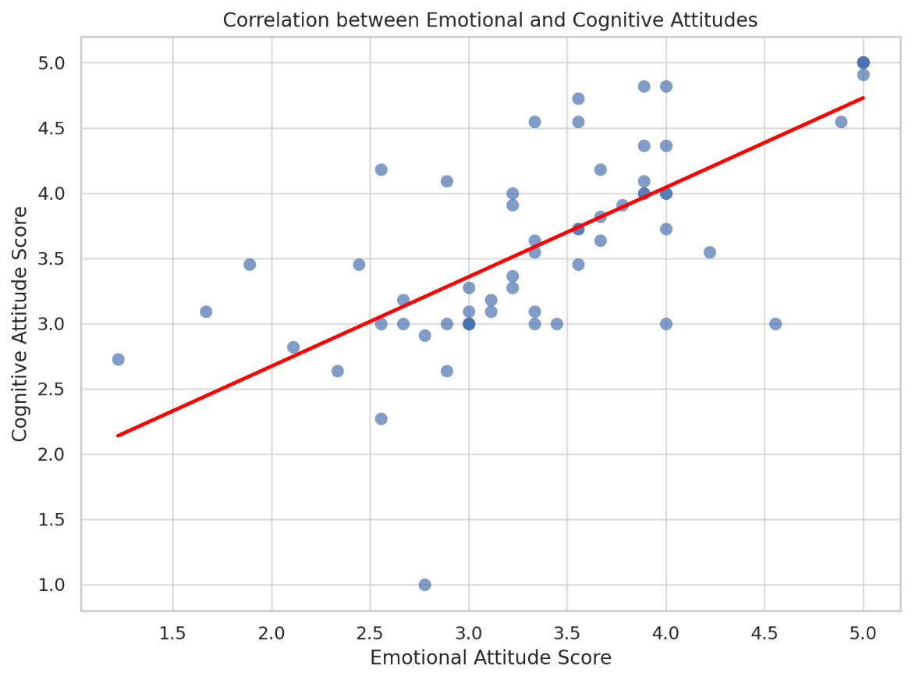

**CONCLUSION**

The subject of this study was an analysis of the emotional and cognitive attitudes of the non-aligned Senior High School (S H S) strand students in the selection of ICT-based college programs. It was found that both emotional and cognitive attitudes have a great impact on the students as decision-makers with slight differences in that the cognitive attitudes are a little bit preferred over the emotional ones. Under emotional factors, high passion in technology and excitement over ICT were prominent compared to external peer and family pressure. When it comes to cognitive reasoning, students answered job opportunities as the most motivating factors, followed by the global relevance and logical career growth.

The outcomes of the correlation analysis indicated moderate significant positive correlation (r = 0.72) between emotional and cognitive attitudes which implied that students who feel emotionally connected with ICT are also the ones who think critically on its long term effects. This affirms the fact that emotional engagement and critical appraisal go hand-in-hand to form educational decisions.

The course of these findings confirms the utility of incorporating both affective and cognitive support in both academic advising and curriculum planning, especially when it comes to students switching from non-ICT strands. It is also a testimony to the increasing attractiveness of ICT career choice among the youth in the Philippines regardless of the strand they were in originally.

**RECOMMENDATIONS**

Following the conclusion and findings of this study, several suggestions are given below.

1. Improve career guidance that is provided to students.

School career orientation regularly and uses data to discuss the importance of being prepared emotionally and by thinking rationally. They should give students the opportunity to match their interests with work they might be interested in.

1. Supply non-ICT students with Bridging Courses.

You could design and provide short programs or courses in ICT for students who chose a different strand to help them handle the technology used in ICT courses.

1. In SHS, support students in planning their careers reflectively.

School educators should help pupils learn about their interests, passions and future career prospects early on.

1. Include skills related to decision-making in the SHS curriculum.

When modules or activities focus on decision-making, evaluation of skills and planning for the future, students may choose academically balanced lessons.

1. Try to Find More Information

In future, researchers may conduct interviews or organize focus groups to learn more about how students decide on their courses. Scientists may study patients from additional regions to ensure their results can be used more widely.

**REFERENCES**

Ajzen, I. (1991). The theory of planned behavior. Organizational Behavior and Human Decision Processes, 50(2), 179–211. https://doi.org/10.1016/0749-5978(91)90020-T

Castillo, M. A. (2021). Student course preferences and the rise of ICT programs in higher education institutions. Philippine Journal of Education and Development, 10(1), 25–39.

De Guzman, A. B., & Choi, K. O. (2013). The Filipino youth's perspectives on career choice and decision-making. Asia Pacific Education Review, 14(4), 611–621.

Department of Education. (2016). Senior High School Career Guidance Program Manual. https://deped.gov.ph

Garcia, R. S., & Evangelista, M. A. (2020). Career decision-making difficulties among senior high school students in the Philippines: Implications for guidance programs. International Journal of Research in Counseling and Education, 4(2), 89–95. https://doi.org/10.24036/00291za0002

Lent, R. W., Brown, S. D., & Hackett, G. (1994). Toward a unifying social cognitive theory of career and academic interest, choice, and performance. Journal of Vocational Behavior, 45(1), 79–122.

Savickas, M. L. (2013). Career construction theory and practice. In S. D. Brown & R. W. Lent (Eds.), Career development and counseling: Putting theory and research to work (2nd ed., pp. 147–183). Wiley.

Torres, M. P., & Lontoc, J. R. (2022). Factors influencing course shifting among Senior High School graduates: A case study in Northern Luzon. Asia Pacific Journal of Multidisciplinary Research, 10(3), 15–24.