Probabilistic Rainfall Assessment and Climate-Resilient Crop Strategies for North Bihar's Zone II Wetlands

Abstract: This research investigates the long-term rainfall behaviour across Zone II of North Bihar by analysing historical data spanning a century. Employing probability distribution methods and regression modelling, the study explores the variability of rainfall across seasonal intervals winter, pre-monsoon, monsoon, and post-monsoon. The outcomes reveal significant inconsistencies in rainfall patterns, influencing water availability and agricultural planning. Based on these findings, season-specific adaptive cropping strategies are proposed for wetlands that remain non-submerged, aiming to improve agricultural resilience amid climatic uncertainties.
Keywords: Rainfall trends, probability analysis, adaptive cropping, Zone II, wetlands, seasonal rainfall, resilient agriculture.

- Introduction
The Zone II of North Bihar is characterized by wetlands that are temporarily free from prolonged inundation but remain sensitive to erratic rainfall and climatic stress. The region's agriculture is highly dependent on the monsoon, with frequent challenges from unpredictable weather conditions. Given the susceptibility of these wetlands to both excess rainfall and dry periods, it becomes essential to evaluate historical rainfall data to develop context-specific agricultural responses. This study focuses on understanding temporal rainfall dynamics in Zone II to inform more robust and resilient crop planning strategies tailored to its unique hydrological and agro-ecological conditions. “Competent drivers must plan how they can safely react to a variety of potential future behaviours of other agents before they make their next move. This requires contingency planning: explicitly planning a set of conditional actions that depend on the stochastic outcome of future events” (Rhinehart et al., 2021). Recognizing these vulnerabilities and complexities, the present investigation seeks to analyse century-scale rainfall variability and devise seasonally adaptive crop planning frameworks that enhance climate resilience in the temporally non-submerged wetlands of Zone II in North Bihar.

2. Materials and Methods

2.1 Study Area
The study focuses on Zone II of North Bihar, encompassing districts like Purnia, Katihar, Araria, Kishanganj, Supaul, Saharsa, Madhepura, and Khagaria. These areas are agriculturally rich but frequently affected by climate extremes such as flooding and unseasonal droughts. The region's wetlands, while largely non-submerged for most of the year, remain sensitive to rainfall anomalies, affecting sowing windows and crop choices fig 1.
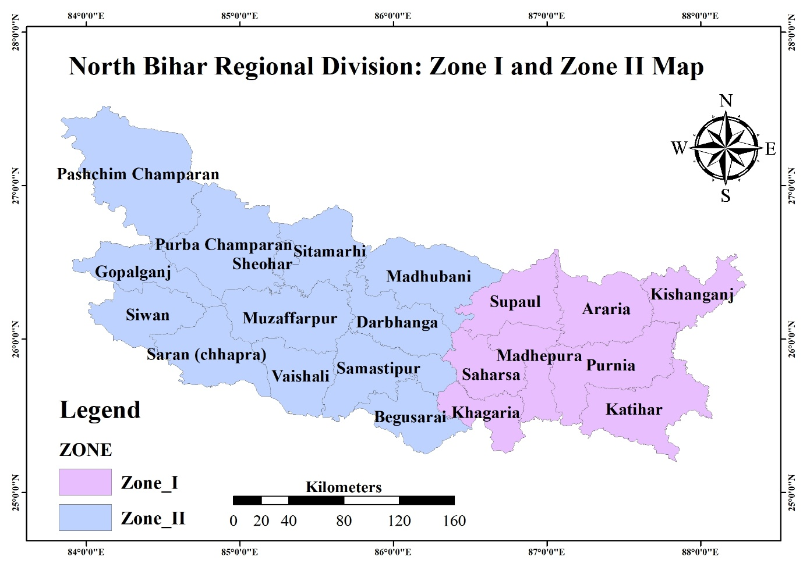
Fig 1. North Bihar Regional Division: Zone I and Zone II Map

2.2 Data Acquisition
Rainfall records from 1923 to 2022 were collected from regional meteorological sources. The dataset was organized into four seasonal categories:
- Winter (January–February)
- Pre-Monsoon (March–May)
- Monsoon (June–September)
- Post-Monsoon (October–December)
These categories helped isolate seasonal behaviours and trends for targeted analysis.

2.3 Analytical Techniques
- Probability Distribution (Weibull Method): Rainfall probabilities at 50%, 70%, and 90% levels were estimated, along with return periods to understand frequency and intensity of wet/dry spells. “Weibull distribution across many shapes and sample sizes, followed by the weighted Maximum Likelihood estimation method. If the shape parameter is known to be larger than 1, the Maximum Product of Spacing method is the most accurate whereas in the opposite case, the mixed method is to be preferred” (Cousineau et al., 2009)
- Trend Analysis (Regression Models): Seasonal and annual rainfall trends were analysed using linear regression, supported by R² values to evaluate trend strength. “Generally, logistic regression is well suited for describing and testing hypotheses about relationships between a categorical outcome variable and one or more categorical or continuous predictor variables. In the simplest case of linear regression for one continuous predictor X (a child’s reading score on a standardized test) and one dichotomous outcome variable Y (the child being recommended for remedial reading classes), the plot of such data results in two parallel lines each corresponding to a value of the dichotomous outcome” (Peng et al., 2002)
3. Results and Discussion
3.1 Rainfall Estimation Using Weibull's Method
The Table 1 shows the estimated rainfall values at different probabilities. Rainfall decreases with increasing probability levels, indicating higher chances of low rainfall events. Table 2 provides probable rainfall for selected return periods.
Table 1: Estimated rainfall at different probabilities
Target Probability | Estimated Rainfall (cm)
50% | 333.00
70% | 295.30
90% | 268.10
Table 2 probable rainfall for selected return periods.
Return Period (Years) | Probable Rainfall (mm)
25 | 414.425
75 | 603.535
100 | 698.09
This figure 2 demonstrates the rainfall trends in Zone II using Weibull’s probability distribution method. The analysis captures significant temporal rainfall variations, underlining the climatic instability in the region over the past century. It provides a scientific basis for assessing flood and drought vulnerability in Zone II. “Wind speed frequency distribution has been represented by various probability density functions such as gamma, lognormal, three parameter beta, Rayleigh and Weibull distributions. However in recent years Weibull distribution has been one of the most commonly used, accepted, recommended distribution to determine wind energy potential and it is also used as a reference distribution for commercial wind energy softwares such as Wind Atlas Analysis and Application Program (WAsP)” (Akdag et al., 2009).
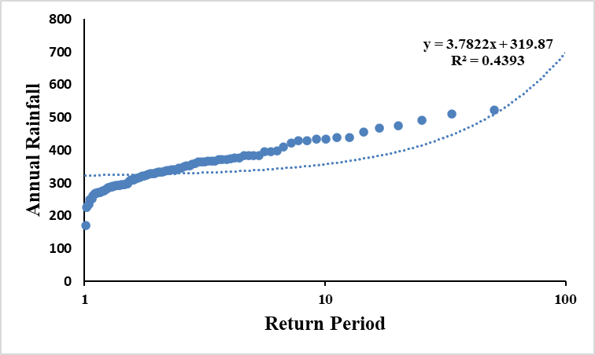
Figure 2. Weibull's Rainfall Analysis for 100 Years for Zone II
3.2 Regression Analysis of Rainfall Trends
These results reflect moderate variability in seasonal rainfall, with the pre-monsoon phase showing the most positive trend. Summary of regression equation with corresponding R2 value during 1923-2022 for Zone II was furnished in table 3. In” correlation analysis, the correlation coefficient “r” is a dimensionless number whose value ranges from −1 to +1. A value toward −1 indicates inverse or negative relationship, whereas towards +1 indicate a positive relation. When there is a normal distribution, the Pearson’s correlation is used, whereas, in nonnormally distributed data, Spearman’s rank correlation is used” (Kumari et al., 2018).
Table.3 Summary table of regression equation with corresponding R2 value during 1923-2022 for Zone II
Temporal Phases | Regression equation | R² | Trend
Winter | y = 95.35x10²-0.04x | 0.034 | Slight decrease
Pre-Monsoon | y = 2.73x10²+0.17x | 0.05 | Increasing
Monsoon | y = 7.52x10²-0.21x | 0.008 | Stable
Post-Monsoon | y = 4.72x10²-0.17x | 0.014 | Slight decrease
Annual Average | y = 2.62x10²-0.07x | 0.008 | Minimal change

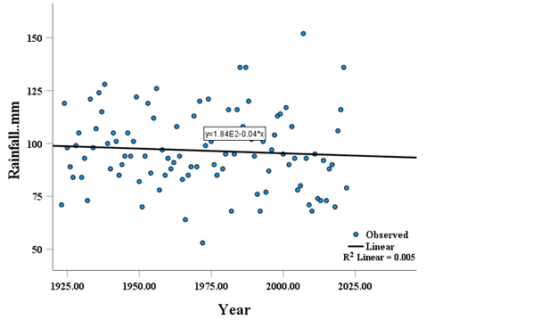
Figure 3: Regression Analysis Using Curve Estimation for Zone I (Annual Rainfall vs. Year)
This figure 3 the plot between Annual Rainfall vs Year of 100 years in Zone I represents the annual rainfall trends in Zone I over a century. The regression analysis reveals a slight decline in rainfall, with an R² value of 0.005, indicating minimal explanatory power of the trendline for the observed data. Despite the weak trend, this figure emphasizes the importance of understanding long-term rainfall variability in the region. “The computational cost of unnecessarily ﬁtting a complex model that includes spatial effects is negligible compared with the dangers of ignoring potentially important auto correlations in the errors and, because spatial and non-spatial methods are equivalent in the absence of spatial auto correlation in the errors, the precautionary principle suggests models which incorporate spatial autocorrelation should beﬁtted by default” (Beale et al., 2010)
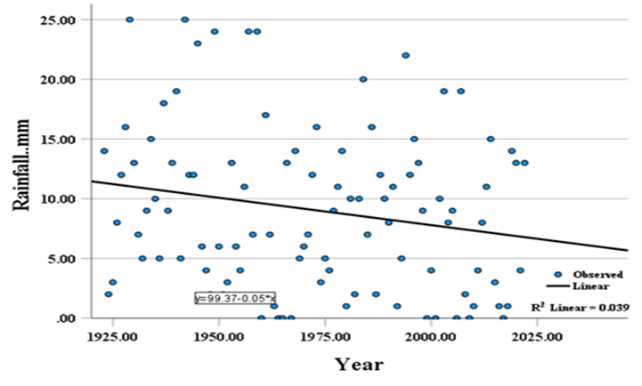
Figure 4: Winter Rainfall vs. Year for Zone I
This figure 4 the plot between Winter Rainfall vs Year of 100 years in Zone I plots winter rainfall against years for Zone I. The regression equation indicates a slight decrease in rainfall over time, with an R² value of 0.039, suggesting weak but noticeable changes in winter rainfall patterns. This has implications for rabi crop cultivation in North Bihar.
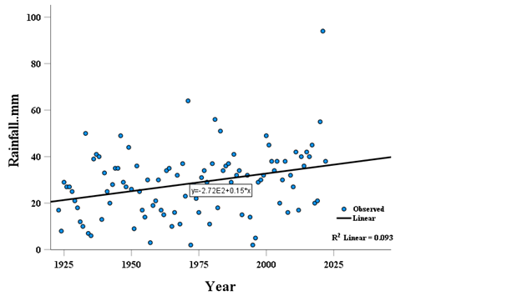
Figure 5. Pre-Monsoon Rainfall vs. Year for Zone I
This fig 5 shows the plot between Pre-Monsoon Rainfall vs Year of 100 years in Zone I shows pre-monsoon rainfall trends in Zone I over a century. The regression analysis highlights an increasing trend, with a higher R² value of 0.093, indicating some significance. The upward trend in pre-monsoon rainfall suggests changing climatic conditions that could influence kharif crop sowing periods.
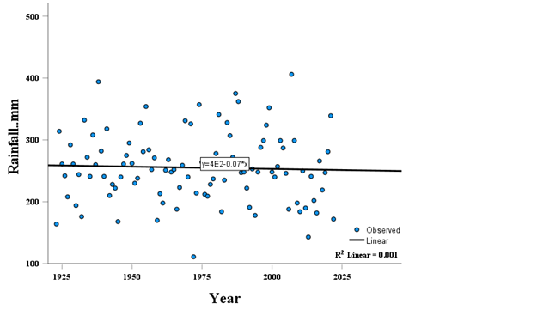
Figure 6. Monsoon Rainfall vs. Year for Zone I
This figure 6 shows the plot between Monsoon Rainfall vs Year of 100 years in Zone I captures monsoon rainfall variations in Zone I. The regression analysis reveals minimal change, with an R² value of 0.001, suggesting no significant trend. Monsoon rainfall remains a critical factor for agricultural productivity and flood occurrence in the region.
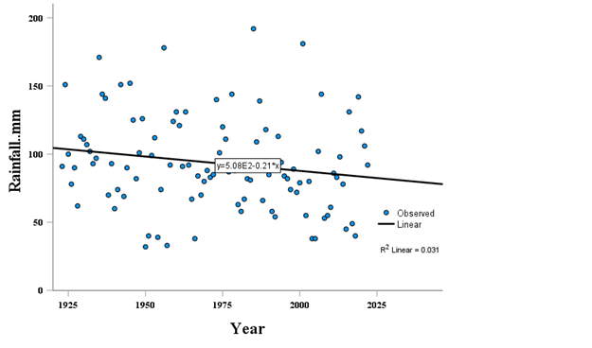
Figure 7 Post-Monsoon Rainfall vs. Year for Zone I
This figure 7 shows the plot between Post-Monsoon Rainfall vs Year of 100 years in Zone I illustrates post-monsoon rainfall trends for Zone I, with a regression analysis showing a slight decrease in rainfall and an R² value of 0.031. Post-monsoon rainfall impacts water availability and winter cropping systems.

3.2 Adaptive Crop Planning Strategies
Winter Season (Rabi Period):
- Encourage timely planting of cereals and oilseeds like wheat and mustard by utilizing conserved soil moisture.
- Promote conservation agriculture practices such as reduced tillage to minimize water loss.
- Facilitate access to supplementary irrigation via on-farm water storage systems or shallow bore wells.
- “Liquid fertilizers are best suited for fertigation however in India, inadequate availability and high cost of liquid fertilizers restricts their uses. Hence there is a need of selecting proper fertigation system for application of fertilizers with water. Venturi Injector, fertilizer injector pump and fertilizer tank are the available fertigation equipment in market among this venture is the most commonly used device for fertigation through drip irrigation because of its simplicity, ease in use and low cost.” (singh et al., 2018).
Pre-Monsoon Period:
- Support the cultivation of short-duration legumes such as mung bean and urad during early summer showers.
- Recommend moisture-preserving approaches including organic mulching and minimum soil disturbance.
- Integrate multi-purpose tree species along field boundaries to diversify income and improve microclimate.
Rainy Season (Kharif Period):
- Advocate for climate-resilient, fast-maturing rice cultivars that can escape late-season flooding.
- Design localized emergency crop response plans at the panchayat or block level.
- Integrate animal husbandry with cropping systems to spread climatic risk and stabilize farm income.
Post-Monsoon Period:
- Recommend pulses and oilseeds that can thrive on declining residual moisture during late autumn.
- Employ precision irrigation methods like drip or sprinklers to optimize limited water resources.
- Encourage sowing of green manure and legume-based cover crops to enhance soil organic matter and prevent erosion.

3.3 Resilience Measures for Flood-Impacted Regions
Site-Specific Interventions:
- Deploy submergence-tolerant rice varieties such as ‘Sahbhagi Dhan’ in areas with frequent inundation.
- Utilize elevated planting platforms or furrow-bed systems to reduce crop damage during waterlogging.
- After flood recession, recommend quick-sown direct-seeding options to restore cropping cycles rapidly.
- Establish decentralized, farmer-led seed reserves equipped with stress-adapted genetic materials.
- Upgrade canal systems, check dams, and farm-level irrigation networks to ensure water availability and drainage.
- Build capacity of farming communities through participatory training on adaptive agricultural techniques.
- Deliver timely agro-climatic advisories using ICT tools and community-based dissemination platforms.
4. Conclusion The analysis of historical rainfall data in Zone II of North Bihar reveals notable seasonal fluctuations and long-term variability, posing challenges to traditional agricultural practices in temporarily non-submerged wetland areas. By applying probabilistic methods and trend analysis, this study has identified critical insights into rainfall distribution patterns across different seasons. Based on these findings, targeted crop planning and adaptive strategies have been formulated to optimize water use, reduce climate-related risks, and improve farm productivity. These measures are intended to strengthen the region’s agricultural resilience and support sustainable livelihoods for farming communities under increasing climatic uncertainty.
References
Rhinehart, N., He, J., Packer, C., Wright, M. A., McAllister, R., Gonzalez, J. E., & Levine, S. (2021, May). Contingencies from observations: Tractable contingency planning with learned behavior models. In 2021 IEEE International Conference on Robotics and Automation (ICRA) (pp. 13663-13669). IEEE.

Cousineau, D. (2009). Fitting the three-parameter Weibull distribution: Review and evaluation of existing and new methods. IEEE Transactions on Dielectrics and Electrical Insulation, 16(1), 281-288.

Akdağ, S. A., & Dinler, A. (2009). A new method to estimate Weibull parameters for wind energy applications. Energy conversion and management, 50(7), 1761-1766.

Peng, C. Y. J., Lee, K. L., & Ingersoll, G. M. (2002). An introduction to logistic regression analysis and reporting. The journal of educational research, 96(1), 3-14.

Kumari, K., & Yadav, S. (2018). Linear regression analysis study. Journal of the practice of Cardiovascular Sciences, 4(1), 33-36.

Beale, C. M., Lennon, J. J., Yearsley, J. M., Brewer, M. J., & Elston, D. A. (2010). Regression analysis of spatial data. Ecology letters, 13(2), 246-264.

Singh, B. G., Babu, G. R., Kumar, K., Babu, R. G., & Edukondalu, L. (2018). Performance evaluation of different fertigation equipment and hydraulic performance of drip fertigation system. Andhra Agric. J, 65-658.

