Design and development of Maize sheller machine

Abstract
A maize shelling machine was designed and developed, which comprised frame, feeding channel, shelling cylinder and shaft along with helical ribs on cylinder. The three openings were made in the machine for entering the unshelled cobs, grain outlet and shelled cobs outlet. A concave clearance is placed upward for separating grains out of its cobs. The machine is operated by an electric prime mover, in conjunction with different belts and pullies of different sizes. The developed maize sheller was then evaluated by changing with varied rotational shelling speeds of 300, 400, 500 and 600 rpm and different concave clearance of 15, 20, 30 and 40 mm. The performance parameters like shelling rate (kg/h), shelling efficiency (%), unshelled grain (%), grain damage (%), power requirement (kW) and germination percentage (%) were calculated for each combination and data compared statistically for standardization of combination in order to get maximum whole grain output, minimum grain damage with high shelling efficiency. The shelling rate (kg/h), shelling efficiency (%) and grain damage (%) increased with increase in the shelling speed for all the treatment combinations under study. It was observed that the shelling rate increased with increase in the quantity of feed while as shelling efficiency and grain damage decreased with increase in the quantity of feed. The optimum performance obtained during the evaluation of the machine with grain damage of less than 0.81%, germination count of more than 95%, shelling rate of 218.30 kg/h and higher shelling efficiency (97.5%) was obtained at treatment combination of N₃C₃ (N₃ =500 rpm, C₃= 30 mm concave clearance).
Keywords: sheller, maize, moisture content, performance evaluation
Introduction
Maize is one of the most versatile and widely grown crops globally, with diverse uses ranging from food to industrial applications. In India, approximately 60% of maize production is allocated to animal feed, while 13% is utilized for human consumption (Mehta & Dias, 1999). The crop's high adaptability allows it to thrive in various climatic conditions, making it a critical food source for billions. Additionally, maize plays a significant role in the production of starch, syrup, and biofuels, further cementing its importance in the agricultural economy. Globally, maize production reaches approximately 1,147.7 million metric tons across 193.7 million hectares (FAOSTAT, 2020). The United States, China, and Brazil are the leading producers, while India ranks sixth in production. Karnataka is the largest maize-producing state in India, contributing significantly to the country's overall yield. The production growth in India has been remarkable, increasing from 1.73 million metric tons in 1950-51 to 35.9 million metric tons by 2018-19 (DACNET, 2020). Maize cultivation is predominantly rainfed, requiring warm temperatures and adequate rainfall for optimal growth. Proper land preparation, spacing, and maintenance practices are essential for achieving high yields. Harvesting involves ensuring the kernels are fully mature and dried to prevent spoilage. While mechanization has advanced in many farming processes, shelling remains largely manual, leading to inefficiencies and grain losses. Traditional shelling methods are labour-intensive and time-consuming, often resulting in damaged grains and reduced quality (CIMMYT., 2009).
Current shelling machinery is often heavy and expensive, making it less accessible for small and marginal farmers. Existing hand-operated maize shellers, while suitable for women farmers, are uncomfortable and yield low outputs. The predominant farming demographic in India consists of marginal and small farmers, who often rely on labour-intensive methods that expose harvested maize to environmental hazards. Thus, there is a pressing need for the development of efficient, cost-effective maize shelling machinery tailored to the capabilities and resources of small and marginal farmers (Anon., 2013).
The solution to overcome all these problems, there is need to development of small maize shelling machine. Large farmers can use tractor-driven equipment with a capacity of more than 2000 kg/h and engine-operated equipment with a capacity of 1000 to 1800 kg/h. Manually operated equipment has a capacity ranging around 150 kg/h, making it appropriate for marginal and small farms. Therefore, the development of a power-operated maize sheller with a capacity of 250 kg/h and improved shelling efficiency is urgently needed for marginal, medium and small farmers. Keeping the above factors in view, present study was undertaken on Development and performance evaluation of maize sheller for small and marginal farmers.
Materials and Methods
It involves determination of design values for maize sheller like (engg. Physical, aerodynamic and frictional Properties). The design for the maize sheller was finalized based on the following design values and further used for prototype development. Finanly the developed maize sheller was evaluated at College of Agricultural Engineering, Bangalore.

Engineering Properties of Maize
The present investigation focuses on the shelling of maize grains. To adapt to local conditions, we studied four maize varieties: MAH-14-138, Hema hybrid, MAH-14-5, and JP-2007. The study examined the physical, aerodynamic, and frictional properties of the cobs, grains, and husks of these varieties. This foundational information is crucial for the development of effective equipment.
For this study, 20 random samples from each of the selected four varieties were taken. Various linear measurements of the maize cobs, grains, and husks were taken using a digital Vernier calliper, while weights were recorded using a weighing balance with an accuracy of 0.01 mm and 0.01 g, respectively. The measurements are illustrated in Fig. 1.
Physical Properties of the Maize
Linear measurements were used to assess various physical properties of maize, including roundness, geometric mean diameter, and surface area, which were important for determining the dimensions of different machine components. Additionally, bulk density, test weight, and the grain-to-straw ratio were measured according to standard procedures
Aerodynamic Property
The most critical aerodynamic property in agricultural products is terminal velocity, which is vital for the design of air-conveying systems, separation, and cleaning equipment. In this study, terminal velocity was measured using a mechanically controlled air stream column. Samples of maize grains and husk were dropped from the top into the air stream, which was supplied by an air pump at the other end. The air velocity in the column was recorded using a digital anemometer with a minimum resolution of 0.1 m/s. The air velocity required to suspend the sample in the column was identified as the terminal velocity of the material. Additionally, the Material Other Than Grain (MOG) that entered the separation and cleaning unit after passing through the threshing drum was included in the study (Sahay and Singh, 1994).
Frictional Properties
Frictional properties, such as the angle of repose and coefficient of friction, are important for designing hoppers, pneumatic conveying systems. To measure the angle of repose, a rectangular box filled with grains was placed horizontally, allowing the grains to flow onto a horizontal circular disc below. The flow was halted once the grains formed a complete heap on the disc. The coefficient of friction was then utilized to establish the angle at which hoppers, collecting trays, and chutes should be positioned to ensure a consistent flow of materials (Sahay and Singh, 1994).
Design and Development of Power Operated Maize Sheller
Shelling Cylinder
Principle of working: The developed prototype is powered by a 3 hp single-phase motor. Power from the motor is transmitted to the shelling shaft via a belt and pulley system. The shelling space in the machine is defined by a concave arrangement paired with a lever mechanism that includes a set of seven levers operated by a spring system. During operation, maize cobs are fed into the shelling cylinder through a feeding hopper. Inside the shelling chamber, the maize cobs experience a combination of impact and tangential forces generated by the shelling helix welded to the cylinder shaft, facilitating the shelling process. The shelled maize grains exit the cylinder through a bottom opening, and a grain collecting tray directs the grains into a suitable container. The process was conducted at various RPMs and concave clearances to identify the optimal combination that maximized the output and productivity of the prototype.
Cylinder Design
In developing the power-operated maize sheller (MS), the goal was to create equipment suitable for small, marginal, and medium farmers, with a capacity ranging from 200 to 800 kg/h. The diameter, length, and peripheral velocity of the threshing cylinder were key factors influencing the threshing capacity. Therefore, the length of the cylinder (l_{c}) for the axial flow maize sheller was calculated using (Singh, 2010 and Klenin et al., 1985) established relations, as represented by the following equation (Eq. 1).
$q=q_{0} l M$
where q = Desired feed rate to be assumed for developing maize sheller, kg s⁻¹; q₀ = Permissible feed rate as per standard recommendations by = 0.0216 kg s⁻¹ m⁻¹ for cereals; l_{c} = Length of cylinder, m; M = Number of helical (for cereals M = 10–15) (Klenin et al., 1985).
The feed rate (q) was taken as 0.167 kg s⁻¹ for feeding cobs continuously to machine. Permissible feed rate (q0) was taken as 0.0216 kg s⁻¹ m⁻¹ length of the cylinder. Number of helical (M) for making cylinder was taken as 13, as the recommended values for the cereal threshers were 10 -15 (Klenin et al., 1985).
Thus, the cylinder length (1) was calculated by,
$$l=\frac{q}{q_{0} M}=\frac{0.167}{0.0216×13}=0.59 m$$
The total length of cylinder was kept as 600 mm, this is slightly more than the designed length of 590 mm to get more retention time for maize cobs inside the cylinder and concave which in turn help for completely shelling of cobs before they reach to main outlet of the machine.
The cylinder consists of helix on its peripheral surface. Number of helical on cylinder of axial flow system was taken as 13 for providing sufficient impediment and space to avoid carrying of un-shelled maize cobs to periphery of shelling cylinder, which in turn helps in reducing total power requirement for shelling. The schematic view of cylinder with helical ribs were shown in fig 1.
The diameter of cylinder was kept 90 mm to achieve the designed peripheral tip speed of cylinder in this prototype.
Total Mass of shelling cylinder
The mass of shelling cylinder was calculated using the following equation (Mogaji, 2016):
M_{cs}= ρ × 𝑉_{𝑐𝑠}
Where,
ρ = Density of high carbon steel grade, 7.8× 10⁻⁶ kg.mm⁻³,
v_{cs} = volume of cylinder shaft, mm³
v_{cs} = cross sectional area × thickness
v_{cs} = π × D × L ×T
v_{cs} = 3.14×0.09×6×0.002
v_{cs} = 0.00339 m³
M_{cs}= 7840×0.00339 = 26.55 kg
mass of two hub plates
The mass of two hubs were calculated using the following equation;
M_{ths}= ρ × 𝑉_{ths}
𝑉_{ths} = 2×π×r²×t
𝑉_{ths} = 2×3.14× (0.045)²×0.002
𝑉_{ths} = 0.000025
M_{ths}=0.000025×7840= 0.1994 kg
The total mass of shelling cylinder is
M_{tcs} = M_{cs}+M_{ths}
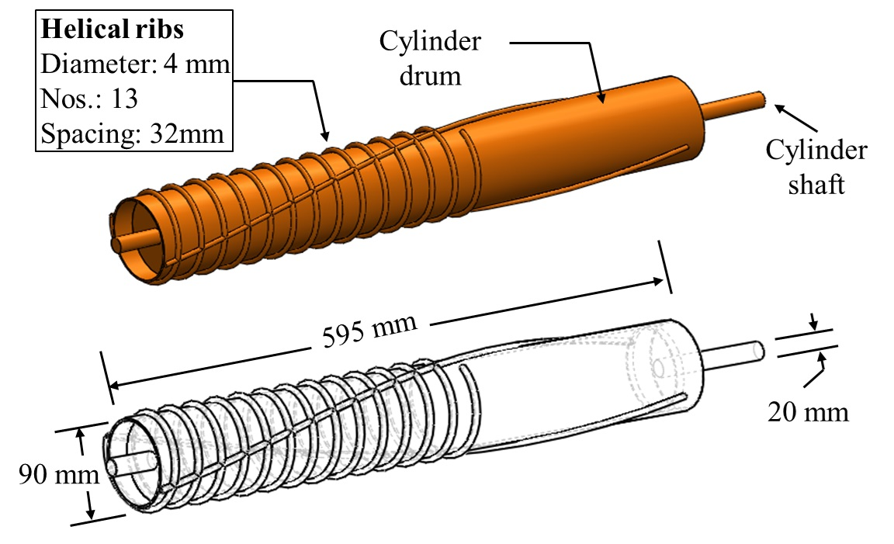
26.55+0.1994=26.7 kg

Fig 1 Isometric view of the shelling cylinder

Concave assembly
Concave is the component which provides space for shelling of maize and is located at the top of the cylinder. It consists a single MS sheet (quarter circular) attached to the main frame in the hopper section. The MS sheet (20 mm width, 550 mm length and 6 mm thick) is fixed in the main frame using nut and bolts. This concave arrangement is paired with lever mechanism, which include a set of 7 levels operated with the help of a spring system. This assembly enables the user to adjust the clearance between the cylinder and concave as per requirement. The concave clearances were decided based on the diameter of the shelled cob.

Hopper assembly
The ‘throw-in’ type feeding hopper was selected to feed cobs by gravity flow. The hopper height from the ground level was 700 mm. The hopper had trapezoidal opening (Top: 400 (l) × 385 (w) ×130 (h) mm and bottom 400 (l) × 220 (w) × 40 (h) mm) was provided with parallel to cylinder axis. The complete assembly was attached to the main frame using bots. The schematic view of the hopper assembly is shown in Fig. 2.
Feeding chute volume
The volume of feeding chute was calculated using the following equation (Mogaji, 2016)
$V_{h}=\frac{V_{ct}-V_{cb}}{2}+V_{cb}$
Where,
V_{h}= volume of feeding chute, m³,
V_{ct}= volume of feeding chute top and its length and breadth, m³ and
V_{cb =} volume of feeding chute bottom and length and breadth, m³
V_{ct} = 400 ×385×130 = 0.0202 m³
V_{cb} = 400×220×40 = 0.00352 m³
$V_{h}$ $=\frac{0.020-0.0035 }{2}+0.00352$
V_{h} = 0.0117 m³
Then the capacity of the hopper can be calculated as,
Capacity, kg = Density × Volume = 720 × 0.0117 = 8.42 kg

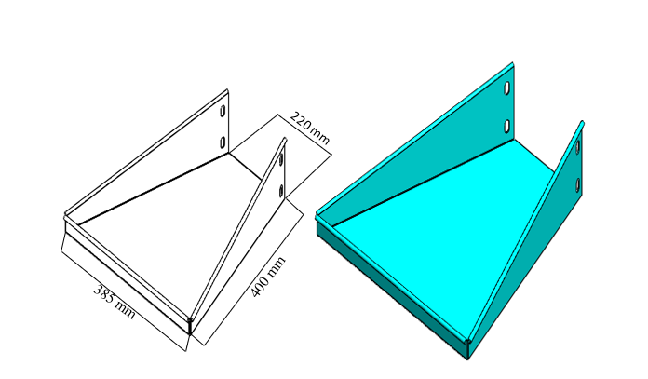
Fig 2. Schematic view of the feed channel assembly
Grain outlet
The grain collecting tray was developed based on the frictional properties of the grains with grains and MS sheet. A downward inclined plate was fitted in the bottom-end side, perpendicular to the axis of the cylinder, which collected the shelled grains directly from the cylinder. The plate conveys the grains to an open rectangular unit (220 mm width x 60 mm height x 180 mm length), which was mounted at an angle of 35° from ground surface. The grain outlet isometric view is shown in Fig. 3.
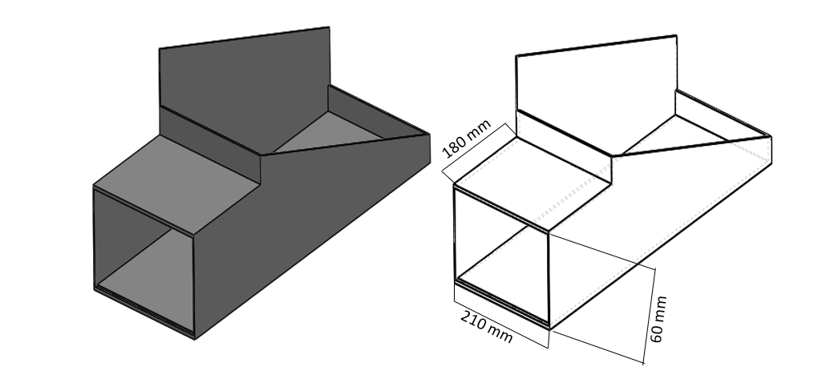Fig 3. Schematic view of the grain outlet

Main frame
A rectangle shaped frame was fabricated of 670 mm x 270 mm x 690 mm. Same size of MS angle iron was welded across all the members of frame to make it as rigid frame which supported all the parts such as cylinder, lever etc.,

Pulley
The diameter of pulley was calculated by the following formula (Murgesan and Tajuddin, 1997):
N₁ × D₁ = N₂ × D₂
where,
N₁ = speed of motor pulley 750 (rpm)
N₂ = speed of motor shaft 300 (rpm)
D₁ = diameter of motor pulley 40 (mm)
D₂ = diameter of rotor pulley (mm)
For motor pulley speed of 750 rpm, shaft diameter of 40 mm, and rotor shaft speed of 300 rpm, the calculated value of the diameter of pulley shaft was 100 mm. accordingly a value of 100mm was considered

Power requirement
Torque was calculated using the following equation
T = m×g×r
Where
T = torque, Nm,
M = mass of shelling cylinder, (23.4 kg)
g = acceleration due to gravity, (9.81 m/s), and
r= radial distance of shelling cylinder shaft, (0.12 m)
T= 23.4×9.81×0.12
T= 27.55 Nm
Power requirement was calculated using the following equation (khurmi, 2005)
$$p=\frac{2πNT}{60}$$

where
N = speed of shaft (750 rpm)
T = torque (27.55 kg.m), and
P = power, kW.

Thus, power requirement was
P = $\frac{2π× 750× 27.55}{60}$
P = 2164 W
P = 2.164 kW

Power transmission system
Length of belt
For present design an open drive was considered as the two parallel shafts was required to rotate in same direction
The length of the belts was calculated by the formula:
$Belt size (cm)=\frac{2c+\frac{π}{2}×\left(d_{1}+d_{2}\right)+{\left(d_{1}+d_{2}\right)}^{2}}{4c}$
L= 2 ×250 +$\frac{π(100+40)}{2}$+$\frac{{(100-40)}^{2}}{4c}$
L = 723.54 mm
A standard belt of length 720 mm was selected for power transmission from motor to shelling cylinder
where
d1 = diameter of large size pulley (cm)
d2 = diameter of smaller pulley (cm)
C = distance between the centres of two pulley (cm)

Performance Evaluation of Maize Sheller
Performance evaluation of designed power operated maize sheller was carried out at Agricultural Research Station, UAS, Bangalore with commonly grown variety maize variety (CP-818) in accordance with procedure and guidelines prescribed by the standard code IS: 7051–1973 and IS: 6284–1985 for cereals. In Pre-test observations, the moisture content and grain to straw ratio were observed as 11.25% and 3.75. multimeter was used for test at no-load and load to know the power consumption of MS. During the test at load, the machine-performance evaluated at different levels of independent operational parameters viz. Cylinder Speed (N, rpm) (N1 = 300, N2 = 400, N3 = 500, N4 = 600) and Concave Clearance (C, mm) (C1 = 15, C2 = 20, C3 = 30, C4 = 40) were selected. The optimization study shows that machine performance at cylinder speed of 500 rpm with concave clearance of 30 mm . The data study was done by asymmetric factorial experiment with completely randomized design was used for statistical analysis with Design Expert package licenced to UAS, bangalore. The standardising data with non-dominated numerical optimization technique. As per IS standard, each trial of 25 kg sample fed and output samples collected for 60 s form all outlets separately. The total grain input per unit time (G_{in}) were calculated by summing clean grains, broken grains and unthreshed grains collected over per unit time from all outlets. Shelling Efficiency (SE) is alternative to fraction of unthreshed grain [i.e. 100 - (% of unthreshed grains)]. The unthreshed grain percentage is the ratio of unthreshed grains per unit time from all outlets to G_{in}. Total losses were the sum of the percentage of broken grains and unthreshed grains. Where, broken grain percentage is the ratio of the quantity of broken grain from all outlets per unit time to Gin . The multimeter used to determine the power consumption at idle and load condition of MS for particular F for unit time to determine the Input capacity per kW-h(Ci). The Ci calculated by relation (Eq. 16) shown below.
$$Ci=\frac{Amount of material fed; kg}{ Time taken for feeding,h × Average wattmeter reading, kW}$$

Germination percentage of seeds was determined by the standard germination test using Paper towel method as prescribed by International Seed Testing Association (ISTA). The total germination counts (on the fourth day and seventh day for I and II counts) were made on normal healthy seedlings from a sample of fifty seeds in three replications and germination percentage was calculated by the ratio of number of grains were germinated at the end of II count to total number of seeds used in test. For safe storage of seeds and proper germination, the protection of embryo is important by intact seed-coat. Therefore seed-coat damage identified by standard ferric chloride test. In this method, 20% of ferric chloride solution (20 g of FeCl3 in 100 ml distilled water) was prepared in 250 ml beaker and 100 seeds were soaked for 15 min in beaker. The seeds were observed in electronic microscope and images were acquired using Leica Application Suit, (Version 2.1.0 (Build 97) made by Leica Microsystems, Switzerland). The brown/- dark coloured crack lines/patches over seed-coat were identified as mechanically damaged (since they can’t be used as seeding purpose and not capable for longer storage) and the fraction of coloured to total seeds used in test were represented as Seed-coat damage percentage (Dc)

Results and Discussion
Engineering Properties Used for Design MS
The oval flattened shape of maize grains was observed for all the varieties and other aspects of measurements were shown in table 1. The maize properties’ average (avg.) and standard deviation (SD) values were drawn at moisture content of 12.5% (w.b.) prior to experiment. The average length of the shelled maize cob was 148.50 mm and having deviation of 15.43 mm, which helpful to decide minimum width of cob-outlet as well as helical spacing over threshing cylinder. Similarly, difference in minimum and maximum diameter of cob without grains was observed as (27.25 - 22.59) 4.66 mm with maximum SD of ± 2.86 mm. This is key factor for keeping the optimal CC towards cob-outlet, this must be more than the minimum diameter of cob without grains. Number of grains in line and number of lines was counted which were having average of 37 and 16 numbers, respectively. Among the four varieties, the number of grains in one line of cob was maximum in Hema variety (38 numbers) while it was minimum [33 numbers] in MAH-14-138. The averaged three orthogonal dimensions viz. length, width and thickness of grains were found as 10.87, 8.47 and 4.05 mm with deviation of 0.82, 0.76 and 0.75 mm, respectively, which helps in deciding the sieve hole diameter and axial variable CC for threshing operation. The weight of un-dehusked cob was found maximum (308.42 g) in Hema variety, while it was minimum (210.34 g) in JP-2007. Which, helps in deciding load on hopper. The Table 2,3, and 4 shows that, physical, aero dynamical and frictional properties of maize. The roundness of maize grain varied from 0.26 to 0.34 for MAH-14-5 and Hema variety of the maize, this is measure for flow characteristics of grains in concave and over sieve.
The maximum angle of repose for maize grains was found in Hema variety (23.96) and was minimum in MAH-14-138 variety 19.30. The maximum coefficient of friction of maize grain on MS sheet was found in Hema variety (0.48) and the minimum coefficient of friction was recorded in MAH-14-138 (0.28) with a deviation of 0.02. In the present design, 35 angle selected for tray to separating seeds from MOG.

Table 1 Parameters and properties of maize variety selected for the study

Particulars |  | Average values of varieties |  |  |  | Mean
Name of the varieties |  | MAH-14-138 | Hema variety | MAH-14-5 | JP- 2007 | Mean
Linear dimensions of maize grains | l mm | 10.56 | 11.36 | 11.25 | 10.33 | 10.87
Linear dimensions of maize grains | b mm | 8.47 | 7.32 | 8.29 | 8.18 | 8.06
Linear dimensions of maize grains | t mm | 4.15 | 4.29 | 4.03 | 3.76 | 4.05
No. of grain lines in cobs |  | 16.00 | 15.02 | 15.52 | 16.32 | 15.71
No. of grains in one line of cob |  | 33.00 | 38.20 | 38.00 | 37.44 | 36.66
Min. diameter of cob without grains, mm |  | 22.04 | 23.92 | 21.56 | 22.87 | 22.59
Max. diameter of cob without grains, mm |  | 25.43 | 26.72 | 28.56 | 28.32 | 27.25
Avg. length of shelled cob, mm |  | 150.32 | 150.42 | 138.32 | 154.96 | 148.50

Table 2 Physical properties of the maize grains

Properties | Average values of varieties |  |  |  | Mean
Properties | MAH-14-138 | Hema variety | MAH-14-5 | JP- 2007 | Mean
Roundness | 0.28 | 0.34 | 0.26 | 0.30 | 0.29
Arithmetic mean diameter, mm | 7.72 | 7.65 | 7.85 | 7.42 | 7.66
Geometric mean diameter, mm | 7.17 | 7.09 | 7.20 | 6.81 | 7.06
Sphericity | 0.67 | 0.62 | 0.64 | 0.65 | 0.64
Surface area, mm² | 161.4 | 157.84 | 162.77 | 145.62 | 156.8
Bulk density, g/ cm3 | 0.78 | 0.78 | 0.79 | 0.78 | 0.78
True density, g/ cm3 | 1.3 | 1.24 | 1.26 | 1.28 | 1.27
Test weight, g | 252.38 | 308.42 | 232.52 | 210.34 | 250.91
Grain straw ratio | 3.67 | 2.92 | 2.98 | 3.45 | 3.25

Table 3 Aerodynamic properties of the grains and husk of maize cob
Property |  | Average values of varieties |  |  |  | Mean
 |  | MAH-14-138 | Hema variety | MAH-14-5 | JP- 2007 | Mean
Terminal velocity,  m/s | Grain | 14.78 | 15.23 | 15.34 | 15.59 | 15.23

Table 4 Frictional properties of maize grain

Properties |  | Average values for different varieties |  |  |  | Mean
 |  | MAH-14-138 | Hema variety | MAH-14-5 | JP- 2007 | Mean
Angle of repose, degree |  | 19.30 | 23.96 | 22.7 | 23.52 | 22.37
Coefficient of friction of grains with | Grains | 0.35 | 0.34 | 0.33 | 0.36 | 0.34
Coefficient of friction of grains with | MS sheet | 0.28 | 0.48 | 0.32 | 0.33 | 0.35

Development of maize sheller
The maize sheller was developed based on the above determined design values and material availability at GKVK, Bengaluru. The detailed specifications of the developed maize sheller are given in Table 5.
Table 5. Detailed specifications of the developed maize shellers

Sl. no | Component | Values
1 | Feeding Feed channel (l×w×h), mm | 400×385×130
2 | Shelling cylinder (d×l), mm | 90×595
3 | Frame (l×w×h), mm | 664×269×690
4 | Rotar shaft (d×l), mm | 20×710
5 | Electric motor (hp, speed) | 3, 1440
6 | Pulley (d), mm | 60, 100, 172.8, 216 and 288
7 | Belt (d), mm | 720
8 | Outlet, (l×b), mm | 210×60

Performance of Developed MS
The power operated MS operated at 500 rpm cylinder speed at concave clearance of 30 mm with feeding maize cobs at rate of 240 kg/h. The different machine and seed quality performance results shown in Table 6. The shelling efficiencies were found above 98% with high germination percentage of 98% with seed coat damage of 3.03%. The performance aspects are in agreement with other threshers as reviewed in [34]. The total production cost comprises the cost involved in raw materials (MS angles, MS flat, MS square rod, MS flywheel, Pedestal bearing, Nut and bolts, Shaft, Pulley, V-belts, Sieve, Electric motor, Paint, Welding rods etc.), electricity and man-power was found to be Rs. 12200. The payback period (Investment/net annual return = Rs. 12200/Rs. 19457) for the developed MS was found to be 0.62 year by considering six years of life time.

Table 6 The performance aspects of maize sheller and economic aspect
Machine performance aspects
Shelling rate | 218.30
Shelling efficiency | 97.5
Total losses | 3.63
Seed quality performance aspects
Broken grains | 0.81
germination | 98
Seed coat damage | 3.03
Cost economics
Initial cost of machine | 12200
Cost of operation for hiring | 5 per quintals
Payback period | 0.62 years

Conclusions
The developed maize sheller for producing quality seeds was satisfied for desired capacity to suit small and medium farmers in Southern Transition Zone of Karnataka as per objectives. The conclusions drawn over findings of the study are shown below.
1. The engineering properties; physical, frictional and terminal velocity of ear-head and grain were essential for design of threshing system. The study of maize seeds, MOG were used in deciding hopper, concave, cob outlet dimensions, collecting/conveying units and sieve configurations.
2. For producing good quality grains for seeding purpose, the special care was taken in design of shelling cylinder by welding rods in form of helical hub on cylinder found satisfactory for seeding.
3. The machine-performance parameters of MS; shelling efficiency were found greater than 98%. The total loss of 3.03%.
4. The seed-quality parameters of MS; broken grains of 1.05%, germination percentage of 98 and 3.03% of seed-coat damage were observed.
5. The initial cost of the MS was Rs. 12200 and the annual cost of operation was recorded as Rs. 13,080 with payback period of 0.62 year (with life time of 6 years)

References
Anonymous, 2013a, India maize summit-2013: Multidimensional approach for outlook, implications & perspective, Mar 21-22, FICCI, New Delhi, India. www.ficci.com/events-page.asp?evid=21371.
IS: 6284-1985, Test code for power thresher for cereals (Second revision), Indian Standard Institution, Manak Bhavan, 9 Bahadur Shah Zafar Marg, New Delhi- 110001, pp. 1-28.
IS: 7051-1973, Specification for maize sheller. Indian Standard Institution, Manak Bhavan, 9 Bahadur Shah Zafar Marg, New Delhi 110001, pp. 1-7.
KHURMI, R. S. AND GUPTA, J. K., 2005, Machine design. Eurasia Publishing House (Pvt.) Ltd. Ramanagar, New Delhi-110 055, India.
KLENIN, N. I., POPOV, I. F. AND SAKUN, V. A., 1985, Agricultural machines. Amerind Publishing Co. Pvt. Ltd. New Delhi, India.
MEHTA, D.C. AND DIAS, F.F., 1999. Maize: Perspectives and applications in India. Starch‐Stärke, 51(2‐3), pp.52-57.
MOGAJI, P.B., 2016. Design and fabrication of an improved maize shelling machine. African journal of science, Technology, Innovation and development, 8(3), pp.275-280.
MURUGESAN, R. AND TAJUDDIN, A., 1997. Design and development of feeding unit to power groundnut stripper for operators' safety.
SAHAY, K. M. AND SINGH, K. K., 1994, Unit operations of agricultural processing. Vikas Publishing House Private, Limited, Noida, Uttar Pradesh-201 301, India.
SINGH S. P., 2010, Ergonomical interventions in developing hand operated maize dehusker-sheller for farm women. Ph. D. (Ag. Engg.) Thesis, Maharana Pratap University of Agriculture and Technology, Udaipur, Rajasthan.

