"Socio-Economic and Impact Assessment of Edible Oilseed Crops (Soybean and Groundnut) in Sagar District of Madhya Pradesh"

ABSTRACT
The study investigates the socio-economic dynamics of soybean and groundnut cultivation in the Sagar District of Madhya Pradesh for the agricultural year 2023-24. The primary objective is to analyse the economic status and socio-economic factors influencing farming practices among different farm size categories (marginal, small, medium, and large). The data was collected from 300 randomly selected farmers across 10 villages in two blocks (Khurai and Khimlasa), with a multistage sampling technique used to ensure a diverse representation. Findings revealed that the majority (55%) of farmers belong to the marginal category, with the highest annual income reported by large farmers. Income generation was found to be 40% from farm-based activities and 60% from non-farm sources. The study also highlighted significant socio-economic factors influencing farming participation, such as family size, gender, age, educational status, tenure status, and occupation, with chi-square tests confirming these variables as statistically significant (p-value < 0.05). The results emphasize the important role of socio-economic characteristics in shaping the livelihoods of oilseed farmers and provide valuable insights for policy interventions aimed at improving agricultural productivity and supporting farmers’ economic well-being.
Keywords- socio-economic, significant, marginal, livelihoods, influencing.
1.Introduction
Edible oilseeds occupy a pivotal role in the global agricultural system, serving as indispensable sources of oils that are widely utilized in culinary, food processing, and diverse industrial sectors. Among the numerous oilseed crops, soybean (Glycine max) and groundnut (Arachis hypogea) emerge as two of the most economically influential, celebrated not only for their substantial oil content but also for their exceptional nutritional profile. Soybean, a leguminous plant indigenous to East Asia, has become a staple crop globally, renowned for its high oil yield and its dual utility as a potent source of protein, essential fatty acids, and numerous industrial derivatives. Groundnut, or peanut, is a versatile crop predominantly cultivated in tropical and subtropical climates, providing a vital source of edible oil, protein, and energy, thereby contributing significantly to food security and agricultural economies worldwide.
In recent decades, the global cultivation of these oilseeds has seen marked expansion, driven by their economic viability and the burgeoning global demand for vegetable oils, which are central to both food and biofuel industries. The increasing focus on sustainable agricultural practices, coupled with the urgency to address the nutritional needs of a rapidly expanding global population, has stimulated significant research and innovation aimed at optimizing the yield, oil content, and overall quality of these crops. As pivotal components of the agricultural economy, both soybean and groundnut play an essential role in supporting the livelihoods of millions of farmers, while also providing the raw materials required for the burgeoning oil extraction industries that fuel global markets.
This paper endeavours to delve into the multifaceted characteristics, cultivation methodologies, and economic significance of soybean and groundnut, examining their agronomic attributes, oil composition, and the complex challenges encountered in their production. By exploring the potential avenues for enhancing cultivation techniques and optimizing the utilization of these oilseeds, this study aims to illuminate strategies that can bolster their productivity and contribute to meeting the ever-evolving demands of the global edible oil market.
1.1 Research Objective
- To study socio-economic profile of oilseed crop growers in different size of farm groups in study area.
2. RESEARCH METHODOLOGY
2.1 Sampling Design
Samples were selected by using a multi-stage sampling technique for the selection of districts, blocks, villages, (respondents). Groundnut and soybean growers.
2.2 Selection of the Study Area
Madhya Pradesh, a major agricultural state in central India, was selected for this study due to its significant contribution to the country’s oilseed production, particularly soybean & groundnut. Within the state, Sagar district was purposively chosen for its high concentration of oilseed farmers and its economic relevance. From the district's eleven blocks, Khimlasa and Khurai were selected based on the even distribution of soybean & groundnut growers across different farm sizes. A total of 10 villages—Dhanora, Nardha, Ghorat, Talapar, Tewra, Bhugawli, Basari, Halau, Madana, and Pathariya—were randomly selected from these blocks, representing 5% of the total villages, to serve as the sample area for the study.
2.3 Data Collection
Primary data for this study was collected from 300 randomly selected soybean farmers in the Sagar district of Madhya Pradesh during the agricultural years 2023–2024. Data was gathered through structured personal interviews aimed at addressing the specific objectives of the research. The information collected included cropping patterns, land utilization, area under soybean cultivation, production levels, and post-harvest losses. Supplementary data and regional agricultural statistics were obtained from the Madhya Pradesh Agriculture Department and the District Statistical Department to support and validate the primary findings.
District | Blocks | Villages | Marginal | Small | Medium | Large | Total
Sagar | Khurai | Dhanora | 11(10) | 8(8.60) | 6(9.3) | 3(9.0) | 28(9.3)
Sagar | Khurai | Nardha | 9(8.1) | 7(7.5) | 5(7.8) | 4(12.12) | 25(8.3)
Sagar | Khurai | Ghorat | 13(11.81) | 12(12.9) | 8(12.5) | 2(6.06) | 35(11.6)
Sagar | Khurai | Talapar | 12(10.90) | 10(10.75) | 6(9.3) | 5(15.15) | 33(11)
Sagar | Khurai | Tewra | 10(9.0) | 9(9.96) | 7(10.9) | 3(9.0) | 29(9.6)
Sagar | Khimlasa | Bhugawali | 13(11.81) | 11(11.82) | 8(12.5) | 3(9.0) | 35(11.6)
Sagar | Khimlasa | Basari | 10(9.0) | 9(9.6) | 7(10.9) | 2(6.06) | 28(9.3)
Sagar | Khimlasa | Halau | 9(8.18) | 8(8.6) | 6(9.3) | 3(9.0) | 26(8.6)
Sagar | Khimlasa | Madana | 11(10) | 9(9.6) | 5(7.8) | 4(12.12) | 29(9.6)
Sagar | Khimlasa | Pathariya | 12(10.90) | 10(10.75) | 6(9.3) | 4(12.12) | 32(10.6)
Total no of farmers in different categories |  |  | 110(100) | 93(100) | 64(100) | 33(100) | 300(100)
Table 1. Allocation of Respondents from different villages.
I have selected these 300 farmers from a total of 2960 farmers across all the villages.
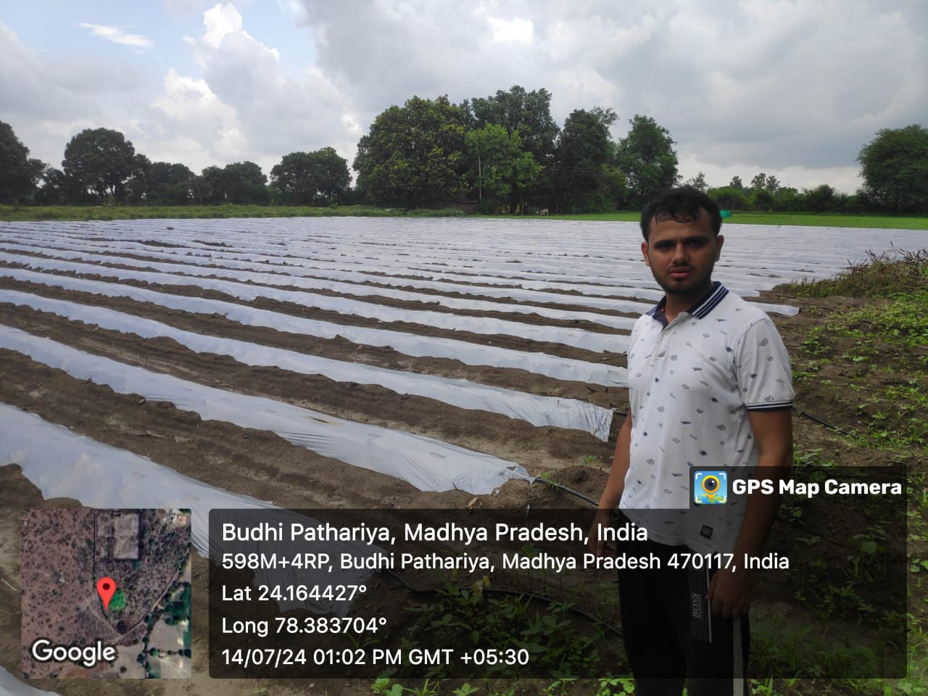Data collection from respondents' fields of soybean and groundnut was carried out during the study as shown in the photographs.

3. Analytical Tools used
The following mathematical and statistical tools have been employed in the Research work to analyse the various aspects of the study in order to fulfil the objective:
  - Chi – square Test:
Chi – Square test of independence is used to analyse and determine inter-reliability of two variables.
$$χ^{2}=∑ \frac{{(O_{i}- E_{i })}^{2}}{E_{i }}$$
Here,
O_{i} = Observed Value
E_{i} = Expected Value
χ² = Chi – squared value

  - Percentage:
$$P= \frac{X}{Y}*100$$
Here,
P = Percentage value
X = number of farmers falling into the specific category to be measured
Y = Total number of farmers

  - Arithmetic Mean:
$$X= \frac{Σ X_{i}}{N}$$
Here,
X = arithmetic mean
Σ X_{i} = Sum of observations
N = total number of observations

4. RESULTS & DISCUSSION
Table 2. Overall representation of socio-economic factors:
Sl. No. | Socio-Economic factors | Category of farmers |  |  |  | Total | Chi-square value (χ²) | p-value | Decision
Sl. No. | Socio-Economic factors | Marginal | Small | Medium | Large
1. | Family Size: |  |  |  |  |  | 3.27 | 0.0077 | Significant
1. | < 6 | 62 | 54 | 35 | 15 | 166 | 3.27 | 0.0077 | Significant
1. | 6 – 8 | 38 | 27 | 21 | 12 | 98 | 3.27 | 0.0077 | Significant
1. | > 8 | 10 | 12 | 8 | 6 | 36 | 3.27 | 0.0077 | Significant
2. | Gender: |  |  |  |  |  | 11.65 | 0.0086 | Significant
2. | Male | 70 | 68 | 46 | 31 | 215 | 11.65 | 0.0086 | Significant
2. | Female | 40 | 25 | 18 | 2 | 85 | 11.65 | 0.0086 | Significant
3. | Age: |  |  |  |  |  | 11.33 | 0.0076 | Significant
3. | < 30 years | 32 | 28 | 17 | 1 | 78 | 11.33 | 0.0076 | Significant
3. | 30 – 50 years | 55 | 46 | 34 | 25 | 160 | 11.33 | 0.0076 | Significant
3. | > 50 years | 23 | 19 | 13 | 7 | 62 | 11.33 | 0.0076 | Significant
4. | Tenure status: |  |  |  |  |  | 10.27 | 0.0016 | Significant
4. | Owner-cum-tenant | 86 | 70 | 53 | 33 | 242 | 10.27 | 0.0016 | Significant
4. | Pure tenant | 24 | 23 | 11 | 0 | 58 | 10.27 | 0.0016 | Significant
5. | Educational status: |  |  |  |  |  | 68.15 | 0.0071 | Significant
5. | Illiterate | 53 | 51 | 24 | 5 | 133 | 68.15 | 0.0071 | Significant
5. | Primary & Middle School | 49 | 37 | 31 | 12 | 129 | 68.15 | 0.0071 | Significant
5. | Matriculation | 8 | 4 | 6 | 7 | 25 | 68.15 | 0.0071 | Significant
5. | Higher Secondary | 0 | 1 | 2 | 8 | 11 | 68.15 | 0.0071 | Significant
5. | Graduation | 0 | 0 | 1 | 1 | 2 | 68.15 | 0.0071 | Significant
6. | Occupation: |  |  |  |  |  | 24.94 | 0.0030 | Significant
6. | Only farming | 60 | 56 | 24 | 7 | 147 | 24.94 | 0.0030 | Significant
6. | Both farming/ off-farm | 34 | 19 | 28 | 20 | 101 | 24.94 | 0.0030 | Significant
6. | Owner | 16 | 18 | 12 | 6 | 52 | 24.94 | 0.0030 | Significant
(α = 0.05)
When the p-value from a chi-square test is less than 0.05, it means the results are statistically significant, and we reject the null hypothesis (H₀), which assumes no relationship between the variables. Instead, we accept the alternative hypothesis (H₁), suggesting there is a real association. In my case, since all p-values are below 0.05, it shows that factors like gender, family size, education, tenure, and occupation are meaningfully linked to farming participation, and these results are unlikely to be due to random chance.
4.1Possession of livestock:
Livestock plays an important role among the farming population in our country, serving as both a source of food and a means of livelihood. Cows and buffaloes are kept for milk, poultry birds for eggs, and goats for milk and meat. As shown in Table 4.9, marginal farmers own the most livestock, with over 550 animals and an average of 5 animals per farmer, followed by small farmers with 493 animals, medium farmers with 276, and large farmers with 207. Among all types of livestock, poultry is the most commonly owned, followed by cows, buffaloes, and goats being the least.
Table 3 Possession of livestock
 | Marginal  (n=110) | Small  (n=93) | Medium  (n=64) | Large  (n=33)
Cow | 155 | 134 | 75 | 62
Buffalo | 125 | 112 | 52 | 54
Goat | 90 | 83 | 47 | 15
Poultry | 180 | 164 | 102 | 76
TOTAL: | 550 | 493 | 276 | 207
MEAN: | 5 | 5.30 | 4.31 | 6.27
[Total Respondents – 300]
Source: Primary probe
- Graphical Representation:

Fig. 1 : Livestock possession
4.2.Agricultural equipment possessions:
Implements are essential for timely agricultural work. As seen in Table 4.10, medium and large farmers mostly own farmhouses, tractors, and harvesters. All farmers, regardless of their category, own livestock and therefore have cattle sheds and bullock carts. Basic agricultural tools like harrows, levellers, pump sets, threshers, and sprayers are available to all. On average, marginal farmers own 5.44 pieces of equipment, small farmers 8.84, medium farmers 12.97, and large farmers 17.30. Overall, medium and large farmers have the most agricultural equipment.
Table 4 Agricultural equipment possessions:
Agri. Equipment possessions: | Marginal  (n=110) | Small  (n=93) | Medium  (n=64) | Large  (n=33)
Farm house | 0 | 0 | 35 | 52
Cattle shed | 130 | 112 | 62 | 30
Bullock cart | 95 | 93 | 31 | 25
Wooden/Iron plough | 110 | 108 | 162 | 72
Harrows | 52 | 93 | 65 | 40
Hoes | 0 | 93 | 64 | 33
Leveller | 98 | 98 | 74 | 98
Pump sets | 22 | 74 | 79 | 45
Thresher | 24 | 82 | 67 | 24
Sprayer | 67 | 69 | 72 | 67
Tractor | 0 | 0 | 55 | 37
Harvester | 0 | 0 | 64 | 48
Total equipment’s: | 598 | 822 | 830 | 571
Avg. equipment possession: | 5.44 | 8.84 | 12.97 | 17.30
Source: Primary probe
4.3 Size of farms:
It can be seen from table 4.11 that the average cultivated area for marginal farmers is 0.82 ha, for small farmers 2.09 ha, for medium 6.13 ha and for large farmers it is 12.52 ha. Net area cultivated under soyabean is 705 ha of which marginal farmers (46 ha), small farmers (112 ha), medium farmers (257 ha) and large farmers (290 ha.). Similarly, net area cultivated under groundnut is 252 ha of which marginal farmers (22 ha), small farmers (54 ha), medium farmers (87 ha) and large farmers (89 ha). About 64.74 % and 23.14 % of total cultivated area is occupied by soybean and groundnut respectively.

Table 5 Size of farms:
Size of farms: | Marginal | Small | Medium | Large | TOTAL
No. of selected farms | 110 | 93 | 64 | 33 | 300
Total cultivated area (ha) | 90 | 194 | 392 | 413 | 1089
Avg. cultivated area (ha) | 0.82 | 2.09 | 6.13 | 12.52 | 3.63
Area cultivated under soybean (ha) | 46 | 112 | 257 | 290 | 705
% of total cultivated area | 51.11 | 57.73 | 65.56 | 70.22 | 64.74
Avg. area under soybean (ha) | 0.42 | 1.20 | 4.02 | 8.79 | 2.35
Area cultivated under groundnut (ha) | 22 | 54 | 87 | 89 | 252
% of total cultivated area | 24.44 | 27.84 | 22.19 | 21.55 | 23.14
Avg. area under groundnut (ha) | 0.20 | 0.58 | 1.36 | 2.70 | 0.84
Source: Primary probe
4.4 Cropping pattern of farmers:
The cropping pattern across three seasons is shown in Table 4.12. Major Kharif crops include soybean, maize, arhar, moong, urad, sorghum, millet, and groundnut, while main Rabi crops are wheat, gram, peas, lentil, and mustard, along with some bitter gourd and fodder crops. The total cropped area is 1089 ha, with marginal farmers covering 90 ha, small farmers 194 ha, medium farmers 392 ha, and large farmers 413 ha. Most farming activity happens in the Kharif season, followed by the Rabi season. Soybean and groundnut are the most important crops, grown on 705 ha and 252 ha respectively.
Table 6 Cropping pattern of farmers
Cropping pattern:  (Area in ha) | Marginal | Small | Medium | Large
Kharif:
Soybean | 46 | 112 | 257 | 290
Maize | 0 | 0 | 4 | 4
Arhar | 2 | 1.5 | 5 | 3.7
Moong | 1 | 5.4 | 8 | 1
Urad | 0 | 3 | 4.4 | 2
Sorghum | 0 | 0 | 2 | 0
Millet | 0 | 0 | 2 | 0
Groundnut | 22 | 54 | 87 | 89
Rabi:
Wheat | 5.6 | 5 | 9.2 | 10
Gram | 0 | 1 | 2.4 | 0
Peas | 5.5 | 3 | 5 | 5.3
Lentil | 2.5 | 2 | 3 | 3
Mustard | 3.4 | 3 | 0 | 2
Zaid:
Bitter gourd | 2 | 2 | 2 | 2
Fodder crops | 0 | 1.6 | 1 | 1
TOTAL CROPPED AREA (ha): | 90 | 194 | 392 | 413
Source: Primary probe
Conclusion
This study highlights the critical influence of socio-economic factors on the farming practices and economic outcomes of oilseed crop growers, particularly soybean and groundnut farmers in Sagar District, Madhya Pradesh. The analysis reveals that variables such as family size, gender, age, education, land tenure, and occupation significantly impact farming participation and income levels across different farm sizes. Large farmers tend to have higher incomes and better access to advanced agricultural resources, while marginal farmers face economic challenges despite holding substantial land. The findings emphasize the importance of non-farm income sources for economic stability and suggest the need for targeted agricultural policies to address the distinct challenges faced by small and large farmers. By fostering sustainable growth in the soybean and groundnut sectors, this research aims to enhance the livelihoods of farmers and contribute to the agricultural economy of Madhya Pradesh.

REFERENCES
- Sen, P. K. (2013). Profitability of different value added products of Soybean: A case study of Kota district in Rajasthan. MBA (ABM) Thesis submitted to Acharya NG Ranga Agricultural University, Hyderabad.
- Saha, J. C. (2023). A study on oilseed economy of India. Indian Journal of Agricultural Marketing, 37(1), 74-94.
- PUT, M. S. R. (1990). An economic analysis of area, Production and productivity of major oilseed crops in gird region (MP).
- Parmar, N. (2019). Profitability and Constraints Analysis of Soybean Crop Production in Sehore District of Madhya Pradesh (Doctoral dissertation, Rajmata Vijayaraje Scindia Krishi Vishwa Vidyalaya).
- Mythili, T. (2023). Value Chain Analysis of Groundnut in Chittoor District of Andhra Pradesh (Doctoral dissertation, University of Agricultural Sciences, GKVK, Bangalore).

