Original Research Article

Hydrological Impacts of Forest Disturbances and Water Balance Changes in Fire-affected sites of Uttarakhand, India

ABSTRACT
Forest fires are increasingly frequent and intense due to climate change and long-standing fire suppression practices, yet their impact on hydrological processes particularly changes in water storage remains underexplored. The research was carried out in Uttarakhand, India, a fire-prone region located on the southern slopes of the Himalayas. A total of 42 burnt sites from the 2019 forest fire season, as identified by the Forest Research Institute (FRI), Dehradun, were selected for analysis. These sites span five major forest types. This study assesses the effects of forest fires on water balance using the Thornthwaite-Mather Water Balance (TMWB) approach. Change in storage was estimated by integrating precipitation data from CHIRPS, runoff using the SCS Curve Number method, and actual evapotranspiration (ETa) from GLDAS AET Version 2.1. The results revealed a consistent post-fire decline in both ETa and water storage, with the most significant reduction in change in storage observed at site S35 in the STP forest (-59.85%) and the smallest reduction at site S26 in the TOF forest (-4.08%). The decrease is primarily attributed to reduced infiltration and fire-induced soil degradation, along with the loss of vegetation that regulates hydrological balance. These findings highlight the critical role of forests in sustaining water resources and emphasize the need for integrated fire and water management strategies. By shedding light on the hydrological consequences of forest fires, this research supports the development of climate-resilient policies and restoration efforts that safeguard ecosystems and the communities that depend on them.
Keywords: Evapotranspiration; Changing in Storage; Runoff; Forest Fire;

- INTRODUCTION
Forest fires are becoming more frequent across the globe, driven by both climate change and longstanding fire suppression practices (Littell et al., 2016; Pechony and Shindell, 2010; Westerling et al., 2006; Wotton et al., 2010). Fire disturbances cause long-term changes in plant communities and large-scale ecological impacts, including biodiversity loss, reduced forest cover, soil degradation, increased greenhouse gas emissions, and accelerated desertification. They also alter ecosystem water balance by reducing vegetation and surface cover, affecting runoff and evapotranspiration (Keeley, 2009; Poon & Kinoshita, 2018). Evapotranspiration (ETa) is one of the most responsive hydrologic processes to vegetation disturbances (DeBano et al., 1998). Beyond affecting ETa, wildfires also influence several key physical processes on the landscape that affect water movement along hillslopes, including precipitation throughfall, infiltration rates, snowmelt dynamics and sub storage change (Hallema et al., 2017). When vegetation is significantly disturbed by fire, transpiration can decline enough to outweigh any increase in evaporation driven by altered surface energy dynamics, leading to an overall reduction in net actual evapotranspiration (ETa) (Biederman et al., 2014; Tague et al., 2019). This decrease in ETa, resulting from vegetation loss, can directly influence the change in water storage in post-fire conditions. The change in storage can be estimated using the water balance method developed by Thornthwaite and Mather (1955, 1957), which quantifies the relationship between key hydrological components. According to Eagleson (2005), the water balance framework focuses on long-term averages of precipitation, runoff, evapotranspiration, and change in storage components that play a central role in the hydrological cycle.
Despite its importance, there has been limited research aimed at understanding how forest fires influence the dynamics of change in water storage. Studying this change is critical, as it not only reflects the altered capacity of an ecosystem to retain water but also affects downstream hydrological processes, water availability, and overall ecosystem resilience. This research specifically focuses on assessing the impact of forest fires on changes in storage, providing insights into a largely overlooked aspect of post-fire hydrology.

MATERIAL AND METHOD

Study Area
The study was conducted in Uttarakhand, India, located on the southern slopes of the Himalayas, covering 53,483 km² between latitudes 28°44′ and 31°28′N and longitudes 77°35′ and 81°01′E. Geographically, the state includes the Terai, Siwaliks, and Himalayan zones, with predominantly hilly terrain and steep slopes. Climate varies from subtropical in the foothills to cool temperate in higher altitudes. The average annual rainfall is 1,547 mm (ICFRE, 2013). Forests cover 45.44% of the state’s area, with 6,482 km² classified as open forest, 12,768 km² as moderately dense, and 5,055 km² as very dense (FSI, 2021). Forest types include 34 categories across eight groups, such as subtropical pine and Himalayan moist temperate forests (Champion & Seth, 1968). A net 2% forest cover change was recorded, indicating dynamic forest conditions and the need for ongoing monitoring and management. This study carried out by considering 42 selected polygons in Uttarakhand across the 2019 forest fire provided by FRI, Dehradun. The study area was further classified based on fire severity classification by ICFRE, Dehradun so that the study sites selected represent the typical physiographic, vegetation and FF intensity (low and medium) across the state. The study area is classified into five distinct forest types, each comprising a different number of fire-affected sites. The Subtropical Pine Forest (STP) includes 20 burnt sites, the Himalayan Moist Tropical Forest (HMT) includes 11 sites, the Tropical Moist Deciduous Forest (TMD) comprises 6 sites, the Trees Outside Forest (TOF) category includes 3 sites, and the Tropical Dry Deciduous Forest (TDD) consists of 2 sites.
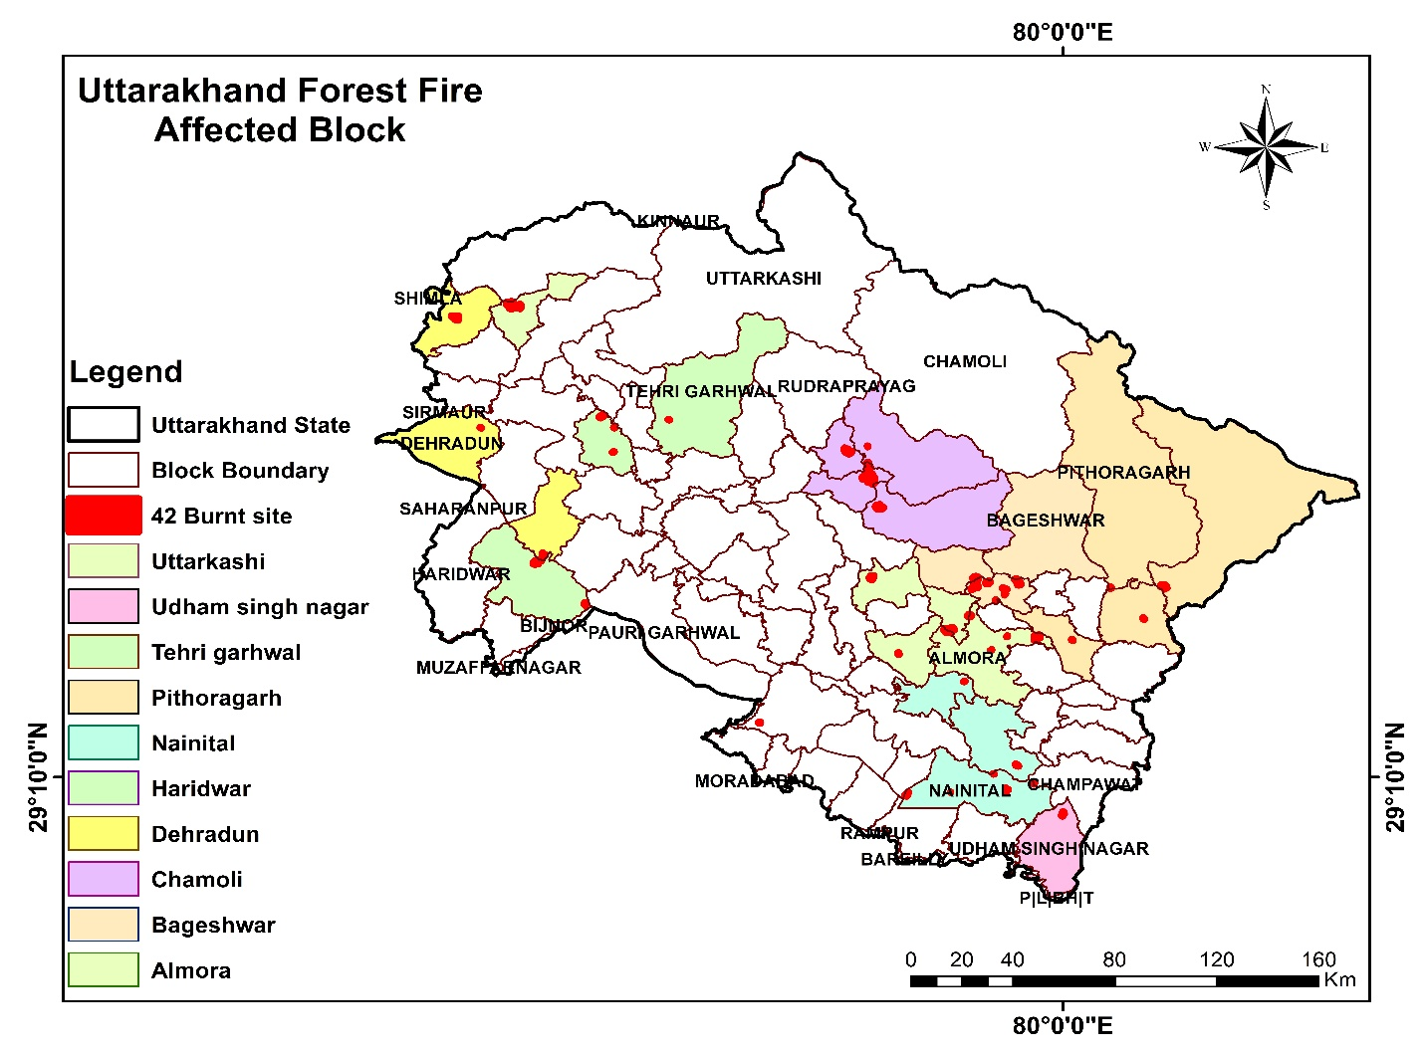Fig. 1 Map of Uttarakhand showing the locations of the 42 burn sites categorized by block
The area lies within a subtropical monsoon zone and receives an average annual rainfall of around 1,547 mm, with over 81% of the precipitation falling during the months of July and August. The climate in the catchment area varies from humid continental to tropical, depending on altitude and season. The southern foothills have a subtropical climate, with summer temperatures averaging around 30°C and winter temperatures near 18°C. In contrast, the Middle Himalayan valleys experience a warm temperate climate, with summer temperatures reaching about 25°C and relatively mild winters. In the highest regions of the Middle Himalayas, cool temperate weather predominates. Summer temperatures often range from 15°C to 18°C, while winter temperatures fall below freezing.
Assessment of water balance

Computation of Hydrological Water Balance
Water balance is based on law of conservation of mass and this method is used to calculate ET. Thornthwaite-Mather Water Balance Approach
$P=RO+AET+ Change in sub-storage (SM)$ Equation (1)
Where, P = Rainfall; RO = Runoff; AET = Actual evapotranspiration; SM = Change in soil moisture.

Precipitation Data
For this study, rainfall data was obtained using CHIRPS, a dataset developed in collaboration with the USGS EROS Center to support early warning systems, such as trend analysis and seasonal drought monitoring. CHIRPS integrates data from terrain-based precipitation models, ground station observations, and satellite-derived precipitation estimates from NASA and NOAA to produce high-resolution (0.05°) gridded climatological data. Given the relatively small scale of our forest fire-affected study area, CHIRPS data is considered suitable for our analysis. Rainfall data covering the period from June 2019 to May 2020 was used for this study.

Assessment of Change in Runoff

2.4.1 Soil Conservation Service Curve Number (SCS-CN) Method
The SCS-CN method estimates direct runoff from storm rainfall using a curve number (CN), based on empirical data. It relies on the water balance and two key assumptions:
(a) Water balance equation
$P=I_{a} +F +Q$ Equation (2)
(b) Water balance equation
$\frac{Q}{P – I_{a}} = \frac{F}{S}$ Equation (3)
(c) I_{a}-S relationship (second hypothesis)
$I_{a}= λS$ Equation (4)
Where P is total rainfall, I_{a} is initial abstraction, F is infiltration (excluding I_{a}), Q is direct runoff, and S is maximum potential retention.
The first assumption (Equation 2) uses proportionality, and the second (Equation 4) defines a linear link between I_{a} and S. Combining them gives:
$Q = \frac{{\left(P- I_{a}\right)}^{2}}{P- I_{a} +S}$ For P ≥ I_{a}, otherwise 0 Equation (5)
General form of the popular SCS-CN method is equation (Equation 5) and is valid for P ≥ I_{a}; Q = 0 otherwise. For λ = 0.2, the coupling of (Equation 4) and (Equation 5) results in:
$Q = \frac{{\left(P- I_{a}\right)}^{2}}{P+ 0.8S}$ Equation (6)
Equation (6) is widely acknowledged as a commonly used form of the established SCS-CN method. Consequently, the standard SCS-CN method with λ = 0.2 serves as a single-parameter model for calculating surface runoff from daily storm rainfall, offering significant importance, practicality, and extensive unexplored potential.

2.5 Assessment of Evpotranspiration
For water balance analysis, this study uses GLDAS datasets, which provide terrestrial hydrologic data, including AET. The GLDAS AET (Version 2.1), available from 2000 to present, is measured in mm of water loss and derived by NASA using the Noah Land Surface Model (NLSM) with satellite and ground-based observations (Khan et al., 2018). Several studies (e.g., Singh et al., 2022; Pal et al., 2021; Zhan et al., 2019) have shown that GLDAS AET products hold significant potential for hydrological studies at global, regional, and local scales, especially in data-scarce regions like India. For post-fire condition AET is -15% is applied for this study (collar et al., 2023).

3 Results and discussion

3.1 Monsoon Evapotranspiration Variations in Burnt and Unburnt Sites
The GLDAS AET evapotranspiration data was downloaded and used to represent pre-fire conditions. For post-fire conditions, a 15% reduction in AET was applied in this study. Monsoon season evapotranspiration (covering the four months from June to September) was calculated based on forest type. Five forest types with varying numbers of burnt sites were considered: the first forest type, Subtropical Pine Forest (STP), includes 20 sites; the second, Himalayan Moist Tropical Forest (HMT), includes 11 sites; the third, Tropical Moist Deciduous Forest (TMD), includes 6 sites; the fourth, Trees Outside Forest (TOF), includes 3 sites; and the fifth, Tropical Dry Deciduous Forest TDD), includes 2 sites.
The highest ET values for each forest type at specific sites are as follows: in the STP forest type, sites S20 and S21 recorded the highest ET at 382.45 mm; in the HMT forest type, site S41 recorded 372.57 mm; in the TMD forest type, site S31 recorded 393.32 mm; in the TOF category, sites S26 and S32 recorded 389.19 mm; and in the TDD forest type, site S3 recorded 379.06 mm. The calculated ET for both pre- and post-fire conditions, based on forest type and corresponding burnt sites, is presented in the graph below.

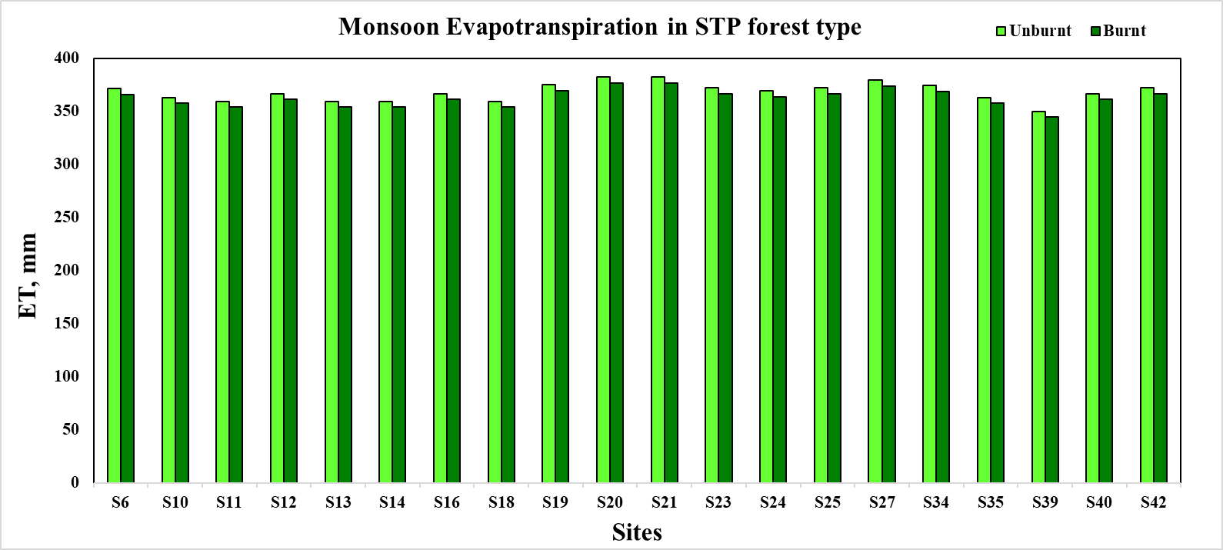
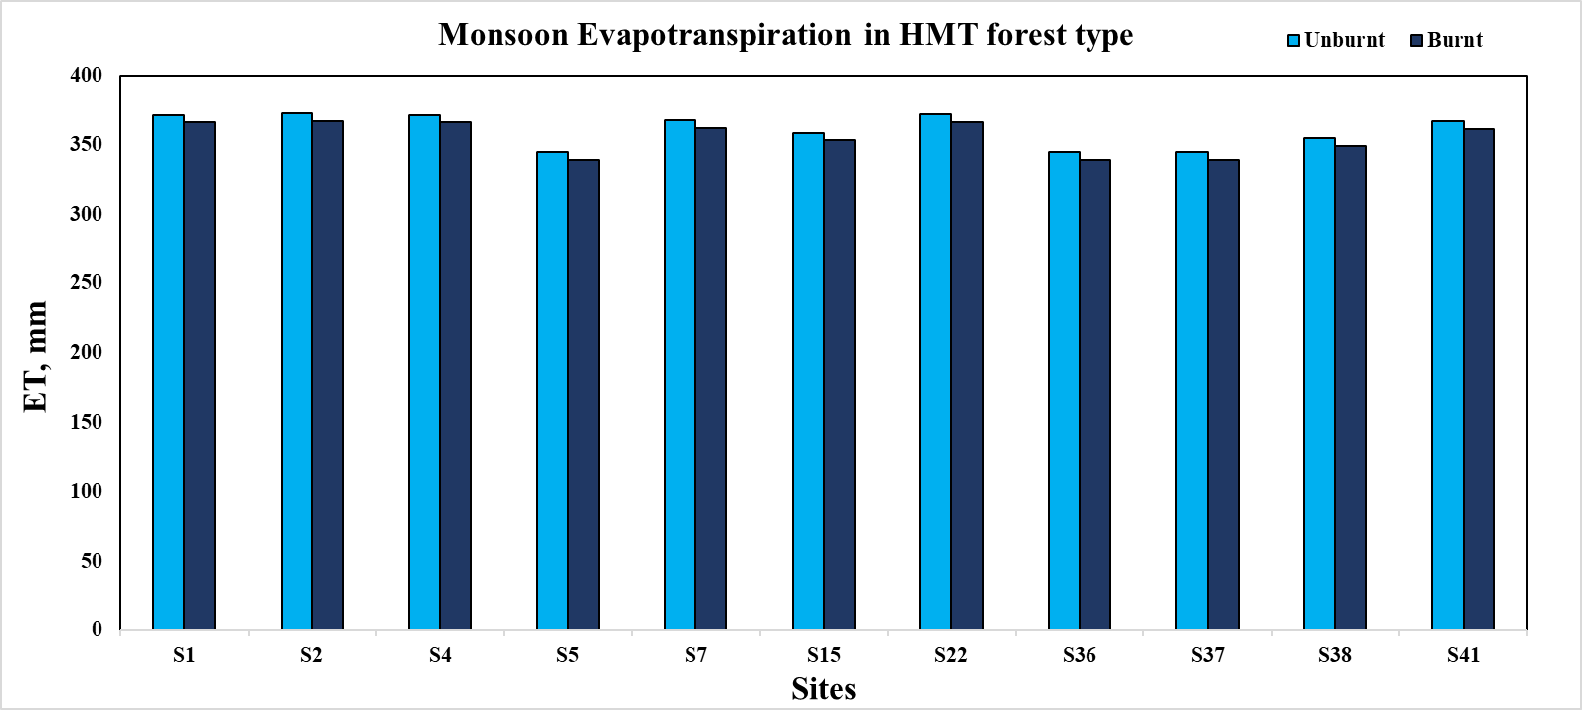
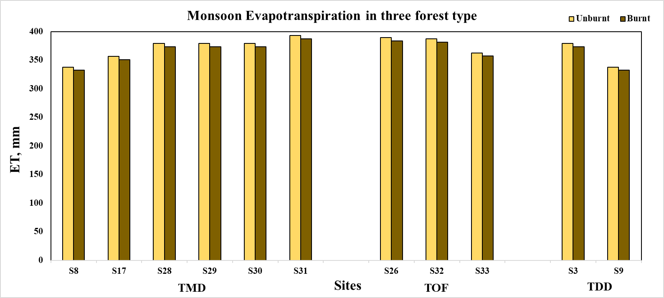

Fig. 2 Monsoon Evapotranspiration variations in burnt and unburnt sites across 5 forest types

3.2 Monsoon Δ Storage Variations in Burnt and Unburnt Sites
For the estimation of change in storage during the monsoon period (June to September), we calculated the percentage change across five distinct forest types. Five forest types with varying numbers of burnt sites were considered: the first forest type, Subtropical Pine Forest (STP), includes 20 sites; the second, Himalayan Moist Tropical Forest (HMT), includes 11 sites; the third, Tropical Moist Deciduous Forest (TMD), includes 6 sites; the fourth, Trees Outside Forest (TOF), includes 3 sites; and the fifth, Tropical Dry Deciduous Forest (TDD), includes 2 sites.
The analysis was performed on a site-specific basis, and the results indicate a consistent decrease in storage at all locations, reflecting the impact of seasonal dynamics on the hydrological regime. In the STP forest type, which comprises 20 sites, the most pronounced decline in storage was observed at site S35, with a reduction of -59.85%, while the smallest decrease was noted at site S12 with a decline of -7.44%. Similarly, in the HMT forest type, the maximum reduction was recorded at site S4 at -58.49%, whereas site S7 exhibited the least decline of -14.09%. For the TMD forest type, the highest decline was -34.26% at site S30, and the smallest decline was -19.4% at site S8. In the TOF forest type, storage decreased most significantly at site S33 (-21.00%), while site S26 experienced a minimal decline of -4.08%. In the TDD forest type, the greatest reduction occurred at site S3 (-34.04%), and the least was observed at site S9 (-22.72%). These findings underscore the spatial variability of storage reductions during the monsoon period, likely influenced by differences in vegetation cover, soil properties, and underlying hydrological processes across the forest types.

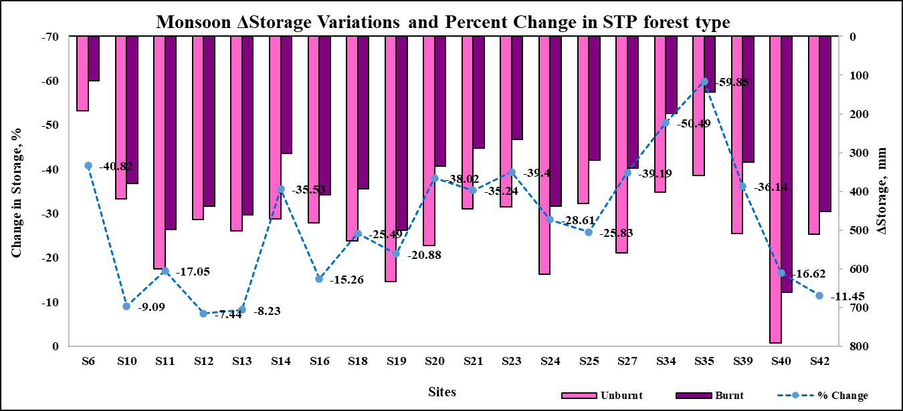
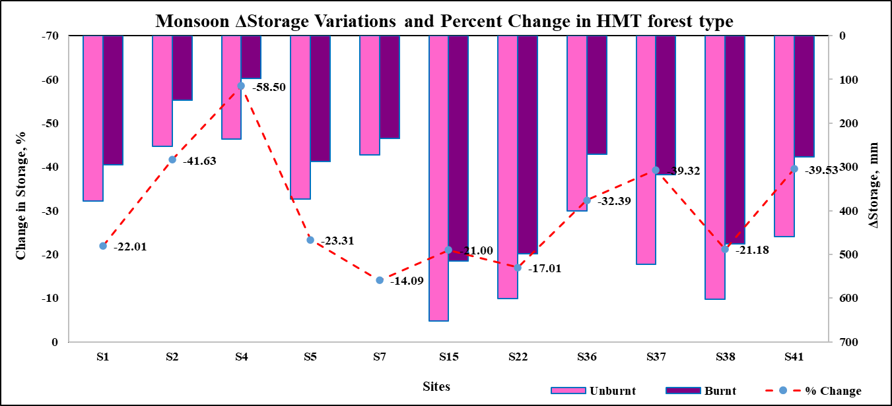
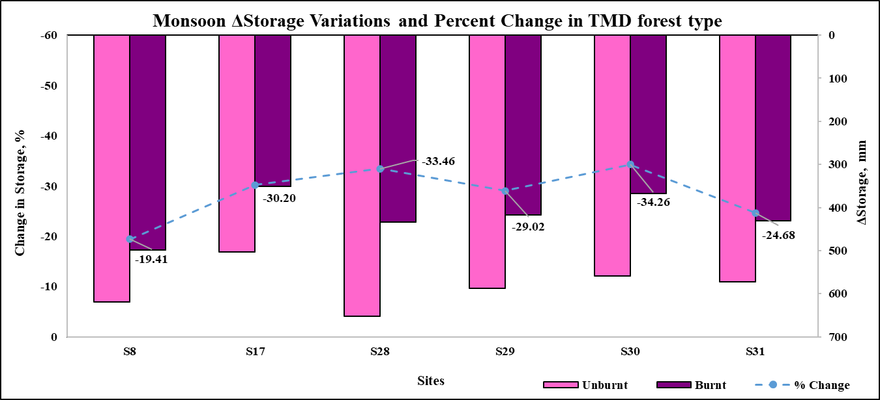
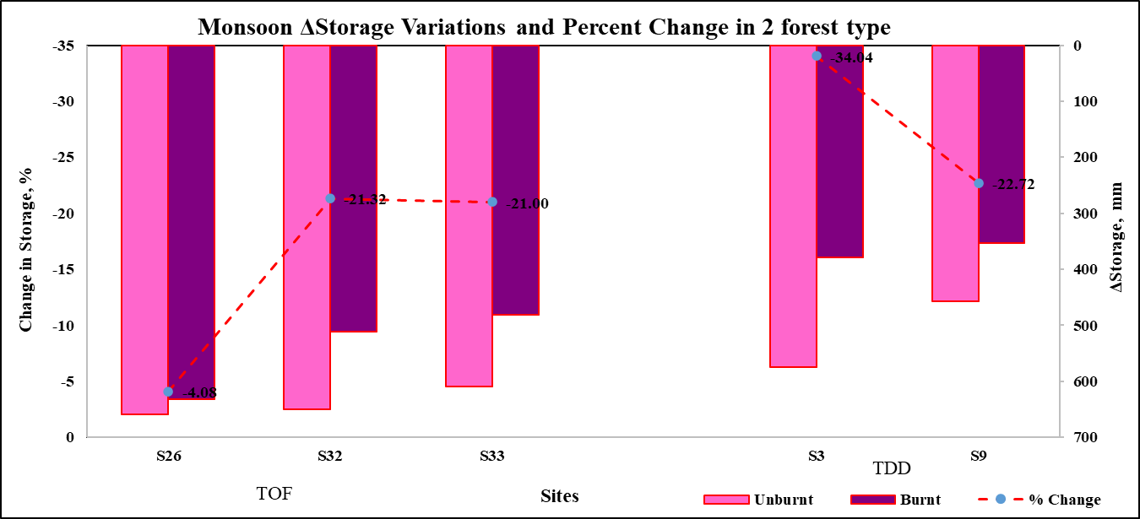
Fig. 3. Monsoon change in storage variations with percent change in burnt and unburnt sites across 5 forest types

4. CONCLUSION
The present study conclusively demonstrates a consistent decline in water storage across all 42 study sites following forest fire events. This decline underscores the substantial hydrological impact of forest fires on terrestrial ecosystems. The highest actual evapotranspiration (ETa) values recorded post-fire for each forest type are as follows: STP forest sites S20 and S21 (382.45 mm), HMT forest site S41 (372.57 mm), TMD forest site S31 (393.32 mm), TOF forest sites S26 and S32 (389.19 mm), and TDD forest site S3 (379.06 mm). Despite these relatively high ET values, the overall trend was a significant reduction in change in storage across the landscape. The most pronounced reduction occurred at site S35 in the STP forest, with a decline of -59.85%, while the smallest decrease was observed at site S26 in the TOF forest (-4.08%). The reduction in water storage is primarily attributed to decreased infiltration capacity and fire-induced changes in soil structure and composition. The loss of vegetation further exacerbates this condition by diminishing canopy interception and root-mediated soil stability, both of which are critical for maintaining infiltration and soil moisture retention. These findings highlight the substantial influence of forest fires on hydrological dynamics, particularly in sensitive forest ecosystems.
Overall, this research underscores the critical role of forest cover in regulating water storage and the far-reaching implications of fire disturbances on ecosystem water balance. It emphasizes the need for integrated forest and water resource management strategies that account for fire impacts, promote post-fire restoration, and support long-term ecosystem resilience.

Consent (where ever applicable)

Not Available (N.A.)

Ethical approval (where ever applicable)

Not Available (N.A.)

REFERENCES
Atchley, A.L., Kinoshita, A.M., Lopez, S.R., Trader, L., Middleton, R., (2018). Simulating surface and subsurface water balance changes due to burn severity. Vadose Zone Journal 17 (1), 1–13.
Bart, R.R., Tague, C.L., (2017). The impact of wildfire on baseflow recession rates in California. Hydrological Processes 31 (8), 1662–1673.
Biederman, J.A., Harpold, A.A., Gochis, D.J., Ewers, B.E., Reed, D.E., Papuga, S.A., Brooks, P.D., (2014). Increased evaporation following widespread tree mortality limits streamflow response. Water Resources Research 50 (7), 5395–5409.
Champion, H. G., & Seth, S. K. (1968). A revised survey of the forest types of India. Manager of publications.
Collar, N. M., Ebel, B. A., Saxe, S., Rust, A. J., & Hogue, T. S. (2023). Implications of fire-induced evapotranspiration shifts for recharge-runoff generation and vegetation conversion in the western United States. Journal of Hydrology, 621, 129646.
DeBano, L. F., Neary, D. G., & Ffolliott, P. F. (1998). Fire effects on ecosystems. John Wiley & Sons.
Eagleson, P. S. (2005). Ecohydrology: Darwinian expression of vegetation form and function. Cambridge University Press.
Ebel, B. A. (2013). Wildfire and aspect effects on hydrologic states after the 2010 Fourmile Canyon Fire. Vadose Zone Journal, 12(1), vzj2012-0089.
Forest Survey of India. (2021). India State of Forest Report. MOEF, Govt. of India.
Goeking, S. A., & Tarboton, D. G. (2020). Forests and water yield: A synthesis of disturbance effects on streamflow and snowpack in western coniferous forests. Journal of Forestry, 118(2), 172-192.
Hallema, D. W., Sun, G., Bladon, K. D., Norman, S. P., Caldwell, P. V., Liu, Y., & McNulty, S. G. (2017). Regional patterns of postwildfire streamflow response in the Western United States: The importance of scale‐specific connectivity. Hydrological Processes, 31(14), 2582-2598
ICFRE, (2013). Forest Types of India: Revisited, Indian Council of Forestry Research and Education, Dehradun, India, pp. 484
Keeley, J. E. (2009). Fire intensity, fire severity and burn severity: a brief review and suggested usage. International journal of wildland fire, 18(1), 116-126.
Khan, M. S., Liaqat, U. W., Baik, J., & Choi, M. (2018). Stand-alone uncertainty characterization of GLEAM, GLDAS and MOD16 evapotranspiration products using an extended triple collocation approach. Agricultural and Forest Meteorology, 252, 256-268.
Littell, J. S., Peterson, D. L., Riley, K. L., Liu, Y., & Luce, C. H. (2016). A review of the relationships between drought and forest fire in the United States. Global change biology, 22(7), 2353-2369.
Pal, L., Ojha, C. S. P., & Kumar, A. (2021). Characteristics of GLDAS Evapotranspiration and Its Response to Climate Variability Across Ganga Basin, India. Climate Change Impacts on Water Resources: Hydraulics, Water Resources and Coastal Engineering, 241-251.
Pechony, O., & Shindell, D. T. (2010). Driving forces of global wildfires over the past millennium and the forthcoming century. Proceedings of the National Academy of Sciences, 107(45), 19167-19170.
Perry, T. D., & Jones, J. A. (2017). Summer streamflow deficits from regenerating Douglas‐fir forest in the Pacific Northwest, USA. Ecohydrology, 10(2), e1790.
Poon, P. K., & Kinoshita, A. M. (2018). Spatial and temporal evapotranspiration trends after wildfire in semi-arid landscapes. Journal of hydrology, 559, 71-83.
Singh, V., Singh, P. K., Jain, S. K., Jain, S. K., Cudennec, C., & Hessels, T. (2022). Examining evaporative demand and water availability in recent past for sustainable agricultural water management in India at sub-basin scale. Journal of Cleaner Production, 346, 130993.
Tague, C. L., Moritz, M., & Hanan, E. (2019). The changing water cycle: The eco‐hydrologic impacts of forest density reduction in Mediterranean (seasonally dry) regions. Wiley Interdisciplinary Reviews: Water, 6(4), e1350.
Thornthwaite, C. W. (1955). The water balance. Public. in Climatol., 8(1), 1-104.
Thornthwaite, C. W., & Mather, J. R. (1957). Instructions and tables for computing potential evapotranspiration and the water balance.
Westerling, A. L., Hidalgo, H. G., Cayan, D. R., & Swetnam, T. W. (2006). Warming and earlier spring increase western US forest wildfire activity. science, 313(5789), 940-943.
Wotton, B. M., Nock, C. A., & Flannigan, M. D. (2010). Forest fire occurrence and climate change in Canada. International Journal of Wildland Fire, 19(3), 253-271.
Zhan, S., Song, C., Wang, J., Sheng, Y., & Quan, J. (2019). A global assessment of terrestrial evapotranspiration increase due to surface water area change. Earth's future, 7(3), 266-282.

