Extraction from pomegranate peel (lat. Punica granatum): The effect of different extraction techniques and solvents on extraction yield

.
ABSTRACT
In this study, polyphenolic compounds from pomegranate peel (Punica granatum) were extracted using different extraction methods. Three techniques were applied for polyphenol extraction: Soxhlet extraction, ultrasound-assisted extraction, and maceration. These methods varied in the time required for extraction and the yield of dry extract. For Soxhlet and ultrasound-assisted extraction, two solvents were used: methanol and ethanol. While maceration is simple and cost-effective, it was found to be the least efficient method for extraction. The removal of ethanol and methanol from the extracts was successfully achieved through evaporation, ensuring the purity of the extracts.
The results indicated that Soxhlet extraction with methanol provided the highest yield of polyphenolic compounds from pomegranate peel, with only a small difference compared to using an ethanol solution. Ultrasound-assisted extraction also yielded significant results, but the difference in yield was more pronounced depending on the solvent used. The goal of this study was to determine and present the efficiency of each extraction method. Further research will focus on assessing the antioxidant capacity of the extracted polyphenolic compounds.

Keywords: Extraction; polyphenolic compounds; Punica granatum; Soxhlet extraction; ultrasound-assisted extraction; maceration.

1. INTRODUCTION

Pomegranate (Punica granatum) peel is rich in antioxidants, polyphenols, dietary fiber, and vitamins, all of which contribute to its remarkable bioactivity (Kyriakidou, 2021). The major polyphenols in pomegranate peel are punicalagin and ellagic acid, with punicalagin being the primary contributor to its antioxidant activity (Xie, 2019; Ranjha, 2020).
Punicalin is a natural organic compound, molecular formula C₃₄H₂₂O₂₂ and mass of 782.53 g/ mol.

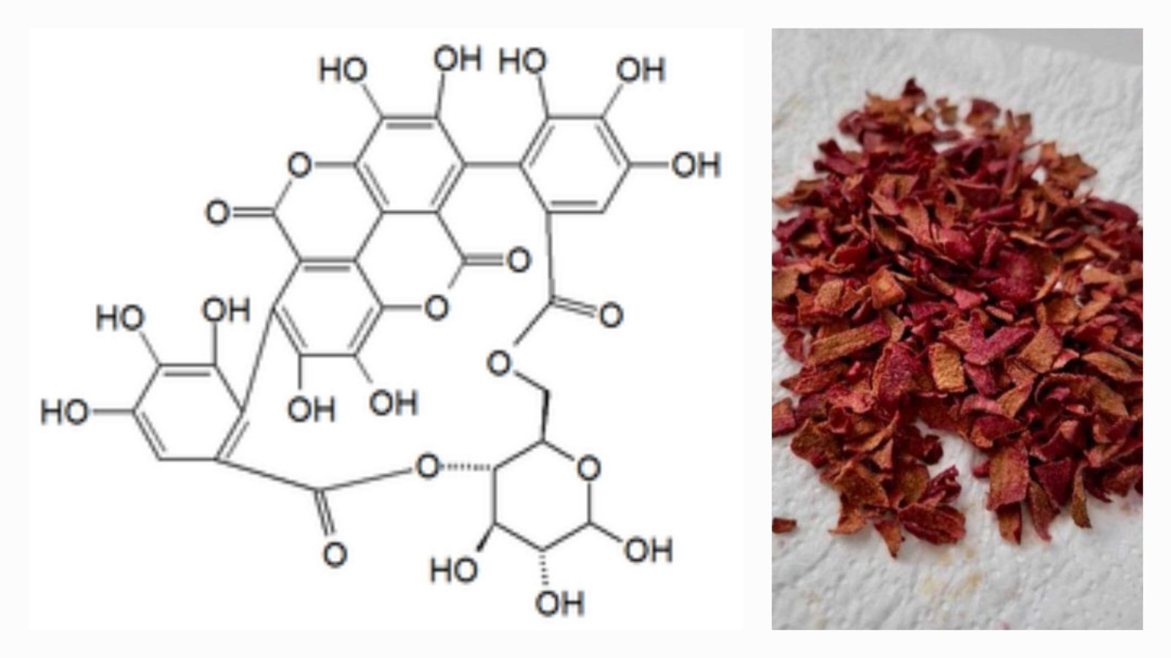
Figure 1. Chemical structure of punicalin

Efficient extraction of valuable compounds from pomegranate peel depends on several factors, including the extraction method and the type of solvent used. Organic polar solvents such as ethyl acetate, ethanol, methanol, and acetone are commonly employed for extracting polyphenols (Ross, 2009; Ranjha, 2020). This study focuses on three extraction techniques: maceration, Soxhlet extraction, and ultrasound-assisted extraction (UAE), also known as sonication. Maceration is a traditional, simple, and cost-effective extraction method that only requires a basic container for the extraction process. However, it typically demands a long extraction time. Despite its simplicity, maceration is widely used for extracting active compounds because it can be performed almost anywhere (Tambun, 2021).
In Soxhlet extraction, the process usually takes between 6 to 24 hours for a sample mass of approximately 10 g. The solvent-to-sample ratio for solvents like toluene and methanol is typically 10:1 (vol/vol). The Soxhlet process involves heating, and although it is sequential, it can be operated continuously in larger setups. This method requires minimal equipment and operator skills, but the extraction time is relatively long. On the other hand, ultrasound-assisted extraction (sonication) is a faster method compared to Soxhlet extraction. For sample masses ranging from 2 to 30 g, the extraction time is typically 3 to 5 minutes per sample. All solvent combinations are used in equal proportions. Like Soxhlet extraction, the ultrasound-assisted method also benefits from low development time, minimal equipment requirements, and less operator expertise (Patel, 2019).
The aim of this research is to evaluate how different extraction techniques and solvents affect the yield of polyphenols from pomegranate peel, and to estimate their polyphenol content.
- material and methods

The pomegranate was purchased in a grocery store nearby Tuzla in Bosnia and Herzegovina, and carefully selected to ensure optimal quality—fresh, ripe, and free from visible damage.

Preparation and drying of pomegranate peel

To preserve its valuable bioactive compounds, a precise preparation process was followed, beginning with a thorough washing in clean water. This step was essential to remove any impurities, dust, or potential pesticide residues from the peel. Once washed, the pomegranate was gently wiped with a clean cloth and left to air dry completely, preventing excess moisture that could interfere with further processing. The fresh pomegranate was then peeled, and the outer rind was carefully separated from the fruit. The peel was cut into smaller pieces to increase the surface area, allowing for more efficient drying and extraction of beneficial compounds.
The crushed peel was then subjected to natural air drying. It was spread out in a well-ventilated but dark space, where it remained for 3 to 4 days. The chosen drying environment was crucial—proper airflow prevented mold formation, while the absence of direct light helped preserve delicate bioactive compounds such as polyphenols and vitamins, which degrade when exposed to light. After completing the drying process, the pomegranate peel was prepared for maceration and extraction.

  - Ultrasound – assisted extraction of polyphenol compounds from pomegranate peel
Ultrasound-assisted extraction (UAE) is one of the key techniques for the extraction of the bioactive compounds from plant materials. It involves the use of ultrasound waves in the frequency range of 20 kHz to 2 MHz for disruption of the plant matrix and improving the penetration of solvents (Huang, 2025) (Panja, 2018). Basically, this method relies on sonication, including the creation and collapse of cavitation bubbles near the plant matrix give rise to high-pressure, high-temperature microjets. These microjets crash onto the surface of .the plant with great force, breaking up its matrix and ensuring that the solvent comes into direct contact with the active ingredients of the cell, thereby enhancing their leaching into the solvent more effectively (Huang, 2025) (Chemat, 2011).

    - Detailed steps of extraction and solvent removal
- Pulverization of plant material (lat. Punica granatum peel). 2.5 grams of pulverized plant material were weighed andplaced into two flat-bottomed flasks. Each flask wasthen mixed with solvents (methanol, 96% ethanol). The flasks were sealed with parafilm to prevent evaporation and contamination during the extraction process.

- The samples were subjected to extraction in an Bandelin Sonorex ultrasonic bath for 35 minutes on room temperature. During the extraction large amounts of energy are generated. To maintain the desired temperature, ice was used to cool the samples and prevent overheating.

- After completed extraction, the samples were filtered through filter paper (Macherey – Nagel MN 617 filter paper). The filtrates were collected in porcelain lab bowls. First 5 mL of filtrates were collected in small lab beaker and discarded from further analysis.

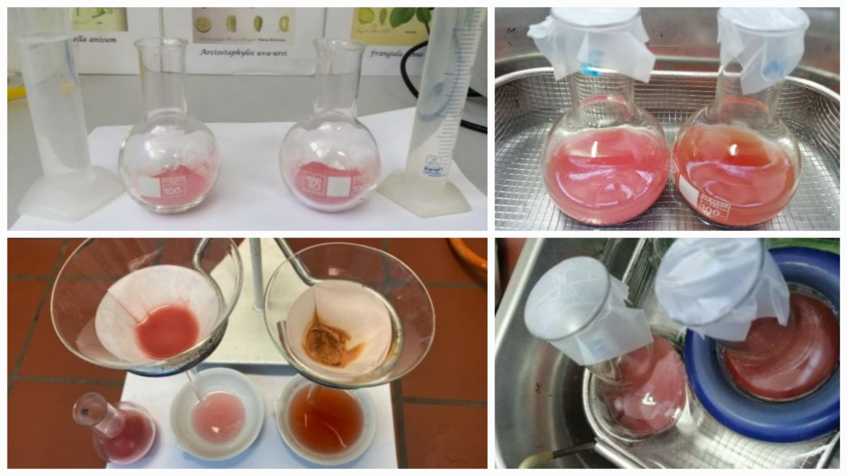
Figure 2. Ultrasound-assisted extracts

4. Removal of ethanol and methanol solvents

Large laboratory beaker was filled halfway with water and heated to boiling. Once water vapor began to form, a porcelain lab bowl containing the filtrate was placed over the beaker. The ethanol evaporated from the extract due to the heat from the water vapor. After the ethanol was completely removed, the dry pomegranate extract was carefully removed from the porcelain lab bowl, stored in paper, and then transferred to sterile cups for further use. For the methanol solvent, the porcelain dish containing the methanol extract filtrate was left overnight in a laboratory fume hood. As methanol evaporates at room temperature, it was completely removed from the extract. Once the methanol had evaporated, the dry pomegranate extract was carefully removed from the porcelain bowls, stored in paper, and then transferred to sterile cups for further use.
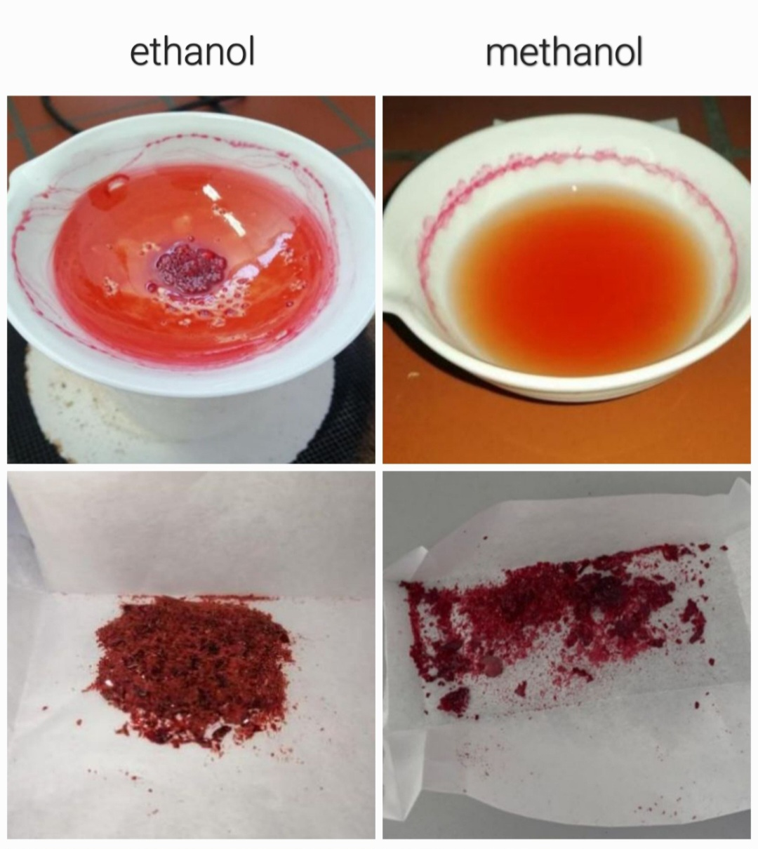

Figure 3. Ultrasound-assisted dry extracts

  - Soxhlet extraction of polyphenol compounds from pomegranate peel
Franz Ritter von Soxhlet is credited with inventing the extraction technique that bears his name in 1879. The method was a significant advance in the isolating of solutes from difficult-to-extract solid samples. For well over 100 years, Soxhlet extraction was considered the gold standard in the analytical extraction of solids. (Raynie, 2019).

Soxhlet extraction is a laboratory technique used for the extraction of compounds from solid materials. It involves the continuous washing of the sample with a solvent, through a cycle of boiling and condensation, enabling efficient extraction of the desired compounds into the solvent (Ultrasonic Soxhlet Extraction).

    - Detailed steps of extraction and solvent removal

- Sample preparation: Accurately weighs 20 grams of finely ground plant material (Cortex Punica granatum). Place it into a filter paper thimble and seal it with cotton wool.
- Sample placement: Insert the prepared thimble into the extraction chamber of the Soxhlet apparatus.
- Solvent addition: Add 200 mL of solvent (methanol or 96% ethanol) to the apparatus through the funnel above the condenser.
- Heating: Position the flask in a water bath and heat it, maintaining a temperature between 60 and 80°C.
- Extraction process: The extraction proceeds for 6 hours, during which the solvent evaporates, condenses, and percolates through the sample, dissolving the target compounds.
- Extract isolation: Upon completion, transfer the alcoholic extract into a porcelain dish and remove the solvent by evaporation, leaving behind the pure extract.

- Ethanol removal

A large laboratory beaker was filled halfway with water and heated to boiling. Once water vapor began to form, a porcelain lab bowl containing the filtrate was placed over the beaker. The ethanol evaporated from the extract due to the heat from the water vapor. After the ethanol was completely removed, the dry pomegranate extract was carefully removed from the porcelain lab bowl, stored in paper, and then transferred to sterile cups for further use.

- Methanol removal

The porcelain lab bowl containing the methanol extract was left overnight in a laboratory fume hood. As methanol evaporates at room temperature, it is completely removed from the extract. Once the methanol had evaporated, the dry pomegranate extract was carefully removed from the porcelain lab bowl, stored in paper, and then transferred to sterile cups for further use.
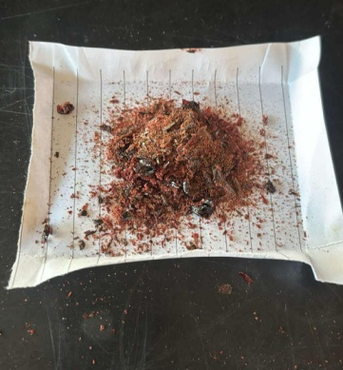

Figure 4. Extract obtained by Soxhlet extraction

  - Maceration extraction of polyphenol compounds from pomegranate peel
Maceration is one of the most commonly used methods for extracting bioactive compounds from plant material. In this process, the plant material is soaked in an organic solvent at room temperature, allowing the solvent to penetrate the plant cells and dissolve the active substances within. Maceration is favored due to its simplicity and low cost, as it requires only basic laboratory equipment, making it accessible for a variety of experiments (Huang, 2025). While maceration is a straightforward method, it has the disadvantage of a long extraction time. It is particularly suitable for the extraction of thermo-labile compounds. Since the system remains stationary during the maceration process, extraction occurs through molecular diffusion, which is a time-consuming process. This results in the dispersal of concentrated solution around the surface of the particles, bringing fresh solvent to the surface for further extraction (Patel, 2019).

    - Detailed steps of extraction and solvent removal
- Preparation of plant material
Cleaned and air dried crushed plant material, 1.5 g pomegranate peel (lat. Punica granatum peel), is dipped in 15 mL of a solvent called menstruum (96% ethanol) in a laboratory baker.

- Enabling optimal conditions
The laboratory beaker is closed with a watch glass and allowed to stand still under complete steady state at room temperature.

- Concentration equalization
The content is stirred periodically during 3 days.

- Filtration
The damp solid material is first decanted and then filtered using filter paper (Macherey – Nagel MN 617 filter paper). The filtrates were collected in porcelain lab bowls.

- Ethanol removal
Large laboratory beaker was filled halfway with water and heated to boiling. When water vapor begins to form, we place a porcelain lab bowl with filtrate on the glass. Ethanol evaporates from the extract. Dry pomegranate extract was removed from the porcelain lab bowl and stored in paper and then in sterile cups.

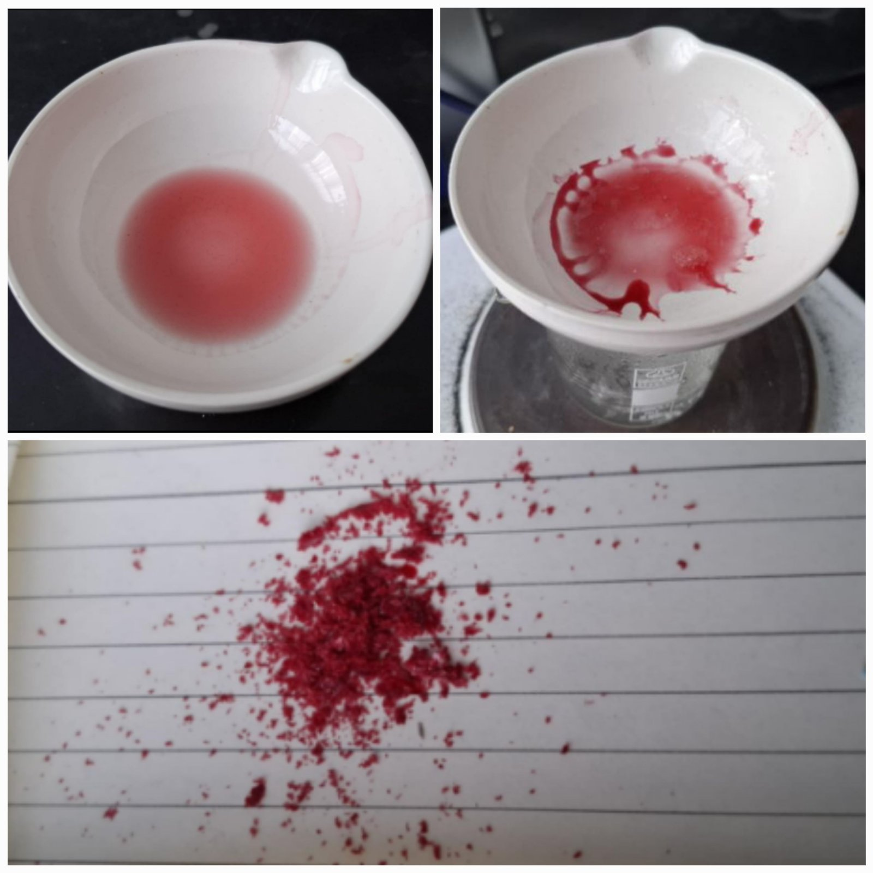
Figure 5. Extract obtained by maceration

3. results and discussion

Table 1 shows the yield results of the used extraction methods with pomegranate peel material. The calculation of the yield of the obtained extract is shown in the following formula.

Extract or percentage yield was calculated by using the following formula:

$$\text{Percentage yield=}\frac{\text{Weight of extract sample (g)}}{\text{Initial weight of sample (g)}}\text{×100\%}$$

Table 1. Extraction types and percentage yield
Extraction types | Extract sample | Initial weight of sample (g) | Weight of extract sample (g) | Percentage yield (%)
Ultrasonic extraction | Methanol extract | 2.50 | 0.82 | 32.8
Ultrasonic extraction | Ethanol (96%) extract | 2.50 | 0.43 | 17.2
Soxhlet extraction | Methanol extract | 20.00 | 6.70 | 33.5
Soxhlet extraction | Ethanol (96%) extract | 20.00 | 6.09 | 30.45
Maceration extraction | Ethanol extract | 1.50 | 0.11 | 7.33

Ethanol extraction of natural products is effective due to its broad solubility range as a neutral solvent, capable of extracting a wide variety of compounds, including both hydrophilic components soluble in water and lipophilic components like fats. Its antimicrobial properties contribute to reducing contamination risks and preserving the quality of extracts. Ethanol is considered relatively safe and economical, as it evaporates quickly after extraction, which aids in the concentration process. These properties make ethanol widely used for extracting bioactive compounds, especially those with high antioxidant activity. In solvent extraction, the choice of solvent is critical, depending on factors like selectivity. Common solvents for extraction include ethanol, methanol, and water. Depending on the type of compound to be isolated and extracted, different solvents can be combined and used.
Ethanol, being a polar solvent, is highly effective in extracting both polar and nonpolar compounds. It is particularly useful for extracting bioactive substances such as phenolic compounds, lipids, fatty acids, and terpenoids, and it has the added advantage of being safe for use in pharmaceuticals. On the other hand, methanol is a polar solvent with high solubility, which is also effective for extracting various polar compounds. Despite its high extraction efficiency, methanol's toxicity requires careful handling. In addition to phenolic compounds, lipids, and fatty acids, methanol is also used to extract anthocyanins, terpenoids, lignans, polysaccharides, and proteins (Lee, 2024).
The results show that ultrasonically assisted extraction (UAE) with methanol gave a higher yield compared to ethanol, which confirms its greater efficiency in the extraction of polyphenolic compounds from pomegranate peel. The UAE method proved to be a fast and economical alternative, allowing for relatively high yields in a significantly shorter period of time.
Soxhlet extraction, although time-consuming and more demanding in terms of solvent quantity, gave the highest overall extract yield. The difference between methanol and ethanol in this method is smaller than in UAE, which indicates the high efficiency of both solvents in this procedure.
Maceration gave the lowest extract yield, but remains suitable for the extraction of thermosensitive compounds due to the mild nature of the process. The results indicate the importance of choosing the appropriate extraction method depending on the specific requirements of the analysis and the type of bioactive compounds to be isolated.

4. Conclusion

In this experimental study, the effects of various solvents and three extraction methods on the final yield were evaluated. The results indicated that the Soxhlet extraction method using methanol as the solvent provided the highest yield. After selecting the most effective method based on the yield of the desired compounds, further research will focus on determining the antioxidant activity of the key compounds. Although Soxhlet extraction provided the highest yields, ultrasonic extraction with methanol would be preferred for future studies due to its shorter extraction time. Antioxidants, which are natural organic compounds, are crucial for human health and are becoming an increasingly important area of scientific research.

References

- Kyriakidou, A., Makris, D.P., Lazaridou, A., Biliaderis, C.G. and Mourtzinos, I. Physical Properties of Chitosan Films Containing Pomegranate Peel Extracts Obtained by Deep Eutectic Solvents. Foods. 10(6), 1262; https://doi.org/10.3390/foods10061262 (2021)

- Ranjha, M. M. A. N., et al. Extraction of Polyphenols from Apple and Pomegranate Peels Employing Different Extraction Techniques for the Development of Functional Date Bars. International Journal of Fruit Science. 20(sup3), S1201–S1221. https://doi.org/10.1080/15538362.2020.1782804 (2020)

- https://sh.wikipedia.org/wiki/Punikalin#/media/Datoteka:Punicalin.png

- Rahimi, H. R., Arastoo, M., and Ostad, S. N. A Comprehensive Review of Punica granatum (Pomegranate) Properties in Toxicological, Pharmacological, Cellular and Molecular Biology Researches. Iranian journal of pharmaceutical research: IJPR, 11(2), 385–400. https://pubmed.ncbi.nlm.nih.gov/24250463/ (2012)

- Kushwaha, S.C., M.B. Bera, and P. Kumar. Extraction of polyphenols from fresh pomegranate peel using response surface methodology. Asian J. Chem. 27(12):4320–4326. https://doi.org/10.14233/ajchem.2015.19051 (2015)

- Singh, B., J.P. Singh, A. Kaur, and N. Singh. Antimicrobial potential of pomegranate peel: A review. Int. J. Food Sci. Technol. 54(4):959–965. https://doi.org/10.1111/ijfs.13964 (2019)

- Xie Z, Li X, Tang R, et al. Reactions of polyphenols in pomegranate peel with nitrite under simulated stomach conditions. Food Sci Nutr. 7(9):3103-3109. https://pubmed.ncbi.nlm.nih.gov/31572603/ (2019)

- Ross, K.A., T. Beta, and S.D. Arntfield. A comparative study on the phenolic acids identified and quantified in dry beans using HPLC as affected by different extraction and hydrolysis methods. Food Chem. 113(1):336–344. https://doi.org/10.1016/j.foodchem.2008.07.064 (2009)

- Tambun, R., Alexander, V. and Ginting, Y. Performance comparison of maceration method, soxhletation method, and microwave-assisted extraction in extracting active compounds from soursop leaves (Annona muricata): A review, IOP Conference Series: Materials Science and Engineering. 1122, 012095. doi: 10.1088/1757-899X/1122/1/012095 (2021)

- Patel, K., Panchal, N. and Ingle, P. Review of Extraction Techniques: Extraction Methods: Microwave, Ultrasonic, Pressurized Fluid, Soxhlet Extraction, Etc., International Journal of Advanced Research in Chemical Science (IJARCS). 6(3), pp. 6-21. doi:10.20431/2349-0403.0603002 (2019)

- Lee, J.-E., et al. The influence of solvent choice on the extraction of bioactive compounds from Asteraceae: A comparative review. Foods. 13, p. 3151. https://www.mdpi.com/2304-8158/13/19/3151 (2024)

- Huang Z, Foo SC, Choo WS. A review on the extraction of polyphenols from pomegranate peel for punicalagin purification: techniques, applications, and future prospects. RSC. 3, 396-413 doi: 10.1039/D4FB00304G (2025)

- Panja P. Green extraction methods of food polyphenols from vegetable materials. Current Opinion in Food Science. 23: 173-182. https://doi.org/10.1016/j.cofs.2017.11.012. (2018)

- Chemat F,Huma Z, Khan MK. Applications of ultrasound in food technology: Processing, preservation and extraction, Ultrasonics Sonochemistry. Science Direct. 18(4):813-835. https://doi.org/10.1016/j.ultsonch.2010.11.023. (2011)

- Raynie, Douglas E. Looking at the past to understand the future: Soxhlet extraction. LCGC North America. 37(8), pp.510-513. https://www.chromatographyonline.com/view/looking-past-understand-future-soxhlet-extraction (2019)

- Patel K, Panchal N, Ingle P. Techniques Adopted for Extraction of Natural Products: Extraction Methods: Maceration, Percolation, Soxhlet Extraction, Turbodistillation, Supercritical Fluid Extraction. International Journal of Advanced Research in Chemical Science (IJARCS). 6(4): 1-12. http://dx.doi.org/10.20431/2349-0403.0604001 (2019)

