***Original Research Article***

**Spatiotemporal Analysis of Rainfall Variability and Drought in the Malwa Region of Madhya Pradesh**

ABSTRACT

The present study investigates the rainfall variability and drought characteristics across 16 districts in the western part of Madhya Pradesh, India, using long-term rainfall records from 1980 to 2023. A combination of statistical techniques, including homogeneity testing (Pettitt’s test), randomness and autocorrelation testing (Durbin-Watson statistics), rainfall variability analysis, standardized rainfall anomaly (SRA) assessment, and rainfall departure and probability distribution analysis, was employed to evaluate the spatial and temporal distribution of rainfall and drought events. The results indicated that while most districts exhibited homogeneous and random rainfall patterns, a few stations demonstrated significant non-homogeneity and negative autocorrelation. Spatial variability analysis revealed that the Malwa Plateau region received relatively less rainfall and exhibited greater variability compared to the Nimar Valley and Jhabua Hills regions. The frequency and severity of droughts were found to be higher in the Malwa region, with drought return periods as short as two to three years, while the southern districts experienced fewer and less severe drought events. This study highlights the pressing need for region-specific drought mitigation strategies and better water resource management practices to enhance climate resilience in western Madhya Pradesh. The findings offer valuable insights for policymakers and stakeholders involved in sustainable agricultural and water management planning.

*Keywords: Rainfall variability, Drought assessment, Standardized Rainfall Anomaly (SRA), Homogeneity test, Rainfall departure.*

# INTRODUCTION

Rainfall variability refers to the fluctuations in the amount, intensity, timing, and distribution of rainfall over time and space. It is one of the most critical aspects of climate that directly affects agricultural production, water resources, and ecosystem stability [1]. The unpredictable nature of rainfall, including times of excess (floods) or shortage (droughts), both within and between years, is captured by variability, as opposed to average annual rainfall [2]. In many regions of the world, especially those dependent on rainfed agriculture, rainfall variability can be more consequential than long-term changes in mean rainfall, leading to significant challenges in food security, water management, and rural livelihoods [3,4,5].

India’s rainfall regime is primarily governed by the southwest monsoon, which contributes nearly 75%–80% of the annual precipitation between June and September [6,7]. Despite being a monsoon-dominated country, India exhibits significant spatial and temporal rainfall variability. Some regions receive more than 2,000 mm of annual rainfall (like the Western Ghats and northeastern states), while others, such as Rajasthan and parts of Gujarat, receive less than 500 mm [8,9]. However, the average figures mask a deeper issue—the high variability in rainfall across different time scales, including seasonal, annual, and decadal fluctuations. Rainfall variability in India manifests through delayed onset or early withdrawal of the monsoon, prolonged dry spells during the cropping season, uneven distribution across regions, and sudden intense rainfall events [10]. These inconsistencies have become more prominent in recent decades, influenced by factors such as land use changes, urbanization, deforestation, and global warming. The erratic nature of rainfall creates challenges in planning and managing irrigation, crop calendars, water harvesting, and flood control. In rainfed regions, which constitute nearly 60% of India's net sown area, the consequences of rainfall variability are particularly severe [11,12]. It leads to increased risk of crop failure, food insecurity, groundwater depletion, and rural distress. Therefore, understanding and analyzing rainfall variability at both national and regional levels is essential for developing resilient agricultural systems and water resource policies tailored to local conditions.

Madhya Pradesh (MP) is a crucial region in India where variations in rainfall have a significant impact on water management and agriculture. Madhya Pradesh, often referred to as the "heart of India," is geographically diverse, comprising plateaus, river basins, and hilly terrains. The state receives an average annual rainfall of approximately 1,000 mm, with around 90% of it concentrated during the southwest monsoon season (June–September) [13,14,15,16]. However, the distribution of rainfall is highly uneven across its different agro-climatic zones, ranging from the high rainfall areas of eastern MP to the relatively drier western and central regions [17,18]. Rainfall variability in MP is characterized by delayed or erratic monsoon onset, uneven intra-seasonal distribution, and an increasing number of dry spells during critical crop growth stages. [19,20] Studies have indicated that while the average annual rainfall in MP has remained somewhat stable over long periods, its temporal variability has intensified, leading to more frequent droughts, flood events, and challenges in water resource management. The rainfed agricultural systems, covering a large portion of the state, are highly vulnerable to these variations, impacting crop yields, food security, and rural incomes [21].

The Malwa region, situated in the western part of Madhya Pradesh, is one of the most agriculturally important yet rainfall-sensitive areas. This plateau region includes districts such as Indore, Ujjain, Dewas, Mandsaur, Neemuch, Ratlam, and Shajapur. The Malwa Plateau is characterized by fertile black cotton soils (Vertisols) that are highly suitable for growing soybean, pulses, wheat, and other important crops. The region receives average annual rainfall ranging from 800 mm to 1,200 mm, with the majority of precipitation concentrated during the monsoon months. However, the variability of rainfall within the Malwa region is pronounced and has increased in recent decades. Patterns such as delayed monsoon arrival, reduction in the number of rainy days, increase in high-intensity short-duration rainfall events, and prolonged mid-season dry spells are becoming more common [22,23]. This irregularity directly impacts crop productivity, groundwater recharge, and the sustainability of traditional water storage systems like tanks and ponds.

Rainfall variability in Malwa not only affects agriculture but also triggers a chain of environmental and socio-economic problems. Years with deficient rainfall often lead to agricultural droughts, forcing farmers to either abandon crops or incur heavy losses. Excess rainfall within short periods leads to soil erosion, flooding, and sometimes crop destruction. Furthermore, the region has seen a growing dependency on groundwater for irrigation, which is increasingly stressed due to irregular recharge caused by variable rainfall. Traditional rainwater harvesting structures, once effective under more predictable rainfall regimes, are struggling to cope with the new patterns of precipitation. Given the crucial role of rainfall in sustaining agriculture and rural livelihoods in the Malwa region, a comprehensive understanding of its variability is essential. This research aims to assess of the rainfall variability using standard statistical indicator and quantification of droughts using rainfall departure analysis, in order to obtain a better knowledge of drought frequency, drought prone districts and probability distribution analysis of drought in the Malwa region of Madhya Pradesh.

# STUDY AREA

The Malwa region is spread in the 16 districts of Madhya Pradesh. It lies at the center of India and is located below the Indo-Gangetic plain to the north of the undulating Vindhyan mountain range which are spread across the northwest to the south. In the western part of Madhya Pradesh Three agro-climatic zone of Malwa plateau, Nimar Valley and Jhabua Hills out of which 16 districts are taken namely Malwa Plateau - Agar Malwa, Dewas, Dhar, Indore, Mandsaur, Neemuch, Rajgarh, Ratlam, Shajapur, Ujjain; Nimar Valley - Badwani, Burhanpur, Khandwa, Khargone and from Jhabua Hills - Alirajpur, Jhabua. The region lies between 22025ʹ N to 24000ʹ N latitude and 75000ʹ E to 76025ʹ E longitude with a total area of 72,291 sq. km. Most of the agriculture is rain-fed and the main occupation of the local population is agriculture.

The average annual rainfall varies between 650 mm and 1018 mm and about 90% of it occurs during the south-west monsoon. The rainfall pattern is erratic and uncertain with very high variability. Maximum temperature of 480 C is recorded in Badwani district and minimum temperature of 60 C is recorded in Ratlam district. The map showing the study area is given in Fig. 1.

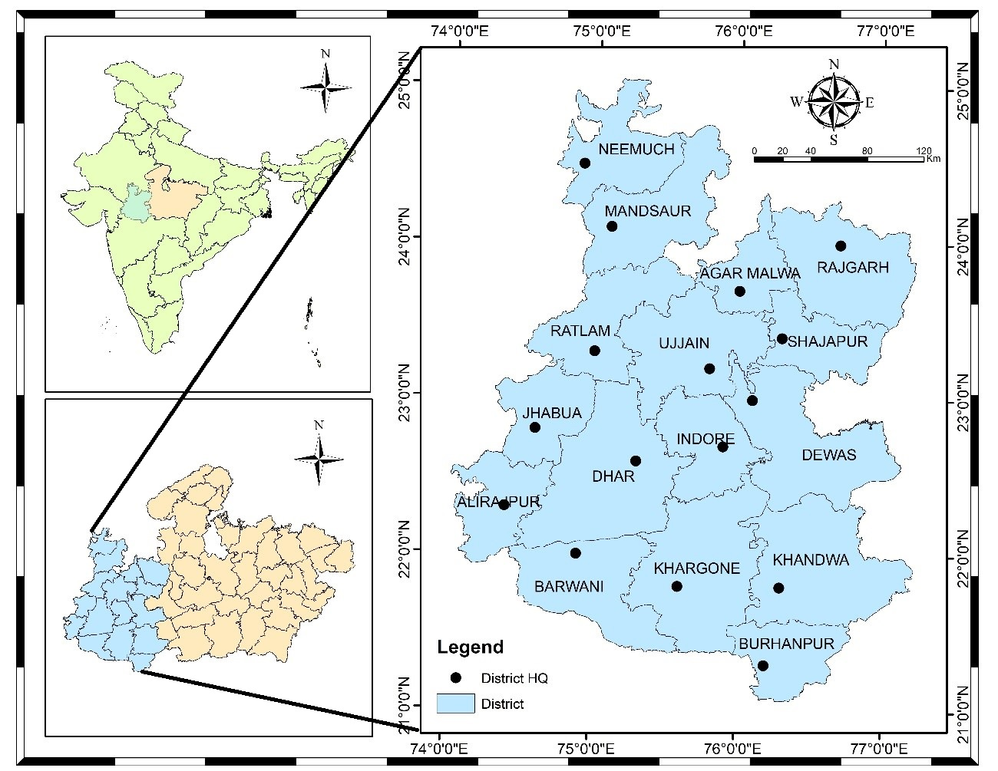

**Fig. 1. Map of Malwa Region**

There are various rivers which egresses from this plateau and they are: Mahi, Chambal, Gambhi, Kshipra, Kalisindh, Parvati etc. All the above rivers flow from west to east direction due to the physical Slope of India. Malwa Region is drained by two river systems belonging to The Arabian Sea and The Bay of Bengal. Most of the areas (including north, north-west, central, northeast and east) of the region is drained by Chambal, Sindh and Betwa with their tributaries belonging to the Bay of Bengal drainage system while the rest of the area (south-east, south-west and southern) is drained by Mahi, Tapi and Narmada with their tributaries belonging to the Arabian Sea drainage system.

Most of the part of Malwa Region is covered by black soil which is formed due to erosion of basalt rocks of Deccan Traps. It is popularly known as "Black Cotton Soil" because of its dark brown color and suitability for growing cotton. It is very fertile soil which is, in India, also known as ‘regur’ soil. It is mostly clay soil and form deep cracks during dry season. An accumulation of time is generally noticed at varying depths. Regur soil is deficient in nitrogen, phosphoric acid and organic matter but rich in calcium, potash and magnesium.

### Data collection

Daily rainfall data for 16 districts of Malwa region was collected by India meteorological department, Pune. At a resolution of 0.25*0.25, the rainfall gridded data was downloaded in grd format for the years 1980–2023 [24]. On the other hand, the analysis for the years 1980 to 2023 in this study was done using the grd format. IMD grid extractor software was used to extract the data.

# METHODOLOGY

This section includes the description about the study area, collection of required data, statistical analysis of data and methods used to achieve research objective. The study involves the examination of rainfall variability using statistical tests, coefficient of variation, standard deviation, estimation of meteorological drought by rainfall departure analysis its characteristics as per their classification, at the end of the chapter, Drought frequency and severity analysed and the spatial representation of these analysis in the study area have done in this chapter.

### Homogeneity, Randomness and Autocorrelation Test

A homogeneity test for rainfall data is essential in hydrological and climatological investigations to confirm the data's dependability and consistency throughout time. Rainfall data, which is commonly collected over extended periods of time, can be influenced by a variety of factors, including changes in measuring techniques, the relocation of weather stations, and environmental changes. These factors might cause non-climatic movements or trends in the data, leading to incorrect conclusions if not discovered and corrected. In the present study non-parametric Pettitt’s test was carried out at 95% level of significance (alpha=0.05) to test the homogeneity in the annual rainfall time series of 16 district of Malwa region. Assume that the null hypothesis at the time of applying this test is homogenous data over the entire period. If the computed "p" value is larger than the significance level alpha=0.05, the null hypothesis (H0) cannot be rejected. The alternative hypothesis (Ha) should be accepted and the null hypothesis (H0) should be rejected if the computed p-value is less than the significance level alpha = 0.05. The formulas involved in the Pettitt test are as follows.

* **Rank the data:**

Rank the data point X1, X2,……,Xn in the time series.

* **Calculate the rank sum Rt :**

For the data point t, calculate the rank sum of the first t data points,

$R_{t}=\sum_{i=1}^{t}{R(X_{i})} …(1)$

where R(Xi) is the rank of the ith observation in the entire series.

* **Compute the Test Statistic Ut :**

For each time point t, compute the Pettitt test statistic.

$$U_{t}=2R_{t}-t\left(n+1\right) …(2)$$

where n is the total number of observations

* **Identify the Change Point (k):**

The test statistic k is defined as the maximum absolute value of Ut​.

The Durbin-Watson test is a widely used statistical test to detect the presence of autocorrelation in the residuals from a regression analysis. Autocorrelation, particularly in time series data like rainfall, can indicate that the residuals (errors) are not independent, which violates one of the key assumptions of ordinary least squares regression. In the present study, the Durbin-Watson autocorrelation test was used to test the presence of autocorrelation or randomness in the data set. The autocorrelations near-zero or zero indicates the presence of randomness in the data set and when the autocorrelations are significantly non-zero indicate the non-random or auto correlated data set. The Durbin-Watson statistic ranges from 0 to 4, where a value near 2 suggests no autocorrelation, a value close to 0 indicates positive autocorrelation, and a value approaching 4 indicates negative autocorrelation. A thumb rule is that test statistic values in the range of 1.5 to 2.5 are relatively normal [25]. A normally auto correlated rainfall data was found more suitable for the analysis as it reduces the variability and improve predictive power of the results. A negative correlation may lead to bias in trend analysis, misleading statistical significance, and greater variability during statistical analysis which may be taken care during interpretation of results. The Durbin-Watson statistic‘d’ is calculated using the following Equation (4)

$$d= \frac{\sum_{t=2}^{n}{{\left(e_{t}-e_{t-1}\right)}^{2}}}{\sum_{t=1}^{n}{e_{t}^{2}}} …(4)$$

Where,

et is the residual (difference between observed and predicted values) at time t

n is the number of observations.

### Rainfall Variability Assessment

Rainfall variability refers to the inconsistencies in rainfall patterns observed over different timescales, ranging from short-term fluctuations (such as daily or monthly changes) to long-term trends (annual or decadal variations). These variations include differences in the quantity, intensity, duration, and timing of rainfall. Factors like geographic location, atmospheric conditions, and climate change significantly influence rainfall variability [26]. Understanding and managing rainfall variability is crucial for ensuring sustainable development in this vulnerable area. The area has seen enormous variations in precipitation in recent years, from severe droughts to flooding. As per study [27], the growing fluctuations in rainfall have intensified the scarcity of water and decreased crop production, impacting the means of subsistence for smallholder farmers, who make up the bulk of the populace in Malwa region. To assess the spatial and temporal variability associated with the rainfall in 16 districts of Malwa region, the statistical analysis of annual, pre-monsoon, monsoon, post-monsoon, and winter rainfall as well as rainy days were carried out to compute the mean, standard deviation, coefficient of variation.

### Statistical Mean

The average or mean used to determine the central tendency of the data is called the statistical mean. Equation (5) is used to compute it by adding up all of the data points in a population and dividing the result by the total number of data points.

$$\overline{X}=\frac{\sum_{i=1}^{N}{X_{i}}}{N} …(5)$$

where,

$\overline{X}$ is the mean value of observations

Xi is the ith data value

N is the total number of data

### Standard Deviation

The standard deviation, which expresses the dispersion of the dataset with relation to its mean, is the square root of the variance.A low standard deviation suggests values are close to the sample mean, while a high standard deviation shows values are spread out over a larger range. The variance and standard deviation have been calculated using Equations (6 and 7)

$$S^{2}= \frac{\sum_{i=1}^{n}{{\left(x_{i}-\overline{x}\right)}^{2}}}{\left(n-1\right)} …(6)$$

$$SD=\sqrt{\frac{\sum_{i=1}^{n}{{\left(x_{i}-\overline{x}\right)}^{2}}}{\left(n-1\right)}} …(7)$$

where,

S2 is the sample Variance

SD is the Standard Deviation

xi is the observation value

$\overline{x}$ is the mean value of observations

n is the number of observations

### Coefficient of Variation (CV)

A standardized measurement of the dispersion of a probability or frequency distribution is the coefficient of variation, sometimes referred to as the relative standard deviation. The standard deviation to mean ratio is used to express it. The coefficient of variation is a dimensionless quantity that is computed using Equation (8) and is commonly given as a percentage. By comparing two data sets according to the degree of variance, it is possible to comprehend the intricate picture of rainfall variability throughout location and time.

$$CV=\frac{SD}{\overline{X}}×100 …(8)$$

where,

CV is the coefficient of variation

SD is the Standard Deviation

$\overline{X}$ is the mean of the observation value

### Extreme values of climatic parameters

To evaluate the features linked to rainfall and temperature extremes, statisticians must determine sample maximum and minimum values of climatic variables that differ from location to location and season to season. The maximum and minimum values of various temperature and rainfall statistics from every station were used in the analysis for this study.

### Seasonal rainfall contribution and Precipitation Concentration Index (PCI)

The Precipitation concentration index is used as statistical descriptors of rainfall variability. The PCI values are calculated as given by Oliver (1980) and are described in equation…..

$$PCI=100*\left[\sum{\frac{{Pi}^{2}}{{\left(\sum{Pi}\right)}^{2}}}\right] ...(9)$$

Where,

Pi= The rainfall of the ith month

∑= Summation over the 12 months

According to Oliver (1980), the PCI values of the less than 10 indicates the uniform monthly distribution of rainfall, the values between 11 to 20 indicate high concentration, and the values above 21 indicate very high concentration.

### Standardized Rainfall Anomalies (SRA)

Standardized Rainfall Anomalies(SRA) were calculated and graphically presented to evaluate inter-annual fluctuations of rainfall in the study area over the period of observation. It is described by the equation below:

$$SRA=\frac{\left(P_{t}-P_{m}\right)}{s} ….(10)$$

Where,

SRA= Standardized rainfall anomaly

Pt= Annual rainfall in t year

Pm= The long-term mean annual rainfall over the period of observation

S= The standard deviation of annual rainfall over the period of observation

The drought severity classes are extreme drought (SRA<-1.65), Severe drought (-1.28>SRA>-1.65), moderate drought (-0.84>SRA>-1.28) and no drought (SRA>-0.84).

### Rainfall Departure Analysis

The measurement of actual rainfall variations from long-term averages is a critical process in rainfall departure analysis, which is useful for planning agricultural impacts, managing water resources, and comprehending hydrological patterns. In this research work drought frequency, return period, and severity have all been assessed using the rainfall departure analysis of yearly rainfall. If the annual rainfall shortfall is more than or equal to 25% of the long-term norm, the year is deemed to be in a drought [28,29]. Droughts are further categorized based on how severe they are: a moderate drought occurs when the annual rainfall shortfall falls between 25% and 50%, while a severe drought occurs when the rainfall deficit exceeds 50%. The researcher [30,31], have carried out an analysis to identify droughts, their frequency and magnitudes in selected areas of Malwa region and India. To diagnose meteorological drought, it's important to include region-specific atmospheric conditions, as precipitation deficits vary greatly among regions (NDMC). In this study, drought years were identified using at more than 25% deficiency of annual and seasonal rainfall departure (D) which have been calculated using Equation (11). The frequency and return period of droughts were calculated for further analysis using Equations (12 and 13).

$$Rainfall Departure \left(D\right)=\left(\frac{X_{i}-X_{m}}{X_{m}}\right)*100 …(11)$$

where Xi and Xm are annual rainfall and mean annual rainfall respectively.

$$Frequency \left(F\right)= \frac{Total No. of drought in the period}{Total No. of year} …(12)$$

$$Return period=\frac{Total No. of year}{Total No. of drought in the period } …(13)$$

### Probability distribution analysis

The probability distribution analysis of rainfall is very important for the investigation of extreme events occurrence. An area can be considered drought-prone if the probability of exceedance 75% of normal rainfall is less than 80% [32]. Researcher [33] have carried out studies to identify drought-prone areas in Madhya Pradesh at 75% of average annual rainfall and in Malwa region, [34] has carried out study to identify drought prone area at 80% of average annual rainfall to assessment of drought proneness. For computing the probability of exceedance (P), Weibull’s distribution was fitted to the ranked annual rainfall data using Equation (14).

$$P= \left(\frac{M}{N+1}\right)*100 …(14)$$

Where, M is the rank and N is the number of years of data used.

# RESULTS AND DISCUSSION

The analysis has been carried out to assess rainfall variability and drought characteristics of 16 districts western part Madhya Pradesh state using long-term rainfall data with the help of statistical tests, Rainfall Departure analysis and Probability Distribution analysis.

### Homogeneity, Randomness and Autocorrelation Test of rainfall data

Climate data homogenization is crucial because non-climatic variables that are included in the data collecting process during monitoring could lead to data that is not reflective of the real climate, which could have an impact on the findings of hydrological and climatic studies. The Pettitt’s test has been applied for assessment of homogeneity and Durbin-Watson test statistics has been applied for assessment of randomness and autocorrelation in the data set of 16 stations of western part Madhya Pradesh and results are shown in Table 1.

**Table 1: Durban-Watson statistics and Pettitt’s test of rainfall of Malwa Plateau, Nimar Valley and Jhabua Hills**

|  |  |  |  |  |  |  |
| --- | --- | --- | --- | --- | --- | --- |
| **Agro-climatic Zones** | **District** | **Annual RF (mm)** | **Randomness & Autocorrelation** | | **Homogeneity** | |
|  |  |  | **D-W Test statistics** | **Interpretation** | **Pettitt's Test statistics** | **Interpretation** |
| **Malwa Plateau** | **Agar Malwa** | 1001 | 1.79 | PA | 0.55 | H |
| **Dewas** | 908 | 2.23 | NA | 1.00 | H |
| **Dhar** | 941 | 2.17 | NA | 0.31 | H |
| **Indore** | 991 | 2.31 | NA | 0.77 | H |
| **Mandsaur** | 824 | 2.10 | NA | 0.12 | H |
| **Neemuch** | 867 | 1.65 | PA | 0.00 | NH |
| **Rajgarh** | 974 | 1.97 | PA | 0.11 | H |
| **Ratlam** | 1018 | 2.05 | NA | 0.24 | H |
| **Shajapur** | 1006 | 2.11 | NA | 0.25 | H |
| **Ujjain** | 986 | 2.19 | NA | 0.29 | H |
| **Nimar Valley** | **Badwani** | 653 | 1.92 | PA | 0.80 | H |
| **Burhanpur** | 807 | 1.30 | PA | 0.12 | H |
| **Khandwa** | 979 | 1.02 | PA | 0.00 | NH |
| **Khargone** | 786 | 2.07 | NA | 0.71 | H |
| **Jhabua Hills** | **Alirajpur** | 838 | 1.89 | PA | 0.17 | H |
| **Jhabua** | 892 | 1.77 | PA | 0.03 | NH |

*H= Homogeneous, NH = Non-Homogeneous, PA = Positive Autocorrelated, NA = Negative Autocorrelated*

From the analysis of results shown in Table 1, it was observed that the annual rainfall data from 1980 to 2023 was homogeneous at all station except at Neemuch, Khandwa and Jhabua where the p-values were lower than the significance level alpha=0.05. The annual rainfall time series data was found to be relatively normal for most of the districts where the Durbin- Watson (D-W) statistic was found lying between 1.5 to 2.5. All stations have shown negative autocorrelation in the data set as the D-W test statistic was found higher than 2 except Agar Malwa, Neemuch, Rajgarh, Badwani, Burhanpur, Khandwa, Alirajpur and Jhabua where the D-W test statistics was observed lower than 2. A normally autocorrelated rainfall data was found more suitable for the analysis as it reduces the variability and improve predictive power of the results. A negative correlation may lead to bias in trend analysis, misleading statistical significance, and greater variability during statistical analysis which may be taken care during interpretation of results.

### Variability Analysis of rainfall

Rainfall variability refers to the inconsistencies in rainfall patterns observed over different timescales, ranging from short-term fluctuations (such as daily or monthly changes) to long-term trends (annual or decadal variations). These variations include differences in the quantity, intensity, duration, and timing of rainfall. Factors like geographic location, atmospheric conditions, and climate change significantly influence rainfall variability.Rainfall variability in the Western region of Madhya Pradesh has significant implications for agriculture, water resource management, and socio-economic stability. Rainfall variability has been carried out using statistical analysis of 16 districts of western part of Madhya Pradesh for 44 years of rainfall data. This statistical study was carried out to assess the mean, standard deviation, and coefficient of variation of the temporal and spatial variation in rainy days and rainfall of the monsoon, post-monsoon, winter rainfall, pre-monsoon, and annual, as shown in Table 2 and its variances have been described by spatial maps, as shown in the Fig. 2 to Fig. 4.

|  |  |  |  |  |  |  |  |  |  |  |  |  |  |  |  |  |  |  |  |  |  |  |  |
| --- | --- | --- | --- | --- | --- | --- | --- | --- | --- | --- | --- | --- | --- | --- | --- | --- | --- | --- | --- | --- | --- | --- | --- |
| **Agro-climatic Zones** | **District** | **Annual** | | | | **Pre-monsoon** | | | **Monsoon** | | | | **Post-monsoon** | | | | **Winter rain** | | | | **Rainy Day** | | |
| **Avg** | **Std Dev** | **CV** | **PCI** | **Avg** | **Std Dev** | **CV** | **Avg** | **Std Dev** | **CV** | **PCI** | **Avg** | **Std Dev** | **CV** | **Avg** | | **Std Dev** | **CV** | **Avg** | | **Std Dev** | **CV** |
| **Malwa Plateau** | **Agar Malwa** | 1001.4 | 330.2 | 33.0 | 32.14 | 13.6 | 25.3 | 185.5 | 940.1 | 319.8 | 34.0 | 35.9 | 38.8 | 60.4 | 155.6 | 8.9 | | 21.9 | 245.8 | 39.1 | | 8.2 | 21.0 |
| **Dewas** | 907.9 | 241.7 | 26.6 | 31.69 | 4.9 | 12.3 | 251.6 | 854.2 | 239.7 | 28.1 | 34.6 | 43.6 | 54.9 | 126.0 | 5.3 | | 15.7 | 296.0 | 42.0 | | 9.6 | 22.9 |
| **Dhar** | 940.6 | 257.3 | 27.4 | 30.14 | 9.3 | 20.8 | 223.8 | 877.4 | 260.8 | 29.7 | 33.8 | 48.9 | 53.3 | 109.1 | 5.0 | | 11.2 | 222.3 | 45.7 | | 9.9 | 21.8 |
| **Indore** | 990.7 | 246.2 | 24.8 | 29.21 | 16.8 | 15.8 | 94.0 | 913.2 | 229.4 | 25.1 | 33.7 | 51.2 | 55.1 | 107.5 | 9.5 | | 15.5 | 163.7 | 46.0 | | 9.7 | 21.0 |
| **Mandsaur** | 823.9 | 231.5 | 28.1 | 32.81 | 10.4 | 13.5 | 129.2 | 770.7 | 233.1 | 30.2 | 37 | 35.4 | 47.8 | 135.0 | 7.3 | | 15.7 | 214.1 | 37.8 | | 9.0 | 23.9 |
| **Neemuch** | 866.7 | 311.3 | 35.9 | 35.08 | 12.5 | 21.2 | 170.2 | 807.1 | 295.7 | 36.6 | 39.5 | 41.2 | 57.1 | 138.3 | 5.8 | | 9.8 | 168.6 | 41.0 | | 13.2 | 32.1 |
| **Rajgarh** | 974.1 | 331.1 | 34.0 | 32.54 | 18.0 | 22.7 | 126.6 | 891.1 | 308.9 | 34.7 | 38.2 | 47.8 | 77.3 | 161.7 | 17.3 | | 26.1 | 150.3 | 42.8 | | 10.5 | 24.5 |
| **Ratlam** | 1018.1 | 334.5 | 32.9 | 34.54 | 4.3 | 15.8 | 367.1 | 966.9 | 331.7 | 34.3 | 37.7 | 45.4 | 66.4 | 146.3 | 1.5 | | 5.1 | 342.2 | 43.6 | | 10.4 | 23.8 |
| **Shajapur** | 1006.1 | 287.2 | 28.5 | 30.34 | 19.7 | 26.5 | 134.4 | 928.8 | 283.1 | 30.5 | 35 | 43.8 | 57.8 | 132.0 | 13.8 | | 21.3 | 154.4 | 47.8 | | 7.9 | 16.5 |
| **Ujjain** | 986.0 | 297.2 | 30.1 | 30.03 | 17.7 | 25.6 | 145.0 | 911.1 | 299.9 | 32.9 | 34.8 | 44.2 | 56.8 | 128.5 | 13.1 | | 21.3 | 163.1 | 41.3 | | 9.8 | 23.8 |
| **Average** | 951.6 | 286.8 | 30.1 | 31.9 | 12.7 | 20.0 | 182.7 | 886.1 | 280.2 | 31.6 | 36 | 44.0 | 58.7 | 134.0 | 8.8 | | 16.4 | 212.1 | 42.7 | | 9.8 | 23.1 |
| **Nimar Valley** | **Badwani** | 652.7 | 281.6 | 43.1 | 28.98 | 10.2 | 23.4 | 229.8 | 598.6 | 266.6 | 44.5 | 33 | 41.8 | 59.0 | 141.1 | 2.1 | | 5.1 | 242.5 | 36.3 | | 12.5 | 34.4 |
| **Burhanpur** | 807.5 | 289.4 | 35.8 | 28.39 | 15.7 | 25.0 | 159.3 | 726.3 | 262.6 | 36.2 | 33.9 | 55.4 | 54.9 | 99.0 | 10.1 | | 17.6 | 174.4 | 42.5 | | 10.9 | 25.7 |
| **Khandwa** | 978.6 | 408.4 | 41.7 | 28.1 | 16.8 | 27.4 | 163.1 | 885.3 | 405.3 | 45.8 | 33.1 | 63.8 | 61.2 | 95.9 | 12.8 | | 24.9 | 194.7 | 44.5 | | 8.7 | 19.5 |
| **Khargone** | 786.4 | 253.9 | 32.3 | 27.3 | 13.8 | 23.4 | 169.6 | 708.7 | 253.5 | 35.8 | 32.8 | 56.6 | 50.3 | 88.8 | 7.3 | | 11.6 | 158.3 | 40.3 | | 8.7 | 21.6 |
| **Average** | 806.3 | 308.3 | 38.3 | 28.2 | 14.1 | 24.8 | 180.5 | 729.7 | 297.0 | 40.6 | 33.2 | 54.4 | 56.3 | 106.2 | 8.1 | | 14.8 | 192.5 | 40.9 | | 10.2 | 25.3 |
| **Jhabua Hills** | **Alirajpur** | 838.1 | 317.0 | 37.8 | 31.69 | 9.5 | 27.7 | 289.9 | 787.7 | 308.4 | 39.1 | 35.4 | 39.0 | 39.5 | 101.3 | 1.9 | | 4.1 | 216.7 | 41.1 | | 9.3 | 22.7 |
| **Jhabua** | 892.3 | 296.2 | 33.2 | 31.21 | 6.4 | 19.8 | 311.3 | 841.6 | 306.2 | 36.4 | 34.5 | 42.3 | 48.6 | 114.9 | 2.1 | | 5.6 | 268.8 | 40.0 | | 10.0 | 25.0 |
| **Average** | 865.2 | 306.6 | 35.5 | 31.4 | 8.0 | 23.8 | 300.6 | 814.7 | 307.3 | 37.8 | 34.9 | 40.6 | 44.0 | 108.1 | 2.0 | | 4.9 | 242.7 | 40.6 | | 9.7 | 23.9 |

**Table 2. Descriptive Statistics of Rainfall in 3 Agro climatic Zones of Western Madhya Pradesh**

Table 2 gives an overview of the amount of rainfall in each of the 16 districts in the Western Madhya Pradesh. To aid in understanding, the entire study area has been divided into three agro-climatic regions: Malwa Plateau, Nimar Valley and Jhabua Hills. These districts are situated in the whole western part of Madhya Pradesh state. The statistical analysis has been shown in Table 2 Owing to the existence of a Vindhya range subcategory (Bhander Chains) in the north, the Aravali range in the west and Bundelkhand in the east of the study area.The Ratlam district of Malwa region had the most rainfall. The average annual, monsoon were found similar and pre-monsoon rainfall were found to be dissimilar; average annual were found to be highest in Ratlam and and lowest in Badwani district, average pre-monsoon were found to be highest in Shajapur which is 19.4 and lowest in ratlam which is 4.3mm and monsoon rainfall with magnitudes ranging from 966.9 to 598.6 mm, respectively. The post-monsoon rainfall average was found to be highest (63.8 mm) in Khandwa and lowest (35.4 mm) in Mandsaur. Rajgarh and Ratlam districts experienced the highest and lowest average winter rainfall 17.3 mm and 1.5 mm, respectively. The average number of rainy days was found to be highest in Shajapur (48 days), and lowest in Badwani district (36 days). The annual and monsoon PCI (Precipitation Concentration Index) values, derived from monthly rainfall data between 1980 and 2023, are presented in Table 2. During the annual period, PCI values ranged from 27.3% to 35.1%, while during the monsoon season, they varied between 32.8% and 39.5%. The highest PCI values were observed in the northern and northeaster parts of the study area, whereas the southern and south-western regions exhibited the lowest PCI values, around 33.0%. As illustrated in Table 2, the PCI results highlight an uneven monthly rainfall distribution across most stations during the annual period. Similarly, the seasonal PCI values suggest a heterogeneous pattern of rainfall distribution during the monsoon. Furthermore, it was observed that the PCI values exceeded 30% across the majority of western Madhya Pradesh, indicating a high degree of rainfall irregularity during both the annual and monsoon periods.

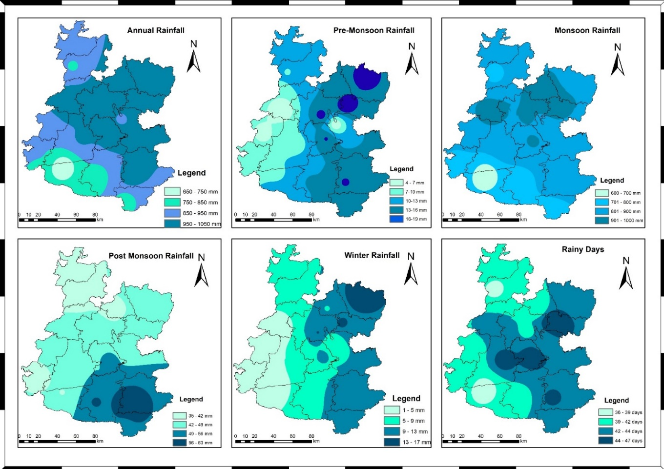

**Figure. 2. Average rainfall distribution in Western Madhya Pradesh for the period of 1980-2023**

From the Fig. 2 it was observed that north-eastern part of the western Madhya Pradesh were received more average rainfall in annual, pre-monsoon and monsoon and least rainfall received at Northern part. Higher Post-monsoon rainfall received at southern part whereas least at from the northern part. Winter rainfall was observed lowest in west portion of Madhya Pradesh e.g. Ratlam, Jhabua, Alirajpur and part of Dhar and Barwani whereas highest in east portion e.g. Rajgarh and part of Shajapur district. North and west portion of western Madhya Pradesh was received less rainy days while south and east portion respectively.

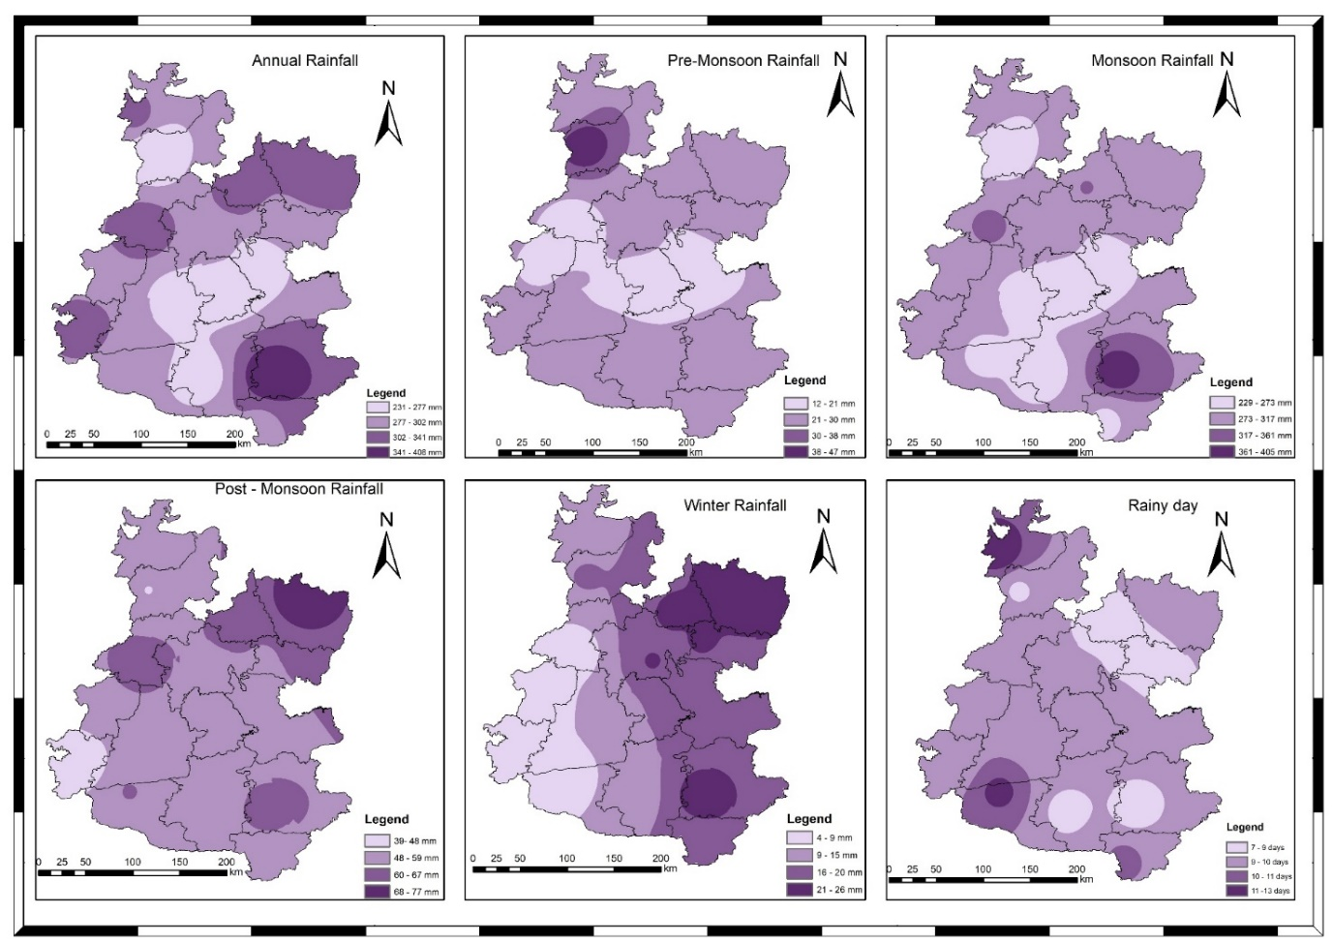

**Figure.3. Average Standard deviation distribution in Western Madhya Pradesh for the period of 1980-2023**

Important statistical indicators that can provide a complex picture of rainfall on both a spatial and temporal scale are the Standard Deviation (SD), which measures a dispersion in the dataset and the Coefficient of Variation (CV), which depends on inter-annual rainfall variation. These are described in detail in Table 2 and spatial distribution displayed in Fig. 3 and Fig. 4 the SD of average annual rainfall was observed highest at Khandwa (408.4 mm) and lowest at Mandsaur (231.5 mm) and CV for average annual rainfall was observed highest for Badwani (43.1%) and lowest for Indore district with 24.8%. It was observed that SD of pre-monsoon rainfall is highest at Alirajpur (27.7 mm) and highest Ratlam 367.1% of CV and lowest SD was found at Dewas (12.3 mm), the lowest CV was observed at Indore district which was 94% for pre-monsoon rainfall. For the monsoon rainfall highest SD was observed for Ratlam district which was 966.9 mm, highest CV was found 45.8% for Khandwa and lowest SD was observed at Indore (229.4 mm), lowest CV was found 25.1% at Indore. For the post-monsoon rainfall, the maximum SD was observed at Rajgarh district (77.3 mm) with 161.7% CV and the lowest SD was observed at Alirajpur district which was 39.5 mm and the lowest CV was found 88.8% at Khargone district. Winter rainfall was observed that, the highest SD and CV were found at Rajgarh district (26.1 mm) and Ratlam (342.2%) respectively, and the lowest SD and CV were found at Alirajpur (4.1 mm) and Rajgarh (150.3%) respectively. In western Madhya Pradesh state it was observed that the lowest SD and CV were found at Shajapur district which was 7.9 days with 16.5% variance and the highest SD was found at Neemuch district (13.2 days) and highest CV was found at 34.4% for Badwani district.

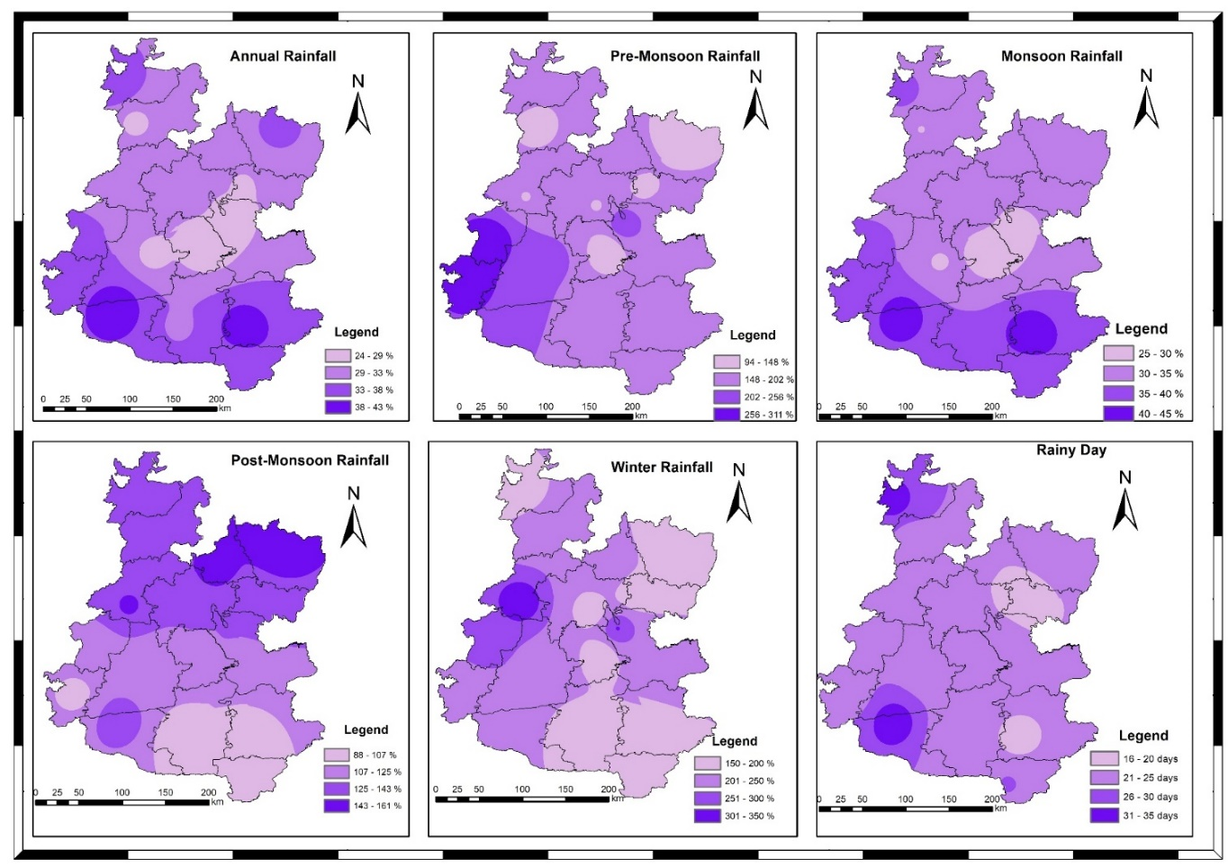

**Figure. 4. Average coefficient of Variance distribution in Western Madhya Pradesh for the period of 1980-2023**

According to the Fig. 3 It has been shown that the southern part of the Western Madhya Pradesh has the highest standard deviation, meaning that there is a greater chance of rainfall variance in this area. On the other hand, the middle of the Western Madhya Pradesh experiences lower rainfall due to its topography, as there are no hills or other obstructions that could cause orographic precipitation. The south-west part of the western Madhya Pradesh has the lowest rainfall, as indicated by the Fig.2, and the lowest standard deviation and coefficient of variance. Accordingly, the south west part of Madhya Pradesh had a relatively high coefficient of variance, whereas the middle part had a low value. The SD of rainy days was found to be highest in the northern and southern part and decrease in the value as one moves eastward.

### Standardized Rainfall Anomalies (SRA)

The Standardized Rainfall Anomalies (SRA) values is calculated for the Malwa region, it is shown that for the Khandwa district the first driest year is 1992 with -1.2%, second driest year is 2000 with -1,2%. Figure 3. shows the standard anomaly of the annual rainfall of the stations with the highest SRA value within each agroclimatic zone. Table 3 shows the driest and wettest years based on Standard Anomalies of annual rainfall analysis in 16 districts. SRA values were found negative during the dry years and positive during wet years. The driest SRA i.e. highest negative anomaly was observed -2.5 at Rajgarh in Malwa Plateau. Similarly, the higher negative anomalies were also seen at Rajgarh, Khandwa. The highest positive SRA anomaly was seen 4.0 at Mandsaur, Badwani and Agar Malwa. The higher positive SRA was also seen at Khandwa, Indore and Badwani spread in different agroclimatic zones. Rainfall in Madhya Pradesh exhibits substantial decadal variability, i.e. persistence; a year with a negative anomaly is more likely to be followed by another year with a negative anomaly, as is also seen with a positive anomaly.

The Standardized Rainfall Anomaly (SRA) values were calculated for the Malwa region to assess inter-annual rainfall variability. Table 3 presents the driest and wettest years across 16 districts based on the SRA analysis. Negative SRA values corresponded to dry years, while positive values indicated wet years. The most extreme negative anomaly, with an SRA of -2.5, was recorded at Rajgarh in the Malwa Plateau. Significant negative anomalies were also observed in Rajgarh and Khandwa districts. Conversely, the highest positive SRA value of 4.0 was recorded at Mandsaur, Barwani, and Agar Malwa. Elevated positive anomalies were also evident in Khandwa, Indore, and Barwani, which are distributed across different agro-climatic zones. Overall, rainfall in Madhya Pradesh demonstrates substantial decadal variability, characterized by persistence, wherein a year exhibiting a negative anomaly is likely to be succeeded by another year with a negative anomaly, and similarly for positive anomalies. Standardized Rainfall Anomaly also showed by graph in figure 5 (a&b) for Khandwa and Rajgarh district.

**Table 3 Standardized Rainfall Anomaly for 16 district of Malwa region**

|  |  |  |  |  |  |  |  |  |
| --- | --- | --- | --- | --- | --- | --- | --- | --- |
| **District** | **1st driest year** | **SRA** | **2nd driest year** | **SRA** | **1st wettest year** | **SRA** | **2nd wettest year** | **SRA** |
| **Agar Malwa** | 2001 | -1.6 | 1989 | -1.3 | 2015 | 3.3 | 2006 | 2.3 |
| **Dewas** | 2005 | -1.9 | 1989 | -1.7 | 2013 | 1.9 | 2019 | 1.6 |
| **Dhar** | 1991 | -1.3 | 1987 | -1.3 | 2022 | 2.0 | 1994 | 2.0 |
| **Indore** | 2000 | -1.5 | 2001 | -1.4 | 2022 | 3.0 | 2013 | 2.3 |
| **Mandsaur** | 2000 | -1.8 | 2020 | -1.7 | 2019 | 4.0 | 2023 | 1.9 |
| **Neemuch** | 1986 | -1.9 | 1988 | -1.6 | 2019 | 3.2 | 2006 | 1.7 |
| **Rajgarh** | 1989 | -2.5 | 2005 | -2.2 | 2011 | 1.9 | 2019 | 1.6 |
| **Ratlam** | 2014 | -1.7 | 2001 | -1.6 | 2006 | 3.0 | 2013 | 1.7 |
| **Shajapur** | 2005 | -1.5 | 2000 | -1.3 | 2015 | 2.9 | 2006 | 2.4 |
| **Ujjain** | 1991 | -1.8 | 1985 | -1.7 | 2006 | 2.3 | 2015 | 2.1 |
| **Badwani** | 2018 | -1.4 | 2012 | -1.1 | 2022 | 3.5 | 1994 | 2.3 |
| **Burhanpur** | 2009 | -1.7 | 2008 | -1.6 | 1993 | 2.4 | 1988 | 1.7 |
| **Khandwa** | 1992 | -1.2 | 2000 | -1.2 | 2019 | 3.2 | 2013 | 2.4 |
| **Khargone** | 1995 | -1.7 | 2005 | -1.6 | 1988 | 2.0 | 1981 | 0.0 |
| **Alirajpur** | 1985 | -1.4 | 1991 | -1.3 | 2006 | 2.5 | 2006 | 2.0 |
| **Jhabua** | 1985 | -2.0 | 2000 | -1.8 | 2006 | 2.7 | 2004 | 1.8 |

**Fig. 5(a). Standardized Rainfall Anomalies of Khandwa district**

**Fig. 5(b). Standardized Rainfall Anomalies of Rajgarh district**

### Drought assessment

In this study, the drought assessment has been carried out using rainfall departure analysis and probability distribution analysis approach in 16 districts of western part of Madhya Pradesh which is discussed in details in this section.

### Rainfall Departure Analysis

The departure analysis of annual and monsoon rainfall has been carried out of 16 districts of western part of Madhya Pradesh to evaluate drought frequency, return period and drought severity/vulnerability, although all these characteristics are further estimated by drought indices. The district wise drought frequency analysis based on annual and monsoon rainfall departure analysis at 75% has been shown below in Tabular format. By the rainfall departure analysis, it was observed that the (North part) that is Malwa region experienced highly rainfall deficit as compare to Nimar valley and Jhabua Hills that is South part of the Western Madhya Pradesh because presence of Vindhyan hill’s sub division. The rainfall departure at typical stations from different district is shown in Fig. 6 to Fig. 8. From these Fig.s it has been shown that the highest annual rainfall departure in Rajgarh district was observed -85.59% in year 1989 and highest monsoon rainfall departure –86.02% in 1989. Highest Annual rainfall departure and monsoon rainfall departure at Burhanpur district was observed -53.7% and -55,9% in 1989. It was observed that the highest annual and monsoon rainfall departure -51.47 and -48.42% in 2005 at Dewas district.

**Fig. 6. Annual and monsoon rainfall departure at Rajgarh district**

**Fig. 7. Annual and monsoon rainfall departure at Burhanpur district**

**Fig. 8. Annual and monsoon rainfall departure at Dewas district**

### Analysis of drought characteristics for annual and monsoon season

The India Meteorological Department states that when the annual or seasonal rainfall deficit exceeds 25% of the long-term normal rainfall, the year can be classified as a drought year. The drought frequencies evaluated using annual and monsoon rainfall at all districts of Western Madhya Pradesh has been shown in Table 4 and the spatial representation has been shown in Fig. 10.

**Table 4. Annual and monsoon drought return period and frequency**

|  |  |  |  |  |  |  |  |
| --- | --- | --- | --- | --- | --- | --- | --- |
| **Physical Range** | **District** | **Annual rainfall based analysis** | | | **Monsoon rainfall based analysis** | | |
| **Return Period** | **Drought Frequency** | **Drought Vulnerability** | **Return Period** | **Drought Frequency** | **Drought Vulnerability** |
| **Malwa Plateau** | **Agar Malwa** | 4.0 | 25 | 74.7 | 4.9 | 20.5 | 83.4 |
| **Dewas** | 3.7 | 27.3 | 76.8 | 3.4 | 29.5 | 77.3 |
| **Dhar** | 3.1 | 31.8 | 78.4 | 3.7 | 27.3 | 76.5 |
| **Indore** | 4.4 | 22.7 | 81.7 | 4.9 | 20.5 | 82.7 |
| **Mandsaur** | 5.5 | 18.2 | 88.8 | 4.0 | 25.0 | 88.3 |
| **Neemuch** | 3.1 | 31.8 | 74.8 | 3.1 | 31.8 | 76.6 |
| **Rajgarh** | 3.4 | 29.5 | 75.1 | 3.7 | 27.3 | 74.6 |
| **Ratlam** | 2.9 | 34.1 | 78.3 | 3.7 | 27.3 | 76.8 |
| **Shajapur** | 4.0 | 25.0 | 73.8 | 3.4 | 29.5 | 80.5 |
| **Ujjain** | 3.4 | 29.5 | 75.3 | 3.4 | 29.5 | 77.5 |
| **Average** | 3.76 | 27.50 |  | 3.81 | 26.82 |  |
| **Nimar Valley** | **Badwani** | 2.2 | 45.5 | 65.6 | 2.2 | 45.5 | 56.2 |
| **Burhanpur** | 3.7 | 27.3 | 77 | 4 | 25 | 73.7 |
| **Khandwa** | 2.4 | 40.9 | 63.1 | 2.3 | 43.2 | 66.3 |
| **Khargone** | 3.1 | 31.8 | 74.7 | 3.7 | 27.3 | 72.3 |
| **Average** | 2.86 | 36.36 |  | 3.05 | 35.23 |  |
| **Jhabua Hills** | **Alirajpur** | 2.4 | 40.9 | 67.1 | 2.6 | 38.6 | 67.2 |
| **Jhabua** | 3.7 | 27.3 | 81.0 | 3.7 | 27.3 | 77.2 |
| **Average** | 3.06 | 34.09 |  | 3.13 | 32.95 |  |

From the analysis, it was observed that drought return period for annual rainfall found least at Badwani district as one drought year in 2-3 years which means that the chances of drought occurrence in Badwani district is every 2 to 3 years. The highest drought frequency was observed at Badwani district with the value of 45.45%. from the Table 3. It has been observed that district Dewas, Dhar, Neemuch, Rajgarh, Ujjain, Burhanpur, Khargone, Jhabua experience one drought event every 3 to 4 years. When we consider the monsoon rainfall, we found that the Badwani, Khandwa and Alirajpur district had the shortest drought return period, with chance of one drought occurring every two to three years and drought frequency was 45.45, 43.18 and 2.59%. Indore districts had the longest drought return period, with the chance of one drought occurring every five years, and the drought frequency was observed 22.73% for this district.

The severity of the drought was examined to determine whether districts are vulnerable to drought or not. There are two classifications based on the severity of the drought: normal and drought-prone. A district falls into the drought prone category if its rainfall deficit exceeds 25%, whereas it is considered to be normal if it receives more than 75% of its average rainfall. Table 5 shows the analysis of the drought severity for both annual and monsoon rainfall.

**Table 5. Drought severity of Malwa Plateau, Nimar Valley and Jhabua Hills**

|  |  |  |  |  |  |  |  |
| --- | --- | --- | --- | --- | --- | --- | --- |
| **Physical Range** | **District** | **Annual rainfall based analysis** | | | **Seasonal rainfall based analysis** | | |
|  |  | **75% of Annual RF** | **Probability of Exceedance of 75% of Annual RF** | **Station Characteristics** | **75% of Annual RF** | **Probability of Exceedance of 75% of Annual RF** | **Station Characteristics** |
| **Malwa Plateau** | **Agar Malwa** | 751.07 | 80.24 | Normal | 705.07 | 83.43 | Normal |
|  | **Dewas** | 680.95 | 76.79 | Drought Prone | 640.62 | 77.30 | Drought Prone |
|  | **Dhar** | 705.46 | 78.41 | Drought Prone | 658.02 | 76.47 | Drought Prone |
|  | **Indore** | 743.02 | 81.72 | Normal | 684.89 | 82.73 | Normal |
|  | **Mandsaur** | 617.90 | 88.77 | Normal | 578.02 | 88.27 | Normal |
|  | **Neemuch** | 650.01 | 74.78 | Drought Prone | 605.34 | 76.63 | Drought Prone |
|  | **Rajgarh** | 730.61 | 75.06 | Drought Prone | 668.31 | 74.57 | Drought Prone |
|  | **Ratlam** | 763.60 | 78.33 | Drought Prone | 725.19 | 76.77 | Drought Prone |
|  | **Shajapur** | 754.61 | 79.60 | Drought Prone | 696.63 | 80.47 | Normal |
|  | **Ujjain** | 739.52 | 75.34 | Drought Prone | 683.32 | 77.55 | Drought Prone |
|  | **Average** | 713.67 | 78.90 | Drought Prone | 664.54 | 79.42 | Drought Prone |
| **Nimar Valley** | **Badwani** | 489.54 | 65.57 | Drought Prone | 448.94 | 56.17 | Drought Prone |
|  | **Burhanpur** | 605.60 | 77.02 | Drought Prone | 544.70 | 75.27 | Drought Prone |
|  | **Khandwa** | 733.93 | 63.14 | Drought Prone | 663.95 | 66.33 | Drought Prone |
|  | **Khargone** | 589.80 | 74.74 | Drought Prone | 531.49 | 72.28 | Drought Prone |
|  | **Average** | 604.72 | 70.12 | Drought Prone | 547.27 | 67.51 | Drought Prone |
| **Jhabua Hills** | **Alirajpur** | 628.61 | 67.10 | Drought Prone | 590.80 | 67.24 | Drought Prone |
|  | **Jhabua** | 669.25 | 80.98 | Normal | 631.19 | 77.23 | Drought Prone |
|  | **Average** | 648.93 | 74.04 | Normal | 611.00 | 72.23 | Drought Prone |

From the Table 5. It was observed that all sixteen district twelve district to be identified as drought prone, all the other districts were deemed to be normal. Twelve districts Dewas, Dhar, Neemuch, Rajgarh, Ratlam, Ujjain, Badwani, Burhanpur, Khandwa, Khargone, Alirajpur and Jhabua identified as drought-prone upon examination of the monsoon rainfall, other four districts that is Agar Malwa, Indore, Mandsaur and Shajapur were found to be normal condition. A typical annual and monsoon rainfall probability distribution graph for Rajgarh district has been shown in Fig. 9 (a & b) and a spatial representation of the probability distribution of rainfall in Western Madhya Pradesh has been shown in Fig. 10.

**Fig. 9 (a). Annual Rainfall probability distribution graph at Rajgarh district**

**Fig. 9 (b). Monsoon Rainfall probability distribution graph at Rajgarh district**

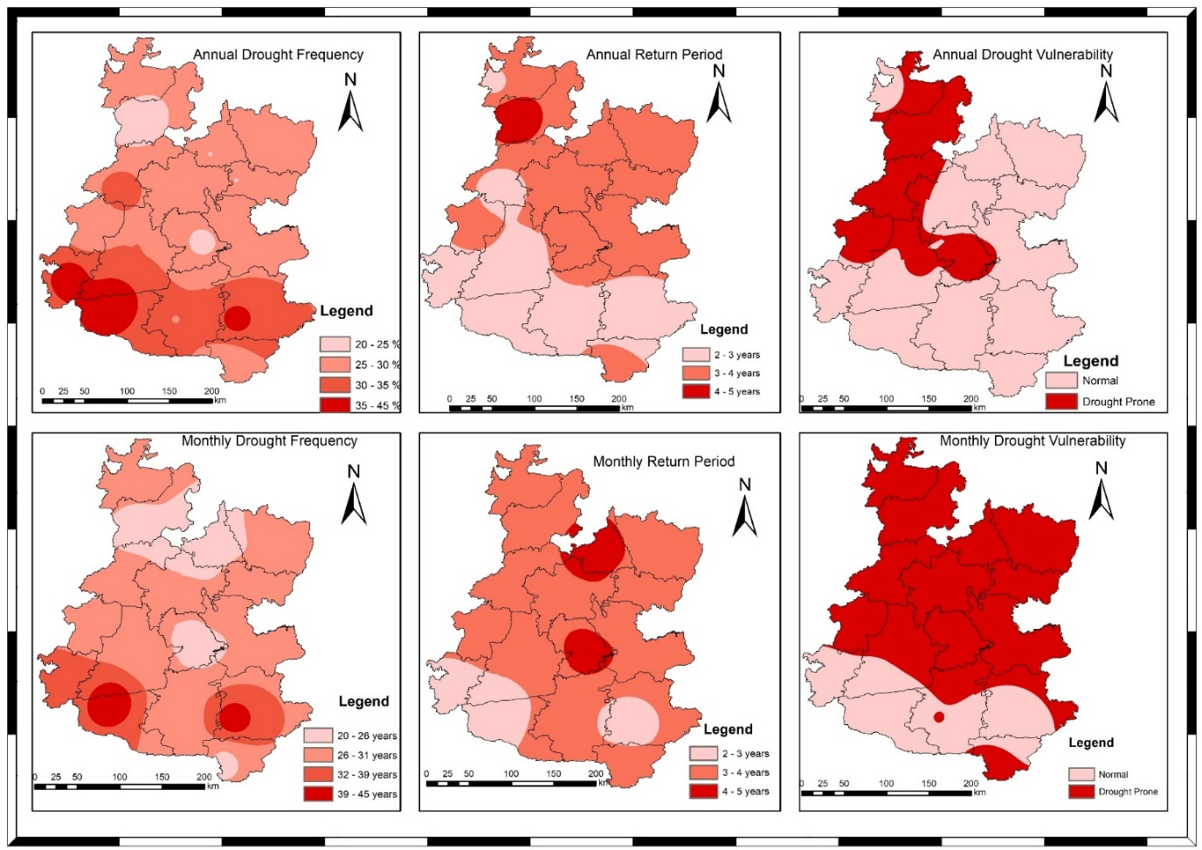

**Figure 10. Drought Frequency, Return Period and Drought vulnerability of both Annual and Monsoon distribution in Western Madhya Pradesh for the period of 1980-2023**

According to the Fig. 10, The northern part that is Malwa region of Western Madhya Pradesh region is recognized as the quickest drought return period because of its plain landscape and absence of mountains, which resulted in less rainfall there, while southern portion of Nimar valley and Jhabua Hills region experience longest drought return period because the presence of subdivision of Vindhyan region. This indicates that the districts which located in Malwa region, experiences more drought events as compare to districts that are located in Nimar valley and Jhabua hills. Drought frequency was found to be lowest in the bottom half of the Nimar Valley and Jhabua Hills region and higher in the top. Severity of drought was observed that drought prone district was found only north part of which is Malwa region which has been shown in Fig. 10.

# SUMMARY AND CONCLUSION

The study assessed the rainfall variability and drought characteristics across 16 districts in the western part of Madhya Pradesh using 44 years of rainfall data (1980–2023). The analysis incorporated various statistical methods, includi homogeneity, randomness, and autocorrelation tests, rainfall variability analysis, standardized rainfall anomaly (SRA) assessments, rainfall departure analysis, and drought frequency and severity studies. The homogeneity and randomness tests revealed that most districts had homogeneous and randomly distributed rainfall data, with a few exceptions like Neemuch, Khandwa, and Jhabua. Negative autocorrelation was observed in several districts, implying variability in trend detection. The rainfall variability analysis showed significant spatial and temporal variations across the region. The highest annual rainfall was recorded in Ratlam, while Badwani recorded the lowest. The coefficient of variation (CV) for rainfall indicated that Badwani had the highest inter-annual variability, highlighting its vulnerability to irregular rainfall.

Spatial patterns demonstrated that the northern and eastern parts received more rainfall compared to the western and southern parts. The Standardized Rainfall Anomalies (SRA) analysis indicated frequent negative anomalies (deficit rainfall) in the Malwa Plateau (northern region), whereas Nimar Valley and Jhabua Hills (southern regions) exhibited relatively better rainfall stability, likely due to the presence of orographic features like the Vindhya ranges. The rainfall departure and drought analysis revealed that the Malwa region experiences higher drought frequency and shorter return periods, suggesting that drought events occur more frequently (every 2–3 years) compared to Nimar Valley and Jhabua Hills. Districts like Badwani, Dewas, Dhar, and Rajgarh emerged as highly drought-prone. Conversely, Indore, Agar Malwa, Mandsaur, and Shajapur were categorized as relatively normal districts based on rainfall deficit thresholds. Spatial mapping of drought severity and frequency confirmed that the northern plain areas of Malwa Plateau are more drought-prone, while the southern regions, protected by the Vindhya hills' sub-division, experience fewer droughts. Malwa region emerges as the most vulnerable zone to rainfall variability and droughts within western Madhya Pradesh. These findings underline the critical need for targeted drought mitigation strategies, sustainable water resource management, and climate-resilient agricultural practices in the region. Future planning and policy interventions must prioritize these vulnerable districts to enhance their resilience against the increasing challenges posed by climate variability and change.

**Declaration of using AI**

The Author, hereby declare that NO generative AI technologies have been used during writing or editing of manuscript.

# REFERENCES

1. Gadgil, S., & Srinivasan, J. (2021). *Monsoon variability and climate change in India*. Current Science, 120(3), 449-457.
2. Galkate, R. V., Pandey, R. P., & Yadava, S. (2022, December). Assessment of Rainfall Variability and Drought Features in Bundelkhand Region of Madhya Pradesh, India. In 5th World Congress on Disaster Management: Volume II (pp. 278-289). Routledge.
3. Dhruw, G., Agrawal, N., & Jaiswal, R. K. (2024). Rainfall-runoff Modelling Using MIKE11 NAM Model for Ravishankar Sagar Catchment, Chhattisgarh, India. International Journal of Environment and Climate Change, 14(4), 719-738.
4. Dhankar, Bhupendra, Jitendra Sinha, and Rahul Kumar Jaiswal. 2025. “Assessment of Rainfall-Runoff Using HEC-HMS in Ravishankar Sagar Reservoir, Dhamtari, Chhattisgarh, India”. International Journal of Environment and Climate Change 15 (4):1-15.
5. Kumari, P., Jaiswal, R. K., & Singh, H. P. (2024). Assessing climate change impacts on irrigation water requirements in the Lower Mahanadi Basin: A CMIP6-based spatiotemporal analysis and future projections. Journal of Water and Climate Change, jwc2024152.
6. Galkate, R. V., Yadav, S., Jaiswal, R. K., & Yadava, R. N. (2020). Trend analysis of river flow and groundwater level for Shipra river basin in India. Arabian Journal of Geosciences, 13(3), 1-9.
7. Jaiswal, R. K., Tiwari, H. L., & Lohani, A. K. (2017). Assessment of climate change impact on rainfall for studying water availability in upper Mahanadi catchment, India. Journal of Water and Climate Change, 8(4), 755-770.
8. Singh, A., Kumar, R., & Das, S. (2021). *Climate change and its impact on rainfall patterns in North-East India*. Journal of Climatology and Weather Forecasting, 9(2), 45-53.
9. Krishna Kumar, K., Rajagopalan, B., & Cane, M. A. (2021). *Climate change and the weakening of the Indian summer monsoon rainfall*. Science, 347(6227), 728-731.
10. Patel, A., Thomas, T., Singh, R. M., Yadav, V. S., Kumar, D., & Kaushal, A. (2025). Assessment of Climatic Variables for the Mahi River Basin in Western India. International Journal of Environment and Climate Change, 15(4), 287–303.
11. Saha, S. K., Nair, A. R., & Goswami, B. N. (2023). *Regional disparities in Indian monsoon rainfall and implications for agriculture*. Climate Dynamics, 60(1), 29-43.
12. Jaiswal, R. K., Lohani, A. K., & Tiwari, H. L. (2015). Statistical analysis for change detection and trend assessment in climatological parameters. Environmental Processes, 2, 729-749.
13. Mishra, V., Tiwari, A. D., & Shah, R. D. (2022). *Extreme weather events and rainfall variability in India under climate change*. Weather and Climate Extremes, 35, 100384.
14. Patel, A., Kumar, D., Yadav, V. S., Harode, P. K., & Kaushal, A. (2025). Comparison of Aridity Indices in Mahi River Basin under Climate Change Scenarios. Journal of Experimental Agriculture International, 47(4), 234–257.
15. Singh, D., Swain, D. L., & Horton, D. E. (2021). *Rising extreme rainfall events over central India and their association with climate change*. Geophysical Research Letters, 48(7), e2020GL090902
16. Galkate, R. V., Pandey, R. P., Thomas, T., Jaiswal, R. K., & Nayak, T. R. (2015). Meteorological and hydrological aspects of drought in central Indiapreparedness and management of water related disasters’, 3rd India Water Week 2015, water Management for Sustainable Development, 13–17 January 2015. New Delhi.
17. Kumar, M., Tripathi, S. K., & Singh, A. (2022). *Socio-economic implications of drought and rainfall variability in Bundelkhand region*. Journal of Climate Change, 8(2), 15-28.
18. Pai, D. S., & Rajeevan, M. (2020). *Observed changes in the Indian summer monsoon rainfall patterns*. Theoretical and Applied Climatology, 141(3-4), 1297-1308.
19. Jaiswal, S., Galkate, R., Chandola, V. K., Singh, P., & Thakur, A. (2019). Assessment of drought in Shipra River Basin, Madhya Pradesh. Journal of Soil and Water Conservation, 18(2), 188.
20. Chowdary, V. M., Rao, V. U. M., & Sikka, A. K. (2023). *Strategies for managing climate-induced rainfall variability in Indian agriculture*. Agricultural Systems, 205, 103556.
21. Panda, S., Tripathi, V. K., & Yadav, V. S. (2025). A synergetic approach for multidimensional drought assessment in the Indian agro-climatic zone using coherency, propagation and AHP techniques. *Environmental Science and Pollution Research*, 1-18.
22. Mall, R. K., Srivastava, R. K., & Banerjee, T. (2022). *Climate change, extreme events and agriculture: Adaptation perspectives from India*. Regional Environmental Change, 22(1), 12.
23. Yadav, V. S., Galkate, R. V., Chandola, V., Panda, S., & Patel, A. (2024). Trend Analysis and Change Point Detection of Climatic Parameters in Ambedkar Nagar District of Uttar Pradesh, India. *International Journal of Environment and Climate Change*, *14*(9), 578–605.
24. Pai, D. S., Rajeevan, M., Sreejith, O. P., Mukhopadhyay, B., & Satbha, N. S. (2014). Development of a new high spatial resolution (0.25× 0.25) long period (1901-2010) daily gridded rainfall data set over India and its comparison with existing data sets over the region. Mausam, 65(1), 1-18.
25. Yadav, V. S., Galkate, R. V., Chandola, V. K., Patel, A., Panda, S., Kaushal, A., & Ahirwar, H. R. (2025). Evaluation of Rainfall Variability and Meteorological Drought in Bundelkhand Region, India. Journal of Experimental Agriculture International, 47(4), 181–200.
26. Joseph, S., Sahai, A. K., & Goswami, B. N. (2021). *Increasing trend of extreme rainfall events over the Western Ghats of India*. International Journal of Climatology, 41(4), 2315-2330.
27. Doe, J., & Smith, A. (2024). Understanding rainfall variability and its implications. *Climate Research Journal, 35*(4), 215-230.
28. Gupta, A. K., Nair, S. S., Ghosh, O., Singh, A., & Dey, S. (2014). Bundelkhand drought: retrospective analysis and way ahead. *National Institute of Disaster Management, New Delhi*, *148*.
29. Ramaraj, A. P., Kokilavani, S., Manikandan, N., Arthirani, B., & Rajalakshmi, D. (2015). Rainfall stability and drought valuation (using SPI) over southern zone of Tamil Nadu. Current World Environment, 10(3), 928.
30. Yaseen, K., AL-Timimi & AL-Jiboori. (2013). Assessment of spatial and temporal drought in Iraq during the period 1980-2010. International Journal of Energy and Environment, 4(2): 291-302.
31. Singh, R., Kumar, M., & Tripathi, S. (2020). Rainfall variability and its impact on agriculture in Bundelkhand. Climate Change Journal, 15(2), 157-172.
32. India Meteorological Department. (2002). End of season report [Online]. Southwest monsoon. Available: 〈http://www.imd.gov.in/section/nhac/dynamic/mid1.htm〉; 4 October 2002 Accessed February 2013
33. Wilhite, D. A. (Ed.). (2012). *Drought assessment, management, and planning: theory and case studies: theory and case studies* (Vol. 2). Springer Science & Business Media.
34. Meena, P. K., Khare, D., Chandniha, S. K., & Harithalekshmi, V. Spatial and Temporal Trend Analysis of Precipitation and Temperature Data in Malwa Region of Kshipra River Basin, India.