“Effect of organic manure on the growth performance of chia (Salvia hispanica L.) under eucalyptus based agroforestry system”

Abstract
The study evaluated the effects of various organic treatments on plant growth and productivity indicators, including plant height, number of inflorescences, number of leaves, leaf dimensions, collar diameter, dry weight, and seed weight. Eight treatments were applied: T₁ (FYM), T₂ (Vermicompost), T₃ (Goat Manure), T₄ (Vermicompost + FYM), T₅ (Vermicompost + Goat Manure), T₆ (FYM + Goat Manure), T₇ (Vermicompost + FYM + Goat Manure), and T₈ (Control). Results indicated that T₃ (Goat Manure) showed the highest values for plant height (106.43 cm), dry weight (22.12 g), and seed weight (7.03 g), followed closely by T₅ (Vermicompost + Goat Manure) with significant improvements in the number of leaves (49.33), inflorescences (17.00), and seed weight (5.60 g). In contrast, the control (T₈) recorded the lowest values across all parameters, emphasizing the importance of organic amendments in enhancing plant performance. These findings suggest that goat manure and its combinations are the most effective treatments for improving plant growth and yield, potentially providing a sustainable solution for agricultural practices.
Keywords
Agroforestry system, Organic manure, Vermicompost, Goat manure, FYM, Inflorescence,

Introduction
Chia (Salvia hispanica L.) is an annual herb, which is considered as nutrient rich crop belongs to the family Lamiaceae. Chia grows well in sandy loam and clay loam soils with good drainage facility. It can be grown at an altitude ranging from 400-2500 meters above mean sea level, it is intolerant to freezing in all developmental stages. The period of growth of chia and grain development depends upon the latitude where it grows. It is a short-day plant with a requirement of optimum temperature range of 16-26°C (Chaitanya et al., 2022).The search of functional foods with overall health beneficial effects has gained interest in recent years. Whole seed can be consumed as such or hydrated. Consuming soaked chia seed results in cooling effect to body. Chia seeds produce gel with good water binding capacity, oil holding capacity, viscosity and emulsion activity which easily can be extracted for potential use in frozen foods as a thickener, emulsifier and stabilizer (Ixtaina et al., 2008). Due to the hydrophilic properties of chia seeds, they are used as substitutes for eggs and fat, seeds are used whole, ground and in the form of gel and oil. Gel of chia seeds may be used as a substitute of oil or eggs in baked products. Currently, chia seeds are consumed as ingredients or additions to many foodstuffs: baked products, muesli, dairy drinks, fruit smoothies or salads. They are also used as thickeners in soups and sauces (Kulczynski et al., 2019). According to National Agroforestry Policy 2014, there is insufficient research on agroforestry models suitable for the diverse agro-climatic regions, for the indigenous and multi-purpose species or on domestication of species, resulting in over emphasis on few species like Poplar, Eucalyptus, Kadam etc. (GOI, 2014). Therefore, there is need to study other species growing naturally in any area for agroforestry systems. Eucalyptus is a fast-growing Multipurpose Tree (MPT) that has gained popularity in India. It is a promising short-duration tree cultivated for timber, fuelwood, essential oil, and pulp. Large scale plantations of eucalyptus species are established with care in various sectors, including roadside and canal-side plantations. These plantations are crucial for obtaining bole wood production and play a significant role in the plantation industries (Kaur & Monga, 2021).
Recently, crop yields in the majority of agrarian nations have been static or decreasing (Paramesh et al., 2023). The long-term use of inorganic fertilizers without organic supplement have damaged the soil physical, chemical and biological properties leading to environmental pollution (Albiach et al., 2000). According to recent reports, the Indian fertilizer market reached $887 billion and is projected to increase by 5.5 % by 2026 (IFA, 2020). The agriculture causes rise in global greenhouse gas emissions, which is mostly attributable to the use of synthetic fertilizers and pesticides. The careless use of fertilizers, particularly nitrogen, is one of the main contributors to environmental contamination (Davidson et al., 2014). Thus, organic farming is not only the paradigm for sustainable agriculture and food security, but smart combinations of organic and conventional methods, that could contribute toward productivity increases in global agriculture. Organic food is gaining popularity throughout the world.

Material methods
The field experiment was carried out during rabi season of 2023-24 at Herbal Garden of Indira Gandhi Krishi Vishwavidyalaya Raipur, (C.G.). At a latitude of 21°.23‟39.77”N latitude, 81°.69‟44.30”E longitude and at an altitude of 289.56 meters above mean sea level. This region experiences a sub-humid climate with an average annual rainfall ranging from 1200 to 1400 mm and temperature extremes of 10°C in December and 42.5°C in May. The soil was classified as clay loam, with sand (20.87%), silt (27.14%), and clay (51.99%) content. It had an acidic pH of 6.68 and an electrical conductivity of 0.28 dS/m, indicating neutral salinity. The research was conducted at the 28-year-old Eucalyptus plantation. The eucalyptus plantation is spaced at 5 × 3 meters. The experiment was conducted during the month of February 2024 . Plant height, leaf length, and leaf width were recorded using a scale, while collar diameter was measured using a digital caliper. For this, the suitable experimental design was laid out on Randomize Block Design (RBD), wherein 8 Treatments and 3 Replications were carried out on the field, the treatments details are given below:
List 1: Treatments details
Sr. No. | Treatment | Treatment combination
1 | T₁ | FYM (on nitrogen equivalent ratio basis)
2 | T₂ | Vermicompost (on nitrogen equivalent ratio basis)
3 | T₃ | Goat manure (on nitrogen equivalent ratio basis)
4 | T₄ | Vermicompost + FYM
5 | T₅ | Vermicompost + Goat manure
6 | T₆ | FYM+ Goat manure
7 | T₇ | FYM+ vermicompost + Goat manure
8 | T₈ | Control

Results and discussion

This experiment investigates the effect of different organic treatments on various plant growth parameters. The treatments utilizing organic amendments significantly enhanced the growth attributes compared to the control.
The tallest plant were observed under T₃ (Goat Manure) with a height of 106.43 cm, indicating its superior ability to enhance vegetative growth. Likely due to its high nutrient content. T₂ (Vermicompost) and T₅ (Vermicompost + Goat Manure ) also resulted in substantial increases in plant height (93.07 cm and 97.00 cm, respectively). The shortest plants were recorded in the control treatment, with a height of 58.27 cm. Goat manure improved the chemical properties of the soil and enhanced the growth and yield. Increased crop growth rate, yield, ability to tolerate stressful conditions, and product quality in relation to the application of goat manure have been widely reported (Odedina et al., 2011). Ano and Ubochi (2007) had shown that goat manure improved N, P, K, Ca, Mg and CEC status of soil and also reduced the exchangeable acidity (EA) of soil. Positive changes in soil contents of K, Ca and Mg and reduction in values of EA accompanied by increases in CEC upon application of animal manures have been documented by other workers (Ano & Ubochi, 2007; Uwah et al., 2012).

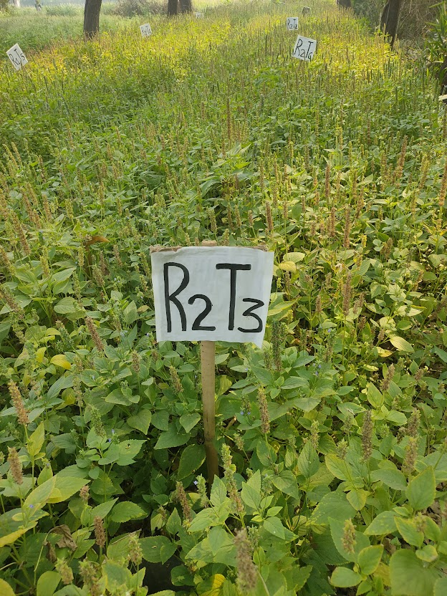
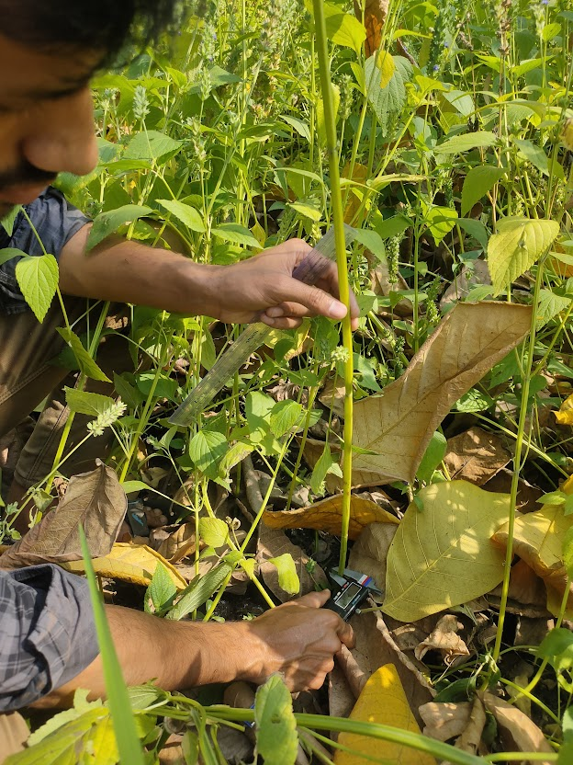
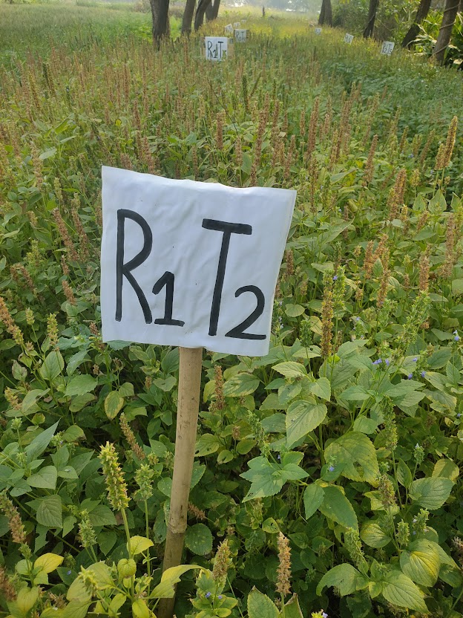
Plate-1: Field View of Chia plant
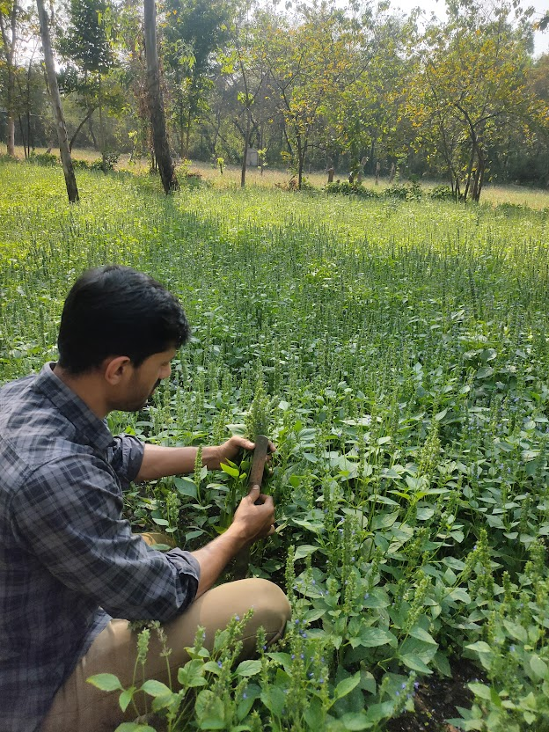
Plate-2: Plant Height and Collar Diameter Measurement

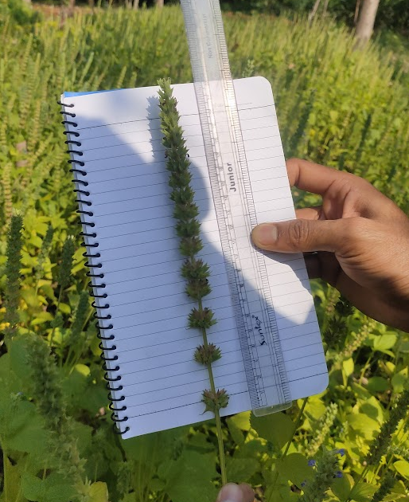
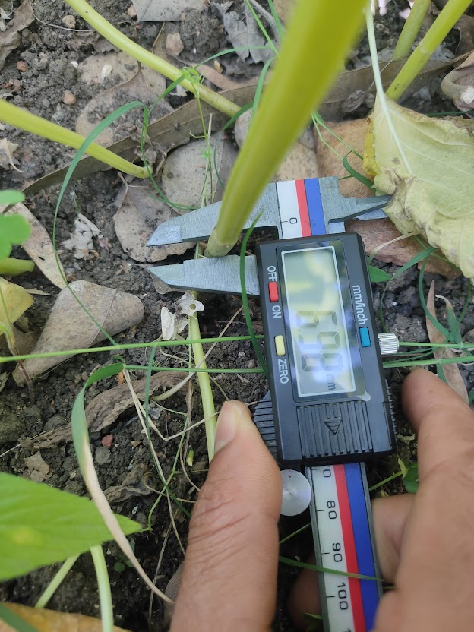
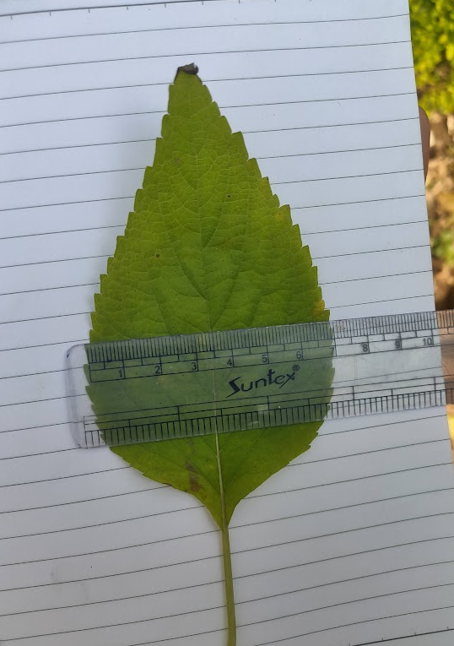
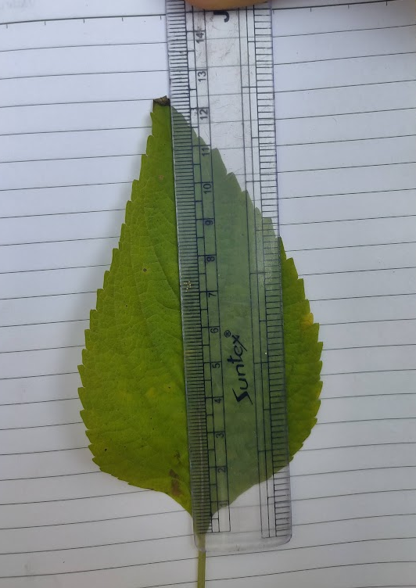
Plate-3: Leaf Length and Leaf Width Measurement
Plate-4: Inflorescence Length and Collar Diameter Measurements

The thickest collar was recorded in T₃ ( Goat Manure) at 6.63 mm, followed by T₂ ( Vermicompost ) at 6.09 mm. The control group exhibited the thinnest collar diameter (3.56 mm), indicating poor stem development. The calcium and organic matter in goat manure promote thicker, more resilient stems. Goat manure was found to be an efficient source of N, P, K, Ca, Mg and organic matter reported by (Nweke et al., 2013).
The highest number of leaves was observed in T₇ ( Vermicompost + FYM+ Goat Manure) with 52.67 leaves, followed closely by T₅ 49.33 leaves.The control treatment T₈ showed the lowest leaf production (25.33), reaffirming the importance of organic amendments in increasing vegetative growth. Similar effect of Vermicompost application was also reported by (Joshi et al., 2015). Vermicompost increased number of leaves, leaf area, leaf dry weight, total yield. Palit, (2005) reported that the application of organic manure increasing leaf length. It might be due to higher nitrogen content in cowdung and fertilizers were not applied in the control plot. Nitrogen enhances the protein synthesis, which allows plant to grow faster, and stimulates apical growth as well as increases leaf size.
T₅ (Vermicompost+ Goat Manure) resulted in the highest number of inflorescences ( 17.00), followed by T₃ (Goat Manure) with 16.33. This highlights the combined effect of vermicompost and goat manure in boosting reproductive growth. The control T₈ showed the least number (6.67), indicating that the absence of organic inputs limits reproductive potential. This is consistent with findings from other studies that highlight the benefits of organic amendments in improving plant growth (Atiyeh et al., 2000 and Gutiérrez-Miceli et al., 2007). Vermicompost enhances nutrient availability in the soil. The organic matter and beneficial microorganisms present in vermicompost aid in nutrient release and improve nutrient uptake by plants (Mupambwa and Mnkeni, 2018). This ensures that crops have access to the nutrients they need, contributing to healthier and more vigorous plant growth.
T₃ (Goat Manure) produced the longest leaves (9.87 cm) and substantial leaf width (5.10 cm), reflecting its effectiveness in promoting healthy leaf growth. Leaf dimensions were lowest in control treatment T₈ with 6.33 cm length and 3.51 cm width, showing limited growth without organic inputs. Imran et al. (2010) studied the effect of different organic and inorganic fertilizers on growth and yield of Mukhi kachu cv. Sali kachu. The result revealed that plant height, length and breadth of leaf blade were highest in organic manure treated plant.
The maximum dry weight was observed in T₃ (22.12 g), signifying the robust vegetative growth under goat manure treatment. T₈ (Control) had the lowest dry weight (11.10 g), highlights its poor performance without organic amendments. Seed weight was highest in T₃ (7.03 g), followed by T₅ (5.60 g), showing the positive influence of goat manure, either alone or in combination. The control group (T₈) recorded the least weight (2.03 g), emphasizing the importance of organic treatments for better yield.
Table 1: Effect of Organic Manure on the growth Performance of Chia plant.
Treatments Details | Plant Height (cm) | No. of Leaves | No. of Inflorescence | Leaf Length (cm) | Leaf Width (cm) | Collar Diameter (mm) | Dry Weight (gm) | Seed Weight (gm)
T1- FYM | 75.37 | 28.67 | 8.67 | 6.93 | 4.57 | 4.13 | 11.29 | 2.57
T2- Vermicompost | 93.07 | 42.33 | 14.67 | 8.2 | 5.87 | 6.09 | 15.05 | 4.19
T3- Goat Manure | 106.43 | 40.67 | 16.33 | 9.87 | 5.1 | 6.63 | 22.12 | 7.03
T4- Vermicompost + FYM | 92.53 | 32.33 | 9.67 | 7.77 | 4.14 | 4.75 | 15.43 | 3.01
T5- Vermicompost + Goat Manure | 97 | 49.33 | 17 | 8.47 | 6.1 | 5.61 | 19.1 | 5.6
T6- FYM+ Goat Manure | 76.4 | 29.33 | 10.33 | 7.57 | 4.3 | 3.66 | 16.09 | 3.52
T7- Vermicompost + FYM + Goat Manure | 81.67 | 52.67 | 13.67 | 7.6 | 4.83 | 4.72 | 17.6 | 5.21
T8- COMNTROL | 58.27 | 25.33 | 6.67 | 6.33 | 3.51 | 3.56 | 11.1 | 2.03
SEm± | 1.96 | 3.11 | 0.89 | 0.54 | 0.65 | 0.83 | 2.84 | 1.22
CD | 5.97 | 9.45 | 2.72 | 1.64 | 1.98 | 2.52 | 8.61 | 3.71
Note: *Significant at <0.05

CONCLUSION
This study highlights the significant impact of organic amendments on plant growth and productivity. Among the treatments, goat manure (T₃) and its combination with vermicompost (T₅) emerged as the most effective in enhancing key growth parameters, such as plant height, number of leaves, dry weight, and seed weight. The consistently lower performance of the control (T₈) underscores the critical role of organic inputs in promoting plant health and yield. These findings advocate for the use of goat manure, either alone or in combination with other organic amendments, as a sustainable approach to boost agricultural productivity while maintaining soil health.

References:

Ano, A. O., & Ubochi, C. I. (2007). Neutralization of soil acidity by animal manures: mechanism of reaction. African J. Biotech, 6(4): 364-368.
Atiyeh, R. M., Subler, S., Edwards, C. A., Bachman, G., Metzger, J. D., & Shuster, W. (2000). Effects of vermicomposts and composts on plant growth in horticultural container media and soil. Pedobiologia, 44(5):579–590.
Chaitanya, A., Murali, K., Kumar, N., Rao, G. E., Anand, S. R., Ravindra, U., & Chikkaramappa, T. (2022). Effect of Spacing and Organic Sources of nutrients on Growth and Yield of Chia (Salvia hispanica L.). Mysore Journal of Agricultural Sciences, 56(4).
Davidson E A, Galloway J N, Millar N and Leach A M. 2014. N-related greenhouse gases in North America: innovations for a sustainable future. Current Opinion in Environmental Sustainability 9(10):1–8.
GOI. 2014. National Agroforestry Policy 2014. Department of Agriculture and Cooperation, Ministry of Agriculture, New Delhi, Government of India. 29p.
Gutiérrez-Miceli, F. A., Santiago-Borraz, J., Montes Molina, J. A., Nafate, C. C., Abud-Archila, M., Oliva Llaven, M. A., Rincón-Rosales, R., & Dendooven, L. (2007). Vermicompost as a soil supplement to improve growth, yield, and fruit quality of tomato (Lycopersicum esculentum). Bioresource Technology, 98(15): 2781–2786.
IFA (International Fertilizer Association). 2020. “Short-term fertilizer outlook 2020-2021” in public summary of IFA virtual strategic forum (Paris, France: International Fertilizer Association). pp. 17–19.
Imran, S. M., Sattar, M. A., Islam, M. R., Hossain, M. M. A., & Alam, M. S. (2010). Effect of different organic and inorganic fertilizers on growth and yield of mukhi kachu (Colocasia esculenta) cv. sali kachu. Journal of Agroforestry and Environment, 4(2):53–56.
Ixtaina VY, Vega A, Nolasco SM, Tomas MC, Gimeno M, Barzana E et al. Supercritical carbon dioxide extraction of oil from Mexican chia seed (Salvia hispanica L.): Characterization and process optimization. Journal of Supercrit Fluids. 2010; 55:192-99.
Joshi, R., Singh, J., Vig, A.P. (2015). Vermicompost as an effective organic fertilizer and biocontrol agent: effect on growth, yield and quality of plants. – Reviews in Environmental Science and Bio/Technology, 14(1):137–159.
Kaur, A., & Monga, R. (2021). Eucalyptus trees plantation: a review on suitability and their beneficial role. International Journal of Bio-resource and Stress Management. 12(1): 16 25.
Kulczyński, B., Kobus-Cisowska, J., Taczanowski, M., Kmiecik, D., & Gramza-Michałowska, A. (2019). The chemical composition and nutritional value of chia seeds—Current state of knowledge. Nutrients, 11(6): 1242.
Mupambwa HA, Mnkeni PNS. Optimizing the vermicomposting of organic wastes amended with inorganic materials for production of nutrient-rich organic fertilizers: a review. Environ Sci Pollut Res. 2018;25(11):10577–95.
Nweke, I. A., Ijearu, S. I., & Igili, D. N. (2013). Effect of different sources of animal manure on the growth and yield of okra (Abelmuschus esculentus (L.) Moench) in ustoxic dystropept at Enugu, south eastern Nigeria. Int’l. J. Scientific & Tech. Res., 2(3): 135-137.
Odedina,J.N., Odedina, S.A., and Ojeniyi, S.O. (2011). Effect of types of manure on growth and yield of cassava ( Manihot esculenta Crantz ). Researcher,2(5):1-8
Palit, K.M. 2005. Effect of organic manure on morphological features, growth and abscission of reproductive structure and yield in soybean. M.S. thesis, Dept. Crop bot. Bangladesh agric Univ., Mymensingh.
Uwah, D. F., Ukoha, G. O., & Iyango, J. (2012). Okra performance and soil and water conservation as influenced by poultry manure and organic mulch amendments. Journal of food, agriculture and environment, 1, 748-754.

