Original Research Article
Incidence of Leaf Rot Disease of Coconut in Southern Kerala and its management

Abstract
The coconut is an important crop in Kerala and contributes substantially to the region's economy. However, its productivity is significantly threatened by leaf rot disease (LRD), primarily caused by major fungal pathogens, such as Colletotrichum sp., Fusarium sp., and Exserohilum rostratum. This study investigated the incidence and management of LRD and Root (wild) disease (RWD) in coconut palms across the southern districts of Kerala, namely, Thiruvananthapuram, Kollam, and Pathanamthitta. A detailed survey revealed significant regional variations in disease incidence, with Thiruvananthapuram showing the highest rates of LRD and RWD. This study identified Colletotrichum sp., Fusarium sp., and Exserohilum sp. as the primary pathogens responsible for LRD, which predominantly affects spindle leaves. Symptomatological observations demonstrated the progression of LRD from initial water-soaked lesions on young leaves to the formation of a characteristic fan-like appearance of the palm crown. Pathogenicity tests confirmed the involvement of the identified pathogens, satisfying Koch’s postulates. The study also explored the efficacy of biocontrol agents, such as Trichoderma sp. and Bacillus amyloliquefaciens, which showed significant antagonistic effects on pathogens. Trichoderma sp. (NW2) exhibited the highest inhibition rates among all pathogens, making it a promising candidate for sustainable disease management. These findings highlight the potential of integrated disease management, combining biocontrol agents and chemical treatments, to effectively control LRD and RWD in coconut plantations. This approach can significantly improve coconut productivity while minimizing environmental impact.
Keywords: Leaf Rot Disease; Root (Wilt) Disease; Coconut; Biocontrol Agents; Pathogen Management.

1. Introduction
Coconut (Cocos nucifera L.) is a crucial perennial crop that forms the backbone of the agricultural economy in Kerala, India, a region often termed the “Land of Coconuts.” This tree holds not only economic importance, but also cultural and ecological significance. Coconut cultivation supports the livelihoods of millions of people and provides raw materials for various industries, including food, cosmetics, and textiles [1]. However, growing coconut plantations faces increasing challenges due to plant diseases, particularly leaf rot disease (LRD) and root (wild) disease (RWD). LRD, primarily caused by fungi such as Colletotrichum spp., Fusarium spp., and Exserohilum rostratum, damages leaf tissues, thereby impairing photosynthesis and reducing productivity [2]. Concurrently, RWD continues to proliferate across Kerala, complicating disease management efforts [3]. These diseases are often interrelated, and their concurrent presence exacerbates the condition of the affected palms [4]. The warm and humid climate in Kerala’s southern districts facilitates rapid spread of these pathogens. Despite its prevalence, studies focusing on the incidence and progression of LRD are limited. Historically, LRD was first identified in the 1880s by Travancore and Cochin [5, 6]. Butler (1908) [7] reported spindle symptoms without identifying any specific pathogens. Subsequently, Radha and Lal (1968) [8] observed LRD in 16–40% of palms in RWD-affected areas. Collectively, these diseases result in significant losses, with Menon and Nair (1948) [5] estimating the annual damage to Rs. 5.6 million due to RWD alone. Furthermore, LRD accounts for an estimated 461 million nuts annually, underscoring the need for enhanced disease-management strategies.
LRD is predominantly induced by fungal pathogens including Colletotrichum sp., Fusarium sp., and Exserohilum rostratum [9]. These pathogens cause necrosis in the spindle leaves, resulting in a decline in the photosynthetic capacity and yield of the palm. This condition is exacerbated in palms already afflicted by RWD, as compromised plants are more vulnerable to fungal invasion. The severity of LRD is significantly influenced by climatic factors such as humidity, rainfall, and temperature. The monsoon season in Kerala, characterized by high humidity, provides optimal conditions for fungal proliferation. Radha and Lal (1968) [8] noted that even palms not visibly affected by RWD may subsequently develop LRD, indicating the need for further investigation into the LRD-RWD disease complex. Recent trends suggest that climate change and alterations in agricultural practices may contribute to the resurgence of LRD in certain regions [2]. Historical assessments underscore the magnitude of the threat: Menon and Nair (1948) [5] documented an average yield reduction of 20% owing to RWD. Radha et al. (1962) [9] reported that LRD could decrease yields by up to 70% and RWD by 43–82%. A study by the Central Plantation Crops Research Institute [10] recorded annual RWD-related losses of 968 million coconuts with a disease incidence of 26.444% The Department of Agriculture, Kerala (1997) [11], later observed a reduced incidence of 24.05%, attributed to improved disease management and replanting practices. Nonetheless, quantifying losses from LRD remains challenging because of their overlap with RWD symptoms and progression, highlighting the necessity for integrated research and management.
Initial management strategies for LRD predominantly rely on chemical fungicides. However, concerns regarding sustainability, environmental impact, and pathogen resistance have prompted a transition towards Integrated Disease Management (IDM) approaches [12]. The application of biological control agents, such as Trichoderma spp. isolates (NW2 and KAU) and Bacillus amyloliquefaciens (VLY24), is recognized for their ability to suppress fungal pathogens and enhance plant resilience. This study aimed to assess the incidence of LRD, identify the primary fungal pathogens responsible for this disease, and examine its symptoms and progression. To assess the efficacy of biocontrol agents such as Trichoderma sp. and Bacillus amyloliquefaciens in managing these diseases. Ultimately, the objective is to develop an integrated disease management approach that combines biocontrol and chemical treatments to improve coconut productivity while minimizing environmental impact.
3. Materials and Methods
3.1 survey and collection of leaf rot disease specimens
A roving survey was conducted from 2021 to 2023 across three districts of southern Kerala to identify the incidence of LRD. The survey focused on the southern districts of Kerala, Thiruvananthapuram, Kollam, and Pathanamthitta, and recorded the varieties of infected palms at each location. Coconut palms exhibiting leaf rot symptoms were identified, and disease incidence was determined using a standard formula. Disease symptoms under natural conditions were documented by examining the affected palms and analyzing rotten spindle leaf samples collected from the surveyed locations. This study also explored the association between RWD and LRD in coconut palms.
Percent disease incidence = $\frac{(Number of infected palms)}{(Total number of palms)}$ ×100
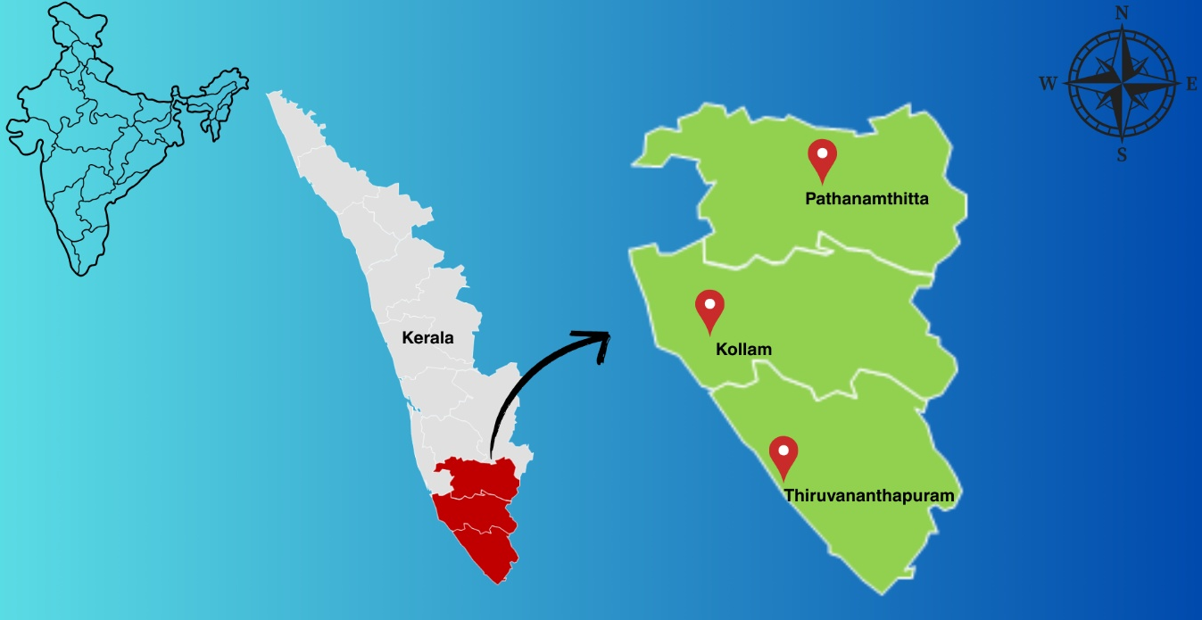
Figure. 1 Map showing the southern districts of Kerala (Thiruvananthapuram, Kollam, and Pathanamthitta) highlighted for the roving survey conducted to assess LRD prevalence
3.2 Symptomatology
Observations were conducted on the coconut palms that exhibited symptoms of LRD. This study focused on symptom progression, lesion development, and extent of crown infection under natural environmental conditions. Field surveys were conducted in RWD-endemic regions to quantify the distribution of LRD symptoms across different leaf whorls.
3.3 Isolation and pathogenicity
Rotting spear leaves from the inner whorl of the palm were collected and transported to the laboratory for analysis. For pathogen isolation, infected spear leaf samples showing progressive symptoms were selected and rinsed under running tap water to remove any surface debris. Tissue segments (approximately 0.5 cm), including both healthy and diseased portions, were excised and surface-sterilized using 1% sodium hypochlorite for 60 s, followed by three rinses with sterile distilled water. The sterilized tissue segments were then placed on sterilized Petri dishes containing potato dextrose agar (PDA) medium supplemented with a trace amount of cephalosporin. The plates were incubated at room temperature (28 ± 2°C) for 4–5 days. After incubation, hyphal tips from emerging fungal colonies were aseptically transferred to fresh PDA-amended plates. Subsequent subculturing was performed to establish pure cultures. The presence of major leaf rot pathogens was confirmed by microscopy.
The isolates were cultured on PDA and evaluated for colony characteristics. Mycelial discs, each 8 mm in diameter, were excised from 7-day-old cultures of each isolate and transferred to PDA Petri dishes. The plates were incubated at 28±1°C for one week. The mean radial growth (mm per day) and colony color of each isolate were recorded. The conidial characteristics were examined using a Leica DM 500 microscope equipped with a digital camera (Leica Microsystems, Germany). Conidia were mounted in 100% lactic acid. Preliminary identification of the isolates was based on colony colour, morphology, and shape, size, and growth patterns of the conidia.
Pure cultures of the isolated fungi were subjected to pathogenicity assessment. Healthy, unopened, spindle leaves of the coconuts were collected from the field. The pathogens were inoculated by placing 5 mm diameter mycelial bits from seven-day-old cultures onto the inner surface of the leaflet after creating pinpricks with a sterilized needle. To maintain adequate moisture and humidity, moistened cotton was placed over the inoculated area, and the leaflets were covered with a polyethylene sheet, labelled, tied, and incubated at room temperature (28 ± 2°C). Leaflets exhibiting disease symptoms were used for pathogen reisolation. The re-isolated pathogens were compared with the original isolates to confirm Koch’s postulates. To evaluate the virulence of the major LRD pathogen isolates, seven-day-old cultures of the isolates were inoculated onto detached spindle leaflets. Each isolate was inoculated onto a healthy leaflet in triplicate. Among the major pathogens, the most virulent isolate was selected for further study.
3.4 In vitro management
The direct antagonistic effects of phylloplane microflora on LRD pathogens were assessed using the dual-culture technique. The assay incorporated three promising biocontrol agents: B. amyloliquefaciens (VLY24), two native Trichoderma isolates (NW2 and KAU), and chemical fungicide control (COC). For the assay, seven-day-old cultures of the LRD pathogens and three-day-old cultures of the selected biocontrol agents were employed. To evaluate the antagonistic effects, 5 mm culture discs were excised from the actively growing mycelial tips of the pathogens and positioned at the center of 1:1 NA+PDA amended plates. A loopful of bacteria was streaked at 2 cm from the periphery of the plate on both sides of the pathogen disc. Pathogen cultures without any treatment were used as the controls.
For fungal biocontrol agents (Trichoderma isolates NW2 and KAU), a 5 mm culture disc of each biocontrol agent was placed opposite the pathogen disc (2 cm from the periphery of the same PDA plate). The poisoned food technique was used to compare the effectiveness of fungal biocontrol agents with that of COC. In this method, 0.2 g) was dissolved in 50 ml sterile water and mixed with 50 ml of melted, cooled double-strength PDA medium. This poisoned medium was poured into sterile petri plates, and the pathogen discs were placed at the center. Plates containing untreated pathogens were used as the controls. Each treatment had ten replications, and all plates were incubated at room temperature (27 ± 2°C). Observations of radial growth of leaf rot pathogens and biocontrol agents were recorded on 5th, and 7th days after inoculation. The percentage inhibition of pathogen growth by the biocontrol agents was calculated using the following formula [13].
Analysis of Percent Inhibition (I):
$$I=\frac{C-T}{C} ×100$$
where I is the percentage inhibition, C is the Growth of the test pathogen in the absence of treatment (cm), and T is the Growth of the test pathogen in the presence of treatment(cm).
3.5 Statistical Analysis
The experimental design was completely randomized design (CRD) for all experiments. Statistical analysis was performed using analysis of variance at a significance level of (P=0.05) using Grapes 1.1.0 software [14]. Each experiment was conducted with appropriate replicates, and the data were analyzed using standard statistical procedures [15].
4. Results
4.1 Survey
A survey conducted across the districts of Thiruvananthapuram, Kollam, and Pathanamthitta has provided comprehensive data on the incidence of LRD and RWD, along with the prevalence of these diseases across various varieties. The data, collected from 50 palms from each location and five locations from each block within these districts, revealed significant variation in disease occurrences, with specific blocks exhibiting higher disease incidences. The disease incidence percentages for both LRD and RWD were recorded for each block, highlighting the prevalence of these diseases and the crop varieties observed. The incidences of LRD and RWD varied substantially across the surveyed regions. In Thiruvananthapuram, the highest disease incidence was recorded in Athiyannur (47.1%), whereas the lowest was observed in Mallapally in Pathanamthitta (22.6%). RWD prevalence also varied, with Athiyannur exhibiting the highest occurrence at 28.2%, Nedumangad and Thiruvananthapuram, while it had the lowest prevalence (20.8%).
In terms of specific disease incidences, Thiruvananthapuram showed disease rates ranging from 41.8% in Vamanapuram to 47.1% in Athiyannur. The prevalence of RWD in this district ranges from 20.8% in Nedumangad to 28.2% in Athiyannur. In Kollam, the disease incidence was generally low, ranging from 36.5% in Vettikad to 45.2% in Makathala. The RWD prevalence in Kollam ranged from 24.5% in Makathala to 27.6% in Chadayamangalam. Pathanamthitta had the lowest disease incidence, recorded at 38.2% in Elanthur and 22.6% in Mallapally. The prevalence of RWD in this district ranges from 22.5% in Pandalam and Koipuram to 27.8% in Elanthur. Across all blocks, the varieties observed included WCT, CGD, T×D, and COD, with varying levels of disease susceptibility noted across these varieties.
Table 1. Disease incidence of leaf rot of coconut in surveyed locations
District | Block | LRD Disease incidence (%) | Root (wilt) disease incidence (%) | Varieties observed
Thiruvananthapuram | Pothencode | 45.2 | 23.5 | CGD, WCT
Thiruvananthapuram | Chirayinkeezhu | 42.6 | 25.6 | T×D, WCT
Thiruvananthapuram | Varkala | 41.9 | 22.2 | WCT
Thiruvananthapuram | Athiyannur | 47.1 | 28.2 | T×D, WCT
Thiruvananthapuram | Nemom | 44.3 | 25.6 | CGD, WCT
Thiruvananthapuram | Parassala | 42.5 | 23.5 | WCT
Thiruvananthapuram | Perumkadavila | 46.5 | 24.6 | COD, WCT
Thiruvananthapuram | Vellanad | 45.4 | 26.5 | WCT
Thiruvananthapuram | Kilimanoor | 42.6 | 26.1 | CGD, WCT
Thiruvananthapuram | Nedumangad | 45.2 | 20.8 | COD, WCT, T×D
Thiruvananthapuram | Vamanapuram | 41.8 | 25.2 | WCT
Kollam | Chittumala | 40.6 | 25.9 | WCT
Kollam | Ithikkara | 37.4 | 26.3 | T×D, WCT
Kollam | Makathala | 45.2 | 24.5 | WCT
Kollam | Chadayamangalam | 37.8 | 27.6 | CGD, WCT
Kollam | Kottarakkara | 42.9 | 26.3 | WCT
Kollam | Vettikad | 36.5 | 24.8 | CGD, WCT
Pathanamthitta | Elanthur | 38.2 | 27.8 | WCT
Pathanamthitta | Koipuram | 32.9 | 22.5 | COD, WCT
Pathanamthitta | Mallapally | 22.6 | 26.1 | WCT
Pathanamthitta | Pandalam | 26.1 | 22.5 | COD, WCT
Pathanamthitta | Parakode | 27.4 | 25.2 | WCT

4.2 Symptomatology
During the survey of coconut palms, LRD symptoms were predominantly observed in spindle leaves, which are the youngest unopened leaves of the palm. The initial symptom was spindle-shaped deterioration (Fig. 1A), characterized by whitening and softening of leaflets. These compromised leaflets became highly susceptible to LRD, which initially presented as small, water-soaked lesions on the leaf surface. Under conditions of high humidity, rainfall, and low temperature, the lesions gradually enlarged and coalesced, particularly on the soft, tender leaflets of the spindle. As the disease progresses, extensive rotting occurs, often spreading to the interior of the spindle. The lesions expanded rapidly, particularly when infection occurred early during spindle emergence. A tender, unopened spindle leaf with a thinner epidermal layer and a high moisture content became the primary site of infection.
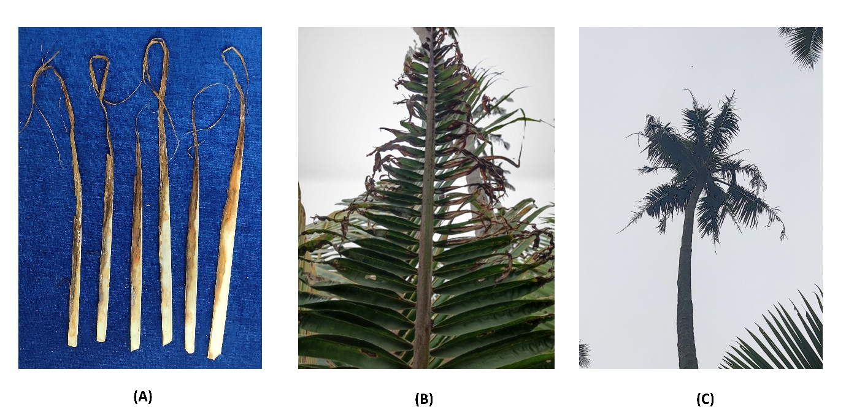
As the disease progressed, the infected spindle began to decay and the tips of the leaflets adhered together. These tips dried, turned black, and eventually detached. In addition, the tips and midribs of the leaflets often shriveled and blackened (Fig. 1B). In more mature leaves, the disease progressed more slowly, with rotting primarily affecting the upper portions of the leaves while leaving some basal portions symptom-free. This resulted in a fan-like appearance of the palm crown (Fig. 1C), which is a characteristic feature of this disease. The fan-like structure indicates that LRD affected the palm in succession, with varying degrees of rot across different leaves. In severe cases, rotting leads to a significant decline in the photosynthetic capacity of the palm, resulting in reduced vigor, stunted growth, and fruit yield. If is left unmanaged, the disease can eventually lead to the death of the palm.
Figure. 2 Symptoms of LRD (A) Deterioration of the spindle leaves, (B) Rotten tips of the leaflets (C) fan-like appearance of crown
4.3 Isolation and pathogenicity
Isolation was performed using infected symptomatic leaves, leading to identification of the primary pathogens responsible for LRD, including Colletotrichum sp., Fusarium sp., and Exserohilum sp. These isolates were subsequently selected for pathogenicity assessment and detailed characterization. For pathogenicity testing, the pathogens were artificially inoculated onto detached leaves. Each isolate induced disease symptoms that closely mirrored those observed in the field, including development of lesions and leaf rot. Koch's postulates were successfully satisfied, as the pathogens isolated from the artificially infected symptomatic stems produced symptoms identical to those observed in the field.
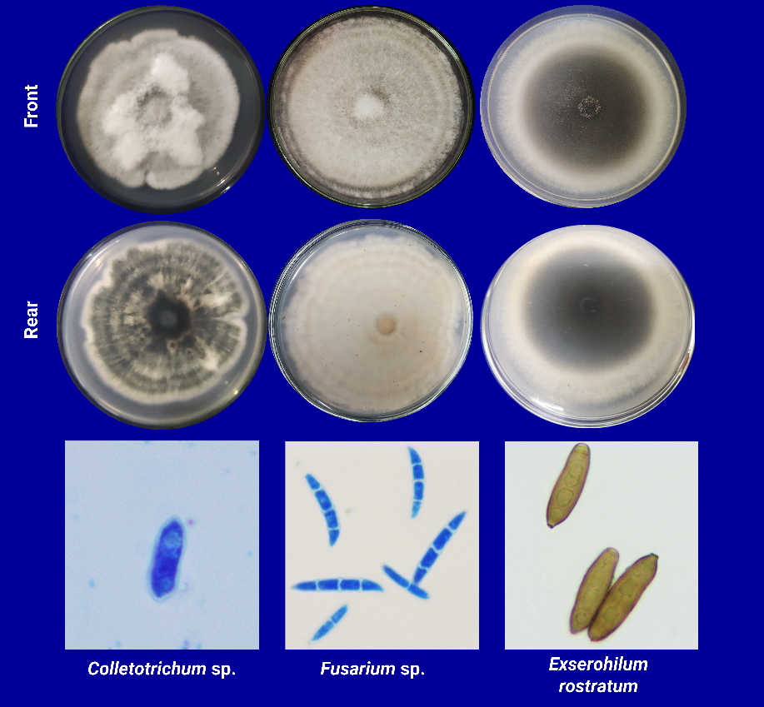
The isolates were morphologically characterized using light microscopy. Colletotrichum cultures grown on PDA medium exhibited a dense, cottony morphology, with the colony colour ranging from white to grey on the obverse and white to dark green on the reverse. The aerial mycelium appeared white to greyish-white and consisted of hyaline, septate, and branched hyphae. The conidia were hyaline, straight, single-celled, with central constriction, cylindrical in shape, and contained a central oil globule. Similarly, Fusarium isolates demonstrated dense cottony colony morphology on the PDA medium. Colony colour varied from white to off-white on the upper surface and from off-white to light yellow on the underside. The mycelia were hyaline, septate, and branched, producing both macroconidia and microconidia. The macroconidia were hyaline, septate, sickle-shaped, and comprised 2-4 cells in length, whereas the microconidia were hyaline, single-celled, and clavate. Exserohilum isolates exhibited cottony colony morphology, with coloration ranging from off-white to grey. The mycelia varied from light to deep brown, featuring a distinct protruding truncate hilum. The conidia displayed bipolar germination and were fusiform, cylindrical, pyriform, or oval, with 2-4 septa. All isolates were incubated at 28±1°C under a 12:12-hour light:dark photoperiod. Based on their morphological and conidial characteristics [16], the isolates were identified as Colletotrichum sp., Fusarium sp., and Exserohilum sp.

Figure. 3 Characteristics of major LRD pathogens
4.4 In vitro management
The antagonistic effects of the biocontrol agents on the three LRD pathogens were assessed using a dual-culture technique. Trichoderma sp. (NW2) strongly inhibited Colletotrichum sp. (72.58%), Fusarium sp. (75.43%), and Exserohilum sp. (74.65%). Trichoderma sp. (KAU) also showed significant inhibition, with 75.48% inhibition against Colletotrichum sp., 71.92% against Fusarium sp., and 65.69% against Exserohilum sp. Both Trichoderma isolates effectively suppressed all three pathogens, although Trichoderma sp. (NW2) showed a slightly higher inhibition across pathogens, particularly against Fusarium sp. B. amyloliquefaciens (VLY24) was highly effective against Exserohilum sp., with 79.33% inhibition, and exhibited 74.19% inhibition against Colletotrichum sp. and 73.68% inhibition against Fusarium sp. The chemical fungicide COC resulted in complete inhibition of Fusarium sp. (100%) but was less effective against Exserohilum sp. (44.63%). It showed 91.93% inhibition against Colletotrichum sp., indicating its potent control over some pathogens but less effective against others. However, no inhibition was observed in the control group. These results highlight the potential of both Trichoderma isolates and B. amyloliquefaciens as effective biocontrol agents for managing LRD pathogens.
Table. 2 In vitro dual culture plate assay against major LRD pathogens
Treatment | Colletotrichum sp. | Fusarium sp. | Exserohilum sp.
Treatment | Per cent inhibition of mycelial growth (%)* | Per cent inhibition of mycelial growth (%) | Per cent inhibition of mycelial growth (%)
Trichoderma sp. (NW2) | 72.58 (60.53)** | 75.43 (60.29) | 74.65 (59.68)
Trichoderma sp. (KAU) | 75.48 (60.32) | 71.92 (58.00) | 65.69 (54.02)
B. amyloliquifaciens (VLY24) | 74.19 (59.46) | 73.68 (59.13) | 79.33 (62.88)
COC | 91.93 (73.50) | 100 (90) | 44.63 (41.73)
Control | 0 (0) | 0 (0) | 0 (0)
*Mean of 10 replicates **Values in parenthesis are arc sine transformed values
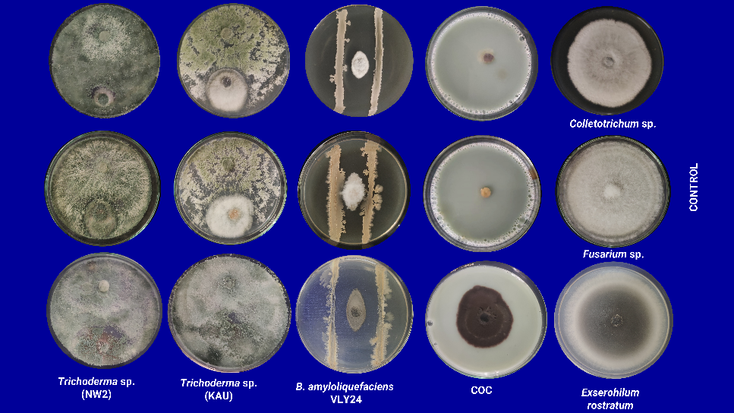
Figure. 4 In vitro evaluations of the biocontrol agents and COC against major LRD pathogens
5. Discussion
The results of this study provide a comprehensive overview of the incidence and management of LRD and RWD in coconut palms in Southern Kerala. A survey conducted across the districts of Thiruvananthapuram, Kollam, and Pathanamthitta revealed significant regional variation in disease incidence. Higher incidences of LRD were reported in the blocks of Thiruvananthapuram, with the highest incidence in Athiyannur (47.1%) and the lowest in Mallapally and Pathanamthitta (22.6%). These variations highlight the patchy distribution of LRD across the coconut-growing regions, which could be attributed to the diverse environmental conditions, soil types, and farming practices in each district. Notably, Thiruvananthapuram showed the highest disease incidence for both LRD and RWD, which may indicate environmental factors such as high humidity and rainfall prevalent in coastal areas, which favor the spread of these diseases. In conclusion, the incidence of LRD is higher than that in earlier surveys [4, 5, 8].
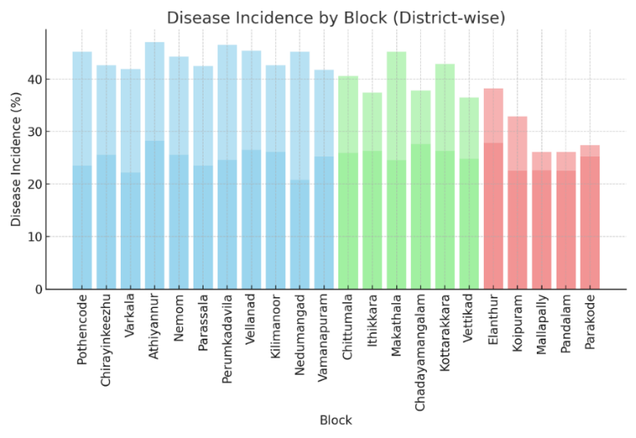
The observed variation in disease incidence across different coconut varieties further supports the hypothesis that certain varieties may exhibit differential susceptibilities to LRD and RWD. Among the varieties, WCT and CGD were commonly observed in the survey areas, and their susceptibility to LRD was significant in several blocks, particularly Thiruvananthapuram and Kollam. However, there was no clear pattern linking a particular variety to consistently high or low disease incidence across all blocks, suggesting that varietal resistance may be influenced by local conditions rather than being a universal trait.
Figure. 5 Bar chart showing the disease incidence percentage for LRD and RWD across different blocks in the districts of Thiruvananthapuram, Kollam, and Pathanamthitta. The bars are color-coded by district and disease type, with blue representing Thiruvananthapuram, green representing Kollam, and red representing Pathanamthitta. Disease incidence is broken down into LRD and Root Wilt, illustrating regional variations in disease prevalence at the block level.
Symptomatological observations confirmed the nature of LRD, with spindle leaves being the most affected. The disease was initiated as small water-soaked lesions on the spindle leaves, which then enlarged and merged under humid conditions, leading to extensive rotting. This progression highlights the role of environmental factors in the spread and severity of LRD. In the advanced stages, rotting leads to a characteristic fan-like appearance of the palm crown, which is indicative of the sequential impact of LRD on the palm. The visual symptoms observed, including blackened and shriveled tips of leaflets, directly impacted the photosynthetic efficiency of the palm, resulting in reduced vigor and fruit yield. This finding is consistent with previous studies linking LRD to significant crop losses in coconut production [16, 4, 17].
Pathogenicity tests confirmed that Colletotrichum sp., Fusarium sp., and Exserohilum sp. were the primary causal agents of LRD, and Koch’s postulates were successfully fulfilled. Pathogenicity testing and subsequent morphological identification of these pathogens underline the complexity of the etiology of LRD. The distinct colony morphologies and conidial characteristics of the three pathogens identified in this study provide critical insights into diagnostic purposes and future disease management strategies. When inoculated onto detached leaves, these pathogens cause lesions and leaf rot that mirror those observed in field conditions, reinforcing their role as the primary agents of LRD in the region [16, 17].
Biocontrol agents have demonstrated promising results in terms of management strategies. Trichoderma sp. isolates (NW2 and KAU) exhibited strong antagonistic effects on the three LRD pathogens, with inhibition percentages ranging from 65.69% to 75.48%. The effectiveness of Trichoderma sp. against Colletotrichum sp. and Fusarium sp. suggests that it could be a viable biocontrol option for integrated disease management. Additionally, B. amyloliquefaciens (VLY24) showed excellent inhibition, especially against Exserohilum sp., with an inhibition rate of 79.33%. The high efficacy of these biocontrol agents suggests that they could potentially be utilized in sustainable disease management practices, reducing reliance on chemical fungicides [12].
However, the chemical fungicide COC, while effective against Fusarium sp., showed varying degrees of success against other pathogens, with only 44.63% inhibition against Exserohilum sp. and 91.93% inhibition against Colletotrichum sp. These results point to the potential for a targeted approach using specific fungicides for particular pathogens, while integrating biocontrol agents such as Trichoderma sp. and B. amyloliquefaciens for broader pathogen suppression. This integrated approach could help reduce the environmental impact of fungicide use, while maintaining effective disease control.
6. Conclusion
This study highlights the varying incidences of LRD and RWD across Southern Kerala, with significant regional differences observed in Thiruvananthapuram, Kollam, and Pathanamthitta. This study identified Colletotrichum sp., Fusarium sp., and Exserohilum sp. as the primary pathogens responsible for LRD, and symptomatological observations confirmed the detrimental effects of the disease on coconut palms. These findings underscore the potential of biocontrol agents, such as Trichoderma sp. and B. amyloliquefaciens, as effective alternatives to chemical fungicides, offering sustainable solutions for disease management. The integration of these biocontrol agents with targeted chemical treatments could significantly reduce disease impact and enhance coconut productivity in the region. Future research should focus on refining these biocontrol methods for large-scale applications to ensure the long-term health of coconut crops in Southern Kerala.
References
1. Kappil SR, Aneja R, Rani P (2021) Decomposing the performance metrics of coconut cultivation in the South Indian States. Humanit Soc Sci Commun 8:114. https://doi.org/10.1057/s41599-021-00783-0
2. Rithesh L, N V R, Thara SS, et al (2024) A Centenary Review on Leaf Rot Disease of Coconut. J Adv Biol Biotechnol 27:993–1005. https://doi.org/10.9734/jabb/2024/v27i111684
3. Ramjegathesh R, Rajendran L, Karthikeyan G, Raguchander T (2022) Coconut (Cocos Nucifera Linn.) Diseases And Management Strategies. In: Diseases of Horticultural Crops, 1st ed. Apple Academic Press, Boca Raton, pp 73–96
4. Srinivasan N, Gunasekaran M (1999) COCONUT LEAF ROT DISEASE COMPLEX A REVIEW. CORD 15:34. https://doi.org/10.37833/cord.v15i01.323
5. Menon KPV, Nair UK (1948) The leaf rot disease of coconut in Travancore and Cochin. Indian Cocon J 1:33–39
6. MENON, KV, NAIR, UK (1951) Scherne for the investigation of the root and leaf diseases of the coconut palm in South India. Consolidated final report of the work done from 8th March 193 7 to 3 1 st March 1948. Indian Cocon J 5:5–19
7. Butler E (1908) Report on coconut palm disease in Travancore. Agric Res Inst Pusa Bull 9:23
8. Radha, K, Lal, SB (1968) Some observations on the occurrence of leaft rot disease of coconut and associated factors. jakarta
9. Radha K, Sahasranaman KN, Menon, K. P. V (1962) A note on the yield of coconut in relation to rainfall and leaf rot and root (wilt) diseases. Indian Cocon Jx 16:3–11
10. CPCRI (1985) Coconut Root (wilt) Disease- Intensity, Production Loss and Future Strategy, A Survey Report
11. DEPARTMENT OF AGRICULTURE, GOVERNMENT OF KERALA (1997) Coconut root (wilt) survey
12. Srinivasan N, Chandramohanan R, Bharathi R, et al (2014) Development of Technology and Popularization of Biological Control Agents for Integrated Management of Coconut Leaf Rot Disease. CORD 27:13. https://doi.org/10.37833/cord.v27i1.123
13. Vincent JM (1947) Distortion of Fungal Hyphæ in the Presence of Certain Inhibitors. Nature 159:850–850. https://doi.org/10.1038/159850b0
14. Gopinath PP, Parsad R, Joseph B, Adarsh V. S (2021) grapesAgri1: Collection of Shiny Apps for Data Analysis in Agriculture
15. Gomez KA, Gomez AA (1984) Statistical procedures for agricultural research, 2.ed. Wiley, New York
16. Srinivasan N, Gunasekaran M (1996) Incidence of fungal species associated with leaf rot disease of coconut palms in relation to weather and the stage of lesion development. Annals of Applied Biology 129:433–449. https://doi.org/10.1111/j.1744-7348.1996.tb05766.x
17. Srinivasan N, Gunasekaran M (1996) Pathogenecity of preponclent fungi associated with leaf rot disease of coconut. Indian Cocon J 27:2–4

