Review Article

Oats (Avena Sativa) as a Functional Food: Nutritional Significance, Processing Approaches, and Multifaceted Applications

ABSTRACT
Oats (Avena sativa) are gaining recognition globally as a functional grain owing to their impressive nutritional profile and versatility in both human and animal diets. This review explores the composition, health benefits, anti-nutritional factors, and processing techniques associated with oats. Rich in beta-glucan, soluble dietary fiber, and unique antioxidants such as avenanthramides, oats have shown promising roles in reducing cholesterol, improving glycemic control, enhancing gut microbiota, and mitigating risks associated with cardiovascular and metabolic disorders. The growing interest in oats is driven not only by their nutritional value but also by their adaptability to low-input agricultural systems, making them a reliable crop in both irrigated and rain-fed conditions. Oats are extensively used as fodder in India due to their high green biomass yield, palatability, and digestibility. However, their potential as a human food resource has led to the development of oat-based products like flour, flakes, oat milk, and cereals. Modern processing methods such as dehulling, steaming, flaking, and fermentation have improved their nutritional bioavailability while reducing anti-nutritional components like phytates, tannins, and oxalates. Furthermore, the application of oats in dairy feed has demonstrated enhanced animal performance, including better lactation outcomes. Given their health-promoting potential and agronomic viability, oats hold significant promise in addressing both nutritional security and sustainable farming. This review aims to consolidate current research findings to facilitate future applications of oats in food systems, healthcare, and also support animal nutrition.

Keywords: Health benefits, Oat processing, β-glucan, Prebiotic effect, Anti-nutritional factors, Animal feed

1. INTRODUCTION
Oats are considered distinct among cereals, recognized as one of the richest sources of dietary fiber (Butt et al., 2008). Historically, the cultivation of oats dates back to around 2000 B.C., though their domestication occurred later than that of barley and wheat. The earliest evidence of oats has been found in Egypt and among the lake dwellers of ancient Switzerland (Coffman, 1961). According to the U.S. Department of Agriculture Technical Bulletin 1100, thirteen species and subspecies of the genus Avena (family Gramineae) are officially recognized. Among them, Avena sativa is the most widely cultivated and utilized species globally, accounting for over 75% of the world’s oat cultivars (Coffman, 1961).Oats can grow in acidic soils with a pH as low as 4.5, but they perform best in soils with a pH range of 5.3 to 5.7 (Alam and Adams, 1979). They thrive in cool, moist climates and are sensitive to hot, dry weather. As a result, global oat production is mainly concentrated between the 40th parallel in the Southern Hemisphere and the 60th in the Northern Hemisphere, including countries such as Australia, China, North America, Scandinavia, and Russia (Schrickel, 1986). According to FAS-USDA (2025), the European Union is the largest producer of oats (7.7 million metric tons ≈ 35% of global production), followed by Russia, Canada, the USA, Poland, and Finland. In India, oats are cultivated over approximately 100,000 hectares, yielding about 35–40 tonnes of green fodder per hectare (Chaudhary and Kesh, 2018). The crop is grown extensively across diverse regions—from the Himalayan belt in the north to the Deccan plateau in the south—including states like Punjab, Haryana, Jammu & Kashmir, Himachal Pradesh, Uttar Pradesh, Madhya Pradesh, Rajasthan, Maharashtra, and West Bengal (Chaudhary and Kesh, 2018).
Despite their nutritional value, oats are cultivated in limited varieties, with grain yields typically ranging from 15 to 25 quintals per hectare under optimal conditions. This highlights the need for high-yielding varieties to enhance human nutrition (Ahmad and Zaffar, 2014). Oats, especially rolled oats, are known for their high protein and fiber content. Their protein content surpasses that of many other cereals. Most vitamins and minerals in oats are concentrated in the bran and germ, making oats a nutrient-dense grain. Oat food products derived from whole groats retain essential nutrients, fiber, and healthy fats. In India, particularly in the western and north-western regions, oats adapt well due to favorable climatic conditions, showing quick regrowth and strong performance. Oat grains are a valuable part of the human diet due to their rich chemical composition and nutrient profile (Hahn et al., 1990; Bartnikowska et al., 2000; Sadiq Butt et al., 2008). Their protein has a balanced amino acid composition, favorable fatty acid profile, high polyunsaturated fatty acid (PUFA) content, and is rich in water-soluble β-glucans and antioxidants (Bartnikowska, 2003; Butt et al., 2008).
In this review, we begin by highlighting the general processing method of manufacturing oat flakes and oat flour and its nutritional profile. Major focus is given on the various health benefits of oat. Additionally, anti-nutritional factors and multiple use of oats as animal feed has also been incorporated. All these sections were detailed to provide maximum information.

2. GENERAL OAT PROCESSING FOR FLAKES AND FLOUR
In the market oat flakes and oat flour are the most common and popular oat-based products available. The processing of oats into flakes and flour involves several key steps designed to retain nutritional quality while improving shelf-life, palatability, and versatility. A detailed explanation of the processing steps involved in manufacturing oat flakes and flour has been well documented by Resane et al. (2015) and Decker et al., (2014). The basic steps involved in preparation of oat flour and flakes have been summarized in the Fig. 1. Initially, raw oats are cleaned to remove foreign materials, followed by dehulling to separate the inedible hulls from the groats. The groats are then subjected to kilning, a heat treatment process that inactivates enzymes, enhances flavor, and reduces moisture to extend storage life. For producing oat flakes, the kilned groats are steamed to soften them and then rolled into thin flakes using heavy rollers. These are further toasted or dried to attain the desired texture and stability. In the case of flour production, the groats or flakes are milled into fine particles using hammer or roller mills. This yields oat flour suitable for baking and thickening applications. The entire process ensures that the nutritional integrity of oats—especially their beta-glucan content and antioxidant profile—is maintained. Processing variables such as moisture control, thermal treatment, and mechanical forces are carefully regulated to optimize the final product's texture, nutritional value, and shelf life.
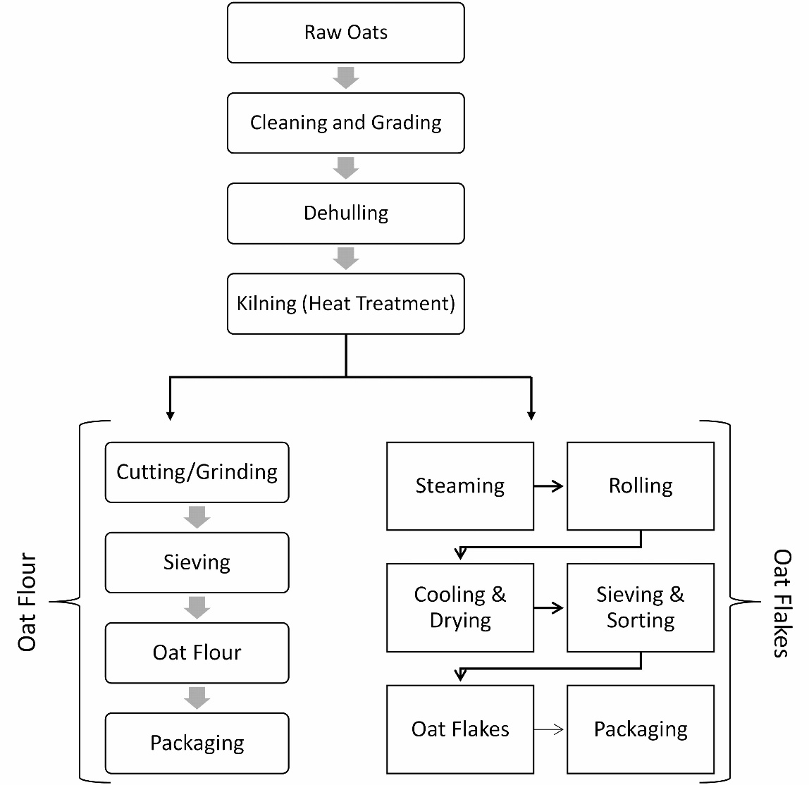
Fig. 1: Processing steps involved in the manufacturing of oat flour and flakes

3. NUTRITIONAL OVERVIEW
Oats are often regarded as a "supergrain" due to their numerous health benefits. They are rich in bioactive compounds such as soluble fiber, polyphenols, and avenanthramides—potent antioxidants. Table 1 presents the major constituents present in oats. The U.S. FDA has approved a health claim for the cholesterol-lowering properties of oat-based products, provided they contain a minimum amount of oat beta-glucan. Belonging to the Poaceae family, oats—commonly known as “Jai” or “Javi” in the Indian subcontinent—are cultivated both for animal feed and human consumption, primarily as oatmeal. Historically, oats have been valued as a health-promoting food, although their specific effects were not well understood. Today, oats are recognized for enhancing satiety, slowing nutrient absorption, and reducing the risk of various gastrointestinal disorders. These benefits are primarily due to their high soluble fibre content. Oats are one of the most accessible and cost-effective sources of soluble dietary fibre. When research revealed that oat fibre could lower cholesterol levels, scientists became more interested in oats. Furthermore, soluble fibre from oats has been proven to modulate postprandial blood glucose levels (Wood et al., 2000; Tiwari and Cummins, 2011; Hooda et al., 2010; Dong et al., 2011; Regand et al., 2011). Oats also lower the incidence of colon cancer and can help regulate the immune system (Malkki, 2001; Yang, 2008).

According to Zwer (2004), oats play a significant role in human nutrition due to their physiological and nutritional benefits, including high levels of tocopherols, natural antioxidants, β-glucans, and other dietary fiber components. Tocopherols and tocotrienols together form tocols, which exhibit vitamin E activity. Zielinski et al. (2001) found that alpha-tocopherol remains a major antioxidant component in crude oats, even after lipid refinement. Oats also contain beneficial fatty acids. Studies by Gehuera et al. (2005) and Chillard et al. (2000) have emphasized the positive effects of monounsaturated (MUFA) and polyunsaturated fatty acids (PUFA) on human health. Additionally, Cai et al. (2011) demonstrated that ethanol extracts of oats exhibit antioxidant activity and help inhibit oleic acid-induced hepatic steatosis. Wholegrain oat consumption is associated with improved gut health and a reduced risk of cardiovascular diseases (CVD). Cooper et al. (2015) reported that wholegrains enhance gut health, while studies by Thies et al. (2014b) and Aune et al. (2016) show that they significantly reduce CVD risk. Other benefits of wholegrains include better regulation of fasting blood glucose (Pick et al., 1996; Jensen et al., 2006), reduced inflammation (Nilsson et al., 2008a; Singh et al., 2013), and improved lipid metabolism (Jonnalagadda et al., 2011; Pins et al., 2002; Johansson-Persson et al., 2014;Behall et al., 2004; Tang et al., 2015).A meta-analysis by Cooper et al. (2015) found that wholegrain intake is linked to a 21% reduction in relative risk for chronic diseases and improved overall health. The cardiovascular protective effects of oats are primarily attributed to their high soluble fiber content, particularly oat β-glucans, which are proven to lower cholesterol and blood glucose levels (Tosh & Chu, 2015; Whitehead et al., 2014;Tappy et al., 1996; Tosh, 2013).

Table1: Nutritional composition of whole grain oat and oat bran
Nutrient | Whole Grain Oats | Oat Bran
Protein | 15 – 17 % | 15-18%
Starch And Sugars | 59 -70% | 10-50%
Total Dietary Fiber | ~12% | ~14-15%
Ash | ~3.5% | ~2.4%
Beta Glucan | 2-6% | 5-20%
Cellulose | ~ 14% | ~2.5%
Lignin | ~12% | ~4.5%
Fat | ~4.5% | ~6.5%
Nutritional composition of whole grain oat and oat bran (Usman et al,2010)

Oats are considered highly nutritious compared to other cereals owed to their high protein content and well-balanced amino acid profile (Brand & Merwe, 1996; Petkov et al., 2001). Among all cereal grains, oat groats contain the highest protein content, ranging from 12.4% to 24.5% (Robert et al., 1983; Miller et al., 1993; Robbins et al., 1971). While the bran contains about 20% protein, the hull contributes less than 2% (Youngs, 1982). Oats are unique among cereals in that most of their grain proteins are salt-soluble globulins, with only small fractions being alcohol-soluble prolamins or water-soluble albumins. According to Sobotka et al. (2012), phenolic compounds found in oats and their by-products exhibit significant antioxidant activity. Enzymes are the most significant metabolically active proteins in oats from a biological perspective. Like other cereal grains, oat grout is packed with enzymes. Oats are rich in antioxidants that prevent lipid oxidation, contributing to the stability and shelf-life of oat products. They contain about 2.3 mg of tocopherols per 100 g of grain, making them a good source of these natural antioxidants (Peterson, 1995; Morrison et al., 1978; Youngs et al., 1986).In addition to tocopherols, oat grains also possess a variety of low molecular weight phenolic compounds. Recent nutritional and medical studies have highlighted the protective role of these plant-based antioxidants in preventing certain diseases. Our understanding of phenolic compounds in oats has significantly advanced through recent research (Collins, 1986; Dimberg et al., 2005).

4. HEALTH BENEFITS OF OATS
Oats are rich in many nutrients and exhibit several health benefits (Fig. 2).
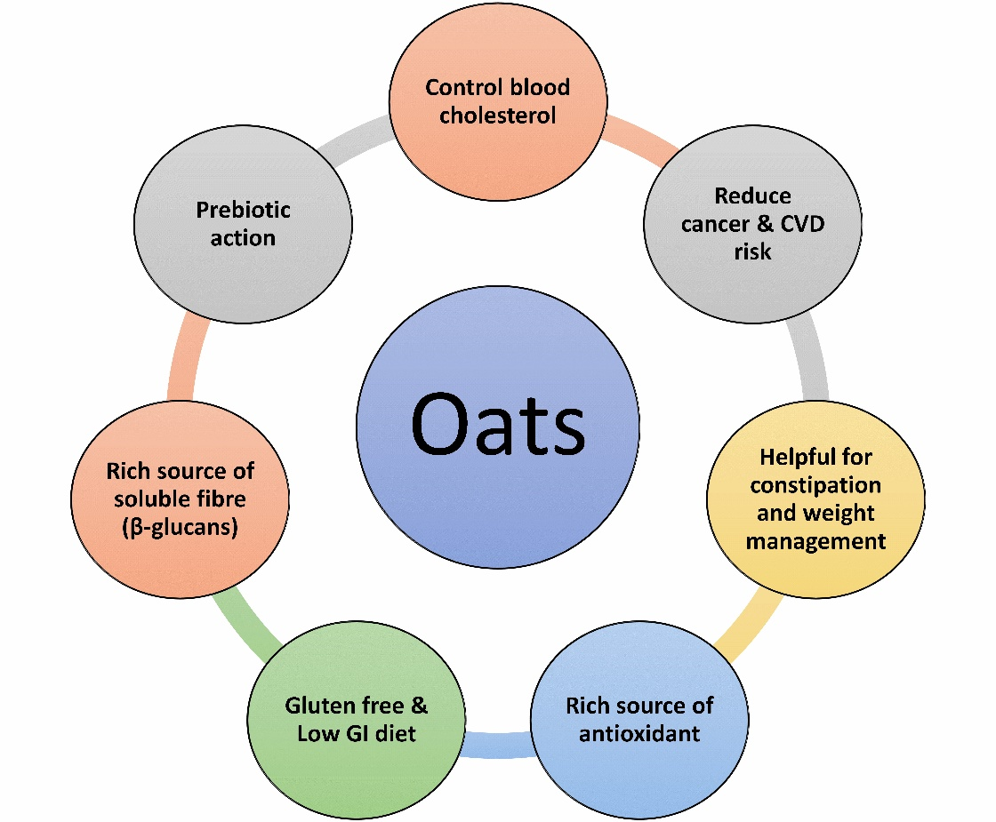

Fig. 2: Several health benefits of oats

4.1 Benefits from β-Glucan
It regulates the immune system by binding to surface receptors and activating macrophages, white blood cells, neutrophil phygocytosis, and lymphocytes, so promoting antitumor and antimicrobial activities. In cosmetics, β-glucan immunological functions activate langerhans cells, which generate cytokine, mainly interleukin-1 (il-1), and stimulate the proliferation of fibroblasts (skin cells) and production of collagen, elastin, and proteoglycan. β-glucan offers various benefits, including film-forming, anti-aging, moisturising, wound-healing, skin-soothing, UV protection, and anti-irritation. β-glucan may promote healing of vascular injuries.

4.1.1 Blood cholesterol and oat β-glucan
The highest concentration of cholesterol, LDL-cholesterol, harms blood arteries because of its proclivity to infiltrate and accumulate inside artery walls. LDL cholesterol is also more susceptible to structural alterations such as oxidation and glycosylation, which are important in the development of atherosclerosis. This is particularly true with tiny, dense LDL cholesterol. High serum HDL-cholesterol levels are protective against CHD because they can scavenge and eliminate excess cholesterol from the artery wall while also shielding LDL from oxidative damage. The capacity of oats to decrease cholesterol was first demonstrated in 1963. Oats lowered total and LDL cholesterol by 2-23 percent, making them significantly hypocholesterolemic. Oats improve future lipid profiles by increasing blood levels of HDL cholesterol and apolipoprotein A-I, both of which are significant components of HDL (Glore et al., 1994).

4.2 Oats Reduce the Risk of cancer
Oats are widely recognized for their health benefits due to their rich content of antioxidants, including vitamin E and various phenolic compounds, which exhibit strong antioxidant activity both in vitro and in vivo (Cai et al., 2011). These oat phenolics help neutralize reactive oxygen and nitrogen species and chelate transition metals, thereby reducing oxidative stress (Chen et al., 2004). Recent studies by Hong et al. have explored the use of orally administered beta-glucan as an immune adjuvant. When combined with monoclonal antibodies that activate complement proteins, beta-glucan enhances the innate immune system’s ability to target and destroy cancer cells. This approach enables primed neutrophils—normally ineffective against tumors because they recognize them as “self”—to bind and kill tumor cells. Traditional cancer immunotherapies, such as monoclonal antibodies and vaccines, stimulate the adaptive immune response but do not alter the innate immune system’s perception of tumors. Consequently, monoclonal antibodies alone do not engage innate immune mechanisms. Notably, Demir et al. (2007) found that oral beta-glucan significantly increased monocyte proliferation and activation in the peripheral blood of patients with advanced breast cancer, suggesting its potential in immunotherapy.

4.2.1 Oat β-glucan prevents cancer
Since 1980, β-glucans have been employed as an immune adjuvant therapy for tumours and malignancies. β-glucan inhibits tumour formation in various experimental models (di Luzio et al., 1979). The vast bulk of published publications and scientific research were undertaken in Japan. Studies indicate that β-glucans have antitumor and anticancer effects. The end-points were tumour development, tumour volume, degree of metastases, and/or survival, with (1, 3)-β-glucan given prophylactically. The anticancer efficacy of (1, 3)-β-glucan is influenced by factors such as tumour type, host animal genetic background, dosage, timing, and method of administration, as well as tumour burden.

4.3 Oats against Vascular Injury
Vascular injury theatres a significant role in the development of cardiovascular diseases (CVD), particularly in individuals with type 2 diabetes (Liuba & Pesonen, 2005; Kibos et al., 2007). Dietary fibers such as β-glucan have shown potential in enhancing collagen synthesis, aiding tissue repair, and promoting wound healing, as observed in diabetic mice models (Wei et al., 2002; Berdal et al., 2007).

4.4 Oats as Rich Source of Antioxidants
Oats contain a unique and potent antioxidant profile, including avenanthramides (AVAs), oat saponins, wax alcohols, and acid esters. AVAs, in particular, are phenolic compounds found predominantly in the bran and outer layers of the oat kernel and are recognized for their high antioxidant activity (Meydani, 2009). Research indicates that the antioxidant power of AVAs is 10–30 times greater than that of other common cereal phenolics like ferulic acid and vanillic acid (Verardo et al., 2011; Yang et al., 2014). These compounds inhibit the formation of reactive oxygen species, reducing LDL oxidation and atherogenicity, and may synergize with vitamin C to enhance cardiovascular protection.

4.4.1 Avenanthramides
Avenanthramides are formed by the reaction of an anthranilic acid derivative with a hydroxycinnamic acid derivative. Avenanthramides 1, 3, and 4, also known as A, B, and C, are the three primary avenanthramides found in oats (Peterson et al., 2002). According to Mattila et al. (2005), oat flakes contain 26 to 27 μg/g of avenanthramides, while oat bran has just 13 μg. These compounds are bioavailable and exhibit antioxidant, anti-inflammatory, and anti-atherogenic properties (Peterson et al., 2002).

4.5 Oats improve Post Prandial Glucose and Insulin Responses
When used as part of a low-glycemic diet, the soluble fiber in oats significantly improves postprandial insulinemic and glycemic responses. Studies suggest that oats, when consumed as purified beta-glucans, oat bran, or oatmeal, help suppress fasting and postprandial blood glucose and insulin levels. Insulin resistance, Type 2 diabetes anda primary cause of metabolic syndromeis the main target for therapeutic interventions using oat β-glucans.There is strong evidence supporting the association between high dietary fiber intake and greater insulin sensitivity. A negative correlation exists between insulin resistance and the dietary intake of total, soluble, and insoluble fiber (Galisteo 2008; Ylonen et al. 2003). Multiple therapeutic investigations have demonstrated the glucose-lowering effects of oat β-glucans. These β-glucans made a gel in the digestive tract, which slows down digestion and absorption of nutrients, especially carbohydrates, thereby reducing the rate of glucose absorption and improving blood sugar control (Butt et al. 2008).
According to Katz (2001), gel-forming beta-glucans act as a barrier to digestion and absorption, resulting in lower postprandial glucose and insulin replies. Tapola et al. conducted a study on Type-2 diabetic patients using glucose loads, oat bran crisp andoat bran flour (12.5 g and 25 g), both with and without oat bran. Their findings revealed that oat bran products significantly lowered postprandial glucose concentrations within the first hour compared to glucose loads alone. However, after 120 minutes, glucose levels were slightly higher in the oat group than in the glucose-only group.This slower glucose absorption results in reduced insulin release and attenuated pancreatic response. Consequently, oat β-glucans are highly effective in lowering peak glucose levels and modulating insulin release, making them valuable in the prevention and management of diabetes (Hooda et al., 2010).

4.6 Oats Are Gluten-Free and Helpful for Celiac Patients
The common oat (Avena sativa) offers numerous nutritional benefits and is particularly effective in managing symptoms of celiac disease through dietary approaches (Butt et al., 2008). Officially recognized as gluten-free under European Commission Regulation (EC) No. 41/2009, oats are considered safe for individuals with celiac disease (Rasane et al., 2015). Incorporating oats can significantly improve the nutritional value of a gluten-free diet.The safety of oats for celiac patients has been well-studied, with clinical evidence confirming that consumption of pure, uncontaminated oats is safe at intake levels of 50–70 g/day for adults and 20–25 g/day for children. Unlike gliadin and gluten proteins found in wheat and other cereals, the oat protein avenin does not trigger autoimmune responses in celiac individuals (Butt et al., 2008). Consequently, oats have been used to formulate gluten-free products such as biscuits, Pasta and snacks suitable for celiac patients (Ballabio et al., 2011).

4.7 Oats and Bowel Function
A high intake of dietary fiber is commonly effective in managing and preventing constipation. Oats are composed of approximately 45% water and 55% water-soluble fiber, primarily beta-glucan, along with a significant portion of insoluble fiber. Soluble fiber serves as a substrate for colonic fermentation and has a strong capacity for water binding and swelling. According to Bell et al. (2009), insoluble fiber increases fecal bulk, enhances laxation, and alleviates constipation due to its low absorbability, thereby reducing intestinal transit time.Oat beta-glucan functions as a prebiotic—a non-digestible food ingredient that selectively stimulates the growth and/or activity of beneficial bacterial strains in the colon, thereby improving host health (Gibson and Roberfroid, 1995). In the small intestine, beta-glucan remains undigested, as mammalian enzymes cannot hydrolyze it. Upon reaching the large intestine, it is fermented, resulting in an increase in microbial cell mass, which retains water and increases stool moisture content—helping to relieve constipation. Additionally, beta-glucan supports the production of short-chain fatty acids (SCFAs) and acts as a selective factor promoting the growth of beneficial bacterial strains. The positive effects on colon function stem both from enhanced microbial mass with strong water-retention ability and from the bulking action of the insoluble fiber components (Malkki& Virtanen, 2001; Perry & Young, 2016).

4.8 Oats and Weight Management
Oats are rich in dietary fiber, which plays a vital role in supporting weight management. Clinical and epidemiological studies suggest that a fiber-rich diet can help prevent excessive weight gain, reduce the risk of obesity (defined as body weight more than 30% over optimal), and assist in maintaining a healthy weight. Obesity is an independent risk factor for coronary artery disease and leads to other health problems such as dyslipidaemia, hypertension, and high blood glucose levels. Observational studies indicate that individuals who lose weight experience an improved coronary risk profile. Dietary fiber, especially the viscous kind found in oats, is associated with increased satiety and reduced energy intake. This is partly due to its texture, which promotes longer chewing, and its ability to delay gastric emptying, slow small bowel transit, and inhibit the digestion and absorption of fats and carbohydrates. These physiological effects help regulate the glycemic response, enhance satiety, and support calorie control. Moreover, beta-glucan from oats has been found to increase plasma levels of cholecystokinin (CCK), a hormone responsible for signaling fullness, particularly after fat intake. Oats are also higher in protein than many other common grains, and protein is known to be more satiating than equivalent amounts of fat or carbohydrate. Additionally, the amino acid profile of oats, characterized by a low lysine-to-arginine ratio, is hypocholesterolemic and may offer cardioprotective benefits (Katz, 2001).

4.9 Prebiotic Effects and Metabolic Benefits of Oats
Recent studies have highlighted oats as a potent functional food due to their prebiotic potential and metabolic health benefits. Connolly (2012) demonstrated that wholegrain oat-based cereals significantly enhance the populations of Bifidobacteria and Lactobacilli during in vitro fermentation. These cereals also increased the production of beneficial short-chain fatty acids (SCFAs) like butyrate, while maintaining a lower glycaemic index (GI) compared to non-wholegrain alternatives, supporting improved glucose control and gut health. Expanding on these findings, Sargautiene (2012) evaluated non-starch polysaccharides (NSPs) extracted from oats. The study revealed that these fibers—particularly β-glucans and arabinoxylans—stimulated beneficial gut microbes and led to higher SCFA production, especially acetate and propionate. Soluble NSPs were fermented more rapidly and effectively, contributing to a reduced pH in the colon environment, which is favorable for microbial growth. These results support the inclusion of oat NSPs in functional foods to support digestive health.
Further supporting the metabolic benefits, Xu (2021) compared oat consumption to white rice in mildly hypercholesterolemic individuals. Oats significantly reduced LDL and total cholesterol while enhancing SCFA production and the diversity of gut microbiota. The cholesterol-lowering and prebiotic effects were attributed to oat beta-glucan, a soluble fiber that promotes fermentation and microbial diversity. Collectively, these studies confirm that oats, especially in wholegrain form or as NSP extracts, offer notable prebiotic benefits. Their ability to support gut microbial balance, lower blood cholesterol, and regulate glucose absorption highlights their value in managing metabolic disorders such as type 2 diabetes and hypercholesterolemia.

5. ANTI-NUTRITIONAL ASPECTS OF OATS
This study explored the nutritional and anti-nutritional composition of various oat (Avena sativa) varieties cultivated in Ethiopia, focusing on their implications for mineral bioavailability. While oats are recognized for their high protein, fiber, and mineral content, they also contain anti-nutritional factors—phytates, tannins, and oxalates—that can hinder the absorption of essential minerals like calcium, iron, and zinc. Phytates were found to be the most abundant anti-nutrient, with concentrations ranging from 269.6 to 520.4 mg/100 g depending on the variety. Although phytates can reduce mineral bioavailability by forming insoluble complexes, most oat varieties examined had ‘phytate:calcium’ molar ratios below the critical 0.24 threshold, indicating limited interference with calcium absorption(Ma et al., 2007). However, ‘phytate:zinc’ and ‘phytate:iron’ molar ratios indicated potential inhibitory effects on these minerals, especially zinc, when exceeding the 15:1 molar ratio (Gemede, 2020; Ma et al., 2007; Norhaizan and Ain, 2009).
Tannin concentrations ranged from 38.8 to 51.5 mg/100 g. Tannins reduce protein digestibility and impair non-heme iron absorption. Still, the values recorded were well below the acceptable daily intake of 560 mg, assuming a 100 g serving(Sandberg, 2002). Processing techniques like fermentation and germination are recommended to further reduce these compounds. Oxalate levels varied between 28.2 and 71.4 mg/100 g. While oxalates can hinder calcium, magnesium, and iron absorption, only the yellow oat variety slightly exceeded the advised daily intake limit of 50 mg/day (Brzezicha-Cirocka et al., 2015). Other varieties fell within safe consumption levels. Despite these anti-nutritional factors, the overall levels in oats were within acceptable dietary limits. The study emphasizes the importance of processing methods such as soaking, fermentation, germination, and cooking that can significantly reduce anti-nutrient content and improve mineral bioavailability. Therefore, Ethiopian oat varieties offer substantial nutritional benefits, and with appropriate processing, the anti-nutritional drawbacks can be minimized. These findings support oats as a safe and health-promoting cereal grain, particularly in regions where they serve as a staple food.

6. MULTIPLE USES AND ANIMAL FEED APPLICATIONS OF OATS
Oats (Avena sativa) have emerged as a versatile crop with extensive applications across human nutrition, animal feed, and industrial domains. Traditionally valued as a high-yielding, digestible, and palatable forage crop in India (Roy et al., 2021), oats are now gaining prominence in the human diet due to their nutritional composition and functional food potential (Rasane et al., 2015). Processing techniques like dehulling, scouring, steaming, and flaking allow oats to be transformed into oatmeal, flour, bran, flakes, and oat milk, meeting a wide range of consumer needs (Wolever et al., 2019; Maina et al., 2021). Scouring and milling further yield oat bran, slurry, and milk, while groats can be crafted into instant, rolled, and steel-cut oat products (AlHasawi et al., 2017; Fernandesa et al., 2018). The presence of oat-based items such as porridge, energy drinks, and baked goods in markets highlights its rising demand and consumer acceptance (Fernandesa et al., 2018).
From a livestock perspective, oats serve as an important winter forage, preferred for their digestibility and nutritional superiority over other cereal straws (Valentine, 2005; Pan et al., 2021). Oats can be consumed as green fodder, hay, haylage, silage, or straw and are often processed with urea (4%) to enhance preservation and palatability. Their utility as a catch crop and winter-hardy forage makes them essential in seasonal fodder planning (Suttie & Reynolds, 2004; Morey, 1961). Notably, oat straw increases lactation feed intake and weaning weight in pigs, showing improved performance compared to wheat straw (Agyekum et al., 2019; Dong et al., 2019).
Oat forage is primarily utilized for feeding livestock. It typically contains around 10–12% crude protein and 22–23.5% cellulose (Chaudhary and Kesh, 2018). As a significant winter fodder crop, oats are commonly fed in their green form, while any excess is preserved as silage or hay for periods of fodder scarcity. Oats are highly favored by a wide range of livestock, with their straw being softer and nutritionally superior compared to wheat and barley straw. Notably, oat forage offers high nutritional value, with a dry matter digestibility exceeding 75%, especially beneficial for dairy cattle (Chaudhary and Kesh, 2018). Although cereal straws generally have a similar chemical makeup, oat straw provides higher levels of digestible organic matter and metabolizable energy.
While berseem is a commonly preferred fodder crop in irrigated regions, oat cultivation offers a suitable alternative, especially in areas with limited water availability. India, which accommodates around 20% of the global livestock and 16.8% of the human population, occupies only 2.3% of the world’s land area, placing significant pressure on existing feed and fodder resources (Chaudhary and Kesh, 2018). Livestock numbers have notably increased in several states, including Punjab, Gujarat, Uttar Pradesh, Sikkim, Bihar, Assam, Meghalaya and Chhattisgarh. Given the declining area available for dedicated fodder cultivation, and the dependency on irrigation for most traditional fodder crops, oats stand out as a viable solution in water-scarce areas (Chaudhary and Kesh, 2018). They can thrive under relatively dry conditions and are particularly useful when more water-demanding crops like lucerne and berseem are not feasible. Traditionally, oats serve as a vital livestock feed, used in the form of green fodder or silage, especially during periods of forage scarcity.

7. CONCLUSION
Oats have steadily transitioned from being primarily a forage crop to a widely recognized functional grain with comprehensive applications in human nutrition and animal feed. Their rich content of β-glucan, dietary fiber, and unique bioactive compounds underscores their significance in promoting health, particularly in reducing cholesterol, managing blood glucose levels, and supporting gut health. Moreover, their prebiotic effects and antioxidant potential further enhance their suitability as a functional ingredient in modern diets. The cultivation of oats offers multiple agronomic advantages. They grow well under diverse environmental conditions and are especially beneficial in areas with limited irrigation. In India, oats serve as an important winter fodder crop, with green forage and preserved silage contributing significantly to livestock nutrition. Their high digestibility and nutritional value make them an ideal feed, especially during lean seasons. From a processing perspective, the transformation of oats into consumable products such as flour, flakes, and beverages has increased their market value and consumer appeal. Technological interventions such as steaming, scouring, and fermentation have improved their palatability and reduced anti-nutritional factors, enhancing the bioavailability of key nutrients. Continued research into processing technologies and varietal improvements will further amplify their utility in both human and animal food systems. In conclusion, oats present a sustainable, nutrient-rich, and adaptable solution to modern dietary and agricultural challenges. With strategic investments in research and farmer awareness, oats can contribute meaningfully to global food and nutrition security.

REFERENCES
Agyekum, A. K., Columbus, D. A., Farmer, C., & Beaulieu, A. D. (2019). Effects of supplementing processed straw during late gestation on sow physiology, lactation feed intake, and offspring body weight and carcass quality. Journal of Animal Science, 97(8), 3958–3971. https://doi.org/10.1093/jas/skz248
Ahmad, M., & Zaffar, G. (2014). Evaluation of oats (Avena sativa L.) genotypes for β-glucan, grain yield and physiological traits. Applied Biological Research, 16(1), 1–3.
Alam, S. M., & Adams, W. A. (1979). Effect of soil pH on the growth and mineral content of oats. Pakistan Journal of Scientific and Industrial Research, 22, 147–151.
AlHasawi FM, Fondaco D, Ben-Elazar K, Ben-Elazar S, Fan YY, Corradini MG, Ludescher RD, Bolster D, Carder G, Chu Y, Chung Y, Kasturi P, Johnson J, Rogers MA (2017) In vitro measurements of luminal viscosity and glucose/maltose bioaccessibility for oat bran, instant oats, and steel cut oats. Food Hydrocolloids 70, 293–303. doi:10.1016/ j.foodhyd.2017.04.015
Ballabio, C., Uberti, F., Manferdelli, S., Vacca, E., Boggini, G., Redaelli, R., et al. (2011). Molecular characterisation of 36 oat varieties and in vitro assessment of their suitability for celiac’s diet. Journal of Cereal Science, 54, 110–115.
Bartnikowska, E. (2003). Oat grain preparations as a source of important health-related substances in human nutrition. Bulletin of the Institute of Plant Breeding and Acclimatization, 229, 235–245.
Bartnikowska, E., Lange, E., & Rakowska, M. (2000). Oat grain – underrated source of nutrients and biologically active substances. Bulletin of the Institute of Plant Breeding and Acclimatization, 215, 209–237.
Berdal, M., Appelbom, H. I., Eikrem, J. H., Lund, A., Zykova, S., Busund, L. T., Seljelid, R., & Jenssen, T. (2007). Aminated β-1,3-D-glucan improves wound healing in diabetic db/db mice. Wound Repair and Regeneration, 15, 825–832.
Brzezicha-Cirocka, J., Grembecka, M., &Szefer, P. (2016). Oxalate, magnesium and calcium content in selected kinds of tea: impact on human health. European Food Research and Technology, 242, 383-389.
Cai, S., Huang, C., Ji, B., Zhou, F., Wise, M. L., Zhang, D., et al. (2011). In vitro antioxidant activity and inhibitory effect on oleic acid-induced hepatic steatosis of fractions and subfractions from oat (Avena sativa L.) ethanol extract. Food Chemistry, 124, 900–905.
Chaudhary, M., & Kesh, H. (2018). Oat—Potential food and feed crop. In V. B. Dongre & A. R. Ahlawat (Eds.), Plastics: A major concern (pp. 784–789). Indian Farmer (Magazine), 5(7), 146 pages.
Chilliard, Y., Ferlay, A., Nansbridge, R. M., &Doreau, M. (2000). Ruminant milk fat plasticity: Nutritional control of saturated, polyunsaturated, trans and conjugated fatty acids. Annales de Zootechnie, 49, 181–200.
Coffman, F. A. (1961). Oats and oats improvement. American Society of Agronomy, Madison, Wisconsin, 8, 263–329.
Collins, F. W. (1986). Oat phenolics: Structure, occurrence and function. In F. H. Webster (Ed.), Oats: Chemistry and Technology (pp. 227–295). American Association of Cereal Chemists, St. Paul, Minnesota.
Collins, F. W. (1989). Oat phenolics: Avenanthramides, novel substituted N-cinnamoylanthranilate alkaloids from oat groats and hulls. Journal of Agricultural and Food Chemistry, 37, 60–66.
Connolly, M. L., Tuohy, K. M., & Lovegrove, J. A. (2012). Wholegrain oat-based cereals have prebiotic potential and low glycaemic index. British journal of nutrition, 108(12), 2198-2206.
Demir, G., Klein, H. O., Mandel-Molinas, N., &Tuzuner, N. (2007). Beta-glucan induces proliferation and activation of monocytes in peripheral blood of patients with advanced breast cancer. International Immunopharmacology, 7(1), 113–116.
Di Luzio, N. R., Williams, D. L., McNamee, R. B., Edwards, B. F., &Kitahama, A. (1979). Comparative tumor inhibitory and anti-bacterial activity of soluble and particulate glucans. International Journal of Cancer, 24, 773–779. https://doi.org/10.1002/ijc.2910240613
Dimberg, L. H., Gissén, C., & Nilsson, J. (2005). Phenolic compounds in oat grains (Avena sativa L.) grown in conventional and organic systems. American Biotechnology, 34, 331–337.
Dong, W., Wang, Q., Chen, J., & Zhang, L. (2019). Apparent total tract digestibility of nutrients and the digestible and metabolizable energy values of five unconventional feedstuffs fed to growing pigs. Journal of Applied Animal Research, 47(1), 273–279. https://doi.org/10.1080/09712119.2019.1652436
Fernandesa CG, Sonawaneb SK, Arya SS (2018) Cereal based functional beverages: a review. Journal of Microbiology, Biotechnology and Food Sciences 8, 914–919. doi:10.15414/jmbfs.2018-19.8.3.914-919
Foreign Agricultural Services – U.S. Department of Agriculture (FAS-USDA) (2025). Production – Oats, Top producing countries. https://www.fas.usda.gov/data/production/commodity/0452000. Accessed on 14th April, 2025.
Galisteo, M., Duarte, J., &Zarzuelo, A. (2008). Effects of dietary fibres on disturbances clustered in the metabolic syndrome. Journal of Nutritional Biochemistry, 19, 71–84.
Gebauer, S., Harris, W. S., Kris-Etherton, P. M., & Etherton, T. D. (2005). Dietary n-6:n-3 fatty acid ratio and health. In Healthful Lipids. AOCS Press, CRC.
Gemede, H. F. (2020). Nutritional and antinutritional evaluation of complementary foods formulated from maize, pea, and anchote flours. Food Science & Nutrition, 8(4), 2156-2164.
Gibson, G. G., &Roberfroid, M. B. (1985). Dietary modulation of the human colonic microbiota: Introducing the concept of prebiotics. Journal of Nutrition, 125, 1401–1412.
Glore, S. R., Van Treeck, D., Knehans, A. W., & Guild, M. (1994). Soluble fiber and serum lipids: A literature review. Journal of the American Dietetic Association, 94(4), 425–436. https://doi.org/10.1016/0002-8223(94)90099-X
Hooda, S., Matte, J. J., Vasanthan, T., & Zijlstra, R. T. (2010). Dietary purified oat β-glucan reduces peak glucose absorption and portal insulin release in portal-vein catheterized grower pigs. Livestock Science, 134(1–3), 15–17.
Liuba, P., & Pesonen, E. (2005). Infection and early atherosclerosis: Does the evidence support causation? Paediatrica, 94, 643–651.
Ma, G., Li, Y., Jin, Y., Zhai, F., Kok, F. J., & Yang, X. (2007). Phytate intake and molar ratios of phytate to zinc, iron and calcium in the diets of people in China. European Journal of Clinical Nutrition, 61(3), 368-374.
Maina NH, Rieder A, De Bondt Y, Mäkelä-Salmi N, Sahlstrøm S, Mattila O, Lamothe LM, Nyström L, Courtin CM, Katina K, Poutanen K (2021) Process-induced changes in the quantity and characteristics of grain dietary fiber. Foods 10, 2566. doi:10.3390/foods10112566
Mälkki, Y., & Virtanen, E. (2001). Gastrointestinal effects of oat bran and oat gum: A review. Lebensmittel-Wissenschaft & Technologie, 34, 337–347.
Meydani, M. (2009). Potential health benefits of avenanthramides of oats. Nutrition Reviews, 67, 731–735.
Morey DD (1961). Forage production of small grains under maximum favourable condition. Agron. J. 53: 57-59. http://dx.doi.org/10.2134/agronj1961.00021962005300010023x
Norhaizan, M. E., & Nor Faizadatul Ain, A. W. (2009). Determination of phytate, iron, zinc, calcium contents and their molar ratios in commonly consumed raw and prepared food in Malaysia. Malaysian journal of nutrition, 15(2).
Orozco-Mena, R., Salmerón-Ochoa, I., Ortega-Rivas, E., & Perez Vega, S. (2014). Development of a sustainable process for the solid-liquid extraction of antioxidants from oat. Sustainability, 6, 1504–1520.
Pan L, Huang KH, Middlebrook T, Zhang D, Bryden WL, Li X (2021) Rumen degradability of barley, oats, sorghum, triticale, and wheat in situ and the effect of pelleting. Agriculture 11, 647. doi:10.3390/ agriculture11070647
Perry, J. R., & Ying, W. (2016). A review of physiological effects of soluble and insoluble dietary fibers. Journal of Nutrition & Food Sciences, 6, 476.
Peterson, D. M., Hahn, M. J., & Ammonds, C. L. (2002). Oat avenanthramides exhibit antioxidant activities in vitro. Food Chemistry, 79(4), 473–478. https://doi.org/10.1016/S0308-8146(02)00122-3
Petkov, K., Biel, W., Kowieska, A., & Jaskowska, I. (2001). The composition and nutritive value of naked oat grain Avena sativa var. nuda. Journal of Animal and Feed Sciences, 10(2), 303–307.
Rasane P, Jha A, Sabikhi L, Kumar A, Unnikrishnan VS (2015) Nutritional advantages of oats and opportunities for its processing as value added foods – a review. Journal of Food Science and Technology 52, 662–675. doi:10.1007/s13197-013-1072-1
Roy AK, Agrawal RK, Bhardwaj NR, Chand S (2021) ‘50 years journey of AICRP on forage crops and utilization.’ (Eds AK Roy, RK Agrawal, NR Bhardwaj, S Chand) (ICAR-IGFRI, Jhansi: Jhansi, UP, India)
Sandberg, A. S. (2002). Bioavailability of minerals in legumes. British Journal of nutrition, 88(S3), 281-285.
Sargautiene, V., Nakurte, I., &Nikolajeva, V. (2018). Broad prebiotic potential of non-starch polysaccharides from oats (Avena sativa L.): an in vitro study. Polish journal of microbiology, 67(3), 307.
Schrickel, D. J. (1986). Oats: Production, value and use. In Oats: Chemistry and Technology, 1–11.
Suttie JM, Reynolds SG (2004). Fodder Oats: A World Overview. FAO, http://www.fao.org/docrep/008/y5765e/y5765e00.htm.
Tapola, N., Harvonen, H., Niskamen, L., Mikola, M., & Sarkkinen, E. (2005). Glycemic responses of oat bran products in type 2-diabetic patients. Nutrition, Metabolism & Cardiovascular Diseases, 15, 255–261.
Usman, S., Nazir, S., Ali, S., Nasreen, Z., & Najim, A. (2010). Determination of biochemical composition of Avena sativa (oat).
Valentine J (2005) Fodder oats: a world overview. In ‘Experimental agriculture’. Vol. 41. (Eds JM Suttie, SG Reynolds) p. 509. (Cambridge University Press: Cambridge, UK)
Verardo, V., Serea, C., Segal, R., & Caboni, M. F. (1997). Free and bound minor polar compounds in oats: Different extraction methods and analytical determinations. Journal of Cereal Science, 54, 211–217.
Wei, D., Zhang, L., Williams, D. L., & Browder, I. W. (2002). Glucan stimulates human dermal fibroblast collagen biosynthesis through a nuclear factor-1 dependent mechanism. Wound Repair and Regeneration, 10, 161–168.
Wolever TMS, Johnson J, Jenkins AL, Campbell JC, Ezatagha A, Chu Y (2019) Impact of oat processing on glycaemic and insulinaemic responses in healthy humans: a randomised clinical trial. British Journal of Nutrition 121, 1264–1270. doi:10.1017/S000711451 9000370
Xu, D., Feng, M., Chu, Y., Wang, S., Shete, V., Tuohy, K. M., Liu, F., Zhou, X., Kamil, A., Pan, D., Liu, H., Yang, X., Yang, C., Zhu, B., Lv, N., Xiong, Q., Wang, X., Sun, J., Sun, G., & Yang, Y. (2021). The prebiotic effects of oats on blood lipids, gut microbiota, and short-chain fatty acids in mildly hypercholesterolemic subjects compared with rice: a randomized, controlled trial. Frontiers in immunology, 12, 787797.
Yang, J., Ou, B., Wise, M. L., & Chu, Y. F. (2014). In vitro total antioxidant capacity and anti-inflammatory activity of three common oat-derived avenanthramides. Food Chemistry, 160, 338–345.
Yang, J., Ou, B., Wise, M. L., & Chu, Y. F. (2014). In vitro total antioxidant capacity and anti-inflammatory activity of three common oat-derived avenanthramides. Food Chemistry, 160, 338–345.
Ylonen, K., Saloranta, C., Kronberg-Kippila, C., Groop, L., Aro, A., & Virtanen, M. (2003). Associations of dietary fibre with glucose metabolism in non-diabetic relatives of subjects with type 2 diabetes. Diabetes Care, 26, 1979–1985.
Rasane, P., Jha, A., Sabikhi, L., Kumar, A., & Unnikrishnan, V. S. (2015). Nutritional advantages of oats and opportunities for its processing as value added foods-a review. Journal of food science and technology, 52, 662-675.https://doi.org/10.1007/s13197-013-1072-1
Decker, E. A., Rose, D. J., & Stewart, D. (2014). Processing of oats and the impact of processing operations on nutrition and health benefits. British Journal of Nutrition, 112(S2), S58-S64.https://doi.org/10.1017/S000711451400227X

