TECHNO - ECONOMIC EVALUATION OF POWER OPERATED OUAT FINGER MILLET THRESHER IN CHHATTISGARH- A CASE STUDY

Abstract
Finger millet, a nutritionally significant and drought-resistant crop cultivated across India, traditionally undergoes labor-intensive processing. This research addresses the need for mechanized solutions by evaluating a finger millet thresher (OUAT model) at KVK Kanker, IGKV, Raipur. The study commenced with an investigation of the physical and engineering properties of finger millet, including panicle characteristics (finger length, ear head length, peduncle length, number of fingers per panicle, and panicle weight), crop-grain ratio, grain-straw ratio, and grain properties (sphericity, surface area, volume, and geometric mean diameter), with a noted significant influence of moisture content on grain length. The thresher, an axial flow fed machine powered by a 1 hp single-phase electric motor, has dimensions of 1750 mm x 1200 mm x 1400 mm and weighs 150 kg, featuring a peg and canvas threshing cylinder, semi-circular concave, shaker mechanism, sieves, and an aspirator blower. Utilizing Response Surface Methodology (RSM) to optimize processing and quantify the impact of operating parameters, the research determined that a 100 kg/h feed rate, 12 m/s peripheral speed, and 14% moisture content yielded maximum threshing efficiency (98.3%), while maximum cleaning efficiency (98.9%) was achieved at 60 kg/h feed rate, 7.5 m/s peripheral speed, and 10% moisture content, and the lowest broken grain percentage (1.3%) occurred at 120 kg/h feed rate, 12 m/s peripheral speed, and 14% moisture content; these findings offer valuable insights for enhancing farmer livelihoods.
Keywords: Mechanization, Post-harvest processing, Threshing efficiency, Cleaning efficiency, Broken grain, Operating parameters, Response Surface Methodology (RSM),

Introduction

India promoted millets in 2018, leading up to the 2023 International Year of Millets, with government initiatives to enhance awareness and participation in their cultivation and consumption. Millets, including finger millet (Eleusine coracana L.), are small-seeded grasses with significant nutritional value. Finger millet is a staple crop in parts of Africa and Asia, including India, and is valued for its resilience, nutritional benefits, and diverse culinary uses. Despite its importance, post-harvest processing of finger millet in many regions, including Chhattisgarh, remains heavily reliant on traditional, labor-intensive practices that are time-consuming, tedious, low-yielding, unhygienic, and degrade germination quality. This research aims to evaluate a finger millet thresher to improve the efficiency of post-harvest processing, addressing the need for mechanization, particularly for small and medium-scale farmers in Chhattisgarh.

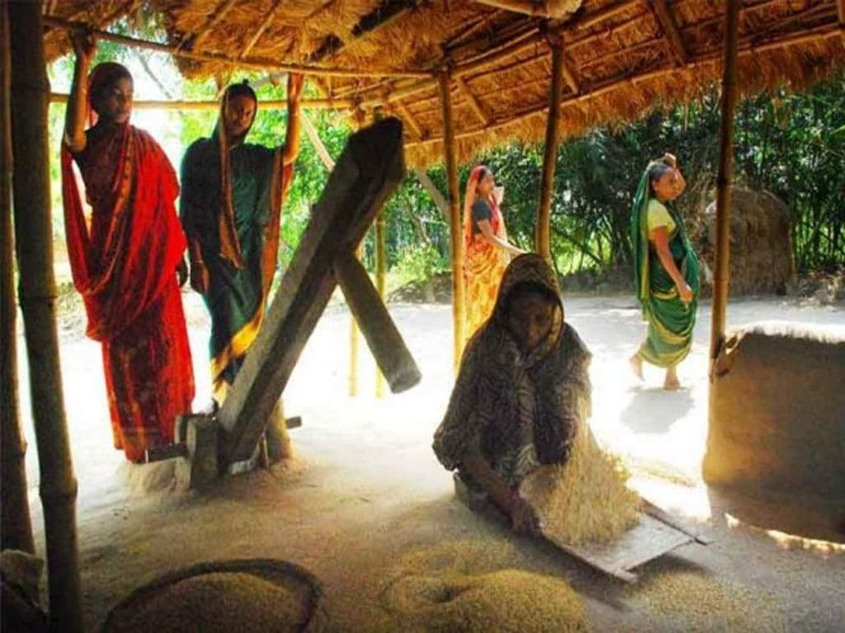

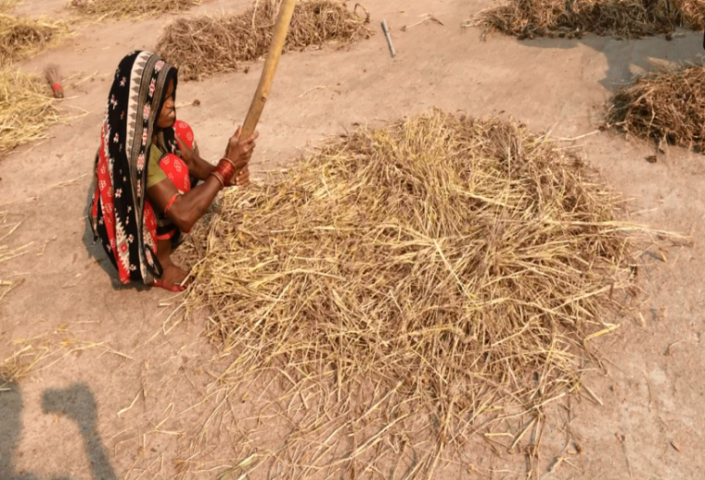
Fig.1 Traditional method of threshing finger millet
2. Material and Methods

2.1 Study Area
The evaluation was conducted in Krishi Vigyan Kendra, Kanker districts of Chhattisgarh, where finger millet is widely cultivated by tribal farmers.
2.2 Components and working of the OUAT Finger Millet Thresher
The OUAT finger millet thresher was developed in year 2021. It comprises a feeding chute, threshing unit, oscillating sieve assembly, aspirator, and power transmission system. The feeding chute delivers finger millet panicles to the threshing cylinder, which utilizes stud-type and canvas-type threshing components. The oscillating sieve assembly, with two mild steel screens, separates threshed material, while an aspirator removes lighter florets and stalks. The power transmission system includes a series of spur gears, gearboxes, shafts, and a belt and pulley arrangement, driven by a 1 hp motor. The finger millet thresher employs an axial flow design with a threshing cylinder, concave, aspirator, and reciprocating sieve, powered by a 1 hp electric motor. A belt and pulley system drives the thresher, with the threshing cylinder, blower, and aspirator rotating simultaneously. Dry finger millet panicles are fed into the threshing cylinder, where threshing occurs through impact and shearing by stud-type and canvas-type components. The threshed crop moves axially, with straw exiting through the main outlet. Grains, florets, and small straws pass through the concave to the oscillating sieves for separation. The aspirator removes remaining lightweight florets, while clean grains are collected from the bottom sieve.
The technical details of thresher are presented in table 1 and the photographs of the components are shown in fig. 2 .
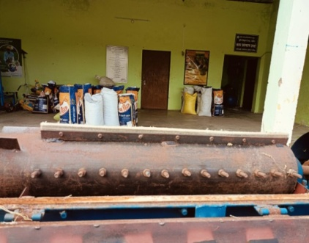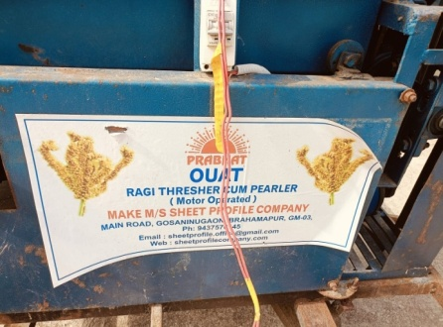 | 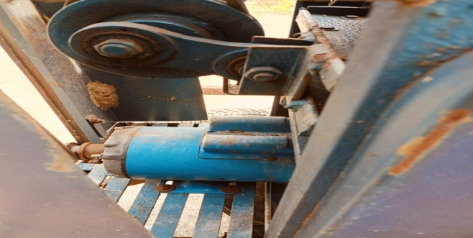 | 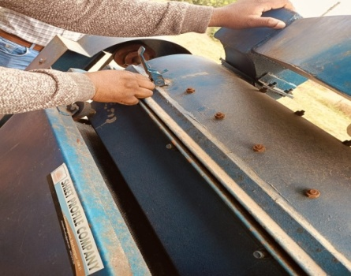
 | 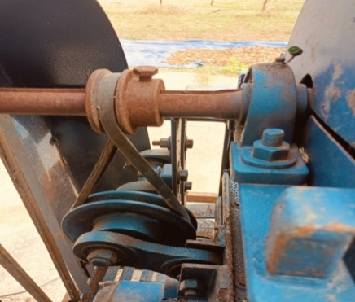 | 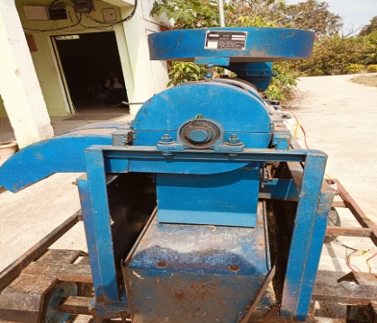
 | Fig. 2 Components of finger millet thresher

Table 1 Dimensions of main components of thresher
Particulars | Detail specifications
Type | Finger millet thresher
Power source | Electric power , 1 hp motor
- Mainframe (L×W×H) mm | 150×500×905
- Feeding chute (L×W×t×D) mm | 450 ×310× 2 ×170
- Threshing unit
Type of threshing cylinder | Peg and canvas type.
Description | Diameter 175 mm , Thickness 5 mm.  14 pegs (3nos. rows), total 42 pegs, 5 knives at alternate side of peg row, Material MS, Peg height- 37 mm,Dia 12 mm.
Length of the cylinder | 750 mm
Peripheral speed | 7.34-9.00 m/sec
Concave type | Semi-cylindrical having 75mm width and 700mm length
Recommended concave clearance | 12 mm (Average)
Constructional features | 26 nos. of 10 mm mild steel rods with 3 mm gaps are welded axially above 3 nos. support of MS flats (25 x 5) mm in a semi-circular shape
- Cleaning unit
Oscillating sieve  Upper (L×W) mm  Lower(L×W) mm | Punctured GI sheet, 2 nos Size (mm)  765×340 , 2.75 mm hole  1270×340, 1 mm hole
Sieve slope | Upper: 30 degrees (fixed)  Lower: 30 degrees (fixed)
Blower nos and type | One, Centrifugal-Aspirator type
Number of blades & Size of blades | 4 blades, 115 x 115 x 2, depth- 20 mm

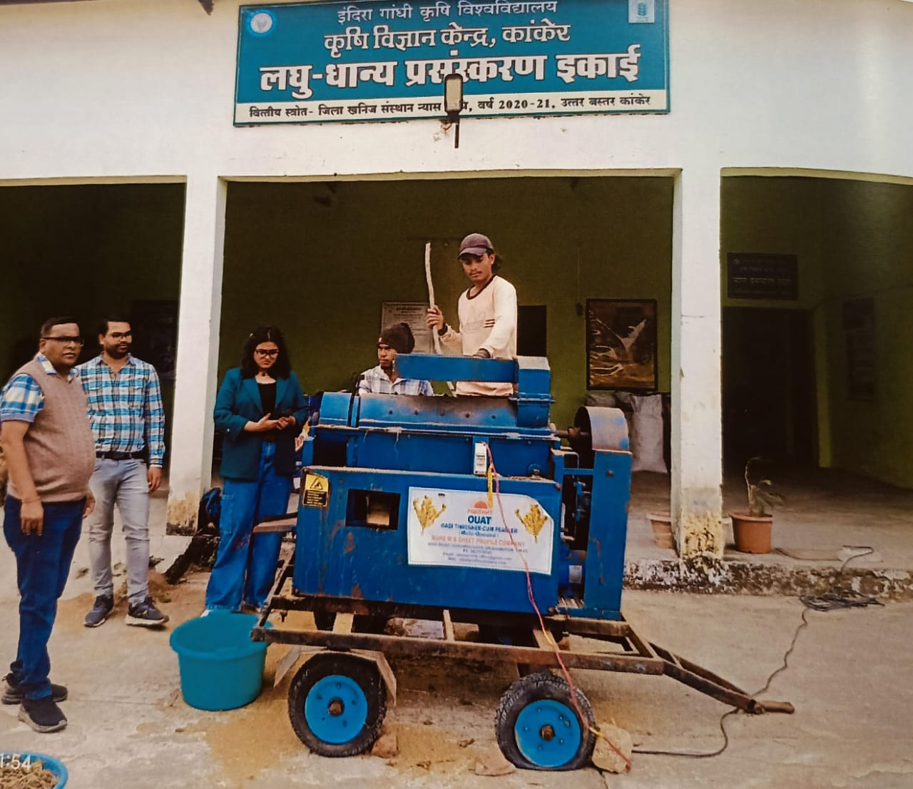
Fig 3 Performance evaluation of OUAT finger millet thresher at KVK, Kanker

The machine was evaluated under field conditions using test protocols outlined by the Bureau of Indian Standards (IS: 6284-1985). The details of independent parameters each five levels and dependent parameters are presented in table 2. The following are the parameters were recorded:
$$Output capacity\left(\frac{kg}{h}\right)=\frac{Weight of grain threshed(kg)}{Time taken (h)}$$
$$Threshing efficiency\left(\%\right)=\left(\frac{Total threshed grain}{Total grain input}\right)×100$$
$$Cleaning efficiency\left(\%\right)=\left(\frac{Clean grain collected }{Total threshed grain}\right)×100$$
$$Grain damage\left(\%\right)=\left(\frac{Damaged or broken grain collected }{Total threshed grain}\right)×100$$
The response surface methodology (RSM) was employed to model and analyze the process, identifying the relationship between independent variables (moisture content, feed rate, and peripheral speed) and dependent parameters (output capacity, threshing efficiency, cleaning efficiency, pearling efficiency, and broken grain). Statistical models (linear, quadratic, 2FI, or cubic) were used to analyze the experimental data, and the best-fit model.
3. Result And Discussion
Optimizing parameters of finger millet thresher using Response Surface Methodology (RSM)

Threshing efficiency of the OUAT finger millet thresher was varied in the ranged from 82.2% to 98.3%. The optimal performance was observed at lower moisture content i.e. 14% db, mc and a feed rate of 100 kg/h. It may be due to better grain detachment. The cleaning efficiency was observed in the range of 91.3% to 98.9%. Moisture content significantly impacted cleaning, with lower moisture content (around 10%) leading to better cleaning due to easier glume removal. Peripheral speed had a less pronounced effect. .Pearling efficiency ranged from 83.2% to 90.2%. Higher feed rates initially increased pearling efficiency up to a point (around 140 kg/h), after which it decreased. Lower moisture content (14%) and a feed rate of 80kg/h resulted in higher pearling efficiency. The type of threshing cylinder significantly affected pearling. Broken grain percentage varied from 1.3% to 4.7%. Higher moisture content (18%) increased breakage. Lower feed rates (60 kg/h) also increased broken grain, possibly due to repetitive impacts. Output capacity ranged from 32.8 kg/h to 61.9 kg/h. The highest output was observed at a feed rate of 120kg/h, peripheral speed of 9.5 m/s and moisture content of 12%. The lowest output was observed at a feed rate of 60 kg/h, peripheral speed of 7.5 m/s and moisture content of 10%. Higher feed rates generally led to increased output, while the effect of peripheral speed and moisture content seems to be more complex and requires further analysis. The graphs and the optimization results clearly demonstrate the interplay between the input parameters and the performance of the finger millet thresher. The study successfully identified a parameter combination that maximizes efficiency across multiple metrics while minimizing broken grain percentage. The chosen solution represents a well-balanced configuration that offers high performance under the tested conditions.

Table 2 Effect of independent parameters on dependent parameters
Std | Run | Feed rate,  kg/h | Peripheral speed,  m/s | Moisture content,  % | Threshing efficiency,  % | Cleaning efficiency,  % | Pearling efficiency,  % | Broken grain,  % | Output capacity ,kg/h
9 | 1 | 120 | 9.5 | 14 | 98.2 | 97.4 | 89.4 | 2.1 | 61.9
2 | 2 | 140 | 7.5 | 10 | 86.2 | 94.2 | 90.2 | 3.6 | 49.6
18 | 3 | 100 | 9.5 | 16 | 95.3 | 95.4 | 85.7 | 2.5 | 47.5
15 | 4 | 100 | 9.5 | 14 | 96.1 | 98.2 | 86.2 | 1.8 | 43.9
10 | 5 | 80 | 9.5 | 16 | 96.2 | 96.3 | 87.3 | 2.2 | 44.6
8 | 6 | 140 | 11.5 | 18 | 88.3 | 93.5 | 83.2 | 4.4 | 46.8
19 | 7 | 100 | 9.5 | 14 | 97.6 | 97.9 | 88.4 | 2.5 | 45.7
12 | 8 | 100 | 12 | 14 | 98.3 | 98.5 | 87.4 | 1.3 | 48.7
1 | 9 | 60 | 7.5 | 10 | 97.8 | 98.9 | 88.5 | 2.5 | 32.8
7 | 10 | 60 | 11.5 | 18 | 94.3 | 96.3 | 84.6 | 4.7 | 35.6
14 | 11 | 100 | 9.5 | 18 | 90.4 | 94.6 | 83.2 | 4.3 | 44.3
5 | 12 | 60 | 7.5 | 18 | 97.6 | 94.7 | 88.9 | 2.3 | 34.7
17 | 13 | 120 | 9.5 | 14 | 97.9 | 97.6 | 85.7 | 3.5 | 60.2
16 | 14 | 120 | 9.5 | 14 | 97.8 | 97.7 | 88.2 | 2.3 | 60.3
20 | 15 | 120 | 9.5 | 14 | 98.2 | 97.6 | 89.4 | 2.1 | 60.9
11 | 16 | 100 | 8.5 | 10 | 96.3 | 98.9 | 87.2 | 2.5 | 49.3
6 | 17 | 140 | 7.5 | 18 | 93.5 | 91.3 | 84.1 | 4.5 | 46.4
13 | 18 | 120 | 8.5 | 12 | 97.6 | 98.4 | 87.6 | 2.8 | 49.1
4 | 19 | 140 | 11.5 | 10 | 82.2 | 93.9 | 86.3 | 4.1 | 50.4
3 | 20 | 60 | 11.5 | 10 | 98.3 | 98.5 | 89.4 | 1.9 | 34.3
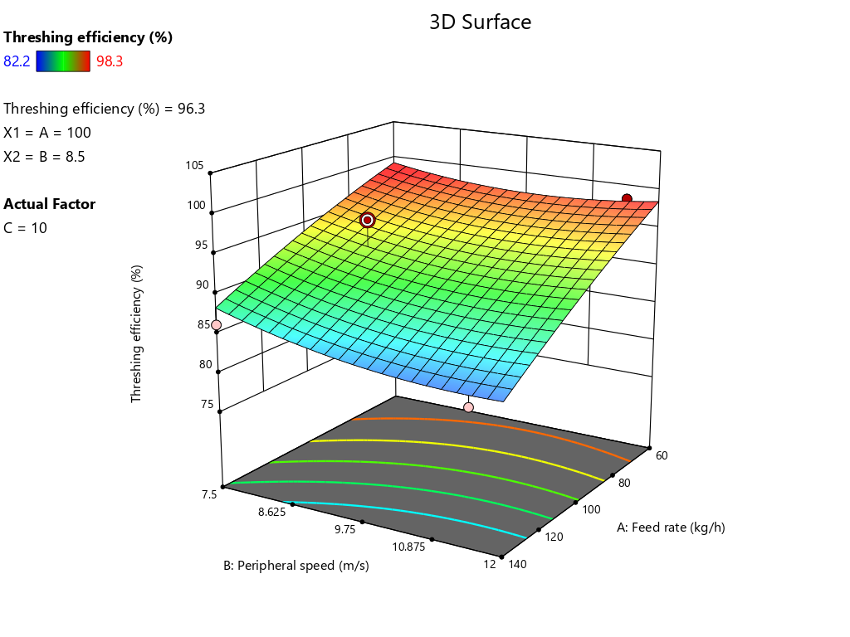 | 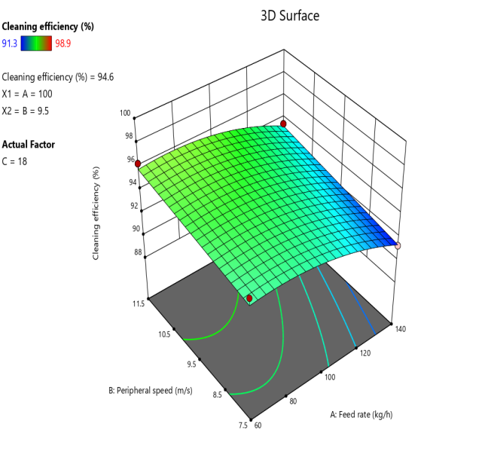
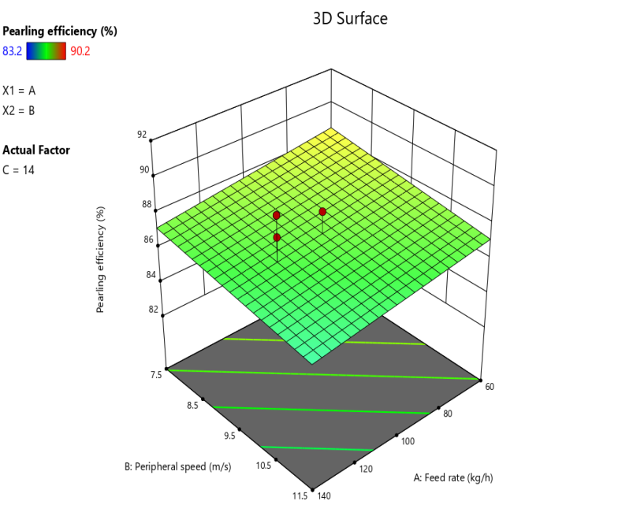 | 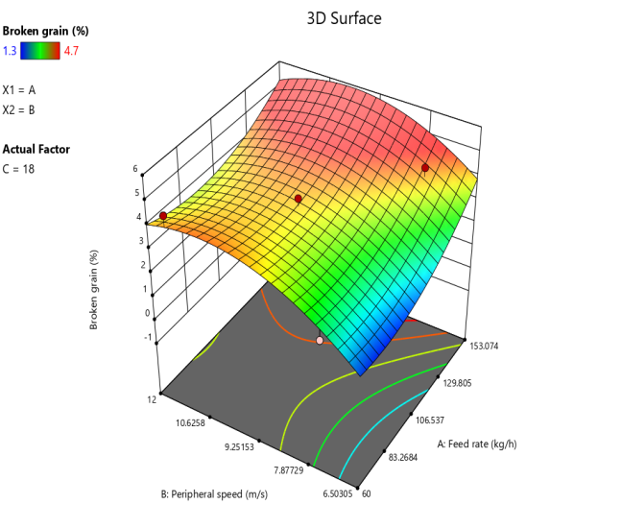
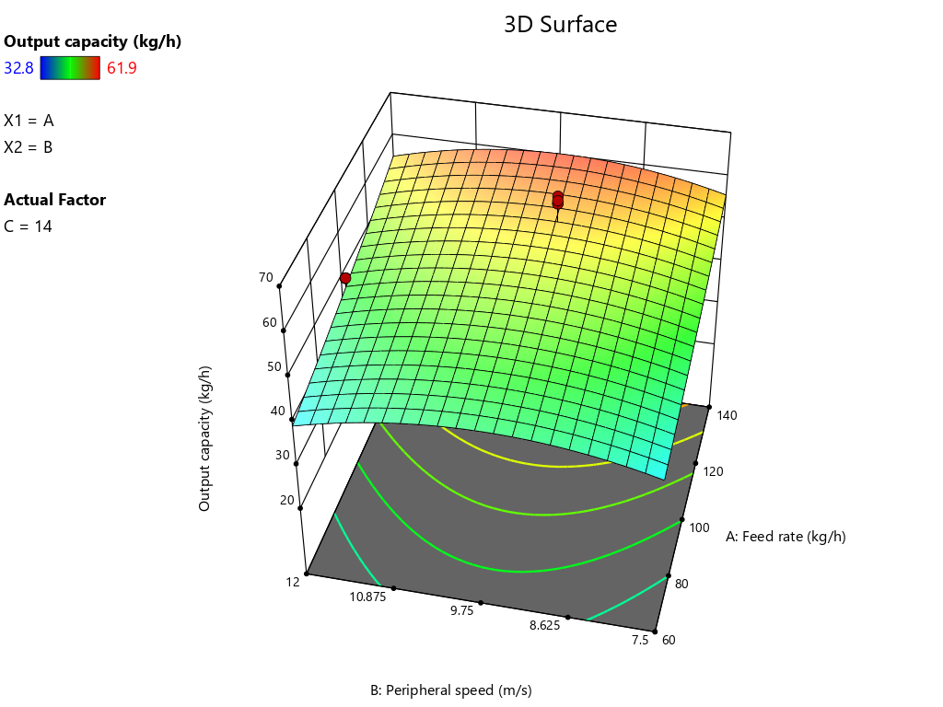 | Fig.4 3D graph of effect of independent parameter(feed rate, peripheral speed and moisture content) on dependent parameter (threshing efficiency, cleaning efficiency, pearling efficiency, broken grain, output capacity) through Response Surface Methodology

- Ergonomic assessment through BPDS and Postural analysis tools

Ergonomic assessments revealed significant postural stress and musculoskeletal disorder risks for thresher operators. RULA scores (5-6) indicated a need for investigation and immediate changes, while REBA scores (9-10) also suggested necessary changes. Goniometric measurements showed that operators' postures, particularly in the upper limbs, neck, and trunk, contribute to these risks. Elevated heart rates (83-98 bpm) indicate the task's physiological demands and potential for fatigue. The findings suggest that the thresher's design and/or work practices should be modified to mitigate identified ergonomic risks and reduce operator strain.

Table 3.Drudgery analysis through body part discomfort score chart
S.No. | Body parts | Manual Hand Beating | OUAT Thresher | IGKV Thresher
1 | Neck | 7.00 | 5.50 | 3.00
2 | Clavicle left | 6.85 | 1.25 | 5.25
3 | Clavicle right | 7.12 | 3.51 | 5.70
4 | Left shoulder | 4.80 | 3.50 | 4.80
5 | Right shoulder | 4.80 | 6.98 | 4.80
6 | Left arm | 4.70 | 2.35 | 4.70
7 | Right arm | 6.40 | 6.49 | 6.40
8 | Left elbow | 6.20 | 6.20 | 4.39
9 | Right elbow | 6.60 | 6.32 | 4.57
10 | Left forearm | 5.25 | 3.54 | 3.89
11 | Right forearm | 7.30 | 5.69 | 4.17
12 | Left wrist | 5.30 | 5.38 | 3.30
13 | Right wrist | 6.30 | 5.97 | 4.53
14 | Left palm | 5.50 | 3.50 | 3.50
15 | Right palm | 6.74 | 3.60 | 3,59
16 | Upper back | 6.50 | 5.30 | 3.18
17 | Middle back | 6.20 | 5.85 | 2.16
18 | Lower back | 8.20 | 4.49 | 3.19
19 | Buttocks | 8.95 | 3.58 | 1.38
20 | Left thigh | 7.90 | 6.98 | 3.19
21 | Right thigh | 8.30 | 7.18 | 3.12
22 | Left knee | 7.56 | 8.39 | 5.80
23 | Right knee | 8.98 | 8.43 | 5.79
24 | Right leg | 8.12 | 5.32 | 4.34
25 | Left leg | 7.60 | 4.65 | 4.58
26 | Left foot | 7.50 | 5.34 | 3.51
27 | Right foot | 7.60 | 4.30 | 3.46
 | Total score | 191.27 | 139.59 | 106.70
 | ODR | 7.08 | 5.17 | 3.95

- Conclusion

Performance evaluation of the developed OUAT finger millet thresher, using RSM, identified optimal operating parameters (feed rate, peripheral speed, and moisture content) to maximize threshing and cleaning efficiencies while minimizing broken grain. Ergonomic and physiological assessments revealed potential risks associated with thresher operation, highlighting the need for design modifications and improved work practices to enhance operator safety and comfort. This research contributes information’s to improve finger millet processing technologies, offering potential benefits to small and medium farmers in Chhattisgarh by increasing efficiency, reducing labor, and improving grain quality.

7.Reference

Anonymous. 1985. Indian Standard Test Code for power thresher for cereals. Indian Standard Institution, Manak Bhavan, 9 Bahadur Shah Zafar Marg, New Delhi 110002.6284: 1-28.
Anonymous. 1986. Specification for power thresher- spike tooth type. Indian Standard Institution, Manak Bhavan, 9 Bahadur Shah Zafar Marg, New Delhi 110002. IS 11691.
Bansal, N.K. and Lohan, S.K. (2009). Design and development of an Axial flow thresher for seed crops. Journal of Agricultural Engineering, 46(1):1-8
Chaturvedi, S. and Rathore, F. 2018. Development of threshing cylinder for small millets. Agric. Sci. Digest., 38(3) 2018: 178-182.
Gbabo, A., Gana, I.M. and Amoto, M.S. 2013. Design, fabrication and testing of a millet thresher. Net Journal of Agricultural Science, 1(4):100-106.
Hanumantharaju, K.N., Poornima, D.S., Ramya, H.N. and Ashok S.B.S. 2019. Development and performance evaluation of whole crop finger millet thresher. Multilogic in Science, 9(31):32-36.
Hota, S., Mishra, J. N., Mohanty, S. K., & Khadatkar, A. (2017). Design and development of pedal operated Ragi thresher for tribal region of Odisha, India. Agricultural Mechanization in Asia, Africa and Latin America, 48(4), 71-75.
Joshi, P., Jethi, R., Chandra, N., Roy M.L., Kharbikar, H.L. and Atheequlla, G. 2015. Ergonomics assessment of post harvest finger millet threshing for reducing women drudgery. Indian Research Journal Extension Education, 15(1):25-30.
Ojediran, O.J.,Adamu, M.A. and Jim-George, D.L. 2010. Some physical properties of pearl millet (Pennisetum glaucum) seeds as a function of moisture content. African Journal of General Agriculture, 6(1):39-56.
Olaoye, J.O., Oni, K.C. and Olaoye, M.O. 2011. Computer applications for selecting operating parameters in a stationary grain crop thresher. Journal of Agricultural Technology, 7(1):39-56.
Parihar, D.S., Shrivastava, A.K., Singh, A.K., Singh, N.K., Mahadik, A.S. and Awasthi,V.J. 2022. Optimization of operational parameters for axial flow paddy thresher using rsm. International Journal of Environment and Climate Change, 12(9):253-263.
Parmanand,Verma, A. and Guru. P.K. 2015. Ergonomic evaluation of developed pedal operated millet thresher for threshing of finger millet. International Journal of Agricultural Science and Research, 5(6):15-24
Patel, G., Naik, R.K. and Dewangan, S.K, (2024).Study on different threshing technology and factor influencing threshing of linseed for the development of linseed thresher ; A review. International journal of advanced biochemistry research, 8(8);321-326.
Patel, G., Naik, R.K. and Dewangan, S.K, (2024)Design optimization of linseed thresher for higher efficiency. International Journal of Manufacturing and Production Engineering (IJMPE), 2(2):24-32.
Patel, G., Naik, R.K. and Patel, K.K. (2021). Studies on Some Physical and Engineering Properties of Linseed. Biological Forum – An International Journal, 13(3): 303-308.
Patel, G., Naik, R.K., Dewangan, S.K. and Tuteja, H.S.(2024). Studies on design parameters for development of head cut type linseed thresher. International Journal of Research in Agronomy,7(9):435-440.
Patel, K. K., Naik, R.K., Patel, G. and Pandey (2022) Studies on some Physical and Engineering Properties of Finger Millet for Designing Thresher. Biological Forum – An International Journal, 14(4): 387-393.
Sial, S. K. (2018). Development and evaluation of ragi thresher-cum-pearler operated by bullock power in rotary mode (Doctoral dissertation, CAET, OUAT).
Sial, S.K., Swain, S.K., Behera, D., Mohapatra, P.M., Mohapatra A.K., and Dash, A.K. 2019. Moisture related engineering properties of different OUAT released varieties of ragi. Green Farming, 10(3): 341-345
Tiwari, P., 2019. M. Tech. thesis. Ergonomical assessment of selected farming operations in Bastar Plateau Zone. Indira Gandhi Krishi Viswavidyalaya, Raipur.
Tiwari, P., Shrivastav, A.K. and Dave, A.K., 2022. Ergonomical assessment of pedal operated thresher for tribal women of Bastar plateau zone of Chhattisgarh.
Tiwari, P., Shrivastav, A.K. and Dave, A.K., 2022. Ergonomical assessment of pedal operated thresher for tribal women of Bastar plateau zone of Chhattisgarh.
Verma, S.S., Singh, A. and Shahi, N.C. 2012. Response Surface Methodology for selection of machine parameters for enhancing pearling efficiency of finger millet dehuller-cum-pearler. International Journal of Science and Research (IJSR), 3(10):1469-1472.

