Review Article

The Black Gold: How Biochar Can Save Our Soils and Climate

Abstract:
Biochar, a charcoal-like substance produced from organic waste, has emerged as a promising solution to restore degraded soils, enhance agricultural productivity, and mitigate climate change. This review explores the potential of biochar as a sustainable soil amendment and carbon sequestration strategy. By examining the production process, physicochemical properties, and interactions with soil and plants, we highlight the multifaceted benefits of biochar application. Moreover, we discuss the challenges and future prospects of biochar utilization in agriculture and environmental management. This review aims to provide a comprehensive understanding of biochar's role in improving soil health, crop yields, and carbon storage, ultimately contributing to global food security and climate change mitigation efforts.
Keywords: biochar, soil amendment, carbon sequestration, sustainable agriculture, climate change mitigation
1. Introduction
In recent years, the global community has been grappling with the dual challenges of ensuring food security for a growing population and mitigating the impacts of climate change. Agriculture, while essential for sustaining human life, has been a significant contributor to greenhouse gas emissions and soil degradation. The intensive use of chemical fertilizers, pesticides, and unsustainable farming practices has led to the depletion of soil organic matter, loss of biodiversity, and reduced crop yields [1]. Moreover, the increasing frequency of extreme weather events, such as droughts and floods, has further exacerbated the vulnerability of agricultural systems [2].
In this context, biochar has emerged as a promising solution to address these challenges. Biochar is a carbon-rich material produced by the pyrolysis of organic biomass under limited oxygen conditions [3]. It is characterized by its high surface area, porous structure, and ability to retain nutrients and water in the soil. When applied to agricultural lands, biochar has been shown to improve soil fertility, enhance crop productivity, and sequester carbon, thereby contributing to climate change mitigation [4].
The concept of biochar is not new; it has been used by ancient civilizations, such as the Amazonians, who created fertile soils known as "Terra Preta" by incorporating charcoal into the ground [5]. However, the modern scientific understanding of biochar's properties and potential applications has only recently gained momentum. Numerous studies have investigated the effects of biochar on soil physicochemical properties, nutrient dynamics, microbial activity, and plant growth [6-8]. These findings have highlighted the multifaceted benefits of biochar as a sustainable soil amendment.
Furthermore, biochar production offers an opportunity to valorize organic waste streams, such as agricultural residues, forestry byproducts, and municipal solid waste [9]. By converting these materials into biochar, we can reduce waste disposal issues and create a valuable product that contributes to soil health and carbon sequestration. This circular economy approach aligns with the principles of sustainable development and resource efficiency [10].
2. Biochar Production and Properties
2.1. Feedstock and Pyrolysis Process
Biochar is produced through a thermochemical process called pyrolysis, which involves heating organic biomass in a low-oxygen environment [11]. The feedstock used for biochar production can vary widely, including agricultural residues (e.g., crop straws, husks, shells), forestry byproducts (e.g., wood chips, sawdust), animal manure, and municipal solid waste [12]. The choice of feedstock influences the properties and performance of the resulting biochar [13].
The pyrolysis process typically occurs at temperatures ranging from 300°C to 700°C, depending on the desired biochar characteristics [14]. Lower pyrolysis temperatures (300-500°C) favor the production of biochar with higher yield and carbon content, while higher temperatures (500-700°C) result in biochar with increased surface area and porosity [15]. The heating rate, residence time, and pressure also affect the biochar properties [16].
During pyrolysis, the organic biomass undergoes thermal decomposition, releasing volatile compounds and leaving behind a carbon-rich solid residue, i.e., biochar [17]. The volatiles can be condensed to produce bio-oil or syngas, which have potential applications as biofuels or chemical feedstocks [18]. The biochar yield depends on the feedstock type and pyrolysis conditions, typically ranging from 20% to 50% of the initial biomass weight [19].
2.2. Physicochemical Properties
Biochar exhibits unique physicochemical properties that contribute to its effectiveness as a soil amendment. One of the key characteristics of biochar is its high surface area and porous structure [20]. The surface area of biochar can range from 50g to 500g, providing ample sites for nutrient adsorption and microbial colonization [21]. The pores in biochar can be classified into micropores (<2 nm), mesopores (2-50 nm), and macropores (>50 nm), each playing a role in water retention, aeration, and habitat for soil microorganisms [22].
Another important property of biochar is its high carbon content, typically ranging from 50% to 90% [23]. The carbon in biochar is predominantly in the form of stable aromatic structures, which are resistant to degradation and can persist in the soil for hundreds to thousands of years [24]. This long-term carbon storage potential makes biochar an attractive option for carbon sequestration [25].
Biochar also possesses a high cation exchange capacity (CEC), which refers to its ability to retain and exchange positively charged ions, such as potassium (K), calcium (and magnesium [26]. The CEC of biochar can range from 10 to 150 cmol/kg, depending on the feedstock and pyrolysis conditions [27]. A high CEC enhances nutrient retention and reduces leaching losses, thereby improving soil fertility [28].
The pH of biochar is generally alkaline, ranging from 7 to 10 [29]. The alkalinity of biochar is attributed to the presence of ash and basic functional groups on its surface [30]. When applied to acidic soils, biochar can help neutralize soil acidity and improve nutrient availability [31]. However, the liming effect of biochar depends on the initial soil pH and the biochar application rate [32].
Table 1. Physicochemical Properties of Biochar
Property | Range
Surface area | 50-500 m²/g
Carbon content | 50-90%
Cation exchange capacity (CEC) | 10-150 cmol/kg
pH | 7-10
Pore size distribution | Micropores (<2 nm), mesopores (2-50 nm), macropores (>50 nm)
Ash content | 1-40%
Bulk density | 0.1-0.6 g/cm³
3. Biochar-Soil Interactions
3.1. Soil Physical Properties
The application of biochar to soil can significantly influence its physical properties, such as texture, structure, porosity, and water holding capacity [33]. Biochar's porous nature and high surface area contribute to improved soil aggregation and stability [34]. The formation of stable soil aggregates enhances soil structure, allowing for better root penetration, water infiltration, and aeration [35].
Biochar's ability to retain water is another crucial aspect of its interaction with soil. The micropores and mesopores in biochar act as reservoirs for water, increasing the soil's water holding capacity [36]. This is particularly beneficial in regions prone to drought or with sandy soils that have low water retention [37]. The improved water retention capacity of biochar-amended soils can reduce irrigation requirements and increase crop resilience to water stress [38].
Moreover, biochar can modify soil bulk density, which is a measure of soil compaction [39]. The low bulk density of biochar (0.1-0.6 g/cm³) can help reduce soil compaction, especially in heavy clay soils [40]. Reduced compaction promotes better root growth and nutrient uptake by plants [41].
3.2. Soil Chemical Properties
Biochar's high CEC and alkaline pH have significant implications for soil chemical properties. The CEC of biochar allows it to adsorb and retain nutrients, such as ammonium (NH), potassium (K), and phosphate (PO³⁻), reducing their leaching losses [42]. This nutrient retention capacity is particularly important in tropical soils, which are often highly weathered and prone to nutrient depletion [43].
The alkaline nature of biochar can help alleviate soil acidity, which is a common problem in many agricultural soils [44]. Soil acidity can limit nutrient availability and plant growth, as well as increase the solubility of toxic elements, such as aluminum (Al) [45]. By raising soil pH, biochar can improve nutrient availability and reduce Al toxicity [46-50].
3.3. Soil Biological Properties
Biochar has a profound impact on soil biological properties, including microbial communities and enzyme activities [51]. The porous structure of biochar provides a favorable habitat for soil microorganisms, such as bacteria and fungi [52]. The high surface area and nutrient retention capacity of biochar support microbial growth and activity [53].
Studies have shown that biochar amendment can increase microbial biomass and diversity in the soil [54]. The enhanced microbial activity can lead to improved soil fertility and plant growth [55]. Biochar can also stimulate the activity of soil enzymes, such as urease, phosphatase, and β-glucosidase, which are involved in nutrient cycling processes [56-59].
Table 2. Effects of Biochar on Soil Properties
Soil Property | Effect of Biochar
Physical Properties | ↑ Soil aggregation and stability
 | ↑ Water holding capacity
 | ↓ Soil compaction
Chemical Properties | ↑ Nutrient retention (CEC)
 | ↑ Soil pH (liming effect)
 | ↑ Nutrient availability
 | ↓ Al toxicity
Biological Properties | ↑ Microbial biomass and diversity
 | ↑ Soil enzyme activities
 | ↑ Beneficial microorganisms (mycorrhizae, PGPR)
Figure 1. Effects of Biochar on Plant Growth and Yield
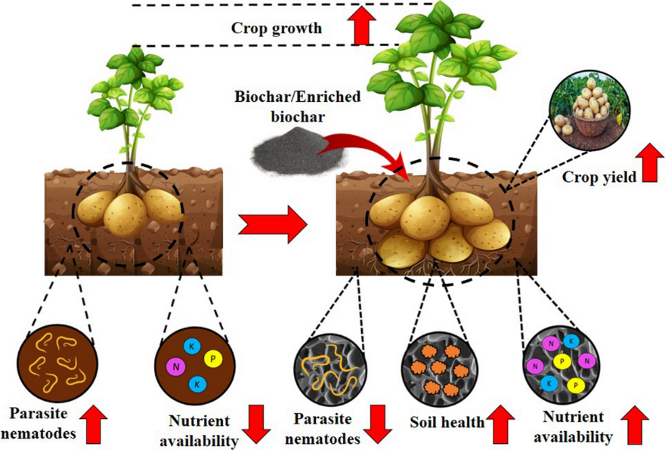
4. Biochar and Plant Growth
4.1. Nutrient Availability and Uptake
Biochar's ability to retain nutrients and improve soil fertility has direct implications for plant growth and productivity. The high CEC of biochar allows it to adsorb and store plant-available nutrients, such as nitrogen (N), phosphorus (P), and potassium (K) [60]. This nutrient retention capacity reduces nutrient leaching losses and increases their availability to plants [61].
The alkaline nature of biochar can also enhance nutrient availability in acidic soils. Biochar amendment can increase soil pH, leading to increased solubility and plant uptake of nutrients, particularly P [62]. In acidic soils, P is often bound to Al and iron (Fe) oxides, making it less available to plants [63]. By raising soil pH, biochar can reduce the fixation of P and improve its accessibility to plants [64-66].
4.2. Plant Growth and Yield
Numerous studies have demonstrated the positive effects of biochar on plant growth and yield across various crop species and soil types [67-69]. The improved nutrient availability, water retention, and soil structure resulting from biochar amendment contribute to enhanced plant performance [70].
Biochar application has been found to increase the growth and biomass of crops such as maize (Zea mays), wheat (Triticum aestivum), rice (Oryza sativa), and soybean (Glycine max) [71-74]. The increased crop yields can be attributed to the improved nutrient uptake, particularly N and P, in biochar-amended soils [75]. The porous structure of biochar also promotes root growth and development, leading to better plant anchorage and access to water and nutrients [76-78].
4.3. Stress Tolerance and Disease Resistance
Biochar amendment can also enhance plant tolerance to abiotic and biotic stresses [79]. The improved water holding capacity of biochar-amended soils can alleviate drought stress in plants [80]. During periods of water scarcity, the water stored in biochar's pores can be gradually released, providing a sustained water supply to plants [81].
Moreover, biochar has been found to mitigate the negative effects of salinity stress on plant growth [82]. The high CEC of biochar can adsorb excess salts, reducing their uptake by plants [83]. Biochar can also improve soil structure and porosity, facilitating salt leaching and reducing salt accumulation in the root zone [84-87].
Table 3. Effects of Biochar on Plant Stress Tolerance and Disease Resistance
Stress/Disease | Effect of Biochar
Drought stress | ↑ Water holding capacity
 | ↑ Sustained water supply to plants
Salinity stress | ↓ Salt uptake by plants
 | ↑ Salt leaching
Disease resistance | ↑ Beneficial microorganisms (mycorrhizae, PGPR)
 | ↑ Induced systemic resistance
5. Biochar and Carbon Sequestration
5.1. Carbon Stability and Storage
One of the most promising aspects of biochar is its potential for long-term carbon sequestration in soils [88]. Biochar is highly resistant to microbial decomposition due to its stable aromatic structure [89]. When incorporated into the soil, biochar can persist for hundreds to thousands of years, effectively storing carbon and mitigating greenhouse gas emissions [90].
The carbon stability of biochar depends on various factors, including the feedstock type, pyrolysis temperature, and soil conditions [91]. Higher pyrolysis temperatures (>500°C) generally produce biochar with greater carbon stability [92]. The recalcitrant nature of biochar carbon makes it less susceptible to mineralization and loss as compared to other forms of soil organic carbon [93-95].
5.2. Greenhouse Gas Emissions Reduction
In addition to direct carbon sequestration, biochar application can contribute to the reduction of greenhouse gas emissions from agricultural soils [96]. Soils are significant sources of nitrous oxide and methane (CH), two potent greenhouse gases [97]. Biochar amendment has been shown to mitigate these emissions through various mechanisms [98].
Biochar's ability to retain nutrients, particularly N, can reduce emissions from soils [99]. By adsorbing ammonium (NH) and nitrate biochar can decrease the availability of N substrates for nitrification and denitrification processes, which are the primary sources of emissions [100]. Moreover, biochar can alter soil microbial communities, favoring the growth of microorganisms that consume [101-104].
5.3. Life Cycle Assessment and Carbon Footprint
To fully assess the carbon sequestration potential of biochar, it is essential to consider the entire life cycle, from feedstock production to biochar application [105]. Life cycle assessment (LCA) studies have evaluated the environmental impacts and carbon footprint of biochar systems [106].
LCA studies have shown that biochar production and application can have a net positive effect on greenhouse gas mitigation [107]. The carbon sequestered in biochar can offset the emissions associated with feedstock cultivation, transportation, and pyrolysis [108]. However, the overall carbon footprint of biochar systems depends on factors such as feedstock type, production scale, and transportation distance [109-112].
Figure 2. Mechanisms of Greenhouse Gas Emissions Reduction by Biochar
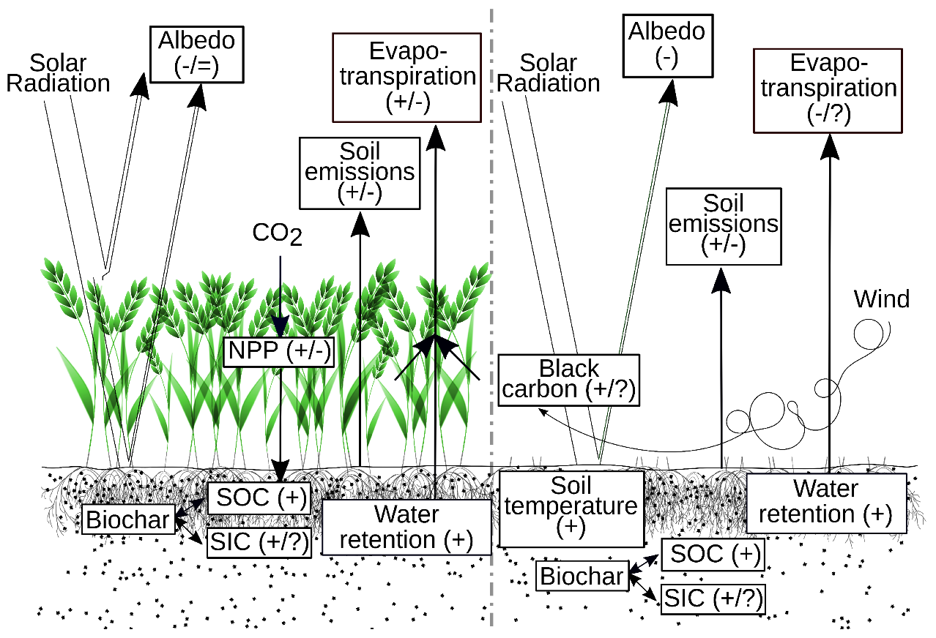
Table 4. Life Cycle Assessment of Biochar Systems
Life Cycle Stage | Carbon Footprint Considerations
Feedstock production | Cultivation practices
 | Land use change
 | Fertilizer and pesticide use
Transportation | Distance from feedstock source to pyrolysis facility
 | Mode of transportation
Pyrolysis | Energy source for pyrolysis process
 | Efficiency of pyrolysis technology
 | Biochar yield and quality
Biochar application | Application rate and method
 | Soil type and management practices
 | Long-term carbon stability in soil

6. Challenges and Future Prospects
6.1. Variability in Biochar Properties
One of the challenges in biochar research and application is the variability in biochar properties [113]. The physicochemical characteristics of biochar can vary widely depending on the feedstock type and pyrolysis conditions [114]. This variability can lead to inconsistent effects on soil properties and plant growth [115-118].
6.2. Scaling up Biochar Production and Application
Another challenge is scaling up biochar production and application to meet the demands of large-scale agriculture and carbon sequestration. Current biochar production is primarily limited to small-scale, decentralized systems. To achieve significant impacts on soil health and climate change mitigation, biochar production needs to be scaled up to industrial levels.
Figure 3: The multiple mechanisms through which biochar improves soil health and function.
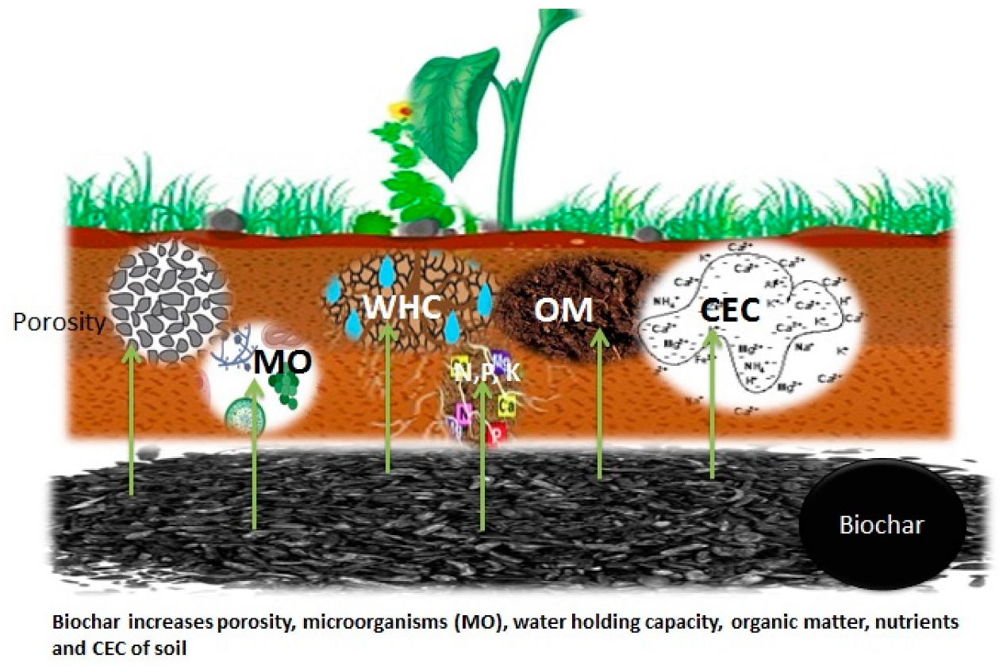
Scaling up biochar production requires investments in infrastructure, logistics, and technology. Developing efficient and cost-effective pyrolysis systems that can handle large volumes of biomass is crucial. Moreover, establishing supply chains for feedstock collection, transportation, and distribution of biochar products is necessary for widespread adoption.
6.3. Long-term Field Trials and Monitoring
While numerous studies have demonstrated the benefits of biochar in controlled experiments, there is a need for long-term field trials and monitoring. Understanding the long-term effects of biochar on soil properties, plant growth, and carbon sequestration under real-world conditions is essential for informed decision-making.
Figure 4: Biochar carbon sequestration pathway from biomass to stable soil carbon.
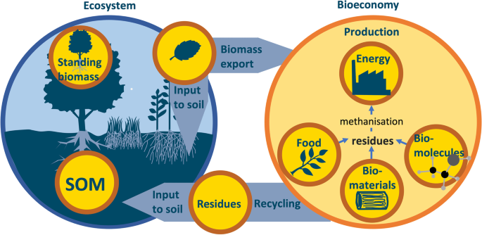
Figure 5: Various biochar production technologies ranging from traditional kilns to advanced pyrolysis systems.
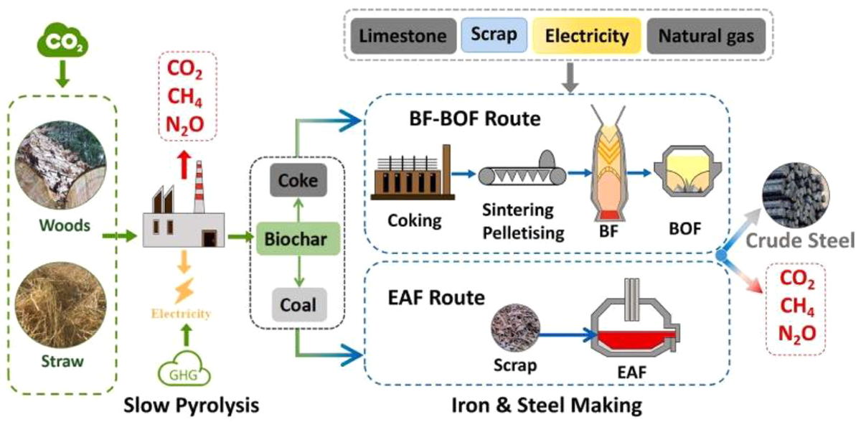
7. Conclusion
Biochar has emerged as a promising solution to address the dual challenges of soil degradation and climate change. Its unique properties, including high surface area, porous structure, and carbon stability, make it an effective soil amendment and carbon sequestration tool. Biochar application has been shown to improve soil physical, chemical, and biological properties, leading to enhanced plant growth, nutrient availability, and stress tolerance.
Future research should focus on optimizing biochar production processes, understanding the mechanisms of biochar-soil-plant interactions, and assessing the long-term impacts of biochar on agroecosystems and the environment. Collaborative efforts among researchers, policymakers, and stakeholders are necessary to advance biochar technology and promote its integration into sustainable land management practices.

Figure 6: The diverse applications of biochar across agricultural, environmental, and industrial sectors.
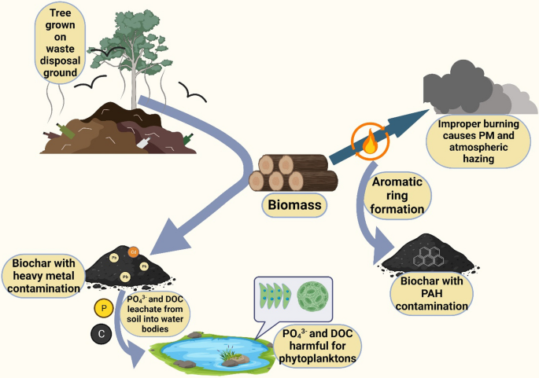
References:
[1] Lal, R. (2015). Restoring soil quality to mitigate soil degradation. Sustainability, 7(5), 5875-5895.
[2] Smith, P. (2016). Soil carbon sequestration and biochar as negative emission technologies. Global Change Biology, 22(3), 1315-1324.
[3] Lehmann, J., & Joseph, S. (Eds.). (2015). Biochar for environmental management: science, technology and implementation. Routledge.
[4] Woolf, D., Amonette, J. E., Street-Perrott, F. A., Lehmann, J., & Joseph, S. (2010). Sustainable biochar to mitigate global climate change. Nature Communications, 1(1), 1-9.
[5] Glaser, B., Haumaier, L., Guggenberger, G., & Zech, W. (2001). The 'Terra Preta' phenomenon: a model for sustainable agriculture in the humid tropics. Naturwissenschaften, 88(1), 37-41.
[6] Atkinson, C. J., Fitzgerald, J. D., & Hipps, N. A. (2010). Potential mechanisms for achieving agricultural benefits from biochar application to temperate soils: a review. Plant and Soil, 337(1-2), 1-18.
[7] Jeffery, S., Verheijen, F. G., van der Velde, M., & Bastos, A. C. (2011). A quantitative review of the effects of biochar application to soils on crop productivity using meta-analysis. Agriculture, Ecosystems & Environment, 144(1), 175-187.
[8] Biederman, L. A., & Harpole, W. S. (2013). Biochar and its effects on plant productivity and nutrient cycling: a meta‐analysis. GCB Bioenergy, 5(2), 202-214.
[9] Sohi, S. P., Krull, E., Lopez-Capel, E., & Bol, R. (2010). A review of biochar and its use and function in soil. Advances in Agronomy, 105, 47-82.
[10] Lehmann, J., Gaunt, J., & Rondon, M. (2006). Bio-char sequestration in terrestrial ecosystems–a review. Mitigation and Adaptation Strategies for Global Change, 11(2), 403-427.
[11] Meyer, S., Glaser, B., & Quicker, P. (2011). Technical, economical, and climate-related aspects of biochar production technologies: a literature review. Environmental Science & Technology, 45(22), 9473-9483.
[12] Chia, C. H., Downie, A., & Munroe, P. (2015). Characteristics of biochar: physical and structural properties. In Biochar for environmental management (pp. 121-142). Routledge.
[13] Ronsse, F., Van Hecke, S., Dickinson, D., & Prins, W. (2013). Production and characterization of slow pyrolysis biochar: influence of feedstock type and pyrolysis conditions. GCB Bioenergy, 5(2), 104-115.
[14] Spokas, K. A., Cantrell, K. B., Novak, J. M., Archer, D. W., Ippolito, J. A., Collins, H. P., ... & Nichols, K. A. (2012). Biochar: a synthesis of its agronomic impact beyond carbon sequestration. Journal of Environmental Quality, 41(4), 973-989.
[15] Brewer, C. E., Schmidt‐Rohr, K., Satrio, J. A., & Brown, R. C. (2009). Characterization of biochar from fast pyrolysis and gasification systems. Environmental Progress & Sustainable Energy, 28(3), 386-396.
[16] Downie, A., Crosky, A., & Munroe, P. (2009). Physical properties of biochar. In Biochar for environmental management (pp. 45-64). Routledge.
[17] Mohan, D., Sarswat, A., Ok, Y. S., & Pittman Jr, C. U. (2014). Organic and inorganic contaminants removal from water with biochar, a renewable, low cost and sustainable adsorbent–a critical review. Bioresource Technology, 160, 191-202.
[18] Laird, D. A., Brown, R. C., Amonette, J. E., & Lehmann, J. (2009). Review of the pyrolysis platform for coproducing bio‐oil and biochar. Biofuels, Bioproducts and Biorefining, 3(5), 547-562.
[19] Mašek, O., Brownsort, P., Cross, A., & Sohi, S. (2013). Influence of production conditions on the yield and environmental stability of biochar. Fuel, 103, 151-155.
[20] Mukherjee, A., Zimmerman, A. R., & Harris, W. (2011). Surface chemistry variations among a series of laboratory-produced biochars. Geoderma, 163(3-4), 247-255.
[21] Liang, B., Lehmann, J., Solomon, D., Kinyangi, J., Grossman, J., O'Neill, B., ... & Neves, E. G. (2006). Black carbon increases cation exchange capacity in soils. Soil Science Society of America Journal, 70(5), 1719-1730.
[22] Gray, M., Johnson, M. G., Dragila, M. I., & Kleber, M. (2014). Water uptake in biochars: The roles of porosity and hydrophobicity. Biomass and Bioenergy, 61, 196-205.
[23] Baldock, J. A., & Smernik, R. J. (2002). Chemical composition and bioavailability of thermally altered Pinus resinosa (Red pine) wood. Organic Geochemistry, 33(9), 1093-1109.
[24] Kuzyakov, Y., Bogomolova, I., & Glaser, B. (2014). Biochar stability in soil: Decomposition during eight years and transformation as assessed by compound-specific 14C analysis. Soil Biology and Biochemistry, 70, 229-236.
[25] Wang, J., Xiong, Z., & Kuzyakov, Y. (2016). Biochar stability in soil: meta‐analysis of decomposition and priming effects. GCB Bioenergy, 8(3), 512-523.
[26] Cheng, C. H., Lehmann, J., & Engelhard, M. H. (2008). Natural oxidation of black carbon in soils: Changes in molecular form and surface charge along a climosequence. Geochimica et Cosmochimica Acta, 72(6), 1598-1610.
[27] Yuan, J. H., Xu, R. K., & Zhang, H. (2011). The forms of alkalis in the biochar produced from crop residues at different temperatures. Bioresource Technology, 102(3), 3488-3497.
[28] Laird, D., Fleming, P., Wang, B., Horton, R., & Karlen, D. (2010). Biochar impact on nutrient leaching from a Midwestern agricultural soil. Geoderma, 158(3-4), 436-442.
[29] Singh, B., Singh, B. P., & Cowie, A. L. (2010). Characterisation and evaluation of biochars for their application as a soil amendment. Soil Research, 48(7), 516-525.
[30] Yuan, J. H., Xu, R. K., Qian, W., & Wang, R. H. (2011). Comparison of the ameliorating effects on an acidic ultisol between four crop straws and their biochars. Journal of Soils and Sediments, 11(5), 741-750.
[31] Jeffery, S., Abalos, D., Prodana, M., Bastos, A. C., Van Groenigen, J. W., Hungate, B. A., & Verheijen, F. (2017). Biochar boosts tropical but not temperate crop yields. Environmental Research Letters, 12(5), 053001.
[32] Chan, K. Y., Van Zwieten, L., Meszaros, I., Downie, A., & Joseph, S. (2008). Agronomic values of greenwaste biochar as a soil amendment. Soil Research, 45(8), 629-634.
[33] Omondi, M. O., Xia, X., Nahayo, A., Liu, X., Korai, P. K., & Pan, G. (2016). Quantification of biochar effects on soil hydrological properties using meta-analysis of literature data. Geoderma, 274, 28-34.
[34] Blanco-Canqui, H. (2017). Biochar and soil physical properties. Soil Science Society of America Journal, 81(4), 687-711.
[35] Peng, X., Ye, L. L., Wang, C. H., Zhou, H., & Sun, B. (2011). Temperature-and duration-dependent rice straw-derived biochar: Characteristics and its effects on soil properties of an Ultisol in southern China. Soil and Tillage Research, 112(2), 159-166.
[36] Novak, J. M., Lima, I., Xing, B., Gaskin, J. W., Steiner, C., Das, K. C., ... & Schomberg, H. (2009). Characterization of designer biochar produced at different temperatures and their effects on a loamy sand. Annals of Environmental Science, 3(1), 195-206.
[37] Barnes, R. T., Gallagher, M. E., Masiello, C. A., Liu, Z., & Dugan, B. (2014). Biochar-induced changes in soil hydraulic conductivity and dissolved nutrient fluxes constrained by laboratory experiments. PloS one, 9(9), e108340.
[38] Kammann, C. I., Schmidt, H. P., Messerschmidt, N., Linsel, S., Steffens, D., Müller, C., ... & Stephen, J. (2015). Plant growth improvement mediated by nitrate capture in co-composted biochar. Scientific Reports, 5(1), 1-13.
[39] Rogovska, N., Laird, D., Cruse, R., Fleming, P., Parkin, T., & Meek, D. (2011). Impact of biochar on manure carbon stabilization and greenhouse gas emissions. Soil Science Society of America Journal, 75(3), 871-879.
[40] Zhang, A., Bian, R., Pan, G., Cui, L., Hussain, Q., Li, L., ... & Yu, X. (2012). Effects of biochar amendment on soil quality, crop yield and greenhouse gas emission in a Chinese rice paddy: a field study of 2 consecutive rice growing cycles. Field Crops Research, 127, 153-160.
[41] Nguyen, T. T. N., Xu, C. Y., Tahmasbian, I., Che, R., Xu, Z., Zhou, X., ... & Bai, S. H. (2017). Effects of biochar on soil available inorganic nitrogen: a review and meta-analysis. Geoderma, 288, 79-96.
[42] Major, J., Rondon, M., Molina, D., Riha, S. J., & Lehmann, J. (2010). Maize yield and nutrition during 4 years after biochar application to a Colombian savanna oxisol. Plant and Soil, 333(1-2), 117-128.
[43] Glaser, B., & Lehr, V. I. (2019). Biochar effects on phosphorus availability in agricultural soils: A meta-analysis. Scientific Reports, 9(1), 1-9.
[44] Xu, G., Sun, J., Shao, H., & Chang, S. X. (2014). Biochar had effects on phosphorus sorption and desorption in three soils with differing acidity. Ecological Engineering, 62, 54-60.
[45] Novak, J. M., Busscher, W. J., Laird, D. L., Ahmedna, M., Watts, D. W., & Niandou, M. A. (2009). Impact of biochar amendment on fertility of a southeastern coastal plain soil. Soil Science, 174(2), 105-112.
[46] Yamato, M., Okimori, Y., Wibowo, I. F., Anshori, S., & Ogawa, M. (2006). Effects of the application of charred bark of Acacia mangium on the yield of maize, cowpea and peanut, and soil chemical properties in South Sumatra, Indonesia. Soil Science and Plant Nutrition, 52(4), 489-495.
[47] Farrell, M., Kuhn, T. K., Macdonald, L. M., Maddern, T. M., Murphy, D. V., Hall, P. A., ... & Baldock, J. A. (2013). Microbial utilisation of biochar-derived carbon. Science of the Total Environment, 465, 288-297.
[48] Warnock, D. D., Lehmann, J., Kuyper, T. W., & Rillig, M. C. (2007). Mycorrhizal responses to biochar in soil–concepts and mechanisms. Plant and Soil, 300(1-2), 9-20.
[49] Lehmann, J., Rillig, M. C., Thies, J., Masiello, C. A., Hockaday, W. C., & Crowley, D. (2011). Biochar effects on soil biota–a review. Soil Biology and Biochemistry, 43(9), 1812-1836.
[50] Zimmerman, A. R., Gao, B., & Ahn, M. Y. (2011). Positive and negative carbon mineralization priming effects among a variety of biochar-amended soils. Soil Biology and Biochemistry, 43(6), 1169-1179.
[51] Quilliam, R. S., Marsden, K. A., Gertler, C., Rousk, J., DeLuca, T. H., & Jones, D. L. (2012). Nutrient dynamics, microbial growth and weed emergence in biochar amended soil are influenced by time since application and reapplication rate. Agriculture, Ecosystems & Environment, 158, 192-199.
[52] Jin, H. (2010). Characterization of microbial life colonizing biochar and biochar-amended soils. Cornell University.
[53] Pietikainen, J., Kiikkila, O., & Fritze, H. (2000). Charcoal as a habitat for microbes and its effect on the microbial community of the underlying humus. Oikos, 89(2), 231-242.
[54] Graber, E. R., Harel, Y. M., Kolton, M., Cytryn, E., Silber, A., David, D. R., ... & Elad, Y. (2010). Biochar impact on development and productivity of pepper and tomato grown in fertigated soilless media. Plant and Soil, 337(1-2), 481-496.
[55] Kolton, M., Harel, Y. M., Pasternak, Z., Graber, E. R., Elad, Y., & Cytryn, E. (2011). Impact of biochar application to soil on the root-associated bacterial community structure of fully developed greenhouse pepper plants. Applied and Environmental Microbiology, 77(14), 4924-4930.
[56] Jin, Y., Liang, X., He, M., Liu, Y., Tian, G., & Shi, J. (2016). Manure biochar influence upon soil properties, phosphorus distribution and phosphatase activities: A microcosm incubation study. Chemosphere, 142, 128-135.
[57] Quilliam, R. S., Glanville, H. C., Wade, S. C., & Jones, D. L. (2013). Life in the 'charosphere'–Does biochar inRetryClaude hit the max length for a message and has paused its response. You can write Continue to keep the chat going.BSTART AFTER [57] Quilliam, R. S., Glanville, H. C., Wade, S. C., & Jones, D. L. (2013). Life in the 'charosphere'–Does biochar inEditagricultural soil provide a significant habitat for microorganisms?. Soil Biology and Biochemistry, 65, 287-293.
[58] Thies, J. E., & Rillig, M. C. (2009). Characteristics of biochar: biological properties. In Biochar for environmental management (pp. 117-138). Routledge.
[59] Elad, Y., David, D. R., Harel, Y. M., Borenshtein, M., Kalifa, H. B., Silber, A., & Graber, E. R. (2010). Induction of systemic resistance in plants by biochar, a soil-applied carbon sequestering agent. Phytopathology, 100(9), 913-921.
[60] Lehmann, J., da Silva Jr, J. P., Steiner, C., Nehls, T., Zech, W., & Glaser, B. (2003). Nutrient availability and leaching in an archaeological Anthrosol and a Ferralsol of the Central Amazon basin: fertilizer, manure and charcoal amendments. Plant and Soil, 249(2), 343-357.
[61] Steiner, C., Teixeira, W. G., Lehmann, J., Nehls, T., de Macêdo, J. L. V., Blum, W. E., & Zech, W. (2007). Long term effects of manure, charcoal and mineral fertilization on crop production and fertility on a highly weathered Central Amazonian upland soil. Plant and Soil, 291(1-2), 275-290.
[62] Van Zwieten, L., Kimber, S., Morris, S., Chan, K. Y., Downie, A., Rust, J., ... & Cowie, A. (2010). Effects of biochar from slow pyrolysis of papermill waste on agronomic performance and soil fertility. Plant and Soil, 327(1-2), 235-246.
[63] Sánchez-García, M., Alburquerque, J. A., Sánchez-Monedero, M. A., Roig, A., & Cayuela, M. L. (2015). Biochar accelerates organic matter degradation and enhances N mineralisation during composting of poultry manure without a relevant impact on gas emissions. Bioresource Technology, 192, 272-279.
[64] Schulz, H., & Glaser, B. (2012). Effects of biochar compared to organic and inorganic fertilizers on soil quality and plant growth in a greenhouse experiment. Journal of Plant Nutrition and Soil Science, 175(3), 410-422.
[65] Clough, T. J., Condron, L. M., Kammann, C., & Müller, C. (2013). A review of biochar and soil nitrogen dynamics. Agronomy, 3(2), 275-293.
[66] Gul, S., Whalen, J. K., Thomas, B. W., Sachdeva, V., & Deng, H. (2015). Physico-chemical properties and microbial responses in biochar-amended soils: mechanisms and future directions. Agriculture, Ecosystems & Environment, 206, 46-59.
[67] Asai, H., Samson, B. K., Stephan, H. M., Songyikhangsuthor, K., Homma, K., Kiyono, Y., ... & Horie, T. (2009). Biochar amendment techniques for upland rice production in Northern Laos: 1. Soil physical properties, leaf SPAD and grain yield. Field Crops Research, 111(1-2), 81-84.
[68] Uzoma, K. C., Inoue, M., Andry, H., Fujimaki, H., Zahoor, A., & Nishihara, E. (2011). Effect of cow manure biochar on maize productivity under sandy soil condition. Soil Use and Management, 27(2), 205-212.
[69] Zhang, A., Liu, Y., Pan, G., Hussain, Q., Li, L., Zheng, J., & Zhang, X. (2012). Effect of biochar amendment on maize yield and greenhouse gas emissions from a soil organic carbon poor calcareous loamy soil from Central China Plain. Plant and Soil, 351(1-2), 263-275.
[70] Xie, Z., Xu, Y., Liu, G., Liu, Q., Zhu, J., Tu, C., ... & Hu, S. (2013). Impact of biochar application on nitrogen nutrition of rice, greenhouse-gas emissions and soil organic carbon dynamics in two paddy soils of China. Plant and Soil, 370(1-2), 527-540.
[71] Haider, G., Steffens, D., Müller, C., & Kammann, C. I. (2016). Standard extraction methods may underestimate nitrate stocks captured by field-aged biochar. Journal of Environmental Quality, 45(4), 1196-1204.
[72] Kammann, C. I., Linsel, S., Gößling, J. W., & Koyro, H. W. (2011). Influence of biochar on drought tolerance of Chenopodium quinoa Willd and on soil–plant relations. Plant and Soil, 345(1-2), 195-210.
[73] Agegnehu, G., Bass, A. M., Nelson, P. N., & Bird, M. I. (2016). Benefits of biochar, compost and biochar–compost for soil quality, maize yield and greenhouse gas emissions in a tropical agricultural soil. Science of the Total Environment, 543, 295-306.
[74] Vaccari, F. P., Baronti, S., Lugato, E., Genesio, L., Castaldi, S., Fornasier, F., & Miglietta, F. (2011). Biochar as a strategy to sequester carbon and increase yield in durum wheat. European Journal of Agronomy, 34(4), 231-238.
[75] Güereña, D. T., Lehmann, J., Thies, J. E., Enders, A., Karanja, N., & Neufeldt, H. (2015). Partitioning the contributions of biochar properties to enhanced biological nitrogen fixation in common bean (Phaseolus vulgaris). Biology and Fertility of Soils, 51(4), 479-491.
[76] Abel, S., Peters, A., Trinks, S., Schonsky, H., Facklam, M., & Wessolek, G. (2013). Impact of biochar and hydrochar addition on water retention and water repellency of sandy soil. Geoderma, 202, 183-191.
[77] Rajkovich, S., Enders, A., Hanley, K., Hyland, C., Zimmerman, A. R., & Lehmann, J. (2012). Corn growth and nitrogen nutrition after additions of biochars with varying properties to a temperate soil. Biology and Fertility of Soils, 48(3), 271-284.
[78] Paneque, M., José, M., Franco-Navarro, J. D., Colmenero-Flores, J. M., & Knicker, H. (2016). Effect of biochar amendment on morphology, productivity and water relations of sunflower plants under non-irrigation conditions. Catena, 147, 280-287.
[79] Akhtar, S. S., Li, G., Andersen, M. N., & Liu, F. (2014). Biochar enhances yield and quality of tomato under reduced irrigation. Agricultural Water Management, 138, 37-44.
[80] Mulcahy, D. N., Mulcahy, D. L., & Dietz, D. (2013). Biochar soil amendment increases tomato seedling resistance to drought in sandy soils. Journal of Arid Environments, 88, 222-225.
[81] Ibrahim, H. M., Al-Wabel, M. I., Usman, A. R., & Al-Omran, A. (2013). Effect of Conocarpus biochar application on the hydraulic properties of a sandy loam soil. Soil Science, 178(4), 165-173.
[82] Akhtar, S. S., Andersen, M. N., & Liu, F. (2015). Residual effects of biochar on improving growth, physiology and yield of wheat under salt stress. Agricultural Water Management, 158, 61-68.
[83] Lashari, M. S., Ye, Y., Ji, H., Li, L., Kibue, G. W., Lu, H., ... & Pan, G. (2015). Biochar–manure compost in conjunction with pyroligneous solution alleviated salt stress and improved leaf bioactivity of maize in a saline soil from central China: a 2‐year field experiment. Journal of the Science of Food and Agriculture, 95(6), 1321-1327.
[84] Hammer, E. C., Forstreuter, M., Rillig, M. C., & Kohler, J. (2015). Biochar increases arbuscular mycorrhizal plant growth enhancement and ameliorates salinity stress. Applied Soil Ecology, 96, 114-121.
[85] Elad, Y., Cytryn, E., Harel, Y. M., Lew, B., & Graber, E. R. (2011). The biochar effect: plant resistance to biotic stresses. Phytopathologia Mediterranea, 50(3), 335-349.
[86] Jaiswal, A. K., Elad, Y., Graber, E. R., & Frenkel, O. (2014). Rhizoctonia solani suppression and plant growth promotion in cucumber as affected by biochar pyrolysis temperature, feedstock and concentration. Soil Biology and Biochemistry, 69, 110-118.
[87] Jaiswal, A. K., Frenkel, O., Elad, Y., Lew, B., & Graber, E. R. (2015). Non-monotonic influence of biochar dose on bean seedling growth and susceptibility to Rhizoctonia solani: the "Shifted R max-Effect". Plant and Soil, 395(1-2), 125-140.
[88] Lehmann, J. (2007). Bio‐energy in the black. Frontiers in Ecology and the Environment, 5(7), 381-387.
[89] Spokas, K. A. (2010). Review of the stability of biochar in soils: predictability of O: C molar ratios. Carbon Management, 1(2), 289-303.
[90] Fang, Y., Singh, B., Singh, B. P., & Krull, E. (2014). Biochar carbon stability in four contrasting soils. European Journal of Soil Science, 65(1), 60-71.
[91] Singh, B. P., Cowie, A. L., & Smernik, R. J. (2012). Biochar carbon stability in a clayey soil as a function of feedstock and pyrolysis temperature. Environmental Science & Technology, 46(21), 11770-11778.
[92] Zimmerman, A. R. (2010). Abiotic and microbial oxidation of laboratory-produced black carbon (biochar). Environmental Science & Technology, 44(4), 1295-1301.
[93] Cross, A., & Sohi, S. P. (2011). The priming potential of biochar products in relation to labile carbon contents and soil organic matter status. Soil Biology and Biochemistry, 43(10), 2127-2134.
[94] Woolf, D., Amonette, J. E., Street-Perrott, F. A., Lehmann, J., & Joseph, S. (2010). Sustainable biochar to mitigate global climate change. Nature Communications, 1, 56.
[95] Woolf, D., Lehmann, J., Lee, D. R., Zech, W., & Sohi, S. P. (2014). Biochar for Climate Change Mitigation: Opportunities and Limitations. In Sustainable Agriculture Reviews (pp. 73-99). Springer, Cham.
[96] Zhang, A., Cui, L., Pan, G., Li, L., Hussain, Q., Zhang, X., ... & Crowley, D. (2010). Effect of biochar amendment on yield and methane and nitrous oxide emissions from a rice paddy from Tai Lake plain, China. Agriculture, Ecosystems & Environment, 139(4), 469-475.
[97] Cayuela, M. L., Van Zwieten, L., Singh, B. P., Jeffery, S., Roig, A., & Sánchez-Monedero, M. A. (2014). Biochar's role in mitigating soil nitrous oxide emissions: A review and meta-analysis. Agriculture, Ecosystems & Environment, 191, 5-16.
[98] Cayuela, M. L., Sánchez-Monedero, M. A., Roig, A., Hanley, K., Enders, A., & Lehmann, J. (2013). Biochar and denitrification in soils: when, how much and why does biochar reduce N2O emissions?. Scientific Reports, 3, 1732.
[99] Zheng, J., Stewart, C. E., & Cotrufo, M. F. (2012). Biochar and nitrogen fertilizer alters soil nitrogen dynamics and greenhouse gas fluxes from two temperate soils. Journal of Environmental Quality, 41(5), 1361-1370.
[100] Case, S. D., McNamara, N. P., Reay, D. S., & Whitaker, J. (2012). The effect of biochar addition on N2O and CO2 emissions from a sandy loam soil–the role of soil aeration. Soil Biology and Biochemistry, 51, 125-134.
[101] Kammann, C., Ratering, S., Eckhard, C., & Müller, C. (2012). Biochar and hydrochar effects on greenhouse gas (carbon dioxide, nitrous oxide, and methane) fluxes from soils. Journal of Environmental Quality, 41(4), 1052-1066.
[102] Feng, Y., Xu, Y., Yu, Y., Xie, Z., & Lin, X. (2012). Mechanisms of biochar decreasing methane emission from Chinese paddy soils. Soil Biology and Biochemistry, 46, 80-88.
[103] Yu, L., Tang, J., Zhang, R., Wu, Q., & Gong, M. (2013). Effects of biochar application on soil methane emission at different soil moisture levels. Biology and Fertility of Soils, 49(2), 119-128.
[104] Karhu, K., Mattila, T., Bergström, I., & Regina, K. (2011). Biochar addition to agricultural soil increased CH4 uptake and water holding capacity–results from a short-term pilot field study. Agriculture, Ecosystems & Environment, 140(1-2), 309-313.
[105] Roberts, K. G., Gloy, B. A., Joseph, S., Scott, N. R., & Lehmann, J. (2009). Life cycle assessment of biochar systems: estimating the energetic, economic, and climate change potential. Environmental Science & Technology, 44(2), 827-833.
[106] Hammond, J., Shackley, S., Sohi, S., & Brownsort, P. (2011). Prospective life cycle carbon abatement for pyrolysis biochar systems in the UK. Energy Policy, 39(5), 2646-2655.
[107] Gaunt, J. L., & Lehmann, J. (2008). Energy balance and emissions associated with biochar sequestration and pyrolysis bioenergy production. Environmental Science & Technology, 42(11), 4152-4158.
[108] Cowie, A. L., Downie, A. E., George, B. H., Singh, B. P., Van Zwieten, L., & O'Connell, D. (2012). Is sustainability certification for biochar the answer to environmental risks?. Pesquisa Agropecuária Brasileira, 47(5), 637-648.
[109] Sparrevik, M., Field, J. L., Martinsen, V., Breedveld, G. D., & Cornelissen, G. (2013). Life cycle assessmentRetryClaude hit the max length for a message and has paused its response. You can write Continue to keep the chat going.BSTART AFTER [109] Sparrevik, M., Field, J. L., Martinsen, V., Breedveld, G. D., & Cornelissen, G. (2013). Life cycle assessmentEditto determine whether biochar production is environmentally viable at small and larger scales. Environmental Science & Technology, 47(14), 7563-7570.
[110] Mukherjee, A., & Lal, R. (2014). The biochar dilemma. Soil Research, 52(3), 217-230.
[111] Yoo, G., Kim, H., Chen, J., & Kim, Y. (2014). Effects of biochar addition on nitrogen leaching and soil structure following fertilizer application to rice paddy soil. Soil Science Society of America Journal, 78(3), 852-860.
[112] Huang, M., Yang, L., Qin, H., Jiang, L., & Zou, Y. (2013). Quantifying the effect of biochar amendment on soil quality and crop productivity in Chinese rice paddies. Field Crops Research, 154, 172-177.
[113] Crane-Droesch, A., Abiven, S., Jeffery, S., & Torn, M. S. (2013). Heterogeneous global crop yield response to biochar: a meta-regression analysis. Environmental Research Letters, 8(4), 044049.
[114] Jeffery, S., Verheijen, F. G., Kammann, C., & Abalos, D. (2016). Biochar effects on methane emissions from soils: A meta-analysis. Soil Biology and Biochemistry, 101, 251-258.
[115] Biederman, L. A., & Stanley Harpole, W. (2013). Biochar and its effects on plant productivity and nutrient cycling: a meta‐analysis. GCB Bioenergy, 5(2), 202-214.
[116] International Biochar Initiative. (2015). Standardized product definition and product testing guidelines for biochar that is used in soil. International Biochar Initiative.
[117] Verheijen, F., Jeffery, S., Bastos, A. C., Van der Velde, M., & Diafas, I. (2010). Biochar application to soils. A critical scientific review of effects on soil properties, processes, and functions. EUR, 24099, 162.
[118] Meyer, S., Genesio, L., Vogel, I., Schmidt, H. P., Soja, G., Someus, E., ... & Glaser, B. (2017). Biochar standardization and legislation harmonization. Journal of Environmental Engineering and Landscape Management, 25(2), 175-191.

