DESIGN, DEVELOPMENT AND ANALYSIS OF A 3-WAY RIGHT ANGLE BEVEL GEARBOX

Abstract
A gearbox is a mechanical device which helps in either increasing or decreasing the output speed of corresponding shaft. Although there are many commercially available gearbox's, most of them involved constant decrease in output gear speed ratio. A 3-way right angle bevel-gearbox was designed and developed to achieve increased gear ratio with two different rpm's at two output shafts. The present study of developing a 3-way right angle bevel-gearbox was undertaken as a sub-study in the development of a tractor powered manure pulverizer cum applicator in which gearbox is used to run pulverizer and applicator simultaneously^{10,11,18}. Three spur gears and two bevel gears were synchronously meshed to achieve different output rpm's at two output shafts. A laboratory model was developed and studied prior to developing a gearbox prototype. Model was evaluated at different input rpm's to note the increase in output rpm at the output shafts. Noise and vibration of the model was noted less at a input frequency of 18 Hz (540 rpm) corresponding to an output rpm of 1498 at both shafts. Input rpm to the gearbox prototype was varied between 300 to 540 rpm and the resultant change in application rate of manure pulverizer cum applicator was noted.
Keywords: Gear ratio, gearbox, spur gear, bevel gear, P.T.O, pulverizer, applicator

1 Introduction
In the present study a 3-way right angle bevel gearbox is designed and developed to achieve different or equal rpms from both the output shafts. Although there are a lot of commercially available 3-way right angle bevel gearboxes, they mainly involved gear reduction with output shafts opposite to each other which resulted in equal RPM at two output shafts^{2,3}. For simultaneous running of pulverizer and blower unit which are at right angle to each other, development of new gearbox was taken up. Here in this case, a 3-way gearbox with output shafts at right angle to each other were recommended.
Commercial models use bevel assembly alone to provide motion in right angles either in vertical or horizontal direction. But the RPM remains same on both the ends. Increasing and changing the direction of input shaft with a bevel assembly at the top might serve the purpose but cannot achieve the required increase in speed ratio (1:2.8). Several gearbox models were dismantled and studied to come up with a new gearbox to serve the purpose.
2 Materials and Methods
2.1 Working of a manure pulverizer cum applicator
Manure pulverizer cum applicator is a tractor powered machine which helps in pulverizing the manure clods along with simultaneous application of pulverized manure in the field as shown in Fig. 1. Suitable gearbox was necessary to rotate both pulverizer and applicator unit at different speeds based on the requirement to achieve higher application rate in the field. Input shaft takes drive from tractor P.T.O and drives output shaft 1 and 2 which reaches pulverizer and blower unit as shown in Fig. 1. Prior to development, laboratory studies were conducted to find the optimum input rpm for blower that has to be achieved for satisfactory working of the gearbox.

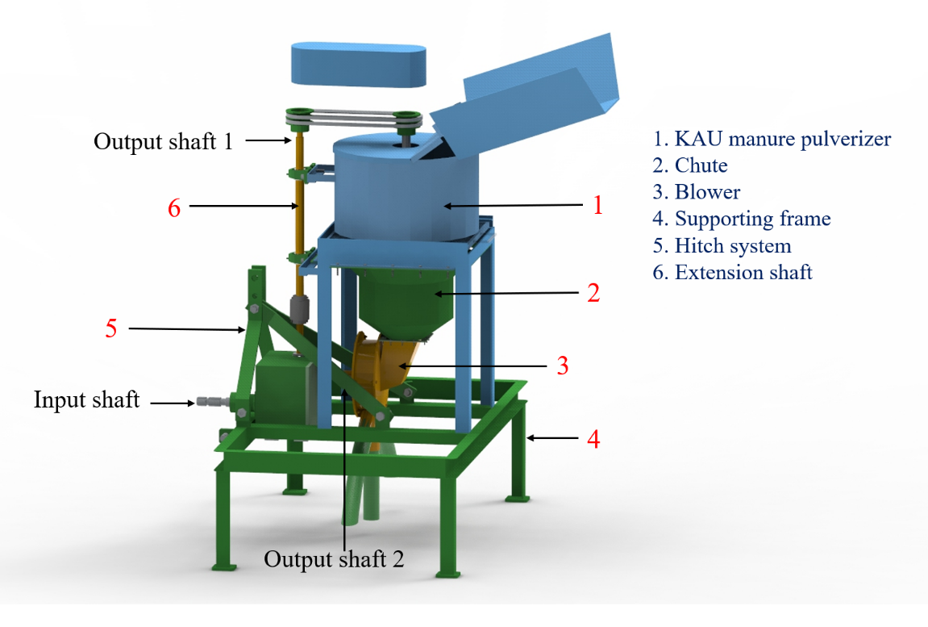
Fig. 1 Tractor powered manure pulverizer cum applicator
2.2 Design and Development of a 3-Way Right Angle Bevel Gearbox
In the present study a 3-way right angle bevel gearbox was designed and developed to achieve different or equal rpms from both the outputs. Commercially available 3-way right angle gearboxes mainly involved gear reduction with output shafts opposite to each other. But here in this case a gearbox with output shafts at right angle to each other capable of achieving different output rpms were recommended. Hence a laboratory model was worked out first before proceeding for actual gearbox prototype. Here the input power for gearbox is derived from the tractor PTO(540rpm) that is converted into 1000rpm at both outputs (1&2). Output shaft 2 was used for impeller rotation in the blower and output shaft 1 was for rotating pulverizer blade connected by means of a pulley. It consists of 3 spur gears and 2 bevel gears of 1:1 ratio inclined at 90 degree under synchrony-meshed condition.
The experimental setup consist of a 3-phase induction motor, VFD and gear assembly. The gear assembly was directly connected to 3 phase induction motor by a propeller shaft and flange joint. Results from the experimental setup of blower indicate that an impeller input RPM of 800-1000 provided a good clogging free manure dissipation. So an RPM of 1000 was preferred at the output shaft 2.
2.2.1 Development of a laboratory model
A laboratory model was developed to predict the possibility of deriving two variable speeds from a single output. Results obtained from the blower experimental setup show that an rpm of 800-1000 was sufficient for running the blower with a discharge rate of 3 kg min⁻¹ with radial impeller. In case of pulverizer unit, results showed that an output of 500 kg h⁻¹ was obtained with a maximum rpm of 1440rpm with 1.5 HP AC motor. So right angle bevel gear set up with 1: 1.6 gear ratio was developed and evaluated as shown in Fig. 4.
2.2.2 Variable frequency drive(VFD)
A variable frequency drive (VFD) is a type of motor controller that drives an electric motor by varying the frequency and voltage of its power supply. Though the drive controls the frequency and voltage of power supplied to the motor, it is often referred as speed control, since the result is an adjustment of motor speed. VFD is always limited to a 3 phase input current. So a 3 phase 1 hp AC motor that runs at a maximum rpm of 1440 was selected.
The VFD used in the study was of following configuration:
Make: ABB
Rated power: 0.37-4 Kw
Voltage: 380-480 v ac
Current: 7.3 a
Weight: 1.4 kg
Experimental setup consists of a VFD, 3 phase induction motor and gear assembly setup as shown in Fig. 2. Power to the VFD was drawn from a 3-phase power supply which is then connected to 1 HP AC motor. Rotational power to the primary shaft in the gear assembly was taken from the motor shaft connected by means of a hub. By varying the frequency of motor, the performance of the gearbox setup was observed.

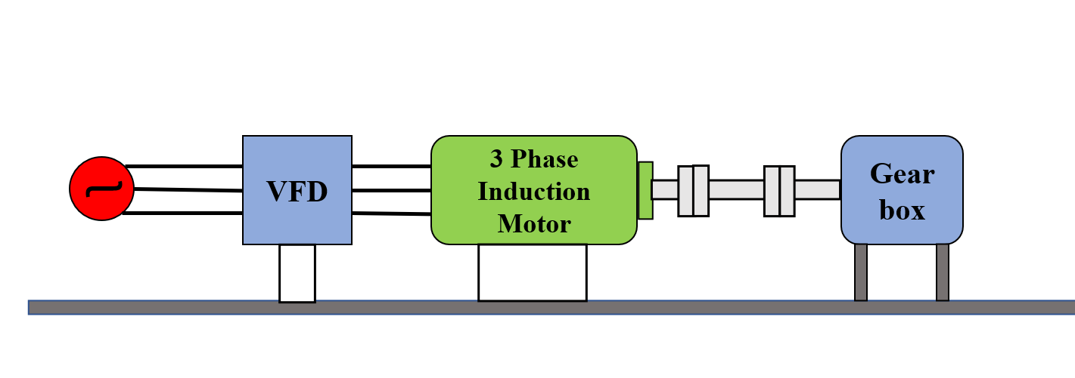
Fig. 2 Various parts of the gearbox experimental setup

2.2.3 Gear assembly
Gear assembly consist of 3 straight spur gears and 2 right angle bevel gears. The input rpm to the gearbox from tractor p.t.o was increased consequently but not rapidly to prevent breakage of teeth. The spur gears were arranged in decreasing order of number of teeth as shown in Fig. 3. The clockwise rotation of spur gear 1 (SG1) gets converted into anticlockwise rotation at SG2 so a third gear SG3 was aligned to get clockwise rotation at two output shafts.
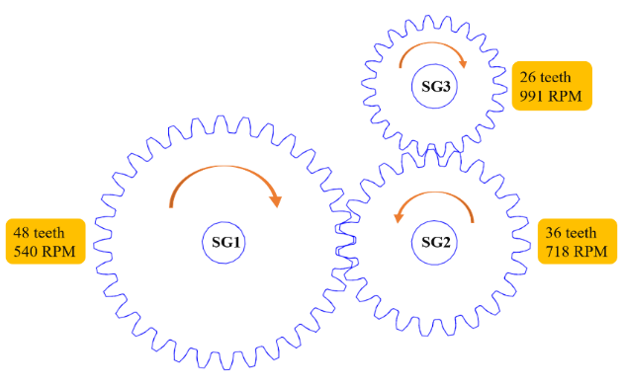
Fig. 3 Arrangement of spur gears
SG1 with 48 teeth is directly connected to input motor shaft running at 540 rpm which is further aligned to SG2 with 36 teeth increasing the gear ratio to 1:1.33. So 540 rpm at SG1 is converted into 718 rpm at SG2. Further SG2 is connected to SG3 with 26 teeth increasing the gear ratio to 1:1.38. The shaft supporting SG3 is also provided with a bevel gear set of 1:1.6 gear ratio such that two outputs at right angle to each other are obtained. So the rpm is finally increased to 991 rpm (≈1000) at output shafts 2 and 1545 rpm at output shaft 1.
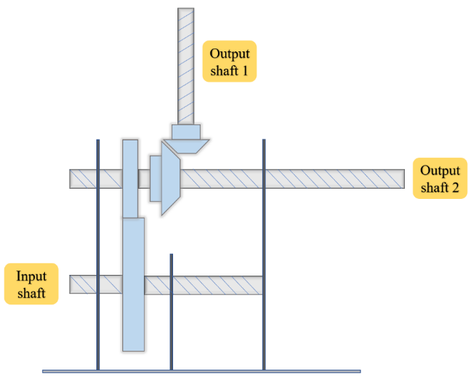
Fig. 4 Line diagram of a 3-way right angle bevel gearbox model
Performance of the model assembly model was found to be perfect to carry out both impeller and blade rotation simultaneously. Instead of using 3 spur gears at the first place, one can choose only 2 with maximum difference in the number of teeth. But it results in anticlockwise rotation of output shafts and more noise and wear due to huge increase in gear ratio at a single instant. Also, 1:2 incremental gear ratio of bevel gears resulted in more vibration and less strength at the output shaft 1. So it is decided to choose a 1:1 gear ratio that results in achieving equal rpm at both the shafts 1 and 2. Same spur gears are further used for developing gearbox prototype along with newly developed bevel gear.
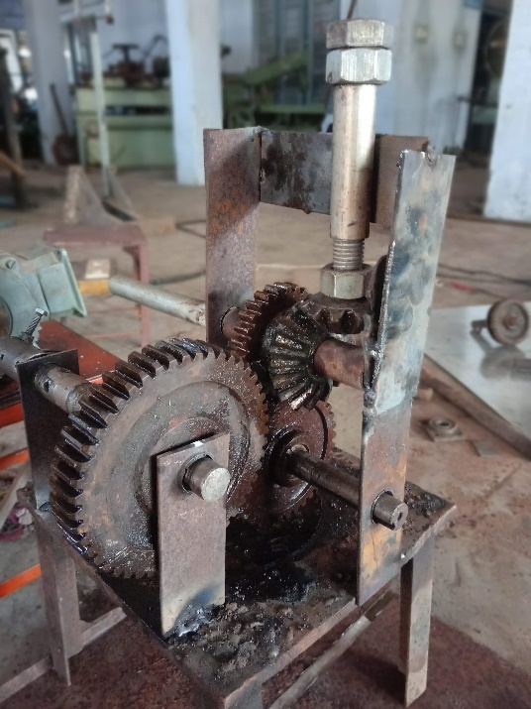
Fig. 5 Experimental setup of a 3-way right angle gearbox
2.3 ANSYS analysis on gearbox setup
Since performance of the model was found satisfactory without any failure, the model was then scaled up and subjected to varying torque and magnitude using ANSYS workbench 2020. During working condition, gearbox will be subjected to maximum deformation and stress due to high speed rotating elements with subsequent increase in temperature inside the gearbox^{8,16}. Parts viz., gearbox casing, spur gears, bevel gears, shafts etc., were analyzed using thermal and static structural analysis.
Workbench 2020 allows user to simulate various computer models for failure as well as to determine the maximum stress and deformation that the model can withstand^{7,14}.
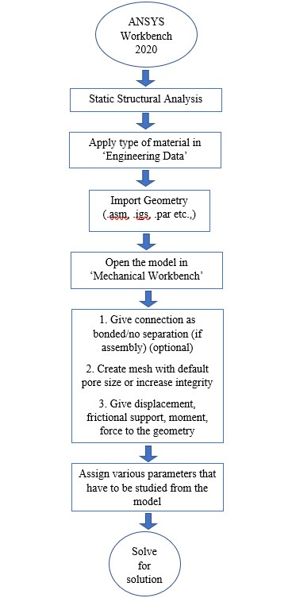
Fig. 6 Process flowchart for ANSYS
2.4 Development of gearbox prototype
2.4.1 Development of casing
In order to decide the dimensions of gearbox before fabricating the prototype, a graphical model was designed in SOLID EDGE software. For safe and satisfactory operation of the gearbox, there is a need to create spacious chamber that can accommodate more lubrication oil. From the model, the dimensions of the box was decided as 300×170×250 mm. A mild steel plate of 12 mm thickness was selected for casing.
Faces of mild steel plates were cut and marked to drill holes for supporting shafts and ball bearings.
2.4.2 Selection and development of gears
Gear drives also called positive drives are toothed members which transmit power or motion between two shafts by meshing without any slip²¹. In any pair of gears, there is a driver member which is driving the other. When smaller gear is the driver, it results in step down drive in which the output speed decreases and the torque increases². On the other hand, when the larger gear is the driver, it results in step up drive in which the output speed increases and the torque decreases^{2,21}.
Three commercially available spur gears were selected depending on the requirement from the production list and a bevel gear set of 1:1 gear ratio was developed. Spur gears have their teeth parallel to the axis and are used for transmitting power between two parallel shafts. Bevel gears transmit power between two intersecting shafts at right angle or between non- intersecting shafts.
SG1 with 48 teeth is directly connected to input motor/P.T.O. shaft running at 540 rpm which is further aligned to SG2 with 36 teeth increasing the gear ratio to 1:1.33. So 540 rpm at SG1 is converted into 718 rpm at SG2. Further SG2 is connected to SG3 with 26 teeth increasing the gear ratio to 1:1.38. The shaft supporting SG3 is also provided with a bevel gear set such that two outputs at right angle to each other are obtained. So the rpm is finally increased to 991 rpm (≈1000) at both output shafts 1 and 2 (Fig. 11).
Hole 1,2 and 3 are marked on the plates by considering the center to center distances of selected gears. Pitch circle diameter, root diameter and module of the gears were noted and cross checked for better alignment. SG1, SG2 and SG3 are arranged on a flat surface in designed manner to measure the center to center distances and are marked on the plates leaving 90 mm from the side. A full bore of 25mm and 7mm depth bore of 52mm diameters are drilled to input p.t.o shaft at hole 1(since ball bearing OD is 52mm). For the other two shafts only 7mm depth bores of 52mm OD are drilled to accommodate ball bearings. The other plate that comes exactly opposite to the first plate is drilled following the same procedure but in clockwise manner. Edges of the plates are chamfered at 45º angle to form a groove at the joining further filled with arc welding.
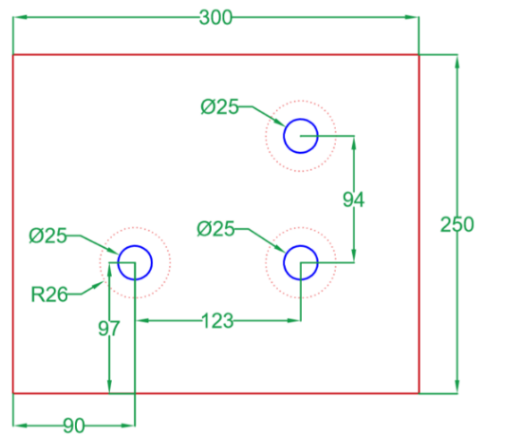
Fig. 7 Elevation view of drilled holes
2.4.3 PTO coupling
Input p.t.o shaft undergoes tension, bending and breaking stress during operation. To stabilize the rotation of input shaft and to prevent oil leakage an oil sealed coupling block was developed and welded to gearbox casing. A cylindrical cast iron block was used to develop coupling with dimension as shown in Fig. 8.
Basic coupling of almost any gearbox consists of enough bore diameter to accommodate input p.t.o shaft, ball bearing and oil sealing. A cylindrical cast iron block of 3 inch dia and 4 inch height is taken. The block is centered and facing was done by using a lathe machine. Centre of the block was drilled with varying drill bit sizes and depths to create steps inside the coupling which restrict the lateral moment of p.t.o shaft. A ball bearing of ID 30 mm and OD 55 mm was placed in 25mm depth bore at the front face. The remaining length of the block is cutoff to reach a diameter of 63.5 mm.
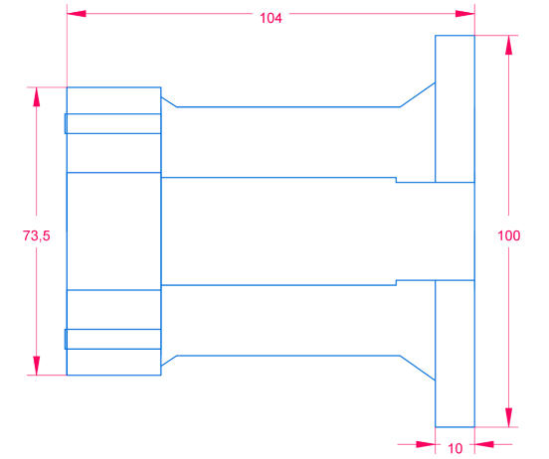
Fig. 8 Elevation view of P.T.O coupling
2.4.4 Shafts
Four shafts viz., p.t.o, stationary shaft, output shafts 1 and 2 were developed using mild steel rods. The diameter of the input p.t.o shaft was varied throughout its length of 360mm to facilitate splines, cast iron coupling and ball bearings.

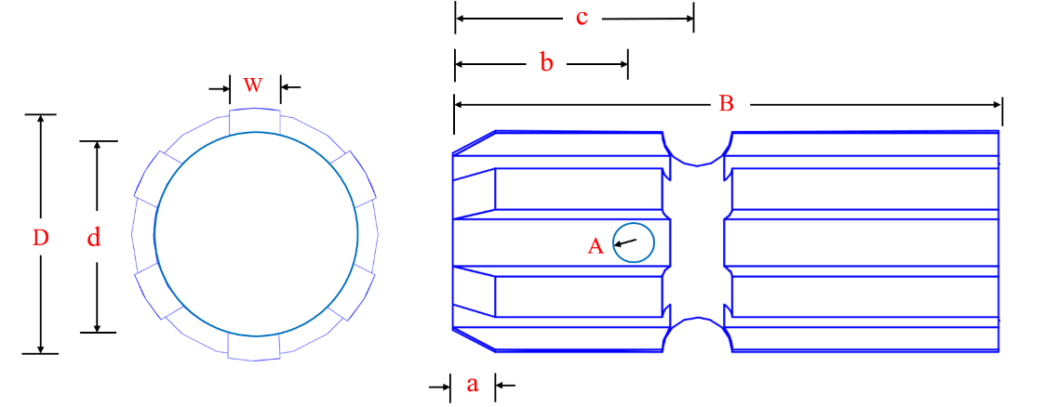
Fig. 9 Elevation view of input P.T.O shaft

Where,
D = Outer diameter of p.t.o. shaft
d = Outer diameter of p.t.o. excluding splines
W = Width of spline
B = Length of the spline
A = Diameter of lock pin
b = Distance from p.t.o. face to the center of lock pin
c = Distance from p.t.o. face to spring pin center
Sl. No. | Specification | As per IS: 4931-1995 | Developed shaft, mm
1 | No. of splines | 6 | 6
2 | Input speed (rpm) | 540±10 | 540
3 | D | 34.79±0.06 | 34.5
4 | d | 28.91±0.05-0.15 | 28
5 | W | 8.69-(0.09 to 0.16) | 7
6 | B | 76 (min) | 86
7 | b | 25±0.5 | 26.5
8 | c | 38 | 38.5
9 | a | 7.0 | 6.63
10 | A | 8.3 | 7.5
Table 1 − Elevation view of developed P.T.O shaft
A stationary shaft of length 190 mm is completely cased inside the gearbox with ball bearings on either side. An output shaft 2 of length 360 mm was in parallel to the input shaft which is projected outside for running blower. And an output shaft 1 of length 200mm having a uniform diameter of 25mm throughout its length was arranged perpendicular to output shaft 2 connected by means of a bevel gear as shown in Fig. 10 was developed.
Development of p.t.o shaft follows IS: 4931-1995 standard with 6 splines and nominal speed of 540±10 rpm in clockwise direction^{2,14,21}.

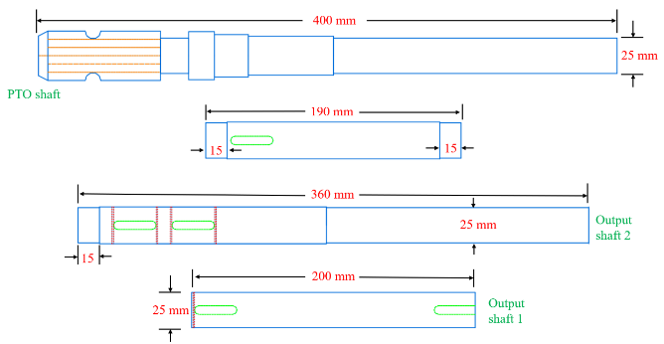
Fig. 10 Elevation view of shafts

Key slots of dimension 30×6 mm are made on four shafts to maintain stiffness of gears. Sir pins are attached on either side of each gear to prevent lateral movement of gears.
2.4.5 Assembly
Gearbox casing was welded on all three sides leaving one side open for assembling and further closed by L-angle M14 machine bolts. First the p.t.o shaft is enclosed by an oil tight casing, inserted through the input shaft hole and welded directly to the gearbox casing. The spur gears (1,2 & 3) evaluated in the model are directly used in the development of prototype. Spur gear 1 (SG1) was attached to the input shaft and locked in key slot between sir pins. Spur gear 2 (SG2) of 36 teeth was aligned to the input shaft which results in an increase in the gear ratio by 1:1.33. Spur gear 2 is mounted on a shaft which acts as an idler completely enclosed in the gearbox without any output shaft. So an input rpm from the tractor p.t.o is increased at the second shaft but the rotation is in anti-clock wise direction. In order to further increase the rpm and change the direction of rotation, a third spur gear (SG3) was used.
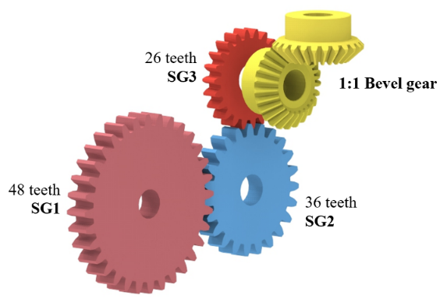
Fig. 11 Arrangement of gears
As a result, the rotation will be in clock wise direction and rpm at the output shaft 2 increases with a gear ratio of 1:1.38. The bevel gear setup mounted on the output shaft 2 gives an output at the top of the gearbox which acts as an output shaft 1 to rotate the pulverizer unit as shown in Fig. 1. Bevel gears with 1:1 gear ratio was chosen so an rpm of 1000 will be noted at both the outputs.

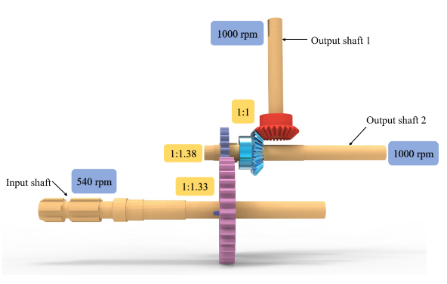
Fig. 12 Isometric view of gearbox prototype
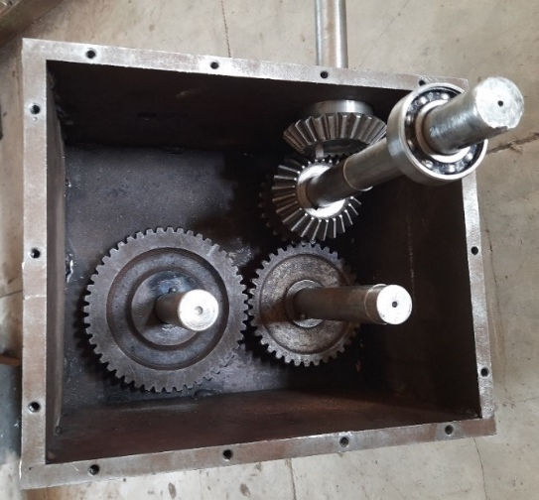
Fig. 13 Final assembly of gearbox

3 Results and discussion
Gearbox acts as a primary energy source which derives torque from tractor P.T.O. and divides it into two equal or unequal outputs. Since gearbox was arranged in offset to P.T.O. shaft, there are lateral stresses acting on the input shaft due to swinging type hitching system^{12,16}. So ANSYS analysis was taken up to study various forces acting inside and outside the gearbox. Model was modified until a failure free satisfactory performance was observed.
3.1 Variation in gearbox output speeds due to variation in Tractor P.T.O./engine rpm
Engine rpm or p.t.o rpm are the primary driving units in a tractor. Every minor variation in the input rpm results in the change of output speeds of two shafts^{2,15}. Hence application rate of manure can be varied in the field for selected levels of blower output rpm. Maximum rpm at the p.t.o is obtained by running the tractor at maximum engine rpm as shown in Fig. 14.
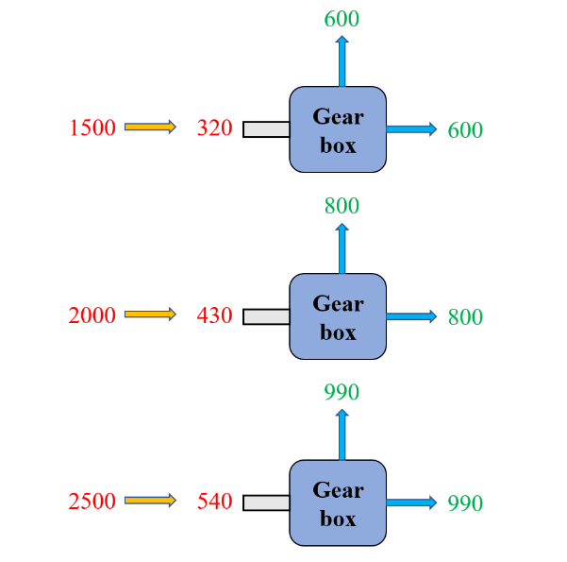
Fig. 14 Variation in gearbox output speeds, RPM
3.2 ANSYS analysis on spur gear and bevel assembly
Static structural analysis was done on both spur and bevel assembly to determine the total deformation and equivalent stress and strain^{13,20}. ANSYS 2020 Workbench was used to perform structural analysis at different input magnitudes and torque^{5,9,11}. Grey cast iron was programmed as engineering material and meshing was done with default pore size. Correspondingly frictional support was given at the centre of the moving elements with no separation (bonded) for contact regions. Commands for direction of displacement and motion in clockwise direction with information regarding to magnitude and torque was given to ANSYS model before solving for solution^{5,9,11}.
Varying the input torque from 0 to 10,000 N at the bonded region was found to be satisfactory and executed without any error. Engineering parts which undergo heavy stress are represented with red colour and the corresponding concentric circles represent the flow of momentum from centre to sides.
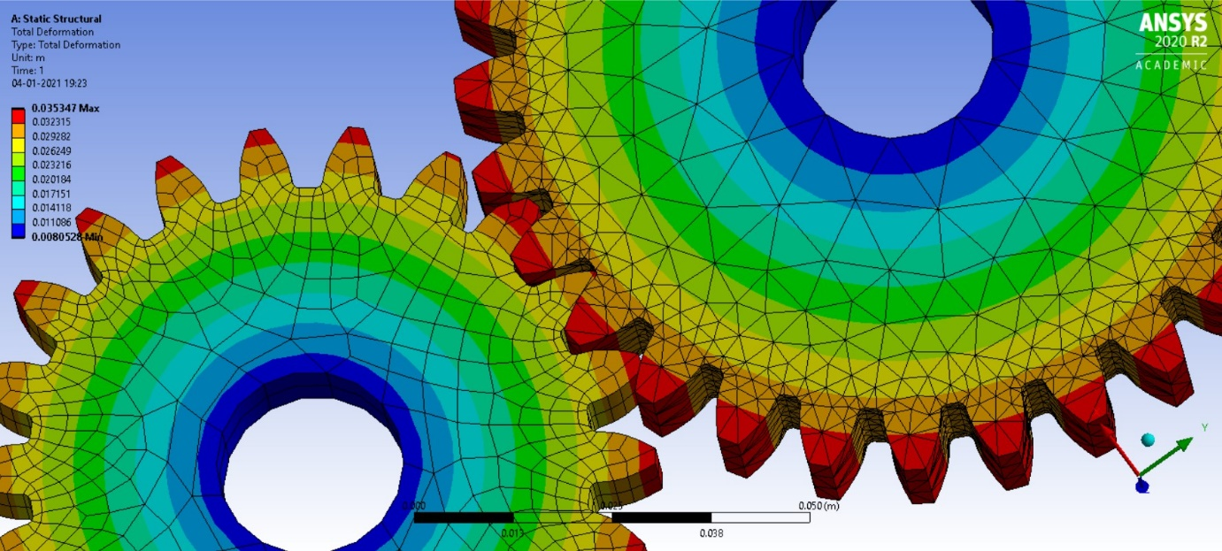
Fig. 15 Total deformation on spur assembly
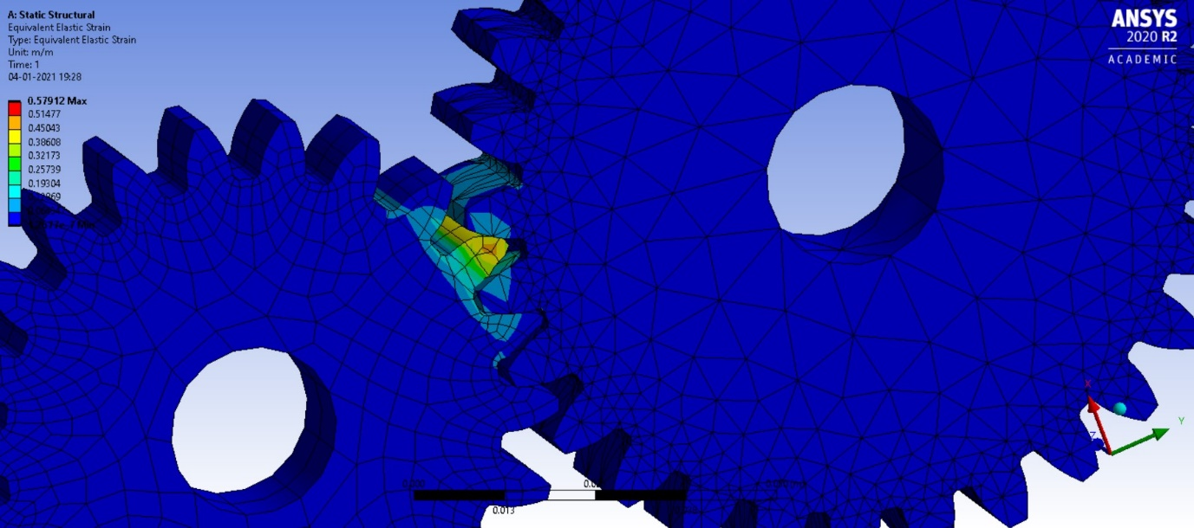
Fig. 16 Equivalent elastic strain on spur assembly
Time [s] | Minimum [m] | Maximum [m] | Average [m]
Total Deformation
1 | 8.05E-03 | 3.53E-02 | 2.83E-02
Equivalent Elastic strain
1 | 1.27E-07 | 0.57912 | 6.29E-03
Equivalent Elastic stress
1 | 10169 | 5.91E+10 | 5.68E+08
Table − 2 Static Structural Analysis on Spur gears
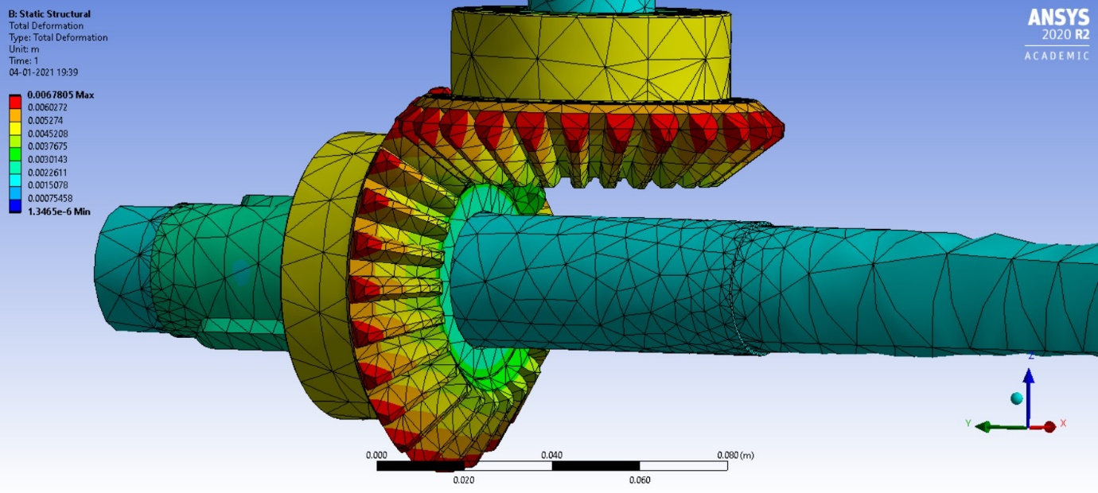
Fig. 17 Total deformation on bevel assembly
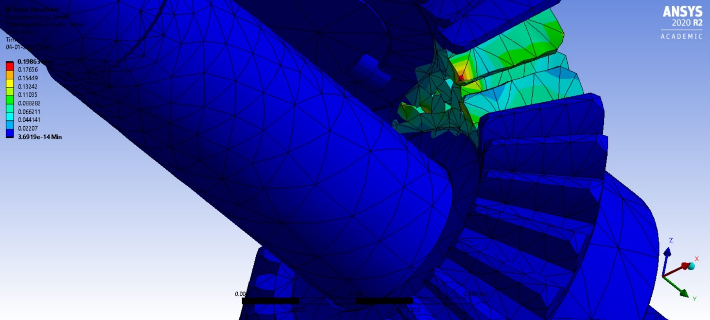
Fig. 18 Equivalent elastic strain on bevel assembly
Time [s] | Minimum [m] | Maximum [m] | Average [m]
Total Deformation
1 | 1.35E-06 | 6.78E-03 | 3.52E-03
Equivalent Elastic strain
1 | 3.69E-14 | 0.19863 | 5.74E-03
Equivalent Elastic stress
1 | 1.05E-03 | 1.67E+10 | 4.52E+08
Table – 3 Static Structural Analysis on Bevel gears
Conclusion
A 3-way right angle bevel gearbox was designed and developed as a primary objective to run both pulverizer and applicator simultaneously in a tractor powered manure pulverizer cum applicator. Laboratory model was developed and evaluated as trial and error method. Further model was scaled up and analyzed with ANSYS Workbench 2020 to predict any failure in the model prior to final prototype. Results from the analysis put forth the maximum values of stress and deformation that the gearbox can withstand during working conditions. No failure was observed in the model and results were found satisfactory. Performance evaluation of the final gearbox was done in the field and no heavy noise, vibration and failure were noted with changing input rpm from 0 to 540.

References
- Beena Devendra B, Salim Abbasbhai C & Sugnanam Naga, R.H, J of the Inst Eng, 99(3) (2017) 277.
- Bevan T, The Theory of Machines, Longman.
- Browing E.P, Distinguished series of ASAE, 1985.
- Chowda Reddy M, Prakash K.V, Veerangoud M & Yarnal, R.S, Int J Agric Engg, 6(2) (2013) 519.
- Chunxi L, Ling W.S & Akui J.Y, Energy Convers and Manag, 52(9) (2011) 902.
- Close CM, Fredrick DK & Newwell IC, Modelling and Analysis of Dynamic System, (John Wiley & Sons), 2001.
- Franklin GF & Powell JD, Digital Control of Dynamic System, (Addison Wesley Publ.), 1980.
- Howard I, Jia S, Mechanical System and Signal Processing, 15(5) (2001) 831.
- James K.P & Roger A.B, Pharmaceutical Technology, (2000) 84.
- Jayan P.R, Amal D.J, Arya K.T, & Harsha S, Krishiyankanam, 23(5) (2017) 13.
- Jegan P & Jerry Vasanth P, Int J of Adv Eng and Res Dev, 4(4) (2017) 770.
- Kepner RA, Bainer R & Berger EL, Principles of Farm Machinery, (AVL Publ), 1978.
- Litvin F, Fuentes A, Carvendali I.G, Kawasaki K & Handschun R.F, Comput Methods Appl Mech Engg, 192 (2003) 3619.
- Mabie HH & Ocrirk FW, Mechanism and Dynamics of Machinery, (John Wiley & Sons), 1987.
- Mari G.R, Pakist J of Agric Eng Vet Sci, 16(1) (2000) 45.
- Moaveni S, Prentic-Hill inc, 1999.
- Neeraj Patel & Tarun Gupta, Int J of Engg Res & Technol, 5(01) 2016.
- Patil S.T & Munde P.A, Eng and Technol in India, 8(1) (2017) 80.
- Patil S.T & Munde P.A, Int. J. Agric. Eng. 10(2) (2017) 531.
- Rahi Jain & Pratik Goyal, Int J of Mech Engg and Technol, 7(6) (2016) 510.
- Shigley JE & Uicker JJ, Theory of Machinery and Mechanism, (McGraw Hill), 1980.
- Yan G & Xi P, Inst of Electr and Electr Eng, 4 (2010) 42.

Sl. No. | Specification | As per IS: 4931-1995 | Developed shaft, mm
1 | No. of splines | 6 | 6
2 | Input speed (rpm) | 540±10 | 540
3 | D | 34.79±0.06 | 34.5
4 | d | 28.91±0.05-0.15 | 28
5 | W | 8.69-(0.09 to 0.16) | 7
6 | B | 76 (min) | 86
7 | b | 25±0.5 | 26.5
8 | c | 38 | 38.5
9 | a | 7.0 | 6.63
10 | A | 8.3 | 7.5
Table − 4 Elevation view of developed P.T.O shaft
Time [s] | Minimum [m] | Maximum [m] | Average [m]
Total Deformation
1 | 8.05E-03 | 3.53E-02 | 2.83E-02
Equivalent Elastic strain
1 | 1.27E-07 | 0.57912 | 6.29E-03
Equivalent Elastic stress
1 | 10169 | 5.91E+10 | 5.68E+08
Table − 5 Static Structural Analysis on Spur gears
Time [s] | Minimum [m] | Maximum [m] | Average [m]
Total Deformation
1 | 1.35E-06 | 6.78E-03 | 3.52E-03
Equivalent Elastic strain
1 | 3.69E-14 | 0.19863 | 5.74E-03
Equivalent Elastic stress
1 | 1.05E-03 | 1.67E+10 | 4.52E+08
Table − 6 Static Structural Analysis on Bevel gears
List of figures
Fig. No. | Caption | Page No.
1 | Tractor powered manure pulverizer cum applicator | 3
2 | Various parts of the gearbox experimental setup | 4
3 | Arrangement of spur gears | 5
4 | Line diagram of a 3-way right angle bevel gearbox model | 5
5 | Experimental setup of a 3-way right angle gearbox | 6
6 | Process flowchart for ANSYS | 7
7 | Elevation view of drilled holes on casing plate | 9
8 | Elevation view of P.T.O coupling | 10
9 | Elevation view of input P.T.O shaft | 10
10 | Elevation view of shafts | 11
11 | Arrangement of gears | 12
12 | Isometric view of gearbox prototype | 13
13 | Final assembly of gearbox | 13
14 | Variation in gearbox output speeds, RPM | 14
15 | Total deformation on spur assembly | 15
16 | Equipment elastic strain on spur assembly | 15
17 | Total deformation on bevel assembly | 16
18 | Equipment elastic strain on bevel assembly | 16

