Assessment of Accessible Toilets for Differently abled people: A Case Study on Inclusivity and Compliance

Abstract: Study was carried out in Chaudhary Charan Singh Haryana Agricultural University, to find out the accessibility as per differently abled people. Seven buildings (College of Community Science, College of Agriculture, College of Agricultural Engineering, College of Basic Sciences and Humanities, Nehru Library, I.G. Auditorium and Fletcher Bhawan) of CCSHAU, Hisar were taken as locale of the research. From the findings, door width of toilet in COBS&H (70.7±1.2 cm), Nehru Library (76.2±1.2 cm), F.B (66.3±0.2 cm) and in I.G auditorium (63.2±1.3 cm) was found to be less than recommended dimensions (90-100 cm) whereas in rest of the buildings (COCS, COA, COAE) door width was appropriate and correlated with recommended dimensions. Feature of kick plate were not provided in any of the toilet door while colour of toilet door in I.G. Auditorium was not found to be contrast in colour with the wall. Special toilets for differently abled people were found to be in COCS, COA and COAE but it was lacking in rest of the buildings so western toilets were studied during the research. Roughed ceramic tiles were used in the toilets, which prevents the floor from being slippery, while guiding blocks and tilted mirrors were not found in any of the buildings, even though mirror height was significantly (‘t'=4.1) higher than the recommended dimensions (90 cm) in all of them. Further, the floor area within the toilet was measured and found that sufficient space was provided for easy manoeuvring in COCS, COA, and COAE, which was significantly correlated with the recommended dimensions. There was no emergency alarm in any of the buildings. At least one special toilet should be provided at the ground floor of each building with proper space for manoeuvring of wheelchair person.
Keywords: Accessible toilet, recommended dimensions, guiding blocks and emergency alarm

Introduction
At some point in our lives, we are all physically disabled; a child, a person with a broken leg, a parent pushing a pram, an elderly person, and so on are all disabled. Few people live their entire lives healthy and able-bodied. Physical disability is extremely unpredictable, as a formerly vibrant and able-bodied individual might become physically impaired overnight because of an accident or as a side effect of sickness treatment. Hundreds of families around the world are affected by disability; roughly 15% of the global population is disabled, with 2-4 percent of that population suffering from mobility issues. People with disability are on the rise around the world, and they're linked to the many other health issues like mental illness, cardiovascular disease, respiratory sickness and injury, cancer, and so on (WHO and World Bank 2011). Indian Census (2011) depicted that the percentage increase in the disabled population to the total population was 2.13% to 2.21%. In rural areas, percentage hike was 2.21% in 2001 to 2.24% in 2011 and in urban areas, disabled population was increase from 1.93% to 2.17%, the same was inline among population of male and females during this period. Further report concluded that, 8.53% of the disabled persons were having graduate and above qualification. Among the State/UTs; Chandigarh had the highest (19.68%) graduates. Major proportion (73%) of disabled children (5-19 years) that was attending School/ Colleges reported from Goa & Kerala, 70% from Maharashtra and Lakshadweep. One third (39%) of the disabled children were never attended school/ colleges in Nagaland and Assam. When it comes to the built environment, it is critical that it should be barrier-free and adaptable to meet the requirements of all individuals equally so, buildings and infrastructure should be barrier-free and accessible to people with disabilities, according to the Rights of People with Disabilities Act (2016). Non-discrimination in participation, non-discrimination of roads, and non-discrimination of the built environment are all covered under sections 44 and 45. Section 46 mandates wheelchair-accessible toilets, handrails, and ramps in public buildings, as well as braille and auditory aids. According to a study, the accessibility of differently abled students as compared to without disabilities for overall participation and academic achievements in higher education in the state of Andhra Pradesh. It was found from the study that differently abled students take more time to meet the demands of their studies, often used computers and information technology and were having less participation in social and extracurricular activities (Ganapathy 2014). Further, Masood and Shaheen (2014) while studying “Barrier free environment: An analysis of Aligarh city, India”, concluded that an upper level of difficulty was raised by the barriers which making the environment unsafe for disabled and were limiting their participation and grabbing opportunity.
A barrier-free environment is one that allows individuals with disabilities to move around securely and freely while also taking advantage of the built environment's amenities. The purpose of barrier-free design is to create an environment that supports persons independent functioning so that they may access and engage in everyday activities such as purchasing goods and services without help. Indian government has launched Sugamaya Bharat Abhiyan or Accessible India Campaign in 2015 mainly for the differently abled people of the country. As per survey report 50% of the public buildings and transportation facility were to be made accessible for all by July 2018 but according to the Department of Empowerment of Persons with Disability, still only 3% of buildings have become disabled friendly (Hindustan Times, 2018). It is pointless to consider overall development without ensuring that everyone has equal access to resources and opportunities. So, with all these considerations in mind, the current study was designed to investigate the infrastructure barrier in building’s toilets and develop potential solutions for making infrastructure accessible to all.
Methodology
The study was conducted in campus of CCS HAU, Hisar to find out the problems faced by differently abled people. Seven buildings (College of Home Science, College of Agriculture, College of Agricultural Engineering, College of Basic Sciences and Humanities, Nehru Library, I.G. Auditorium and Fletcher Bhawan) of CCS HAU (Fig-1), Hisar were taken as locale of the research. Accessible toilets of each building were examined by using observation and case study method. Further, buildings were studied based on AICTE and CPWD guidelines and critically analysed as per barrier free environment solution. Data was analysed by using Correlation and ‘t’ test, on the basis of result recommendations were given as per accessible buildings codes.

CCS HAU, Hisar
COCS
College of Basic Sciences & Humanities
College of Agriculture
College of Agricultural Engineering
Fletcher Bhawan
I. G. Auditorium
Nehru Library
Toilet as (per differently abled people)
Location
Features of building

Fig-1 Study location

Results and discussion:
Table 1; Assessment of toilet door of buildings as per accessible building codes
Variable | Recommended dimensions | COCS | COBS&H |  | COA | COAE | N. Library | F.B. | I.G |  | T value
Toilet door
Width | 90-100 | 99.2* |  | 70.7±1.2 (ns) | 102.3* | 92.1* | 76.2±1.2 (ns) | 66.3±0.2 (ns) |  | 63.2±1.3 (ns) | -1.4 (ns)
Handle height | 90 -100 | 118±0.4 (ns) |  | 107±0.9 (ns) | 109±1.1 (ns) | 109±1.3 (ns) | 105±1.2 (ns) | 108.6±1.1 (ns) |  | 98.7±0.3* | 5.92**
Signage height | 140-160 | 210.3±2.1 (ns) |  | 152.3±3.2* | 211.2±2.1 (ns) | × | 150.1±2.31* | 154.2±1.20* |  | 176.2±1.2 (ns) | 2.19*
Kick plate height | 30-40 | × |  | × | × | × | × | × |  | × | NA
Colour | Contrast colour with the wall | Brown colour door with light coloured wall |  | Brown colour door with light coloured wall | Blue colour with light coloured wall | Brown colour with light coloured wall | Yellow colour on light colour wall | Brown colour on light colour wall |  | Not contrast | NA
All the dimensions are in cm, **Significant at 1% level of significance, * Significant at 5% level of significance
Assessment of toilet door of buildings as per accessible building codes
Toilet doors were analysed on the basis of standard norms for easy accessibility, data in Table 1 further explain results that door width of toilet in COBS&H (70.7±1.2 cm), Nehru Library (76.2±1.2 cm), F.B (66.3±0.2 cm) and in I.G auditorium (63.2±1.3 cm) was found to be less than recommended dimensions (90-100 cm) whereas in rest of the buildings (COCS, COA, COAE) door width was appropriate and correlated with recommended dimensions. Further handle height of the door in all the buildings significantly more than recommended dimensions (90-100 cm) in COAE while only in I.G building door’s handle height (98.7±0.3 cm) was found within the prescribed range. There was no use of sign was found in toilet doors of COAE whereas in COCS, COA and I.G auditorium signages height was more than recommended dimensions (140-160 cm). signages height was found to be at appropriate height in buildings of COBS&H (152.3±3.2), Nehru Library (150±2.31) and F.B (176.2±1.2). Feature of kick plate were not provided in any of the toilet door while colour of toilet door in I.G auditorium was not found to be contras in colour with the wall.
Fig 2- Accessible Toilets for Differently abled people
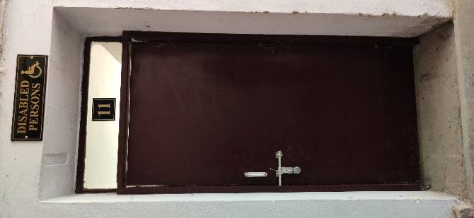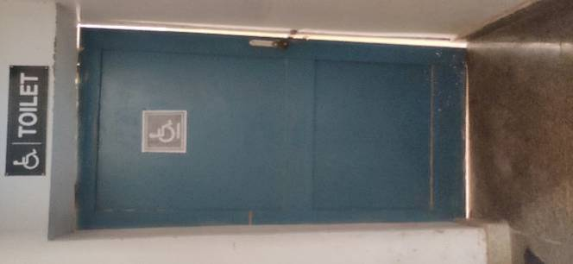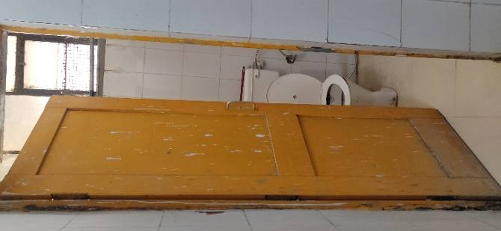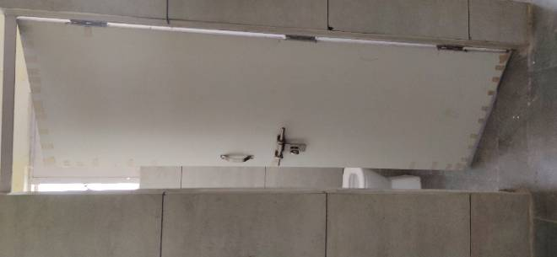
COCS COA N. Library I.G.
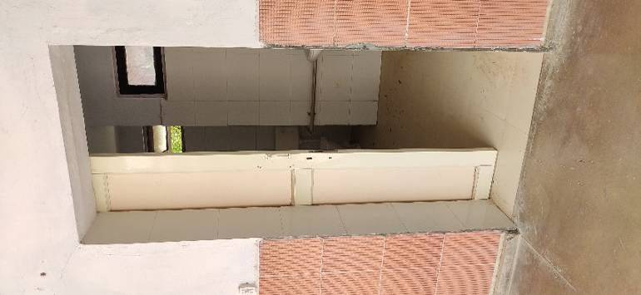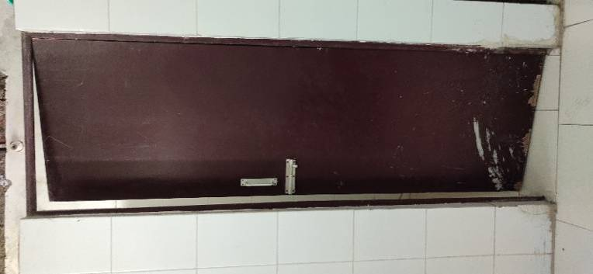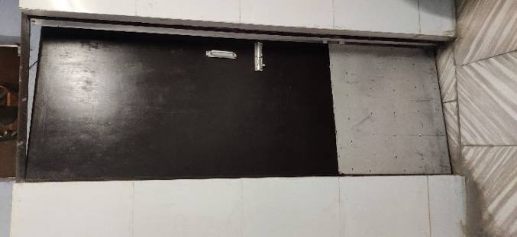
COAE F.B. COBS&H

Table 2; Assessment of building toilets as per accessible building codes
Variable | Recommended dimensions | COCS | COBS&H | COA | COAE | N. Library | F.B. | I.G | T value
Door opening | >90cm | 99.6 * | 70.4(ns) | 102* | 87.8 (ns) | 76.2 (ns) | 66. 3 (ns) | 63.2 (ns) | -1.5 (ns)
Surface | Non slip | non-slip | non-slip | non-slip | non-slip | non-slip | non-slip | non-slip | NA
Guiding block | On wall | × | × | × | × | × | × | × | NA
Mirror angle | 15⁰Tilt | × | × | × | × | × | × | × | NA
Mirror height | < 90 | 104.6 | 115.6±0.93 | × | 93.4 | × | 116.8 | 108.6±0.1 | 4.1*
Door handle | D shape | √ | √ | √ | √ | √ | √ | √ | NA
Rear grab bar | Length (90-94) | × |  | × | × | × | × | × | NA
Side grab bar | Length (140-150) | 59.6 (ns) | × | × | 98.7 (ns) | × | × | × | -3.6(ns)
Side grab bar | Height (95.0) | 76.2 | × | × | 66.4 | × | × | × | -1.0 (ns)
Side grab bar | Diameter- (4-5) | 2.4 (ns) | × | × | 4* | × | × | × | -0.3 (ns)
Toilet seat | height (40-45) | 40.64* | 41.2 * | 44.3* | 42.3 * | 41.2 * | 42.3 * | 40.3 * | -6.3 (ns)
Floor area | >150 x 150 | 203.3x284.7* | 120x100 (ns) | 180.2 x 190.3* | 340x 220* | 160x 100* | 120x120(ns) | 135x146(ns) | 1.6
Alarm | For Emergency | × | × | × | × | × | × | × | NA
Location | Ground floor | G. F | G. F | G. F | G. F | G. F | S. F | G. F | NA
Roughed ceramic tile (non-slip)
All the dimensions are in cm, **Significant at 1% level of significance, * Significant at 5% level of significance
Assessment of building toilet as per accessible building codes
Specially designed toilets with required features must be provided in public buildings to enhance the accessibility to differently abled people. Findings in Table-2 exposed that, special toilets for disabled were found to be provided in COCS, COA and COAE but it was lacking in rest of the buildings so western toilets were studied during the research. Door width in COBS&H, N. Library, F.B and I.G auditorium was 70.4 cm, 87.8 cm, 76.2 cm 66.3 cm and 63.2 cm, respectively and was significantly lower than recommended dimensions of door i.e., >90 cm. In COCS and COA the width of door was 99.6 cm and 102 cm which was significantly as per recommended dimensions (>90 cm). On the other hand, roughed ceramic tiles were used in the toilets which makes floor non slippery while guiding blocks and tilted mirror were not found in any of the building which were essential for wheelchair user whereas mirror height was found significantly (‘t’=4.1) more than the R.D (<90 cm) in all the buildings. Further, operable door handle (D shaped) was found in all buildings whereas rear grab bar was not provided in any toilet. In addition to this, side grab bar was measured which was provided in COCS and COAE, length of side grab bars was non significantly (‘t’=-3.6) correlated with the recommended dimensions (140-150 cm) similarly, height and diameter of side grab bar were also statistically non significantly correlated with (‘t’ value -1.0 and -0.3) recommended dimensions. Toilet seat height was calculated in all buildings of university and was found to be significantly correlated with the recommended dimensions (40-45 cm). Further inside toilet, floor area was also measured it was clear from findings that in COCS, COA, COAE sufficient area was provided for easy manoeuvring which was significantly correlated with the recommended dimensions. Emergency alarm was not found to be in any of the buildings. Similar study done by Ochien et al. (2013) depicted that public toilet were found to be having barriers in use due to the absent of handrails, narrow doors and high threshold had a negative impact on the accessibility of differently abled students to these building infrastructures.
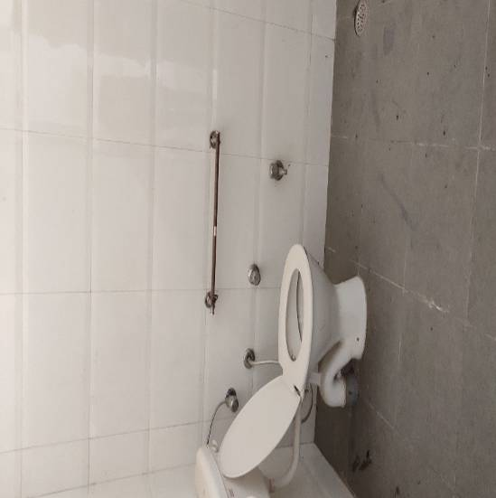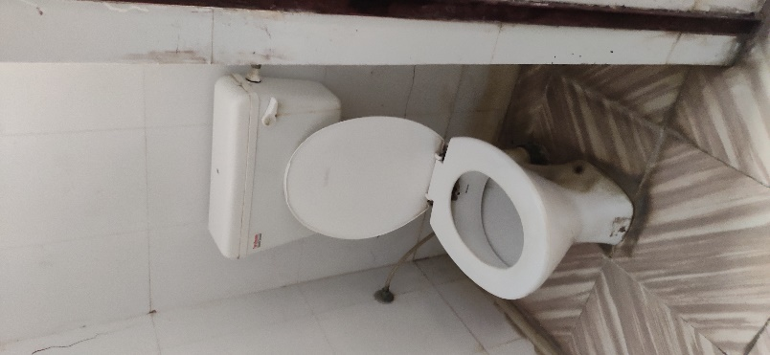
COCS COBS&H
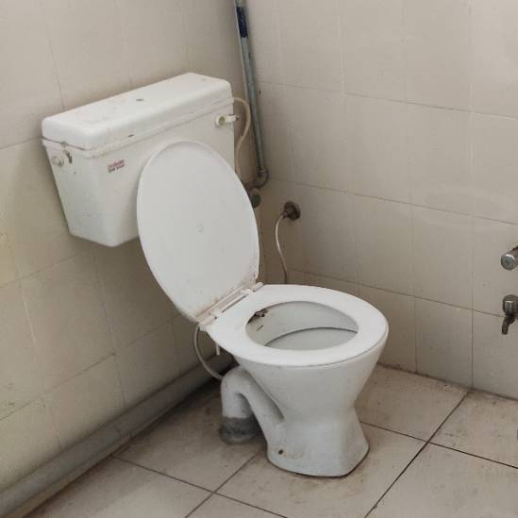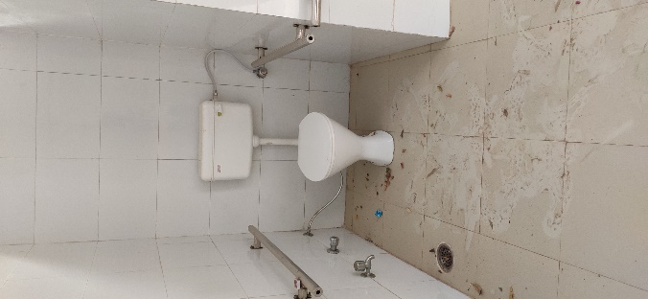
COA COAE
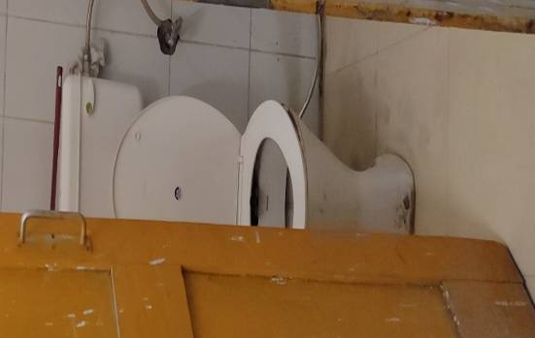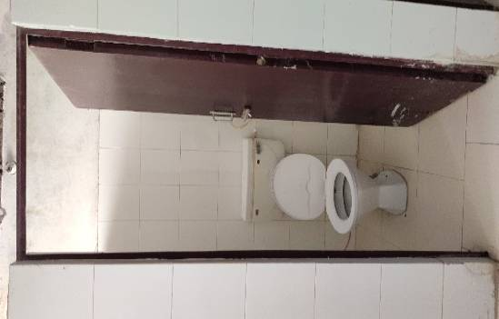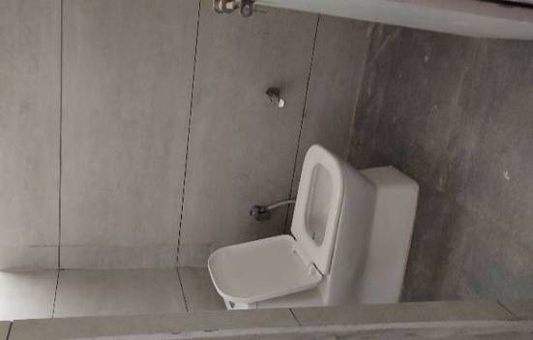
N. Library F.B. I.G.

Fig 3- Public toilets

List 1-Recommendation as per accessible building codes
Door
 |  | - In the entire buildings name plate and number plate on door should be at the height of 140-160cm and from side of the door.  - Construct a ramp/add wooden ramp to remove high thresholds.  - Door handles should be located at a comfortable height between 0.90 m and 1.00 m from the floor surface. |  | 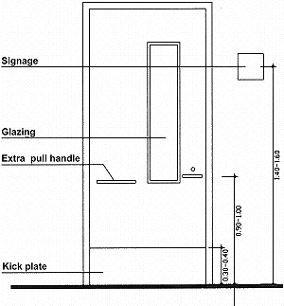
Toilet
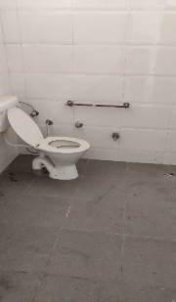 | - Proper space should be provided inside the toilet for maneuvering of wheelchair person  - The side grasp bar, in existing toilet, could be added at a height of 95cm. so that without constructing new toilet existing toilet can be easily access by person with special needs.  - Placing a guiding block 30 cm from the toilet door to aid a visually impaired or cane user in gaining entrance.  - Emergency alarm is necessary component of disabled toilet by which person can use it when needed, must be installed  - On the side of the door, an international symbol of accessibility should be provided. |  | 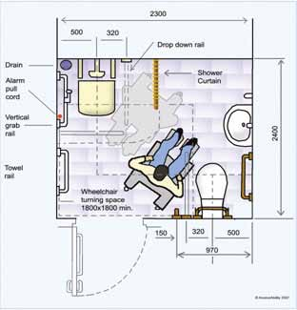

Conclusion
For making environment accessible to all each and every feature of the building should be built as per differently abled people. From the present study, door width of toilet in COBS&H, Nehru Library, Fletcher Bhawan and in I.G. was found to be less than recommended dimensions (90-100cm), whereas in rest of the buildings (COCS, COA and COAE) door width was appropriate. There was no use of sign/accessibility symbol was found in toilet doors of COAE, Feature of kick plate were not provided in any of the toilet door while colour of toilet door in I.G auditorium was not found to be contras in colour with the wall. As per the present study, it was clear that differently abled people were not found to be considered in infrastructure design of building. About special toilets, it was found only in three buildings Side grab bar was found in only two buildings, length of grab bar measured less than the recommended dimensions. Rear grab bar, emergency alarm and guiding blocks were major lacking features in all the buildings. For making built environment accessible, without constructing new toilet, at least one western toilet should be converted to special toilet for differently abled by providing grab bar/side bar and proper manoeuvring for wheelchair. Placing a guiding block 30 cm from the toilet door to aid a visually impaired or cane user in gaining entrance. On the side of the door, an international symbol of accessibility should be provided.
LIST OF ABBREVIATIONS

AICTE : All India Council of Education
CPWD : Central Public Works Department
COCS : College of Community Science
COBS&H : College of Basic Sciences and Humanities
COA : College of Agriculture
COAE : College of Agricultural Engineering
N. Library : Nehru Library
F.B. : Fletcher Bhawan
I.G. : Indra Gandhi Auditorium

Reference
- All India Council for Technical Education (AICTE). Savyam foundation and CBR network, Design Manual for a Barrier Free Environment in Universities/Colleges. https://www.aicte-india.org/downloads/Svayam-AICTE%20Guidelines-modified.pdf
- Census, (2011). Census retrieved from http://disabilityaffairs.gov.in/uploadfiles/files/first%20 Country%Report%20(1)_compressed.pdf
- Central Public Works Department (1998). Guidelines and space standards for barrier free built environment for disabled and elderly person, Central public works department, Ministry of urban affairs and employment India
- Ganapathi, B. (2014). Does inclusive higher education can help for physical disability handicapped people in India? A comparative analysis. International Journal of Research in Applied, Natural and Social Sciences. 2(5):1-16
- Hindustan Times (2018). Published article on Accessible India Campaign. https://www.hindustantimes. com/editorials/with-just-3-of-india-s-buildings-accessible-our-disabled-are-at-a-huge-disadvantage/story-Rh2rd4QzNzw9kHpmaTPV1H.html.
- Masood, H. and Shaheen,S. S. (2014). Barrier free environment: An analysis of Aligarh City, India.in International journal of interdisciplinary and studies.1(9):8-15.
- Ochieng, M. A., Onyango, G. M., & Wagah, G. G. (2013). Accessibility of Students with Physical Disability to Washrooms in Bungoma Bus Terminus, Kenya.194-812.
- World Health Organization and The World Bank (2011). World report on disability https:// www.who.int/disabilities/world_report/2011/report.pdf

