Harnessing Agricultural Waste: A Review on Recent Advancements in Waste Processing Technologies in Rice and Sugarcane

ABSTRACT
This review paper discusses significant problem of agricultural waste management, especially the by-products produces through farming systems such as rice and sugarcane cultivation. This is because both these crops find a place among the most produced globally, thereby causing a significant proportion of agricultural waste which leads to environmental issues like pollution and exhaustion of resources. This paper reviewed the types and amount of wastes generated from rice and sugarcane processing (Straw, husks, bagasse and leaves). In this we assess the consequences of these wastes to the environment and delve into select management strategies that can be used to reduce their significance. Attention is given to innovative methods that encourage the recycling and reuse of these by-products. One potential approach is to utilize composting, bioconversion for biofuels. In addition, the paper presents best practice in successful case studies and ways that farmers can deploy these strategies to improve economic viability while supporting environmental sustainability.
Keywords: Rice straw, rice husk, sugarcane press mud, sugarcane bagasse, sugarcane baggase ash, sugarcane vinasse.
1. INTRODUCTION
Agriculture is the foundation of many economies across the world, providing food, raw materials, and job opportunities. Agricultural waste is defined as the by-products and leftovers produced by farming operations such as crop cultivation, animal raising, and forestry. Crop remnants (Stalks, leaves, and husks), animal dung, wasted or spoilt products, and unused harvest crop portions are all examples of waste. Agricultural waste, whether organic or inorganic, frequently presents environmental concerns if not adequately managed, ultimately resulting in pollution and resource inefficiency. Crop residue is generated in India on a yearly basis in the range of 500-550 million tonnes. Uttar Pradesh accounts for 60 million tonnes, comes after Punjab (51 million tonnes) then Maharashtra (45 million tonnes). Cereals yield the maximum agricultural waste (351 million tones), next to fibres (66 million tones), oilseeds (29 million tones), pulses (13 million tones), and sugarcane (12 million tones). Cereal crops such as wheat, corn and maize contributes 70% while rice contributes about 34%. Wheat ranked at second with 22% of crop residue (MoA, 2012). Proper agricultural waste management and recycling may help in improving soil health, minimise pollution, and promote efficient farming methods (UNEP, 2011). Rice, wheat and sugarcane wastes are enormous, posing a significant waste management challenge. If not appropriately handled, this will result in environmental damage, health risks, and economic losses. Agricultural waste management has emerged as a critical component in the worldwide push for sustainability. With rising demand to reduce carbon footprints and maximise resource efficiency, it is critical to develop and execute solutions for managing agricultural crop wastes. Wheat, rice, and sugarcane are among the most widely grown crops in the world, and they contribute significantly to agricultural waste. Rice and wheat are staple grains that are widely grown around the world. Cultivation entails vast volumes of straw and husks, which are generally left unused or burned in open areas, leading to environmental pollution and resulting in greenhouse gas emissions (Jain et al., 2014). Sugarcane is another significant crop grown in the tropics and subtropics, and it produces massive volumes of bagasse and press mud, byproducts that present both a burden and an opportunity for waste treatment. The waste is produced in the form of stalks and seed husk. Traditionally, they were left in the field to decompose or burnt, but this method is rapidly becoming seen as unsustainable. The improper handling of waste from agriculture not just degrades the environment, but it also wastes potential resources that could be used for a variety of beneficial purposes.
Several methods and approaches were developed to improve agricultural waste management, including composting, bioenergy generation, the manufacture of biochar, and the use of leftovers in bio-composites. Each of these processes has distinct advantages and disadvantages, depending on waste qualities and local variables. For example, while producing bioenergy from garbage is very efficient, it necessitates significant upfront expenditures and infrastructure construction. Composting is one of the oldest methods of agriculture waste management, converting organic leftovers into nutrient-rich fertiliser. The strategy lowers waste while enhancing soil fertility and carbon sequestration. Composting requires adequate management to be effective and sustainable in terms of emission control and nutrient balance. Another intriguing research path is the creation of bio-char - a kind of charcoal that is utilised as a soil supplement (Zhang et al., 2021). The utilisation of agricultural leftovers in bio-composites and other industrial uses is also becoming more common. Crop leftovers are used to create bio-composites, which have uses in building, packaging, and other sectors, substituting traditional material usages (Kumar et al., 2019). The problems of scaling up these technologies while maintaining their economic viability continues. We would like to analyse all rice and sugarcane residue management options and discuss how to improve agricultural sustainability. We hope to discuss current techniques, technical advancements, and policy frameworks which will aid in the proper management of byproducts. By highlighting these potential and difficulties, we want to contribute to the ongoing efforts to establish a more sustainable, adaptable agriculture that aligns with global objectives for environmental preservation and resource efficiency (Kumar and Sharma, 2019).
2. Understanding Waste Types
2.1 Rice Straw
The byproduct remains left after rice crop is harvested. The total biomass of the residue is variable due to several factors such as weather, fertiliser management system, type and receptivity of soil. Rice straw is either spread out or heaped into bulk in the field using self-propelled combine harvesters, or stationary threshers. The amount of rice straw to be removed from field depends greatly on the cutting height. Main composition of rice straw: cellulose (32-38.6%), hemicellulose (19.7-35.5%) and lignin (13%), cellulose(28.6-43.3%), hemicellulose(22–29.7%) respectively (Mirmohamdsadeghi and Karimi, 2020).
2.1.1 Rice straw management strategies
There are two types of management strategies i.e. In-field operations for rice straw management and Off- field operations for rice management.
In-field operations for rice straw management
There are two types of management strategies i.e. open burning of rice stubble in the field and incorporation of rice straw in the field.
a) Open burning of rice stubble in the field
Open burning is frequently seen as the most efficient and cheapest technique for getting rid of rice residue after harvest. It takes little labour and no additional equipment or techniques such as composting or integration into the soil. After harvesting, farmers frequently burn rice straw to prepare the land for the following planting season. It provides a quick method of preparing the soil for sowing that does not require any further mechanical operations. Rice cultivation generates a great amount of rice straw, and open burning may appear to be an easy way to dispose of it fast. Burning rice straw emits significant amounts of CO₂ gas, contributing to the greenhouse effect and negatively impacting the environment. Rice straw burning depletes nutrients, requiring farmers to supplement with more fertilizers and nutrients, adding to the cost load. Using this management strategy results in the depletion of various nutrients from the soil such as phosphorus pentoxide 2.3 kg/tonne, nitrogen 7 kg/tonne, potassium oxide 17.5 kg/tonne, magnesium 2 kg/tonne and calcium 3.5 kg/tonne.
b) Incorporation of rice straw in the field
Rice straw is high in organic matter and includes nutrients such as Nitrogen, potassium, carbon and phosphorus. When degraded, it increases the organic matter of the soil and improves soil health. The gradual decomposition process slowly releases nutrients, rendering their availability to crops for a longer time. Straw improves soil texture by improving porosity, allowing for greater air circulation, water penetration and root development. It lowers soil compaction and may boost microbial activity. Rice straw helps to maintain soil moisture, lowering the requirement for irrigation and crop water stress. Integrating rice straw in the soil rather than burning it lessens air pollution and limits the generation of damaging greenhouse gases. Burning agricultural leftover causes soil damage (Yadav et al., 2015). The most frequent way is to plough the rice straw in the soil. This can be accomplished with regular ploughs or more advanced technology built for straw integration. Conventional tillage involves either ploughing the straw beneath or mixing it with the topsoil to decompose. Rice straw is frequently cut or chopped into smaller bits before inclusion. This helps to accelerate the breakdown process by expanding the surface area accessible to microbial activity. Another method is no tillage farming which involves spreading rice straw on the soil surface as mulch and planting crops into it, leaving the soil undisturbed. This strategy decreases soil erosion and retains soil structure, although further management may be required to guarantee adequate straw decomposition. Researchers are developing easy composting technologies to convert leftover rice straw into soil-rich nutrients (Verma, 2014).
Off- field options for rice management
There are two types of management strategies i.e. use of rice straw in agriculture/poultry purposes and use of rice straw in energy production.
Use of rice straw in agriculture/poultry
Rice straw can be used in many ways such as - breeding material for crops (Rice straw offers a dry, clean, pleasant, non-slip, and sanitary environment, reducing the risk of lameness and injury. Healthy legs improve milk production and reproductive efficiency for animals), in mushroom cultivation (Cultivation of mushroom requires rice straw with optimum moisture, temperature, etc.) (Kaushik et al., 2018), nutrients for the soil (Rice straw has both nutrients and caloric values. During the composting process, organic wastes are degraded by microbial populations. Composting offers various advantages, including bulk and mass reduction, high C/N ratio (carbon to nitrogen), and sanitation)
Use of rice straw in energy production
Rice straw can be used in many ways for the production of energy such as – thermal power generation (Rice straw has a thermal efficiency of between 60 and 75%, depending on the technique used to burn it) (Vagg, 2015) combustion material (rice straw can be used as fuel for combustion purposes, as a fertilizer for the soil, feedstock for cattle and also raw material for various industries) (Zhiqiang et al., 2011) and in the production of bio gas. For the production of biogas, underground containers built of cement and bricks typically measure 2.5 meters in width and 4 meters in height, with a dome-shaped top, for producing biogas from rice straw. There are openings for the water entry and gas outflow at the bottom and top of the container, respectively. On top of the straw layer, two layers are stacked one half a meter thick: one is rice straw, and the other is cow manure. Until the plant is fully filled, these stages are repeatedly performed. After adding water to the plant, the fermentation process commences, and a week later, biogas production starts. Five to six cubic meters of biogas are created from one tonne of straw over the course of four months (Patil and Sharanagouda, 2017). The various strategies are shown in (Fig. 1).
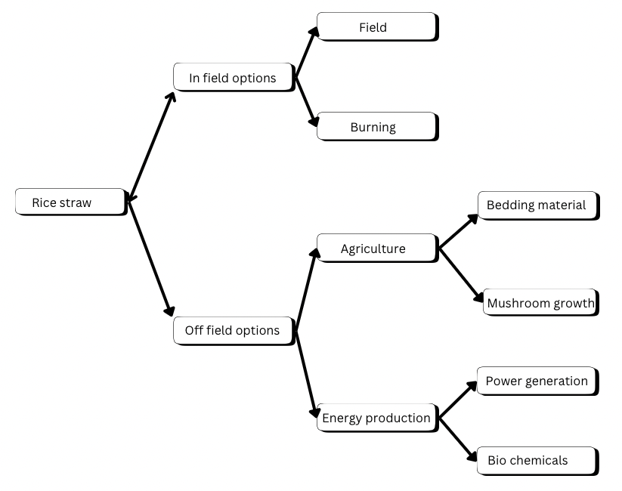
Fig. 1. Rice straw management strategies

2.2 Rice Husk
Rice (Oryza sativa) is a staple meal for over 50% of the global population. Rice Husk is a by-product of rice grains during the shelling and milling processes. The milling sector generates around 22% of the weight of rice, which is then utilised as an alternative fuel for paddy processing and energy production via gasification (Patil and Sharanagouda, 2017) India, being the world's second-largest rice grower, generates around 20 million tonnes of RHA (Shwetha et al., 2014). Raw rice husk has 75% organic matter and ash generation of other components is 25%. The main roles of the husk are to keep rice filling and protect grains from water loss (preventing drying), white light which is essential for photosynthesis, but promotes heat build up; also it allows tolling insects escape out. Grain development: The husk from which the grain is derived may inhibit grain filling (Fu et al., 2015).
2.2.1 Rice husk management strategies
Rice husk can be managed in various ways
Agricultural industry
Biological control agents
Rice husk can be used to create habitat for beneficial microorganisms and insects that helps in controlling pest population. Certain plant pathogens that are antagonistic to plant pathogens can be cultured on rice husks. It can also be used as a substrate for rearing beneficial insects like predatory beetles or parasitic wasps which then can be released in the field to control pest populations.
Improving soil fertility
Proper processing of rice husk is beneficial to soil due to the bioavailability of silica in rice paddy fields, which affects the crop growth and development (Sekifuji and Tateda, 2019). Rice husk can also be used in composting. Composted rice husk can be added back to the soil to enhance and preserve organic matter, boost yields from agriculture, and reduce the need for chemical inputs (Thiyageshwari et al., 2018).
Mulching
Mulch is a layer of material that is added to the soil to improve its physical, biological (soil microbiota), chemical, and weed-inhibiting qualities as well as to decrease water evaporation, prevent soil erosion, decreases the release of nitrogen for plant uptake, and increase productivity (Adnan et al., 2020).
Food and feed industry
A potential absorptive action of rice husk towards aflatoxins has been demonstrated (Seaglioni and Badiale-Furlong, 2016). The Aspergillus fungus penetrates the food chain and produces aflatoxins, which are carcinogenic compounds (Ansari et al., 2021). Agricultural management strategies are shown in (Fig. 2).
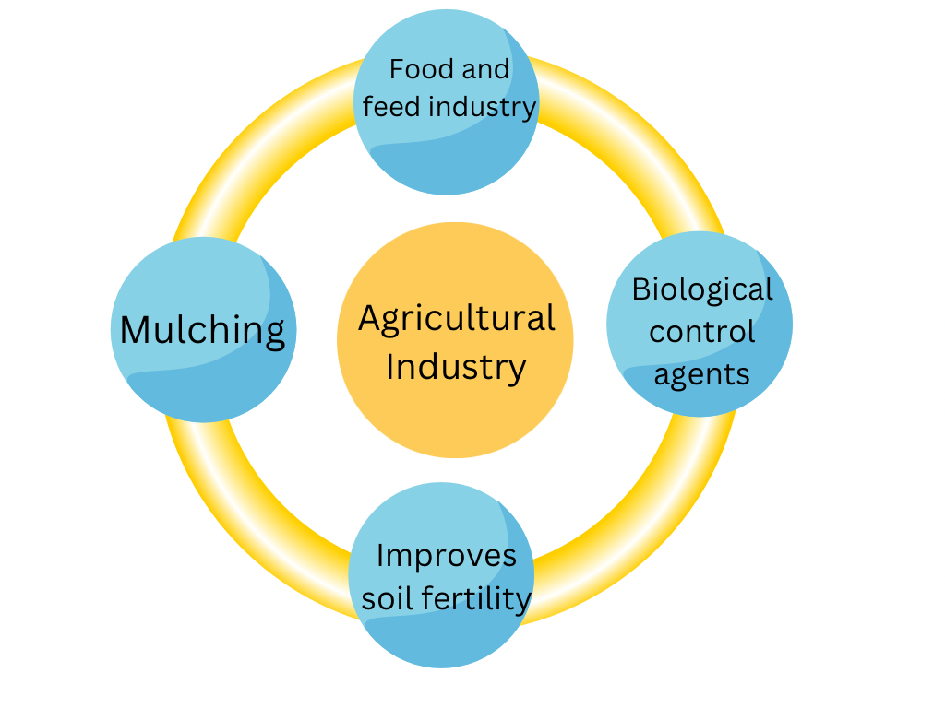
Fig. 2. Major Benefits of Rice husk
Environmental application
Soil remediation
Rice husk can help in improving soil structure as it is rich in silica. When rice husk is incorporated into the soil, they help in improving aeration and drainage which is beneficial for plant roots. Rice husk decomposes slowly adding organic matter to the soil over time. This organic matter improves soul fertility and water holding capacity.
Water refining industry
Rice husks can be converted into activated carbon, a substance that is very useful for purifying water. Many pollutants, such as organic molecules, chlorine, and certain heavy metals, can be adsorbed by activated carbon. To make porous carbon, rice husks are heated to high temperatures while a gas, such as steam, is present (Uddin and Khan, 2012).
Dye removal
Rice husk has adsorption properties for separating chemicals from industrial effluents (Prapagdee et al., 2016). Many dye variations are hazardous, and some of them are agents that cause mutation and disease, thus they must be removed from the environment. Rice husk is used in removing colour compounds, for example methylene blue from aqueous solutions (Vaz et al., 2017).
Composite production
Rice husk takes on a more special name for potential fillers in the production of bio-composites reinforcing already commercially composite due to its abundant existence (Majeed et al., 2017). Until now, the rice husk filled hybrid composites was fabricated varied depend on using as matrix and resins & natural rubbers such us polypropylene, polyethylene both for matrices/ resin too (Bisht et al., 2020). Excels in higher specific strength and modulus; lower tool wear; low cost, less density economically viable, biodegradable environmental friendly than conventional metallic alloys. That shows, that they were used in both basic and industrial research (Hemnath et al., 2021).
Biofuel production
In order to create activated charcoal, silica, syngas, and biofuel, rice husks have a 3D network structure made of organic carbon and silica. Rice husk is a good replacement to coal with fewer pollutants (Nayak et al., 2017). The process of anaerobic digestion, which occurs when bacteria break down organic matter (found in plants and animals) into gas and valuable soil products (found in liquid and solid forms), is known as biogas processing. Methane (50–70%) followed by carbon dioxide (30–40%) and trace amounts of other gases are all present in biogas (Gopal et al., 2019).
Other energy resources
Nanostructured rice husk have been conventionally utilized in contemporary energy industries such as solar cells, li-ion batteries, supercapacitor and triboelectric nanogenerators (Wang et al., 2018). In addition, rice husk is utilized in producing carbonaceous compounds such as graphene oxide, which is employed in biomaterials, electronics, energy production (Manpetch et al., 2022). Environmental strategies are shown in (Fig. 3).
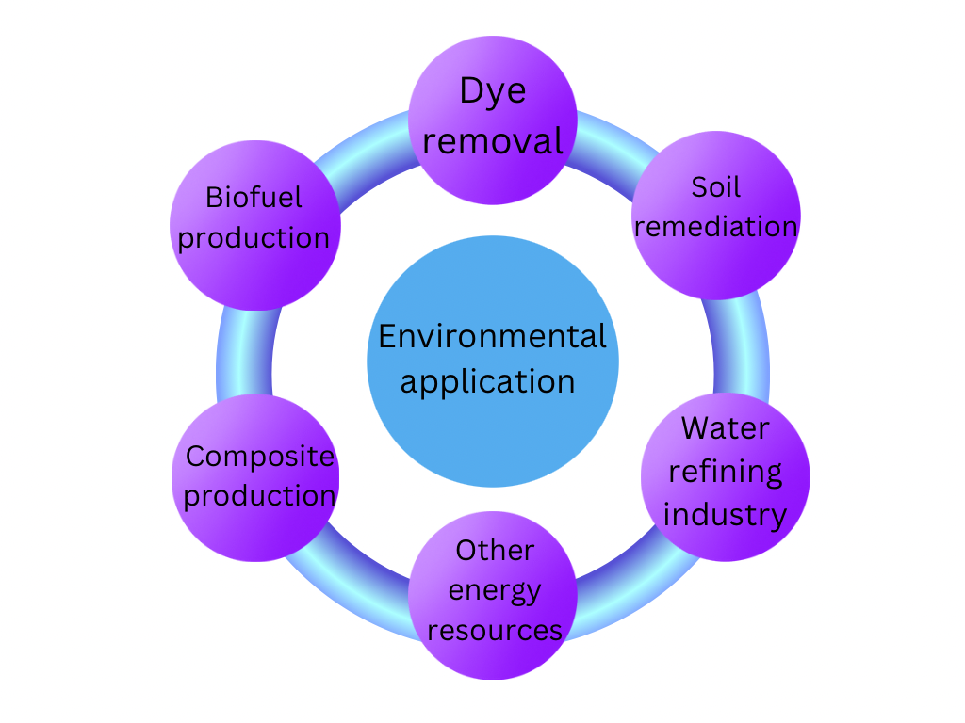
Fig. 3. Environmental application of Rice husk
Construction materials
Ceramics
Rice husk has used on ceramics production. The process of preparation of ceramics from rice husk includes; grinding, Rice husk mixing with liquid phenol resin in a ratio of 3:1, drying at 150 to 180 °C, carbonisation, crushing of carbonised mixture, mixture of crushed mixture and powdered phenol resin under a pressure for the formation of a disc, re-carbonisation of formed discs, and finally, a cooling of ceramic discs Because rice husk has a lot of silica, it can be used in the ceramics sector, protecting natural resources (Shibata et al., 2014).
Brick industry
Along with conventional cement, the use of agricultural wastes like rice husk and bagasse ash in the making of bricks has greatly lowered costs. Moreover, compared to conventional clay bricks, the resultant bricks are lighter and more resilient (Kumar et al., 2022). Rice husk is also used in the production of construction products such as cement and bricks (Jattin et al., 2020). According to research, a 4:1:2 blend of kaolin, rice clay, and plastic clay produces an ideal refractory surface and good insulation. Fig 4 shows the management strategies used in construction materials.
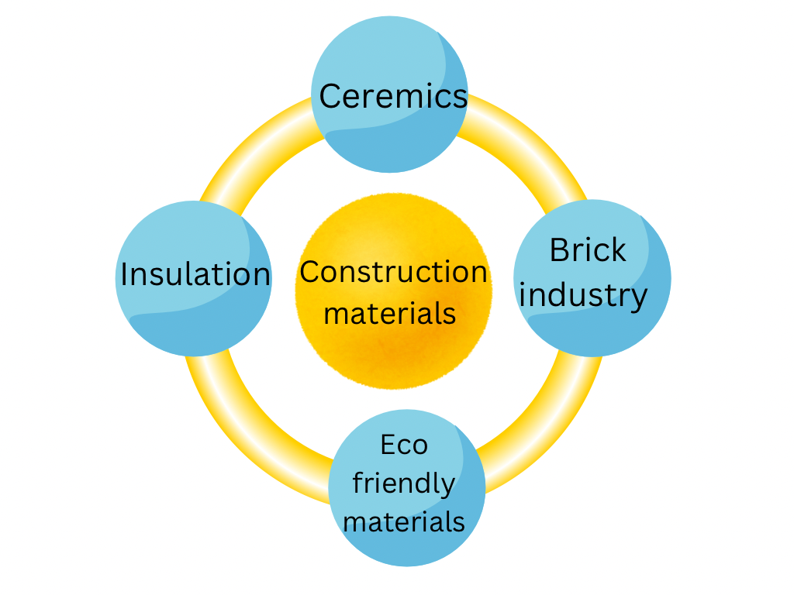
Fig 4. Construction materials manufactured from Rice husk

3. Waste management of Sugarcane
The different types of wastes or by-products that are being produced from sugarcane include sugarcane press mud(sugarcane industries produce the by-product called filter cake or Sugarcane Press Mud; this an amorphous type residue left after forcing sugar-canes in clarifying/checking station), bagasse for 2nd generation ( Bagasse is a waste product produced when performing juice extraction from cane sugars/fiber crops.), ash from Bagacillo, molasses (it is thick and dark syrup that a secondary result of cane sugars digestion process) vinass (it is liquid waste generated by alcohol plants based on sugar canes.). It is a dark brown, slightly viscous liquid with an unpleasant odour) and sugarcane leaves and straws/tops (Sugarcane leaves and tops, commonly known as straws or litter, are lignocellulosic materials that vary in chemical composition based on plant stage, variety, location, and climate).
3.1 Sugarcane Press Mud
Press mud also known as filter cake is remaining black spongy solid after clarification and and sugarcane juice filtration (Ghulam et al., 2012). During purification of sugar by carbonation or sulphitation process, a byproduct is formed which is known as press mud. Both techniques fractionate clear juice on the head and muck around the tail. For processing hundred tonnes sugarcane, three tonnes press mud is generated (Gupta et al., 2011). Press mud is a complex material, containing 15–30% fibers, 5–15% crude proteins, 5–15% sugar, 5–14% crude wax, 9–10% total ash, 4–10% silica, 1–4% calcium oxide, 1–3% potassium oxide and 0.5–1.5 magnesium oxide. It is an organic-rich solid residue known as press mud. Press mud, which is one of the final by-products in sugar industry, serves as the substrate for bio-composting (Chand et al., 2011). As press mud is an organic residue, it contributes carbon to soil microorganisms, it enhances the microflora that then affects the turnover of nutrients. Red soil with inorganic fertilisers and press mud increased cane output. Sugar press mud at rate of 25 tonnes per hectare markedly enhances yield in sugarcane (Ventakakrishnan and Ravichandran, 2013).
3.1.1 Management of sugarcane press mud
Press mud is a calcium, nitrogen, phosphorus and organic material rich waste, which can be used as soil fertiliser (Casas et al., 2015). It is proven to minimize soil degradation due to crusting, cracking, erosion, and compaction (Fantaye et al., 2016). Press mud can be composted alone or its possible to mix and use it with wastewater, ethanol distillation residue, animal manure, bagasse and other vegetable waste. It can also undergo vermicomposting with earthworm species such as Eisenia fetida and Eudrillus eugeniae (Nenciu et al., 2022). Organic composting takes time, space, and machinery for the turning, aerating, and watering of organic matter piles (Ungureanu et al., 2022). However, denser press mud field application over a long span of time can cause soil pollution, accumulation of heavy metals (zinc, copper, lead) and its adverse impacts on agricultural crops growth (Kumar et al., 2015). The broad variety of applications include for instance aquaculture, adsorption of dyes and metal ions from liquid solutions, synthesis of hydrocarbons and chemicals, paints, cement and foaming agents and others (Gupta et al., 2011). Different types of biofuels including ethanol and biogas, biofuel briquettes from bagasse, cane straws, bagasse ash, and press waste.
3.2 Sugarcane bagasse
Bagasse is the fibrous by-product left behind after sugarcane stalks are crushed to extract the juice. Out of this, 0.25–0.30 tonnes of bagasse is produced per tonne of sugarcane processed (Clauser et al., 2016). It had been reported that one tonne of sugarcane yielded 0.14 tonnes of bagasse (dry mass) and 0.14 tonnes of straw(stems) (Costa et al., 2014). Worldwide, over 700 million tonnes of bagasse are generated every year (Monterio et al., 2016). The top 10 countries that cultivate sugarcane alone produce more than 540 million tonnes of bagasse a year (Khoo et al., 2018). Sugarcane bagasse is heterogeneous depending on plant variety, agricultural conditions, harvesting methods, and processing. The composition of sugarcane bagasse is about 45-50% water, 2-5% soluble sugars and 40-45% fibre and 60-80% carbohydrates (Sahu, 2018). Sugarcane bagasse has a fibrous structure consisting of cellulose 42%, hemicellulose 28% and lignin 20%, with different composition for each component, like any other natural vegetable fibres (Alves-Rezende et al., 2011).
3.2.1 Management of sugarcane bagasse
Bagasse is an important sort of recoverable trash in large sugarcane-growing nations, with over 40 potential applications (Barrera et al., 2016). Approximately 58-76% of bagasse's wet mass is made of polysaccharides that can be hydrolysed into monosaccharides (glucose and xylose) and subsequently converted by microbial fermentation into enzymes, lipids, proteins, biofuels, feed and other biochemical compounds (Munagala et al., 2021). Various management strategies that are used in case of sugarcane bagasse.
Sugarcane bagasse energy recovery
Sugarcane bagasse has a moisture content of approximately 48% and a calorific value of 8021 kJ/kg and is often employed as a fuel type in cogeneration facilities for the generation of thermal energy (steam) and electricity within the same plant (Chandel et al., 2018). These energy products could provide for all the heat and electrical energy necessary for the sugar industry to operate, with the excess of energy generated finally delivered to the national electric grid (Alves et al., 2015).
Bioethanol production facility from sugarcane bagasse
Use of ethanol in modern internal combustion engines is an excellent alternative fuel. The high cellulose content and large yields of sugar related to the sugar industry, but it is replaced by the simple monomeric sugar for the synthetic process, a necessary compound for the synthesis of bioethanol from sugar cane bagasse, which serves as an essential raw material for bioethanol synthesis (Krishanan et al., 2010). Bioconversion of lingo-cellulosic biomass to ethanol proceeds in four steps. Biomass pretreatment is a process where microbial enzymes are used to cleave lignin and hemicellulose from lignocellulosic biomass to release cellulose. The final ethanol yield is greatly influenced by the quality of the bagasse and the pretreatment method used (Niju and Swathika, 2019). Cellulase and hemicellulase are the main enzymatic hydrolases of cellulose and hemicellulose, cleaving glycosidic bonds and transforming them into glucose. Various species of bacteria like Celulomonas, Bacillus, Thermonospora, Erwinia and fungi like Trichoderma, Fusarium, Phanerochaete etc. produce cellulose-related enzymes (Padella et al., 2019). Various bacteria produce cellulase enzymes, including those found in the genera Celulomonas, Bacillus, Thermonospora, and Erwinia, as well as fungi such as Trichoderma, Fusarium, and Phanerochaete (Khonngam and Salakkam 2019). Biological and physicochemical parameters which include substrate composition and nature, temperature, pH, oxygen, and types of microbe, affect the optimum enzymatic conversion process of sugarcane bagasse to value-added products. (3) Microorganisms like Zymomonas mobilis and Saccharomyces cerevisiae are capable of ferment the hexoses and pentose into bioethanol from saccharified biomass with high efficiency for ethanol production (Nava-Cruz et al., 2016). The last step is to distill the ethanol, which then will be 95% pure since forming a low boiling water-ethanol azeotrope (Pereira et al., 2015). The whole process of bio ethanol production from sugarcane bagasse (Fig. 5).

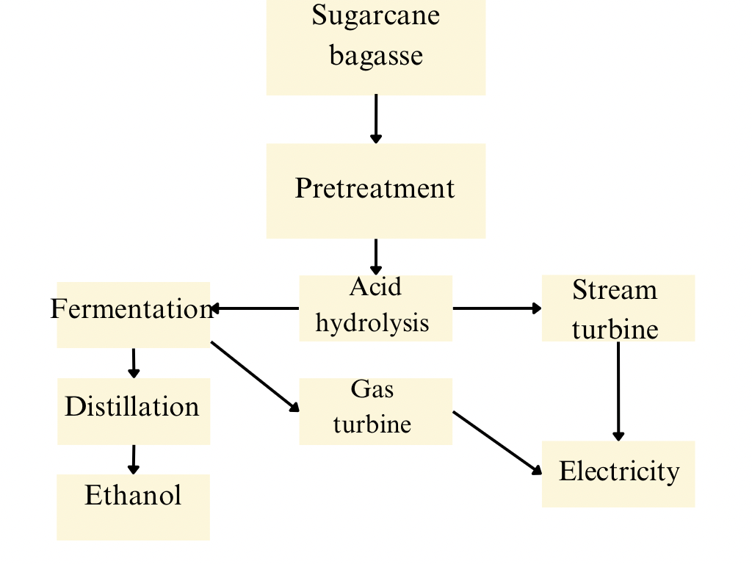
Fig 5. Bioethanol production from sugarcane bagasse
3.3 Sugarcane bagasse ash
It comes from the combustion of sugarcane bagasse in order to generate energy. More than half of the sugarcane is bagasse, and is widely used for manufacture and burned to produce energy. Bagasse ash (predominantly of fly ash and bottom ash), after incineration of whole cane will be the last waste of sugar production stream (Joglekar et al., 2022). When 1 tonne of sugarcane bagasse is incinerated,15-35 kg of ashes are produced but only 5-6.6 kg fly ash. Production wise, around 148 million tons of bagasse generate around 3.6 million tons of bagasse ash in Brazil every year if one considers that each ton of sugarcane processed yields about 250 kg of bagasse with the combustion of that bagasse yielding 6 kg of ash. Likewise, in China an annual production of 1.25 to 2 million tons of sugarcane bagasse is generated. Bagasse ash production in Australia is around 230 K tons (Xu et al., 2018). Both siliceous and non-siliceous ash are produced in the range of 70-90% inorganic compounds (Arif et al., 2016), with multiple characteristics such as crystalline, glassy, and amorphous (Barrera Torres et al., 2021), with aluminium, iron, and calcium oxides, along with un-burnt carbon (Santos et al., 2014). Bagasse ash is usually discarded to landfills (this is common practice in India) (Paya et al., 2018).
3.3.1 Management of sugarcane bagasse ash
Introduction Bagasse ash can be a potential agricultural soil amendment, but considered a low-nutritional fertiliser due to its deficiency of mineral elements. Ash can be become more nutritious when, in mixture with cane juice filtration sludge or ethanol distillation vinasse. A challenge to the use of ash as fertiliser in agriculture is the high levels of heavy metals (aluminium, chromium, lead) and phenol found in ash above national standards (Deepika et al., 2017). Solid fuels were prepared by briquetting bagasse ash with binder or additives. Biosolid recovery additive may also be originated from biomass waste additional ecological material, thus using these solid biofuels is able to assist cut carbon footprint along with protect the environment. The study showed that the briquettes with use of tropical root cassava flour had good mechanical and thermal proprieties, densification at 1.12 g/cm³ and calorific value of 25.551 kJ/kg. To make charcoal briquettes for household, carbonising bagasse gives ecological coal, which is mixed with clay and molasses. No smoke is released when using these briquettes: Ash: 36.4%, Volatile matter: 27.2% and calorific energy: 4.390 Kcal/g (Xu et al., 2018).
Bagasse is used as a sand substitute and addition in construction materials such as bricks, cement, mortar, and concrete. Cement-based products containing bagasse ash have superior mechanical properties (Setter et al., 2020), (Kazmi et al., 2016). Furthermore, this form of ash utilisation can assist reduce greenhouse gas emissions from cement manufacturers, as the cement industry accounts for 8% of total anthropogenic CO₂ emissions (De siqueira et al., 2022). Furthermore, the application of bagasse ash in cement industry decreases the cost of construction material, mitigates the pressure of waste disposal (storage cost is increasing), and minimizes soil and air pollution (Tripathy and Acharya, 2022).
In the rubber industry, Bagasse ash, raw bagasse and fibres are blended using natural rubber to produce more environment-friendly composite materials with number of enhanced mechanical properties such as hardness, resistance against compression deformation and friction (Andrew, 2018).
3.4 Sugarcane vinasse
Vinasse is the fermented liquid medium without ethanol, is regarded a significant environmental pollutant after the ethanol distillation process. Vinasse symbolises a discharge of acidic wastewater (pH 3.5-5), dark brown in colour, has a foul odour (Portilla et al., 2017), a high chemical oxygen demand (COD), and high salt content (Kusumaningtyas et al., 2020). It includes suspended organic particles, minerals, yeast, sugarcane proteins, and phenolic structure (Hoarua et al., 2018). The nutrients concentrations (nitrogen, phosphorus, potassium) is high It also contains heavy metals (such as zinc, copper, barium and chromium) along with some residual sugar and some volatile compounds. Each litre of ethanol made from sugarcane yields between 10-15 L of vinasse. It is anticipated that by 2024, vinasse production would reach 1742 billion litres. Each litre of ethanol made from sugarcane yields between 10-15 L of vinasse. It is anticipated that by 2024, vinasse production would reach 1742 billion litres (Kusumaningtyas et al., 2020). The composition of sugarcane vinasse is water (93%), nitrogen (3.3%), ash (3.3%), phosphorus 1130mg/litre, potassium 120mg/litre, organic matter 19.5g/litre (Carpanez et al., 2022).
3.4.1 Management of sugarcane vinasse
Vinasse is often treated through anaerobic digestion due to its enormous generation quantities and limited applications (Joglekar et al., 2022). Anaerobic digestion of vinasse reduces pollutants by removing organic materials and producing renewable biogas (Moreira et al., 2022). Vinasse contains significant concentrations of sulphides, resulting in biogas with high concentrations of hydrogen sulphide. This gas is highly corrosive and can damage installation pipes if not removed promptly (Kaini et al., 2022). Vinasse can also be subsequently stored in lagoons where it is treated by oxidation under natural conditions before being applied as liquid organomineral fertiliser to sugarcane fields near ethanol distilleries via sprinkling systems, thereby contributing to increased agricultural production (Ramos et al., 2022). Crops cultivated on soils where vinasse is applied are not likely to suffer from phosphorus deficiency because Vinasse contains a high level of phosphorus sampling. Future studies on vinasse should examine the ideal application ratio based on soil and crop specifics; otherwise, high application rates will be harmful due to lower yields and extended ripening periods for sugarcane crops that have a low sucrose quality. In addition, high concentrations of vinasse also cause environmental problems like soil contamination with heavy metals, soil salinization and soil acidity (Carpanez et al., 2022). Vinasse was used as a culture medium for filamentous fungus Neurospora intermedia in laboratory conditions and as a substrate for the production of unicellular biomass (protein, lipids, enzymes, organic acids, alcohols) because of its abundant micronutrients content. The developed biomass is characterized by a protein content of 45% and essential amino acids that are required by the body (Santos et al., 2019).
4. CONCLUSION
To summarise, effective agricultural waste management, especially that of rice and sugarcane, is crucial to advancing sustainability and enhancing the financial sustainability in the agricultural business. This review examined the many forms of waste created by these crops, including rice straw, rice husk, sugarcane bagasse, sugarcane vinasse etc., and identified a number of innovative management strategies for each. Rice trash, including husks and straw, presents a unique mix of challenges and opportunities. Converting rice husks into bio-char is a promising technology that not only enhances soil's fertility but also retains carbon, lowering greenhouse gas emissions. Rice waste management techniques needs to take into account both local factors and farmer specific demands. Educational activities that raise awareness about these various uses are vital. Educating farmers with the necessary knowledge and resources can help them adopt sustainable approaches that are compatible with their economic circumstances. Sugarcane waste, which comprises sugarcane bagasse, vinasse offers great potential for long-term management. Implementing integrated waste management methods that include the crop's whole life cycle can assist to improve resource efficiency. Furthermore, government rules that encourage waste-to-energy operations or give incentives for ecologically beneficial behaviours may increase wider adoption. Despite the huge potential for managing paddy and sugarcane waste, several issues must be addressed. One of the most serious issues is a lack of infrastructure for handling and using agricultural waste properly. Investing in facilities that can transform waste into energy or products with added value is crucial. Furthermore, ongoing research is critical for improving management strategies and developing new technologies. Collaborative research initiatives involving industrial partners, colleges and universities will be crucial in driving progress in this area. By properly using these wastes, we may minimise environmental impact, increase soil health, and create economic possibilities in rural areas. Future projects should prioritise raising awareness, improving infrastructure, and fostering stakeholder involvement. By adopting modern waste management approaches, we can lay the groundwork for a more resilient and environmentally friendly agricultural business, boosting food safety and preservation of the environment for future generations.
REFERENCES
Adnan, M., Asif, M., Khalid, M., Abbas, B., Hayyat, M. S., Raza, A., et al. (2020). Role of mulches in agriculture: A review. International Journal of Botany Studies, 3, 309‒314.
Ali, M. S., Azmah Hanim, M. A., Tahir, S. M., Jaafar, C. N. A., Mazlan, N., & Amin Matori, K., (2017). The effect of commercial rice husk ash additives on the porosity, mechanical properties, and microstructure of alumina ceramics. Advances in Materials Science and Engineering, 1–10.
Alves, Moises, Ponce, Gustavo H. S. F., Silva, Maria Aparecida, Ensinas, & Adriano V, (2015). "Surplus electricity production in sugarcane mills using residual bagasse and straw as fuel," Energy, Elsevier, 91,751–757.
Alves-Rezende, C., de Lima, M. A., Maziero, P., Ribeiro de Azevedo, E., Garcia, W., & Polikarpov, I. (2011). Chemical and morphological characterization of sugarcane bagasse submitted to a delignification process for enhanced enzymatic digestibility. Biotechnology Biofuels, 4, 54–72.
Andrew, R. M. (2018). Global CO₂ emissions from cement production. Earth System Science Data, 10, 195–217.
Ansari, S., Mousavi. A., Safarnejad, M. R., Farrokhi, N., Alavi S. M, Schillberg, S., et al., (2021). Selection and characterization of two monoclonal antibodies specific for the Aspergillus flavus major antigenic cell wall protein Aflmp1. Fungal Biology, 125(8), 621–629.
Arif, E., Clark, M. W., & Lake, N. (2016). Sugar cane bagasse ash from a high efficiency co-generation boiler: Applications in cement and mortar production. Construction and Building Materials, 128, 287–297.
Barrera Torres, G., Dognani, G., da Silva Agostini, D. L., dos Santos, R. J., Carmago Cabrera, F., Gutierres Aguilar, C. M., et al. (2021). Potential eco-friendly application of sugarcane bagasse ash in the rubber industry. Waste and Biomass Valorization, 12, 4599–4613.
Barrera, I., Amezcua-Allieri, M. A., Estupinan, L., Martínez, T., & Aburto, J. (2016). Technical and economical evaluation ofbioethanol production from lignocellulosic residues in Mexico: Case of sugarcane and blue agave bagasses. Chemical Engineering Research and Design, 107, 91–101.
Bisht, N., Gope, P. C., & Rani, N. (2020). Rice husk as a fibre in composites: A review. Journal of Mechanical Behaviour of Material, 29(1), 147–162.
Carpanez, T. G., Moreira, V. R., Assis, I. R., & Amaral, M. C. S. (2022). Sugarcane vinasse as organo-mineral fertilizers feedstock: Opportunities and environmental risks. Science of The Total Environment, 832, 154998.
Casas, L., Hernandez, Y., Mantell, C., Casdelo, N., & Ossa, E. M. (2015). Filter cake oil-wax as raw material for the production of biodiesel: Analysis of the extraction process and the transesterification reaction. Journal of Chemistry, 946462.
Chand, K., Shahi, N. C., Lohani, U. C., & Garg, S. K. (2011). Effect of storage conditions on keeping qualities of jaggery. Sugar Tech, 13(1), 81–85
Chandel, A. K., Antunes, F. A., Teran-Hilares, R., Cota, J., Ellilä, S., Silveira, M. H., et al. (2018). Bioconversion of hemicellulose into ethanol and value-added products: Commercialization, trends, and future opportunities. In Advances in Sugarcane Biorefinery. Technologies, Commercialization, Policy Issues and Paradigm Shift for Bioethanol and By-Products; Elsevier B.V.: Amsterdam, The Netherlands, pp. 97–134.
Chowdhury, S., Mishra, R., Saha, P., & Kushwaha, P., (2011). Adsorption thermodynamics, kinetics and isosteric heat of adsorption of malachite green onto chemically modified rice husk. Desalination, 265, 159–168.
Clauser, N. M., Gutiérrez, S., Area, M. C., Felissia, F. E., & Vallejos, M. E., (2016). Small-sized biorefineries as strategy to add value to sugarcane bagasse. Chemical Engineering Research and Design, 107, 137–146.
Contreras-Lisperguer, R., Batuecas, E., Mayo, C., Diaz, R., Perez, F. J., & Springer, C., (2018). Sustainability assessment of electricity cogeneration from sugarcane bagasse in Jamaica. Journal of Cleaner Production, 200, 390–401.
Costa, S. M., Aguiar, A., Luz, S. M., Pessoa, A., & Costa, S. A., (2014). Sugarcane straw and its cellulosic fraction as raw materials for obtainment of textile fibers and other bioproducts. Polysaccharides, 513–533.
De siqueira, A. A., & Cordeiro, G. C., (2022). Sustainable cements containing sugarcane bagasse ash and limestone: Effects on compressive strength and acid attack of mortar. Sustainability, 14, 5683.
Deepika, S., Anand, G., Bahurudeen, A., & Santhanam, M. (2017). Construction products with sugarcane bagasse ash binder. Journal of Materials in Civil Engineering, 29, 10, 04017189.
Dobermann, A., & Fairhurst, T., (2002). Rice straw management. Better Crops International, 16: 1-11.
Fantaye, A., Fanta, A., & Melesse, A. M., (2016). Effect of filter press mud application on nutrient availability in aquert and fluvent soils of Wonji/Shoa sugarcane plantation of Ethiopia. In Landscape Dynamics, Soils and Hydrological Processes in Varied Climates; Melesse, A., Abtew, W., Eds., Springer Geography: Berlin/Heidelberg, Germany, pp. 549–563.
Fu, J. R., Zhu, L. X., Sun, X. T., Zhou, D. H., Ouyang, L. J., & Bian, J. M. (2015). Genetic analysis of grain shape and weight after cutting rice husk. Genetics and Molecular Research, 14(4), 17739–17748.
Gandiglio, M., & Lanzini, A. (2022). Biogas resource potential and technical exploitation. In Comprehensive Renewable Energy, 2nd ed.; Sayigh, A., Ed., Elsevier B.V., Amsterdam, The Netherlands.
Ghulam, S., Khan, M. J., Usman, K., & Shakeebullah. (2012). Effect of different rates of press mud on plant growth and yield of lentil in calcareous soil. Sarhad Journal of Agriculture, 28(2), 249–252.
Gopal, P. M., Sivaram, N. M., & Barik, D. (2019). Paper industry wastes and energy generation from wastes. In: Barik D. Energy from Toxic Organic Waste for Heat and Power Generation. Amsterdam, the Netherlands: Elsevier: 83–97.
Gupta, N., Tripathi, S., & Balomajumder, C. (2011). Characterization of press mud: a sugar industry waste. Fuel, 90(1), 389–394.
Gupta, N., Tripathi, S., & Balomajumder, C. (2011). Characterization of press mud: A sugar industry waste. Fuel, 90, 389–394
Hemnath, A., Anbuchezhiyan, G., NanthaKumar, P., & Senthilkumar, N. (2021). Tensile and flexural behaviour of rice husk and sugarcane bagasse reinforced polyester composites. Materials Today Proceedings, 46, 3451–3454.
Hoarau, J., Caro, Y., Grondin, I., & Petit, T. (2018). Sugarcane vinasse processing: Toward a status shift from waste to valuable resources: A review. Journal of Water Process Engineering, 24, 11–25.
Jain, N., Bhatia, A., Pathak, H. (2014). Emission of air pollutants from crop residue burning in India. Aerosol and Air Quality Research, 14(1), 422–430.
Jittin, V., Bahurudeen, A., & Ajinkya, S. D. (2020). Utilisation of rice husk ash for cleaner production of different construction products. Journal of Cleaner Production, 263, 121578.
Joglekar, S. N., Dalwankar, G., Qureshi, N., & Mandavgane, S. A. (2022). Sugarcane valorization: Selection of process routes based on sustainability index. Environmental Science and Pollution Research, 29, 10812–10825.
Kadam, K. L., McMillan, J. D., & Jennings, E. (2000). Energy balance of sugarcane ethanol production in India. Energy Policy, 28(9), 675–684.
Kaushik, S., Ipsita, D., & Kumar, S. (2018). Sugarcane valorization: Selection of process routes based on sustainability index. Environmental Science and Pollution Research, 10(5), 1183–1185.
Kazmi, S. M. S., Abbas, S., Saleem, M. A., Munir, M. J., & Khitab, A. (2016). Manufacturing of sustainable clay bricks: Utilization of waste sugarcane bagasse and rice husk ashes. Construction and Building Materials, 120, 29–41.
Khan, S., Lu, F., Kashif, M., & Shen, P. (2021). Multiple effects of different nickel concentrations on the stability of anaerobic digestion of molasses. Sustainability, 13, 4971.
Khonngam, T., & Salakkam, A. (2019). Bioconversion of sugarcane bagasse and dry spent yeast to ethanol through a sequential process consisting of solid-state fermentation, hydrolysis, and submerged fermentation. Biochemical Engineering Journal, 150, 107–284.
Khoo, R. Z., Chow, W. S., & Ismail, H. (2018). Sugarcane bagasse fiber and its cellulose nanocrystals for polymer reinforcement and heavy metal adsorbent: A review. Cellulose, 25, 4303–4330.
Kiani, M. K. D., Parsaee, M., Ardebili, S. M. S., Pereda Reyes, I., Fuess, L. T., & Karimi, K. (2022). Different bioreactor configurations for biogas production from sugarcane vinasse: A comprehensive review. Biomass Biorenergy, 161, 106–446.
Krishnan, C., Da costa Sousa, L., Jin, M., Chang, L., Dale, B. E., & Balan, V. (2010). Alkali-based AFEX pretreatment for the conversion of sugarcane bagasse and cane leaf residues to ethanol. Biotechnology and Bioengineering, 107, 441–450.
Kumar, D. C., Vasanthi, P., & Devaraju, A. (2022). Development of agroindustrial wastes in material production. In: Palani I A, Sathiya P, Palanisamy D. Recent Advances in Materials and Modern Manufacturing. Singapore: Springer, 973–981.
Kumar, S., & Sharma, P. (2019). Crop Residue Management in the Indian Agriculture: Prospects and Challenges. Journal of Environmental Research and Development, 14(1), 52–58.
Kumar, S., Gupta, J. P., & Singh, P. K. (2019). Valorization of sugarcane bagasse: A sustainable approach towards the development of environmental benign materials. Journal of Environmental Management, 239, 483–494.
Kumar, V., & Chopra, A. K. (2015). Fertigation with agro-residue based paper mill effluent on a high yield spinach variety. International Journal of Vegetable Science, 21, 69–97.
Kusumaningtyas, R. D., Hartanto, D., & Rohman, H. A. (2020). Mitamaytawati; Qudus, N.; Daniyanto. Valorization of sugarcane-based bioethanol industry waste (vinasse) to organic fertilizer. In Valorisation of Agro-industrial Residues—Volume II: Non-Biological Approaches; Zakaria, Z., Aguilar, C., Kusumaningtyas, R., Binod, P., Eds.; Applied Environmental Science and Engineering for a Sustainable Future; Springer: Cham, Switzerland, 2020.
Majeed, K., Arjmandi, R., Al-Maadeed, M. A., Hassan, A., Ali, Z., & Khan, A. U. (2017). Structural properties of rice husk and its polymer matrix composites. In: Jawaid M, Tahir P M, Saba N. Lignocellulosic Fibre and Biomass-Based Composite Materials. Amsterdam, the Netherlands: Elsevier, 473–490.
Manpetch, P., Singhapong, W., & Jaroenworaluck, A. (2022). Synthesis and characterization of a novel composite of rice husk-derived graphene oxide with titania microspheres (GO-RH/TiO2) for effective treatment of cationic dye methylene blue in aqueous solutions. Environmental Science and Pollution Research, 29(42), 63917–63935.
Mirmohamadsadeghi, S., Karimi, K. (2020). Recovery of Silica From Rice Straw and Husk. Current Developments in Biotechnology and Bioengineering. Elsevier, Amsterdam, pp. 411–433.
MoA. (Ministry of Agriculture). Govt. of India, New Delhi. 2012.
Monteiro, S. N., Candido, V. S., Braga, F. O., Bolzan, L. T., Weber, R. P., & Drelich, J. W. (2016). Sugarcane bagasse waste in composites for multilayered armor. European Polymer Journal, 78, 173–185.
Moreira, L. C., Borges, P. O., Cavalcante, R. M., & Young, A. F. (2022). Simulation and economic evaluation of process alternatives for biogas production and purification from sugarcane vinasse. Renewable and Sustainable Energy Reviews, 163, 112532.
Munagala, M., Shastri, Y., Nalawade, K., Konde, K., & Patil, S. (2021). Life cycle and economic assessment of sugarcane bagasse valorization to lactic acid. Waste Management, 126, 52–64.
Nava-Cruz, N. Y., Contreras-Esquivel, J. C., Aguilar-Gonzalez, M. A., Nuncio, A., Rodríguez-Herrera, R., & Aguilar, C. N. (2016). Agave atrovirens fibers as substrate and support for solid-state fermentation for cellulase production by Trichoderma asperellum. BioTech, 6, 115.
Nayak, R. K., Athira, V. G., Selvan, D., & Kumar, S. S. (2017). Rice husk as an alternate fuel. 2017 IEEE Technological Innovations in ICT for Agriculture and Rural Development (TIAR). April 7‒8, 2017. Chennai, India: IEEE, 126–129.
Nenciu, F., Stanciulescu, I., Vlad, H., Gabur, A., Turcu, O. L., & Apostol, T., et al., (2022). Decentralized processing performance of fruit and vegetable waste discarded from retail, using an automated thermophilic composting technology. Sustainability, 14, 2835.

Niju, S., & Swathika, M. (2019). Delignification of sugarcane bagasse using pretreatment strategies for bioethanol production. Biocatalysis and Agricultural Biotechnology, 20, 101263.
Padella, M., O’Connell, A., & Prussi, M. (2019). What is still limiting the deployment of cellulosic ethanol? Analysis of the current status of the sector. Applied Sciences, 9921, 4523.
Patil, N. B., & Sharanagouda, H. (2017). Rice husk and its applications: Review. International Journal of Current Microbiology and Applied Sciences, 6(10), 1144–1156.
Paya, J., Monzo, J., Borrachero, M. V., Tashima, M. M., & Soriano, L. (2018). Bagasse ash. In Waste and Supplementary Cementitious Materials in Concrete Characterisation, Properties and Applications; Woodhead Publishing Series in Civil and Structural Engineering; Woodhead Publishing: Sawston, UK, 2018; Chapter 17, pp, 559–598.
Pereira, L. G., Chagas, M. F., Dias, M. O. S., Cavalett, O., & Bonomi, A. (2015). Life cycle assessment of butanol production in sugarcane biorefineries in Brazil. Journal of Cleaner Production, 96, 557–568.
Portilla, O. M., Espinosa, V., Jarquin, L., Salinas, A., Velazquez, G., & Vazquez, M. (2017). Sugar cane molasses as culture media component for microbial transglutaminase production. Indian Journal of Biotechnology, 16, 419–425.
Prapagdee, S., Piyatiratitivorakul, S., & Petsom, A. (2016). Physico-chemical activation on rice husk biochar for enhancing of cadmium removal from aqueous solution. Asian Journal of Water, Environment and Pollution, 13(1), 27–34.
Raharja, R., Murdiyatmo, U., Sutrisno, A., & Wardani, A. K. (2019). Bioethanol production from sugarcane molasses by instant dry yeast. IOP Conference Series Earth and Environmental Science, 230, 012076.
Ramos, L. R., Lovato, G., Domingues Rodrigues, J. A., & Silva, E. L. (2022). Scale-up and energy estimations of single and two stage vinasse anaerobic digestion systems for hydrogen and methane production. Journal of Cleaner Production, 349, 131–459.
Sahu, O. (2018). Assessment of sugarcane industry: Suitability for production, consumption, and utilization. Annals of Agrarian Science, 16, 389–395.
Santos, F., Eichler, P., Machado, G., De Mattia, J., & De Souza, G. (2019). By-products of the sugarcane industry. In Sugarcane Biorefinery, Technology and Perspectives; Santos, F., Rabelo, S., De Matos, M., Eichler, P., Eds.; Academic Press: Cambridge, MA, USA, pp. 21–48.
Santos, R. J. D., Agostini, D. L. D. S., Cabrera, F. C., Ruiz, M. R., Teixeira, S. R., & Job, A.E. (2014). Sugarcane bagasse ash: New filler to natural rubber composite. Polimeros, 24, 646–653.
Sardar, S, Ilyas, S. U., Malik, S. R, & Javaid, K. (2013). Compost fertilizer production from sugar press mud (SPM). International Journal of Microbial Research, 1(2), 20–27.
Scaglioni, P. T., & Badiale-Furlong, E. (2016). Rice husk as an adsorbent: A new analytical approach to determine aflatoxins in milk. Talanta, 152, 423–431.
Sekifuji, R., & Tateda, M. (2019). Study of the feasibility of a rice husk recycling scheme in Japan to produce silica fertilizer for rice plants. Sustainable Environment Research, 29(1), 1–9.
Setter, C., Sanchez Costa, K. L., Pires de Oliveira, T. J., & Farinassi Mendes, R. (2020). The effects of kraft lignin on the physicomechanical quality of briquettes produced with sugarcane bagasse and on the characteristics of the bio-oil obtained via slow pyrolysis. Fuel Processing Technology, 210, 106561.
Shibata, K., Yamaguchi, T., & Hokkirigawa, K. (2014). Tribological behavior of RH ceramics made from rice husk sliding against stainless steel, alumina, silicon carbide, and silicon nitride. Tribology International, 73, 187–194.
Shwetha, M. K., Geethanjali, H. M., & Chowdary, K. (2014). A great opportunity in prospective management of rice husk. International Journal of Commerce and Business Management, 7(1), 176–180.
Thiyageshwari, S., Gayathri, P., Krishnamoorthy, R., Anandham, R., & Paul, D. (2018). Exploration of rice husk compost as an alternate organic manure to enhance the productivity of blackgram in typic haplustalf and typic rhodustalf. International Journal of Environmental Research and Public Heath, 15(2), 358.
Tripathy, A., & Acharya, P. K. (2022). Characterization of bagasse ash and its sustainable use in concrete as a supplementary binder—A review. Construction and Building Materials, 322, 126391.
Uddin, M. K., & Khan, M. M. (2012). "Activated carbon from rice husk: An overview." Journal of Environmental Chemical Engineering, 1(1), 1–6.
UNEP. (2011). Towards a Green Economy: Pathways to Sustainable Development and Poverty Eradication. Retrieved from: www.unep.org/greeneconomy
Ungureanu, N., Vladuț, V., & Biriș, S. (2022). Sustainable Valorization of Waste and By-Products from Sugarcane Processing. Sustainability, 14(17), 11089. https://doi.org/10.3390/su141711089
Usmani, Z., Sharma, M., Diwan, D., Tripathi, M., Whale, E., Jayakody, L.N., et al. (2022). Valorization of sugar beet pulp to value-added products: A review. Bioresource Technology 346, 126580.
Vagg, A. (2015). Rice Straw Utilisation. Nuffield Australia Farming Scholars, Australia.
Vaz, M. G., Pereira, A. G. B., Fajardo, A. R., Azevedo, A. C. N., & Rodrigues, F. H. A. (2017). Methylene blue adsorption on chitosan-g-poly (acrylic acid)/rice husk ash superabsorbent composite: Kinetics, equilibrium, and thermodynamics. Water Air Soil Pollution, 228(1): 14.
Venkatakrishnan, D., & Ravichandran, M. (2013). Integrated nutrient management on sugarcane yield and yield attributes. Plant Arch, 13(1), 239–242.
Verma, D. (2014). Technologies for stubble use. Journal of Agriculture & Life Sciences, 1(2), 106–110.
Wang, Z. F., Smith, A. T., Wang. W. X., & Sun, L. Y. (2018). Versatile nanostructures from rice husk biomass for energy applications. Angewandte Chemie International Edition, 57(42): 13722–13734.
Xu, Q., Ji, T., Gao, S. J., Yang, Z., & Wu, N. (2018). Characteristics and applications of sugar cane bagasse ash waste in cementitious materials. Materials, 12, 39.
Yadav, M., Prawasi, R., Satyawan, R. P., Kumari, K. & Karamdeep, R. (2015). Assessment of Rice Straw Burning and its power generation potential in major rice-growing districts of Haryana, India. International Journal of Science Engineering and Technological Research, 4(5), 1287-1293.
Zhang, D., Hui, S., & Huang, G. (2016). Biomass and bioenergy production from mustard crop residues: A sustainable solution. Renewable Energy, 91, 174–182.
Zhiqiang, L., Xu, A. and Zhao, T. 2011. Energy from the combustion of rice straw: Status and challenges to China. Energy Power Eng., 3, 325–331.

