A STUDY ON THE POTENTIAL APPLICATIONS OF ARTIFICIAL INTELLIGENCE (AI) FROM DRUG DISCOVERY TO PRODUCT DEVELOPMENT

ABSTRACT :
The drug discovery process has been time-consuming and expensive in the past. Also, previous drugs were not formulated as well as the drugs being expected and developed using AI and ML technologies. This review shall elaborate on the stages of drug discovery and development where AI and ML modeling have revolutionized the traditional methods of drug development. Machine learning, being one of the branches of artificial intelligence, learns and advances with past experiences, similar to human intelligence, and is being used more and more in drug discovery and design. Integration of AI and ML in the drug discovery and development pipeline has facilitated more accurate target identification, decreased levels of toxicity, and more efficient dosage forms. AI, in the broader context, has been taken up and implemented at each stage of drug discovery, from target identification and validation to hit finding and the progression from hit to lead optimization, with a vital role in streamlining the formerly time-consuming process of drug screening.
Several methods based on machine learning are being used to predict drug targets, predict the structures of drug targets, predict binding sites, perform ligand-based similarity searches, design ligands with certain desired properties de novo, develop scoring functions for molecular docking, build QSAR models for the prediction of biological activity, and predict the pharmacokinetic and pharmacodynamic properties of ligands. Over the past few years, these predictive models and tools have shown high accuracy.
KEYWORDS :
Drug discovery, artificial intelligence, Machine learning, Alpha fold, Deepchem, Drug development
INTRODUCTION :
ARTIFICIAL INTELLIGENCE
Artificial Intelligence (AI) is a computer science discipline that deals with developing intelligent computer systems that can perceive, analyze, and respond accordingly to different inputs.(1,2) Through AI, a better-prepared life is attained where tasks are performed by automated machines on behalf of humans, saving their time and energy. In general, humans have two kinds of assistants at their disposal: manual (in the shape of robots) and digital (such as chatbots), which can perform dangerous, monotonous, and difficult tasks. The process of making such machines entails a close study of human behavior and the use of logic in the form of algorithms, leading to innovations in software, hardware, robots, and so on, making the human race more capable. The main objective of AI is to build systems that are more transparent, interpretable, and explainable, and end up being better intelligent agents.
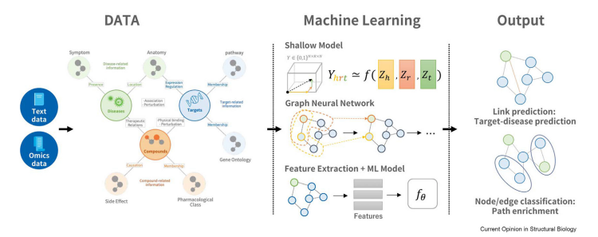
Fig 1 : AI / ML Development Pipeline
CLASSIFICATION :
Types of AI (Based on Capabilities)
The various types of artiﬁcial intelligence based on the capabilities can be classiﬁed as
- Weak or narrow AI
- General AI
- Strong AI
Weak or narrow AI: This type of AI is able to perform a limited number of predetermined tasks without showing any ability to reason. Apple's Siri, Alexa, Alpha Go, IBM's Watson supercomputer, and the humanoid Sophia are all examples of weak AI. (3)
General AI: This type of AI has the ability to perform tasks in a manner similar to that of humans.
Strong AI: This type of AI is expected to surpass human intelligence. It may result in the emergence of a situation where the machines are superior and rule the humans.
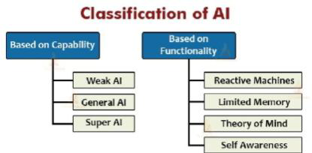
Fig. 2: Classification Of AI
Types of AI (Based on Functionality)
Based on the functionality, artiﬁcial intelligence can be classiﬁed as per the following types:
- Reactive machines
- Limited memory
- Theory of mind
- Self-awareness.
Reactive machines: The machines work based on data obtained from a pre-existing dataset. They have no ability to save past or future data and can only work on the data that exists at the moment. Examples are Google's Alpha Go. (3)
Limited memory: These machines have the capacity to store past experiences or memory for a limited period. For instance, self-driving vehicles can recall information like speed, distance, and the required speed limit for direction.
Theory of mind: These kinds of machines are predicted to understand human psychological and emotional aspects, enabling them to react appropriately.
Self-awareness: This type of machine is a hypothetical idea that would be regarded as super-intelligent, having the capacity to think, act, and be self-aware, similar to human consciousness and emotions.
Subsets of Artificial Intelligence: Artificial intelligence has been a valuable resource for society in creating sophisticated ways to solve real-world problems. The two main subsets of AI are:
- Machine Learning (ML)
- Deep Learning (DL)
Machine Learning: ML is considered a subfield of AI, which uses algorithms to learn from data and improve performance.
Deep Learning: DL, again, is considered to be a subfield of ML, applying artificial neural networks that have several layers to process data and make predictions.
MACHINE LEARNING
Human beings can reason, enhance through a process of self-improvement, and acquire knowledge from their past; AI systems too can learn from the past by means of an approach known as Machine Learning (ML). Machine learning is interested in developing algorithms through which computers can learn independently from their data and past experience. In this method, the machine investigates the given data set, also referred to as training data, and uses algorithms to predict possible results based on given inputs. While carrying out the computational task, the machine accepts data as an input and provides results by using a fitting algorithm. (4)
Classiﬁcation Of Machine Learning
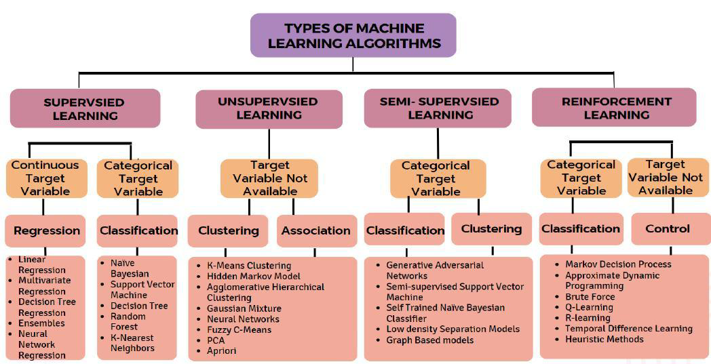
Fig. 3: Classification of ML
Based on the nature of the learning signal or response that the machine gets; machine learning can be classiﬁed into following categories:
- Supervised learning
- Unsupervised learning
- Reinforcement learning
Supervised learning: It is a method that sees the machine given many labeled datasets to assist in the process of obtaining correct results based on the input. The algorithms are classified into two categories, regression and classification. Spam filtering is an example of this method. (5,6)
Unsupervised learning: In this method, the machine learns by itself without any supervisory guidance, i.e., the input data is not labeled or categorized. The algorithm acquires knowledge by recognizing patterns and similarities in the data to define the right output for the task. This approach assists in shaping data that can be connected to the desired result. The algorithms in this type are clustering and association types. (6,7)
Reinforcement learning: This technique is mainly a feedback-based learning approach where the machine is rewarded for doing something right and penalized for doing it wrong, thus learning from its previous experiences. Reinforcement learning includes a robot dog learning from its errors and a computer playing video games independently. (7)

POTENTIAL APPLICATION OF AI AND ML FROM DRUG DISCOVERY TO PRODUCT DEVELOPMENT
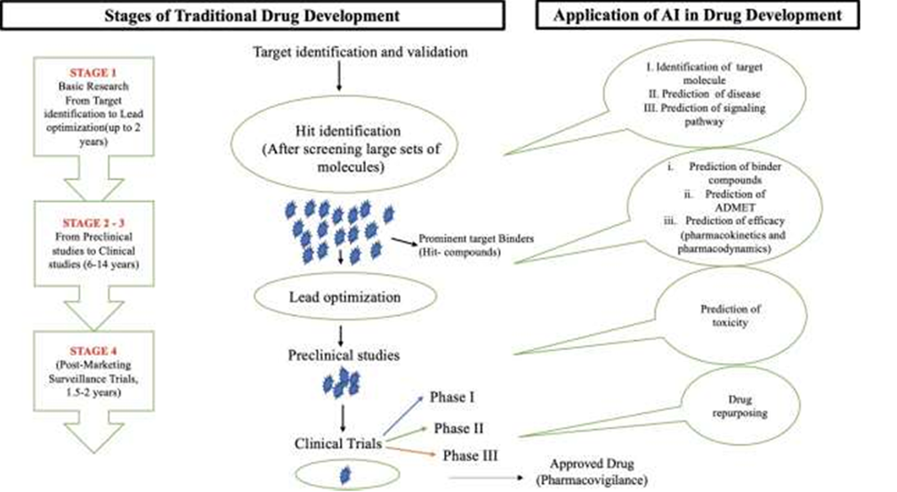
Fig. 4: Application of AI/ML in Drug Development
1.AI & ML IN TARGET IDENTIFICATION AND VALIDATION
The identification of potential biological targets like proteins and genes is critical during the drug discovery process. Artificial intelligence and machine learning software can scan large amounts of biological information like genomics, proteomics, and transcriptomics and predict potential targets for a disease. This alignment helps recognize patterns and relationships that could indicate a potential drug target. For instance, machine learning algorithms can analyze genetic information to identify mutations that could cause disease.
AI models are very good at finding complex patterns within datasets. From clinical trials or preclinical data, AI is able to recognize genes or proteins whose alterations correlate strongly with mechanisms of disease. This approach often leads to the discovery of novel targets.
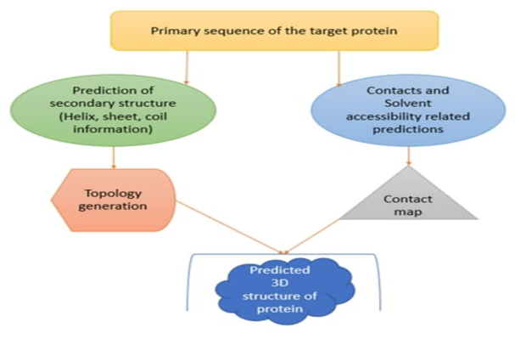
Fig. 5 : Application Of ML Algorithms In Protein Structure Prediction
Knowing the structure of a target protein is important in creating an effective drug, and artificial intelligence (AI) and machine learning (ML) have been used more and more to predict protein conformational structures to find potential drug targets.(8) The three-dimensional structure of a protein provides information on how a ligand, or drug, would bind to it. Ligand-binding prediction programs like AlphaFold have been able to accurately predict the structures of small molecules that can be optimized into drugs and are able to predict the three-dimensional protein/target structure along with its binding affinity, with the target usually being a major determinant of the disease under investigation.(9) AlphaFold is regarded as one of the most effective tools for early drug discovery and as an ancillary resource to experimental approaches for the determination of protein structures. (10)

TOOL | MOA | PROS | CONS
Alphafold | AlphaFold’s mode of action is dependent on a clever neural network that computes evolutionary data, infers interactions between ammino acids, iteratively improves the structure, and produces a high-confidence prediction of protein folding. Its achievement lies in its capability to utilize principles of evolutionary biology and innovative machine learning methodologies | - Enhanced Protein Structure Understanding  - Cost Efficiency and Speed  - Undruggable Target Handling  - Conformational Change Predicting  - Enhancing Repurposing and Drug Discovery | - Does Not Anticipate Functional Activity:  - Experimental Validation Requirement  - Limited Predictions of Druggability  - Flexibility in Proteins
Table 1 : Drug Development – Related Tools , Moa And Their Pros And Cons.

2. HIT DISCOVERY (SCREENING)
Hit identification is the next step in drug discovery and in this process large swaths of molecules are exposed to the target to identify molecules that bind with greater affinity. AI and ML can optimize virtual screening by predicting how well a compound will bind to a target using molecular docking simulations, reducing the need for labour-intensive experimental screening. Deep Docking is a QSAR model dependent, deep learning tool, that allows for the identification of the best hit compounds by thousands of times greater enrichment of compound without the loss of any effective binders. (11)
Multiple machine learning techniques are employed for hit identification and screening, including Random Forest (RF), Support Vector Machines (SVM), Light Gradient Boosting Machine (LGBM), Deep Neural Network (DNN), and Graph Convolutional Neural Network. (12,13)
2.2 LIGAND-BASED VIRTUAL SCREENING (LBVS):
A lot of virtual screening applications of artificial intelligence target ligands based on the assumption that structurally related compounds will have similar biological actions. Ligand-based virtual screening (LBVS) is premised on the belief that structurally similar ligands are likely to have similar affinities for the target molecule. Fingerprint similarity searching, the identification of compounds with similar molecular shapes, and pharmacophore modeling are used by this technique. A major difficulty in this process is choosing molecular descriptors from different categories, such as two-dimensional (2D) fingerprints, three-dimensional (3D) descriptors that encode the geometric properties of the structure, and four-dimensional (4D) descriptors that encode the stereo electronic characteristics of the molecule.
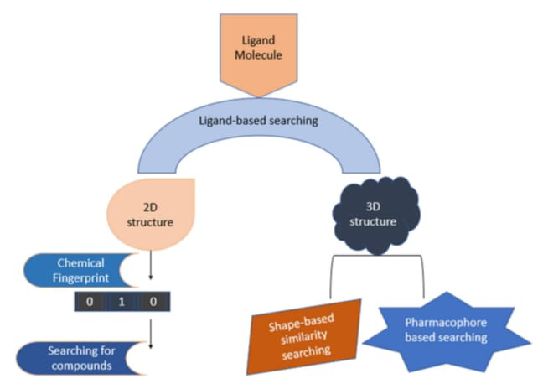

Fig.6 : Ligand – based similarity search approaches
Virtual screening involves computationally evaluating a vast database of compounds against a drug target to identify potential candidates. The process can be improved by machine learning and AI, which predict the likelihood of compounds binding to a target based on their molecular structure. This is achieved through AI models, including deep learning and reinforcement learning, which are trained on known interactions between compounds and targets. These models can estimate the binding affinity of new, untested compounds. Convolutional neural networks (CNNs), a specific type of AI model, are especially effective at predicting the binding affinity between molecules and target proteins, crucial for choosing promising candidates. AI systems such as DeepChem, an open-source web-based system for the analysis of small molecule properties, have been developed. DeepChem allows for the conversion of compounds to molecular descriptors and the construction of models with greater accuracy. These models can predict the biological and molecular properties of the compounds, such as toxicity, activity, lipophilicity, and solubility.
An example of this is Atomwise’s AtomNet system, which employs deep learning algorithms to improve predictions regarding molecule behavior, enabling the fast and cost-efficient discovery of new drug candidates.
2.3 DE NOVO DRUG DESIGN
AI and ML are also applicable in de novo drug design, where new chemical entities (hits) are created from the ground up. These models are capable of crafting molecules that are tailored to interact with a target, drawing on established patterns from existing drugs or targets. This is achieved through generative models, such as Variational Autoencoders (VAEs) or Generative Adversarial Networks (GANs), which are utilized to produce novel compounds. These models navigate the chemical space to create molecules possessing the desired attributes, optimizing for both target affinity and drug-like properties.
Computational methods can be employed to construct chemical molecules with specific physicochemical and biological characteristics. Supervised learning algorithms are applied to train the model for generating chemically viable SMILES strings, as well as for evaluating the biological features of compounds. Reinforcement learning for structural evolution (ReLeaSE) is a deep reinforcement learning-based framework used to generate and evaluate the biological properties of de novo compounds.(14)
An RNN-based ligand generative model has also been developed by deriving relevant chemical and biological information from a vast set of known bioactive. (15)
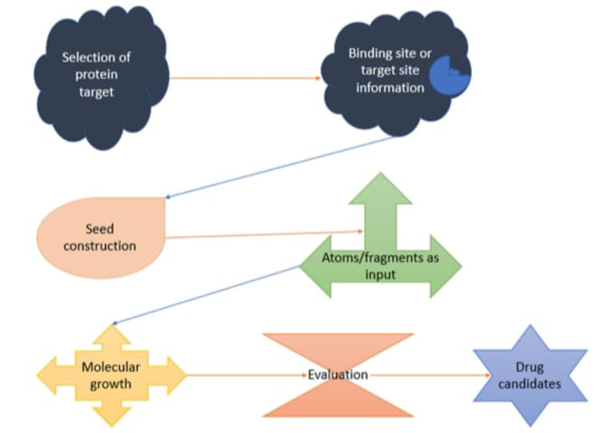
Fig.7: De Novo Designing Of Drug Candidates With Desired Properties On Target Binding Sites
TOOLS | MOA | PROS | CONS
DeepChem | DeepChem’s action mechanism in artificial intelligence-based chemical research is most dependent on deep learning methods, including graph neural networks, convolutional networks, and recurrent networks. With the help of molecular representations such as graphs or SMILES strings, it makes predictions for a broad spectrum of molecular properties to support drug discovery, material science, and other chemical uses. Its potential to predict molecular behaviors, determine drug potency and toxicity, and even develop novel molecules gives it a useful status in today’s pharmaceutical and chemical research. | - Enhanced Accuracy with Machine Learning Models  - Faster Drug Discovery  - Supports Predictive Modeling  - Can Handle Large Datasets | - Data Dependence  - Expertise Requirement  - Difficulty in Preparing Data  - Limited Interpretability
Graph Convolutional Networks (GCN) | Graph Convolutional Networks (GCNs) utilize the graph structure of molecules to make deep learning-based predictions of molecular properties. Through aggregating information from neighboring nodes (atoms) and learning representations of individual atoms and whole molecules, GCNs are able to predict properties like bioactivity, toxicity, and binding affinity. This renders them extremely useful tools in drug discovery, allowing for faster, more accurate predictions and optimizations of drug candidates. | - Natural Representation of Biological Data  - Drug Repurposing and Target-Drug Interaction Prediction  - Improved Performance with Sparse or Incomplete Data  - Modeling Complex Pathways and Disease Mechanisms | - Scalability and Computational Complexity  - Limited data availability  - Difficulty in Handling Heterogeneous Data  - Dependency on Graph Quality
Graph Attention Networks (GAT) | The strength of Graph Attention Networks (GATs) is their power to learn dynamically and adaptively what regions of a graph are most relevant to a given task, and hence they are a strong extension of classical graph neural networks. | - Multi-task Learning  - Enhancing Drug-Target Interaction Predictions  - Scalability and Flexibility  - Better Feature Aggregation and Representation | - Computational Complexity  - Dependence on Graph Structure and Quality
TABLE 2 : : Drug Development – Related Tools , Moa And Their Pros And Cons

3. LEAD OPTIMIZATION
In drug discovery, lead optimization is the critical phase in which the most suitable compounds (leads) are optimized for potency, selectivity, and desirable drug-like properties prior to entering preclinical and clinical trials. This step undergoes refinement through AI and ML which fundamentally resolve issues pertaining to this step and help make better decisions enhancing efficiency and success.
Evidence reveals AI and machine learning can determine the biological activity of lead compounds by reviewing their chemical frameworks and biological interactions. AI systems leverage existing datasets to assess compound-target interactions and estimate a lead’s effectiveness in terms of binding potency. It Works USING ML models such as Random Forests, Neural Networks, and Support Vector Machines, the model is trained to predict target blocked based on molecular attributes (descriptors) thereby predicting the potency of the compound eliminating the need for expensive experimental tests.
3.1 QUANTITATIVE STRUCTURE ACTIVITY RELATIONSHIP (QSAR) MODELLING
The framework of a molecule may affect its physical, chemical, and biological behavior is the idea of QSAR or QSPR. QSAR has successfully modeled numerous physiochemical attributes like toxicity, metabolism, drug interactions, and carcinogenesis. The initial QSAR models including Hansch and free-Wilson analysis (Hansch is the only numerical method that directly correlates biological properties with structure features and free-Wilson analysis correlates biological activity values with physiochemical properties) sought potency regression with structural and chemical attributes, complexing chelation, substitution pattern surface activities, hydrophobicity, solubility, and electronic factors. Conscientious evaluation gave rise to molecular and atom-based descriptors, quantum chemical calculation, and spectroscopy derived descriptors. The overall guide for drug designing QSAR models stipulates advanced processes using algorithmic language which breaks down the sequential steps into modules processed utilizing chemoinformatics and ML techniques.

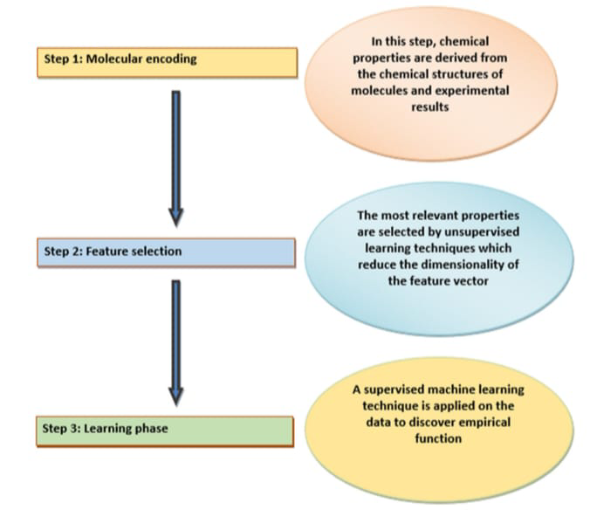
Fig.8 : Steps involved in QSAR Modeling
In QSAR modeling, the first step is molecular encoding, and it begins with a drug molecule’s chemical structure from which its features and properties will be derived. Design of the structure also makes use of experimental data. The following step is feature selection, where the most significant properties are determined with unsupervised learning techniques. Feature selection starts with a dataset obtained from molecular encoding and builds informative feature sets that are intended for reduced dimensionality. The last and most important step is the learning phase, where an algorithm identifies the empirical function that establishes optimal mapping between input feature vectors and biological responses using a supervised learning technique. (16)
3.2 MOLECULAR DOCKING
The integration of AI and machine learning can improve virtual screening which is important for determining how well a compound binds to a target. AI can further molecular docking simulations and temporally identify prospective candidates with the best binding affinity to the target protein. It Functions Site binding is determined by machine learning while refinement of docking poses along with the enhancement of molecular interactions is performed by reinforcement learning. Molecular docking is used to find the optimal pose of a drug towards a drug target. Scoring functions during the docking phase evaluate the binding free energies of the complexes for poses and rank them according to the binding free energy. (17)
Machine learning algorithms show great precision and effectiveness when computing scoring functions. Classical docking programs reliant on scoring functions generally utilize three scoring types: force field, knowledge-based, and empirical scoring, whereas the functional form of the machine learning scoring functions is learned from unprejudiced training data. (18) Machine learning techniques draw upon the binding attributes determined from a massive set of protein-ligand complexes from protein databases. These approaches enhance the accuracy of scoring functions used in docking by drawing upon large datasets for the target as well as its ligand complex. Machine learning techniques are also used to evaluate the affinity of a ligand to a target protein. Both binding affinity and binding free energies are parameters for virtual screening of ligands against a particular protein . (19)
AI and machine learning may be applied to simulate how a drug interacts with the target at the molecular level, providing information on mechanisms of action and helping in alterations to maximize binding affinity and specificity. Machine learning may be used to mimic molecular dynamics and predict how a drug might interact with its target, allowing scientists to understand how structural modifications to a compound can either enhance or inhibit binding.
TOOL | MOA | PROS | CONS
ChemProp | A deep learning-based tool specifically used for predicting molecular properties and activity. It can predict properties like solubility, toxicity, and binding affinity. | - Reduction in Experimental Costs and Time  - Improved Drug Design and SAR Analysis  - Accurate Property Predictions  - Efficient Screening of Chemical Libraries | - Data Dependency  - Computational Cost  - Focused on Molecular Properties  - Limited Generalization
DeepDock | Use docking algorithms and ML models to predict the interaction between a drug candidate and a target protein.  Helps optimize molecular structure for better binding affinity. | - Faster Prediction  And Screening  - Handling Complex and Flexible Molecules  - Reduction of Experimental Costs  - Integration with Other AI Models | - Data Dependency  - Computationally Expensive  - Requires Large Amounts of Data  - Lack of Experimental Validation
TABLE 3: Drug Development – Related Tools , Moa And Their Pros And Cons
3.3 PHARMACOKINETIC AND PHARMACODYNAMICS PREDICTIONS
In hit finding, it is important not only to find compounds that bind to a target but also to confirm that these compounds have good pharmacokinetics, toxicity, and bioavailability (ADMET properties). AI can predict these properties early in the discovery process, allowing researchers to eliminate compounds that are likely to fail in later stages. This is achieved through machine learning models that have been trained on large sets of chemical compounds and can predict properties like solubility, permeability, metabolic stability, and toxicity and thereby aid in the selection of promising hits that are more likely to be successful in development. (20) AI facilitates the efficient optimization of lead compounds and enables the evaluation of target affinity, which can be fine-tuned through medicinal chemistry.(21) The "rule of five" established by Lipinski has served as a guideline for evaluating drug-like qualities and the potential for oral bioavailability in drug development. But this rule has acted as a hindrance to the advancement of drugs that, although possessing desirable drug-like properties, fail to meet Lipinski's requirements. AI is able to be used to find solutions to their appropriateness as drug candidates using machine learning to achieve lower time and financial costs. (22,23)
Various physicochemical parameters dictate the rates of ADME. Machine learning tools have been designed to predict these factors. In silico machine learning models have been established for prediction of metrics such as human oral absorption, human intestinal absorption, Caco-2 permeability, P-glycoprotein substrates, Cytochrome P450 (CYP) enzyme inhibition, blood-brain barrier permeability, hERG channel blockage, phospholipidosis, as well as prediction of mutagenicity and carcinogenicity.(24)
An ADMET opt module has been implemented in this tool to further augment the potency of a lead compound based on predicted ADMET attributes. Model data were drawn from DrugBank, ChEMBL, carcinogenic potency data base, and other related efforts like Tox21, and SVM, RF, and KNN methods were employed to develop the models. In ADMET SAR 2.0, six features—molecular weight (MW), logP, number of atoms, number of rings, H-bond acceptors, and H-bond donors—were used to calculate the applicability domain and the distribution of these features were inspected in training sets. A plasma protein binding module was developed using the graph CNN technique. Moreover, ADME and toxicity predictions guide required adjustments to current leads to design a viable candidate drug. (25,26)
TOOLS | MOA | PROS | CONS
Convolutional neural networks (CNNs) | CNNs are designed to automatically detect features in data by applying convolutional filters and pooling operations. This allows them to learn hierarchical features and make predictions with reduced computational complexity. | Feature Extraction Automation  Parameter Sharing  Spatial Hierarchy | Resets high Coquire  Large computational  Cost Sensitivity to Data Quality
Varitional autorenders | Encoder maps input data to a distribution in the latent space.  The reparameterization trick allows for backpropagation through the latent variable.  The decoder reconstructs the input from the sampled latent variable.  After training, new data can be generated by sampling from the latent space and passing it through the decoder. | Smooth Latent Space Efficient Learning Generative Power | Blurry Outputs  Balancing Loss Terms  Choice of Prior might not always be the best
TABLE 4: Drug Development – Related Tools , Moa And Their Pros And Cons

4.PRE-CLINICAL STUDIES
The integration of AI and ML with animal research has shown immense value in enhancing both translation and reproducibility and supporting traditional procedures like the usage of animal models. AI and ML can provide an enhancement in preclinical investigation with animal models through analyzing challenging data sets, optimizing experimental layout, and making predictions. All this helps to enable scientists to draw more relevant information from experiments using animals.(27). When AI/ML analysis of animal model data is integrated with human clinical data, it promotes the better translation of research findings. This collaborative approach bridges the gap between preclinical and clinical research, hence improving the translation of animal model findings to human disease. AI is used to monitor and analyze animal movement independently in both natural and controlled environments. This helps to understand behavioral trends, social behaviors, and responses to environmental variations.(28)
Different platforms, including MoSeq, DeepHL, DeepPoseKit, SLEAP, and DeepLabCut, apply deep learning techniques for estimating animal behavior poses. Specifically, DeepLabCut has become prominent as a top deep learning platform for behavioral studies, solving several issues concerning animal posture and providing accurate behavior monitoring in different settings.(29)
ML algorithms can be trained to recognize individual animals based on their facial features or unique markings.(30) In animal studies using symbolic language, ML can help decipher and interpret the signals' meanings. Artificial intelligence's application in medicine is vital since it can predict many diseases. AI techniques have been used in clinical settings for disease diagnosis including hypertension, chronic heart disease, stroke, diabetes, cancer, Alzheimer's disease, and skin and liver diseases. ML-based applications include early disease detection, treatment planning, outcome prediction and prognosis, personalized medicine, behavioral variation analysis, drug discovery, manufacturing, clinical trial research, radiology and radiotherapy, smart electronic health records, and epidemic outbreak prediction. Due to the novel Sars-COV-2 pandemic, AI was utilized effectively for the surveillance of infectious diseases.
The current review by Weissler et al. emphasizes the role of ML in clinical investigation and its capacity to reshape the future of evidence creation. Deep learning methods have been used to diagnose large databases of 12-lead ECGs for the detection of asymptomatic cardiovascular disease, i.e., left ventricular systolic dysfunction, hypertrophic cardiomyopathy, or asymptomatic atrial fibrillation from sinus rhythm.
Ginley et al. used machine learning to analyze digitized kidney biopsy samples in diabetic nephropathy patients and cross-validated their results in a streptozotocin mouse model of diabetes mellitus (DM). They analyzed glomerular structures using an automated computational pipeline and reduced these to three prominent components: nuclei, capillary lumina, and Bowman space, and later used this data to classify diabetic nephropathy. Simon et al. were able to deploy a SVM model independently as well as in combination with a neural network for glomerular detection from histopathological whole-slide images (WSIs) of kidney tissue sections and mouse and rat biopsies.
One recent study evaluated a supervised ML tool, FIBER-ML, to measure fibrosis in histological sections obtained from two models: acute stress-induced cardiomyopathy in rats and HIV-induced nephropathy in mice.

5. CHEMISTRY MANUFACTURING CONTROL [CMC]
AI/ML models can forecast a drug's shelf-life by analyzing parameters like temperature, humidity, light exposure, and other environmental factors. This enables the storage conditions and packaging materials to be optimized. They can also analyze large datasets from the manufacturing process to identify the optimum operating conditions (e.g., temperature, pressure, time) that ensure product uniformity and quality. Machine learning models can be trained on previous data to project the results of different process parameters and provide real-time information for best adjustments. ML models have the ability to predict quality properties (such as dissolution rates, potency, and stability) depending on input factors, thus facilitating process changes.
With manufacturing processes getting more sophisticated and the need for higher efficiency and product quality, modern manufacturing systems are making efforts to transfer human knowledge to machines, leading to a change in the way manufacturing is done. (31) Implementation of AI in manufacturing may prove helpful for the pharmaceutical industry as well. For example, software such as CFD utilize Reynolds-Averaged Navier-Stokes solvers to investigate the impact of agitation and levels of stress through different equipment (e.g., stirred tanks).
DEM has been extensively utilized in the pharmaceutical industry, ranging from the examination of powder segregation in binary blends, the determination of the effects of varying blade speed and form, the determination of tablet trajectory during the coating process, and the determination of the time that tablets remain within the spray region. (32) ANNs and fuzzy models have investigated how machine settings are related to capping problems, with the view to reducing capping on the production floor. (33)
Meta-classifiers and tablet-classifiers are AI tools that help ensure the quality of final products by detecting possible errors in tablet production. (34) A patent has been applied for a system that can establish the best combination of medication and dosage for specific patients by using a processor to take in patient information and design a corresponding transdermal patch. (35)
Quality assurance and control with AI are critical, as the creation of the desired product from raw materials requires balancing a number of parameters. (34) Manual intervention is presently required for quality control tests and maintaining consistency between batches, which might not always be the best approach, emphasizing the need for AI implementation in this regard. (32) The FDA has updated the Current Good Manufacturing Practices (cGMP) by implementing a 'Quality by Design' framework to understand the critical operations and particular criteria that affect the end quality of pharmaceutical products.
AI can also be used to control in-line manufacturing processes to ensure product standards as required. (36) ANN-based process monitoring of freeze-drying is applied, integrating self-adaptive evolution, local search, and backpropagation algorithms. This technique is capable of predicting future temperature and desiccated-cake thickness (at time t + Δt) for a specified set of operating parameters and, finally, aids in product quality oversight. Data mining and other knowledge discovery techniques in the Total Quality Management expert system can be useful approaches to taking complex decisions and creating new technologies for smart quality control. (37)
This strategy can help in coming up with better formulations and having batch-to-batch consistency. They assist in reducing costly trial-and-error techniques and ensure easier transition during scale-up, along with improving the use of PAT tools, which allow real-time evaluation of key quality attributes (CQAs) during production. These tools rely on algorithms and sensors to ensure that the final product is of quality level.
Technique | Application in PAT
Neural Networks (ANN, CNN) | Pattern recognition in spectra (e.g., NIR)
Support Vector Machines (SVM) | Classification of material properties
Random Forests | Predicting quality metrics from multivariate PAT data
PCA/PLS | Data dimensionality reduction and spectral analysis
K-means Clustering | Grouping process states or batches
Reinforcement Learning | Real-time adaptive process control
TABLE 5 : Techniques and their Applications in PAT

6. FILING AN IND
Preparing an IND involves compiling lengthy information on the drug's preclinical tests, manufacturing processes, quality control, and safety that can be a complicated and time-consuming process. One of the most time-consuming processes in preparing an IND submission is accumulating and organizing the huge documentation that regulatory authorities require. Artificial intelligence-based software, such as Natural Language Processing (NLP) engines like Clarifai, TextRazor, and DeepAI, can automate the preparation and structuring of these documents to meet required formats, structures, and regulatory guidelines. NLP techniques can retrieve vital information from preclinical research, clinical trial results, or scientific literature and integrate it into IND submission documents automatically. This reduces manual effort and increases documentation accuracy.
The Chemistry, Manufacturing, and Controls (CMC) section of an IND demands complete information about drug manufacturing processes, quality control procedures, and product stability. Machine learning and AI can predict optimal manufacturing conditions so that processes are repeatable, scalable, and meet regulatory standards, thus enabling the preparation of accurate CMC data for the IND. Visualization tools like Graphviz, Visdom, and Pygal, which are augmented by AI, can generate graphs, charts, and other visual aids that make complex data easy to read for regulatory reviewers. These graphical representations can highlight pivotal aspects of the IND filing, increasing the convenience with which regulators assess the drug's potential and related risks. With the help of AI and machine learning technologies, the IND filing process is greatly enhanced by automatically generating documents, improving data analysis, maximizing clinical trial design, ensuring regulatory compliance, and streamlining CMC processes. These innovations reduce the time and expense of preparing an IND application, raise the level of accuracy and completeness of submissions, and finally speed the path to bringing new medicines to market.
Combining AI and machine learning into the IND filing process allows pharma companies to properly confirm that their filings are regulatory compliant, thus improving the likelihood of expedited clinical trial approval. (38)
TOOLS | MOA | PROS | CONS
DeepAI | DeepAI can automate the creation and organization of these documents, ensuring that they adhere to the required format, structure, and regulatory standards. NLP techniques can be used to extract key information from preclinical studies, clinical trial data, or scientific literature and automatically incorporate it into IND submission documents | - Efficiency & Speed  - Data Integration  - Predictive Analytics  - Regulatory Compliance  - Continuous Learning  - Cost Reduction | - Data Quality Dependency  - Lack of Interpretability  - Validation Requirements
Visdom | Visdom can generate graphs, charts, and other visual aids that make complex data more accessible to regulatory reviewers. These visualizations can help highlight key points in the IND application, making it easier for regulators to assess the drug’s potential and risks. | - Real-Time Visualization  - Customizable Dashboards  - Support for Multimodal Data  - Ease of Use for Prototyping  - Open-Source and Free | - Not Designed for Regulatory Submissions  - Limited Security and Audit Trails  - Lacks Data Governance Features  - Scalability Issues  - Limited Long-Term Support
TABLE 6 : Drug Development – Related Tools , Moa And Their Pros And Cons

CONCLUSION
Artificial intelligence technology has the capability to help solve some of the biggest challenges, like reducing cost, time, and workload at the early stages of drug discovery through in silico approaches to de novo drug design, synthesis prediction, and prediction of bioactivity. Quantum machine learning, integrating quantum physical principles with machine learning, is becoming a solid tool that not only provides quantum speed benefits but also boosts conventional machine learning techniques. Machine learning techniques have been widely applied in cheminformatics for the concurrent optimization of compound potency, selectivity, and ADMET properties. The contribution of AI to drug discovery is undoubtedly revolutionary and promises to revolutionize the pharmaceutical industry. The impact of AI permeates the entire drug development pipeline, from target identification to clinical trials and beyond. Mathematical treatment of chemical graphs enables the creation of a set of 2D or 3D chemical descriptors, which are aggregated as chemical fingerprints in various machine learning systems. With its ongoing development, the impact of AI on the pharmaceutical industry is expected to be profound. Faster and more individualized drug design, improved results of treatment, and the promise of personalized treatment for each patient are all imminent. Drug discovery through AI represents a powerful tool to address unmet medical needs, reduce expense, and spur innovative therapies within the healthcare field.

REFERENCES :
1. Spector, L.: Evolution of artiﬁcial intelligence. Artif. Intell. 170(18), 1251–1253 (2006)
2. Kamble, R., Shah, D.: Applications of artiﬁcial intelligence in human life. Int. J. Res. 6(6),178–188 (2018)
3. Singh, H.: Artiﬁcial intelligence revolution and India’s AI development: challenges and scope.Int. J. Sci. Res. 3(3), 417–421 (2017)
4. Simeone, O.: A brief introduction to machine learning for engineers. Found. Trends SignalProcess. 12(3–4), 200–431 (2018)
5. Wang, X., Lin, X., Dang, X.: Supervised learning in spiking neural networks: a review ofalgorithms and evaluations. Neural Netw. 125, 258–280 (2020)
6. Jiang, F., Jiang, Y., Zhi, H., Dong, Y., Li, Hao:, Ma, Sufeng: , Wang, Yongjun:, Dong, Q.,Shen, H., Wang,Y.: Artiﬁcial intelligence in healthcare: Past, present and future. Stroke Vasc.Neurol.2( 4), 230 – 243 (2017).
7. Simeone, O.: A very brief introduction to machine learning with applications to communicationsystems. IEEE Trans. Cogn. Commun. Netw. 4(4), 648–664 (2018)
8. Bajorath, J., Kearnes, S., Walters, W. P., Meanwell, N. A., Georg, G. I., & Wang, S. (2020). Artificial intelligence in drug discovery: Into the great wide open. Journal of Medicinal Chemistry, 63(16), 8651–8652. https://doi.org/10.1021/acs.jmedchem.0c01077
9. Akella, L. B., & DeCaprio, D. (2010). Cheminformatics approaches To analyze diversity in compound screening libraries. Current Opinion in Chemical Biology, 14(3), 325–330
10. Bajorath, J. (2017). Molecular similarity concepts for informatics apPlications. In J. Keith (Ed.), Bioinformatics. Methods in molecuLar biology, vol. 1526. Humana Press.
11. Brooks, B. R., Brooks, C. L. III, Mackerell, A. D. Jr., Nilsson, L., Petrella, R. J., Roux, B., Won, Y., Archontis, G., Bartels, C., Boresch, S., Caflisch, A., Caves, L., Cui, Q., Dinner, A. R., Feig, M., Fischer, S., Gao, J., Hodoscek, M., Im, W., … Karplus, M. (2009). CHARMM: The biomolecular simulation program. Journal of Computational Chemistry, 30(10), 1545–1614. https://doi.org/10.1002/jcc.21287
12. Burbidge, R., Trotter, M., Buxton, B., & Holden, S. (2001). Drug de-Sign by machine learning: Support vector machines for phar-Maceutical data analysis. Computers & Chemistry, 26(1), 5–14. https://doi.org/10.1016/S0097-8485(01)00094-8
13. Carvalho, T. F. M., Silva, J. C. F., Calil, I. P., Fontes, E. P. B., & Cerqueira, F. R. (2017). Rama: A machine learning approach for ribosomal protein prediction in plants. Scientific Reports, 7, 16273. https://doi.org/10.1038/s41598-017-16322-4
14. Popova, M., Isayev, O., & Tropsha, A. (2018) Deep reinforcement Learning for de novo drug design. Science Advances, 4(7), Eaap7885.
15. Merk, D., Friedrich, L., Grisoni, F., & Schneider, G. (2018). De novo Design of bioactive small molecules by artificial intelligence. Molecular Informatics, 37(1–2), 1700153
16. Varnek, A., & Baskin, I. (2012). Machine learning methods for prop-Erty prediction in chemoinformatics: Quo Vadis Journal of Chemical Information and Modeling, 52(6), 1413–1437.
17. Torres, P. H. M., Sodero, A. C. R., Jofily, P., & Silva-Jr, F. P. (2019). Key topics in molecular docking for drug design. International Journal of Molecular Sciences, 20(18), 4574. https://doi.Org/10.3390/ijms20184574
18. Guedes, I. A., Pereira, F. S. S., & Dardenne, L. E. (2018). Empirical Scoring functions for structure-based virtual screening: Applications, critical aspects, and challenges. Frontiers In Pharmacology, 24(9), 1089. https://doi.org/10.3389/Fphar.2018.01089
19. Ballester, P. J., & Mitchell, J. B. (2010). A machine learning approach To predicting protein-ligand binding affinity with applications To molecular docking. Bioinformatics, 26(9), 1169–1175.
20. Jia L, Gao H. Machine Learning for In Silico ADMET Prediction. In: Heifetz A, editor. Artificial Intelligence in Drug Design [Internet]. New York, NY: Springer US; 2022 [cited 2022 Dec 5]. p. 447-60. (Methods in Molecular Biology; vol. 2390). Available from: https://link.springer.com/10.1007/978-1-0716-1787-8_20 https://doi.org/10.1007/978-1-0716-1787-8_20
21. Wu F, Zhou Y, Li L, Shen X, Chen G, Wang X, et al. Computational Approaches in Preclinical Studies on Drug Discovery and Development. Front Chem. 2020 Sep 11; 8:726. https://doi.org/10.3389/fchem.2020.00726
22. Vijayan RSK, Kihlberg J, Cross JB, Poongavanam V. Enhancing preclinical drug discovery with artificial intelligence. Drug Discovery Today. 2022 Apr; 27(4):967-84. https://doi.org/10.1016/j.drudis.2021.11.023
23. Walters WP. Going further than Lipinski's rule in drug design. Expert Opinion on Drug Discovery. 2012 Feb; 7(2):99-107. https://doi.org/10.1517/17460441.2012.648612
24. Van Der Graaf, P. H., & Gabrielsson, J. (2009). Pharmacokinetic-pharmacodynamic reasoning in drug discovery and early development. Future Medicinal Chemistry, 1(8), 1371–1374. https://doi.org/10.4155/fmc.09.124
25. Rakhimbekova, A., Akhmetshin, T. N., Minibaeva, G. I., Nugmanov, R. I., Gimadiev, T. R., Madzhidov, T. I., Baskin, I. I., & Varnek, A. (2021). Cross-validation strategies in QSPR modelling of chemical reactions. SAR and QSAR in Environmental Research, 32(3), 207–219. https://doi.org/10.1080/1062936X.2021.1883107
26. Tuntland, T., Ethell, B., Kosaka, T., Blasco, F., Zang, R. X., Jain, M., Gould, T., & Hoffmaster, K. (2014). Implementation of pharmacokinetic and pharmacodynamic strategies in early research phases of drug discovery and development at Novartis Institute of Biomedical Research. Frontiers in Pharmacology, 28(5), 174. https://doi.org/10.3389/fphar.2014.00174
27. Cortes C, Vapnik V. Support-vector networks. Mach Learn. 1995;20:273–97. [Google Scholar]
28. A Movement Ecology Paradigm for Unifying Organismal Movement Research. PNAS.doi:10.1073/pnas.0800375105 Available from: https://www.pnas.org/doi/full/100.1073/pnas.0800375105. [Last accessed on 2023 Nov 24] [DOI] [PMC free article] [PubMed] [Google Scholar]
29. DeepLabCut: Markerless Pose Estimation of User-Defined Body Parts With Deep Learning. Nature Neuroscience. doi: 10.1038/s41593-018-0209-y. Available from: https://www.nature.com/articles/s41593-018-0209-y. [Last accessed on 2023 Dec 16] [DOI] [PubMed] [Google Scholar]
30. Regularized S-map for Inference and Forecasting with Noisy Ecological Time Series – Cenci – 2019 – Methods in Ecology and Evolution – Wiley Online Library. Available from: https://besjournals.onlinelibrary.wiley.com/doi/10.1111/2041-210X.13150. [Last accessed on 2023 Nov 24] [Google Scholar]
31.Meziane F. Intelligent systems in manufacturing: current developments and future prospects. Integr. Manuf. Syst. 2000;11:218–238. [Google Scholar]
32. Rantanen J., Khinast J. The future of pharmaceutical manufacturing sciences. J. Pharm. Sci. 2015;104:3612–3638. doi: 10.1002/jps.24594. [DOI] [PMC free article] [PubMed] [Google Scholar]
33.Das M.K., Chakraborty T. ANN in pharmaceutical product and process development. In: Puri Munish., editor. Artificial Neural Network for Drug Design, Delivery and Disposition. Elsevier; 2016. pp. 277–293. [Google Scholar]
34.Gams M. Integrating artificial and human intelligence into tablet production process. AAPS PharmSciTech. 2014;15:1447–1453. doi: 10.1208/s12249-014-0174-z. [DOI] [PMC free article] [PubMed] [Google Scholar]
35.Kraft, D.L. System and methods for the production of personalized drug products. US20120041778A1.
36.Aksu B. A quality by design approach using artificial intelligence techniques to control the critical quality attributes of ramipril tablets manufactured by wet granulation. Pharm. Dev. Technol. 2013;18:236–245. doi: 10.3109/10837450.2012.705294. [DOI] [PubMed] [Google Scholar]
37.Wang X. 2009 International Conference on Computational Intelligence and Software Engineering. IEEE; 2009. Intelligent quality management using knowledge discovery in databases; pp. 1–4. [Google Scholar]

