Original Research Article

Rapid Transport of Orally Administered Low-Molecular-Weight Hyaluronic Acid into the Bloodstream via Mesenteric Lymph Nodes

.
ABSTRACT

Background
The 35 kDa low-molecular-weight hyaluronic acid (HA35) injection has shown efficacy in alleviating various types of pain, reducing inflammation and edema, and exhibiting potential in lipolysis and cosmetic applications. Compared to injectable forms, oral administration offers enhanced convenience and better patient compliance. However, the absorption mechanism of orally administered low-molecular-weight hyaluronic acid (LMWHA, <100 kDa) remains poorly understood. This study investigates the absorption pathways of two LMWHA—HA35 and HA70—which differ in their cellular binding affinity but have similar tissue permeability. Particular emphasis is placed on the role of the mesenteric lymphatic system in mediating their absorption.
Methods
Rats were administered high oral doses of HA35 and HA70. Blood and tissue samples were collected at predefined time points following administration. The concentrations of hyaluronic acid (HA) in serum, mesenteric lymph nodes, liver, and spleen were quantified using enzyme-linked immunosorbent assay (ELISA) to monitor absorption kinetics and tissue distribution.
Results
Both HA35 and HA70 were rapidly absorbed into the systemic circulation, primarily via the mesenteric lymphatic pathway, bypassing the conventional portal vein–liver route. HA levels in the mesenteric lymph nodes increased significantly within 30 minutes post-administration and remained elevated over time. No significant increases in free HA were observed in the liver or spleen, suggesting that lymphatic uptake is the principal route of absorption.
Conclusion
In contrast to high-molecular-weight hyaluronic acid (HMWHA, >1000 kDa), which requires degradation before absorption, this study demonstrates for the first time that LMWHA (HA35 and HA70) molecules, with a molecular weight of less than 100 kDa, can be directly absorbed through the intestinal lymphatic system. These findings provide new insights into the absorption mechanisms of LMWHA, unveiling a novel pathway that may modulate lymphatic immune responses and offer a promising strategy for oral drug delivery, circumventing the hepatic first-pass effect. This research lays the groundwork for future clinical investigations into the therapeutic potential of orally administered LMWHA.

Keywords: Low molecular weight hyaluronic acid; oral administration; intestinal absorption; mesenteric lymph nodes; lymphatic system absorption.

1. INTRODUCTION
HA is a linear polysaccharide composed of repeating disaccharide units of D-glucuronic acid and N-acetylglucosamine. It is widely distributed in the skin, synovial fluid, and connective tissues, where it plays essential roles in maintaining tissue hydration, providing lubrication, and regulating cellular behavior [1]. Currently, six categories of medical devices and pharmaceutical products based on HMWHA are commercially available, including intra-articular injection formulations [2], viscoelastic agents for ophthalmic surgery [3], dermal fillers [4], anti-adhesion barriers for abdominal surgery [5], therapies for interstitial cystitis [6], and treatments for dry eye syndrome [7]. HMWHA and its degradation fragments interact with a range of cell surface receptors and pain-related calcium channels, such as CD44 [8], LYVE-1 [9], RHAMM [10], HARE [11], Siglec-9 [12], TLR2 [13], CEMIP [14], and TMEM2 [15]. The presence of these receptors suggests that both HMWHA and its fragments exert a broad spectrum of biological activities in vivo. However, due to its large molecular size (>1000 kDa), HMWHA exhibits poor tissue permeability, and injectable administration does not allow for immediate tissue penetration to achieve its therapeutic effects.
Following the regulatory approval of HA as a food additive in countries such as South Korea, Japan, and China, interest in oral HA research has increased significantly [16]. In recent years, LMWHA has garnered considerable attention due to its superior bioavailability and potential for systemic effects. Our previous studies have demonstrated that radiolabeled HA35 can be rapidly absorbed via lymph nodes following subcutaneous injection, showcasing strong biological activity in clinical applications such as pain relief, anti-inflammation, and facial slimming in cosmetic use [17–25]. Unlike HMWHA, LMWHA can be absorbed through the gastrointestinal tract into systemic circulation, where it exerts various biological functions, including immunomodulation, anti-inflammatory effects, and enhanced skin hydration [26]. In contrast, orally administered HMWHA is primarily degraded into smaller fragments such as disaccharides and tetrasaccharides, which are limited in their distribution and efficacy, especially in applications related to the skin [27]. Despite these promising findings, the precise mechanisms underlying the systemic absorption of LMWHA remain unclear. Specifically, the role of the intestinal lymphatic system—a key component of the gut-associated immune system—in facilitating the rapid entry of LMWHA into the bloodstream warrants further investigation.
The intestinal lymphatic system plays a critical role in the absorption of certain macromolecules, such as chylomicrons, fat-soluble vitamins, and specific peptide molecules, allowing them to bypass hepatic first-pass metabolism via mesenteric lymphatics [28]. Prior research has suggested that LMWHA is more readily absorbed across intestinal tissues and into the bloodstream compared to HMWHA [26]. Among LMWHA molecules, those closer to the 100 kDa threshold tend to exhibit stronger cell-binding affinity and more pronounced biological effects [29]. Building upon our previous findings that HA35 can enter the lymphatic system following subcutaneous injection [30–34], the present study investigates the absorption pathways of two <100 kDa LMWHA types—HA35 and HA70—following high-dose oral administration in rats. A central objective is to determine whether these molecules can be absorbed via the mesenteric lymph nodes and subsequently enter systemic circulation. To this end, we employed ELISA to quantify the concentrations of HA35 and HA70 in serum and intestinal lymphatic tissues at various time points. These findings are expected to provide experimental evidence supporting the involvement of the intestinal lymphatic system in the oral absorption of LMWHA and offer a feasibility assessment for future high-dose oral clinical applications in humans [35].

2. material and methods

2.1 Production and Characterization of HA35 and HA70
HA35 was prepared by enzymatic degradation of HMWHA (1600 kDa) using recombinant hyaluronidase PH20, expressed in CHO cells (purity: 99.0%). The enzymatic reaction was carried out at 37 °C for 6 hours, with the pH maintained between 5.5 and 6.0 to optimize enzyme activity and control the molecular weight distribution. Following hydrolysis, an equal volume of absolute ethanol was added to precipitate proteins, and a second ethanol precipitation was performed using 2.5 times the sample volume to enhance product purity. The precipitate was collected via centrifugation (8000 g for 15 minutes), then dried in a vacuum oven at 40 °C. To prevent moisture absorption and degradation, it was stored at –20 °C in a dry environment.
HA70 was obtained commercially (food-grade, purity >95%, Liyang Biotechnology Inc., Shandong, PRC). Upon receipt, the product was sealed and stored appropriately. Its purity and molecular weight distribution were verified prior to use.
Molecular weights of HA35 and HA70 were determined using agarose gel electrophoresis in both aqueous and lyophilized forms to confirm their consistency with expected values. Samples were dissolved in 1× TAE buffer and subjected to 0.5% agarose gel electrophoresis (120 V, 45 min). The gels were stained, and molecular weight distributions were analyzed using a gel imaging system.

2.2 Animal Experimentation
A total of 48 male Wistar rats (6–8 weeks old, 300–330 g) were purchased from Jinan Pengyue Laboratory Animal Breeding Co., Ltd. The animals were housed in an SPF facility under controlled environmental conditions (23 ± 1 °C, 50%–60% relative humidity, 12 h/12 h light/dark cycle) with ad libitum access to sterile water and standard chow. After a 7-day acclimation period, body weights were recorded on the day of administration. All experimental protocols were approved by the Animal Care and Use Committee of Longcore Biotech (Qingdao) Co., Ltd., in accordance with national regulations on laboratory animal care.
The rats were randomly divided into two groups (n = 6 per time point): the HA35 group and the HA70 group, with each group receiving an oral gavage of the corresponding HA solution. Each group was subdivided into four time points: 0 min (pre-gavage), and 30 min, 60 min, and 120 min post-gavage. HA35 and HA70 powders were dissolved in sterile water (100 mg/mL), filtered through a 220-nm membrane, and prepared as sterile oral solutions. A dose of 0.4 g/kg body weight was administered via a disposable gavage needle.
At each time point, rats were anesthetized with 10% chloral hydrate (3.5 mL/kg, i.p.), and blood samples (5 mL from the heart and 3 mL from the portal vein) were collected into serum separation tubes. Samples were kept at room temperature for 30 minutes, pre-cooled (4–12 °C), and centrifuged (1000 g, 15 min). The resulting serum was aliquoted and stored at –20 °C.
Following euthanasia by cervical dislocation under anesthesia, tissue samples—including 3–4 mesenteric lymph nodes, one spleen, and one liver per rat—were harvested. Tissues were rinsed in PBS, placed into sterile tubes, and stored at 4–12 °C for same-day processing. All biological waste was disposed of in accordance with standard biosafety protocols.

2.3 Quantification of HA35 and HA70 Concentrations
After removal of surface blood, tissues were weighed and homogenized with PBS (1:16 w/v) using a glass homogenizer. The homogenates were sonicated (40 kHz, 10 min) to promote cell lysis, followed by centrifugation at 5000 g for 10 min. Supernatants were collected and stored at –20 °C.
HA35 and HA70 concentrations in serum and tissues were quantified using the Quantikine™ ELISA Hyaluronan Immunoassay Kit (R&D Systems, DHYAL0). Prior to the assay, wash buffer and substrate solutions A and B were prepared, with substrate solutions protected from light. Standards were reconstituted by dissolving the Hyaluronan Standard in 2 mL of Calibrator Diluent RD5-18 to a concentration of 40 ng/mL, followed by serial dilution to generate a standard curve (20, 10, 5, 2.5, 1.25, 0.625, and 0 ng/mL).
The assays were conducted following the manufacturer's protocol. Briefly, 50 μL of Assay Diluent RD1-14 and 50 μL of standard or sample were added to each well. Plates were sealed and incubated at room temperature on a shaker (500 rpm) for 2 hours. After five washes (400 μL/well), 100 μL of Hyaluronan conjugate was added and incubated for another 2 hours. Following a second wash, 100 μL of substrate solution was added to each well and incubated in the dark for 30 minutes. The reaction was terminated with 100 μL of stop solution, and absorbance was measured at 450 nm with a reference wavelength of 540 or 570 nm.

2.4 Data Analysis
Data were analyzed using GraphPad Prism 8.0.1 (GraphPad Software, San Diego, CA, USA) and are expressed as mean ± standard deviation (SD). Statistical comparisons between groups were performed using Student’s t-test. Differences were considered statistically significant at p < 0.05, p < 0.01, and p < 0.001.

3. results

3.1 Molecular Weight Analysis of HA35 and HA70 by Electrophoresis
To verify the molecular weight integrity of HA35 and HA70, both samples were filtered through a 220 nm membrane to remove potential production-related impurities. Both HA35 and HA70 passed through the filter smoothly, indicating effective impurity removal and suggesting good tissue permeability. Electrophoresis was subsequently employed to confirm their molecular weights (Fig. 1).
The electrophoretic profiles revealed that lane 1 (Enzyme-digested HA35) and lane 2 (HA35 powder re-dissolved after dry-baking) migrated to the same position on the gel, situated between the 10 kDa and 50 kDa molecular weight standards, with an estimated molecular weight of approximately 35 kDa. This result confirms that the dry-baking process did not cause noticeable degradation or polymerization of HA35. In contrast, lane 3 (HA70 powder) exhibited a molecular weight significantly higher than the 50 kDa marker, clearly distinguishing it from HA35. These findings align with the expected molecular weights of the samples [30,31].
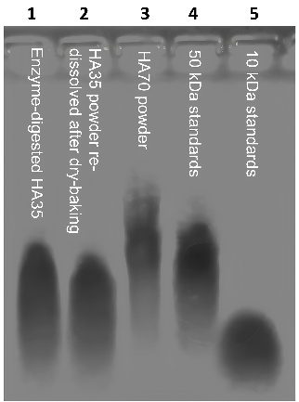
Fig. 1. Molecular weight of HA determined by gel electrophoresis
3.2 Changes in HA35 and HA70 Levels in Blood
To assess the absorption of orally administered HA35 and HA70, body weights of the experimental animals were recorded at each time point. No significant differences in body weight were observed between the HA35 and HA70 groups, both before and after gavage (P > 0.5), indicating that body weight did not serve as a confounding factor.
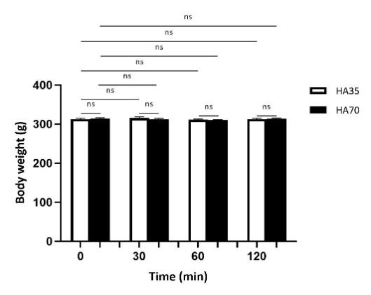
Fig. 2. Standard curves for HA detection
Serum samples from both the portal vein and cardiac blood were analyzed by ELISA. Sample types and dilution ratios are summarized in Table 1. The standard curves for the ELISA assay (Fig. 3A, B) demonstrated excellent linearity (R² = 0.99). Although potential interactions between HA and its binding partner Aggrecan may slightly influence detection sensitivity, statistical robustness was ensured by analyzing a large sample set.

Table 1. Sample collection and dilution conditions for portal and cardiac blood in rats

Group |  | HA35 (n=6) |  | HA70 (n=6)
Sample |  | Portal Vein Blood | Cardiac Blood | Portal Vein Blood | Cardiac Blood
Sample Detection Form |  | Serum | Serum | Serum | Serum
Sampling Volume (mL) |  | 3 | 6 | 3 | 6
Serum Separation Volume (mL) |  | 1 | 2 | 1 | 2
Detection Dilution Ratio | Blank Group | 8 | 8 | 8 | 8
 | 30min | 8 | 8 | 8 | 8
 | 1h | 8 | 8 | 8 | 8
 | 2h | 8 | 32 | 8 | 16
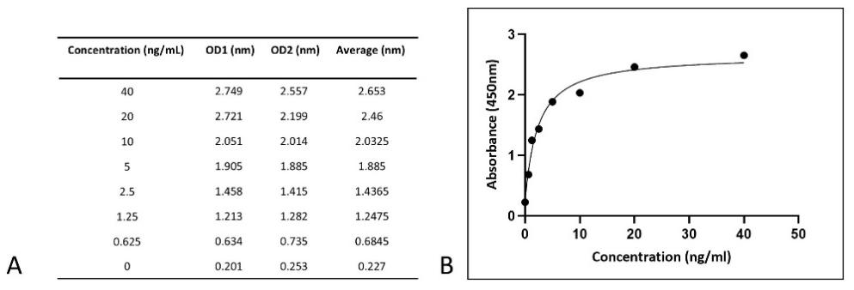
Fig. 3. Standard curves for HA detection
Note: A shows the OD values of the standard curve; B shows the curve derived from the OD values
The serum HA concentrations calculated from the standard curve are presented in Figs. 4 and 5. A time-dependent increase in HA levels was observed in both portal vein (Fig. 4) and cardiac blood (Fig. 5). However, no statistically significant differences were detected between the HA35 and HA70 groups at any individual time point. HA concentrations were consistently higher in cardiac blood than in portal vein blood, suggesting that HA is primarily absorbed into the systemic circulation via non-portal pathways. Further analysis showed a significant increase in HA levels in cardiac blood 30 minutes post-gavage compared to baseline (HA35: 129.84 ± 50.92 ng/mL, P < 0.01; HA70: 102.56 ± 50.78 ng/mL, P < 0.05). HA levels continued to rise at 60 minutes (HA35: 297.20 ± 123.87 ng/mL, P < 0.01; HA70: 255.36 ± 130.20 ng/mL, P < 0.05) and peaked at 120 minutes (HA35: 604.48 ± 269.37 ng/mL, P < 0.01; HA70: 567.84 ± 300.75 ng/mL, P < 0.01). These data indicate that both HA35 and HA70 are rapidly absorbed into the bloodstream following oral administration, predominantly via non-portal circulation.
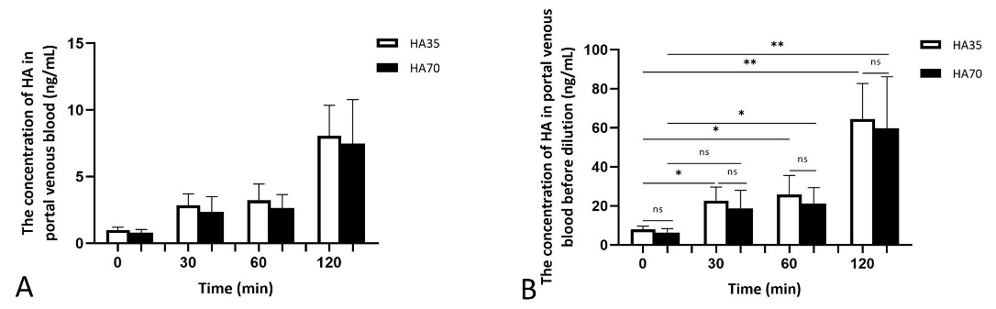
Fig. 4. HA concentration in rat portal vein blood
Note: A shows calculated concentrations from the standard curve; B shows original concentrations after multiplying by dilution factors.
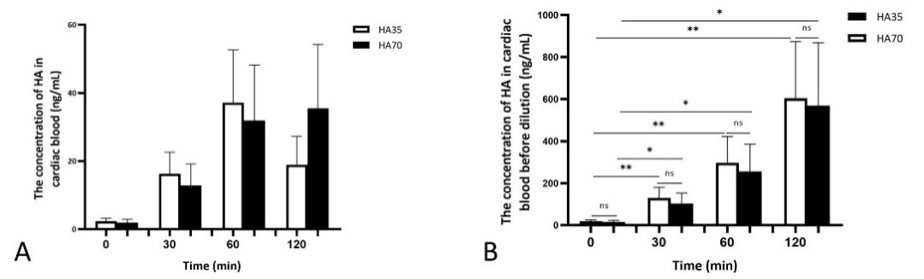
Fig. 5. HA concentration in rat cardiac blood
Note: A shows calculated concentrations from the standard curve; B shows original concentrations after multiplying by dilution factors.

3.3 Absorption of HA35 and HA70 in Tissues
To further investigate tissue-level absorption, HA concentrations were measured in the mesenteric lymph nodes, liver, and spleen. Tissue weights and corresponding dilution ratios are listed in Table 2, and HA distributions in various tissues are shown in Figs. 6 and 7. As shown in Fig. 6D, HA concentrations in the mesenteric lymph nodes significantly increased 30 minutes after oral administration (HA35: 17.94 ± 8.16 ng/mL, P < 0.01; HA70: 16.24 ± 8.00 ng/mL, P < 0.01) compared to pre-gavage levels (HA35: 0.87 ± 0.32 ng/mL; HA70: 0.73 ± 0.33 ng/mL). These results suggest that both HA35 and HA70 are effectively absorbed through the mesenteric lymphatic system.
In contrast, HA concentrations in the spleen (Fig. 7A) and liver (Fig. 7B) remained low and showed no significant differences before and after gavage (P > 0.05), indicating limited absorption into these organs. These findings support the hypothesis that oral HA is absorbed primarily via the intestinal lymphatic pathway, rather than undergoing first-pass hepatic metabolism.
Furthermore, no statistically significant differences were observed between the HA35 and HA70 groups in any of the tissues examined across all time points (P > 0.05), suggesting that tissue permeability and absorption through mesenteric lymph nodes are not strongly dependent on molecular size within the tested range.
Table 2. Weights and dilution conditions for mesenteric lymph nodes, liver, and spleen in rats
Group |  | HA35 (n=6) |  |  | HA70 (n=6)
Sample |  | Mesenteric Lymph Nodes | Spleen | liver | Mesenteric Lymph Nodes | Spleen | liver
Sample Detection Form |  | Tissue Fluid | Tissue Fluid | Tissue Fluid | Tissue Fluid | Tissue Fluid | Tissue Fluid
Sampling Weight | Blank Group | 0.2 | 0.8 | 1.0 | 0.1 | 0.9 | 1.0
 | 30min | 0.2 | 0.8 | 1.0 | 0.1 | 0.9 | 1.0
 | 1h | 0.2 | 0.8 | 1.0 | 0.1 | 0.9 | 1.0
 | 2h | 0.2 | 0.8 | 1.0 | 0.1 | 0.9 | 1.0
Tissue Volume for Dissolution and Extraction | Blank Group | 3.2 | 12.8 | 16 | 1.6 | 14.4 | 16
 | 30min | 3.2 | 12.8 | 16 | 1.6 | 14.4 | 16
 | 1h | 3.2 | 12.8 | 16 | 1.6 | 14.4 | 16
 | 2h | 3.2 | 12.8 | 16 | 1.6 | 14.4 | 16
Detection Dilution Ratio | Blank Group | 5 | 10 | 10 | 5 | 10 | 10
 | 30min | 50 | 10 | 10 | 25 | 10 | 10
 | 1h | 50 | 10 | 10 | 25 | 10 | 10
 | 2h | 50 | 10 | 10 | 25 | 10 | 10

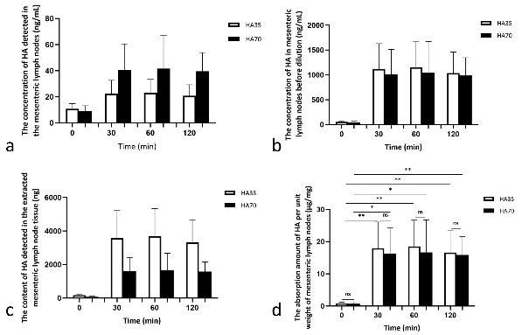

Fig. 6. HA concentration in mesenteric lymph nodes of rats.
Note: a = calculated from standard curve; b = total HA amount after multiplying by solution volume; c = HA concentration in dissolved tissue after multiplying by dilution factor; d = HA content per unit tissue weight.

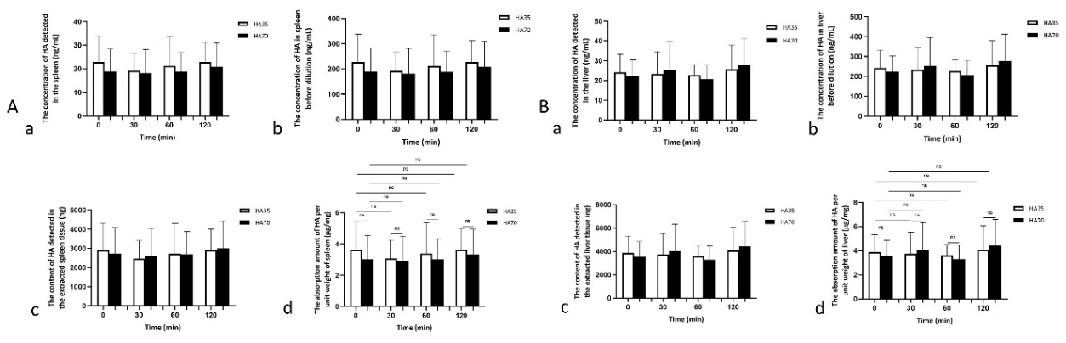
Fig. 7. HA concentration in rat spleen and liver of rats
Note: A = spleen; B = liver. a = calculated from standard curve; b = total HA amount after multiplying by solution volume; c = HA concentration in dissolved tissue after multiplying by dilution factor; d = HA content per unit tissue weight.

4. DISCUSSION
HA has gained widespread application in the cosmetics, food, and pharmaceutical industries due to its remarkable moisturizing, anti-inflammatory, and tissue-reparative properties [36]. Among the various modes of administration—topical, injectable, and oral—oral delivery has attracted increasing attention as a non-invasive and potentially effective approach. However, the mechanisms underlying the absorption of orally administered HA remain unclear and are still debated in the literature. Kimura et al. proposed that HMWHA must be degraded by gastric acid, digestive enzymes, and gut microbiota into smaller fragments before absorption [26,27]. In contrast, Sato et al. demonstrated that low-molecular-weight HA (LMWHA), specifically 2000 Da, can be absorbed via both the portal vein and the intestinal lymphatic system [36], offering new insights into the absorption pathways of LMWHA.
In this study, we first characterized the molecular weights of HA35 and HA70 using electrophoresis. Compared to viscosity-based methods typically used for HMWHA, electrophoresis offers a more direct and reliable assessment for LMWHA. Our results confirmed that both HA35 and HA70 have molecular weights greater than 10 kDa. Building upon previous studies involving radiolabeled HA35 injections [31], we further investigated the oral absorption routes of HA35 and HA70. Previous studies showed that 125I-labeled HA35 rapidly accumulated in lymph nodes within 5 minutes of subcutaneous injection and entered lymphoid organs like the spleen within 10 minutes. This suggests that HA35 may exert immunomodulatory effects by promoting lymphocyte recirculation. Having established the molecular weights of HA35 and HA70, we next focused on exploring whether these two compounds follow a similar lymphatic absorption route when administered orally or are absorbed directly into the portal circulation. To this end, we used ELISA to measure HA levels in rat tissues and serum following oral administration. Our findings revealed that, consistent with previous injection studies, HA concentrations in mesenteric lymph nodes increased significantly 30 minutes post-gavage and remained elevated at 60 and 120 minutes. In contrast, portal vein blood showed comparatively modest increases in HA levels, suggesting that HA is primarily absorbed via the mesenteric lymphatic system rather than directly through the intestinal mucosa into the portal vein. The concurrent rise in HA concentrations in cardiac blood at 120 minutes further supports the notion that HA35 and HA70 enter systemic circulation through lymphatic absorption. Interestingly, HA levels in the spleen and liver did not show significant changes post-gavage, which contrasts with findings from previous studies, where radiolabeled HA accumulated in these organs after injection [31]. This discrepancy could be attributed to the different methodologies used: while radiolabeling tracks both free and cell-bound HA, ELISA detects only unbound HA, potentially underestimating the total absorption in tissues like the spleen and liver. Therefore, the ELISA-based results likely reflect the levels of circulating, unbound HA35 and HA70. Moreover, no significant differences were observed between HA35 and HA70 in terms of absorption efficiency or tissue distribution, indicating that LMWHA fragments under 100 kDa can be effectively absorbed via the mesenteric lymphatic system, regardless of minor differences in molecular weight. Notably, Ma et al. (2025) reported that HA70 may exhibit enhanced biological activity, as demonstrated in red blood cell physiology assays [36].
Beyond its role in lymphatic recirculation and immune modulation, absorbed HA may also influence intestinal fat absorption, metabolic homeostasis, and drug delivery processes mediated by the gut lymphatic system [16]. The mesenteric lymphatic system is known to play a critical role in the transport of chylomicrons, fat-soluble vitamins, and certain peptide fragments, as well as in regulating lipid metabolism and energy balance [28]. By promoting lymphatic absorption, HA35 and HA70 could potentially influence lipid digestion and metabolic regulation. Previous studies have suggested that HA35 improves intestinal barrier function, modulates the lipid microenvironment, and reduces adipose tissue inflammation, contributing to lipolysis and fat metabolism [37]. Anecdotal reports also suggest that high doses of HA35 and HA70 (Food Production License No.: SC10637028502320) may exhibit lipolytic and facial slimming effects, although the underlying mechanisms remain poorly understood. Future research should investigate the impact of orally absorbed HA on lipid metabolism and assess its therapeutic potential in metabolic disorders.
Furthermore, the unique absorption mechanism of HA35 and HA70 presents promising opportunities for oral drug delivery. One of the major challenges in oral pharmacology is overcoming hepatic first-pass metabolism, where a significant proportion of drugs are metabolized in the liver before reaching systemic circulation [40]. Lymphatic absorption offers a promising alternative, potentially enhancing the bioavailability of orally administered compounds. Given their efficient lymphatic uptake, HA35 and HA70 may serve as novel carriers for the oral delivery of anti-inflammatory agents or other macromolecules. Future studies could focus on developing HA-based nanoparticles or HA-drug conjugates to evaluate their performance in enhancing drug absorption and modulating lipid metabolism.
Despite the strong experimental evidence provided by this study, there are some limitations. First, the ELISA method used detects only free HA and cannot quantify cell-associated HA, potentially leading to an underestimation of total absorption. Future studies could incorporate isotopic labeling or other advanced imaging techniques to quantify both free and cell-bound HA, providing a more comprehensive view of its absorption and distribution. Second, the findings were obtained from rat models, and their applicability to humans remains uncertain. Human clinical trials are necessary to confirm the absorption dynamics and therapeutic potential of orally administered LMWHA. Additionally, the ELISA kit employed in this study is based on HA–aggrecan binding, and the low solubility and prolonged incubation times associated with aggrecan may influence assay sensitivity and accuracy.
5. Conclusion
In conclusion, this study is the first to systematically demonstrate that LMWHA (<100 kDa), specifically HA35 and HA70, is primarily absorbed into systemic circulation via the mesenteric lymphatic immune system rather than through the traditional portal vein–liver route following oral administration. These findings offer new insights into the absorption mechanisms of orally delivered HA and pave the way for future clinical trials aimed at exploring its physiological functions and potential applications in metabolic health and drug delivery.

Ethical approval
The Animal Care and Use Committee of Longcore Biotech (Qingdao) Co., Ltd., approved the protocol of this study. All experimental animal tests were carried out according to the 2016 China Laboratory Animal Standards and other related regulations in the Animal Welfare Law.
References
- Hargittai, I. (2010). Pioneer of hyaluronan structural chemistry and other studies of polysaccharides: Torvard C. Laurent (1930–2009). Structural Chemistry, 21(4), 471–480.
- Marshall, K. W. (1998). Viscosupplementation for osteoarthritis: Current status, unresolved issues, and future directions. Journal of Rheumatology, 25(11), 2056–2058.
- Huerta Angeles, G., & Neporova, K. (2021). Hyaluronan and its derivatives for ophthalmology: Recent advances and future perspectives. Carbohydrate Polymers, 259, 117697.
- Beasley, K. L., Weiss, M. A., & Weiss, R. A. (2009). Hyaluronic acid fillers: A comprehensive review. Facial Plastic Surgery, 25(2), 86–94.
- Kramer, K., Senninger, N., Herbst, H., et al. (2002). Effective prevention of adhesions with hyaluronate. Archives of Surgery, 137(3), 278–282.
- Sherif, H., Sebay, A., Kandeel, W., et al. (2018). Safety and efficacy of intravesical hyaluronic acid/chondroitin sulfate in the treatment of refractory painful bladder syndrome. Turkish Journal of Urology, 45(4), 296–301.
- Hynnekleiv, L., Magno, M., Vernhardsdottir, R. R., et al. (2022). Hyaluronic acid in the treatment of dry eye disease. Acta Ophthalmologica, 100(8), 844–860.
- Chaudhry, G. E., Akim, A., Naveed Zafar, M., et al. (2021). Understanding hyaluronan receptor (CD44) interaction, HA-CD44 activated potential targets in cancer therapeutics. Advanced Pharmaceutical Bulletin, 11(3), 426–438.
- Johnson, L. A., & Jackson, D. G. (2021). Hyaluronan and its receptors: Key mediators of immune cell entry and trafficking in the lymphatic system. Cells, 10(8), 2061.
- Messam, B. J., Tolg, C., McCarthy, J. B., et al. (2021). RHAMM is a multifunctional protein that regulates cancer progression. International Journal of Molecular Sciences, 22(19), 10313.
- Pandey, M. S., Harris, E. N., & Weigel, P. H. (2015). HARE-mediated endocytosis of hyaluronan and heparin is targeted by different subsets of three endocytic motifs. International Journal of Cell Biology, 2015, 524707.
- Mei, Y., Wang, X., Zhang, J., et al. (2023). Siglec-9 acts as an immune-checkpoint molecule on macrophages in glioblastoma, restricting T-cell priming and immunotherapy response. Nature Cancer, 4, 1273–1291.
- Jiang, D., Liang, J., Fan, J., et al. (2005). Regulation of lung injury and repair by Toll-like receptors and hyaluronan. Nature Medicine, 11(11), 1173–1179.
- Domanegg, K., Sleeman, J. P., & Schmaus, A. (2022). CEMIP, a promising biomarker that promotes the progression and metastasis of colorectal and other types of cancer. Cancers, 14(20), 5093.
- Tobisawa, Y., Fujita, N., Yamamoto, H., et al. (2021). The cell surface hyaluronidase TMEM2 is essential for systemic hyaluronan catabolism and turnover. Journal of Biological Chemistry, 297(5), 101281.
- Zheng, X., Wang, B., Tang, X., Mao, B., Zhang, Q., Zhang, T., Zhao, J., Cui, S., & Chen, W. (2023). Absorption, metabolism, and functions of hyaluronic acid and its therapeutic prospects in combination with microorganisms: A review. Carbohydrate Polymers, 299, 120153.
- Xu, F., Treger, D., Ma, X., et al. (2024). Local injection of a freshly manufactured 35 kDa hyaluronan fragment reduces neuropathic and inflammatory pain: A clinical study. European Journal of Inflammation, 22.
- Treger, D., Zhang, L., Jia, X., Hui, J. H., Gantumur, M. A., Hui, M., & Liu, L. (2024). A clinical study of the local injection of a freshly manufactured 35 kDa hyaluronan fragment for treating chronic wounds. International Wound Journal, 21(5), e14906.
- Dashnyam, K., Treger, D., Jia, X., et al. (2023). Injection of 35 kDa hyaluronan fragment alleviates pain associated with radiotherapy for treatment of colorectal and rectal cancer. [Journal Name], 1(1), 131–135.
- Zhang, Z., Jia, X., Treger, D., & Hui, M. (2024). Low molecular weight 35 kDa hyaluronan fragment HA35 in the treatment of bone metastasis pain: A case report. Medicine, 103(31), e39145.
- Hui, M., Hui, J., Gantumur, M., & Treger, D. (2024). Clinical functions and bioactivities of hyaluronan and its fragments: A minireview. Current Trends in Biomedical Engineering & Biosciences, 22(3), 556087.
- Purevsuren, E., Treger, D., Ma, Z., Jia, X., Ganbaatar, T., Gantumur, M., Hui, M., & Nkhtuvshin, D. (2025). Therapeutic effects of 35 kDa hyaluronan injection at trigger points in the treatment of myofascial pain syndrome. International Journal of Clinical Medicine, 16, 1–15.
- Zhang, H., Treger, D., Jia, X., Ma, Z., & Hui, M. (2024). Analgesic effect of 35 kDa hyaluronan fragment on vaginal oocyte retrieval operation-associated pain: A case report. Case Reports in Clinical Medicine, 13, 503–511.
- Xu, F., Treger, D., Jia, X., Hui, M., & Ma, Z. (2025). Analgesic and curative effects of 35 kDa hyaluronan fragment on zoster-associated pain: A case report of two patients. Pain Medicine Case Reports, 9(1), 51–54.
- Ding, M., Zhao, X., Jia, X., Shofaro, J. H., Ma, Z., & Hui, M. (2025). Exploratory study on 35 kDa hyaluronan with microneedling for skin concerns: A series of 16 cases. Journal of Dermatology & Skin Science, 7(1), 1–9.
- Marinho, A., Nunes, C., & Reis, S. (2021). Hyaluronic acid: A key ingredient in the therapy of inflammation. Biomolecules, 11(10), 1518.
- Kimura, M., Maeshima, T., Kubota, T., Kurihara, H., Masuda, Y., & Nomura, Y. (2016). Absorption of orally administered hyaluronan. Journal of Medicinal Food, 19(12), 1172–1179.
- Tso, P., Bernier-Latmani, J., Petrova, T. V., et al. (2025). Transport functions of intestinal lymphatic vessels. Nature Reviews Gastroenterology & Hepatology, 22, 127–145.
- Ma, X., Wang, X., Jia, X., Hui, J. H., Shofaro, J. H., Tao, R., & Hui, M. M. (2025). Size-dependent aggregation of erythrocytes by low molecular weight hyaluronic acids of different sizes: Bioactivity and quality control potential. Frontiers in Physiology, 16, 1527354.
- Jia, X., Shi, M., Wang, Q., Hui, J., Shofaro, J. H., Erkhembayar, R., Hui, M., Gao, C., & Gantumur, M. A. (2023). Anti-inflammatory effects of the 35 kDa hyaluronic acid fragment (B-HA/HA35). Journal of Inflammation Research, 16, 209–224.
- Gantumur, M. A., Jia, X., Hui, J. H., Barber, C., Wan, L., Furenlid, L. R., Martin, D. R., Hui, M., & Liu, Z. (2024). Characterization, bioactivity, and biodistribution of 35 kDa hyaluronan fragment. Life, 14(1), 97.
- Johnson, L. A., Banerji, S., Lagerholm, B. C., & Jackson, D. G. (2021). Dendritic cell entry to lymphatic capillaries is orchestrated by CD44 and the hyaluronan glycocalyx. Life Science Alliance, 4(5), e202000908.
- Stanly, T. A., Fritzsche, M., Banerji, S., Shrestha, D., Schneider, F., Eggeling, C., & Jackson, D. G. (2020). The cortical actin network regulates avidity-dependent binding of hyaluronan by the lymphatic vessel endothelial receptor LYVE-1. Journal of Biological Chemistry, 295(15), 5036–5050.
- Balogh, L., Polyak, A., Mathe, D., Kiraly, R., Thuroczy, J., Terez, M., Janoki, G., Ting, Y., Bucci, L. R., & Schauss, A. G. (2008). Absorption, uptake and tissue affinity of high-molecular-weight hyaluronan after oral administration in rats and dogs. Journal of Agricultural and Food Chemistry, 56(22), 10582–10593.
- Bellar, A., Kessler, S. P., Obery, D. R., Sangwan, N., Welch, N., Nagy, L. E., Dasarathy, S., & de la Motte, C. (2019). Safety of hyaluronan 35 in healthy human subjects: A pilot study. Nutrients, 11(5), 1135.
- Sato, Y., Joumura, T., Takekuma, Y., & Sugawara, M. (2020). Transfer of orally administered hyaluronan to the lymph. European Journal of Pharmaceutics and Biopharmaceutics, 154, 210–213.
- Ray, S., Huang, E., McMullen, M. R., Jatana, S., de la Motte, C., & Nagy, L. E. (2025). 35 kDa specific-sized hyaluronan ameliorates high-fat diet-induced liver injury in murine model of moderate obesity. Matrix Biology, 136, 1–8.
- Pashkina, E., Bykova, M., Berishvili, M., Lazarev, Y., & Kozlov, V. (2025). Hyaluronic acid-based drug delivery systems for cancer therapy. Cells, 14(2), 61.
- Bokatyi, A. N., Dubashynskaya, N. V., & Skorik, Y. A. (2024). Chemical modification of hyaluronic acid as a strategy for the development of advanced drug delivery systems. Carbohydrate Polymers, 337, 122145.
- Azman, M., Sabri, A. H., Anjani, Q. K., Mustaffa, M. F., & Hamid, K. A. (2022). Intestinal absorption study: Challenges and absorption enhancement strategies in improving oral drug delivery. Pharmaceuticals, 15(8), 975.

