Clinical image

“Psoriasis vulgaris with Kaposi varicelliform eruptions secondary to second-degree syphilis: A rare case”

Psoriasis is an immune-mediated inflammatory skin disease that can cause sharply demarcated, erythematous, and scaly skin lesions often found on the surface of the skin.¹ Although the exact origins of the condition are unknown, environmental and genetic factors may play a role. Numerous genes, including human leukocyte antigen (HLA)-Cw6, loci for the T-helper type 2 and T-helper type 17 pathways, innate immune signaling pathways, and adaptive immune pathways involving CD8 T cells, have recently been identified as potentially linked to psoriasis.^{2,3} The incidence rate varies depending on the country-to-country basis, but it generally falls between 2% and 3%.⁴ However, if psoriasis is associated with various other health issues, it could be deadly. Since psoriasis cannot be cured, avoiding triggers, such as changing one's lifestyle and using moisturizers to prevent dry skin, is crucial. A 28-year-old male person was brought to the hospital with itchy skin and lesions all over the body. He was normal four months ago until he got several hyperpigmented papules on his left hand. These papules quickly spread to other parts of his body within four months, and he also experienced intermittent fever, gradual weight loss, and decreased hearing starting at three to four weeks. After the investigation, it was found that he was suffering from psoriasis vulgaris with Kaposi varicelliform eruptions secondary to second degree syphilis.

Differential diagnosis: Pityriasis rosea, seborrheic dermatitis, eczema, rickettial infection, chickenpox

Key words: Psoriasis vulgaris, Kaposi varicelliform eruptions, syphilis, autoimmune disorder, dermatitis

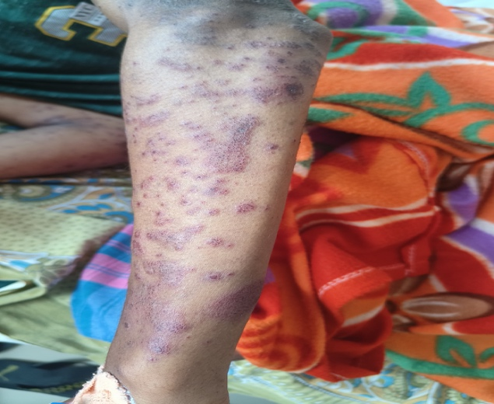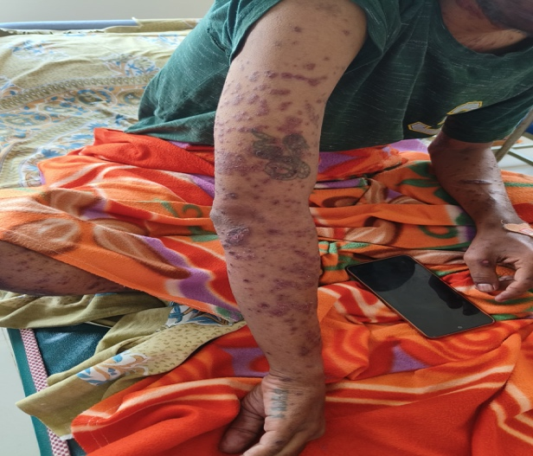

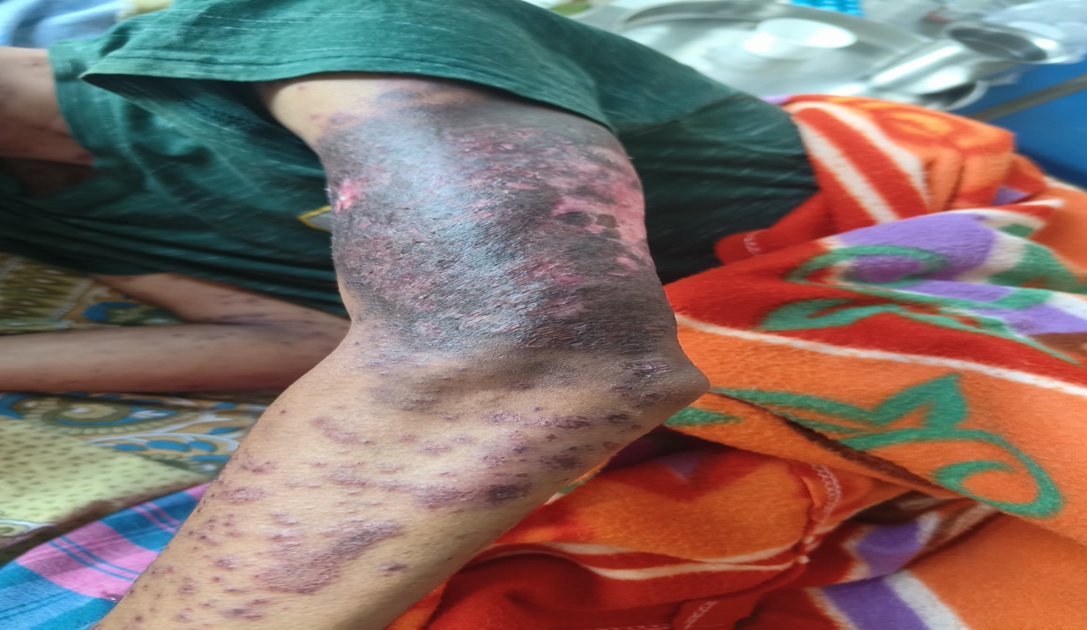

Figure 1: Multiple hyperpigmented erythematous papules and plaques in both hands

Conclusion:

Kaposi varicelliform eruptions are generally caused by a variety of viruses, but most often by herpes simplex in a patient with pre-existing dermatosis, and are mainly seen in adult’ patients. The transmission mainly occurs through contact with an infected person or primary or recurrent herpes. Generally, Kaposi varicelliform eruptions are triggered by total serum immunoglobulin E. Therefore. It is important to diagnose the case early with appropriate lab tests, which will help in timely intervention and cure.

Reference:

- Nair PA, Badri T. Psoriasis. [Updated 2023 Apr 3]. In: StatPearls [Internet]. Treasure Island (FL): StatPearls Publishing; 2025 Jan-. Available from: https://www.ncbi.nlm.nih.gov/books/NBK448194/

- Chhabra S, Dogra S, Sharma K, Raychaudhuri SK, Raychaudhuri SP. Recent update on immunopathogenesis of psoriasis. Indian Journal of Dermatology [Internet]. 2022 Jul 1;67(4):360–73. Available from: https://doi.org/10.4103/ijd.ijd_569_22

- Li K, Huang CC, Randazzo B, Li S, Szapary P, Curran M, et al. HLA-C*06:02 Allele and Response to IL-12/23 Inhibition: Results from the Ustekinumab Phase 3 Psoriasis Program. Journal of Investigative Dermatology [Internet]. 2016 Jul 30;136(12):2364–71. Available from: https://doi.org/10.1016/j.jid.2016.06.631

- Damiani G, Bragazzi NL, Aksut CK, Wu D, Alicandro G, McGonagle D, et al. The Global, regional, and National Burden of Psoriasis: Results and Insights from the Global Burden of Disease 2019 Study. Frontiers in Medicine [Internet]. 2021 Dec 16;8. Available from: https://doi.org/10.3389/fmed.2021.743180

