Original Research Article

Low molecular weight hyaluronan fragment HA35 serves as a dual antagonist of pain-related calcium channel TRPV1 and TRPA1

.
ABSTRACT

Background
Pain, especially chronic pain, remains a major health challenge, and transient receptor potential (TRP) channels, including Transient Receptor Potential Vanilloid 1 (TRPV1) and Transient Receptor Potential Ankyrin 1 (TRPA1), play crucial roles in pain perception. Hyaluronic acid (HA), particularly 35kDa molecular weight HA (HA35), has shown potential in modulating pain-related TRP channels, though its effects on TRPV1 and TRPA1 remain understudied.
Methods
The inhibitory effects of HA35 on TRPV1, TRPA1, and TRPV3 channels were investigated using the patch-clamp electrophysiology technique in human embryonic kidney (HEK293) cells transfected with the corresponding channel genes. The electrophysiological recordings were performed to assess the ion currents of TRPV1, TRPA1, and Transient Receptor Potential Vanilloid 3 (TRPV3) channels before and after application of HA35 and high molecular weight HA (HMWHA). Data were analyzed to determine the inhibition rates of each HA fragment on the respective channels.
Results
Our results show that both HA35 and HMWHA effectively inhibit TRPV1 and TRPA1 ion currents in HEK293 cells, with HA35 demonstrating a more potent inhibitory effect compared to HMWHA. Specifically, HA35 inhibited capsaicin-induced TRPV1 currents by 34.46% and AITC-induced TRPA1 currents by 29.27%, whereas HMWHA resulted in inhibition rates of 22.33% and 22.32%, respectively. Notably, HA35 did not affect TRPV3 ion currents, indicating selective antagonism of TRPV1 and TRPA1 channels. These findings are consistent across 12 independent experiments, with statistical significance observed (P < 0.001).
Conclusion
HA35 selectively inhibits TRPV1 and TRPA1 channels, demonstrating a more potent analgesic effect than HMWHA. Its target-specific action and superior tissue permeability suggest that HA35 could be a promising therapeutic for pain management, particularly in conditions mediated by TRPV1 and TRPA1.

Keywords: Low molecular weight hyaluronic acid (HA35); Hyaluronic Acid (HA); TRPV1; TRPA1; Pain Modulation; Ion Channels.

1. INTRODUCTION

Pain is a major global health issue that significantly impacts the quality of life for hundreds of millions of people worldwide[1,2]. Both acute and chronic pain present substantial challenges in modern medicine, as they are associated with various pathological factors. Understanding the molecular mechanisms underlying pain is crucial for developing novel analgesic therapies[3]. Pain is a complex physiological and psychological experience, often involving actual or potential tissue damage, and leading to diverse therapeutic targets. These targets include ion channels (e.g., voltage-gated sodium channels[4], calcium channels[5], and TRP channels[6]), neurotransmitters and their receptors (e.g., opioid receptors[7], γ-aminobutyric acid (GABA) receptors[8], and 5-hydroxytryptamine (5-HT) receptors[6]), inflammation-related mediators (e.g., cyclooxygenase (COX)[9] and tumor necrosis factor-α (TNF-α)[10]), and signaling pathway molecules (e.g., mitogen-activated protein kinase (MAPK) pathways[11] and nuclear factor-κB (NF-κB) pathways[12]).
A landmark contribution to pain research came from David Julius, who was awarded the 2021 Nobel Prize in Physiology or Medicine for his work on capsaicin receptors, bringing significant attention to the TRPV1 channel[13]. TRPV1 is a well-established pain-related receptor that can be activated by capsaicin, heat (≥43°C), acidic pH, and endogenous lipid mediators such as prostaglandin E2 (PGE2) (Fig. 1a)[14-16]. Currently, over 100 TRPV1-targeted drugs are in development worldwide, with 31 in preclinical stages, and only two approved for clinical use: Qutenza (capsaicin 8% patch) and Zucapsaicin. Both of these are TRPV1 agonists that, when used at high doses, desensitize sensory neurons involved in pain, thereby reducing pain perception[17,18]. While TRPV1 antagonists offer a promising avenue for blocking TRPV1 activation and inhibiting pain signal transmission, challenges persist. Agents like SAF312 and PSFL2874 have shown potential in treating chronic, inflammatory, and neuropathic pain but are often associated with undesirable side effects, such as elevated body temperature and off-target interactions[19]. These limitations highlight the need for further refinement and development of TRPV1-targeting therapies.
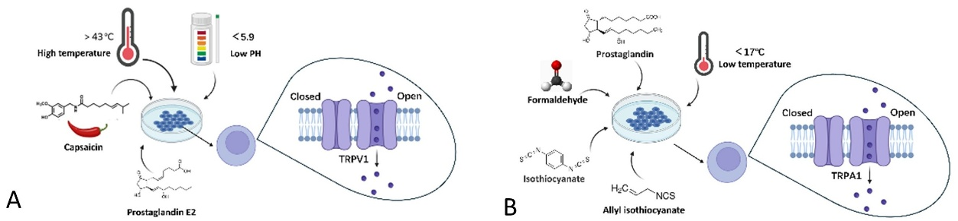

Fig.1 The activation conditions of TRPV1 and TRPA1
HA is a naturally occurring polysaccharide known for its important roles in tissue repair, lubrication, and anti-inflammatory processes[20]. Studies indicate that the biological functions of HA are significantly influenced by its molecular weight[21]. HMWHA (>1 MDa) typically exhibits anti-inflammatory and barrier properties, while low molecular weight HA (LMWHA, <500 kDa) plays a more prominent role in immune modulation and cell signaling[22]. Recent findings suggest that a 35 kDa fragment of LMWHA (HA35/B-HA) promotes lymphatic drainage, facilitates the resolution of inflammation, and inhibits inflammatory cytokine secretion, akin to HMWHA[23,24]. Clinically, HA35 has demonstrated efficacy in promoting wound healing and reducing redness and swelling associated with inflammatory responses[25]. Our studies have also shown that HA35 has significant analgesic effects, including relief from chronic pain associated with diabetic foot ulcers, inflammatory pain in the shoulder, neck, and temporomandibular region, neuropathic pain from shingles, and cancer-related pain in conditions such as colorectal cancer and bone metastasis[25-28]. While previous research in Nature Communications has explored the inhibitory effects of HMWHA on TRPV1, the effects of LMWHA, particularly HA35, on pain signaling pathways remain poorly understood[29,30].
As research on TRP channels expands, there has been increasing interest in TRPA1, a key player in pain perception alongside TRPV1. TRPA1 is highly sensitive to oxidative stress products (e.g., isothiocyanates and formaldehyde) and inflammatory mediators, and it is critically involved in detecting cold and mechanical pain signals (Fig. 1b)[31]. Notably, TRPA1 and TRPV1 not only independently contribute to pain perception but also synergistically amplify pain signals under certain pathological conditions, making them attractive targets for therapeutic intervention[32]. In 2020, Nayeon et al. proposed that dual antagonists targeting both TRPV1 and TRPA1 could provide enhanced analgesic efficacy while minimizing side effects compared to single-target approaches[32]. This insight further supports the rationale for investigating HA35 as a dual modulator of these two channels.
In this study, we aim to explore the role of HA35 in pain signal transmission. Based on existing literature, we hypothesize that HA35 may exert a dual antagonistic effect on both TRPV1 and TRPA1 channels. Through in vitro experiments, we investigate the dual antagonistic effects of HA35 on TRPV1 and TRPA1, aiming to uncover its novel mechanism in pain modulation and provide both theoretical and experimental support for multi-target analgesic strategies.

2. material and methods

2.1 Molecular Weight Determination by Electrophoresis
Gel Electrophoresis: Samples and standards were diluted to 0.5% concentration and mixed with loading buffer at a 1:4 ratio. A total volume of 12 μL was loaded into wells of a 1% agarose gel, and electrophoresis was performed at 4°C, applying a constant voltage of 80V for 1 hour, until the samples migrated to approximately one-third of the gel length. The gel was stained on a shaker for 2 hours, followed by rinsing with running water. Staining was visualized under visible light when clear sample bands appeared.
GPC-MALLS: The molecular weight of the samples was determined using gel permeation chromatography with multi-angle laser light scattering (GPC-MALLS). A Shodex OHpak SB-806HQ column (8.0 mm x 300 mm, 13 μm, Japan) was used in series with an SB-806HQ column. The mobile phase consisted of ultrapure water (pH = 6) containing 0.02% sodium azide, filtered through a 0.22 μm membrane. The flow rate was maintained at 1.0 mL/min, and the column temperature was set to 40°C. A 100 μL manual injection volume was employed for each sample[23].

2.2 Cell Transfection
Cell transfection was performed using electroporation. HEK293 cells were thawed, cultured, and transfected with TRPV1, TRPA1, and TRPV3 genes (sourced from OriGene or Addgene) that were amplified via RT-PCR. The amplified genes were ligated into the pGEM-T Easy vector and transformed into Escherichia coli DH5α competent cells. Positive clones were selected, and plasmid DNA was extracted and sequenced for verification. The plasmid concentration was determined using a Nanodrop spectrophotometer (Thermo Fisher) to ensure efficient transfection.
For transfection, HEK293 cells were cultured to 70%-80% confluence, 24 hours prior to transfection. Electroporation was conducted using the Nucleofector™ II system (Lonza) and the Amaxa™ Nucleofector™ Kit, following the manufacturer’s instructions. Approximately 2 μg of cDNA for TRPV1, TRPA1, or TRPV3 was mixed with an appropriate volume of Opti-MEM serum-free medium and liposome-based transfection reagent (e.g., Lipofectamine 2000) to form transfection complexes.
Gene expression was verified via RT-qPCR for mRNA detection and Western blotting for protein detection. Stable cell lines expressing the target proteins were cryopreserved. One week prior to patch-clamp experiments, cells were thawed and cultured.

2.3 Cell Revival and Culture
Stable HEK293 cell lines expressing human TRPV1 (hTRPV1) (AddexBio, San Diego, CA, USA), human TRPA1 (hTRPA1) (Eurofins, Luxembourg), and human TRPV3 (hTRPV3) were plated in black clear-bottom 96-well plates. HEK293 cells were used for all electrophysiological experiments. The cells were maintained in DMEM (Gibco) supplemented with 10% fetal bovine serum (FBS) and 1% penicillin/streptomycin, under a 5% CO₂ atmosphere at 37°C. All experiments were performed during the logarithmic growth phase to ensure optimal cell health and viability.

2.4 Preparation of HA35 and HA1600
HA35 and HA1600 (HMWHA, 1600 kDa) were obtained from Hynaut Laboratory and Bloomage Freda Biopharm, respectively. Both HA solutions were prepared at a concentration of 400 μg/mL in phosphate-buffered saline (PBS) to mimic physiological conditions and assess their effects on TRPV1, TRPA1, and TRPV3 activity. The solutions were filtered for sterilization and stored at 4°C until use. Prior to experiments, the solutions were diluted to the final working concentration (400 μg/mL).

2.5 Patch-Clamp Electrophysiology
Electrophysiological recordings were performed using a HEKA EPC10 amplifier. Patch pipettes were pulled from glass capillaries and had a resistance of 3-5 MΩ when filled with an internal solution containing 150 mM KCl. The external bath solution consisted of standard physiological saline containing 145 mM NaCl, 5 mM KCl, 1.8 mM CaCl₂, 1 mM MgCl₂, and 10 mM HEPES (pH 7.4).

2.5.1 Seal Formation and Whole-Cell Configuration
A glass microelectrode was brought into contact with the HEK293 cell membrane, and a slight negative pressure was applied to form a gigaseal (1-10 GΩ). Once a stable seal was achieved, the recording mode was switched to the whole-cell configuration, and the membrane was perforated using an appropriate voltage protocol.

2.5.2 Current Recording
The activity of TRPV1, TRPA1, and TRPV3 channels was recorded using the voltage-clamp mode. To generate current-voltage (I-V) curves, the membrane potential was stepped from -100 mV to +100 mV in 10 mV increments. Intracellular currents were continuously recorded during the experiment.

2.5.3 Agonist Stimulation
To activate TRPV1, TRPA1, and TRPV3, specific agonists were applied: TRPV1 (capsaicin, 1 μM), TRPA1 (allyl isothiocyanate, AITC, 10 μM), and TRPV3 (2-aminophenylborate, 2-APB, 200 μM). Current responses were recorded both before and after agonist application, and the data were compared to baseline values.

2.5.4 Comparison Before and After Drug Treatment
Cells were incubated at room temperature for 30 minutes prior to experimentation. Baseline currents were recorded before the application of the specific agonists (capsaicin, 1 μM; AITC, 10 μM; or 2-APB, 200 μM) to HEK-TRPV1, HEK-TRPA1, and HEK-TRPV3 cells. Following this, cells were exposed to 400 μg/mL HA35 or HA1600, and changes in current were recorded. Afterward, cells were washed with PBS, and post-wash currents were measured.

2.6 Data Analysis
All data were analyzed using Origin 9.0 software. Current values were recorded at each voltage step and used to generate I-V curves. The inhibitory effects of HA fragments on ion channel activity were assessed by comparing peak current values between drug-treated and control groups. Data are presented as Mean ± SD and analyzed using GraphPad Prism 6.0. Statistical significance was determined using Student’s t-test, with the following significance levels: P > 0.05 (not significant, ns), P < 0.05 (*), P < 0.01 (**), and P < 0.001 (***).

3. results

3.1 Molecular Weight Determination of B-HA and HMWHA by Gel Electrophoresis and GPC-MALLS
The molecular weights of HA1600 and HA35 were determined using gel electrophoresis and GPC-MALLS. HA35 was derived by enzymatic digestion of HA1600 using recombinant human hyaluronidase PH20. The electrophoresis results are shown in Fig. 2a. After 1 hour of electrophoresis, band 1, corresponding to HA35, appeared at approximately 35 kDa, while band 2 (HA1600) remained near the loading well due to its high molecular weight. Reference standards included HA markers of 10 kDa (Creative PEG Works), 24 kDa (Bloomage Biotech), and 50 kDa (Creative PEG Works). The GPC-MALLS results are presented in Table 1, where the average molecular weight of HA35 was measured at 20.94 kDa, and HA1600 at 114.216 kDa, both slightly lower than the values obtained from electrophoresis and the manufacturer’s specifications.
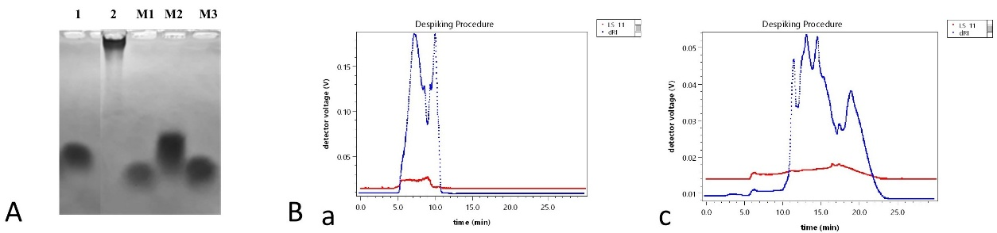
Fig. 2. Determination of molecular weight distribution of HA35 and HA1 600 by agarose gel method and GPC-MALLS method
Note: A: HA35(lane-1), HA1 600(lane-2), M1-10 kDaHA Marker, M2-50 kDaHA Marker, M3-24 kDaHA Marker; B: a represents HA35, while b represents HA1600.
Table 1 Determination of molecular weight peaks of HA35 and HA1 600 by GPC-MALLS
Molar mass moments (g/mol) | Peak1 | Peak2 | Peak3 | Peak4 | Peak5
Mw（Da） | 1.311×104 (±6.124%) | 2.512×104 (±13.421%) | 2.560×104 (±14.429%) | 1.993×104 (±47.587%) | —
CV
Mw（Da） | 9.951×105 (±5.780%) | 1.022×106 (±6.014%) | 1.167×106 (±6.133%) | 9.667×105 (±6.977%) | 1.560×106 (±7.903%)
CV

3.2 HA35 Inhibits Capsaicin-Induced TRPV1 Ion Currents
In a study by Caires et al., the IC50 of 5 MDa HA in inhibiting calcium influx ([Ca²⁺]ᵢ) induced by a 48°C heat pulse in SHSY5Y-TRPV1 cells (a human neuroblastoma cell line expressing TRPV1) was 135 ± 3 μg/mL [29]. The same study also demonstrated that 400 μg/mL of 5 MDa HA significantly inhibited both heat- and capsaicin-induced calcium influx in HEK-TRPV1-EYFP cells and dorsal root ganglion (DRG) primary sensory neurons [29].
Building on these findings, the effects of 400 μg/mL HA35 (B-HA) and HA1600 on capsaicin (CAP)-induced calcium influx were investigated in HEK-TRPV1 cells. The results for the HA35 group are shown in Fig. 3A: The initial current in HEK-TRPV1 cells was 873.2 pA, which increased to 1724.7 pA upon activation with 1 μM CAP. Following incubation with HA35, the current decreased to 1431.3 pA, resulting in an inhibition rate of 34.46%. Similarly, in the HA1600 group, Fig. 3B show that the initial current was 472.5 pA, which increased to 7249.0 pA after activation with 1 μM CAP. After incubation with HA35, the current decreased to 5736.0 pA, reflecting an inhibition rate of 22.33%.
Given the inherent variability in current values between individual cells (Fig. 3A-a and -b, 3B-a and -b), 12 independent experiments were conducted to reduce this variability. The final current values and inhibition rates (n = 12) are summarized in Fig. 3C- 3E. Statistical analysis revealed a significant difference (P < 0.001).
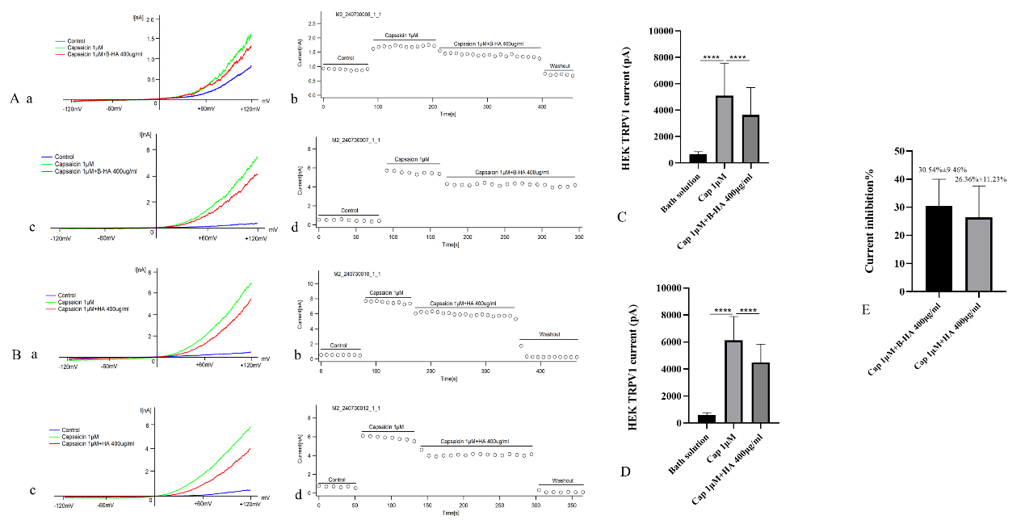
Fig. 3. Effects of HA35 and HA1600 on activated TRPV1 currents
Note: (A) TRPV1 activation and the effect of HA35 on TRPV1 currents. (B) TRPV1 activation and the effect of HA1600 on TRPV1 currents. (C) Inhibition data for HA35. (D) Inhibition data for HA1600. (E) Comparison of inhibition rates between HA35 and HA1600.

3.3 HA35 Inhibits Allyl Isothiocyanate-Induced TRPA1 Ion Currents
In addition to its effects on the TRPV1 pathway, Caires et al. also examined the influence of ultra-high molecular weight HA on the TRPA1 pathway in recombinant systems and cultured mouse DRG and nodose ganglion neurons. However, the results indicated that HMWHA did not modulate TRPA1 channels.
Based on these findings, this study explored the effects of 400 μg/mL HA35 (B-HA) and HA1600 on the modulation of AITC-induced calcium influx in HEK-TRPA1 cells. The results for the HA35 group are shown in Fig. 4A: the initial current in HEK-TRPA1 cells was 354.9 pA, which increased to 3009.3 pA after activation with 10 μM AITC. Following incubation with HA35, the current decreased to 2232.4 pA, corresponding to an inhibition rate of 29.27%. Similarly, for the HA1600 group, Fig. 4B show that the initial current was 300.7 pA, which increased to 2231.8 pA after activation with 10 μM AITC. After incubation with HA35, the current decreased to 1800.8 pA, with an inhibition rate of 22.32%.
Variability in current values was observed between different cells (Fig. 4A-a and -b, 4B-a and -b). To reduce this variability, 12 independent experiments were conducted. The final current values and inhibition rates (n = 12) are shown in Fig. 4C- 4E, with statistical significance (P < 0.001).
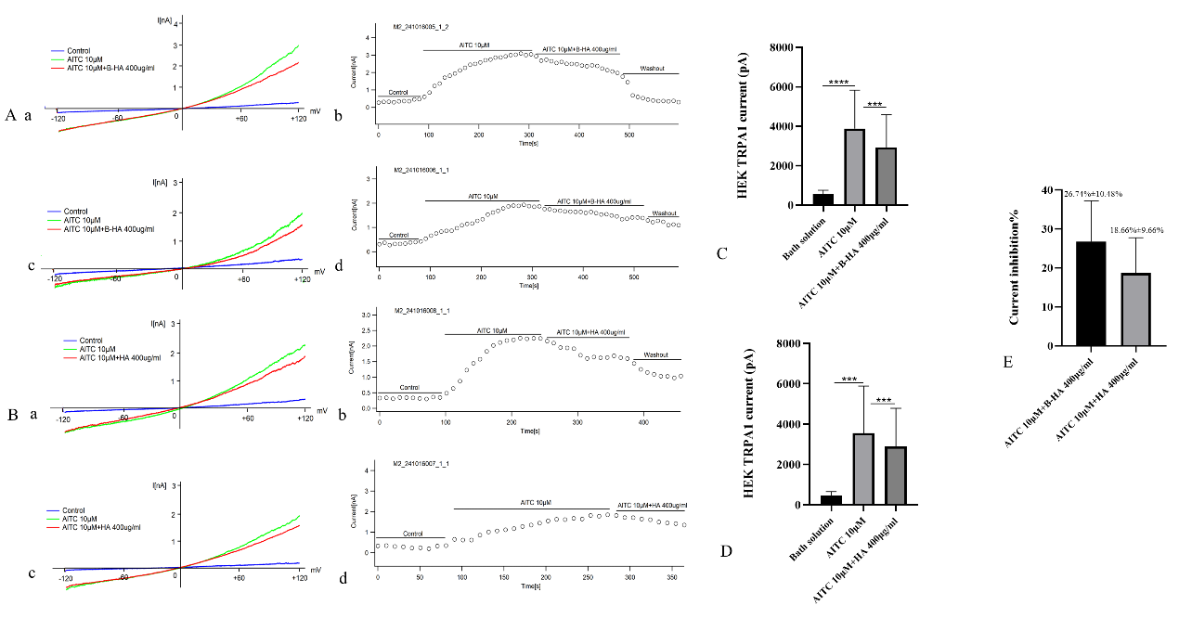
Fig. 4. Effects of HA35 and HA1600 on activated TRPA1 currents
Note: (A) TRPA1 activation and the effect of HA35 on TRPA1 currents. (B) TRPA1 activation and the effect of HA1600 on TRPA1 currents. (C) Inhibition data for HA35. (D) Inhibition data for HA1600. (E) Comparison of inhibition rates between HA35 and HA1600.

3.4 HA35 Does Not Affect 2-Aminoethyl Diphenylborinate-Induced TRPV3 Ion Currents
TRPV3 shares approximately 42% sequence homology with TRPV1 and is involved in signaling pathways related to itch, dermatitis, hair growth, and skin regeneration. Given the clinical observations that HA35 alleviates skin itching and its demonstrated inhibition of TRPV1 channels, we investigated whether HA35 also modulates TRPV3 channels.
However, as shown in Fig. 5E, 400 μg/mL HA35 (B-HA) and HA1600 did not exert any inhibitory or stimulatory effects on TRPV3 ion currents. The data in Fig. 5C and 5D demonstrate that 200 μM 2-APB significantly activated TRPV3 currents. In the HA35 group (Fig. 5A), the initial average current of normal cells was 685.99 pA, which increased to 5771.60 pA after the addition of 200 μM 2-APB. However, 400 μg/mL HA35 had no significant effect on 2-APB-activated currents (P > 0.05). Similarly, in the HA1600 group (Fig. 5B), the initial average current was 419.82 pA, which increased to 13,525.93 pA after the addition of 200 μM 2-APB, with no significant effect of 400 μg/mL HA on 2-APB-activated currents (P > 0.05).
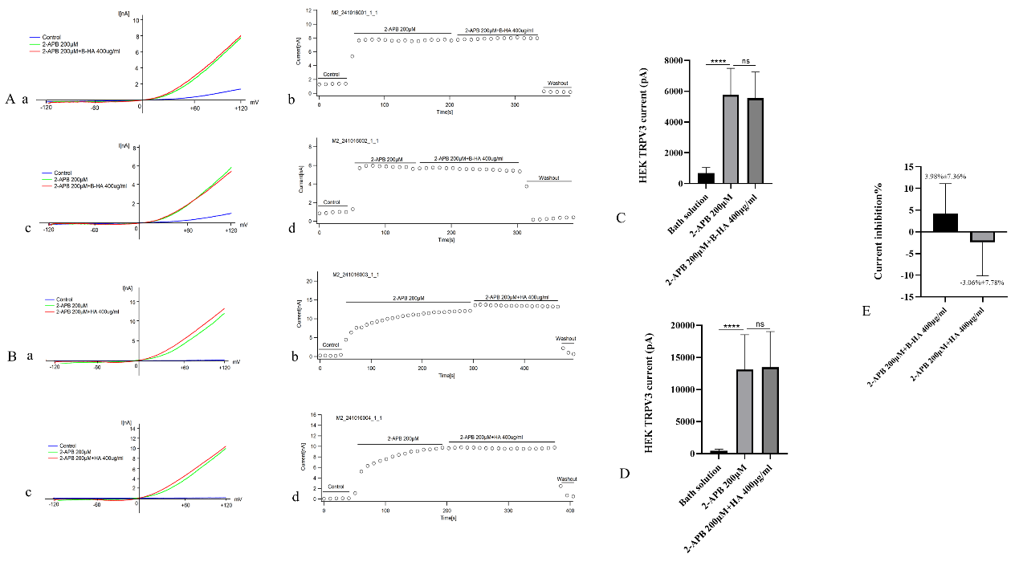
Fig. 5. Effects of HA35 and HA1600 on activated TRPV3 currents
Note: (A) TRPV3 activation and the effect of HA35 on TRPV3 currents. (B) TRPV3 activation and the effect of HA1600 on TRPV3 currents. (C) Inhibition data for HA35. (D) Inhibition data for HA1600. (E) Comparison of inhibition rates between HA35 and HA1600.

4. DISCUSSION
TRP ion channels, such as TRPV1 and TRPA1, are thermosensitive cation channels that are often co-expressed in nociceptive primary sensory neurons. These channels play an integral role in pain modulation and inflammation [29,30]. TRP channels have been implicated in a wide range of pain and inflammation models, including inflammatory pain [34], cancer pain [35], radiotherapy-related pain [16], chronic pelvic pain [36], orthodontic pain [37], muscle pain [34], burn-induced chronic pain [16], as well as various inflammation models, such as pulmonary, intestinal, and skin inflammation [34]. Given their crucial physiological functions, the development of antagonists or agonists targeting TRPV1 and TRPA1 has emerged as a promising strategy for treating pain-related disorders.
In 2015, Caires et al. published a study in Nature Communications exploring the regulatory effects of HA on TRPV1, TRPA1, and TRPM8 channels [29]. Their study indicated that HA could modulate TRPV1 channel opening, reducing peripheral nociceptor activity and pain. However, ultra-high molecular weight HA (5.8 MDa) failed to inhibit TRPA1 activation. TRPV1 is widely involved in inflammatory and neuropathic pain signaling, and its excessive activation can lead to neuronal hyperexcitability, resulting in intense pain. While TRPV1 agonists can desensitize sensory neurons through overstimulation, thereby alleviating pain, their initial use can exacerbate pain, and prolonged application may lead to tolerance, dependence, or even tissue damage. In contrast, this study focused on HA35, which, unlike agonists, exhibited an inhibitory effect on TRPV1 (Fig. 3). Previous research has highlighted the significant therapeutic effects of HA35 on inflammatory pain, tumor pain, and traumatic pain [26-28]. Using HMWHA (HA1600, 1600 kDa) as a control, this study further explored the inhibitory effects of HA35 on TRPV1 and TRPA1 channels and examined its potential mechanisms of action.
Our experimental results suggest that the inhibitory effect of HA35 on TRPV1 may occur through interference with the channel's opening mechanism, significantly reducing pain signal transmission. In addition to suppressing TRPV1 activation, HA35 also exhibited an inhibitory effect on the TRPA1 channel. TRPA1, which has a higher calcium permeability compared to other TRP channels, shares a high co-expression rate with TRPV1 in sensory neurons, suggesting potential interactions through heterodimeric channel formation [38]. Our findings demonstrate that HA35 significantly inhibits TRPA1, effectively alleviating pain associated with chemical stimuli (Fig. 4). These results indicate that HA35 functions not only as a TRPV1 inhibitor but also as a TRPA1 inhibitor, and its dual action makes it superior to single-channel antagonists in terms of analgesic efficacy.
These findings suggest that HA35 may exert a multi-target synergistic effect in pain treatment. However, its lack of a significant effect on activated TRPV3 channels further indicates that HA35 exhibits selective antagonistic action (Fig. 5). TRPV3, a calcium ion channel in the vanilloid family, is primarily expressed in epidermal keratinocytes, sensory nerve endings, and other non-neuronal tissues [39]. Although TRPV3 plays a role in tissue inflammatory responses and thermosensation, this study did not observe an inhibitory effect of HA35 on TRPV3-induced pain-related currents. Since TRPV3 is less involved in pain signaling pathways compared to TRPV1, its primary function appears to be related to other physiological processes, such as skin barrier regulation [42]. Therefore, the lack of HA35 inhibition on TRPV3 suggests that its analgesic effect is target-specific.
Further analysis revealed that both HA35 and HA1600 exhibited similar inhibitory effects on TRPV1 and TRPA1 in cell culture studies (which do not consider tissue permeability). This suggests that HMWHA and LMWHA fragments may share the same receptor-binding region, resulting in similar receptor-binding capabilities. However, due to its superior tissue permeability, HA35 can more effectively reach pain-related tissues, thereby demonstrating a more pronounced analgesic effect in clinical applications.
When considering previous research findings, it is clear that HA35 not only directly exerts analgesic effects through dual antagonism of TRPV1 and TRPA1, but may also alleviate inflammation-related pain through other mechanisms, such as diffusion via the lymphatic system and the elimination of inflammatory factors [23,24]. These results not only further validate the potential clinical value of HA35 in pain management, but also provide significant theoretical support for its synergistic mechanisms of action. Future in-depth research on the multi-target mechanisms of HA35 is expected to yield new breakthroughs in the treatment of pain and related inflammatory diseases.
5. Conclusion
Both HA35 and HMWHA exhibited dual inhibitory effects on pain-related calcium ion channels TRPV1 and TRPA1 at the cellular level. These findings suggest that HA35's ability to target TRPV1 and TRPA1, combined with its superior tissue permeability, makes it a promising candidate for clinical trials aimed at chronic pain management. These findings highlight the potential of HA35 as an effective modulator of TRPV1 and TRPA1, offering a promising approach for pain management.

Consent
It is not applicable.

Ethical approval
It is not applicable.

References
- Ho, A., & Nair, S. (2018). Chapter Nine - Global Chronic Pain: Public and Population Health Responses. Developments in Neuroethics and Bioethics, 1, 171–189.
- Goldberg, D.S., & McGee, S.J. (2011). Pain as a global public health priority. BMC Public Health, 11, 770.
- Basbaum, A.I., Bautista, D.M., Scherrer, G., & Julius, D. (2009). Cellular and molecular mechanisms of pain. Cell, 139(2), 267–284.
- Catterall, W.A. (2012). Voltage-gated sodium channels at 60: structure, function and pathophysiology. The Journal of Physiology, 590(11), 2577–2589.
- Dolphin, A.C. (2016). Voltage-gated calcium channels and their auxiliary subunits: physiology and pathophysiology and pharmacology. The Journal of Physiology, 594(19), 5369–5390.
- Nichols, D.E., & Nichols, C.D. (2008). Serotonin receptors. Chemical Reviews, 108(5), 1614–1641.
- Kieffer, B.L., & Gaveriaux-Ruff, C. (2002). Exploring the opioid system by gene knockout. Pharmacological Reviews, 54(2), 411–418.
- Olsen, R.W., & Sieghart, W. (2008). International Union of Pharmacology. LXX. Subtypes of γ-aminobutyric acidA receptors: classification on the basis of subunit composition, pharmacology, and function. Pharmacological Reviews, 60(3), 243–260.
- Smith, W.L., Garavito, R.M., & DeWitt, D.L. (1996). Prostaglandin endoperoxide H synthases (cyclooxygenases)-1 and -2. Journal of Biological Chemistry, 271(52), 33157–33160.
- Aggarwal, B.B. (2003). Signalling pathways of the TNF superfamily: a double-edged sword. Nature Reviews Immunology, 3(9), 745–756.
- Pearson, G., Robinson, F., Beers Gibson, T., Xu, B.E., Karandikar, M., Berman, K., & Cobb, M.H. (2001). Mitogen-activated protein (MAP) kinase pathways: regulation and physiological functions. Endocrine Reviews, 22(2), 153–183.
- Ghosh, S., & Karin, M. (2002). Missing pieces in the NF-κB puzzle. Cell, 109(2), S81–S96.
- Logan, D.W. (2021). Hot to touch: the story of the 2021 Nobel Prize in Physiology or Medicine. Disease Models & Mechanisms, 14(10), dmm049352.
- Rosenberger, D.C., Binzen, U., Treede, R.D., & Greffrath, W. (2020). The capsaicin receptor TRPV1 is the first line defense protecting from acute non-damaging heat: a translational approach. Journal of Translational Medicine, 18(1), 28.
- Willis, W.D. Jr. (2009). The role of TRPV1 receptors in pain evoked by noxious thermal and chemical stimuli. Experimental Brain Research, 196(1), 5–11.
- Iftinca, M., Defaye, M., & Altier, C. (2021). TRPV1-targeted drugs in development for human pain conditions. Drugs, 81(1), 7–27.
- Blair, H.A. (2018). Capsaicin 8% Dermal Patch: A Review in Peripheral Neuropathic Pain. Drugs, 78(14), 1489–1500.
- Studer, M., & McNaughton, P.A. (2010). Modulation of single-channel properties of TRPV1 by phosphorylation. The Journal of Physiology, 588(Pt 19), 3743–3756.
- Fan, J., Ke, H., Lei, J., et al. (2024). Structural basis of TRPV1 inhibition by SAF312 and cholesterol. Nature Communications, 15, 6689.
- Ouyang, Y., Zhao, J., & Wang, S. (2023). Multifunctional hydrogels based on chitosan, hyaluronic acid, and other biological macromolecules for the treatment of inflammatory bowel disease: A review. International Journal of Biological Macromolecules, 227, 505–523.
- Chen, L.H., Xue, J.F., Zheng, Z.Y., Shuhaidi, M., Thu, H.E., & Hussain, Z. (2018). Hyaluronic acid, an efficient biomacromolecule for treatment of inflammatory skin and joint diseases: A review of recent developments and critical appraisal of preclinical and clinical investigations. International Journal of Biological Macromolecules, 116, 572–584.
- Chistyakov, D.V., Astakhova, A.A., Azbukina, N.V., Goriainov, S.V., Chistyakov, V.V., & Sergeeva, M.G. (2019). High and Low Molecular Weight Hyaluronic Acid Differentially Influences Oxylipins Synthesis in Course of Neuroinflammation. International Journal of Molecular Sciences, 20(16), 3894.
- Jia, X., Shi, M., Wang, Q., Hui, J., Shofaro, J.H., Erkhembayar, R., Hui, M., Gao, C., & Gantumur, M.A. (2023). Anti-inflammatory effects of the 35kDa hyaluronic acid fragment (B-HA/HA35). Journal of Inflammation Research, 16, 209–224.
- Gantumur, M.A., Jia, X., Hui, J.H., Barber, C., Wan, L., Furenlid, L.R., Martin, D.R., Hui, M., Liu, Z. (2024). Characterization, bioactivity, and biodistribution of 35 kDa hyaluronan fragment. Life (Basel), 14(1), 97.
- Treger, D., Zhang, L., Jia, X., Hui, J.H., Gantumur, M.A., Hui, M., & Liu, L. (2024). A clinical study of the local injection of a freshly manufactured 35 kDa hyaluronan fragment for treating chronic wounds. International Wound Journal, 21(5), e14906.
- Xu, F., Treger, D., Ma, X., et al. (2024). Local injection of a freshly manufactured 35 kDa hyaluronan fragment reduces neuropathic and inflammatory pain: A clinical study. European Journal of Inflammation, 22.
- Xu, F., Treger, D., Jia, X., Hui, J.H., & Ma, Z. (2025). Analgesic and curative effects of 35kDa hyaluronan fragment on Zoster-associated pain: A case report of two patients. Pain Medicine Case Reports, 9, 51–54.
- Zhang, Z., Jia, X., Treger, D., & Hui, M. (2024). Low molecular weight 35 kDa hyaluronan fragment HA35 in the treatment of bone metastasis pain: A case report. Medicine (Baltimore), 103(31), e39145.
- Caires, R., Luis, E., Taberner, F.J., et al. (2015). Hyaluronan modulates TRPV1 channel opening, reducing peripheral nociceptor activity and pain. Nature Communications, 6, 8095.
- de la Peña, E., Gomis, A., Ferrer-Montiel, A., et al. (2016). TRPV1 channel modulation by hyaluronan reduces pain. Channels (Austin), 10(2), 81–82.
- Viana, F. (2016). TRPA1 channels: Molecular sentinels of cellular stress and tissue damage. Journal of Physiology, 594(15), 4151–4169.
- Do, N., Zuo, D., Kim, M., Kim, M., Ha, H-J., Blumberg, P.M., Ann, J., Hwang, S.W., Lee, J. (2024). Discovery of dual TRPA1 and TRPV1 antagonists as novel therapeutic agents for pain. Pharmaceuticals, 17(9), 1209.
- Kalinovskii, A.P., Utkina, L.L., Korolkova, Y.V., & Andreev, Y.A. (2023). TRPV3 ion channel: From gene to pharmacology. International Journal of Molecular Sciences, 24(10), 8601.
- Straub, R.H. (2014). TRPV1, TRPA1, and TRPM8 channels in inflammation, energy redirection, and water retention: Role in chronic inflammatory diseases with an evolutionary perspective. Journal of Molecular Medicine, 92, 925–937.
- Szallasi, A. (2024). Targeting TRPV1 for cancer pain relief: Can it work? Cancers (Basel), 16(3), 648.
- Piao, J.J., Kim, S., Shin, D., Lee, H.J., Jeon, K.H., Tian, W.J., Hur, K.J., Kang, J.S., Park, H.J., Cha, J.Y., Song, A., Park, S.H., Rajasekaran, M., Bae, W.J., Yoon, S.K., & Kim, S.W. (2025). Cannabidiol alleviates chronic prostatitis and chronic pelvic pain syndrome via CB2 receptor activation and TRPV1 desensitization. World Journal of Men's Health, 43(1), 228–238.
- Gao, Y., Liu, Y., Zhu, K., Zhang, Z., Qiao, H., Lu, Z., Zhong, T., Liu, Y., Zhou, H. (2016). Blocking of TRPV-1 in the parodontium relieves orthodontic pain by inhibiting the expression of TRPV-1 in the trigeminal ganglion during experimental tooth movement in rats. Neuroscience Letters, 628, 67–72.
- Souza Monteiro de Araujo, D., Nassini, R., Geppetti, P., & De Logu, F. (2020). TRPA1 as a therapeutic target for nociceptive pain. Expert Opinion on Therapeutic Targets, 24(10), 997–1008.
- Su, W., Qiao, X., Wang, W., He, S., Liang, K., & Hong, X. (2023). TRPV3: Structure, diseases and modulators. Molecules, 28(2), 774.

