Haematological and Histopathological Sex-Related Changes Associated with Chronic Tramadol Hydrochloride Administration in Wistar Albino Rats

ABSTARCT
This study explored the hematological and histopathological effects of tramadol administration in Wistar albino rats. A total of 28 adult rats were allocated into four groups based on sex and treatment status. Tramadol was administered at a dosage of 100 mg/kg daily for four weeks to simulate chronic misuse, while control groups received normal saline. Hematological parameters, such as PCV, RBC, hemoglobin concentration, MCV, MCH, MCHC, WBC, and differential leukocyte counts, were assessed using an automated hematology analyzer. Additionally, histopathological evaluations of the brain, liver, and kidneys were conducted at post-mortem. The findings revealed significant decreases in PCV, RBC, hemoglobin concentration, MCV, MCH, and WBC in the treatment groups, with females experiencing greater changes. MCHC values remained unchanged. Differential leukocyte analysis showed decrease neutrophil, lymphocyte, eosinophil, and monocyte counts, while basophil counts were unaffected. Histopathological analysis indicated tramadol-induced alterations in the brain, liver, and kidney tissues. Statistical analysis using ANOVA and Tukey's HSD test highlighted notable sex-specific differences in hematological parameters between treatment and control groups. These results emphasized the hematotoxic and organ-specific risks associated with tramadol misuse, with females exhibiting higher susceptibility to hematological changes. The study highlighted the importance of careful monitoring of tramadol use due to its potential impact on critical physiological and histological functions.
Keywords: Rats, Sex, Tramadol, Chronicity Haematology, Histopathology.

INTRODUCTION
Rats Rattus norvegicus (Rodentia: Muridae) originated from Central Asia and are distributed all over the world (Desvars-Larrive et al. 2018). The rat (Rattus norvegicus) in 1850 was the first mammalian specie to be domesticated for the purpose of research. The Wistar strain of the albino rats was developed at the Wistar Institute in Philadelphia. Albino and hooded rats are one of the most used laboratory animals for the past 150 years. The albino strain of the brown rat (R. norvegicus) is mostly used as an experimental animal in research due to their docile nature, shortened gestational interval, and genetic uniformity (Krubaa and Yogitha, 2024). They can survive in various habitats, including wooded areas, urban environments, and agricultural regions, and also adapt to extreme weather conditions. Albino rats are omnivorous,they have the ability to consume a wide variety of food, ranging from grains, seeds, fruits, vegetables, and protein sources like meats (Allaqaband et al., 2022).
The Wistar Rats have some similarities with humans with regards to physiology and genetics, this makes them ideal model for studying human diseases and developing new treatments (Iannaccone and Jacob, 2009). In addition, rats have a relatively short life cycle, several generations can be studied within a short period of time. Rats have been used as research models for research and experiments (Koolhaas, 2010). Rats have been used as research tools in various fields, including reproductive physiology, drug development, toxicology, immunology, and neuroscience (Modlinska and Pisula, 2020). Furthermore, they exhibit depression-like behaviors, which makes them an ideal model for studying psychiatric disorders (Redei et al., 2008).
Tramadol hydrochloride is an opioid analgesic that is widely sold worldwide (Shipton, 2000). It is the second opioid analgesic that has been reported to be a substance of abuse among medical practitioners (Adams et al., 2006). In some parts of the world tramadol is considered as a control drug and therefore requires prescription before use. However, it is readily available by remote prescription including internet pharmacies with relative ease (Solarino et al., 2010). In most parats of the world Tramadol dependence became an increasing trend and at the time an alarming problem in Africa (Roussin et al., 2012). Tramadol is easy and widely available as apain killer for immediate pain and many other forms of pain, this could be the major reason for its spread and abuse (Hussein and Elguindy, 2017). Tramadol hydrochloride has been reported to have detrimental effects on both male and female albino rats. Studies by Paulis and Abbas, (2015) reported that administration of Tramadol in female rats reduced both pituitary sex hormones (LH and FSH) and gonadal hormones progressive weight loss in female wistar albino rats.
Materials and Methods
Study Area
The study was conducted in Maiduguri, Nigeria, situated at an altitude of 354m above sea level, between latitude 10.2oN and 13.4oN and longitudes 9.8oE and 14.4oE. Maiduguri is located in North Eastern Nigeria.
Ethics:
All the protocol used for sample collection and laboratory analysis were in accordance with the principles and guidelines of the Institutional Animal Utilization Protocol (IAUPC), the ethical approval was sorted and approved by the Animal Use and Ethics Committee, Faculty of Veterinary Medicine, University of Maiduguri with the approval number AUP-R003/2025.
Experimental Animals
A total of 28 adult female and male Wistar albino rats were used for this study. They were purchased from the College of Medical Sciences, University of Maiduguri.
Grouping
They were distributed equally into four groups of 7 rats each with equal number of male and female. Group A (female control), (Group B male control), Group C (female treatment)
Group D (male treatment) Normal saline was given to 14 rats in the control group. Tramadol was administered to female and male treatment groups.
Housing and Acclimatization
The rats were kept for two weeks in order to adapt to the new environment before the commencement of the experiment. They were kept in a cage, the floor was tiled and roofed with Asbestos. It was well ventilated with temperature of about 35.0-37.0 ºC. The laboratory animals were kept in the laboratory animal’s house of the Faculty of Veterinary Medicine University of Maiduguri
Source of the Drug
The drug Tramadol hydrochloride 50mg/kg (Novalab Healthcare Private, Limited, India) was obtained from the Faculty of Pharmaceutical Sciences, University of Maiduguri.

Feeding regimen
Poultry feed from Ultima feed was fed to every animal in this trial. Essential nutrients such as 20% protein, 4.5% fats and key amino acids, 5% fiber, fortified minerals and vitamins, and 3050 kcal/kg of energy are all included in the feed. Daily feedings and unlimited access to drinking water were provided to the experimental animals. The treatment and control groups received the appropriate amount of feed and water ad libitum.
Drug Administration
Dosage: Tramadol hydrochloride was administered intravenously (IV) at a daily dose of 50 mg/kg for a treatment duration of 28 days as follows:
Dose = Dosage (mg/Kg) x Rats body weight (kg)/Drug concentration (mg/mL).

Sample collection and storage
Direct cardiac puncture was used to obtain blood samples at the end of the therapy period (Parasuraman, Raveendran and Kesavan, 2010). To avoid clotting, around 2 mL of blood is extracted from each rat and placed in EDTA tubes for hematological analysis. To preserve integrity, the materials are processed within two hours and kept at 4°C (Weiss and Wardrop, 2010).
Histopathology
Tissue samples of the brain, liver and kidney were fixed in 10% phosphate-buffered formalin for 72 hours. The sections were trimmed and embedded in paraffin wax as described by Baker et al. (1985). The paraffin blocks were then sectioned at 5μm thickness and stained with hematoxylin and eosin (H&E). The stained slides were observed using light microscopy, and photomicrographs were taken.

RESULTS
Table 1: Mean (±SD) hematological parameters of Wister albino rats untreated control and treated with 100mg/kg of tramadol
PARAMETER | UNTREATED GROUPS |  | TREATED GROUPS
PARAMETER | FEMALE | MALE | MALE | FEMALE
PCV (%) | 45.71 ± 3.01 | 47.00 ± 1.07 | 34.14 ± 5.08* | 28.29 ± 3.65*
RBC  (10^6/µL) | 7.35 ± 0.22 | 7.33 ± 0.41 | 5.53 ± 0.21 | 6.29 ± 0.29
WBC (10^4/µL) | 50.14 ± 3.09 | 48.14 ±3.48 | 29.00 ± 2.62 | 39.00 ± 5.45
HB (g/dl) | 15.20 ± 1.00 | 15.67 ± 0.36 | 11.50 ± 1.64* | 9.40 ± 1.22*
MCH (Pg) | 21.09 ± 1.26 | 21.43 ± 1.02 | 20.77 ± 2.75* | 14.91 ± 1.51*
MCV (FL) | 62.66 ± 2.84 | 64.29 ± 3.63 | 61.85 ± 8.35* | 44.90 ± 4.67*
MCHC (g/dl) | 33.40 ± 0.17 | 33.33 ± 0.00 | 33.31 ± 0/01 | 33.31 ± 0.01
The parameters in asterisk (*) are indicative of a significant difference from the control group (p < 0.05).
Table 2: Differential Leukocytes Count for Untreated and Treated Groups with Tramadol 100mg/kg
PARAMETERS | CONTROL | TREATMENT
Neutrophils | 26.6±2.2ª | 13.4±1.8^{b}
Lymphocytes | 15.7±2.4ª | 12.0±1.6^{b}
Monocytes | 3.4±0.6ª | 1.9±0.3^{b}
Eosinophils | 1.6±0.3ª | 0.9±0.2^{b}
Basophils | 0.3±0.2ª | 0.2±0.1ª

Histopathology
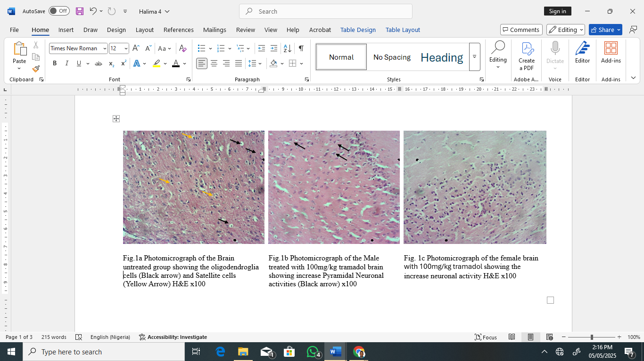
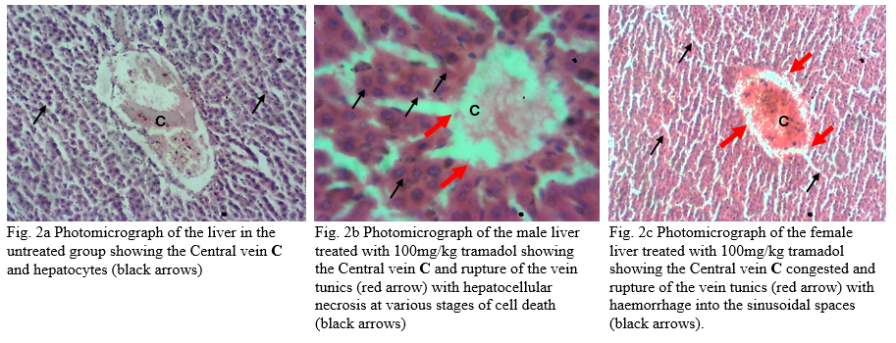

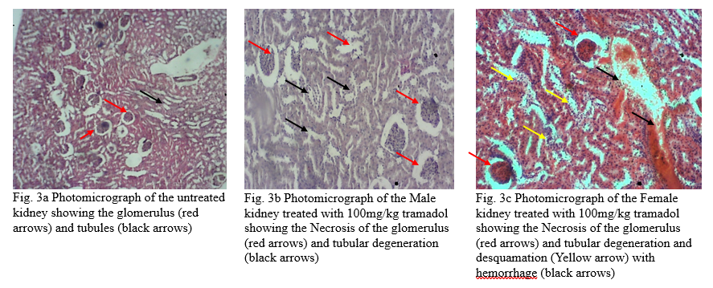

Discussion
The findings of this study indicate significant alterations in blood parameters and tissue integrity, particularly in the brain, liver, and kidney. In this study, tramadol administration led to a significant decrease in Packed cell volume in both male and female rats, with females showing a more pronounced reduction. A decrease in PCV is often indicative of anemia, which has been observed in other studies with tramadol as well. For instance, Darbar et al. (2022) reported a similar decline in PCV in rats treated with tramadol, suggesting that the drug may interfere with erythropoiesis or promote the destruction of red blood cells. The greater reduction in PCV in females observed here is consistent with findings by Schelde et al., (2020), who noted gender-based differences in hematological responses to various drugs, possibly due to hormonal influences on red blood cell production.
The decrease in RBC count in all treated groups in this study mirrors the changes observed in previous work with opioid analgesics. For example, Alam et al. (2016) documented a similar decline in RBC count in rats treated with morphine, which is closely related to tramadol in terms of its action on the central nervous system. The more significant reduction in females aligns with the PCV results, suggesting that female rats may be more vulnerable to tramadol-induced suppression of erythropoiesis or may experience more pronounced changes in red blood cell turnover.
The reduction in hemoglobin levels, particularly in the female rats, supports the hypothesis of a drug-induced reduction in the oxygen-carrying capacity of the blood. This finding is in agreement with other studies on opioids and their effects on hematological parameters. For example, a study by Piri et al. (2020) reported reduced hemoglobin levels in rats treated with morphine, suggesting a potential common mechanism of action among opioids that could affect red blood cell function or production. In our study, both MCV and MCH were significantly decreased in treated rats, with females again exhibiting a more pronounced reduction. This trend mirrors findings by Ibrahim et al. (2019), who observed that opioids such as tramadol led to microcytic hypochromic anemia in rats, suggesting that tramadol may alter red blood cell morphology by affecting their size and hemoglobin content. However, the MCHC remained unaffected, which is consistent with some studies that report no significant change in this parameter despite reductions in MCV and MCH (Naz et al., 2021). The unchanged MCHC indicates that although red blood cells may be smaller and contain less hemoglobin, the concentration of hemoglobin in each cell remains stable.
WBC counts were significantly reduced in the treated groups, particularly in females. This suppression of the immune system has been reported in previous studies with tramadol and similar analgesics. For example, a study by Chaithra et al. (2018) found that tramadol treatment led to a marked decrease in WBC, which they attributed to tramadol’s possible suppressive effects on bone marrow function or immune cell production. The differential leukocyte count in our study showed a reduction in neutrophils, lymphocytes, and eosinophils, which is consistent with findings by Sayed et al. (2018), who observed similar decreases in all leukocyte subtypes following tramadol administration.
The histopathological examination of brain tissue revealed increased neuronal activity in both male and female rats treated with tramadol. These changes are in line with those reported by Rachmani et al. (2018), who noted that opioids such as tramadol can alter neuronal firing patterns and increase pyramidal neuronal activity. The effects were more pronounced in females, which aligns with the findings of Mittal et al. (2024), who observed gender-specific differences in central nervous system responses to opioids. This could suggest that female rats may have heightened sensitivity to tramadol’s effects on brain function, which could influence behavior or cognitive performance.
The liver histology revealed significant damage in both male and female rats, with the female rats showing more severe changes, such as rupture of the central vein tunics and hepatocellular necrosis. Similar hepatic toxicity has been documented in studies investigating tramadol’s effects on liver function. A study by Ahmed et al. (2018) reported hepatocellular degeneration and necrosis in rats treated with tramadol, noting that such damage could be due to tramadol-induced oxidative stress or direct cytotoxic effects. The male rats in our study exhibited congestion and hemorrhage, which is consistent with findings from Alowaid,et al. (2024), who reported vascular congestion and hemorrhage in the liver of rats treated with high doses of tramadol.
The kidney histology showed signs of necrosis in the glomeruli and tubular degeneration in both sexes. These findings agree with the work of Ali et al. (2020), who observed nephrotoxic effects of tramadol in rats, including glomerular necrosis and tubular damage. The presence of hemorrhage and tubular desquamation in the female rats suggests a more severe form of renal injury, which could be linked to the increased sensitivity of females to tramadol, as observed in the liver. Male rats also showed significant kidney damage, including hemorrhage, which was consistent with the findings of Barbosa et al. (2020) in their study on tramadol-induced nephrotoxicity. In the brain there is increased neuronal activity in those rats treated with 100mg/kg tramadol, probably the cause of euphoria perceived by individuals involved in substance abuse with tramadol.
This study highlights notable sex differences in the response to tramadol. Female rats consistently showed more pronounced reductions in hematological parameters and more severe histopathological damage in the liver and kidney. These findings support previous studies suggesting that female rats are more sensitive to the toxic effects of various drugs, including opioids. For instance, a study by Ardakani,et al. (2014) indicated that sex differences in drug metabolism, hormone levels, and immune responses might contribute to the greater vulnerability of female rats to drug-induced toxicity. The heightened sensitivity observed in females in this study may also be related to hormonal differences, particularly estrogen, which can influence drug metabolism and immune function (Moussa et al., 2020).
Conclusion
The results of this study demonstrate that tramadol administration at a dose of 100mg/kg induces significant hematological and histopathological changes in Wistar albino rats. The observed alterations in red blood cell parameters, white blood cell count, and tissue damage in the brain, liver, and kidney highlight the potential toxic effects of tramadol. The more pronounced effects observed in female rats suggest that sex-specific differences in drug metabolism and sensitivity should be considered when evaluating tramadol's safety profile. These findings provide valuable insight into the potential risks associated with tramadol use, and they support the need for further research into its long-term effects, particularly in vulnerable populations.
Disclaimer (Artificial Intelligence)
Author(s) hereby declare that NO generative AI technologies such as Large Language Models (ChatGPT, COPILOT, etc) and text-to-image generators have been used during writing or editing of this manuscript.

References
Adams, A., Joseph, B., & Williams, C. (2006). Tramadol dependence and abuse trends among medical practitioners.
Ahmed, A. I., El-Dawy, K., Fawzy, M. M., Abdallah, H. A., Elsaid, H. N. A., & Elmesslamy, W. O. (2018). Retrospective review of tramadol abuse.
Ali, H. A., Afifi, M., Saber, T. M., Makki, A. A., Keshta, A. T., Baeshen, M., & Al-Farga, A. (2020). Neurotoxic, hepatotoxic and nephrotoxic effects of tramadol administration in rats. Journal of Molecular Neuroscience, 70, 1934-1942.
Allaqaband, S., Dar, A. H., Patel, U., Kumar,N., Nayik, G. A., Khan, S. A., Ansari, M. J., Alabdallah, N. M., Kumar, P., Pandey, V. K. and Kovács, B. (2022).
Alowaid, H. F. H., Hassan, A. A., & Majeed, M. F. (2024). Functional and histological signs of early detection of liver and kidney stress under the influence of tramadol oral administration in male rats. Adv. Anim. Vet. Sci, 12(8), 1556-1562.
Ardakani, Y. H., & Rouini, M. R. (2007). Pharmacokinetics of tramadol and its three main metabolites in healthy male and female volunteers. Biopharmaceutics & drug disposition, 28(9), 527-534.
Baker, F. J., Silverton, R. E. and Luckcock, E. D. (1957). Histology. Pages 133 – 196.
Barbosa, J., Faria, J., Garcez, F., Leal, S., Afonso, L. P., Nascimento, A. V., ... & Dinis-Oliveira, R. J. (2020). Repeated administration of clinical doses of tramadol and tapentadol causes hepato-and nephrotoxic effects in Wistar rats. Pharmaceuticals, 13(7), 149.
Chaithra, S., Saikia, B., Konwar, B., Bayan, H., Devi, T. R., Das, C. J., & Zorinpuii, H. (2024). Comparative studies on haemato-biochemical changes following pre-emptive analgesia with tramadol, pentazocine lactate and meloxicam inpain management of canine ovariohysterectomy. The Indian Journal of Animal Sciences, 94(2), 123-130.
Darbar, S., Saha, S., Pramanik, K., & Chattopadhyay, A. (2022). Haematological Modulations by Fixed Dose Combination (FDC) of Tramadol Hydrochloride/Paracetamol (THP). In Frontiers in Clinical Drug Research-Hematology (pp. 154-167). Bentham Science Publishers.
Desvars-Larrive, A., Baldi, M., Walter, T.,Zink, R. and Walzer, C. (2018). Brown rats (Rattus norvegicus) in urban ecosystems: are the constraints relatedto fieldwork a limit to their study? UrbanEcosystems, 21: 951 – 964.
Hussien, R., & Elguindy, M. (2017). Assessment of the role of naloxone in the prognosis of tramadol intoxicated patients. Journal of Clinical Toxicology, 7(366), 21610495. In: Introduction of Medical Laboratory Technology. Second Edition, Butterworths, London, United Kingdom.
Koolhaas, J. M. (2010). The laboratory rat. The UFAW Handbook on the Care and Management of Laboratory and Other Research Animals, 8: 311 – 326.
Krubaa, P. and Yogitha, P. S. (2024). Albino Wistar rats: Advantages and limitations in biomedicalresearch. SBV Journal of Basic, Clinical and Applied Health Science, 7(2): 61 – 65.
Mittal, V., & Yadav, K. S. (2024). Optimizing nasal drug delivery for peptides, proteins, and small molecules: strategic use of materials and techniques to target the CNS. International Journal of Polymeric Materials and Polymeric Biomaterials, 1-24.
Modlinska, K. and Pisula, W. (2020). The Norway rat, from an obnoxious pest to a laboratory pet. eLife, 9: e50651. https: //doi.org/10.7554/eLife.50651
Moussa, M., Tolba, N., Ashry, S., Ali, A., & Atallah, S. (2020). Impact of Chronic Tramadol Intake on Reproductive Hormones and Related Histopathological Changes in Adult Albino Rats. Ain Shams Journal of Forensic Medicine and Clinical Toxicology, 35(2), 1-13.
Naz, S., Hussain, R., Ullah, Q., Chatha, A. M. M., Shaheen, A., & Khan, R. U. (2021). Toxic effect of some heavy metals on hematology and histopathology of major carp (Catla catla). Environmental science and pollution research, 28, 6533-6539.
Paulis, M. G., & Abbas, M. F. (2015). Tramadol subchronic toxicity on pituitary-gonadal axis and ovarian functions in adult female rats. First International Forensic Medicine and Clinical Toxicology Conference, Minia University.
Piri, Z., Arami, M. K., Shahidi, M., & Nazari, S. (2020). Alteration of Hematologic Parameters in Morphine-Dependent Rats by Long-Term Administration of Orexin Type 1 Receptor Antagonist. International Journal of High Risk Behaviors and Addiction, 9(3), 1-e99081.
Sayed, J. A., Abd Elshafy, S. K., Kamel, E. Z., Riad, M. A. F., Mahmoud, A. A., & Khalaf, G. S. (2018). The impact of caudally administrated tramadol on immune response and analgesic efficacy for pediatric patients: a comparative randomized clinical trial. The Korean journal of pain, 31(3), 206-214.
Schelde, A. B., Sørensen, A. M. S., Hindsø, M., Christensen, M. B., Jimenez-Solem, E., & Eriksson, R. (2020). Sex and age differences among tramadol users in three Nordic countries. Dan Med J, 67(7), A06190336.
Shipton, E. A. (2000). Global trends in tramadol use and abuse: A comprehensive review.
Solarino, M., Rodriguez, A., & Bonito, V. (2010). The role of internet pharmacies in tramadol availability and misuse Utilization of fruit seed-based bioactive compounds for formulating the nutraceuticals and functional food: A review. Frontiers in Nutrition, 9: 902554. https://doi.org/10.3389/fnut. 2022.902554

