Life Cycle Assessment (LCA) of Plastic Food Packaging Materials: A Short Review

Abstract
Plastic is the most common material used for food packaging. Life cycle assessment (LCA) can help to study the environmental impacts of food packaging materials throughout their life cycle, thus enabling the identification of the environmentally friendly packaging materials among the given alternatives. This study aimed to assess the life cycle of plastic materials through conducting a literature review. Literature confirms that the life cycle of plastics has a significant negative impact on the environment and human health. The production of plastic packages consumes huge amounts of water and energy with the emission of heat. The projected trend shows that the primary plastic waste will gradually continue to be generated with less recycling. Thus, the use of alternative, easily recyclable packaging materials should be emphasised hand in hand with the innovation of biodegradable plastic packaging materials in inorder to overcome the negative impacts associated with current commonly used plastic food packaging materials. Also, enhancing recycling infrastructure and promoting better recycling practices can help divert plastic waste from landfills.

1.0 Introduction
Packaging of food is very crucial to the preservation and safety of all food products. It enhances product shelf life and provides a significant barrier against contamination. Plastic is a most versatile packaging material that is commonly used in food packaging (Sarkar and Aparna, 2020). Global plastic materials production has increased gradually over the past several decades; the total annual world production of plastics was estimated to be 368 million tons in 2019, an increase from approximately 15 million tons in 1960s. This growth is due to many features of plastics such as their versatility in application, durability, and continued increasing technical properties from ongoing innovation development (Gu et al., 2017; Jankowska et al., 2022). There are three main fates of plastic wastes namely recycling or reprocessing into secondary materials, thermal destruction and discarding or land fills (Geyer et al., 2017; Kan and Miller, 2022). The rate of those fates may vary between regions across the world.
The most commonly used plastics in food packaging are Polyethylene Terephthalate (PET), Polypropylene (PP), Low-Density Polyethylene (LDPE), Polyvinyl Chloride (PVC), Polystyrene (PS) and High-Density Polyethylene (HDPE) (Singh and Demirsöz, 2022). The life cycle of plastic materials mainly includes the initial extraction of fossil fuels, the production and distribution of plastic products, their use and maintenance, and ultimately, their end-of-life management, including recycling, reuse, and final disposal. A life-cycle approach helps understand the environmental, social, and economic impacts of plastics throughout their entire existence (Nielsen et al., 2020).
Life cycle assessment (LCA), or life cycle analysis, is a methodology for assessing environmental impacts or outcomes associated with all the stages of the life cycle of a material or product. It is the powerful tool to help in decision making (Shaked et al., 2015). Because widely used plastics are produced from fossil fuels, their extraction contributes to a significant emission of greenhouse gases to the environment. Massive accumulation of micro plastics on earth pose a deadly problem for ecosystem. Additionally processing, distribution and end life of plastics also contribute much in the environmental impact (Nicholson et al., 2021). Apart from greenhouse gas emission, plastic packaging materials can pollute the water bodies and contaminate the soil since there are non-biodegradable. The leaching of micro plastics in packaged foods also pose human health risks to chronic diseases such as cancer, abnormal endocrine functioning and reproductive problems (Nicholson et al., 2021; Dey et al., 2024).
Conducting a Life Cycle Assessment (LCA) is crucial for understanding the full environmental impact of a product, service, or process, from raw material extraction to disposal. It helps businesses and the general public identify environmental hotspots, set sustainability goals, and make informed decisions to reduce their environmental footprint. LCAs also promote innovation by highlighting areas for resource efficiency and cost reduction, while also strengthening brand credibility and aiding in regulatory compliance (Barbhuiya and Das, 2023). This short article aimed to review the life cycle assessment (LCA) of plastic materials in food packaging. The goal is to make readers have a quick picture on the influence of plastic food packaging materials on the environmental and human health.
2.0 Methodology
In April 2025, different electronic databases, namely Google Scholar, Scopus, PubMed, Web Science, and African Journal Online, were for the information search. The keyword search terms consisted of Life Cycle Assessment, LCA of plastics, plastic AND food packaging, raw materials of plastics, plastics AND environment, food packaging, 'greenhouse, global warming, 'microplastics, plastics AND ecosystem, global plastic production, plastics AND human health, plastics AND food, plastics AND animal health. The relevant information was extracted from the articles written in the English language which were selected after carefully and independently reviewing the relevancy of the information contained in their titles and abstracts. Different 48 publications were included in this study, listed in the bibliography.

3.0 Overview of Plastic materials in food packaging
Packaging of food is very crucial to the preservation and safety of all food products. It enhances product shelf life and provides a significant barrier against contamination (Fadiji et al., 2023). Plastic is a very versatile packaging material that is commonly used in food packaging (Sarkar and Aparna, 2020). Plastics contain basic constituents, although they are made into different forms. In the food packaging industry, plastics are derived from fossil fuels, and they account for about 50% of all packaging materials (Piergiovanni et al., 2016; Sarkar and Aparna, 2020). Although recently there are some efforts of making biodegradable plastics, the widely used plastics originating from fossil fuels are persistent in the environment and take many years to degrade, or they are totally non-degradable (Ncube et al., 2020). The most commonly used plastics in food packaging are Polyethylene Terephthalate (PET), Polypropylene (PP), Low-Density Polyethylene (LDPE), Polyvinyl Chloride (PVC), Polystyrene (PS) and High-Density Polyethylene (HDPE) (Singh and Demirsöz, 2022).
PET is widely used for water bottles and food packaging. It is popular due to its lightweight and recyclability, though it lacks heat resistance and can release harmful chemicals when exposed to high temperatures (Ajaj et al., 2022). PP is mostly found in yoghurt cups and microwaveable containers; it is durable and safe for food use but can release toxins when overheated; hence, care should be taken when using it. LDPE is known to be flexible and resistant to tearing, commonly used for bread bags and wraps, but also melts easily and can contaminate food at high temperatures. PVC is effective for meat trays and cling film but involves harmful production chemicals and releases toxic chlorine gas when burnt. PS, used in disposable food containers, poses serious environmental risks due to its slow decomposition and chemical release. HDPE is strong and safe for food packaging but can also release chemicals when heated (Piergiovanni et al., 2016; Hassanpour and Unnisa, 2017; Singh and Demirsöz, 2022).
A material life cycle begins with the extraction of raw materials from natural resources in the ground and the energy generation. This cycle is crucial for understanding the environmental, social, and economic impacts of materials throughout their lifespan. The life cycle of plastics encompasses several stages, with significant environmental impacts at each stage (Figure 1).
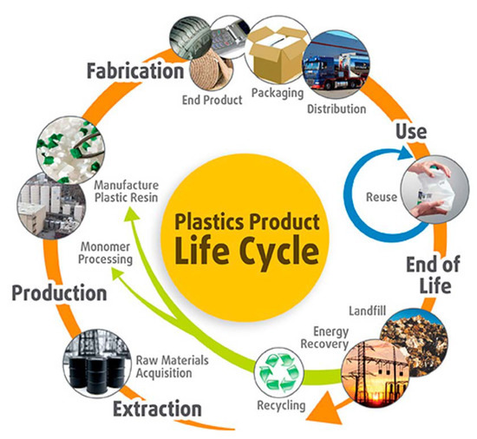
Figure 1: Life cycles of plastic products (Alhazmi et al., 2021)

4.0 LCA of plastic food packaging materials
Life Cycle Assessment (LCA) in food packaging follows four main stages: (i) Goal and Scope Definition, (ii) Life Cycle Inventory (LCI), (iii) Life Cycle Impact Assessment (LCIA), and (iv) Interpretation. These stages help understand the environmental impact of food packaging throughout its entire lifecycle, from raw material extraction to end-of-life treatment (Alhazmi et al., 2021). Those steps were conducted in reviewing the literatures for LCA of plastics.
4.1 Goal and scope definition
The goal of the study is to review the life cycle assessment (LCA) of plastic food packaging materials. The study intends to inform environmental management stakeholders and the general public about the status of the environmental impact of plastic food packaging materials. Different functional units were used depending on the data found in the specific literature. The review of the LCA was conducted for the different life cycle stages of different plastic food packaging materials, including raw materials extraction, raw material transportation, production, distribution, the use phase, and end of life.

4.2 Life Cycle Inventory (LCI) analysis
4.2.1 Raw materials
Plastics are made from natural materials such as natural gas, cellulose, coal, salt and crude oil, which are all found in nature. Mainly the production is through a polymerisation or polycondensation process. The life cycle of plastic materials mainly starts with the extraction of oil and natural gas as the basic resources for production (Yadav et al., 2024). Raw materials are finally refined into ethane and propane. Heat is then applied to propane and ethane, resulting in a process known as "cracking", which transforms them into propylene and ethylene, respectively, which are later polymerised into small plastic pellets. Once those pellets are formed, they are typically transferred to a packaging facility to make plastic products (packaging materials) (Gholami et al., 2021).
Because widely used plastics are produced from fossil fuels, their extraction contributes to a significant emission of greenhouse gases into the environment. The raw materials extraction process results in the release of toxic organic substances, metals, acid gases, and other toxic substances into the water, soil, and air (Adebayo-Ige et al., 2020; Nanda et al., 2021). The study conducted by Larasati et al., (2024) found that the raw material production process shows a higher level of harmful impact on the environment compared to other stages of the production process. The situation is also evidenced by OECD, (2022) and Ritchie and Roser, (2023) (Figure 2).
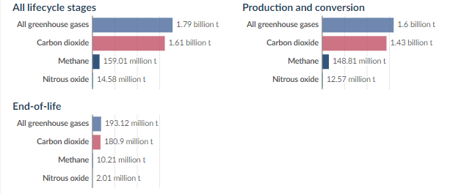
Figure 2: Greehouse gas emmission from plastics, 2019 (OECD, 2022; Ritchie and Roser, 2023).
4.2.2 Raw materials transport
The raw materials from the extraction area can be transported to the processing facility by truck, rail or pipeline. It is estimated that just the extraction of raw materials for plastic manufacturing and their transportation to processing factories currently emits about 1.5 to 12.5 million metric tonnes of greenhouse gases. Most of the processing industries are located far from the extraction areas, increasing the carbon footprint of the plastic packaging materials (Kumar et al., 2021).
4.2.3 Production
Plastic production globally has grown by an average of 9% annually since the 1950s, with single-use plastic (SUP) polymers being the most significant segment of general plastics manufactured (figure 3). The manufacturing of desired plastic packaging materials can be achieved through processes such as injection moulding, extrusion or blow moulding (Chen et al., 2021; Okoffo et al., 2021).
Literature reported various amounts of energy consumed in the production of plastics and the amount of heat emitted/calorific value (Table 1). Additionally, the high amount of water is also needed in the production of plastic packaging materials. For example, it takes around 83 litres of water to make 0.5 kg of plastic. Particularly, it takes almost twice as much water in order to produce a plastic water bottle as the amount of water contained within it (Wardrop et al., 2017; Marczak, 2022). Generally, the world production of plastics is still higher; however, recently the rate of production of degradable bioplastics has increased when compared to the rate of production of non-biodegradable plastics (Ncube et al., 2020).
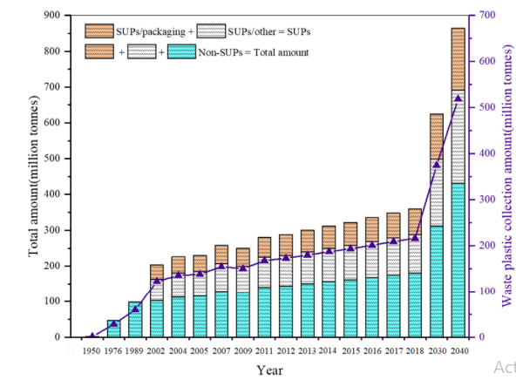
Figure 3: Global plastic and SUP production growth trends (Chen et al., 2021).

Table 1: Primary energy consumption in the production of selected plastics (Marczak, 2022).
Polymer | Energy consumption [MJ/kg] |  |  | Raw material consumption (petrol) [kg/kg] | Calorific value [MJ/kg]
Polymer | From petroleum | From other sources of energy than petroleum | Total | Raw material consumption (petrol) [kg/kg] | Calorific value [MJ/kg]
Polyethylene | 55 | 15 | 70 | 1.06-1.35 | 43
Polypropylene | 58 | 15 | 73 | 1.11-1.40 | 44
Polystyrene | 55 | 22 | 80 | 1.06-1.54 | 40
Polycarbonate | 36 | 71 | 107 | 0.69-2.05 | 31
Polyvinyl chloride | 24 | 29 | 53 | 0.46-1.02 | 18

4.2.4 Distribution of plastics
The plastic materials from the processing facility can be distributed to the end users through truck, rail or air transport. It is estimated that just the extraction of raw materials for plastic manufacturing and their transportation and distribution currently emits about 1.5 to 12.5 million metric tonnes of greenhouse gases (Kumar et al., 2021). Most of the end users are located far from the processing facilities, increasing the carbon footprint of the plastic packaging materials (Di et al., 2022).
4.2.5 End of life of plastics
It is well known that generally plastic materials do not decompose, but they break up into smaller pieces termed 'microplastics (Gazal and Gheewala, 2020). However, there are three main fates of plastic wastes, namely recycling or reprocessing into secondary materials, thermal destruction and discarding or landfills (Geyer et al., 2017; Kan and Miller, 2022). The rate of those fates may vary between regions across the world. The case study for the USA is shown in Table 2. Although the plastic can be recycled, the amount of solid waste generated by them is becoming a significant problem due to their environmental impact (Evode et al., 2021). The end of life had fewer emissions of greenhouse gases when compared with production and conversion stages (Figure 4).
Table 2: Recycling rate, incineration rate, and landfill rate of plastic material in the USA in 2015 (Kan and Miller, 2022).
Plastic material | Recycling rate (%) | Incineration rate (%) | Landfill rate (%)
Polyethylene terephthalate (PET) | 24 | 15.2 | 60.8
High-density polyethylene (HDPE) | 16.4 | 16.7 | 66.9
Low-density polyethylene (LDPE) | 13 | 17.4 | 69.6
Polypropylene (PP) | 3.8 | 19.2 | 77
Polystyrene (PS) | 5.4 | 18.9 | 75.7

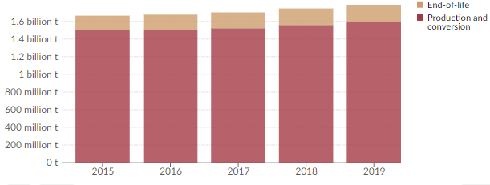
Figure 4: Greenhouse gas emissions from plastic by life-cycle stage, 2015 to 2019 (Emissions are measured in tons of carbon dioxide-equivalents) (OECD, 2022).

4.3 Life Cycle Impact Assessment (LCIA)
4.3.1 Environmental animals’ health impacts
Plastic packaging materials are said to be among the major environmental pollutants due to their resistance to biodegradation and poor management measures, thus leading to environmental accumulation or pollution (Ncube et al., 2021). Plastic materials production is responsible for 4.5% of global greenhouse gas emissions (Stegmann et al., 2022). For instance, polyethylene mulch film residue in soil was reported to range from 80 to 502.2 kg/ha, with recognisable environmental pollution in China. Furthermore, plastic residues in the environment impair water use efficiency and plant growth, thus reducing yields (Gu et al., 2024). Plastic waste from agricultural activities and other sources is easily transported to water bodies, including oceans, consequently impacting marine ecosystems (Chen et al., 2021). The extraction of raw materials for plastics again pollutes the environment and disrupts the ecosystem. The trend shows that plastics will continue to be generated with less recycling (Figure 5).
Furthermore, massive accumulation of microplastics on earth poses a deadly problem for ecosystems (Roy et al., 2022). For instance, if too much microplastic accumulates in an animal over overtime, it can cause intestinal blockages or punctured organs (Bhowmik et al., 2024). The persistence of plastic in our environment is said to be lasting hundreds to thousands of years (Rhodes, 2019). This phenomenon disrupts natural processes and degrades most of the habitats of marine and wildlife animals (Sharma and Chatterjee, 2017; Chatterjee and Sharma, 2019). Similarly, plastic pollution poses significant threats to animal health through ingestion, entanglement, and habitat disruption, impacting their survival and overall well-being (Morrison et al., 2022; Jeong et al., 2024). The environmental impacts imply the cost required for environmental cleaning, protecting water bodies, water cleaning, protecting plants, protecting animals, etc. (Kolawole and Iyiola, 2023).
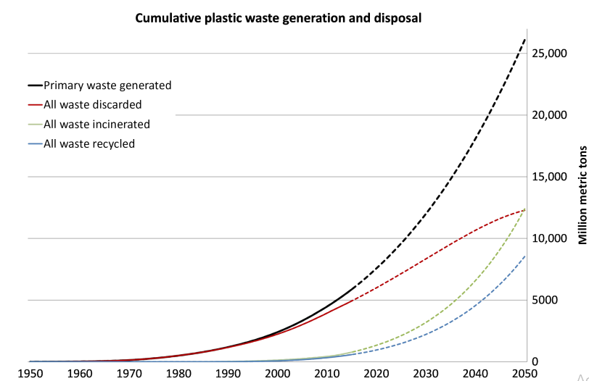
Figure 5: Global cummulative plastic waste generation and disposal (in million metric tons): solid lines shows the historical data while doted lines showa the projected trends from 2015 to 2020) (Geyer et al., 2017).

4.3.2 Impact on human health
The human health impact of plastics can be in different forms, including the one caused by environmental pollution due to extraction, transportation and distribution. Furthermore, the interaction of the plastic materials and the packaged foods can lead to the migration of microplastics into foods, consequently entering the human body following consumption of contaminated food. Some of the chemicals found in plastics, like phthalates, bisphenol A (BPA), and styrene, can migrate from the plastic into the food, especially when exposed to agents such as heat, acidity, or long-term storage (Manoli and Voutsa, 2019). These compounds are linked to serious chronic health problems such as cancer, endocrine disruption, insulin resistance, weight gain and impaired reproductive health (Benjamin et al., 2017; Godswill and Godspel, 2019). Those are very serious chronic health problems which affect human health. The impact on human health reflects the economic losses due to the death or sickness of people who can contribute to the economy; also, the expenditure of money for disease treatment is another cost implication.
4.4 Interpretation
Life cycle of plastic packages consumes huge amount of water and energy with the emission of heat (Kan and Miller, 2022). Raw materials extraction, transportation and distribution of plastic materials contributes less to the environmental impacts as compared to production and end of life stages. Production stage leads in the emission of greenhouse gases followed by end life stage, and among the greenhouse gases, CO₂ is the major leading greenhouse gas in polluting the environment (Ritchie and Roser, 2023).
The primary plastic waste will gradually continue to be generated with less recycling. The plastic materials will contaminate the environment more than twice by 2050 as compared to current situation (Geyer et al., 2017). This also implies that the impact on the environment such as greenhouse gas emission will double (Stegmann et al., 2022). Generally the production of biodegradable plastics is increasing today (Ncube et al., 2020). Land fill is the major fate of plastic wastes while recycling being the least (Kan and Miller, 2022).
The human health impact of plastics can be in different forms including the one caused by environmental pollution due to extraction, transportation and distribution, but the major leading chronic health problems are the one attributed by migration of plastic chemicals into packaged foods (Muzeza et al., 2023). Further health effects are shown in figure 6. The control of plastics in food packaging in thus important to prevent migration of micro plastics into packaged food items.
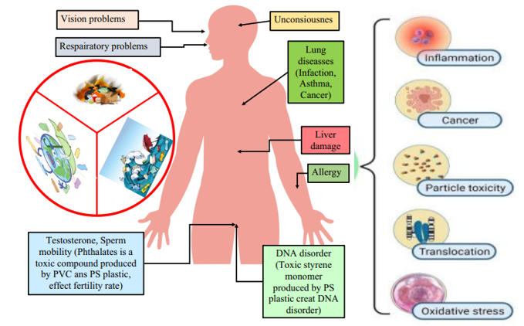
Figure 6: Negative impact of waste plastic on human health (Shah et al., 2024)

Conclusion
Plastic packaging materials are more widely used than any other type of materials in food packaging. Throughout their life cycle, plastics consume a lot of energy and water and emit heat to the environment. Furthermore, plastics pollute the environment and negatively impact life on earth. The use of alternative, easily recyclable packaging materials should be emphasised hand in hand with the innovation of biodegradable plastic packaging materials in inorder to overcome the negative impacts associated with current commonly used plastic food packaging materials. Also, enhancing recycling infrastructure and promoting better recycling practices can help divert plastic waste from landfills.

DISCLAIMER (ARTIFICIAL INTELLIGENCE)
Authors hereby declare that NO generative AI technologies such as Large Language Models (ChatGPT, COPILOT, etc.) and text-to-image generators have been used during the writing or editing of this manuscript.

REFERENCES
Adebayo-Ige, P. O., Engelhardt, S. M., & Larson, M. C. (2020). Mixed plastics waste to ethylene and propylene feedstocks. Senior Design Reports (CBE).
Ajaj, R., Abu Jadayil, W., Anver, H., & Aqil, E. (2022). A revision for the different reuses of polyethylene terephthalate (PET) water bottles. Sustainability, 14(8), 4583.
Alhazmi, H., Almansour, F. H., & Aldhafeeri, Z. (2021). Plastic waste management: A review of existing life cycle assessment studies. Sustainability, 13(10), 5340.
Barbhuiya, S., & Das, B. B. (2023). Life Cycle Assessment of construction materials: Methodologies, applications and future directions for sustainable decision-making. Case Studies in Construction Materials, 19, e02326.
Benjamin, S., Masai, E., Kamimura, N., Takahashi, K., Anderson, R. C., & Faisal, P. A. (2017). Phthalates impact human health: Epidemiological evidences and plausible mechanism of action. Journal of hazardous materials, 340, 360-383.
Bhowmik, A., Saha, G., & Saha, S. C. (2024). Microplastics in Animals: The Silent Invasion. Pollutants, 4(4), 490-497.
Chatterjee, S., & Sharma, S. (2019). Microplastics in our oceans and marine health. Field Actions Science Reports. The Journal of Field Actions, (Special Issue 19), 54-61.
Chen, Y., Awasthi, A. K., Wei, F., Tan, Q., & Li, J. (2021). Single-use plastics: Production, usage, disposal, and adverse impacts. Science of the total environment, 752, 141772.
Dey, S., Veerendra, G. T. N., Babu, P. A., Manoj, A. P., & Nagarjuna, K. (2024). Degradation of plastics waste and its effects on biological ecosystems: A scientific analysis and comprehensive review. Biomedical Materials & Devices, 2(1), 70-112.
Di Paolo, L., Abbate, S., Celani, E., Di Battista, D., & Candeloro, G. (2022). Carbon footprint of single-use plastic items and their substitution. Sustainability, 14(24), 16563.
Evode, N., Qamar, S. A., Bilal, M., Barceló, D., & Iqbal, H. M. (2021). Plastic waste and its management strategies for environmental sustainability. Case studies in chemical and environmental engineering, 4, 100142.
Fadiji, T., Rashvand, M., Daramola, M. O., & Iwarere, S. A. (2023). A review on antimicrobial packaging for extending the shelf life of food. Processes, 11(2), 590.
Gazal, A. A., & Gheewala, S. H. (2020). Plastics, microplastics and other polymer materials–a threat to the environment. J. Sustain. Energy Environ, 11, 113-122.
Geyer, R., Jambeck, J. R., & Law, K. L. (2017). Production, use, and fate of all plastics ever made. Science advances, 3(7), e1700782.
Gholami, Z., Gholami, F., Tišler, Z., & Vakili, M. (2021). A review on the production of light olefins using steam cracking of hydrocarbons. Energies, 14(23), 8190.
Godswill, A. C., & Godspel, A. C. (2019). Physiological effects of plastic wastes on the endocrine system (Bisphenol A, Phthalates, Bisphenol S, PBDEs, TBBPA). International Journal of Bioinformatics and Computational Biology, 4(2), 11-29.
Gu, F., Guo, J., Zhang, W., Summers, P. A., & Hall, P. (2017). From waste plastics to industrial raw materials: A life cycle assessment of mechanical plastic recycling practice based on a real-world case study. Science of the total environment, 601, 1192-1207.
Gu, X., Yin, R., Cai, W., Chen, P., Cui, K., Du, Y., ... & Cai, H. (2024). Residual plastic film decreases crop yield and water use efficiency through direct negative effects on soil physicochemical properties and root growth. Science of The Total Environment, 946, 174204.
Hassanpour, M., & Unnisa, S. A. (2017). Plastics; applications, materials, processing and techniques. Plastic Surgery Mod Tech, 2, 109.
Jankowska, E., Gorman, M. R., & Frischmann, C. J. (2022). Transforming the plastic production system presents opportunities to tackle the climate crisis. Sustainability, 14(11), 6539.
Jeong, E., Lee, J. Y., & Redwan, M. (2024). Animal exposure to microplastics and health effects: a review. Emerging Contaminants, 100369.
Kan, M., & Miller, S. A. (2022). Environmental impacts of plastic packaging of food products. Resources, Conservation and Recycling, 180, 106156.
Kolawole, A. S., & Iyiola, A. O. (2023). Environmental pollution: threats, impact on biodiversity, and protection strategies. In Sustainable utilization and conservation of Africa’s biological resources and environment (pp. 377-409). Singapore: Springer Nature Singapore.
Kumar, S., Singh, E., Mishra, R., Kumar, A., & Caucci, S. (2021). Utilization of plastic wastes for sustainable environmental management: a review. ChemSusChem, 14(19), 3985-4006.
Larasati, K., Frimawaty, E., & Chairani, E. (2024). LIFE CYCLE ASSESSMENT OF PLASTIC PACKAGING PRODUCTION. Journal of Environmental Science and Sustainable Development, 7(1), 460-479.
Manoli, E., & Voutsa, D. (2019). Food containers and packaging materials as possible source of hazardous chemicals to food. Hazardous Chemicals Associated with Plastics in the Marine Environment, 19-50.
Marczak, H. (2022). Energy inputs on the production of plastic products. Journal of Ecological Engineering, 23(9).
Morrison, M., Trevisan, R., Ranasinghe, P., Merrill, G. B., Santos, J., Hong, A., ... & Somarelli, J. A. (2022). A growing crisis for One Health: Impacts of plastic pollution across layers of biological function. Frontiers in Marine Science, 9, 980705.
Muzeza, C., Ngole-Jeme, V., & Msagati, T. A. M. (2023). The mechanisms of plastic food-packaging monomers’ migration into food matrix and the implications on human health. Foods, 12(18), 3364.
Nanda, S., & Berruti, F. (2021). Thermochemical conversion of plastic waste to fuels: a review. Environmental Chemistry Letters, 19(1), 123-148.
Ncube, L. K., Ude, A. U., Ogunmuyiwa, E. N., Zulkifli, R., & Beas, I. N. (2020). Environmental impact of food packaging materials: A review of contemporary development from conventional plastics to polylactic acid based materials. Materials, 13(21), 4994.
Ncube, L. K., Ude, A. U., Ogunmuyiwa, E. N., Zulkifli, R., & Beas, I. N. (2021). An overview of plastic waste generation and management in food packaging industries. Recycling, 6(1), 12.
Nicholson, S. R., Rorrer, N. A., Carpenter, A. C., & Beckham, G. T. (2021). Manufacturing energy and greenhouse gas emissions associated with plastics consumption. Joule, 5(3), 673-686.
Nielsen, T. D., Hasselbalch, J., Holmberg, K., & Stripple, J. (2020). Politics and the plastic crisis: A review throughout the plastic life cycle. Wiley Interdisciplinary Reviews: Energy and Environment, 9(1), e360.
OECD (2022) – processed by Our World in Data. “World” [dataset]. OECD, “Global Plastics Outlook - Plastics waste in 2019 by region, polymer and application” .
Okoffo, E. D., Donner, E., McGrath, S. P., Tscharke, B. J., O'Brien, J. W., O'Brien, S., ... & Thomas, K. V. (2021). Plastics in biosolids from 1950 to 2016: A function of global plastic production and consumption. Water Research, 201, 117367.
Piergiovanni, L., Limbo, S., Piergiovanni, L., & Limbo, S. (2016). Plastic packaging materials. Food packaging materials, 33-49.
Rhodes, C. J. (2019). Solving the plastic problem: From cradle to grave, to reincarnation. Science progress, 102(3), 218-248.
Ritchie, H., & Roser, M. (2023). How much of global greenhouse gas emissions come from plastics?. Our World in Data.
Roy, P., Mohanty, A. K., & Misra, M. (2022). Microplastics in ecosystems: their implications and mitigation pathways. Environmental Science: Advances, 1(1), 9-29.
Sarkar, S., & Aparna, K. (2020). Food packaging and storage. Research Trends in Home Science and Extension AkiNik Pub, 3, 27-51.
Shah, M. M., Yousaf, J., Khalid, U., Li, H., Yee, J. J., & Naqvi, S. A. Z. (2024). Plastic roads: asphalt mix design and performance. Discover Applied Sciences, 6(4), 195.
Shaked, S., Crettaz, P., Saade-Sbeih, M., Jolliet, O., & Jolliet, A. (2015). Environmental life cycle assessment. CRC Press.
Sharma, S., & Chatterjee, S. (2017). Microplastic pollution, a threat to marine ecosystem and human health: a short review. Environmental Science and Pollution Research, 24, 21530-21547.
Singh, N., & Demirsöz, R. (2022). Recycling of traditional plastics: PP, PS, PVC, PET, HDPE, and LDPE, and their blends and composites. In Nanomaterials in Manufacturing Processes (pp. 235-258). CRC Press.
Stegmann, P., Daioglou, V., Londo, M., van Vuuren, D. P., & Junginger, M. (2022). Plastic futures and their CO2 emissions. Nature, 612(7939), 272-276.
Wardrop, N. A., Dzodzomenyo, M., Aryeetey, G., Hill, A. G., Bain, R. E., & Wright, J. (2017). Estimation of packaged water consumption and associated plastic waste production from household budget surveys. Environmental Research Letters, 12(7), 074029.
Yadav, P., Silvenius, F., Katajajuuri, J. M., & Leinonen, I. (2024). Life cycle assessment of reusable plastic food packaging. Journal of Cleaner Production, 448, 141529.

