DESIGN AND CONSTRUCTION OF A TOP-HAT BARREL KILN

ABSTRACT
The design and construction of a barrel kiln involves the development of a structure that can efficiently produce heat for the purpose of firing ceramics, pottery, or other materials. This process involves the use of a cylindrical chamber made of insulating materials such as bricks, which is loaded with fuel (gas) and then ignited to create high temperatures of 1200ºc. various samples were looked into and were molded using 50mm by 50mm sizes, compressive strength test, thermal shock, bulk density, apparent porosity, water absorption test and shrinkage test were carried out, this was to identity the best sample suitable for the barrel kiln production. The construction process required careful attention to details in order to ensure that the kiln was properly insulated and that the heat was evenly distributed throughout the chamber. The design of the barrel kiln was done using a Computer Aided Design software (Rhino) this was to take into account detail and structure of how the kiln looked before proceeding to the development of the kiln. The best kaolin sample was selected in producing the best brick composition because of its low apparent porosity, high compressive strength, good thermal shock result, low shrinkage and best bulk density. The sample that was select is sample D which had 40% of kaolin, 40% of Saw dust and 20% of Ball Clay. The barrel kiln provides a cost-effective and reliable source of heat for various industrial and ceramic applications.
Keywords: Ball Clay, Ceramic materials, feldspar, CAD, Kiln

Introduction
Ceramic industries play an important role in creating and encouraging fast industrialization, (Akande-Adedeji,Olufunke and Sasa, John Mofolorunso, 2020). The success of any ceramic artist is heavily reliant on their ability to fire ceramic products. The ‘kiln’ is one such piece of equipment that is required for a successful firing. Ceramics are generally made by taking mixtures of clay, earthen materials and water which will be shaped into desired forms when heated to become hard, impervious and durable for utility and aesthetic purposes, (Akande-Adedeji,Olufunke and Sasa, John Mofolorunso, 2020). Once ceramics clay body is prepared, it will therefore be shaped by any clay forming technique which will then be subjected to desired heat temperature oven known as kiln. A Kiln is a thermally insulated chamber, a type of oven that produces temperatures sufficient to complete some process, such as hardening, drying, or chemical changes, (Wikipedia, 2021).
The word kiln descend from the Old English xylene Kylene, which was adopted from the latin “culian” for kitchen, cooking-stove, burning place according to Paragon (2021) .Kilns hardens ceramic bodies, heat treat steel, melt glass into crucibles, fuse layers of stained glass, melt enameling powder onto copper jewelry, and fire porcelain.
Refractory bricks are classified as ceramic building blocks used in fireplaces, fireboxes, kilns, and furnaces. In addition to being made particularly to withstand high temperatures, refractory bricks typically have low thermal conductivity for better energy efficiency. In other words, it is a non-metallic brick with a strong resistance to fusion that can tolerate high temperatures. They may readily be molded into bricks or other types of construction materials since they are chemically inert, strong enough to support the weight of the molten material, and relatively resistant to cracking and splitting under different temperatures. Refractories are ceramic materials that have the ability to withstand the action of very high temperature and remain unmelted and undeformed under load. According to Odewale (2018), refractories are high temperature and chemical resistance ceramic materials used in the insulation of furnaces and kilns against heat and chemical attacks. They are designed to withstand extremely high temperatures and resist thermal shock and corrosion and they are used in a variety of high-temperature applications, such as furnaces, kilns, incinerators, and reactors. They are typically made from ceramic materials such as alumina, magnesia, silica, and zirconia (Hugh O. Pierson, 1996).
This paper seeks to fabricate a barrel kiln which is a type of kiln made from waste barrel metal oil
Container or any container lined with refractory materials (such as brick, ceramic fibers) to enable the container to radiate and conserve the heat during ceramic firing process. The barrel kiln only use gas as a source of fuel and was constructed with barrel oil container and ceramic bricks. Ball clay, Kaolin and Sawdust were used to make the ceramic bricks, which were obtained in Akure and Ekiti State. In search of refractory materials, the prominent early researchers found out that clays could be suitable for furnace construction with respect to their thermal shock resistance, crushing strength and bulk density typical for dense refractory bricks Aniyi and Adewara, (1986), Hassan and Adewara (1993) and Lori et al., (2007). The bricks which were used to line the barrel drum is mainly insulating and refractory bricks. The refractory products in form of bricks are used in metallurgical, chemical, glass and petrochemical industries in furnace construction and maintenance. In Nigeria, most of the manufacturing and processing industries depend mainly on imported insulating refractory bricks for their furnaces, kilns, boilers, ovens, etc. in order to improve energy efficiency and reduce the loss of heat energy despite the abundant resources of fireclays in in the country. (Obidiegwu, E. O., Esezobor, D.E., Bodude, M.A. and Lawal, n.d.).

Statement of the Problem
The ceramic sector in Nigeria is experiencing underperformance, which has been attributed to the country's unfavorable economic situation. The ceramic industries have been unable to function successfully due to a lack of basic infrastructure for production and cost differential between ceramic items created in Nigeria and those made in other countries. High cost of essential materials, expensive energy generation, lack of fabrication equipment, particularly 'KILNS,' lack of processed materials, and finally, limited research centers for ceramics material processing, are the key infrastructural challenges of ceramic production in Nigeria. In order for the country to mitigate this downward economic trend, it will be necessary to develop inventive and adaptive ways to confront the current infrastructural deficit. As a result, this research explores the barrel kiln as a viable alternative to other kiln burning methods for the ceramic firing process.
The aim of this work was to design and construct a functional barrel kiln as a solution to the infrastructural deficit at the Department of Industrial Design Studio, Federal University of Technology, Akure. This paper looks into the previous gaps of kiln development. The barrel gas kiln that will be built will attain to the temperature of 1200⁰C. A barrel kiln burning gives variety of smoking options, allows for material experimentation and is unquestionably an excellent instructional activity. This research was limited to the sourcing of raw materials for brick making from Akure, Ondo State, and Igbimo Ekiti in Ekiti State, for the Design and construction of barrel kiln at the Industrial Design Department studio of the Federal University of Technology Akure.

The Advantages of barrel kiln over other types of kilns are;
The barrel kiln has several advantages over other types of kilns, including its ability to maintain a stable temperature, its fuel efficiency, and its relatively simple construction. According to Joe Finch, barrel kilns are efficient because they allow for good heat retention and can maintain a stable temperature. This is because the cylindrical shape of the kiln allows for a uniform distribution of heat throughout the kiln. Additionally, barrel kilns are fuel-efficient because they require less fuel than other types of kilns to achieve the same temperature. Barrel kilns are also relatively simple to construct, which makes them a popular choice for potters and ceramic artists
- Shape: The cylindrical shape of a barrel kiln allows for more efficient heat distribution and more even heating of the materials being fired.
- Fuel Efficiency: Because of their shape and size, barrel kilns can be more fuel efficient than other type of kilns, as the heat produced by the fire is able to circulate more evenly around the kiln.
- Cost: Barrel kilns can be relatively inexpensive to construct, especially compared to more modern kiln designs that require specialized equipment and materials.
- Consistent firing - The cylindrical shape of the barrel kiln promotes a more even distribution of heat and gases throughout the firing chamber, resulting in more consistent firing and fewer defects in the finished products.
- Easy to operate - Barrel kilns are relatively easy to operate and require minimal supervision compared to other types of kilns.

Raw materials and Methods adopted for the Research
As an earth substance, clay has characteristics that help identify it as clay and characteristics that cause it to behave in a peculiar way, indicating whether it is clay suitable for a particular ceramic purpose or not. Every earth material is supposed to be recognized based on its mineralogical composition. Every type of clay is thought to be the end result of geological processes that transform feldspar rock into an earthen mineral called clay. According to korankye and Oteng (2008) this feldspar has alkaline, silica and alumina as its main components and these are reduced to alumino silicates combined with the humidly of the environment and gives rise to the formation of new material called clay. Home (1953), also affirmed that this new material called clay differ from place to place due to the difference in the minerals present during the formation. However, said that almost all clays apart from kaolin have some level of plasticity, a physical property that allow for modeling and forming with the clay. There are factor that influence the plasticity of every clay.
The particle size of the clay according to Kwakume (2010) is a determinate factor of the plasticity of the clay. Finer [particle size contribute to high plasticity whereas coarser particle reduce plasticity. Speight and Toki (1999) explained that clays differ in their degree of plasticity. Some are so sticky they are almost impossible to shape. Rhode (1977) mentioned color as another physical property of clay that easily effect the clays thermal responses. He said that there are minerals that shoe their color only when the clay mineral has been exposed to heat. He explained these as metallic oxides that in some cases act as fluxes reducing the maturing temperature of the clay. This study determined that clay's plasticity is crucially important because it is a property that facilitates the binding of materials, particularly when non-plastic materials are involved. The introduction of non-plastic material can reduce the plasticity property, which is of primary importance. Appropriate control measures help to achieve the desired outcome. Nearly all of the clays that are readily available are relatively plastic.

Processing of Materials
These details are steps and methods used in the processing of the raw materials used in achieving the test tiles in a cubic shape for several physical and chemical test through lot of experimentations. The procedures used in achieving the goal of study were carried out based on their objectives.

Materials processing: The raw material sourced (ball clay) were packed, bagged and transported to the ceramic studio for final processing which includes drying, pounding, grinding and sieving into a very fine particle size using a macro mesh of size 125um before it could be used, while the saw dust which serves as the combustible was packed from Akure, and also sieved into a very particle size too. The Kaolin is already processed.
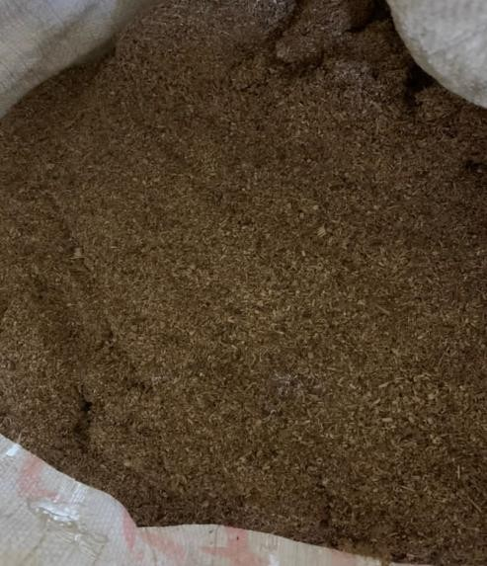

Plate 1: Saw Dust
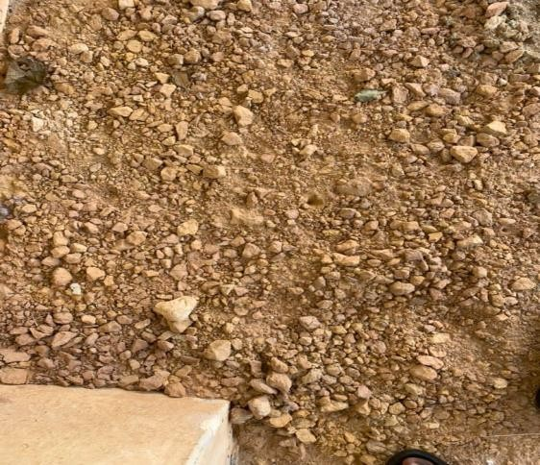
- Drying: This process involves the sun drying of the material (ball clay), just to make it well dried for easy pounding, grinding and sieving, which took 2weeks to complete this process.
Plate 2: Ball Clay

- Crushing of the material: This step involves pounding of the ball clay using the mortar and pestle, just for easy grinding when using the grinding machine (Maintenance of machines)
- Grinding: This is the process of grinding the ball clay using the grinding machine, this process makes sieving very easy and convenient for the materials to pass through the sieve.
- Sieving: This process involves extracting the fine particles from the grinded ball clay using the macro mesh of size 120, just to separate out coarser materials and impurities.

Test Tiles Body Formulation:
The test tiles were made of three basic components: kaolin, ball clay, and sawdust (combustible). The test tiles were constructed based on their intended use (as refractory bricks), and they were then constructed with refractory bricks in mind. The discovery of refractory bricks body formulations that are appropriate for refractory bricks was made possible by literature. In order to produce refractory bricks for kiln construction, this study used four different body sample compositions from earlier studies. Table 1 displays the compositions used in this study and provides an explanation of how the list of refractory brick samples (cubic shape test tiles) was derived.

Test Samples Formation
The study's other perspective is to describe its methodology. The other perspective of this research is to describe the technique (press molding method) used in forming the test samples.

Test Sample Making with Press Method
The steps involved in the forming of test samples using press method are;
  - Mold making: A wood was used as a mold. Cubic mold of 50mm by 50mm were machined using a lathe machine at Agricultural Engineering Department Workshop, FUTA to make sure that the edges of the cube are perfectly equal to each other, these was done according to standard precision that could be accommodated by Universal Testing Machine used in Building Department of FUTA, where test will be carried out on my samples
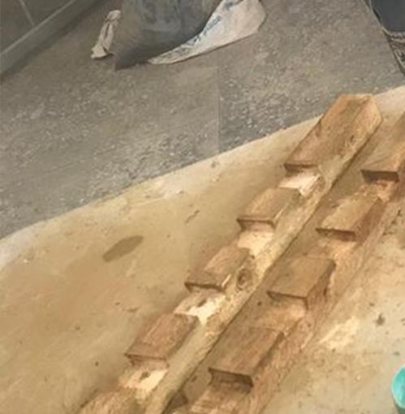
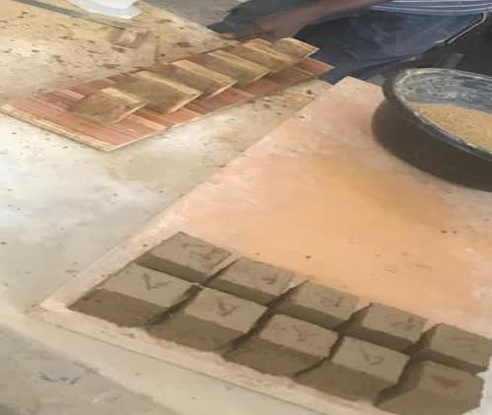
Plate 3: Mold Plate 4: Pressed out Test Tile
  - Mixing of Materials: The 3 materials which are kaolin, ball clay and saw dust (combustible) were mixed together in different %, into 4 different compositions with the addition of water strictly measured and was properly mixed and well kneaded just to ensure a homogeneous mixing of the compositions.
  - Pressing: Materials mixed together homogenously were pressed into the mold of 5 cubes to produce 5 samples at a time. Engine oil were applied on the mold which serves as the mold-releasing agent to make the materials remove conveniently from the mold and make the cubes perfect and accurate.
  - Weighing: Each of the 4 different composition were measured as all materials for each compositions weighed 600g using the by weight method of composition, it was recorded that the S600g of each composition were able to produce five 50mm by 50mm cubes of materials mixed together. And all cubes were still measured after production and recorded

Firing of the Test Samples
- Drying of the test sample
This process involve drying of the test sample in a gradual process before been put into the kiln chamber for firing, the test sample took 2weeks to dry after which it was placed on the kiln bat in the kiln. The kiln was sealed up with a mix clay with water to avoid heat from escaping from the kiln.

Preheating of the test sample
The test sample was pre-heated to about 500-600°c to allow the remaining traps moisture in the sample dry up before allowing it to experience a full blasting.

Firing of the test sample
The test sample attained to the degree of 1150°c which is known as the bisque and was allow to cool in the kiln.
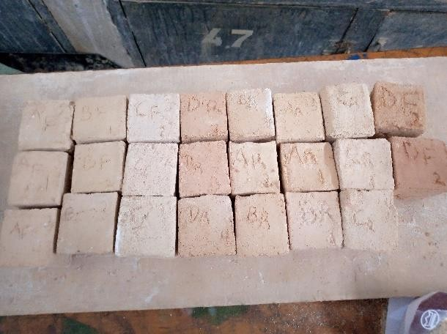
Plate 5: Fired Test Samples

Process of Producing Refractory Brick
There are three basic materials used in the producing insulating brick which are ball clay (binder), Kaolin and Saw dust. Various Composition was carried out alongside with testing of the test tile before getting into conclusion about the best composition that will suite the main refractory brick.
We have 4 various composition which was carried out on the table which indicated various percentage in each. Composition A, could not pass the vitreous test which resulted to excess saw dust in the composition, composition B could not withstand high level of firing which result to warping at 1150ºC, having an in balance between Kaolin and Ball clay. composition C, almost had a very close result with Composition D, but it could not pass the porosity and water absorption test, while composition D had a balance mixing in all having an equal almost small quantity of ball clay with a high percentage of kaolin and saw dust which is known as a refractory material that increase the melting point of a ware during firing and combustible that burns out when bricks are burning in the kiln which leaves hole in the brick. The pores formed as the admixtures are burned out allow the heat to enter the innermost part of the core, thus escaping unburnt cores, whereas the admixtures on their own part act as additional fuel that provides more energy for the fire.
Table 1: Composition of the three material.
Composition | A | B | C | D
Kaolin | 30 | 50 | 50 | 40
Ball Clay (binder) | 20 | 10 | 20 | 20
Combustible Saw dust | 50 | 40 | 30 | 40

Steps Taken During Brick Production:
1. Mixture of Composition: The mixture of composition involves 40% of kaolin, 40% of saw dust and 20% of ball clay with a little water. This process has been tested and found to be the best composition for making brick.

2. Brick Formation: This process involved putting the mixed composition into the brick maker or mold, this has various sizes. The handle of the brick maker is smashed hardly on the body of the mold for easy forming of brick before it is been removed.

3. Drying of Bricks: This process come after the bricks has been formed. The drying process takes 2weeks to dry before loading it into the kiln.
4. Firing Process: Firing of brick come after when the bricks has been successful loaded into the kiln, pre heating process has been carried out and then the full blasting. The brick is allow to cool for 2 days before offloading it out from the kiln. The spy hole is remove during this days to allow the cooling process to be successful. The fired brick attain to the temperature of 1000℃, the kiln was allowed to cool for two days before offloading it.

Designed Prototype of the Proposed Kiln
According to Adelabu, (2018) prototyping is a product development method used in nearly all design professions. It is a basic design step that entails the creation of functioning models (mockups) of envisioned items for mass manufacturing. Previously, the development of ceramic prototypes was done in a manual and time-consuming procedure that relied heavily on the abilities of an expert craftsman who solely used hand tools. The introduction of CAD technology to the ceramics industry has brought a wide range of answers to some of the challenges associated with manual ceramic production methods. The capacity to provide items faster than before by developing designs using graphic-enabled computer software has become a major enterprising aspect in the ceramic sector toward the delivery of excellent products. In the ceramic workshop, design templates created with computer design tools are increasingly being used to create clay product prototypes that exhibit precision and geometric regularity. Various glaze software systems have been developed abroad since the late 1970s to assist ceramic students and practitioners with their glaze calculation and formulation processes, yet this innovation is just now gaining traction in Nigeria. It's also worth noting that in Nigeria, an automated production system is already being used to mass-produce clay bricks. With a production capacity of 70,000 medium bricks per day, Kaduna Bricks and Clay Products Limited in Kaduna State, Nigeria, is an example of the implementation of this technology for the production of clay brick products. To this aim, the ability to create improve the functional, generate complex patterns on ceramic items, and manufacture ceramic products using computer-assisted applications has undoubtedly contributed to the attractiveness and enhancement of the built environment.
Rhinoceros will be utilized as the Computer Aided Design (CAD) software for this project, which will aid to detail the model of a barrel kiln into a simpler shape.

Barrel Materials (Drum, Metal Plates)
The metal plate/sheet that used was 4 by 8 feets measured, the metal sheet was fabricated in a round shape at the Department of Agricultural Engineering, Federal University of Technology, Akure. The barren kiln was shaped having both the body and the cover weld separately, the body of the barren kiln was smoothen properly to avoid unfinished cut. The hole which include, spy hold, burner pot, chimney and the lock was observed.
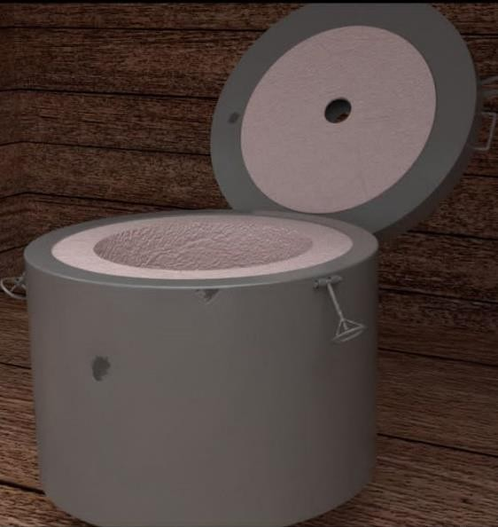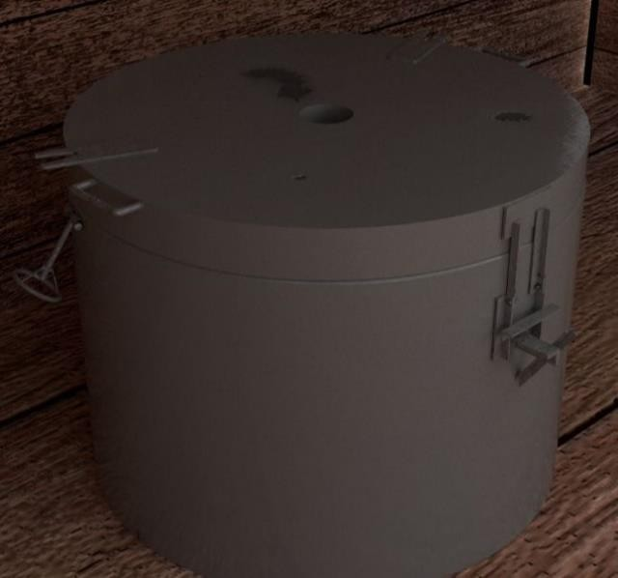
Plate 6: Open and Close views of the proposed barrel Kiln;

Barrel Kiln Construction
The foundation of the kiln was filled with mortar which was prepared using grog and kaolin in 3:1 respectively, sodium silicate was added to the materials which is an important thing when constructing a kiln as it helps serves as a strong binder that fuse bricks together and make it stronger, it serves as a deflocculant (substances which prevent flocculation and causes reduction in apparent viscosity). The kiln was filled up to 1feet before lining it with bricks. The body of the kiln was lined up with both mortar and bricks. The holes was observed during this process which include the spy hole, burner pot and chimney, the cover of the kiln was coated with mortar, brick and fiber. The kiln was allowed to dry for 3weeks before pre-heating it for 5 days, the kiln was washed properly using grog and kaolin in 3:1 in order to seal up the crack on it.
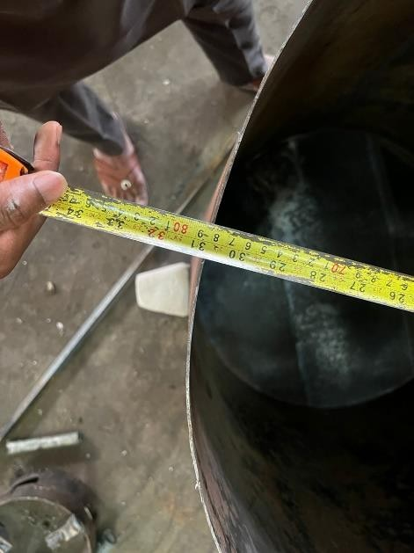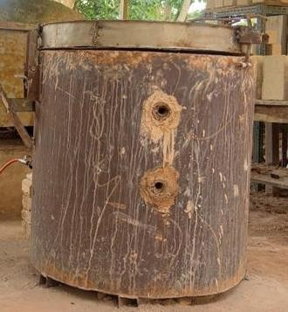
Plate 7: Construction of barrel kiln

Presentation and Discussion of Result
This chapter discuses and presents the results of the use of Igbimo clay which was sourced from Igbimo ekiti in Ekiti State, and saw dust as locally obtainable raw materials for the composition of refractory bricks for the construction of a barrel kiln. It also discusses and evaluates the suitability of the locally composed mortar and the products from the firing of the constructed kiln. The research findings and analysis of the data collected from various analyses conducted on the design and construction of a top hat barrel kiln are discussed under the following heading, each objective was strictly observed and documented in table and graph.

Production of Test Samples Using Various Compositions;
It was observed from Table 1 that there are four composition which are composition A – D, a total number of 16 sample were products which represent 4 from each composition the sample were allowed to dried at room temperature before it was fired using a gas kiln at 1150℃
Table 2: Test Samples Using Various Compositions
Composition | A | B | C | D
Kaolin | 30 | 50 | 50 | 40
Ball Clay (binder) | 20 | 10 | 20 | 20
Combustible Saw dust | 50 | 40 | 30 | 40

Observation
It was observed that, each samples absorb water at different rate, sample A which had high rate of combustible (saw dust) had high rate of water absorption and could not pass the vitreous test compare to sample B-D. Composition B could not withstand high level of firing which result to warping at 1150ºC, having an in balance between Kaolin and Ball clay. composition C, almost had a very close result with Composition D, but it could not pass the porosity and water absorption test, while composition D had a balance mixing in all having an equal almost small quantity of ball clay with a high percentage of kaolin and saw dust which is known as a refractory material that increase the melting point of a ware during firing and combustible that burns out when bricks are burning in the kiln which leaves hole in the brick. The pores formed as the combustible burned out allow the heat to enter the innermost part of the core, thus escaping unburnt cores, whereas the combustible on their own part act as additional fuel that provides more energy for the fire.

Determine the Physio-Mechanical Content of the Test Sample;
Various test were conducted on each samples which are Shrinkage test, Bulk Density, apparent porosity, compressive strength, water absorption, thermal shock test. This helped selecting the best composition that was suitable for the design of barrel kiln, the result of the test was documented in Tabular and graphical form.

Shrinkage Test
Table .2 gave the length, and weight of the samples (A-D) after firing. The table also shows the result for the percentage shrinkage of the test samples in accordance to ASTM C20-00 standard. The percentage shrinkage of the bricks produced investigated after firing at 1150ºc indicated that samples (A-D) of bricks had % total shrinkage ranging from 7% - 20%. This shrinkage was due to the percentage of combustible material (burn out) added to create pores in the bricks. The higher the combustible material the higher the shrinkage. Thus, it can be inferred from figure 1 below that the samples produced with the lowest percentage of combustible (C&D) had the least shrinkage value as they falls within the recommended value range of 7-10% for refractory bricks, while others (A&B) fell out, Chester (1973).

Table 3: Shrinkage Test Values for Samples Produced

SAMPLES | DRY LENGTH | FIRED LENGTH | DRY WEIGHT | FIRED WEIGHT | TOTAL SHRINKAGE  (%)
A | 57 | 53 | 239 | 219 | 20
B | 58 | 56 | 219 | 204 | 15
C | 59 | 57 | 274 | 267 | 7
D | 58 | 56 | 233 | 224 | 9

Figure 1: Shrinkage Values of Samples Produced

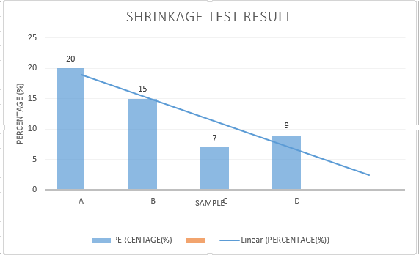
Bulk Density Test
The result of the bulk density as shown in table 3 below revealed that sample A- C has the lowest bulk density value (0.60%- 0.65%) as the brick samples had a range of 0.60 g/cm3 – 1.45 g/cm3.
The values of density and porosity determined by standard methods are used to recommend or predict the use of refractories for specific applications (Aderiye, 2015). In general, the higher the density, the lower the porosity, and a good refractory brick must have a high range of bulk density, which was why sample D was considered the best with a range of 1.45%
Table 4: Bulk Density Values for Samples Produced

SAMPLES | DRY WEIGHT  (D) | SUSPENDED WEIGHT (I) | SOAKED WEIGHT  (W) | (W-D) | V= (W-I) | BULK  DENSITY(g/cm^3)
A | 68 | 35 | 130 | 62 | 95 | 0.65
B | 79 | 45 | 135 | 56 | 90 | 0.62
C | 90 | 51 | 149 | 59 | 98 | 0.60
D | 99 | 59 | 147 | 48 | 88 | 1.45

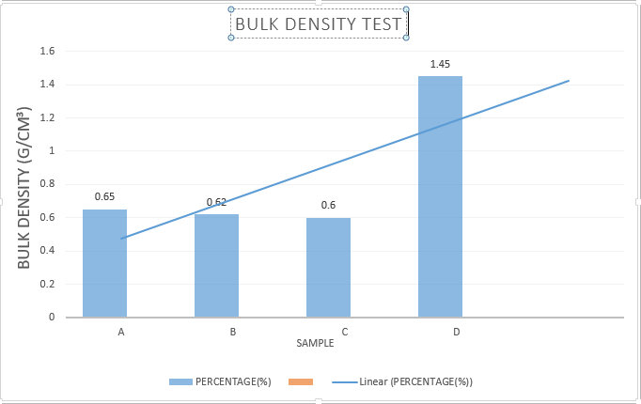

Figure 2: Bulk Density for Samples Produced

Apparent Porosity Test
Table 5 gave the estimated result of apparent porosity of the refractory brick samples produced. The result of the percentage porosity of the bricks indicated that sample A-D of brick had a range of 53.3% - 65.3% as revealed in figure 4 below. It was discovered that the higher the percentage of combustible materials the higher the burn out and pores also the higher the porosity of the bricks. However, all the samples fell within the required recommended porosity range of 40% - 85% of a refractory brick (Charles, 2004; Schulle & Schlegel, 1991 and William, 2006).
Sample D was considered the best because of its low range of porosity among others with 53.3%, as it is observed that a good refractory must not be too porous.
Table 5: Estimated Apparent Porosity of Refractory Brick Samples Produced

SAMPLES | DRY WEIGHT (D) | IMMERSED WEIGHT (I) | SOAKED WEIGHT (W) | (W-D) | V= (W-I) | APPARENT POROSITY (%) (W-D)÷V×100
A | 68 | 35 | 130 | 62 | 95 | 65.3
B | 79 | 48 | 135 | 56 | 87 | 64.4
C | 90 | 50 | 149 | 59 | 99 | 59.6
D | 99 | 57 | 147 | 48 | 90 | 53.3
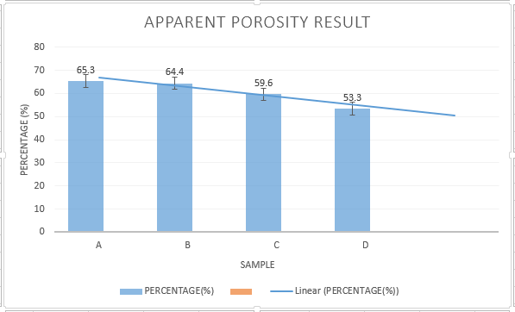
Figure 3: Apparent Porosity of Value of Samples Produced

Cold Crushing Test
The estimate obtained from the compressive strength is as presented in bar chart representation in figure 4. The result shown that sample C had the highest compressive strength of 7.2 as all samples are within the range of 2.4N/mm²-7.2N/mm^{2.} It was discovered that the higher the percentage of combustible materials the lower the crushing strength of the refractory bricks. However, only sample A fell below the required recommended cold crushing test range of 5MPa – 10MPa (Chester, 1973), while other samples are considered as the best because their high compressing strength.
Table 6: Compressive Strength Test
Samples | Compressive (MPa)
A | 2.4
B | 5.1
C | 7.2
D | 5.6

SAMPLE
D
C
B
A
2
1
0
2.4
5
4
3
5.1
5.6
7
6
7.2
8
COMPRESSIVE STRENGTH TEST (MPa)

STRENGTH OF MATERIALS

Figure 4: compressive strength result

Water Absorption
The result of the percentage water absorption of the refractory brick samples as produced in Table
6 indicates that sample A-D of brick had a range of 48.5% - 76.5%. It was discovered that the higher the percentage of combustible materials, the more it absorbs water, then the higher the water absorption of the bricks. However, all samples fell out of the required recommended water absorption range of 15% - 30% of a refractory brick (Charles, 2004; Schulle & Schlegel, 1991 and William, 2006). Sample D could be considered as it has the least water absorption range of 48.5% because a good refractory must not be too water absorbing.

Table 7: Water Absorption Test Conducted on Refractory Brick Samples
SAMPLES | SOAKED WEIGHT (W2) | DRY WEIGHT (W1) | WATER ABSORPTION (%) W2-W1 × 100  W1 1
A | 120 | 68 | 76.5
B | 135 | 79 | 70.9
C | 149 | 90 | 65.6
D | 147 | 99 | 48.5

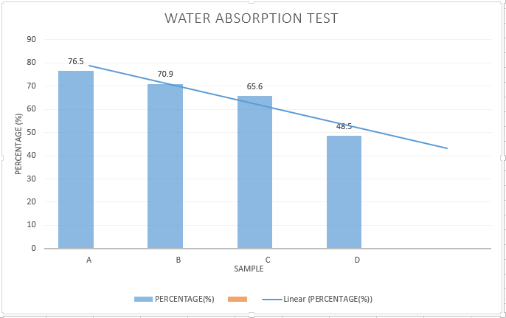
Figure 5: Water Absorption Value of Samples Produced

Thermal Shock Test
Insulating bricks are designed to have low thermal conductivity and high thermal resistance, making them suitable for use in high-temperature applications where heat insulation is critical. However, they are generally more susceptible to thermal shock than dense refractory materials due to their lower density and porosity. Thermal shock is the rapid temperature change that occurs when a material is exposed to a sudden and extreme temperature difference. This can cause stress within the material, which can result in cracking or failure.
Observation
Sample C and D was selected as the best and it was used to carry out the thermal shock test. Both sample came out well without any sign of crack or damages.

Production of Refractory Brick with the Best Composition
The brick that was used for the barrel kiln was selected from the best sample which was sample D, The mixture of the composition involves 40% of kaolin, 40% of saw dust and 20% of ball clay with a little water. This process has been tested and found to be the best composition for making brick. The process involved putting the mixed composition into the brick maker or mold, the mold used was constructed using wooden and it was in 15cm by 15cm, the materials was mixed homogenous and pressed out using the precise mode. 270 insulting bricks was pressed out and was allowed to dry in a room temperature, the bricks was left to dry for 2weeks before loading it into the kiln for firing. Firing of brick come after when the bricks has been successful loaded into the kiln, pre heating process has been carried out and then the full blasting. The brick is allow to cool for 2 days before offloading it out from the kiln. The spy hole is remove during this days to allow the cooling process to be successful.

Produce a Prototype Barrel Kiln
The barrel kiln was earlier designed using a Computer Aided Software named Rhinoceros, the dimension and size of the kiln was strictly observed, the design concept was developed using the design of a drum which is cylindrical in shape.
Mortal was used to lay the foundation of the kiln with a composition of grog and kaolin which is 3:1 and sodium silicate, the brick was lad on the side of the metal body alongside with the mortal for firmness and hardness. The cover of the barrel kiln was lad with bricks and mortar to the brim. The kiln was allowed to dry for two weeks and it was pre-heated for two days before it was loaded with wares and fired to the temperature of 900ºc. The kilns was allowed to cool before offloading the ware, the barrel kiln was painted to prevent the metal sheet from rusting.

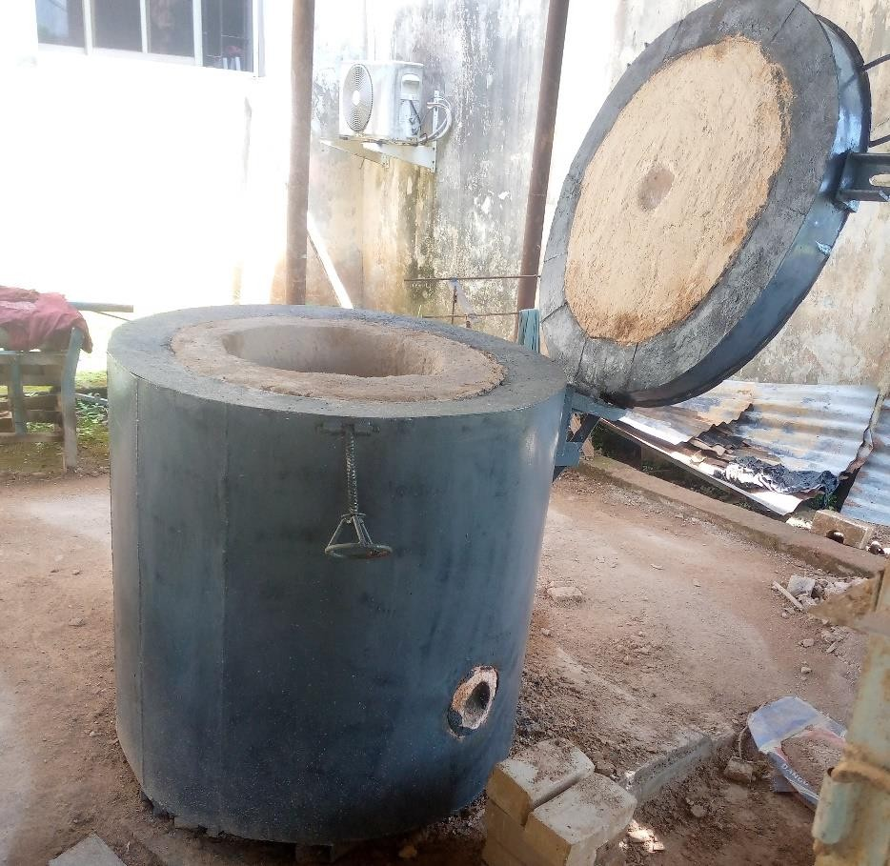
Plate 8: Painted barrel kiln

Summary
The design and construction of a barrel kiln involved the creation of a cylindrical chamber made of insulating materials, such as bricks, the construction process required careful attention to ensure proper insulation and even heat distribution. It was discovered that the higher the combustible materials the higher the shrinkage, water absorption and apparent porosity test while the lower the bulk density and crushing strength of the bricks. However, sample D of brick sample gave the most favorable result when considering the percentage shrinkage, bulk density, average crushing strength, and water absorption. Therefore 40% of saw dust can be used as combustible material for mass production of refractory bricks together with kaolin and ball clay (Binder) of 40% and20 % respectively sourced from Igbimo-Ekiti, Ekiti State, Nigeria. Refractory bricks of this kind can be used in both construction and maintenance of furnaces and kilns used ceramic industries.

Conclusion
In conclusion, the design and construction of a barrel kiln is a complex process that requires careful attention to detail and consideration of various factors such as size, insulation, fuel efficiency, and safety. The use of advanced materials, techniques, and alternative energy sources has contributed to the optimization of barrel kilns, through the use of the best sample which is sample D, this make the barrel kiln more efficient, cost-effective, and environmentally friendly.
However, regular maintenance and adherence to safety guidelines are also crucial to ensure the optimal performance and safety of the kiln.
The finding of this study also proved expedient use of Igbimo Ekiti clay for the production of refractory bricks that is being fired to 1150ºc. The study further shows that particle size of 125um could be suitable for the production of refractory bricks in order to have a smooth body and other desired properties. The findings of this study could liberate large and small scale industries, ceramic students in various tertiary institutions, and intending manufacturer of refractory bricks to effectively produce refractory bricks using locally available clay materials.

REFERENCE

Adelabu O.S, (2019). Prototyping Design for Ceramic Industry (Kiln Construction and Development) Lecture Note pp: 8-15.
Agberia, J.T (1998) “The Ceramic Industry In Nigeria: Problems And Prospects” USO:Nigerian Journal Of Art, Vol. (1&2), Pg. 64-71.
Amy Tikannen 2019. What is Kaolin? ; retrieved from: https://www.britannica.com/science/kaolin on 12th of November, 2019
ASTM C27 / C27M-21 Standard Specification for Fireclay and High-Alumina Refractory Brick:https://www.astm.org/Standards/C27.htm
ASTM International. (2018). ASTM C373-18a - Standard Test Method for Water Absorption, Bulk Density, Apparent Porosity, and Apparent Specific Gravity of Fired Whiteware Products, Ceramic Tiles, and Glass Tiles. Retrieved from https://www.astm.org/cgi-bin/resolver.cgi?C373
ASTM, 2001. ASTM C 67-99a, Standard Test Methods for Sampling and Testing Brick and Structural Clay Title. Annual Book of Standards. Vol. 04.0, American Society for Testing and Materials, West Conshohocken, PA.
Charles, A.S. (2004). Refractories Handbook, Marcel Dekker, Inc., 17-19
Chester, J.H. (1973). Refractories, properties and production, The Iron and Steel Institute Publication, 1973 edition. 87-92.
Egbai, J.C (2013). Kaolin Quantification in Ukwu-nzu and Ubulu-Uku using Electrical Resistivity Method. International Journal of Education Researchers Vol 14, Issue 3. Pp.23-76
Emmanuel A. Okunade, 2008. The Effect of Wood Ash and Sawdust Admixtures on the Engineering Properties of a Burnt Laterite-Clay Brick. Journal of Applied Sciences, 8: 1042-1048.
FMST (2010). Federal Ministry of Science and Technology. Non-metallic mineral endowments in Nigeria.
Hassan S.B. and Adewara J.O.T, (1993), Refractory properties of some Nigerian clays. Nigerian Society of Engineers Technical Transactions.28 (3), 21-25.
Iqbal, Y, and Lee, W.E (2000) “Microstructural evolution in Triaxial porcelain” J. Am. Ceram. Soc. 83 [12] pp. 3121-27.
Mofolorunsho, J., & T, U. (2021). Barrel Kiln: A Practical Alternative to Firing in Ceramics Production. 8(9), 1–10.
Obidiegwu, E. O.,Esezobor, D.E., Bodude, M.A. and Lawal, G. I. (n.d.). PHYSICO-MECHANICAL AND THERMAL PROPERTIES OF INSULATING REFRACTORY BRICKS DEVELOPED FROM IKORODU. 47–57.
Odewale, I. O., Ibiam, A., Polytechnic, F., Ameh, E., Amaakaven, V., & Production, R. B. (2018). COMPARATIVE ANALYSIS OF INSULATING BRICK PRODUCED FROM LOCALLY SOURCED CLAYS AND COMBUSTIBLE MATERIALS Journal of Science, Engineering Development, Environment Technology LOCALLY SOURCED CLAYS AND COMBUSTIBLE MATERIALS . Department of Ceramic and Glass Technology, Akanu Ibiam Federal Polytechnic Department of Metallurgical and Materials Engineering Enugu State University of. August 2020.
Paragon. (2021). what is a kiln. paragonweb.com/support/what-is-a-kiln/
Wikipedia. (2021). kiln. http://en.m.wikipedia.org/wiki/kiln

