***Original Research Article***

**Spatial Dynamics and Environmental Implications of Abandoned Residential Properties in Urban Nigeria: A Case Study of Abeokuta**

**Abstract**

This study investigates the spatial dynamics and environmental implications of abandoned residential properties in urban Nigeria, using Abeokuta as a case study. The increase of abandoned buildings in government-developed estates presents critical urban and environmental challenges, yet little empirical research has examined their spatial distribution and ecological consequences in Nigerian cities. This study addresses this gap through a mixed-methods approach, integrating geospatial analysis with field-based environmental assessment. Data were collected from four major housing estates in Abeokuta Ibara GRA, Asero, Obasanjo Hilltop, and Laderin using handheld GPS devices, environmental observation checklists, and photographic documentation. A total of 400 abandoned properties were recorded, with Ibara GRA accounting for the highest concentration (156 structures). Spatial mapping using QGIS revealed clusters of abandonment in Ibara and Asero, Environmental assessments identified a range of hazards including illegal waste dumping, overgrown vegetation, stagnant water, and rodent infestations. Statistical analysis using linear regression produced a strong predictive relationship between abandonment factors and environmental impacts (R² = 0.612; B = 0.327; p < 0.001), validating the spatial-environmental connection. Field survey responses further revealed high levels of crime vulnerability (mean = 4.39) and pollution concerns (mean = 3.88) associated with these sites. The findings underscore the urgent need for environmentally informed urban housing policies that incorporate geospatial tools. Policy recommendations include the creation of a GIS-based registry of abandoned properties, enforcement of development timelines, promotion of adaptive reuse strategies, and improved collaboration between urban planning and environmental health agencies. By demonstrating the environmental burden of urban neglect and the potential of spatial diagnostics, this study contributes to a more sustainable framework for managing abandonment and revitalizing Nigerian cities.

**Keywords**: *Abandoned buildings, spatial analysis, environmental impact, GIS, urban policy, Nigeria, Abeokuta.*

**1. Introduction**

Urbanization is a defining feature of modern development, especially across developing countries where the population surge in cities often outpaces the capacity of infrastructure, housing, and public services (Dijkstra *et al.* 2021). In Nigeria, a country experiencing rapid urban growth, the strain on urban planning and land use management has led to complex challenges, one of which is the proliferation of abandoned residential properties in government established estates. These abandoned buildings not only reflect underlying socio-economic dysfunction but also pose serious threats to environmental sustainability, urban aesthetics, and public health (Santos & Ramalhete, 2024).

Residential buildings are meant to provide shelter and support the social and economic well-being of urban dwellers (Muianga et al., 2022). However, when these buildings are left vacant or abandoned, often due to factors such as the death of the original owner, financial constraints, litigation, or mismanagement, they deteriorate physically and become environmental liabilities. Over time, abandoned structures contribute to urban decay by attracting illegal dumping, overgrown vegetation, stagnant water pools, and infestations of rodents and insects (Ngakane, 2021). They also increase the risk of fire hazards and serve as breeding grounds for criminal activity. Despite these significant concerns, the environmental dimension of building abandonment in urban Nigeria remains largely underexplored in scholarly literature.

While several studies such as Obakin et al., (2024) have examined the socio-economic drivers and effects of housing abandonment in Nigeria, there is a noticeable gap in spatial and environmental analysis. Most existing research focuses on policy, governance, or real estate implications, with insufficient attention given to the spatial distribution and ecological consequences of urban abandonment. Moreover, the few environmental studies conducted in this area lack empirical grounding in geospatial techniques such as Geographic Information Systems (GIS), which offer powerful tools for mapping and analyzing urban patterns.

This study addresses that critical gap by applying a spatial analytical lens to the problem of abandoned residential buildings in selected government housing estates in Abeokuta, the capital city of Ogun State in southwestern Nigeria. Using QGIS software for spatial analysis, supported by field-based environmental observations and community-level data, this research investigates both the distribution of abandoned buildings and their environmental impacts within four prominent estates: Ibara, Asero, Obasanjo Hilltop, and Laderin. These estates were chosen for their strategic urban significance and documented cases of abandonment. By combining spatial data with environmental field assessments, this research contributes to a more holistic understanding of urban decline in Nigerian cities. It highlights the urgent need to incorporate spatial thinking into housing and environmental policies, particularly in the face of increasing urban population pressures. The study also supports ongoing discourse on adaptive reuse, advocating for environmentally beneficial transformations of abandoned spaces such as conversion to green areas, parks, or community centers.

**2. Vacant and Abandoned Properties in Urban Spaces**

Abandonment in the urban context refers to the process by which buildings and land lose their active use and fall into disrepair, often due to neglect, socio-economic dislocation, or policy failures (Obakin et al., 2024). While the terms "vacant" and "abandoned" are sometimes used interchangeably, scholars make a distinction between temporary vacancy and long-term neglect. Vacant properties may still be maintained and habitable, whereas abandoned properties typically lack upkeep and ownership accountability, posing risks to public safety, aesthetics, and land utility (Nouaihed, 2021).

In Nigeria, abandoned housing estates are commonly found in both government and private developments. These structures often reflect broader systemic issues such as insufficient project financing, planning inconsistencies, bureaucratic delays, and poor regulatory oversight (Babalola et al., 2024) Although abandonment is not simply a product of economic failure it is also deeply spatial, manifesting in identifiable clusters that shape the landscape of urban blight and environmental decline.

**2.1. Spatial Patterns of Urban Abandonment**

Urban spatial analysis is critical for identifying and understanding patterns of neglect within cities. GIS-based approaches offer powerful tools for detecting concentrations of abandoned properties, establishing correlations with socio-economic and environmental variables, and guiding urban policy interventions. Studies in the United States and Europe have shown that abandoned properties tend to cluster in neighborhoods with lower income, aging infrastructure, and weak housing markets (Wang, 2016). In such contexts, spatial concentration leads to cumulative decline, where one abandoned structure often precipitates further disinvestment and neglect in adjacent properties a phenomenon known as the “contagion effect.”

In the Nigerian context, few studies have engaged spatial technologies to map or analyze abandoned properties. Most existing research (e.g., Alaezi, et al., 2021; Obakin, 2024) focus on the socio-economic drivers or policy dimensions of abandonment without incorporating geographic visualization or environmental externalities. This limits the ability of policymakers and planners to formulate targeted, data-driven interventions.

**2.2. Environmental Impacts of Abandoned Residential Properties**

The environmental consequences of abandoned buildings are diverse and far-reaching. Derelict structures often become sites for illegal dumping, air and water pollution, overgrowth of invasive plant species, and breeding grounds for disease vectors such as mosquitoes and rodents (Adla et al., 2022). These physical conditions pose risks to local biodiversity, strain municipal waste management systems, and endanger public health.

In addition, stagnant water in abandoned buildings can promote the spread of malaria and other vector-borne diseases in tropical climates, while overgrown vegetation may heighten fire hazards during dry seasons. Unmaintained structures also accumulate solid waste, leading to increased environmental degradation and loss of visual quality in residential neighborhoods (Mutisya, 2016). Despite these risks, environmental concerns are often underrepresented in urban housing studies in Nigeria. Most urban policy documents address abandonment as a housing or economic issue, rarely acknowledging the environmental and ecological burdens imposed by such properties. This oversight points to a critical research gap that this paper aims to fill.

**2.3. Adaptive Reuse and Sustainable Urban Development**

Urban scholars and practitioners have increasingly emphasized adaptive reuse as a sustainable response to property abandonment. Adaptive reuse refers to the process of repurposing old or abandoned structures for new functions that serve the community, such as green parks, social centers, or affordable housing (Stanganelli et al., 2023). These interventions not only restore the utility of the built environment but also reduce the pressure on natural ecosystems by minimizing the need for new land conversion.

In cities like Detroit and Cleveland, large-scale demolition of abandoned homes has given way to community gardens, urban agriculture, and energy-efficient infill development. Such practices are, however, largely absent in Nigeria, where abandoned properties are more often left to deteriorate. Efforts at revitalization remain fragmented and poorly coordinated due to weak institutional frameworks, lack of funding, and insufficient integration of environmental planning in housing policy (Unegbua et al., 2024).

**2.4. Theoretical Perspective: Environmental Determinism and New Urbanism**

The theoretical underpinning of this study is drawn from Environmental Determinism, which posits that environmental conditions significantly shape human behavior, settlement patterns, and land use outcomes (Livingstone, 2011). In the context of abandonment, deteriorating environmental quality reinforces urban decline, disincentivizes reinvestment, and reduces the resilience of local communities.

Additionally, New Urbanism which advocates for compact, walkable, and environmentally sustainable neighborhoods provides a framework for rethinking abandoned properties as opportunities for green integration, public open spaces, or infill redevelopment (Cysek-Pawlak & Pabich, 2021). By aligning spatial planning with environmental goals, urban regeneration efforts can simultaneously address ecological challenges and social disparities.

**3. Methodology**

**3.1. Study Area**

The research was conducted in Abeokuta, the capital of Ogun State, southwestern Nigeria. As a medium-sized but rapidly urbanizing city, Abeokuta presents a unique blend of traditional settlement patterns and modern estate development driven by government housing policies. The city has experienced considerable expansion in recent decades, partly due to its proximity to Lagos and its growing administrative significance.

Four major government-established housing estates within Abeokuta were purposively selected for this study: **Ibara GRA**, **Asero Estate**, **Obasanjo Hilltop**, and **Laderin Estate**. These estates were chosen based on preliminary evidence of high rates of housing abandonment, their socio-economic diversity, and their significance in the urban residential structure of the city. Collectively, they represent a range of spatial, demographic, and environmental conditions relevant to the study of urban abandonment.

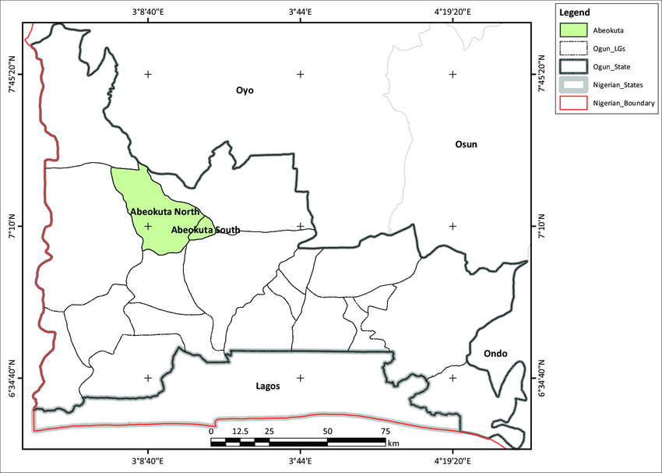

Figure 1: Location map showing Abeokuta in Ogun State.

**3.2. Research Design**

This study adopted a mixed-methods case study design, integrating quantitative geospatial analysis with qualitative environmental assessment. This approach enabled a comprehensive understanding of the spatial distribution and environmental consequences of abandoned residential buildings.

The design was guided by three interrelated objectives: (1) to identify and map the spatial distribution of abandoned buildings, (2) to examine their environmental impacts, and (3) to provide evidence for sustainable urban policy interventions.

**List 1 : Data Sources and Collection process**

|  |  |
| --- | --- |
| **Primary Data** | **Secondary Data** |
| Field surveys involving direct observation of abandoned properties to assess environmental degradation indicators such as overgrowth, waste accumulation, standing water, and animal infestation. | Data sourced from the Ogun State Ministry of Housing (MOH). |
| GPS coordinate mapping of abandoned buildings using handheld devices, with data imported into QGIS for spatial analysis. | Data sourced from the Ministry of Physical Planning and Urban Development (MPPUD). |
| Photographic documentation of abandoned buildings and their surrounding environments. | Data sourced from the Ogun State Property Investment Corporation (OPIC). |
| Environmental observation checklists completed by field assistants during site visits. | Data sourced from the Ogun State Urban Planning Authority. |

**3.4. Sampling Technique**

A purposive sampling strategy was adopted to select the four housing estates with the highest known levels of abandonment. Within each estate, all visibly abandoned residential buildings were identified and recorded during field visits. A total of 400 GPS-mapped abandoned buildings were documented across the four estates, broken down as follows:

* Ibara GRA – 156 structures
* Asero Estate – 97 structures
* Obasanjo Hilltop – 80 structures
* Laderin Estate – 67 structures

This spatial sample formed the empirical base for GIS-based mapping and environmental risk profiling.

**4. Findings**

This section presents the findings from the spatial and environmental analysis of abandoned residential buildings across four major housing estates in Abeokuta: Ibara GRA, Asero, Obasanjo Hilltop, and Laderin. The results are drawn from field surveys, QGIS-based spatial mapping, and environmental impact assessments conducted during the study.

**4.1 Spatial Distribution of Abandoned Properties**

Spatial analysis using QGIS revealed significant clustering of abandoned structures in all four estates. Table 1 shows the total number of abandoned properties including completed but unoccupied buildings, uncompleted structures, and vacant plots across the study areas.

Table 1: Spatial Distribution of Abandoned Residential Structures in Selected Estates in

|  |  |  |  |  |  |
| --- | --- | --- | --- | --- | --- |
| NAME OF ESTATE | TOTAL NO OF PLOTS | ABANDONDED COMPLETED HOUSES | ABANDONED UNCOMPLETED BUILDING | VACANT ABANDONED LANDED PROPERTIES | TOTAL ABANDONED PROPERTY |
| ASERO HOUSING ESTATE | 282 | 31 | 34 | 32 | 97 |
| OBASANJO HILLTOP ESTATE | 516 | 39 | 12 | 29 | 80 |
| LADERIN HOUSEING ESTATE | 360 | 30 | 14 | 23 | 87 |
| IBARA GRA HOUSING ESTATE | 500 | 56 | 11 | 89 | 156 |

**Source**: *Field Survey, October 2024​.*

**Figure 2** below shows an imagery generated in QGIS, illustrating the density of abandoned buildings. The Ibara estate exhibits the highest concentration, followed by Asero.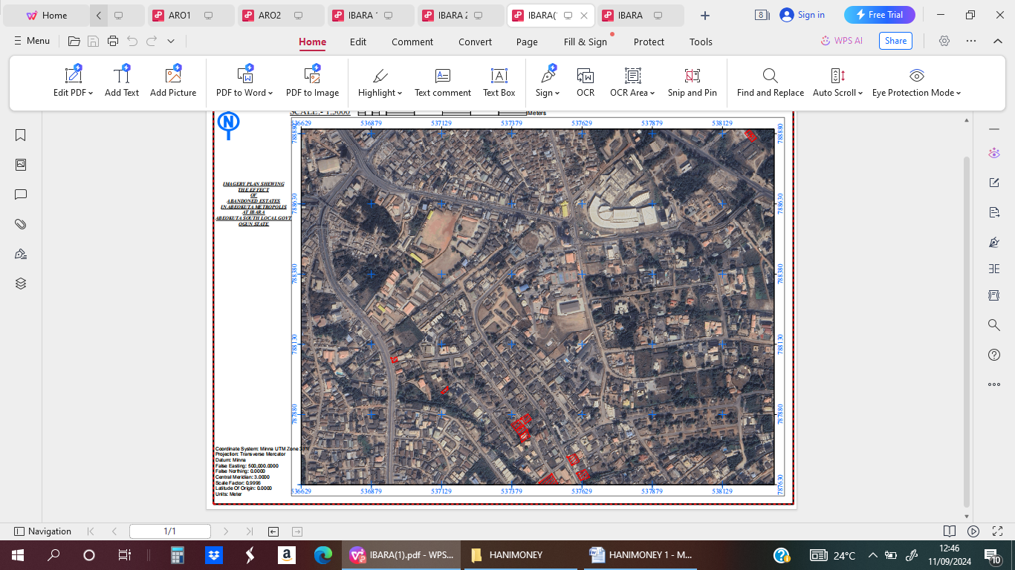

Figure 2: Imagery showing some abandoned area in Ibara, Abeokuta Ogun State.

Source: Data analysis using*QGIS , 2024*

**4.2 Typology and Geolocation of Abandoned Properties**

The abandoned structures were geolocated using handheld GPS devices. A sample of GPS coordinates for Ibara GRA is shown in Table 2:

Table 2: Sample Coordinates of Abandoned Buildings in Ibara Housing Estate  
*Source: Field Survey, 2024*

|  |  |  |  |
| --- | --- | --- | --- |
| **Station** | **Eastings** | **Northings** | **Status** |
| 01 | 537609 | 787670 | A/B |
| 02 | 537575 | 787729 | A/B |
| 03 | 537520 | 787668 | V/L |
| 04 | 537412 | 787866 | A/B |
| 05 | 537409 | 787863 | A/B |

*Note: A/B = Abandoned Building; V/L = Vacant Land*

**4.3 Environmental Impacts of Abandoned Properties**

Field observations and survey responses revealed that abandoned buildings have notable environmental effects on surrounding communities.

Table 3: Environmental Impacts of Abandoned Residential Buildings  
*Source: Field Survey, 2024*

|  |  |  |
| --- | --- | --- |
| **Effect** | **Mean Score** | **Standard Deviation** |
| Crime Vulnerability | 4.39 | 0.946 |
| Decrease in Property Value | 1.40 | 0.190 |
| Pollution | 3.88 | 0.710 |
| Decay of Property | 3.94 | 0.642 |
| Invasion of Reptiles | 3.56 | 0.853 |
| Waste Dumping Sites | 3.80 | 0.620 |

These impacts were corroborated by testimonies from residents and estate managers who described abandoned buildings as sites for:

* Illegal refuse disposal
* Mosquito and rodent breeding grounds
* Hiding spots for criminals
* Fire hazards due to bush overgrowth and discarded flammables

One respondent noted:

*“This building is no longer safe. We see snakes, the smell from the refuse is unbearable, and sometimes, strange people enter the place at night”*.

**4.4 Statistical Analysis of Environmental Impact Factors**

Using regression analysis, the study tested the relationship between the frequency of abandonment and its environmental implications. The results show:

Table 4: Linear Regression of Factors and Effects of Residential Building Abandonment

|  |  |  |  |  |
| --- | --- | --- | --- | --- |
| **Models** | **B** | **SE** | **T** | **Sig.** |
| Constant | 45.782 | 2.965 | 15.445 | <0.001 |
| Factors | 0.327 | 0.051 | 6.412 | <0.001 |
| *F (1,98) =41.10, Sig=<0.001, R2 =0.612 B: Standardized coefficient, SE: Standard Error, Sig: Level of significance | | | | |

The regression showed a strong predictive value (R² = 0.612), with qualitative observations and interviews affirming the significance of abandonment effects on the environment.

**5. Discussion**

The findings of this study highlight a pressing urban and environmental challenge within Abeokuta’s residential estates, the growing prevalence and environmental consequences of abandoned buildings. By integrating spatial mapping through QGIS with environmental impact assessment, this research offers new empirical and theoretical insights into the underexplored area of urban housing abandonment and ecological degradation in Nigerian cities.

**5.1. Spatial Concentration and Drivers of Abandonment**

The spatial distribution of abandonment reveals a pattern of clustering, with estates like Ibara GRA and Asero showing significantly higher densities of abandoned properties. This aligns with the theory of spatial contagion, which posits that urban blight tends to spread from one property to its neighbors (Hunter & Brown, 2012). The existence of 156 abandoned properties in Ibara alone suggests not just isolated neglect but systemic urban vulnerability. The typologies of abandonment ranging from vacant lands to uncompleted and deteriorated buildings are a reflection of broader socio-economic pressures, including absentee ownership, legal disputes, and cost inflation in the housing sector. These findings corroborate previous Nigerian studies such as Opawole et al., (2017) that identified poor project continuity and lack of access to finance as core contributors to urban property decay. Yet, this study expands on those by showing the spatial expressions of these drivers using geospatial evidence.

**5.2. Environmental Consequences: Physical and Public Health Risks**

The environmental consequences observed across the four housing estates were both immediate and far-reaching. The accumulation of solid waste, stagnant water, and invasive vegetation surrounding many abandoned properties create breeding grounds for mosquitoes, snakes, and rodents. These physical threats were frequently cited by residents during interviews and were also observed through photographic documentation and field checklists.

The high mean scores for crime vulnerability (4.39) and environmental pollution (3.88**)** (Table 3) confirm that abandoned buildings are not neutral spaces they actively degrade surrounding communities. This supports findings by Dewar & Thomas (2013), who documented similar patterns of environmental decay linked to long-term abandonment in U.S. cities. However, this study uniquely situates these risks within the ecological context of Nigeria’s urban fringe, where high rainfall and porous institutional oversight exacerbate these problems. The perception of abandoned spaces as criminal hideouts and dumping grounds not only erodes the social fabric of affected neighborhoods but also introduces direct public health risks, including increased exposure to vector-borne diseases, water contamination, and potential fire outbreaks. These outcomes affirm the hypothesis that abandonment significantly undermines both environmental quality and public safety.

**5.4. Adaptive Reuse and Missed Opportunities**

Despite the magnitude of the challenge, the study also points to significant untapped opportunities in managing abandoned properties. Field survey responses revealed support for adaptive reuse strategies, with high mean scores for conversion into green spaces (4.86) and renovation for reuse (4.21). These findings resonate with urban sustainability frameworks that advocate for the transformation of blighted properties into public assets rather than liabilities (Pileggi, 2024). Yet, such strategies remain underutilized in the Nigerian context due to policy fragmentation, institutional inertia, and lack of community engagement in redevelopment processes. The spatial data generated in this study could serve as the foundation for urban renewal initiatives that prioritize both environmental resilience and social equity.

**5.5. Synthesis with Theoretical Frameworks**

The findings also align with Environmental Determinism, which suggests that neglected environments shape human behavior and health outcomes negatively. As residents increasingly avoid blighted zones due to safety or health concerns, these areas become further marginalized, perpetuating cycles of decay. Meanwhile, the New Urbanism theory which emphasizes compact, walkable, and green urban design provides a compelling framework for repurposing these abandoned estates into inclusive, ecologically sustainable spaces.

Together, these theories support the study’s conclusion that abandonment is not merely a symptom of economic failure but also a spatial-environmental process that can be reversed through informed, place-based interventions.

**6. Conclusion and Policy Recommendations**

**6.1. Conclusion**

This study examined the spatial distribution and environmental impacts of abandoned residential properties within four major housing estates in Abeokuta, Nigeria. Using a mixed-methods approach that combined QGIS-based spatial analysis with environmental field assessments, the research provided new empirical evidence on the clustering patterns, risk zones, and ecological consequences associated with residential housing abandonment in a rapidly urbanizing Nigerian city.

Key findings indicate that abandonment is most severe in the Ibara and Asero housing estates, where clusters of unoccupied or decaying buildings are linked to socio-economic pressures such as absentee ownership, rising construction costs, and weak regulatory enforcement. The environmental consequences are substantial: abandoned properties serve as magnets for illegal waste dumping, promote vector-borne disease proliferation, contribute to fire hazards, and depreciate the aesthetic and functional quality of neighborhoods. These findings highlight a dangerous synergy between urbanneglect and ecologicaldegradation, which remains insufficiently addressed in Nigeria’s urban housing and environmental policies. The study also demonstrated the practical utility of geospatial tools in urban diagnostics and planning. The integration of spatial data with environmental fieldwork allowed for the identification of urban risk zones and the mapping of abandonment densities—providing a replicable model for other Nigerian cities facing similar challenges.

Overall, the research concludes that abandoned residential properties represent more than isolated instances of neglect they are spatially interconnected phenomena with profound environmental, social, and public health implications. Addressing this issue requires a multidisciplinary, data-driven, and environmentally informed approach to urban housing management.

**6.2. Policy Recommendations**

Drawing on the findings, the following policy recommendations are proposed to address the environmental and spatial impacts of housing abandonment and promote sustainable urban redevelopment. First, urban planning authorities should establish a centralized GIS-based registry of abandoned properties to support monitoring and renewal efforts. Second, governments should enforce time-bound development regulations, ensuring that uncompleted or unoccupied buildings are either redeveloped or penalized after a set period. Third, structurally sound abandoned buildings should be considered for adaptive reuse such as parks, urban farms, or affordable housing and retrofitted for environmental benefits. Fourth, collaboration between urban planning and environmental health units should be strengthened to ensure regular inspections for hazards like stagnant water, waste build-up, and pests. Fifth, incentives such as tax rebates or grants should be offered to encourage the rehabilitation of abandoned buildings. Sixth, residents should be involved in estate management through reporting mechanisms and community-led reuse projects. Finally, environmental impact guidelines should be extended to cover abandoned properties, especially in ecologically sensitive areas.

**6.3 Limitations and Suggestions for Further Research**

Although limited by dry-season data collection, restricted site access, and the lack of real-time satellite imagery, this study still offers a credible, data-driven analysis of the spatial and environmental implications of housing abandonment to inform urban planning and environmental policy.

Areas for further research include: using time-series geospatial data to track abandonment over time; examining the social and psychological effects of living near abandoned properties; and comparing patterns across rural–urban fringe areas in other Nigerian cities.

**References**

Adla, K., Dejan, K., Neira, D., & Dragana, Š. (2022). Degradation of ecosystems and loss of ecosystem services. In *One health* (pp. 281-327). Academic Press.

Alaezi, J. O., Rugu, E. A., Marut, J., & Igwe, C. O. (2021). The Effects of Abandonement of Projects in Plateau State Nigeria.

Babalola, O., Ugah, U. U. K., & Ndimako, O. (2024). Evaluating Governmental Constraints on Construction in Nigeria: A Review.

Chima, C. I. (2012). *Monitoring and modelling of urban land use in Abuja Nigeria, using geospatial information technologies* (Doctoral dissertation, Coventry University).

Cysek-Pawlak, M. M., & Pabich, M. (2021). Walkability–the New Urbanism principle for urban regeneration. *Journal of Urbanism: International Research on Placemaking and Urban Sustainability*, *14*(4), 409-433.

Dewar, M., & Thomas, J. M. (Eds.). (2012). *The city after abandonment*. University of Pennsylvania Press.

Dijkstra, L., Florczyk, A. J., Freire, S., Kemper, T., Melchiorri, M., Pesaresi, M., & Schiavina, M. (2021). Applying the degree of urbanisation to the globe: A new harmonised definition reveals a different picture of global urbanisation. *Journal of Urban Economics*, *125*, 103312.

Hunter, M. C. R., & Brown, D. G. (2012). Spatial contagion: Gardening along the street in residential neighborhoods. *Landscape and Urban Planning*, *105*(4), 407-416.

Livingstone, D. N. (2011). Environmental determinism. *The SAGE handbook of geographical knowledge*, 368-380.

Muianga, E. A. D., KnatzKowaltowski, D. C. C., Silva, V. G. D., Granja, A. D., Moreira, D. D. C., & Ruschel, R. C. (2022). Housing transformations and their impacts on the well-being of dwellers. *Ambiente construído*, *22*, 255-274.

Mutisya, E. M. (2016). *an Assessment ff Urban Decay in Residential Neighbourhoods* (Doctoral dissertation, University of Nairobi).

Ngakane, L. (2021). *Health concerns related to housing, sanitation, water access and waste disposal in a poor mixed urban community, Mbekweni in Paarl* (Doctoral dissertation, Stellenbosch: Stellenbosch University).

Nouaihed, R. (2021). *Vacant Properties as Opportunities to Enhance Neighborhood Public Life: the Case Of Badaro, Beirut* (Doctoral dissertation).

Obakin, O. A., Afolami, S. K., & Akande, O. K. (2024). Causative factors of Abandoned Urban Housing Projects and Strategies for Revitalization in Ibadan, Nigeria. *Journal of Contemporary Urban Affairs*, *8*(2), 582-602.

Pileggi, J. R. (2024). *Dilapidated to vibrant: adaptive reuse as a catalyst for regenerating urban areas through public private partnerships* (Doctoral dissertation, Kansas State University).

Santos, T., & Ramalhete, F. (2024). Urban Transformation: Analyzing the Combined Forces of Vacant Building Occupancy and Socio-Economic Dynamics. *Sustainability*, *16*(11), 4351.

Stanganelli, M., Gerundo, C., Coppola, G., & Laino, G. (2023). Adaptive reuse of abandoned urban assets for cultural and social innovative development. In *Resilient and Sustainable Cities* (pp. 569-603). Elsevier.

Unegbua, H., Yawasa, D. S., Dan-asabea, B., & Alabia, A. A. (2024). Sustainable Urban Planning and Development: A Systematic Review of Policies and Practices in Nigeria. *Journal of Sustainable*, *1*(1), 38-53.

Wang, K. (2016). *The characteristics of resilient neighborhood housing markets during and after the US housing crisis* (Doctoral dissertation, PhD dissertation, Georgia Institute of Technology, Atlanta, GA).