Original Research Article
Evaluation of the ecological and health risks of the water of the Santiago River, Mexico.

ABSTRACT
Water security threatens the world's population, so the evaluation of the quality of water in reservoirs is one of the priority issues and represents a challenge for the sustainability of ecosystems and the human population. The Rio Grande de Santiago is considered the most polluted river in Mexico, as a result of the discharge of water from the industrial corridors of the region, agricultural activities in the area and wastewater from the Guadalajara Metropolitan Area (GMA) and riverside populations without adequate treatment, causing an increase in diseases, ecological deterioration and low quality of life.
Aims: The objective of this research is to evaluate the physicochemical parameters and heavy metals of the water of the Santiago River to determine the water quality indices and estimate the ecological and health risks in this century.
Study design: An ecological study was carried out using indices of water quality, pollution, and ecological and health risks in the Santiago River during the period 2009-2024.
Methodology: The water quality data of the Santiago River was obtained through the Jalisco State Water Commission. The analyses were carried out on a monthly basis from 2009 to 2024. Subsequently, the CWQI, WQI, ISQA, NP, HPI, HEI, DC, PERI, HQ, HI, THI, CR and TCR indices were calculated to determine water quality and ecological and health risks.
Results: The distribution of parameter concentration showed great spatial and temporal variation. The physicochemical parameters are within both national (NOM-001-SEMARNAT-2021) and international (CCME) standards with the exception of fluorides, and total dissolved solids and suspension. The heavy metals Al, As, Cr, Cu, Fe, Hg, Ni, Pb and Zn have concentrations above the national and international standard. Pearson's correlation analysis showed that trace elements have negative correlations that show different sources; and positive correlations of both natural and anthropogenic origin. The water quality at all monitoring points according to the WQI is between 100 and 200, which is categorized as poor quality, while the CWQI shows poor water quality (20-30). The ISQA showed average values of 40 considered as poor quality. According to the NP index (0 to 14500), the concentrations of heavy metals showed very high levels of contamination. The HPI index (89) showed moderate to high levels of heavy metal contamination. The HEI index showed average levels of 30, indicating high pollution. The DC presented an average of 21, classified as a high degree of contamination. The PERI index showed that the ecological risk from heavy metals is moderate to high. Non-carcinogenic hazard indices indicate that river water is not suitable for drinking, and poses a high health risk via ingestion, while dermal contact poses no health risk to residential and recreational recipients, while the carcinogenic hazard index for Cr begins to pose risks.
Conclusions: According to the water quality, ecological risk and health indices, the water quality of the Santiago River is poor, with a high degree of contamination by heavy metals and represents ecological and health risks (carcinogenic and non-carcinogenic).
Keywords: Water quality, ecological risks, health risks, Santiago River.
1. INTRODUCTION
Water resources are indispensable for a healthy ecological environment and livelihoods. The quality and availability of water have influenced the development of civilizations and the development of populations [1-5]. Water quality is very sensitive to climate variability, climate change, and intense anthropogenic activities, as they have a major impact on ecosystems and human health [6-8]. Water security threatens the world's population, so the evaluation of the water quality of water bodies is one of the important issues that represent a current challenge to guarantee the sustainability of ecosystems and the human population [9-12].
The physicochemical, microbiological and trace element parameters in the water are the most widely used indicators to determine the health of water bodies. On the other hand, heavy metals in water bodies are among the most dangerous pollutants due to their persistence, carcinogenicity, and environmental toxicity [13-17]. Many regions of the planet face serious water pollution, especially from heavy metals [12, 18-19]. Heavy metal contamination in freshwater bodies has been a global concern in recent years [16, 20-22], so contaminated water can make it unsuitable for a wide range of activities such as human consumption, development of aquatic life, recreation, irrigation, grazing, among others. The accumulation of heavy metals in water can cause adverse health effects for aquatic and human organisms [11, 23]. Multiple investigations have been carried out on water quality, health and ecosystem risk assessment; the identification of sources of heavy metals in well water, rivers, shallow groundwater, lakes and drinking water. However, human activities have increased in recent years, which is a potential threat to the sustainable development and ecological security of water bodies.
The contamination of water bodies represents a global concern, to the point that some consider it an epidemic environmental problem. In Mexico, this situation impacts various basins such as the Lerma-Chapala-Santiago, Balsas, Bravo, Grijalva and Papaloapan, as well as those located in the Northern Gulf, North Pacific and Central Gulf hydrographic regions. Nationally, approximately 243 m³/s of municipal wastewater and 188.7 m³/s of industrial origin are discharged into rivers. However, only 40.5% of the former and less than 16% of the latter receive some type of treatment.
In Mexico, water quality monitoring is limited, as only some parameters are analyzed, despite the fact that rivers receive hundreds of chemical substances. The absence of a solid regulatory framework for integrated water management has weakened the capacity of institutions to monitor, supervise, and enforce environmental regulations. Added to this are social and economic factors, which also influence the protection of water resources. Traditionally, water has been seen only as a resource for domestic, agricultural or industrial use, leaving aside its conservation, which is essential to preserve ecosystems; which has caused its overexploitation and pollution.
The most emblematic case is that of the Santiago River; the inhabitants of the municipalities of El Salto and Juanacatlán, have denounced the industrial, agricultural and wastewater discharges from GMA, as well as the increase in diseases and the decrease in their quality of life since 2002. In 2007, the case was presented to the Latin American Water Tribunal, highlighting the risks it poses to the health of the population. A year later, the death of a child, allegedly due to arsenic poisoning after falling into the river, generated a media conflict between the community and the government over responsibility for the events. In 2009, the Jalisco State Human Rights Commission issued a recommendation to the governor and other authorities of 14 municipalities, urging them to take steps to stop the pollution. By the end of 2010, the Ministry of Environment and Sustainable Development (SEMADES), together with the Ministry of Health of Jalisco and the State Water Commission, decreed the Environmental Fragility Polygon in the El Ahogado Basin, in response to this recommendation. Almost three years later, the "El Ahogado" wastewater treatment plant was put into operation, with the promise of ecologically restoring the dam of the same name and promoting the recovery of aquatic biodiversity in part of the Santiago River basin. However, the communities continue to express their disagreement, since attention to the health problems derived from pollution is still insufficient. Although there is abundant documentation on the problem in El Salto, and the CEAJ have published monthly data on water quality since 2009, however, these lack a comprehensive analysis and are scarce in terms of public health information [24].
Thus, key unresolved questions remain: Is there a real risk of exposure to the contaminated water of the Santiago River in the region? What is known about this risk?, Who are the most vulnerable and who are responsible for the pollution?, What substances are present in the river due to industrial, agricultural and domestic discharges? There are still no answers to these questions, focusing on ecological and health risk factors in the Alto Santiago Basin, with emphasis on the problem of water pollution. In the present study, the analyses of the physicochemical parameters and heavy metals of the water of the Santiago River were collected and analyzed during the period 2009-2024, to evaluate the quality of the water and the ecological and human health risks they represent. These results can provide valuable insights into water quality management and the protection of human health.
BACKGROUND
The Santiago River Basin (SRB) is located in west-central Mexico, between coordinates 23° 24' 36" and 20° 18' 03" north latitude and -101° 16' 48" and -105° 28' 12" west longitude [25]. Its surface area is 76,277 km² and includes the partial territories of seven states: Durango, Aguascalientes, Guanajuato, Jalisco, Nayarit, San Luis Potosí, and Zacatecas (Figure 1). It also includes the total or partial territory of 125 municipalities [26]. The semi-warm sub-humid climate predominates in 31% of the territory, followed by the semi-arid temperate in 23% and temperate sub-humid in 19%. A variety of climates are distributed in smaller proportions in the rest of the surface (Figure 3) [27]. According to the information obtained by the National Meteorological Service (SMN) of CONAGUA for the climatological normals of the period 1991 - 2020, the average annual temperature in the basin ranges between 16°C and 26°C. The average annual rainfall ranges from 400-500 mm in the upper parts of the basin in Zacatecas and Aguascalientes, to 1400-1600 mm in the lower part in the coastal region of Nayarit. Most of the territory is in the 600-800 mm range.
The main stream is the Santiago River, which rises on the eastern shore of Lake Chapala in the municipality of Ocotlán, Jalisco and flows into the Pacific Ocean in the state of Nayarit, completing a route of 562 km [26]. Its main tributaries are the Verde, Juchipila, Bolaños and Huaynamota rivers. The Zula River in Jalisco is also considered, which, although part of the Lerma-Chapala hydrological subregion, interacts with the Santiago River and directly influences the quantity and quality of its waters. This happens particularly during the dry season, when the gates at the Ocotlán pumping plant are closed, preventing the natural discharge of the Zula River into Lake Chapala and the flow is diverted to the Santiago River; with pumping equipment, with the aim of providing water to the city of Guadalajara and the 013 Irrigation District [28].
The basin's cover consists mainly of forests for 32% of the area, followed by agricultural activities including rainfed agriculture and induced pastures for 29%, jungles for 17%, natural grasslands for 11% and irrigated agriculture for 5%. A variety of vegetation types and minor land uses are distributed in the remaining 6% of the area [29].
In the CRS there are 10,877 localities that together add up to a population of 8,675,489 inhabitants. Of the 125 municipalities in the basin, only 95 concentrate 50% or more of their population within these limits. Regarding the distribution of the population, 98% of the localities are rural, with less than 2,500 inhabitants, while the Guadalajara Metropolitan Area, the Aguascalientes Metropolitan Area, and the Tepic Metropolitan Area concentrate about 79% of the total population [30].

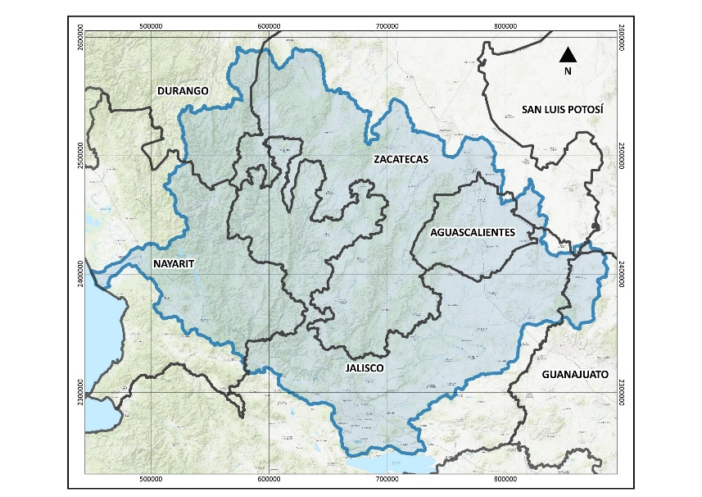
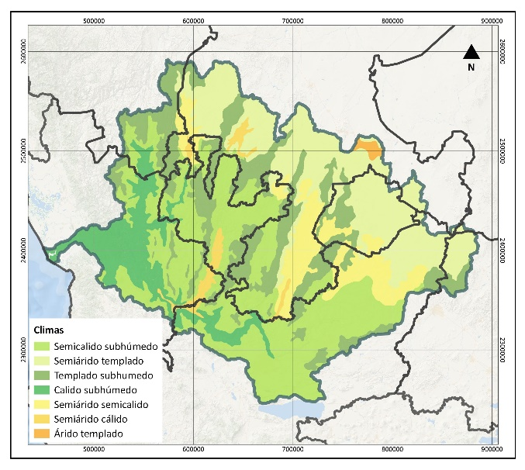
Figure 1. CRS State Administrative Boundaries. Source: INEGI (2021) [30].
Figure 2. Distribution of climates. Source: Data from García and CONABIO (1998) [27]

The Santiago River basin belongs to the Administrative Hydrological Region VIII Lerma–Santiago–Pacific. The availability of surface waters, the average annual volume of runoff from the basin is 7,606 hm³ [31]. The 33 sub-basins that make up the basin are currently in a condition of availability, however, 21 of them have an average annual availability of less than 1 hm³. There are surface water reserve areas for domestic and urban public uses with a volume of 307.5 hm³, as well as volumes of ecological flow [32].
As for underground hydrology, 43 aquifers are located in whole or in part in the territory of the basin. According to the latest availability update, the total average annual recharge of the 43 aquifers is 2,688 hm³. Currently, 23 of the 43 aquifers are overexploited, presenting negative availability values [33]. The aquifers with the greatest deficits in their average annual availability are: Valle de Aguascalientes (-100.4 hm³), Toluquilla (-75.6 hm³), Encarnación (-51.9 hm³), and Lagos de Moreno (-32.1 hm³).
The quality of surface water, according to the National Network for the Measurement of Water Quality, reports that 185 monitoring sites are located in the basin in lotic (rivers and streams), lentic (dams, lakes and lagoons) water bodies, belonging to this network. The quality of surface water in the period 2012-2021 is shown, presenting the values measured in each site through a traffic light, whose colors make up the joint evaluation of 8 physicochemical and microbiological indicators (Figure 3): 46% of the sites are in red, 30% in yellow, and 24% in green [34]. The results of groundwater quality monitoring are carried out in 85 monitoring wells in the period 2012 – 2021. The values are also presented in the traffic light, integrating the joint evaluation of 14 physicochemical and microbiological indicators (Figure 4). 42% of the sites are in green, 7% in yellow, and 51% in red [35].
According to the Public Registry of Water Rights (REPDA), there are concessions in the basin for a total of 3,614.9 million m³ for different consumptive uses (Figure 5), of which 51% come from underground sources and 49% from surface sources [36]. The main use of water is agricultural, which represents 63% of the total volume concessioned. The water destined for this use is obtained in 54% from groundwater and 46% from surface water. The largest consumers of groundwater are Lagos de Moreno, San Juan de los Lagos, Aguascalientes, while the largest consumers of surface water are Calvillo, Tepic and Santiago Ixcuintla.

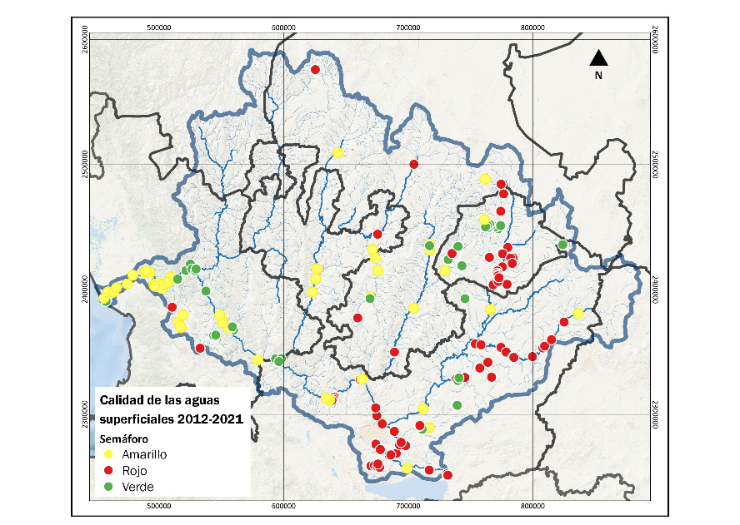
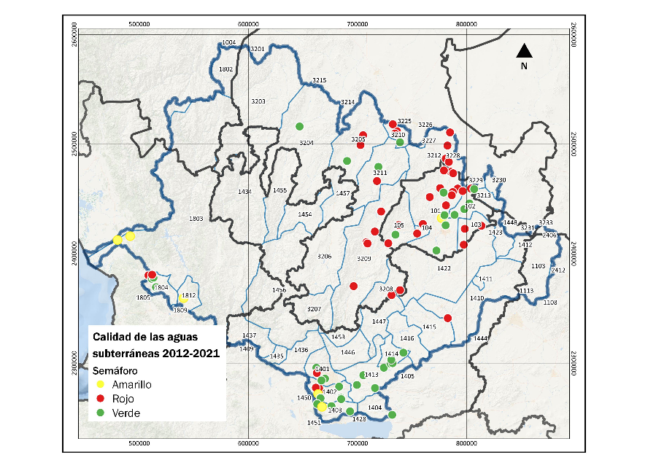
Figure 3. Surface water quality monitoring sites. Source: CONAGUA (2022) [35].
Figure 4. Groundwater quality monitoring sites. Source: CONAGUA (2022) [35].

In second place is the public supply, to which 32% of the water concession is allocated (Fig. 5). According to REPDA data, 53% of the volume recorded for this use comes from surface water and 47% from groundwater. The municipality with the largest volume of surface water concessioned for this use is Chapala, Jalisco (236.5 hm³ /year). This volume is imported from the Lerma Chapala basin and, as with the modules of irrigation district 013, is governed by the distribution decree of the Lerma Chapala Basin Council. The water is extracted through the Chapala – Guadalajara aqueduct with a flow of 5.5 m³/s and the old system of the Santiago River with a flow of 2 m³/s and is distributed to the population of the Guadalajara Metropolitan Area. On the other hand, the municipality with the largest volume of groundwater concessioned for public supply is Aguascalientes (100 hm³/year), this being the only source of supply for the city. Other municipalities with concessions for this use greater than 50 hm³/year are Tepic and Lagos de Moreno. Similarly, the municipalities of Tlajomulco de Zúñiga, Tlaquepaque and Zapopan, which are part of the GMA, stand out as they have large volumes of concessions, as it shows that aquifers are an important source for the city's supply.
Finally, self-supplied industry consumes 5% of the water concessioned and obtains 90% of it from underground sources (Figure 5). The municipalities with the highest consumption for this use are Zapopan, Tlajomulco, Zapotlanejo, Guadalajara and El Salto, in Jalisco and the city of Aguascalientes.
Along the Santiago River there are a series of hydroelectric plants run by the Federal Electricity Commission (CFE) that require a significant volume of water for their operation. In total, the concessions for the generation of energy in these plants add up to 17,795 hm³ per year, which represents 83% of the total volume concessioner.
Wastewater discharges in natural environments, such as water reservoirs, dams, riverbeds, marine areas, national assets or other areas, where there is a risk of contaminating the subsoil or aquifers, are part of the REPDA and according to the latter, the municipalities in the basin with the highest volume of discharges are Aguascalientes, Jesús María, Tepic, Tlajomulco de Zúñiga, Tonalá, Zapopan and Zapotlanejo.
Most of the municipalities present in the territory of the basin report a coverage of piped water in the house or property equal to or greater than 95% [30]. However, there are still some municipalities with predominant rural populations that are lagging behind in this aspect. Such as Bolaños (83.66%), Mezquitic (70.77%) and Villa Guerrero (80.71%) in the north of Jalisco; Del Nayar (69.37%), in Nayarit; and El Mezquital, south of Durango (>50%). Similarly, in rural localities of some municipalities that make up the AMG, piped water coverage is still below 85%, as is the case in San Pedro Tlaquepaque (80.51%), Tonalá (84.50%) and Zapopan (81.52%). The lag in sewerage coverage is even greater in some municipalities of the basin, being the municipalities of Mezquital, Durango (27.50%); Del Nayar, Nayarit (31.11%); Mezquitic (40.35%) and Bolaños (64.11%), Jalisco, which have a smaller percentage of their population connected to the drainage network or septic tank. The lack of coverage in the rural communities of the municipalities of San Felipe (80.73%) in Guanajuato is also notorious; Chimaltitán (82.77%), Huejuquilla el Alto (84.03%), San Miguel el Alto (83.98%), Villa Guerrero (73.86%) and Zapopan (83.83%) in Jalisco; La Yesca (73.75%) in Nayarit; Genaro Codina (76.53%), Pinos (84.40%) and Valparaíso (80.62%) in Zacatecas.
The basin is home to 33 of the country's main storage dams [37] (Figure 6). The hydroelectric plants of Aguamilpa (6,950 hm³), Leonardo Rodríguez Alcaine "El Cajón" (2,282 hm³) and Ing. Alfredo Elías Ayub "La Yesca" (1,329 hm³) stand out for their storage volume.
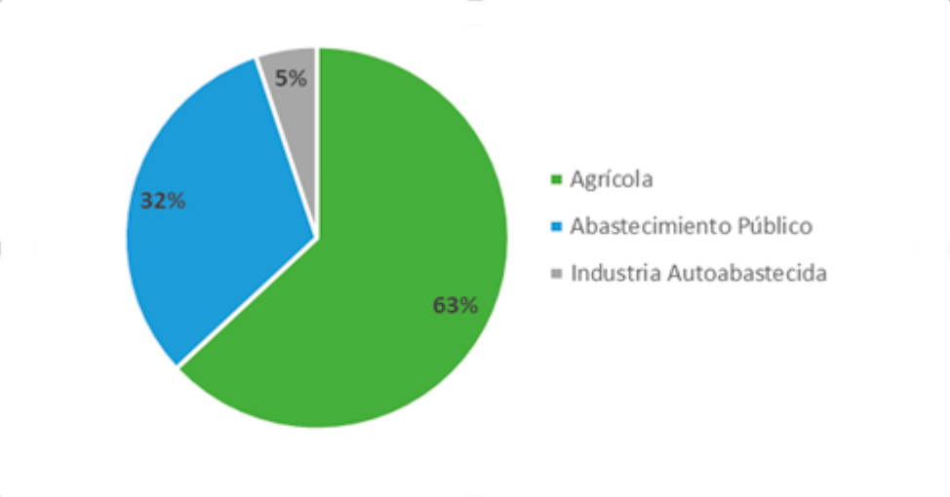
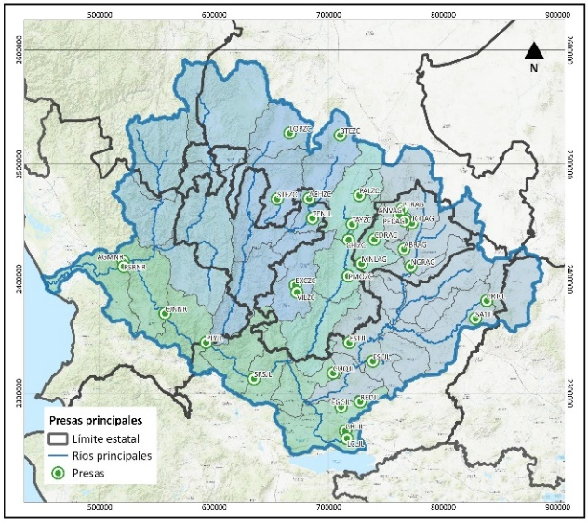
Figure 5. Distribution of concessioned volume by use. Source: CONAGUA (2021) [36].

Figure 6. Hydroelectric power generation plants run by the CFE [37].

As already mentioned, the Santiago River basin is located in the Administrative Hydrological Region VIII Lerma – Santiago – Pacific in Western Mexico. It is divided into five sub-basins: the one that constitutes the Santiago River and its four tributaries: the Huaynamota River, the Bolaños River, the Juchipila River and the Verde River. The research only covers the part of the Santiago River sub-basin that corresponds to the state of Jalisco that rises on the eastern shore of Lake Chapala in the municipality of Ocotlán, Jalisco and up to the Yesca dam on the limits of the state of Nayarit, and the Zula River that tributes to the Santiago River near Ocotlán.
The contamination of water bodies, in addition to affecting biota, reduces the availability of water for different uses and is associated with an increase in the incidence of diseases in human populations, due to exposure to substances, contamination of food by irrigation or by its capacity as a reservoir of vectors. At least 18 million children under the age of five die each year worldwide from diseases related to pollution in rivers and lakes. In an area of the Santiago River basin (the area of the El Ahogado dam and the El Salto waterfall) contamination has persisted for years, which is a local risk factor to human health. The communities on the riverbank have expressed the existence of signs of affecting their health. The discomfort and suffering reported by inhabitants of the municipalities of El Salto and Juanacatlán have been documented and accredited by organizations responsible for the protection and defense of human rights such as the State Human Rights Commission and the Latin American Water Tribunal. The information obtained is limited, which could be underestimating the health problems in the area. It has been shown that in the four-year period of 2007-2010, there was a higher mortality rate due to diarrhea and gastroenteritis of presumed infectious origin, hypertensive kidney disease, asthmatic status and unspecified renal failure in the municipality of Juanacatlán, while in the municipality of El Salto there is an increase in mortality rates due to hypertensive kidney disease, chronic renal failure and unspecified renal impairment. Likewise, it has been reported that the municipalities of the central region (El Salto-Juanacatlán-Ixtlahuacán de los Membrillos) and the southeast region of the Santiago River (Ocotlán) presented the highest specific mortality rates in diseases such as intestinal infectious, hypertensive, and chronic diseases of the upper respiratory tract in the period 1998-2010. On the other hand, mortality from tumors and congenital malformations has been demonstrated in the population of children under 15 years of age. In both El Salto and Juanacatlán, death rates from malignant tumors of the digestive system and marginally lymphoid leukemia and breast cancer exceeded the state average. As for congenital malformations, some of them have no record since they are not lethal. However, when comparing the total sum of mortality due to malformations, the data show that the communities of El Salto, Juanacatlán and Ocotlán have presented higher rates than the state average. This corroborates the perception that the population has regarding the risk to their health in the area. The public health problem is serious, however, there are no official data on the factors that predispose or enhance the development of diseases.
Based on the above, it is of vital importance to evaluate the physicochemical parameters and heavy metals, to determine the quality of the lake's water, ecological and health risks, to establish if the quality of the lake's water may be associated with negative effects on the public health of the population that uses its waters as a source of drinking water supply.
2. Material and Methods
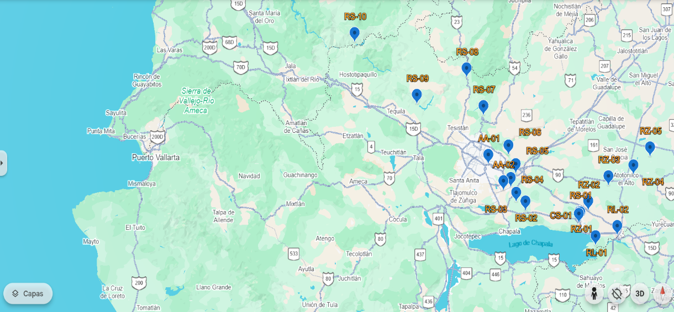
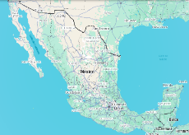
Water quality data from 20 monitoring stations (Figure 7) in the Santiago River basin that correspond to the state of Jalisco were obtained through the Jalisco State Water Commission (CEAJ). The monitoring was carried out on a monthly basis from 2009 to 2024 and the data include: 43 parameters between physicochemical and heavy metals. The parameters were compared with the Official-Mexican Standard NOM-001-SEMARNAT-2021, which establishes the maximum permissible limits of pollutants in wastewater discharges into national water bodies [38] and the limits of the Canadian water quality guidelines: Water Quality Guidelines for the Protection of Aquatic Life Freshwater, Marine [39] and Water Quality Guidelines for the Protection of Agriculture Irrigation. Livestock of the Canadian Environmental Quality Guidelines [40].

Figure 7. Water quality analysis monitoring sites of the Santiago River basin in the state of Jalisco (Google Earth, 2024).
The lake water samples were taken according to international standards for water sampling. The samples were transferred to the laboratory of the Jalisco State Water Commission, which has laboratories accredited to perform water quality analysis in accordance with the regulations approved in Mexico by the National Water Commission, which in turn are based on internationally approved protocols [41-42].
With the results of the parameters analyzed during the period 2009-2024, statistical techniques were applied to describe the behavior of the data collected. And the CWQI, WQI, ISQA, NP, HPI, HEI, DC, ecological risk PERI, and health risk HQ, HI, THI, CR and TCR water quality indices were calculated, according to the following formulas and impact criteria:
2.1. Canadian Water Quality Index (CWQI)
The Canadian Water Quality Index (CWQI) is one of the most widely used indices and was proposed by the Canadian Council of Ministers of the Environment known as CCME-CWQI, it was developed to simplify the reporting of water quality data. It is a tool for generating summaries of quality data that are useful for both technicians and politicians, as well as for the general public interested in this knowledge. This index is based on the determination of three factors that represent scope, frequency and amplitude. Scope (F1) defines the percentage of variables that have values outside the range of desirable levels for the use being evaluated with respect to the total number of variables considered. The frequency (F2) is found by the relationship between the number of values outside the desirable levels with respect to the total data of the variables studied. While amplitude is a measure of the deviation that exists in the data, determined by the magnitude of the excesses of each data out of range when compared to its threshold [43].
Scope: $F_{1}=\frac{\# de variables fuera de rango}{Total de variables}*100$
Frequency: $F_{2}=\frac{\# de datos fuera de rango}{Total de variables}*100$
Amplitude:
$F_{3}=\left(\frac{nse}{0.01\left(nse\right)+0.01}\right)*100 nse=\frac{\sum{Excursion}}{Total de datos} Excursion=\left(\frac{Valor excedido del rango}{rango}\right)-1$
And $CWQI=100-\left(\frac{\sqrt{F_{1}^{2}+F_{2}^{2}+F_{3}^{2}}}{1.732}\right)$
The CWQI is considered a useful tool for obtaining a comprehensive description of the water quality of a river or lake. The index summarizes the different water quality parameters from a large amount of physicochemical parameter and element data in the water using a simple number. Five water quality categories are presented according to CWQI value between 95-100 Excellent, 80-94 Good Quality, 65-79 Fair, 45-64 Marginal and 0-44 Poor Quality [43].
Another water quality index that is considered useful for getting a complete picture of the water quality of rivers or lakes is the WQI. The index summarizes different water quality parameters converted from a large amount of data (physical-chemical parameters and trace elements) into a single number. The WQI is calculated as follows:
$$WQI=\sum{\left[Wi×\left(\frac{C_{i}}{S_{i}}\right)\right]×100}$$
Where $W_{i}=\frac{w_{i}}{\sum{w_{i}}}$ , which is the relative weight. $w_{i}$ it is the weight of each parameter according to its relative effects on the importance of drinking and human health. The relative weights $w_{i}$ of each parameter are: pH=4, TDS=4, Cr=5, Mn=5, Ni=1, Cu=2, Zn=1, As=5, Cd=5, Ba=2 and Pb=5; the other elements do not have relative weights. $\sum{w_{i}}$ it is the sum of $w_{i}$what in this case is 39. $C_{i}$ is the concentration of the element in the water sample, and $S_{i}$represents the limit concentration of the element in the lake water. Five water quality ratings are presented according to the values of the: $WQI$ < 50 represents excellent quality, 50-100 represents good quality, 100-200 represents poor quality, 200-300 represents very poor quality, and > 300 indicates that the water is unfit for drinking.
The Simplified Water Quality Index (ISQA) developed in Spain by Queralt in 1982, is one of the indices with the best applicability to water quality studies in lentic (reservoirs, lakes) and lotic (rivers) systems and is calculated only with five parameters temperature (T), dissolved oxygen (DO), electrical conductivity (EC), chemical oxygen demand (COD) and total suspended solids (TSS). The ISQA allows guaranteed results to be obtained, minimizing time and resources and is obtained from the equation:
$$ISQA=T(COD+TSS+DO+EC)$$
The values range from 0 to 100 in 5 ratings: from 85 -100 Excellent quality, from 60 - 85 to Good quality, from 45 - 60 to Medium quality, from 30 - 45 Poor quality, < 30 Very poor quality.
2.2. Nemerov Pollution Index (NP)
The Nemerov Pollution Index (NP) is applied to comprehensively assess water, sediment, or soil quality, taking into account the maximum and average values of a single factor and can highlight the role of heavy pollutants [14, 44-45]. The NP is calculated using the equation:
$$NP=\sqrt{\frac{{\left(\frac{C_{i}}{S_{i}}\right)}_{mean}^{2}+{\left(\frac{C_{i}}{S_{i}}\right)}_{max}^{2}}{2}}$$
Where:
$Ci$ is the trace element of the water sample,
$Si$ represents the permissible limit of drinking water, and
${\left(\frac{C_{i}}{S_{i}}\right)}_{mean}^{2}$and ${\left(\frac{C_{i}}{S_{i}}\right)}_{max}^{2}$ refer to the average and maximum values among all trace elements. ${\left(\frac{C_{i}}{S_{i}}\right)}_{}^{2}$
NP is divided into five classes [14]: clean (<0.7), still clean (0.7–1.0), low pollution (1.0–2.0), moderate pollution (2.0–3.0), and high pollution (>3.0).

2.3. Heavy Metal Contamination Index (HPI)
The Heavy Metal Contamination Index (HPI) is used to assess the influence of individual heavy metals on overall water quality [39]. The rating system is an arbitrary value between 0 and 1, and the selection depends on the importance of the individual heavy metals [46-47]. HPI is calculated by:
$HPI=\frac{\sum_{i=1}^{n}{\left(W_{i}Q_{i}\right)}}{\sum_{i=1}^{n}{W_{i}}}$ $Q_{i}=\frac{C_{i}}{S_{i}}$ and $W_{i}=\frac{k}{S_{i}}$
Where:
n is the number of heavy metal parameters considered;
Wi is the unit weight of the parameter i-th trace element;
Qi is the subscript of the i-th trace element parameter;
Ci is the concentration of the heavy element in the water sample;
Si represents the permissible limit of drinking water and
k constant of proportionality. k=1 was selected for the calculation [48].
The calculated HPI values are classified into three levels of heavy element contamination: low (HPI<15), moderate (15-30), moderate to heavy (30-100), and high (HPI>100).

2.4. Heavy Metal Assessment Index (HEI)
The Heavy Metal Assessment Index (HEI) reflects water quality with respect to heavy metal concentrations [49-50]. The HEI is used to rate the combined influence of each parameter on the overall water quality and are used to assess the level of contamination caused by heavy metals [16]. The equation used for the calculation of HEI is [49]:
$$HEI=\sum_{i=1}^{n}{\frac{C_{i}}{MAC_{i}}}$$
Where $C_{i}$ are the current concentrations of heavy metals and $MAC_{i}$is the maximum allowable concentration of the heavy metal. The classification of surface water quality based on HEI is low (HEI<10), moderate (10-20), and high pollution (HEI> 20) [51].
2.5. Degree of contamination (DC)
The Contamination Grade Index (DC) is used to quantify the level of contamination with trace elements. The CD summarizes the combined effects of elements considered harmful to domestic water [52]. It is determined by the following equation [50, 52]:
$$DC=\sum_{i=1}^{n}{C_{fi}} and C_{fi}=\frac{C_{i}}{MAC_{i}}-1$$
Where:
$C_{fi}$ represents the pollution factor,
$C_{i}$ and $MAC_{i}$ are the values of the actual concentration and the maximum permissible concentration of the i-th component.
DC values are grouped into three pollution grade categories: low (DC<1), moderate (1-3), and high (DC >3) [51].

2.6. Risk assessment
2.6.1. Ecological risk
The potential impact of trace element contamination on organisms was determined through an ecological risk assessment. The Potential Ecological Risk Index (PERI) is often used in ecological risk assessments of aquatic environments and is calculated as follows [53-54]:
$$PERI=\frac{C_{i}}{ALC_{i}}$$
Where:
$C_{i}$ and $ALC_{i}$ are the actual concentration and aquatic life values, respectively. Risk levels were classified as: no risk (PERI<0.1), low risk (0.1–1), moderate risk (1–10), and high risk (PERI>10) [54].
2.6.2. Health risk
Hazard ratios (HQs) are widely used to assess toxicity caused by trace elements in aquatic ecosystems [21, 55, 56] and the potential total non-carcinogenic risks resulting from different methods are assessed by HI. Carcinogenic risks (CRs) are assessed only for elements that have carcinogenic slope factors (CAFs) [54]. Health risks are calculated separately for residential and recreational recipients (adults and children) with the following equations [57]:
Non-cancer risks (HQ) for residential recipients:
$${HQ}_{injection}=\frac{C_{w}×{IRW}_{res}×{EF}_{res}×ED}{BW×{AT}_{res}×R_{f}D_{o}×{10}^{3}}$$
$${HQ}_{dermal}=\frac{C_{w}×SA×K_{p}×ET_{res}×EV×{EF}_{res}×ED}{BW×{AT}_{res}×R_{f}D_{o}×GIABS×{10}^{6}}$$
Non-carcinogenic (HQ) risks for recreational receptors:
$${HQ}_{injection}=\frac{C_{w}×{IRW}_{rec}×{EF}_{rec}×ED}{BW×{AT}_{rec}×R_{f}D_{o}×{10}^{3}}$$
$${HQ}_{dermal}=\frac{C_{w}×SA×K_{p}×ET_{rec}×EV×{EF}_{rec}×ED}{BW×{AT}_{rec}×R_{f}D_{o}×GIABS×{10}^{6}}$$
The total potential noncarcinogenic risks of all individual trace minerals are assessed using the hazard index (HI). The total HI (THI) for different receptors is calculated by adding the HIs in each exposure pathway.
$$HI=HQ\left(Al\right)+HQ\left(V\right)+….+HQ\left(Pb\right)+HQ\left(U\right)$$
$$THI={HI}_{injection}+{HI}_{dermal}$$
If HQ, HI, or THI are > 1, human health effects should be considered [58].
Carcinogenic Risks (CR) for Residential Receivers:
$${IFW}_{rec}=\frac{{EF}_{rec}×ED_{a}×{IRW}_{rec-a}}{BW_{a}}+\frac{{EF}_{rec}×ED_{c}×{IRW}_{rec-c}}{BW_{c}}$$
$$CR_{injection}=\frac{C_{w}×{IFW}_{rec}×CSF_{o}}{AT×{10}^{3}}$$
$${ET}_{event-rec}=\frac{{ET}_{res-a}×ED_{a}+{EF}_{res-c}×ED_{c}}{ED}$$
$${DFW}_{res}=\frac{{EV_{a}×EF}_{res}×ED_{a}×SA_{a}}{BW_{a}}+\frac{{EV_{c}×EF}_{res}×ED_{c}×SA_{c}}{BW_{c}}$$
$$CR_{dermal}=\frac{C_{w}×{K_{p}×0.001×ET}_{event-res}×DFW_{res}×CSF_{o}}{AT×{GIABS×10}^{3}}$$
Carcinogenic Risks (CR) for Recreational Recipients:
$${IFW}_{res}=\frac{{EF}_{res}×ED_{a}×{IRW}_{res-a}}{BW_{a}}+\frac{{EF}_{res}×ED_{c}×{IRW}_{res-c}}{BW_{c}}$$
$$CR_{injection}=\frac{C_{w}×{IFW}_{res}×CSF_{o}}{AT×{10}^{3}}$$
$${ET}_{event-rec}=\frac{{EF}_{rec-a}×ED_{a}+{EF}_{rec-c}×ED_{c}}{ED}$$
$${DFW}_{rec}=\frac{{EV_{a}×EF}_{rec}×ED_{a}×SA_{a}}{BW_{a}}+\frac{{EV_{c}×EF}_{rec}×ED_{c}×SA_{c}}{BW_{c}}$$
$$CR_{dermal}=\frac{C_{w}×{K_{p}×0.001×ET}_{event-rec}×DFW_{rec}×CSF_{o}}{AT×{GIABS×10}^{3}}$$
Total cancer risk (TCR) is calculated by adding up cancer risks (CRs).
$$TCR = CR_{injestion} +CR_{dermal}$$
According to the USEPA [59], cancer risks are classified into three levels based on the CR value: negligible (CR<¹⁰⁻⁶), acceptable (10-6 - 10-4), and high risk (CR>10-4). International values were used for oral reference doses (RfDo), dermal permeability constant (Kp), oral slope factor (CSFo) and gastrointestinal absorption (GIABS) for each element analyzed.

2.7. Statistical analysis
Descriptive statistics, Pearson correlation matrix of heavy metals, and all indices were calculated using Excel 2019.
3. Results and discussion
The descriptive statistics of the physicochemical and heavy metal parameters of the water of the Santiago River are presented in Table 1. The temperature ranges between 17.3 and 27.6 °C with an average of 22.0 °C. The conductivity ranged between 377 and 1303 μS/cm and an average of 827 μS/cm. Total Dissolved Solids (TDS) ranged from 300 to 800 mg/l with an average of 543 mg/l. Turbidity ranged from 17 to 278 NTU and average of 104 NTU. Dissolved oxygen DO range from 3.7 to 8.1 mg/l with an average of 6.7 mg/l. The water showed pH between 7.2 and 8.1 and an average of 7.6. Total alkalinity ranged from 128 to 440 mg/l with an average of 281 mg/l. The Na ranged from 25 to 133 mg/l and a mean of 84 mg/l. Sulfates ranged from 18 to 122 mg/l with an average of 76 mg/l. Chlorides ranged from 18 to 90 mg/l and an average of 56 mg/l. Fluorides ranged from 4.2 to 34.1 mg/l, with an average of 13.1 mg/l. Phosphorus (P) ranged from 0.9 to 4.6 mg/l and average 2.2 mg/l. Nitrate ranged from 0.2 to 5.4 mg/l with an average of 1.6 mg/l. The N ranged from 0.5 to 19.8 mg/l and an average of 9.20 mg/l. Al ranged from 0.9 to 13.8 mg/l with an average of 5.1 mg/l. The trace elements (including heavy metals) showed the following concentrations: As ranged from 0.0027 to 0.0102 mg/l with an average of 0.0058 mg/l, Ba ranged from 0.0659 to 0.225 mg/l and an average of 0.1196 mg/l, Cd presented values between 0.0060 and 0.0283 and an average of 0.0033 mg/l, Cr presented values between 0.0498 and 0.0853 mg/l and an average of 0.0559 mg/l, Fe ranged from 0.5513 to 12.2521 mg/l and average of 4.1308 mg/l, Hg ranged from 0.0927 to 0.8528 mg/l and average of 0.2812 mg/l, Mn ranged from 0.0005 to 0.0008 mg/l with an average of 0.0006 mg/l, Ni ranged from 0.1000 to 0.1136 mg/l and value of 0.1014 mg/l, Pb ranged from 0.0046 to 0.0217 mg/l with an average of 0.0091 mg/l, Zn ranged from 0.0356 to 0.1998 mg/l and an average of 0.0742 mg/l. Physicochemical and heavy metal parameters have increased as a function of time.
Table 1. Statistics on water quality parameters in the Santiago River during the period 2009-2024
Parameter | Average | SE | Min | Max | NOM-001 | CCME
Temp | 22 | 2 | 17 | 28 | 35
pH | 8 | 0 | 7 | 8 | 6-9 | 8.5
DO | 7 | 1 | 4 | 8 | 100 | 9.5
Conductivity | 827 | 264 | 377 | 1303
Turbidity | 104 | 84 | 17 | 278 |  | 1
Total Alkalinity | 281 | 93 | 128 | 439
Total Chlorides tot | 56 | 21 | 18 | 90 |  | 110
Total hardness | 170 | 39 | 102 | 237
Fluorides | 1 | 0 | 0 | 2 |  | 1
Nitrates | 2 | 1 | 0 | 5 |  | 100
Nitrites | 0 | 0 | 0 | 2
N ammoniacal | 7 | 6 | 1 | 21
N tot Kjedhal | 10 | 8 | 3 | 30
Sulphates | 76 | 31 | 18 | 122 |  | 500
SAAM | 1 | 1 | 0 | 6
BOD 5 | 25 | 30 | 5 | 128
COD | 86 | 65 | 33 | 304 | 100
Fats and oils GYA (GYA) | 10 | 3 | 8 | 19 | 15
Total P | 2 | 1 | 1 | 5 | 15
TSS | 117 | 91 | 12 | 293 | 60
TSD | 543 | 148 | 301 | 801 | 20
SS | 0 | 0 | 0 | 1
Sulphides | 3 | 3 | 0 | 13
Al | 5.0854 | 4.2006 | 0.9268 | 13.8102 |  | 0.01
As | 0.0058 | 0.0021 | 0.0027 | 0.0102 | 0.2 | 0.01
Ba | 0.1196 | 0.0520 | 0.0659 | 0.2252 |  | 1
Cd | 0.0033 | 0.0076 | 0.0006 | 0.0283 | 0.2 | 0.01
Cr | 0.0559 | 0.0092 | 0.0498 | 0.0846 | 1 | 0
Cu | 0.0532 | 0.0082 | 0.0489 | 0.0853 | 4 | 0
Fe | 4.1308 | 4.0237 | 0.5513 | 12.2521 |  | 0.3
Hg | 0.2812 | 0.1651 | 0.0927 | 0.8528 | 0.01 | 0
Mn | 0.0006 | 0.0001 | 0.0005 | 0.0008 |  | 0.05
Ní | 0.1014 | 0.0032 | 0.1000 | 0.1136 | 2 | 0.03
Pb | 0.0091 | 0.0040 | 0.0046 | 0.0217 | 0.2 | 0
Na | 83.8263 | 31.8820 | 24.6074 | 133.2472 |  | 200
Zn | 0.0742 | 0.0487 | 0.0356 | 0.1998 | 10 | 0.03
Coliforms totals | 8D+06 | 1E+07 | 1E+05 | 5E+07
Coliforms fecal | 6E+06 | 1E+07 | 1E+05 | 4E+07
Acidity total | 14 | 7 | 5 | 35
Hardness Ca | 91 | 14 | 65 | 115
S Tot | 645 | 128 | 408 | 848
N Tot | 13 | 9 | 4 | 34 | 25

The distribution of concentrations showed significant spatial and temporal variation. The parameters with percentages above the CCME standard are: Fluorides, Al, As, Cd, Cr, Cu, Fe, Hg, Ni, Pb and Zn. Parameters outside of NOM-001 are COD, GYA, total P, TSS, TDS, heavy metals and total N. The results show that the main contaminants present in the monitoring sites of the Santiago River are heavy metals and some microbiological parameters such as the high presence of Total Coliforms, Fecal Coliforms, BOD and fats and oils; all of anthropogenic origin (agriculture, livestock and municipal discharges).
Pearson's correlation analysis between heavy metals for water samples from the Santiago River, and the results are summarized in Table 2. A correlation analysis was performed between the mean concentrations of heavy metals in the basin water samples to evaluate possible similar sources of origin. The inverse correlations that occur in 31 of the 67 combinations of metals mean that the presence of these metals in the basin is unrelated and that they have very diverse origins. As for the positive correlations, 20 combinations represent low correlation (<0.4), which means that in some cases they may have the same origin, but in the vast majority their origin is from a very different source. As for the positive correlations between the following metals: Ba, Fe, Al, Ni, Pb Cu, Zn, Mn and Fe demonstrate that some metals are strongly associated with the composition of the lithological structure of the region [70]. However, the major positive correlations (<0.4) involving Pb, Al, Fe, Cr, Zn, Cd, Hg, Ba, Mn, As, and Pb as the following: Al-Ba (0.917), Al-Fe (0.928), Cd-Zn (0.858), Al-Zn (0.778), Ba-Fe (0.776), Mn-Zn (0.759), Fe-Hg (0.720), Fe-Pb (718), Ba-Pb (0.706), Al-Hg (0.577), Mn-Ni (0.561), Cd-Mn (0.539), Cr-Cu (0.515), As-Cu (0.484), Hg-Pb (0.469), and Ni-Zn(0.480) are related to anthropogenic activities, mainly due to industrial sources (mining, metallurgy, electroplating, and fossil fuel emissions). Such strong correlations could also be associated with discharges of untreated domestic wastewater, as has already been demonstrated in other watersheds [60]. These results may be relevant to understanding common sources of pollution and indicate the interactions between these pollutants in the environment and their potential effects on health and ecosystems. Thus, heavy metals represent a risk and are the result of discharges from very diverse industrial, agricultural and domestic processes, without any treatment.

Table 2. Multiple correlation of heavy metals analyzed in the Santiago River during the period 2009-2024
 | Al | As | Ba | Cd | Cr | Cu | Fe | Hg | Mn | Ní | Pb | Zn
Al | 1.000
As | -0.337 | 1.000
Ba | 0.917 | -0.156 | 1.000
Cd | -0.134 | 0.182 | -0.266 | 1.000
Cr | -0.042 | 0.306 | -0.047 | 0.182 | 1.000
Cu | 0.172 | 0.484 | 0.244 | 0.146 | 0.515 | 1.000
Fe | 0.928 | -0.518 | 0.776 | -0.165 | -0.073 | 0.089 | 1.000
Hg | 0.577 | -0.670 | 0.395 | -0.218 | -0.112 | -0.133 | 0.720 | 1.000
Mn | -0.723 | 0.329 | -0.798 | 0.539 | 0.369 | -0.023 | -0.709 | -0.390 | 1.000
Ní | -0.245 | -0.018 | -0.333 | 0.248 | 0.073 | 0.235 | -0.270 | -0.004 | 0.561 | 1.000
Pb | 0.778 | -0.272 | 0.706 | 0.047 | 0.250 | 0.251 | 0.718 | 0.469 | -0.427 | -0.132 | 1.000
Zn | -0.299 | 0.198 | -0.466 | 0.858 | 0.278 | 0.052 | -0.332 | -0.232 | 0.759 | 0.480 | -0.095 | 1.000

The WQ, CWQI and ISQA indices are assessment tools to represent the combined effects of various water quality parameters and measure the suitability of water for consumption in different activities. The WQI, CWQI and ISQA values of the Santiago River are shown in Table 3 and figures 1-3. The indices were very similar in the period analyzed.
The general CWQI values of the Santiago River ranged from 19 to 28, with an average of 25, which classifies it as poor-quality water. For the use of drinking water, it presented an average of 44 with a category of poor quality. For aquatic life, the average value was 15 with a category of poor quality. For recreational uses, the average was 83 with a good quality category. For irrigation, the average was 52 with a marginal quality category. For grazing, the average was 78 with a category of regular quality. In summary, for all uses except recreation and grazing, the water quality of the Santiago River is poor according to this index (Table 3 and Figures 1).
The ISQA values of the Santiago River ranged from 19 to 63, with an average of 40 (Table 3 and Fig. 1). The quality of the water according to the ISQA was categorized as poor quality.
The WQI values of the Santiago River ranged from 107 to 251, with an average of 167 (Table 3 and Fig. 2). The water quality according to the WQI was categorized as poor quality.
Nemerov contamination indices (NP) were performed in Turb, pH, TDS, Na, SO₄⁼, Cl⁻, F⁻, NO₃⁻ and heavy metals, heavy metal contamination index (HPI), heavy metal evaluation (HEI) and degree of contamination (DC) were evaluated for As, Cd, Cr, Ni, Pb, Al, Cu, Hg, Mn, Ba and Zn. The values of NP, HPI, HEI and DC of the water of the Santiago River are shown in tables 4 and 5. The values of NP, HPI, HEI, DC were temporally and spatially very heterogeneous throughout the period 2009-2024. However, the values indicated that the risk of heavy metals at most monitoring sites is at a very high level.
NP values take into account the maximum and average values of individual trace elements and highlight the role of heavy contaminants [14, 45]. The values of Turbidity and F⁻ and heavy metal NP were high, ranging from 0.3 to 14500 [14], the NP indices showed high levels of contamination. The NP values of metals from highest to lowest were as follows: Al > Cr > Cu > Cd > Fe > Zn > Pb > Mn > As > Ni > Hg > Ba (Table 4).
Table 3. CWQI, WQI and ISQA water quality indices of the Santiago River during the period 2009-2024
 | CWQI |  |  |  |  |  | ISQA | WQI
Est. Monit | Drinking | Aquatic | Recreation | Irrigation | Livestock | Overall | ISQA | WQI
RS-01 | 40 | 13 | 42 | 53 | 85 | 22 | 50 | 137
RS-01 | Poor | Poor | Poor | Marginal | Good | Poor | Fair | Poor
RS-02 | 57 | 16 | 100 | 61 | 76 | 26 | 63 | 139
RS-02 | Marginal | Poor | Excellent | Marginal | Fair | Poor | Average | Poor
RS-03 | 51 | 15 | 42 | 58 | 76 | 22 | 54 | 140
RS-03 | Marginal | Poor | Poor | Marginal | Fair | Poor | Average | Poor
RS-04 | 49 | 18 | 100 | 57 | 85 | 25 | 33 | 132
RS-04 | Marginal | Poor | Excellent | Marginal | Good | Poor | Fair | Poor
RS-05 | 51 | 15 | 100 | 54 | 85 | 24 | 33 | 136
RS-05 | Marginal | Poor | Excellent | Marginal | Good | Poor | Fair | Poor
RS-06 | 49 | 17 | 100 | 57 | 80 | 25 | 39 | 134
RS-06 | Marginal | Poor | Excellent | Marginal | Good | Poor | Fair | Poor
RS-07 | 41 | 15 | 100 | 40 | 70 | 19 | 30 | 200
RS-07 | Poor | Poor | Excellent | Poor | Fair | Poor | Fair | Poor
RS-08 | 36 | 12 | 100 | 31 | 54 | 19 | 28 | 191
RS-08 | Poor | Poor | Excellent | Poor | Marginal | Poor | Fair | Poor
RS-09 | 51 | 15 | 100 | 40 | 66 | 23 | 60 | 122
RS-09 | Marginal | Poor | Excellent | Poor | Fair | Poor | Average | Poor
RS-10 | 56 | 16 | 42 | 49 | 76 | 26 | 62 | 107
RS-10 | Marginal | Poor | Poor | Marginal | Fair | Poor | Average | Poor
AA-01 | 36 | 12 | 100 | 47 | 75 | 20 | 19 | 153
AA-01 | Poor | Poor | Excellent | Marginal | Fair | Poor | Poor | Poor
AA-02 | 42 | 13 | 42 | 45 | 75 | 20 | 26 | 138
AA-02 | Poor | Poor | Poor | Marginal | Fair | Poor | Fair | Poor
RZ-01 | 41 | 13 | 42 | 57 | 85 | 24 | 29 | 141
RZ-01 | Poor | Poor | Poor | Marginal | Good | Poor | Fair | Poor
RZ-02 | 38 | 14 | 100 | 50 | 79 | 24 | 23 | 244
RZ-02 | Poor | Poor | Excellent | Marginal | Fair | Poor | Poor | Very Poor
RZ-03 | 42 | 14 | 100 | 61 | 84 | 27 | 45 | 251
RZ-03 | Poor | Poor | Excellent | Marginal | Good | Poor | Fair | Very Poor
RZ-04 | 42 | 15 | 100 | 62 | 84 | 28 | 52 | 168
RZ-04 | Poor | Poor | Excellent | Marginal | Good | Poor | Average | Poor
RZ-05 | 43 | 18 | 100 | 62 | 85 | 30 | 50 | 176
RZ-05 | Poor | Poor | Excellent | Marginal | Good | Poor | Fair | Poor
RL-01 | 43 | 13 | 100 | 63 | 84 | 27 | 46 | 195
RL-01 | Poor | Poor | Excellent | Marginal | Good | Poor | Fair | Poor
RL-02 | 42 | 13 | 100 | 58 | 86 | 27 | 21 | 222
RL-02 | Poor | Poor | Excellent | Marginal | Good | Poor | Poor | Very Poor
CS-01 | 37 | 14 | 42 | 32 | 71 | 25 | 44 | 211
CS-01 | Poor | Poor | Poor | Poor | Fair | Poor | Fair | Very Poor

Figure 8 CWQI Index and ISQA Index of the Santiago River during the period 2009-2024

Figure 9 WQI Index of the Santiago River during the entire period 20 09-2024

Table 4. Nemerow Pollution Index (NP) of the Santiago River during the period 2009-2024
NP | Peat | PH | TDS | Na | SO4 | Cl- | F- | NO3- | To the | Cr | Mn | Nor | Cu | Zn | Ace | CD | Ba | Pb | Faith | Hg
RS-01 | 532.75 | 1.00 | 1.21 | 0.69 | 0.86 | 1.13 | 2.32 | 0.05 | 6105 | 49.65 | 17.09 | 4.00 | 36.06 | 143.66 | 10.93 | 2.26 | 0.69 | 16.57 | 60.56 | 0.54
RS-02 | 420.24 | 0.93 | 0.83 | 0.73 | 0.26 | 0.95 | 3.46 | 0.01 | 2788 | 226.43 | 15.08 | 4.00 | 48.71 | 8.67 | 5.35 | 0.40 | 0.44 | 26.97 | 53.42 | 1.19
RS-03 | 550.64 | 0.96 | 0.92 | 0.83 | 2.23 | 1.28 | 3.07 | 0.03 | 4461 | 49.47 | 20.24 | 5.49 | 174.59 | 16.98 | 3.26 | 0.40 | 0.42 | 99.35 | 23.39 | 1.49
RS-04 | 743.74 | 0.94 | 0.92 | 0.94 | 0.31 | 1.01 | 38.82 | 0.05 | 4741 | 53.63 | 16.31 | 4.00 | 63.80 | 9.10 | 3.11 | 5.80 | 0.43 | 21.70 | 18.87 | 0.57
RS-05 | 679.50 | 0.95 | 0.92 | 0.93 | 0.34 | 1.01 | 2.52 | 0.05 | 2714 | 80.47 | 16.14 | 7.47 | 33.11 | 22.50 | 2.74 | 4.57 | 0.43 | 20.44 | 19.70 | 0.59
RS-06 | 990.34 | 0.97 | 0.98 | 0.96 | 0.31 | 1.08 | 2.84 | 0.11 | 5185 | 71.66 | 22.60 | 4.00 | 53.07 | 19.29 | 2.23 | 2.77 | 0.44 | 96.36 | 115.76 | 0.62
RS-07 | 1344.65 | 0.97 | 1.27 | 0.78 | 0.31 | 0.99 | 3.48 | 0.06 | 9512 | 481.97 | 13.12 | 14.87 | 269.62 | 106.52 | 3.47 | 382.57 | 0.77 | 49.45 | 50.81 | 2.29
RS-08 | 484.63 | 0.95 | 1.46 | 0.82 | 0.30 | 1.11 | 3.61 | 0.05 | 4076 | 125.84 | 15.37 | 6.46 | 114.26 | 275.81 | 17.57 | 154.89 | 0.65 | 190.80 | 49.82 | 0.90
RS-09 | 367.46 | 0.96 | 0.70 | 0.63 | 0.29 | 0.81 | 39.61 | 0.08 | 3451 | 84.92 | 11.55 | 13.97 | 268.10 | 62.96 | 18.55 | 1.72 | 0.28 | 127.35 | 18.33 | 2.27
RS-10 | 350.93 | 1.05 | 0.62 | 0.53 | 0.22 | 0.67 | 61.92 | 0.12 | 2103 | 229.90 | 10.10 | 6.16 | 124.80 | 46.10 | 40.64 | 0.97 | 0.70 | 18.82 | 35.94 | 2.15
AA-01 | 790.37 | 0.93 | 0.95 | 2.02 | 0.40 | 1.79 | 4.55 | 0.03 | 2714 | 1142.78 | 49.31 | 15.05 | 81.29 | 19.64 | 5.41 | 1.76 | 0.44 | 21.79 | 22.66 | 1.47
AA-02 | 900.42 | 1.02 | 1.13 | 1.12 | 0.57 | 1.58 | 3.51 | 0.06 | 1704 | 50.00 | 32.49 | 7.56 | 744.12 | 26.16 | 3.46 | 3.50 | 0.43 | 59.80 | 11.88 | 3.97
RZ-01 | 533.84 | 0.95 | 1.24 | 0.74 | 0.81 | 1.68 | 19.11 | 0.17 | 7067 | 49.65 | 14.62 | 4.27 | 109.02 | 10.91 | 4.12 | 0.69 | 0.50 | 51.79 | 82.18 | 0.48
RZ-05 | 2621.85 | 0.90 | 0.83 | 0.25 | 0.11 | 0.30 | 1.03 | 0.18 | 14158 | 65.24 | 68.99 | 4.14 | 40.89 | 9.06 | 1.52 | 0.45 | 0.55 | 62.10 | 277.39 | 0.40
RZ-04 | 2268.92 | 0.96 | 0.58 | 0.21 | 0.08 | 0.22 | 0.95 | 0.13 | 14479 | 63.58 | 69.27 | 4.45 | 49.14 | 15.06 | 1.03 | 0.48 | 0.71 | 62.37 | 284.73 | 0.27
RZ-03 | 1142.77 | 0.90 | 0.43 | 0.31 | 0.08 | 0.45 | 1.02 | 0.07 | 12510 | 69.55 | 103.07 | 4.38 | 35.68 | 8.99 | 1.71 | 0.49 | 0.63 | 46.70 | 160.88 | 0.28
RZ-02 | 870.96 | 0.90 | 0.88 | 0.87 | 0.08 | 1.43 | 1.52 | 0.17 | 8181 | 58.21 | 25.57 | 4.00 | 103.53 | 3.29 | 0.91 | 0.28 | 0.69 | 207.75 | 118.27 | 0.27
RL-02 | 718.56 | 0.95 | 0.60 | 0.57 | 0.24 | 0.54 | 1.98 | 0.06 | 10992 | 50.00 | 14.32 | 4.00 | 25.00 | 4.68 | 2.45 | 0.30 | 0.61 | 27.05 | 90.69 | 0.23
RL-01 | 605.85 | 0.95 | 0.70 | 0.68 | 0.23 | 0.69 | 1.34 | 0.06 | 6190 | 50.00 | 15.33 | 4.00 | 25.00 | 3.83 | 3.77 | 0.48 | 0.63 | 25.39 | 65.16 | 0.29
CS-01 | 610.11 | 1.02 | 0.94 | 0.74 | 0.26 | 0.82 | 1.65 | 0.03 | 6972 | 358.66 | 13.32 | 4.00 | 178.83 | 3.93 | 5.77 | 0.85 | 0.53 | 23.65 | 80.33 | 0.27
The HPI index is used to assess total trace element contamination in water samples. The selection of HPI depends on the importance of individual heavy metals [46]. According to the HPI classification criteria, HPI values for heavy metals were moderate to high, with an average value of 89. The HEI and DC indices are calculated based on the integration of the maximum and maximum permissible concentrations of the element [49, 52]. HEI values ranged from 8.2 to 67 and an average of 30. The HEI index with levels above of 10 indicates high contamination. DC values ranged from 1 to 64 with an average of 21, with a high degree of contamination (Table 5).
Table 5. Santiago River HPI, HEI and DC pollution indices between 2009-2024
 | HPI | HEI | DC
RS-01 | 88.98 | 22.42 | 13.42
RS-02 | 89.00 | 8.30 | -0.70
RS-03 | 88.99 | 12.06 | 3.06
RS-04 | 88.98 | 9.96 | 0.96
RS-05 | 88.98 | 9.87 | 0.87
RS-06 | 88.97 | 14.62 | 5.62
RS-07 | 88.46 | 27.45 | 18.45
RS-08 | 88.56 | 26.60 | 17.60
RS-09 | 88.98 | 12.46 | 3.46
RS-10 | 88.99 | 8.29 | -0.71
AA-01 | 88.97 | 17.83 | 8.83
AA-02 | 88.97 | 11.82 | 2.82
RZ-01 | 88.97 | 27.09 | 18.09
RZ-05 | 88.95 | 43.47 | 34.47
RZ-04 | 88.94 | 48.07 | 39.07
RZ-03 | 88.93 | 58.60 | 49.60
RZ-02 | 88.88 | 66.51 | 57.51
RL-02 | 88.89 | 73.43 | 64.43
RL-01 | 88.94 | 46.70 | 37.70
CS-01 | 88.90 | 52.32 | 43.32
Average | 88.91 | 29.89 | 20.89

Ecological risks
Ecological risks were assessed using the values of the PERI index of trace elements in surface waters; they are calculated by dividing the concentration of each element in the water by the ALC value. The ALC values of the analyzed trace elements are As=4.66, Cd=0.43, Cr=7.06, Ni=4.46, Pb=5.65, Hg=0.3 and Zn=25.64. The PERIs of the elements in the water samples of the Santiago River are shown in Table 6. The results show that most of the PERI values are >1, which indicates a high risk for the organisms of the Santiago River. PERI's indicate a higher risk in the following order of heavy metals: Ni > Cd > Cr > Zn > Hg > Pb > As. The results show that the ecological risk posed by heavy metals in the Santiago River is high at most monitoring sites.
Table 6. Ecological Risk Index of the Santiago River during the period 2009-2024
PERI | Ace | CD | Cr | Nor | Pb | Hg | Zn
RS-01 | 1.3895 | 1.7303 | 6.9817 | 22.4215 | 0.8774 | 2.0655 | 4.0844
RS-02 | 1.4552 | 1.3938 | 7.3428 | 22.4215 | 0.9081 | 2.1524 | 1.4277
RS-03 | 1.1827 | 1.4427 | 6.9325 | 22.5280 | 1.3309 | 2.1200 | 1.7314
RS-04 | 1.1707 | 3.0350 | 7.0883 | 22.4215 | 1.2283 | 2.0101 | 1.8401
RS-05 | 1.0923 | 2.7498 | 7.1464 | 22.6541 | 1.1990 | 2.1079 | 2.0867
RS-06 | 0.9618 | 2.2598 | 7.1195 | 22.4215 | 1.5135 | 2.1272 | 2.3547
RS-07 | 1.3052 | 65.7553 | 8.4308 | 23.7264 | 1.5248 | 2.7540 | 7.5731
RS-08 | 1.6685 | 52.6176 | 7.4593 | 22.6210 | 1.9665 | 2.4812 | 7.7910
RS-09 | 1.5431 | 2.6536 | 7.1394 | 23.0138 | 1.0938 | 2.3292 | 3.2710
RS-10 | 2.1477 | 1.7950 | 7.3206 | 22.5510 | 0.8225 | 2.4754 | 2.4726
AA-01 | 1.1118 | 2.5113 | 8.5924 | 25.4634 | 1.3868 | 2.5242 | 4.5234
AA-02 | 1.1948 | 2.5324 | 7.0822 | 22.8671 | 1.5777 | 2.7094 | 4.4756
RZ-01 | 1.2624 | 1.5510 | 6.9831 | 22.4422 | 1.0456 | 2.0093 | 1.9367
RZ-05 | 0.6024 | 1.4702 | 7.1980 | 22.4501 | 1.6844 | 1.8121 | 1.6941
RZ-04 | 0.5802 | 1.4702 | 7.2341 | 22.5071 | 1.6584 | 1.7552 | 1.8937
RZ-03 | 0.6780 | 1.5948 | 7.2479 | 22.5074 | 1.8627 | 1.8149 | 1.9492
RZ-02 | 0.6386 | 1.3986 | 7.1554 | 22.4215 | 3.8331 | 1.7759 | 1.6555
RL-02 | 1.1810 | 1.8019 | 7.0822 | 22.4215 | 2.5657 | 1.7080 | 2.0922
RL-01 | 1.4522 | 1.9411 | 7.0822 | 22.4215 | 1.7018 | 1.7461 | 1.6613
CS-01 | 2.1840 | 2.6174 | 12.0813 | 22.4215 | 2.4658 | 1.7601 | 1.3895

Non-carcinogenic health risks
The hazard quotient method is used in health risk assessment and was developed by USEPA [58]. The total values of the hazard quotients for the Santiago River are shown in Table 7. The hazard ratios of the trace water elements for residential adults and children had average values of 2.2 and 3.1, respectively (Table 7). Hazard ratios for adults and children were above the threshold of 1.0, suggesting that non-cancer risks for adults and children are high. The total hazard ratios of the trace water elements for adults and children for recreational use had average values of 0.43 and 0.62 respectively, which does not represent a risk (Table 7). The non-carcinogenic risks for residential adults and children were 1.89 and 2.75 for water ingestion and 0.28 and 0.32 for dermal contact, while the non-carcinogenic risks for adults and recreational children were 0.042 and 0.16 for water intake; and 0.39 and 0.46 for dermal contact (Table 7). These results revealed that recreational receivers via water ingestion were less sensitive than residential receivers. In addition, the adverse effect of water ingestion on residents health was greater than that of dermal contact. Thus, noncarcinogenic risks from ingestion and dermal contact for residential and recreational adults were lower than those of residential and recreational children, indicating that children were more sensitive than adults when exposed to trace elements in surface water, which is consistent with the results of other studies [11, 66]. Regarding the route of exposure to water ingestion, Cr was the element with the highest risk ratios for residential and recreational recipients. The highest order of exposure by route of ingestion is as follows: As > Cr > Pb > Al > Ni > Cu > Zn. Thus, the water of the Santiago River is not suitable for drinking, so it represents a high risk to health through ingestion. The highest order of exposure by dermal route is as follows: Cr > As > Ni > Al > Cu > Pb > Zn. Thus, the water of the lake is suitable for dermal contact for both residential and recreational use in both adults and children, and for the moment they do not represent a health risk due to contact.
In both children and adults, the heavy metals with the highest hazard ratios for residential and recreational receptors are As, Cr, Pb, Al, and Ni, while Cu and Zn contributed the least to hazard ratios by both ingestion and contact.
Carcinogenic health risks
The carcinogenic risk (CR) values are shown in Table 8. As and Cr, which have a carcinogenic incidence factor, are the two elements that were used to evaluate CR and TCR. The TCR of As and Cr for residential receivers presented values of 1.5x 10⁻⁰⁸ and 1.3X10⁻⁰⁷ respectively, while for recreational it presented values of 6.03X10⁻⁰⁷for As and 5.5X10⁻⁰⁶ for Cr. Consequently, according to the indicators, these do not represent high risks for residential and recreational recipients. Analyzing the CR values of Cr by routes of ingestion and dermal contact for residential and recreational recipients, these were lower than the objective risk of 1×10⁻⁴ (Table 8); likewise, the values of As via ingestion and dermal contact for residents were lower than the objective risk (Table 8). Ingested CR was the predominant contributor to total TCR and the dermal pathway was the least contributor to TCR. The results indicate that As would not pose a carcinogenic risk to residents and recreators in different surface waters, while Cr may pose a slight carcinogenic risk to recreational receptors. Perhaps one of the consequences of the increase in poor water quality and in ecological and human health risks is due to the change in land use that the Santiago River basin has experienced; due to greater industrial, agricultural and domestic discharges due to the growth of the area in the twentieth century; Heavy metals put agricultural production at risk and make it possible to transfer heavy metals to food.
The discharge of poorly treated or untreated wastewater and domestic water and the lack of measures to control runoff from agricultural areas lead to a detriment to physicochemical characteristics and an increase in pollution, mainly by heavy metals, and the loss of several of the potential uses as a reserve area for aquatic and terrestrial species. It also puts agriculture and human health at risk due to ingestion and dermal contact with the waters of the Santiago River. Thus, health problems (kidney diseases, brain damage, cancer and malformations) that affect children and young people from the indigenous communities of the Ciénega Zone could be the result of high levels of contamination, mainly by heavy metals, however, epidemiological studies are needed to be able to affirm that the diseases are associated with the direct consumption of water from the river and nearby contaminated wells.
Table 7. Non-carcinogenic risk index in residential and recreational residents (adults and children) of the water of the Santiago River during the period 2009-2024
 | Adults |  |  |  |  |  | Childrens
 | Residents |  |  | Recreation |  |  | Residents |  |  | Recreation
 | Hiing | HiDerm | THI | Hiing | Hider | THI | Hiing | HiDerm | THI | Hiing | HiDerm | THI
RS-01 | 1.7788 | 0.2612 | 2.0400 | 0.0392 | 0.3641 | 0.4034 | 2.5899 | 0.3007 | 2.8906 | 0.1537 | 0.4234 | 0.5770
RS-02 | 1.7433 | 0.2738 | 2.0171 | 0.0385 | 0.3820 | 0.4204 | 2.5382 | 0.3150 | 2.8532 | 0.1506 | 0.4441 | 0.5947
RS-03 | 1.6517 | 0.2585 | 1.9102 | 0.0364 | 0.3602 | 0.3967 | 2.4049 | 0.2973 | 2.7022 | 0.1427 | 0.4188 | 0.5615
RS-04 | 1.6270 | 0.2639 | 1.8909 | 0.0359 | 0.3680 | 0.4039 | 2.3690 | 0.3036 | 2.6726 | 0.1406 | 0.4278 | 0.5684
RS-05 | 1.5871 | 0.2658 | 1.8529 | 0.0350 | 0.3706 | 0.4056 | 2.3108 | 0.3058 | 2.6166 | 0.1371 | 0.4309 | 0.5680
RS-06 | 1.5909 | 0.2646 | 1.8556 | 0.0351 | 0.3690 | 0.4041 | 2.3164 | 0.3045 | 2.6209 | 0.1375 | 0.4290 | 0.5664
RS-07 | 1.9636 | 0.3135 | 2.2771 | 0.0433 | 0.4377 | 0.4810 | 2.8590 | 0.3612 | 3.2202 | 0.1697 | 0.5089 | 0.6785
RS-08 | 2.1284 | 0.2794 | 2.4078 | 0.0470 | 0.3898 | 0.4367 | 3.0990 | 0.3220 | 3.4211 | 0.1839 | 0.4532 | 0.6371
RS-09 | 1.8429 | 0.2671 | 2.1101 | 0.0407 | 0.3724 | 0.4130 | 2.6833 | 0.3074 | 2.9908 | 0.1592 | 0.4329 | 0.5922
RS-10 | 2.1027 | 0.2751 | 2.3778 | 0.0464 | 0.3838 | 0.4302 | 3.0615 | 0.3166 | 3.3781 | 0.1817 | 0.4462 | 0.6279
AA-01 | 1.8210 | 0.3188 | 2.1398 | 0.0402 | 0.4449 | 0.4851 | 2.6513 | 0.3670 | 3.0184 | 0.1573 | 0.5172 | 0.6746
AA-02 | 1.7383 | 0.2641 | 2.0024 | 0.0384 | 0.3682 | 0.4065 | 2.5309 | 0.3041 | 2.8351 | 0.1502 | 0.4281 | 0.5782
RZ-01 | 1.7617 | 0.2611 | 2.0228 | 0.0389 | 0.3639 | 0.4028 | 2.5651 | 0.3003 | 2.8654 | 0.1522 | 0.4231 | 0.5753
RZ-05 | 1.6268 | 0.2675 | 1.8943 | 0.0359 | 0.3730 | 0.4089 | 2.3686 | 0.3077 | 2.6763 | 0.1406 | 0.4337 | 0.5742
RZ-04 | 1.6461 | 0.2689 | 1.9151 | 0.0363 | 0.3750 | 0.4113 | 2.3968 | 0.3094 | 2.7061 | 0.1422 | 0.4360 | 0.5782
RZ-03 | 1.7983 | 0.2701 | 2.0684 | 0.0397 | 0.3767 | 0.4164 | 2.6183 | 0.3107 | 2.9290 | 0.1554 | 0.4380 | 0.5933
RZ-02 | 2.0935 | 0.2671 | 2.3606 | 0.0462 | 0.3725 | 0.4186 | 3.0482 | 0.3072 | 3.3554 | 0.1809 | 0.4330 | 0.6139
RL-02 | 2.2467 | 0.2662 | 2.5130 | 0.0496 | 0.3712 | 0.4208 | 3.2713 | 0.3063 | 3.5775 | 0.1941 | 0.4316 | 0.6257
RL-01 | 2.0902 | 0.2660 | 2.3562 | 0.0461 | 0.3708 | 0.4170 | 3.0434 | 0.3059 | 3.3493 | 0.1806 | 0.4312 | 0.6118
CS-01 | 3.0392 | 0.4484 | 3.4875 | 0.0671 | 0.6285 | 0.6955 | 4.4250 | 0.5156 | 4.9406 | 0.2626 | 0.7307 | 0.9933

Table 8. Carcinogenic risk index in residential and recreational residents of the Santiago River water during the period 2009-2024
 | TCR Resident |  | TCR Recreation
 | Ace | Cr | Ace | Cr
RS-01 | 1.68E-08 | 1.28E-07 | 6.76E-07 | 5.14E-06
RS-02 | 1.76E-08 | 1.35E-07 | 7.08E-07 | 5.41E-06
RS-03 | 1.43E-08 | 1.27E-07 | 5.75E-07 | 5.11E-06
RS-04 | 1.42E-08 | 1.30E-07 | 5.69E-07 | 5.22E-06
RS-05 | 1.32E-08 | 1.31E-07 | 5.31E-07 | 5.27E-06
RS-06 | 1.16E-08 | 1.31E-07 | 4.68E-07 | 5.25E-06
RS-07 | 1.58E-08 | 1.55E-07 | 6.35E-07 | 6.21E-06
RS-08 | 2.02E-08 | 1.37E-07 | 8.11E-07 | 5.50E-06
RS-09 | 1.87E-08 | 1.31E-07 | 7.51E-07 | 5.26E-06
RS-10 | 2.60E-08 | 1.34E-07 | 1.04E-06 | 5.39E-06
AA-01 | 1.35E-08 | 1.58E-07 | 5.41E-07 | 6.33E-06
AA-02 | 1.45E-08 | 1.30E-07 | 5.81E-07 | 5.22E-06
RZ-01 | 1.53E-08 | 1.28E-07 | 6.14E-07 | 5.15E-06
RZ-05 | 7.29E-09 | 1.32E-07 | 2.93E-07 | 5.30E-06
RZ-04 | 7.02E-09 | 1.33E-07 | 2.82E-07 | 5.33E-06
RZ-03 | 8.21E-09 | 1.33E-07 | 3.30E-07 | 5.34E-06
RZ-02 | 7.73E-09 | 1.31E-07 | 3.11E-07 | 5.27E-06
RL-02 | 1.43E-08 | 1.30E-07 | 5.74E-07 | 5.22E-06
RL-01 | 1.76E-08 | 1.30E-07 | 7.06E-07 | 5.22E-06
CS-01 | 2.64E-08 | 2.22E-07 | 1.06E-06 | 8.90E-06

Of the questions raised at the beginning of this work, in some there are already indications: Is there a real risk due to exposure to the contaminated water of the Santiago River in the region? there are definitely real ecological and health risks due to exposure to the water of the Santiago River; What is known about this risk? the study shows high risk mainly due to heavy metals in the Santiago River in the state of Jalisco. Who are the most vulnerable and who is responsible for pollution? The most vulnerable are the populations near the river and those who use its waters without prior treatment; while those responsible are the companies and municipalities that discharge their wastewater without adequate treatment; What substances are present in the river due to industrial, agricultural and domestic discharges? The substances are diverse; however, the main risk is in heavy metals.
4. Conclusion
The main conclusions are:
- The distribution of concentrations showed significant spatial and temporal variation in the monitoring sites of the Santiago River. The parameters with percentages above the CCME standard are: Fluorides, Al, As, Cd, Cr, Cu, Fe, Hg, Ni, Pb and Zn, while the parameters outside the NOM-001 are COD, GYA, total P, SST, SDT, heavy metals and total N. The rest of the physicochemical parameters are within NOM-001.
- The results show that the main contaminants present in the Santiago River are heavy metals and microbiological parameters such as Total Coliforms, Fecal Coliforms, BOD and fats and oils.
- The inverse Pearson correlations mean that the presence of heavy metals in the basin is unrelated and that they are of very diverse origins. Positive correlations greater than 0.4 involving Pb, Al, Fe, Cr, Zn, Cd, Hg, Ba, Mn, As, and Pb are related to anthropogenic activities, mainly due to untreated industrial, agricultural, and domestic discharges.
- Water quality according to the CWQI, WQI, ISQA indices was categorized as poor quality.
- According to the NP index, HPI, heavy metal concentrations showed high levels of contamination. The HEI index showed a state of high contamination. The DC value was classified as high degree of contamination and the PERI index showed that the ecological risk from heavy metals is high.
- Non-carcinogenic hazard indices indicate that the water of the Santiago River is not suitable for drinking, and poses a high health risk, while dermal contact does not pose a health risk to residential and recreational recipients.
- According to the water quality, ecological risk and health indexes, the water quality of the Santiago River in the State of Jalisco is poor, with a high degree of contamination and represents ecological and health risks (non-carcinogenic).
- The health problems (kidney diseases, brain damage, cancer and malformations) that affect the communities near the Santiago River could be the result of high levels of pollution, mainly by heavy metals, however, epidemiological studies are needed to be able to affirm that the diseases are associated with the direct consumption of water from the lake and nearby wells.

References
- Nichols, S. J., & Dyer, F. J. (2013). Contribution of national bioassessment approaches for assessing ecological water security: An AUSRIVAS case study. Frontiers of Environmental Science & Engineering, 7(5), 669–687. https://doi.org/10.1007/s11783-013-0535-3
- Ahmed, S. S., Bali, R., Khan, H., Mohamed, H. I., & Sharma, S. K. (2021). Improved water resource management framework for water sustainability and security. Environmental Research, 201, 111527. https://doi.org/10.1016/j.envres.2021.111527
- Lu, J., Lin, Y., Wu, J., & Zhang, C. (2021). Continental-scale spatial distribution, sources, and health risks of heavy metals in seafood: Challenge for the water-food-energy nexus sustainability in coastal regions. Environmental Science and Pollution Research, 28, 63815–63828. https://doi.org/10.1007/s11356-021-14994-z
- Lu, J., Wu, J., & Wang, J. (2022a). Metagenomic analysis on resistance genes in water and microplastics from a mariculture system. Frontiers of Environmental Science & Engineering, 16(1), 4. https://doi.org/10.1007/s11783-021-1396-4
- Lu, J., Zhang, Y., Wu, J., & Wang, J. (2022b). Intervention of antimicrobial peptide usage on antimicrobial resistance in aquaculture. Journal of Hazardous Materials, 427, 128154. https://doi.org/10.1016/j.jhazmat.2021.128154
- Singh, V. B., Ramanathan, A., Pottakkal, J. G., & Kumar, M. (2014). Seasonal variation of the solute and suspended sediment load in Gangotri glacier meltwater, central Himalayas, India. Journal of Asian Earth Sciences, 79, 224–234. https://doi.org/10.1016/j.jseaes.2013.09.005
- Aalirezaei, A., Khan, M. S. A., Kabir, G., & Ali, S. M. (2021). Prediction of water security level for achieving sustainable development objectives in Saskatchewan, Canada: Implications for resource conservation in developed economies. Journal of Cleaner Production, 311, 127521. https://doi.org/10.1016/j.jclepro.2021.127521
- Badolá, N., Bahuguna, A., Sasson, Y., & Chauhan, J. S. (2022). Microplastics removal strategies: A step toward finding the solution. Frontiers of Environmental Science & Engineering, 16, 7. https://doi.org/10.1007/s11783-021-1441-3
- He, J., & Charlet, L. (2013). A review of arsenic presence in China drinking water. Journal of Hydrology, 492, 79–88. https://doi.org/10.1016/j.jhydrol.2013.03.052
- Chowdhury, S., Mazumder, M. A. J., Al-Attas, O., & Husain, T. (2016). Heavy metals in drinking water: Occurrences, implications, and future needs in developing countries. Science of The Total Environment, 569–570, 476–488. https://doi.org/10.1016/j.scitotenv.2016.06.166
- Xiao, J., Wang, L., Deng, L., & Jin, Z. (2019). Characteristics, sources, water quality and health risk assessment of trace elements in river water and well water in the Chinese Loess Plateau. Science of the Total Environment, 650(2), 2004–2012. https://doi.org/10.1016/j.scitotenv.2018.09.322
- Islam, A. R. M. T., Islam, H. M. T., Mia, M. U., Khan, R., Habib, M. A., Bodrud-Doza, M., Siddique, M. A. B., & Chu, R. (2020). Co-distribution, possible origins, status and potential health risk of trace elements in surface water sources from six major river basins, Bangladesh. Chemosphere, 249, 126180. https://doi.org/10.1016/j.chemosphere.2020.126180
- Milicevic, T., Relic, D., Skrivanj, S., Tesic, Z., & Popovic, A. (2017). Assessment of major and trace element bioavailability in vineyard soil applying different single extraction procedures and pseudo-total digestion. Chemosphere, 171, 284–293. https://doi.org/10.1016/j.chemosphere.2016.12.096
- Li, L., Wu, J., Lu, J., Min, X., Xu, J., & Yang, L. (2018). Distribution, pollution, bioaccumulation, and ecological risks of trace elements in soils of the northeastern Qinghai-Tibet Plateau. Ecotoxicology and Environmental Safety, 166, 345–353. https://doi.org/10.1016/j.ecoenv.2018.09.105
- Li, L., Wu, J., Lu, J., & Xu, J. (2020). Trace elements in Gobi soils of the northeastern Qinghai-Tibet Plateau. Chemistry and Ecology, 36(10), 967–981. https://doi.org/10.1080/02757540.2020.17800 44
- Saleem, M., Iqbal, J., & Shah, M. H. (2019). Seasonal variations, risk assessment and multivariate analysis of trace metals in the freshwater reservoirs of Pakistan. Chemosphere, 216, 715–724. https://doi.org/10.1016/j.chemosphere.2018.10.181
- Mokarram, M., Pourghasemi, H. R., & Zhang, H. (2020). Predicting non-carcinogenic hazard quotients of heavy metals in pepper (Capsicum annuum L.) utilizing electromagnetic waves. Frontiers of Environmental Science & Engineering, 14, 114. https://doi.org/10.1007/s11783-020-1276-6
- Carafa, R., Faggiano, L., Real, M., Munné, A., Ginebreda, A., Guasch, H., Flo, M., Tirapu, L., & von der Ohe, P. C. (2011). Water toxicity assessment and spatial pollution patterns identification in a Mediterranean River Basin District. Tools for water management and risk analysis. Science of the Total Environment, 409, 4269–4279. https://doi.org/10.1016/j.scitotenv.2011.07.001
- Chanpiwat, P., & Sthiannopkao, S. (2014). Status of metal levels and their potential sources of contamination in Southeast Asian rivers. Environmental Science and Pollution Research, 21, 220–233. https://doi.org/10.1007/s11356-013-1867-4
- Canpolat, Ö., Varol, M., Okan, Ö. Ö., Eriş, K. K., & Çağlar, M. (2020). A comparison of trace element concentrations in surface and deep water of the Keban Dam Lake (Turkey) and associated health risk assessment. Environmental Research, 190, 110012. https://doi.org/10.1016/j.envres.2020.11 0012
- Githaiga, K. B., Njuguna, S. M., Gituru, R. W., & Yan, X. (2021). Water quality assessment, multivariate analysis and human health risks of heavy metals in eight major lakes in Kenya. Journal of Environmental Management, 297, 113410. https://doi.org/10.1016/j.jenvman.2021.113410
- Li, D., Yu, R., Chen, J., Leng, X., Zhao, D., Jia, H., & An, S. (2022). Ecological risk of heavy metals in lake sediments of China: a national-scale integrated analysis. Journal of Cleaner Production, 334, 130206. https://doi.org/10.1016/j.jclepro.2021.130206
- Ustaoglu, F., Tepe, Y., & Taş, B. (2020). Assessment of stream quality and health risk in a subtropical Turkey river system: A combined approach using statistical analysis and water quality index. Ecological Indicators, 113, 105815. https://doi.org/10.1016/j.ecolind.2020.105815
- Aguilar, O., Ortega-Elorza, L., & Gesundheit Montero, P. (2012, July). Study of pollution in the Santiago River basin and public health in the region. Mexico City: Agrupación Un Salto de Vida A.C., Greenpeace and UCCS.
- COCURS (2014). Program of preventive and mitigation measures of drought (1st version) Santiago River Basin Council.
- CONAGUA (2019). Water statistics in Mexico 2019. National Water Commission
- García, E., & Comisión Nacional para el Conocimiento y Uso de la Biodiversidad (CONABIO). (1998). Climate map 1:1,000,000 (Köppen classification modified by E. García). http://www.conabio.gob.mx/informacion/gis/
- SIAPA (2010). Summary of the Organic Regulations of the Intermunicipal System for Public Water and Sewerage Services of the Guadalajara Metropolitan Area. https://www.zapopan.gob.mx/wp-content/uploads/2018/08/Reglamento-Org%C3%A1nico-SIAPA-.pdf
- INEGI (2021a). Land use and vegetation, series VII (national continuum), scale 1:250000. National Institute of Statistics and Geography
- INEGI (2021). Population and Housing Census 2020. National Institute of Statistics and Geography
- SEMARNAT (2020a). Agreement updating the average annual availability of national surface waters of the 757 hydrological basins that comprise the 37 Hydrological Regions into which the United Mexican States is divided. Ministry of Environment and Natural Resources. Official Gazette of the Federation. https://www.dof.gob.mx/nota_detalle.php?codigo=5600849&fecha=21/09/2020
- SEMARNAT (2018). Decree abolishing the existing closures in the hydrological basins that make up the Río Santiago Hydrological Subregion, of Hydrological Region number 12 Lerma-Santiago and establishing national surface water reserve areas for domestic, urban and environmental public uses or ecological conservation. Ministry of Environment and Natural Resources. Official Gazette of the Federation. https://www.dof.gob.mx/nota_detalle.php?Codigo= 5525357&fecha=06/06/2018#gsc.tab=0
- SEMARNAT (2020b). Agreement updating the average annual availability of groundwater in the 653 aquifers of the United Mexican States, which are part of the hydrological-administrative regions indicated. Ministry of Environment and Natural Resources. Official Gazette of the Federation. https://www.dof.gob.mx/nota_detalle.Php?code=5600593&date=17/09/2020#gsc.tab=0
- CONAGUA (2022c). Water quality. https://www.gob.mx/conagua/articulos/calidad-del-agua
- CONAGUA (2022). Watersheds (national). National Water Information System (SINA). National Water Commission. http://sina.conagua.gob.mx/sina/
- CONAGUA (2021b). Main dams. National Water Information System. National Water Commission
- CONAGUA (2021a). Public Registry of Water Rights. National Water Commission
- SEMARNAT (2021). NOM-001-SEMARNAT-2021: Which establishes the permissible limits of pollutants in wastewater discharges in receiving bodies owned by the nation. Ministry of Environment and Natural Resources. Official Gazette of the Federation. Published on March 11, 2022.
- CCME (2003) Water quality guidelines for the protection of aquatic life: Freshwater, marine. Canadian Council of Ministers of the Environment. https://ccme.ca/en/resources/water-aquatic-life
- CCME. (2003) Water quality guidelines for the protection of agriculture: Irrigation, livestock. Canadian Council of Ministers of the Environment. https://ccme.ca/en/resources/water-aquatic-life
- CONAGUA (2016) Current Mexican Standards for the Water Sector. National Water Commission https://www.gob.mx/conagua/acciones-y-programas/normas-mexicanas-83266
- Rice, E. W., Baird, R. B., & Eaton, A. D. (Eds.). (2017). Standard methods for the examination of water and wastewater (23rd ed.). American Public Health Association; American Water Works Association; Water Environment Federation.
- Government of Newfoundland and Labrador, Department of Environment and Conservation. (2005). Site Specific Water Quality Index 1.0 calculator [WQI(SS) 1.0]. http://www.env.gov.nl.ca/env/waterres/quality/background/wqi(ss).xls
- Karunanidhi, D., Aravinthasamy, P., Subramani, T., Chandrajith, R., Janardhana Raju, N., & Antunes, I. M. H. R. (2022). Provincial and seasonal influences on heavy metals in the Noyyal River of South India and their human health hazards. Environmental Research, 204, 111998. https://doi.org/10.1016/j.envres.2021.111998
- Mahmudul, H., Mahfujur, R., Alif, A., Md, A. I., & Mahfuzur, R. (2022). Heavy metal pollution and ecological risk assessment in the surface water from a marine protected area. Regional Studies in Marine Science, 52, 102278. https://doi.org/10.1016/j.rsma.2022.102278
- Mohan, S. V., Nithila, P., & Reddy, S. J. (1996). Estimation of heavy metal in drinking water and development of heavy metal pollution index. Journal of Environmental Science and Health, Part A, 31(2), 283–289. https://doi.org/10.1080/10934529609376357
- Reddy, S. J. (1995). Encyclopedia of environmental pollution and control (Vol. 1). Environ. Stocking.
- Wanda, E. M. M., Gulula, L. C., & Phiri, G. (2012). Determination of characteristics and drinking water quality index in Mzuzu City, Northern Malawi. Physics and Chemistry of the Earth, 50–52, 92–97. https://doi.org/10.1016/j.pce.2012.09.001
- Edet, A. E., & Offiong, O. E. (2002). Evaluation of water quality pollution indices for heavy metal contamination monitoring. GeoJournal, 57, 295–304. https://doi.org/10.1023/B:GEJO.0000007250 .92458.70
- Prabakaran, K., Eswaramoorthi, S., Nagarajan, R., Anandkumar, A., & Franco, M. F. (2020). Geochemical behaviour and risk assessment of trace elements in a tropical river, Northwest Borneo. Chemosphere, 252, 126430. https://doi.org/10.1016/j.chemosphere.2020.126430
- Prasanna, M. V., Praveena, S. M., Chidambaram, S., Nagarajan, R., & Elayaraja, A. (2012). Evaluation of water quality pollution indices in groundwater environments: A case study from the Tamil Nadu Coastal Region, India. Environmental Earth Sciences, 67, 1987–2001. https://doi.org/10.1007/s12665-012-1639-2
- Backman, B., Bodis, D., Lahermo, P., Rapant, S., & Tarvainen, T. (1997). Application of a groundwater contamination index in Finland and Slovakia. Environmental Geology, 36, 55–64. https://doi.org/10.1007/s002540050320
- Cui, L., Wang, X., Li, J., Gao, X., Zhang, J., & Liu, Z. (2021). Ecological and health risk assessments and water quality criteria of heavy metals in the Haihe River. Environmental Pollution, 290, 117971. https://doi.org/10.1016/j.envpol.2021.117971
- Gao, X. Y., Wang, X. N., Li, J., Ai, S. H., Fu, X. L., Fan, B., Li, W. W., & Liu, Z. T. (2020). Aquatic life criteria derivation and ecological risk assessment of DEET in China. Ecotoxicology and Environmental Safety, 188, 109881. https://doi.org/10.1016/j.ecoenv.2019.109881
- Carvalho, V. S. D., Santos, I. F. D., Almeida, L. C., Souza, C. T. D., Júnior, J. B. D. S., Souza, L. A., Santos, L. O. D., & Ferreira, S. L. C. (2021). Spatio-temporal assessment of trace elements and evaluation of water quality in the estuarine system of Todos los Santos Bay, Brazil. Chemosphere, 282, 130942. https://doi.org/10.1016/j.chemosphere.2021.130942
- Özgür, C., Memet, V., Özlem, Ö. Ö., Kürşad, K. E., & Metin, Ç. (2020). A comparison of trace element concentrations in surface and deep water of the Keban Dam Lake (Turkey) using multivariate statistical techniques. Environmental Research, 190, 110012. https://doi.org/10.1016/j.envres.2020.110012
- United States Environmental Protection Agency (USEPA). (2018b). Regional Screening Level (RSL) Summary Table (TR=1E-06, THQ=1.0). United States Environmental Protection Agency. https://semspub.epa.gov/work/HQ/197414.pdf
- United States Environmental Protection Agency (USEPA). (2004). Risk Assessment Guidance for Superfund Volume I: Human Health Evaluation Manual (Part E) (OSWER 9285.7-02EP). United States Environmental Protection Agency.
- United States Environmental Protection Agency (USEPA). (1991). Human Health Evaluation Manual, Supplemental Guidance: Standard Default Exposure Factors (OSWER Directive 9285.6-03). United States Environmental Protection Agency.
- Asim, M., & Nageswara Rao, K. (2021). Assessment of heavy metal pollution in Yamuna River, Delhi-NCR. Environmental Monitoring and Assessment, 193, 103. https://doi.org/10.1007/s10661-020-08794-3

