Ecosystem Distress Syndrome (EDS) and its Impacts across Sokoto State, Northwestern Nigeria: A Geospatial Analysis.

Abstract
Ecosystem Distress Syndrome (EDS) signifies a situation in which a given ecosystem becomes so stressed, highly degraded and incapable to sustain economic activities. This is because, its ability to supply the essential goods and services necessary for human livelihood and economic development is impaired. This state of the ecosystem poses a serious challenge to the livelihoods and sustainable development across Sokoto State, Northwestern Nigeria. However, EDS in this region proceeds gradually and often unnoticed unless conscious efforts are made towards monitoring and analysis of this phenomenon. This could prove difficult using traditional land survey methods particularly over a large spatial and long temporal extents. This research utilised integrated approaches including remotely sensed data (MODIS-NDVI), geospatial techniques and other qualitative approaches to analyse the trend of EDS and its impacts across the state. This is with a view of providing evidence-based information to the policy makers for effective policies and programmes aimed at addressing the menace of EDS in the state for improved livelihood and sustainable development. The result indicates an increasing trend of EDS which is manifested in many forms such as loss of fertile agricultural and grazing lands, increasing land degradations, increasing water scarcity among others. These in many cases leads to conflicts over land and its resources and migrations. Preventive and restorative strategies such as sustainable land and water management practices and alternative means of livelihoods that are more ecosystem friendly among others are suggested as a remedy to these challenges.
Keywords: Ecosystem Distress; Human Livelihood; Sokoto State; Geospatial Analysis

Introduction
Globally, many ecosystems both terrestrial and aquatic are becoming so stressed and highly degraded which significantly affect their ability to provide essential goods and services necessary for human livelihood and sustainable development. This situation is generally referred to as “Ecosystem Distress Syndrome (EDS)” (Jibrillah et al., 2018; Jibrillah & Hamisu, 2023; Rapport et al., 1998). EDS is prevalent and posing a serious challenge to both terrestrial and aquatic ecosystem across Sokoto State with adverse impacts to the livelihood and overall economic development of the state. Some of the physical manifestations of EDS in the state includes declining biological and economic productivity of land, declining food production, increasing water scarcity as well as loss of fertile agricultural and grazing lands among others(Eniolorunda & Jibrillah, 2020; Jibrillah et al., 2018, 2019; Jibrillah & Hamisu, 2022). Many divers both natural and anthropogenic as well as direct and indirect are responsible for EDS at both global, regional and local scales. Climate change and population increase are some of these drivers that operate at different spatial and temporal scales (Jibrillah & Saleh, 2023; Liu et al., 2023; Qi et al., 2024; Xu & Guo, 2015; Zlinszky et al., 2015).
Climate change is one of the direct drivers of EDS whose effects are becoming apparent in many parts of the world and on different types of ecosystems both aquatic and terrestrial. Intergovernmental Panel on Climate Change ([IPCC] 2007), observed that, “human induced warming (climate change) over the recent decades is already affecting many physical and biological processes (including ecosystem) on every continent”. Globally, temperatures and rainfall pattern are changing and that could directly or indirectly affect all components of ecosystems including the provision of ecosystem services. In the way, land and sea surface temperatures has been on the increase and since the year 1970, this increase is at an alarming rate of about 0.17ᵒC every decade and that, during the year 2016, global average temperature across the land and oceans was 0.94ᵒC above 20th Century average. At the same time, rainfall pattern has changed globally with many areas particularly the arid and semiarid (drylands) becoming drier, increasing frequency of extreme events such as flooding, droughts, with severe wind and thunder storms as well as alterations in the length and timing of rainy seasons (Casper, 2010; IPCC, 2013; Millennium Ecosystem Asessment, 2005; Qin et al., 2007). The cumulative effects of all this has been serious changes in the world ecosystems including changes in the species distribution and abundance, change in the timing of phenological events such as vegetation green up and senescence, species migration and extinction, land degradation and decline in the supply of essential ecosystem services among other things (Grimm et al., 2013; Jibrillah, 2018b).
Population growth n the other hand, is an indirect driver that can cause changes in land use which could in turn lead to the alteration of the ecosystem (Jibrillah & Shamaki, 2024; Qi et al., 2024). Increasing population growth and climate change in the recent decades has impacted negatively on the ecosystem across Sokoto state which adversely affected its ability to provide adequate and qualitative goods and services necessary for livelihood and sustainable development of the area. This situation becomes particularly serious considering the fact that majority of the inhabitants of the area engage in livelihood activities that primarily depends on the ecosystem and its services such as crop cultivation, animal husbandry and fishing among others (Jibrillah & Hamisu, 2022, 2023; Jibrillah & Saleh, 2023; Jibrillah & Shamaki, 2024). Climate change related activities in the area such as declining amount and duration of rainfall and increasing temperature as well as human activities such as over grazing, bad farming practices, habitat destruction and fragmentation, deforestation and land cover change are among the principal drivers of ecosystem change in the area (Jibrillah, 2018c; Jibrillah & Saleh, 2023; Jibrillah & Shamaki, 2024). This situation therefore, underscores the need for frequent and systematic monitoring and of the state of ecosystem in the area in order to provide evidence-based information to guide policies and programmes geared towards restoring the integrity of the ecosystem in the area.
This research work is a response to that need by employing integrated approach that combines geospatial data and techniques with other field surveys and qualitative research approaches. Geospatial technologies including Remote Sensing and Geographical Information System has over the decades provides invaluable data and methods for effective monitoring and assessment of ecosystem dynamics at different spatial and temporal scales (Abdullahi Ahmed et al., 2021; Jabrayilov, 2022; Jibrillah, 2018a; Jibrillah & Saleh, 2023; Qi et al., 2024). The synoptic view of the satellite remote sensing data, its spatial coverage, the availability of many indices useful for monitoring and assessing the structure and processes in the ecosystem couple with the possibility of archiving the data over a long period of time which makes it possible to monitor the condition of a given ecosystem over a large temporal scale including the past years makes it an invaluable tool for monitoring and analysing EDS in both terrestrial and aquatic environments (Fan et al., 2022; Ibañez-Alvarez et al., 2022). Normalized Difference Vegetation Index (NDVI) is one of such indices commonly used in monitoring and assessing ecosystem structure and functions due to is positive correlation with vegetation Vigour and dominant role of vegetation in controlling the structure, functions and different processes in an ecosystem (Bukar et al., 2020; Chen et al., 2021; Fan et al., 2022; Msoffe et al., 2020).
NDVI is derived from the ratio of red and near infrared reflectance and is based theoretically on the fact that, vegetation chlorophyll absorbs red rays of the electromagnetic spectrum (EMS), while mesophyll leaf structure scatters near infrared rays of EMS, leading to low reflectance in red and high reflectance in the near infrared regions of the EMS, the ratio of which is used to discriminate vegetation from other types of land cover and a healthy vegetation from a stressed one. NDVI values ranges from -1 to +1, with positive values representing vegetated areas, while negative values corresponding to areas that are devoid of vegetation cover. NDVI values positively correlate with the vegetation health and productivity. Higher the NDVI values indicates a healthier and more productive vegetation which signifies a healthy and highly complex ecosystem. On the other hand, lower NDVI values signifies poor vegetation condition which is the characteristics of a distressed ecosystem (Chen et al., 2021; Jibrillah & Saleh, 2023; Rapport et al., 1998; Suo et al., 2008; Wu & Wang, 2023). In this study, Annual NDVI Mean (am_NDVI) from the Moderate Resolution Imaging Spectrometer (MODIS) was used to monitor EDS in the study area with high am_NDVI values representing a healthy and robust ecosystem while lower and declining am_NDVI indicating a distressed ecosystem.

Materials and Methods

Study Area
Sokoto State occupies the extreme North-western part of Nigeria, between latitudes 11ᵒ 30′ to 13ᵒ 50′ N and longitudes 4ᵒ 00′ to 6ᵒ 00′ E (Figure 1). The state shares common boundaries with the republic of Niger to the North and West, Zamfara State to the East and Kebbi State to the South(Jibrillah, 2018a). Sokoto consist of 23 local government areas covering approximately 23,000 kilometres square. The state is characterized by tropical continental climate with a very fragile ecosystem. Temperatures are high throughout the year while rainfall, low and erratic which barely lasts for more than five months in a year. Average annual rainfall barely exceeds 630 mm while temperatures could be as high as 45ᵒC or even higher, particularly during the months of March, April and May which usually records the highest temperatures. The area is also characterized by Sudan Savannah type of vegetation dominated by short grasses and shrubs, interspaced by short woody trees (Davis, 1982; Jibrillah et al., 2019). Together, these provide a vast grazing land for the large population of livestock and wild herbivores in the area. The grasses look green and luxuriant during the rainy season, but eventually wither and die during the dry season, leaving the more drought resistant thorny shrubs that usually shed their leaves as an adaptation mechanism to reduce water loss through transpiration. Crop cultivation and animal husbandry are the dominant economic activities in the area. Six Local Government Areas (LGAs), two from each of the tree senatorial districts were selected for this study. These Local Government areas include Illela and Goronyo LGAs form the Sokoto East Senatorial District, Wamakko and Kware LGAs from Sokoto Central Senatorial District as well as Shagari and Tambuwal LGAs from the Sokoto South Senatorial District (See Figure 1).
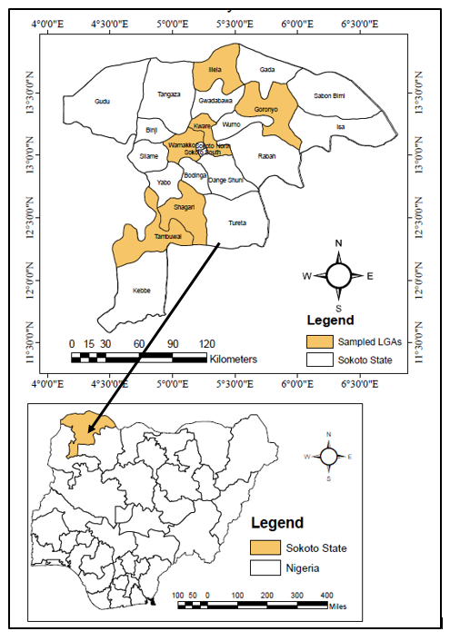
Figure 1: The Study Area

Data and Analyses
The basic data used for determining and assessing Ecosystem Distress Syndrome (EDS) in this study is the Normalized Difference Vegetation Index (NDVI) derived from the Moderate Resolution Imaging Spectrometer (MODIS) on board NASA’s Terra (EOS AM) and Aqua (EOS PM) satellites. MODIS – NDVI (MOD13Q1.V6) is one of the products of MODIS that is designed to provide consistent spatial and temporal comparisons of vegetation condition using blue, red and near-infrared reflectance captured at 469 nanometers, 645 nanometers and 858 nanometers respectively (Didan, 2017). The data is presented using 16 days composite and 250m spatial resolution computed from the atmospherically corrected bi-directional surface reflectance that have been masked for water, clouds, heavy aerosols and cloud shadows. 23 NDVI images each for the years 2001, 2006, 2011, 2016, 2021 and 2023 totaling 138 images were downloaded from the official site of the United States Geological Survey (USGS) via the Earth Explorer and used for this study.
Data processing operations were performed using ArcGIS software Version 10.6. These includes extraction of NDVI sub-dataset from the series of datasets (Layers) contained in MOD13Q1.V6 vegetation indices data, raster calculation to rescale the data range to the original NDVI range of “From -1 to +1”, re-projection of the original dataset from sinusoidal projection to WGS 84, for appropriate representation of the study area, clipping of the study area from the larger datasets (Figure 2). Ground Control Points (GCPs) and Training Sample were also collected using GPS from the six selected LGAs (Figure 1) for Ground truthing and validation of the final results of the processed remote sensing imageries.

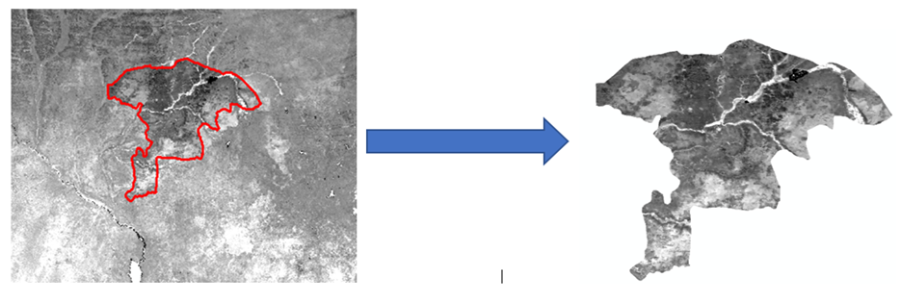
Figure 2: Clipped Image of the Study Area.
Each image represents a 16 days composites giving a total of 23 images per year covering all seasons. Mean NDVI was calculated from each of the 23 images in a year and then their mean was taken to determine the Annual NDVI Mean (Am_NDVI) which was used as a surrogate for ecosystem vigour (Health and productivity). High Am_NDVI values represents a healthy and robust ecosystem while declining Am_NDVI values indicates increasing ecosystem distress. This was calculated separately for each of the 6 LGAs in the state chosen for this study in order to allow for spatio-temporal comparisons.
To obtain information regarding the manifestations and impacts EDS in the study area, fifty structured questionnaires were randomly administered in each of the 6 selected LGAs giving a total of 300 questionnaires. Finally, one Focus Group Discussion FGD was conducted in each LGA to triangulate the information obtained from the Questionnaires administered. The data gathered from the field was analysed using Statistical Package for Social Sciences (SPSS). Descriptive statistics was used in analysing and reporting the result from both remote sensing data, questionnaires and FGD.

Results and Discussions

Trend in Ecosystem Distress Syndrome (EDS)
Analysis of the remote sensing data revealed an increasing trend in Ecosystem Distress Syndrome as represented by the Annual NDVI Mean (Am_NDVI) in table 1. On the whole, the mean annual NDVI decline from 0.56 in 2001 to 0.40 in 2023 representing close to 29% decline within twenty two years period. This a clear indication of EDS as declining Am_NDVI is an indication of a stressed ecosystem with declining photosynthetic activities of the vegetation which is the most important component of any ecosystem due to its important role of primary production upon which, all other components of the ecosystem drive their sustenance. This trend, although proceeds gradually and unnoticed, its poses a serious challenge to the ecosystem of the area as it negatively affects its ability to supply qualitative and quantitative goods and services that are necessary for both human livelihood, environmental protection and sustainable development of the area. The fact that over 80% of the inhabitants of the area engages in livelihood activities with high over dependence on the ecosystem and its service further compound the situation calling for serious and urgent intervention measures (Jibrillah et al., 2018; Jibrillah & Saleh, 2023; Jibrillah & Shamaki, 2024).
Table 1: Trend in EDS in the Study Area
LGAs | 2001 | 2006 | 2011 | 2016 | 2021 | 2023 | Mean
Tambuwal  Shagari  Wamakko  Kware  Goranyo  Illela | 0.66  0.61  0.59  0.57  0.49  0.47 | 0.63  0.59  0.56  0.54  0.45  0.43 | 0.59  056  0.54  0.51  0.38  0.37 | 0.54  0.52  0.50  0.48  0.36  0.34 | 0.49  0.47  0.45  0.44  0.34  0.31 | 0.46  0.45  0.43  0.42  0.33  0.30 | 0.56  0.53  0.51  0.49  0.39  0.37
Mean | 0.56 | 0.53 | 0.49 | 0.45 | 0.42 | 0.40 | 0.48
As the Am_NDVI continues to decline as depicted by figure 3, it indicates a distressed ecosystem characterized by low and declining photosynthetic activities leading to low production of organic matter and other essential ecosystem goods and services. Declining photosynthetic activities of the vegetation in an ecosystem would have serious implications on the entire ecosystem considering the crucial role of vegetation of primary production which support all other components of the ecosystem. More so, the fact that all components of an ecosystem both biotic and abiotic are tightly knit together through mutual interactions and interdependence means that any change in one component particularly the vegetation would affect all other components (Bukar et al., 2020; Gabriele et al., 2022; Jibrillah, 2018c; Jibrillah & Shamaki, 2024; Rapport et al., 1998).

Figure 3: Temporal Trend of EDS in the Study area
Rapport et al. (1988) described the above trend as “ecosystem distress syndrome” which according to them is prevalent in both terrestrial and aquatic ecosystems. They further observed that, these kind of changes often proceeds gradually and unnoticed unless a conscious effort is made to monitor them. However, its impacts present a serious challenge to both the ecosystem itself and the livelihoods of the inhabitant of this region due to their overdependence on the ecosystem and the goods and services it offers through such economic activities as crop cultivation and animal rearing. This partly is responsible for the increasing poverty and declining standard of living in this region.

However, EDS in the study area revealed a spatial South – North trend as revealed by Figure 4. That is, although all the LGAs under study suffer from EDS, but it magnitude increase with increasing latitudes from South toward North.

Figure 4: Spatial Trend of EDS in the Study Area
The above trend can be attributed to many drivers of ecosystem change both natural and anthropogenic as well as direct and indirect drivers. Some of these drivers may include recent climate change and variability and in particular, the North – South decline in the rainfall regime in the area. Other drivers such as population increase and its associated consequences, land use conversions and fragmentation, habitat destruction, pest and diseases, presence of invasive species, unsustainable land and water managements, cultural practices as well as certain political decisions and policies also contributed greatly.

Impacts of Ecosystem Distress Syndrome in the Study Area
Ecosystem Distress Syndrome has impacted in both the environment and the livelihood of the inhabitants of the study area in a number of ways. Table 2, summarizes some of these impacts as generated form the questionnaire administration, Focus Group Discussions and field observation.
Table 2: Impacts of EDS in the Study Area.
Impact | Frequency | Percentage | Ranking
Loss of Vegetation cover  Destruction of Farmlands and grazing Areas  Declining Food Production  Increasing Water Scacity  Declining Livelihood and Family Income  Conflicts over Land and Communal Resources  Migration | 30  63  72  31  43  35  26 | 10  21  24  11  14  12  08 | 6th  2nd  1st  5th  3rd  4th  7th
Total | 300 | 100
Although, all the respondents were unanimous on the occurrence of all of the above impacts, there were however, divergence of opinions as to which amongst them is the most spectacular and most challenging impact of EDS in the area. About 24% of the respondents considers declining food production the most serious and challenging impact of EDS in the area. Food production is one of the major provisioning services of an ecosystem that is very crucial for sustainable livelihoods of any community. Many of the respondents believe that, food production in the study area has been on the decline due to the declining ecosystem vigour and the declining trend observed in the length of the growing season of the area over the years, this has negatively affected crops and livestock productivity in the area according to them. A resident of Kalmalo village in Illela Local Government area for example, made the following assertions during the FGD session on the 28th of August 2024:
“During the last 30 years, rainfall in the area has been very unreliable. Sometimes occasioned by late onset and early or even abrupt cessation. Because of this, the growing season is becoming shorter and shorter, leading to low crop output despite increasing investment in farm inputs. Sometimes, total crop failure is even recorded due to insufficient rainfall”.
Some authors such as Abdulrahim (2012) and Aliyu (2013), also reported similar decline in crop production in the area. Similar declining productivity were also observed in the livestock and fishery sectors which are other important components of food production in the area. On this, a resident of Romon Sarki Village in Tambuwal LGA opines during the FGD session on the 15th of July 2024:
“Unlike before, some 30 to 40 years back when there were extensive grazing reserves that are rich in pasture for animal grazing, in the recent years the grazing areas are becoming increasingly drier year after year, due to lower amount and shorter duration of rainfall couple with increasing temperatures. This has greatly affected both the animal population and productions of milk, meat, cheese and butter. As a result, many nomads have migrated to the southern part of the country with their flocks in search of better pasture and grazing areas”.
Regarding the fish production in the area, an artisanal fisherman in Kalkwalawa village of Dundaye district in Wamakko Local Government Area, clearly observed during the FGD session on the 6th of September 2024:
“During the recent year, the amount of fish catch has drastically reduced partly due to the low and variable rainfall and also due to the shrinking and drying of many steams and ponds in the area. Many people are now into fish farming in order to augments the gross decline in the fish supply, a situation which led to the drastic increase in the price of fish in the area”.
Destruction of Farmlands and grazing Areas was ranked as the second most challenging impact of EDS in the study area. This happens in extreme cases when increasing aridity of land due to the declining rainfall and increasing temperature results in total loss of vegetation cover, which in turn exposes a piece of land (farmland or grazing area) to actions of different agents of denudation such soil erosion, weathering and mass deposit of sand. This sometimes leads to complete loss of the land, which could be either agricultural land used for crop cultivation or a grazing land. Many of such destroyed land has been encountered in many areas across the study area during field observation by the researchers. Figure 5 shows an example of such destroyed agricultural and grazing land in the study area. Picture A, is an agricultural land Shagari Local Government Area being destroyed due to severe aridity caused by a long period of declining rainfall and increasing temperature, leading to loss of vegetation cover, which exposes the soil to severe weathering and erosion, which renders the land completely unproductive. Picture B, is a destroyed grazing land in Wamakko Local Government Area that is seriously eroded by the action of wind and running water due the loss of vegetation cover caused by the same declining rainfall and increasing temperature in the area.
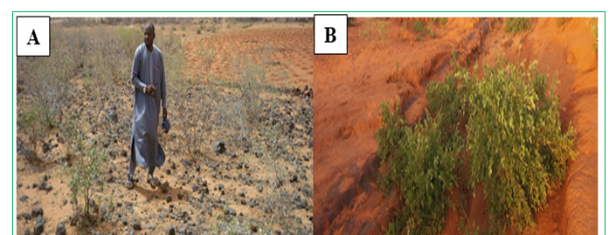
Figure 5. Examples of Destroyed Agricultural and Grazing Lands in the Study area.
This problem has led many people in the study area to abandon farming and pursue alternative sources of livelihoods such as petty businesses and street hawking, while other migrate to other parts of the country in search of fertile agricultural land. The problem also led many nomadic livestock herders to migrate to the middle belt and southern parts of the country in search of greener pasture for their flocks.
Declining livelihood and family income is ranked as the third most challenging impact of EDS in the study area. This problem is caused by the combination of both the first and second impacts discussed above. This is because, majority of the inhabitant of the study area are rural peasants that depends largely on the natural ecosystem and the goods and services derived from the ecosystem for their livelihoods. The dominant economic activities in the area includes crops cultivation, livestock husbandry and fishing. Declining productivity of crops, livestock and fishing due to EDS will lead to a similar decline in the livelihoods and income of the inhabitant of the area. Other group of people that also derived their livelihoods and income from the service provisions, processing and marketing of the crops, livestock and fish products and bye products would also be negatively affected. These group people include farm labourers, transporters and those involved in the trading of crops, livestock, fish and their bye products, both retailers and whole sellers. Almost all respondents in this research from both focus group discussions (FGD) and questionnaire administration admitted and express a deep and serious concern over this problem of declining livelihood and family income which is responsible for the increasing level of poverty among the inhabitants of the area.
During our FGD session of 5th August in Bankanu Village of Kware Local Government Area, one of the group members’ lament:
“There has been increasing hardships in the recent years due to the persistent low agricultural outputs which is our major source of food and income. Our income from agriculture is persistently declining. The outputs in some years is not even enough to feed our families till the next harvest, talk less of having surplus which we usually sold to meet other domestic needs. As a result, most of us must look for other means to support our family. This also has affected our ability to invest in the farm in terms of fertilizer, improved seeds and modern farming implements to improve our farming activities”.
Livestock farmers and fishermen also suffers similar declining livelihood and family income due to declining productivity in the livestock and fishing sectors over the years in the area.
Another major challenging impact of EDS in the study area is the increasing water scarcity for both domestic and agricultural uses. This is caused mainly by decreasing rainfall, which affect the supply of both surface and sub-surface water and increased temperature which accelerate evapotranspiration in the area, thereby creating more water deficit. This is further exacerbated by the shrinking and drying up of many streams and lakes (such as Kalmalo lake) in the area. The increasing difficulty faced by both urban and rural communities in sourcing domestic water and increasing number of water vendors in the area is a clear testimony to this fact (Figure 6). This problem also features in all our FGD sessions and people in the study area complain so much about the increasing scarcity and difficulty in sourcing water for domestic and other uses. This situation becomes particularly acute during the dry season particularly, between the summer months of April, May and June due to relatively higher temperature which accelerate evapotranspiration. During our FGD session of 28th August 2024 in Rumbuki Village of Shagari Local Government Area, an elderly member of the community, opined:
“Water scarcity particularly during the dry season is one of the serious problems in this community particularly during the recent years. This is because, most of the open wells we are using got dried up during the dry season. The streams and ponds for watering our livestock also becomes dry during the dry season. As a result of this sourcing water for domestic uses and for our animals is a serious problem during the dry season. Sometimes we buy the water from the water vendors, while some other times our children have to walk long distance in search of water, which in some cases affects their school attendance”.
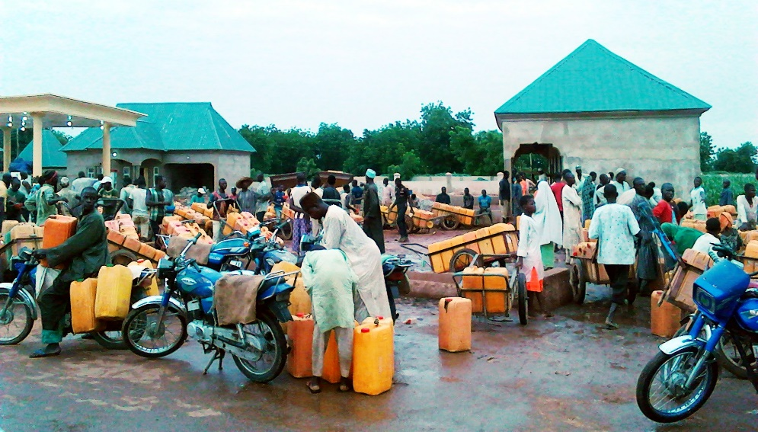
Figure 6 Water Scarcity in the study Area
Gada (2016), also observed an increasing scarcity of rural water supply in the Sudano-Sahelian region of Nigeria, within which the study area is located. He however, attributed this, to the declining rainfall trend and increasing population of the area, which heighten the water demand in the recent years.
Other impacts of EDS in the area include loss of vegetation cover, conflict over land and other communal resources such as water and grazing areas as well as migration. Anthropogenic activities such as deforestation, overgrazing and unsustainable farming practices causes vegetation loss which also exposes soil to agents of denudation such wind and water erosions. Jibrillah (2018c), reported about 23% loss of vegetation cover in the area between 2000 to 2016. Conflicts over land and communal resources take different forms and usually involves all categories of resource users in the area. In the first instance, one major form of conflicts is between pastoralists and farmers over destruction of crops and farming facilities by the pastoralist or encroachment into grazing reserves and livestock routes by the farmers. Secondly there is another form of conflicts between pastoralists and artisanal fishermen over the access and use of water resources such as rivers, streams and ponds for either fishing or livestock watering or both. Thirdly, there are conflicts amongst the artisanal fishermen themselves over the fishing methods and ownerships of water resources such as river, streams and ponds. Finally, there are also cases of conflicts between pastoralist on one hand, and hunters and gatherers on the other hand over the exploitation and use of vegetal resources.
Migration from one place to another is another impact of EDS in the study area which usually comes as a last resort to the people involved. Some time, the adverse effects of EDS in the area such as drought, loss of agricultural land due to land degradation, shrinking and drying of water bodies such as rivers, streams, and ponds and the likes, forces some individuals both amongst farmers, pastoralists and fishermen to migrate to other places in search of a better fortunes. These are mostly people who are either displaced from or no longer feel safe in their usual places of residence due to serious risk or threats posed to their lives, livelihoods or welfare as a result of adverse impacts of EDS such as land degradation, crop depletion, deforestation, soil erosion, floods and droughts all of which manifest at different degrees in the study area. Cases of these types of migration are very common in the study which involves both temporary, seasonal and in some cases permanent migrations as confirmed through FGD and questionnaire administration. In some case, these types of migrations particularly when it involves large people as with case of pastoralists, leads to eruption of conflicts at the destination mostly due to the hostility of the host communities for the fear of domination of their resources by the migrant population.

Conclusion and Recommendations
Evidences from this research confirmed that, ecosystem in the study area is under increasing challenges and threats from many stressors both natural and anthropogenic a situation generally described as Ecosystem Distress Syndrome. That, this situation limits the ability of the ecosystem to provide adequate and qualitative good and services necessary for sustainable development of the area. This presents serious threats to food security, sustainable livelihoods of the inhabitants and overall development of the area.
To mitigate the adverse impacts of EDS in the area, the research recommends effective and frequent environmental monitoring using Geoinformatics, environmental education, massive enlightenment drives, training of the local inhabitants on the sustainable land and water management practices as well as pursuing alternative means of livelihoods that are more ecosystem friendly among others. Mitigation and adaptation capacities of the famers, livestock pastoralists and artisanal fishermen should also be strengthened to enable them to address the low productivity resulting from EDS and associated challenges. Finally, programmes and policies geared towards restoring the degraded ecosystems and conserving the existing ones should also be given utmost priority.

References
Abdullahi Ahmed, M., Barde, U., & Iliyasu, I. (2021). Assessment of Urban Growth Using Geographic Information System (Gis) and Remote Sensing In Potiskum Town Potiskum local government area. International Journal of Advances in Engineering and Management (IJAEM), 3(7), 1154–1163. https://doi.org/10.35629/5252-030711541163
Bukar, M. A., Bukar, W. M., Bakari, K., & Mbaya, R. P. (2020). Monitoring Vegetation Change using NDVI Analysis and Image Differencing from Lands at imagery in North-Eastern Nigeria , 1975 – 2016. Journal of Environmental Science, Toxicology and Food Technology (IOSR-JESTFT), 14(10), 26–34. https://doi.org/10.9790/2402-1410032634
Casper, J. K. (2010). Changing Ecosystems: Effects of Global Warming. Facts on File, Inc.
Chen, P., Liu, H., Wang, Z., Mao, D., Liang, C., Wen, L., Li, Z., Zhang, J., Liu, D., Zhuo, Y., & Wang, L. (2021). Vegetation Dynamic Assessment by NDVI and Field Observations for Sustainability of China ’ s Wulagai River Basin. International Journal of Environmental Research and Public Health, 18, 2–20.
Davis, G. (1982). Rainfall and Temperatue. In P. S. Abdu (Ed.), Sokoto State in Maps: An Atlas of physical and Human Resources. University Press.
Eniolorunda, N. B., & Jibrillah, A. M. (2020). Application of Tasselled - Cap Transformation to Soil Textural Mapping of a Semi - Arid Environment : A Case of Usmanu. Nigerian Journal of Environmental Sciences and Technology (NIJEST), 4(1), 97–110.
Fan, Z., Bai, X., & Zhao, N. (2022). Explicating the responses of NDVI and GDP to the poverty alleviation policy in poverty areas of China in the 21 st century. PLoS One, 17(8), 1–16. https://doi.org/10.1371/journal.pone.0271983
Gabriele, M., Brumana, R., Previtali, M., & Cazzani, A. (2022). A combined GIS and remote sensing approach for monitoring climate change ‑ related land degradation to support landscape preservation and planning tools : the Basilicata case study. In Applied Geomatics. Springer Berlin Heidelberg. https://doi.org/10.1007/s12518-022-00437-z
Grimm, N. B., Staudinger, M. D., Staudt, A., Carter, S. L., Iii, F. S. C., Kareiva, P., Ruckelshaus, M., & Stein, B. A. (2013). Climate-change impacts on ecological systems : introduction to a US assessment In a nutshell : Front Ecol Environ, 11(9), 456–464. https://doi.org/10.1890/120310
Ibañez-Alvarez, M., Farr, P., Calleja, J. A., Rouco, C., Brolly, M., Burnside, N. G., Baraza, E., Bartolom, J., & Serrano, E. (2022). Satellite-Based Monitoring of Primary Production in a Mediterranean Islet Post Black Rat Eradication. Remote Sensing, 14(101), 2–18. https://doi.org/https://doi.org/10.3390/rs14010101
IPCC. (2013). Summary for Policymakers. Climate Change 2013: The Physical Science Basis. Contribution of Working Group I to the Fifth Assessment Report of the Intergovernmental Panel on Climate Change, 33. https://doi.org/10.1017/CBO9781107415324
Jabrayilov, E. A. (2022). Monitoring of Fragile Ecosystems With Spectral Indices Using Sentinel-2a Msi Data in Shahdagh National Park. Geography, Environment, Sustainability, 15(1), 70–77. https://doi.org/10.24057/2071-9388-2021-006
Jibrillah, A. M. (2018a). A Remote Sensing Analysis of Vegetation Dynamics in the Dryland Ecosystem of Sokoto Close-settled Zone, North-western Nigeria. FUDMA Journal of Sciences (FJS), 2(3), 54–67.
Jibrillah, A. M. (2018b). Assessing the Impacts of Climate Change and Variability on Ecosystem Health and Vegetation Phenology using Geo- Informatic : A Case of Sokoto , Northwestern Nigeria. Unpublished PhD Thesis, Department of Geography, Universiti Kebangsaan Malaysia.
Jibrillah, A. M., Choy, L. K., & Jaafar, M. (2018). Monitoring The Health of Dryland Ecosystem Across North-western Nigeria using Multi-temporal MODIS-NDVI Remote Sensing Data. FUDMA Journal of Sciences, 2(2), 262–272.
Jibrillah, A. M., & Hamisu, I. (2022). Geospatial Analysi of Ecosytem Vigour in Kuyambana Game Reserve, Zamfara State, North Western Nigeria. Osun Geographical Review, 5, 113–120.
Jibrillah, A. M., & Hamisu, I. (2023). Climate Change, Ecosystem and Livelihoods: A Survey of the Perceotions of Rural people in the Sokoto-Closed Settled Zone, Nothwestern Nigeria. Territoires, Sociétés & Environnement, 1(30–42).
Jibrillah, A. M., Jaafar, M., & Choy, L. K. (2019). Monitoring Vegetation Change in the Dryland Ecosystem of Sokoto , North- western Nigeria using Geoinformatics. Indonesian Journal of Geography, 51(1), 9–16.
Jibrillah, A. M., & Saleh, A. A. (2023). Geospatial Analysis of Ecosystem Distress Syndrome in the West African Sudano-Sahelisn Region: A case ot Northwetern Nigeria and Southwestern Niger Republic. Territoires, Sociétés et Environnement (TSE), 1, 177–185.
Jibrillah, A. M., & Shamaki, M. A. (2024). Monitoring the Impact of Population Growth on Ecosystem in Sokoto Closed Settled Zone, Northwestern Nigeria using Geoinformatics. Scientific Journal of Population Education, 2(1), 3–14.
Liu, C., Liu, D., Li, P., Li, X., Liu, Z., & Zhao, Y. (2023). Assessment of occupation of natural habitat by urban expansion and its impact on crucial ecosystem services in China’s coastal zone. Ecological Indicators, 154(March), 110682. https://doi.org/10.1016/j.ecolind.2023.110682
Millennium Ecosystem Asessment. (2005). Ecosystems and human well-being: current state and trends, Volume 1 (R. Hassan, R. Scholes, & N. Ash (eds.); Vol. 1). Island Press.

Msoffe, F., Nauss, T., & Zeuss, D. (2020). Use of Current Remote Sensing Methods for Biodiversity Monitoring and Conservation of Mount Kilimanjaro National Park Ecosystems. 6th International Conference on Geographical Information Systems Theory, Applications and Management (GISTAM2020), Gistam, 175–183. https://doi.org/10.5220/0009357701750183
Qi, G., Cong, N., Luo, M., Qiu, T., Rong, L., Ren, P., & Xiao, J. (2024). Contribution of Climatic Change and Human Activities to Vegetation Dynamics over Southwest China during 2000 – 2020. Remote Sensing, 16, 1–16. https://doi.org/https://doi.org/10.3390/rs16183361
Qin, D., Manning, M., Chen, Z., Marquis, M., Averyt, K. B., & Kingdom, U. (2007). FAQ-From the report accepted by Working Group I of the Intergovernmental Panel on Climate Change. IPCC, 2007: Climate Change 2007: The Physical Science Basis. Contribution of Working Group I to the Fourth Assessment Report of the Intergovernmental Panel on Climate Change, 35. https://doi.org/10.1002/div.5469
Rapport, D. J., Costanza, R., & McMichael, A. J. (1998). Assessing ecosystem health. Trends in Ecology and Evolution, 13(10), 397–402. https://doi.org/10.1016/S0169-5347(98)01449-9
Suo, A. N., Xiong, Y. C., Wang, T. M., Yue, D. X., & Ge, J. P. (2008). Ecosystem health assessment of the Jinghe River Watershed on the Huangtu Plateau. EcoHealth, 5(2), 127–136. https://doi.org/10.1007/s10393-008-0167-z
Wu, F., & Wang, Z. (2023). Assessing the impact of urban land expansion on ecosystem carbon storage: A case study of the Changzhutan metropolitan area, China. Ecological Indicators, 154(May), 110688. https://doi.org/10.1016/j.ecolind.2023.110688
Xu, D., & Guo, X. (2015). Some Insights on Grassland Health Assessment Based on Remote Sensing. Sensors, 15(2), 3070–3089. https://doi.org/10.3390/s150203070
Zlinszky, A., Heilmeier, H., Balzter, H., Czúcz, B., & Pfeifer, N. (2015). Remote sensing and GIS for habitat quality monitoring: New approaches and future research. Remote Sensing, 7(6), 7987–7994. https://doi.org/10.3390/rs70607987

