**Structural Model Evaluation: Validating the Goodness-of-Fit Indices of GUAM Framework**

**Abstract**

*Models are fitted to data in an attempt to understand underlying processes that have been operating. To be useful, they should be parsimonious and clearly understood. For structural models, a huge variety of fit indices has been developed. These indices, however, can point to conclusions about the extent to which a model actually matches the observed data. The study evaluates the goodness-of-fit of a generic usability and acceptance model (GUAM). Measures for the study were adopted from the GUAM, and a questionnaire tagged Learning Innovations Adoption Questionnaire was used. Exploratory and confirmatory factor analyses were used to test and understand the underlying structure of the proposed model, using structural equation modelling (SEM). As regards model fit, the model went through a number of iterations until a good model was realised. Validity and reliability of the proposed generic model were also examined, both showing satisfactory validity and good internal consistency, which indicate that a good model fit has been attained.* *On this basis, GUAM model is considered a valid and reliable theoretical tool for learning innovations adoption and use.*

**Key words**: *Structural Equation Modeling; Model Fits; Model Evaluation, Goodness-of-Fits Indices; GUAM*

1. **Introduction**

In Structural Equation Modelling (SEM), a model is said to fit the observed data to the extent that the model-implied covariance matrix is equivalent to the empirical covariance matrix. Once a model has been specified and the empirical covariance matrix is given, a method has to be selected for parameter estimation. Different estimation methods have different distributional assumptions and different discrepancy functions to be minimised. When the estimation procedure has converged to a reasonable solution, the fit of the model should be evaluated. Model fit determines the degree to which the structural model fits the sample data. Although there are no well-established guidelines for what minimal conditions constitute an adequate fit, a general approach is to establish that the model is identified, that the iterative estimation procedure converges, that all parameter estimates are within the range of permissible values, and that the standard errors of the parameter estimates have reasonable size. To Schermelleh-Engel et al (2003), the fit criteria of a structural model indicate the extent the specified model fits the empirical data.

The importance of Information Systems (IS) for knowledge impartation is widely recognised (Amadin et. al, 2018). Their implementation is preceded by their development through design methodologies which utilise information models to specify IS on a conceptual level. Such conceptual models have been successfully employed throughout IS theory and practice. These include the Technology Acceptance Model (TAM), the Theory of Reasoned Action (TRA), the Theory of Planned Behavior (TPB), the Motivational Model (MM), a combined Theory of Planned Behaviour/Technology Acceptance Model (C-TPB-TAM), the Model of PC Utilization (MPCU), the Innovation Diffusion Theory (IDT) developed by Rogers (2003), the Social Cognitive Theory (SCT), and the Unified Theory of Acceptance and Use (UTAUT) developed by Venkatesh et al.,(2003).

However, these models have some limitations in addressing technology adoption problems faced by learning institutions (Hariri and Roberts, 2015; Oye et al., 2012; Petter et al., 2008; Miller et al., 2000). For instance, despite being a robust model, UTAUT was limited to the fact that UTAUT’s variance on learning innovation is poor (Mbete and Raisamo, 2014; Thamos et al., 2013; Hsu, 2012; Yeboah et al., 2014). Hence, inappropriate for learning innovations (Hariri and Roberts, 2015; Lahtinen, 2012; Straub, 2009). Supporting this, Petter et al., (2008) noted that the current theoretical perspective on user acceptance is very weak in providing prescriptive guidance to researchers when investigating adoption in schools.” Straub (2009) further argues that the TAM model or even its successor UTAUT, does not give the full picture whether or not an individual will adopt a particular LI ~~or not~~. He claims that technology adoption is a complex, inherently social, and developmental process. Therefore, to successfully facilitate an adoption, an organisation has to be able to address individuals’ cognitive, affective and contextual interests and concerns.”

The quality of conceptual models, on the other hand, is believed to have an enormous impact on ~~to~~ related IT and IS artifacts, as conceptual models used in the requirements specification phase of a system development process determine the acceptability and usability of the product to be built (Lauesen and Vinter, 2001). In line with this assertion, Obienu and Amadin (2021) “developed a generic usability and acceptance model (GUAM) with a view to measuring behavioural intention in accepting and using learning innovations.

GUAM incorporates four constructs (as illustrated in Figure 1): user expectancy, institutional supports, social influence, and perceived system expectations. Individual differences – such as age, gender, awareness, accessibility, and experience – were hypothesised to moderate the effects of these constructs on behavioural intention and innovation use. Measures for the study were developed while some were adopted from previous studies, and a questionnaire tagged “Learning Innovations Adoption Questionnaire” was used. Exploratory and confirmatory factor analyses were used to test and ~~better~~ understand the underlying structure of the proposed model, using Structural Equation Modelling (SEM). Results from the survey with learning innovation that used data of 1,357 respondents supported our generic model. In contrast to extant acceptance models which can predict up to 41% accuracy of user acceptance (Davis et al., 1989), GUAM produced a substantial improvement in the variance explained in behavioural intention (72%) and technology use (63%) of learning innovations.” This demonstrated that domain or discipline sensitive models have the potential to outperform generic adoption models like TAM or UTAT, due to variations on technological features and characteristics of user groups. On this basis, GUAM model is considered a valid and reliable theoretical framework for learning innovations adoption and use (Obienu and Amadin, 2021). However, this assertion can be validated by evaluating the goodness of fits of the conceptual model.

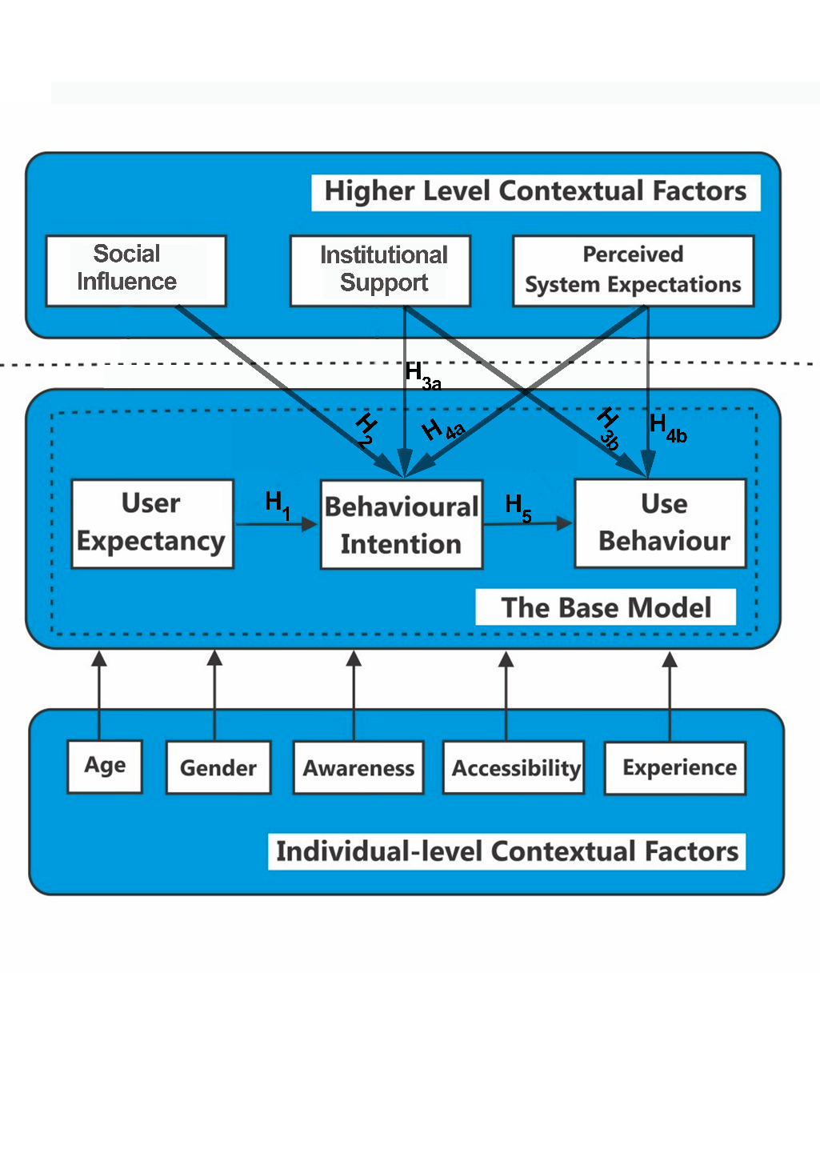

**Figure 1**: A Generic Usability and Acceptance Model (GUAM) for Learning Innovation (Obienu and Amadin, 2021)

Meanwhile, Information system research is based upon the idea of progress; hence, it must comprise approaches for differentiating between competing alternatives. Thus, evaluation must be seen as a core substantive element of IS research. The importance of rigorous evaluative research can be stated as follows: No problem-solving process can be considered complete until evaluation has been carried out. It is the evaluation which helps us to measure the effectiveness of the problem-solving process and the problem solver in the 'problem situation'. Unless this element is considered, there is no way of establishing that the 'problems' have been successfully resolved. Evaluation is defined as the systematic study of a research artifact (here, modelling methods) to determine its usefulness, effect, or impact. To achieve this, this study evaluates the Goodness of Fit (GOF) indices of GUAM framework.

1. **“Goodness-of-Fit (GOF) Indices**

For structural equation models, a huge variety of fit indices has been developed. The GOF of a measurement model describes how well it fits into a set of observations (Olivares and Forero, 2010). GOF indices sum up the discrepancy between the observed qualities and the qualities expected under a measurable model. GOF statistics are GOF indices with known sampling distributions, usually obtained using asymptotic methods that are used in statistical hypothesis testing. While assessing the model goodness-of-fit, Hair et al. (2010) recommended the following fits criteria, namely: Absolute Model Fit, Incremental Model fit and Parsimonious Model Fit.

1. **Absolute Model Fit** is a direct measure of how well the model specified by the researcher reproduces the observed data; that is, the discrepancy between a model and the data. Assessing absolute model is critical in applications, as inferences drawn on poorly fitting models may be badly misleading (Olivares and Forero, 2010). ~~Continuing~~, They noted that applied researchers must examine not only the overall fit of their models, but they should also perform a piecewise assessment. It may well be that a model fits well overall but that it fits poorly some parts of the data, suggesting the use of an alternative model. The piecewise GOF assessment may also reveal the source of misfit in poorly fitting models. These include: *χ2* - Chi-square; *df* - degree of freedom; *p* - Probability value (Recommended to be less than 0.05); *RMSEA* - Root Mean Square Error of Approximation (Recommended to be less than 0.1); and *GFI* - Goodness of Fit Index (Between 0-1. Higher values indicate good model fit).”

* The **χ2 test statistic** is estimated by (Equation 1):

$x^{2}\left(df\right)=\left(N-1\right) F\left[S,ε(θ)\right]$ (1)

With ***df = s – t***degrees of freedom,

***Where:***

***s*** is the is the number of non-redundant element in ***S,***

***t*** is the total number of parameters to be estimated,

***N***is the sample size,

**S** is the empirical covariance matrix, and

$\sum{ (θ)}$ is the model-implied covariance matrix.

* ***RMSEA*** is estimated by (Equation 2):

- ), 0 (2)

Where:

$F(S,\sum{(θ))}$ is the minimum of a fit function,

***df = s – t*** is the number of degree of freedom, and

***N***  is the sample size.

* **Goodness-of-Fit-Index (GFI)** is estimated by (Equation 3):

***GFI = $1- \frac{F_{t}}{F_{n}}$ = $1-\frac{x_{t}^{2}}{x_{n}^{2}}$*  ,** (3)

Where:

$x_{n}^{2}$ is the chi-square of the null model (Baseline model),

$x_{t}^{2}$ is the chi-square of the target model, and

***F*** is the corresponding minimum fit function value.

These measures provide the most fundamental indication of how well the proposed theory fits the data (Hooper et al. 2008). Unlike incremental fit indices, their calculation does not rely on comparison with a baseline model but a measure of how well the model fits in comparison to no model at all” (Jöreskog and Sörbom, 1993).

1. **Incremental Model Fit** differs from absolute fit indices because they assess how well the estimated model fits relative to some alternative baseline model; that is, the discrepancy between two models. Incremental model fit is also known as relative model fit (McDonald and Ho, 2020) or Comparative Model Fit (Miles and Shevlin, 2007). These include *CFI* - Comparative Fit Index (Between 0-1. Higher values indicate good model fit); *NFI*- Normed Fit Index (Recommended to be above 0.8); and *TLI* - Tucker Lewis Index (Recommended to be above 0.8).

* The ***Comparative Fit Index (CFI)*** is estimated by (Equation 4):

***CFI = 1 $\frac{\max{[\left(x_{t - }^{2} df_{t}\right), 0}}{\max{[(} x_{t - }^{2}df_{t}), x_{i}^{2} - df_{i}), 0]}$***(4)

Where:

**max** denotes the maximum of the values given in brackets

$x_{i}^{2}$ is the chi-square of the independence model (Baseline model)

$x_{t }^{2}$ is the chi-square of the target model, and

***df***is the number of degree of freedom.

* The **Normed Fit Index (NFI)** is estimated by (Equation 5):

***NFI = $\frac{x_{i }^{2}- x_{t}^{2}}{x_{i }^{2}}=1- \frac{x_{t}^{2}}{x_{i }^{2}}=1- \frac{F_{t}}{F_{i}} ,$***  (5)

*Where:*

$x_{i}^{2}$ is the chi-square of the independence model (Baseline model),

$x_{t }^{2}$ is the chi-square of the target model, and

***F***  is the corresponding minimum fit function value.

As the name implies, they are a group of indices that do not use the chi-square in its raw form but compare the chi-square value to a baseline model. For these models the null hypothesis is that all variables are uncorrelated (McDonald and Ho, 2002).

”

1. **Parsimonious Model Fit** has a nearly saturated, complex model where the estimation process is dependent on the sample data (Hooper et al. 2008). This results in a less rigorous theoretical model that paradoxically produces better fit indices. To overcome this problem, parsimonious model fit was developed. It was designed specifically to provide information about which model among a set of competing models is best, considering its fit relative to its complexity. These include: *χ2/df* - Chi-square/degree of freedom (Below 5. The less, the better); *AGFI* - Adjusted Goodness of Fit Index; (Recommended to be above .80), and *PNFI* - Parsimony Normed Fit Index (Between 0-1. Higher values indicate good model fit).”

* ***Adjusted Goodness-of-Fit-Index (AGFI)*** is estimated by (Equation 6):

**AGFI** = $1- \frac{df_{n}}{df_{t}} \left(1-GFI\right)=1- \frac{X_{t}^{2} /df_{t}}{x_{n}^{2} /df_{n}}$, (6)

Where:

$x_{n}^{2}$ is the chi-square of the null model (Baseline model),

$x_{t}^{2}$ is the chi-square of the target model,

*d $f_{n}$ = s = p ( p+1 )/2* is the number of degree of freedom for the null model, and

$df_{t}$ =*s – t* is the number of degree of freedom for the target model.

* ***Parsimony Normed Fit Index (PNFI)*** is estimated by (Equation 7):

***PNFI = $\frac{df_{t}}{df_{i}} NFI$*** (7)

Where:

$df_{t}$ is the number of degrees of freedom of the target model,

$df_{i}$ is the number of degree of freedom of the independence model, and

***NFI*** is the Normal Fit Index.

From the above, a number of criteria can be used to assess the "goodness" of models. This include Chi-square, Normed Fit Index (NFI) and Goodness of Fit Index (GFI), which are all recommended to be greater than 0.8 (Hair et al. 2010). While there are no golden rules for assessment of model fit, reporting a variety of indices is necessary because different indices reflect a different aspect of model fit (Hooper et al., 2008). Hence, this study adopted several fits criteria as to minimise biases in results.

1. **Materials and Method**

In testing theoretical models, Anderson and Gerbing in Obienu and Amadin (2021) have recommended the use of covariance structure analysis. Covariance Structure Analysis is a statistical technique in which a theoretical model, or a covariance structure is constructed, and the covariances predicted by the theoretical model are compared with that of the observed data. The covariance structure analysis aimed to minimise the difference between the observed covariances (sample covariances) and the covariances predicted by the covariance structure model (population covariances). The adequacy of the model in reproducing the sample covariances is reflected by estimates of the parameters of the model and measures indicating the goodness of fit (Hair et al., 2010).

Generally, GUAM is a combined model that consists of two components: (1) a structural model (that specifies causal relationships between the latent constructs), and (2) a measurement model (that specifies the relationships between the latent constructs and their indicator variables) (Obienu and Amadin, 2021; Magal and Mirchandani, 2001).”

* **Structural Model**

The structural equation model or latent variable model specifies the causal relationships among the latent variables (see equation 8):

$$Ƞ= ßƞ+ Гξ+ ζ; (8)$$

Where:

**Ƞ** is a vector of latent dependent variables,

**ξ** is a vector of latent independent variables,

**ζ** is a vector of errors in equations,

**ß** is a matrix of coefficients relating the latent dependent variables to one another, and

**Γ** is a matrix of coefficients relating the latent independent variables to the latent dependent variables.

Hence, the structural equation model is a general matrix representation in which the assumed causal relationships between latent variables are described.

* **Measurement Model**

The measurement model specifies how the latent variables of the structural equation are measured in terms of the observed variables (see Figure 2). A measurement model is a factor-analytic model derived from theory in which the researchers identify the latent (unobservable) constructs of interest and also indicate which observed variables will be used to measure each latent construct” (Magal and Mirchandani, 2001). The measurement model consists of a pair of (confirmatory) factor equations (Equation 9):

$$Y= ΛyȠ + Ԑ;$$

$$X= Λxξ+ ծ; --------------- -(9)$$

Where:

**Y** is the vector of the observed dependent variables,

**X** is a vector of the observed independent variables,

**ξ** and **ծ** are vectors of unique factors (that is, errors in measurement),

**Λy** and **Λx** are matrices of loadings of the observed **y** variables and the observed **x** variables on the latent **Ƞ** variables and the latent **ξ** variables respectively.

The equations of the measurement model in essence describe the multivariate regressions of y on Ƞ and of x on ξ.

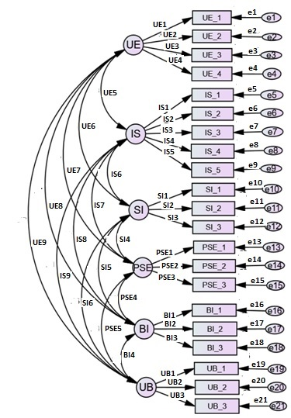

Figure 2: GUAM Measurement Model

* **Data Collection**

The reliability of the measures was tested using a pilot study where the questionnaire “(see Appendix 1) was distributed to the staff members and students of the two selected universities in South-South Nigeria: University of Port Harcourt, and Michael and Cecilia Ibru University, a privately owned university. The University of Port Harcourt was selected purposely because it is well resourced in terms of infrastructure and academic manpower and one of the pioneering users of internet technology. Additionally, Michael and Cecilia Ibru University was selected based on the fact that the university possesses a variety of innovative tools for teaching and research.

Out of 381 participants contacted (100 staff members and 281 students) and who started the questionnaire, only 54 staff members and 231 students completed it, making a total of 285 respondents. Some of these responses were partial responses and they were dropped. Upon the successful collection of the data, the Exploratory Factor Analysis (EFA) and Confirmatory Factor Analysis (CFA) were performed to study the underlying relationships in the model and to test its reliability and validity using 262 useable completed responses.”

* **Data Analysis**

Upon the successful collection of the data, “the Exploratory Factor Analysis (EFA) and Confirmatory Factor Analysis (CFA) were performed to study the underlying relationships in the model and to test its reliability and validity (Hariri and Roberts, 2015). EFA enables the investigation of possible underlying structures behind correlations between different factors (Brace, et al., 2012). Using the SPSS software v22, EFA was performed using the maximum likelihood extraction method and a Promax rotation method. This is in line with previous studies on the subject (Hariri and Roberts, 2015; Brace, et al, 2012; Hair, et al, 2010). Maximum likelihood estimation is used to determine unique variance and correlations, but more importantly, it is used to ensure consistency with the subsequent CFA stage. The EFA performed helped the researchers in reaching a base model, thereby explaining which measures are related and which are not.

Given this insight, the researchers then proceeded to develop and assess the measurement model, which represents a CFA of scales used in this study. This is done to assess how well measurement items reflect the latent variables they are explaining (Byrne, 2010). More so, the validity and reliability of the various factors in measurement model was also examined. This is a necessary step to be taken prior to developing the structural model of this study. Otherwise, we cannot be sure that items are measuring what they are supposed to measure accurately and reliably.

Statistical tools such as AMOS, Stats Tools Package, and SPSS were used to verify that the GUAM model displays an acceptable fit to the data, as well as, to modify the model to achieve a better fit (Venkatesh et al. 2003). The CALIS procedure recommended refinements to the initial models. These modifications are made so that the model would represent the theoretical causal model that the researchers want to develop using the flowchart in Figure 4.”

1. **Results Analysis**

**4.1 “Exploratory Factor Analysis**

A total of six (6) constructs were analysed using the Exploratory Factor Analysis (EFA), and the results of the analyses are presented in Appendix 2**.** After the initial assessment and the removal of low loading and non-loading factors (Hair, et al., 2010), the resulting model (see Appendix 3) had a Kaiser-Meyer-Olkin (KMO) value of 0.873, which is above the acceptable value of 0.7. Bartlett’s Test of Sphericity (BTS) (χ² = 863.916; *df* = 153; *p* < .000) indicated the dataset was adequate for factorability analysis. Commonalities for each variable were sufficiently high (above 0.500). The adequacy of all the variables and the model were also confirmed. From the pattern matrix produced (see Appendix 3), all the constructs have shown high convergent validity, that is, above the threshold of 0.350 (Hair et al., 2010). The total variance explained by the tested model was 80%, which is considered significant.

With respect to factor loadings, the item related to User Expectancy (UE_5), Social Influence (SI_4, SI_5) and Perceived System Expectations (PSE_4, PSE_5) were found with low loadings, which suggests that the variables are candidates for deletion from the model (Hair et al., 2010). Consequently, the researchers had to drop those constructs in other to avoid further issues in the confirmatory factor analysis stage.”

* 1. **Confirmatory Factor Analysis (CFA)**
* **“Initial CFA Model**

Using the outcome (result) gotten from the final EFA analysis, the following initial CFA model (shown in Figure 4) was created using the AMOS software v24. The oval shaped items represent the various factors, also known as latent variables or unobserved variables. Co-variances between each of these factors are also drawn and the values are reported. Each factor is represented by a number of measured variables designated by a box. These measured variables were captured in the questionnaire used for this study. Factor loadings for measured variables are also reported (the line between the oval and box). Lastly, each measured variable has an error variance that is estimated by the software package. In this study, the researchers relied on a number of model-fit indices and their thresholds (Table 1), as discussed by Hair et al. (2010). Results from initial CFA analysis is shown in Table 1 and depicted in Figure 5. From Table 1 and Figure 4, the CFA analysis shows that the observed variables do not fit the estimated covariance matrix. Hence, the CFA model needs improvement.”

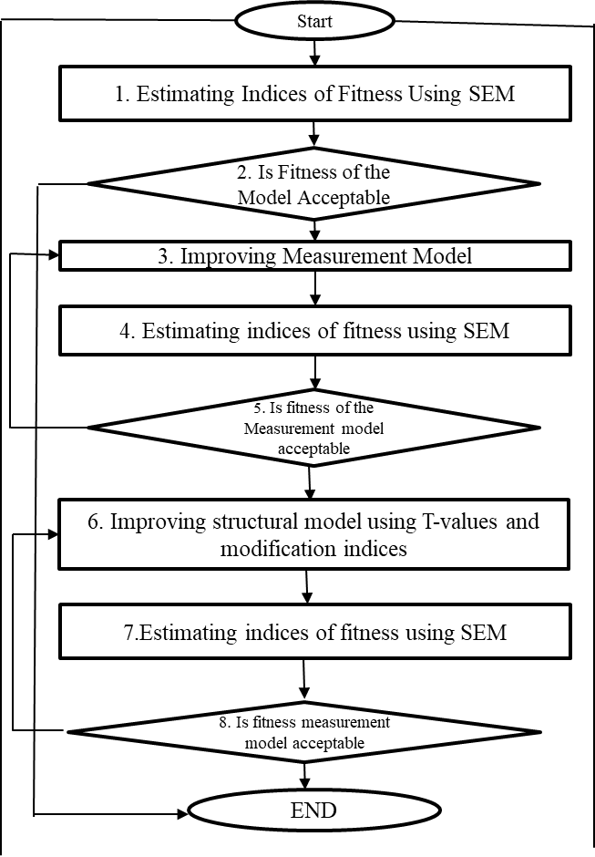

Figure 3: Flowchart for evaluating the fit of Structural Equation Models

Table 1. “CFA* Goodness of Fit Indices.

|  |  |  |
| --- | --- | --- |
| **Model-Fit**  **Parameters** | **Obtained**  **Values** | **Recommended Values (Hair et al., 2010)** |
| 1. **Absolute Fit Indices** | | |
| **Chi-square (χ2):** | 391.809 | |
| **DF:** | 174 | |
| **P-value:** | 0.000 | Recommended to be less than 0.05 |
| **RMSEA** | 0.126 | Recommended to be less than 0.1 |
| **GFI:** | 0.784 | Between 0-1. Higher values indicate good model fit. A value of 1 indicates perfect fit. |
|  | | |
| 1. **Incremental Fit Indices** | | |
| **CFI:** | 0.822 | Between 0-1. Higher values indicate good model fit. Values close to 1 indicate very good fit. |
| **NFI:** | 0.764 | Recommended to be above 0.8 |
| **TLI:** | 0.723 | Recommended to be above 0.8 |
|  | | |
| 1. **Parsimonious Fit Indices** | | |
| **CMIN/DF:** | 2.252 | Below 5. The less, the better |
| **AGFI:** | 0.746 | Recommended to be above .80 |
| **PNFI:** | 0.722 | Between 0-1. Higher values indicate good model fit. A value of 1 indicates perfect fit. |

**CMIN/DF** - Chi-square/degree of freedom; **P** - Probability value; **RMSEA** - Root Mean Square Error of Approximation; **GFI** - Goodness of Fit Index; **AGFI** - Adjusted Goodness of Fit Index, **CFI** - Comparative Fit Index; **NFI** - Normed Fit Index; **TLI** – Tucker Lewis Index; **PNFI** - Parsimony Normed Fit Index.”

* + **“CFA: Modification and Improvements**

As seen from the result of the CFA reported above, there is plenty of room to improve the model fit and it is not unusual that the model-fit process goes through different iterations or tests until a better model is achieved. Hair et al. (2010) recommend~~ed~~ a number of steps that can be taken to improve the GOF. First, factors with low loadings can be dropped (Hair et al., 2010). Therefore, we dropped a number of items to improve the GOF. Ideally, each factor should have a minimum of three items; although it would still be acceptable if some constructs had less than three (Iacobucci, 2010). Therefore, it is best to keep as many items as possible while achieving a good model-fit.

Taking the above step of improving the model-fit into consideration, the researchers were able to reach the following improved model as shown in Table 2 and depicted in Figure 5. As seen from the model fit summary in Table 2, goodness-of-it (GOF) indices indicate that the model is better than the initial one, ~~al~~though there is still room for improvement. Hair et al., (2010) further suggested that if the model is not getting fitted as desired, and is close to the value we are predicting, then modification indices analysis can be carried out.”

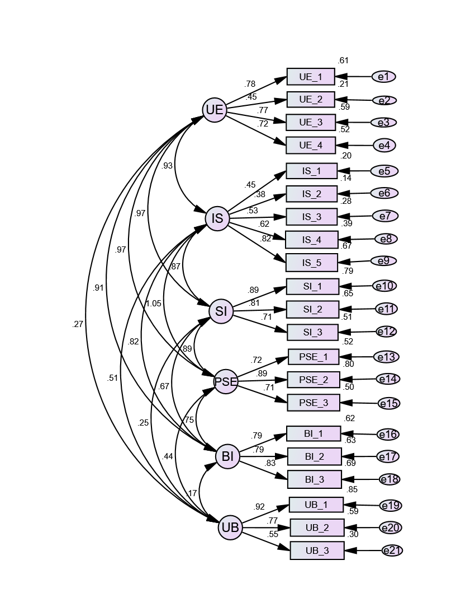Figure 4. Initial CFA Model.

**4.3 “Modification Indices Analysis**

Another step that can be taken to improve the GOF is to introduce new connections as suggested by modification indices (MI) values (Hair et al., 2010). Modification indices are measures for the extent to which the model-fit would be improved if the user accounted for the parameter which is not accounted for (Hair et al., 2010). Investigation of the modification indices indicated high covariance~~s~~ values between a number of error terms. ~~and~~ One way to resolve such issues is to create covariances between errors that belong to the same factor to account for the parameter (Hair et al., 2010). Creation of covariances between error terms relating to the same factor is justified because in many cases, they are systematically correlated (highly related) as they have been worded similarly and people responding to the questionnaire answered them within the same block and they are very close to each other (Byrne, 2010). Therefore, respondents are likely to have answered them similarly.”

Putting the above steps of improving the model-fit into considerations, the researchers were able to reach the following improved model as shown in Figure 6. The model fit parameters were all in the accepted region (RMSEA = 0.079, GFI = 0.85, CFI = 0.908, NFI = 0.85, TLI = 0.879, CMIN/DF = 1.752, AGFI = 0.814, PNFI = 0.802). One can consider Figure 7 as a good model as it fits the data adequately. As seen from the model fit summary in Table 3, Goodness-of-Fit (GOF) indices indicate that the model is better than the previous ones, and in comparison, to the previous model, GOF indices indicate a good model fit.

**4.4 Reliability and Validity of the Constructs**

To reflect latent factors appropriately, observed variables need to show the evidence of reliability and validity (Schumacker and Lomax, 2010; Straub, et al., 2004). Using an initial PLS algorithm for confirmatory factor analysis, the reliability and validity testing results were calculated. This was done to ensure minimum error in the model constructs (Field, 2019). A high reliability score signifies low measurement errors (Hair, et al., 2017). Table 4 shows the results of factor loadings, composite reliability and average variance extracted.

**Table 2: “**CFA* Goodness of Fit Indices.

|  |  |  |
| --- | --- | --- |
| **Model-Fit**  **Parameters** | **Obtained**  **Values** | **Recommended Values (Hair et al., 2010)** |
| 1. **Absolute Fit Indices** | | |
| **Chi-square (χ2):** | 223.393 | |
| **DF:** | 171 | |
| **P-value:** | 0.000 | Recommended to be less than 0.05 |
| **RMSEA** | 0.093 | Recommended to be less than 0.1 |
| **GFI:** | 0.841 | Between 0-1. Higher values indicate good model fit. A value of 1 indicates perfect fit. |
|  | | |
| 1. **Incremental Fit Indices** | | |
| **CFI:** | 0.890 | Between 0-1. Higher values indicate good model fit. Values close to 1 indicate very good fit. |
| **NFI:** | 0.867 | Recommended to be above 0.8 |
| **TLI:** | 0.858 | Recommended to be above 0.8 |
|  | | |
| 1. **Parsimonious Fit Indices** | | |
| **CMIN/DF:** | 1.862 | Below 5. The less, the better |
| **AGFI:** | 0.803 | Recommended to be above .80 |
| **PNFI:** | 0.798 | Between 0-1. Higher values indicate good model fit. A value of 1 indicates perfect fit. |

**CMIN/DF** - Chi-square/degree of freedom; **P** - Probability value; **RMSEA** - Root Mean Square Error of Approximation; **GFI** - Goodness of Fit Index; **AGFI** - Adjusted Goodness of Fit Index, **CFI** - Comparative Fit Index; **NFI** - Normed Fit Index; **TLI** – Tucker Lewis Index; **PNFI** - Parsimony Normed Fit Index.”

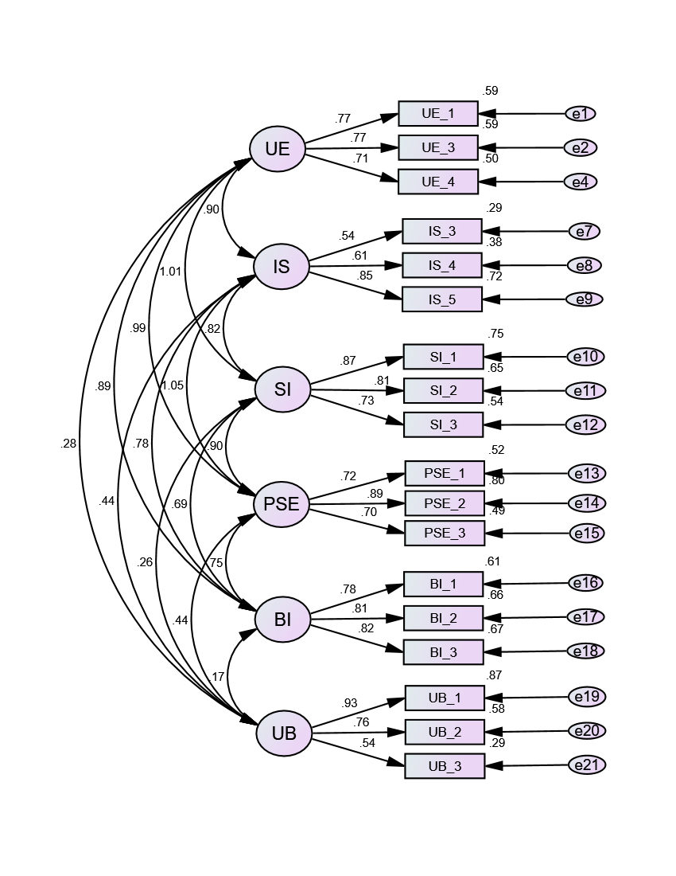

Figure 5:Improved CFA Model

As revealed in Table 4, all outer loadings were higher than the 0.7 recommended value by Hair et al., (2017), except for IS_3 and UB_3 which had a loading of 0.57 and 0.54 respectively. “However, these items were retained due to their content validity and the fact that discarding them does not further improve the average variance extracted values (Hair et al., 2017). In addition, composite reliability values exceed the 0.7 (0.751 to 0.846) threshold, confirming the attainment of reliability for the generic model. Relating to average variance extracted, the values obtained range~~s~~ from 0.500 to 0.649, which were all greater than the 0.5 criterion (Hair et al., 2017). The analysis of the figures for the measurement model indices as depicted in Table 4 show that internal consistency was achieved for the measurement model.”

Table 3: **“**CFA* Goodness of Fit Indices for MI Testing

|  |  |  |
| --- | --- | --- |
| **Model-Fit**  **Parameters** | **Obtained**  **Values** | **Recommended Values (Hair et al., 2010)** |
| 1. **Absolute Fit Indices** | | |
| **Chi-square (χ2):** | 206.711 | |
| **DF:** | 118 | |
| **P-value:** | 0.000 | Recommended to be less than 0.05 |
| **RMSEA** | 0.079 | Recommended to be less than 0.1 |
| **GFI:** | 0.853 | Between 0-1. Higher values indicate good model fit. A value of 1 indicates perfect fit. |
|  | | |
| 1. **Incremental Fit Indices** | | |
| **CFI:** | 0.908 | Between 0-1. Higher values indicate good model fit. Values close to 1 indicate very good fit. |
| **NFI:** | 0.875 | Recommended to be above 0.8 |
| **TLI:** | 0.879 | Recommended to be above 0.8 |
|  | | |
| 1. **Parsimonious Fit Indices** | | |
| **CMIND/DF:** | 1.752 | Below 5. The less, the better |
| **AGFI:** | 0.814 | Recommended to be above .80 |
| **PNFI:** | 0.802 | Between 0-1. Higher values indicate good model fit. A value of 1 indicates perfect fit. |

**CMIN/DF** - Chi-square/degree of freedom; **P** - Probability value; **RMSEA** - Root Mean Square Error of Approximation; **GFI** - Goodness of Fit Index; **AGFI** - Adjusted Goodness of Fit Index, **CFI** - Comparative Fit Index; **NFI** - Normed Fit Index; **TLI** – Tucker Lewis Index; **PNFI** - Parsimony Normed Fit Index.”

Table 4: Internal Consistency Measures for Measurement Model

|  |  |  |  |  |
| --- | --- | --- | --- | --- |
| **Construct** | **Indicators** | **Outer Loadings** | **Composite Reliability (CR)** | **Average Variance Extracted (AVE)** |
| User Expectancy (UE) | UE_1 | 0.770 |  |  |
| UE_3 | 0.770 | 0.7944 | 0.5633 |
| UE_4 | 0.710 |  |  |
| Institutional Supports (IS) | IS_3 | 0.570 |  |  |
| IS_4 | 0.690 | 0.7510 | 0.5078 |
| IS_5 | 0.850 |  |  |
| Social Influence (SI) | SI_1 | 0.870 |  |  |
| SI_2 | 0.810 | 0.8464 | 0.6486 |
| SI_3 | 0.730 |  |  |
| Perceived System Expectations (PSE) | PSE_1 | 0.720 |  |  |
| PSE_2 | 0.890 | 0.8464 | 0.7510 |
| PSE_3 | 0.700 |  |  |
| Behavioural Intention (BI) | BI_1 | 0.780 |  |  |
| BI_2 | 0.810 | 0.8453 | 0.6456 |
| BI-3 | 0.820 |  |  |
| Use Behaviour (UB) | UB_1 | 0.930 |  |  |
| UB_2 | 0.760 | 0.7971 | 0.5780 |
| UB_3 | 0.540 |  |  |

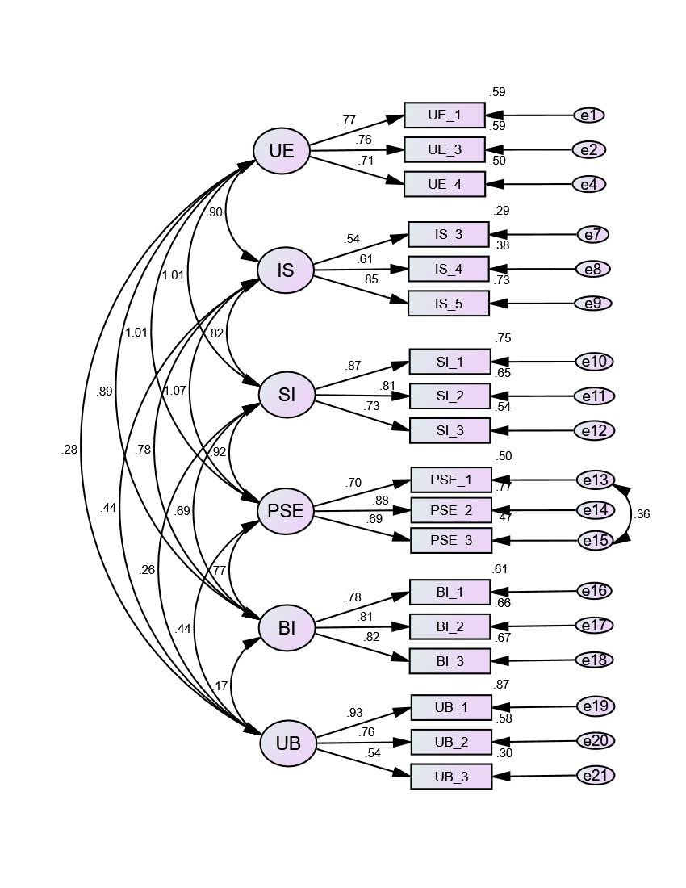

Figure 6: Final CFA Model.

**4.5 Invariance Testing**

Measurement Invariance was used to “reduce any form of bias that may have resulted from data collection method or respondents’ characteristics, since the research spans across different groups (Cohen, et al., 2011). In line with this, Hair, et al., (2017) recommend establishing some form of metric-invariance before examining the path estimates. Following their recommendation, the researchers carried out invariance testing to prove that the factor structure is equivalent across the different groups (staff and students). That is, the investigation was about finding out if the factor structure for both staff and student model are the same.”

To achieve this, the AMOS and Stats Tools Package were used (Hariri and Roberts, 2015; Gaskin, 2012). Using AMOS v24, “the staff/student group was created using categorical data captured in the survey to test the model across user. The Stats Tools Package, on the other hand, helps in comparing Chi-square and degree of freedom values for unconstrained and fully constrained models (Hariri and Roberts, 2015). In the fully constrained model, regression values were removed from the lines and variances for factors were restricted to 1. Thereafter, the chi-square difference test was run using the group mentioned above to ensure that the model is equivalent across the group at the model level. Table 5 presents the output from comparing both the constrained and unconstrained model.”

Table 5: Invariance Testing for the Model

|  |  |  |  |  |
| --- | --- | --- | --- | --- |
|  | **Chi-square** | **df** | **p-val** | **Invariant?** |
| **“Overall Model”** |  |  |  |  |
| “Unconstrained” | 483.634 | 240 |  |  |
| “Fully constrained” | 510.984 | 258 |  |  |
| “Number of groups” |  | 2 |  |  |
| Difference | 27.35 | 18 | 0.079 | NO |

As revealed in table 5 above, “the p-value is not significant and is greater than Byrne‘s (2010) 0.05 cut-off. This confirms that there is no significant difference between the group at the model level and metric invariance have been achieved.”

1. **Discussion and Conclusion**

Over the last decades, conceptual models have been employed to facilitate, systemise and aid the process of information system engineering. Conceptual models, on the one hand, describe object systems (e.g. a learning innovation) of some domain in semantic terms, using an abstract yet formalised language. Purposes served by conceptual models in the context of IS development include communicating between developers and users, thereby bridging the misunderstanding gap between requirements analysis and implementation specification. Further purposes of conceptual models include helping analysts to understand a domain, providing input to the design process and documenting the requirements for future reference.

On the other hand, the quality of conceptual models~~,~~  is believed to have an enormous impact on ~~to~~ related IT and IS artifacts, as conceptual models used in the requirements specification phase of a system development process determine the acceptability and usability of the product to be built (Lauesen and Vinter, 2001). In line with this assertion, Obienu and Amadin (2021) “developed a generic usability and acceptance model (GUAM) with a view to measure behavioural intention in accepting and using learning innovations. GUAM incorporates four constructs (as presented in Figure 1) including user expectancy, institutional supports, social influence, and perceived system expectations. Individual differences (such as age, gender, awareness, accessibility, and experience) were hypothesised to moderate the effects of these constructs on behavioural intention and innovation use. The generic usability and acceptance model (GUAM) in contrast to UTAUT provides a significantly better explanation of behavioural intention (72%) and technology use (63%) for learning innovations (Obienu and Amadin, 2021). This demonstrated that domain or discipline sensitive models have the potential to outperform generic adoption models like TAM or UTAT due to variations on technological features and characteristics of user groups.

Models are fitted to data in an attempt to understand underlying processes that have been operating. To be useful, they should be parsimonious and clearly understood. The study demonstrated GUAM to be a good theoretical tool to university staff and students’ adoption of learning innovations. Goodness-of-Fit (GOF) was applied as an index for the complete model fit, to verify that the model sufficiently explains the empirical data (Obienu and Amadin, 2021; Henseler and Sarstedt 2012; Tenenhaus et al. 2005). To this end, the GUAM went through a number of iterations until a good model was realised. Based on experts’ recommendations (e.g. Hair et al. 2017; Henseler and Sarstedt 2012) and by following a number of iterations to improve mode fit, the final CFA model (seen in Figure 7) was reached as it adequately fits the data.

Assessing absolute model is critical in applications as inferences drawn on poorly fitting models may be misleading (Olivares and Forero, 2010). Absolute model fit measures the discrepancy between the conceptual model and the data, as well as demonstrates which proposed model has the most accurate fit (McDonald and Ho, 2002). Included in this category are the Chi-square (*χ2)*; degree of freedom (*df)*; Probability value – *p* (recommended to be less than 0.05); *RMSEA* - Root Mean Square Error of Approximation (recommended to be less than 0.1); and *GFI* - Goodness of Fit Index (between 0-1. Higher values indicate good model fit). From Table 3, it is shown that the absolute fit indices of the final CFA model, which indicate how well the conceptual model fits the data have been attained (χ2 = 206.71, df = 118, *p*-value = 0.00, RMSEA = 0.079, GFI = 0.85). Unlike incremental fit indices, their calculation does not rely on comparison with a baseline model, but a measure of how well the model fits in comparison to no model at all (Hooper et. al, 2008).

Increment fit indices differs from absolute fit indices by their assessment of how well the estimated model fits relative to some alternative baseline model; that is, the discrepancy between two models. Incremental model fit is also known as Relative Model Fit (McDonald and Ho, 2020) or Comparative Model Fit (Miles and Shevlin, 2007). For these models the null hypothesis is that all variables are uncorrelated (McDonald and Ho, 2002). These include *CFI* - Comparative Fit Index (between 0-1 higher values indicate good model fit); *NFI*- Normed Fit Index (recommended to be above 0.8); and *TLI* - Tucker Lewis Index (recommended to be above 0.8). From Table 3, it is shown that the incremental fit indices of the final CFA model, which compare the chi-square value to a baseline model were all in the accepted region (CFI = 0.908, NFI = 0.85, TLI = 0.879) as recommended by Hair et al., (2010).

Having a nearly saturated, complex model means that the estimation process is dependent on the sample data. This results in a less rigorous conceptual model that paradoxically produces better fit indices (Hair et al, 2017, Hooper et al., 2008). To overcome this problem, parsimonious model fit was developed. It was designed specifically to provide information about which model among a set of competing models is best, considering its fit relative to its complexity. Included in this category are the χ2/df - Chi-square/degree of freedom (below 5. the less, the better); AGFI - Adjusted Goodness of Fit Index; (recommended to be above .80), and PNFI - Parsimony Normed Fit Index (between 0-1. higher values indicate good model fit). From Table 3, it is shown that the parsimonious fit indices of the final CFA were attained (CMIN/DF = 1.752, AGFI = 0.814, PNFI = 0.802).”

Table 3 and Table 4 show~~s~~ the summary of the results of the Goodness-of-Fit indices that were tested, which indicate that a good model fit has been attained (χ2 = 206.71, df = 118, p-value = 0.00, RMSEA = 0.079, GFI = 0.85, CFI = 0.908, NFI = 0.85, TLI = 0.879, CMIN/DF = 1.752, AGFI = 0.814, PNFI = 0.802). Overall, the results support the applicability and validity of GUAM as a theoretical base to predict staff/students’ behavioural intentions and use of learning innovations. Subsequent studies may focus on testing and on exploring various relationships in the model as well as any mediation and moderation effects.

Also, GUAM reveals that institutional supports, user expectancy, perceived system expectations and social influence are the main predictors of learning innovations adoption and use (Obienu and Amadin, 2021). Therefore, the authors recommend that university administrators and educational planners should provide the right environment before deploying learning innovations. If 21st-century learners are to succeed in a fast-changing world, then the tools used in disseminating information have to be the ones of modern interface (Amadin et al., 2018). The first step towards inculcating knowledge is to create awareness (Obienu and Amadin, 2021). Again, increased awareness of a new technology initiative is essential to gain public acceptance and confidence, particularly in learning innovation (Noor, et al. 2014). Knowledge provides the technology users with the ability to comprehend the need for a new technology, which would eventually promote compliance (Saad, 2010). Thus, it is paramount to educate the intended users (staff and students) on what is expected from the new innovation in order to increase their levels of compliance. This supports the fact that positive gains derived from system usage, especially towards the execution of job or task related purposes, in turn influence the intention formation of users towards that innovation. Therefore, relevant authorities must still focus on various ways to increase students’ acceptance and use of learning innovation.

Though GUAM model needs to undergo further testing, a number of contributions have been achieved so far. Firstly, in addition to existing constructs, a number of new constructs (user expectancy, perceived system expectations, and institutional supports) were proposed. EFA and CFA results indicate that the proposed model fits the data. Secondly, new measures were developed for three constructs, which showed adequate reliability and validity. Thirdly, though changes were made to the existing measures to capture information related to several innovations, these measures are still reliable and valid. Also, the study adopted several Goodness-of-Fit indices to validate the model. Future studies investigating the adoption of learning innovations are likely to benefit from adopting GUAM model as a starting point. Further research is required towards a better understanding of the adoption of innovations within schools in order to help diffuse learning innovations.

**Declarations**

**Ethics approval and consent to participate**

Approval for this study was granted by the Institutional Ethics Review Committee, Bayelsa Medical University. Consent form describing the study was sent. Written informed consent was obtained from Universities involved in this study.

**Consent for publication**

Not applicable.

**Availability of data and materials**

The datasets used and/or analyzed during the current study are available from the corresponding author on reasonable request.

**References:**

Amadin, F. I., Obienu, A. C., and Osaseri, R. O. (2018). Main barriers and possible enablers of Google apps adoption among university staff members. Nigerian Journal of Technology, 37(2), 432–439.

Brace, N., Kemp, R., & Snelgar, R. (2012). *SPSS for Psychologists*. Basingstoke: Palgrave Macmillan.

Byrne, B. M. (2010). *Structural Equation Modeling with Amos: Basic Concepts, Applications, and Programming* (2nd ed.). New York: Taylor and Francis Group.

Cohen, L., Manion, L., & Morrison, K. (2011). *Research Methods in Education* (7th ed.). New York: Routledge.

Field, A. (2009). *Discovering Statistics Using SPSS* (3rd ed.). London: Sage Publications.

Gaskin, J. (2012). Stats Wiki and Stats Tools Package. Available online at http://statwiki.kolobkreations.com/

Hair J. F., Hult G. T., Ringle C. M., and Sarstedt S. (2017). A Primer on Partial Least Squares Structural Equation Modeling (PLS-SEM), 2nd edn. Thousand Oaks: Sage.

Hair J.F., Anderson R.E., Tatham R.L. and Black, W. C. (2010), Multivariate Data Analysis with Readings, 3rd edn. Macmillan, New York.

Hariri, A., and Roberts, P. (2015). Adoption of Innovation within Universities: Proposing and Testing an Initial Model. Creative Education, 6, 186-203.

Henseler, J., and Sarstedt, M. (2012). Goodness-of-Fit Indices for Partial Least Squares Path Modeling. Computational Statistics, 28(2), 565–580.

Hooper, D., Coughlan, J. and Mullen, M. R. (2008). “Structural Equation Modelling: Guidelines for Determining Model Fit.” The Electronic Journal of Business Research Methods Volume, 6 (1), pp. 53 - 60, available online at [www.ejbrm.com](http://www.ejbrm.com)

Hsu, H. (2012). The Acceptance of Moodle:An Empirical Study Based on UTAUT, Scientific research. Vol 3, 44–46.

Iacobucci, D. (2010). Structural Equations Modeling: Fit Indices, sample size, advanced topics. Journal of Consumer Psychology, 20(1), 90 – 98.

Jöreskog, K. and Sörbom, D. (1993), *LISREL 8:* Structural Equation Modeling with the SIMPLIS Command Language. Chicago, IL: Scientific Software International Inc.

Lahtinen, M. (2012). “E-Invoice Adoption in Organisation”. Department of Marketing, Hanken School of Economics: Helsinki, Finland.

Lauesen, S., and Vinter, O.(2001): Preventing Requirement Defects: An Experiment in Process Improvement. Requirements Engineering 6, 37-50

Magal, S. and Mirchandani, D, (2001). "Validation of the Technology Acceptance Model for Internet Tools" (2001). *AMCIS 2001Proceedings*. 100. Retrieved on 4th July, 2018 from http://aisel.aisnet.org/amcis2001/100

Mbete, J. S. and Raisamo, R. (2014) “Investigating students‟ behavioral intention to adopt and use mobile learning in higher education in East Africa”, International Journal of Education and Development using Information and Communication Technology (IJEDICT), 2014, 10(3), pp. 4-20

McDonald, R.P. and Ho, M.-H.R. (2002), "Principles and Practice in Reporting Statistical Equation Analyses," Psychological Methods, 7 (1), 64-82.

Miles, J. and Shevlin, M. (2007), "A time and a place for incremental fit indices," Personality and Individual Differences, 42 (5), 869-74.

Miller, J., Martineau, L., and Clark, R. (2000). Technology Infusion and Higher Education: Changing Teaching and Learning. *Innovative Higher Education*, *24*(3): 227–241.

Noor, F. M. N., Anna, A. C. A., & Leelanayagi, R. (2014). The unified theory of acceptance and use of technology (UTAUT) and the goods and service tax (GST) application system. Research Journal of Applied Sciences, Engineering and Technology, 8(17), 1911–1916.

Obienu, A. C., and Amadin, F. I. (2021) “User acceptance of learning innovation: A structural equation modelling based on the GUAM framework”. Educ Inf Technol 26, 2091-2123. Available online @ https://doi.org/10.1007/s10639-020-10341-x

Olivares, A. M. and Forero, C. G (2010). Goodness-of-Fit Testing. International Encyclopedia of Education (2010), vol. 7, pp. 190-196

Oye, N. D., Iahad, N. Ab. Rahim, A., and Zairah, N. (2012). A comparative study of acceptance and use of ICT among university academic staff of ADSU and LASU: Nigeria. International Journal of Science and Technology, 1(1), 40-52.

Petter, S., DeLone, W. and McLean, E. (2008). Measuring information systems success: models, dimensions, measures,and interrelationships. European Journal of Information Systems (17): 236–263

Rogers, M. E. (2003). Diffusion of Innovations (5th ed.). New York: Free Press.

Saad. N. (2010). The use of technology (audiovisual aids) in teaching English as a foreign language in Benghazi secondary schools (unpublished master thesis). Leicester University.

Schermelleh-Engel, K; Moosbrugger, H; and Muller, H. (2003). Evaluating the fit of Structural Equation Models: Tests of Significance and Descriptive Goodness-of-Fit Measures. Methods of Psychological Research Online 2003, Vol.8, No.2, pp. 23-74

Straub, D., Boudreau, M. C., and Gefen, D. (2004). *Validation Guidelines For Positivist.* Communications of the Association for Information Systems,(13): 380–427.

Straub, E. T. (2009). Understanding Technology Adoption: Theory and Future Directions for Informal Learning. Review of Educational Research, 79(2), 625– 649.

Thomas, T. D., Singh, L., and Gaffar, K. (2013). The utility of the UTAUT model in explaining mobile learning adoption in higher education in Guyana. International Journal of Education and Development Using Information and Communication Technology (IJEDICT), 9(3): 71–85.

Venkatesh, A., Morris, M. G., and Davis, G. B. (2003), User acceptance of information technology: Toward a unified view, MIS Quarterly, vol. 27(3), pp. 425–478.

Yeboah A., Moore, G., and Benbasat, I. (2014). Development of an Instrument to Measure The Perceptions of Adopting an Innovation Technology Innovation,‖ Information Systems Research, vol. 2, no. 3, pp. 192-222.

**Appendix 1: “Survey Questionnaire**

|  |  |  |
| --- | --- | --- |
| **Construct** | **Item Code** | **Item** |
| User Expectancy (UE) | UE_1 | Using LI would increase my academic productivity. |
| UE_2 | I would find Learning innovations easy to use. |
| UE_3 | Learning through LI makes class participation and collaboration more interesting |
| UE_4 | Using Learning Innovation in learning is fun and entertaining, compared to traditional method. |
|  | UE_5 | Learning innovations make it easier to study course content |
| Institutional Support (IS) | IS_1 | I am aware that Learning Innovations (LIs) provided by my institution are meant for staff and students’ use. |
|  | IS_2 | My institution has made available the needed resources (adequate computers and internet connectivity) for LIs Usage |
|  | IS_3 | I have no difficulty accessing and using LI I see fit, in my institution. |
|  | IS_4 | My institution has equipped me with the necessary skills to use any of learning innovation I see fit. |
|  | IS_5 | A trial could convince me that using learning innovation is better than traditional method of learning |
| Social Influence (SI) | SI_1 | People whose opinions I value would expect me to use the LI. |
| SI_2 | Being conversant with the LIs increases my effectiveness as a lecturer/student |
| SI_3 | I agree with my institution support with the use of LIs for the educational purposes |
| SI_4 | Using the LI would improve my image within the institution. |
| SI_5 | In other for me to prepare for future job, it is necessary to use LI. |
| Perceived “ System Expectations (PSE) | PSE_1 | In my teaching/learning, the usage of Learning Innovation is important |
| PSE_2 | Using Learning innovations leads to my exploration of new perspective during learning process. |
| PSE­_3 | Using LI helps me meet or exceed my expectations as a staff/student |
| PSE_4 | I evaluate the learning innovation I use to ensure that it enhances my students‘ learning |
| PSE_5 | I structure the LI I use to be sure that it enhances my students' learning process” |
| Behavioural ” Intention (BI) | BI_1 | I intend to use LI more because it is appropriate for my teaching/learning style. |
| BI_2 | In future, I intend to use LI more because of the benefits. |
| BI_3 | I will strongly recommend other peers to use learning innovations for their teaching/learning/research purposes.” |
| Use Behaviour (UB) | UB_1 | I use learning innovations for accessing online learning resources. |
| UB_2 | I use learning innovations for online discussion and interaction |
| UB_3 | I use learning innovations to turn in assignments” |

**Appendix 2: Exploratory Factor Analysis for the Initial Model**

|  |  |  |
| --- | --- | --- |
| **KMO and Bartlett's Test** | | |
| Kaiser-Meyer-Olkin Measure of Sampling Adequacy. | | .873 |
| Bartlett's Test of Sphericity | Approx. Chi-Square | 1032.171 |
| df | 210 |
| Sig. | .000 |

|  |  |  |  |  |
| --- | --- | --- | --- | --- |
| **Communalitiesa** | | | | |
|  | | Initial | | Extraction |
| UE_1 | | .746 | | .757 |
| UE_2 | | .648 | | .999 |
| UE_3 | | .772 | | .671 |
| UE_4 | | .701 | | .671 |
| UE_5 | | .452 | | .277 |
| SI_1 | | .845 | | .999 |
| SI_2 | | .790 | | .999 |
| SI_3 | | .705 | | .786 |
| SI_4 | | .265 | | .149 |
| SI_5 | | .354 | | .319 |
| IS_1 | | .365 | | .215 |
| IS_2 | | .473 | | .295 |
| IS_3 | | .523 | | .332 |
| IS_4 | | .601 | | .542 |
| IS_5 | | .763 | | .848 |
| PSE_1 | | .699 | | .734 |
| PSE_2 | | .830 | | .823 |
| PSE_3 | | .638 | | .564 |
| PSE_4 | | .256 | | .147 |
| PSE_5 | | .425 | | .218 |
| BI_1 | | .662 | | .586 |
| BI_2 | | .664 | | .729 |
| BI_3 | | .751 | | .797 |
| UB_1 | | .643 | | .737 |
| UB_2 | | .607 | | .748 |
| UB_3 | | .503 | | .430 |
| Extraction Method: Maximum Likelihood. | | | | |
|  | | | | |
| **Total Variance Explained** | | | | | | | | | | |
| Factor | Initial Eigenvalues | | | | | | Extraction Sums of Squared Loadings | | | Rotation Sums of Squared Loadingsa |
| Total | | % of Variance | | | Cumulative % | Total | % of Variance | Cumulative % | Total |
| 1 | 8.797 | | 46.299 | | | 46.299 | 6.350 | 33.423 | 33.423 | 7.475 |
| 2 | 2.123 | | 11.172 | | | 57.471 | .541 | 2.847 | 36.270 | 5.501 |
| 3 | 1.270 | | 6.685 | | | 64.155 | 3.086 | 16.240 | 52.510 | 2.808 |
| 4 | 1.078 | | 5.675 | | | 69.830 | 1.729 | 9.100 | 61.610 | 4.765 |
| 5 | .893 | | 4.699 | | | 74.529 | .832 | 4.376 | 65.986 | 4.376 |
| 6 | .867 | | 4.562 | | | 79.091 | .504 | 2.650 | 68.637 | 3.955 |
| 7 | .668 | | 3.518 | | | 82.608 |  |  |  |  |
| 8 | .603 | | 3.173 | | | 85.781 |  |  |  |  |
| 9 | .469 | | 2.466 | | | 88.248 |  |  |  |  |
| 10 | .377 | | 1.984 | | | 90.232 |  |  |  |  |
| 11 | .365 | | 1.920 | | | 92.152 |  |  |  |  |
| 12 | .310 | | 1.632 | | | 93.784 |  |  |  |  |
| 13 | .257 | | 1.355 | | | 95.139 |  |  |  |  |
| 14 | .232 | | 1.224 | | | 96.363 |  |  |  |  |
| 15 | .196 | | 1.031 | | | 97.394 |  |  |  |  |
| 16 | .153 | | .807 | | | 98.201 |  |  |  |  |
| 17 | .151 | | .795 | | | 98.996 |  |  |  |  |
| 18 | .108 | | .569 | | | 99.564 |  |  |  |  |
| 19 | .083 | | .436 | | | 100.000 |  |  |  |  |
| Extraction Method: Maximum Likelihood. | | | | | | | | | | |
| a. When factors are correlated, sums of squared loadings cannot be added to obtain a total variance. | | | | | | | | | | |

|  |  |  |  |  |  |  |  |  |  |  |  |  |
| --- | --- | --- | --- | --- | --- | --- | --- | --- | --- | --- | --- | --- |
| **Factor Correlation Matrix** | | | | | | | | | | | | |
| Factor | 1 | | 2 | | 3 | | 4 | | 5 | | 6 | |
| 1 | 1.000 | | .411 | | .578 | | .269 | | .305 | | .403 | |
| 2 | .411 | | 1.000 | | .517 | | .333 | | .347 | | .497 | |
| 3 | .578 | | .517 | | 1.000 | | .214 | | .462 | | .496 | |
| 4 | .269 | | .333 | | .214 | | 1.000 | | .275 | | .347 | |
| 5 | .305 | | .347 | | .462 | | .275 | | 1.000 | | .187 | |
| 6 | .403 | | .497 | | .496 | | .347 | | .187 | | 1.000 | |
| Extraction Method: Maximum Likelihood.  Rotation Method: Promax with Kaiser Normalization. | | | | | | | | | | | | |
| **Pattern Matrixa** | | | | | | | | | | | | | |
|  | | Factor | | | | | | | | | | | |
| 1 | | 2 | | 3 | | 4 | | 5 | | 6 | |
| IS_5 | | .976 | |  | |  | |  | |  | |  | |
| IS_3 | | .579 | |  | |  | |  | |  | |  | |
| IS_2 | | .536 | |  | |  | |  | |  | |  | |
| IS_4 | | .413 | |  | |  | |  | |  | |  | |
| IS_1 | | .397 | |  | |  | |  | |  | |  | |
| BI_3 | |  | | .884 | |  | |  | |  | |  | |
| BI_1 | |  | | .801 | |  | |  | |  | |  | |
| BI_2 | |  | | .497 | |  | |  | |  | |  | |
| SI_2 | |  | |  | | .878 | |  | |  | |  | |
| SI_1 | |  | |  | | .802 | |  | |  | |  | |
| SI_3 | |  | |  | | .679 | |  | |  | |  | |
| SI_4 | |  | |  | | .347 | |  | |  | |  | |
| SI_5 | |  | |  | | .329 | |  | |  | |  | |
| UE_4 | |  | |  | |  | | .803 | |  | |  | |
| UE_1 | |  | |  | |  | | .884 | |  | |  | |
| UE_3 | |  | |  | |  | | .563 | |  | |  | |
| UE_2 | |  | |  | |  | | .563 | |  | |  | |
| UE_5 | |  | |  | |  | | .311 | |  | |  | |
| PSE_1 | |  | |  | |  | |  | | .688 | |  | |
| PSE_2 | |  | |  | |  | |  | | .686 | |  | |
| PSE_3 | |  | |  | |  | |  | | .552 | |  | |
| PSE_4 | |  | |  | |  | |  | | .320 | |  | |
| PSE_5 | |  | |  | |  | |  | | .321 | |  | |
| UB_1 | |  | |  | |  | |  | |  | | .814 | |
| UB_2 | |  | |  | |  | |  | |  | | .880 | |
| UB_3 | |  | |  | |  | |  | |  | | .591 | |
| Extraction Method: Maximum Likelihood.  Rotation Method: Promax with Kaiser Normalization. | | | | | | | | | | | | | |
| a. Rotation converged in 8 iterations. | | | | | | | | | | | | | |

**Appendix 3: Exploratory Factor Analysis for the Final Model**

|  |  |  |
| --- | --- | --- |
| **KMO and Bartlett's Test** | | |
| Kaiser-Meyer-Olkin Measure of Sampling Adequacy. | | .864 |
| Bartlett's Test of Sphericity | Approx. Chi-Square | 863.916 |
| df | 153 |
| Sig. | .000 |

|  |  |  |
| --- | --- | --- |
| **Communalitiesa** | | |
|  | Initial | Extraction |
| UE_1 | .746 | .757 |
| UE_2 | .648 | .999 |
| UE_3 | .772 | .671 |
| UE_4 | .701 | .671 |
| SI_1 | .845 | .999 |
| SI_2 | .790 | .999 |
| SI_3 | .705 | .786 |
| IS_1 | .365 | .215 |
| IS_2 | .473 | .295 |
| IS_3 | .523 | .332 |
| IS_4 | .601 | .542 |
| IS_5 | .763 | .848 |
| PSE_1 | .699 | .734 |
| PSE_2 | .830 | .823 |
| PSE_3 | .638 | .564 |
| BI_1 | .662 | .586 |
| BI_2 | .664 | .729 |
| BI_3 | .751 | .797 |
| UB_1 | .643 | .737 |
| UB_2 | .607 | .748 |
| UB_3 | .503 | .430 |
| Extraction Method: Maximum Likelihood. | | |
| a. One or more communalitiy estimates greater than 1 were encountered during iterations. The resulting solution should be interpreted with caution. | | |

|  |  |  |  |  |  |  |  |
| --- | --- | --- | --- | --- | --- | --- | --- |
| **Total Variance Explained** | | | | | | | |
| Factor | Initial Eigenvalues | | | Extraction Sums of Squared Loadings | | | Rotation Sums of Squared Loadingsa |
| Total | % of Variance | Cumulative % | Total | % of Variance | Cumulative % | Total |
| 1 | 8.624 | 47.914 | 47.914 | 6.145 | 34.138 | 34.138 | 7.210 |
| 2 | 2.121 | 11.785 | 59.699 | .533 | 2.959 | 37.097 | 5.897 |
| 3 | 1.243 | 6.903 | 66.602 | 3.090 | 17.168 | 54.265 | 2.867 |
| 4 | .923 | 5.130 | 71.732 | 1.720 | 9.556 | 63.821 | 4.769 |
| 5 | .878 | 4.879 | 76.612 | .786 | 4.367 | 68.188 | 4.420 |
| 6 | .681 | 3.786 | 80.398 | .485 | 2.696 | 70.885 | 3.271 |
| 7 | .630 | 3.502 | 83.900 |  |  |  |  |
| 8 | .500 | 2.780 | 86.680 |  |  |  |  |
| 9 | .454 | 2.521 | 89.201 |  |  |  |  |
| 10 | .367 | 2.039 | 91.240 |  |  |  |  |
| 11 | .358 | 1.988 | 93.228 |  |  |  |  |
| 12 | .259 | 1.437 | 94.665 |  |  |  |  |
| 13 | .233 | 1.292 | 95.957 |  |  |  |  |
| 14 | .213 | 1.181 | 97.138 |  |  |  |  |
| 15 | .160 | .887 | 98.026 |  |  |  |  |
| 16 | .153 | .851 | 98.877 |  |  |  |  |
| 17 | .118 | .654 | 99.532 |  |  |  |  |
| 18 | .084 | .468 | 100.000 |  |  |  |  |
| Extraction Method: Maximum Likelihood. | | | | | | | |
| a. When factors are correlated, sums of squared loadings cannot be added to obtain a total variance. | | | | | | | |

|  |  |  |  |  |  |  |
| --- | --- | --- | --- | --- | --- | --- |
| **Factor Correlation Matrix** | | | | | | |
| Factor | 1 | 2 | 3 | 4 | 5 | 6 |
| 1 | 1.000 | .440 | .403 | .387 | .379 | .424 |
| 2 | .440 | 1.000 | .206 | .484 | .520 | .384 |
| 3 | .403 | .206 | 1.000 | .208 | .181 | .030 |
| 4 | .387 | .484 | .208 | 1.000 | .452 | .408 |
| 5 | .379 | .520 | .181 | .452 | 1.000 | .377 |
| 6 | .424 | .384 | .030 | .408 | .377 | 1.000 |
| Extraction Method: Maximum Likelihood.  Rotation Method: Promax with Kaiser Normalization. | | | | | | |

|  |  |  |  |  |  |  |
| --- | --- | --- | --- | --- | --- | --- |
| **Pattern Matrixa** | | | | | | |
|  | Factor | | | | | |
| 1 | 2 | 3 | 4 | 5 | 6 |
| IS_5 | .976 |  |  |  |  |  |
| IS_3 | .579 |  |  |  |  |  |
| IS_2 | .536 |  |  |  |  |  |
| IS_4 | .413 |  |  |  |  |  |
| IS_1 | .397 |  |  |  |  |  |
| BI_3 |  | .884 |  |  |  |  |
| BI_1 |  | .801 |  |  |  |  |
| BI_2 |  | .497 |  |  |  |  |
| SI_2 |  |  | .878 |  |  |  |
| SI_1 |  |  | .802 |  |  |  |
| SI_3 |  |  | .679 |  |  |  |
| UE_4 |  |  |  | .803 |  |  |
| UE_1 |  |  |  | .884 |  |  |
| UE_3 |  |  |  | .563 |  |  |
| UE_2 |  |  |  | .563 |  |  |
| PSE_1 |  |  |  |  | .688 |  |
| PSE_2 |  |  |  |  | .686 |  |
| PSE_3 |  |  |  |  | .552 |  |
| UB_1 |  |  |  |  |  | .814 |
| UB_2 |  |  |  |  |  | .880 |
| UB_3 |  |  |  |  |  | .591 |
| Extraction Method: Maximum Likelihood.  Rotation Method: Promax with Kaiser Normalization. | | | | | | |
| a. Rotation converged in 8 iterations. | | | | | | |