Original Research Article

Text vs. Comics: An Action Research on Prose Comprehension
ABSTRACT
This study aims to explore the effectiveness of using comic strips in teaching reading comprehension to Grade VII students. A pre-experimental design was employed, involving a single group exposed to two different teaching methods. The study sample consisted of 20 randomly selected Grade VII students from Chitkara International School, Panchkula, Haryana. One NCERT chapter was taught using text material, while another chapter was taught using comic strips to enhance engagement and comprehension. To assess the effectiveness of both approaches, post-tests were conducted after each instructional method, allowing for a comparative analysis of knowledge retention and the impact of comic strip-based pedagogy. A mixed-method approach was adopted, combining quantitative assessment with qualitative feedback from students. Additionally, student’s feedback was obtained about their experience with comic strips in learning. The post test results favoured the use of comic strip pedagogy as compared to teaching using text content. The interactive nature of the comic strips activity fostered active participation, making learning more enjoyable and accessible. This study highlights the potential of comic strips as an effective instructional tool, contributing to a more engaging and student-centred classroom environment.

Keywords: Comic strips, text, NCERT, Qualitative, Quantitative

- INTRODUCTION
Reading comprehension plays a crucial role in language learning, as it enables students to construct meaning, interpret ideas, and engage critically with texts. However, many students, particularly at the middle school level, struggle with understanding narrative texts due to various cognitive and motivational challenges. Snow (2002) emphasizes that reading comprehension is a complex process influenced by multiple factors, including background knowledge, vocabulary and the ability to make inferences. Traditional teaching methods often rely on direct instruction and text-heavy materials, which may not sufficiently support struggling readers or cater to diverse learning styles.
To address these challenges, researchers have explored the integration of visual media as a means to enhance student engagement and comprehension. Guthrie and Wigfield (2000) argue that motivation plays a significant role in reading success, and students are more likely to develop strong comprehension skills when instructional materials are engaging and interactive. One such medium is comic strips, which blend textual and visual elements to create a multimodal learning experience. Comics provide contextual clues that aid comprehension, making abstract ideas more accessible and reducing cognitive load. Ranker (2007) further highlights that comic strips encourage active reading by allowing students to connect images with text, promoting a deeper understanding of the narrative structure.
Despite these advantages, the use of comic strips in middle school reading instruction remains underexplored, particularly in terms of its measurable impact on comprehension. While some studies suggest that visual storytelling can improve literacy skills, there is a need for empirical research to quantify its effectiveness in structured classroom settings. This study aims to address this gap by investigating the impact of comic strips on the reading comprehension of Grade VII students. Using a pre-experimental design with post-test measures, this research aims to determine whether incorporating comic strips as a teaching tool enhances students' ability to understand narrative texts. The findings will contribute to the growing body of literature on innovative reading strategies and offer practical insights for educators looking to foster a more engaging and effective learning environment.
Variable Defined
What is a Comic Strip?
Comic strips are a form of multimodal text that blend words and images to narrate a story (Budiman, Sada & Wardah, 2018). This combination enhances the visual experience, fostering greater student motivation, boosting creative skills, and supporting a more engaging and innovative learning process (Gilakjani et al., 2011). Sharma (2020) suggests that comic strips can serve as an effective tool for teaching grammar by having students fill in the blanks for comic strip dialogues or create sentences for those dialogues. Additionally, comic strips offer authentic material to demonstrate how grammar functions in real-life conversations.
What is a Text?
In the literary sense, a text is a form of writing, like a novel or poem, created to tell a story or entertain, typically found in fictional works. While its main purpose is often aesthetic, it can also convey political ideas or viewpoints. In the U.S., students and their parents are taught that literary texts differ from informational texts, which aim to inform rather than entertain. Informational texts, including science reports and history books, are gaining more focus in school curricula, particularly with the introduction of the Common Core State Standards (Wikipedia).
1.2 Objectives
- to enhance the learning outcome of teaching prose content using comic strips.
- to improve understanding and retention through visual art.
- to boost engagement of students by using comic strips in English class.
- to encourage creativity by designing comic strips.
- to enhance communication skills using comic strips.
1.4 Delimitations of the Study
This study was conducted with a sample of 20 Grade 7 students, selected through random sampling. Since the research was limited to a single grade level, the findings may not be generalizable to students of different ages or academic backgrounds. The study focused on only two chapters, one taught using traditional methods and the other through comic strip-based pedagogy.
These delimitations define the scope of the study and establish a focused framework within which the research findings should be interpreted.
- LITERATURE REVIEW
Research shows that comic strips enhance learning by combining visuals with text, engaging both visual and verbal learners. Juliana Toppo (2019) supports the idea that acquiring a powerful word knowledge can be a daunting activity, but with the help of comics, this task can be made easy, fun, and productive. Gardner’s (1983) theory of multiple intelligences indicates that people cater to different learning styles, particularly for visual and linguistic learners. Bloom’s Taxonomy provides a structured framework for classifying learning objectives, progressing from basic recall of information to higher-order cognitive skills such as analysis, evaluation, and creation (Adams). This aligns with the idea that comic strips not only aid in comprehension but also support critical thinking by encouraging students to interpret and analyze content visually. Rengur and Sugirin (2019) concluded that "the use of comic strips was more effective than the use of conventional media in students' reading comprehension." When integrated into NCERT lessons, comic strips can make traditional content more interactive and engaging.
- METHODOLOGY
3.1 Sample
The study involved 20 Grade 7 students, selected through random sampling to ensure an unbiased representation of the student population. The same group of students was taught two different chapters using different instructional methods—one through traditional teaching methods and the other using comic strips.
3.2 Research Design
This study employed a quasi-experimental research design to examine the impact of comic strips on students' learning outcomes compared to teaching through text. The research was conducted in two main phases: instruction and assessment.
3.3 Research Tool
The primary research tools used in this study were post-tests designed to assess students' comprehension and knowledge retention. The tests were structured based on Bloom’s Taxonomy, ensuring that questions covered various cognitive levels, including remembering, understanding, applying, analysing, evaluating, and creating. This approach provided a comprehensive evaluation of student learning outcomes.
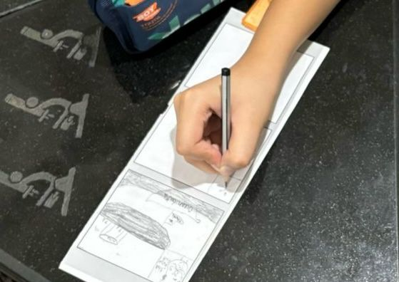
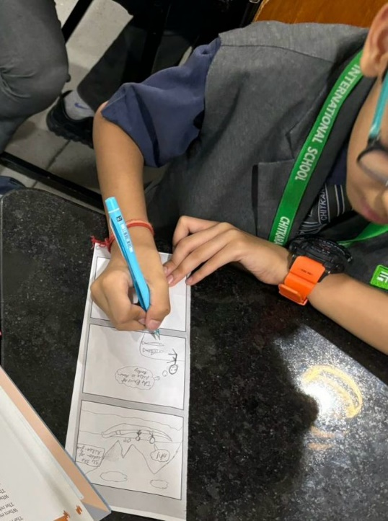

Image 1-Images of students creating comic strips at Chitkara International School, Panchkula, Haryana
3.4 Procedure
The study involved 20 Grade VII students to assess the effectiveness of comic strips as a pedagogical tool in comparison to traditional teaching methods. To provide a basis for comparison, students were taught two different chapters using distinct instructional approaches. One chapter from the NCERT Class 7 English textbook Honeycomb, "Quality," was delivered through conventional methods, including textbook reading, lectures, and written exercises. In contrast, another chapter from the same textbook, "Gopal and the Hilsa Fish," was taught using comic strips, allowing students to engage with the material visually and creatively.
Following the implementation of both teaching approaches, post-tests were conducted to assess students' comprehension and knowledge retention. The questions for these tests were carefully designed based on Bloom's Taxonomy, a hierarchical framework that categorizes cognitive skills from basic recall to higher-order thinking. By incorporating different levels of cognitive processes—ranging from remembering and understanding to analysing and evaluating, it ensured a comprehensive assessment of students' learning outcomes. The test results were then analysed to compare the effectiveness of comic strips versus text content. An additional activity to test the engagement and critical thinking of students was conducted wherein they were given comic strips with blank dialogue boxes to put their ideas in and compose an alternate story. They were thereafter encouraged to narrate their stories in the class.
- ANALYSIS AND INTEPRETATION OF DATA
The data collected from the post-tests results provided a comparative evaluation of the effectiveness of text versus comic strip-based pedagogy. The analysis focused on assessing students’ knowledge retention, comprehension, and overall performance across both instructional approaches.

Quantitative data analysis
Table- 1 Showing the Post Test Scores of Students Using Text and Comic Strip Pedagogy
Sr No. | Post-test  (Text Method) | Post Test  (Comic Strip Method)
1 | 24.5 | 29
2 | 35 | 37
3 | 13.5 | 17
4 | 35 | 35
5 | 27.5 | 25
6 | 26.5 | 26
7 | 13 | 17
8 | 33 | 34
9 | 25.5 | 21
10 | 18 | 20
11 | 22 | 17
12 | 23 | 25
13 | 14.5 | 20
14 | 22 | 25
15 | 30 | 30
16 | 27.5 | 30
17 | 30 | 34
18 | 31 | 32
19 | 21.5 | 30
20 | 32 | 35

Figure-1 Graphical Representation of Post-test Scores of Students Using Text Method

Figure-2 Graphical Representation of Post-test Scores of Students Using Comic Strips

From Table 1 and Figures 1 and 2, it is revealed that out of 20 students, 17 showed an increase in scores through the comic-based approach as compared to traditional text-based instruction. This indicates that the comic-based approach was more effective in enhancing student comprehension and retention than conventional teaching methods.
However, students at Sr. No. 5, 9, and 11 showed a decline in scores through the comic-based approach.

Table- 2 Showing the Post Test Scores Using Text and Comic Strip Pedagogy
 | Post-test (Text Method) | Post Test (Comic Strip Method)
Mean | 25.25 | 26.83
Avg. Gain | 6.26%

From Table 2, the mean score of the post-test through text-based instruction was 25.25, while the mean score of the post-test through the comic-based approach was 26.83. An increase of 6.26% in average gain was found.

Qualitative data analysis
Observational data further supported these findings, as students in the comic strip-based sessions exhibited increased participation, interaction, and enthusiasm toward the learning material. Their ability to connect with the content visually contributed to sustained attention and motivation. In contrast, students in the text-based group relied more on rote memorization, which sometimes resulted in passive learning behaviours. Students expressed that the visual format enhanced engagement, simplified complex concepts, and encouraged creativity.
Overall, the comparative analysis highlights the potential of comic strips as an effective instructional tool for enhancing engagement and conceptual clarity. These results suggest that integrating visual storytelling into pedagogy can offer significant advantages in improving student learning outcomes, particularly in subjects that require critical thinking and conceptual application.
- DISCUSSION AND CONCLUSION
The post-test results of the text-based group (mean score: 25.25) and the comic-based group (mean score: 26.83) indicated an overall increase in scores, suggesting that the use of the comic strip method was effective in enhancing student learning. The 6.26% increase in the average mean scores further validates the efficacy of comic strip pedagogy compared to text-based instruction.
However, the study also revealed that three students (Sr. No. 5, 9, and 11) scored lower in the post-test through the comic-based approach. A probable cause for this decline could be inattentiveness or perceiving comic strip pedagogy as purely entertaining rather than an academic tool. Teachers should anticipate such tendencies in the classroom and implement strategies to ensure students remain engaged in meaningful learning. Additionally, this may be attributed to the fact that not all students are visual learners and may struggle with processing information through illustrations. Despite these variations, the number of students who faced challenges was minimal, indicating that the overall effectiveness of this pedagogy in classrooms cannot be underestimated.
The first objective was to enhance the learning outcome of teaching prose content using comic strips which was evident from the scores obtained by the students. The second, third and fourth objectives were to improve understanding and retention through visual art, boost engagement and encourage creativity by designing comic strips. The same was achieved in the class, wherein students were observed actively engaging in the activity of creating their own comic strips, adding relevant content, filling in dialogues, and developing their own stories based on the given context. This creative exercise allowed students to personalize their learning experience while reinforcing their understanding of the subject matter. The last objective was to enhance communication skills using comic strips, which was achieved when students narrated stories exclusively created by them in the class.
To conclude, we can say that incorporating comic strips as a pedagogical tool can significantly enhance student engagement and comprehension compared to teaching through text method. Additionally, students demonstrated higher participation, creativity, and enthusiasm during comic strip-based lessons. The study underscores the importance of diverse instructional strategies in the classroom. Given these findings, educators should consider incorporating comic strips and other visual tools into their teaching practices to enhance comprehension, boost motivation, and promote active learning.

- SUGGESTIONS FOR FURTHER RESEARCH
- The study was carried out over a short period, which may not fully capture the long-term impact of comic strips on learning and retention. The same can be investigated further.
- Qualitative aspects such as student motivation, creativity or attitudes toward learning using comic strips can further be investigated.
- Similar research in different educational settings with varying curricula and teaching styles can be conducted.
- Teacher’s efficiency in teaching through comic strips could also be an area of investigation.

REFRENCES
  - Adams, N. E. (2015). Bloom’s taxonomy of cognitive learning objectives. Journal of the Medical Library Association, 103(3), 152–153. https://pmc.ncbi.nlm.nih.gov/articles/PMC4511057/
  - Budiman, P. G., Sada, C., & Wardah. (2018). Improving students’ vocabulary by using comic strips in teaching narrative text. Jurnal Pendidikan Dan Pembelajaran Khatulistiwa, 7(9), 1–8. https://jurnal.untan.ac.id/index.php/jpdpb/article/download/28279/75676578327
  - Gilakjani, A. P., Ismail, H. N., & Ahmadi, S. M. (2011). The effect of multimodal learning models on language teaching and learning. Theory and Practice in Language Studies, 1(10), 1321–1327. https://doi.org/10.4304/tpls.1.10.1321-1327
  - Guthrie, J. T., & Wigfield, A. (2000). Engagement and motivation in reading. In M. L. Kamil, P. B. Mosenthal, P. D. Pearson, & R. Barr (Eds.), Handbook of reading research (Vol. 3, pp. 403-422). Routledge. https://books.google.co.in/books?hl=en&lr=&id=2vhQAwAAQBAJ
  - Guthrie, J. T., McRae, A., & Klauda, S. L. (2007). Contributions of concept-oriented reading instruction to knowledge about interventions for motivations in reading. The Reading Teacher, 61(4), 331-335. https://ila.onlinelibrary.wiley.com/doi/abs/10.1598/RT.61.4.2
  - Juliana, T. (2019). The impact of comic strips on vocabulary acquisition and reading comprehension. New Academia: An International Journal of English Language, Literature and Literary Theory, 8(SI). https://interactionsforum.com/images/pdfs/newacademia/v8/Si/juliana.pdf
  - Rengur, B., & Sugirin. (2019). The use of comic strips in improving students' reading comprehension. Proceedings of the 2nd International Conference on Educational Assessment and Policy (ICEAP 2019), 257-263. Atlantis Press. https://www.atlantis-press.com/article/125909986.pdf
  - Sharma, R. (2020). Comics: A tool of teaching language through literature. International Journal of Creative Research Thoughts (IJCRT, 8(4), 3200–3204. https://ijcrt.org/papers/IJCRT2004452.pdf
  - Snow, C. E. (2002). Reading for understanding: Toward an R&D program in reading comprehension. RAND Corporation. https://books.google.co.in/books?hl=en&lr=&id=R1t9btYnK_EC
  - Wikipedia. (n.d.). Text types. Retrieved from https://en.wikipedia.org/wiki/Text_types#:~:text=A%20literary%20text%20is%20a,the%20Common%20Core%20State%20Standards

