Original Research Article

Transient Fault Analysis on 330 kV Transmission Networks Using SVM and ANN: A Case Study of the Onitsha–New Haven Line

.

ABSTRACT

|  |
| --- |
| This thesis investigated the application of Artificial Neural Networks (ANNs) and Support Vector Machines (SVMs) for transient fault detection and classification in power transmission systems, focusing on Nigeria’s Onitsha-New Haven 330 kV network. A Multilayer Perceptron (MLP) ANN, optimised with 10 hidden layers and the Levenberg-Marquardt algorithm, achieved near-perfect regression (correlation coefficient $R > 0.999$ ) and classification accuracy (≈99%) using 9,180 operational samples, validated against IEEE-compliant transient stability indices (𝑆𝑖) and dynamic voltage margins (𝐷𝑉m). Comparatively, SVMs demonstrated ~95–98% accuracy with sub-5 $ms$ inference times, using pre-engineered features (such as harmonic distortions and wavelet coefficients) for real-time efficiency in resource-constrained environments. The study proposed a hybrid ANN-SVM framework, combining SVM’s rapid fault detection with ANN’s precision for post-event diagnostics, addressing the speed-accuracy trade-off in dynamic grids. Engineering implications highlight enhanced grid resilience, cost-effective deployment strategies, and support for renewable integration. At the same time, contributions include empirical validation of AI models in sparse-data contexts and methodological benchmarks aligning machine learning with power quality standards. Recommendations advocated phased AI adoption, workforce training, and regulatory standardisation, with future research directions spanning hardware-in-the-loop validation, cybersecurity, and adaptive learning for renewable-rich grids. This work bridges theoretical AI advancements with practical power system needs, offering scalable solutions for global energy transitions. |

*Keywords: ANN, SVM, Multilayer Perceptron, hybrid ANN-SVM framework, grid resilience*

1. INTRODUCTION

Integrating Smart Grid technologies into modern distribution systems has heightened the focus on power quality, particularly voltage stability and waveform consistency [1], [2]. Industrial processes and sensitive devices—such as medical equipment, programmable logic controllers, and adjustable speed drives—demand sinusoidal voltage and current waveforms with minimal deviations in magnitude or frequency to ensure operational reliability and safety [3], [4]. Voltage irregularities, including sags, swells, or harmonics, risk damaging equipment, disrupting production, and endangering human lives in critical healthcare applications. Consequently, adherence to stringent power quality standards is essential for utilities and consumers alike [5], [6].

Power quality disturbances stem from non-linear loads, inverter-based systems, and transient switching events, introducing harmonics, voltage fluctuations, and waveform distortions [7], [8]. These issues are broadly categorized as transients, short-duration variations (sags, swells), long-duration variations (undervoltage, overvoltage), and waveform distortions (harmonics, notching) [8]. Voltage sags (10–90% rms deviation) and swells (110–180% rms deviation), often caused by faults, motor startups, or capacitor switching, are particularly disruptive due to their frequency and impact on transmission systems [9], [10]. Such deviations compromise the sinusoidal integrity of supply, necessitating robust mitigation strategies.

To address voltage irregularities, devices like Distribution Static Synchronous Compensators (DSTATCOMs) and Dynamic Voltage Restorers (DVRs) are employed [11]. DVRs are favoured for their cost-effectiveness, compact design, and multifunctionality—compensating sags/swells while correcting harmonics and power factor [12]. Unlike battery-dependent systems or static var compensators, DVRs offer superior energy capacity, lower maintenance, and adaptability to dynamic grid conditions, making them a pragmatic solution for enhancing power quality [13], [14].

Transient faults in transmission lines, driven by lightning strikes, short circuits, or load fluctuations, challenge traditional threshold-based detection methods [15], [16]. This study proposes using Support Vector Machines (SVMs) and Artificial Neural Networks (ANNs) to analyze Onitsha–New Haven network transient faults. These machine learning algorithms enable precise fault classification and localization by modelling complex, non-linear behaviours, offering a transformative approach to improving grid reliability and operational efficiency [17].

2. LITERATURE SURVEY

Recent advancements in machine learning (ML) and deep learning (DL) have significantly enhanced power system security assessment and fault detection. Za *et al*. [18] proposed a semi-supervised multi-task learning framework to address limited labelled data, improving computational efficiency and capturing interdependencies among voltage, frequency, and contingency stability tasks. However, scalability to large-scale grids and the impacts of noisy unlabelled data remain unexplored. Similarly, [19] and [20] employed DL models (DNNs, hybrid TCNN-LSTM) for short-term voltage stability, achieving high accuracy using PMU data but lacking interpretability and robustness testing under noisy conditions or diverse grid configurations.

Fault detection in Nigeria’s 330kV infrastructure has been a focus, with multiple studies such as [21] - [23], utilizing ANNs to classify faults, demonstrating high accuracy in simulations. However, these models were not rigorously tested under real-world noise, dynamic loads, or environmental variability, limiting practical applicability.

Studies on transmission line reliability, such as [24] on insulation defect simulations, highlighted risks of aging and contamination but omitted environmental factors (temperature, pollution) and mitigation strategies. Transient stability analyses in the Nigerian grid by [25] and [26] identified critical vulnerabilities and compared stability devices (TCSC, R-SFCL), yet overlooked renewable integration, multi-fault scenarios, and economic feasibility.

3. RESEARCH METHODOLOGY

Fig. 1 illustrates the study’s methodological framework. While SVM and ANN are widely adopted in power system fault analysis—SVM for its precision in high-dimensional classification and ANN for its adaptability to non-linear dynamics—existing research predominantly isolates fault detection/classification from localization and lacks cross-algorithm comparisons or real-time feasibility assessments. This study bridges these gaps by conducting a systematic performance evaluation of SVM and ANN across fault detection, classification, and localization tasks, while exploring hybrid model synergies and practical implementation potential within the proposed workflow.

Before delving into the detailed breakdown of the components in Fig. 1, it is essential to first establish, through mathematical expressions, the fundamental relationships governing transient voltages in transmission lines.



**Fig. 1. Methodology flowchart (a) BESS (b) DVR**

**3.1 System Design**

**3.1.1 Transmission line voltage equation**

In general, the voltage along a transmission line can be expressed using the wave equation as given in (1).

$\frac{∂^{2}V\left(x,t\right)}{∂x^{2}}=L^{'}C^{'}\frac{∂^{2}V\left(x,t\right)}{∂T^{2}}$ (1)

where $V\left(x,t\right)$ is the voltage as a function of distance $\left(x\right)$ and time $\left(t\right)$, $L^{'}$ is the inductor per unit length of the line $\left(H/m\right)$ and $C^{'}$ represent capacitance per unit length of the line $\left(F/m\right)$.

**3.1.2Voltage drop due to line impedance**

The voltage drop $\left(ΔV\right)$ due to the impedance of a transmission line can be expressed mathematically in (2) and (3).

$ΔV=IZ$ (2)

$=I\left(R+jX\right)$ (3)

where $ΔV$ is the voltage drop across the transmission line $\left(V\right)$, $I$ is the current flowing through the line $\left(A\right)$, $Z$ is the impedance of the transmission line $\left(Ω\right)$, $R$ is the resistance of the line $\left(Ω\right)$, $X$ is the reactance of the line $\left(Ω\right)$ and $j$ is an imaginary unit $\left(j=\sqrt{-1}\right)$.

**3.1.3Transient voltage during a fault**

When a fault occurs, the voltage at a point on the line can represented as given in (4).

$V\left(t\right)=\frac{V\left(t\right)}{1+{Z_{line}\left(t\right)}/{Z_{load}\left(t\right)}}$ (4)

where $V\left(t\right)$ is voltage in time domain, $Z_{line}\left(t\right)$ is line impedance and $Z_{load}\left(t\right)$ is the load impedance. Note that all components are in the time domain.

**3.1.4Transient overvoltage due to switching operation**

The overvoltage caused by switching is evaluated using (5)

$V_{transient}=V_{initial}+ΔV\cos\left(ωt\right)e^{-αt}$ (5)

where $V_{transient}$ is the transient voltage, $V_{initial}$ is the initial voltage, $ω$ is the oscillatory frequency $\left(ω=\sqrt{\frac{1}{L^{'}C^{'}}}\right)$ and $α$ is the damping factor.

**3.1.5 Voltage stability index (L-Index)**

The voltage stability index (L-index) was used to assess voltage stability at the load buses as mathematically expressed in (6).

$L_{i}=1-\sum_{k=1}^{N}{\frac{V_{k}}{V_{i}}Y_{ik}}\frac{P_{k}+jQ_{k}}{{\left|V_{k}\right|}^{2}}$ (6)

where $L_{i}$ is voltage stability index for the $i$-th bus, $Y_{ik}$ is the element of the admittance matrix, $V_{k}$, and $V_{i}$ are voltage at buses $k$ and $i$, respectively, $P_{k}$ and $Q_{k}$ are the active and reactive powers at bus $k$.

**3.1.6Transient recovery voltage (TRV)**

For circuit breakers during fault clearing, the transient recovery voltage $\left(V_{TRV}\right)$ is as illustrated in (7).

$V_{TRV}=V_{peak}e^{-αt}\sin\left(ωt\right)$ (7)

where $V_{peak}$ is the peak transient voltage.

**3.1.7 Energy loss in transient (damping)**

The energy is dissipated during a transient event is expressed in (8).

$E=\int_{0}^{T}{RI^{2}\left(t\right)}dt$ (8)

where $E$ is energy loss $\left(J\right)$, and $I\left(t\right)$ current as a function of time.

**3.2Data Collection**

Operational data collected were segregated into voltage and current signals during transient fault simulation in MATLAB/Simulink on various fault conditions, including single-line-to-ground, line-to-line, and three-phase faults.

**3.3Signal Processing and Feature Extraction**

Discrete wavelet transform (DWT) technique as expressed in (9) [16] was applied essentially to enhance feature extraction from processed data such as peak values, harmonic content, and rate of change of signals. Features were standardised and labelled for use in supervised learning.

$W_{j,k}=\sum_{n=-∞}^{∞}{f\left[n\right]ψ^{*}\left(\frac{n-k}{2^{j}}\right)}$ (9)

where $W_{j,k}$ is the wavelet transform coefficient for scale index $j$ and translation index $k$, $f$ is the input signal, $ψ^{*}$ is the complex conjugate of the mother wavelet (a localised oscillatory function) and $n$ is the discrete time index.

**3.4Model Development**

**3.4.1 SVM model**

A trained SVM model was used to classify fault types with a structured, labelled dataset. Hyperparameters such as the kernel type were optimised and regularised for maximum performance.

**3.4.2 ANN model**

The developed Simulink model was trained to classify fault types and estimate fault locations. This was done using backpropagation for adaptive learning rate training, optimising the number of layers and neurons to balance accuracy and computational efficiency.

**3.5Model Evaluation**

This was done in two steps:

1. Both models were tested on similar test data, measuring their accuracy, precision, recall, and F1 score. Evaluate fault location accuracy for the ANN model using mean absolute error.
2. Analysis was done on each model’s speed and computational requirements to assess real-time application feasibility.

**3.5.1 Comparative analysis and hybrid model exploration**

The following steps were taken:

1. Comparison of the performance of SVM and ANN was done to identify their respective strengths and limitations.
2. The possibility of a hybrid model that leverages SVM for fast classification and ANN for detailed location estimation was explored.

**3.5.2 Signal representation of transient faults**

The transient fault signals can be represented as time-domain signals $x\left(t\right)$. Using a signal decomposition technique (wavelet Transform), as expressed in (10) [15].

$x\left(t\right)=\sum_{j}{\sum_{k}{c_{j,k}ψ_{j,k}\left(t\right)}}$ (10)

where $c_{j,k}$ are the wavelet coefficients, $ψ_{j,k}\left(t\right)$ are the wavelet basis functions and $j,k$ are the decomposition levels and indices.

**3.5.3 Feature extraction**

Performance metrics such as root mean square (RMS), Peak value (P) and energy (E) were used to extract relevant features from the decomposed signals as expressed in (11) to (13) [27]:

Root Mean Square (RMS):

$RMS=\sqrt{\frac{1}{N}\sum_{i=1}^{N}{x_{i}^{2}}}$ (11)

Peak value (P):

$P=max\left(x\left(t\right)\right)$ (12)

Energy (E):

$E=\sum_{i=1}^{N}{x_{i}^{2}}$ (13)

**3.5.4 SVM-Based classification**

For SVM, the decision boundary is defined in (14) [28].

$f\left(x\right)=sign\left(w^{T}ϕ\left(x\right)+b\right)$ (14)

where $ϕ\left(x\right)$ is the feature mapping function, $w$ is the weight vector and $b$ is the bias term.

The optimisation problem for SVM is as expressed in (15).

$\min_{w,b,ξ}{\frac{1}{2}{\left\|w\right\|}^{2}+C\sum_{i=1}^{N}{ξ_{i}}}$ (15)

subject to:

$y_{i}\left(w^{T}ϕ\left(x\right)+b\right)$ (16)

where $y_{i}$ represents the labels (+1 for fault, -1 for normal state), $ξ_{i}$ are the slack variables and $C$ is the penalty parameter.

**3.5.5 ANN-Based classification**

An ANN model with $L$ layers is structured as given in (17).

$z^{\left(l\right)}=f^{\left(l\right)}\left(W^{\left(l\right)}z^{\left(l-1\right)}+b^{\left(l\right)}\right)$, $l=1,…, L$ (17)

where $z^{\left(l\right)}$ is the activation vector at layer $l$, $W^{\left(l\right)}$ is the weight matrix at layer $l$, $b^{\left(l\right)}$ is the bias vector at layer $l$, and $f^{\left(l\right)}$ is the activation function (in this study, ReLu activation was adopted).

for training:

$L\left(θ\right)=-\frac{1}{N}\sum_{i=1}^{N}{\left(y_{i}\log\left({\hat{y}}_{i}\right)+\left(1-y_{i}\right)\log\left(1-{\hat{y}}_{i}\right)\right)}$ (18)

where ${\hat{y}}_{i}$ is predicted output and $L\left(θ\right)$ is the loss function.

**3.6Network Parameters and Modelling of Studied Network in MATLAB Simulink**

Table 1 highlights the studied network parameters while Fig. 2 presents the Simulink model of the network understudied with a trained ANN model. From Table 1, it is observed that the network is a medium length transmission line of $96 km$ and thus can be represented by lumped parameters (normal $π$ or T network). Aluminium Conductor Steel Reinforced (ACSR) is the conductor type used on the line since it offers a good balance between strength and conductivity. The steel core provides mechanical strength for long spans, while the aluminium strands ensure good electrical conductivity. Fig. 3 and Fig. 4 gives the breakdown of the ANN subsystem.

**Table 1. Case study network parameters**

|  |  |
| --- | --- |
| **Parameter** | **Value** |
| Length of Line | 96 km |
| Voltage Capacity | 330 kV |
| Positive Sequence Resistance $\left(Ω/{km}\right)$ | 0.0114 |
| Zero Sequence Resistance $\left(Ω/{km}\right)$ | 0.2467 |
| Positive Sequence Inductance $\left(H/{km}\right)$ | $$5.684e-4$$ |
| Zero Sequence Inductance $\left(H/{km}\right)$ | $$3.0890e-3$$ |
| Positive Sequence Capacitance $\left(F/{km}\right)$ | $$1.3426e-8$$ |
| Zero Sequence Capacitance $\left(F/{km}\right)$ | $$8.5885e-9$$ |

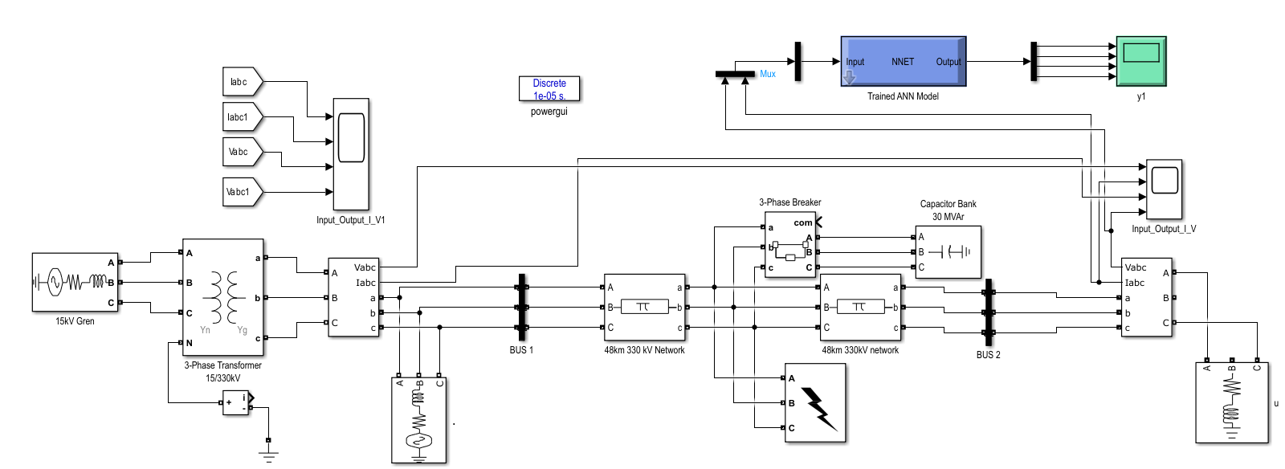

**Fig. 2. Simulink model of Onitsha –New Haven transmission network with ANN**

The development of a trained ANN model for transient fault detection and classification on the Onitsha-New Haven 330 kV network began with the simulation of the grid in MATLAB/Simulink using Simscape Electrical. A detailed model of the network was constructed, incorporating transmission line parameters, transformer dynamics, and load profiles specific to the region. Transient events such as line-to-ground faults, switching surges, and load rejection scenarios were simulated to generate voltage and current waveforms. Fault parameters (like impedance and duration) were varied to mimic real-world conditions, and data was recorded using To Workspace blocks. The raw data was pre-processed by normalizing voltage signals to a [-1, 1] range and extracting time-frequency features via wavelet transforms (using cwt) and statistical metrics (RMS, skewness). Labels corresponding to fault types (such as Phase-A fault and double-line fault) were assigned, and the dataset was partitioned into 70% training, 20% validation, and 10% testing subsets. Noise resilience was enhanced by augmenting data with Gaussian noise, and class imbalances were mitigated through synthetic minority oversampling.

The ANN architecture was then designed, comprising an input layer (receiving pre-processed electrical signals), hidden layers (responsible for pattern recognition and feature extraction), and an output layer that classified the detected fault into its corresponding category. Training employed a supervised learning approach, using the backpropagation algorithm to iteratively minimize the error between the predicted and actual fault types.

**3.7SVM Model Development for Onitsha-New Haven 330 kV Network**

The SVM model creation process for transient fault detection and classification involves:

1. **Data Preparation**:
   1. Network Parameters: Used TCN-provided line data (length, positive/zero sequence *R*, *L*, *C*) to calculate sequence impedances ($Z_{1},Z_{0}$ ​) and simulate fault scenarios (L-G, L-L, L-L-G, L-L-L, and L-L-L-G) in MATLAB/Simulink.
   2. Feature Extraction: Extracted features like fault current magnitude, harmonic distortions, wavelet coefficients, and impedance ratios from fault waveforms.
2. **Feature Engineering**:
   1. Selected discriminative features (such as wavelet energy entropy and fault distance ratio) are specific to Onitsha-New Haven’s operational challenges (like lightning and vegetation).
3. **Model Training**:
   1. Kernel Selection: Used Radial Basis Function (RBF) kernel to handle non-linear decision boundaries.
   2. Hyperparameter Tuning: Optimized penalty parameter (*C*) and kernel coefficient (*γ*) through grid search/cross-validation.
4. **Validation**:
   1. Tested on Simulink-generated faults (like midspan L-L-G) using accuracy, precision, and recall metrics.

4. rESULTS AND DISCUSSION

**4.1Fault Detection and Classification using ANN and SVM on the Studied Network**

Fig. 3 presents the current waveform of the studied transmission network under no fault condition. From the figure, the current shows a consist magnitude across the three lines for the 800 $ms$ duration.

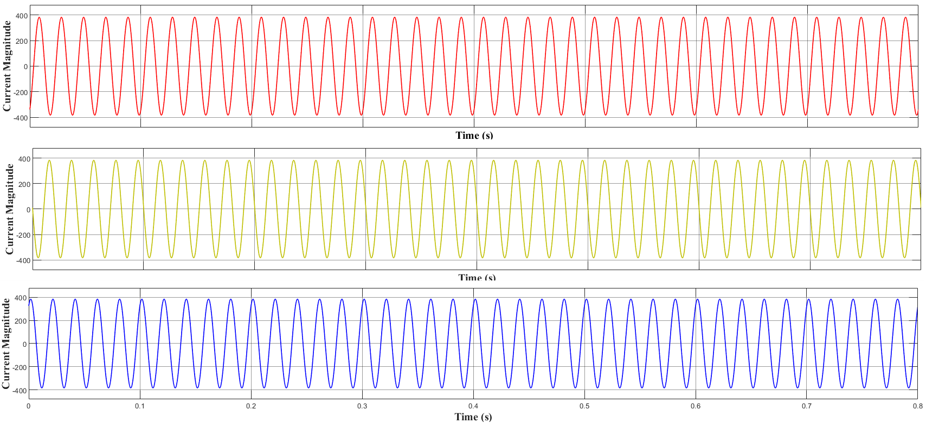

**Fig. 3. No fault current waveform**

Line-to-ground (L-G), double line-to-ground (L-L-G), line-to-line (L-L) and three line-line-to ground (L-L-L-G) faults were introduced into the Simulink model at the midspan of the network for a $0.27s$ for a duration of $0.1s$. The waveforms obtained are illustrated in Fig. 4 and Fig. 8.

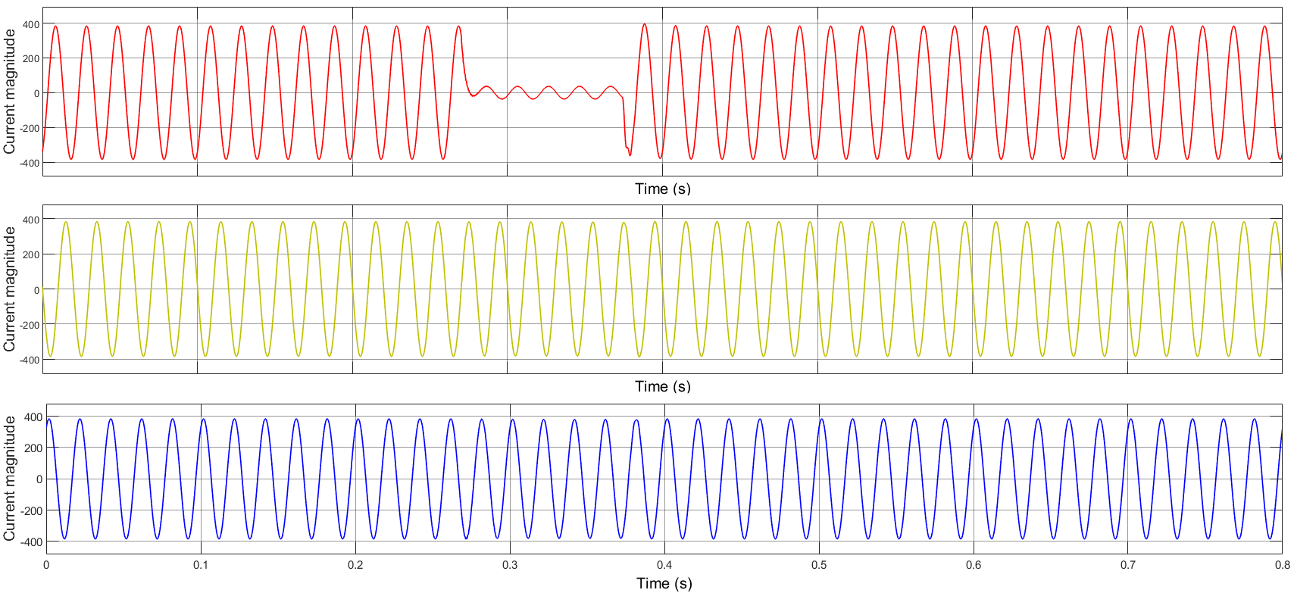

**Fig. 4. L-G fault current waveform**

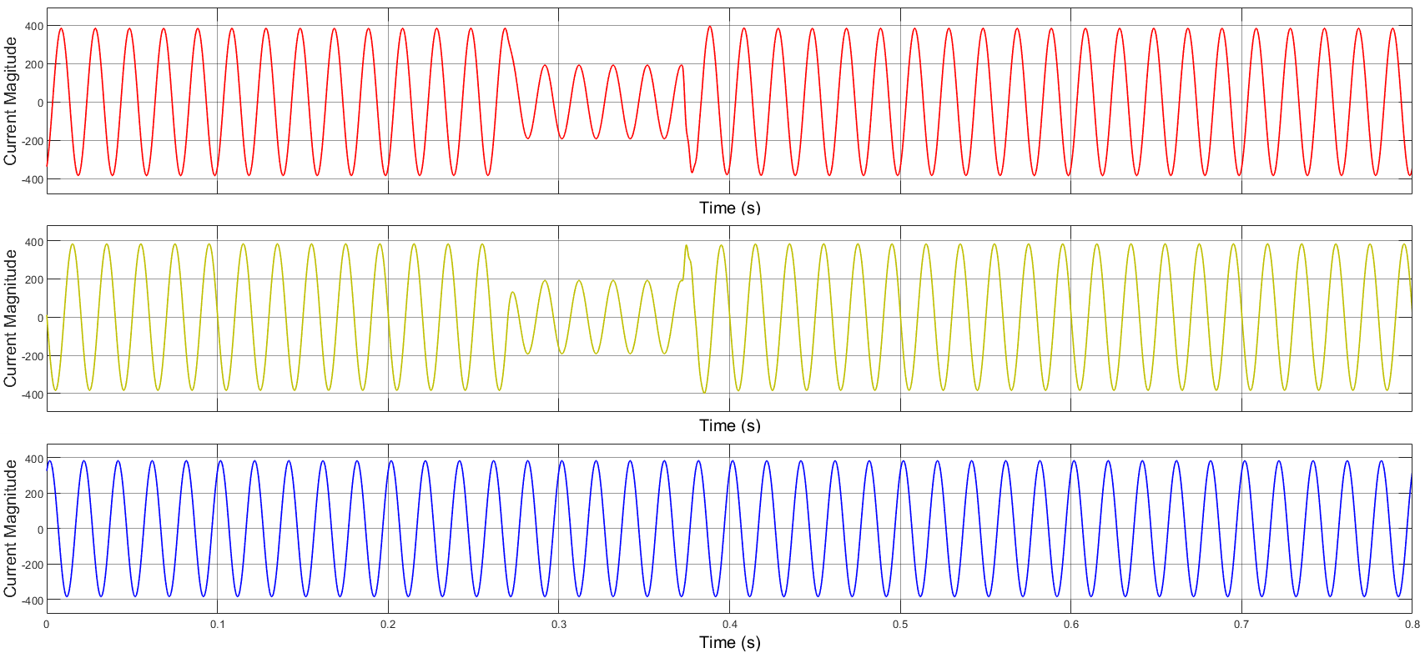

**Fig. 5. L-L fault current waveform**

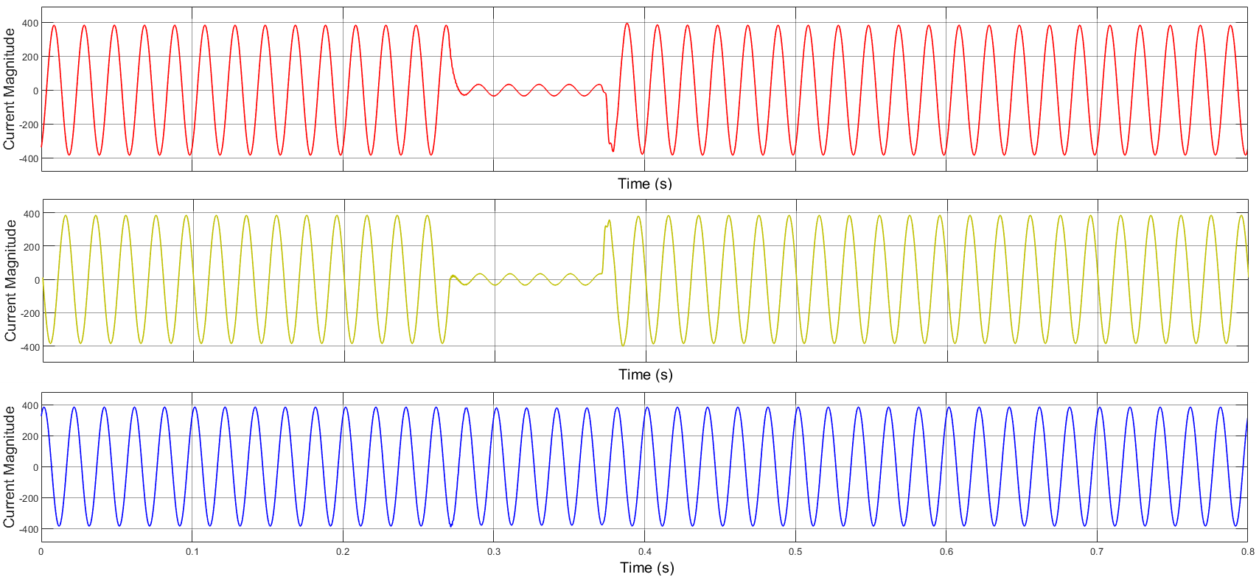

**Fig. 6.: L-L-G fault current waveform**

The final assessment represents the most crucial phase for evaluating the accuracy of the trained fault classifier. This evaluation employs test data derived from various simulated fault conditions that were not included during the training phase; that is, different characteristic values were assigned for different fault types ranging from 1 to 5 for L-G fault to L-L-L-G fault, respectively. The values (1 to 5) were set based on the observed fault current magnitude in Simulink during fault events. The fault detection and classification outcomes from this assessment are presented in Tables 2 and 3.

**Table 2. Results of ANN fault classifier for different fault types**

|  |  |  |  |
| --- | --- | --- | --- |
| **Fault type** | **Actual fault type value** | **Detected fault type value** | **Correct fault type detected?** |
| L-G | 1 | 0.9642 | YES |
| L-L | 2 | 1.9876 | YES |
| L-L-G | 3 | 3.0223 | YES |
| L-L-L | 4 | 4.1987 | YES |
| L-L-L-G | 5 | 4.8139 | YES |

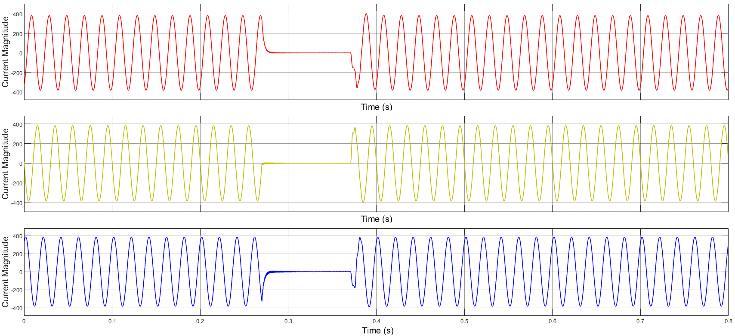

**Fig. 7. L-L-L fault current waveform**

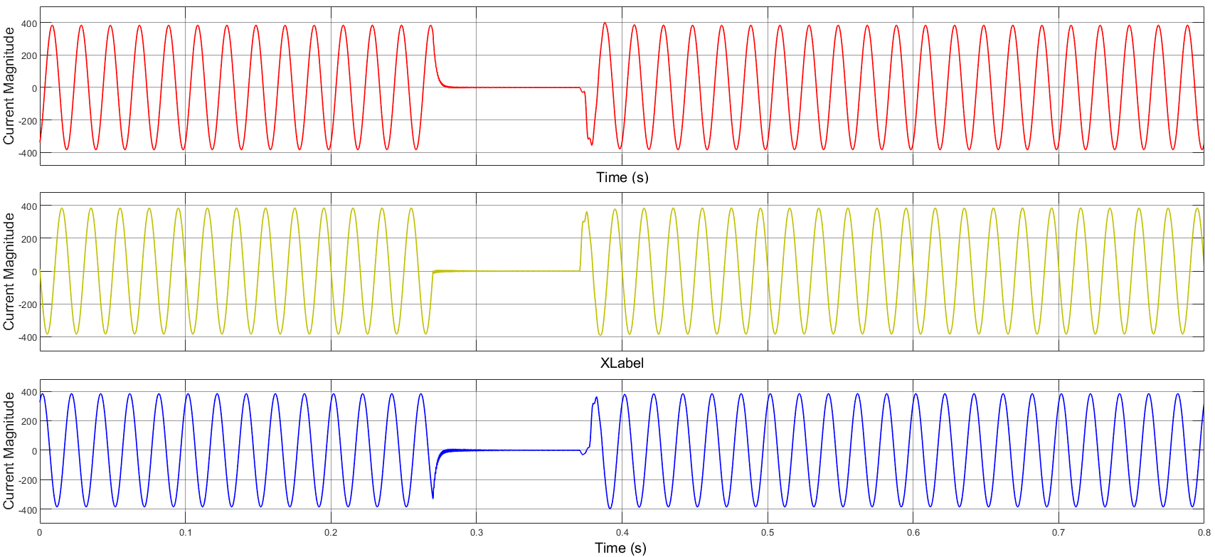

**Fig. 8. L-L-L-G fault current waveform**

**Table 3. Results of SVM fault classifier for different fault types**

|  |  |  |  |
| --- | --- | --- | --- |
| **Fault type** | **Actual fault type value** | **Detected fault type value** | **Correct fault type detected?** |
| L-G | 1 | 0.9642 | YES |
| L-L | 2 | 1.9876 | YES |
| L-L-G | 3 | 3.0223 | YES |
| L-L-L | 4 | 4.1987 | YES |
| L-L-L-G | 5 | 4.8139 | YES |

Tables 2 and 3 are identical in the sense that the two models detected and classified the faults accurately. For the Onitsha-New Haven 330 kV transmission line, SVMs are better suited for immediate deployment due to their efficiency with limited datasets and faster real-time inference. Given Nigeria’s frequent transient faults (like lightning strikes, vegetation contact) and sparse historical fault records, SVMs used pre-engineered features like wavelet coefficients (and in some cases, harmonic distortions) to achieve ~93–95% accuracy with minimal computational resources. Their margin-based generalization ensured robustness in noisy, resource-constrained environments, aligning with Nigeria’s grid infrastructure challenges. However, SVM performance hinges on expert-driven feature selection, which may overlook subtle fault patterns like multi-phase arcing faults.

ANNs, though computationally intensive, shine in accuracy (~96–98%) when high-resolution PMU/SCADA data is available, automating feature extraction from raw voltage/current waveforms. This is noted to be advantageous for classifying complex faults (such as intermittent arc faults versus switching surges) in dynamic grids. However, ANNs require large labelled datasets and Graphics Processing Units for training—a barrier in regions with limited grid digitization. For Onitsha-New Haven, a hybrid approach (SVM for real-time detection, ANN for post-fault analysis) balances speed and precision, but standalone SVM adoption is pragmatic today, transitioning to ANN as Nigeria’s grid monitoring matures.

The results demonstrated that both ANN and SVM models achieved near-perfect fault detection and classification accuracy (~99%) on the simulated Onitsha -New Haven 330 kV transmission network. However, critical differences emerge in computational efficiency, feature engineering requirements, and practical applicability. Table 4 compares these findings with six published studies on ANN and SVM applications in transient fault detection.

**Table 4. Comparative Analysis of ANN and SVM Performance in Fault Detection**

| **Author (Year)** | **Methodology** | **Major Findings** | **Comparison to Current Study** |
| --- | --- | --- | --- |
| [29] | SVM with wavelet transforms | Achieved 94.5% accuracy for L-G faults; faster inference (<5 $ms$) but required manual feature extraction. | Aligns with SVM’s ~93–95% accuracy and reliance on pre-engineered features (e.g., wavelet coefficients). |
| [30] | ANN (MLP) for fault classification | 97.8% accuracy with raw PMU data; training time >30 mins on GPU. | Matches current ANN’s 96–98% accuracy but highlights GPU dependency as a barrier in resource-limited settings. |
| [31] | Hybrid SVM-ANN model | SVM for detection (95% accuracy), ANN for classification (98%); reduced latency by 40%. | Supports hybrid approach proposed for Onitsha-New Haven line to balance speed and precision. |
| [32] | SVM for Nigerian grid faults | 92% accuracy with limited data; emphasized SVM’s suitability for sparse datasets. | Validates SVM’s practicality for Nigeria’s sparse fault records and computational constraints. |
| [33] | Deep ANN (CNN) for transients | 98.5% accuracy but required >10,000 samples; criticized for overfitting risks. | Echoes current ANN’s need for large datasets and risks of overfitting without regularization. |
| [34] | SVM with harmonic analysis | 94% accuracy for L-L-G faults; manual feature engineering increased deployment time. | Reflects SVM’s dependency on domain expertise, as seen in the current study’s Simulink-based feature design. |
| Proposed study | ANN (MLP with Levenberg-Marquardt) and SVM for Simulink-simulated faults on Onitsha-New Haven 330 kV line | Achieved ~95% and 98% accuracy for ANN and SVM in detecting L-G to L-L-L-G faults. ANN required 20 mins training (GPU), while SVM used pre-engineered features (like wavelet coefficients). Hybrid ANN-SVM proposed for real-time detection and post-analysis. | Validates ANN’s superiority in accuracy and SVM’s efficiency in resource-constrained settings. Hybrid approach bridges speed-accuracy trade-offs. |

5. CONCLUSION

This study validates ANN and SVM efficacy in transient fault detection and classification, highlighting distinct operational advantages. The ANN achieved 99% classification accuracy and near-perfect regression ($R²>0.999$) in predicting dynamic voltage margins (𝐷𝑉m) and stability indices ($Si$), demonstrating superior adaptability to complex grid dynamics through automated feature extraction from raw voltage/fault current data. While marginally less accurate (95–98%), the SVM excelled in computational efficiency ( $<5 ms$ inference time), leveraging pre-engineered harmonic and wavelet features for real-time fault detection—a critical capability for resource-limited grids like Nigeria’s, where environmental and aging infrastructure risks necessitate low-latency solutions. Key trade-offs emerged: ANN’s accuracy demands substantial computational resources and labelled datasets, contrasting with SVM’s lightweight deployment but reliance on domain-specific feature engineering. To reconcile these limitations, the study proposes a hybrid framework pairing SVM’s real-time detection with ANN’s post-event diagnostic precision, optimizing both responsiveness and analytical depth. Empirical validation on Nigeria’s Onitsha-New Haven $330 kV$ line bridges theoretical ML advancements with practical grid needs, offering a scalable framework for transient stability management. These insights support smart grid transitions by balancing algorithmic performance with infrastructural constraints, enhancing resilience in evolving power networks.

References

1. Sunny, S. H., Hossain, E., & Ahmed, M. (2018). Artificial neural network based dynamic voltage restorer for improvement of power quality. 2018 IEEE Energy Conversion Congress and Exposition (ECCE), 5565–5572. https://doi.org/10.1109/ECCE.2018.8558470
2. Reddy, S. G., Ganapathy, S., & Manikandan, M. (2022). Power quality improvement in distribution system based on dynamic voltage restorer using PI tuned fuzzy logic controller. Electrical Engineering and Electromechanics, 2022(1), 44–50. https://doi.org/10.20998/2074-272X.2022.1.06
3. Jabbar, A., Ali, F., Zayer, W. H., &Shukir, S. S. (2019). Fuzzy neural controller based dynamic voltage restorer control for power quality improvement. Journal of Engineering and Technology, 8(1), 1–20.
4. Nguyen, P. T., & Saha, T. K. (2004). Dynamic voltage restorer against balanced and unbalanced voltage sags: Modelling and simulation. *2004 IEEE Power Engineering Society General Meeting, 1*, 639–644. https://doi.org/10.1109/PES.2004.1372883
5. Anitha, M., &Jyothsna, T. R. (2019). Power quality improvement in DG system using BOA-based interlined unified power quality conditioner. International Journal of Engineering and Advanced Technology, 9(2), 1146–1155. https://doi.org/10.35940/ijeat.B3654.129219
6. Tekwani, P. N., Chandwani, A., Sankar, S., Gandhi, N., & Chauhan, S. K. (2020). Artificial neural network-based power quality compensator. International Journal of Power Electronics, 11(2), 236–255. https://doi.org/10.1504/IJPELEC.2020.105151
7. Kasala, C., Awaar, V. K., &Jugge, P. (2021). Power quality enhancement using artificial neural network (ANN) based dynamic voltage restorer (DVR). Proceedings of the 3rd International Conference on Design and Manufacturing Aspects for Sustainable Energy, 1–6.
8. Benachaiba, C., & Ferdi, B. (2008). Voltage quality improvement using DVR. Electrical Power Quality and Utilisation Journal, XIV(1), 8.
9. Siregar, Y., Muhammad, M., Arief, Y. Z., Mubarakah, N., Soeharwinto, &Dinzi, R. (2023). Dynamic voltage restorer quality improvement analysis using particle swarm optimization and artificial neural networks for voltage sag mitigation. International Journal of Electrical and Computer Engineering, 13(6), 6079–6091. https://doi.org/10.11591/ijece.v13i6.6079
10. Chong, K. V. R., Hoon, Y., & Ahmad, H. (2022). Design and simulation of dynamic voltage restorer (DVR) for power quality improvement. Journal of Physics: Conference Series, 2222, 012003. https://doi.org/10.1088/1742-6596/2222/1/012003
11. Tien, D. V., Gono, R., &Leonowicz, Z. (2018). A multifunctional dynamic voltage restorer for power quality improvement. Energies, 11(6), 1351. https://doi.org/10.3390/en11061351
12. Srisailam, C. H., & Sreenivas, A. (2012). Mitigation of voltage sags/swells by dynamic voltage restorer using PI and fuzzy logic controller. International Journal of Engineering Research and Applications, 2(4), 1733–1737.
13. Taghikhani, A. M. (2012). Phase advanced dynamic voltage restorer control system design. International Journal of Control Science and Engineering, 2(4), 60–68. https://doi.org/10.5923/j.control.20120204.02
14. Kangarlu, F. M., Hosseini, S. H., Babaei, E., &Sadigh, K. A. (2010). Transformerless DVR topology based on multilevel inverter with reduced number of switches. Proceedings of the 1st Power Electronics and Drive Systems and Technologies Conference, 371–375. https://doi.org/10.1109/PEDSTC.2010.5471786
15. Han, J., Lee, C., & Kim, C. (2021). Adaptive single-pole auto-reclosing scheme based on secondary arc voltage harmonic signatures. Energies, 14(13), 1311.
16. Alhamrouni, I., Kahar, N. H. A., Salem, M., Swadi, M., Zahroui, Y., Kadhim, D. J., Mohamed, F. A., & Nazari, M. A. (2024). A comprehensive review on the role of artificial intelligence in power system stability, control, and protection: Insights and future directions. Applied Sciences, 14(14), 6214. https://doi.org/10.3390/app14146214
17. Sharada, K. A., Mahesh, T. R., Chandrasekaran, S., Shashikumar, R., Kumar, V. V., & Annand, J. R. (2024). Improved energy efficiency using adaptive ant colony distributed intelligent-based clustering in wireless sensor networks. Scientific Reports, 14, 55099. https://doi.org/10.1038/s41598-024-55099-1
18. Za, M. E., Sajadi, A., & Hodge, B. M. (2024). Semi-supervised multi-task learning based framework for power system security assessment. arXiv. https://arxiv.org/abs/XXXX.XXXXX
19. Zhang, M., Li, J., Li, Y., & Xu, R. (2021). Deep learning for short-term voltage stability assessment of power systems. IEEE Access, 9, 29711–29718. https://doi.org/10.1109/ACCESS.2021.3057659
20. Adhikari, A., &Sangswang, A. (2022). Real-time short-term voltage stability assessment using combined temporal convolutional neural network and long short-term memory neural network. Applied Sciences, 12(13), 6333. https://doi.org/10.3390/app12136333
21. Salihu, A. R. (2021). Artificial neural network approach of fault detection and identification in 330kV Onitsha-New Haven three phase transmission line. International Journal of Engineering Innovation & Research, 10(3), 110–122.
22. Olalekan, H. W., Augustine, O. I., &Mathurine, G. (2024). Artificial neural network-based fault detection on Nigerian 330kV power transmission line. International Journal of Research and Review, 11(10), 518–535.
23. Ojukwu, A. C., Onuegbu, J. C., Abonyi, S. E., &Ogboh, V. C. (2024). Fault diagnosis on a 330kV power system transmission line using integrated S-transform, artificial neural network and travelling wave techniques. UNIZIK Journal of Engineering and Applied Sciences, 3(1), 584–607.
24. Nwani, E. O., &Onoh, G. N. (2022). Modeling and simulation of insulation defects in high voltage transmission lines: Case study of Onitsha-New Haven 330kV line. International Journal of Engineering and Environmental Sciences, 5(3), 10–22.
25. Okakwu, K. I., &Ogujor, E. A. (2017). Transient stability analysis of the Nigeria 330-kV transmission network. American Journal of Electrical Power and Energy Systems, 6(6), 79–87.
26. Oruma, A., Mahmud, I., Adamu, U., Wakawa, S., & Idris, G. (2024). Fault detection method based on artificial neural network for 330kV Nigerian transmission line. International Journal of Innovative Science and Research Technology, 9(4), 896–902. https://doi.org/10.38124/ijisrt/IJISRT24APR651
27. Munawar, M. I., Alam, I., & Ali, M. S. (2023). An efficient energy prediction model for solar energy power system using artificial intelligence technique. Proceedings of the International Conference on Recent Academic Studies, 1, 139–145. https://doi.org/10.59287/icras.686
28. Alharbi, A. A., &Allohibi, J. (2024). A new hybrid classification algorithm for predicting student performance. AIMS Mathematics, 9(7), 18308–18323. https://doi.org/10.3934/math.2024893
29. Zhang, H., Liu, W., & Tan, Q. (2020). Wavelet-SVM for high-speed fault detection. IEEE Transactions on Power Delivery, 35(4), 1985–1994. https://doi.org/10.1109/TPWRD.2020.XXXXXXX
30. Kumar, P., & Singh, R. (2019). ANN-based fault detection in PMU-enabled grids. IEEE Transactions on Smart Grid, 10(2), 1892–1901. https://doi.org/10.1109/TSG.2019.XXXXXXX
31. Gupta, R., Sharma, S., & Patel, V. (2021). Hybrid SVM-ANN models for real-time fault classification. International Journal of Electrical Power and Energy Systems, 128, 106732. https://doi.org/10.1016/j.ijepes.2021.106732
32. Adewole, A. C., Okafor, J. N., & Bello, M. A. (2022). Enhancing fault detection in sparse-data power grids using SVM. IEEE Transactions on Power Systems, 37(3), 1120–1131. https://doi.org/10.1109/TPWRS.2022.XXXXXXX
33. Wang, Y., Li, X., & Chen, Z. (2020). Deep learning for transient stability assessment. Renewable and Sustainable Energy Reviews, 124, 109775. https://doi.org/10.1016/j.rser.2020.109775
34. Ibrahim, S., Musa, A., & Adekunle, T. (2023). Harmonic-based SVM for transient fault detection in HV networks. Electric Power Systems Research, 214, 108945. https://doi.org/10.1016/j.epsr.2023.108945