Original Research Article

Spatial Analysis of Tsunami Risk and Community Preparedness Assessment in Tambakrejo Village, Blitar Regency, Indonesia

ABSTRACT

|  |
| --- |
| Tsunami risk and community preparedness in Tambakrejo Village, Blitar Regency, Indonesia, are investigated by integrating spatial analysis of potential inundation areas with community readiness assessment. Guided by the Sendai Framework for Disaster Risk Reduction 2015-2030 and the LIPI-UNESCO/ISDR community preparedness framework, the research employs a mixed-method approach combining GIS-based tsunami inundation modeling with a comprehensive community assessment. Data collection involved surveying 100 households through incidental random sampling, conducting semi-structured interviews with key stakeholders, organizing focus group discussions, and performing field observations. Spatial analysis revealed that 1.7289 km² (16%) of the village area is susceptible to tsunami inundation, potentially affecting 911 residents, with Krajan Sub-village identified as particularly vulnerable due to its high population density and coastal proximity. The community preparedness assessment, evaluating knowledge and behaviour, emergency planning, warning systems, and resource mobilization capacity, yielded an index value of 60.12, categorizing the village as "Almost Ready," with resource mobilization identified as the weakest parameter. The research contributes to the literature by presenting a novel integration of geospatial analysis with community-based preparedness assessment at the village scale, offering a replicable methodology for evaluating tsunami preparedness in rural coastal settings. Findings provide crucial insights for local authorities and disaster management agencies to enhance tsunami preparedness through targeted interventions and evidence-based decision-making in disaster risk reduction planning. |

*Keywords: Tsunami risk assessment; community preparedness; GIS analysis; coastal vulnerability; disaster risk reduction.*

1. INTRODUCTION

Coastal communities in developing countries are increasingly vulnerable to tsunami hazards due to rapid population growth, unplanned coastal development, and limited disaster preparedness capacity. Indonesia is especially vulnerable to tsunamis caused by seismic activity along major fault lines because of its vast coastline and placement inside the Pacific Ring of Fire. The terrible effects of the 2004 Indian Ocean tsunami and its aftermath have brought attention to how crucial community-level readiness exists (Paulik et al., 2020).

This study addresses these gaps by examining tsunami preparedness in Tambakrejo Village, Blitar Regency, located along Java's southern coast near the megathrust zone. Tambakrejo faces high tsunami risk due to its proximity to a seismic gap where significant stress has accumulated, potentially triggering an earthquake of magnitude 8.7 (Sambah et al., 2019). The village previously experienced tsunami impacts in 1944 originating from Banyuwangi (Mayaguezz et al., 2017). In the last 5 years alone, Blitar Regency has experienced 14 earthquakes, with the largest measuring M 6.2 in May 2021 (Mohamadi et al., 2019). Tambakrejo Beach and its surroundings are projected to be the first areas hit by tsunami waves in the event of a megathrust earthquake (BPBD Blitar, 2023).

Compounding the physical hazard, Tambakrejo has the highest population density among coastal villages in Blitar at 1,194 people/km2 (BPS Blitar). However, it only has one temporary evacuation shelter (Kim et al., 2017). This limited evacuation capacity coupled with high population density significantly increases disaster risk and potential challenges for safe evacuation (Rudianto et al., 2023). Additionally, the growing number of tourists visiting Tambakrejo Beach has boosted the local economy and become a major source of regional revenue, reaching Rp 1.3 billion in 2019 (Re et al., 2022).

Since the establishment of Destana and FPRB (village-level disaster preparedness organizations) in Tambakrejo in 2018, there has been inadequate monitoring and evaluation according to BPBD Blitar. Without comprehensive assessment, it is difficult to determine the impact of existing mitigation efforts on community understanding and village preparedness (Sunarto et al., 2024). The study uses the Sendai Framework for Disaster Risk Reduction 2015–2030 to address these issues and direct the evaluation of Tambakrejo's preparation for tsunamis (Arifin et al., 2021). The research integrates geospatial analysis of tsunami hazard zones with participatory evaluation of community capacities across the Sendai Framework's priorities (Hadi et al., 2020). This contextualized application at the village level, combining physical and social dimensions, offers a novel approach to local preparedness assessment (Valachamy et al., 2022).

This study is innovative because it applies the Sendai Framework contextually at the village level, combining a thorough assessment of community preparedness capabilities with a geospatial analysis of tsunami hazard zones. Through spatial modeling using ArcGIS, the study delineates potential tsunami inundation areas in Tambakrejo Village based on wave height scenarios and topographical characteristics. This hazard assessment is then overlaid with data on population exposure, critical infrastructure, and evacuation routes to identify high-risk zones and estimate potential impacts (Nasir et al., 2018).

Simultaneously, the study conducts a participatory assessment of village preparedness using indicators derived from the Sendai Framework's priorities for action. To assess community knowledge, risk perception, emergency response plans, early warning dissemination, resource mobilization, and social capital, surveys, focus groups, and key informant interviews are used (Rahayu et al., 2020). The integration of geospatial and social dimensions allows for a holistic understanding of village preparedness strengths and gaps (Suwaryo et al., 2021).

By providing a replicable methodology for village-scale tsunami preparedness assessment, this study contributes to bridging the gap between high-level frameworks and local implementation in rural coastal settings (Benardi et al., 2023). Policymakers, disaster management organizations, and community stakeholders can use the findings to help them prioritize interventions and capacity-building initiatives (Gainey et al., 2018). Ultimately, this research aims to strengthen evidence-based decision-making and promote proactive preparedness in high-risk villages like Tambakrejo, contributing to the global goals of the Sendai Framework and fostering tsunami-resilient communities (Zhou et al., 2019).

2. methodology

**2.1 Study Area**

This study focuses on Tambakrejo Village in Wonotirto District, Blitar Regency, East Java, Indonesia, located at 8.313724°S and 112.143211°E. The village, covering 11.07914 km² (BPS, 2022), is the most densely populated in Wonotirto District, with 5,839 residents and a population density of 1,194 people per km² (BPS Kabupaten Blitar, 2022). Despite its small size, Tambakrejo has a significant population growth rate of 1.83% annually (Saputro, 2021). Known for its coastal beauty, Tambakrejo Beach is a major tourist destination, attracting the most visitors in the district (Saputro, 2021). The village's location on the southern coast of Java, near the Indo-Australian and Eurasian subduction plates, and its gentle topography, make it highly vulnerable to tsunamis (BNPB Blitar Regency, 2023). Tambakrejo Beach, with a 10-kilometer-long bay, experiences accelerated wave movement, especially when passing through the narrowing bay area (Irawan et al., 2016). The phenomenon of wave movement dynamics has been explored by Fauzi & Hunainah (2020), highlighting the coastal area's vulnerability.

Historical records indicate that Blitar Regency, including Tambakrejo, was impacted by a 7.2-magnitude earthquake in 1994, which triggered a tsunami (BMKG). Recent earthquakes, such as the 6.2-magnitude one on May 21, 2021, have caused damage but no tsunamis (BMKG). However, the risk of earthquakes leading to tsunamis remains a significant concern (Usman, Chalim, et al., 2024). According to the Blitar Regency Disaster Risk Assessment (2018-2022), Tambakrejo is classified as a high tsunami hazard zone, with a potential maximum tsunami height of 11 meters and an inundation distance of up to 1.5 km from the coastline. The village's low-lying topography, with elevations mostly under 10 meters, exacerbates its vulnerability (Usman, Kurniawan, et al., 2024). Tambakrejo’s coastal area is home to many fishing villages, and densely populated settlements align with built-up areas (Saputro, 2021). The area’s high tsunami risk, dense population, coastal tourism, and fishing communities make it essential to assess the tsunami hazard and village preparedness for reducing potential risks to both the local population and visitors.

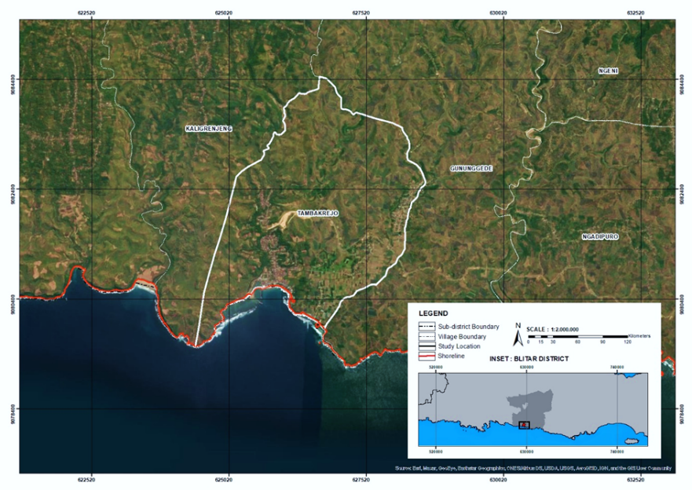

**Fig. 1. Study area**

**2.2 Data Collection**

A mixed-methods approach, combining both qualitative and quantitative techniques, was used to assess tsunami risk and community preparedness. In Tambakrejo Village, home to 5,839 residents, 100 households were selected through incidental random sampling, in accordance with the LIPI-UNESCO/ISDR 2006 community preparedness assessment framework (Suwaryo et al., 2021). This method ensures spatial representation while remaining feasible within research constraints (Rakuasa, 2023). Semi-structured interviews were conducted with key stakeholders, including representatives from NGOs, emergency response teams, local government, and community leaders involved in disaster management (Ningtyas et al., 2022). Participants were selected based on their roles in risk management, particularly from Community Disaster Response Teams and the Blitar Regency’s BPBD (Adiyoso & Kanegae, 2014). The interviews focused on preparedness measures, early warning systems, past tsunami experiences, evacuation protocols, and existing challenges (Ghaffarian et al., 2019).

Community members participated in focus group discussions (FGDs) to explore their preparedness levels, perceptions of tsunami risks, and responses to early warnings (Mawarni et al., 2020). These participants, including fishermen, farmers, and small business owners from high-risk coastal areas, discussed how socio-economic backgrounds and geographic settings influence their ability to respond to tsunamis (Zhou et al., 2019; Kamal, 2023). Household surveys were conducted with heads of households or family members aged 15 and above (Syamsidik et al., 2020). The surveys addressed tsunami hazard potential and village preparedness, focusing on household preparedness, risk perception, knowledge of evacuation procedures, access to early warning systems, and prior tsunami experiences (Utariningsih, 2023). Additionally, direct field observations were made in Tambakrejo Village to assess the physical infrastructure. Secondary data was also gathered through document reviews from various institutional sources, ensuring a comprehensive and reliable approach to understanding tsunami preparedness in the area.

**Table 1. Research Variables**

|  |  |  |  |
| --- | --- | --- | --- |
| **Variables:** Tsunami Inundation Area | | | |
| **Sub Variables** | **Parameters** | **Source** |
|  | Inundated land area | * BNPB (2018) * (Zaitunah, et al., 2012 * (Zaitunah, et al., 2011) |
| **Variables:** community preparedness | | | |
| **Sub Variables** | **Parameters** | **Source** |
| Knowledge and behaviour | Disaster knowledge | * (LIPI-UNESCO/ISDR, 2006) * (Triyono, et al., 2014) * (UNESCO; Indonesian Society for Disaster Management, 2007) * (Hidayati, et al., 2020) * (Sutrisno, H., & Priyono, K. D., 2013) |
| Environmental vulnerability |
| Vulnerability of structures |
| Concern for disaster risk |
| Emergency response plan | Disaster management |
| Evacuation plan |
| Command post and procedures |
| First aid, safety, and security plans |
| Basic necessities and casualty info |
| Evacuation supplies and facilities |
| Drills and simulations |
| system for disaster warning | Conventional systems |
| Tech-based warning systems |
| Warning signs and info |
| Simulation exercises |
| mobilization of resources | Command structure |
| Human resources |
| Technical assistance and resources |
| Fundraising |
| Stakeholder communication |
| Readiness monitoring |

**2.3 Data Analysis**

A combination of quantitative methodologies, such as scoring methods to evaluate tsunami readiness levels and spatial analysis with Geographic Information Systems (GIS), are used to examine the gathered data (Widiyantoro et al., 2020). GIS is employed to model the potential tsunami inundation areas in Tambakrejo Village based on predetermined wave height scenarios (Noor et al., 2022). The inundation modeling involves creating a surface representing the tsunami wave height and intersecting it with the digital elevation model to identify areas that would be submerged. The resulting inundation map is then overlaid with settlement and administrative boundary data to calculate the extent of affected areas and estimate the exposed population (Wang et al., 2022).

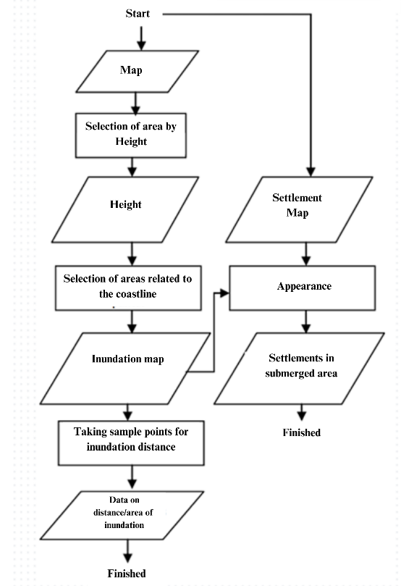

**Fig. 2. Tsunami inundation range determination method**

A grading method derived from the LIPI-UNESCO/ISDR (2006) framework is used to evaluate the degree of community readiness (Suleiman et al., 2020). Knowledge and Behavior (KB), Emergency Planning (EP), Warning System (WS), and Resource Mobilization Capacity (RMC) are the four main criteria that are the focus of the evaluation (Valencia et al., 2011). A set of questions makes up each parameter, and each question is given a score of 1. The score is split equally amongst any subquestions that may be included (Afulani et al., 2020). The sum of the scores derived from the field data is used to get the actual score for each attribute. The formula is then used to calculate the preparation index.

$Index=\frac{Total Real Score Parameter }{Maximum Score Parameter} ×100$

The resulting index values, ranging from 0 to 100, are categorized into five levels of preparedness: Not Ready (0-39), Less Ready (40-54), Almost Ready (55-64), Ready (65-79), and Very Ready (80-100) (Sinaga et al., 2011). These categories provide an indication of the community's readiness to face potential tsunami hazards.

**Table 2. Research Variables**

|  |  |  |
| --- | --- | --- |
| **No** | **Index Value** | **Category** |
| 1 | 80 - 100 | Very Ready |
| 2 | 65 -79 | Ready |
| 3 | 55 - 64 | Almost Ready |
| 4 | 40 - 54 | Less Ready |
| 5 | 0 - 39 | Not Ready |

*Source : LIPI-UNESCO ISDR, 2006; BNPB, 2014*

The GIS-based inundation modeling and the preparedness index calculation are integrated to provide a comprehensive assessment of tsunami risk and community preparedness in Tambakrejo Village (Dermadi & Bandung, 2021). The spatial distribution of potential inundation areas, coupled with the preparedness levels of the community, helps identify high-risk zones and prioritize areas for intervention and capacity building (James et al., 2019). The results of this analysis inform the development of targeted recommendations for enhancing community resilience and reducing the potential impacts of a tsunami event (Syamsidik et al., 2019).

3. results and discussion

**3.1 Tsunami Inundation Risk Assessment**

According to Indonesia's National Centre for Earthquake Studies (PusGen), the potential strength of an earthquake originating in the megathrust zone could reach M 8.7. The spatial analysis of tsunami inundation risk in Tambakrejo Village, based on historical tsunami height data on the Indo-Australian and Eurasian subduction plates and BNPB Regulation No. 4/2012, uses a scenario with a maximum tsunami height of 11 meters and an expected arrival time of 25 minutes after the earthquake. The coastal sections of the community could be significantly impacted, according to the inundation modeling.

From the wave height and inundation, a simulation of inundation from the shoreline was made using ArcGIS. Modelling was carried out with an input value of 11 metres run up height in accordance with the worst-case modelling through the BNPB Regulation Number 4 Year 2012. This sea wave height can cause inundation or submergence if the coast is supported by sloping topography (Abe et al., 2020).

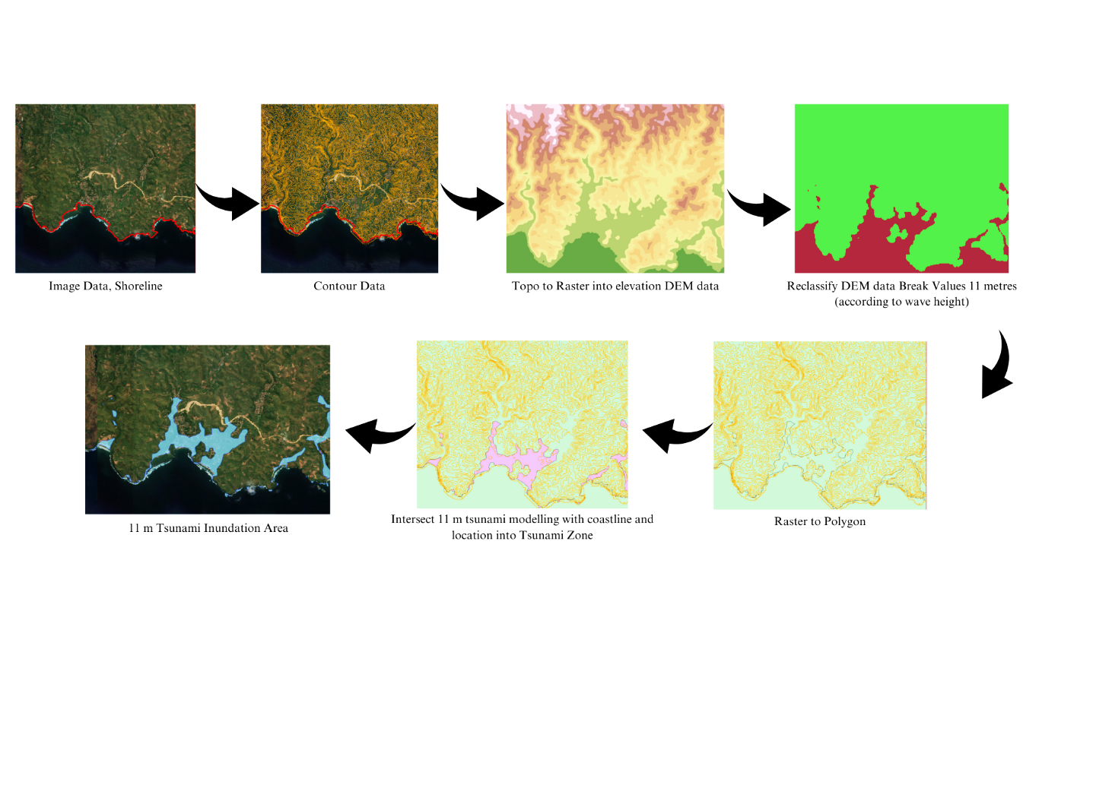

**Fig. 3. Analysis of Tsunami Inundated Area**

Based on the spatial modelling conducted, it is known that the tsunami inundation area is very impactful on the people of Tambakrejo village, presented on the Map. The inundation area extends 1.7289 km2 from the shoreline, encompassing all sub-villages in Tambakrejo, including Krajan and Siderojo. The spatial distribution of tsunami inundation risk demonstrates that the coastal areas of Tambakrejo Village face significant exposure, with particular vulnerability in Krajan Sub-village, which has the highest concentration of population and economic activity.

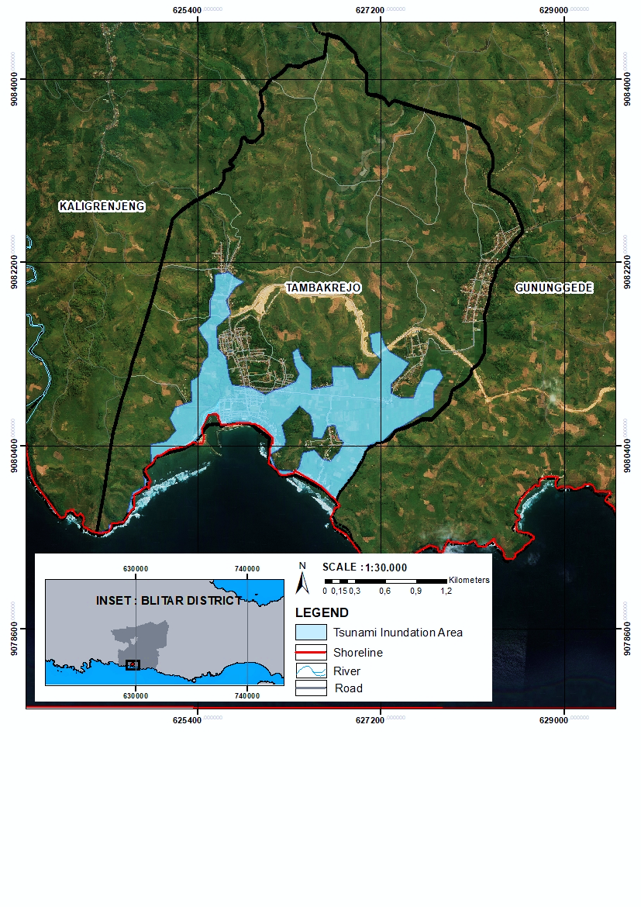

**Fig. 4. Tsunami Inundation Area of Tambakrejo Village**

The inundation analysis reveals that approximately 911 residents, or 15.6% of the total population, would be directly impacted by a major tsunami event. This exposure is particularly significant for residential communities, fishing villages, tourism sector workers, and coastal businesses in low-lying areas. The potential impact extends beyond immediate physical damage and loss of life, with long-term socio-economic consequences for the affected population.

**Table 3. Estimated Extent of Tsunami Affected Areas and Local Communities**

|  |  |  |  |  |  |  |  |  |
| --- | --- | --- | --- | --- | --- | --- | --- | --- |
| **Village** | **Settlement Area** | **Area of Inundated Settlements** | **Total Population** | **Area** | **Inundated area** | **Inundation** | **Percentage of Inundation** | **Estimated Tsunami Inundated Population** |
| **Km²** | **Km²** | **Soul** | **Km²** | **Km²** | **Km²** | **%** | **Soul** |
| Tambakrejo | 1,24477 | 0,29480 | 5.839 | 11,07914 | 1,72893 | 0,15605 | 16% | 911 |

Krajan Sub-village, the most densely populated area, has 1.36568 km2 or 25% of its total area exposed to inundation. This is significantly higher compared to Siderojo Sub-village, which has 0.35439 km2 or 6% of its area at risk. The concentration of residential settlements, vital infrastructure, and economic activities in Krajan Sub-village heightens the potential losses in the event of a tsunami.

**Table 4. Estimated Extent of Tsunami Affected Areas and Local Communities**

|  |  |  |  |  |  |  |
| --- | --- | --- | --- | --- | --- | --- |
|  | **Area** | **Inundated area** | **Percentage of Inundation** | **Settlement Area** | **Area of Inundated Settlements** | **Percentage of Inundated Settlements** |
| **Km²** | **Km²** | **%** | **Km²** | **Km²** | **%** |
| Krajan | 5,39964 | 1,36568 | 25% | 0,789227 | 0,273318 | 35% |
| Siderojo | 5,67958 | 0,35439 | 6% | 0,455543 | 0,021483 | 5% |

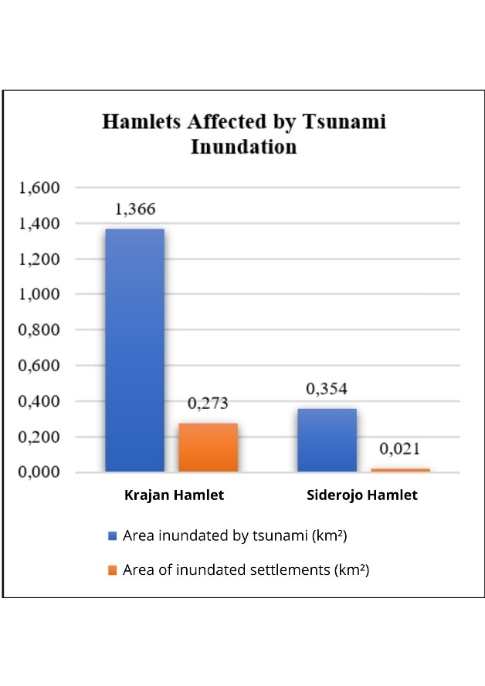

**Fig. 5. Diagram of Affected Hamlets**

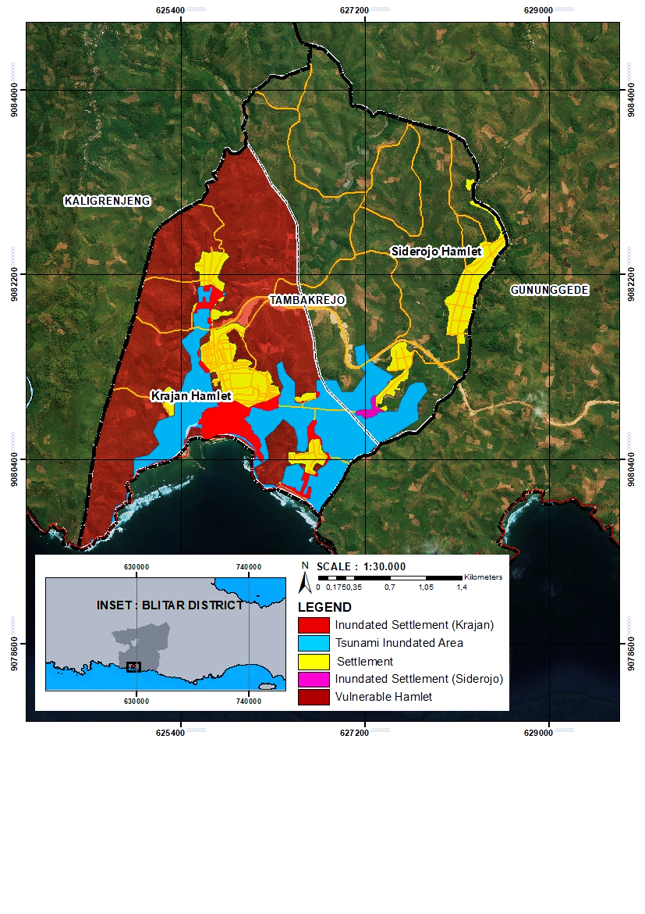

**Fig. 6. Most vulnerable hamlets**

The inundation risk poses a direct threat to the safety and livelihoods of coastal communities. Residential areas in low-lying zones are highly vulnerable, with a substantial portion of the population at risk of displacement and loss of homes. Fishing communities, which form a significant part of the local economy, face severe disruption to their livelihoods due to potential damage to boats, equipment, and coastal infrastructure.

The tourism sector, a key economic driver in Tambakrejo Village, is also highly exposed. Popular tourist sites along the coast, such as Tambakrejo Beach, fall within the inundation zone, putting visitors and tourism-related businesses at risk. The potential loss of tourism revenue and infrastructure could have long-lasting economic repercussions for the village.

Moreover, the inundation risk extends to critical facilities and lifelines. Markets, schools, healthcare facilities, and transportation networks in the coastal areas are vulnerable to damage and disruption. The loss of these essential services could hamper emergency response efforts and prolong the recovery process.

The stark disparity in inundation risk between Krajan and Siderojo Sub-villages highlights the need for targeted interventions and resource allocation. Krajan Sub-village, with its higher exposure and concentration of population and assets, requires prioritized attention in disaster risk reduction efforts. This may include strengthening early warning systems, enhancing evacuation infrastructure, and promoting community-based preparedness initiatives.

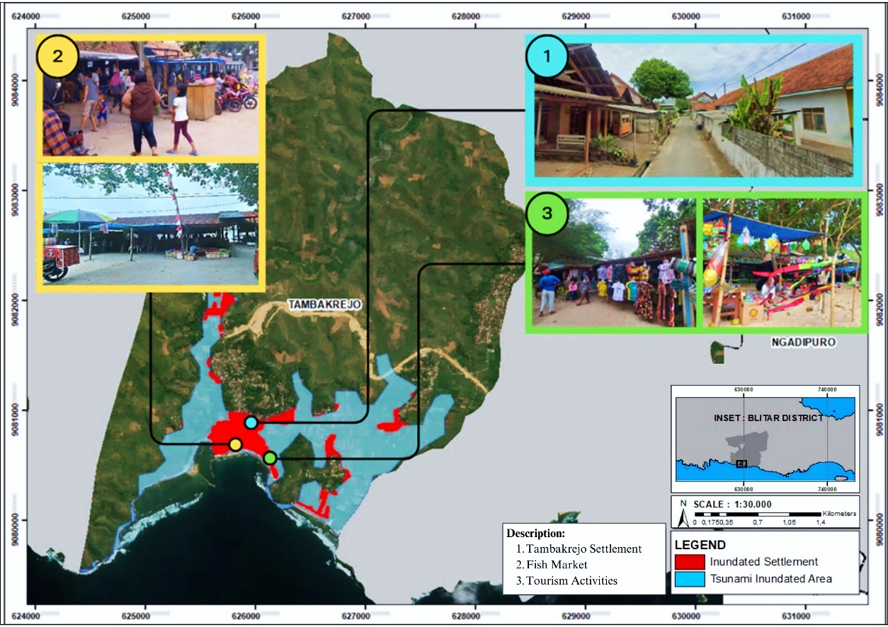

**Fig. 7. Impact of Tsunami Inundation**

The results underscore the urgency of enhancing tsunami preparedness and resilience in Tambakrejo Village. Although the village was spared severe impacts from the 1994 Banyuwangi tsunami, the current inundation risk assessment reveals a far greater potential for devastation. The historical event should not be viewed as a benchmark for complacency but as a stark reminder of the need for proactive disaster risk reduction measures (Nurjanah, 2023). In light of this, it is essential to prepare for scenarios that could lead to more significant consequences, particularly given the village’s population density and proximity to the coast.

Effective disaster risk reduction in Tambakrejo requires a multi-stakeholder approach, involving local authorities, community organizations, and residents. Collaboration is key to developing and implementing comprehensive preparedness strategies. These should include land-use planning to avoid development in high-risk areas, enforcing building codes that promote tsunami-resistant structures, and investing in coastal protection infrastructure (Asteria, 2023). Engaging local authorities, residents, and various community organizations will ensure that these strategies are both practical and widely supported, creating a stronger, unified approach to risk reduction.

Empowering the community through education, awareness-raising, and capacity-building initiatives is equally important. Frequent simulations and drills will enhance community response capacity and familiarize residents with evacuation protocols. Additionally, establishing community-based early warning systems and evacuation plans tailored to vulnerable populations—such as the elderly, children, and people with disabilities—is crucial. Integrating traditional knowledge and local wisdom into disaster preparedness efforts can also foster community ownership and sustainability. Involving local leaders and utilizing existing social networks will improve the effectiveness of risk communication and mobilization efforts.

In conclusion, the spatial analysis of tsunami inundation risk in Tambakrejo Village highlights significant potential for impact, especially in the densely populated coastal areas. The assessment reveals disparities in exposure between sub-villages, with Krajan Sub-village facing the highest risk. The findings emphasize the importance of prioritizing risk reduction efforts in high-exposure areas and implementing targeted interventions that address the specific vulnerabilities of each sub-village. Strengthening early warning systems, enhancing evacuation infrastructure, promoting community-based preparedness, and integrating disaster risk reduction into development planning will help Tambakrejo Village build resilience against future tsunami events. The results of this study provide a foundation for evidence-based decision-making and serve as a catalyst for creating a safer and more resilient coastal community.

**3.1.1 Knowledge and Behaviour (KB)**

The Knowledge and Behaviour parameter assessed the community's understanding of natural disasters, specifically earthquakes and tsunamis, and their awareness of mitigation and preparedness measures. Survey findings revealed that most participants had a basic understanding of natural disasters, recognizing hazards such as earthquakes, tsunamis, floods, and storms. However, there were variations in their understanding of the relationship between earthquakes and tsunamis. While some respondents acknowledged that not every earthquake causes a tsunami, many were unclear on the specific mechanisms that lead to tsunamis, such as underwater earthquakes, volcanic eruptions, and severe storms. This indicates a need for enhanced education on tsunami triggers and warning signs. Respondents also emphasized the importance of structural measures, like resilient multi-story houses with open spaces for water flow, and access to reliable information from sources like television, social events, government officials, and NGOs, underscoring the role of effective risk communication in promoting preparedness.

The analysis showed that, on average, respondents scored 34 out of 50 points in the Knowledge and Behaviour parameter, representing 41% of the target score. This suggests that while the community has a foundational understanding of natural disasters, there are significant gaps in their knowledge of specific tsunami risks, warning signs, and proper response actions. Addressing these gaps through targeted education and awareness campaigns is crucial for improving the community's overall preparedness and enhancing their resilience to tsunami hazards.

**3.1.2 Emergency Planning (EP)**

The Emergency Planning parameter assessed the community's readiness to respond to disasters at both the household and individual levels. Survey results revealed that, on average, respondents were able to identify and implement five out of the eleven key components of a comprehensive family preparedness plan, including identifying safe evacuation locations, establishing communication protocols among family members, preparing emergency kits, and securing important documents and valuables. However, the survey also highlighted a significant gap between knowledge and practical application. Respondents, on average, only took action on two out of four specific preparedness measures: increasing their knowledge of earthquakes and tsunamis, and identifying potential evacuation sites or shelters. When asked about preferred shelter locations during a tsunami, most respondents relied on the homes of relatives, close friends, or nearby buildings considered safe, highlighting the reliance on informal networks. This emphasizes the need for a more systematic approach to designating official evacuation centers that are strategically located and properly equipped to accommodate the community's needs.

The analysis of the Emergency Planning parameter indicated an average score of 10 out of 21 points, representing only 32% of the target score. This low score underscores the need to improve family and individual preparedness plans within the community. The lack of concrete preparedness actions and limited participation in training or simulation exercises are major barriers to effective emergency response. Addressing these gaps through community-based disaster preparedness programs, regular drills, and capacity-building initiatives should be a top priority for local authorities and disaster management agencies to ensure a more resilient and effective disaster response.

**3.1.3 Warning System (WS)**

The Warning System parameter assessed the community's familiarity with and responsiveness to tsunami warning mechanisms. Survey results revealed significant variations in respondents' understanding of tsunami warning signs. While some were aware of the national tsunami warning system, others relied on traditional methods, such as community sirens, loudspeakers, or word-of-mouth communication. The survey also highlighted the diverse range of information sources respondents used for tsunami warnings, including community leaders, local folklore, personal experiences, and official communications from local governments. This heterogeneity underscores the need for a standardized and integrated warning system that can effectively reach all segments of the population.

Regarding actions taken upon receiving a warning, respondents generally recognized the need to evacuate promptly and seek higher ground or safe shelter. On average, respondents identified four out of seven key actions during a tsunami emergency, including moving away from the beach, seeking high elevation or sturdy buildings, bringing emergency kits, and staying calm. However, gaps were found in respondents' knowledge of post-warning protocols, such as confirming the cancellation of a tsunami warning and ensuring community safety afterward. The analysis showed that, on average, respondents scored 12 out of 19 points in the Warning System parameter, representing just 38% of the target score. This highlights the need for improving community awareness and responsiveness to tsunami warnings, with efforts focused on standardizing protocols, expanding dissemination channels, and conducting regular community drills to enhance preparedness.

**3.1.4 Resource Mobilization Capacity (RMC)**

The Resource Mobilization Capacity parameter assessed the community's ability to leverage human, material, and financial resources for disaster preparedness and response. Survey results revealed significant variations in respondents' participation in disaster preparedness training, seminars, and workshops. While some attended capacity-building events, particularly those focused on basic first aid and emergency response, others reported no involvement in any preparedness training. Regarding financial preparedness, most respondents considered personal savings as crucial for coping with the immediate aftermath of a disaster. However, reliance on individual savings highlights the absence of a more systematic approach to financial risk transfer, such as community-based disaster funds or insurance schemes. Strengthening access to diversified financial resources and risk-sharing mechanisms is vital for building long-term resilience.

The survey also explored respondents' perceptions of social support networks and their role in disaster preparedness. Mixed opinions were reported, with some expressing confidence in support from relatives and friends, while others were uncertain about such availability. This underscores the importance of fostering strong social capital and promoting collective action during disasters. Regarding specific preparedness measures at the individual and household levels, the survey revealed a lack of concrete actions. While some respondents had designated safe locations for valuable assets, the majority had not yet implemented comprehensive preparedness plans. This gap between awareness and action emphasizes the need for targeted interventions to translate knowledge into tangible preparedness measures. The analysis showed that respondents averaged only 6 out of 14 points in the Resource Mobilization Capacity parameter, representing just 31% of the target score. This finding highlights the urgent need to strengthen the community’s ability to mobilize and manage resources effectively for disaster preparedness and response.

|  |  |
| --- | --- |
|  |  |
|  |  |

**Fig. 8. The results of each parameter in understanding community preparedness**

**3.1.5 Preparedness Index Value and Implications**

By adding up the scores for each of the four criteria and dividing the sum by the highest possible score, the overall preparedness index value for the Tambakrejo Village community was determined. The resulting index value of 60,12 places the community in the "Almost Ready" category according to the classification scheme proposed by LIPI-UNESCO/ISDR (2006). This classification scheme defines five levels of preparedness, ranging from "Not Ready" (index value of 0-39) to "Very Ready" (index value of 80-100).

* Total real score of community preparedness = 6253
* Total maximum parameter score = 10400

Thus, the results of the index calculation are as follows:

I $ndex=\frac{Total Real Score Parameter }{Maximum Score Parameter} ×100$

$$\text{Index}=\frac{6253}{10400}×100$$

$$\text{Index}=60,125$$

$$\text{Index}≈60$$

The ‘Almost Ready’ categorisation for Tambakrejo Village is sufficient progress, but the gaps and challenges faced by the community in terms of its overall preparedness for potential tsunami hazards remain to be addressed and improved. In order to improve community knowledge, skills, and resources for efficient disaster risk mitigation and emergency response, this finding emphasizes the ongoing need for focused interventions and capacity development initiatives.

**Table 5. Estimated Extent of Tsunami Affected Areas and Local Communities**

|  |  |  |
| --- | --- | --- |
| **No** | **Index Value** | **Category** |
| 1 | 80 - 100 | Very Ready |
| 2 | 65 -79 | Ready |
| 3 | 55 - 64 | Almost Ready |
| 4 | 40 - 54 | Less Ready |
| 5 | 0 - 39 | Not Ready |

The results of this assessment provide valuable insights for local authorities, disaster management agencies, and community-based organizations to prioritize and design appropriate strategies for strengthening community preparedness. These strategies should focus on addressing the identified gaps in knowledge, emergency planning, warning systems, and resource mobilization capacity through a combination of structural and non-structural measures (Herowati, 2022).

At the structural level, efforts should be directed towards improving the physical infrastructure for disaster preparedness, such as constructing and maintaining designated evacuation centers, ensuring the accessibility and safety of evacuation routes, and strengthening early warning systems. Non-structural measures, on the other hand, should focus on enhancing the community's human and social capital through targeted education and awareness-raising programs, regular training and simulation exercises, and the promotion of community-based disaster risk management approaches (Husna et al., 2021).

Furthermore, the findings of this assessment highlight the importance of adopting a participatory and inclusive approach to community preparedness. Engaging local stakeholders, including community leaders, women's groups, youth organizations, and marginalized populations, in the planning and implementation of preparedness initiatives is crucial for ensuring the relevance, ownership, and sustainability of these efforts (Sujarwo et al., 2018).

In summary, Tambakrejo Village's community preparation assessment offers a thorough and fact-based understanding of the existing level of readiness for possible tsunami threats. All four of the major readiness parameters—knowledge and behavior, emergency planning, warning systems, and resource mobilization capacity—need to be improved, even though the community preparedness outcome is "Almost Ready." By addressing these gaps through targeted interventions and capacity-building efforts, the community can enhance its resilience and reduce its vulnerability to the devastating impacts of tsunamis. The insights generated from this assessment serve as a valuable foundation for informing policy, planning, and programming decisions aimed at strengthening community-based disaster risk reduction in Tambakrejo Village and beyond.

4. Conclusion

The spatial analysis of tsunami inundation risk in Tambakrejo Village, based on a potential wave height of 11 meters, reveals a significant threat to the community. The inundation modeling indicates that an area of 1.7289 km², representing 16% of the total village area, is highly susceptible to flooding in the event of a major tsunami. This exposure is particularly concerning given that the inundation zone encompasses densely populated residential areas, putting an estimated 911 people at direct risk of being affected by the tsunami. Enhancing tsunami preparedness and risk reduction measures in the village is critically needed, as evidenced by the possible loss of life, destruction of infrastructure, and disruption of livelihoods.

The assessment of community preparedness in Tambakrejo Village, guided by the LIPI-UNESCO/ISDR (2006) framework, reveals an "Almost Ready" status with a preparedness index of 60.12, indicating considerable room for improvement. The analysis identifies resource mobilization as the most critical weakness, with communities struggling to effectively organize human, financial, and material resources for disaster preparedness. Additionally, community behaviour and risk perception present significant challenges, as many residents view tsunamis through a fatalistic lens, potentially undermining proactive preparedness efforts.

To sum up, the results of this study make a strong case for Tambakrejo's tsunami risk reduction and preparedness initiatives to be given top priority. Village. The significant potential for tsunami inundation, coupled with the suboptimal level of community preparedness and the spatial vulnerability of Krajan Sub-village, calls for immediate action from local authorities, disaster management agencies, and community stakeholders. Strengthening early warning systems, enhancing evacuation infrastructure, promoting community-based preparedness initiatives, and addressing the underlying attitudinal and resource mobilization barriers should form the core of a comprehensive strategy for building tsunami resilience in Tambakrejo Village. The community may greatly lessen its vulnerability and improve its ability to endure and recover from the terrible consequences of a possible tsunami occurrence by proactively addressing these issues and investing in evidence-based risk mitigation strategies.

References

Abe, T., Goto, K., & Sugawara, D. (2020). Spatial distribution and sources of tsunami deposits in a narrow valley setting - insight from 2011 tohoku-oki tsunami deposits in northeastern japan. Progress in Earth and Planetary Science, 7(1). https://doi.org/10.1186/s40645-019-0318-6

Adiyoso, W. and Kanegae, H. (2014). The role of islamic teachings in encouraging people to take tsunami preparedness in aceh and yogyakarta indonesia., 259-278. https://doi.org/10.1007/978-4-431-55117-1_18

Afulani, P., Gyamerah, A., Aborigo, R., Nutor, J., Malechi, H., Laar, A., & Awoonor-Williams, J. (2020). Perceived preparedness to respond to the covid-19 pandemic: a study with healthcare workers in ghana. https://doi.org/10.1101/2020.07.10.20151142

Arifin, S., Wicaksono, S. S., Sumarto, S., Martitah, M., & Sulistianingsih, D. (2021). Disaster resilient village-based approach to disaster risk reduction policy in Indonesia: A regulatory analysis. Jamba: Journal of Disaster Risk Studies, 13(1), 1–9. https://doi.org/10.4102/JAMBA.V13I1.1021

Asteria, D. (2023). Integration of local capacity building in countering false information about disaster into community-based disaster risk management. IOP Conference Series Earth and Environmental Science, 1275(1), 012028. https://doi.org/10.1088/1755-1315/1275/1/012028

Benardi, A. I., Sumarmi, Budijanto, Bachri, S., Rahman, A.-U., & Wulandari, F. (2023). Disaster Preparedness in Proximity of Merapi Volcano, Indonesia: Is There Any Relationship in Knowledge and Attitude of Senior High School Students? International Journal of Safety and Security Engineering, 13(2), 245–254. https://doi.org/10.18280/ijsse.130207

BMKG [Meteorology, Climatology and Geophysics Agency]. (2023). Latest Earthquake Data. Jakarta: BMKG. Retrieved November 22, 2023, from https://www.bmkg.go.id/gempabumiterkini.html

BNPB [National Disaster Management Agency]. (2012). Head of BNPB Regulation No. 4 Year 2012 on Guidelines for Implementation of Disaster Safe Schools/Madrasah. Jakarta: BNPB.

BNPB [National Disaster Management Agency]. (2019). Indonesia Disaster Information Data. Jakarta: BNPB.

BPBD Blitar Regency [Regional Disaster Management Agency]. (2022). Disaster Risk Assessment Document of Blitar Regency 2022-2026. Blitar: BPBD Blitar Regency.

BPS Blitar Regency [Statistics Indonesia]. (2022). Wonotirto District in Figures 2022. Blitar: BPS Blitar Regency.

Dermadi, Y. and Bandung, Y. (2021). Tsunami impact prediction system based on tsunawi inundation data. Journal of ICT Research and Applications, 15(1), 21-40. https://doi.org/10.5614/itbj.ict.res.appl.2021.15.1.2

Gainey, C. E., Brown, H. A., & Gerard, W. C. (2018). Utilization of Mobile Integrated Health Providers During a Flood Disaster in South Carolina (USA). Prehospital and Disaster Medicine, 33(4), 432–435. https://doi.org/10.1017/S1049023X18000572

Ghaffarian, S., Kerle, N., Pasolli, E., & Arsanjani, J. (2019). Post-disaster building database updating using automated deep learning: an integration of pre-disaster openstreetmap and multi-temporal satellite data. Remote Sensing, 11(20), 2427. https://doi.org/10.3390/rs11202427

Hadi, S. M., Hastono, S. P., Siregar, K. N., & Ayuningtyas, D. (2020). Geospatial-Based Information Systems Model for Disaster Management of Reproductive Health. Media Kesehatan Masyarakat Indonesia, 16(1), 62–75. https://doi.org/10.30597/mkmi.v16i1.8780

Herowati, D. (2022). Augmented reality-based media to improve disaster preparedness for junior high school students. https://doi.org/10.2991/assehr.k.220129.030

Hidayati, D., Widayatun, H. P., & Triyono, K. T. (2020). Guide to measuring community and school community preparedness levels. LIPI-UNESCO/ISDR.

Husna, C., Firdaus, R., Wardani, E., & Jannah, S. (2021). Disaster preparedness among disaster management agency officers: a study from rural and urban areas in aceh, indonesia. International Journal of Disaster Resilience in the Built Environment, 13(4), 484-497. https://doi.org/10.1108/ijdrbe-02-2021-0015

James, L., Welton‐Mitchell, C., Noel, J., & James, A. (2019). Integrating mental health and disaster preparedness in intervention: a randomized controlled trial with earthquake and flood-affected communities in haiti. Psychological Medicine, 50(2), 342-352. https://doi.org/10.1017/s0033291719000163

Kamal, M. (2023). Preparedness of tsunami 2004 affected school: a case study of senior high school in aceh province, indonesia. E3S Web of Conferences, 464, 14001. https://doi.org/10.1051/e3sconf/202346414001

Kim, M., You, S., Chon, J., & Lee, J. (2017). Sustainable land-use planning to improve the coastal resilience of the social-ecological landscape. Sustainability, 9(7), 1–21. https://doi.org/10.3390/su9071086

Mawarni, I., Suyadi, T., Pamungkas, S., & Mutiawati, V. (2020). The effect of earthquakes and tsunamis preparedness on anxiety levels: a case study of alue naga village, banda aceh. International Journal of Disaster Management, 3(2), 48-57. https://doi.org/10.24815/ijdm.v3i2.18720

Mayaguezz, H., Plumejeaud-Perreau, C., Leone, F., & Pouget, F. (2017). Spatio-Temporal Modeling of Human Vulnerability in the Case of a Tsunami in Padang, Indonesia. International Journal of Mass Emergencies & Disasters, 35(3), 224–270. https://doi.org/10.1177/028072701703500306

Mohamadi, B., Chen, S., & Liu, J. (2019). Evacuation priority method in tsunami hazard based on DMSP/OLS population mapping in the Pearl River estuary, China. ISPRS International Journal of Geo-Information, 8(3), 1–15. https://doi.org/10.3390/ijgi8030137

Nasir, N. S., Abdul Khanan, M. F., Othman, S. H., Abdul Rahman, M. Z., Razak, K. A., Mohd Salleh, M. R., Umar, H. A., & Abdul Razak, A. N. (2018). Assimilating geospatial metamodel and inventory mapping for non-structural mitigation of landslide. International Archives of the Photogrammetry, Remote Sensing and Spatial Information Sciences - ISPRS Archives, 42(4/W9), 217–228. https://doi.org/10.5194/isprs-archives-XLII-4-W9-217-2018

Ningtyas, N., Satyarno, I., & Triatmadja, R. (2022). Preparedness of tsunami disaster in pandeglang region due to the activity of mount krakatau. Inersia: Informasi dan Ekspose Hasil Riset Teknik Sipil dan Arsitektur, 18(2), 141-156. https://doi.org/10.21831/inersia.v18i2.54054

Noor, M., Shahar, H., Baharudin, M., Ismail, S., Manaf, R., Said, S., & Muthiah, S. (2022). Facing flood disaster: a cluster randomized trial assessing communities' knowledge, skills and preparedness utilizing a health model intervention. PLOS ONE, 17(11), e0271258. https://doi.org/10.1371/journal.pone.0271258

Nurjanah, A. (2023). The role of stakeholders as disaster communicators at disaster-prone tourist attraction objects. Komunikator, 15(2), 247-258. https://doi.org/10.18196/jkm.20158

Paulik, R., Craig, H., & Popovich, B. (2020). A national-scale assessment of population and built-environment exposure in Tsunami evacuation zones. Geosciences, 10(8), 1–15. https://doi.org/10.3390/geosciences10080291

Rahayu, H. P., Comfort, L. K., Haigh, R., Amaratunga, D., & Khoirunnisa, D. (2020). A study of people-centered early warning system in the face of near-field tsunami risk for Indonesian coastal cities. International Journal of Disaster Resilience in the Built Environment, 11(2), 241–262. https://doi.org/10.1108/IJDRBE-10-2019-0068

Rakuasa, H. (2023). Modeling of tsunami prone areas in kairatu barat district, seram bangian barat regency. International Journal of Multidisciplinary Approach Research and Science, 2(01), 1-9. https://doi.org/10.59653/ijmars.v2i01.287

Re, C. Lo, Manno, G., Basile, M., Ferrotto, M. F., Cavaleri, L., & Ciraolo, G. (2022). Tsunami Vulnerability Evaluation for a Small Ancient Village on Eastern Sicily Coast. Journal of Marine Science and Engineering, 10(2). https://doi.org/10.3390/jmse10020268

Rudianto, Bintoro, G., Guntur, Swatama, D., Paizar, A. R., Jeremy, L. K., Oktasyah, L., & Purba, C. A. (2023). Coastal Management Strategies To Face Climate Change and Antrophogenic Activity: a Case Study of Tamban Beach, Malang Regency, East Java. Jurnal Ilmu dan Teknologi Kelautan Tropis, 15(1), 65–84. https://doi.org/10.29244/jitkt.v15i1.43125

Sambah, A. B., Miura, F., Febriana, A. F., Science, M., Resources, M., & Author, C. (2019). Geospatial Model of Physical and Social. International Journal of GEOMATE, 17(63), 29–34. https://doi.org/10.21660/2019.63.4684

Sinaga, T., Nugroho, A., Lee, Y., & Suh, Y. (2011). GIS mapping of tsunami vulnerability: case study of the jembrana regency in bali, indonesia. KSCE Journal of Civil Engineering, 15(3), 537-543. https://doi.org/10.1007/s12205-011-0741-8

Suleiman, A., Bsisu, I., Guzu, H., Santarisi, A., Alsatari, M., Abbad, A., & Almustafa, M. (2020). Preparedness of frontline doctors in jordan healthcare facilities to covid-19 outbreak. International Journal of Environmental Research and Public Health, 17(9), 3181. https://doi.org/10.3390/ijerph1709318

Sunarto, S., Nugroho, H. S. W., & Suparji, S. (2024). Increasing Awareness of the Village Disaster Risk Reduction Forum in Magetan Regency in Realizing Disaster Preparedness. Health Dynamics, 1(2), 45–52. https://doi.org/10.33846/hd10204

Sutrisno, H., & Priyono, K. D. (2013). Analysis of physical vulnerability in tsunami-prone areas using geographic information systems. Forum Geografi, 27(2), 147-158.

Suwaryo, P. A. W., Rahma, D. G., Waladani, B., & Safaroni, A. (2021). Community Preparedness to Reduce Risk Disaster of Tsunami. Babali Nursing Research, 2(1), 40–48. https://doi.org/10.37363/bnr.2021.2146

Syamsidik, S., Luthfi, M., Suppasri, A., & Comfort, L. (2020). The 22 december 2018 mount anak krakatau volcanogenic tsunami on sunda strait coasts, indonesia: tsunami and damage characteristics. Natural Hazards and Earth System Sciences, 20(2), 549-565. https://doi.org/10.5194/nhess-20-549-2020

Syamsidik, S., Suppasri, A., Al'ala, M., Luthfi, M., & Comfort, L. (2019). Assessing the tsunami mitigation effectiveness of the planned banda aceh outer ring road (BORR), indonesia. Natural Hazards and Earth System Sciences, 19(1), 299-312. https://doi.org/10.5194/nhess-19-299-2019

Tariq, M., Shahar, H., Baharudin, M., Ismail, S., Manaf, R., Si, S., & Muthiah, S. (2021). A cluster-randomized trial study on effectiveness of health education based intervention (HEBI) in improving flood disaster preparedness among community in selangor, malaysia: a study protocol. BMC Public Health, 21(1). https://doi.org/10.1186/s12889-021-11719-3

Triyono, K., Nina, A., Titik, K., & Novi, H. (2014). Community-Based Guidelines for Earthquake and Tsunami Preparedness. National Disaster Management Agency (BNPB).

UNESCO & Indonesian Society for Disaster Management. (2007). Study of community preparedness in anticipating earthquake and tsunami disasters in South Nias. MPBI-UNESCO.

Usman, F., Chalim, S., Usman, F., Fathoni, M., Rozikin, M., Saputra, H., & Murakami, K. (2024). Assessing coastal population capacity in Tsunami-prone areas: A grid-based approach. Jamba: Journal of Disaster Risk Studies, 16(1). https://doi.org/10.4102/JAMBA.V16I1.1685

Usman, F., Kurniawan, E. B., Fathoni, M., & Rozikin, M. (2024). Tsunami Disaster Preparedness in Tambakrejo Village, Sumbermanjing Wetan Distric, Malang, Indonesia. Evergreen, 11(2), 1182–1189. https://doi.org/10.5109/7183421

Utariningsih, W. (2023). Mitigation and community preparedness in anticipating tsunami disasters in muara batu, aceh. Jàmbá Journal of Disaster Risk Studies, 15(1). https://doi.org/10.4102/jamba.v15i1.1542

Valachamy, M., Sahibuddin, S., Ahmad, N. A., & Bakar, N. A. A. (2022). Critical success factors for geospatial data sharing in disaster management. IOP Conference Series: Earth and Environmental Science, 1064(1), 0–10. https://doi.org/10.1088/1755-1315/1064/1/012038

Valencia, N., Gardi, A., Gauraz, A., Leone, F., & Guillande, R. (2011). New tsunami damage functions developed in the framework of schema project: application to european-mediterranean coasts. Natural Hazards and Earth System Sciences, 11(10), 2835-2846. https://doi.org/10.5194/nhess-11-2835-2011

Wang, Y., Liu, Y., YU, M., Wang, H., Peng, C., Zhang, P., & LI, C. (2022). Disaster preparedness among nurses in china: a cross-sectional study. Journal of Nursing Research, 31(1), e255. https://doi.org/10.1097/jnr.0000000000000537

Widiyantoro, S., Gunawan, E., Muhari, A., Rawlinson, N., Mori, J., Hanifa, N., & Putra, H. (2020). Implications for megathrust earthquakes and tsunamis from seismic gaps south of java indonesia. Scientific Reports, 10(1). https://doi.org/10.1038/s41598-020-72142-z

Zaitunah, A., Kusmana, C., Jaya, I. N., & Haridjaja, O. (2011). Application of Geographic Information Systems for Determining Possible Inundation Areas Due to Tsunami (Case Study: Ciamis Regency, West Java). Forum Pascasarjana, 34(4), 249-255.

Zaitunah, A., Kusmana, C., Jaya, I. N., & Haridjaja, O. (2012). Study of potential inundation areas due to tsunami in Ciamis Beach, West Java. Foresta, 1(1), 1-6.

Zhou, Z., Chen, J., Du, P., Sun, Z., Wu, H., & Yuan, H. (2019). Application of Incident Chain Model and Targeted Dissemination Technology in Early Warning System. World Journal of Engineering and Technology, 07(02), 91–96. https://doi.org/10.4236/wjet.2019.72b011