Statistical Model of Generating Electricity Using Municipal Solid Waste (MSW)

Abstract
Electricity generated from municipal solid waste is renewable since this source is inexhaustible. Waste is well managed by this process as it frees landfill sites of garbage. Combustion or incineration, gasification and pyrolysis are three principal waste-to-energy methods that may be employed to convert garbage into electricity, however this paper is limited to the analysis of incineration process. This process is effected at a very high temperature and ended up with a resourceful by-product for the construction industry. This study was done by selecting ten most municipal solid waste (MSW) generating countries from each of the four continents (America, Europe, Asia, and Africa) in the world. This waste was aggregated into recyclable, landfilled and power produced clusters. Mathematical models were deployed to estimate electricity generated from the landfilled piles of each continent. The researchers also approximated the quantity of carbon dioxide that would have been emitted into the environment if fossil fuels (coal, crude oil and natural gas) were used to produce the total electricity from the four continents.

Key Words: Electricity, Municipal Solid Waste, Incineration, Waste-to-Energy, Recyclable, Landfilled, Carbon Dioxide

- INTRODUCTION
Waste-to-Energy (WtE) also known as Energy-from-Waste (EfW) is the process of converting municipal solid waste (garbage) and industrial solid waste (wood processing and agriculture processing wastes) into electricity, fuels or heat (Young, 2010). Generating electricity from waste-to-energy is a sustainable way of managing waste. There are other benefits that one can derive from burning the waste in incinerator to produce electricity. The ashes that are left over after combustion of the waste is known as bottom ash; this bottom ash contains recyclable metals and clinker (Aneeta et al, 2018). The metals can be used to produce metal products such as iron rods and binding wires; the clinker can be used in road construction.

It is believed that, two-third of all domestic waste can be classified as biomass, it means that, this volume of waste can be sent to waste-to-energy plant for processing. Combustion of Municipal Solid Waste (MSW) reduces the amount of garbage by about 87 percent (US-EIA, 2019). It should be noted that, only a small percentage of MSW ends up in the waste-to-energy processing plant. The rest are either sent to the landfill sites, burnt into the open air or end up in drains or gutters. Only few of such plants are available in Africa (Torben, 2018). Waste-to-energy can help eliminate or reduce reliance on fossil fuels for electricity generation; it can ultimately lessen CO₂ (carbon dioxide) emission into the atmosphere.

The United Nations Environmental Programme stated that, municipal solid waste generated by the world in 2023 was 2.1 billion tons (5.5 million tons per day); it is predicted that, this will increase to 3.8 billion tons per annum by the year 2050 (UNEP, 2024). The same Agency specified that, in 2020 the cost of waste management in the world was 252 billion USD. When pollution, poor health and climate change from poor waste disposal are factored into the cost, the expenditure would rise to 362 billion USD. Without urgent remedial action, the global waste management expenditure will reach 640.3 billion USD by 2050. Breaking down this waste generation into continental bases, the American continent produced approximately 600 million metric tons of municipal solid waste in 2023. In the same year, the European continent generated about 400 million metric tonnes; the Asian continent produced approximately 920 million metric tonnes. The African and Oceanic continents generated about 250 and 33 million metric tonnes respectively. Waste produced by urban population will increase three folds what is generated today by 2100; by the same year it is estimated that the global solid waste generation will exceed 11 million metric tonnes per day (Hoornweg et al, 2013). The volume of this waste so generated will pose a serious challenge to cities all over the world.

1.1 Management of Waste
Human as we are will generate waste and continue to generate waste; waste from the kitchens, waste from the industries, waste from the offices and waste from the farms. As much as possible, one has to learn how to prevent waste generation; this is the surest way to save scarce resources and protect the environment from unnecessary garbage. It is incomprehensible not to generate waste at all, therefore it is imperative to minimize generation of waste. If waste is generated, efforts should be made as much as possible to reuse some of the materials constituting the waste. If it becomes impossible to reuse these waste materials then recycling should be considered. It is unfashionable in some parts of the world (Sweden and Denmark) to send recyclable waste to the landfill sites. In Sweden over 99 percent of their Municipal Solid Waste is recycled, 50.3 percent of all domestic waste is sent to the waste-to-energy processing plants for recovery of energy (Amy, 2018). In the case of Denmark, in its capital city, Copenhagen, only 3 percent of garbage is sent to the landfill sites, 54 percent to the Waste-to-energy processing plants.

Energy recovery should be considered first before final disposal, this is consistent with modern integrated waste management practice as illustrated in the waste management hierarchy model in figure 1. In our view, waste is better managed if the biodegradable part of the waste is reduced to zero; the unrecyclable to produce electricity, by so doing, the amount that goes to the landfill sites become insignificant.
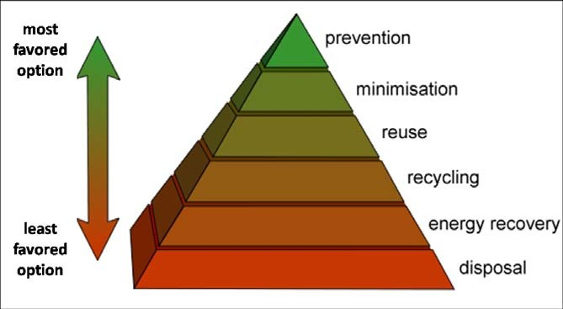
Fig 1: Waste Management Hierarchy Model
In this era of shortage of landfills for solid waste disposal in some parts of the world, using waste-to-energy plants to reduce the volume of garbage cannot be over emphasized. Figure 2 illustrates how waste-to-energy plants can be used to recover useful energy from garbage and the volume of the remaining waste that goes to the final disposal site in a form of ash. In this particular example, 1000 cubic metre (m³) of waste was combusted, a 17,000 kWh electricity was generated and only 10 cubic metre (m³) of residue, 90 percent reduction was left for the landfill. This demonstrates the enormous benefits that the world, especially Africa can derive from integration management of waste.
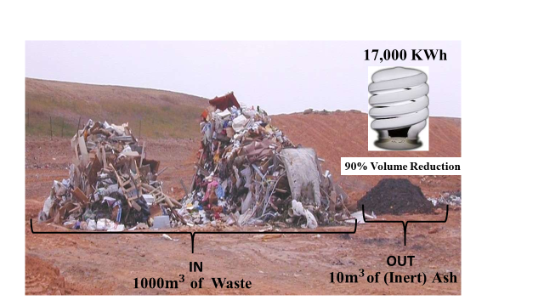
Fig.2: Landfills Management

1.2 Types of Waste-to-Energy Plants for Municipal Solid Waste (MSW)
There are so many waste-to-energy technologies or plants that can be used to process Municipal Solid Waste (MSW); the most common include:
- Incineration
- Gasification
- Pyrolysis

1.2.1 Incineration method of Waste-to-Energy (WtE) Plant
Incineration plant is waste management facility where waste is combusted in a controlled manner to generate electricity and reduce the volume of waste (Nabavi et al, 2017). The incineration method also known as combustion method of WtE plant is broadly divided into two categories; these are: the mass burning of “as received” and inhomogeneous waste and the burning of pretreated and homogenized waste (World Bank, 1999) There is little (post-recycling) or no pre-treatment (raw) of waste required in mass burning of “as received” and inhomogeneous waste. Typical example of mass burning system is the Movable Grate Incineration system. This system is widely used; it is a tried and tested technology and has good technical performance. It is used for large scale waste at various calorific values and composition. Fluidized bed incineration system is an example of burning pretreated and homogenized waste. In this system, the waste that goes into the incinerator is first reduced in size by shredding and manual sorting. The usage of this technology is limited as compared to moving grate system. The movable Grate waste-to-energy plant is generally divided into four sections as shown in figure 3; the waste delivery section, the incineration section, the energy recovery (electricity) section and flue gas cleaning section.

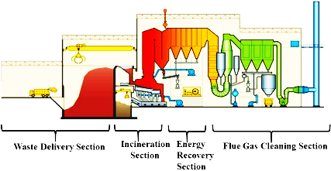

Fig. 3: Moving Grate WtE Plant Sections

The main components of the waste delivery section are the discharge hall, the waste bunker and the crane; those of the incineration section are the steam boiler, incineration grate and the bottom ash bunker. The major components of the energy recovery section are the steam turbine and the generator whereas those of the flue gas cleaning section are the flue gas reactor, emission monitoring system, residue silo (flying ash) and the hydrated lime. The major parts of the plant are illustrated in figure 4.

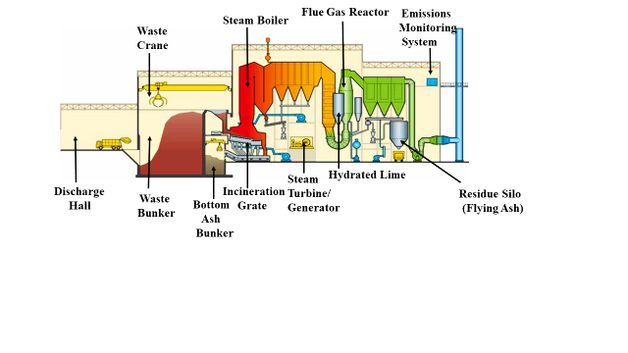

Fig. 4: Major Parts of Movable Grate Incinerator

The garbage that are burnt in movable grate incinerator are: Municipal Solid Waste (MSW), Commercial and Industrial Waste (C&IW) and Refuse Derived Fuel (RDF) or Solid Recovered Fuel (SRF) (Dieter, 2017). In the grate incinerator, the waste is conveyed to the combustion chamber by a hydraulic ram or a travelling grate through a feeding chute. The garbage otherwise known as the fuel is arranged in a form of a bed on top of a grate and combustion air is circulated through the grate. The primary combustion air is injected from below the grate while the secondary above the grate. Figure 5 shows grate elements with holes, from where the primary combustion air is supplied. The flow of the primary air among other things cools the grate itself; the secondary air helps in burning completely the flue gases. The admissible temperature in the combustion chamber to burn the waste is 850 to 1,200 degree Celsius (Seeker, 1991). The function of the grate is to control the transportation of the waste in the combustion chamber. The design of the grate is such that the waste in the combustion chamber is completely burnt before the ash is discharged from the furnace. There are four major kinds of grate; these are the forward reciprocating grate, the reverse reciprocating grate, the roller grate and the horizontal grate.
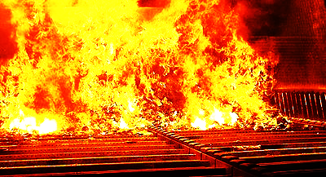

Fig. 5: Moving Grate Incinerator with Holes in Grate Elements

For fluidized bed incineration system, pretreatment (sorting, chipping and shredding) of the garbage is a necessity. Pretreatment of waste is essential in this type of incineration because the waste fuel needs to be in a uniform size and calorific value (Van et al, 2012). The fluidized bed has four processes as illustrate in figure 6. The types of garbage that can be incinerated by fluidized bed method are Municipal Solid Waste (MSW), Commercial and Industrial Waste (C&IW) and Refuse
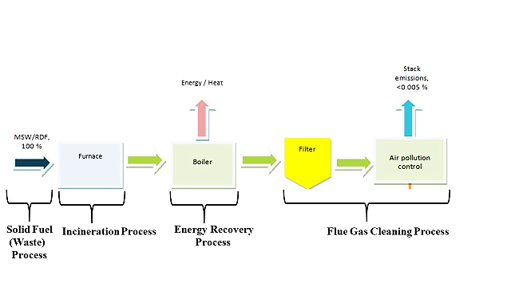

Fig. 6: Fluidized Bed WtE Plant Process

Derived Fuel (RDF) or Solid Recovered Fuel (SRF). RDF is a left over refuse after non-combustible materials such as metal and glass have been removed from the garbage. The fluidized bed incineration system is made up of many components but the major ones are: the solid fuel feeding system, bed material dosing system, super heaters, bottom ash system and flue gas air preheater. These main components are depicted in figure 7.
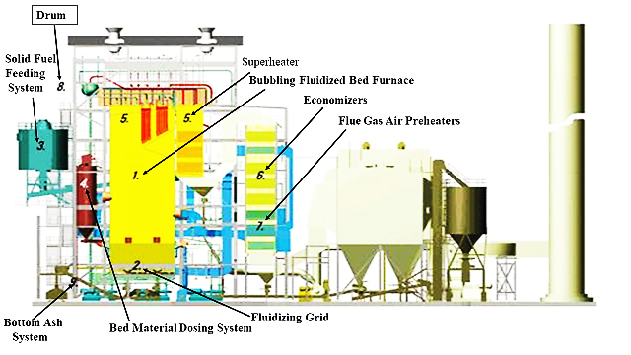

Fig. 7: Main Components of Fluidized Bed Incinerator

The technology employed in fluidized bed incinerator is based on replacing the conventional grate with a bed of solid particles with a mixture of fuel (RDF) which is fluidized by a flow of air from below (Jorgen et al, 2013). The bed is made with sand, however other inert materials such as ashes and lime can be used. Its combustion chamber is in the shape of a rectangle or a cylinder where relatively small particle size of wastes is burnt in a fluidized sand bed. The combustion of the fuel (waste) in the chamber takes place within and above the bed. There are two set of temperatures that are employed in this incinerator, the temperature that is above the bed ranges between 850 to 950 degree Celsius and the temperature in the bed itself is about 650 degrees Celsius. The fluidized bed (FB) incinerator has three types of beds or reactors; these are the bubbling FB reactor, the circulating FB reactor and the revolving (internally recirculating) FB reactor.

Even though generating electricity from waste using the combustion method is the same, there are few differences depending on the technologies that are adopted (Cuéllar et al, 2015). The moving grate incineration which is an example of the mass burning method does not require pre-treatment of the waste before burning. The burning pre-treated waste method would sort out manually or automatically non-combustible and recyclable materials from the garbage as much as possible before the incineration. The fluidized bed incineration is an example of this method. The waste to be processed to generate electricity is discharged into an enclosed waste bunker. An overhead crane mixes the garbage and send the appropriate waste into the incinerator. To avoid bad scent and dust from the discharge hall and waste bunker from engulfing the building, air from these two places is employed in the combustion of the garbage (Lee, 2020). The movement of the waste in the combustion chamber (furnace) is done on a movable metal grate or on a strong revolving fluidized bed of sand. This process is always monitored, guided and controlled from a centralized location as shown in figure 8. The high temperature in the furnace ensures total combustion of the waste. The heat emanating from the combustion chamber is used to heat water in a boiler which is capable of recovering more than 80 percent of the energy embedded in the waste (Hill, 2011). The boiler produces steam; the steam is used to turn a steam turbine which drives a generator to produce electricity. The electricity so generated is integrated into the utility grid.

The electricity generated from the waste is considered renewable energy because the fuel used in the process is sustainable, inexhaustible and replenishable. The average electricity generating efficiency of these incineration plants in the European Union is approximately 58 percent, whereas those in the United States are as low as about 44 percent (NGS, 2012). Even though electricity generation efficiency of these plants is low, this is compensated for by using the leftover energy from the incineration for district heating facility. Thus, after the steam has been used to produce electricity, the heat from the used steam is hot enough to provide heating water for residents in and around the plants.
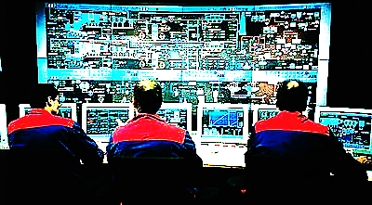

Fig. 8: Control Room of a Typical Moving Grate

After incineration of the garbage, two solid residues are obtained; these residues are the Incinerator Bottom Ash Aggregate (IBAA) and Air Pollution Control (APC) residues which include fly ash. The bottom ash or slag is aggregate materials obtained from the bottom of the grate or fluidized bed after the combustion of the waste. These materials include: ash, ferrous metals and non-ferrous metals; the ferrous metals are removed from the aggregate by the help of magnet while the non-ferrous metals are removed by eddy current separator. These recovered metals are sold to companies for recycling. The ash has its application in the real estate or construction industries. Technology and modernity have increased in the waste incineration industries to the extent that the bottom ash can be melted at a high temperature to produce vitrified or glassy amorphous slag material and metal fraction (Kevin et al, 2013). The slag material has its application in the construction industries where it can be used to fabricate concrete and interlocking blocks as illustrated in figure 9.
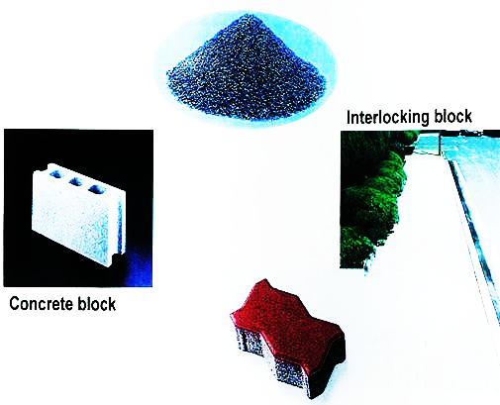

Fig. 9: Concrete and Interlocking Blocks from Bottom Ash

This slag material can also be used in the road construction industry as it is evident in figure 10 where it is used as asphaltic over laid for road construction. The metal fraction is another source of income generation for the plant.
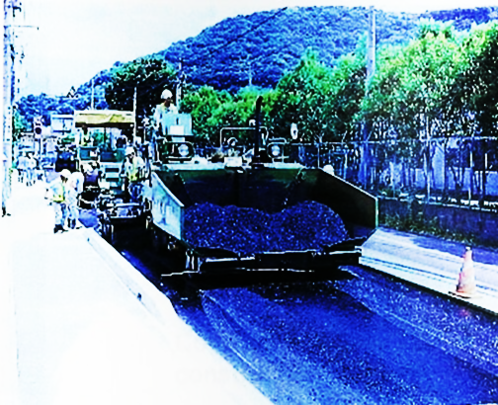

Fig. 10: Vitrified Slag Used for Asphaltic Road Construction

In the course of incineration, fine particulate known as fly ash gets lodged in the baghouse which serve as a vacuum cleaner for the plant. The fly ash is material collected by the air pollution controllers; this material is hazardous since it is due to the chemicals removed from the flue gases. The fly ash is treated and neutralized of its toxicity before sending it to its final disposal site (Phua et al, 2019). The incineration plant does not only generate electricity and produce district heating water but also reduce the volume of garbage which would be landfilled by 90 percent (Dijkgraaf et al, 2004). The weight of the ash residues obtained after combustion is about 20 to 30 percent of the weight of waste sent to the incineration plant. Waste burning or incineration is always accompanied with gaseous exhaust pollutants such as (US-NRC, 2000):
- HCL (Hydrogen Chloride), obtained from the burning of PVC (Polyvinyl Chloride).
- SO₂ (Sulfur Dioxide), got from the burning of Sulfurous compounds.
- HF (Hydrogen Fluoride), obtained from combustion of fluorine compounds.
- NOx (Nitrogen Oxide), got from the nitrogen in the waste and N₂ in the air.
These pollutants which are found in the hot flue gases, are produced in the combustion chamber. These pollutants go through the Air Pollution Control (APC) system as shown in figure 11 to be cleaned and purified of these poisonous gases. These gases are now cleaned enough to be released into the atmosphere through the chimney of the plant, after they have been monitored by the Emission Monitoring System. The Dioxins and Heavy metals such as antimony (Sb), arsenic (As), cadmium (Cd), chromium (Cr), cobalt (Co), copper (Cu), lead (Pb), manganese (Mn), mercury (Hg), nickel (Ni), thallium (Tl) and vanadium (V) which are found in the fly ash are also treated and made cleaned as much as possible before sending them to the landfill (Cong et al, 2000).
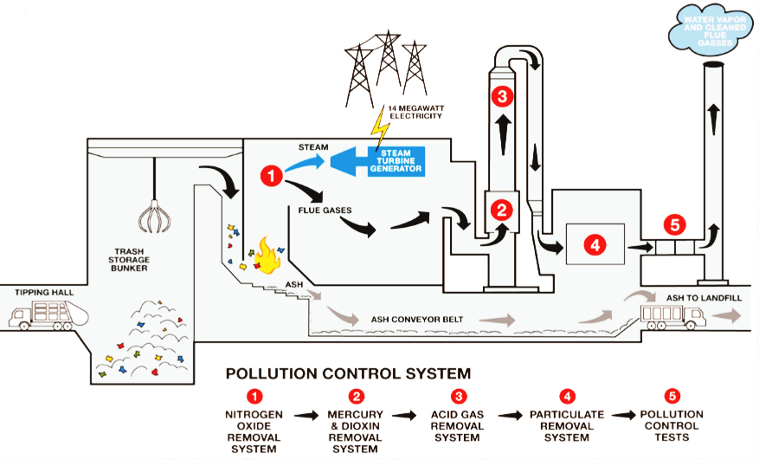

Fig.11: Air Pollution Control System

1.2.2 Gasification and Pyrolysis Methods of Waste-to-Energy (WtE) Plants
Both gasification and pyrolysis are advanced thermal treatment of waste; they are waste treatment systems whereby the garbage is thermally treated in the absence of oxygen (Gopu et al, 2018). The wastes that are processed by gasification technology includes Municipal Solid Waste (MSW), Commercial & Industrial Waste (C&IW), Refuse Derived Fuel (RDF) or Solid Recovered Fuel (SRF) and Non-Waste Fuels such as woods, rice husks, peanut husks and other form of biomass. Gasification plants are generally smaller than mass burning plants and therefore has waste treatment capacity of 25 to 150 thousand tons per year. Gasification is achieved at temperature ranging between 760 and 1,650 degree Celsius under high pressure (Liu et al, 2015). The major components of the plant include: waste bunker, waste airlock, combustion bed, gas outlet, scrubber cooler and slag. Figure 12 shows a typical gasification plant. Even though the reactors employed in the processing of garbage in waste incineration and in waste gasification are relatively similar, gasification process is more difficult to achieve than incineration process. However, the technology used for waste gasification reduces the solid waste into simpler molecules and its destruction of substances such as dioxins and furans are quite different from that of waste incineration (Avfally, 2008). Reduction of waste that is achieved from waste gasification is as high as 95 percent.
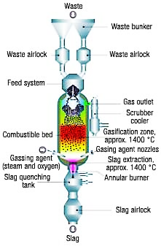

Fig. 12: Gasification Reactor

The temperatures at which thermal degradation begins in pyrolysis process is between 350 and 550 degrees Celsius. Its decomposition temperatures can even go up to 700 to 800 degree Celsius (Chowdhury et al, 2017). In the pyrolysis processes the pretreatment of the municipal solid waste is paramount since waste materials such as glass, metals and inert materials should be removed from the garbage before the rest is sent to the pyrolysis reactor. The main components that are employed in pyrolysis reactor include: refuse bunker, overhead crane, pyrolysis kiln (reactor), combustion chamber, superheater, turbine, generator and emission monitoring system. These parts are illustrated in figure 13.
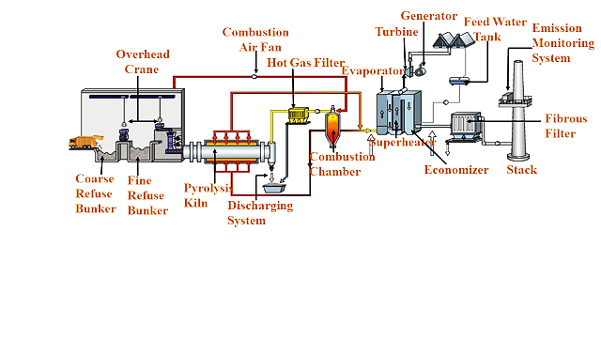

Fig. 13: Components of a Pyrolysis Plant for Specific Solid Waste Treatment

Gasification is environmentally friendlier than incineration since harmful pollutants such as dioxins and furans are largely neutralized during the process (Barkha et al, 2019). The waste in gasification is converted to a gas known as synthesis gas or syngas. This gas can be used to turn gas turbine directly to drive a generator to produce electricity or can combust a boiler, the steam from the boiler is used to rotate a steam turbine which in turn would drive a generator to produce electricity (Jenkins et al, 2007). This process is as shown in figure 14. Just as in the gasification process, the waste in pyrolysis process is also converted to syngas which can be used in gas turbine or steam turbine to generate electricity. The char which is a by-product of the conversion can be used as boiler fuel to produce steam.
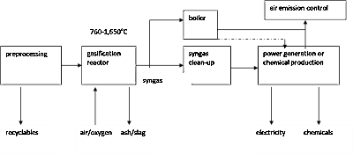

Fig. 14: MSW Gasification Process

- METHODOLOGY

Municipal Solid Waste (MSW) can be a source of wealth and employment generations when managed well especially in developing countries. It is the view of this paper that waste should be redefine to derive the valuable resource therein. This section of the paper brought to the fore municipal solid waste generated, recycled and used for the production of electricity by selected countries in the world in 2023. The researchers used the four major continents (America, Europe, Asia and Africa) in this endeavor. Data for the studies was extrapolated, derived and analysed from various international agencies with emphasis or specialized in waste research and management (UNEP, 2024; Statista 2025; Statista, 2023; Statista, 2024; Zhang, 2024). This data is presented in tables 1, 2, 3, and 4. The tables show ten highest waste generating countries in each of the continent.

Table 1: Ten Highest Municipal Solid Waste Generating Countries in American Continent
America
Countries | MSW Generation in Million Metric Tons | Per Capita Waste in kg (Waste per Individual Daily) | Recycling Rates (%) | Population in Million | Capacity (MW)
United States | 350 | 2.3 | 32 | 334 | 2,720
Brazil | 80 | 1.2 | 15 | 203
Mexico | 55 | 1.071 | 10 | 128
Canada | 36 | 2.7 | 28 | 40 | 2,117
Argentina | 16 | 1.2 | 15 | 46.2
Colombia | 12 | 1.2 | 20 | 52.32
Chile | 8 | 1.3 | 12 | 19.7
Peru | 7.5 | 1 | 12 | 33.8
Cuba | 5 | 1.1 | 5 | 11.1
Venezuela | 4.8 | 1 | 7 | 28.3

Table 2: Ten Highest Municipal Solid Waste Generating Countries in European Continent

Europe
Countries | MSW Generation in Million Metric Tons | Per Capita Waste in kg (Waste per Individual Daily) | Recycling Rates (%) | Population in Million | Capacity (MW)
Russia | 64 | 1.68 | 45.75 | 145.4
Germany | 53 | 1.5 | 70 | 84.55 | 698.6
France | 38 | 1.3 | 47 | 66.4 | 245.4
United Kingdom | 33 | 3.85 | 43.5 | 68.68 | 508
Italy | 29 | 1.38 | 65 | 59.5 | 266
Spain | 23 | 1.38 | 40 | 48
Poland | 14 | 0.97 | 40 | 38.76
Netherlands | 9 | 1.3 | 57 | 18.1 | 269.4
Ukraine | 9 | 0.77 | 15 | 37.7
Belgium | 6.2 | 1.14 | 54 | 11.7 | 109.1

Table 3: Ten Highest Municipal Solid Waste Generating Countries in Asian Continent

Asia
Countries | MSW Generation in Million Metric Tons | Per Capita Waste in kg (Waste per Individual Daily) | Recycling Rates (%) | Population in Million | Capacity (MW)
China | 250 | 1.2 | 20 | 1422.58 | 13,000
India | 180 | 0.5 | 30 | 1430.0 | 300
Indonesia | 75 | 0.8 | 9 | 281.2
Japan | 45 | 0.88 | 19.6 | 124.62
Turkey | 36 | 1.4 | 30 | 87.27
Pakistan | 30 | 0.43 | 10 | 241.49
Thailand | 27 | 1.13 | 30 | 71.7
Vietnam | 23 | 1.25 | 30 | 100.35
Iran | 23 | 1.2 | 15 | 90.61
South Korea | 19 | 1.18 | 60 | 51.75

Table 4: Ten Highest Municipal Solid Waste Generating Countries in African Continent

Africa
Countries | MSW Generation in Million Metric Tons | Per Capita Waste in kg (Waste per Individual Daily) | Recycling Rates (%) | Population in Million | Capacity (MW)
Nigeria | 42 | 0.6 | 10 | 227.88
Egypt | 25 | 0.9 | 30 | 114.54
South Africa | 21 | 1.2 | 10 | 63
Algeria | 13 | 0.9 | 12 | 46
DRC | 12 | 0.64 | 4.9 | 106
Morocco | 7.5 | 0.75 | 10 | 38
Ethiopia | 7 | 0.5 |  | 126.5 | 25
Angola | 6.5 | 0.6 | 6 | 37
Kenya | 6 | 0.7 | 15 | 55 | 10
Ghana | 5 | 0.6 | 10 | 34

By the year 2023 all the continents have increased their share of municipal solid waste generation through factors such as consumer behaviour, urbanization, population growth and industrial activities. Total data with respect to generation of municipal solid waste, growth in population and electricity generating capacities by each continent is as shown in table 5.
Table 5: Municipal Solid Waste Generation, Population Growth and Electricity Generating Capacities
Continents | Total  MSW Generation in Million Metric Tons | Total  Population in Million | Total  Capacity (MW)
America | 574.3 | 901.42 | 4,837
Europe | 278.2 | 641.79 | 2,096.5
Asia | 708 | 3901.57 | 13,300
Africa | 145 | 847.92 | 35
- PRESENTATION OF RESULTS AND DISCUSSIONS

In this section of the paper, the researchers analysed the quantity of electricity generated from the municipal solid waste sent to the landfill sites by each continent in 2023.

3.1 Electricity Generated from MSW deposited at landfill sites by Ten Countries in American continent
According to our research only the United States and Canada generated significant amount of electricity from municipal solid waste (MSW). The United States and Canada generated 2,720 MW and 2,117 MW respectively each year by 2023. Using the formula below, the amount of MSW used to generate this power can be obtained:
$Amount of MSW in Tonne=\frac{Electricity Produced in MWh}{Calorific Value in\frac{MJ}{kg} * Conversion Efficiency in \%}$ …………………….(1)
Where:
- Electricity Produced = 2,720 MW
- Converting 2,720 MW to MWh = 2,720 x 24h x 365 = 23,827,200 MWh
- Calorific Value * Conversion Efficiency = the assumption is that for every one metric tonne of MSW processed, approximately 0.55 MWh (thus 0.55 MWh/tonne) of electricity was generated from the waste to energy plants.
- $⇒$ $Amount of MSW in Tonne=\frac{23,827,200 MWh}{ 0.55 MWh/tonne}=43.4 million metric tonne$
Therefore the amount of municipal solid waste used to produce power in USA and Canada was 43.4 metric million tonnes and 33.7 million metric tonnes respectively.

Even though other types of waste were used to generate electricity, this research was limited to MSW. For instance, Brazil used bagasse to generate electricity; by the end of 2023 it had about 12,400 MW of installed capacity (Coelho et al, 2024).
All the countries selected for this project have some percentage of waste recycled and the rest going to landfill sites or other sources (open burning, drains …) of disposal. Figure 15 shows the amount of MSW that was recycled, landfilled and used to produce electricity.

Fig 15: MSW Recycled, Landfilled and Used to generate Electricity in Million Metric Tonne in America
The amount of municipal solid waste that the ten countries sent to the landfill sites was 373.8 million metric tonnes; (thus 208.5 + 68 + 49.5 + 1.7 + 13.6 + 9.6 + 7 + 6.6 + 4.8 + 4.5) MMT.
3.2 Electricity Generated from MSW deposited at landfill sites by Ten Countries in European Continent
Six out of the ten countries in the European continent generated some amount of electricity from municipal solid waste in 2023. This accession is evident in figure 16; while Germany generated the most Russia, Spain, Poland and Ukraine produced none. Germany and Russia recycled more than the rest, however Germany’s management of municipal solid waste was excellent. It generated 53 million metric tonnes of MSW in 2023, recycled 29.3 million metric tonnes and utilized 11 million metric tonnes to generate electricity. This good management constituted more than 76% of all MSW produced in the year under review.

Fig 16: MSW Recycled, Landfilled and Used to generate Electricity in Million Metric Tonne in Europe

Just as in the American continent, 122.2 million metric tonnes (34.7 + 12.6 + 18.1 + 14.1 + 8.7 + 13.8 + 8.4 + 2 +7.7 + 2.1) MMT of municipal solid waste from the European continent ended up in the landfill sites.

3.3 Electricity Generated from MSW deposited at landfill sites by Ten Countries in Asian Continent
In this continent, only China and Indian generated electricity from municipal solid waste. China generated the most, this constituted 82.8% of all MSW generated in 2023, this excluded recycled waste. India and South Korea recycled the most waste while the rest of the countries the least as shown in figure 17.

Fig 17: MSW Recycled, Landfilled and Used to generate Electricity in Million Metric Tonne in Asia

These ten countries landfilled a total of 371.3 million metric tonnes (34.4 + 118 + 68.3 + 36.2 + 25.2 + 27 + 18.9 + 16.1+ 19.6 + 7.6) MMT of municipal solid waste.

3.4 Electricity Generated from MSW deposited at landfill sites by Ten Countries in African Continent
There are two countries in Africa, Ethiopia and Kenya that generated some quantity of electricity from municipal solid waste. These countries together produced 35 MW of electricity from 800 million metric tonnes of MSW. This amount constituted 0.63% of the total municipal solid waste generated by the ten nations excluding recycled waste. Ethiopia in the year under review recycled none, the rest recycled insignificant amount. This claim is depicted in figure 18.

Fig 18: MSW Recycled, Landfilled and Used to generate Electricity in Million Metric Tonne in Africa

The total volume of municipal solid waste landfilled by these ten counties was 125.8 million metric tonnes (37.8 + 17.5 + 18.9 + 11.4 + 11.4 + 6.8 + 6.5 + 6.1 + 4.9 + 4.5) MMT.
The landfilled waste by each continent could produce a significant amount of electricity, therefore equation 2 was used to estimate this.
$Electricity=\frac{η*M*LCV}{8760 h}$ ……………………………………………………………………………………………(2)
Where:
- Electricity = Power generated in a year in MW
- $η$= Efficiency for MSW plants; it is assumed to be:
- 25% for Asia and Americas
- 30% for Europe
- 12% for Africa
- M = Total Mass of MSW in Tonne/year (assumed to be dried)
- LCV = Lower Calorific Value is assumed to be:
  - 10 MJ/kg for Asia
  - 11 MJ/kg for Americas and Europe
  - 09 MJ/kg for Africa
- 8670 h = since the power is generated per year, (thus 1 year = 365 days * 24 hours=8760 hours)

- Conversion
- 1 Tonne = 1000 kg
- $⟹$373.8 * 10⁶ Tonnes = 373.8 * 10⁶ * 1000 = 373.8 * 10⁹ kg
- 1 * 10⁶ J/kg = 0. 2778 kWh/kg
- $∴$ 10*10⁶ J/kg =2.778 kWh/kg for Asia
- $∴$ 11*10⁶ J/kg =3.056 kWh/kg for Americas and Europe
- $∴$ 09*10⁶ J/kg =2.50 kWh/kg for Africa

- For the American continent
$$Electricity=\frac{0.25*373.8*{10}^{6} Tonnes*11*{10}^{6}J/kg}{8760 h}$$
$Electricity=\frac{0.25*373.8*{10}^{9} kg*3.056 kWh/kg}{8760 h}=32,600.8 MW$
Therefore Electricity generated from the 373.8 million metric tonnes was 32,600.8 MW
- For the European Continent
$$Electricity=\frac{0.30*122.2 *{10}^{6} Tonnes*11*{10}^{6}J/kg}{8760 h}$$
$Electricity=\frac{0.30*122.2 *{10}^{9} kg*3.056 kWh/kg}{8760 h}=12,789.2 MW$
Therefore Electricity generated from the 122.2 million metric tonnes was 12,789.2 MW
- For the Asian Continent
$$Electricity=\frac{0.25*371.3 *{10}^{6} Tonnes*10*{10}^{6}J/kg}{8760 h}$$
$Electricity=\frac{0.25*371.3 *{10}^{9} kg*2.778 kWh/kg}{8760 h}=29,436.97 MW$
Therefore Electricity generated from the 371.3 million metric tonnes was 29,436.97 MW
- For the African Continent
$$Electricity=\frac{0.12*125.8 *{10}^{6} Tonnes*09*{10}^{6}J/kg}{8760 h}$$
$Electricity=\frac{0.12*125.8 *{10}^{9} kg*2.500 kWh/kg}{8760 h}=4,308.22 MW$
Therefore Electricity generated from the 125.8 million metric tonnes was 4,308.22 MW.
The total quantity of electricity that could have been generated by the four continents would be 79,135.19 MW. This implied that, the Waste to Energy process would have saved landfill sites of 993.1 million metric tonnes of municipal solid waste. Figure 19 demonstrates the corresponding power generated by each continent. While the American continent produced the most (41%), Africa generated the least (4%), Europe generated about16% of the total. It generated this magnitude because it incinerated more municipal solid waste than the rest. Asia generated approximately 37%. Even though population growth plays significant role in waste generation, income earning and development cannot be ignored. Inhabitants in high income earning and well developed countries generate more waste. This is evident in the following examples; the Per Capita Waste in kilogramme of United Kingdom, Canada and United States are respectively 3.85, 2.7 and 2.3 while that of Nigeria, India and Ethiopia are 0.6, 0.5 and 0.5.
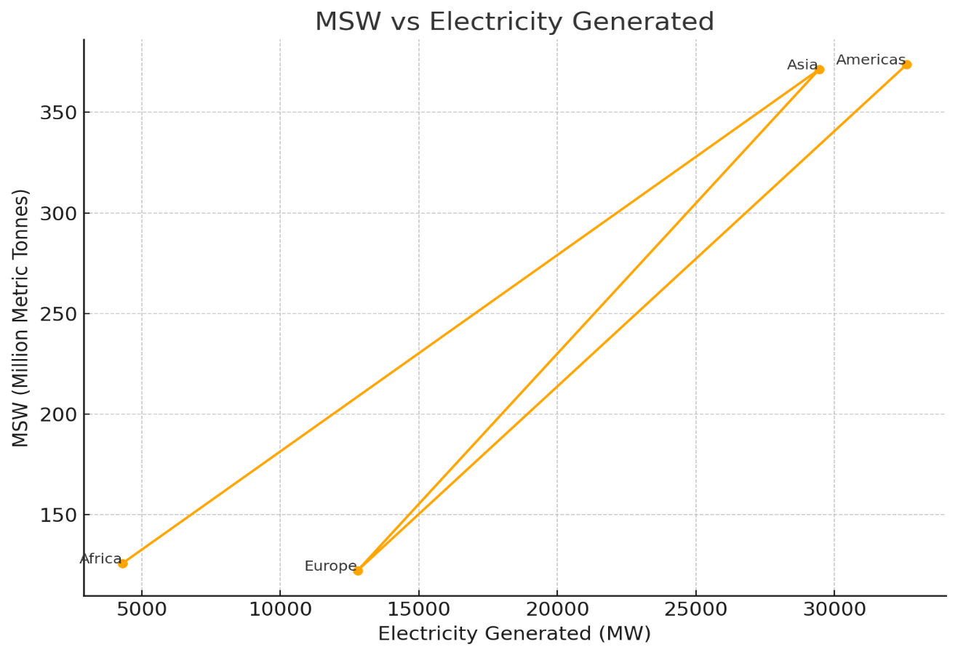
Fig 19: Power Generated by Each continent from MSW

Assuming that, the total electricity (79,135.19 MW) generated by the forty countries in the four continents emanated from fossil fuel sources such as coal or crude oil; there would have been emission of the carbon dioxide (CO₂). The researchers estimated the quantity of this dangerous gas into the atmosphere by using Emission Factor Formula as shown in equation 3.
${CO}_{2}=\frac{7.0555*{10}^{-4}Metric Tonnes*Electricity in kWh}{1kWh.}$.........................................................................................(3)
$${CO}_{2}=\frac{7.0555*{10}^{-4}Metric Tonnes*79,135.19*{10}^{6} kWh}{1kWh.}$$
${CO}_{2}=$55,833,833.305 Metric Tonnes.
This implied that, carbon dioxide (CO₂) emission into the environment would have been reduced by 55,833,833.305 metric tonnes. This tonnage would have constituted 0.395% of total carbon dioxide emitted in 2023 from production of electric power in the world. It should be noted that the carbon dioxide emitted globally into the atmosphere to generate electricity in 2023 was approximately 14.15 billion metric tonnes (Ian, 2014)

- CONCLUSION

Among Combustion, the Gasification and Pyrolysis technologies the combustion method is the most popular and widely used in the world. Countries such as Denmark, Sweden, Japan and Norway just to mention a few, have integrated waste-to-energy into their waste management systems. These countries have integrated the 3Rs concept firmly into their waste management strategy. The 3Rs stand for Reduce (minimize); reduce solid waste generation, Reuse; reuse discarded material as much as possible and Recycle; transforming waste material into another form of useful material.

The landfills should never be the last resort; incineration should always be considered after the 3Rs concept. The benefits from the incineration process cannot be over emphasis. Apart from electricity generation from the incineration plants, the bottom ash are used as aggregate for road construction. Harmful gasses and flying ash are produced during the incineration, gasification and pyrolysis processes. The gasses are treated of the toxic pollutants before their discharge into the atmosphere. The flying ash is also treated from its toxicity as much as possible before sending it to its final disposal site. In all this, there are International protocols and Environmental Protection Agency standards and limits that safeguard the release of these gasses into the environment. Electricity generated from Incineration is always estimated by mathematical models. The construction of these plants does not come cheap, but the high expenditure is compensated for by the numerous benefits derived from their construction.

REFERENCES
Amy Yee, (2018). The New York Times in Sweden, Trash Heats Homes, Powers Buses and
Fuels Taxi Fleets, Retrieved from https://www.nytimes.com/2018/09/21/climate/sweden-garbage-used-for-fuel.html.
Aneeta Mary Joseph, Ruben Snellings, Philip Van den Heede, Stijn Matthys and Nele De Belie,
(2018). A Belgian Point of View: The Use of Municipal Solid Waste Incineration Ash in
Various Building Materials,
Avfally Sverige, (2008). “Toward a Greener Future with Swedish Waste to Energy”.
Barkha Vaish, Bhavisha Sharma, Vaibhav Srivastava, Pooja Singh, M. Hakimi Ibrahim & Rajeev
Pratap Singh (2019). Energy Recovery Potential and Environmental Impact of Gasification
for Municipal Solid Waste, Biofuels, 10:1, 87-100, DOI: 10.1080/17597269.2017.1368061.
Chowdhury Zaira Zaman, Kaushik Pal, Wageeh A. Yehye, Suresh Sagadevan, Syed Tawab
Shah, Ganiyu Abimbola Adebisi, Emy Marliana, Rahman Faijur Rafique and Rafie Bin
Johan, (2017). Pyrolysis: A Sustainable Way to Generate Energy from Waste, DOI:
10.5772/intechopen.69036,
Coelho Junior, L.M., Santos Júnior, E.P., da Silva, C.F.F. et al. (2024). Supply of Bioelectricity
from Sugarcane Bagasse in Brazil: a Space–Time Analysis. Sustain Environ Res 34,
https://doi.org/10.1186/s42834-024-00223-z
Cong Zeng, Yan Lyu, Dehong Wang, Yanzhong Ju, Xiaoyu Shang, Luoke Li, (2020).
"Application of Fly Ash and Slag Generated by Incineration of Municipal Solid Waste in
Concrete", Advances in Materials Science and Engineering, vol. 2020, Article ID 7802103,
7 pages.
Cuéllar-Franca, Rosa M., and Adisa Azapagic, (2015). “Carbon Capture, Storage and Utilization
Technologies: A Critical Analysis and Comparison of Their Life Cycle Environmental
Impacts." Journal of CO₂ Utilization 9, pp.82-102.
Dieter Mutz, Dirk Hengevoss, Christoph Hugi, Thomas Gross, (2017) Waste-to-Energy Options
in Municipal Solid Waste Management, Retrieved from
www.giz.de › downloads › GIZ_WasteToEnergy_Guidelines_2017,
Dijkgraaf, E., & Vollebergh, H. R., (2004) .Burn or Bury? A Social Cost Comparison of Final
Waste Disposal Methods. Ecological Economics, 50(3-4), pp.233-247.
Gopu, Chitanya, Lihui Gao, Maurizio Volpe, Luca Fiori, and Jillian L. Goldfarb, (2018).
"Valorizing Municipal Solid Waste: Waste to Energy and Activated Carbons for Water
Treatment via Pyrolysis." Journal of Analytical and Applied Pyrolysis 133, pp.48-58.
Hill, J. M., (2011). Study of Low-Grade Waste Heat Recovery and Energy Transportation
Systems in Industrial Applications
Hoornweg Dan, Bhada-Tata, Chris Kennedy, (2013). Global Waste on Pace to Triple by 2100-
World Bank Group, October 2013. Retrieved from https://www.worldbank.org › news ›
feature › 2013/10/30 › global-waste-on. October 2013.

Ian Tiseo, (2024). Statista, Global CO₂ Emissions 1970-2023, By Sector, Retrieved from

https://www.statista.com/statistics/276480/world-carbon-dioxide-emissions-by-sector/,
Jenkins, S.D., (2007). Conversion technologies: A New Alternative for MSW Management, Earth
Scan.
Jorgen Haukhol, Torben Kristiansen, (2013). Waste Incineration, World Health Organization
Regional Office for Europe, EPA Export p8.
Kevin Whiting, Steven Wood and Mick Fanning, (2013). Waste Technologies: Waste to Energy
Facilities, WSP Environmental Ltd for the Government of Western Australia, Department of
Environment and Conservation, p28.
Lee County, (2020). Waste-to-energy: How it works, Retrieved from www.leegov.com >
solidwaste > facilities > rrf> wte-how-it-works.
Liu, Guohai; Vimalchand, Pannalal; Peng, WanWang, (2015). High Temperature
WorldWideScience.org. Retrieved from worldwidescience.org › topicpages › high+temperature+gasification.
Nabavi-Pelesaraei, Ashkan, Reza Bayat, Homa Hosseinzadeh-Bandbafha, Hadi Afrasyabi, and
Kwok-wing Chau, (2017). "Modeling of Energy Consumption and Environmental Life Cycle
Assessment for Incineration and Landfill Systems of Municipal Solid Waste Management-
A Case Study in Tehran Metropolis of Iran." Journal of Cleaner Production 148, pp.427-440.
National Geographic Society (NGS), (2012). Geothermal Energy, Retrieved from
www.nationalgeographic.org › encyclopedia › geothermal-energy,
Phua, Zhenghui, Apostolos Giannis, Zhi-Li Dong, Grzegorz Lisak, and Wun Jern Ng, (2019).
"Characteristics of Incineration Ash for Sustainable Treatment and Reutilization."
Environmental Science and Pollution Research 26, no. 17, pp.16974-16997.
Seeker, W. R., (1991). Waste Combustion, In Symposium (International) on Combustion, Elsevier
Vol. 23, No. 1, pp. 867-868.
Statista, (2025). Europe: Per Capita Waste Generation by Country.
Statista, (2023). Municipal Waste Generated in Europe 2023 by Countries.

Statista, (2024). Global Waste Generation Outlook by Region 2016-2050.
Statista, (2024). MSW share burned for Energy Recovery Globally by Country.
Torben Kristiansen, (2018). Massive Waste in African Megacities calls for Sustainable Waste-to-
Energy Facilities. Retrieved from

https://www.cowi.com/insights/massive-waste-in- african-megacities-calls-for-sustainable-waste-to-energy-.

UNEP - United Nations Environment Programme, (2024). World must move beyond Waste

Era and turn Rubbish into Resource: UN Report 2024
UNEP -United Nations Environmental Programme, (2024). Global Waste Management Outlook
2024.
United States-Energy Information Administration (US-EIA), (2019). Biomass Explained Waste
-to-energy (Municipal Solid Waste), Retrieved from

https://www.eia.gov/energyexplained/biomass/waste-to-energy.php,
United States- National Research Council (US-NRC), (2000). Committee on Health Effects of
Waste Incineration. Waste Incineration & Public Health. Washington (DC): National
Academies Press (US); Incineration Processes and Environmental Releases, Retrieved
from
https://www.ncbi.nlm.nih.gov/books/NBK233627/.
Van Caneghem, Anke Brems, Patrick Lievens, Carlo Vandecasteele, (2012). Progress in
Energy and Combustion Science Retrieved from
DOI: 10.1016/j.pecs.2012.03.001,
38(4):pp.551-582,
World Bank Technical Report 1999, (2000). Municipal Solid Waste Incineration, Washington
DC
Young, G. C. (2010). Municipal Solid Waste to Energy Conversion Processes: Economic,
Technical, and Renewable Comparisons. John Wiley & Sons.
Zhang Z., (2024).ScienceDirect.com, Municipal Solid Waste Management Challenges.

