Original Research Article

THE EFFECT OF ALTITUDE, WIND SPEED AND VEHICLE SPEED ON POWER GENERATION BY VEHICLE-MOUNTED WIND TURBINE

ABSTRACT

Aim-The research investigated the influence of wind speed, driving speed and altitude on the electrical power generated by vehicle mounted wind turbine.
Study Design. - A vehicle-mounted wind turbine (VMWT) was developed and tested at varying altitudes.
Place and duration - Wind and vehicle speeds across the Northern and Southern zones of Nigeria to assess its electrical energy generation potentials for use in powering electric vehicles.
Methodology-The wind turbine utilized a dynamo rated at 12V 10 W at 325 rpm, operating directly without a mechanical multiplier system, a cup anemometer and a datalogger to capture real-time data. The data obtained was grouped using six driving speed ranges (0-20km/hr,20-40km/hr,40-60km/hr,60-80km/hr,80-100km/hr and 100-120km/hr), four altitude ranges (0-100m,100-200m,200-300m, and 300-400m) and four wind speed ranges (0-50m/s,50-100m/s,200-250m/s and above 250m/s).The effect of driving speed, wind speed on electrical power generated was investigated.
Result and discussion -The lowest mean wind speed of 8.68m/s was recorded at a car driving speed range of 0-20km/hr and at an altitude range of 0-100m and the mean power generated was 266.476mW. while the highest mean wind speed of 108.47m/s occurred at a driving speed range of 100-120km/hr at altitude range of 100-200m with a peak electrical power of 6479.242mW. The peak power output of 6662.131mW for this experimental set up was recorded at the altitude range of 300-400m, driving speed range of 100-120km/hr and wind speed 570m/s.
Conclusion- The result of this research shows that electrical power generation increased with higher vehicle speeds and wind speeds across all altitude ranges.

Keywords: Altitude, Wind Speed, Vehicle Speed, Power Generation and Wind Turbine

1. Introduction
Fossil fuels have been the primary sources of energy for humans for a long time and this energy will sooner than later face depletion. Accelerated development in the transportation sector has increased fossil fuel consumption and the resultant environmental pollution. The transportation sector accounts for 15.1% of the global greenhouse gas emission. UNEP (2024). Electric vehicles (EVs) have recently gained momentum as an integral part of the transportation sector and one of the key drivers is energy. Energy is therefore required to support the smooth running and sustainability of EVs operations. Khan, et al. (2021), opined that renewable energy sources (such as wind energy) have an important role to play in the automobile sector towards designing energy-harvesting electric vehicles (EH-EV) to mitigate energy reliance on fossil fuels and the national grid.
One of the limitations of electric vehicles is the lack of sufficient energy storage to increase the range or make the vehicle run a long time because the energy storage capacity of batteries used in electric vehicles is very low compared to conventional fuels used in modern automobiles, the operation, performance and efficiency of electric vehicles are much better than engine driven vehicles, yet electric vehicle fall behind in automobile industries due to battery storage capacity. Ferdous, et al. (2011). Therefore, to continuously generate electrical power when the vehicle is moving a wind turbine mounted on the vehicle becomes expedient.
Many researchers have worked on Vehicle-mounted wind turbines (VMWT) for generating electrical power from a moving vehicle. Ferdous, et al. (2011), developed a VMWT and reported designing a model electric vehicle with a charging facility using wind energy and reported a theoretical power generation of 180W provided the vehicle is moving at a constant velocity of 15m/s. Gedion Quatey and Stephen Adzimah (2014), designed a VMWT and reported that the theoretical power that can be generated was found to be 3.26KW. Subhashini, et al. (2018) reported achieving a Voltage of 17V on a wind turbine mounted on a motorcycle fitted with a geared DC generator rotating at 1297rpm. Awal, et al. (2015) developed a VMWT, from the driving experiment it was reported that up to 200 W of electricity is acquirable from a single vehicle (< 80 km/hr). Additionally, Prajapati and Thakkar (2013), developed a VMWT that generated 3.6 W at a vehicle speed of 40km/hr. However, available literature reveals a gap in research regarding the effects of altitude, driving speed, and wind speed on power generation from VMWTs. Most studies have concentrated on the impact of vehicle and wind speeds on power output. The present study aims to investigate the effects of wind speed, car speed, and altitude on power generation using VMWT on a moving vehicle.
2. MATERIALS AND METHODS
2.1 Material Selection
The design and development of the MVMWT take into account key factors such as the availability of local materials, cost, and weight. For the turbine blades, a three-blade configuration made from polyethylene thermoplastic material, weighing 0.6 kg with a blade length of 0.225 m, is selected, as shown in Fig.1. This material was chosen for its lightweight properties and resistance to abrasion. The blades are connected to a 12V, 325 rpm permanent magnet DC motor, manufactured by HMC Electric Fan Company, as depicted in Fig. 2. Permanent magnet DC motors are preferred due to their ability to generate voltage at relatively low speeds. The entire system is mounted on a mild steel beam and secured to the top of a Toyota Hilux double-cabin pickup truck with a 132 kW (177 hp) engine.

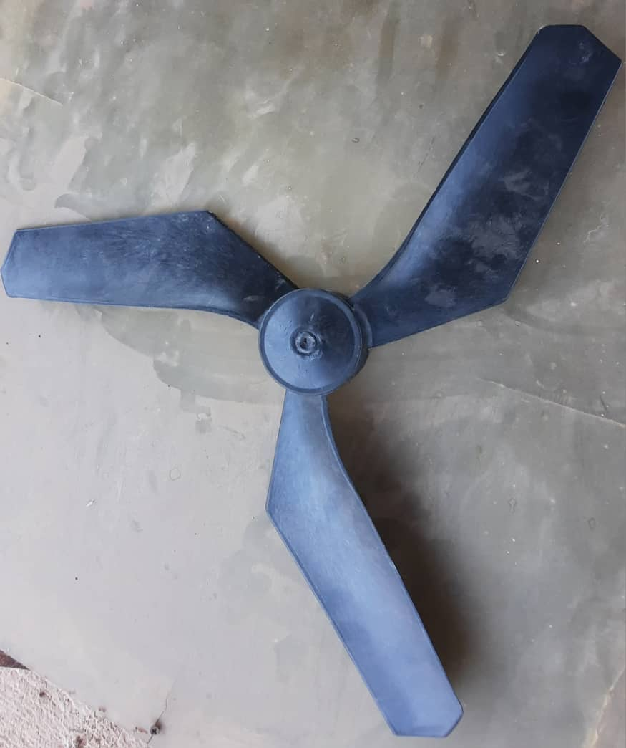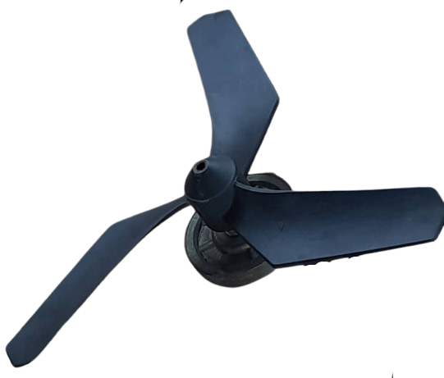
blade
dc motor
Fig.1.The polyethylene thermoplastic turbine blade Fig.2.The coupled turbine blade (1) and dc motor (2)
Attached to the same beam on the top of the motor vehicle at 0.9m space is a cup anemometer, to measure the real-time wind speed at every vehicle speed. As shown in Fig. 3
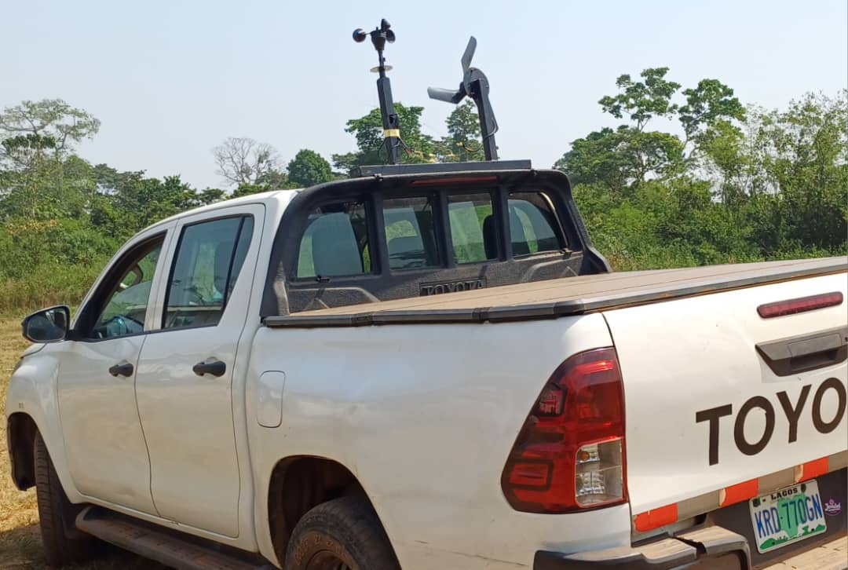
Cup Anemometer
Vehicle mounted wind turbine
Fig. 3. Vehicle-mounted wind turbine with a cup anemometer
2.2. Data Acquisition.
To capture real-time data, an automatic data logger and control system, as shown in Fig. 4, is implemented using an Arduino Mega 2560 microcontroller. The microcontroller is equipped with a gyroscope, accelerometer, GPS, real-time clock, and microSD module to record key parameters such as car speed, wind speed, altitude, and the power generated by the wind turbine.

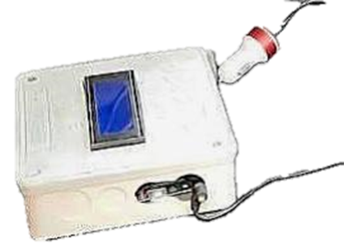
Fig. 4. Arduino Data Logger.

3. Wind turbine design
The blade's efficient design aims to maximize lift while minimizing drag. The swept area refers to the region enclosed by the turbine blade during its motion. For a horizontal axis wind turbine (HAWT), the swept area is determined by Equation 1, as described by Johansen and Sørensen (2007).
$S=πr^{2}$ (1)
Where; S is the swept area (m²), r is the radius of the circle which is equal to the length of one of the blades (m).
S = 3.142 × 0.225²
S = 0.159 m²
The induced velocity in the upstream part of the rotor is represented by equation 2, according to Larin et al. (2016)
$V_{u}=V_{∞}au$ (2)

Where V_{u} is the upstream induced velocity, V∞ is the free stream air velocity and au is the upstream interference factor, which is less than 1 as the induced velocity is less than the ambient velocity.
The tip speed ratio, the ratio of the speed of the wind to the speed of the blade is governed by equation 3. According to Tyagi, 2012,
$λ=\frac{2πRN}{V_{∞}}$ (3)
where,
V∞ is the speed of wind without any rotor intervention
R is the radius of the rotor, which signifies the swept area
N is the rotational speed of the rotor in rps
The Power generated by a wind turbine is governed by the Equation 4
by Ulgen and Hepbasli, (2003).
$P_{WT}\left(t\right)=0.5×C_{p}×ρ_{air}×v^{3}(t)$ (4)
where,
C_{p} is the power coefficient (0.593, also known as Betz’s coefficient.)
V is the wind speed (m/sec), Ρ is the density (kg/m³), and A is the swept area of the rotor (m²).

4. Result and Discussion
A driving test was conducted at various altitudes across the western, midwestern, and northern regions of Nigeria, including Ondo, Edo, Lagos, and Kaduna States. The objective was to evaluate the effects of driving speed, wind speed, and altitude on the power generated by a vehicle-mounted wind turbine (VMWT).
The collected data were categorized into six driving speed ranges (0–20 km/h, 20–40 km/h, 40–60 km/h, 60–80 km/h, 80–100 km/h, and 100–120 km/h) and four altitude ranges (0–100 m, 100–200 m, 200–300 m, and 300–400 m), as summarized in Table 1. Grouping the data was essential for analysis due to variations in the frequencies, times, and locations of data collection. Ensuring a reliable distribution pattern for the recorded data was critical.
The variations in altitude recorded during the driving test were compiled and analyzed using statistical techniques. Probability density functions were applied to model the distribution of the recorded parameters over the test period, utilizing MS Excel and Minitab 18 software. The distribution models used included the Normal, Weibull, Gamma, and Log-normal distributions, as illustrated in Fig. 5 (a), (b), (c), and (d).
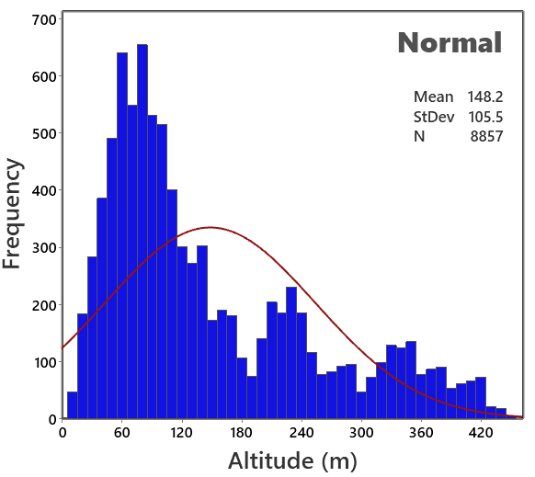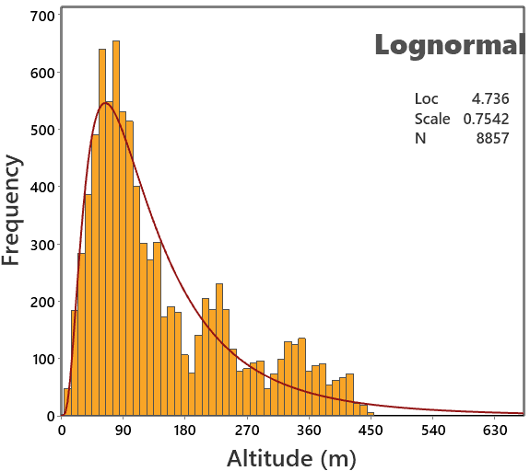
- (b)
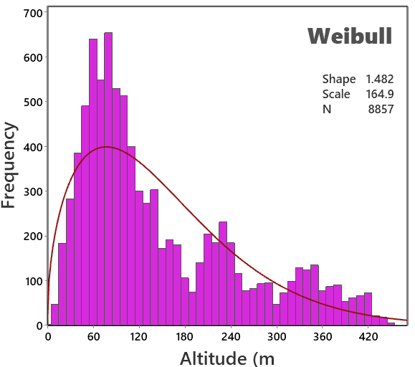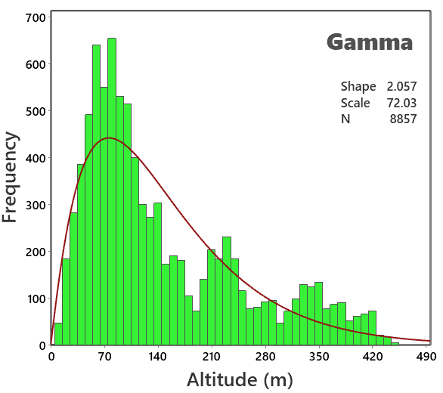
(c) (d)
Fig. 5. Frequency of the altitude recorded during the driving test for the wind turbine.
The driving tests conducted at various locations revealed a significant increase in wind turbine speeds at higher altitudes. This observation aligns with findings reported by Jamdade and Jamdade (2012) and Aydin et al. (2022).
Table 1. Descriptive statistics of the altitude recorded during the driving test for the wind turbine
Altitude (m) | Stat | 0-20 km/h | 20 - 40 km/h | 40-60 km/h | 60-80 km/h | 80-100 km/h | 100-120 km/h
0 - 100 | Mean | 60.61 | 68.09 | 66.85 | 65.44 | 59.13 | 61.93
100 - 200 | Mean | 133.64 | 133.82 | 137.94 | 137.39 | 136.7 | 143.2
200 - 300 | Mean | 225.79 | 234.58 | 238.63 | 239.55 | 244.25 | 283.35
300 - 400 | Mean | 357.35 | 354.03 | 356.47 | 362.09 | 364.65 | 362.79
The effect of driving speed on wind speed concerning altitude was established in Table 1
As shown in Table 2, an increase in driving speed at higher altitudes results in a corresponding rise in wind speed. The lowest mean wind speed of 8.68 m/s was recorded at a driving speed of 0–20 km/h and an altitude of 0–100 m, while the highest mean wind speed of 108.47 m/s occurred at a driving speed of 100–120 km/h and an altitude of 100–200 m. This indicates that a 25% increase in driving speed nearly doubles the wind speed, thereby enhancing the power generated. A similar trend was observed by El Khchine and Sriti (2021) during their evaluation of wind turbine performance for energy production in Morocco’s coastal regions.
Table 2 Descriptive statistics of the driving speed recorded during the driving test for the wind turbine

Driving speed (km/h) | Stat | 0 - 100 m | 100 - 200 m | 200 - 300 m | 300 - 400 m
0 - 20 | Mean | 8.68 | 10.47 | 10.81 | 11.4
20 - 40 | Mean | 30.04 | 29.47 | 29.26 | 30.12
40 - 60 | Mean | 49.91 | 49.93 | 51.86 | 50.14
60 - 80 | Mean | 70.12 | 69.86 | 69.93 | 71.73
80 - 100 | Mean | 89.8 | 89.22 | 89.05 | 90.43
100 - 120 | Mean | 107.65 | 108.47 | 105.95 | 106.94
Table 3. Descriptive statistics of the wind speed recorded during the driving test for the wind turbine at varying altitude ranges.
Wind speed (m/s) | Stat | 0 - 100 m | 100 - 200 m | 200 - 300 m | 300 - 400 m
0 - 50 | Mean | 16.56 | 20.27 | 22.73 | 22.69
50 - 100 | Mean | 74.78 | 72.65 | 72.31 | 77.74
100 - 150 | Mean | 121.42 | 123.39 | 123.49 | 119.35
150 - 200 | Mean | 173.12 | 169.31 | 168.31 | 172.28
200 - 250 | Mean | 219.81 | 220.91 | 218.13 | 221.23
Above 250 | Mean | 278.92 | 297.3 | 411.7 | 570.6

Table 3 presents the recorded wind speed distribution during the VMWT driving test across varying altitude ranges and wind speed intervals, with a uniform wind speed distribution format of 50 m/s.
The mean wind turbine speeds were calculated for each wind speed class interval at different grouped altitudes. The table reveals trends in turbine speed values, which generally increase with wind speed and altitude. However, irregular variations were observed, attributed to external factors such as passing trucks, traffic congestion, and other vehicular obstructions during the driving tests. Similar observations were reported by Han et al. (2019) and Alkesaiberi et al. (2022).
For wind speed intervals:
- 0–50 m/s: The highest mean turbine speed (22.73 m/s) was recorded at an altitude of 200–300 m, while the lowest (16.56 m/s) occurred at 0–100 m.
- 50–100 m/s: The highest mean turbine speed (77.74 m/s) was observed at 300–400 m, with the lowest (72.31 m/s) at 200–300 m.
- 200–250 m/s: The highest mean turbine speed (221.23 m/s) was recorded at 300–400 m, while the lowest (218.13 m/s) occurred at 200–300 m.
- Above 250 m/s: The highest mean turbine speed (570.60 m/s) was observed at 300–400 m, with the lowest (278.92 m/s) at 0–100 m.
These results highlight the influence of altitude on wind turbine performance across different wind speed ranges.

Fig.6 The Graphical representation of wind speed and driving speed at different grouped altitudes

Fig 7. Bar Chart representation of wind speed and driving speed at different grouped altitudes
Figures 6 and 7 illustrate the graphical and bar chart representations of wind speed and driving speed across different grouped altitudes. The charts indicate that wind speed increases with higher driving speeds and greater altitudes. This trend is consistent with observations reported by Ayodele et al. (2012), Gashaw et al. (2021), and Yao et al. (2015).

Table. 4. Descriptive statistics of the generated power recorded during the driving test for the wind turbine at varying altitude range

Generated power (mW) | Stat | 0 - 100 m | 100 - 200 m | 200 - 300 m | 300 - 400 m
0 -1000 | Mean | 266.476 | 331.086 | 338.742 | 408.979
1000 - 2000 | Mean | 1420.758 | 1438.901 | 1449.995 | 1430.505
2000 - 3000 | Mean | 2343.55 | 2372.765 | 2419.165 | 2368.736
3000 - 5000 | Mean | 3750.494 | 3782.983 | 3789.572 | 3780.093
5000 - 6000 | Mean | 5745.753 | 5757.1 | 5687.647 | 5576.035
6000 - 7000 | Mean | 6475.362 | 6479.242 | 6526.637 | 6662.131

Table 4 demonstrates that the mean electrical power generated increases with higher car speeds, wind speeds, and altitudes. At an altitude of 0–100 m, the mean power generated was 266.476 mW. At the peak altitude for the 0–1000 mW power range, a mean value of 408.979 mW was recorded.
Similarly, within the 2000–3000 mW power range, the highest mean power generated was 2368.736 mW, observed at an altitude of 300–400 m, while the lowest mean power value (2343.550 mW) occurred at 0–100 m. The peak power output for this experimental setup was recorded in the 6000–7000 mW range at an altitude of 300–400 m, with a value of 6662.131 mW.
These findings confirm that changes in altitude impact wind parameters, leading to variations in wind speed that directly influence the electricity produced by the turbine. Similar conclusions were reported by Harison et al. (2008) and Enock et al. (2021).

Fig. 8. The bar char representation of electrical power generated at different altitudes
Fig.8 shows that power generated by the VMWT increases at increasing driving speed and wind speed for all ranges of altitude considered during the driving test.
The peak value generated from the driving test experiment was 6662.131mW at an altitude range of 300-400m.
Table 5 Correlation matrix between the parameters recorded during the driving test
 | Driving speed (km/hr) | Wind speed (m/s) | Altitude (m) | Power (mW)
Driving speed (km/hr) | 1 | 0.868 | 0.04 | 0.951
Wind speed (m/s) | 0.868 | 1 | 0.249 | 0.779
Altitude (m) | 0.04 | 0.249 | 1 | 0.094
Power (mW) | 0.951 | 0.779 | 0.094 | 1

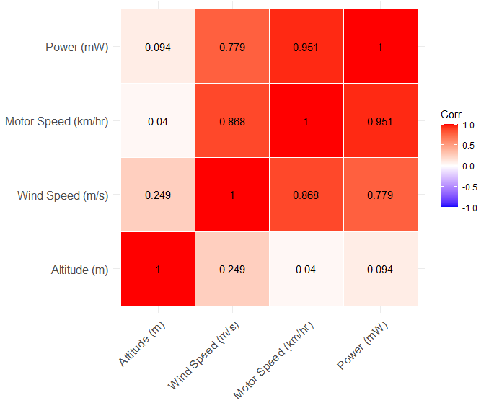
Fig.9 Heat map and correlation matrix plot expression for parameters recorded during the driving test

Table 5 and Fig.9, show that there are significant correlation between the generated wind power and is highly related to the driving speed and wind speed variations for the experimental tests carried out.
4. CONCLUSION.
A motor vehicle-mounted wind turbine was designed, and real-life driving tests were conducted at varying driving speeds, wind speeds, and altitudes. The experimental results demonstrated that power generation increased with higher car speeds and wind speeds across all altitude ranges. The peak power generated during the driving experiments was 6.662 W.
This output can be further enhanced by utilizing both a mechanical multiplier and a buck-boost converter to efficiently charge the car battery, thereby extending the vehicle's driving range.

ReferenceS
Alkesaiberi, A., Harrou, F. and Sun, Y. E. (2022). Wind Power Prediction Using Machine Learning Methods: A Comparative Study. Energies 2022, 15, 2327. https:// doi.org/10.3390/en15072327
Awal Md Rabiul, Muzammil Jusoh, Md. Nazmus Sakib, Fakir Sharif Hossain, Mohd Rashidi Che
Aydin, O., Iglinski, B., Krukowski, K. and Sieminski, M. (2022). Analyzing Wind Energy Potential Using Efficient Global Optimization: A Case Study for the City Gda´nsk in Poland. Energies, 15(3159):1-22. https://doi.org/10.3390/en15093159
Ayodele, T. R., Jimoh, A. A. and Munda, J. L. (2012). Statistical analysis of wind speed and wind power potential of Port Elizabeth using Weibull parameters. Journal of Energy in Southern Africa 23(2):30-38
Beson and Syed Alwee Aljunid (2015) Design and Implementation of Vehicle Mounted
Chen, T.Y, Liao, Y.T, Cheng, C.C. (2012). Development of small wind turbines for moving vehicles: Effects of flanged diffusers on rotor performance Experimental Thermal and Fluid Science. Volume 42, October 2012, Pages 136-142
El khchine, Y. and Sriti, M. (2021). Performance evaluation of wind turbines for energy production in Morocco’s coastal regions. Results in Engineering 10(100215):1-12.
Enock, M., Dominicus D. D. P. and Aditya, R. P. (2021). Estimating the potential of wind energy resources using Weibull parameters: A case study of the coastline region of Dar es Salaam, Tanzania. Open Engineering, 11: 1093–1104.
Ferdous, S.M, Walid Bin Khaled, Benazir Ahmed, Sayedus Salehin, Enaiyat Ghani Ovy. (2011). Electric Vehicle with Charging Facility in Motion using Wind Energy World Renewable Energy Congress 2011, Sweden, 8-13 May 2011 Linkoping Sweden.
Gashaw, A. A., Abdulkadir, A. H. and Yihun, T. S. (2021). Performance Investigation of Small Wind Turbine Installed over a Pick-up Vehicle to Charge an Electric Vehicle Battery
Gedion Quatey and Stephen Kwasi Adzimah. (2014). Generation of Electrical Power by a wind turbine for charging a moving electric cars. Journal of energy technology and policy. ISSN 2224-3232 Vol.4,No.3,2014
Halima Begum, Md. Arafat Hossain. (2023). Design and Comparison of Vehicle Mounted Wind Turbines. International Journal of Emerging Trends in Engineering Research.Volume 11. No.1, January 2023. ISSN 2347 – 3983,2023
Han, S., Qiao, Y.H., Yan, J., Liu, Y.Q., Li, L., Wang, Z. (2019). Mid-to-long term wind and photovoltaic power generation prediction based on copula function and long short-term memory network. Appl. Energy 2019, 239, 181–191. [CrossRef]
Harrison, G. P., Cradden, L. C. and Chick, J. P. (2008). Preliminary assessment of climate change impacts on the UK onshore wind energy resource. Energy Sources, Part A: Recovery, Utilization, and Environmental Effects, 30(14 & 15):1286e99.
Jamdade, S. G. and Jamdade, P. G. (2012). Analysis of wind speed data for four locations in Ireland based on Weibull distributions linear regression model, Int. J. Renew. Energy Resour. 2 (3) (2012) 451–455.
Johansen, J. and Sørensen, N. (2007). Numerical Analysis of Winglets on Wind Turbine Blades using CFD. Risø-R-1543(EN), Risø National Laboratory, Roskilde
Khan, Z.A.; Sherazi, Larin, P. Paraschivoiu, M. and Aygun, C. (2016). CFD based synergistic analysis of wind turbines for roof mounted integration, Journal of Wind Engineering and Industrial Aerodynamics, 156:1-13. https://doi.org/10.1016/j.jweia.2016.06.007.
October, 2015. ISSN 1819-6608
Prajapati, V.M, Thakkar, K.H. (2013). Determination of Energy Produced By Wind Mill on Running Vehicle. International Journal of Engineering Research and Applications (IJERA) ISSN: 2248-9622 www.ijera.com Vol. 3, Issue 1, January-February 2013, pp.106-110
Subhashini, G., Raed Abdulla, Thinaga Raj R Mohan. (2021). Wind Turbine Mounted on A Motorcycle for Portable Charger for Connected Vehicles in Green Cities. Energies 2021, 14, 5408, Internation Journal of Power Electronics and Drive System (IJPEDS)
Tyagi, R.K, (2012). Wind Energy and Role of Effecting Parameters, European Journal of Applied Engineering and Scientific Research, 2012, 1 (3): 73-83
Ulgen, K. and Hepbasli, A. (2003). A study evaluating the power generation of solar-wind hybrid systems in Izmir, Turkey. Energy Sources, 25(3):241–252.
United Nations Environment Programme. UNEP (2024). Emissions Gap Report 2024: No more hot air … please! With a massive gap between rhetoric and reality, countries draft new climate commitments. Nairobi. https://doi.org/10.59117/20.500.
Wind Turbine. ARPN Journal of Engineering and Applied Sciences, VOL. 10, NO 19,
Yao, A. W. and Chiu, C (2015). Development of a Wind Power System on Trucks Universal Journal of Mechanical Engineering 3(5): 151-163. Vol. 9, No. 4, December 2018, pp. 1814~1822 ISSN: 2088-8694,

