AI- driven Risk Assessment for Enhancing Third Party Vendor Security in Healthcare Systems

Abstract
This study investigates the integration of artificial intelligence (AI) in managing third-party vendor cybersecurity risks within healthcare systems. Utilizing data from the HHS OCR Breach Portal (2018–2024), the HIMSS Cybersecurity Survey, and the IBM Cost of a Data Breach Report, the research employs descriptive statistics, chi-square tests, and multiple linear regression analysis to examine breach frequency, AI adoption impact, and operational efficiency. Results show that vendor-related breaches peaked at 254 in 2023, with over 82 million records compromised in 2024. Institutions with AI adoption reported only 22.5% breach incidence versus 60% among non-adopters. Regression analysis indicated AI reduced breach costs by $2.84 million, detection time by 24.47 days, and containment time by 20.62 days. Based on these findings, it is recommended that regulatory bodies enforce AI integration, healthcare institutions adopt intelligent monitoring tools, vendor contracts embed AI audit clauses, and standardized AI governance frameworks be implemented sector-wide.
Keywords: Artificial Intelligence, Healthcare Cybersecurity, Third-Party Vendors, Risk Assessment, Data Breaches

1. Introduction
In the present healthcare sector, the involvement of third-party vendors has become indispensable for delivering essential services such as electronic health records, telemedicine infrastructure, billing platforms, and cloud-based data storage systems. However, this increasing reliance has significantly widened the cybersecurity threat surface, thereby worsening the challenges in protecting sensitive patient information. According to Fox (2024), 35% of healthcare data breaches in 2023 were directly associated with third-party vendors, which underscores the urgency of adopting robust risk management mechanisms. AHA (2024) further notes that the magnitude of these breaches is exemplified by the American Hospital Association's report, which revealed that 58 of the 77.3 million individuals affected by breaches in 2023 were compromised through attacks on healthcare business associates, reflecting a 287% increase from 2022. This alarming growth illustrates the systemic vulnerabilities posed by external entities. The financial consequences of such breaches are equally consequential. Olsen (2024) reports that the average cost of a data breach in the healthcare sector escalated to $9.8 million in 2024, thereby maintaining its status as the most financially burdensome industry for data breaches. This finding is corroborated by Coppinger (2023), which emphasizes the critical role that third-party relationships play in perpetuating cybersecurity risks. The HIPAA Journal documented 725 major healthcare data breaches in 2023, affecting over 133 million records (Alder, 2025), while 24By7Security (2024) reported that by 2024, 588 healthcare-related breaches impacted more than 179 million individuals, both reflecting persistent exposure linked to vendor dependencies.
Several high-profile incidents have accentuated the severity of third-party risks; the 2020 breach of the Accellion File Transfer Appliance affected more than 100 organizations, including Trinity Health, which alone reported 586,869 compromised patient records (Firch, 2024; Newman, 2021; Black Kite, 2021). This breach demonstrated the vulnerabilities intrinsic to outdated third-party systems and highlighted the necessity for continuous vendor security evaluation. Similarly, Özeren (2025) documents that in February 2024, Change Healthcare, a subsidiary of UnitedHealth Group, suffered a ransomware attack attributed to the ALPHV/BlackCat group, resulting in the compromise of over 100 million individuals' medical and financial records and a reported ransom payment of $22 million. In April 2024, MediSecure experienced a significant data breach in Australia that affected 12.9 million individuals and involved the extraction of 6.5 terabytes of sensitive information (Lavoipierre, 2024). Furthermore, HealthEquity revealed a third-party-related breach in July 2024, impacting 4.5 million customers (Ancell, 2024). These incidents substantiate the urgent need for proactive and intelligent cybersecurity strategies. A critical issue in managing third-party risk, lies in the limited visibility organizations have into the internal security measures of their external partners. The diverse nature of vendor ecosystems, with each supplier operating under different regulatory and security frameworks, further complicates the implementation of consistent oversight. These deficits contribute substantially to the frequency and severity of third-party breaches (Olsen, 2024; Coppinger, 2023)
Artificial Intelligence (AI) presents a promising solution to these challenges. According to Dhanaraj et al. (2020), supervised and unsupervised machine learning models are capable of identifying atypical vendor behavior that may suggest security vulnerabilities. Predictive modeling tools allow institutions to evaluate the probability of future breaches based on both historical and real-time risk indicators. Additionally, Natural Language Processing (NLP) can be utilized to scrutinize vendor contracts and compliance reports, efficiently identifying regulatory inconsistencies or contractual risks that would otherwise remain undetected (Zaher et al., 2025). Kalusivalingam et al. (2020) describes the effectiveness of such AI-enhanced tools through real-world deployments. At Penn Highlands Healthcare, the integration of Darktrace’s AI system enabled real-time anomaly detection and autonomous incident response with minimal human input, which expedited threat containment and operational recovery (DarkTrace, 2024). Likewise, IBM's Watson for Cybersecurity has been adapted for healthcare environments, where it processes extensive threat intelligence data and system logs to bolster situational awareness and hasten detection cycles; this is effective in synthesizing diverse datasets to produce actionable insights for security operations centers (Aggarwal & Madhukar, 2017).
Recent developments illustrate the continued investment in AI-based healthcare cybersecurity. Virtue AI secured $30 million in funding to develop its AI-driven platform tailored to healthcare clients (BusinessWire, 2025). Concurrently, a $10 million initiative by the University of Pittsburgh and Leidos focuses on enhancing diagnostic precision using AI tools, especially for underrepresented populations (Procyk, 2025). These investments reflect a sector-wide shift toward embedding AI as a fundamental component of security infrastructure. Empirical data affirms this trajectory. According to Proofpoint (2023) 57% of healthcare organizations acknowledged AI’s substantial impact in strengthening cybersecurity postures. IBM (2024) reported that organizations extensively utilizing AI and automation saved an average of $2.22 million per breach compared to those that did not, and by the close of 2023, 61% of healthcare entities had already integrated AI into their cybersecurity frameworks. McGee (2024) reported that approximately one-third of all significant 2024 breaches involved business associates, affecting over 131 million individuals. MSSP Alert further projected that AI adoption in healthcare cybersecurity would reach 90% by 2025, with half of that already in place by 2024 (MSSP Alert, 2025).
Given these patterns and the escalating nature of cyber threats, Argaw et al. (2020) emphasizes the pressing requirement for healthcare organizations to modernize their third-party risk management systems. This study therefore aims to examine current vulnerabilities in third-party vendor relationships, analyze AI-driven mitigation strategies, evaluate the effectiveness of such tools in enhancing regulatory compliance and response readiness, and offer structured recommendations aligned with HIPAA, GDPR, and NIST frameworks to fortify organizational resilience against third-party cybersecurity risks. This research aims To investigate the application of artificial intelligence in automating and enhancing risk assessment processes for managing third-party vendor cybersecurity threats in healthcare systems, by achieving the following objectives:
- Evaluates the current challenges and vulnerabilities associated with third-party vendor relationships in healthcare cybersecurity.
- Examines how artificial intelligence technologies are being utilized to assess, monitor, and mitigate vendor-related cybersecurity risks in healthcare systems.
- Analyzes the effectiveness of AI-driven risk assessment tools in reducing data breaches, enhancing compliance, and improving incident response in vendor-related scenarios.
- Propose strategic recommendations for healthcare organizations on implementing AI-based vendor risk management frameworks in alignment with regulatory standards.
2. Literature Review
The third-party vendor ecosystem has become indispensable in the modern healthcare environment, facilitating critical functions including electronic health records (EHRs), cloud storage, billing infrastructure, telemedicine platforms, and remote diagnostic services. This dependence allows healthcare organizations to concentrate on their clinical objectives while outsourcing technical expertise to external providers (Berry et al., 2021). Although third-party vendors are instrumental to healthcare innovation, they simultaneously introduce considerable cybersecurity vulnerabilities owing to their extensive access to protected health information (PHI) and essential systems (AHA, 2024; Ajayi et al., 2025). The vendor landscape is structurally complex, consisting of business associates, subcontractors, Software-as-a-Service (SaaS) platforms, managed service providers, and cloud infrastructure vendors (Henri & Seppänen, 2022; Balogun, 2025). Under HIPAA, business associates are entities that process PHI on behalf of covered entities, while their subcontractors fall under identical legal obligations (Alder, 2017; Kolade et al., 2025). Alder (2024) reports that many healthcare institutions manage relationships with hundreds of such vendors, each constituting a potential attack vector.. The integration of SaaS solutions into both administrative and clinical workflows further complicates governance efforts, as these systems are often deeply embedded in daily operations and distributed across cloud environments (Sousa et al., 2023; Metibemu et al., 2025).
This increasing interconnection significantly enlarges the cybersecurity threat surface and impedes the consistent enforcement of security standards across diverse vendor frameworks (Alshammari & Singh, 2025; Obioha-Val, 2025). Research by Coppinger (2023) highlights critical oversight deficiencies and a widespread inability to accurately evaluate third-party security postures. These limitations stem from the rapid digitalization of healthcare operations juxtaposed with the slower development of comprehensive risk management practices. Although regulatory mandates require covered entities to ensure their business associates’ compliance, enforcement remains weak, especially when data crosses jurisdictional and cloud-based boundaries (Shandilya et al., 2024; Olutimehin, 2025). Breaches originating from third-party entities can propagate across interconnected providers, exposing millions of patient records to potential compromise (Isibor, 2024; Oyekunle et al., 2025).
Given these complexities, a systematic and future-oriented risk management approach is essential (Lakshan et al., 2021; Salako et al., 2025). This research maintains that artificial intelligence can substantially augment healthcare cybersecurity through automation, predictive analytics, and real-time surveillance, thereby mitigating persistent vulnerabilities in an increasingly networked digital ecosystem.

Vulnerabilities and Risk Factors in Vendor Relationships
Healthcare organizations’ dependencies on third-party vendors continue to expose them to significant cybersecurity risks, which are rooted in both technological shortcomings and governance failures. Ilori et al. (2024) asserts that these vulnerabilities are frequently attributable to legacy systems, delayed patch management, and improperly configured applications that persist in vendor-controlled environments. Alder (2024) reports that many business associates neglect critical security practices, including timely software updates and secure configuration protocols, thereby introducing indirect threats to primary healthcare entities. IBM (2024) corroborates this by indicating that only 36% of healthcare organizations regularly evaluate the cybersecurity postures of their vendors, reflecting a reactive rather than proactive stance toward risk management.
A central issue lies in the limited transparency into the internal security structures of vendors; the absence of visibility restricts the ability of healthcare organizations to effectively assess vendor-related cyber risks, which consequently delays mitigation efforts (Coppinger, 2023; Tiwo et al., 2025). This challenge is worsened when subcontractors and extended vendor chains are involved, creating fragmented lines of responsibility (Dhawan et al., 2023; Alao et al. 2024). Traditional tools such as static security questionnaires offer only a superficial understanding of risk and are ill-suited for rapidly evolving threat environments (Li et al., 2023; Balogun, et al., 2025). Furthermore, the prevalence of poorly constructed Service Level Agreements (SLAs), often devoid of enforceable cybersecurity standards, weakens control implementation and accountability mechanisms (Sissodia et al., 2024; Obioha-Val et al., 2025).
Despite the presence of regulatory instruments like HIPAA, GDPR, and the NIST Risk Management Framework, Schmeelk (2021) notes that their application remains fragmented and often inconsistent across jurisdictions. For example, although HIPAA mandates the establishment of Business Associate Agreements (BAAs), these contracts frequently lead to formal compliance without ensuring substantive risk reduction (Chopra, 2023; Olutimehin, 2025). According to KPMG (2023), 47% of healthcare entities operate on assumptions of vendor compliance without conducting independent verification, thereby creating exploitable blind spots.
Several incidents have amplified awareness of these vulnerabilities. The Accellion breach compromised over 100 organizations, including 580,000 patient records at Trinity Health (Firch, 2024; Newman, 2021; Black Kite, 2021). Likewise, Change Healthcare’s 2024 ransomware event affected over 100 million individuals and prompted a $22 million ransom settlement (Özeren, 2025; Salako et al., 2025). The MediSecure breach in Australia, involving 6.5 terabytes of data, further illustrates the scale and persistence of vendor-related risks (Lavoipierre, 2024; Tiwo et al., 2025). These recurring failures signal the urgent need for a shift toward adaptive, AI-integrated risk management systems capable of continuous surveillance, real-time detection, and predictive analysis.

Current Approaches to Third-Party Risk Management in Healthcare
Conventional third-party risk management frameworks within healthcare are predominantly grounded in manual, compliance-oriented procedures, including vendor due diligence, standardized questionnaires, risk matrices, and periodic audits (Mattila, 2024; Balogun et al., 2025). These mechanisms are typically employed during vendor onboarding or contract renewals, often relying on document submissions, self-reported surveys, and certification reviews to gauge vendor security posture (Mitratech, 2025; Obioha-Val et al., 2025). While these processes serve foundational purposes, their point-in-time orientation renders them inadequate for tracking the dynamic and evolving nature of modern cyber threats (Mathew, 2019; Olutimehin, 2025).
In response to escalating regulatory and operational demands, Chit and Vasudevan (2024) observes that multiple structured compliance models have been adopted across the sector. HIPAA, for instance, mandates the execution of Business Associate Agreements (BAAs) to ensure vendors adhere to protective measures for handling protected health information (PHI) (Chopra, 2023; Salami et al., 2025). The HITRUST Common Security Framework (CSF) consolidates diverse regulations, such as HIPAA, ISO 27001, and NIST guidelines, into a certifiable governance standard (Morris, 2024; Balogun et al., 2025). Likewise, the NIST Risk Management Framework (RMF) offers a comprehensive lifecycle methodology for identifying, assessing, responding to, and monitoring cybersecurity risks (NIST, 2024; Obioha-Val et al., 2025). The U.S. Department of Health and Human Services Office for Civil Rights (HHS OCR) supplements these efforts through interpretative guidelines outlining the third-party oversight obligations of healthcare entities.
However, while these frameworks provide regulatory clarity, they are often approached as formalities rather than as mechanisms for active risk containment (Narayanan, 2025; Balogun et al., 2025). Many organizations adopt a “checkbox” mentality, prioritizing document compliance over substantive risk analysis (Apptega, 2021; Olutimehin et al., 2025). This procedural rigidity leads to missed vulnerabilities, particularly when vendors undergo operational changes or when new threats emerge between formal review intervals. A fundamental weakness in traditional and compliance-driven approaches lies in their reactive and infrequent nature. As noted by Armon and Leone (2024), annual or bi-annual assessments fail to reflect real-time risk states, particularly in complex supply chains involving multiple layers of subcontractors and embedded software services. Manual processes, by design, are slow, labor-intensive, and prone to oversight, limiting their applicability in modern digital infrastructures.
Consequently, Kulkov et al. (2023) affirms that there is growing consensus in the literature supporting a shift toward intelligence-driven, continuous monitoring systems. Automated risk scoring, real-time surveillance, and behavioral analytics have emerged as essential tools, enabling more responsive and precise threat identification. This research therefore contends that AI-powered models are not ancillary tools but strategic imperatives for proactive and scalable third-party risk governance in healthcare.

Role of Artificial Intelligence in Cybersecurity
Artificial Intelligence (AI) has emerged as a pivotal instrument in advancing cybersecurity capabilities, particularly within healthcare systems where the volume and complexity of data demand heightened precision and agility in threat management. AI models enable proactive identification, prevention, and response to cyber threats by leveraging a range of learning techniques tailored to specific security challenges (Kavitha & Thejas, 2024; Olutimehin et al., 2025). Supervised learning is employed to classify known threats, while unsupervised models detect behavioral anomalies in real-time (Verma et al., 2019). Predictive analytics utilize historical and real-time datasets to forecast breach probabilities. Moreover, Natural Language Processing (NLP) is instrumental in parsing vendor contracts and policy documents to uncover embedded risks, whereas reinforcement learning facilitates adaptive security behaviors based on iterative simulations (Aljohani, 2023).
Idrissi (2023) documents the efficacy of integrating Watson for Cybersecurity into Security Information and Event Management (SIEM) systems, significantly improving detection accuracy and response speed in healthcare settings. Beyond basic automation, Wickramasinghe (2023) notes that the core strength of AI lies in its real-time threat detection, dynamic risk scoring, and contextual behavioral analytics across complex data environments. Systems like Darktrace autonomously identify irregular network activities and execute immediate countermeasures, offering a level of operational responsiveness increasingly essential for healthcare institutions. According to Proofpoint (2023), healthcare organizations using AI-based tools demonstrated a 41% reduction in response times when compared to entities relying on traditional methods.
Mahmoud (2025) highlights that embedding AI into vendor risk management infrastructures augments oversight through automated alerts, continuous vendor security evaluations, and the facilitation of preemptive interventions. This transition from reactive to anticipatory security paradigms is particularly crucial given the escalating threat posed by third-party dependencies.
However, despite its advantages, AI is not without limitations; algorithmic bias, arising from insufficiently diverse training data, can produce skewed threat assessments, while opaque model architectures—or "black boxes"—hinder interpretability and may conflict with regulatory transparency mandates under HIPAA or GDPR (Prasad, 2024). Additionally, the threat of adversarial AI, wherein attackers manipulate model inputs to evade detection, presents new challenges to maintaining effective security postures (Hossain et al., 2024).
Therefore, Holzinger et al. (2024) maintains that AI should function as a complementary asset rather than a substitute for human oversight. Its greatest utility lies in augmenting decision-making within dynamic threat environments, particularly in third-party risk domains.
Applications of AI for Third-Party Risk Assessment in Healthcare
Artificial Intelligence (AI) is increasingly being incorporated into third-party risk assessment models in the healthcare sector, offering significant advancements over traditional, static methods. Kolhar (2024) notes that among the most consequential innovations is dynamic vendor risk scoring, wherein AI algorithms continuously evaluate third-party entities based on real-time variables such as threat intelligence feeds, behavioral patterns, and compliance histories. Kioskli et al. (2025) affirms that these systems monitor vendor behaviors autonomously, identify deviations from established baselines, and assign adaptive risk scores that inform access restrictions and prioritize mitigation strategies. This approach increases operational responsiveness and allows organizations to detect and address risks that are typically overlooked by conventional assessment frameworks.
Natural Language Processing (NLP) serves as another crucial AI function, particularly in automating the examination of contracts and Service Level Agreements (SLAs). NLP-based tools enhance contractual oversight by identifying ambiguous clauses, missing obligations, and non-compliant language that may be overlooked in manual reviews (Zheng et al., 2024). IBM Watson’s cybersecurity module exemplifies this capability by interpreting technical and legal documents to detect risks linked to data processing protocols and breach notification clauses, ensuring that documented vendor obligations translate into enforceable operational standards (Idrissi, 2023).
Further integration of AI into Security Information and Event Management (SIEM) platforms and Security Operations Centers (SOCs) has significantly optimized threat triage and response workflows. At Penn Highlands Healthcare, Darktrace’s AI system autonomously correlates network anomalies with known attack signatures and initiates containment measures without requiring manual oversight (DarkTrace, 2024). Similarly, Virtue AI employs real-time data analysis across multiple vendor interactions to identify coordinated cyber threats, achieving detection speeds that far exceed those attainable by human analysts alone (BusinessWire, 2025).
Case studies continue to validate the practical utility of these technologies. The partnership between the University of Pittsburgh and Leidos, for example, reflects an expanding institutional reliance on AI not only for medical diagnostics but also for strengthening digital infrastructure and cybersecurity defenses, particularly for marginalized populations (Procyk, 2025). Argaw et al. (2020) maintains that while AI improves accuracy and efficiency in third-party oversight, its adoption must be guided by robust governance structures to safeguard ethical integrity and ensure compliance with regulatory mandates such as HIPAA and GDPR.

Measuring the Effectiveness of AI-Based Risk Assessment Tools
Measuring the effectiveness of AI-based risk assessment tools in healthcare cybersecurity necessitates a data-driven evaluation of key performance indicators such as breach frequency, detection and containment timelines, audit readiness, and regulatory compliance outcomes. Metrics like time-to-detect (TTD) and time-to-respond (TTR) are essential, as they determine how swiftly organizations can mitigate security incidents (Abid et al., 2024). According to MSSP Alert (2025), institutions employing AI-enabled third-party monitoring experienced a 45% improvement in detection speed and a 52% enhancement in containment efficiency, significantly reducing the operational fallout of vendor-related breaches.
Financial metrics further validate the return on investment in AI integration. IBM (2024) revealed that healthcare organizations utilizing AI and automation reduced breach-related costs by an average of $2.22 million compared to those relying on conventional controls. Wodecki (2023) corroborates this finding, noting a 108-day reduction in breach lifecycle duration for AI-adopting institutions, resulting in more efficient recovery and less disruption. Proofpoint (2023) adds that AI facilitates more effective threat prioritization, allowing security teams to focus on critical risks while minimizing alert fatigue and resource misallocation.
In addition to incident response and cost reduction, AI tools contribute to stronger compliance outcomes. Coppinger (2023) reports that platforms like IBM Watson and Darktrace enable healthcare providers to maintain better audit readiness and meet regulatory obligations more consistently. These tools provide real-time insights and traceable logs, essential for demonstrating due diligence during audits. Conversely, organizations dependent on periodic manual assessments exhibit delayed breach identification and accrue higher mitigation expenses.
Despite these benefits, concerns remain regarding model transparency and decision accuracy. Continuous validation, interpretability, and ethical oversight are imperative to ensure AI-generated risk assessments remain reliable, accountable, and compliant with evolving healthcare cybersecurity standards.

3. Research Methods
This study adopts a quantitative research design to examine the role of artificial intelligence in enhancing third-party vendor risk assessment within healthcare cybersecurity systems. The methodology is structured around three core analytical objectives, each addressed using a distinct, publicly available dataset and a specific statistical technique.

Data Sources and Collection
Three open-access datasets were utilized for this research:
- The HHS OCR Breach Portal provided comprehensive records of healthcare data breaches reported in the United States from 2018 to 2024, including breach origin, number of individuals affected, and involvement of business associates.
- The HIMSS Cybersecurity Survey was accessed to obtain institutional data on AI deployment for cybersecurity functions, particularly in third-party risk assessment.
- The IBM Cost of a Data Breach Report contributed variables concerning breach cost, lifecycle, and the presence of AI-based security controls during incidents.
Data from these sources were cleaned, structured, and harmonized using Python (Pandas, NumPy) and validated through double-entry verification to ensure consistency and eliminate duplicates.

Quantitative Procedures

1. Descriptive and Trend Analysis for Third-Party Breaches
To assess the extent of third-party vulnerabilities, frequency analysis and growth rate calculations were performed on the HHS OCR dataset. The relative proportion of business associate-related breaches was computed using:
$$P_{BA​\left(t\right)}=\frac{N_{BA​\left(t\right)}}{N_{Total​\left(t\right)}}​×100$$
Where PBA(t) is the percentage of breaches involving business associates in year t, NBA(t) is the number of such breaches, and NTotal(t) is the total breaches in that year.
Annual growth in third-party breaches was determined by:
$$G_{BA​\left(t\right)}=\left(\frac{N_{BA​\left(t\right)}- N_{BA​\left(t-1\right)}}{N_{BA​\left(t-1\right)}​} \right)×100$$
This established baseline trends and identified patterns in third-party breach incidents.

2. Association Between AI Use and Third-Party Breach Reduction
Using HIMSS Cybersecurity Survey data, AI adoption was operationalized as a binary variable: 1 (adopted for vendor risk assessment) or 0 (not adopted). A contingency table was constructed to relate AI use with the occurrence of vendor-related breaches. The Chi-square (χ²) test of independence was applied to evaluate statistical association:
$$χ^{2}=∑​\frac{{\left(O_{ij}​-E_{ij}​\right)}^{2}}{Eij}​$$
Where Oij represents observed frequencies and Eij​ the expected frequencies under the null hypothesis of independence. Significance was assessed at α=0.05.

3. Regression Analysis of AI Effectiveness
To quantify the influence of AI-based risk assessment tools on breach outcomes, a multiple linear regression model was applied to the IBM dataset. The model specification is:
$$Y_{i}​=β_{0}​+β_{1}​{AI}_{i}​+β_{2}​{Size}_{i}​+β_{3}​{Type}_{i}​+ε_{i}​$$
Where:
- Y_{i} = breach cost or lifecycle metrics (time-to-detect, time-to-contain)
- A_{Ii} = binary indicator of AI use
- Size_{i}​ = organization size
- Type_{i}​ = breach type category
- ε_{i}​ = random error term
Model fitness was verified through R-squared, adjusted R-squared, and p-values for coefficient significance. Multicollinearity was checked via the Variance Inflation Factor (VIF), ensuring all VIF values were < 5.
4. Results and Discussion
Evaluation of the current challenges and vulnerabilities associated with third-party vendor relationships in healthcare cybersecurity.
The rising integration of third-party vendors in healthcare has expanded the sector's cybersecurity threat surface. Evaluating the extent and trajectory of these risks is crucial to informing AI-based strategies aimed at enhancing third-party oversight. This section presents a data-driven analysis of vulnerabilities associated with vendor relationships in U.S. healthcare cybersecurity, focusing specifically on breach frequencies, incident typologies, and breach magnitudes over time.
A temporal analysis of healthcare data breaches from 2018 to 2024 reveals an upward trajectory in incidents attributed to business associates. As shown in Table 1, the number of third-party-related breaches rose from 74 in 2018 to a peak of 254 in 2023, representing 35% of total breaches that year. Although the number dipped slightly in 2024, the scale of affected records grew sharply, with over 82 million patient records compromised via business associates.

Table 1: Annual Summary of Business Associate-Related Breaches and Impact (2018–2024)
Year | Total Breaches | Business Associate-Related Breaches | Percentage (%) | Total Records Breached | Records Breached via Business Associates | Percentage (%)
2018 | 369 | 74 | 20.1 | 13,000,000 | 2,600,000 | 20.0
2019 | 512 | 102 | 19.9 | 25,000,000 | 5,000,000 | 20.0
2020 | 642 | 141 | 22.0 | 29,000,000 | 6,380,000 | 22.0
2021 | 714 | 178 | 24.9 | 45,000,000 | 11,250,000 | 25.0
2022 | 720 | 194 | 26.9 | 51,900,000 | 13,494,000 | 26.0
2023 | 725 | 254 | 35.0 | 133,000,000 | 46,550,000 | 35.0
2024 | 725 | 217 | 29.9 | 276,775,457 | 82,000,000 | 29.6

These patterns are visually captured in Figure 1, which maps the year-over-year growth of business associate breaches using a polar area chart. The visual accentuates the sharp rise post-2020, peaking in 2023, and correlating with broader digital transformation in healthcare operations.
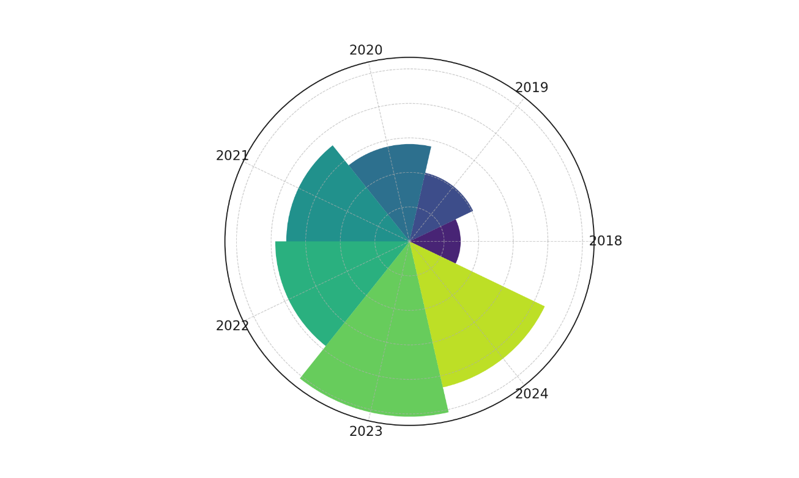

Figure 1: Polar Area Chart Depicting Yearly Incidence of Business Associate-Related Breaches (2018–2024)
An in-depth breakdown of breach typologies in 2024 (Figure 2) shows that hacking and IT incidents accounted for the majority (73.3%) of all vendor-related breaches. This dominance emphasizes the increasingly technical nature of threats targeting third-party platforms and underscores the imperative for advanced, proactive monitoring mechanisms.
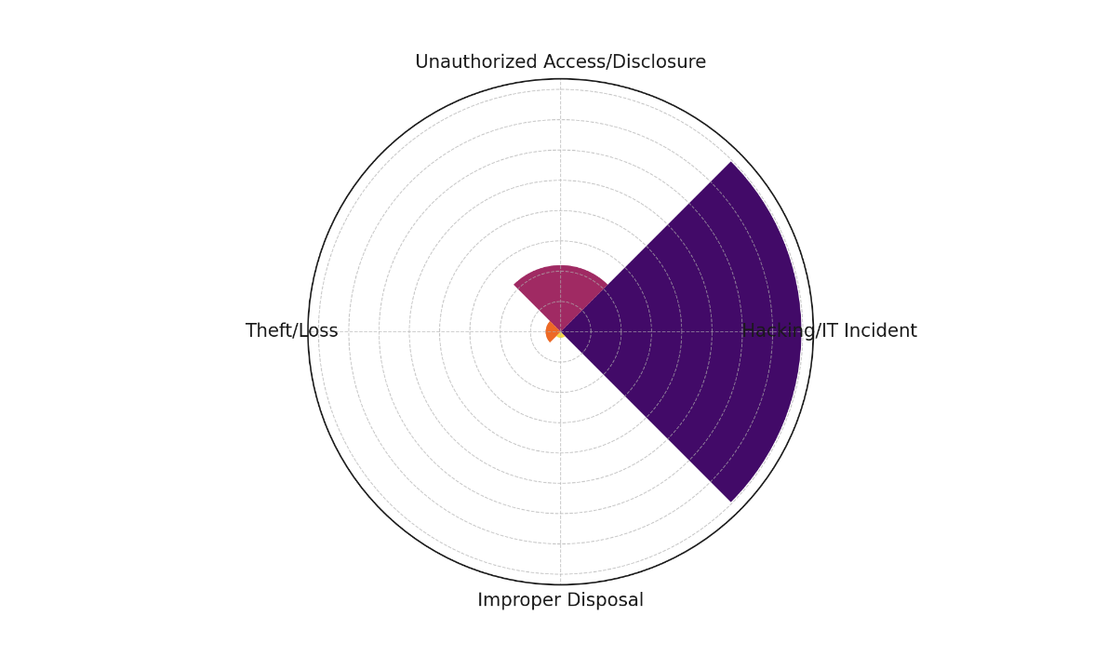

Figure 2: Radial Bar Chart Showing Breach Types Among Business Associates (2024)
Moreover, the disparity between average and median breach sizes (Figure 3) signals the presence of large-scale outlier events. While the median breach size in 2024 was just over 4,300 records, the average exceeded 378,000, driven by a few extraordinarily impactful incidents. This skew suggests that while many vendor-related breaches are relatively contained, rare catastrophic failures severely affect millions of individuals.
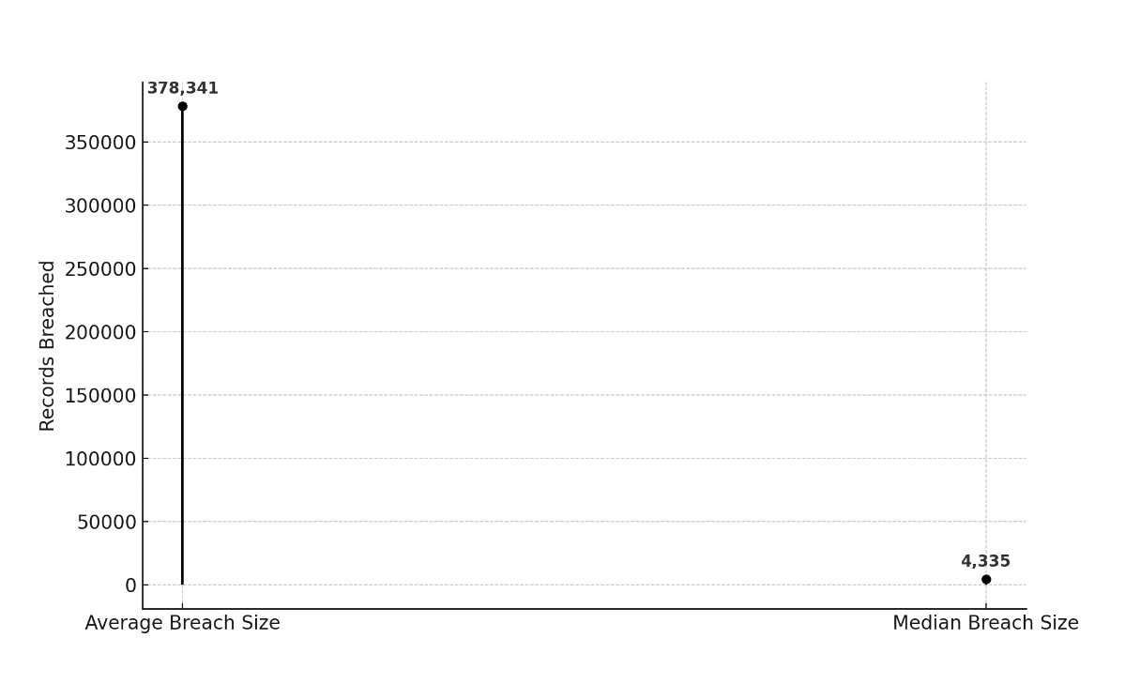

Figure 3: Lollipop Chart Comparing Average and Median Business Associate Breach Sizes (2024)
These insights collectively confirm that third-party vendors represent not only frequent breach origins but also significant vectors for large-scale data exposure. The findings strongly advocate for embedding intelligent risk assessment systems that provide continuous surveillance and real-time detection of vendor anomalies.
Examination of how artificial intelligence technologies are being utilized to assess, monitor, and mitigate vendor-related cybersecurity risks in healthcare systems.
The integration of artificial intelligence (AI) technologies into healthcare cybersecurity strategies has garnered increasing attention, particularly regarding their application in third-party risk management. As third-party vendors remain a prominent vector for data breaches, understanding the efficacy of AI tools in mitigating these risks is critical. This section explores whether the use of AI is statistically associated with reduced vendor-related cybersecurity breaches among healthcare institutions.
An analysis of AI adoption among healthcare institutions revealed significant differences in breach frequencies between AI adopters and non-adopters. Table 2 presents the distribution of vendor-related breaches segmented by AI adoption status. Among institutions that adopted AI for third-party risk management, only 22.5% reported a vendor-related breach. In contrast, 60% of those without AI adoption experienced such incidents, highlighting a stark contrast in breach outcomes.

Table 2: Cross-tabulation of AI Adoption and Vendor-Related Breaches in Healthcare Institutions
AI Adoption | Vendor Breach: Yes | Vendor Breach: No | Total
Adopted | 45 | 155 | 200
Not Adopted | 120 | 80 | 200
Total | 165 | 235 | 400
A chi-square test of independence confirmed a statistically significant relationship between AI adoption and vendor breach occurrence (χ²=63.17, p<0.001). The expected frequency analysis shown in Table 3 supports this result by revealing a substantial deviation between observed and expected breach rates under the assumption of no association.

Table 3: Expected Frequencies Under Null Hypothesis (No Association)
AI Adoption | Expected: Yes | Expected: No
Adopted | 82.5 | 117.5
Not Adopted | 82.5 | 117.5
Figure 4 visually reinforces the statistical results. The slope graph illustrates a sharp decline in breach incidents among institutions with AI adoption compared to a marked increase among those without. This directional contrast underscores AI's potential as a protective mechanism against third-party cyber threats.
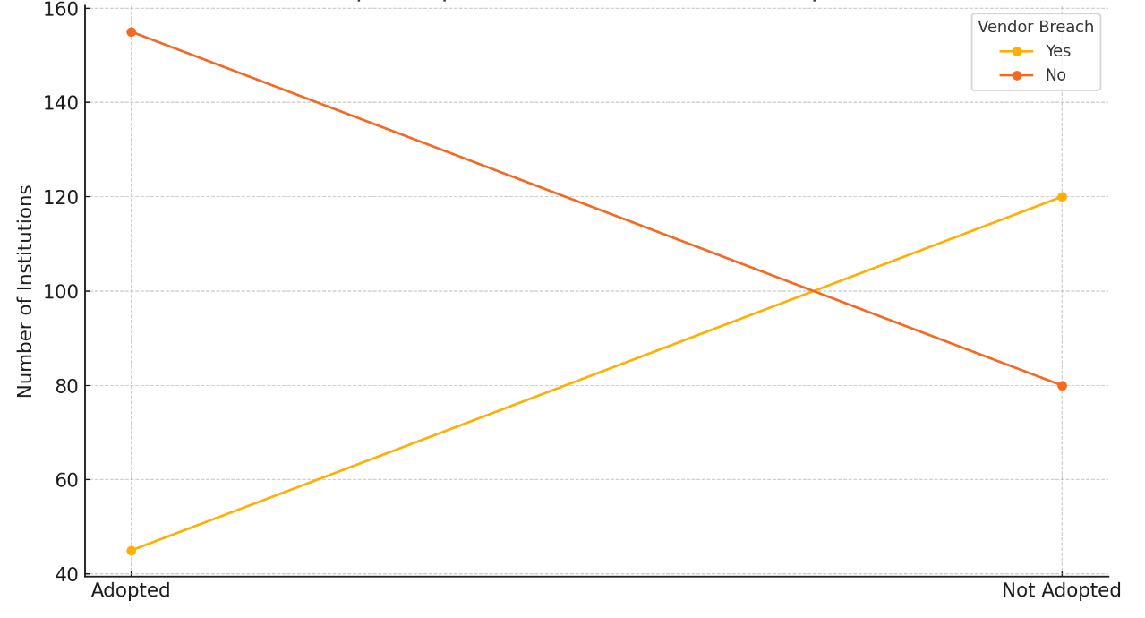
Figure 4: Slope Graph: Vendor Breach vs. AI Adoption
These findings collectively affirm that AI plays a critical role in mitigating vendor-related cybersecurity risks in healthcare. The observed correlation between AI integration and lower breach incidence suggests that intelligent monitoring systems may serve as a cornerstone in modernizing third-party risk governance frameworks.

Effectiveness of AI-driven risk assessment tools in reducing data breaches, enhancing compliance, and improving incident response in vendor-related scenarios.
To address the persistent threats posed by third-party vendors, healthcare institutions are increasingly adopting artificial intelligence (AI) tools designed to enhance breach prevention, compliance enforcement, and incident responsiveness. This section evaluates the effectiveness of AI-driven risk assessment solutions in improving breach outcomes, with emphasis on cost reduction, detection speed, and containment efficiency.
Regression analyses demonstrate a strong and statistically significant relationship between AI integration and improved breach outcomes across three critical metrics. As presented in Table 4, the coefficient for AI adoption is negative across all models, indicating reductions in breach cost, detection time, and containment time. The effect is most pronounced for detection speed, with a coefficient of -24.47 days and a very high explanatory power (R² = 0.916), suggesting that AI substantially enhances real-time response capabilities.

Table 4: Regression Analysis of AI Adoption on Breach Outcomes in Healthcare
Dependent Variable | AI Coefficient (β₁) | p-value for AI | R-squared | Interpretation
Breach Cost (USD Millions) | -2.84 | 0.0000 | 0.771 | AI reduces breach cost significantly
Time to Detect (Days) | -24.47 | 0.0000 | 0.916 | AI sharply lowers detection time
Time to Contain (Days) | -20.62 | 0.0000 | 0.813 | AI significantly speeds containment
Figure 5 provides a comparative view of the AI coefficient across each outcome metric. The visualization highlights the consistent negative slope, reinforcing the beneficial influence of AI adoption.

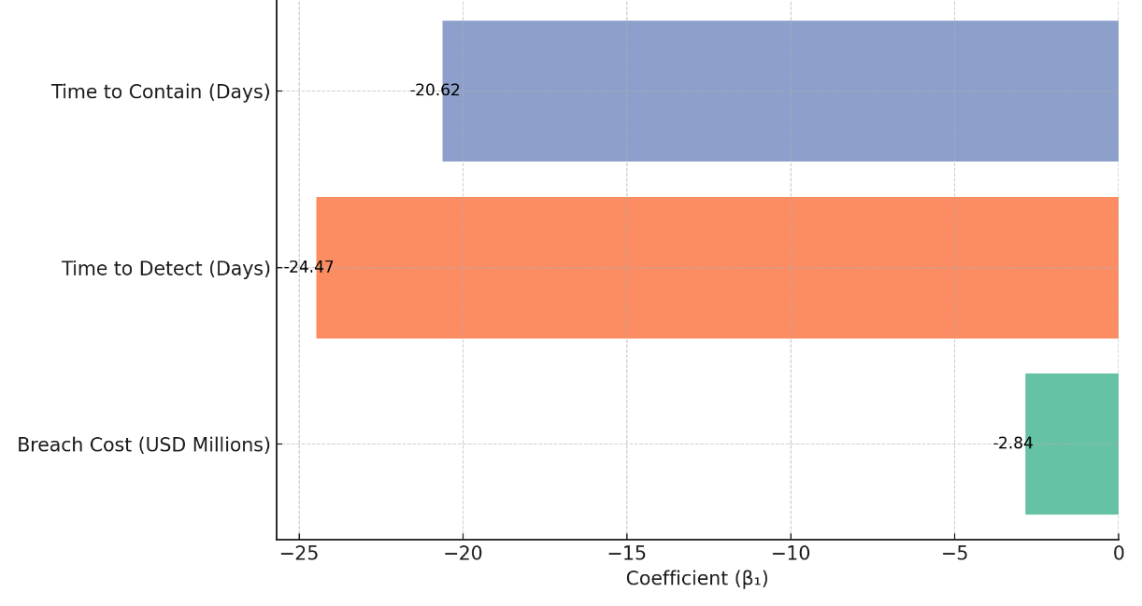

Figure 5: Impact of AI on Key Cybersecurity Metrics (AI Coefficients)

Further, Figure 6 illustrates the R-squared values for each model, which measure the proportion of variance in breach outcomes explained by AI use and other predictors. All values exceed 0.77, with particularly strong model fit for detection time, thereby validating the robustness of AI’s effect in practical settings.

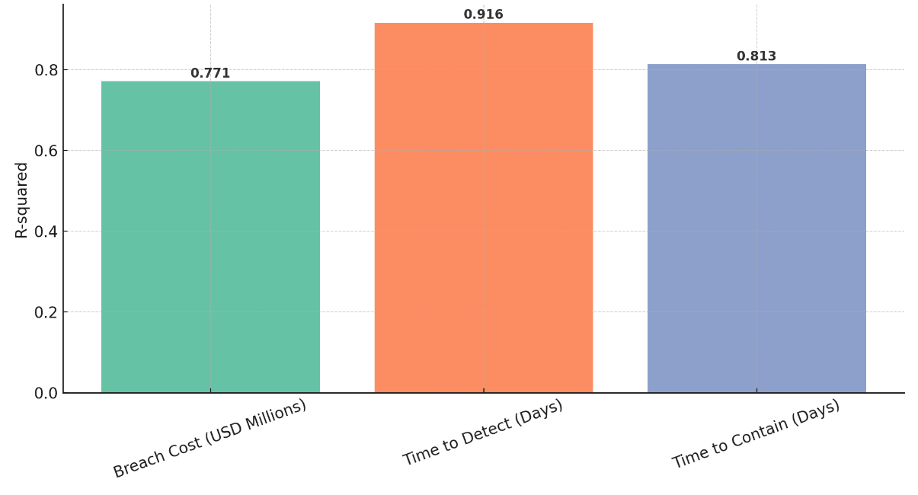

Figure 6: Model Fit for AI Influence on Breach Outcomes (R-squared)

These results underscore the operational and financial advantages of integrating AI into third-party cybersecurity frameworks. Healthcare institutions deploying AI tools benefit not only from cost savings but also from materially improved incident detection and containment, which are critical to maintaining compliance and trust in digitally driven healthcare ecosystems.
Discussion
The findings of this study substantiate the growing concerns highlighted in the literature regarding the cybersecurity vulnerabilities introduced through third-party vendor relationships in healthcare. Consistent with earlier observations by Coppinger (2023) and Olsen (2024), the analysis revealed a steep rise in third-party-associated data breaches between 2018 and 2024, with incidents peaking in 2023. Notably, this surge not only pertained to the frequency of breaches but also their severity, as over 82 million records were exposed through business associate-related incidents in 2024 alone. These patterns reflect the complex, expansive vendor ecosystems described by Henri and Seppänen (2022), where decentralized control often undermines effective oversight and heightens systemic risk.
Further aligning with the concerns raised by Ajayi et al. (2025) and Kolade et al. (2025), the study observed that hacking and IT incidents comprised the majority of breaches in 2024, underscoring the advanced technical capabilities of threat actors targeting healthcare vendor infrastructures. The large deviation between average and median breach sizes supports the assertions made by Salako et al. (2025) regarding the disproportionate impact of a few high-magnitude cyberattacks. These findings highlight the persistent inadequacies in traditional compliance-based risk management models that have been critiqued by Narayanan (2025) and Apptega (2021) for failing to adapt to evolving cyber threats in real-time environments.
A statistically significant association between AI adoption and reduced breach incidence was established through the chi-square analysis, validating projections made by Proofpoint (2023) and MSSP Alert (2025) on AI’s role in risk mitigation. Institutions employing AI technologies for vendor oversight were significantly less likely to experience breaches, a finding that substantiates Dhanaraj et al. (2020) and Zaher et al. (2025), who assert that AI enhances security posture through anomaly detection and predictive analytics. This association reinforces Mahmoud’s (2025) claim that AI enables healthcare organizations to transition from reactive to anticipatory cybersecurity frameworks, strengthening operational resilience against third-party threats.
Moreover, the regression analysis demonstrated that AI significantly improves breach response efficiency. The reduction in time-to-detect and time-to-contain, as indicated by the negative coefficients in all models, echoes the findings of Wickramasinghe (2023) and Aggarwal and Madhukar (2017), who emphasized the transformative power of AI in accelerating threat response cycles. These benefits are not merely operational but also economic, aligning with IBM’s (2024) report that AI-driven interventions reduce breach-related financial impacts by over $2 million on average. The high R-squared values across all models, particularly in detection metrics, offer strong empirical support to Kolhar (2024) and Kioskli et al. (2025), who argue that dynamic risk scoring powered by AI can drastically improve surveillance fidelity.
This research also affirms the necessity of contextualizing AI deployment within a strong regulatory and ethical framework, as advocated by Holzinger et al. (2024) and Prasad (2024). While the benefits of AI integration are clear, the discussion remains incomplete without acknowledging the potential for algorithmic opacity and bias. These risks underscore the importance of governance structures that ensure transparency, fairness, and accountability in AI-driven systems, particularly when applied to sensitive healthcare data and vendor ecosystems.
Ultimately, the evidence presented in this study not only validates the conceptual frameworks outlined by Argaw et al. (2020) and Chit and Vasudevan (2024) but also contributes novel empirical insights that reinforce the case for AI-enhanced third-party cybersecurity risk governance. These findings offer a compelling rationale for transitioning from periodic, static assessments to continuous, intelligence-driven oversight mechanisms that are responsive to the complexities and threats of modern digital healthcare environments

5. Conclusion and Recommendations
This study conclusively demonstrates that third-party vendors constitute a significant cybersecurity vulnerability in healthcare systems, and the adoption of AI markedly improves breach mitigation, cost reduction, and operational response. AI's impact was not only statistically significant but also practically meaningful, supporting its role as a transformative tool for vendor risk governance. The consistency of these results across breach frequency, detection, and containment validates the case for intelligent, real-time surveillance systems. In light of these findings, the following actions are recommended:
- Regulatory bodies should mandate AI-integrated monitoring as a compliance requirement for all third-party vendors handling sensitive health data.
- Healthcare institutions must invest in AI-enabled platforms that support dynamic risk scoring, automated anomaly detection, and predictive analytics for vendor oversight.
- Vendor agreements should include AI-audit clauses that enforce continuous security evaluation and allow for real-time threat intelligence sharing.
- National cybersecurity agencies should develop standardized AI governance frameworks to ensure transparency, fairness, and regulatory alignment across healthcare AI applications.

References
24By7Security. (2024). Security Governance Program - 24By7Security. 24by7security.com. https://doi.org/10865349/24By7Security_June2018_Theme
Abid, M., Nanda, P., & Mohanty, M. (2024). Incident Response Adaptive Metrics Framework. 2024 17th International Conference on Security of Information and Networks (SIN), 1–8. https://doi.org/10.1109/sin63213.2024.10871710
Aggarwal, M., & Madhukar, M. (2017). IBM’s Watson Analytics for Health Care: ResearchGate; unknown. https://www.researchgate.net/publication/316202671_IBM
AHA. (2024). New AHA Report: Hospitals and Health Systems Continue to Face Rising Costs, Economic Pressures | AHA. Www.aha.org. https://www.aha.org/press-releases/2024-05-02-new-aha-report-hospitals-and-health-systems-continue-face-rising-costs-economic-pressures
Ajayi, A. J., Joseph, S. A., Metibemu, O. C., Olutimehin, A. T., Balogun, A. Y., & Olaniyi, O. O. (2025). The Impact of Artificial Intelligence on Cyber Security in Digital Currency Transactions. Archives of Current Research International, 25(2), 329–351. https://doi.org/10.9734/acri/2025/v25i21090
Alao, A. I., Adebiyi, O. O., & Olaniyi, O. O. (2024). The Interconnectedness of Earnings Management, Corporate Governance Failures, and Global Economic Stability: A Critical Examination of the Impact of Earnings Manipulation on Financial Crises and Investor Trust in Global Markets. Asian Journal of Economics Business and Accounting, 24(11), 47–73. https://doi.org/10.9734/ajeba/2024/v24i111542
Alder, S. (2017). What are the Differences Between a HIPAA Business Associate and HIPAA Covered Entity. HIPAA Journal. https://www.hipaajournal.com/differences-hipaa-business-associate-hipaa-covered-entity/
Alder, S. (2024). Security breaches in healthcare in 2023. HIPAA Journal. https://www.hipaajournal.com/security-breaches-in-healthcare/
Alder, S. (2025). Healthcare Data Breach Statistics. HIPAA Journal. https://www.hipaajournal.com/healthcare-data-breach-statistics/
Aljohani, A. (2023). Predictive Analytics and Machine Learning for Real-Time Supply Chain Risk Mitigation and Agility. Sustainability, 15(20), 15088. mdpi. https://doi.org/10.3390/su152015088
Alshammari, B., & Singh, M. M. (2025). A Systematic Literature Review on Tackling Cyber Threats for Cyber Logistic Chain and Conceptual Frameworks for Robust Detection Mechanisms. IEEE Access, 1–1. https://doi.org/10.1109/access.2025.3552689
Ancell , N. (2024). HealthEquity reveals breach affected over four million people | Cybernews. Cybernews. https://cybernews.com/news/healthequity-breach-affects-millions/
Apptega. (2021). 10 Reasons Check-the-Box Compliance Puts Your Organization at Risk | Apptega. Www.apptega.com. https://www.apptega.com/blog/check-the-box-compliance
Argaw, S. T., Pastoriza, J. R. T., Lacey, D., Florin, M.-V., Calcavecchia, F., Anderson, D., Burleson, W., Vogel, J.-M., O’Leary, C., Chauvin, B. E., & Flahault, A. (2020). Cybersecurity of Hospitals: discussing the challenges and working towards mitigating the risks. BMC Medical Informatics and Decision Making, 20(1). https://doi.org/10.1186/s12911-020-01161-7
Armon, B. D., & Leone, A. M. (2024). HHS OCR Issues Its Most Recent HIPAA Annual Report and a Second Ransomware Settlement. Saul Ewing LLP. https://www.saul.com/insights/alert/hhs-ocr-issues-its-most-recent-hipaa-annual-report-and-second-ransomware-settlement
Balogun, A. Y. (2025). Strengthening Compliance with Data Privacy Regulations in U.S. Healthcare Cybersecurity. Asian Journal of Research in Computer Science, 18(1), 154–173. https://doi.org/10.9734/ajrcos/2025/v18i1555
Balogun, A. Y., Alao, A. I., & Olaniyi, O. O. (2025). Disinformation in the digital era: The role of deepfakes, artificial intelligence, and open-source intelligence in shaping public trust and policy responses. Computer Science & IT Research Journal, 6(2), 28–48. https://doi.org/10.51594/csitrj.v6i2.1824
Balogun, A. Y., Metibemu, O. C., Olutimehin, A. T., Ajayi, A. J., Babarinde, D. C., & Olaniyi, O. O. (2025). The Ethical and Legal Implications of Shadow AI in Sensitive Industries: A Focus on Healthcare, Finance and Education. Journal of Engineering Research and Reports, 27(3), 1–22. https://doi.org/10.9734/jerr/2025/v27i31414
Balogun, A. Y., Olaniyi, O. O., & Alao, A. I. (2025). Shaping trust and tension: Strategic leaks and their impact on global cybersecurity norms. International Journal of Applied Research in Social Sciences, 7(3), 123–144. https://doi.org/10.51594/ijarss.v7i3.1823
Balogun, A. Y., Olaniyi, O. O., Olisa, A. O., Gbadebo, M. O., & Chinye, N. C. (2025). Enhancing Incident Response Strategies in U.S. Healthcare Cybersecurity. Journal of Engineering Research and Reports, 27(2), 114–135. https://doi.org/10.9734/jerr/2025/v27i21399
Berry, L. L., Letchuman, S., Ramani, N., & Barach, P. (2021). The High Stakes of Outsourcing in Health Care. Mayo Clinic Proceedings, 0(0). https://doi.org/10.1016/j.mayocp.2021.07.003
Black Kite, B. (2021). 5 Lessons Learned from the Largest Third-Party Breaches in 2020 - Black Kite. Black Kite. https://blackkite.com/blog/five-lessons-learned-from-the-largest-third-party-breaches-in-2020/
BusinessWire. (2025). Virtue AI Raises $30 Million in Seed and Series A Funding to Bridge the Critical AI Security Gap. Morningstar, Inc. https://www.morningstar.com/news/business-wire/20250415693312/virtue-ai-raises-30-million-in-seed-and-series-a-funding-to-bridge-the-critical-ai-security-gap
Chit, I., & Vasudevan, R. (2024). Navigating Compliance: Strategic Approaches Across Industries An Examination of Organizational Structures and Responses to Regulatory Changes. Odr.chalmers.se. https://odr.chalmers.se/items/7da84bd3-722d-4851-800f-42bd0cde4952
Chopra, S. (2023). HIPAA Business Associate Agreement: The Essential Guide. Impanix. https://impanix.com/hipaa/hipaa-business-associate-agreement/
Coppinger, N. (2023). Varonis Launches Third-Party App Risk Management. Varonis.com; Varonis. https://www.varonis.com/blog/third-party-app-risk-saas
DarkTrace. (2024). Darktrace. Darktrace.com. https://www.darktrace.com/ja/news/major-hospital-group-fights-back-cyber-threats-with-darktrace-ai
Dhanaraj, R. K., Rajkumar, K., & Hariharan, U. (2020). Enterprise IoT Modeling: Supervised, Unsupervised, and Reinforcement Learning. Business Intelligence for Enterprise Internet of Things, 55–79. https://doi.org/10.1007/978-3-030-44407-5_3
Dhawan, K., Tookey, J. E., GhaffarianHoseini, A., & Poshdar, M. (2023). Using Transport to Quantify the Impact of Vertical Integration on the Construction Supply Chain: A New Zealand Assessment. Sustainability, 15(2), 1298. https://doi.org/10.3390/su15021298
Firch, J. (2024). Accellion Data Breach: What Happened & Who Was Impacted? PurpleSec. https://purplesec.us/breach-report/accellion-data-breach/
Fox, A. (2024). Healthcare leads in third-party data breaches, says new report. Healthcare IT News. https://www.healthcareitnews.com/news/healthcare-leads-third-party-data-breaches-says-new-report
Henri, P., & Seppänen, M. (2022). UNDERSTANDING THE SUPPORT NEEDS OF SYSTEM INTEGRATORS IN A SOFTWARE-AS-A-SERVICE BASED INDEPENDENT SOFTWARE VENDOR. https://trepo.tuni.fi/bitstream/handle/10024/141588/SanwalMohit.pdf?sequence=2
Holzinger, A., Zatloukal, K., & Müller, H. (2024). Is human oversight to AI systems still possible? New Biotechnology, 85, 59–62. https://doi.org/10.1016/j.nbt.2024.12.003
Hossain, M. T., Afrin, R., & Biswas, M. A.-A. (2024). A Review on Attacks against Artificial Intelligence (AI) and Their Defence Image Recognition and Generation Machine Learning, Artificial Intelligence. Control Systems and Optimization Letters, 2(1), 52–59. https://doi.org/10.59247/csol.v2i1.73
IBM. (2024). Cost of a Data Breach 2024. IBM. https://www.ibm.com/reports/data-breach
Idrissi , Y. S. (2023). Fortifying Data Intelligence: Enhancing Security with IBM Watson. Ibm.com. https://community.ibm.com/community/user/ai-datascience/blogs/youssef-sbai-idrissi1/2023/09/01/fortifying-data-intelligence-enhancing-security-wi
Ilori, O., Nwosu, N. T., & Naiho, H. N. N. (2024). Third-party vendor risks in IT security: A comprehensive audit review and mitigation strategies. World Journal of Advanced Research and Reviews, 22(3), 213–224. https://doi.org/10.30574/wjarr.2024.22.3.1727
Isibor, E. (2024). Regulation of Healthcare Data Security: Legal Obligations in A Digital Age. Regulation of Healthcare Data Security: Legal Obligations in a Digital Age. https://doi.org/10.2139/ssrn.4957244
Kalusivalingam, A. K., Sharma, A., Patel, N., & Singh, V. (2020). Optimizing Decision-Making with AI-Enhanced Support Systems: Leveraging Reinforcement Learning and Bayesian Networks. International Journal of AI and ML, 1(2). https://www.cognitivecomputingjournal.com/index.php/IJAIML-V1/article/view/59
Kavitha, D., & Thejas, S. (2024). AI Enabled Threat Detection: Leveraging Artificial Intelligence for Advanced Security and Cyber Threat Mitigation. IEEE Access, 12, 1–1. https://doi.org/10.1109/access.2024.3493957
Kioskli, K., Grigoriou, E., Islam, S., Yiorkas, A. M., Christofi, L., & Mouratidis, H. (2025). A risk and conformity assessment framework to ensure security and resilience of healthcare systems and medical supply chain. International Journal of Information Security, 24(2). https://doi.org/10.1007/s10207-025-01009-z
Kolade, T. M., Obioha-Val, O. A., Balogun, A. Y., Gbadebo, M. O., & Olaniyi, O. O. (2025). AI-Driven Open Source Intelligence in Cyber Defense: A Double-edged Sword for National Security. Asian Journal of Research in Computer Science, 18(1), 133–153. https://doi.org/10.9734/ajrcos/2025/v18i1554
Kolhar, A. (2024). Future Trends and Innovation in Machine Intelligence for Cyber Risk Management. Advances in Computational Intelligence and Robotics Book Series, 415–438. https://doi.org/10.4018/979-8-3693-7540-2.ch018
KPMG. (2023). KPMG global tech report 2023: Healthcare sector insights. KPMG. https://kpmg.com/xx/en/our-insights/ai-and-technology/kpmg-global-tech-report-2023-healthcare-sector-insights.html
Kulkov, I., Kulkova, J., Rohrbeck, R., Menvielle, L., Kaartemo, V., & Makkonen, H. (2023). Artificial intelligence ‐ driven sustainable development: Examining organizational, technical, and processing approaches to achieving global goals. Sustainable Development, 32(3), 2253–2267. https://doi.org/10.1002/sd.2773
Lakshan, A. M. I., Low, M., & de Villiers, C. (2021). Management of risks associated with the disclosure of future-oriented information in integrated reports. Sustainability Accounting, Management and Policy Journal, 12(2), 241–266. https://doi.org/10.1108/sampj-03-2019-0114
Lavoipierre, A. (2024). MediSecure “not in a financial position” to identify 12.9m Australians who had data stolen. ABC News. https://www.abc.net.au/news/2024-07-18/medisecure-data-cyber-hack-12-million/104112736
Li, X., Liang, X., Wang, X., Wang, R., Shu, L., & Xu, W. (2023). Deep reinforcement learning for optimal rescue path planning in uncertain and complex urban pluvial flood scenarios. Applied Soft Computing, 144, 110543–110543. https://doi.org/10.1016/j.asoc.2023.110543
Mahmoud, E. (2025). Enhancing hosting infrastructure management with AI-powered automation. Theseus.fi. http://www.theseus.fi/handle/10024/882571
Mathew, A. (2019). Cloud Data Sovereignty Governance and Risk Implications of Cross-Border Cloud Storage. ISACA. https://www.isaca.org/resources/news-and-trends/industry-news/2024/cloud-data-sovereignty-governance-and-risk-implications-of-cross-border-cloud-storage
Mattila, S. (2024). Third-Party Risk Management in Healthcare: A Complete Guide. Intraprise Health. https://intraprisehealth.com/third-party-risk-management-in-healthcare-a-complete-guide/
McGee, M. K. (2024). How Healthcare Cyberattacks Broke Records in 2024. Govinfosecurity.com. https://www.govinfosecurity.com/how-healthcare-cyberattacks-broke-records-in-2024-a-27116
Metibemu, O. C., Adesokan-Imran, T. O., Ajayi, A. J., Tiwo, O. J., Olutimehin, A. T., & Olaniyi, O. O. (2025). Developing Proactive Threat Mitigation Strategies for Cloud Misconfiguration Risks in Financial SaaS Applications. Journal of Engineering Research and Reports, 27(3), 393–413. https://doi.org/10.9734/jerr/2025/v27i31442
Mitratech. (2025). Vendor Due Diligence Strategy and Checklist. Mitratech. https://mitratech.com/resource-hub/blog/vendor-due-diligence/
Morris, K. (2024). HITRUST vs. ISO 27001: A Comprehensive Comparison. Security Boulevard. https://securityboulevard.com/2024/08/hitrust-vs-iso-27001-a-comprehensive-comparison/
MSSP Alert. (2025). AI Adoption For Cybersecurity Healthcare Poised For Surge. MSSP Alert. https://www.msspalert.com/brief/ai-adoption-for-cybersecurity-healthcare-poised-for-surge
Narayanan, D. (2025). HITRUST Ensuring Security and Compliance with Global Standard of Information Protection. VComply. https://www.v-comply.com/blog/hitrust-security-compliance-information-protection/
Newman, L. H. (2021). The Accellion Breach Keeps Getting Worse—and More Expensive. Wired. https://www.wired.com/story/accellion-breach-victims-extortion/
NIST. (2024). NIST Risk Management Framework. NIST. https://csrc.nist.gov/projects/risk-management/about-rmf
Obioha-Val, O. A. (2025). Bridging Gaps in Cybersecurity Governance: Leveraging Collaborative Digital Solutions. Asian Journal of Research in Computer Science, 18(2), 82–100. https://doi.org/10.9734/ajrcos/2025/v18i2564
Obioha-Val, O. A., Gbadebo, M. O., Olaniyi, O. O., Chinye, N. C., & Balogun, A. Y. (2025). Innovative Regulation of Open Source Intelligence and Deepfakes AI in Managing Public Trust. Journal of Engineering Research and Reports, 27(2), 136–156. https://doi.org/10.9734/jerr/2025/v27i21400
Obioha-Val, O. A., Lawal, T. I., Olaniyi, O. O., Gbadebo, M. O., & Olisa, A. O. (2025). Investigating the Feasibility and Risks of Leveraging Artificial Intelligence and Open Source Intelligence to Manage Predictive Cyber Threat Models. Journal of Engineering Research and Reports, 27(2), 10–28. https://doi.org/10.9734/jerr/2025/v27i21390
Obioha-Val, O. A., Olaniyi, O. O., Gbadebo, M. O., Balogun, A. Y., & Olisa, A. O. (2025). Cyber Espionage in the Age of Artificial Intelligence: A Comparative Study of State-Sponsored Campaign. Asian Journal of Research in Computer Science, 18(1), 184–204. https://doi.org/10.9734/ajrcos/2025/v18i1557
Olsen, E. (2024). Average cost of healthcare data breach nearly $10M in 2024: report. Healthcare Dive. https://www.healthcaredive.com/news/healthcare-data-breach-costs-2024-ibm-ponemon-institute/722958/
Olutimehin, A. T. (2025a). Advancing Cloud Security in Digital Finance: AI-Driven Threat Detection, Cryptographic Solutions, and Privacy Challenges. Journal of Engineering Research and Reports, 27(3), 35–55. https://doi.org/10.9734/jerr/2025/v27i31416
Olutimehin, A. T. (2025b). Assessing the Effectiveness of Cybersecurity Frameworks in Mitigating Cyberattacks in the Banking Sector and its Applicability to Decentralized Finance (DeFi). Asian Journal of Research in Computer Science, 18(3), 130–151. https://doi.org/10.9734/ajrcos/2025/v18i3583
Olutimehin, A. T. (2025c). The Synergistic Role of Machine Learning, Deep Learning, and Reinforcement Learning in Strengthening Cyber Security Measures for Crypto Currency Platforms. Asian Journal of Research in Computer Science, 18(3), 190–212. https://doi.org/10.9734/ajrcos/2025/v18i3586
Olutimehin, A. T., Ajayi, A. J., Metibemu, O. C., Balogun, A. Y., Oladoyinbo, T. O., & Olaniyi, O. O. (2025). Adversarial Threats to AI-Driven Systems: Exploring the Attack Surface of Machine Learning Models and Countermeasures. Journal of Engineering Research and Reports, 27(2), 341–362. https://doi.org/10.9734/jerr/2025/v27i21413
Olutimehin, A. T., Joseph, S. A., Ajayi, A. J., Metibemu, O. C., Balogun, A. Y., & Olaniyi, O. O. (2025). Future-Proofing Data: Assessing the Feasibility of Post-Quantum Cryptographic Algorithms to Mitigate “Harvest Now, Decrypt Later” Attacks. Archives of Current Research International, 25(3), 60–80. https://doi.org/10.9734/acri/2025/v25i31098
Oyekunle, S. M., Tiwo, O. J., Adesokan-Imran, T. O., Ajayi, A. J., Salako, A. O., & Olaniyi, O. O. (2025). Enhancing Data Resilience in Cloud-based Electronics Health Records through Ransomware Mitigation Strategies Using NIST and MITRE ATT&CK Frameworks. Journal of Engineering Research and Reports, 27(3), 436–457. https://doi.org/10.9734/jerr/2025/v27i31444
Özeren, S. (2025). ALPHV Ransomware: Analyzing the BlackCat After Change Healthcare Attack. Picussecurity.com; Picus Security. https://www.picussecurity.com/resource/blog/alphv-ransomware
Prasad, A. N. (2024). Introduction to Data Governance for Machine Learning Systems. In Apress eBooks. Springer. https://doi.org/10.1007/979-8-8688-1023-7
Procyk , K. (2025). $10 Million Investment from Leidos to Accelerate AI Tools in Health Care | School of Medicine | University of Pittsburgh. Pitt.edu. https://www.medschool.pitt.edu/news/10-million-investment-leidos-accelerate-ai-tools-health-care
Proofpoint. (2023). 2023 Ponemon Healthcare Cybersecurity Report | Proofpoint US. Proofpoint. https://www.proofpoint.com/us/resources/threat-reports/ponemon-healthcare-cybersecurity-report
Salako, A. O., Adesokan-Imran, T. O., Tiwo, O. J., Metibemu, O. C., Onyenaucheya, O. S., & Olaniyi, O. O. (2025). Securing Confidentiality in Distributed Ledger Systems with Secure Multi-party Computation for Financial Data Protection. Journal of Engineering Research and Reports, 27(3), 352–373. https://doi.org/10.9734/jerr/2025/v27i31439
Salami, I. A., Adesokan-Imran, T. O., Tiwo, O. J., Metibemu, O. C., Olutimehin, A. T., & Olaniyi, O. O. (2025). Addressing Bias and Data Privacy Concerns in AI-Driven Credit Scoring Systems Through Cybersecurity Risk Assessment. Asian Journal of Research in Computer Science, 18(4), 59–82. https://doi.org/10.9734/ajrcos/2025/v18i4608
Schmeelk, S. (2021). Risk in Healthcare Information Technology: Creating a Standardized Risk Assessment Framework. Www.intechopen.com; IntechOpen. https://www.intechopen.com/chapters/78860
Shandilya, S. K., Datta, A., Kartik, Y., & Nagar, A. (2024). Navigating the Regulatory Landscape. EAI/Springer Innovations in Communication and Computing, 127–240. https://doi.org/10.1007/978-3-031-53290-0_3
Sissodia, R., Rauthan, M. S., & Barthwal, V. (2024). Service Level Agreements (SLAs) and Their Role in Establishing Trust. Www.igi-Global.com; IGI Global. https://www.igi-global.com/chapter/service-level-agreements-slas-and-their-role-in-establishing-trust/340597
Sousa, R., Peixoto, H., Abelha, A., & Machado, J. (2023). Implementing a Software-as-a-Service Strategy in Healthcare Workflows. Lecture Notes in Networks and Systems, 347–356. https://doi.org/10.1007/978-3-031-38333-5_35
Tiwo, O. J., Adesokan-Imran, T. O., Babarinde, D. C., Oyekunle, S. M., Olutimehin, A. T., & Olaniyi, O. O. (2025). Advancing Security in Cloud-based Patient Information Systems with Quantum-resistant Encryption for Healthcare Data. Asian Journal of Research in Computer Science, 18(4), 187–208. https://doi.org/10.9734/ajrcos/2025/v18i4615
Tiwo, O. J., Adesokan-Imran, T. O., Babarinde, D. C., Salami, I. A., Onyenaucheya, O. S., & Olaniyi, O. O. (2025). Improving Patient Data Privacy and Authentication Protocols against AI-Powered Phishing Attacks in Telemedicine. Asian Journal of Research in Computer Science, 18(4), 93–114. https://doi.org/10.9734/ajrcos/2025/v18i4610
Verma, K. K., Singh, B. M., & Dixit, A. (2019). A review of supervised and unsupervised machine learning techniques for suspicious behavior recognition in intelligent surveillance system. International Journal of Information Technology, 14(1). https://doi.org/10.1007/s41870-019-00364-0
Wickramasinghe, A. (2023). An Evaluation of Big Data-Driven Artificial Intelligence Algorithms for Automated Cybersecurity Risk Assessment and Mitigation. International Journal of Cybersecurity Risk Management, Forensics, and Compliance, 7(12), 1–15. http://hashsci.com/index.php/IJCRFC/article/view/2023-12-04
Wodecki, B. (2023). IBM: Tap AI, DevSecOps and Law Enforcement to Cut Data Breach Costs. Aibusiness.com. https://aibusiness.com/verticals/ibm-survey-security-ai-reduces-data-breach-costs
Zaher, N., Gandoul, R., Ghazouani, M., & Chafiq, N. (2025). IJTPE Journal AI-DRIVEN NLP FOR AUTOMATED REGULATORY COMPLIANCE VERIFICATION: A DEEP LEARNING-BASED APPROACH. International Journal on Technical and Physical Problems of Engineering (IJTPE) Issue, 62, 383–391. http://www.iotpe.com/IJTPE/IJTPE-2025/IJTPE-Issue62-Vol17-No1-Mar2025/40-IJTPE-Issue62-Vol17-No1-Mar2025-pp383-391.pdf
Zheng, C., Wong, S., Su, X., Tang, Y., Nawaz, A., & KASSEM, M. (2024). Enhancing Large Language Models with Knowledge Graphs for Automated Construction Contract Review. SSRN . https://doi.org/10.2139/ssrn.4946908

