Original Research Article
Design and Development of a castor seed shelling and separation machine with finite element analysis of the shelling drum.

ABSTRACT
The development and performance evaluation of a locally developed castor seeds shelling and separating machine was carried out with a view of modelling its shelling drum. The machine was developed in order to reduce the drudgery associated with the processing of castor seeds into oil. The machine consists of two major compartments, the shelling unit and the separation unit (Blower and Shaker mechanism). A separation unit was incorporated to facilitate easy and proper cleaning and separation of the seeds from the chaffs while the finite element analysis of the shelling drum was performed in order to ensure that it satisfies all the design criteria and it does not fail during operation. The performance of the machine was evaluated using two different varieties of castor seeds (Brazilian white and Brazilian black and white) at three different speeds (235 rpm, 260 rpm and 300 rpm) and two concave clearance (10 mm and 15 mm) using 1000 g of both castor varieties. The evaluation was reported using shelling efficiency, seed recovery, separation efficiency and percentage damage as the performance indices. The results show that the shelling efficiency ranged from 74 to 94.4 %, the seed recovery ranged from 25.2 to 59.4 %, the separation efficiency ranged from 64.8 to 96.8 % and the percentage damage ranged from 4.8 to 57.2 %. It can be concluded, that the developed machine performed better at 260 rpm and 15 mm concave clearance compared to the other speeds and concave clearance.
Keywords: castor shelling machine, modelling, development, evaluation, efficiency, shelling drum.
- INTRODUCTION
Castor seed (Ricinus communis L.) belongs to the family Eurphorbiacae (Kirk-Othmer, 1979) and is an oil seed crop with lots of potential. The castor seed is considered native to tropical Africa and is grown widely in arid and semi-arid regions (Yakubu et al., 2020). It is abundant in the North eastern states especially southern part of Borno state and South Eastern states of Nigeria (Ojediran et al., 2013). It is adapted to many types of soil but thrives best on well drained, salt-free and non-compact or pervious soil. It can grow under hot wet and dry conditions (Benagro, 2007). Even though the oil produced from its seed is inedible, it has long been an article of commerce due to its versatility (Ogunniyi, 2006). The oil has a bland taste and is often times used as a purgative. Also, it is an important raw material for pharmaceutical industries, biofuels, varnishes and paint production (Gely and Santalla, 2009; Severino et al., 2012) while the cake is mainly used as a fertilizer but is unsuitable as an animal feed because of the presence of ricin (Ogunniyi, 2006). Before the oil is extracted from castor seeds, the castor pods from the field must undergo a series of processing operations of which shelling and separation/cleaning are important.
The shelling of seeds has been described as the process by which the outer covering of the seeds is removed for further processing of such crops. (Kurien, 1977; Uzo, 1981; Onoja, 1982) defined shelling as the process of removing the fibrous coloured hulls of leguminous seeds. The shell contributes very little to the food value hence they can be disposed of (Onoja 1982). There are two primary methods of shelling castor seeds: traditional and mechanical. The traditional method involves minimal modern technology and requires sun drying the seeds until the casing splits and manually picking out the seeds (Nkpa et al., 1989) which is time-consuming and labor intensive while the mechanical method usually involve the use of attrition mechanism according to research conducted by Oriah et al., 1999; Balami et al., 2012; Pius et al., 2014; Gbabo et al., 2016.
Developed countries have two types of mechanical castor seed shellers available: Hand-operated and power-operated. The hand-powered sheller configuration is such that it has an arrangement of bars that threshes the castor pods as it is being operated while the power-operated shellers consist of rubber-covered vertical discs, where one disc remains stationary while the other rotates via an electric motor. (Schoenleber and Taylor, 1954). However, in Nigeria, castor is processed locally using the traditional method that requires little or no modern technology. The seeds are separated from the spiny husk by prolonged sun drying until the casing splits, or they are beaten or rubbed with a wooden plank. In most parts of the country, the pods are collected into heaps after harvest, and water is sprinkled over them to soften the husk and facilitate dehusking. However, prolonged exposure of castor to sun or heat adversely affects the oil content of the seed. The traditional method of processing castor is time-consuming, laborious, and energy sapping, resulting in low productivity which shows that there is a need to develop more efficient and effective methods for shelling castor seeds to increase productivity and improve the quality of oil extraction. Mechanical methods, such as power-operated shellers, may provide a solution to this problem. After shelling operation, the shells of the castor seed need to be separated from the seeds. This is normally done by winnowing using a blower mechanism followed by cleaning using screens.
Winnowing is a process that separates heavier and lighter materials based on their density. In the case of castor seeds, winnowing is used to remove the outer shell, which is lighter than the seed kernel. This process is done by exposing the castor seeds to a stream of air that blows away the outer shell while leaving the kernel intact. Cleaning is a process that removes foreign materials, such as stones, dirt, and other impurities, from the harvested crops. In the case of castor seeds, cleaning is done after winnowing to remove any remaining impurities. This process is achieved by passing the castor seeds through a series of screens and sieves of different sizes. The screens and sieves are designed to remove impurities of different sizes. Sale (2017) reported that cleaning process present severe challenge than actual shelling process while Ali et al. (2014) reported that winnowing time is 46.6% higher than the shelling time. Ali (1986) reported that traditional methods of shelling and subsequent cleaning of seeds are physically demanding and energy sapping on the person performing the operation. Small scale producers, who accounted for 90% of the total agricultural production, are not using improved technology (RUSEP, 2001). This had led to decreased efficiency in terms of productivity, reduction in quality and quantity of products and puts enormous strains on the labour force. To combat this, previous researches on the development of castor shelling machine either focused on just mechanizing the shelling operation such as Duraisamy and Manian (1990) who developed a hand and power operated castor bean sheller or combined mechanizing both the shelling and winnowing operation such as Oriah et al., (1999), Balami et al., (2012), Pius et al., (2014) and Gbabo et al., (2016) but there is the need to also mechanize the cleaning operation as castor seeds is recently experiencing increasing demand. Therefore, the objective of this study was to design and develop a castor seed shelling and separating machine which incorporates both a shaker and blower mechanism. Also included is the finite element analysis of the rubberized shelling drum to simulate its operating conditions and to assess the stresses, deformations, displacements, and strains induced in it.
- METHODOLOGY
  - Design of the machine component parts
The components of the castor seed shelling machine were designed following required standards as described below:
    - Design of the Hopper.
The hopper/feeding unit is designed to be in a frustrum-like form with two of its sides slanted to allow for the ease of flow of the castor feed material into the machine for the shelling operation. The volume of the hopper was calculated using equation 1 below:
$v=m/ρ$…………………………………… (equation 1)
Where; m = mass of the feed material
$ρ$ = density of the feed material
v = volume of the hopper.
Taking into consideration that the machine is to shell 2 kg of castor fruits per batch and the density of castor fruit is 0.57 g/cm⁻³ (Ahmed et al., 2013), the volume of the hopper was $0.00351 m^{3}$ while the hopper angle was calculated to be $23.27 °$using equation 2 below:
$θ=\tan^{-1}(μ)$ ……………………………………… (equation 2)
Where; $θ$ = hopper angle and
$μ$ = coefficient of static friction of between castor seeds and mild steel (ranges from 0.39 to 0.43 according to Ojolo et al., 2019)
With the assumption that the top and base of the hopper is square shaped while the height is 20 cm, the dimensions of the sides of the hopper ($S1=16.47 cm and S2=22.08 cm)$ was determined according to Gupta (2011) using equation 3 and 4 below:
$S1={(\frac{V×\frac{3}{\tan\left(θ\right)}}{h+\sqrt{h^{2}+3V×\tan\left(θ\right)}})}^{0.5}$………………………………… (equation 3)
$S2={(\frac{V×\frac{3}{\tan\left(θ\right)}}{(\sqrt{h^{2}+3V×\tan\left(θ\right)}-h})}^{0.5}$………………………………… (equation 4)
Where; S1 = length of the hopper base
S2 = length of the hopper top
V = volume of the hopper
$θ$ = hopper angle and
h = height of the hopper.
    - Design of the shelling drum
The shelling drum will also house the shaft and the threshing combs and vanes. It is 51 cm long, cylindrical in form (to ensure all the castor seeds introduced into the machine are shelled) and is to accommodate at least 8 batches of castor seeds fed from the hopper, the diameter of the drum was calculated to be 30 cm using equation 5 below:
$8v ×f=πr^{2}h$ ……………………………………………. (equation 5)
Where; $v$ = volume of the shelling drum
$f$ = (1.25) factor taking into consideration the volume of the shaft and threshing combs.
r = radius of the shelling drum and
h = height (length) of the shelling drum.
    - Design of the screen
The screen to be used in the machine was designed taking into consideration the physical properties of the castor seeds such as the length, width, thickness and mean diameter to determine the open area and holes on the screen. According to Lorestani et al., (2012), the average length, width, thickness and mean diameter of castor seeds are 13.52, 13.39,13.38 and 13.43 mm so the screen holes was calculated to be 1.4 cm using equation 6 below:
$Screen hole= \frac{L+W+T+D}{4}$………………………………. (equation 6)
Where; $l$ = average length of the castor seeds
$w$ = average width of the castor seeds
T = average thickness of the castor seeds and
D = mean diameter of the castor seeds.
Using a screen of radius 150 mm, according to Tiwari (2015), for efficient sieving, the coefficient of open area ($C_{O}$) must be between 30 – 40 %. Using equation 7 below, the $C_{O}$for the screen was calculated to be $32.27 \%$ which is between 30 – 40 %.
$C_{O}=\frac{open area}{Total area}×100$ ……………………………………. (equation 7)
    - Design of the power required to shell and winnow castor seeds
The quantity of castor seeds required to be dehulled by the shelling machine is 16 kg, and the total power ($P_{t}$) required by the machine was calculated to be 3.5 hp using equation 8 below:
$P_{t}=P_{s}+P_{b}+ P_{sha}$ …………… (equation 8)
Where; $P_{t}=Total power$
$$P_{s}=Power required for shelling$$
$$P_{b}=Power required for blowing and$$
$$P_{sha}=Power required by the shaker unit$$
    - Design of the Shelling shaft
The shelling shaft is a rotating machine element which uses the power transmitted to it from the belt and pulley arrangement to perform the shelling operation. The power is delivered to the shaft by some tangential force provided by the pulley and the resultant torque set up within the shaft permits the power to be transferred to the threshing combs and all the other machine components connected to the shaft. The pulley, bearings, threshing combs and other components connected to the shaft creates bending moment in the shaft as a result of their weight so the shelling shaft is subjected to both bending and twisting moments. Therefore, both shear and bending stresses are induced in the shaft.
For the shaft material selection, factors such as high strength, machinability, sensitivity factor, heat treatment properties and wear resistant properties were considered, so a mild steel shaft of 700 mm length was selected to accommodate the pulley and pillow blocks.
The diameter of a shaft was calculated to be 2.2 cm according to Khurmi and Gupta. (2007) using the equation 9 below;
$d^{3}=\frac{16}{πS_{s}}{({\left(K_{b}M_{b}\right)}^{2}+{\left(K_{t}M_{t}\right)}^{2})}^{0.5}$ ……………………………... (equation 9)
Where; d = diameter of the shaft
S_{s} = 42 × 10⁶ N/m² (allowable shear stress for mild steel)
K_{b} = 1.5 (gradually applied load according to Khurmi and Gupta (2007))
K_{t} = 1 (gradually applied load according to Khurmi and Gupta (2007))
$M_{t}= twisting moment$ (71.3 Nm)
$M_{b}$ = bending moment (32.6 Nm)
    - Blower Design.
The number of blades required for the blower was determined to be 3 blades using equation 10 while the blower shaft diameter was calculated to be 2 cm using equation 9;
$N_{b}=\frac{Q_{a}}{V_{v}}$.………… (equation 10)
Where; $N_{b}$ = Number of blades required
$Q_{a}$ = Air flow rate ($0.7872 m^{3}/s$) and
$V_{v}=$ Volume of air displaced per blade (0.269 m/s).
To determine the volume of air displaced by the blade, equation 11 was used while the air flow rate was determined according to Yakubu et al., (2019) using equation 12.
$V_{v}= \frac{π}{4}×(D^{2}-d^{2})×V_{b}$ …. (equation 11)
Where; $V_{b}$ = Velocity of air at the tip of the blade (5.51 m/s)
D = Diameter of the blower (0.25 m)
d = diameter of the shaft (0.020 m)
$Q_{a}= \frac{WD×V_{t}}{μ}$ ………………… (equation 12)
Where; W = Width over which air is required (0.23 m)
D = chaff outlet dimensional parameter (0.419 m)
$V_{t}$ = terminal velocity of castor seed (5.48 m/s) and
$μ$ = blower efficiency (assumed to be 70 %)
    - Design of the Shaker mechanism
According to the value that was gotten from the calculation of screen hole in equation 6, the diameter of the vibrating screen was designed to be 1.4 cm. Also, a shaft of 2 cm was selected to be used for the shaker mechanism since it is majorly subjected to a twisting moment. Using equation 7, the coefficient of open area ($C_{O}$) for the shaker mechanism was calculated to be $32.57 \%$ which is between 30 – 40 % and therefore satisfies Tiwari (2015) criterium for efficient sieving.
    - Determination of Pulley diameter.
The diameter of the shelling and blower pulley was calculated according to Gupta and Khurmi, (2007) to be 30 cm and 10 cm respectively using equation 13:
$N_{1}D_{1}=N_{2}D_{2}$ …………………………………. (equation 13)
Where; $N_{1}$= Speed of driving pulley (1800 rpm)
$N_{2}$= Speed of driven pulley (300 rpm)
$D_{1}$= Diameter of driving pulley (50 mm)
$D_{2}$= Diameter of driven pulley
  - Description of the machine
The machine consists of the hopper, shelling cylinder, bearings, concave, cleaning unit, grain outlet, pulley, shaft, prime mover seat and frame. Figures 1, 2 and 3 shows the isometric, dimensioned and exploded view of the castor shelling machine while Plate 1 shows the constructed castor shelling machine.
- Feeder Unit (Hopper): The feeder unit is also known as the hopper; it has a chasm which is located at its base. The sides of the hopper are slanted to allow free flow of the castor beans seed capsules into the thresher unit.
- Shelling chamber: The shelling chamber is an enclosure in which the shelling operation will take place and was designed based on the shaft configuration, physical properties of the castor seeds and the concave clearance. It was constructed using mild steel while its base was perforated to act as a screen and enclosed in it is the shaft configuration which was constructed using rubbers as the shelling combs. The rubber beaters were attached to mild steel bars welded to the shelling drum.
- Blower: The blower was designed based on the terminal velocity of the castor seed shells and is located under the shaker tray such that there is a large enough area for the shelled castor seeds to come in contact with the stream of blowing air.
- Shaker Unit: This is a mechanical system that acts to separate the shelled castor seeds from the outer shell. The shaker unit consists of a vibrating screen and its mechanism, which is mounted on a frame that is supported by ball bearings.
- Power Transmission Unit: This consists of a petrol engine considering the sporadic supply of electrical power and the locality where castor farmers are and belt and pulley system to transmit power to the various components of the machine.
- Frame: The dimensions and material (mild steel angle iron) of the frame was selected to withstand the shelling machine load and its operation.
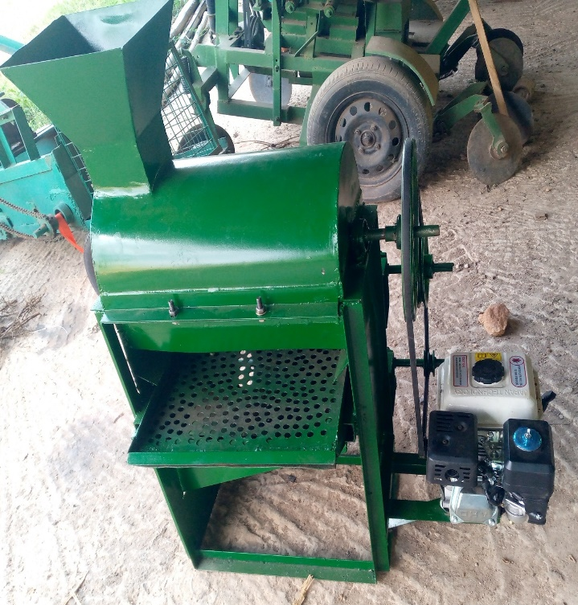
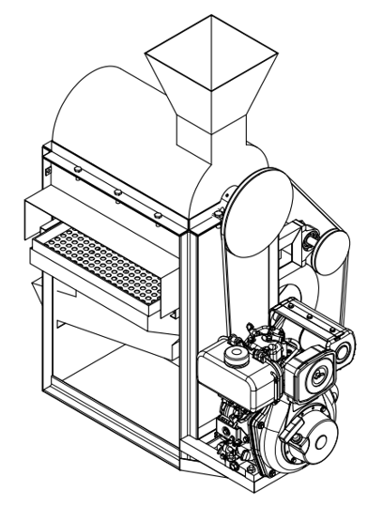
Figure 1: Isometric view of the machine Plate 1: Constructed Castor shelling machine.

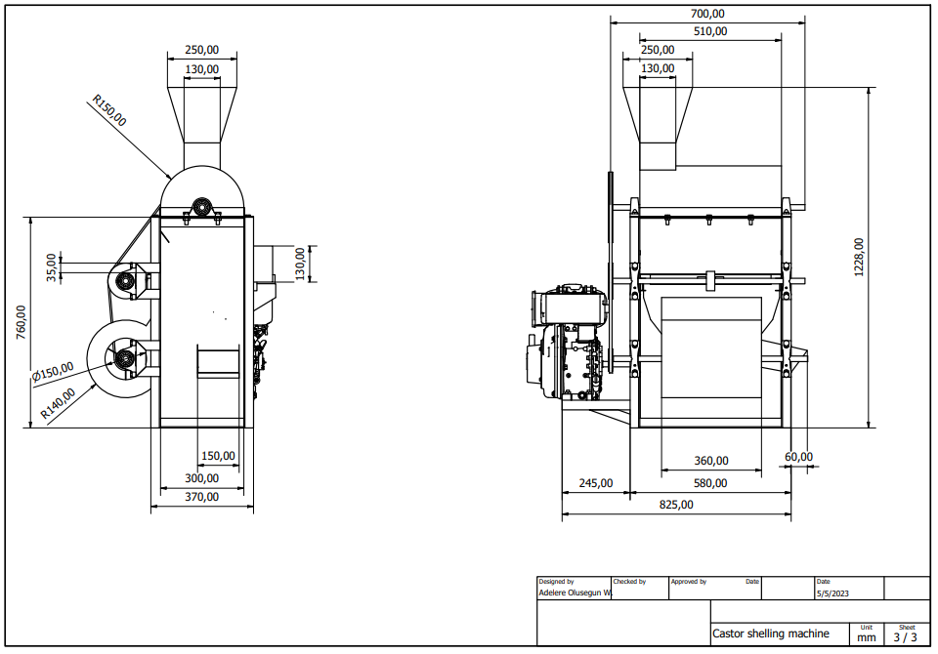
Figure 2: Dimensions of the machine
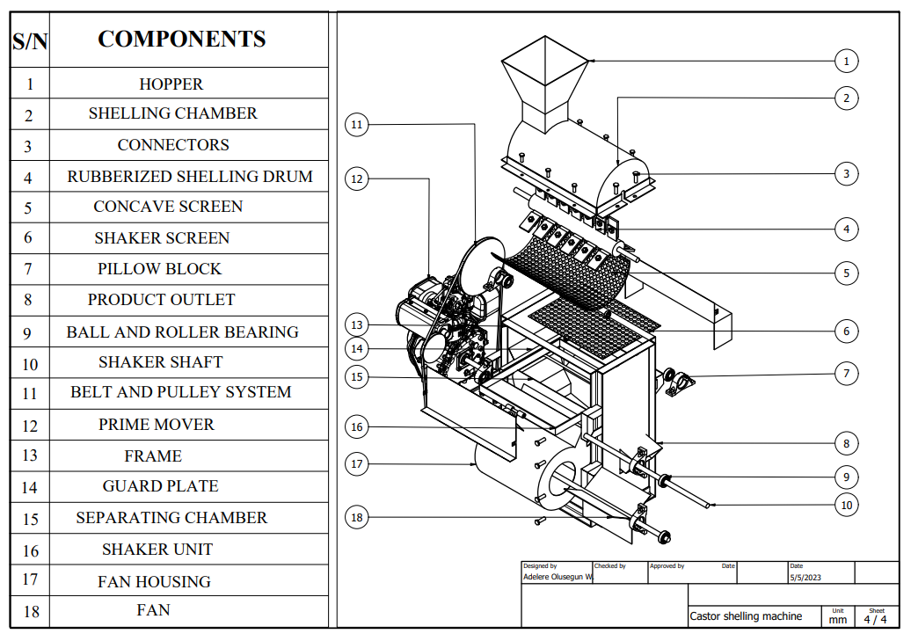
Figure 3: Parts drawing of the machine
  - Finite element analysis (FEA) of Castor seed shelling machine.
Finite element analysis is a numerical technique used to analyze the behavior of structures and mechanical components. FEA breaks down a complex structure into small, simple elements, and solves the equations of motion for each element. The results are then combined to provide an accurate representation of the behavior of the entire structure. FEA can be used to simulate the behavior of mechanical components under various loading conditions, which can be used to optimize their design. The FEA of the rubberized shelling drum was carried out using Autodesk Inventor design software according to the procedure itemized below:
- A 3D model of the shelling drum was created in Autodesk Inventor.
- The loading conditions of the shelling drum were calculated and applied as shown in Table 2.
- The mesh size and type of elements to be used for the analysis was automatically defined by the software once mesh was applied.
- The material properties of the model as shown in Table 1, including Young's modulus, Poisson's ratio, and density were assigned.
- The appropriate boundary conditions were also applied to the model as shown in Table 2. These includes constraints and moments.
- An analysis setup was created that specifies the type of analysis to be performed, the solution type, and the solver settings.
- The analysis was done and the results reviewed. This includes stress, strain, deformation, and displacement plots.
- The results were analyzed.

    - Determination of the shelling torque for Rubberized shelling drum.
The volume of the bars attached to the drum was determined using equation 14.
$volume of the mildsteel bars=lth$ ………………... (equation 14)
$$where;$$
$$l is length of the bar \left(50 mm\right) and$$
$$h is the height \left(60 mm\right) and$$
$$t is the thickness \left(4 mm\right)$$
$$∴volume of a mildsteel bar=0.004×0.050×0.06=1.2×{10}^{-5} m^{3}$$
$$volume of the rubber bars=lth$$
$$where;$$
$$l is length of the bar \left(80 mm\right) and$$
$$t is the thickness \left(8 mm\right) and$$
$$b is the width \left(50 mm\right)$$
$$∴volume of a rubber bar=0.008×0.050×0.08=3.2×{10}^{-5} m^{3}$$
The density of the mild steel bar is $7850$ kg/$m^{3}$ (Autodesk Inventor) while the density of rubber is 930 kg/$m^{3}$.
$$∴mass of the mild steel shelling bars=ρv=7850\frac{kg}{m^{3}}× 1.2×{10}^{-5} m^{3}=0.0942 kg$$
$$and the mass of the rubber bars=930\frac{kg}{m^{3}}×3.2×{10}^{-5}m^{3}= 0.0298 kg$$
Since the shelling drum has 19 rubber and mild steel bars attached to it,
$$∴Total mass of the rubber bars=19×0.0298 kg=0.5662 kg$$
$$and the total mass of the mildsteel bars=19×0.0942=1.7898 kg$$
Angular velocity ($ω)$ was determined to be $31.42 rad/s$, therefore, the force available along the shelling drum (F) can be calculated according to equation 15 as;
$F=\left(m_{r}×ω^{2}×l_{r}\right)+(m_{m}×ω^{2}×l_{m})$………………. (equation 15)
Where;
$m_{r}$ = mass of a rubber bar
$ω$ = angular velocity
$l_{r}$ = thickness of the rubber bar
$m_{m }$= mass of mild steel bar and
$l_{m}$ = thickness of mild steel bar.
$$∴F=\left(0.5662×{31.42}^{2}×0.004\right)+\left(1.7898×{31.42}^{2}×0.008\right)=14.135 N$$
The shelling torque can be determined thus;
$$∴The shelling torque \left(T\right)=F×r=14.135 N×0.133 m=1.88Nm$$
    - Determination of the force exerted by feed load on a single run of the Rubberized shelling drum.
To determine the feed load on a single run assuming the shelling machine is running at full capacity, according to equation 5.
$$The volume of the shelling housing \left(V_{1}\right)= πr^{2}h$$
Where;
r = radius of the shelling housing (150 mm) and
h = length of the shelling housing (510 mm)
$$∴\left(V_{1}\right)= πr^{2}h=π×{0.15}^{2}×0.510=0.036 m^{3}$$
$$The volume of the shelling drum\left(V_{2}\right)= 0.00164 m^{3}(gotten from Autodesk Inventor)$$
$$volume occuppied by the feed=V_{1}-V_{2}=0.036-0.00164=0.03436 m^{3}$$
The force exerted by the feed on the shelling drum can be calculated according to equation 16;
$F_{f}= ρVg$ …………………………(equation 16)
Where;
$ρ$ = density of the castor seed
V = volume occupied by the feed and
$g$ = acceleration due to gravity
$$F_{f}= ρVg=570×0.03436×9.81=192.131 N$$
Since there are 19 connected bars attached to the shelling drum, the force exerted on each bar (F_{b}):
$F_{b}=\frac{F_{f}}{19}=\frac{192.131}{19}=10.112 N$
Table 1: Properties of the shelling drum
Properties | Values
Material | Mild steel
Mass | 12.4741 kg
Area | 545237 mm^2
Volume | 1589050 mm^3
Center of Gravity | x=-0.19637 mm  y=-18.1951 mm  z=121.272 mm
Mass Density | 7.85 g/cm^3
Yield Strength | 207 MPa
Ultimate Tensile Strength | 345 MPa
Young's Modulus | 220 GPa
Poisson's Ratio | 0.275 ul
Shear Modulus | 86.2745 GPa
ul = unit level.

Table 2: Forces and moments on the shelling drum as a result of its operating conditions.
Load type | Magnitude | Vector X | Vector Y | Vector Z
Force 1-6(N) | 10.112 N | 5.056 N | -8.757 N | 0.000 N
Force 7-13(N) | 10.112 N | -10.112 N | 0.000 N | 0.000 N
Force 14-19(N) | 10.112 N | 5.056 N | 8.757 N | 0.000 N
Moment (Nm) | 1.880 Nm | 0.000 Nm | -0.000 Nm | -1.880 N mm
    - Summary of the results from the Finite Element Analysis (FEA).
The shelling drum was discretized into meshes which contains 125050 elements and 203222 nodes. The summary of the results from the Finite Element Analysis of the threshing drum is shown in Table 3 and for the figures generated by the FEA, the colour codes displayed on the right of the figures indicates the intensity of the generated result with red as the highest, followed by yellow, green, sky blue and the lowest being blue.
While running the analysis, the following information was displayed by the software:
- The model contains welds, you may consider excluding them from the analysis
- The model separates into two (2) independent components
- A soft spring was added.
Table 3: Summary of the FEA
Name | Minimum | Maximum
Von Mises Stress (MPa) | 0.000020454 MPa | 79.8792 MPa
1st Principal Stress (MPa) | -18.947 MPa | 82.8901 MPa
3rd Principal Stress (MPa) | -86.5745 MPa | 16.2772 MPa
Displacement (mm) | 0.000000150981 mm | 0.0546794 mm
Safety Factor (ul) | 2.59141 ul | 15 ul
X Displacement (mm) | -0.0542659 mm | 0.0280844 mm
Y Displacement (mm) | -0.0481703 mm | 0.0464784 mm
Z Displacement (mm) | -0.000378 mm | 0.000385846 mm
1st Principal Strain (ul) | -0.00000154347 ul | 0.000333534 ul
3rd Principal Strain (ul) | -0.000348024 ul | 0.00000323011 ul
ul= Unit level
      - Von Mises Stress
The Von Mises stress was first proposed by Richard Edler Von Mises in 1913 (Jones, 2009) and is a value that represents the equivalent stress that would produce the same amount of distortion energy as the actual loading condition and is used to determine if a given material will yield or fracture. It is mostly used for ductile materials such as metals. The von mises yield criterion is used for predicting the onset of yielding in ductile materials and it states that if the von mises stress of a material under load is equal or greater than the yield limit of the same material under simple tension then the material will yield. According to the FEA analysis performed on the metallic shelling drum, the maximum von mises stress is 79.8792 MPa (at the point of linkage between the shelling drum and the shaft) which is less than the yield strength of the material make-up (mild steel) of the shelling drum of 207 MPa implying that the shelling drum passed the von mises stress criterion as shown in Figure 4.
Von mises stress handles any complex 3D loading condition, regardless of the mix of normal and shear stresses. It converts the combination of stresses down to a single number that can be compared to the material’s yield strength.
      - 1st Principal Stress and Strain
The 1st principal stress (σ1) is the maximum normal tensile stress that a material or component part experiences due to its loading conditions and according to Autodesk, it is the value of stress that is normal to the plane in which the shear stress is zero (principal plane) while the 1st principal strain (ε1) is the maximum normal tensile strain that a material experiences due to its loading conditions. The FEA of the 1st principal stress and strain on the shelling drum as presented in Figure 5 and 6 shows that the maximum tensile stress and strain induced on it as a result of the operating conditions is 82.8901 MPa and 0.000333534 ul which is concentrated at the point of linkage between the drum and the shaft. From the results generated, it can be inferred that the model is safe in tensile deformation since the maximum values are very low.
      - 3rd Principal Stress and Strain
The 3rd principal stress according to Autodesk is the value of compressive stress that is normal to the plane in which the shear stress is zero (principal plane). It is the maximum compressive stress induced in the component part due to loading conditions while the strain as a result of this stress is the 3rd principal strain. It is the exact opposite of the 1st principal stress and strain, so, it is colored in reverse as presented in Figure 7 and 8. The maximum value of the 3rd principal stress and strain of 16.2772 MPa and 0.00000323 ul for the shelling drum are very low implying that the model is safe in compressive deformation.
      - Displacement
Displacement is a vector quantity which represents the measure of how far (distance) the model deforms or distorts from its original configuration as a result of the operating conditions. The displacement of the shelling drum as represented in Figure 9. shows that the maximum displacement experienced by the shelling drum is 0.0546794 mm. The model experiences the maximum displacement at the vertical bars attached to the shelling drum.
      - Factor of safety
This is based on the material’s properties and a high factor of safety means a safe model. The lowest factor of safety for the shelling drum as presented in Table 3 is 2.59141 indicating that it is a safe model.
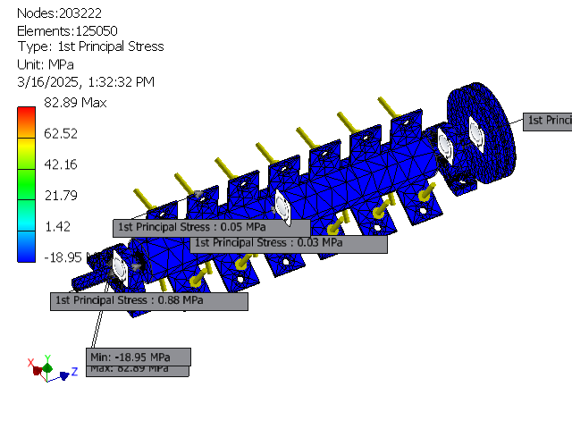
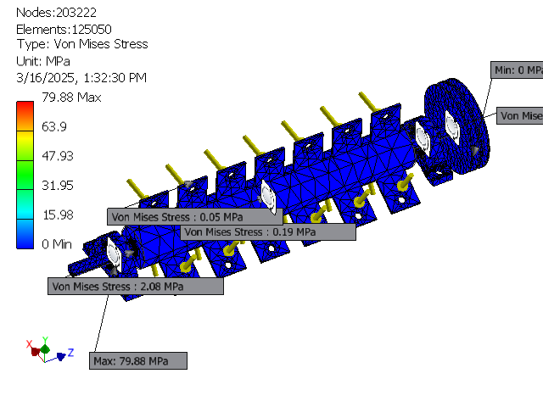
Figure 5: 1st principal stress of the shelling drum.

Figure 4: Von misses stress of the shelling drum.

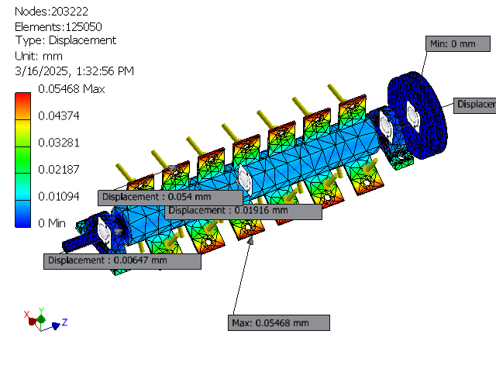
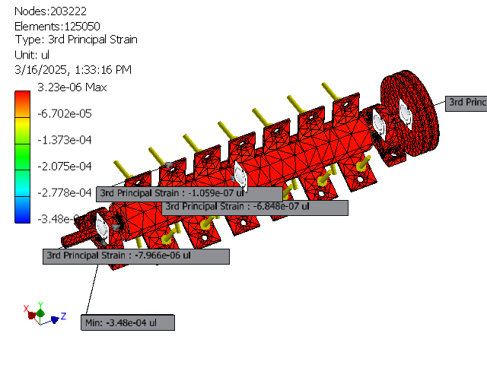
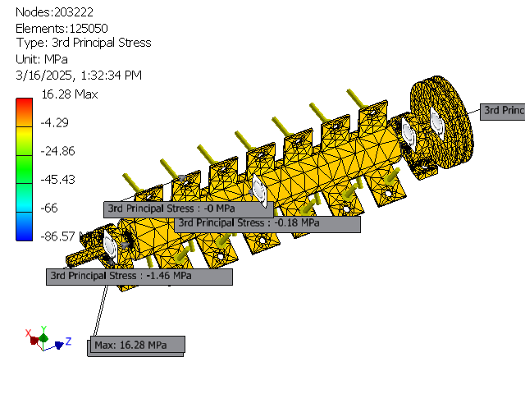
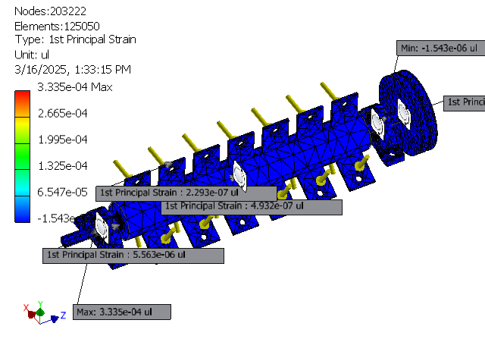
Figure 9: Displacement of the shelling drum.

Figure 8: 3rd principal strain of the shelling drum.

Figure 7: 3rd principal stress of the shelling drum.

Figure 6: 1st principal strain of the shelling drum.

  - Operating Principle of the Castor seed shelling Machine.
The castor pods are fed into the shelling chamber manually through the hopper and as the shelling drum rotates, it rubs the unshelled castor seed pods against the concave to affect the breaking of the pods and release of the castor seeds with minimal damage. The castor seeds and shells then drop on the shaker of the machine such that as the shaker vibrates, a blower which is also connected to the power source rotates and as the blower rotates, it generates a stream of air current which passes through the bottom of the shaker screen. The stream of air blows off the broken shells through chaff outlet and allow the shelled seeds to pass across the air stream to the seed delivery outlet.
- PERFORMANCE EVALUATION OF THE MACHINE.
30 kg of castor seeds were obtained, 12 kg for the Brazilian white variety and 18 kg for Brazilian black and white variety. In order to be sure of the functionality and operation of the machine, it was first run under no load condition using a prime mover of 6.5 hp with rating of 3600 rpm which provides power to the shelling cylinder to run at a speed rating of 235, 260 and 300 rpm by using the choke lever of the prime mover in tandem with the Tachometer to control its speed. The castor seeds were measured using a weighing balance to get a constant mass of 1 kg which was fed into the hopper of the machine at a time. The shelled materials fall through the perforated concave apertures by gravity down to the shaker outlet for the air blast from the blower to remove the chaffs from the mixture during the vibratory motion of the shaker. Also, the time taken for the shelling operation was recorded. The developed machine was evaluated using a factorial experiment with two levels of feed material at different moisture contents (BW at 9.06 % and BWB at 8.6 %), three levels of cylinder speed (235, 260 and 300 rpm), and two levels of concave clearance (10 and 15 mm) using a rubberized shelling drum arranged in 2 × 3 × 2 in completely randomized design (CRD). The results obtained from the experiments were analyzed using the performances parameters discussed below;
- Shelling efficiency: This is a performance parameter which is expressed as the ratio of the mass of the shelled castor seeds to the total mass of the castor pod and it is expressed in percentage as follows in equation 17;
$S_{e}=\frac{M_{s}}{M_{t}} ×100$ …………………… (equation 17)
Where; $S_{e}$ = Shelling efficiency (%)
$M_{s}$ = Mass of the shelled castor seeds (kg)
$M_{t}$ = Total mass of the castor pods. (kg)
- Seed recovery: This is the measure of the mass of shelled castor seeds obtained at the product outlet. It is expressed as the percentage of shelled castor seeds obtained at the product outlet including the damaged seeds and it can be calculated using equation 18;
$S_{r}=\frac{M_{wd}}{M_{t}} ×100$ …………………… (equation 18)
Where; $S_{r}$ = Seed recovery (%)
$M_{wd}$ = Mass of whole and damaged castor seeds at the product outlet (kg)
$M_{t}$ = Total mass of the shelled castor seeds. (kg)
- Separating efficiency: This is the ratio of the mass of castor seeds to the total mass of all the materials collected at the product outlet of the castor shelling machine and is expressed in percentage using equation 19;
$S_{ee}=\frac{M_{cs}}{M_{tp}} ×100$ ………………………… (equation 19)
Where; $S_{ee}$ = Separating efficiency (%)
$M_{cs}$= Mass of the castor seeds collected at the product outlet (kg)
$M_{tp}$ = Total mass of all materials collected at the product outlet (kg)
- Percentage damage: This is the measure of the ratio of quantity of damaged castor seeds to the total quantity of the castor seeds shelled by the machine. It is calculated using equation 20 below;
$P_{d}=\frac{M_{dc}}{M_{sc}} ×100$ ………………………. (equation 20)
Where; $P_{d}$ = Percentage damage (%)
$M_{dc}$ = Mass of the damaged castor seeds (g)
$M_{sc}$ = Total mass of the shelled castor seeds (g)
- RESULTS AND DISCUSSION
Table 4 shows the results of the efficiencies obtained from the performance evaluation of the castor shelling machine at different speeds (235, 260 and 300 rpm) and concave clearance (10 and 15 mm) using 2 different castor varieties (BW and BWB).
Table 4: Efficiencies of the Castor shelling machine
Specie | Concave clearance | Speed | $S_{e}$  $$(\%)$$ | $$S_{r}$$  $$(\%)$$ | $$S_{ee}$$  $$(\%)$$ | $$P_{d}$$  $$(\%)$$
BW_{9.06%} | 10 mm | 235 | 91.4 | 45.7 | 87.2 | 29.7
 |  | 260 | 93.6 | 59.4 | 90.9 | 43.3
 |  | 300 | 82.9 | 53.9 | 91.2 | 57.2
 | 15 mm | 235 | 80.6 | 41.1 | 75.3 | 5.4
 |  | 260 | 76.6 | 39.8 | 93.6 | 7.6
 |  | 300 | 86.3 | 25.2 | 64.8 | 5.9
BWB_{8.6%} | 10 mm | 235 | 91.0 | 53.0 | 96.0 | 18.3
 |  | 260 | 94.4 | 50.0 | 94.3 | 29.7
 |  | 300 | 89.0 | 53.5 | 96.8 | 42.6
 | 15 mm | 235 | 76.6 | 55.2 | 78.4 | 4.8
 |  | 260 | 74.0 | 36.9 | 90.4 | 4.9
 |  | 300 | 80.4 | 33.0 | 90.8 | 5.4

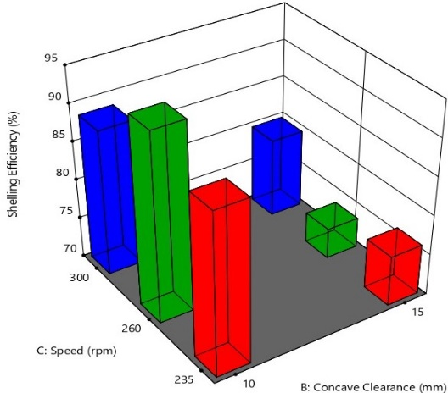
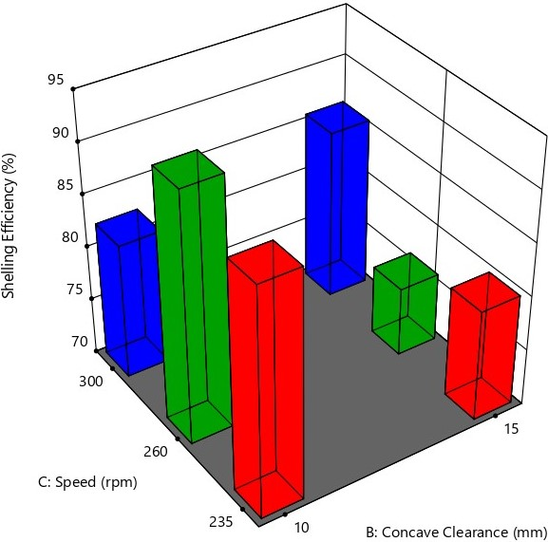
- Shelling efficiency: The optimum shelling efficiency of the machine were obtained at 10 mm concave clearance. It reduced with increase in speed at 10 mm concave clearance but lower shelling efficiencies were obtained at 15 mm concave clearance irrespective of the specie. The maximum shelling efficiency as displayed by Figure 10 and 11 show that higher shelling efficiencies were obtained at 235 rpm which is similar to the Yakubu et al., (2020) who obtained a higher shelling efficiency of 82.25% with metal cylinder type at 220 rpm and Balami et al. (2012) who reported the highest shelling efficiency of 79.33% at 240 rpm which shows that better shelling efficiencies are obtained at lower speeds.
Figure 10: Bar chart showing the shelling efficiency of BW specie
Figure 11: Bar chart showing the shelling efficiency of BWB Specie specie

- Seed recovery: It was observed that generally, the seed recovery rate for the castor shelling machine was low as opposed to what was reported by Balami et al., (2012) who obtained an average of 99.60 %. The low seed recovery rate was due to a portion of the castor seeds remaining on the shaker mechanism rather than dropping through the shaker apertures to be collected at the product outlet which is likely due to the screen holes been smaller than the castor pods. Also, the lowest seed recovery at both 10 and 15mm concave clearance was obtained at 300 rpm as shown in Figure 12 and 13.
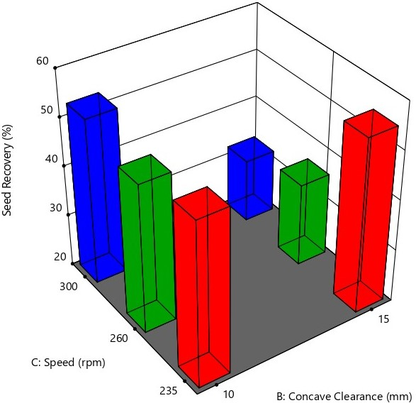
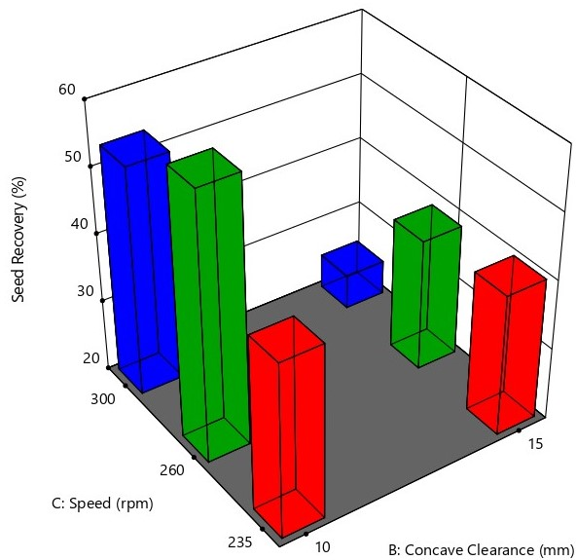
Figure 12: Bar chart showing the seed recovery of BW specie
Figure 13: Bar chart showing the seed recovery of BWB specie
- Separating Efficiency: From the bar charts shown in Figure 14 and 15, it was observed that higher separation efficiencies were obtained at 10 mm concave clearance for both of the castor specie while lower shelling efficiencies were obtained at 15 mm concave clearance. The highest separation efficiency was obtained at 10 mm concave clearance and 300 rpm with the BWB variety while the lowest separation efficiency of 64.8 % at 15 mm concave clearance at 300 rpm using the BW variety which was probably because the region where the feed material was taken from the castor bags was filled with broken pieces of castor pods which can easily slip through the apertures on the shaker unit. These results are higher than both that of Yakubu et al. (2020) who obtained the highest cleaning efficiency of 75.14% at cylinder speed of 220 rpm and 15 mm concave clearance while the lowest cleaning efficiency obtained was 40.58% at 280 rpm and 28 mm concave clearance and Agidi et al. (2015) who obtained the highest and lowest cleaning efficiency of 45.09 and 24% at 240 rpm. From the results shown by the estimated marginal means, higher separation efficiencies are obtained when the Castor shelling machine is operated at 10 mm
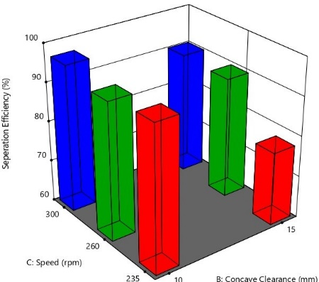
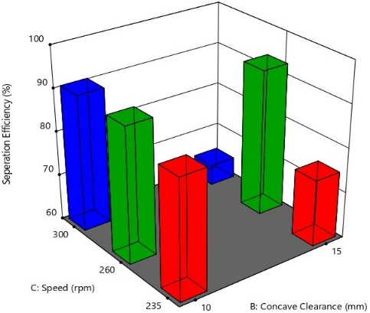
concave clearance and 260 rpm using the BWB castor variety.
Figure 14: Bar chart showing the separation efficiency of BW specie.
Figure 15: Bar chart showing the separation efficiency of BWB specie

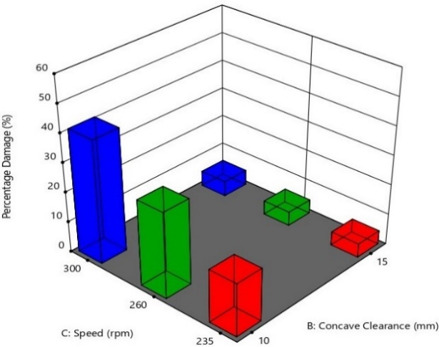
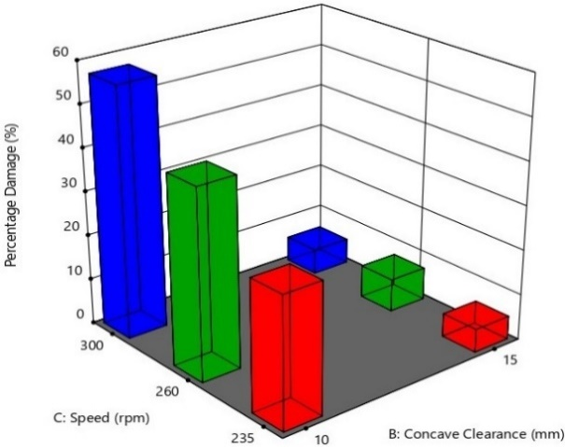
- Percentage damage: It was observed that changing the concave clearance from 10 mm to 15 mm drastically reduced the percentage damage of the shelling mechanism on the castor seeds and generally, the percentage damage increased with increase in speed as shown in Figure 16 and 17. Agidi et al., (2016) considered the percentage damage in relation to moisture content who recorded the percentage damage of 3% and 23% at 10% moisture content while the lowest percentage damage of 1% unshelled grains of 3-5% were obtained at the lowest seed moisture content of 6% and 8% but from the evaluation carried out, concave clearance also has significant effect on the percentage damage.

Figure 16: Bar chart showing the percentage damage of BW specie. Figure 17: Bar chart showing the percentage damage of BW specie.
- CONCLUSION
The performance evaluation of the castor shelling machine revealed the following:
- Though the shelling efficiency reduced from 94.4 % (highest shelling efficiency obtained at 10 mm concave clearance) to 74 % (lowest shelling efficiency obtained at 15 mm concave clearance) when the concave clearance was changed from 10 mm to 15 mm, the percentage damage reduced drastically from 57.2 % (highest percentage damage obtained at 10 mm concave clearance) to the 4.8 % (lowest percentage damage obtained at 15 mm concave clearance) showing that the major determinant of percentage damage is concave clearance.
- Increase in the operating speed also increases the percentage damage, so operation speed in tandem with concave clearance has major effects on percentage damage.
- The shelling efficiency of the machine is influenced by both the species being shelled, concave clearance and speed. Smaller concave clearance yields higher shelling efficiency and percentage damage.
- BWB specie exhibits higher seed recovery compared to BW specie. Speed has an impact on seed recovery but the effect varies depending on the species and concave clearance.
- BWB specie generally exhibits higher separation efficiency compared to BW specie and it tends to increase as speed increases for BW specie.

REFERENCES
Agidi, G., Abdullahi, L., Alhassan, K., and Ndagi, B. (2016). ‘Design and performance assessment of a spiked toothed drum mechanism for shelling of castor’. International Journal of Innovative Science, Engineering & Technology, Vol. 3 Issue 2.
Ahmed, S., Mehmood, S., Raza, S.A., and Rashid, A. (2013). Physical properties of castor (Ricinus communis L.) seeds. International Journal of Agriculture and Biology, 15(6), 1179-1182.
Ali, M. A. (1986). Comparative Ergonomics Studies of Male and Female Operations on Selected Farm Task. Unpublished M.sc. Thesis.Ahmadu Bello University, Zaria, Nigeria.Pp 42-45.
Ali M. A. (2014). Maize Dehusker sheller Development and Women use participation. Samaru journal of Agricultural mechanization. Vo1.1 Pp 43-51.
Balami A. A., Adgidzi D, Kenneth C. A. And Lamuwa G. (2012); Development and Performance Evaluation of a Dehusking and Shelling Machine for Castor Fruits and Seeds, International Organisation of Scientific Research (IOSR) Journal of Engineering, Vol 2, Issue 10, Pp 44 – 48.
Benagro Ltd. (2007). Castor oil seed production. A publication for the Yobe State Government, Nigeria. pp 1– 19.
Duraisamy, V.M. and R. Manian, (1990). Design, development and evaluation of castor bean sheller. Agric. Mech. In Asia, Africa and Latin America., 21(2):41-45.
Gbabo, A., Lukman, A., Kuku, A., and Baba, N (2016). Design and Performance Assessment of A Spike toothed Drum Mechanism for Shelling of Castor.
Gely, M.C. and Santalla, E.M., (2009). Hygroscopic properties of castor seeds (Ricinus communis L.). Brazilian Journal of Chemical Engineering, 26(1): 181–188.
Gupta, S.K. (2011). Engineering Drawing (2nd edition). PHI Learning Private Limited. (Chapter 22: Development of frustums pp. 518 – 522).
https://www.autodesk.com/
Jones, Robert Millard (2009). Deformation Theory of Plasticity, p. 151, Section 4.5.6. Bull Ridge Corporation. ISBN 9780978722319. Retrieved 2025-03-17
Khurmi, R.S. and Gupta, J.K. (2007). Machine Design, 14th Edition, Eurasian Ltd, Ran Nagar, New Delhi, pp 1230.
Kirk-Othmer, (1979). Encyclopedia of Chemical Technology, Vol. 5, John Wiley and Sons, New York. P.45.
Kurien, P.P., (1977). Grain Legume Milling Technology. Central Food Technology Research Institute, Mysore, India.
Lorestani, A. N, Jaliliantabar, F, Gholami, R (2012). Physical and mechanical properties of castor seed. Quality Assurance and Safety of Crops & Foods, 4, e29–e32.
Nkpa, N.N., Akobundu, E.N.T., and Ikeorgu, J.E.G. (1989). Physicochemical properties of Castor bean (Ricinus communis L.) and the potential uses of its oil in various industries. Journal of the American Oil Chemists' Society, 66(10), 1476-1480.
Manuwa, S.I. (2007). Modeling fracture and cracking resistance of palm nuts (Dura Variety). Department of agricultural engineering, Federal University of Technology, Akure, Nigeria.
Ogunniyi, D. S. (2006). Castor oil: A vital industrial raw material. Bioresource Technology, vol. 97, issue 9, pp 1086 – 1091.
Ojediran, J., Raji, A.O., and Owamah, H.I (2013) Isosteric Heats of Water Vapor Sorption in Two Castor Varieties. J Chem Eng Process Technol 4: 146 doi:10.4172/2157 7048.1000146.
Ojolo, S.J., Afolalu, S.A., Alausa, S.K., Akinlabi, E.T., and Olaleye, A.O. (2019). Experimental analysis of the tribological behaviour of castor oil seed on different surfaces. Materials Today: Proceedings, 18, 3291-3299.
Onoja, U.S., (1982). Dehulling of cowpeas II (Vigna Unquiculata). A master degree thesis, department of food science and technology, University of Nigeria, Nsukka.
Oriah, V. N, Okonkwo, E. M, Ofodile, E. E. (1999). Design and fabrication of castor seed shelling machine. 1st National Engineering Design Conference, Abuja, Nigeria.
Pius, O.C., Nnaemeka, S.C., Charles, O., Vincent, O.N., and Chinenye, I.A (2014). Design Enhancement Evaluation of a Castor Seed Shelling Machine.Journal of Scientific Research & Reports 3(7): 924-938, 2014; Article no. JSRR.2014.004.
RUSEP (2001). Needs assessments study for market driven agricultural technology transfer and commercialization in Katsina State. USAID//IITA. Pp51.
Sale N. A. U.S Mohammed, M. A. Gwarzo and S. I. Idris. (2017). Modification and performance evaluation of cleaning system of IAR sorghum thresher. FUOYE Journal Engineering and technology. Vol.2 (2). Pp 90-91.
Schoenleber, L.G and W. E Taylor (1954): Development of a portable Castor Bean huller Agric Engineering Journal p.35, 237 326.
Severino, L.S., Auld, D.L., Baldanzi, M., Cândido, M.J., Chen, G., Crosby, W. (2012). A review on the challenges for increased production of castor. Agronomy Journal;104(4):853-880.
Uzo, F.N.A. (1981). Dehulling of cowpeas. A post graduate diploma thesis, department of food science and technology, University of Nigeria, Nsukka.
Yakubu, A.U., Muhammad, S.U., Ishiaka, M., Muhammmad, S.A., and Sale, N.A (2020). ‘Development and Performance Evaluation of a Castor Seed (Ricnus Communis) Shelling Machine with a Winnowing System’.

