Original Research Article
COMPRESSIVE BEHAVIOUR OF TYRE FIBRE IN LIGHT WEIGHT CONCRETE USING ELEPHANT SUPASET CEMENT.

ABSTRACT: As the population of Nigerians increases, the number of cars and used tyres also increases. Used and expired tyres are non-biodegradable and poses serious threat to human health and the environment. This paper examined the effect of partial replacement of coarse aggregate by tyre fibre on the fresh and hardened concrete cubes. The shredded tyres aggregate used in concrete grade M15 at 0%, 5% and 10% replacement levels, cured for 7 days and 28 days. The finite element analysis software, ANSYS was used to model the compressive behaviour of the concrete. The experimental investigation showed that workability of the concrete is affected by the replacement of coarse aggregate with tyre fibre. As the percentage of tyre fibre increases from 0% to 10%, the compressive strength declines. The 28 days’ compressive strength values at 5% and 10% tyre fibre replacement are 20.7 N/mm² and 17.7 N/mm² respectively. The average equivalent elastic strain value, average equivalent stress, strain energy and the total deformation in the concrete increases as the percentage of tyre fibre increases. In conclusion, less than 10% tyre fibre could be used as partial replacement to coarse aggregates especially in non-structural concrete, such as fill or light weight concrete.
Keywords: Tyre fibre, concrete, Aggregate, compressive strength, ANSYS software.
1. INTRODUCTION
Recycled tyre polymer (RTP) fibre has recently been gaining ever-increasing attention from the scientific community as a promising substitute to synthetic fibres for cementitious composites to improve sustainability (Meng Chen et al. 2020). The inclusion of RTP fibres is favorable in enhancing the splitting tensile properties of concrete under various strain rates (10−1 to 101 s−1), where the dynamic splitting tensile strength and dissipated energy of concrete mixture containing 0.2 vol% RTP fibre are improved by 5.5%–14.2% and 24.9%–36.7% respectively compared to the plain mixture as a result of fibre bridging effect. Fibre pull-out process considerably contributes to the enhancement of energy dissipation capacity (Meng Chen et al. 2020). The research community has been paying a lot of attention to solid waste management (Adewuyi et al., 2015, and Adewuyi et al., 2017). In nature, solid wastes are not biodegradable, hence, creating major problem in environment despite several landfill treatments. Managing these wastes is a significant environmental challenge for the entire world, in fact, the disposal in landfills has been prohibited in many countries due to the swift depletion of suitable sites for garbage disposal. There are various solid wastes, such as construction and demolition debris, hazardous waste lamps, household, hazardous waste (HHW), industrial/commercial waste, regulated medical waste, used electronic equipment, waste tyres and many more (Olaniyi et al., 2019, Olaniyi et al., 2023a and Olaniyi et al., 2023b). The use of RTSF can not only enhance the mechanical properties and sustainability of cementitious materials but also reduce the environmental impact of waste tyres (Meng Chena et al. 2021). Hasanain K. et al. 2023 concluded that the higher the number of bends and fiber content, the more pronounced the enhancement provided by the fibers to the compressive strength and ductility responses and also the elastic properties of plain lightweight concrete remained unaffected by the addition of fibers. panelBaifa Zhang et al. 2022 showed that the incorporation of fibres effectively reduced the brittleness of LCC without altering its composition, and contribute much to the ductility of LCC ss of LCC without altering its composition, and contributed much to the ductility of LCC with the failure mode transforming from brittle to ductile failure. Compared with smooth steel (SS) and polypropylene (PP) fibre, end-hooked steel (ES) fibre exhibited a better improvement to the mechanical properties of LCC.
With the increase in the automobile production, large amounts of waste tyres are causing significant environmental problems. Nigeria imports large quantity of tyres annually as the production of tyres is almost non-existent; survey shows that there are over 20 million tyres consisting of 120 different brands imported annually, NADDC (2018), and when these tyres are discarded, they make up a significant amount of solid trash that are dumped in landfills. They are of non-biodegradable and poses serious threat to human health, the environment, and aesthetics. These discarded tyres are often used in skid-resistant ramps, recreational courts and walks, and road junctions. Thus, steel fibers recovered from waste tires have been preferred as an alternative to industrial steel fibers due to their environmentally friendly and low-cost advantages. In this study, an experimental study was carried out to explore the effect of fiber content on the fresh and hardened state of the concrete (Zeybek Ö, et al. 2022). Management schemes and processing techniques for used tyres include retreading, combustion, pyrolysis, reuse and shredding TALENTA (2019). Another way of managing these tyre wastes is the applications in Portland cement concrete (PCC). This kind of concrete is frequently utilized in the building of highways. The use of waste tyre rubber in concrete has been found as the best disposal method to protect our environment Jamdar & Ansari (2018). This will help to solve the significant environmental problem of disposal and shortage or depletion of natural coarse aggregates in construction. Partial replacing the coarse aggregates of concrete with recycled waste tyre aggregates can improve the qualities such as low unit weight, high resistance to abrasion, durability, absorbing the shocks and vibrations, high ductility etc. (Ashwini & Kariappa, 2020). Generally, plain cement concrete has deficiencies like low tensile strength and allow strain at fracture, and in addition there exist a hike in cost of cement and aggregates, which are the most essential ingredients for making concrete. This urgently calls for a need to find an alternative material that are cost effective for concrete production. Currently, the rapid expansion of the building industry is driving up demand for concrete ingredients, and new ingredients to include in concrete mixes are constantly being researched and developed. Several researchers have suggested the use of waste ceramic tiles, electronic wastes, palm kernel shells, coconut shells, waste tyre rubber etc. which can be used successfully as aggregates in concrete more (Olaniyi et al., 2023c and Olaniyi et al., 2023d). The main aim of this experimental work is to protect our environment by using non decaying material waste tyre in concrete, and to study its compressive behavior in light weight.
2. MATERIALS AND METHODS
2.1. Materials
Cement: Portland Elephant Supaset cement of grade 42.5N as shown in Figure 1 was used for in this study. The specific gravity and finest modulus are 3.15 and 2.23 respectively (1S 4031 Part 1).
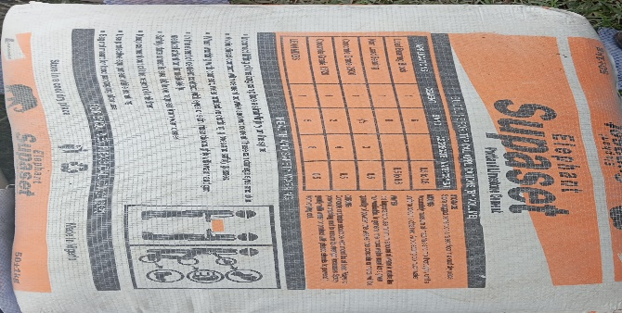
Fig 1: Portland Elephant Supaset cement

2.1.1. Aggregate
Natural river sand of size less than 5mm was used as fine aggregate, while basalt stone with size 16mm and below was used as coarse aggregate. The aggregates were washed to remove dust and dirt and were dried to surface dry condition.
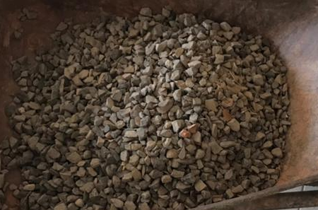
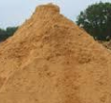
(a) (b)
Fig 2: (a) Coase aggregate
(b) Fine aggregate

2.1.2. Waste Tyre Fibre aggregate
The tyre rubber waste was obtained by shredding to an average size of 16 mm.
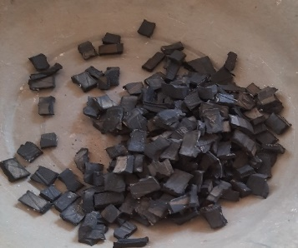
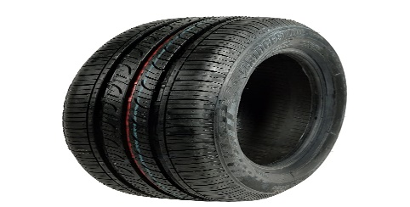

(a) (b)
Fig. 3 (a - b): Tyre Fibre before and after shredding

2.1.3. Water
The water used for mixing and curing processes was portable borehole water, free from any bacteria, oils, acids, salts and other impurities, and confirming to BS EN 1008:2002.

2.2. Methods
2.2.1. Sample mix design
For this experimental study, three different concrete mixes were produced (Table 1). The concrete mix design was prepared using BS 1881-125 (2013). The concrete was mixed manually in ratio 1:2:4, at water-cement ratio of 0.5.
Table 1: Concrete Mix design
Mix Identity | Mix Proportions
0% Fibre Concrete | Concrete with 100% coarse aggregate.
5% Fibre Concrete | Concrete with 95% coarse aggregate + 5% tyre rubber.
10% Fibre Concrete | Concrete with 90% coarse aggregate + 10% tyre rubber.

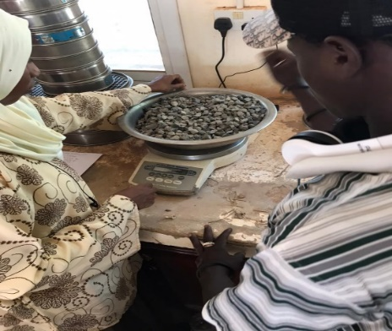
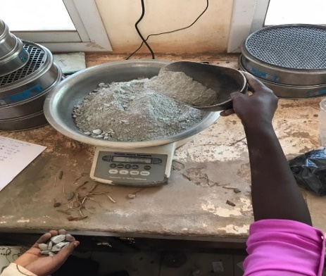
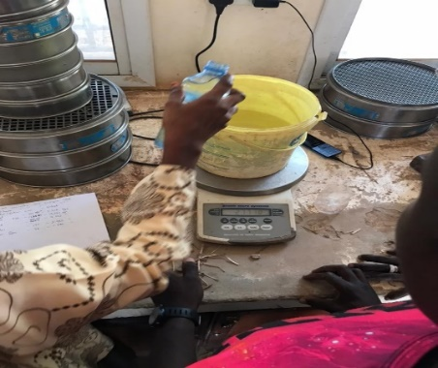

Fig. 4: Weighing of Basalt stone, cement and water for mixing

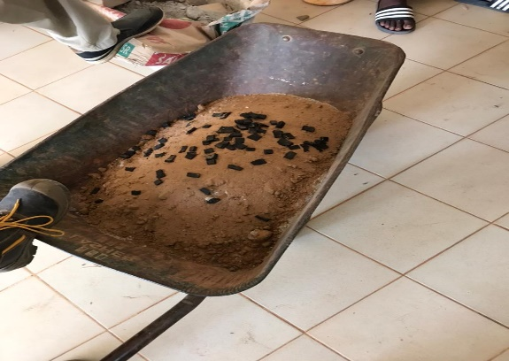
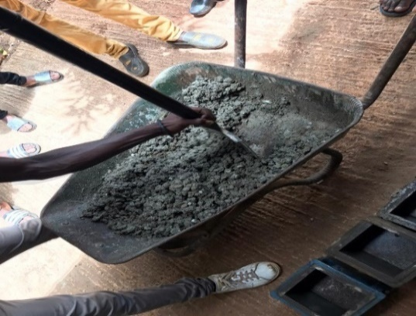

Fig. 5: Addition of waste tyre fibre and mixing
2.2.2. Slump test
The slump test was carried out to assess the workability of the fresh concrete. The apparatus for the test consists of a metal mold, in the shape of the frustum of a cone, open at both ends and provided with a handle, having a top internal diameter of 100mm and bottom internal diameter of 200mm with a height of 300 mm and a tamping rod. Fresh concrete was placed in three layers in the slump cone through the slump funnel with the aid of a scoop. Each layer was given 25 blows using the tamping rod. The blows were evenly distributed around the entire surface of the concrete in the cone. The funnel was removed and the surface of the fresh concrete was troweled with the aid of a straight edge. The slump cone was removed in order to get the slump concrete mix and the slump value was measured.
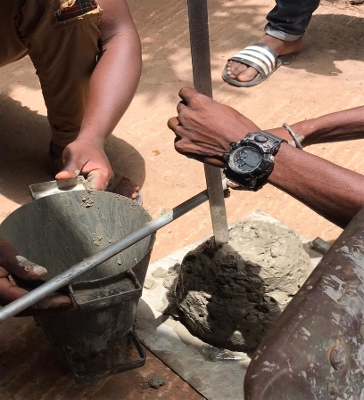
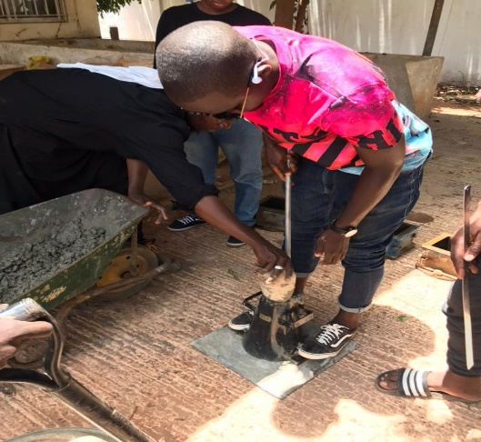

- (b)
Fig. 6: (a) Filling of cone moulds with concrete (b) Finding the Slump value
2.2.3. Casting of cubes specimen
Test specimens of cubes of size 150 mm x 150 mm x 150 mm were prepared using the standard moulds. The concrete was poured in these moulds in three layers with each layer being compacted 25 times by a tamping rod (Figure 9). After the mould was filled, the top was levelled using a trowel. After 24 hours of casting, the cubes were removed from the moulds and then submerged in water tank (cured) for 7 and 28 days.
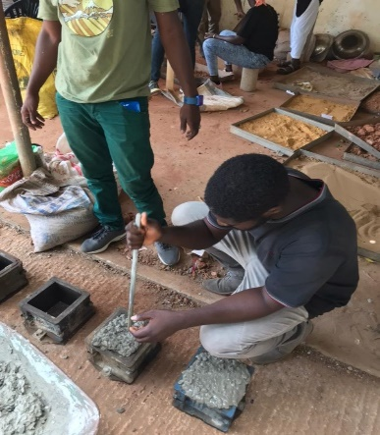
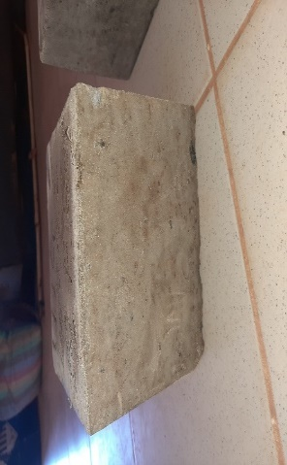
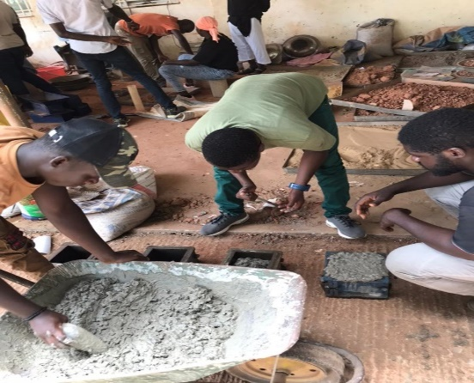
- (b) (c)
Fig. 7: (a) casting of concrete in moulds ; (b) Compacting in layers : (c) Cube after curing

2.2.4. Compressive Strength Test
Compressive strength test was carried out on cubes of dimensions 150 × 150 × 150 mm using a using the Compressive Testing Machine (Figure 8) after 7 days and 28 days curing. For each test and for each mix two specimens were tested. The compressive strength was computed using equation i.
Fc = $\frac{P}{A}$ ………………Eq i.
Where, Fc is the compressive stress in N/mm². P is the maximum load applied in Newton and A is the cross-sectional area in mm².
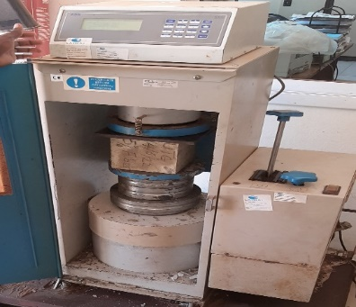

Fig. 8: Compressive test machine test setup.
3. Experimental modelling
The compressive behaviour of the concrete cubes was modelled using ANSYS Software.
4. RESULTS AND DISCUSSION
4.1. Workability of the concrete
The workability of the M15 grade of concrete was measured by widely used slump test with at 0.40 water cement ratio at 0%, 5% and 10% waste tyre fibre addition. The slump values obtained are shown in Figure 9. As seen, the workability of the concrete is affected by the replacement of coarse aggregate with tyre fibre. As the percentage of waste tyre fibre in the overall volume of aggregate increases, the fibre concrete exhibits an increase in slump value. 0.5 kg of water had to be added to the concrete during mixing because it was too stiff to mix, the 10% fibre mix result demonstrated an improvement in workability. However, it can be said that adding tyre fibre has a negative impact on workability.

Fig. 9: Slump value for different percentage (%) of tyre fibre
4.1.2. Compressive Strength Test Results
The result of the compressive strength of tyre fibre concrete after 7-days and 28-days curing are recorded in Tables 2 and 3. This result indicates that as the percentage of waste tyre rubber increases from 0% to 10% the compressive strength declines. This was also observed by Biji & Rajeevan (2018), Ashwini & Kariappa (2020), Durga & krishna (2022), and could be due to the unequal distribution of fibres, and possibly due to the improper adhesion of cement pastes and tyre fibre particles. Also, since tyre fibre has less stiffness than basalt, it reduces both the bulk stiffness and the capacity to support weights of concrete. The Graph of Compressive strenght at different % of tyre fibre is shown in figure 10.
Table 2: Compressive Cube Strength at 7 days

Mix Identity | Mean Weight (g) | Mean Load at Failure (KN) | Compressive Strength(N/mm²)
0% Fibre | 9088 | 456.80 | 20.30
5% Fibre | 8287 | 368.75 | 16.40
10% Fibre | 8040 | 310.95 | 13.80

Table 3: Compressive Cube Strength at 28 days
Mix Identity | Mean Weight (g) | Mean Load at Failure (KN) | Compressive Strength(N/mm²)
0% Fibre | 9205 | 579.70 | 25.80
5% Fibre | 8457 | 466.35 | 20.70
10% Fibre | 7739 | 397.45 | 17.70

Fig. 10: Graph of Compressive strenght at different % of tyre fibre

4.1.3. Experimental modelling results
The compressive behaviour of the concrete cubes was observed from the experimental modeling results from ANSYS as shown in figure 11. It was noticed that the average equivalent elastic strain values which are the limit for the values of strain up to which the concrete will rebound and come back to the original shape upon the removal of the load, increase as the percentage of tyre fibre increases in concrete. This is also true for the average equivalent stress, strain energy and the total deformation values of the tyre fibre concrete as presented in Table 4. The result also shows that there is no increase in these compressive behavior properties after 7 days.
Table 4: Average Equivalent elastic strain(m/m)
Percentage | 7days | 28days
Control (0%) | 1357.6 | 1357.6
5% | 1368.8 | 1357.6
10% | 1374.6 | 1374.6
Average Equivalent stress (J)
Control (0%) | 2.1448e+007 | 2.1448e+007
5% | 2.1631e+007 | 2.1631e+007
10% | 2.1726e+007 | 2.1726e+007
Strain energy (Pa)
Control (0%) | 5.1719e+007 | 5.1719e+007
5% | 5.2166e+007 | 5.2166e+007
10% | 5.2336e+007 | 5.2336e+007
Total deformation (m)
Control (0%) | 104.12 | 104.12
5% | 104.78 | 104.78
10% | 105.01 | 105.01

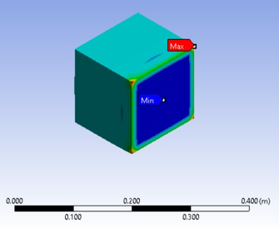
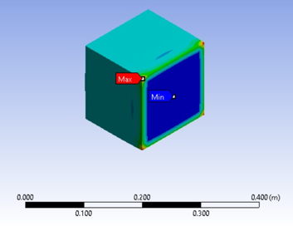

a. Equivalent elastic strain b. Equivalent stress
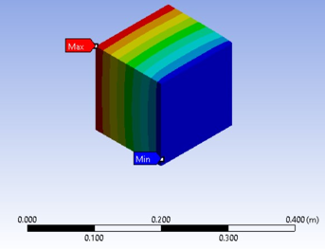
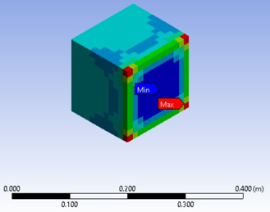

c. Strain energy d. Total deformation
Fig. 11 (a-d): Experimental modeling of concrete cubes using ANSYS Software.
5. CONCLUSIONS
The following conclusions are formed from this experimental work;
Workability of the concrete is affected by the replacement of coarse aggregate with tyre fibre.
As the percentage of waste tyre rubber increases from 0% to 10% the compressive strength declines, possibly due to the improper bonding between the matrix of cement paste and the tyre fibre aggregates.
The 28 days’ compressive strength values at 5% and 10% tyre fibre replacement are greater than 15N/mm². The overall results show that it is possible to use recycled tyre fibre aggregates in concrete construction as partial replacement to mineral coarse aggregates.
The average equivalent elastic strain value, average equivalent stress, strain energy and the total deformation in the concrete increase as the percentage of tyre fibre increases in concrete. No increase in these compressive behavior properties after 7days was observed.

COMPETING INTERESTS DISCLAIMER:
Authors have declared that they have no known competing financial interests OR non-financial interests OR personal relationships that could have appeared to influence the work reported in this paper.

REFERENCES
- Adewuyi, A.P., Otukoya, A.A., Olaniyi, O.A. and Olafusi, O.S. (2015): Comparative Studies of Steel, Bamboo and Rattan as Reinforcing Bars in Concrete: Tensile and Flexural Characteristics. Open Journal of Civil Engineering, 5: 228-238.
- Adewuyi, A.P., Ibrahim K.A., Olaniyi O.A., Babalola D.D. (2017): Physical properties and compressive strength of concrete exposed to progressive heat. Journal of Multidisciplinary Engineering Science Studies (JMESS) ISSN: 2458-925X Vol. 3 Issue 9, September - 20173(9), 2085-2090.
- Ahirwar, K. (2009): Waste tyre rubber as coarse aggregate replacement in cement concrete. Master thesis in Structural Engineering, Civil engineering Department, and IIT Kharagpur.
- Ashwini P. M, & Kariappa M.S. (2020): Experimental Study in Strength of Concrete by using Waste Tyre Rubber as Partial Replacement of Coarse Aggregate. International Research Journal of Engineering and Technology (IRJET). Volume: 07 Issue: 07 July 2020
- Bakri, A. M. M. A., Fadli, S. A. S. N., Bakar, M. D.A., and Leong, K. W. (2007): Comparison of rubber as aggregate and rubber as filler in concrete, First International Conference on Sustainable Materials 2007, Penang.
- Biji B & Rajeevan. B (2018): Experimental Study on Mechanical Properties of Scrap Tyre Fibre Reinforced Concrete. International Journal of Scientific & Engineering Research Volume 9, Issue 7, July-2018 ISSN 2229-5518
- BS 1881-125 (2013): Concrete Mixing and Sampling of Fresh Concrete
- BS EN 1008:2002 - Specification for Mixing Water for Concrete provides detailed requirements for various water types based on intended use.
- Durga G. & krishna. L (2022): An experimental study on steel fibre reinforced rubber concrete. International Journal of Creative Research Thoughts (IJCRT). Volume 10, Issue 12
- Ganjian, E., Khorami, M., Maghsoudi (2008): Scrap-tyre rubber replacement for aggregate and filler in concrete, Construction and Building Materials.
- Hasanain K. Al-Naimi, Ali A. Abbas 2023: Constitutive model for plain and fiber-reinforced lightweight concrete under compression. Structurer concrete, Journal of the fib https://doi.org/10.1002/suco.202200646. Vol. 24, Issue 6, 7625-7647
- IS: 10262 (1982): Recommended Guidelines for Concrete Mix Design. Bureau of Indian standards, New Delhi.
- Jamdar, S. D., and Ansari, U.S (2018): Experimental Study of Rubberized concrete. International Journal of Engineering and Techniques - Volume 4 Issue 1, Jan – Feb 2018.
- Li, G., stubblefield, M. A., Garrick, G., Eggers, J. Abadie, C., Huang, B., (2004): Development of waste tire modified concrete. Cement Concrete Research.
- Malladi, K. S. (2004): Studies on rubberized cement concrete. Master Thesis in Structural Engineering, Civil Engineering Department, IIT Kharagpur.
- Meng Chena, Hanqing Sia, Xiaochun Fanb, Yiwei Xuanc, Mingzhong Zhangc, 2021: Construction and Building Materials 316(3):125896, DOI: 10.1016/j.conbuildmat.2021.125896: Dynamic compressive behaviour of recycled tyre steel fibre reinforced concrete
- Meng Chen, Hui Zhong, Hao Wang, Mingzhong Zhang, 2020: Behaviour of recycled tyre polymer fibre reinforced concrete under dynamic splitting tension, Cement and Concrete Composites, Vol. 114, 103764, ISSN 0958-9465, https://doi.org/10.1016/j.cemconcomp.2020.103764.
- NADDC (2018): Tyre Value Chain Conference Report.
- Olaniyi O. A., Adeyemi F.O., Ogunmodede J. O. and Ogunkoya E. A. (2023A): The Effect of Stone Dust and River Sand as Fine Aggregates on The Compressive Strength of Hollow Sandcrete Blocks, Adeleke University Journal of Engineering and Technology [AUJET] Vol. 6, No 2, 286 - 295 (2023), ISSN: 2714 – 2450.
- Olaniyi O.A., Adewuyi A.P, Oyelami A.K., and Ceesay A.A., (2023B): Comparative Analysis of Concrete Strength made From Basalt and Local Gravel as Available in The Gambia. Epistemics in Science, Engineering and Technology, Vol.13, No.1, 2023, 871-877.
- Olaniyi O.A., Adedeji A.A. and Adewuyi A.P., (2023C): Optimum Design of Steel Reinforcing Bars in the Performance of Concrete Structural Beams Epistemics in Science, Engineering and Technology, Vol.13, No.1, 2023, 860-870.
- Olaniyi O.A., Adedeji A.A., Adewuyi A.P., (2019): Tensile and Flexural Properties of Common Steel Reinforcing bars in Southwestern Nigeria for Concrete Structures, Journal of Multidisciplinary Engineering Science Studies (JMESS) ISSN: 2458-925X Vol. 5 Issue 5, May – 2019 pp 2612- 2617.
- Olaniyi O.A., Adedeji A.A. and Adewuyi A.P., (2023D): Optimal Design of Reinforced Concrete Beams Based on Engineering Properties of Steel Reinforcing Bars. Websjournal of Science and Engineering Application, Wesea Issn: 1974-1400-X, Vol 12, No 2, 2023, pp 682-700.
- PanelBaifa Zhang, Yuan Feng, Jianhe Xie, Jianhua He, Ting Yu, Chaojun Cai, Dongchao Huang, 2022: Compressive behaviours, splitting properties, and workability of lightweight cement concrete: The role of fibres. Construction and Building Mateterials, Vol 320, 126237
- Shanvendra S, & Manish D. (2018): An Experimental Study on Strength of concrete using Tyre Rubber & Replacing Aggregates of Different Percentage with Tyre Rubber. International Journalof Research In Technology (IJRT). Vol. V, No. III, June 2018.
- Talenta Cest II (2019): Used tires recycle management and processing: A review. IOP Conf. Series: Materials Science and Engineering 801 (2020) 012116 IOP Publishing doi:10.1088/1757-899X/801/1/012116
- Zeybek Ö, Özkılıç YO, Çelik Aİ, Deifalla AF, Ahmad M and Sabri Sabri MM (2022): Performance evaluation of fiber-reinforced concrete produced with steel fibers extracted from waste tire. Front. Mater. 9:1057128. doi: 10.3389/fmats.2022.1057128

